Cognitive and Behavioural Neuroscience Webinar on Routine participation in sports and fitness activities among out-patients with psychotic disorders: A multi-site cross-sectional survey in England.

- Jade Donaghy^{ab1}
- Kurt Buhagiar^{ab1}
- Penny Xanthopoulou^{c}
- Kayonda Ngamaba^{d}
- Stefan Priebeª
- Domenico Giacco^{ae}
- ª
- Unit for Social & Community Psychiatry, Queen Mary University of London, UK
- ^{b}
- Department of Research, Innovation and Medical Education, East London NHS Foundation Trust, London UK
- ^{c}
- Mental Health Research Group, University of Exeter, Exeter, UK
- ^{d}
- Department of Social Policy and Social Work, University of York, York, UK
- ^{e}
- Warwick Medical School, University of Warwick, Coventry, UK

Highlights
  - Walking or hiking was the most popular sports/fitness activity.
  - A sub-group of individuals participate less frequently in sports/fitness activities.
  - One-fifth met the WHO recommendation for moderate weekly physical activity.
  - People with psychotic disorders tend to engage in solitary sports/fitness activities.

Background
People with mental health problems are more likely to have smaller social networks and less fitness activities compared to the general population.
Positive social connections and fitness activities are important for our physical and mental wellbeing. They can provide physical fitness, emotional support, practical assistance, information, and a sense of belonging.

Sports and fitness activities among psychotic patients

Sedentary lifestyle is a significant contributor to poor outcomes in people with psychotic disorders. However, little is known about the extent of routine participation in specific sports and fitness activities among those who do take part.
Aim
We investigated the frequency, intensity, time and type of sports and fitness activities (“fitness”) completed by people with psychotic disorders in their daily life and explored correlates associated with fitness participation.

Mental health support in the UK
- GP general practitioner. 1st contact. But if your mental health problems are severe;
- community mental health teams (CMHTs). Outpatients, Support people with mental health problems living in the community.
- social (or community) care. support you need to carry out day-to-day tasks which you're finding difficult (transport, appointment…)
- residential care. If you aren't able to cope on your own at home. Hostels, Residential care home, Supported housing schemes, Rehab (therapeutic com).
- crisis intervention. access to a crisis resolution and home treatment team.
- hospital treatment. Inpatient services support people with severe mental health problems, or people who are experiencing a crisis. Voluntary or sectioned admissions.

Methods
We conducted a cross-sectional survey among out-patients with psychotic disorders (n = 529) recruited from six different NHS sites in England.

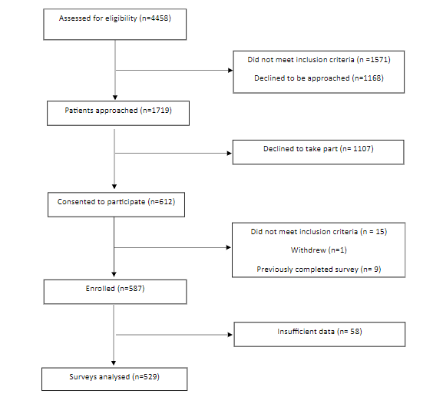

Variable*
Age, years  mean (SD)  median (IQR)  range | 43.5 (10.9)  44 (36-52)  20-69
Sex, female, N (%) | 183 (34.7)
Ethnic group, N (%)  White  Black  Asian  Mixed  Other | 356 (68.0)  76 (14.5)  67 (12.8)  10 (1.9)  16 ((3.1)
Relationship status, N (%)  Single  Married, co-habiting or civil partnership  Divorced or separated  Widowed | 398 (75.7)  78 (14.8)  43 (8.2)  7 (1.3)
Living situation, N (%)  Living alone  Living with family  Living with friends  Shared accommodation | 245 (46.6)  184 (35.0)  8 (1.5)  89 (16.9)
Accommodation, N (%)  Independent or unsupervised accommodation  Supported accommodation  Homeless  Other | 389 (73.8)  113 (21.4)  6 (1.1)  19 (3.6)
Highest level of education, N (%)  Tertiary or further education  Secondary education  Primary education or less | 231 (44.8)  222 (43.0)  39 (7.6)
Employment status, N (%)  Unemployed  Voluntary work  Student  Employed part-time or full-time  Homemaker  Retired  Other | 373 (71.1)  58 (11.1)  19 (3.6)  49 (9.3)  5 (1.0)  9 (1.7)  10 (1.9)
Born in the UK, N (%) | 427 (80.7%)
Place of current residence, N (%)  Bedfordshire  Cornwall  Devon  Co. Durham  London  Oxfordshire  Somerset | 42 (7.9)  50 (9.5)  50 (9.5)  94 (17.8)  166 (31.9)  78 (14.7)  49 (9.2)
Receiving state benefits, N (%) | 471 (89.4)
Diagnosis, N (%)  Schizophrenia  Schizotypal disorder  Delusional disorder  Brief Psychotic Disorder  Schizoaffective disorder  Psychosis NOS | 363 (71.6)  3 (0.6)  11 (2.2)  14 (2.8)  83 (16.4)  33 (6.5)
Co-morbid psychiatric diagnosis, N (%) | 134 (25.3)
Years since first contact with mental health services,  mean (SD)  median (IQR)  range | 17.6 (10.7)  17  1-55
MANSA score, mean (SD) | 4.5 (0.9)
Number of social contacts, Mean (SD) | 2.9 (2.6)
Median (IQR) | 2
*Counts may not add up to total due to missing data
IQR: Interquartile range; MANSA: Manchester Short Assessment of Quality of Life; SD: standard deviation

Subjective participation in fitness activities during the previous week was assessed by an adaptation of the UK Time Use Survey. The main outcome was whether participants met the minimum World Health Organization recommendations for moderate intensity physical activity (≥150 min/week) through fitness. Poisson regression models with robust error variance were used to examine associations of this outcome with participant variables.

Results
In total, 267 (52.2%) participants reported taking part in routine fitness activities in the previous week, many of whom did so alone (n = 163, 59.1%). Only 21.5% (n = 114) completed ≥150 min of fitness activities in the previous week. The likelihood of attaining these recommendations was lower among participants who were female, older in age, in a relationship, unemployed and with fewer social contacts.

Table 2. Summary of sports and fitness participation in the previous week (n=529)
Number of sports and fitness activities practisedª, n (%)  None  1  2  3  4  5 | 253 (47.8)  187 (35.4)  55 (10.4)  26 (4.9)  7 (1.3)  1 (0.2)
Type of sports and fitness activity^{b, c}, n (%)  Cycling  Walking or hiking for 30 minutes or more (recreationally)  Exercise classes (e.g. aerobics, martial arts)  Gym or weight training  Pub games (e.g. snooker, pool, darts)  Racquet sports (e.g. tennis, badminton, squash)  Jogging, cross country, road running  Swimming  Team sports (e.g. rugby, football, cricket, hockey, netball) | 29 (10.5)  181 (65.6)  26 (9.4)  59 (21.4)  34 (12.3)  14 (5.1)  20 (7.3)  26 (9.4)  18 (6.5)
Total weekly duration of 150, minutes  Yes  No  Declined to answer | 114 (21.5%)  414 (78.0%)  1 (0.5%)
Total frequency of sports and fitness participation^{cd}  Mean (SD)  Median  Range | 2.4 (3.6)  1.0  1-22
Number of social contacts  Mean (SD)  Median  Range | 2.9 (2.6)  2  1-15
Participated with^{c}, n (%)  Friend(s)  Family  Carer(s)  Patients  No one else  Other | 45 (16.3)  31 (11.2)  15 (5.4)  18 (6.5)  163 (59.1)  4 (1.5)

Conclusion
Mental health services promoting physical activity interventions among people with psychotic disorders may need to modify their approaches based on previous patient preference and increase their focus on sub-groups of patients who are less likely to routinely engage in fitness activities.

