Global nutrient equity for people and the planet

Helena Kahiluoto^{a,b,c*}, Kate E Pickett^{d}, Will Steffen^{e,f}
ªLUT University, Sustainability Science, Finland
^{b}University of Helsinki, Agroecology, Finland
^{c}Strategic Research Council at the Academy of Finland
^{d}University of York, Health Sciences, and Leverhulme Centre for Anthropocene Biodiversity, Heslington, York, YO10 5DD, UK
^{e}The Australian National University, Canberra, Australia
^{f}Stockholm Resilience Centre, Sweden

*Corresponding author, Tel. +358405118335, E-mail: helena.kahiluoto@lut.fi
[ok? please present all affiliation addresses at the city, state and country levels]

The industrial world has converted inert soil and atmospheric nutrients into reactive fertiliser flows that endanger water quality, biodiversity and climate. Simultaneously, poor nations starve because of the shortage of these nutrients in agricultural soils. Here, we propose redistribution of accumulated nutrients to enhance food security while counteracting the current degradation of critical Earth System processes. Residue and sediment nutrients could be processed and transported to food insecure regions through the opposite logistics used to ship phosphate rock across the globe. Financing through trading accumulated rights could trigger the required innovations in processing, logistics and thinking. Such a socially just ‘One Earth Currency’ could leverage a transformation towards resilience, equity and dignity, across the critical Earth System processes.

Overloading the stern will sink a boat; distributing the load equally will save all – a metaphor that applies to the global distribution of nutrients [ok? would suggest rewording the metaphor to be more concise; a further idea here would be using the metaphor of loading on a container ship?]. Rights to operate [ok? could you specify what is meant by ‘operate’ here as it relates to nutrient distribution or food systems – this phrase needs a little more specificity] are not fairly distributed within humanity, and the global economy does not operate within the carrying capacity of the planet. The nutrients nitrogen and phosphorus are a primary resource for food production, the cornerstone of human security, and use of these nutrients has been extremely uneven in different parts of the world^{1,2}. Far more nitrogen and phosphorus has been converted from inert sources to reactive forms for food production³ than allowed to maintain a well-functioning Earth System⁴. The accumulated nutrient surplus causes expanding anoxic dead zones in open oceans, coastal zones and estuaries⁵ contributing to the sixth mass extinction of biodiversity that we are witnessing and profound impact on the climate⁶. Simultaneously, the nutrient depletion in agricultural land of poor countries leaves a legacy of hunger⁷ and social unrest⁸. [ok? the edits here are suggested to improve flow and specificity for our international readership]
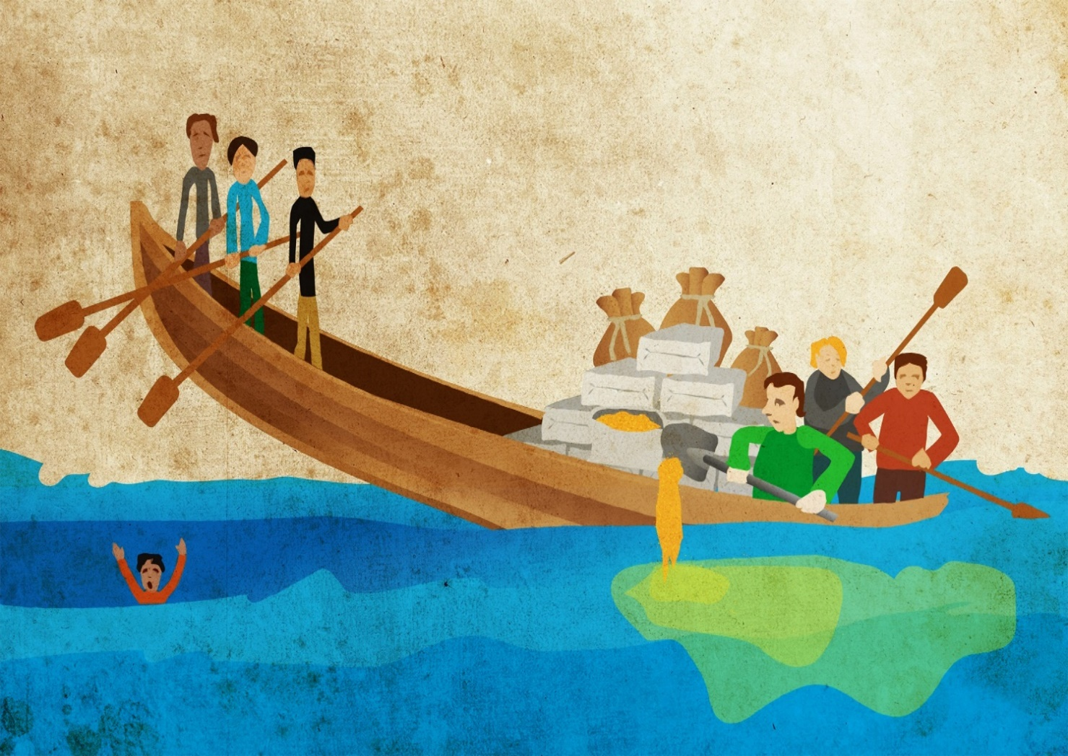
Fig. 1 | Inequity creates wastage and instability. Redistributing the unequally accumulated nutrients would reduce food insecurity while enhancing recovery of aquatic ecosystems and climate.

Consequently, nutrient use must be redistributed [ok? ‘must’ by itself denotes a value system of equity…I wonder if this could be framed as either a question (eg: Is it possible to redistribute nutrient use?) or a statement of your view point (eg: Consequently, we posit that nutrient use must be redistributed). My preference is the latter, a statement of your determination]. Since access to nutrients is related to wealth⁹, economic instruments are required. A global circular nutrient economy and redistributive incentives have, however, been absent in the scientific debate. Here, we propose a transformative initiative to incentivise and finance global redistribution of nutrient use. The synergetic purpose is to restore nutrient-depleted soils in poor countries to enhance food and nutrition security while safeguarding Earth System functioning. The window of opportunities opened up¹⁰ by the current global crises could enable such redistribution serving as a pilot testing of a ‘One Earth Currency’, which could then be potentially extended to all the quantified planetary boundaries⁴ as a foundation for a sustainable, fair and planet-bound economy.

Current and past nutrient use
More than half of all globally applied fertilisers and 85% of manure nitrogen are allocated to 10% of global agricultural land, whereas 80% of African countries suffer from nitrogen scarcity^{11,12}. Similarly, 45% of phosphorus surpluses relative to crop uptake appear on 10% of the global cropland area while 65% of the phosphorus deficits are spatially as concentrated on another 10% of the global cropland¹³. Eliminating nutrient overuse would still allow as much as a 30% increase in production of main cereals; large gains in cereal production could be achieved especially in areas such as sub-Saharan Africa and Eastern Europe by redistributing nutrients¹⁴.

Accumulated disparity. Reactive surplus nutrients have accumulated in the wealthy parts of the globe via the industrialization of agriculture and trade of nutrients, food and fodder. In developed countries since 1960s, nitrogen excesses of 2000 kg ha⁻¹ relative to nitrogen harvested were estimated over 300 million hectares over 30 years¹⁵, with annual accumulation of 25-70 kg ha⁻¹ measured for 50 years in croplands across watersheds¹⁶, and the imbalances continue¹⁷. In European field soils, fertiliser phosphorus of 700 to 800 kg ha⁻¹ has accumulated¹⁸, and in North America, 230 to 1,400 kg ha⁻¹ since 1900¹⁹. Simultaneously in Africa, a depletion of 1100 kg ha⁻¹ nitrogen and 125 kg ha⁻¹ phosphorus has accumulated by 2015. In developing countries, the depletion amounts to an average of 930 kg ha⁻¹ nitrogen and 250 kg ha⁻¹ phosphorus for 200 to 300 Mha of arable land, if the depletion rates for the 30 years before¹⁵ and for 2000²⁰ represent the average for the 50-year period to 2015.

Critical thresholds. Because critical boundaries in Earth System functioning have been transgressed by large amounts, very few new inert nutrients can be converted to reactive forms⁴. In an increasing number of freshwater and coastal ecosystems and estuaries in the industrialized world, greater nutrient loading from bottom sediments compared to loading from cultivated soils^{21,22} have led to persistent, widespread eutrophication. For example, in the Baltic Sea, even with a return to pre-industrial nutrient flows from the watershed, recovery would require more than a century²³, and in freshwaters even a thousand years²⁴. Therefore, the accumulated reserves need to be mined so that aquatic ecosystems can recover²². In poor parts of the world, nutrient depletion triggers a vicious cycle of soil carbon depletion, exponentially decreasing yields^{2,25}. Chronic undernourishment is globally on the rise since 2014 and affects one in five people in Africa²⁶, where the population is projected to grow from 1.5 billion in 2020 to 4 billion in 2100²⁷. Worldwide, more than one in five children are stunted which is related to poverty²⁶, hampering the next generations’ capabilities in the Global South and creating a legacy of inequality.

Specific drivers. Although 70% of the currently known global P-rock reserves are located in Morocco and the western Sahara²⁸, they have been mainly transported to wealthy markets elsewhere. Biological nitrogen fixation is phosphorus-dependent, and the Haber-Bosch process for the conversion of atmospheric nitrogen to reactive forms has a high energy requirement. Consequently, wealth has also determined access to nitrogen⁹. The use of fertiliser in food production by smallholders in low- and middle-income countries is seldom profitable because the fertiliser price is often multiplied due to poor infrastructure and other domestic transaction costs²⁹, the local food price is low relative to that of cash crops, and there is a significant risk of losing the crop¹⁵. For example, in sub-Saharan Africa, the lack of other energy sources leads to the combustion of residues for cooking, thereby reducing the amount recycled³⁰. Also, nutrient import in food to Africa is a recent development³¹, unlike export of cash crops, and the imports serve urban areas with no distribution of the residue nutrients to agricultural soils.

Transformative measures required. Current attempts in wealthy countries towards less nutrient use or loading are focused on dietary changes and reducing waste³, decoupling food production from land use³², local recycling^{33,34} and precision agriculture³⁵. Also, nutrient flow from soils to waters can be prevented and consequences of nutrients in water systems mitigated through geoengineering approaches, but with ecological risks³⁶. Importantly, none of these endeavours is aimed at reversing the disparity in access to nutrients and food between the Global North and South, thus missing the opportunity to build a synergetic outcome. Increased nutrient use in depleted soils is environmentally superior to land expansion³⁷ but synthetic fertilisers worsen the global transgression of the safe space for nitrogen and phosphorus loading. Because nutrient reserves and depletion are spatially separated by historical, persistent global inequities in access to nutrients^{1,2}, global redistribution of these resources needs to be triggered.

Towards equity in nutrient use
While equity across generations is intrinsic to sustainability, the health and psycho-social well-being of all citizens, even the wealthiest, is greater with greater distributional equality³⁸. Equity and well-being within planetary boundaries were conceptualized as the ‘safe and just space for humanity’ by Raworth³⁹. Redistributing excess nutrients to regions with deficits in food¹⁴ and nutrition security^{1,2} not only builds the ‘social foundation’³⁹ for global wellbeing through increasing equity but also respects critical planetary boundaries by reducing wastage (Fig. 2) thus building synergy between these fundamental dimensions of sustainability (Fig. 3).

Equity for dignity and peace. Inequity in access to food is a threat to peace as demonstrated by food riots⁸. For distributional equity, whether based on equality, capability or fundamental needs⁴⁰, procedural equity is required⁴¹. Disparities in wealth and power prevent the consensus needed to reallocate scarce resources⁴² whereas procedures that exemplify ‘justice as fairness’ as proposed by Rawls⁴³ compensate for naturally (or historically) occurring inequalities such as those in wealth, power and nutrients. Consequently, fair procedures decrease threats of conflict world-wide. Procedural justice again is enabled by norms and values⁴². Hunger and poverty reflect and convey the values of societies; these are important also because fear of being considered less worthy triggers violence³⁸. The notion that everyone is equal in dignity and rights represents the deepest form of equity and is the foundation of human rights⁴⁴. Rights to nutrients imply secure access to nutrients for all the world’s nations, farmers and citizens, thus building food sovereignty and

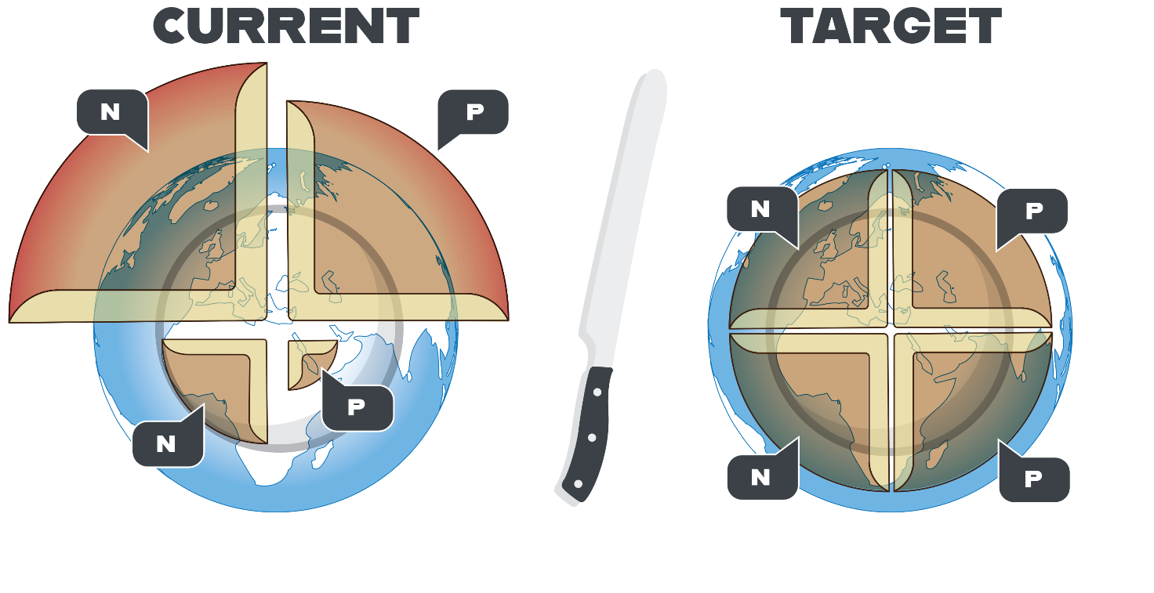
Fig. 2 | Redistribution of nutrients for food security and resilience. Redistribution of nutrients accumulated in wealthy countries of the Global North would counteract the transgression of the planetary boundaries while securing food (‘daily bread’ on the plate) also in the Global South. N=nitrogen, P=phosphorus.

security. Equal rights of access to nutrients⁴⁵ can thus exemplify a global society that promotes dignity and peace^{8,38} (Fig. 3).

A safe and just space for nutrients? [ok? subheadings need to be quite short]
Nutrients to redistribute. The extent of nutrient redistribution needed depends on how much is required to return to the critical nutrient limits in the regions of surplus and to replenish degraded soils for food security in regions of deficit. For example, in Finland the current annual excess flow of reactive nitrogen (40 kg cap⁻¹ a⁻¹) is almost double the global average, and the long-term rate of accumulation (65 kg cap⁻¹ a⁻¹ on average since 1900) is almost triple the global average of 24 kg cap⁻¹ a⁻¹. In contrast, in Ethiopia, there is still space to convert inert nitrogen² to reactive forms. If Finland paid its ‘nitrogen debt’ within as many years as it was accumulated², it could replenish half of the annual depletion of arable land in Ethiopia¹². Half of the debt could be removed by the manure and other agrifood residues produced in Finland⁴⁶. Alternatively, 4% of the nitrogen accumulated in the sediments of the Baltic Sea would be required^{21,23} for the annual debt. Only one-third of the phosphorus in annually produced agrifood residues in Finland³³ would cover the Finnish annual accumulated debt and replenish one-third to one-half of the annual deficit in the Ivory Coast¹¹, one of the most severely phosphorus-depleted areas¹³.

Two-thirds of the nitrogen¹¹ and phosphorus³³ contained in manure produced annually in the EU might be sufficient to restore the world’s depleted soils within a few decades. The phosphorus^{13, 17,18} and nitrogen¹⁶⁻¹⁷ accumulated in the soils of wealthy areas is frequently sufficient for local food production for decades, and a considerable amount of nitrogen and most phosphorus present in agrifood residues could be exported to nutrient-depleted areas. Based on the estimated depletion and accumulation^{15-20,46}, the nutrient amount to be transported from regions with surplus to restore the nutrient-depleted soils within 30 years in in the range of 6 400 to 7 300 Gg a⁻¹ for nitrogen and 830 to 2500 Gg a⁻¹ for phosphorus.

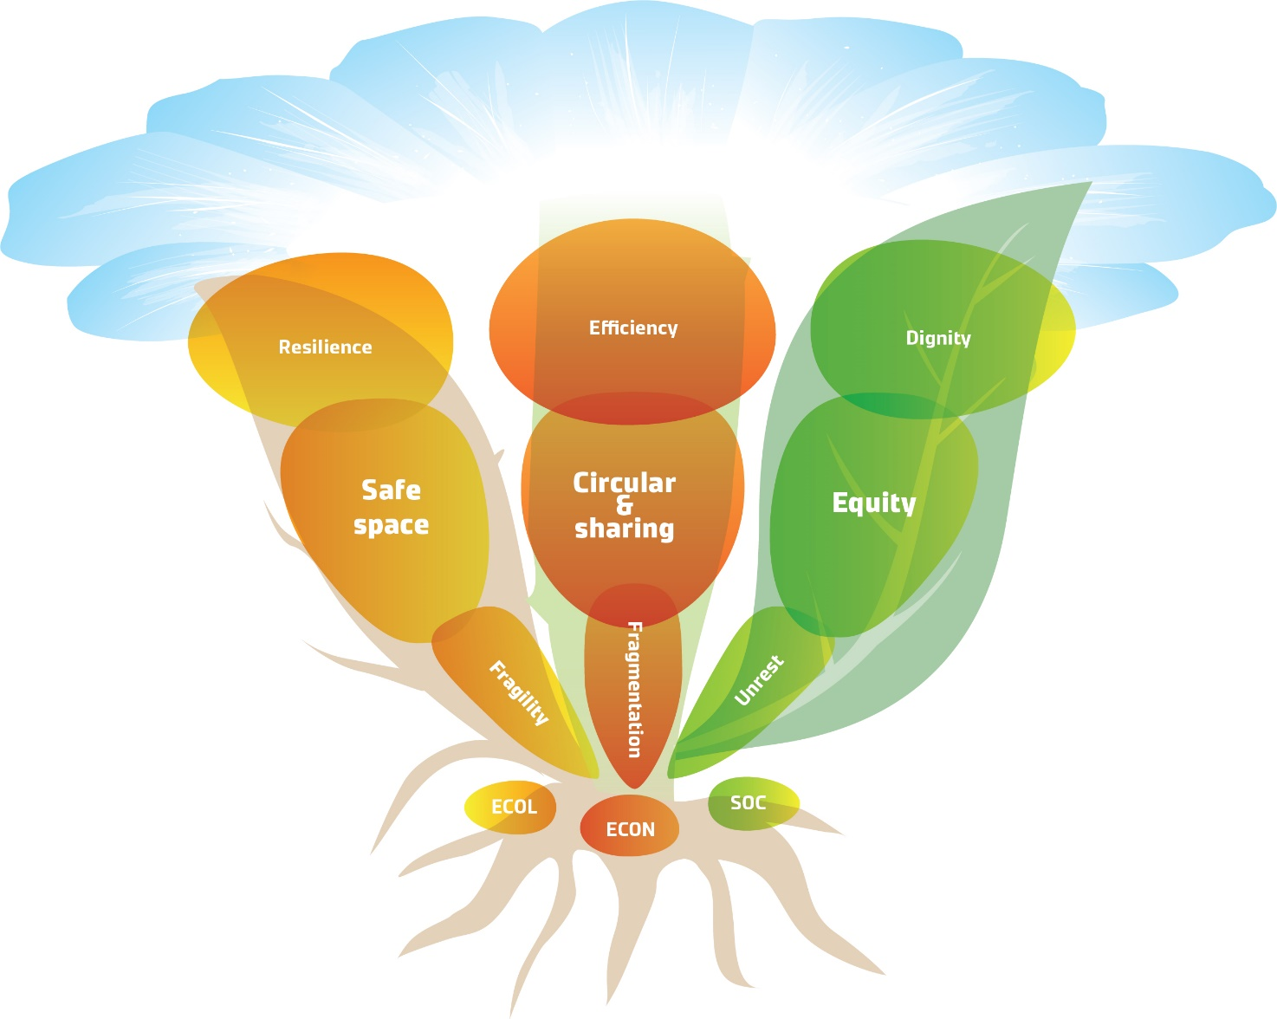
Fig. 3 | Synergetic sustainability in use of nutrients as global commons. A global circular nutrient economy exemplifies synergy growing among resilience, equity and reduced wastage, similar to that among roots, stems and leaves that are all vital for a plant to flourish.

Technologies and logistics. The residue nutrients accumulated in the Global North can be captured in manure, and in sediments through aquatic vegetation or near-bottom nutrient-rich water, for safe use in depleted areas in the Global South. Technologies for recovery from waste-water and industrial gases are rapidly developing. Cropping systems, root zones and residues can be managed and crops improved to enhance the recovery of nutrients from soil reserves and residues. The challenges of transportation can be facilitated by volume-reducing and stabilising technologies and by using standard containers or 0.5 m³ sacks. Separation of residues into liquid and solid phases, combined with production of bioenergy and a nutrient-rich by-product biochar⁴⁷ may provide options together with many other processes under development. Building logistics for nutrient transfers to developing countries, reversing the decades- or centuries-long import of rock phosphate and other raw materials to industrial countries, would create the methodologies for local and global circular nutrient flows. The nutrient quantities that would need to be redistributed roughly correspond to the annual import of rock phosphate by the EU⁴⁸, and the unprocessed dry matter of manure represents two to three per cent of the seaborne trade of developing countries. Creating bioenergy and biochar for the carbon market could generate income which reduces net-costs.

Based on the price range of fertiliser nutrients in sub-Saharan Africa in recent years²⁹, the annual global cost of the redistribution of nutrients would be between €10 billion and €34 billion. Consequently, the annual cost would be a minor part of the cost of nitrogen pollution to societies, estimated to be €70–€320 billion in the EU⁴⁹ and $81–$441 billion USD in USA⁵⁰. These costs could be totally or at least partly avoided through global nutrient redistribution. The economic feasibility of residue processing and transportation may, however, be challenging at current African fertiliser prices, and use of nutrients is not profitable for smallholders even at the current price.

One Earth Currency
A global circular and sharing economy could redistribute nutrient use and accumulated nutrients to benefit human security, water systems and climate, but how can the transformation be incentivized and financed? Since the unequal nutrient use is related to disparities in wealth⁹, trading accumulated rights to nutrients could provide the trigger (Fig. 4). Nations with excessive use of nutrients relative to fair rights would need to pay their accumulated ‘debt’ in nutrients to nations with deficits, coordinated by a global fund but perhaps initiated as a voluntary scheme. Farmers and firms capturing nutrients could sell them to brokers serving nations. Consumers would pay the current level for rights to nutrients as reflected in food prices, thus creating an incentive to reduce use while no new inert phosphorus and little new nitrogen would be allowed. In the market, power is distributed according to wealth but a currency of fair historical rights, jointly enabled by nations, could provide procedural justice⁴¹ and build dignity for those with little power due to past inequities. Governance for dignity⁴³⁻⁴⁵ benefits from an exchange among equal actors rather than from aid on terms of the donor. Global rights to use nutrients allocated among nations equally, accounting for historical use, and among citizens through deliberative democratic procedures⁴³

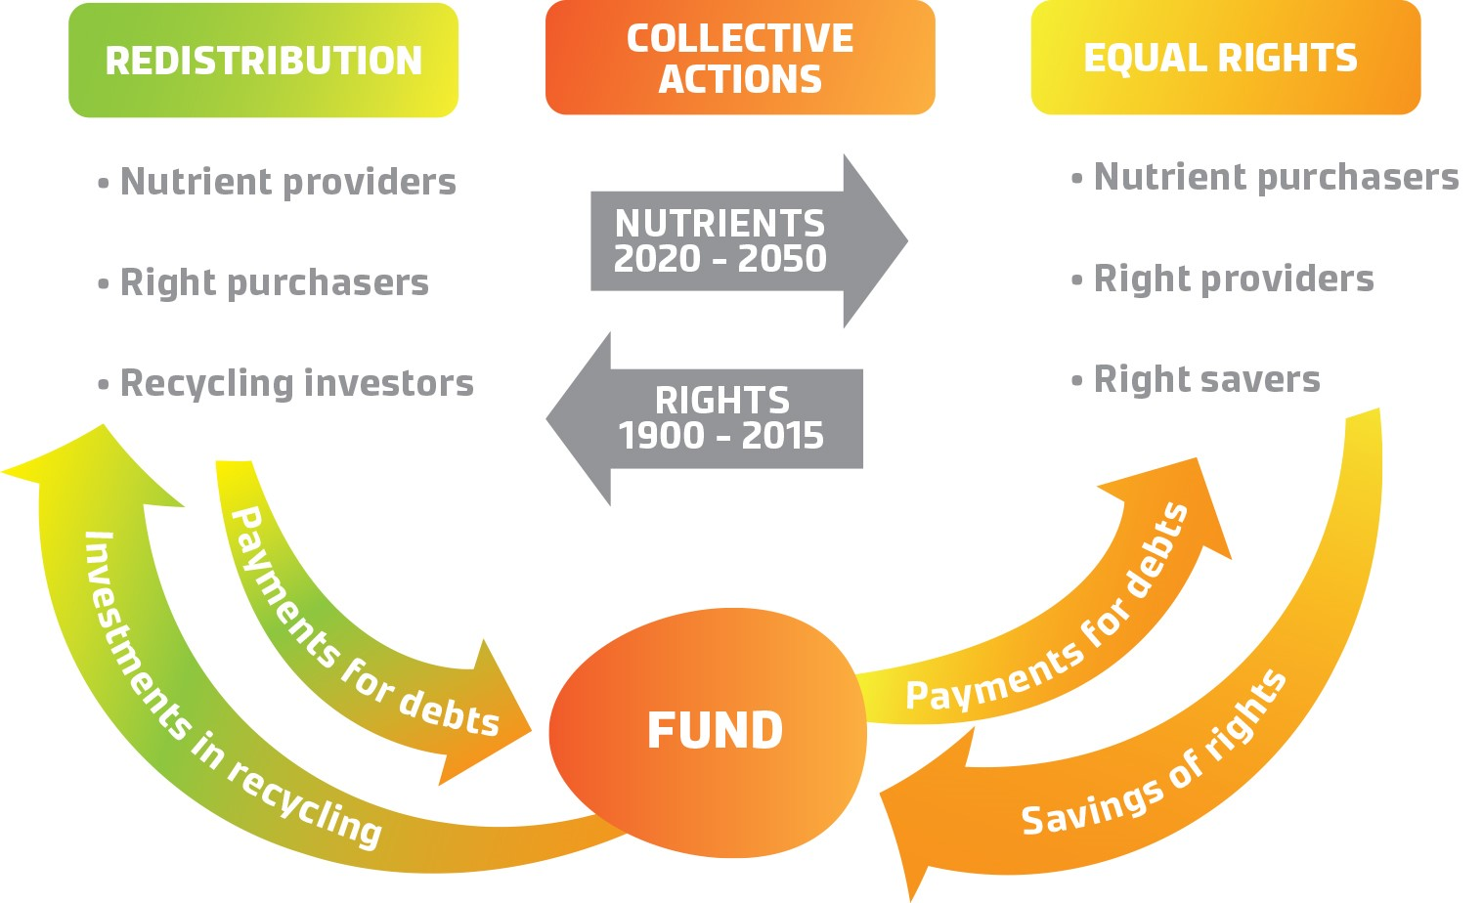
Fig. 4 | Trading fair nutrient rights. The unused rights to nutrients could be paid with the nutrients (or partly with money) by the nations which exceeded their rights. The rights could also be saved for later use or exchange, and thus enable investments in global recycling.

according to perceived fairness, would therefore finance the redistribution of nutrients in a way
that fosters dignity.

Trading rights. The ecological and social ‘externalities’ of nutrient use can be internalized within the economic system through regulations and taxes, baseline and credits system, and trading rights, i.e., permissions to use or emit. Among these approaches, only well-designed cap-and-trade systems⁵¹ provide a high degree of environmental certainty with the cap defined by planetary boundaries. Cap-and-trade systems allow redistribution of rights⁵² to use nutrients among actors and regions through democratic decision-making. When rights were exceeded by a nation, farmer or consumer household, they could be purchased, if surplus rights were available. When demand would exceed supply, price would increase and make selling, rather than using, attractive. Stepwise lowering the cap keeps the price high enough to incentivise reduction in use. The market-led mechanism causes lower administrative costs after start-up than environmental regulations or taxes, robustness, and few rent-seeking benefits^{52,53}.

Cap-and-trade systems tend to mainstream environmental management in firms as a core business activity and are flexible enough to incentivise learning and innovations in capturing, processing and redistributing nutrients, and in trading nutrient rights. Local trading systems have been organized or proposed for air quality, fisheries, water access, wetland management, carbon emissions and nutrients⁵⁴. Up to the present, nutrient right trading systems have only aimed at increasing economic efficiency in reducing nutrient emissions to local water systems. Global trade of nutrient rights that accounts for national historical use per capita² with a stepwise declining cap, and price floor, coupled with a penalty for the activation of new inert nutrients^{51,53}, could redistribute nutrient reserves for mutual global benefit.

Allocation of rights. The quantity of nutrients converted to reactive forms in residues and sediments can be shared according to the unused rights. The national caps or rights to the annual reuse can be weighted according to differences in the accumulated excess or gap relative to the local critical upper limits, or downscaled planetary boundaries, of reactive nutrient flows². Rights to use nutrients in agriculture would be allocated among nations according to cultivation area, and rights to use products with a nutrient footprint (virtual nutrients) according to population. Nation-states can provide the surplus nutrients to countries with a gap and allocate the national cap or rights to farmers. Nitrogen losses are partly gaseous and thus not recyclable, but carbon-sequestering nutrient carriers such as biochar could be considered because they neutralize the warming impact of N₂O⁶ while improving nutrient retention of degraded soils.

Fair rights to use nutrients could be nationally determined based on needs through deliberative democratic consultations or surveys among farmers. Virtual nutrients could be allocated to households through similar processes, for example, among clients of a retailer participating in a voluntary scheme that accounts for number of children and dietary requirements. Trading rights by consumers would incentivise all food value chain actors upstream through demand. Allowing any agent to purchase and sell rights enables a high, positive social and environmental impact.

Monitoring use. Verifying impacts on nutrient flows could be practice-based relying on a scientific, accumulating database. A recycling- and context-sensitive global nutrient-foot-printing could rely on ratios of nutrient purchases and sales in fertilisers and residues, feed and food by farmers, and footprints of products purchased by manufacturers, retailers and consumers. Accumulation, use and exchange of rights would be digitally recorded and transparently marketed using blockchain technologies. Consumers’ food purchases would be recorded at check-out where a new balance would be routinely calculated. Mobile applications, intelligent packages and artificial intelligence facilitate choice by consumers.

The fund. The nutrients would be paid for by the accumulated unused rights of nations or saved for future. The fair planet-bound currency would represent an important part of the price of all products and services. A global fund could govern the exchange of the fair One Earth Currency under the mandate of, for example, the United Nations Development Program (UNDP) (Fig. 4). The fund could set standards for the procedures in trading rights among nations, actors and citizens while learning from diverse emerging practices⁴². Equal access to information and control over the procedure is a key to perceived procedural equity and trust.

Winners and losers. Citizens in areas of nutrient surplus in the Global North would benefit from better water quality and citizens across the world would benefit from mitigation of climate change and reduction in nature loss as well as from empowerment as equal actors in the global economy. Farmers in the Global North and businesses everywhere would benefit from the new economic activity that the scheme would generate. Poor farmers and consumers in nutrient-depleted regions of the Global South would benefit from restored soils and nutrition security. The fertiliser industry has the opportunity to pivot towards the emerging demand, perhaps in coalitions⁵⁵ with proactive food chain actors, nations or cities, United Nations organizations, other global governance platforms and civil society organizations, spurred by agile start-ups⁵⁶, activists and scientists. For rich countries that exceeded their equal rights to nutrients in the past, the immediate cost would represent an investment in long-term ecological and social security, providing a model applicable in many other fields as well.

Stepping stones. Current global crises could enable¹⁰ a disruptive social innovation⁵⁶ of equal trading rights to nutrients, initiated by proactive coalitions as voluntary schemes⁴² that would incentivise research and experimentation towards a sustainable digital currency. Science-based local critical limits of nutrient application will need to be determined². Fair allocation of rights to nutrients would involve users and other actors across scales. Current and past use will need to be explored and the data base for nutrient footprints established. Capturing residue nutrients would be advanced and logistics reverse to rock phosphate export and to within-country flows of agricultural commodities coordinated. Transparent trading of nutrients and rights would be digitalized. Finally, collective learning through action could transform thinking towards global equity, as necessary to create the commitment to maintain planet Earth as a safe and just space for the humanity.

Conclusions
Trading democratically allocated nutrient rights which respect the functioning of the planet would act as an initiative towards a ‘One Earth Currency’ which could be applicable across all planetary boundaries. Such an initiative exemplifies restoring eroded planetary functioning, equity and institutions⁵⁷. A global treaty to set a cap, underpinned by polycentric institutions initiated as self-organized voluntary schemes, would provide legitimacy across scales and invaluable experiments for learning⁴². Coalitions of public, private and civil society actors⁵⁵ that recognize this new-market-based, disruptive business opportunity⁵⁶ could generate the required sustainability transformation as a broader role model.

The fates of humanity and the planet have become intertwined by the current global crises, increasing pressure on regimes which once served well for different needs and goals. Momentum is building to transform¹⁰ the ‘rules of the game’ of the human society. Fairly allocated rights synergetic with Earth System functioning could provide the new economy needed to underpin sustainability. Making the market fair for those with little voice could trigger a paradigm shift towards dignity driven by action, allowing both people and the planet to flourish.

Acknowledgments
We thank Antti Törmälä for elaborating the figures. [ok? could you provide some information on whether the display items were originally created for the manuscripts. If they are adapted or have been previously published please provide that detail. If they are original, I would suggest the word ‘creating the artwork’ is used rather than ‘elaborating the figures’]

Author contributions
All authors contributed to the conceptualisation and the writing of this paper.

Competing interests statement
The authors declare no competing interests.

References
- Steffen, W. & Stafford Smith, M. Planetary boundaries, equity and global sustainability: why wealthy countries could benefit from more equity. Curr. Opin. Environ. Sustain. S403-S408 (2013).
- Kahiluoto, H., Kuisma, M., Kuokkanen, A., Mikkilä, M. & Linnanen, L. Local and social facets of planetary boundaries: right to nutrients. Environ. Res. Lett. 10, 104013 (2015).
- Kahiluoto, H., Kuisma, M., Kuokkanen, A., Mikkilä, M. & Linnanen, L. Taking planetary nutrient boundaries seriously: Can we feed the people? Glob. Food Sec. 3,16-21 (2014).
- Steffen, W. et al. Planetary boundaries: Guiding human development on a changing planet. 15 March Science Express (2015).
- Breitburg, D. et al. Declining oxygen in the global ocean and coastal waters. Science 05 Jan 359 (2018).
- Thompson, R. L. et al. Acceleration of global N₂O emissions seen from two decades of atmospheric inversion. Nat. Clim. Chang. 9, 993-998 (2019).
- Sanchez, P. A. & Swaminathan, M. S. Hunger in Africa: the link between unhealthy people and unhealthy soils. Lancet 365, 442-444 (2005).
- Lagi, M., Bertrand, K. Z. & Bar-Yam, Y. In Conflict and complexity. Understanding complex systems (eds. Fellman, P. V., Bar-Yam, Y. & Minai, A.) 249-259 (Springer, 2015).
- Zhang, X. et al. Managing nitrogen for sustainable development. Nature Dec 3 (2015).
- Geels, F. W. Technological transitions as evolutionary reconfiguration processes: a multi-level perspective and a case-study. Res. Policy 31, 1257–1274 (2002).
- Potter, P., Ramankutty, N., Bennett, E. M. & Donner, S. D. Characterizing the spatial patterns of global fertilizer application and manure production. Earth Interact. 14, 1-22. (2010).
- Liu, J. et al. A high-resolution assessment on nitrogen flows in cropland. Proc. Natl Acad. Sci. USA 107, 8035-8040 (2010).
- MacDonald, G. K., Bennett, E. M., Potter, P. A. & Ramankutty, N. Agronomic phosphorus imbalances across the world’s croplands. Proc. Natl Acad. Sci. USA 108, 3086-3091 (2011).
- Mueller, N. D. et al. Closing yield gaps through nutrient and water management. Nature 490, 254-257 (2012).
- Sanchez, P. A. et al. In Replenishing soil fertility in Africa. (Eds. Buresh, R. J., Sanchez, P. A. & Calhoun, F.) 1-46 (SSSA Special Publ 1997).
- Van Meter, K. J., Basu, N. B., Veenstra, J. J. & Burras, C. L. The nitrogen legacy: emerging evidence of nitrogen accumulation in anthropogenic landscapes. Environ. Res. Lett. 11, 035014 (2016).
- Bouwman, A. F. et al. Lessons from temporal and spatial patterns in global use of N and P fertilizer on cropland. Sci. Rep. 7, 40366 (2017).
- Sattari, S. Z., Bouwman, A. F., Giller, K. E. & van Ittersum, M. K. Residual soil phosphorus as the missing piece in the global phosphorus crisis puzzle. Proc. Natl Acad. Sci. USA 109, 6348-6353 (2012).
- MacDonald, G. K. & Bennett, E. M. Phosphorus accumulation in Saint Lawrence River Watershed Soils: A century-long perspective. Ecosystems 12, 621-635 (2010).
- Tan, Z. X., Lal, R. & Wiebe, K. D. Global Soil Nutrient Depletion and Yield Reduction. J. Sust. Agric. 26, 123-146 (2005).
- Meier, H. E. et al. Impact of climate change on ecological quality indicators and biogeochemical fluxes in the Baltic sea: a multi-model ensemble study. Ambio 41, 558-573 (2012).
- Ekholm, P. & Mitikka, S. Agricultural lakes in Finland: Current water quality and trends. Environ. Monit. Assess. 116, 111-135 (2006).
- Savchuk, O. P. & Wulff, F. Long-term modeling of large-scale nutrient cycles in the entire Baltic Sea. Hydrobiologia 629, 209-224 (2009).
- Carpenter, S. R. Eutrophication of aquatic ecosystems: Bistability and soil phosphorus. Proc. Natl Acad. Sci. USA 102, 10002-10005 (2005).
- Stocking, M. A. Tropical soils and food security: the next fifty years. Science
302, 1356-1359 (2003).
- The State of Food Security and Nutrition in the World 2020. Building Climate Resilience for Food Security and Nutrition (FAO, IFAD, UNICEF, WFP and WHO, 2020).
- World Population Prospects 2019 Highlights. (UN Dep. Economic and Social Affairs, New York, 2019).
- Jasinski, S.M. Mineral Commodity Summaries: Phosphate Rock. U.S. Geol. Surv. (2021).
- Agbahey, J.U.I., Luckmann, J., Grethe, H. & Alemub, B.A. How do domestic policies affect the integration of Ethiopian fertiliser markets with world markets? J. Agric. Rural Dev. Trop. Subtrop. 116, 213-226 (2015).
- Rimhanen, K. & Kahiluoto, H. Management of harvested carbon in smallholder mixed farming in Ethiopia. Agric. Syst. 130, 13-22 (2014).
- Lassaletta, L. et al. Food and feed trade as a driver in the global nitrogen cycle: 50-year trends. Biogeochemistry 118, 225-241 (2014).
- Sillman, J. et al. A life cycle environmental sustainability analysis of microbial protein
production via power-to-food approaches. Int. J. Life Cycle Assess. 25, 2190-2203 (2020).
- Van Dijk, K. C., Lesschen, J. P. & Oenema, O. Phosphorus flows and balances of the European Union Member States. Sci. Total Environ. 542, 1078-1093 (2016).
- Kahiluoto, H. et al. Potential of agrifood wastes in mitigation of climate change and
eutrophication – two case regions. Biomass Bioenergy 35, 1983-1994 (2011).
- Hedley, C. The role of precision agriculture for improved nutrient management on farms. J. Sci. Food Agric. 95, 12-19 (2015).
- Conley, D. J. et al. Tackling hypoxia in the Baltic Sea: Is engineering a solution? Save the Baltic Sea. Env. Sci. Tech. 43, 3407–3411 (2009).
- Van Loon, M. P. et al. (2019) Impacts of intensifying or expanding cereal cropping in sub-Saharan Africa in coming decades on greenhouse gas emissions and food security. Glob. Chang. Biol. 25, 3720-3730.
- Wilkinson, R. G. & Pickett, K. E. Income inequality and social dysfunction. Annu. Rev. Sociol. 35, 493-511 (2009).
- Raworth, K. Oxfam Discussion Paper. (Oxford, UK: Oxfam, 2012).
- van den Berg, N. J. et al. Implications of various effort-sharing approaches for national carbon budgets and emission pathways. Clim. Change 1-18 (2019).
- McDermott, M., Mahanty, S. & Schreckenberg, K. Examining equity: a multidimensional framework for assessing equity in payments for ecosystem services. Environ. Sci. Policy 33, 416-427 (2013).
- Ostrom, E. Polycentric systems for coping with collective action and global environmental change. Glob. Environ. Change 20, 550–557 (2010).
- Rawls, J. A Theory of Justice (Cambridge, Mass., Belknap Press, 1971).
- McCrudden, C. Human dignity and judicial interpretation of human rights. Eur. J. Int. Law 19, 655-724 (2008).
- Ayala, A. & Meier, B. M. A human rights approach to the health implications of food and nutrition security. Public Health Rev. 38, 10 (2017).
- Erisman, J. W. et al. In The European Nitrogen Assessment Ch 2 (Eds. Sutton, M. A. et al.) 9-31 (Cambridge University Press, Cambridge, 2011).
- Abiven, S., Schmidt, M.W.I. & Lehmann, J. Biochar by design. Nat. Geosci. 7, 324-327 (2014).
- Ridder, M., de Jong, S., Polchar, J. & Lingemann, S. Risks and opportunities in the global phosphate rock market. Robust strategies in times of uncertainty. The Hague Centre for Strategic Studies (HCSS). Den Haag (2013)
- Sutton, M. A. et al. Too much of a good thing. Nature 472, 159-161 (2016).
- Sobota, D. J., Compton, J. E., McCrackin, M. L. & Singh, S. Cost of reactive nitrogen release from human activities to the environment in the United States. Environ. Res. Lett. 10:025006 (2015).
- Goulder, L. H. & Schein, L. R. Carbon taxes versus cap and trade: a critical review. Clim. Chang. Econ. 4, 1350010 (2013).
- OECD. Tradeable Permits: Policy Evaluation, Design and Reform. (Paris, OECD, 2004).
- Chen, Y., Wang, C., Nie, P. & Chen, Z. A clean innovation comparison between carbon tax and cap-and-trade system. Energy Strategy Rev. 29, 100483 (2020).
- Green Stream. Framework for a Nutrient Quota and Credits´ Trading System for the
Contracting Parties of HELCOM in order to reduce Eutrophication of the Baltic Sea.

(Green Stream Network, Helsinki 2008).
55. Moberg, E. et al. Combined innovations in public policy, the private sector and culture
can drive sustainability transitions in food systems. Nat. Food 2, 1-9 (2021).
56. Christensen, C. M., McDonald, R., Altman, E. J. & Palmer, J. E. Disruptive innovation: An
intellectual history and directions for future research.﻿ J. Managem. Studies 55, 7 (2018).
57. Henderson, R. Reimagining Capitalism in a World on Fire. (Public Affairs, New York
2020).

