Care
Joanna Latimer

In “Connectedness – an Incomplete Encyclopaedia of the Anthropocene” (2020) edited by Marianne Krogh

Social scientists, among others, write about how we live in times in which the mantra of growth has come to dominate many societies. So much so that a need to care and cherish things, persons and practices are traduced by having their value extracted solely in terms of their potential to create profit and wealth. Following the ‘logic of the market’ leads to modes of organizing for growth that fuse production and consumption directly to the generation of capital. This results not only in societies overlooking their complex interconnections to disposal in terms of wealth and waste. The current fixation on globalization has also led some writers to describe the times we are living in not as the Anthropocene but more specifically as the Capitalocene.

This figuring of everything as resources in the Capitalocene is not so much a logic as it represents what Michel Foucault might call an ‘attitude’, or relation to the world. This is because capitalism today institutes particular relations between human advancement and technoscience. Martin Heidegger, for instance, suggests how technologies more and more institute people and the ‘natural’ environment as ‘standing reserves’ available for extraction and exploitation, the stuff of mines. In a different tradition, the British philosopher Alfred North Whitehead describes the bifurcation of Nature, in which the mind of the human is set apart from the materiality of the world in a subject-object divide, overlooking how human beings are interactants that are deeply entangled with other interactants, as equally entangled parts. Whatever the merits of these different explanations, what is nonetheless observable is the way in which some (hu)Mans appear to stand outside the plane of the action – she or he is not of the same stuff of the world; these (hu)Mans configure themselves as standing outside and able to dominate the world and all those Others that they, explicitly or implicitly, cast as less-than-human.

Pressing an ethics of more-than-human worlds, American philosopher of science Donna Haraway argues that the devaluing relation between the (hu)Man and Others cannot continue:

Cheapening nature cannot work much longer to sustain extraction and production in and of the contemporary world because most of the reserves of the earth have been drained, burned, depleted, poisoned, exterminated, and otherwise exhausted.

The ravaged earth that Haraway evokes is French sociologist and philosopher Bruno Latour’s Gaia. Gaia here represents the entangled, more-than-human assemblages, multiplicities and multitudes that make up earth and that now incorporate in their fabrics and processes the effects of (hu)Man’s carelessness. Gaia, ravaged and angry, has risen up and turned on all that dwell on the planet – through the elementally devastating effects of global warming and climate changes, including extinctions and refuge-lessness, as well as abundances. Gaia is speaking truth to (hu)Man’s destructive power:

As Latour reminds us, the Earth system (Gaia) is both nurturing and destructive. She is not indifferent because she is so clearly affected by human behaviour. But She has aims that directly produce human insecurity and civilizational collapse. She is simultaneously ‘… too fragile to play the calming role of old nature, too unconcerned by our destiny to be a Mother, too unable to be propitiated by deals and sacrifices to be a Goddess.’

Latour exhorts us to face Gaia.
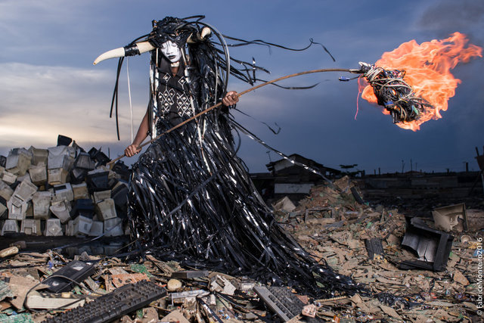
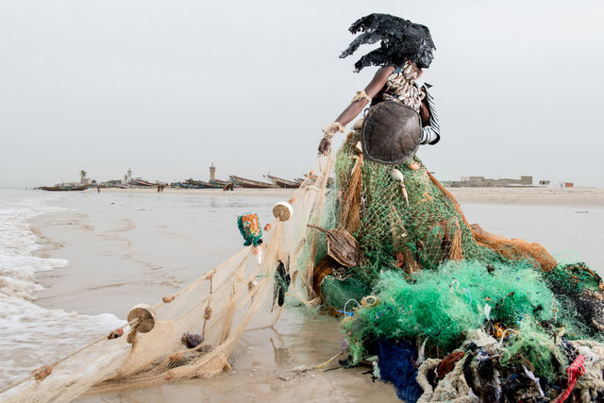
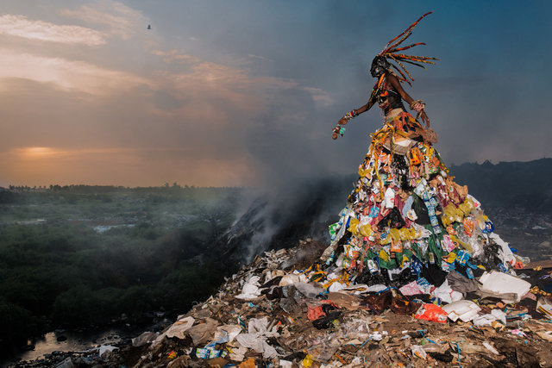
The Prophecy, a series of 13 photographs of composed assemblages set in different African landscapes, citiescapes and seascapes by the Senegalese artist Fabrice Monteiro, seems to me to be facing Gaia. Some of the images evoke a sense of Gaia rising. She is Black, She is Africa. In these images Black Gaia rises like a goddess: partially composed of the waste together with symbols of Africa and its heritage, She is magnified and magnificent, towering over, or rising up from, the ruins. Fabrice’s work enacts how the history of the extraction of Africa’s value – for example, in the form of mining for minerals and the buying and selling of slaves – as well as the more contemporary forms of globalization that are modernizing African life – such as the advance of industrialization and digitalized communication – assembles bodies, machines, infrastructures and networks through which Africa’s value can be capitalized. His art reminds us how the Anthropocene is built upon, and preys upon, intersectional inequities and inequalities: through the rendering of most humans as less-than-human. Fabrice noted in a personal email to me how ‘anthropocenic problems are indissociable from a colonial way of inhabiting the world that has been the norm for the last 5 centuries.’ He makes his African goddess the epitome of all the more-than-human and less-than-human connections and entanglements which co-constitute the Capitalocene and which specific relations between (hu)Mans and the constitution of less-than-human Ohers has produced. What the images emphasize is that the Capitalocene has relied upon the rendering of Others (animals, some human beings, the soil, the air, water, the land) as less-than-human – that there are moral economies* of techno-scientific production and fabricated ecologies always at work that rely upon the elevation of some over others. These are relations of asymmetry and power. But he is also enacting something that both Latour and Haraway advocate, collaboration with non-human others:

Bacteria and fungi abound to give us metaphors; but, metaphors aside (good luck with that!), we have a mammalian job to do, with our biotic and abiotic sym-poietic collaborators, co-laborers. We need to make kin sym-chthonically, sym-poetically. Who and whatever we are, we need to make-with – become-with, compose-with – the earth-bound (thanks for that term, Bruno Latour-in-anglophone-mode).

The Canadian organization studies scholar Beth Dempster contrasts sympoiesis and autopoiesis emphasizing how sympoietic systems, from the Greek words for ‘collective’ and ‘production’, are not closed but ‘organizationally ajar’. They are ‘characterized by cooperative, amorphous qualities’, and ‘interactions among components and the self-organizing capabilities of a system are recognized as the defining qualities’. I want to suggest Fabrice’s art performs sym-poietic collaboration and composition with non-human others – not bacteria and fungi but the materials of Capitalocene’s ‘ruins’. More specifically, the images and the compositions they record invert Capitalocene’s relations because they enact care for what is being ruined. They do this by performing Africa’s dignity, power and beauty and thereby invoking hope: hope that what has almost been lost, the magnificence of Africa, can be revived. We can see similar effects in other continents, not least in Brazil, elegiacally recorded in the work of artist Miguel Rio Branco, housed in the gallery dedicated to him at Inhotim. This work, as at the same time as it connects gendered and racialized violence, poverty and the ravaging of the land to Brazil’s history of slavery and colonialism, it evokes the immanent dynamism and power of peoples and places.

Some critics think that ecological balance can be reset through changing the political economic ordering of things from growth to degrowth and ‘a designed reduction of total energy and material use to realign society with planetary limits, while improving people’s lives and distributing resources fairly. It is an economic model that recognizes that the route to greater welfare for all is not one of more extraction and expansion, but of more sharing and co-operation.’

The problem with this imaginary is the word ‘all’. As important as a changing economic model is, it is not, as Belgian philosopher Isabelle Stengers suggests, enough to think of change as just for and about the human. And that ‘all’ does not take into account those humans who have little choice or who are offered opportunities to improve their lot through selling their labour as a part of their leader’s deals. In addition, it is not that (hu)Man needs just to be less materialistic; rather, as Blanca Callén and Daniel López argue, it is the way of thinking about human-non-human material relations that needs to shift, including the importance of paying more attention to life with objects by emphasizing the affect required to attach to, and detach from, some materials rather than others. To put it bluntly, as Greta Thunberg and Extinction Rebellion** have iterated, and as Fabrice Monteiro’s photographs help reveal, the Anthropocene is best understood, in its widest sense, as a crisis of care. This epithet is usually preserved for the crisis of care in terms of the economic and personal costs of an ageing population, but I want to broaden out the crisis of care to encompass the complexities and entanglements in which the Anthropocene thrives.

The British anthropologist Marilyn Strathern’s work (juxtaposing Melanesian ways of world-making with those of Euro-Americans) can help us here. Strathern stresses a different way of thinking about kin: kin requires recognition of our selves not just as individuals – those sovereign subjects of Cartesian dualistic thinking excited by cultures of consumption and incited to choose among this and that in their ever-desiring to be more complete. Rather, she invites us to reimagine ourselves as ‘dividuals’, whose being depends upon many different others. Haraway stretches this way of thinking to remembering that we are always and forever becoming-with and are dependent upon many different Ohers as no more or less than sym-compounds.

Within this potent framing of things, what Strathern aptly calls natureculture, care becomes a matter of shifting relations to a sensibility and an ethics of ‘more-than-human’. This is to say, moving from anthropocentric relations which elevate human exceptionalism, including competition, domination and extraction of resources – from our individuating each other, and from our treating the earth as an endless, super-abundant resource to be mined – to understandings of relations in which kin and kindness extend and incorporate all that makes it possible to live, to make worlds together with non-human others. Donna Haraway describes this widening of how we should look at the present epoch as the Chthulucene:

One way to live and die well as mortal critters in the Chthulucene is to join forces to reconstitute refuges, to make possible partial and robust biological-cultural-political-technological recuperation and recomposition, which must include mourning irreversible losses. Thom van Dooren and Vinciane Despret taught me that. There are so many losses already, and there will be many more. Renewed generative flourishing cannot grow from myths of immortality or failure to become-with the dead and the extinct.

Within this imaginary of the Chthulucene, soil, air, water, biotic, human and other animals, even minerals themselves are co-labourers. Hence we need ways to let the non-human speak not as less-than-human but as collaborators; they must be heard:
“Water has a role and a responsibility to fulfil, just as people do. We do not have the right to interfere with water’s duties to the rest of Creation. Indigenous knowledge tells us that water is the blood of Mother Earth and that water itself is considered a living entity with just as much right to live as we have.” Social movements such as Extinction Rebellion as well as activists like Greta Thunberg, with the growing movement of striking school pupils across the world, have helped enact how to care, specifically in terms of shifting both attachments and sensibilities, by doing and making worlds together differently. So, it is not simply perspectives on production, consumption and their all-but-forgotten relations to disposal that need to change, as important as these are, but also our sense of attachment and detachment. Attaching and detaching from different things and different others with care means garnering a sense of with whom we are intimately entangled – a sense of with whom and with what we are connected across vast tracts of time-space, to make a world, a life. As we drink Brazilian coffee, we become intimately entangled in Brazilian geopolitics; we become connected to the people whose labour turns Brazilian coffee beans into wealth for the few, to the ruptured soil that produces the coffee plants that is or isn’t treated with care.

Through this reimagining of the sympoietic relations that attachments compose, we can understand how human and the more-than-human can become-with each other in more fruitful and generative ways. This is not to collapse differences in some kind of mulch (apologies to compost lovers!) but to preserve a sense of being alongside each-otherness in partial and intermittent connection, and in ways that do not divide into hierarchical moral economies of division and exploitation that also characterize much of the biosciences, as at the same time as they preserve and respect difference.

Works cited:

Daston, Lorraine. 1995. ‘The Moral Economy of Science’. Osiris, 10, pp. 2–24. https://www.jstor.org/stable/301910. Accessed 8 May 2019.

Dempster, Beth. 2000. ‘Sympoietic and Autopoietic Systems: A New Distinction for Self-Organizing Systems’. In Proceedings of the World Congress of the Systems Sciences and ISSS 2000, ed. J.K. Allen and J. Wilby. Presented at the International Society for Systems Studies Annual Conference, July, Toronto, Canada.

Callén Moreu, Blanca, and Daniel López Gómez. 2019. ‘Intimate with Your Junk! A Waste Management Experiment for a Material World’. The Sociological Review, 62 (2), pp. 318–339.

Foucault, Michel. 1984. What is Enlightenment? In Rabinow, Paul (ed.) The Foucault Reader. Pp. 32-50. New York: Pantheon Books.

Giraud, Eva, Eleanor Hadley Kershaw, Richard Helliwell and Gregory Hollin. ‘Abundance in the Anthropocene’. The Sociological Review, 62 (2), pp. 357–373.

Harper, Phineas. 2019. ‘The Architecture of Degrowth’. Dazeen. https://www.dezeen.com/2019/09/25/oslo-architecture-triennale-architecture-degrowth-phineas-harper/. Accessed 9 January 2020.

Haraway, Donna. 2015. ‘Anthropocene, Capitalocene, Plantationocene, Chthulucene: Making Kin’. Environmental Humanities, 6, pp. 159–165.

Harrington, Cameron. 2017. ‘Posthuman Security and Care in the Anthropocene’. E-International Relations. https://www.e-ir.info/2017/10/10/posthuman-security-and-care-in-the-anthropocene/. Accessed 15 January 2020.

Heidegger, Martin. 1996. ‘The Question Concerning Technology’. In David F. Krell, ed. Martin Heidegger: Basic Writings. Revised and expanded edition. London: Routledge.

Latimer, Joanna. 2013. ‘Being Alongside: Rethinking Relations amongst Different Kinds’. Theory, Culture & Society, 30, 7/8, pp. 77–104.

Latimer, Joanna. 2019. ‘Science under Siege: Being alongside the Life Sciences, Giving Science Life. The Sociological Review, 62 (2), pp. 264–286.

Latimer, Joanna and Daniel López Gómez. 2019. Introduction: Affects, more-than-human intimacies and the politics of relations in Science and Technology. The Sociological Review. 67 (2): 247-263.

Latour, Bruno. 2013. ‘Facing Gaia: Six Lectures on the Political Theology of Nature’. Gifford Lectures, 18–28 February.

Munro, Rolland. 1996. ‘The Consumption View of Self: Extension, Exchange and Identity’. In Stephen Edgell, Kevin Hetherington and Alan Warde, eds. Consumption Matters. Sociological Review monograph series, no. 44, pp. 248–273. Oxford: Blackwell Publisher.

Meulemans, Germain. 2019. ‘Wormy Collaborations in Practices of Soil Construction’. Theory, Culture & Society, pp. 93–122. First published online 7 July. https://doi.org/10.1177/0263276419851857. Accessed 15 January 2020.

Puig de la Bellacasa, Maria. 2019. ‘Re-Animating Soils: Transforming Human–Soil Affections through Science, Culture and Community’. The Sociological Review, 62 (2), pp. 391–407.

Stengers, I. 2015. In Catastrophic Times: Resisting the Coming Barbarism. S.l.: Open Humanities Press.

Strathern, Marilyn. 1980. ‘No Nature, No Culture: The Hagen Case’. In Carol MacCormack and Marilyn Strathern, eds. Nature, Culture and Gender, pp. 174–222. Cambridge: Cambridge University Press.

Strathern, Marilyn. 1988. The Gender of the Gift: Problems with Women and Problems with Society in Melanesia. Oakland: University of California Press.

Strathern, Marilyn. 1991. Partial Connections. Lanham: Rowman and Littlefield.

Tsing, Anna Lowenhaupt. 2015. The Mushroom at the End of the World: On the Possibility of Life in Capitalist Ruins. Princeton: Princeton University Press.

Whitehead, Alfred North. 1920. ‘Theories of the Bifurcation of Nature’. In The Concept of Nature, pp. 26–48. Cambridge: Cambridge University Press.
]

* ‘Moral economies … are integral to science: to its sources of inspiration, its choice of subject matter and procedures, its sifting of evidence, and its standards of explanation.’
** ER images – ‘Grandfather’ & ‘Tigergrowl’, Extinction Rebellion, Waterloo Bridge, London, 15 April 2019 published with kind permission of Mark Latimer.

Foucault 1984.
Heidegger 1996.
Whitehead 1920.
Haraway 2015, p. 160.
Latour 2013.
Tsing 2015.
Giraud et al. 2019.
Harrington 2017.
Latour 2013.
Personal email communication December 2019.
Daston 1995, p. 5.
Haraway 2015, p. 161.
Dempster 2000, p. 5.
Ibid., p. 3.
Tsing 2015.
Harper 2019.
Stengers 2015.
Callén and López 2019.
Strathern 1988.
Strathern 1980.
See also Meulemans 2019; Puig de la Bellacasa 2019.
Haraway 2015, pp. 160–161.
Harrington 2017, drawing on McGregor 2009, pp. 37–38.
See also Munro 1996, drawing on Strathern 1991.
Latimer 2013; Latimer 2019.

