Lattice Softening in Metastable bcc Co_{x}Mn_{100-x}(001) Ferromagnetic Layers for a Strain-Free Magnetic Tunnel Junction
Kelvin Elphick,¹ Kenta Yoshida,² Tufan Roy,³ Tomohiro Ichinose,⁴ Kazuma Kunimatsu,^{4,5} Tomoki Tsuchiya,^{6,7} Kazuya Z. Suzuki,^{4,7} Masahito Tsujikawa,^{3,7} Yasuyoshi Nagai,² Shigemi Mizukami,^{4,6,7} Masafumi Shirai ^{3,6,7} and Atsufumi Hirohata ¹
¹ Department of Electronic Engineering, University of York, Heslington, York YO10 5DD, United Kingdom
² Institute for Materials Research, Tohoku University, Katahira 2-1-1, Sendai 980-8577, Japan
³ Research Institute of Electrical Communication, Tohoku University, Sendai 980-8577, Japan
⁴ WPI Advanced Institute for Materials Research, Tohoku University, Katahira 2-1-1, Sendai 980-8577, Japan
⁵ Department of Applied Physics, Graduate School of Engineering, Tohoku University, Sendai 980-8579, Japan
⁶ Center for Science and Innovation in Spintronics (CSIS), Core Research Cluster (CRC), Tohoku University, Sendai 980-8577, Japan
⁷ Center for Spintronics Research Network (CSRN), Tohoku University, Sendai 980-8577, Japan
Abstract
In spintronics, one of the long-standing questions is why the MgO-based magnetic tunnel junction (MTJ) is almost the only option to achieve a large tunnelling magnetoresistance (TMR) ratio at room temperature (RT) but not as large as the theoretical prediction. This study focuses on the development of an almost strain-free MTJ using metastable bcc Co_{x}Mn_{100-x} (CoMn) ferromagnetic films. We have investigated the degree of crystallisation in MTJ consisting of CoMn/MgO/CoMn in relation to their TMR ratios. Cross-sectional high resolution transmission electron microscopy reveals that almost consistent lattice constants of these layers for 66≤x≤83 with maintaining large TMR ratios of 229% at RT, confirming the soft nature of the CoMn layer with some dislocations at the MgO/Co₇₅Mn₂₅ interfaces. Ab-initio calculations confirm the crystalline deformation stability across a broad compositional range in CoMn, proving the advantage of a strain-free interface for much larger TMR ratios.
1. Introduction
A magnetic tunnel junction (MTJ) is known as a crucial spintronic device because of its broad applications in read heads for hard disk drives (HDDs), magnetic random access memories (MRAMs) and magnetic sensors. This has incurred extensive studies in many research institutions worldwide [1],[2],[3]. The most commonly used MTJs are composed with CoFeB ferromagnetic electrodes with a MgO tunnelling barrier. High tunnelling magnetoresistance (TMR) ratios of >600% were obtained at room temperature (RT) [4],[5],[6],[7]. Recently, the other ferromagnetic alloys such as half-metallic ferromagnetic Heusler alloys and metastable ferromagnets, e.g., Co₇₅Mn₂₅ [8],[9],[10] and Co [11],[12], have been employed as electrodes in MTJ. However, the corresponding TMR ratios measured experimentally are still far below from theoretical predictions of >1,000% at RT [13],[14].
Numerous methods were proposed to improve the degree of crystallisation in MTJ. One of the most popular methods for MTJ fabrication is a thermal annealing process under a magnetic field. It has been reported that for an as-deposited MTJ, the excessive oxygen content in the MgO barrier is accumulated at the interface near the top electrode [15],[16]. The crystallinity of the MgO barrier and the ferromagnetic electrodes facilitates coherent tunnelling [7]. It has been reported that without annealing, the MgO barrier exhibits an amorphous phase within a region in a few nanometres above the bottom electrode [17],[18].
The crystallisation degree of the MTJ can be determined by measuring the saturation magnetisation and crystallographic structure [6],[19]. Cross-sectional high resolution transmission electron microscopy (HRTEM) images for MTJ using different annealing conditions have been reported to date [4],[20]. An epitaxial crystallisation of the entire MgO layer has been obtained under the annealing condition of 90 minutes at 420ºC [6]. Amorphous and polycrystalline grains were observed when MTJ was annealed for 3 minutes instead [21]. However, excessive duration of annealing and annealing at higher temperatures cause diffusion of constituent elements in MTJ [4],[16],[22]. Butler et al. have reported that interfacial roughness and bonding at the electrode/insulator interface are critical to determine the spin-polarised electron transport and resulting TMR ratios [10].
However, the detailed mechanism of the crystallisation process and the corresponding interfacial strain as well as their resulting advantages of MgO over the other epitaxial barriers have yet to be understood conclusively. In this paper, we provide atomic analysis on MTJ consisting of Co_{x}Mn_{100-x} (CoMn)/MgO/CoMn, including their degrees of crystallisation. Cross-sectional HRTEM imaging was carried out to understand the atomic structures at the CoMn/MgO/CoMn interfaces and within the MgO barrier. Inhomogeneous crystallisation was observed especially within the MgO barrier depending on the bottom CoMn crystallinity after the annealing process. The lattice constants estimated from these images were compared with ab-initio calculations to confirm the softness of CoMn. Based on this approach, we explain why the TMR ratios experimentally reported are smaller than the theoretically expected values and why MgO barriers are advantageous for the demonstration of large TMR ratios.
2. Experimental Procedures
MTJ samples were prepared using conventional magnetron sputtering with a base pressure of 2×10⁻⁷ Pa. MgO(001) single crystal substrates were used for the deposition of MTJ consisting of Cr (40)/CoMn (10)/MgO (2.4 and 20)/CoMn (4)/Co₃Fe (1.5)/IrMn (10)/Ru (5) (thickness in nm) with a Ti and Au top electrode as illustrated in the inset of Fig. 1(a) [9],[23]. Two different thicknesses of the MgO layers were used for MTJs with 2.4 nm and reference samples with 20 nm. For CoMn, four different nominal compositions of x=66, 75, 83 and 86 were employed, allowing to control the lattice constants of the bottom and top electrodes precisely [23]. The crystalline phase of CoMn in bulk becomes face-centred cubic (fcc)/hexagonal closed packing (hcp) for those range of x [24]. However, it has been reported that ferromagnetic CoMn, body-centred cubic (bcc) phase can be obtained around x=75 in epitaxial films [25]. To achieve these crystalline engineering in MTJ, in-situ annealing was carried out after the deposition of the Cr seed layer and CoMn layers at 700ºC and 200ºC, respectively. MTJs were then post-annealed at 325ºC for their crystallisation after patterned into pillars with Ti/Au electrodes by photolithography [23].
3. Results and Discussion
TMR measurements were carried out using the conventional four-terminal setup with elevating temperature and the corresponding atomic structures at the CoMn/MgO/CoMn interfaces were studied to understand the compositional dependence of the CoMn MTJ samples. This study primarily focuses on two samples which are x=75 and 86 due to their distinctive TMR ratios of 229% and 142%, respectively. Cross-sectional TEM specimens were prepared using a mechanical polishing technique. HRTEM images were taken using JEOL JEM-2100 Plus at 600k magnification. These results were compared with ab initio calculations on the lattice stability of the CoMn alloys.
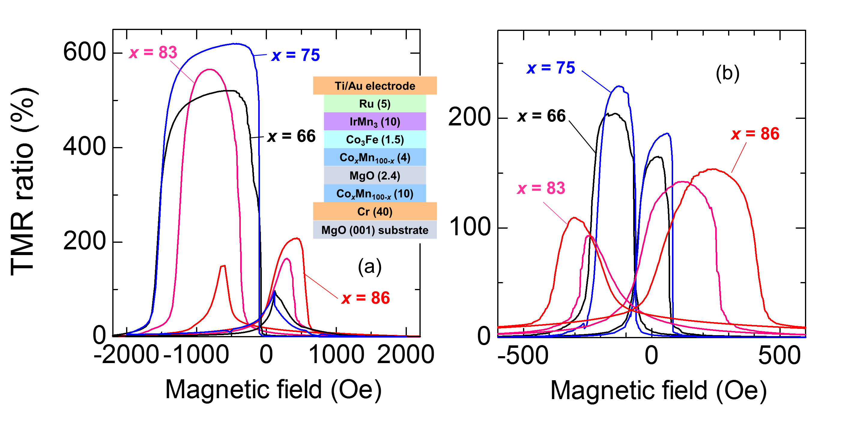
Figure 1 TMR curves of CoMn (66≤x≤86) measured at (a) 10 K and (b) RT (300 K). The inset shows a schematic diagram of MTJ structures studied [9],[23].
First TMR ratios of CoMn-based MTJs post-annealed at 598K for 1 hour were measured between 4 and 300 K as shown in Fig. 1. The TMR ratios measured at 10 K and 300 K show almost square curves for the lower Co concentration of x=75 and 66 as seen in Figs. 1(a) and 1(b) [9],[23], while the curves for the higher Co concentration of x=86 and 83 at 10K and 300K contain stronger components of magnetisation rotation [see Figs. 1(a) and 1(b)]. This suggests incomplete antiparallel states of magnetisations for x=86 and 83, which may be partially due to the large coercivity for the 10nm thick bottom CoMn layer with x =86 and 83 and also the presence of magnetic volume with spin fluctuation at the interfaces. Improved antiparallel states but with lower TMR ratios can be achieved by reducing the annealing temperature to 573K for 1 hour as shown in Fig. A1 in Appendices I and II. Additional decrease in the exchange bias may be induced by the increased roughness at the CoMn/CoFe interface. The difference between x=86 and 83, and 75 and 66 may be related to the stability of the metastable bcc phase against the post-annealing at 325ºC. The former MTJs with the higher Co concentration are less stable than the latter MTJs in this thickness [22]. Using Shang’s model [26] (see Appendix III), we obtained P₀ of 0.87 and A of 1.7×10⁻⁵ K^{-3/2}. A is found to be twice as large as that observed in Fe/MgO/Fe MTJs at (7~9)×10⁻⁶ K^{-3/2} [27]. The spin-independent conductance G_{hop} are also plotted in Fig. A2, which is relatively large at RT. Thus, the temperature dependence of the TMR ratios is mainly induced by the spin fluctuation at the CoMn/MgO interfaces and the spin-independent hopping within the MgO barrier.
To clarify the possible interfacial spin fluctuation and spin-independent hopping in the barrier, atomic structural imaging was performed on these CoMn-based MTJs, namely those for x=75 and 86 with the TMR ratios of 229 and 142%, respectively. Figures 2(a) shows a cross-sectional HRTEM image of the bcc Co₇₅Mn₂₅ MTJ sample with the larger TMR ratio of 229% at RT [24]. Figure 2(a) confirms the fully epitaxial growth of the entire MTJ with some dislocations. Lattice dislocation has been reported as one of the crucial factors on MTJ performance. The TMR ratio is strongly correlated to the density of lattice dislocation at the electrode/barrier interface [10],[28]. Therefore, an inverse Fourier transform is carried out on the corresponding TEM images. The dislocation at the CoMn/MgO/CoMn interface is labelled using a red arrow as shown in Fig. 2(b). The period of the lattice dislocation is calculated to be (11.4±0.3) nm. It should be noted that the dislocations also appear within the top and bottom CoMn layers almost every 1 nm along plane normal, suggesting the metastable CoMn grains have a critical size to maintain their lattice matching with the layers underneath. This indicates that the Co₇₅Mn₂₅ layer may induce plastic deformation rather than elastic deformation with inducing dislocations at the boundaries.
In the MgO layer, only two distinctive crystallographic phases are observed as shown as the regions (i) and (ii). Namely for the regions (i), similar crystalline structures can be found in the other reports where some have claimed that it is an amorphous structure [19],[29] but the others have described it is crystallised in the (200) orientation [30]. In order to clarify the regions (i) and (ii), two inverse Fourier transformations which correspond to the MgO[001] and [100] orientations are extracted from Fig. 2(a) as indicated in Figs. 2(b) and (c), respectively. Firstly, the region (ii) shown in Fig. 2(a) is fully crystallised MgO, which will be discussed further later using the thicker MgO reference in Fig. 3. No fringe splitting is appeared within the green circle in both Figs. 2(b) and (c). The purple circle in Fig. 2(b) shows multiple fringe splitting but not in Fig. 2(c). It indicated the MgO lattice is crystallised but stretched along the [001] orientation introducing the dislocation along the [100] axis. Hence, MTJ with the larger TMR ratio is found to be fully crystallised with lattice stretching in MgO and interfacial dislocations.
Figure 2(d) shows a cross-sectional HRTEM image of the Co₈₆Mn₁₄ MTJ sample with the smaller TMR ratio of 142% at RT. The boundary between CoMn[110] and MgO[100] layers can be clearly observed with some dislocations in this image. In Fig. 2(d), the dark black regions associated with the dislocations indicate where CoMn/MgO is not fully crystallised, which is different from those observed in the Co₇₅Mn₂₅ MTJ. Such features are typically observed at the CoMn/MgO interface and within the CoMn layer. These features are found to be induced by dislocations formed at the CoMn/MgO/CoMn interface as labelled using a red arrow in Fig. 2(e). One of the interesting features is that the dislocations often appear near the dark black regions which are circled in red in Fig. 2(d). This pattern can also be observed in the earlier reports without specific comments to date [9]. Here, we demonstrate the appearance of fringe splitting at the CoMn/MgO/CoMn interfaces is not only due to the lattice dislocation but a partially crystallised structure. The period of the lattice dislocation is calculated to be (8.9±0.3) nm, which is shorter than that for the larger TMR sample. These results coincide with the correlation between the interfacial dislocation density and the TMR ratio correlation reported previously [31],[32]. These dislocations and the associated interfacial mixing/disordering may be the origin of the interfacial spin fluctuation as identified in Fig. 1, i.e., large A. Note that the dislocations are also formed within the top and bottom CoMn layers as the same with the x=75 sample as discussed above. However, their density in the top CoMn layer for x=86 is much higher than that for x=75, while that in the bottom is almost the same. This may be due to the larger discrepancy in the lattice constants between CoMn and MgO as discussed later.
In the MgO barrier, two regions (i) and (iii) can be unambiguously distinguished in Fig. 2(d) as fully crystallised and partially crystallised MgO, respectively. The grain size of these regions is measured to be 2~4 nm in diameter. Such inhomogeneous multi-boundaries in the MgO barrier layer indicate the MgO layer is not epitaxially grown along the [100] orientation. Figure 2(e) is the corresponding inverse Fourier transform corresponding to the MgO[001] of Fig. 2(d). The fringe splitting in Fig. 2(e) is observed within the MgO as labelled as a yellow circle, which is the region where the partially crystallised MgO was identified. Whereas the green circle labelled in Fig. 2(a) is the region where no fringe splitting was observed as represented as crystallised MgO in the region (iii). The lattice mismatch is possible to appear within the layer itself due to local stress as seen in Figs. 2(b) and (c) or partial crystallisation as seen in Fig. 2(e). It can hence be concluded that the fringe splitting appears within the layer is due to the partially crystallisation. Whilst the fringe splitting appears at the interface is caused either by the lattice dislocation or partially crystallised structure (see Fig. A3 for details).
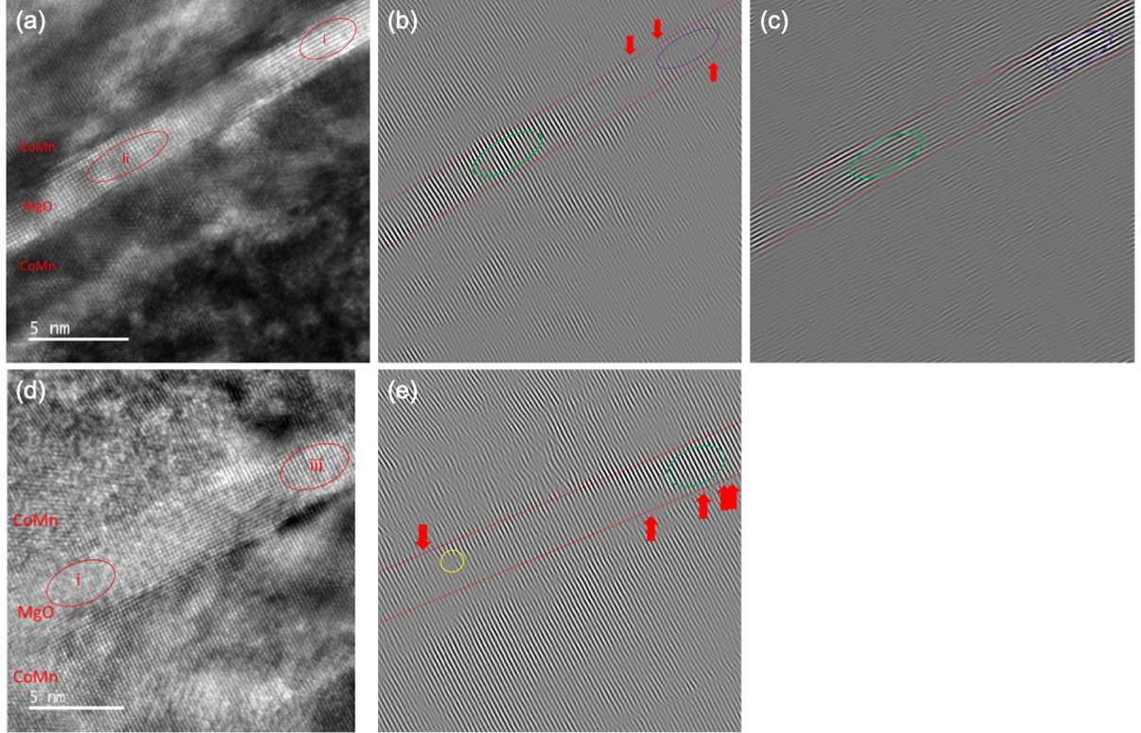
Figure 2 HRTEM images taken on the (a) Co₇₅Mn₂₅ [24] and (d) Co₈₆Mn₁₄ samples. The corresponding Fourier transformations are shown in (b) along the MgO[001], (c) [100] and (e) [001].
The lattice constants of the CoMn and MgO layers in MTJs are measured and compared to investigate their softness (see Appendix V). Figure 3 shows the lattice constants of the top and bottom CoMn and MgO layers with four different CoMn compositions. It shows that apart from the Co₈₆Mn₁₄, the top CoMn lattice constant is almost constant with about 3.5% larger than the bottom layer across MTJs. This may be due to the CoMn lattice strain induced by the MgO tunnel barrier and the Cr seed layer underneath, especially for the top CoMn layer for x≤83. Note that the number of dislocations almost stays the same for both top and bottom interfaces as seen in Fig. 2(a), confirming the soft nature of the lattice constants of CoMn and MgO. The largest difference is measured to be 4.3% in the Co₇₅Mn₂₅. The enhancement in the CoMn lattice constants is mainly induced by the material underneath the CoMn layer. The measured values of the Cr and MgO lattice constant are 0.27nm and 0.40nm, respectively. This is comparable to the theoretical value of 0.29nm and 0.42nm [28]. Assuming the Cr/CoMn and CoMn/MgO interface have 45º ($×\sqrt{2}$) rotation, the lattice constant of Cr became 0.41 nm. Therefore, it consists of about 2.4% difference in the lattice constants [9], which agrees well with the measured values. As the bottom CoMn layer is grown on the Cr seed layer, while the top CoMn is grown on the MgO barrier, the CoMn lattice constants may vary due to the different texture of the underlayers.
Figure 3 (a) Lattice constants of CoMn layers which are located at the top and bottom of the MgO layer with different compositions. (b) Lattice constant of MgO on different CoMn compositions.
As reported earlier in Fe₇₀Pd₃₀ alloys [33], softening of a ferromagnetic lattice allows the junction to form a strain-less interface, which is critical to eliminate any unexpected electron scattering and spin fluctuation. For the metastable bcc CoMn alloys investigated here, we carried out first-principles density-functional calculations to gain the insight into the lattice deformation of metastable bcc CoMn alloys as detailed in Appendix VI. Figure 4(a) shows the total energies of ferromagnetic CoMn alloys with various compositions calculated as a function of the strain, δ, for minor tetragonal distortion around the theoretical equilibrium lattice constant that minimises the total energy of the bcc phase. As shown in Fig. 4(a), the ferromagnetic bcc phase is metastable for x≤93.75, where the curvature of total energy around the bcc phase becomes smaller with increasing x, and eventually it becomes unstable. The curvature of total energy is much smaller for the ferromagnetic CoMn alloys in 68.75≤x≤93.75, compared to that for ferromagnetic bcc Fe. The result suggests that the bcc CoMn alloys are much softer against the tetragonal distortion than bcc Fe. For more quantitative comparison the tetragonal shear modulus C’ was evaluated from the curvature of total energy in Fig. 4(a). The results are plotted as a function of x in Fig. 4(b). The obtained values of C’ are 41.37 and 41.53 GPa for x=68.75 and 75, respectively. These values are about two third of C’ evaluated for bcc Fe (56.1 GPa). Figure 4 shows the softening of bcc CoMn becomes prominent near the boundary of the metastable bcc phase. Although the maximum softness is expected for x=93.75, it is difficult to stabilise a bcc CoMn phase in the form of MTJ with the Cr seed layer used in this study. This may leave some additional potential of this alloy for further improvement in the corresponding magnetotransport properties.
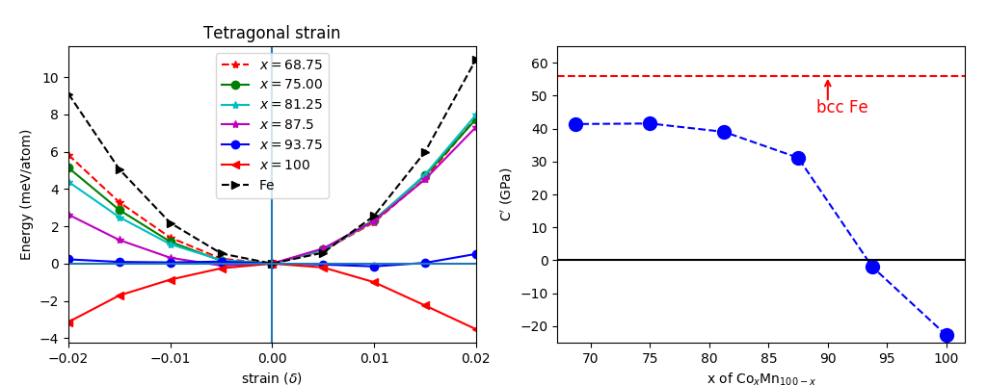
(a) (b)
Figure 4 (a) Total energies of ferromagnetic Co_{x}Mn_{100-x} alloys with 68≤x≤100 calculated as a function of the strain, δ, for tetragonal distortion. The bcc structure corresponds to δ = 0. The total energy of ferromagnetic Fe is also shown for comparison. (b) Tetragonal shear moduli C’ of ferromagnetic CoMn alloys as a function of x. A horizontal broken line represents the value of C’ for bcc Fe.
4. Conclusion
Our investigation confirms the softening of metastable bcc Co_{x}Mn_{100-x} ferromagnetic layers for x≤83, achieving the large TMR ratio of 229% at RT. These MTJs show less dislocations at the CoMn/MgO interfaces due to the CoMn softening and MgO stretching. This proves the robustness of MgO for coherent tunnelling. For x=86, on the other hand, due to the MgO contraction, the higher density of the lattice dislocations is observed, one possible source in the lower TMR ratio of 142%. The first-principles calculation also confirms the softening of bcc CoMn, which becomes prominent near the boundary of the metastable bcc phase. Although the maximum softness is expected for x=93.75, it is difficult to stabilise the bcc CoMn phase in the form of MTJ after post-annealing as experimentally observed for the case of x=86. Further precise control of the lattice matching can demonstrate much larger TMR ratios as required for greater integration and capacity of MTJ-based storages and memories.
Appendix I. Magnetic Tunnel Junction without an IrMn layer
A set of magnetic tunnel junctions (MTJs) consisting of MgO(001) single crystalline substrate/Cr (40)/Co_{x}Mn_{100-x} (10)/MgO (2.4)/Co_{x}Mn_{100-x} (4)/Ni₈₀Fe₂₀ (5)/Ru (10) (thickness in nm) with a Ti and Au top electrode was also fabricated and measured as shown in Fig. A1. The MTJs were annealed at 573K, which achieved stable antiparallel states for x = 83 and 86 as compared with those post-annealed at higher temperature in Fig. 1. This may be due to possible dispersion of Mn within the ferromagnetic Co_{x}Mn_{100-x} layers during annealing but confirms the validity of our MTJ evaluation even without attaching an antiferromagnetic IrMn layer to induce exchange biased pinning. Note that these MTJs show smaller TMR ratios of 178 (146) and 234 (113)% at 10K (RT) for x = 83 and 86, respectively, which are smaller than those measured in Fig. 1 due to less crystallinity by lower annealing temperature.
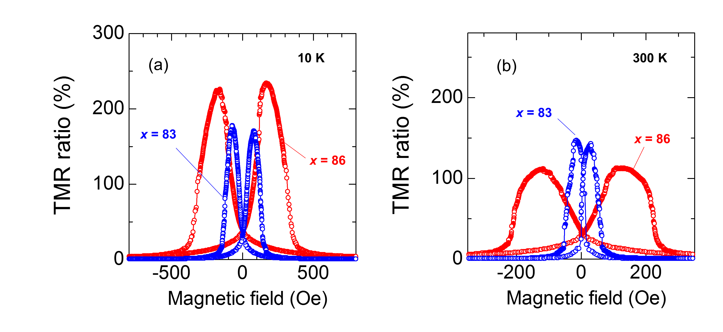
Figure A1 TMR curves of Co_{x}Mn_{100-x} (83 ≤ x ≤86) measured at (a) 10 K and (b) room temperature (RT) (300 K).
Appendix II. Temperature Dependence of Tunnelling Magnetoresistance Ratios and Conductances
The temperature dependence of the TMR ratios for x = 75 is shown in Fig. A2(a), revealing the decreases in the TMR ratios with increasing temperature. In the magnetic tunnelling conductance for x = 75 show in Fig. A2(b), both parallel and antiparallel conductance, G_{p} and G_{ap}, respectively, are found to increase with increasing temperature.
Figure A2 (a) Temperature dependence of the TMR ratios for MTJ with x = 75. (b) Temperature dependence of the conductance for parallel state G_{p} and antiparallel state G_{ap} as well as the spin-dependent and -independent parts of the conductance, $\overline{G}$ and $ΔG$. G_{hop} is the spin-independent conductance due to the two-step hopping via defect states in a MgO barrier.
Appendix III. Analysis Using Shang’s Model
The TMR data are analysed using Shang’s model [35]:
$G_{p (ap)}=G_{0}\left(T\right)\left[1+\left(-\right)P_{0}^{2}m^{2}\left(T\right)\right]+G_{hop}\left(T\right)$. (1)
Here, G₀ is the mean conductance, P₀ is the tunnelling spin polarisation, m is the reduced magnetisation, G_{hop} is the spin-independent conductance due to the two-step hopping via defect states in a MgO barrier. G₀, m, and G_{hop} are expressed as
$m\left(T\right)=1-AT^{\frac{3}{2}}$,
$G_{hop}\left(T\right)=BT^{\frac{4}{3}}$,
$G_{0}\left(T\right)=G_{0}\frac{CT}{\sin{CT}}$,
where A is the parameter characterising spin fluctuation at the interface between a ferromagnet and a barrier. $C=1.387×{10}^{-3} d/\sqrt{ϕ}$with the barrier width d in nm and height $ϕ$ in eV. B and G₀ are constants. Here, the spin-dependent and -independent parts of the conductance, $\overline{G}$ and $ΔG$, respectively, can be defined as follows:
$\overline{G}=\frac{G_{p}+G_{ap}}{2}=G_{0}\left(T\right)+G_{hop}\left(T\right)$, (2)
$ΔG=\frac{G_{p}-G_{ap}}{2}=G_{0}\left(T\right)P_{0}^{2}m^{2}\left(T\right)$. (3)
We find Equations (2) and (3) fit the experimental data very well with C = 1.4 × 10⁻³ as shown in Fig. 2. G_{p}, G_{ap} and the TMR ratio are also found to satisfy the following relationship:
$TMR ratio=\frac{2ΔG}{G_{ap}}×100$,
which is in agreement with the model as seen in Fig. 1(d). From this analysis, we obtained P₀ of 0.87 and A of 1.7 x10⁻⁵ K^{-3/2}. A is found to be twice as large as that observed in Fe/MgO/Fe MTJs at (7-9) × 10⁻⁶ K^{-3/2} [28]. G_{hop} are also plotted in the figure, which is relatively large at RT. Thus, the temperature dependence of the TMR ratios is mainly induced by the spin fluctuation at the CoMn/MgO interfaces and the spin-independent hopping within the MgO barrier.
Appendix IV. TEM Imaging on a Refence Sample
The crystallisation degrees of the MgO barrier are further studied by using reference samples with the thicker MgO barrier, consisting of MgO substrate/Cr (40)/Co_{x}Mn_{100-x} (10)/MgO (20)/Co_{x}Mn_{100-x} (4)/CoFe (1.5)/IrMn (10)/Ru (5) (thickness in nm, x = 75). The MgO layers in the reference samples are approximately 10 times thicker than previous set of MTJ samples to obtain clear selected area electron diffraction (SAED) patterns, allowing to investigate further MgO crystallographic structures. The cross-sectional TEM specimens were prepared using focused ion beam (FIB, Nova 200 NanoLab). The samples were first milled down to a thickness of < 100 nm and were polished down to electron transparency by a Gatan gentle mill (Scientific Technical Development, GENTLE MILL ion miller model IV5).
In Fig. A3, a cross-sectional HRTEM on Co₇₅Mn₂₅ (10)/MgO (20)/Co₇₅Mn₂₅ (4) (thickness in nm) sample with the corresponding SAED image. Here, three different regions of the 20 nm thick MgO layers are analysed over the TEM images to estimate their volume ratios: (a) approximately 58% of crystallised MgO[100] as labelled as the regions (i) and (ii) in Fig. 2, (b) ~ 4% of crystallised MgO with different orientations as seen as the region (iii) in Fig. 2 and (c) almost 38% of partially crystallised MgO. The partially crystallised MgO only appears in the centre of the MgO barrier, which is due to the increased thickness of the MgO barrier, possibly indicating that the MgO crystallisation is initiated at the CoMn/MgO interfaces and is not reached to the centre under the post-annealing condition used. Figure 3(a) shows crystallised MgO where highly ordered electron beam diffraction spots can be observed in selective diffraction patterns. The red squares in Fig. A3(a) show the region where MgO is crystallised along the [100] direction. A similar crystalline structure is observed in Fig. 2(e) but with an additional phase with a different crystalline direction. The blue circles shown in the diffraction pattern in Fig. A3(b) indicate missing diffraction spots, which is a sign of lower degree of crystallinity than that in Fig. A3(a). Nevertheless, the first order diffraction spots are identical to those in Fig. 2(d), indicating that a part of the MgO layer is orientated in a different direction with respect to the [100] axis. Furthermore, the diffraction pattern in Fig. A3(c) represents the dark grey region in the selected MgO layer. Similarly, some of the second order diffraction spots are vanished. The unique feature in this figure is that the first and second order diffraction spots are rather dispersive, which apparently confirms that MgO is not fully crystallised as discussed above. Such partially crystallised MgO can be the origin of the spin-independent hopping and the grain boundaries between the MgO grains with three different phases can act as hopping sites.
In Fig. A3, the formation of a different phase, such as MnO, is not been observed in the electron diffraction patterns in three representative regions. It is also confirmed by the decreasing trend in the lattice constant of MgO with increasing with x, excluding the possible formation of MnO at the MgO/CoMn interfaces as reported previously [35]. Larson et al. have reported that Mn doping up to ~6 at.% at the Co₇₀Fe₃₀/MgO interface does not change the corresponding TMR ratios, which is different from the changes in the TMR ratios within the measured x in this study. Accordingly, the effect of possible Mn diffusion is concluded to be negligible in this study.
Figure A3 HRTEM image of the reference sample, MgO substrate/Cr (40)/Co₇₅Mn₂₅ (10)/MgO (20)/Co₇₅Mn₂₅ (4)/CoFe (1.5)/IrMn (10)/Ru (5) (thickness in nm), focusing on the MgO layer with three distinctive regions confirmed by the diffraction patterns: (a) MgO[100]; (b) MgO with a different orientation from MgO[100] and (c) partially crystallised MgO.
Appendix V. Lattice Constants of CoMn and MgO layers
The lattice constants are calculated by measuring the averaged fringe distance across 20 layers in the corresponding TEM images both in parallel and perpendicular to the CoMn/MgO interfaces. It should be noted that these lattice constants do not show any differences along these two directions.
A monotonic increase in the CoMn lattice constants for the CoMn films annealed at 200ºC has been reported by X-ray diffraction (XRD) with increasing the Mn contents [see Ref. [9] in the main text]. As XRD is a macroscopic measurement, the estimated lattice constants are averaged values over the bottom CoMn layers. Kunimatsu et al. reported that the lattice constants along the plane normal direction show very minor increase from 0.285 nm at x = 86 to 0.290 at x = 50 almost linearly, while the lattice in the in-plane [001] direction stays almost constant (~ 0.288 nm).
For x = 86, the bottom CoMn lattices is found to increase, introducing many dislocations at the bottom CoMn/MgO interface as seen in Fig. 2(d). The top CoMn layer, on the other hand, absorbs the strain by introducing more dislocations within the layer due to the larger difference in the lattice constants between CoMn and MgO underneath, which start to approach the bcc Co grown on the MgO barrier with > 400% TMR ratio at RT as reported previously [see Ref. [10],[11] in the main text]. CoMn may offer such a metastable bcc phase in easily accessible way for MTJ-based devices.
Appendix VI. Elastic Constant Calculation
A cubic crystal has three linearly independent elastic constants which are C₁₁, C₁₂, and C₄₄. These elastic constants could be obtained after calculating the ‘change of energy ($∆E$)’ on the application of three different types of strain, with respect to the ‘energy of the optimized structure’.
Firstly, we apply the hydrostatic pressure on the cubic supercell, in which the strain has a form of
- (δ, δ, δ, 0, 0, 0)
It converts the equilibrium lattice vector $\vec{a }$ to $\vec{a'}$ following the relationship
$\vec{a'}= \left(\begin{matrix}1+δ & 0 & 0 \\ 0 & 1+δ & 0 \\ 0 & 0 & 1+δ\end{matrix}\right) \vec{a}$ (A1)
The change of energy because of this strain is
$∆E= \frac{3}{2}V_{0} \left(C_{11}+2C_{12}\right)δ^{2}$ (A2)
$V_{0}$ is the volume of the optimized system.
Secondly, we apply the volume conserving tetragonal strain on the system, which has a form of
- (δ, δ, (1+δ) ⁻²-1, 0, 0, 0)
It transforms the lattice vectors as
$\vec{a'}= \left(\begin{matrix}1+δ & 0 & 0 \\ 0 & 1+δ & 0 \\ 0 & 0 & \frac{1}{{(1+δ)}^{2}}\end{matrix}\right) \vec{a}$ (A3)
The associated energy change is
$∆E= 3V_{0} \left(C_{11}-C_{12}\right)δ^{2}$ (A4)
From equations (2) and (4), we can obtain C₁₁ and C₁₂.
The strain of the following form is applied to evaluate C₄₄.
- (0, 0, δ²/(1-δ²), 0, 0, δ)
The corresponding lattice vector becomes
$\vec{a'}= \left(\begin{matrix}1 & δ & 0 \\ δ & 1 & 0 \\ 0 & 0 & \frac{1}{1-δ^{2}}\end{matrix}\right) \vec{a}$ (A5)

Finally, C₄₄ is evaluated from the following strain (δ) versus change of energy ($∆E$) relationship:
$∆E= 2V_{0}C_{44}δ^{2}$ (A6)
It is to be mentioned that in each case, $δ$ is varied from -0.02 to +0.02, in the steps of 0.005.
After, evaluating C₁₁, C₁₂, and C₄₄ from equations (2), (4), and (6).
We could obtain the elastic moduli from the following relationship:
- Bulk Modulus $B=\frac{1}{3}(C_{11}+2C_{12})$
- Tetragonal Shear Constant $C^{'}=0.5 (C_{11}-C_{12})$
- Shear Modulus $G= \frac{1}{5}(C_{11}-C_{12}+3C_{44})$
It is to be noted that we used Voigt formalism [36], in the evaluation of shear modulus and bulk modulus. In the Reuss formalism [37], in the expression for shear modulus ($G$), the quantity $C^{'} (=0.5*(C_{11}-C_{12}))$, appears as a multiplicative constant ($G=\frac{5*C_{44}*(C_{11}-C_{12})}{4*C_{44}+3*(C_{11}-C_{12})}$). So, $G$ becomes negative or closed to zero for the compositions which have $C^{'}≈0$, or negative, which may not have a physical meaning. So, here we only report the elastic moduli obtained using Voigt formalism, in which $C^{'}$appears as an additive constant.
The calculations of energies have been carried out using PAW method [38] implemented in Vienna ab-initio simulation package (VASP) [39],[40]. We adopted the generalized gradient approximation [41] for exchange and correlation energies/potentials. We used a 8 × 8 × 8 k-point mesh for Brillouin zone integration and 500 eV for a cut-off energy of plane-wave expansion. We constructed a 16-atom cubic supercell and considered special quasi-random structures (SQSs) [42] to simulate chemical disorder. The SQSs were generated using the alloy theory automated toolkit package [43].
Acknowledgments
This work was partially supported by JST CREST (No. JPMJCR17J5).
Data Availability
All data needed to evaluate the conclusions in the paper are present in the paper.
References
- M. Jullière, “Tunneling between ferromagnetic films,” Phys. Lett. A 54, 225 (1975); https://doi.org/10.1016/0375-9601(75)90174-7.
- T. Miyazaki and N. Tezuka, “Giant magnetic tunneling effect in Fe/Al₂O₃/Fe junction,” J. Magn. Magn. Mater. 139, L231 (1995); https://doi.org/10.1016/0304-8853(95)90001-2.
- J. S. Moodera, L. R. Kinder, T. M. Wong and R. Meservey, “Large magnetoresistance at room temperature in ferromagnetic thin film tunnel junctions,” Phys. Rev. Lett. 74, 3273 (1995); https://doi.org/10.1103/PhysRevLett.74.3273.
- X. D. Xu, K. Mukaiyama, S. Kasai, T. Ohkubo and K. Hono, “Impact of boron diffusion at MgO grain boundaries on magneto-transport properties of MgO/CoFeB/W magnetic tunnel junctions,” Acta. Mater. 161, 360 (2018); https://doi.org/10.1016/j.actamat.2018.09.028.
- B. D. Clark, S. Paul, S. C. Schwarm, A. Singh, A. Natarajarathinam and S. Gupta, “Optimization of perpendicular anisotropy of Ta-inserted double CoFeB/MgO interface MTJ’s for STT-MRAM,” J. Magn. Magn. Mater. 398, 54 (2016); https://doi.org/10.1016/j.jmmm.2015.09.010.
- K. Wang, S. Dong, Z. Xu and Y. Huang, “Crystallization and magnetic properties in amorphous Co₂MnSi alloy films,” Mater. Lett. 180, 140 (2016); https://doi.org/10.1016/j.matlet.2016.05.099.
- S. Ikeda, J. Hayakawa, Y. Ashizawa, Y. M. Lee, K. Miura, H. Hasegawa, M. Tsunoda, F. Matsukura and H. Ohno, “Tunnel magnetoresistance of 604% at 300K by suppression of Ta diffusion in CoFeB/MgO/CoFeB pseudo-spin-valves annealed at high temperature,” Appl. Phys. Lett. 93, 082508 (2008); https://doi.org/10.1063/1.2976435.
- K. Kunimatsu, T. Tsuchiya, K. Elphick, T. Ichinose, K. Z. Suzuki, A. Hirohata and S. Mizukami, “Fabrication of magnetic tunnel junctions with a metastable bcc Co₃Mn disordered alloy as a bottom electrode,” Jpn. J. Appl. Phys. 58, 080908 (2019); https://doi.org/10.7567/1347-4065/ab2f96.
- K. Kunimatsu, T. Tsuchiya, T. Roy, K. Elphick, T. Ichinose, M. Tsujikawa, A. Hirohata, M. Shirai and S. Mizukami, “Magnetic tunnel junctions with metastable bcc Co₃Mn electrodes,” Appl. Phys. Exp. 13, 083007 (2020); https://doi.org/10.35848/1882-0786/aba883.
- T. Tsuchiya, T. Roy, K. Elphick, J. Okabayashi, L. Bainsla, T. Ichinose, K. Suzuki, M. Tsujikawa, M. Shirai, A. Hirohata and S. Mizukami, “Magnetic tunnel junctions with a B2 -ordered CoFeCrAl equiatomic Heusler alloy,” Phys. Rev. Mater. 3, 084403 (2019); https://doi.org/10.1103/PhysRevMaterials.3.084403.
- S. Yuasa, T. Katayama, T. Nagahama, A. Fukushima, H. Kubota, Y. Suzuki and K. Ando, “Giant tunneling magnetoresistance in fully epitaxial body-centered-cubic Co/MgO/Fe magnetic tunnel junctions,” Appl. Phys. Lett. 87, 222508 (2005); https://doi.org/10.1063/1.2138355.
- S. Yuasa, A. Fukushima, H. Kubota, Y. Suzuki and K. Ando, “Giant tunneling magnetoresistance up to 410% at room temperature in fully epitaxial Co/MgO/Co magnetic tunnel junctions with bcc Co(001) electrodes,” Appl. Phys. Lett. 89, 042505 (2006); https://doi.org/10.1063/1.2236268.
- W. H. Butler, X.-G. Zhang, T. C. Schulthess and J. M. MacLaren, “Spin-dependent tunneling conductance of Fe|MgO|Fe sandwiches,” Phys. Rev. B 63, 054416 (2001); https://doi.org/10.1103/PhysRevB.63.054416.
- J. Mathon and A.Umerski, “Theory of tunneling magnetoresistance of an epitaxial Fe/MgO/Fe(001) junction,” Phys. Rev. B 63, 220403 (2001); https://doi.org/10.1103/PhysRevB.63.220403.
- R. C. Sousa, J. J. Sun, V. Soares P. P. Freitas, A. Kling, M. F. da Silva and J. C. Soares, “Large tunneling magnetoresistance enhancement by thermal anneal,” Appl. Phys. Lett. 73, 3288 (1998); https://doi.org/10.1063/1.122747.
- D. M. Jeon, J. W. Park, D. H. Lee, S. Y. Yoon, D. H. Yoon and S. J. Suh, “Annealing effect on the barrier properties and TMR of magnetic tunneling junctions fabricated in various oxidation conditions,” J. Magn. Magn. Mater. 272-276, 1956 (2004); https://doi.org/10.1016/j.jmmm.2003.12.1196.
- L. Loong, X. Qiu, Z. P. Neo, P. Deorani, Y. Wu, C. S. Bhatia, M. Saeys and H. Yang, “Strain-enhanced tunneling magnetoresistance in MgO magnetic tunnel junctions,” Sci. Rep. 4, 6505 (2015); https://doi.org/10.1038/srep06505.
- V. Harnchana, A. T. Hindmarch, A. P. Brown, R. M. Brydson and C. H. Marrows, “TEM investigation of MgO thin films for magnetic tunnel junction application,” J. Phys. Conf. Ser. 241, 012039 (2010); https://doi.org/10.1088/1742-6596/241/1/012039.
- H. Meng, W. H Lum, R. Sbiaa, S. Y. H. Lua and H. K Tan, “Annealing effects on CoFeB-MgO magnetic tunnel junctions with perpendicular anisotropy,” J. Appl. Phys. 110, 033904 (2011); https://doi.org/10.1063/1.3611426.
- J. P. Hadorn, H. Sukegawa, T. Ohkubo, S. Mitani and K. Hono, “Microstructural evolution of perpendicular magnetization films with an ultra-thin Co₂FeAl/MgAl₂O₄(001) structure,” Acta. Mater. 145, 306 (2018); https://doi.org/10.1016/j.actamat.2017.12.018.
- W. G. Wang, J. Jordan-sweet, G. X. Miao, C. Ni, A. K. Rumaiz, L. R. Shah, X. Fan, P Parsons, R. Stearrett, E. R. Nowak, J. S. Moodera and J. Q. Xiao, “In-situ characterization of rapid crystallization of amorphous CoFeB electrodes in CoFeB/MgO/CoFeB junctions during thermal annealing,” Appl. Phys. Lett. 95, 242501 (2009); https://doi.org/10.1063/1.3273397.
- Y. M. Lee, J. Hayakawa, S. Ikeda, F. Matsukura and H. Ohno, “Giant tunnel magnetoresistance and high annealing stability in CoFeB/MgO/CoFeB magnetic tunnel junctions with synthetic pinned layer,” Appl. Phys. Lett. 89, 042506 (2006); https://doi.org/10.1063/1.2234720.
- K. Kunimatsu, T. Roy, J. Okabayashi, K. Elphick, T. Tsuchiya, T. Ichinose, M. Tsujikawa, A. Hirohata, M. Shirai and S. Mizukami, arXiv:2010.03775; https://arxiv.org/abs/2010.03775.
- K. Ishida and T. Nishizawa, “The Co-Mn (Cobalt-Manganese) system,” Bull. Alloy Phase Diagrams 11, 125 (1990); https://doi.org/10.1007/BF02841695.
- D. Wu, G. L. Liu, C. Jing, Y. Z. Wu, D. Loison, G. S. Dong, X. F. Jin and D.-S. Wang, “Magnetic structure of Co_{1-x}Mn_{x} alloys,” Phys. Rev. B 63, 214403 (2001); https://doi.org/10.1103/PhysRevB.63.214403.
- C. H. Shang, J. Nowak, R. Jansen and J. S. Moodera, “Temperature dependence of magnetoresistance and surface magnetization in ferromagnetic tunnel junctions,” Phys. Rev. B 58, R2917 (1998); https://doi.org/10.1103/PhysRevB.58.R2917.
- S. G. Wang, R. C. C. Ward, G. X. Du, X. F. Han, C. Wang and A. Kohn, “Temperature dependence of giant tunnel magnetoresistance in epitaxial Fe/MgO/Fe magnetic tunnel junctions,” Phys. Rev. B 78, 180411(R) (2008); https://doi.org/10.1103/PhysRevB.78.180411.
- S. Kaneko, T. Nagano, K. Akiyama, T. Ito, M. Yasui, Y Hirabayashi, H. Funakubo and M. Yoshimoto, “Large constriction of lattice constant in epitaxial magnesium oxide thin film: Effect of point defects on lattice constant,” J. Appl. Phys. 107, 073523 (2010); https://doi.org/10.1063/1.3361482.
- H.-C. Chung, Y.-H. Lee and S.-R. Lee, “Effect of capping layer on the crystallization of amorphous CoFeB,” Phys. Stat. Sol. (a) 204, 3995 (2007); https://doi.org/10.1002/pssa.200777336.
- G. X. Miao, J. Y. Chang, M. J. van Veenhuizen, K. Thiel, M. Seibt, G. Eilers, M. Münzenberg and J. S. Moodera, “Epitaxial growth of MgO and Fe/MgO/Fe magnetic tunnel junctions on (100)-Si by molecular beam epitaxy,” Appl. Phys. Lett. 93, 142511 (2008); https://doi.org/10.1063/1.2999633.
- F. Bonell, S. Andrieu, C. Tiusan, F. Montaigne, E. Snoeck, B. Belhadji, L. Calmels, F. Bertran, P. Le Fèvre and Taleb-Ibrahimi, “Influence of misfit dislocations on the magnetoresistance of MgO-based epitaxial magnetic tunnel junctions,” Phys. Rev. B 82, 092405 (2010); https://doi.org/10.1103/PhysRevB.82.092405.
- H. Liu, Y. Honda, K. Matsuda, M. Arita, T. Uemura and M. Yamamoto, “Highly spin-polarized tunneling in epitaxial magnetic tunnel junctions with a Co₂MnSi electrode and a MgO barrier with improved interfacial structural properties,” Jpn. J. Appl. Phys. 51, 093004 (2012); https://doi.org/10.1143/JJAP.51.093004.
- J. Buschbeck, I. Opahle, M. Richter, U. K. Rößler, P. Klaer, M. Kallmayer, H. J. Elmers, G. Jakob, L. Schultz and S. Fähler, “Full tunability of strain along the fcc-bcc bain path in epitaxial films and consequences for magnetic properties,” Phys. Rev. Lett. 103, 216101 (2009); https://doi.org/10.1103/PhysRevLett.103.216101.
- D. J. Larson, E. A. Marquis, P. M. Rice, T. J. Prosa, B. P. Geiser, S.-H. Yang and S. S. P. Parkin, “Manganese diffusion in annealed magnetic tunnel junctions with MgO tunnel barriers,” Scripta Mater. 64, 673 (2011); https://doi.org/10.1016/j.scriptamat.2010.12.021.
- W. Voigt, “Ueber die Beziehung zwischen den beiden Elasticitätsconstanten isotroper Körper,” Ann. Phys. 274, 573 (1889); https://ui.adsabs.harvard.edu/link_gateway/1889AnP...274..573V/doi:10.1002/andp.18892741206.
- A. Reuss, “Berechnung der Fließgrenze von Mischkristallen auf Grund der Plastizitätsbedingung für Einkristalle,” Z. Angew. Math. Mech. 9, 49 (1929), https://doi.org/10.1002/zamm.19290090104.
- P. E. Blöchl, " Projector augmented-wave method,” Phys. Rev. B 50, 17953 (1994); https://doi.org/10.1103/PhysRevB.50.17953.
- G. Kresse and J. Furthmüller, “Efficient iterative schemes for ab initio total-energy calculations using a plane-wave basis set,” Phys. Rev. B 54, 11169 (1996); https://doi.org/10.1103/PhysRevB.54.11169.
- G. Kresse and D. Joubert, “From ultrasoft pseudopotentials to the projector augmented-wave method,” Phys. Rev. B 59, 1758 (1999); https://doi.org/10.1103/PhysRevB.59.1758.
- J. P. Perdew, K. Burke and M. Ernzerhov, “Generalized gradient approximation made simple,” Phys. Rev. Lett. 77, 3865 (1996); https://doi.org/10.1103/PhysRevLett.77.3865.
- A. Zunger, S. H. Wei, L. Ferreira and J. Bernard, “Special quasirandom structures,” Phys. Rev. Lett. 65, 353 (1990); https://doi.org/10.1103/PhysRevLett.65.353.
- A. Van De Walle, P. Tiwary, M. De Jong, D. L. Olmsted, M. Asta, A. Dick, D. Shin, Y. Wang, L. Q. Chen and Z. K. Liu, “Efficient stochastic generation of special quasirandom structures,” CALPHAD: Comput. Coupling Phase Diagrams Thermochem. 42, 13 (2013); https://doi.org/10.1016/j.calphad.2013.06.006.

