A review found small variable blocking schemes may not protect against selection bias in randomised controlled trials
Laura Clark*ª Research Fellow, Lauren Burkeª Research Fellow, Dr Rachel Margaret Carrª Research Fellow, Elizabeth Colemanª Statistician, Gareth Robertsª Research Fellow, Professor David J Torgersonª Director
*Corresponding author: Laura Clark (laura.clark@york.ac.uk)

ªYork Trials Unit
Department of Health Sciences
University of York
York
YO10 5DD

Word count: 2846
Declarations of interest: none

Abstract
Objective
Blocking is associated with prediction of the allocation sequence and subversion. This paper explores if blocking strategies lead to an increase in baseline age heterogeneity (a marker for potential subversion) and, whether the use of blocking is changing over time.
Study Design and settings
The British Medical Journal, Journal of the American Medical Association, The Lancet and the New England Journal of Medicine were hand searched to identify open RCTs published in January between 2001-2020. To explore heterogeneity of baseline age meta-analyses were performed on trials implementing blocking, minimisation and simple randomisation.
Results
179 open RCTs were identified: Nine (5.0%) undertook simple randomisation, 104 (58.1%) blocking, 25 (13.9%) minimisation and one (0.6%) both. Baseline age heterogeneity of 24% (p=0.02) was observed in all trials implementing blocking, 62% (p= 0.001) in trials implementing a fixed block of four, 40% (p=0.07) implementing variable blocks including a two and 0% for both simple randomisation and minimisation. Small block sizes are implemented in modern trials.
Conclusion
Variable block sizes including two are associated with subversion and should not be implemented. If centre only stratification is necessary, it should be used alongside larger blocking schemes. Authors should consider alternative methods to restrict randomisation.
Keywords: research design, bias, allocation concealment, randomisation. randomised controlled trials, methodology
Running title: Blocked randomisation in Randomised Controlled Trials

What is new
Key findings
- Recently published trials are observed to be implementing blocking including a block size of two and stratifying by centre.
- Increased heterogeneity of baseline age – an indication of subversion- is observed in trials implementing a variable blocking scheme including a block size of two.
- Avoiding small fixed block sizes and using large variable blocking schemes are recommended to safeguard against prediction of allocation sequence in randomised controlled trials.
What this adds to what is known
- Variable block sizes that include a block size of two are not a safeguard against subversion as they are associated with moderate heterogeneity of baseline age, both when centre stratification has been performed and without.
What is the implication and what should change now?
- If blocking is to be implemented it should be done so with larger blocking schemes that do not include a block size of two

  - Introduction
Randomised Controlled Trials (RCTs) are considered the gold standard to assess a difference of effect between treatment groups (1, 2). They need to be designed to minimise bias, including selection bias, which can ensue if the method used to conceal the allocation sequence is inadequate or predictable (3). Heterogeneity, in meta-analyses, of baseline variables, such as age, is an indicator that some of the included trials have been subverted and therefore impacted by selection bias (4-6). Such heterogeneity may be as a result of using ‘restricted randomisation’. Because of perceived problems with ‘simple’ or unrestricted randomisation most RCTs use a form of restricted randomisation, which maintains balance within the arms, and for specified covariate, during participant recruitment (7). Indeed, approximately 90% of trials published in major clinical journals use some form of restriction in their randomisation process (7).
The use of restricted randomisation in RCTs has long been implemented (8). The reasons for restricted randomisation include the following: for small trials (n < 100) it creates numerically balanced treatment groups which improves statistical efficiency. For larger trials it also leads to balance on stratifying variables, such as treatment centre, and where trials are slow to recruit it also avoids chance temporal effects (9). It can also avoid a streak of the same allocation occurring in a row, which may be useful for logistical reasons (e.g., planning treatment slots) (10). However, restricted randomisation often increases the risk of allocation prediction, which in turn increases the risk of successful allocation subversion (11) . Double blinding through the use of placebos reduces the risk of prediction; however, many trials cannot use placebos and for these ‘open’ trials restricted randomisation may significantly increase the risk of allocation prediction (7).
The most common method of restricting randomisation is by using block randomisation (11). Block randomisation occurs when the allocation sequences are repeated within a fixed block length, giving equal number of each allocation in the block. For example, a block size of four, which is commonly used, with two treatments A and B has six block sequences (i.e., ABAB, ABBA etc). By using block randomisation, we can be sure that within each strata the allocation will never be imbalanced by more than half the block size (e.g., two participants for a block size of four).
Concern regarding selection bias in association with blocking has been reported for many years (12-15). If the block size is known and a record of allocations is kept then for a block size of four the fourth allocation is always 100% predictable and for two of the six possible blocks the last two allocations are always predictable (i.e., AABB, BBAA) (7). It can also be possible to work out the block size by keeping a log, for instance, Brown et al found that 16% of surveyed researchers admitted to keeping a log of previous allocations whilst recruiting participants (16). Consequently, it is often recommended that small fixed block sizes, such as a block size of four, are not implemented and variable block sizes are used to reduce predictability (17). In addition, it has been recommended to use simple randomisation for larger trials (18-22) and deal with chance imbalances with statistical adjustment at the analysis stage (7, 23-25). This technique was implemented recently in the RECOVERY trial which adjusted for a chance imbalance in age (26). Alternatively, trialists should avoid blocking by centre as any centre stratification increases predictability (11).
A common approach that many researchers use to reduce prediction is to have a mixture of small blocks such as two, four and six in the randomisation process (13, 25). Research has shown that varied block sizes does not completely guard against prediction (27, 28), and including very small blocks (e.g., two) in a randomisation scheme actually increases the risk of prediction compared with using a single, larger, block size. Whether using small mixed block sizes leads to increased subversion is unknown. Hill and Wheatley have demonstrated in a simulation study that if the block size was not previously known correct prediction can occur 66% of the time with a block size of eight by guessing the opposite as to the previous allocation (23). There is no empirical evidence that the weakness of small blocks (i.e., their potential predictability) has been exploited in research to select participants into one group or another.
In this paper we explore within a sample of RCTs from high impact journals whether or not using small block sizes leads to an increase in baseline heterogeneity, which is a marker for potential subversion and whether the use of small block sizes is changing over time.
2.1 Methods
2.1.1 Methods for screening and collating all data
Pairs of authors (LC and GR, RMC and LB) hand searched the electronic table of contents of the British Medical Journal, The Journals of the American Medical Association, New England Journal of Medicine, and The Lancet to identify individually randomised open RCTs published in January in each year from 2001 to 2020, each pair compared their identified trials to ensure accuracy. Crossover trials were excluded because the perceived advantage of subverting randomisation would be largely cancelled at the point of crossover; placebo and double-blind trials were excluded because subversion is often considered prohibitively difficult in these designs and cluster trials were excluded because baseline imbalance can occur due to recruitment bias. Interim/preliminary and secondary analyses were also excluded, alongside trials that terminated early. Full-text records were screened with consensus meetings used for trials that could not be categorised with existing decision rules. Data was extracted and second checked by a different author. Uncertainties were resolved by discussion between pairs of authors or by deferring to the wider review team. The following information was extracted from all included RCTs: author, year of publication, publication title, trial design, randomisation method, allocation ratio, block size, stratification factor(s) and baseline age for each arm.
2.1.2 Heterogeneity of age
To assess whether using small block sizes was associated with baseline bias we undertook a series of pre-planned meta-analyses of age differences between the randomised groups. We chose age, rather than any other prognostic factor, because the mean and standard deviation by group is commonly reported in most trials. We did not extract any other prognostic variables as we only intended to use age in our analysis. Furthermore, whilst other prognostic factors might be more powerful than age, they are likely to be correlated with age. A fixed effect meta-analysis of age was performed in RevMan version 5.4 (29) for each set of RCTs on the assumption that there was a common treatment estimate (zero) across the trials. If the null hypothesis is true (i.e., there is no age difference between randomised groups) then we would expect no heterogeneity except by chance. It is robust randomisation (i.e. randomisation that has not been subverted by prediction of the allocation sequence) that creates treatment groups that differ only by chance. Poor allocation concealment has previously been shown to be associated with increase heterogeneity of baseline age (5, 6, 30).
In the case of blocking, if an insecure blocking scheme were implemented that allowed accurate prediction of the allocation sequence, subversion can occur on a prognostic variable (here we tested age) and baseline heterogeneity could be observable. We assessed the heterogeneity of age for all trials implementing blocking and then those trials implementing: a fixed block size of four, block sizes of a fixed block of two and variable schemes where the smallest block is a two, fixed blocks of more than two and a variable scheme that is more than two and where the block size was unknown. This was repeated for those trials implementing stratification by centre. Fixed blocks of four were assessed individually as these are accepted to be an insecure blocking scheme with a body of evidence around the risk of prediction (17) and from our previous work is the most common single small block that is widely used.
To compare the difference in heterogeneity between trials using blocking - that is associated with prediction and subversion of randomisation - we performed the analyses on trials implementing simple randomisation and minimisation which are both considered to be at less risk of subversion.
Heterogeneity was interpreted in line with Cochrane recommendations (31). Trials could be included if their age data were presented in a format that could be converted to a mean and standard deviation (SD). Those trials presenting data in categories or as a mean range were excluded from the age analysis and those presenting age as median and IQR or range, were converted to a mean and SD using standard approximation formulas consistent with Cochrane recommendations (31). When trials had three arms or more the intervention and first reported control arm were analysed, in the case of equivalence studies the first two trial arms were analysed.
3.1: Results
482 trials were screened and 179 open RCTs were identified. Of these nine (5.0%) trials undertook simple randomisation and 157 implemented restricted randomisation (87.7%). When assessing trials implementing restricted randomisation, 104 (66.2%) trials used blocking only with one (0.6%) trial using both minimisation and blocking, 27 stated they used stratification with no further details provided (17.2%), 25 (15.9%) used minimisation only. One study in 2017 that implemented blocking used a separate block size for males and females, both have been recorded in this review where applicable. Figure one illustrates the
flow of studies.
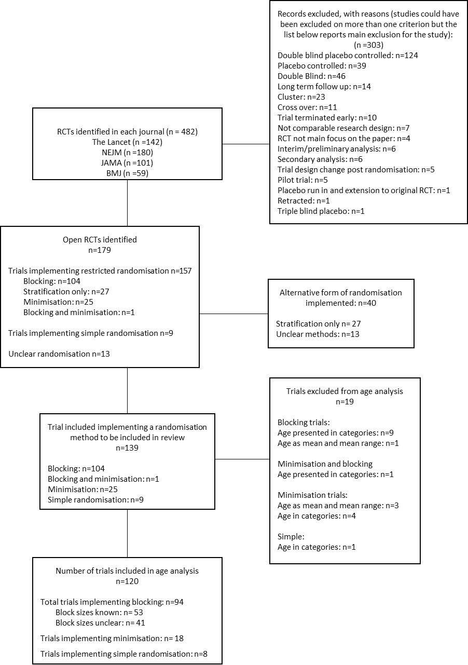
Figure one: Flow of studies through study
The median block size observed throughout the review period was six, this ranged from two to 30, there was no trend in average block size over time. Variable blocking schemes were implemented more frequently than fixed (n=45 and n=33, 42.9% and 31.4% respectively). Table one presents the block sizes and stratification details used in RCTs implementing blocking from 2001-2020. Overall, 28 trials stratified by centre only. Small block sizes have been implemented in recently published trials and in this data set centre stratification with a block size of two was only observed to be implemented from 2015. When examining the proportion of trials implementing centre stratification, we found 33.3% (n=5) trials with a blocking scheme including a two implemented it, 6.3% (n=1) for those using a fixed block of four and 29.0% (n=9) for trials using a blocking scheme of blocks larger than two. Reporting was suboptimal with 45 (42.9%) of trials not reporting a clear block size and 19 (18.1%) trials not reporting the stratification factor(s).

Year | Number open RCTs | Number of trials which used blocking | Block size |  |  |  |  | Stratification |  | Stratification by centre
 |  |  | Fixed size of two | Variable size including a two | Fixed size of four | Greater than two | Unknown | Stratified only by centre | Stratified factors unclear | Block size including two | Fixed block size of four | Block size >2 | Unknown block size
2001 | 4 | 3 |  |  |  | 1 | 2 | 1 |  |  |  |  | 1
2002 | 11 | 5 | 1 |  | 2 |  | 2 |  | 1
2003 | 6 | 4 |  |  |  | 2 | 2 | 2 |  |  |  | 2
2004 | 7 | 3 |  |  |  | 1 | 2 | 1 |  |  |  |  | 1
2005 | 9 | 7 |  | 1 |  | 2 | 4 | 1 | 2 |  |  |  | 1
2006 | 6 | 5 |  | 1 |  | 1 | 3 | 1 | 1 |  |  |  | 1
2007 | 8 | 4 |  |  | 2 |  | 2 | 2 |  |  |  |  | 2
2008 | 9 | 7 |  |  | 1 | 2 | 4 | 2 | 2 |  |  | 1 | 1
2009 | 9 | 7 |  |  | 1 | 4 | 2 | 2 |  |  |  | 2
2010 | 11 | 4 |  |  |  | 1 | 3 | 2 |  |  |  | 1 | 1
2011 | 8 | 6 |  | 1 | 1 | 1 | 3 |  | 2
2012 | 4 | 2 |  |  | 2
2013 | 10 | 4 |  |  | 1 | 1 | 2 | 1 | 1 |  |  |  | 1
2014 | 12 | 6 |  |  |  | 1 | 5 | 1 | 2 |  |  |  | 1
2015 | 11 | 6 |  | 3 | 1 | 1 | 1 | 1 | 1 | 1
2016 | 8 | 3 |  | 1 | 2 |  |  | 1 | 1 | 1
2017 | 10 | 7 |  | 1 * | 1 | 5 * | 1 |  | 1
2018 | 12 | 8 |  | 3 |  | 4 | 1 | 3 | 2 | 1 |  | 1 | 1
2019 | 15 | 10 |  | 1 | 2 | 3 | 4 | 5 | 2 | 1 | 1 | 1 | 2
2020 | 9 | 4 |  | 1 |  | 1 | 2 | 2 | 1 |  |  | 1 | 1
Total | 179 | 105 | 1 | 13 | 16 | 31 | 45 | 28 | 19 | 4 | 1 | 9 | 14
*Trial in 2017, two blocking schedules by gender (included here, 2-4 and 4-6)
Table 1: Block size and centre stratification implementation from 2001-2020
Figure two shows observed statistically significant heterogeneity, I²=24% (p=0.02), when all eligible trials that implement blocking (n=94) are analysed together. One included trial was observed to have a large Standard Deviation (32) following conversion from a 95% Confidence Interval to a Standard Deviation, we undertook the analysis with and without this trial and found the results still hold. In Table two we present the results of the amount of heterogeneity associated with age for the trials implementing block randomisation with different sized blocks, when the block size in unknown, and for trials implementing simple randomisation and minimisation. See appendix A for a list of included studies in the meta-analyses. Simple randomisation and minimisation yielded an expected 0% heterogeneity - which is also seen for trials that implemented mixed blocking schemes where the smallest block size was larger than two.

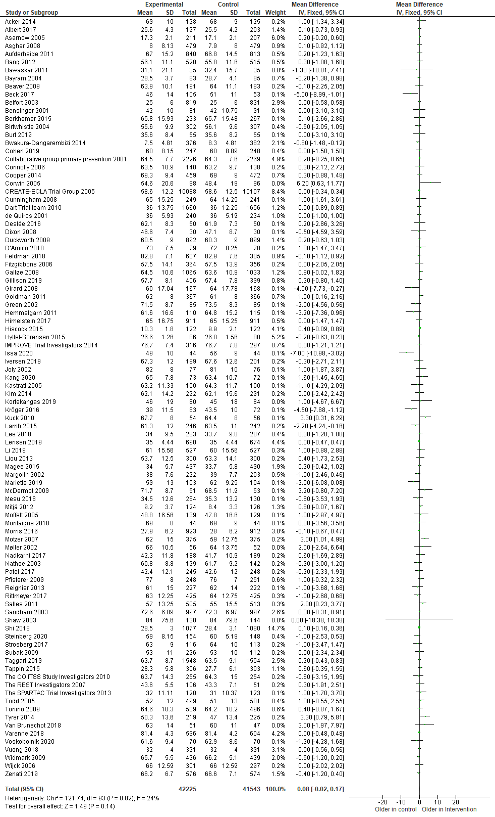
Figure 2: Meta-analysis of all trials implementing blocking to explore heterogeneity in baseline age
For trials that use a fixed block of four a substantial statistically significant heterogeneity of 62% (p=0.001) was observed. For trials that included a block sizes of two within the randomisation schedule moderate heterogeneity was observed (40%), this sample did not include a fixed block of two as there was no age data for the one trial within this dataset that implemented this blocking scheme. When repeating the meta-analyses with only those trials that stratified by centre, the heterogeneity increased slightly in trials using a block size of two (now 42%), however this was not statistically significant. There was zero heterogeneity in mixed blocking schemes with blocks larger than two. There was only one study that used a fixed block size of four that stratified by centre; thus no meta-analysis was conducted.

 | Trials included in MA (n) | X² | P value for heterogeneity | I² | P value of baseline difference
Level of heterogeneity associated with different blocking schemes
Fixed block of four | 14 | 34.03 | 0.001 | 62% | 0.29
Variable blocks where the smallest block is a two | 13 | 20.03 | 0.07 | 40% | 0.41
Fixed blocks of more than two, and variable blocks where the smallest block is greater than a two | 27 | 22.78 | 0.65 | 0% | 0.95
Block size reported* | 53 | 78.16 | 0.01 | 33% | 0.26
Block size not reported | 41 | 43.83 | 0.31 | 9% | 0.26
All trials implementing blocking* | 94 | 121.74 | 0.02 | 24% | 0.14
Level of heterogeneity associated with different blocking schemes stratifying by centre
Fixed block of four | 1 | - | - | - | -
Variable blocks where the smallest block is a two | 4 | 5.14 | 0.16 | 42% | 0.78
Fixed blocks of more than two, and variable blocks where the smallest block is greater than a two | 7 | 2.99 | 0.81 | 0% | 0.68
Block size reported | 12 | 12.03 | 0.36 | 9% | 0.95
Block size not reported | 13 | 10.30 | 0.59 | 0% | 0.70
All trials implementing blocking | 25 | 22.44 | 0.55 | 0% | 0.85
Level of heterogeneity associated with different randomisation methods
Simple randomisation | 8 | 6.88 | 0.44 | 0% | 0.79
Minimisation | 18 | 7.33 | 0.98 | 0% | 0.98
*Trial in 2017, two blocking schedules by gender (included here, 2-4 and 4-6), included as a single trial in this meta-analysis.
Table 2: Level of heterogeneity associated with different blocking schemes, with and without centre stratification and alternative methods of randomisation

4.1: Discussion
Methodologists have been warning for some years about the potential dangers of increased allocation prediction when using blocked randomisation, especially in conjunction with centre stratification (11, 20, 33). In this review we have shown that using blocking is associated with significant heterogeneity in age and that trials using blocked randomisation show an imbalance in age more often than we would expect by chance. A fixed block size of four showed substantial significant heterogeneity. Whilst it is widely recommended to use variable block sizes to reduce the risk of prediction our review suggests that including a block of size two when using variable block sizes may increase age heterogeneity and should be avoided. We examined whether centre stratification led to increased heterogeneity and found that it did not, however the sample size was small. Simple randomisation and minimisation showed zero heterogeneity (I²=0%), which is consistent with what is expected with these methods.
Central – or third party – randomisation is universally accepted as a secure randomisation method and one that should safeguard against subversion (34); however, if a blocking scheme including a two is implemented then third party safeguards may not be sufficient to ensure secure randomisation.
Limitations of this review include missing data, which prevented a full assessment of blocking implementation. When examining the age data some trials were excluded due to the format of reporting age, which could have impacted the observed heterogeneity. Additionally, we were examining heterogeneity of age, whereas selection may have been subverted on a different prognostic variable such as gender: this would lead to underestimation of heterogeneity if baseline variables, other than age, were used to influence treatment allocation. However, performing the analysis on pooled age enabled many trials to be included as it is widely reported, increasing the sample size, and is likely to correlate with the ‘true’ variable that influenced allocation. Some of the meta-analyses were performed with very few studies which decreases the precision.

It is pertinent to consider that the source of the heterogeneity observed could be due to another type of research misconduct rather than subversion of the randomisation schedule. Where participants are selectively excluded at baseline and the baseline heterogeneity analysis is undertaken without these excluded participants which violates intention to treat principles. We find this a less likely explanation than prediction of the randomisation sequence and subversion, particularly as the heterogeneity observed in this study was in line with previous research: that fixed blocks of four are at an increased risk of prediction (therefore higher heterogeneity would be expected). Large block sizes- which are harder to predict and less associated with subversion- and simple randomisation and minimisation which are considered robust randomisation methods have demonstrated the expected low heterogeneity.
There are alternative methods to restrict randomisation that are likely to reduce the risk of prediction and should be implemented whenever possible. Dynamic allocation methods, in comparison to blocking provide a more secure method of allocation concealment (35). We have demonstrated that within this sample, minimisation is associated with zero heterogeneity of baseline age. Table three summarises alternative restricted randomisation methods to blocking which can be considered but have their own drawbacks. Berger and Odia examined permuted block randomisation against Maximally tolerated imbalances (MTI) procedures to assess whether it could be classed as a big stick procedure and determined that it was an inferior method to all existing MTI procedures (36-39) and concludes it should not be used within research (40).

Randomisation type | Description and details | Comments
Minimisation | Dynamic form of randomisation where participants are allocated according to specific prognostic factors that enables balance to be maintained between groups. | Considered to be more practical and efficient than block randomisation. In small trials it has the advantage of producing only a minor difference between groups on variables (41).  Technical issues can lead to imbalance, however regular checks of this can prevent any problems occurring.
Big stick procedures | Type of ‘Maximally tolerated imbalances’ (MTI) procedure which uses a ‘big stick’ to force an allocation sequence back towards balance when it reaches the MTI. Four big stick procedures detailed elsewhere: block urn design (39), Chen’s procedure (38), Big stick procedure (37) and the maximal procedure (36). | Can be used incorrectly and result in excessive prediction. The ‘big stick’ can be invoked when it should not be.  Outperforms block randomisation at reducing prediction.
Pairwise | Two participants are presented for randomisation simultaneously where one is allocated to one arm and the other to the alternative arm. Pairwise randomisation is described in detail by Daniels et al,(42). | Not frequently used since first described in 2004. Beneficial to be used when centre stratification is required and recruitment is simultaneous (10). Issues may arise when a suitable pair is not available to randomise.
Merged block randomisation | Permuted block randomisation with block sequences are merged, to determine the allocation at the point where the sequences merged a coin is tossed and a decision is made on the allocation based on whether it is heads or tails. This novel approach is described in detail in a simulation study by van de Pas (43). | Results in less predictable allocations than block randomisation and is a sensible choice for small multicentre clinical trials where the number of participants recruited at each centre is anticipated to be small (that can lead to imbalances) (43)  Simple and easy to perform in simulations performed.
Table 3: Restricted randomisation methods - Alternatives to blocking

Blocking remains the most prevalent way that trials are restricted and will most likely be for some time. If blocking is to be implemented these are our recommendations to ensure it is conducted as methodologically robust as possible:
- The block size should be concealed from all those involved in participant recruitment.
- Fixed block sizes of four should not be implemented.
- A block size of two should not be implemented, even when used within a variable scheme.
- If centre stratification is necessary, this research suggests it should be implemented with larger blocking schemes that do not include a block size of two.
- CONSORT (2) needs to be followed to ensure full transparent reporting: the block size and stratification factors need to be reported for a risk of bias assessment to occur when the trial is published.
- Teams using central randomisation need to ensure they do not become complacent to the risk of prediction when blocking is used. They need to ensure that small block sizes and stratification by centre only is to be avoided if possible and report their methods transparently.

5.1: Conclusion
There is evidence that blocking is an insecure method of randomisation, in addition to fixed blocks of four, variable block sizes including two should probably not be used. Additionally, stratification by centre only should, ideally, only be undertaken with larger blocking schemes that do not include a block size of two. Alternative methods are available to restrict randomisation which researchers should consider when designing RCTs. Dynamic allocation methods may provide a more secure method to randomise, conceal the allocation and prevent selection bias.
Funding
This research did not receive any specific grant from funding agencies in the public, commercial, or not-for-profit sectors.

CRediT author statement LC: Conceptualisation, methodology, investigation, formal analysis, data curation, validation, Supervision, Writing - Original Draft, Writing - Review & Editing LB: investigation, validation, Writing - Review & Editing. RMC: investigation, validation, Writing - Review & Editing, EC: formal analysis, data curation, Writing - Review & Editing. GR: investigation, validation, Writing - Review & Editing. DT: Conceptualisation, methodology, Supervision, Writing - Review & Editing
References
1. Sibbald B, Roland M. Understanding controlled trials. Why are randomised controlled trials important? BMJ: British Medical Journal. 1998;316(7126):201.
2. Schulz KF, Altman DG, Moher D. CONSORT 2010 statement: updated guidelines for reporting parallel group randomized trials. Annals of internal medicine. 2010;152(11):726-32.
3. Schulz KF, Grimes DA. Allocation concealment in randomised trials: defending against deciphering. The Lancet. 2002;359(9306):614-8.
4. Clark L, Fairhurst C, Cook E, Torgerson DJ. Important outcome predictors showed greater baseline heterogeneity than age in two systematic reviews. Journal of clinical epidemiology. 2015;68(2):175-81.
5. Clark L, Fairhurst C, Hewitt C, Birks Y, Brabyn S, Cockayne S, et al. Assessing the presence of selection bias in meta-analyses of randomised trials using baseline heterogeneity. Trials. 2013;14(1):O96.
6. Mitchell A, Moe‐Byrne T, Cunningham‐Burley R, Dean A, Rangan A, Roche J, et al. Poor allocation concealment methods are associated with heterogeneity in age and statistical significance of the primary outcome: Review of recent trials published in four general medical journals. Journal of Evaluation in Clinical Practice. 2019.
7. Hewitt CE, Torgerson DJ. Is restricted randomisation necessary? Bmj. 2006;332(7556):1506-8.
8. Altman DG, Bland JM. How to randomise. Bmj. 1999;319(7211):703-4.
9. Schultz A, Saville B, Marsh J, Snelling T. An introduction to clinical trial design. Paediatric respiratory reviews. 2019;32:30-5.
10. Fairhurst C, Hewitt CE, Torgerson DJ. Using pairwise randomisation to reduce the risk of bias. Research Methods in Medicine & Health Sciences. 2020;1(1):2-6.
11. Kahan BC, Rehal S, Cro S. Risk of selection bias in randomised trials. Trials. 2015;16(1):1-7.
12. Berger V. Quantifying the Magnitude of Baseline Covariate Imbalances Resulting from Selection Bias in Randomized Clinical Trials. Biometrical Journal 2005;47(2):119-27.
13. Schulz KF. Subverting randomization in controlled trials. JAMA: the journal of the American Medical Association. 1995;274(18):1456.
14. Berger VW, Exner DV. Detecting Selection Bias in Randomized Clinical Trials* 1. Controlled clinical trials. 1999;20(4):319-27.
15. Proschan M. Influence of selection bias on type I error rate under random permuted block designs. Statistica Sinica. 1994:219-31.
16. Brown S, Thorpe H, Hawkins K, Brown J. Minimization—reducing predictability for multi‐centre trials whilst retaining balance within centre. Statistics in medicine. 2005;24(24):3715-27.
17. Efird J. Blocked randomization with randomly selected block sizes. International journal of environmental research and public health. 2011;8(1):15-20.
18. Zhao W. Selection bias, allocation concealment and randomization design in clinical trials. Contemporary clinical trials. 2013;36(1):263-5.
19. Zhao X. Letter to the Editor: The expression of the allocation concealment for randomised controlled trials needs to be improved Injury, international journal of the care of the injured. 2011;42:430-1.
20. Berger VW. Do not use blocked randomization. Headache: The Journal of Head and Face Pain. 2006;46(2):343-.
21. Schulz KF. Unbiased research and the human spirit: the challenges of randomized controlled trials. CMAJ: Canadian Medical Association Journal. 1995;153(6):783.
22. Schulz KF, Grimes DA. Unequal group sizes in randomised trials: guarding against guessing. The Lancet. 2002;359(9310):966-70.
23. Hills RK, Gray R, Wheatley K. Balancing treatment allocations by clinician or center in randomized trials allows unacceptable levels of treatment prediction. Journal of Evidence‐Based Medicine. 2009;2(3):196-204.
24. Rosenberger WF, Lachin JM. Randomization in clinical trials: theory and practice: John Wiley & Sons; 2015.
25. Schulz KF, Grimes DA. Generation of allocation sequences in randomised trials: chance, not choice. The Lancet. 2002;359(9305):515-9.
26. Group RC. Dexamethasone in hospitalized patients with Covid-19—preliminary report. New England Journal of Medicine. 2020.
27. Berger VW. Varying the block size does not conceal the allocation. Journal of critical care. 2006;2(21):229.
28. Kennes LN, Cramer E, Hilgers RD, Heussen N. The impact of selection bias on test decisions in randomized clinical trials. Statistics in medicine. 2011;30(21):2573-81.
29. 5 R. Review Manager (RevMan) [Computer program]. Version 5.4.1, The Cochrane Collaboration, 2020. 2020.
30. Hicks A, Fairhurst C, Torgerson DJ. A simple technique investigating baseline heterogeneity helped to eliminate potential bias in meta-analyses. Journal of clinical epidemiology. 2018;95:55-62.
31. Higgins JPT TJ, Chandler J, Cumpston M, Li T, Page MJ, Welch VA (editors). Cochrane Handbook for Systematic Reviews of Interventions version 6.2 (updated February 2021). Cochrane, 2021. Available from www.training.cochrane.org/handbook.2021.
32. Shaw FE, Bond J, Richardson DA, Dawson P, Steen IN, McKeith IG, et al. Multifactorial intervention after a fall in older people with cognitive impairment and dementia presenting to the accident and emergency department: randomised controlled trial. Bmj. 2003;326(7380):73.
33. Berger V. Selection bias and covariate imbalances in randomized clinical trials: John Wiley & Sons; 2007.
34. Kennedy AD, Torgerson DJ, Campbell MK, Grant AM. Subversion of allocation concealment in a randomised controlled trial: a historical case study. Trials. 2017;18(1):1-6.
35. Beller EM, Gebski V, Keech AC. Randomisation in clinical trials. Medical Journal of Australia. 2002;177(10):565-7.
36. Berger VW, Ivanova A, Deloria Knoll M. Minimizing predictability while retaining balance through the use of less restrictive randomization procedures. Statistics in Medicine. 2003;22(19):3017-28.
37. Soares JF, Jeff Wu C. Some restricted randomization rules in sequential designs. Communications in Statistics-Theory and Methods. 1983;12(17):2017-34.
38. Yung-Pin C. Biased coin design with imbalance tolerance. Stochastic Models. 1999;15(5):953-75.
39. Zhao W, Weng Y. Block urn design—a new randomization algorithm for sequential trials with two or more treatments and balanced or unbalanced allocation. Contemporary clinical trials. 2011;32(6):953-61.
40. Berger VW, Odia I. Characterizing permuted block randomization as a big stick procedure. Contemporary clinical trials communications. 2016;2:80-4.
41. Altman DG, Bland JM. Treatment allocation by minimisation. Bmj. 2005;330(7495):843.
42. Daniels J, Wheatley K, Gray R, editors. Pairwise randomisation to balance within centres without possible foreknowledge of allocation. Controlled Clinical Trials; 2003: ELSEVIER SCIENCE INC 360 PARK AVE SOUTH, NEW YORK, NY 10010-1710 USA.
43. van der Pas SL. Merged block randomisation: A novel randomisation procedure for small clinical trials. Clinical Trials. 2019;16(3):246-52.

