Title: Stimulating parietal regions of the multiple-demand cortex impairs novel vocabulary learning.

Authors: Magdalena W. Sliwinska^{1,2}, Ryan Elson³, David Pitcher²

Affiliations:
¹School of Psychology, Liverpool John Moores University, Byrom Street, Liverpool, L3 3AF
²Department of Psychology, University of York, Heslington, York, YO10 5DD, UK
³School of Psychology, University of Nottingham, East Drive, Nottingham, NG7 2RD

Corresponding author: Magdalena W. Sliwinska, m.w.sliwinska@ljmu.ac.uk

Funding: This work was supported by the British Academy/Leverhulme Small Research Grant awarded to MWS [SRG1819\190805]

Declaration of interest: none

Abstract
Neuroimaging research demonstrated that the early stages of learning engage domain-general networks, non-specialist brain regions that process a wide variety of cognitive tasks. Those networks gradually disengage as learning progresses and learned information becomes processed in brain networks specialised for the specific function (e.g., language). In the current study, we used repetitive transcranial magnetic stimulation (rTMS) in the form of continuous theta burst stimulation (cTBS) to test whether stimulation of the bilateral parietal region of the domain-general network impairs learning new vocabulary, indicating its causal engagement in this process. Twenty participants, with no prior knowledge of Polish, learned Polish words for well-known objects across three training stages. The first training stage started with cTBS applied to either the experimental domain-general bilateral parietal site or the control bilateral precentral site. Immediately after cTBS, the vocabulary training commenced. A different set of words was learned for each site. Immediately after the training stage, participants performed a novel vocabulary test, designed to measure their knowledge of the new words and the effect of stimulation on learning. To measure stimulation effect when the words were more established in the mental lexicon, participants received additional training on the same words but without cTBS (second training stage) and then the full procedures from the first training stage were repeated (third training stage). Results demonstrated that stimulation impaired novel word learning when applied to the bilateral parietal site at the first stage of learning only. This effect was not present when newly learned words were used more proficiently in the third training stage, or at any learning stage during control site stimulation. Our results show that the bilateral parietal region of the domain-general network causally contributes to the successful learning of novel words.
Key words: domain-general network; multiple-demand cortex; parietal lobe; learning; transcranial magnetic stimulation (TMS).
1. Introduction
Prior research demonstrates that learning mechanisms in the human brain involve an interplay between qualitatively distinct domain-specific and domain-general networks (Chein & Schneider, 2005, 2012; Duncan, 2010; Honda et al., 1998; Jueptner et al., 1997; Köhler, Moscovitch, Winocur, Houle, & McIntosh, 1998; Petersson, Elfgren, & Ingvar, 1999). Domain-specific networks are specialised for conducting processes related to a particular cognitive function; for instance, language or movement. In contrast, domain-general networks conduct a wide range of processes required for various cognitive functions (Cabeza & Nyberg, 2000; Duncan, 2010; Fedorenko, Duncan, & Kanwisher, 2013). These processes allow us to pay attention; hold information in working memory; monitor performance; maintain goals; select strategies; choose relevant and supress irrelevant information or behaviour. Domain-general networks extend bilaterally over coactivating fronto-parietal regions, including the dorsolateral surface of the frontal lobes encompassing the inferior frontal gyri and middle frontal gyri; anterior insula and adjacent frontal operculum; presupplementary motor area; dorsal anterior cingulate; intraparietal sulcus. Collectively, these regions form so called the “multiple-demand cortex” (MDC; Duncan, 2010).
Over the last decade there has been an increased interest in the role of MDC in supporting our ability to learn. It has been found that this system is minimally engaged when performing well-learned (automatic) tasks, but its involvement strongly increases during performance of novel tasks (for meta-analysis see Duncan, 2006; Duncan & Owen, 2000). The supporting evidence comes mainly from neuroimaging studies which have reported increased activation in MDC during learning various tasks, including sequential finger movements (Jenkins, Brooks, Nixon, Frackowiak, & Passingham, 1994); noun-verb associations (Raichle et al., 1994); object-location associations (Büchel, Coull, & Friston, 1999); faces (Wiser et al., 2000); abstract shapes (Chein & Schneider, 2005); arbitrary rules (Hampshire et al., 2016); and new words (Sliwinska et al., 2017). These diverse studies have demonstrated a characteristic strengthening of MDC response and connectivity during the initial stages of learning and their reduction as learning progresses.
In our previous study (Sliwinska et al., 2017), repetitive transcranial magnetic stimulation (rTMS) was used to test whether MDC is causally involved in language learning. This study focused on the involvement of the midline superior frontal gyrus and adjacent dorsal anterior cingulate (SFG/dACC) in learning novel words. Stimulation of this MDC region substantially enhanced learning novel words during the initial stages of learning, when involvement of the region was greatest. In contrast, stimulation had no effect on SFG/dACC during the later stages of learning when novel words were used more proficiently. Stimulation had also no effect on the control site, located in the midline precentral gyrus, which showed deactivation during our novel word learning task. The enhancement effect produced by stimulating SFG/dACC is in line with the previous brain stimulation study (Fiori, Kunz, Kuhnke, Marangolo, & Hartwigsen, 2018) which demonstrated improved word learning produced by stimulation of the inferior frontal gyrus (IFG). Both regions belong to the cingulo-opercular network of the MDC (Dosenbach et al., 2007; Dosenbach et al., 2006; Koechlin, Basso, Pietrini, Panzer, & Grafman, 1999; Mantini, Corbetta, Romani, Orban, & Vanduffel, 2013; Nomura et al., 2010; Power et al., 2011) and the learning enhancement induced by their stimulation could be related to an overall decrease in processing effort, observed in the task-related decrease of activity and connectivity (Fiori et al., 2018). Consequently, regions of this MDC network may play a unique orchestrating role during learning which involves a causal modulation of other brain regions determined by the demand levels of a task (Uddin, 2015). These brain stimulation studies provide evidence for an important role of the cingulo-opercular network in learning, but the causal role of the other MDC regions remains to be addressed. One such region is the bilateral parietal region of the MDC.
In our previous study (Sliwinska et al., 2017), the neuroimaging data revealed increased activation in the bilateral parietal region of the MDC when participants were learning novel words. This region is part of the fronto-parietal network (Dosenbach et al., 2007; Dosenbach et al., 2006; Koechlin et al., 1999; Mantini et al., 2013; Nomura et al., 2010; Power et al., 2011), particularly its dorsal-attention sub-network (Power et al., 2011). This network has been consistently activated during various working memory tasks (Ekman, Fiebach, Melzer, Tittgemeyer, & Derrfuss, 2016; Linden et al., 2003; Paulesu, Frith, & Frackowiak, 1993; Salmon et al., 1996; Ungerleider, Courtney, & Haxby, 1998) and it has been suggested that it acts as an attentional modulator during those tasks (Majerus et al., 2007; Ravizza, Delgado, Chein, Becker, & Fiez, 2004). In this role, the parietal regions of the MDC control activation in the long-term memory networks that underpin the initial processing of the information that needs to be retained or shift attention onto the relevant information. An early brain stimulation study that investigated the role of this region in learning was performed by Walsh and his colleagues (1998). Stimulation of the right parietal cortex impaired visual conjunction search task when the stimuli were novel and required a serial search strategy, but not when the particular stimuli were memorised. This study demonstrated the causal involvement of the parietal MDC in learning, however, only the right hemisphere was tested.
Here, we report findings from a study in which rTMS was applied to a bilateral parietal region of the fronto-parietal network of MDC during novel word learning to test whether involvement of this region is crucial to word learning in its early stages. Twenty healthy participants, who had not learned Polish, were asked to learn Polish words of well-known objects. Immediately before learning novel word-object associations, rTMS in the form of continuous theta burst stimulation (cTBS) was applied to either the experimental bilateral parietal site or the control bilateral precentral site. In our previous functional magnetic resonance imaging (fMRI) study (Sliwinska et al., 2017), these regions showed activation and deactivation, respectively, during early stages of learning new words. Therefore, impairment of learning induced by stimulation in its early stages was expected when cTBS was applied to the parietal site, not the control site. The impact of stimulation on learning was measured in the early and late stage of learning using a novel vocabulary test provided to participants immediately after the learning stage. Accuracy and speed of the performance on the test were measured to determine whether the parietal MDC region is causally linked to learning.

2. Materials and methods
2.1 Participants
Twenty right-handed native English speakers who had never learned Polish took part in this study. All participants (15 women and 5 men; aged between 19 and 25, mean: 20 years old, SD: 1.47 years old) were neurologically healthy with normal or corrected-to-normal vision and normal hearing. Informed consent was obtained from all participants after the experimental procedures were explained. All participants were paid for their time. A post hoc power analysis in GPower (Erdfelder, Faul, & Buchner, 1996) indicated that with the present sample size and alpha set to 0.05, power greater than 95% was achieved. The study was approved by the York Neuroimaging Centre Research Ethics Committee at the University of York.

2.2 Stimuli
Two types of stimuli were used: i) photos of objects and ii) auditory recordings of Polish words. 120 normative coloured photos of well-known objects were taken from the Bank of Standardised Stimuli (BOSS; Brodeur, Dionne-Dostie, Montreuil, & Lepage, 2010; Brodeur, Guérard, & Bouras, 2014) and they contained exemplars from different object categories (e.g., tree, castle, shoes). All photos in the database are normalised for a number of factors, including familiarity, visual complexity, viewpoint agreement and manipulability. Photos were divided into two even sets (Set A and Set B). In half of the participants, Set A was assigned to the experimental stimulation site while Set B to the control stimulation site and the reverse order was used in another half of the participants (see Experimental procedures below for more details). A full list of trials used in Set A and Set B is provided in the Supplementary Materials 1. 120 auditory recordings of Polish words constituted Polish names of the objects presented in the used photos. They were recorded and spoken by one of the authors (MWS) who is a native Polish speaker. The Polish words consisted of 1-3 syllables. Each recording lasted approximately 1 second. Words across the two sets were matched for number of syllables and object category as much as possible. All recordings used in this study are provided in the Supplementary Materials 2 and can be used by other researchers.

2.3 Stimulation sites
The experimental stimulation site was located in the bilateral inferior parietal region of the MDC (Duncan, 2013; Fedorenko et al., 2013). The involvement of this site in the early stages of learning novel vocabulary was found in our previous fMRI study (Sliwinska et al., 2017) which showed significantly increased activation in this region during the first learning stage and its gradual decrease as learning progressed. Localisation of the experimental sites was determined based on the activation maps obtained from this study. The group mean coordinates of the experimental site were as follows: [left parietal site: x = -42, y = -56, z = 48; right parietal site: x = 42, y = -56, z = 48] (see Figure 1B).
The control stimulation site was located in the bilateral precentral gyrus and was chosen for two reasons. First, our previous study (Sliwinska et al., 2017) demonstrated deactivation of this region throughout the entire duration of the novel vocabulary learning task, with the greatest deactivation during the initial learning stage. Activation in this region gradually increased across the subsequent learning stages but remained always below zero, even in the final learning stage where participants were highly proficient in newly learned vocabulary. Therefore, we expected stimulation to this region to have no effect on learning. Second, this region was located in close proximity to the experimental site which made it a good candidate for a control site as the somato-sensory and auditory effects produced by stimulation in both sites were similar and difficult to dissociate. The group mean coordinates of the control site were as follows: [left precentral site: x = -41, y = -15, z = 57; right precentral site: x = 41, y = -15, z = 57] (see Figure 1B).
Stimulation targets were mapped onto each participant’s magnetic resonance imaging (MRI) brain scan using the Brainsight frameless stereotaxy system (Rogue Research, Montreal, Canada). During testing, a Polaris Vicra infrared camera (Northern Digital, Waterloo, ON, Canada) was used in conjunction with Brainsight to register the participant's head to their MRI scan for accurate stimulation of the sites throughout the experiment.

2.4 Stimulation
Stimulation was applied off-line (i.e., prior to testing) using a modified form of cTBS (Goldsworthy, Pitcher, & Ridding, 2012). A continuous train of 300 pulses was delivered in bursts of 3 pulses (a total of 100 bursts) at frequency of 30 Hz with a burst frequency of 6 Hz for an approximate duration of 17 seconds and fixed intensity of 45% of the maximum stimulator output. In order to induce a bilateral effect on the parietal site, two trains of cTBS were applied. One train was delivered to the left parietal site and another train was delivered immediately after to the right parietal site. The order of the stimulation sites was counterbalanced across participants. The aim of using cTBS immediately before the training stage was to induce a longer lasting post-stimulation effect on the bilateral parietal region that would affect learning during the subsequent training stage. The effects of the modified cTBS last up to 30 minutes post-stimulation (Goldsworthy et al., 2012) which would encompass the whole duration of the training. The modified cTBS was used instead of the standard cTBS as Goldsworthy and colleagues (2012) showed that this stimulation protocol produces immediate, longer-lasting, and more reliable effects in contrast to the standard cTBS. The TMS parameters were within established international safety limits (Rossi, Hallett, Rossini, Pascual-Leone, & Group, 2009). The TMS coil was held against the participant's head by the experimenter who manually controlled its position throughout testing. All participants wore earplugs in both ears to attenuate the sound of the coil discharge and avoid any damage to their hearing (Counter, Borg, & Lofqvist, 1991). All participants found TMS comfortable.

2.5 Experimental procedures
Each participant attended five testing sessions (Sessions 1-5) performed on five different days (See Figure 1A). All the sessions were completed within 2 weeks and the gaps between the sessions were kept as similar as possible across participants but were subject to participants’ availability. We aimed to perform the first two and the last two sessions on two subsequent days to keep them as close to each other as possible. Sessions 1 and 2 provided the first training stage (Figure 1A: Training 1) in which participants were given the first opportunity to learn new words. At the beginning of Session 1 and Session 2, participants received cTBS after which they began novel vocabulary training followed by a novel vocabulary test. cTBS, novel vocabulary training and novel vocabulary test happened immediately one after another. During those sessions, cTBS was delivered either to the bilateral parietal region (experimental site) or bilateral precentral gyrus (control site). Each stimulation site was tested in a separate session to maximise participants’ safety and avoid any cross-site contamination of the results. The order of the stimulation sites was counterbalanced across participants. In each of the two sessions, participants were exposed to a different set (Set A or Set B) of Polish words. The order of sets was counterbalanced across participants and stimulation sites. The novel vocabulary test measured knowledge of the Polish words learned only in that particular session. Each session lasted approximately 1 hour. Next, Session 3 provided the second training stage (Figure 1A: Training 2). During Session 3, no cTBS was applied, only the novel vocabulary training and test components of Session 1 and Session 2 were repeated to provide participants with more training and increase their proficiency in all Polish words. In Session 3, the delivery order of novel vocabulary training and test sets always followed the order of sets used in Session 1 and then Session 2 for a given participant, with a short break in-between the two sets. This session lasted approximately 30 minutes. Last, Sessions 4 and 5 provided the third training stage (Figure 1A: Training 3). Sessions 4 and 5 were repetitions of Sessions 1 and 2, respectively.

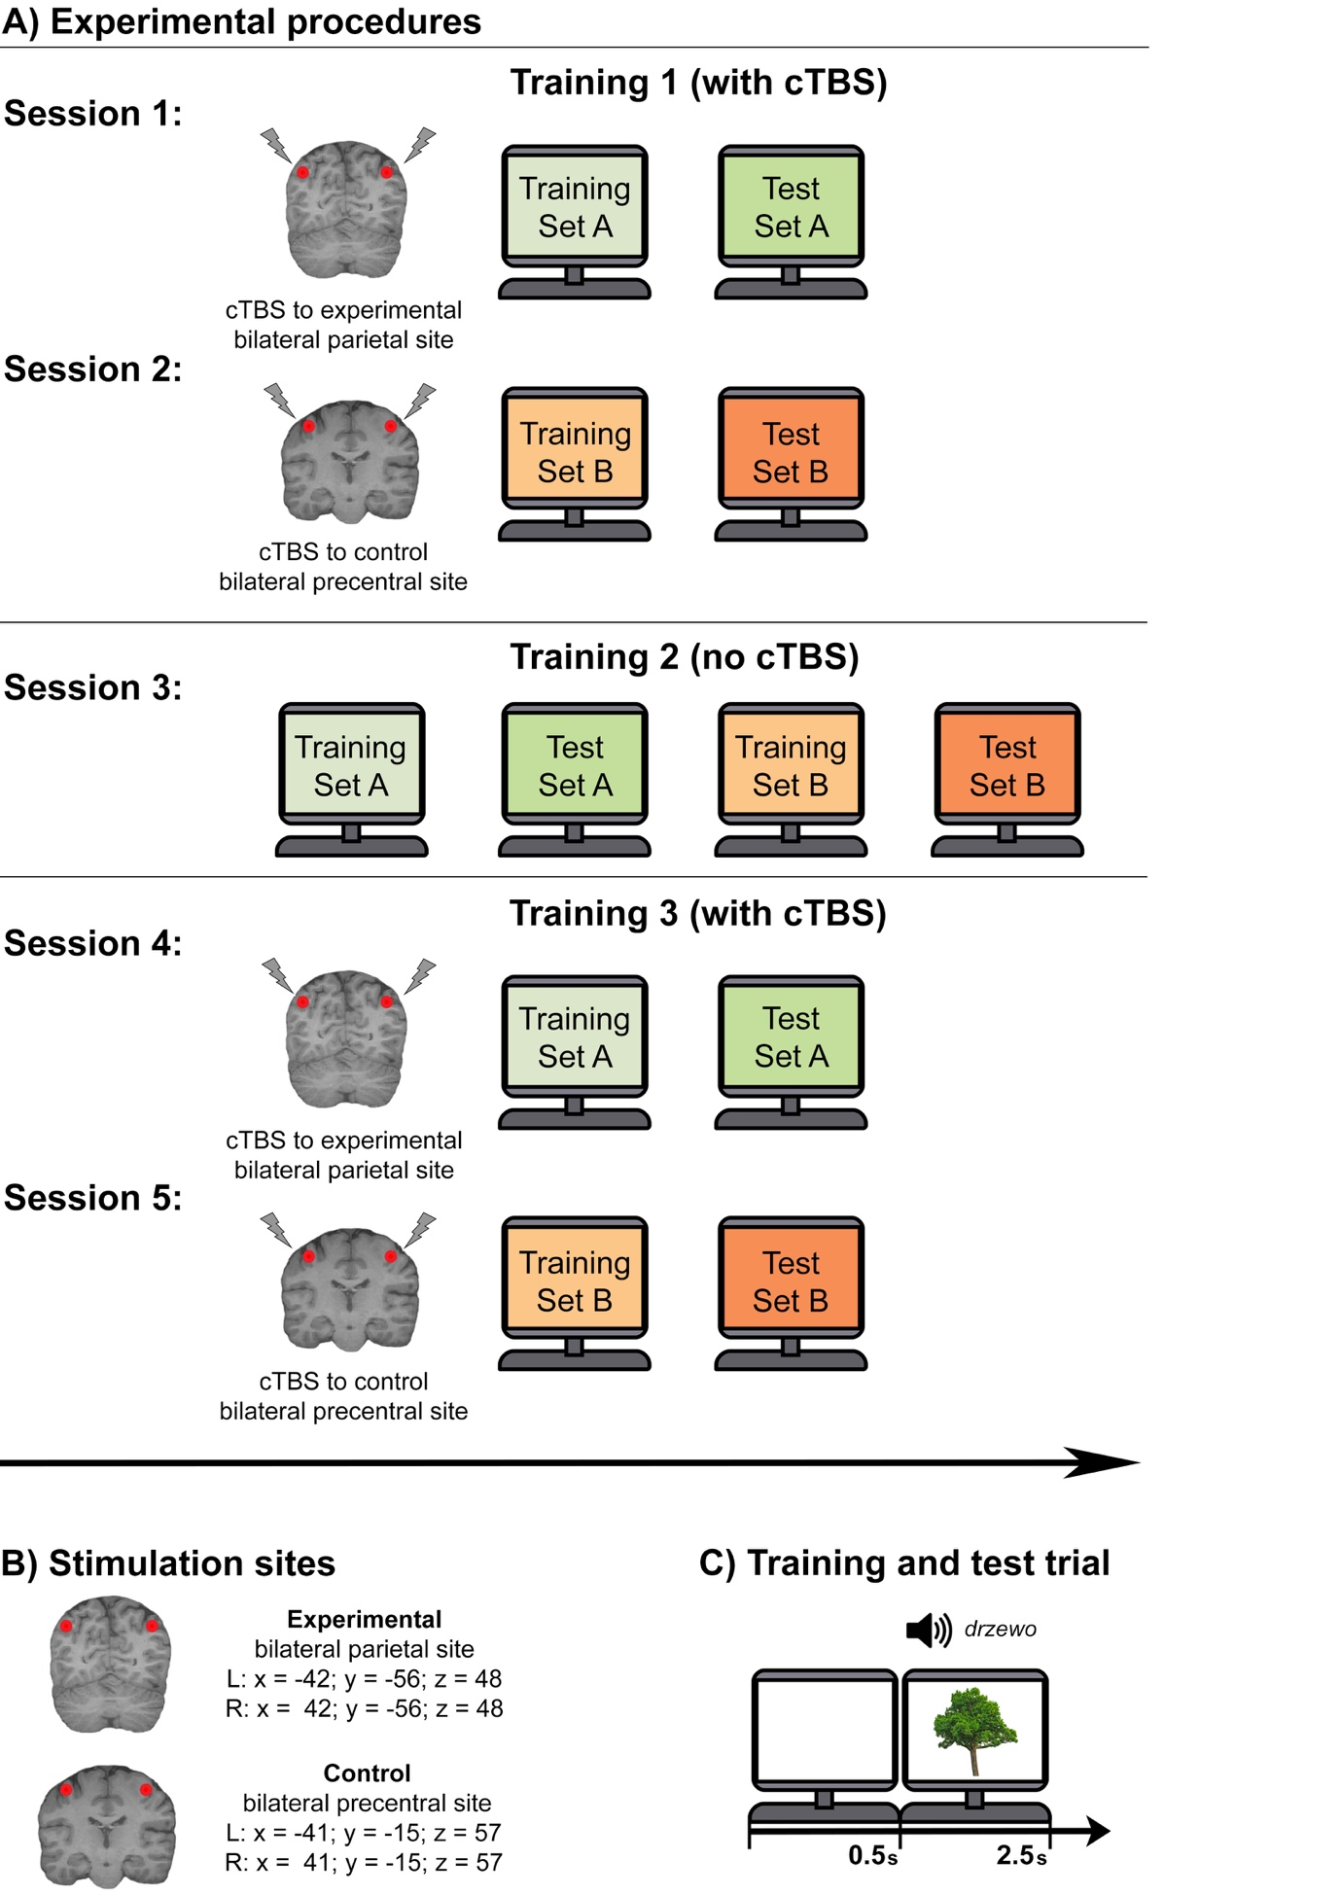

Figure 1: A) The experimental procedures. Note that one set (Set A or Set B) of the novel vocabulary was assigned to one of the two stimulation sites (experimental bilateral parietal site or control bilateral precentral site) for each participant and counterbalanced across participants. cTBS was applied only in Sessions 1-2 (Training 1) and Sessions 4-5 (Training 3) while Session 3 (Training 2) did not include any stimulation. B) Stimulation sites. Group mean coordinates for the two stimulation sites were mapped onto each subject’s individual anatomical brain scan. C) Training and test basic trial procedure. Note that in the novel vocabulary training, the participants were presented with the stimuli and asked to learn word-object associations while in the novel vocabulary test, the participants were presented with the same stimuli and asked to provide a response to the task after the auditory presentation of a word.

2.5.1 Novel vocabulary training
During the novel vocabulary training, participants were required to learn Polish names of well-known objects (e.g., tree - drzewo, castle - zamek; shoes - buty). Each cTBS session (i.e., Sessions 1, 2, 4, and 5) involved one training run during which participants were learning one of the two sets (Set A or Set B) of the novel vocabulary. Each set contained 60 objects. Participants were presented with a photo of an object and simultaneously heard its Polish name. They were asked to remember the Polish name of the object as well as they could. During the training run, a full set was repeated 3 times in three blocks with brief self-regulated breaks between the blocks. Each training trial started with a presentation of a blank white screen displayed for 0.5 seconds, followed by an object display for another 2.5 seconds and a simultaneous presentation of its Polish name (see Figure 1C). Each presentation block lasted 3 minutes and the whole training lasted approximately 15 minutes, which is well within the effective post-stimulation time window. The order of stimuli within a set was always randomised.

2.5.2 Novel vocabulary test
During the novel vocabulary test, participants were asked to perform a computer-based task in which they judged whether a Polish word they heard was the correct name for an object that they saw on a screen. Each object was presented twice (120 trials total), once with a correct name and once with an incorrect name. To create incorrect trials, objects were paired up with a name of a different object from the set they belonged to, avoiding inverse matching (i.e., pairing plane (image) and tree (audio) as well as tree (image) and plane (audio)). The correct and incorrect trials were the same for each participant. The order of trials was randomised across participants, with the restriction that the same object was never presented twice in a row. The test trials were presented in the same manner as the training trials, except that participants were required to respond within the 2.5 seconds of stimulus presentation. The test lasted 6 minutes.

2.5.3 Stimuli presentation
Novel vocabulary training and test were performed using PsychoPy2 (Peirce et al., 2019). All pictures of objects were presented at a size of 500 x 500 pixels in the centre of a white screen on a Mitsubishi Diamond Pro 2070SB 22-inch CRT monitor, set to 1024 x 768 resolution and refresh rate of 85 Hz. All auditory recordings were presented via speakers integrated into a HP EliteDesk 800 G1 Tower PC equipped with 1.5-W amplifier using a fixed volume of 75% of maximum speakers output. All participants heard auditory stimuli without any problems. Participants sat approximately 60 cm away from the monitor. During the test stage, participants used their right index or middle finger to respond “yes” or “no”, respectively, by pressing appropriate keys on a keyboard. Participants were instructed to respond as quickly and accurately as possible within the 2.5 second time limit.

2.6 Data analyses
Behavioural data, including accuracy and reaction time (RT), were collected for the performance on the novel vocabulary test during all three stages of learning (i.e., Training 1-3). To measure whether the learning in the initial stages was affected selectively by cTBS to the bilateral parietal region, accuracy and RT data were analysed in a 2 x 2 repeated measures ANOVA, with Training (1 and 3) and Stimulation Site (experimental bilateral parietal and control bilateral precentral) as independent factors. In addition, for purely illustrative purposes of the learning progress across the three training stages (Training 1-3) for each stimulation site individually, accuracy and RT data were analysed in two one-way repeated measures ANOVAs, with Training (1-3) as independent factor. Two ANOVAs were performed to demonstrate learning effect for each individual site as each region was affected by stimulation in a different way and a comparison across stimulation sites would not reflect the learning progress adequately. Post hoc paired two-tailed t-tests (with Bonferroni correction for multiple comparisons) were used to further characterize results obtained from the ANOVAs. Data were analysed using IBM SPSS Statistics (v24.0).

3. Results
The results are presented in Figures 2 and 3. Most importantly, the accuracy analysis showed that performance on the novel vocabulary test was affected only when cTBS was applied to the experimental bilateral parietal site in the first training stage (Training 1). cTBS did not have any significant effects on the control bilateral precentral site at any training stage. This was indicated by results from both 2 x 2 repeated measures ANOVA and post hoc paired two-tailed t-tests. The ANOVA revealed a significant (F(1, 19) = 6.95; p = 0.02; partial ɲ² = 0.27) two-way interaction between Training (1 and 3) and Stimulation Site (experimental bilateral parietal site and control bilateral precentral site). The subsequent t-tests showed that during the first training stage (Training 1), accuracy was significantly lower when cTBS was applied to the experimental bilateral parietal site (84%) than to the control bilateral precentral site (87%; t(19) = 3.54; p = 0.002; Cohen’s d = 0.40; with Bonferroni correction). In contrast, accuracy in the last training stage (Training 3) was not different (t(19) = 0.08; p = 0.93; Cohen’s d = 4.53; with Bonferroni correction) between the experimental bilateral parietal site (96%) and the control bilateral precentral site (96%). These results are presented in Figure 2 (top panel). Lastly, the difference between cTBS effect (calculated as delta between accuracy scores for cTBS to the experimental bilateral parietal site and cTBS to the control bilateral precentral site) in the first training session (- 4%) and the cTBS effect in the third training session (0%) was significant (t(19) = 2.64; p = 0.02; Cohen’s d = 1.13; this was a single comparison with no Bonferroni correction). The cTBS effects are presented in Figure 3.
In the RT data, the selective effect of cTBS on the novel vocabulary test when applied to the experimental bilateral parietal site in the first training stage was not as statistically strong as for the accuracy data but numerically followed a similar pattern of impairment. While, ANOVA revealed a significant (F(1, 19) = 5.07; p = 0.04; partial ɲ² = 0.21) two-way interaction between Training (1 and 3) and Stimulation Site (experimental bilateral parietal site and control bilateral precentral site), the post hoc t-tests showed that the differences in response times within the first training stage (experimental bilateral parietal site: 1449 ms; the control bilateral precentral site: 1408 ms) and the third training stage (experimental bilateral parietal site: 1124 ms; the control bilateral precentral site: 1150 ms) did not reach significance (both t-tests: t(19) < 1.66; p > 0.11; Cohen’s d < 0.22; with Bonferroni correction). These results are presented in Figure 1 (bottom panel). Nevertheless, the difference between cTBS effect in the first training session (41 ms) and the third learning session (-26 ms) was significant (t(19) = 2.25; p = 0.04; Cohen’s d = 0.64; this was a single comparison with no Bonferroni correction), showing that RTs were slower for experimental site during the first training session that the control site, but faster in the third training session The cTBS effects are presented in Figure 3.
To further investigate whether the significance of the impairment effect results from a decrease in performance in the first training stage due to cTBS to the experimental site but not a slight faciliatory effect of cTBS on the control site in the third training stage , we calculated the cTBS effect for the experimental site and control site across the first and third training stages. This effect was calculated as delta between the first and third training sessions for each site. The effects from both sites were compared using a paired two-tailed t-test. This analysis demonstrated a significant (t(19) = 2.64; p = 0.02; Cohen’s d = 0.70; this was a single comparison with no Bonferroni correction) impairment of learning in accuracy data with a mean accuracy impairment of 12% for the experimental bilateral parietal site and 8% for the control bilateral precentral site. RTs were also significantly (t(19) = 2.25; p = 0.04; Cohen’s d = 0.32; this was a single comparison with no Bonferroni correction) impaired with a mean RT impairment of 325 ms for the experimental bilateral parietal site and 258 ms for the control bilateral precentral site. This indicates that the results are driven by the selective impairment of the experimental bilateral parietal site in the first training stage.
To complete the report of the 2 x 2 repeated measures ANOVA, in the accuracy data there were also significant main effects of Training (F(1, 19) = 62.20; p < 0.001; partial ɲ² = 0.77) and Stimulation Site (F(1, 19) = 13.83; p = 0.001; partial ɲ² = 0.42). For the RT data, the main effect of Training (F(1, 19) = 43.71; p < 0.001; partial ɲ² = 0.70) was significant while the main effect of Stimulation Site (F(1, 19) = 0.17; p = 0.69; partial ɲ² = 0.01) was not significant.
The one-way repeated measures ANOVA showed a gradually improved performance on the novel vocabulary test for each stimulation site as training progressed. Analysis of accuracy for the experimental bilateral parietal site (F(2, 38) = 46.85; p < 0.001; partial ɲ² = 0.71) and control bilateral precentral site (F(2, 38) = 29.79; p < 0.001; partial ɲ² = 0.61) showed a significant main effect of Training (1-3), indicating that performance on the novel vocabulary test differed significantly across the three training stages. For the experimental bilateral parietal site, post hoc t-tests showed that the performance improved over time (Training 1: 84%, Training 2: 92%, Training 3: 96%) with the accuracy in the first training stage being significantly lower than accuracy in the two following training stages (both t-test: t(19) > 5.69; p < 0.001; Cohen’s d > 1.13; with Bonferroni correction) and accuracy in the last training stage being significantly greater from accuracy in the two preceding training stages (t-tests for Training 2 vs. Training 3: t(19) = 4.88; p < 0.001; Cohen’s d = 0.78; with Bonferroni correction). For the control bilateral precentral site, post hoc t-tests also showed that the performance improved over time (Training 1: 87%, Training 2: 94%, Training 3: 96%) with the accuracy in the first training stage being significantly lower than accuracy in the two following training stages (both t-test: t(19) > 5.74; p < 0.001; Cohen’s d > 1.10; with Bonferroni correction) and accuracy in the last training stage being significantly greater from accuracy in the two preceding training stages (t-tests for Training 2 vs. Training 3: t(19) = 2.90; p = 0.009; Cohen’s d = 0.36; with Bonferroni correction).
Analysis of RT showed similar results. There was a significant main effect of Training (1-3) for the experimental bilateral parietal site (F(2, 38) = 34.76; p < 0.001; partial ɲ² = 0.65) and the control bilateral precentral site (F(2, 38) = 29.17; p < 0.001; partial ɲ² = 0.61), indicating that performance on the novel vocabulary test differed significantly across the three training stages. For the experimental bilateral parietal site, post hoc t-tests showed that the performance improved over time (Training 1: 1449 ms, Training 2: 1242 ms, Training 3: 1124 ms) with RT in the first training stage being significantly slower than RT in the two following training stages (both t-test: t(19) > 5.48; p < 0.001; Cohen’s d > 1.00; with Bonferroni correction) and RT in the last training stage being significantly faster than RT in the two preceding training stages (t-tests for Training 2 vs. Training 3: t(19) = 4.88; p < 0.001; Cohen’s d = 0.98; with Bonferroni correction). For the control bilateral precentral site, post hoc t-tests also showed that the performance improved over time (Training 1: 1408 ms, Training 2: 1223 ms, Training 3: 1150 ms) with RT in the first training stage being significantly slower than RT in the two following training stages (both t-test: t(19) > 6.30; p < 0.001; Cohen’s d > 1.04; with Bonferroni correction). The RT in the last training stage was numerically faster than RT in the second training stage (t(19) = 2.19; p = 0.04; Cohen’s d = 0.50; with Bonferroni correction).
Interestingly in the second training stage, the performance on the Experimental Parietal Set (92%, 1242 ms) was worse in contrast to the performance on the Control Precentral Set (94%, 1223 ms), although these differences did not reach statistical significance (both t-tests: t(19) < 1.26; p > 0.22; Cohen’s d < 0.33; with Bonferroni correction). These results may illustrate a disadvantage in learning following its impairment in the first training stage or prolonged effects of cTBS to the parietal site on learning, but this marginal disadvantage was fully recovered by the third training session.

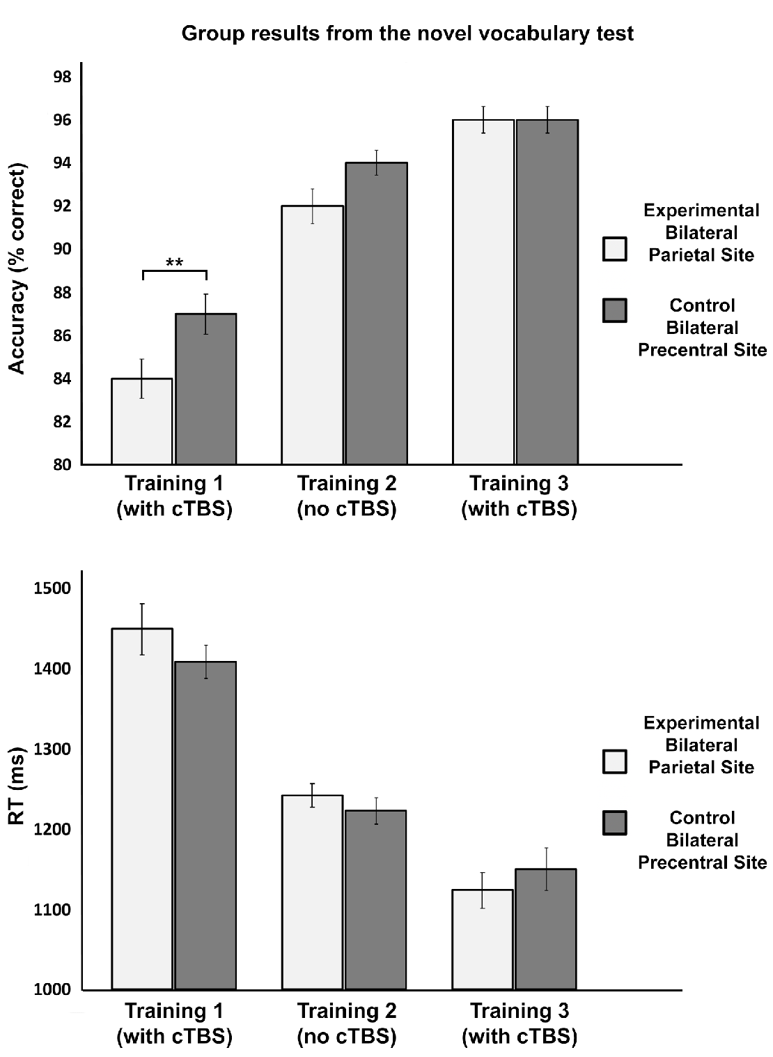
Figure 2: Group mean accuracy and reaction time (RT) for the novel vocabulary test performed across three training stages (Training 1-3). Significance is only marked for the main 2 x 2 repeated measures ANOVA to keep the figure clear. Error bars represent SEM. ** p < 0.005.

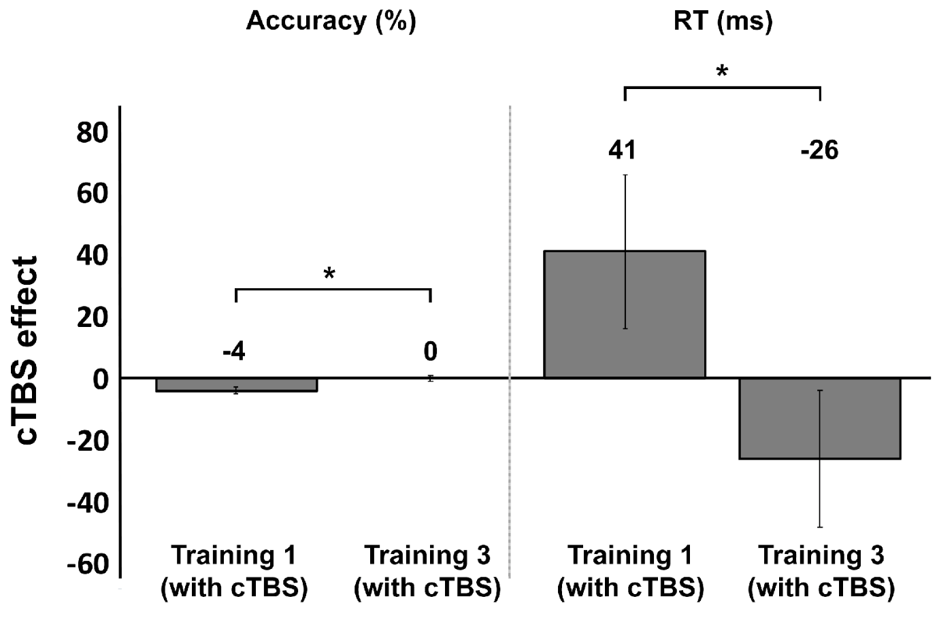

Figure 3: Group mean cTBS effect (calculated as delta between cTBS to the experimental bilateral parietal site and cTBS to the control bilateral precentral site) in the first training session and the third training session for the Accuracy and RT data. Error bars represent SEM. * p < 0.05.

4. Discussion
This study demonstrates the importance of the bilateral parietal MDC during the initial stages of language learning. Applying TMS to this region immediately before the first stage of learning new words impaired the learning of novel Polish vocabulary. Decreased accuracy scores and increased reaction times were observed in the performance on the novel vocabulary test which was administrated immediately after the first learning stage. The novel vocabulary test did not show any learning impairment in the later stage of learning when the newly learned words were used more proficiently or at any learning stage when stimulation was applied to the control site.
These results align with the hypothesis that MDC plays an important role in learning. TMS applied to the bilateral parietal MDC impaired learning new words only at the initial learning stage, when participants were asked to memorise new words for the first time. This demonstration of a causal involvement of MDC during the initial stages of learning supports and extends the previous neuroimaging findings (Andreasen et al., 1995; Büchel et al., 1999; Chein & Schneider, 2005; Hampshire et al., 2016; Jenkins et al., 1994; Kopelman, Stevens, Foli, & Grasby, 1998; Petersson et al., 1999; Raichle et al., 1994; Sliwinska et al., 2017; Toni, Ramnani, Josephs, Ashburner, & Passingham, 2001; Wiser et al., 2000) which showed an increased activation in MDC at the beginning of learning. These neuroimaging studies also demonstrated a gradual deactivation of MDC as learning progressed which is in line with the lack of TMS effect during the later stage of learning in the current study, when the participants had a good knowledge of the words. The lack of TMS effect indicates that the engagement of MDC is no longer required once the new information is learned.
The current study also complements our prior TMS findings (Sliwinska et al., 2017) by revealing the importance of another MDC region in learning. Previously, we used TMS to demonstrate the causal role of the midline SFG/dACC in learning new words. TMS applied to the midline SFG/dACC enhanced learning by improving accuracy and reaction times on the learning task. Here, TMS was used to demonstrate that not only the frontal but also parietal regions of the MDC are causally involved in learning. TMS applied to the bilateral parietal regions of MDC suppressed learning by significantly impairing accuracy and reaction times in the learning task. In both studies, stimulation affected only early stages of learning, strengthening the claim that MDC is required only when the task is novel and demanding.
It has been argued that the causal recruitment of MDC enables learning new tasks and aids their automatization (Duncan & Owen, 2000). The recruitment of the MDC in the initial stages of learning has been considered crucial as it creates a temporary program for performing a novel task (Ruge & Wolfensteller, 2016). This is a complex process which involves refining the performance using multiple processes, such as prediction and outcome monitoring. Once the program is formed, which is when a new task is mastered, it enables the task to be performed with minimal effort and high accuracy. Simultaneously, the program provides a top-down template that accelerates longer-term learning and eventual automatization of the task within domain-specific networks. Throughout the whole process, the interactions between MDC and domain-specific networks are important for rapid and successful learning (Chein & Schneider, 2005, 2012). Although we demonstrated that SFG/dACC and bilateral parietal regions are casually recruited during learning, the opposite (enhancement vs. impairment) effects of TMS on these regions suggest the existence of functional division during learning.
At the theoretical level, the functional dissociation between these two MDC regions is possible as each of them belongs to a distinct MDC network. SFG/dACC is part of the cingulo-opercular network while the parietal region belongs to the fronto-parietal network (Dosenbach et al., 2007; Dosenbach et al., 2006; Koechlin et al., 1999; Mantini et al., 2013; Nomura et al., 2010; Power et al., 2011), particularly its dorsal-attention sub-network (Power et al., 2011). These networks are hypothesised to be functionally dissociable, although they coactivate in neuroimaging studies (for a review see Power & Petersen, 2013). In fact, it has been suggested that regions of the cingulo-opercular network govern other brain networks by modulating their activation and connectivity based on the cognitive demand of a task (Fiori et al., 2018; Uddin, 2015). In contrast, the parietal region is believed to function as an attentional modulator for the working memory, assisting various long-term memory networks in their tasks (Majerus et al., 2007; Ravizza et al., 2004). Considering these functional hypotheses, it seems possible that stimulation of the functionally different MDC networks results in opposite effects on learning. Indeed there is some evidence (Fox et al., 2014) suggesting that stimulation of different nodes of the same network may produce similar outcomes, however, this may not apply across different networks.
In a previous brain stimulation study, Fiori and colleagues (2018) also demonstrated that stimulation of the inferior frontal part of the cingulo-opercular network improved word learning. By combining brain stimulation and neuroimaging, they observed that stimulation induced a task-related decrease of activity and connectivity in the stimulated region which led to the decrease in processing effort across the whole brain. Similarly, Li and colleagues (2019) enhanced cognitive control during the Stop Signal Task following stimulation of the inferior frontal region of the cingulo-opercular network. These and our previous studies (Sliwinska et al., 2017) indicate that stimulation of the cingulo-opercular network has an enhancing effect on the domain-general processes that this network orchestrates. In contrast, another brain stimulation study (Walsh et al., 1998) demonstrated that stimulation applied to the parietal cortex impaired visual conjunction search when the stimuli were novel and required a serial search strategy, but not when the particular stimuli were learned. This and the current study indicate that stimulation of the fronto-parietal network disturbs domain-general processes that involve this network. More clarity into the physiological basis of the diverse effects may be provided by the future neuroimaging investigations determining the influence of stimulation on both networks and the broader set of networks.
From the methodological point of view, there is also a possibility that the discrepancy in the TMS effects between the frontal and parietal sites in our studies may result from using two different TMS protocols across the studies. In the earlier study (Sliwinska et al., 2017), we used repetitive TMS applied in a continuous train of 600 pulses at a frequency of 1Hz and fixed intensity of 55% of maximum stimulator output for duration of 10 minutes. In the current study, repetitive TMS was applied in a continuous train of 300 pulses delivered in bursts of 3 pulses (a total of 100 bursts) at a frequency of 30Hz with a burst frequency of 6 Hz and fixed intensity of 45% of the maximum stimulator output for an approximate duration of 17 seconds. Such different protocols could have affected learning in different ways, however, this requires further investigation. It is currently unclear whether particular stimulation protocol can be associated with either enhancing or inhibiting effects on behaviour (Sliwinska et al., 2017). Conventional wisdom, based on stimulating the motor cortex, suggests that low-frequency (<1 Hz) stimulation decreases cortical excitability, whereas high-frequency (>1 Hz) stimulation increases excitability (Berardelli et al., 1999; Chen et al., 1997; Jennum, Winkel, & Fuglsang-Frederiksen, 1995; Pascual-Leone, Valls-Solé, Wassermann, & Hallett, 1994). Outside the motor cortex, studies using either high- or low-frequency repetitive TMS to areas involved in cognitive processes do not always follow this pattern (Kirschen, Davis-Ratner, Jerde, Schraedley-Desmond, & Desmond, 2006; Mottaghy, Sparing, & Töpper, 2006; Pascual‐Leone, Gates, & Dhuna, 1991; Sliwinska, James, & Devlin, 2015; Uddén et al., 2008; Whitney, Kirk, O'Sullivan, Lambon Ralph, & Jefferies, 2012). A challenge for future studies will be to investigate the effects of various stimulation protocols on a particular brain region and task.
The brain stimulation research, performed so far on healthy participants, seem to indicate that stimulation of the cingulo-opercular network, rather than fronto-parietal network, constitutes a better targeting candidate for experimental therapeutics as its stimulation leads to learning enhancement. Future research needs to determine whether the same effect can be obtained in patient populations. A possibility of using non-invasive stimulation of the MDC as a therapeutic tool in patients who attempt to re-learn their cognitive functions (e.g., post-stroke aphasic patients re-learning their vocabulary) has been a novel and exciting line of research. It was encouraged by the studies which showed that well-functioning MDC is essential to the successful recovery after stroke (Brownsett et al., 2014; Geranmayeh, Brownsett, & Wise, 2014).
It is worth noting that in the current study, we used a fixed set of group mean coordinates taken from our previous fMRI study (Sliwinka et al., 2017). Although the TMS effect was significant on a group level, it was not present in each participant. This could be caused by the fact that in those individuals, we did not target the parietal region of the MDC accurately. For more precise stimulation of MDC, a robust method of identifying stimulation targets in each individual is recommended and this is especially advised in stimulation involving patients. As Fedorenko and her colleagues (2011; 2012; 2013) demonstrated, regions of domain-specific and domain-general networks are very often located in near proximity to each other and it is difficult to isolate them from each other unless a robust functional localisation of each network is used for each individual.
To conclude, this study enriches our understanding of the MDC involvement in learning. It demonstrates a causal role of the bilateral parietal MDC in the early stages of learning novel words. We believe that these findings apply to learning various types of information and skills, considering the domain-general nature of targeted region. The current study provides one of the first steps into establishing the causal involvement of the individual regions of the MDC in learning. The ultimate goal for this research is to find out the precise computations conducted by those regions during learning as well as the interactions MDC networks have with each other and with the domain-specific networks, for instance language-networks, to enable us mastering our unique cognition.

References:
Andreasen, N. C., O'Leary, D. S., Arndt, S., Cizadlo, T., Rezai, K., Watkins, G. L., . . . Hichwa, R. D. (1995). I. PET studies of memory: novel and practiced free recall of complex narratives. NeuroImage, 2(4), 284-295.
Berardelli, A., Inghilleri, M., Gilio, F., Romeo, S., Pedace, F., Curra, A., & Manfredi, M. (1999). Effects of repetitive cortical stimulation on the silent period evoked by magnetic stimulation. Experimental Brain Research, 125(1), 82-86.
Brodeur, M. B., Dionne-Dostie, E., Montreuil, T., & Lepage, M. (2010). The Bank of Standardized Stimuli (BOSS), a new set of 480 normative photos of objects to be used as visual stimuli in cognitive research. PloS one, 5(5), e10773.
Brodeur, M. B., Guérard, K., & Bouras, M. (2014). Bank of standardized stimuli (BOSS) phase II: 930 new normative photos. PloS one, 9(9), e106953.
Brownsett, S. L., Warren, J. E., Geranmayeh, F., Woodhead, Z., Leech, R., & Wise, R. J. (2014). Cognitive control and its impact on recovery from aphasic stroke. Brain, 137(1), 242-254.
Büchel, C., Coull, J., & Friston, K. J. (1999). The predictive value of changes in effective connectivity for human learning. Science, 283(5407), 1538-1541.
Cabeza, R., & Nyberg, L. (2000). Imaging cognition II: An empirical review of 275 PET and fMRI studies. Journal of Cognitive Neuroscience, 12(1), 1-47.
Chein, J. M., & Schneider, W. (2005). Neuroimaging studies of practice-related change: fMRI and meta-analytic evidence of a domain-general control network for learning. Cognitive Brain Research, 25(3), 607-623.
Chein, J. M., & Schneider, W. (2012). The brain’s learning and control architecture. Current Directions in Psychological Science, 21(2), 78-84.
Chen, R., Classen, J., Gerloff, C., Celnik, P., Wassermann, E., Hallett, M., & Cohen, L. G. (1997). Depression of motor cortex excitability by low‐frequency transcranial magnetic stimulation. Neurology, 48(5), 1398-1403.
Counter, S., Borg, E., & Lofqvist, L. (1991). Acoustic trauma in extracranial magnetic brain stimulation. Electroencephalography and Clinical Ceurophysiology, 78(3), 173-184.
Dosenbach, N. U., Fair, D. A., Miezin, F. M., Cohen, A. L., Wenger, K. K., Dosenbach, R. A., . . . Raichle, M. E. (2007). Distinct brain networks for adaptive and stable task control in humans. Proceedings of the National Academy of Sciences, 104(26), 11073-11078.
Dosenbach, N. U., Visscher, K. M., Palmer, E. D., Miezin, F. M., Wenger, K. K., Kang, H. C., . . . Petersen, S. E. (2006). A core system for the implementation of task sets. Neuron, 50(5), 799-812.
Duncan, J. (2006). EPS Mid-Career Award 2004: brain mechanisms of attention. Quarterly Journal of Experimental Psychology, 59(1), 2-27.
Duncan, J. (2010). The multiple-demand (MD) system of the primate brain: mental programs for intelligent behaviour. Trends in Cognitive Sciences, 14(4), 172-179.
Duncan, J. (2013). The structure of cognition: attentional episodes in mind and brain. Neuron, 80(1), 35-50.
Duncan, J., & Owen, A. M. (2000). Common regions of the human frontal lobe recruited by diverse cognitive demands. Trends in Neurosciences, 23(10), 475-483.
Ekman, M., Fiebach, C. J., Melzer, C., Tittgemeyer, M., & Derrfuss, J. (2016). Different roles of direct and indirect frontoparietal pathways for individual working memory capacity. Journal of Neuroscience, 36(10), 2894-2903.
Erdfelder, E., Faul, F., & Buchner, A. (1996). GPOWER: a general power analysis program. Behav. Res. Meth. Instrum. Comput., 28(1), 1-11.
Fedorenko, E., Behr, M. K., & Kanwisher, N. (2011). Functional specificity for high-level linguistic processing in the human brain. Proceedings of the National Academy of Sciences, 108(39), 16428-16433.
Fedorenko, E., Duncan, J., & Kanwisher, N. (2012). Language-selective and domain-general regions lie side by side within Broca’s area. Current Biology, 22(21), 2059-2062.
Fedorenko, E., Duncan, J., & Kanwisher, N. (2013). Broad domain generality in focal regions of frontal and parietal cortex. Proceedings of the National Academy of Sciences, 110(41), 16616-16621.
Fiori, V., Kunz, L., Kuhnke, P., Marangolo, P., & Hartwigsen, G. (2018). Transcranial direct current stimulation (tDCS) facilitates verb learning by altering effective connectivity in the healthy brain. NeuroImage, 181, 550-559.
Fox, M. D., Buckner, R. L., Liu, H., Chakravarty, M. M., Lozano, A. M., & Pascual-Leone, A. (2014). Resting-state networks link invasive and noninvasive brain stimulation across diverse psychiatric and neurological diseases. Proceedings of the National Academy of Sciences, 111(41), E4367-E4375.
Geranmayeh, F., Brownsett, S. L., & Wise, R. J. (2014). Task-induced brain activity in aphasic stroke patients: what is driving recovery? Brain, 137(10), 2632-2648.
Goldsworthy, M. R., Pitcher, J. B., & Ridding, M. C. (2012). A comparison of two different continuous theta burst stimulation paradigms applied to the human primary motor cortex. Clinical Neurophysiology, 123(11), 2256-2263.
Hampshire, A., Hellyer, P. J., Parkin, B., Hiebert, N., MacDonald, P., Owen, A. M., . . . Rowe, J. (2016). Network mechanisms of intentional learning. NeuroImage, 127, 123-134.
Honda, M., Deiber, M.-P., Ibánez, V., Pascual-Leone, A., Zhuang, P., & Hallett, M. (1998). Dynamic cortical involvement in implicit and explicit motor sequence learning. A PET study. Brain: A Journal of Neurology, 121(11), 2159-2173.
Jenkins, I., Brooks, D., Nixon, P., Frackowiak, R., & Passingham, R. (1994). Motor sequence learning: a study with positron emission tomography. Journal of Neuroscience, 14(6), 3775-3790.
Jennum, P., Winkel, H., & Fuglsang-Frederiksen, A. (1995). Repetitive magnetic stimulation and motor evoked potentials. Electroencephalography and Clinical Neurophysiology/Electromyography and Motor Control, 97(2), 96-101.
Jueptner, M., Stephan, K. M., Frith, C. D., Brooks, D. J., Frackowiak, R. S., & Passingham, R. E. (1997). Anatomy of motor learning. I. Frontal cortex and attention to action. Journal of Neurophysiology, 77(3), 1313-1324.
Kirschen, M. P., Davis-Ratner, M. S., Jerde, T. E., Schraedley-Desmond, P., & Desmond, J. E. (2006). Enhancement of phonological memory following transcranial magnetic stimulation (TMS). Behavioural Neurology, 17(3, 4), 187-194.
Koechlin, E., Basso, G., Pietrini, P., Panzer, S., & Grafman, J. (1999). The role of the anterior prefrontal cortex in human cognition. Nature, 399(6732), 148-151.
Köhler, S., Moscovitch, M., Winocur, G., Houle, S., & McIntosh, A. R. (1998). Networks of domain-specific and general regions involved in episodic memory for spatial location and object identity. Neuropsychologia, 36(2), 129-142.
Kopelman, M., Stevens, T., Foli, S., & Grasby, P. (1998). PET activation of the medial temporal lobe in learning. Brain: A Journal of Neurology, 121(5), 875-887.
Li, L. M., Violante, I. R., Leech, R., Hampshire, A., Opitz, A., McArthur, D., . . . Sharp, D. J. (2019). Cognitive enhancement with Salience Network electrical stimulation is influenced by network structural connectivity. NeuroImage, 185, 425-433.
Linden, D. E., Bittner, R. A., Muckli, L., Waltz, J. A., Kriegeskorte, N., Goebel, R., . . . Munk, M. H. (2003). Cortical capacity constraints for visual working memory: dissociation of fMRI load effects in a fronto-parietal network. NeuroImage, 20(3), 1518-1530.
Majerus, S., Bastin, C., Poncelet, M., Van der Linden, M., Salmon, E., Collette, F., & Maquet, P. (2007). Short-term memory and the left intraparietal sulcus: Focus of attention? Further evidence from a face short-term memory paradigm. NeuroImage, 35(1), 353-367.
Mantini, D., Corbetta, M., Romani, G. L., Orban, G. A., & Vanduffel, W. (2013). Evolutionarily novel functional networks in the human brain? Journal of Neuroscience, 33(8), 3259-3275.
Mottaghy, F. M., Sparing, R., & Töpper, R. (2006). Enhancing picture naming with transcranial magnetic stimulation. Behavioural Neurology, 17(3, 4), 177-186.
Nomura, E. M., Gratton, C., Visser, R. M., Kayser, A., Perez, F., & D'Esposito, M. (2010). Double dissociation of two cognitive control networks in patients with focal brain lesions. Proceedings of the National Academy of Sciences, 107(26), 12017-12022.
Pascual-Leone, A., Valls-Solé, J., Wassermann, E. M., & Hallett, M. (1994). Responses to rapid-rate transcranial magnetic stimulation of the human motor cortex. Brain, 117(4), 847-858.
Pascual‐Leone, A., Gates, J. R., & Dhuna, A. (1991). Induction of speech arrest and counting errors with rapid‐rate transcranial magnetic stimulation. Neurology, 41(5), 697-702.
Paulesu, E., Frith, C. D., & Frackowiak, R. S. (1993). The neural correlates of the verbal component of working memory. Nature, 362(6418), 342-345.
Peirce, J., Gray, J. R., Simpson, S., MacAskill, M., Höchenberger, R., Sogo, H., . . . Lindeløv, J. K. (2019). PsychoPy2: Experiments in behavior made easy. Behavior Research Methods, 51(1), 195-203.
Petersson, K. M., Elfgren, C., & Ingvar, M. (1999). Dynamic changes in the functional anatomy of thehuman brain during recall of abstract designs related topractice. Neuropsychologia, 37(5), 567-587.
Power, J. D., Cohen, A. L., Nelson, S. M., Wig, G. S., Barnes, K. A., Church, J. A., . . . Schlaggar, B. L. (2011). Functional network organization of the human brain. Neuron, 72(4), 665-678.
Power, J. D., & Petersen, S. E. (2013). Control-related systems in the human brain. Current Opinion in Neurobiology, 23(2), 223-228.
Raichle, M. E., Fiez, J. A., Videen, T. O., MacLeod, A.-M. K., Pardo, J. V., Fox, P. T., & Petersen, S. E. (1994). Practice-related changes in human brain functional anatomy during nonmotor learning. Cerebral Cortex, 4(1), 8-26.
Ravizza, S. M., Delgado, M. R., Chein, J. M., Becker, J. T., & Fiez, J. A. (2004). Functional dissociations within the inferior parietal cortex in verbal working memory. NeuroImage, 22(2), 562-573.
Rossi, S., Hallett, M., Rossini, P. M., Pascual-Leone, A., & Group, S. o. T. C. (2009). Safety, ethical considerations, and application guidelines for the use of transcranial magnetic stimulation in clinical practice and research. Clinical Neurophysiology, 120(12), 2008-2039.
Ruge, H., & Wolfensteller, U. (2016). Towards an understanding of the neural dynamics of intentional learning: Considering the timescale. NeuroImage, 142, 668-673.
Salmon, E., Van der Linden, M., Collette, F., Delfiore, G., Maquet, P., Degueldre, C., . . . Franck, G. (1996). Regional brain activity during working memory tasks. Brain, 119(5), 1617-1625.
Sliwinska, M. W., James, A., & Devlin, J. T. (2015). Inferior parietal lobule contributions to visual word recognition. Journal of Cognitive Neuroscience, 27(3), 593-604.
Sliwinska, M. W., Violante, I. R., Wise, R. J., Leech, R., Devlin, J. T., Geranmayeh, F., & Hampshire, A. (2017). Stimulating multiple-demand cortex enhances vocabulary learning. Journal of Neuroscience, 37(32), 7606-7618.
Toni, I., Ramnani, N., Josephs, O., Ashburner, J., & Passingham, R. E. (2001). Learning arbitrary visuomotor associations: temporal dynamic of brain activity. NeuroImage, 14(5), 1048-1057.
Uddén, J., Folia, V., Forkstam, C., Ingvar, M., Fernández, G., Overeem, S., . . . Petersson, K. M. (2008). The inferior frontal cortex in artificial syntax processing: An rTMS study. Brain Research, 1224, 69-78.
Uddin, L. Q. (2015). Salience processing and insular cortical function and dysfunction. Nature Reviews Neuroscience, 16(1), 55-61.
Ungerleider, L. G., Courtney, S. M., & Haxby, J. V. (1998). A neural system for human visual working memory. Proceedings of the National Academy of Sciences, 95(3), 883-890.
Walsh, V., Ashbridge, E., & Cowey, A. (1998). Cortical plasticity in perceptual learning demonstrated by transcranial magnetic stimulation. Neuropsychologia, 36(1), 45-49.
Whitney, C., Kirk, M., O'Sullivan, J., Lambon Ralph, M. A., & Jefferies, E. (2012). Executive semantic processing is underpinned by a large-scale neural network: revealing the contribution of left prefrontal, posterior temporal, and parietal cortex to controlled retrieval and selection using TMS. Journal of Cognitive Neuroscience, 24(1), 133-147.
Wiser, A. K., Andreasen, N. C., O'Leary, D. S., Crespo-Facorro, B., Boles-Ponto, L. L., Watkins, G. L., & Hichwa, R. D. (2000). Novel vs. well-learned memory for faces: a positron emission tomography study. Journal of Cognitive Neuroscience, 12(2), 255-266.

