Grid-Connected PV Virtual Instrument system (GCPV-VIS) For Detecting Photovoltaic Failure

Mahmoud Dhimish, Student Member, IEEE, Violeta Holmes, Mark Dales
Dept. Computing and Engineering
University of Huddersfield
Huddersfield, United Kingdom
mahmoud.dhimish2@hud.ac.uk; v.holmes@hud.ac.uk; m.r.dales@hud.ac.uk

Abstract—This paper presents a design and development of a Grid-Connected Photo Voltaic Virtual Instrumentation System (GCPV-VIS) which is intended to facilitate monitoring and failure detection of a grid-connected photovoltaic plant using statistical methods. The approach has been validated using an experimental database of environment and electrical parameters from a 1.98 kWp plant installed at the University of Huddersfield, United Kingdom. There are few instances of statistical tools being deployed in the analysis of PV measured data. The main focus of this research is, therefore, to devise a Virtual Instrument capable of simulating theoretical performances of PV systems and deploying statistical analysis of PV real-time data. The fault detection is based on the comparison between measured and theoretical output power using t-test statistical analysis. The obtained results indicate that the proposed method can detect the faults of the grid-connected PV system, and can be used for continuous monitoring of PV system status.
Keywords—Grid-connected PV; Fault detection; Virtual Instrumentation; Statistics.

Introduction
Photovoltaic (PV) systems have been the focus of research for many years because they are a key renewable energy technology helping to provide an alternative to fossil fuels such as petroleum, coal and natural gas [1, 2]. PV cell performance depends on the properties of semiconductor materials and the photovoltaic effect. Each solar cell contains a p-n junction, which when illuminated by sun light photons, generates a DC current [2, 3].
Driven by the rapid growth in PV systems deployment, better understanding of PV systems performance has become an important subject for research. The energy produced by a grid-connected PV plant depends on various factors. These are the nominal characteristics of the components of the PV system, weather conditions of site of installation mainly with respect to solar irradiance availability and environment temperature, electrical and geometrical configurations, the local horizon, the near field shading and many other factors [4].
It is economically important to operate PV systems at their maximum power point and Maximum Peak Power Tracking (MPPT) may be implemented using intelligent systems. There are many types of micro-controllers that could be used in monitoring and measuring PV systems performance. Virtual Instrumentation (VI) software, such as LabVIEW or Proteus, can also be a good choice for PV control. Such VI software can provide sophisticated designs and simple implementations [5].
Nowadays, many techniques are developed for possible fault detection in grid-connected PV systems. Some of these do not require climate data (module temperature and solar irradiance) such as the earth capacitance measurement established by Taka-Shima [6]. However, Chine, W and Platon, R [7 and 8] proposed a reliable fault detection method for gird-connected photovoltaic plants. The system depends on the real-time climate data (Solar Irradiance and module temperature) in addition to some PV parameters such as DC input/output ratio, AC input/output ration and reference yield measurements.
PV system users are interested in power output and most commercial systems provide this information. Such systems do not, however, relate that information to other relevant parameters which could indicate whether the output is within the expected performance range of the system. It would be useful to detect faults, and incipient fault conditions, based on the monitoring and analysis of data gathered during normal operation. As proposed in [9, 10] the performance of PV systems can be monitored using proprietary software such as LabVIEW. MATLAB software also allows users to create tools to model, monitor and estimate the performance of photovoltaic systems [11].
This paper presents the authors’ initial design and implementation of a grid-connected photovoltaic system for monitoring and analyzing the performance and GCPV system failure.

PV System Installation
GCPV system consists of a gird-connected PV plant. The PV plant contains 9 polycrystalline silicon PV modules with a nominal power of 220 Wp. The photovoltaic modules are organized in 3 strings and each string is made of 3 series-connected PV modules. Each photovoltaic string is connected to a maximum power point tracker that has output efficiency not less than 98%. Battery bank is used to store the energy that is produced by the PV plant. The battery bank is connected to DC/AC inverter which is manufactured by Victron Energy.
The GCPV-VIS consist of three main units. The first unit is the gird-connected PV system which is generating a 1.98 kWp. The second system unit consists of the maximum power point trackers which are designed using FLEXmax 80 MPPT manufactured by Outback Power. The last unit contains the communication devices used to transmit the data from the MPPT to PC/server running VI software. Fig. 1 illustrates the overall system design of the GCPV-VIS system.
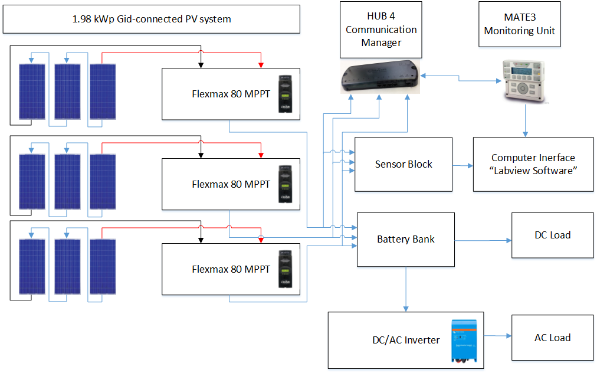
Fig. 1. The GCPV-VIS plant installed at the Huddersfield University, United Kingdom

In order to model the system performance it is necessary to define the PV cell modelling.

PV Cell Modelling
There are various circuit implementations used to model PV module characteristics. For this work the exponential model for PN junction solar cell has been chosen; this is the well-known five parameters (5-p) model [3, 4]. The equivalent circuit of the 5-p model is shown in Fig. 2 and represented by (1).

$I= I_{ph}- I_{o}\left(e^{\frac{\left(V+IR_{s}\right)q}{AKT_{c}}}-1\right)-\left(\frac{\left(V+IR_{s}\right)}{R_{p}}\right) .$ (1)
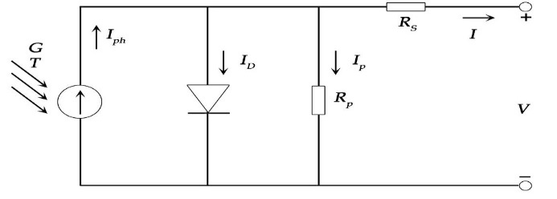
where I_{ph} is Solar cell photocurrent; I_{o} is the dark current of solar cell; V is the output voltage of the solar cell; I is the output current of the solar cell; q is equal to the charge of electron (1.6×10⁻¹⁹ Coulomb); A represents the ideal factor of PN junction; K is the Boltzmann constant (1.38×10⁻²³ J/K); T_{c}
is the absolute temperature of the solar cell (measured in Kelvin; R_{s} represents the series resistance and R_{p} is the parallel resistance of the solar cell.
Fig. 2. Equivalent Circuit for PV cell
The series - parallel combination of cells in a PV module affects the performance of that module. Equation (2) shows the relationship between the series-parallel cell combination and current output (I).
$I\left(1+\frac{Rsm}{Rshm}\right)= N_{p}I_{sc}-N_{p}I_{o}\left(e^{\frac{\left(\frac{V}{N_{s}}+IR_{sm}\right)q}{AKT_{c}}}-1\right)-\left(\frac{\left(\frac{V}{N_{s}}\right)}{R_{shm}}\right)$ (2)

$R_{shm }= \frac{N_{p}}{N_{s}} R_{p}$ (3)

$R_{sm }= \frac{N_{s}}{N_{p}} R_{s}$ (4)

The SMT6 (60) P solar module manufactured by Romag has been used in this work. The electrical characteristics of the solar module are shown in Table I. In addition, the standard test conditions for these solar panels are:
- Solar Irradiance = 1000 W/m²
- Module temperature = 25 °C
TABLE I
Parameters of SMT6 (60) P and SW020-12 at 25°C, 1000 W/m²
Solar Panel Electrical Characteristics | SMT6(60)P
Maximum Power | 220 W
Voltage at maximum power point (Vmp) | 28.7 V
Current at maximum power point (Imp) | 7.67 A
Open Circuit Voltage (Voc) | 36.74 V
Short Circuit Current (Isc) | 8.24 A
Number of cells connected in series | 60
Number of cells connected in parallel | 1

GCPV-VIS System Design
In order to monitor the performance of the GCPV-VIS system, three different communication devices were used: Hub 4 communication manager, Mate3 device, and the sensor block, which support data acquisition and transmission of data between the GCPV system and VI LabVIEW software.
The GCPV system is hard wired to a PC running VI LabVIEW software. The VI model is designed for real-time, long-term data logging and statistical analyses.
The VI component also allows creation of the PV theoretical curves (I-V and P-V) for any photovoltaic solar panel using parameters supplied in manufacturer data sheet for a particular PV solar panel. Furthermore, real time measured data from the PV solar panel system can be monitored on the VI and compared with the PV theoretical curves, and displayed on GUI.

Graphical User Interface (GUI)
LabVIEW tools were used to design graphical user interface unit for the GCPV-VIS system. From the VI GUI, the user can create and model any listed PV solar panel by selecting manufacturer data sheet parameters. The Arduino Input tab provides the means to view the measured data from the sensor block including voltage, current and solar irradiance.
Fig. 3 illustrates the Block Diagram (VI software) designed to accept real-time measured data input from the Arduino controller.

PV Module Theoretical I-V and P-V Curves
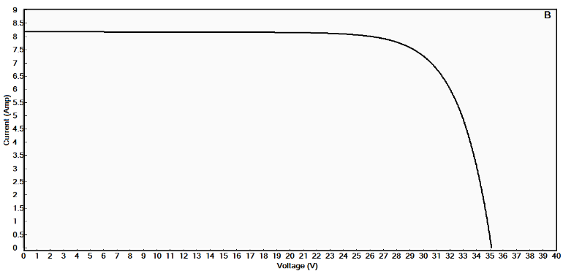
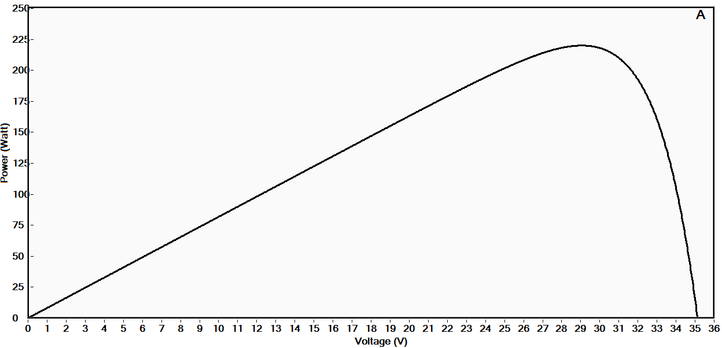
Using the VI graphic user interface, P-V and I-V theoretical curves for the PV module used in this project are presented in Fig. 4. Where the maximum power of the module, at the standard conditions, is 220.

GCPV-VIS Evaluation of Performance Indicators
A comparison between measured samples (red markers) and theoretical PV module power curves for different solar irradiance conditions are shown in Fig. 5. Two different irradiance conditions (750 and 620 W/m²) have been examined. In each case the weather temperature was 8 °C. Block diagram of the GCPV-VIS system in Fig. 1 shows the system configuration for this experiment.
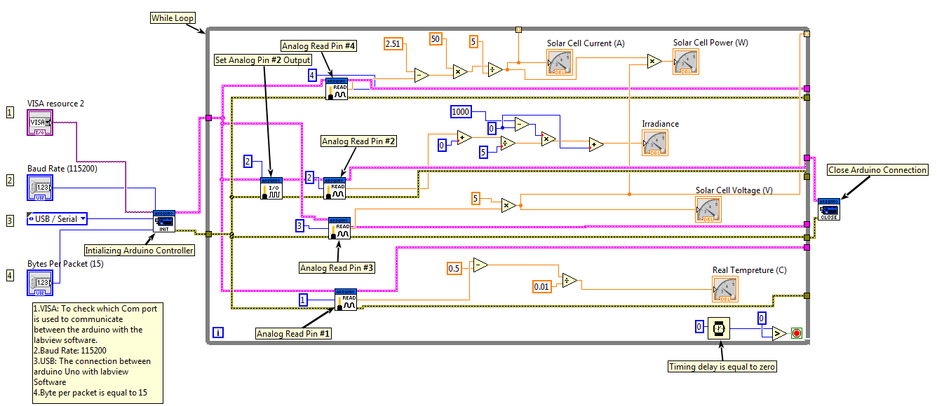
Fig. 3. LabVIEW Arduino Block Diagram Design

In this instance, plotted data was derived by averaging 600 samples, taken at a rate of 1Hz over ten minutes. In each case the mean values for voltage and power lie on the P-V theoretical curve.
The Maximum power point tracker, which is used in the GCPV-VIS, allows the system to operate at the maximum power. The efficiency of this device is always greater than 98%. Table II shows the output power efficiency for this particular test.
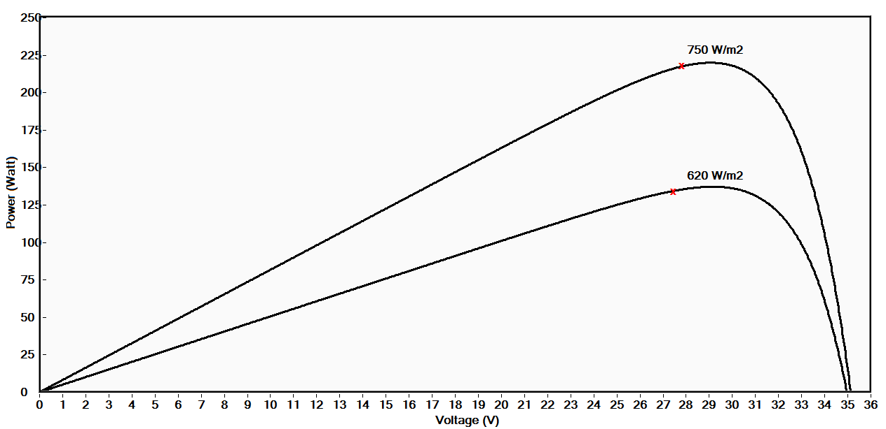
Fig. 5. Theoretical P-V Curves vs. Average Measured Power

TABLE II
MPPT Output Efficiency At various Conditions
Photovoltaic String | Solar Irradiance (W/m²) | Mean Measured Power (W) | Theoretical Power (W) | Efficiency (%)
First | 750 | 498.915 | 504.975 | 98.8
Second | 750 | 500.228 | 504.975 | 99.06
Third | 750 | 499.976 | 504.975 | 99.01
First | 620 | 408.175 | 411.633 | 99.16
Second | 620 | 407.887 | 411.633 | 99.09
Third | 620 | 407.187 | 411.633 | 98.92
Fig 4. (A)Theoretical P-V curve. (B) Theoretical I-V curve

GCPV-VIS Fault detection
In order to identify anomalies in PV system output, and correlate them to possible faults or specific weather conditions, we have devised a statistical component for VI. This component can be used to detect potential faults in GCPV systems.

Statistical analysis Methodology
The proposed fault detection system is based on a statistical analysis of the measured and theoretical PV power data. Initially, by using VI LabVIEW software it is possible to monitor and log the real-time measured data, where the frequency of data logging can be controlled in the VI-program. Moreover, measured power could be compared with a theoretical power value at a specific irradiance and temperature.
The main objective of the fault detection approach is to detect and determine when and where a fault has occurred in the considered GCPV-VIS system. The system uses logged data, over a specific period of time, such as solar irradiance, PV module temperature, and the output DC current and voltage.
In order to decide whether the difference between the measured power data and the theoretical power value is significant, that is to test H_{o =}$µ$ (Population mean), the statistical t-test is calculated based on a logged data of 600 samples using (5) [13].

$t=\frac{\left(\overline{x}- µ \right)\sqrt{n}}{S}$ (5)
Where $\overline{x}$ = sample mean, S = sample standard deviation, n= sample size.
The values obtained from the t-test are displayed in Table III. It is evident that the observed values for both conditions (750 and 620 W/m²) are less than the critical value t∞ = 2.58 (P = 0.01) described in Table IV. The null hypothesis is retained: there is no evidence of systematic error occurred in the system.

TABLE III
T TEST VALUE FOR DIFFERENT SAMPLES CONDITIONS
Solar Irradiance (W/m²) | Temperature Condition (°C) | Total Photovoltaic Plant Power (W) | T Test Value
750 | 8 | 1499.119 | -0.192
620 | 8 | 1223.249 | -0.078

TABLE IV
t distribution Table
Value of t for a confidence interval of Critical value of |t| for P values of number of degrees of freedom | 90 %  (P= 0.1) | 95 %  (P= 0.05) | 99 %  (P= 0.01)
1 | 6.31 | 12.71 | 63.66
20 | 1.72 | 2.09 | 2.85
50 | 1.68 | 2.01 | 2.68
∞ | 1.64 | 1.96 | 2.58

Falut Detection Algorithm
It is possible to detect the error in the GCPV-VIS using t-test statistical approach. If the t-test is below a critical value then there is no evidence of a systematic error in the system. However, if the t-test is more than a critical value then the system will detect the error.
Using an algorithm, shown in Fig. 6, the system is capable of detecting faults across entire PV-system and/or within individual string of PV-Modules. .
The Power of each PV string will be displayed in a graph with the theoretical power and all PV strings will be compared again using statistical t-test with a critical value. The output of this test will illustrate where the error has occurred in the GCPV-VIS. The fault detection algorithm is illustrated in the flowchart presented in Fig. 6. There could be several faults/defects on any grid-connected PV system such as:
- Faulty modules in string
- Faulty string
- Faulty DC/DC converter
- Faulty Battery Bank
- Normal Shading

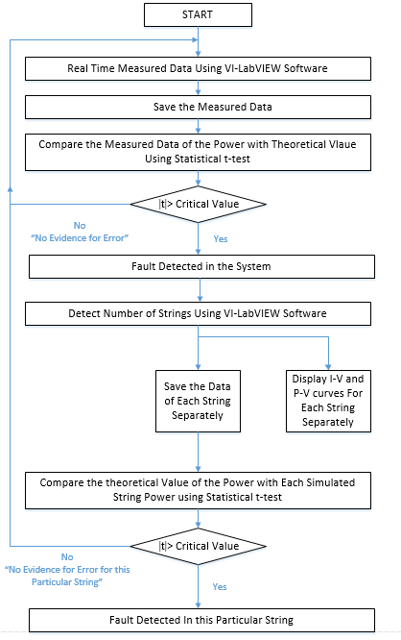

Fig. 6. Flowchart of Fault detecting in GCPV-VIS

Validation of the Developed Approach

Case1: Normal Shading
Initially a test illustrating normal shading is used to evaluate the fault detection technique. Partial shading was applied on the third string of the GCPV-VIS as shown in Fig. 7 A.
Fig. 8 illustrates measured and theoretical power of the examined scenarios using VI LabVIEW software front panel. The system can detect an error of the measured and theoretical data using statistical t-test. Initially, VI program will split the signal into three main data streams. Each row of data stream presents separate string in the GCPV.
The fault detection algorithm continues to detect the fault in the system for the complete period of the simulation which is equal to 1 hour. Furthermore, when a rapid change occurred in the irradiance the detection algorithm was still active and working properly.
Finally, VI LabVIEW software indicates the type of error occurred in the grid-connected photovoltaic system. The type of error is detected based on set of rules implemented in the software.
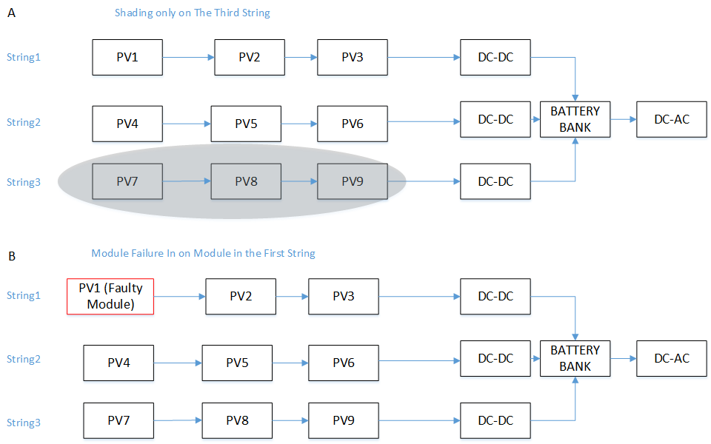
Fig. 7. (A) Shading Fault Test. (B) Module Failure Test

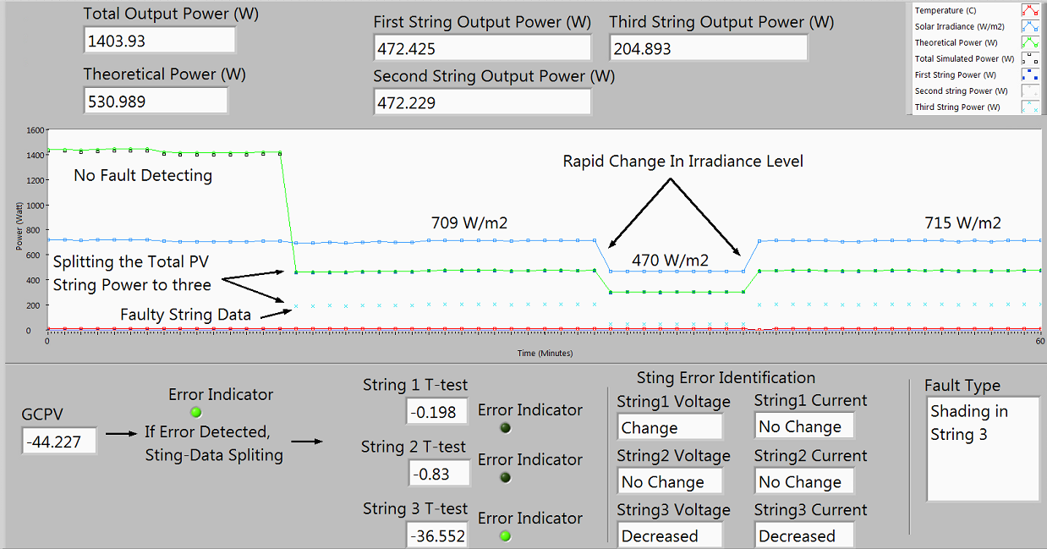
Fig. 8. Shading Fault Detection Using VI LabVIEW Software

Case2: Real Defect in the GCPV-VIS (Faulty Module in a PV string)
In this evaluation test the detection algorithm used to detect the faults in GCPV-VIS system. A faulty module was used in the first string, as shown in Fig. 7 B.
Fig. 9 illustrates the output from this particular evaluation test. Theoretical power vs. the total measured power of the gird-connected photovoltaic system are presented using circle and rectangular points. After 15 min of the simulation, LabVIEW software detected the error in the system using statistical t-test which is equal to -28.227. At that moment, VI LabVIEW program splits the data of the GCPV system into three various data stream, first PV-string power, second PV-sting Power and the third-PV string power.
The detection algorithm can detect the error when there is a rapid change in the solar irradiance levels. Furthermore, text indicator in LabVIEW GUI is on the front panel to allow the user view the error type that occurred in the GCPV-VIS. The sampling rate of the data plotted in in Fig. 9 is equal to 1sample/1min. Moreover, the sampling rate of the data plotted in Fig. 8 and Fig. 9 is equal to 1sample/min.

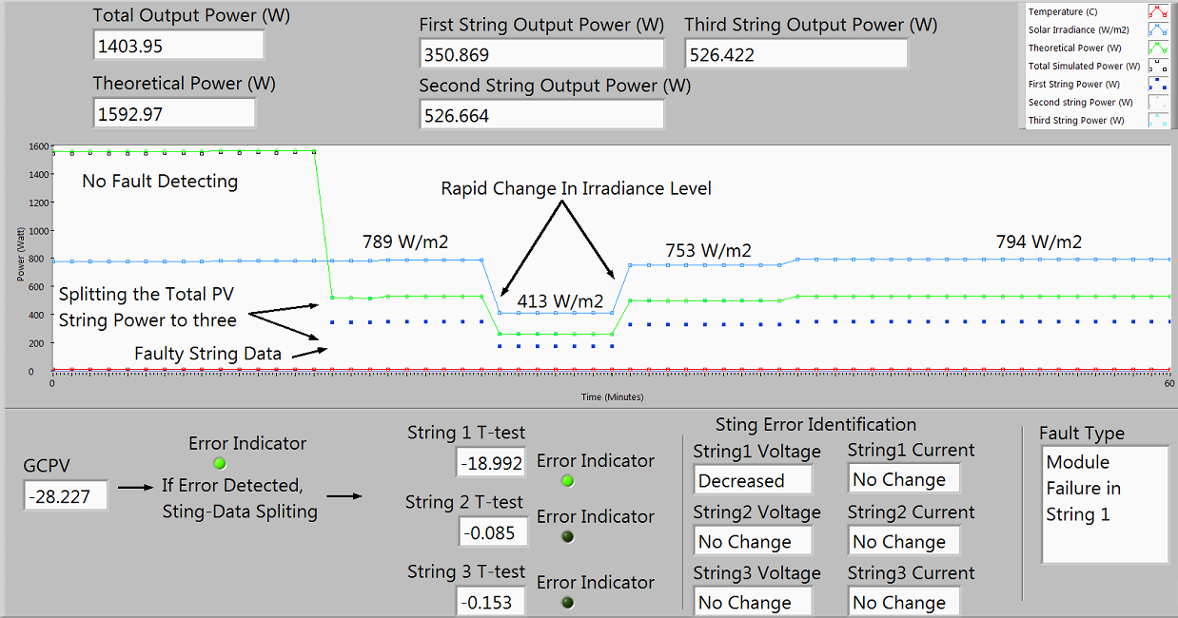
Fig. 9. Module Fault Detection Using VI LabVIEW Software

CONCLUSION
A fault detection algorithm for a grid-connected photovoltaic (GCPV) plant based on the comparison of the theoretical output power and rea-time long-term measured data is proposed and verified experimentally by using LabVIEW software. The detection technique will evaluate the input power with the theoretical output power using statistical analysis t-test.
In order to detect various faults that might occur in the GCPV virtual instrumentation system (GCPV-VIS), we have developed a technique which is working with each string of the PV plant separately. By separating the PV strings, it is possible to monitor and detect the location of the fault in the GCPV-VIS and the time that this fault occurred.
The VI can be used to create I-V and P-V theoretical curves for a photovoltaic module based on the parameters found in the manufacturer data sheets. The PV theoretical curves may be compared with real-time measured data under various solar irradiance and temperature weather conditions. The VI provides statistical testing features. The t-test can be used to evaluate the quality of measured data against theoretical performance data. This feature allows the system to detect where and when the fault occurred in the GCPV system.
Novel contribution of this research is that the GCPV-VIS can detect the faults in the gird-connected photovoltaic plant using statistical analysis of real-time long-term measured data and theoretical thresholds.
In future, the fault detection algorithm will be implemented as a low cost microcontroller-based system. The system fault diagnostic capabilities will be enhanced using Artificial Intelligence machine learning techniques.

References
- Lyden, S., Haque, M. E., Gargoom, A., Negnevitsky, M., & Muoka, P. I. (2012, September). Modelling and parameter estimation of photovoltaic cell. InUniversities Power Engineering Conference (AUPEC), 2012 22nd Australasian(pp. 1-6). IEEE.
- Messenger, R., & Ventre, J. (2000). Photovoltaic systems engineering. Boca Raton; London: CRC Press.
- McEvoy, A. J., Castañer, L., Markvart, T., & Books24x7, I. (2013). Solar cells: Materials, manufacture and operation, second edition (2nd ed.). Waltham, Mass: Elsevier.
- Chine, W., Mellit, A., Pavan, A. M., & Kalogirou, S. A. (2014). Fault detection method for grid-connected photovoltaic plants. Renewable Energy, 66, 99-110. doi:10.1016/j.renene.2013.11.073
- Padgavhankar, A. V., & Mohod, S. W. (2014). Experimental learning of digital power controller for photovoltaic module using proteus VSM. Journal of Solar Energy, 2014 doi:10.1155/2014/736273.
- Takashima, T., Yamaguchi, J., Otani, K., Oozeki, T., Kato, K., & Ishida, M. (2009). Experimental studies of fault location in PV module strings. Solar Energy Materials and Solar Cells, 93(6), 1079-1082.
- Chine, W., Mellit, A., Pavan, A. M., & Kalogirou, S. A. (2014). Fault detection method for grid-connected photovoltaic plants. Renewable Energy, 66, 99-110. doi:10.1016/j.renene.2013.11.073
- Platon, R., Martel, J., Woodruff, N., & Chau, T. Y. (2015). Online Fault Detection in PV Systems. Sustainable Energy, IEEE Transactions on, 6(4), 1200-1207.
- Berberkic, S., Mather, P., Holmes, V., & Sibley, M. J. N. (2011). Design of a monitoring and test system for PV based renewable energy systems.
- Dhimish, M., & Holmes, V. (2016). Fault detection algorithm for grid-connected photovoltaic plants. Solar Energy, 137, 236-245. doi: http://dx.doi.org/10.1016/j.solener.2016.08.021
- Boukenoui, R., Bradai, R., Salhi, H., & Mellit, A. (2015). Modeling and simulation of photovoltaic strings under partial shading conditions using Matlab/Simscape. Paper presented at the 73-77. doi:10.1109/ICCEP.2015.7177603

