Evaluating Progestogens for Preventing Preterm birth International Collaborative (EPPPIC): a meta-analysis of individual participant data from randomised controlled trials
APPENDIX

 | Pages
Additional figures | 2-25
Additional results tables | 26-31
Trial characteristics (included trials) | 32-42
Trial characteristics (unavailable trials) | 43-46
Study identification and example search strategy | 47-48
Specification of one-stage models | 49-51
Linked qualitative study | 52-65

Author Supplement to: The EPPPIC Group. Evaluating Progestogens for Preventing Preterm birth International Collaborative (EPPPIC): meta-analysis of individual participant data from randomised controlled trials. Lancet 2021; 397:1183–94.
APPENDIX: Additional Figures
Study | Random sequence generation (selection bias) | Allocation concealment (selection bias) | Blinding of participants & personnel (performance bias) | Blinding of outcome assessment (detection bias) | Incomplete outcome data (attrition bias) | Availability of IPD outcomes * | IPD checks#
Aboulghar (2012) | + | + | ‒ ³ | + | + | + | +
PROGESTWIN | + | + | + | + | + | + | +
SSTARS (triplets) | + | + | + | + | + | + | +
Combs (2010) (Triplets) | + | + | + | + | + | + | +
Combs (2011) (Twins) | + | + | + | + | + | + | +
PROGRESS | + | + | + | + | + | + | +
Fonseca (2007) | + | + | + | + | + | + | +
Glover (2011) | + | + | + | + | + | + | +
SCAN | + | + | + | + | + | + | +
PREGNANT | + | + | + | + | + | + | +
AMPHIA | + | + | + | + | + | + | +
Majhi (2009) | + | + | ‒ ³ | + | + | + | +
Meis (2003) | + | + | + | + | + | + | +
STOPPIT | + | + | + | + | + | + | +
OPPTIMUM | + | + | + | + | + | + | +
O’Brien (2007) | + | + | + | + | + | + | +
Rai/Rajaram, (2009) | + | + | + | + | + | + | +
PREDICT | + | + | + | + | + | + | +
SSTARS (twins) | + | + | + | + | + | + | +
PHENIX (twins) | + | + | ‒ ³ | + | + | + | +
Serra (2013) | + | + | + | + | + | + | +
Wood (2012 | + | + | + | + | + | + | +
Brizot (2015) | + | + | + | + | + | + | +
Azargoon (2016) | ‒ ¹ | ?² | + | + | + | + | +
TRIPLE P | + | + | + | + | + | + | +
Bafghi (2015) | + | + | ‒ ⁴ | +⁵ | + | + | +
Elimian (2016) | + | ?² | ‒ ⁴ | + | + | + | +
PROGFIRST⁵ | + | + | + | + | + | + | +
Briery (2009) | + | + | + | + | + | + | +
PHENIX (singleton) | + | + | ‒ ³ | + | + | + | +
PROLONG | + | + | + | + | + | + | +

+ low risk of bias; ? unclear risk of bias; ‒ high risk of bias.
Appendix Figure 1: Risk of bias summary for trials providing IPD and included in EPPPIC
* IPD provided for all relevant recorded outcomes. # Significant residual concerns after completing data checking (including correction where necessary) and confirmation. Includes checks on data outliers and implausible values, pattern of randomization (where possible), balance of risk factors by arm and comparison of main outcomes with trial publication (where available). ¹ Participants "were randomly divided into two groups of receiving progesterone treatment (group A) and placebo (group B)" although states that "in each group the patients received the drug administered to group A or B in order of their clinic appearance." ² No allocation concealment methods reported. ³ Participant and study personnel not blinded to treatment allocation (no treatment and no placebo in control group). ⁴ Participant and study personnel could not be blinded to treatment allocation (vaginal compared with intramuscular administration). ⁵Trial was stopped early and women immediately discontinued treatment, which may have impacted on efficacy.

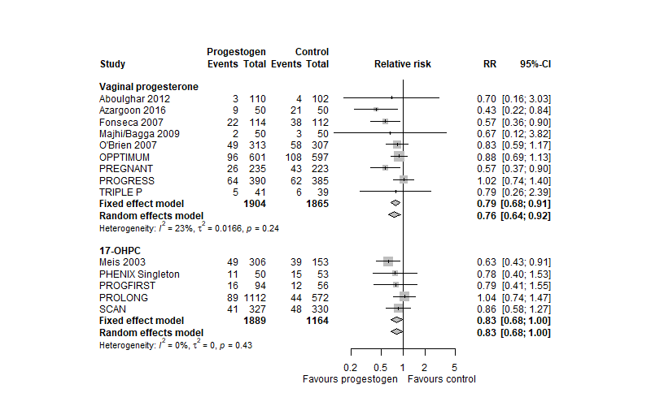
Appendix Figure 2: Singleton pregnancies preterm birth before 34 weeks
(two-stage meta-analysis)

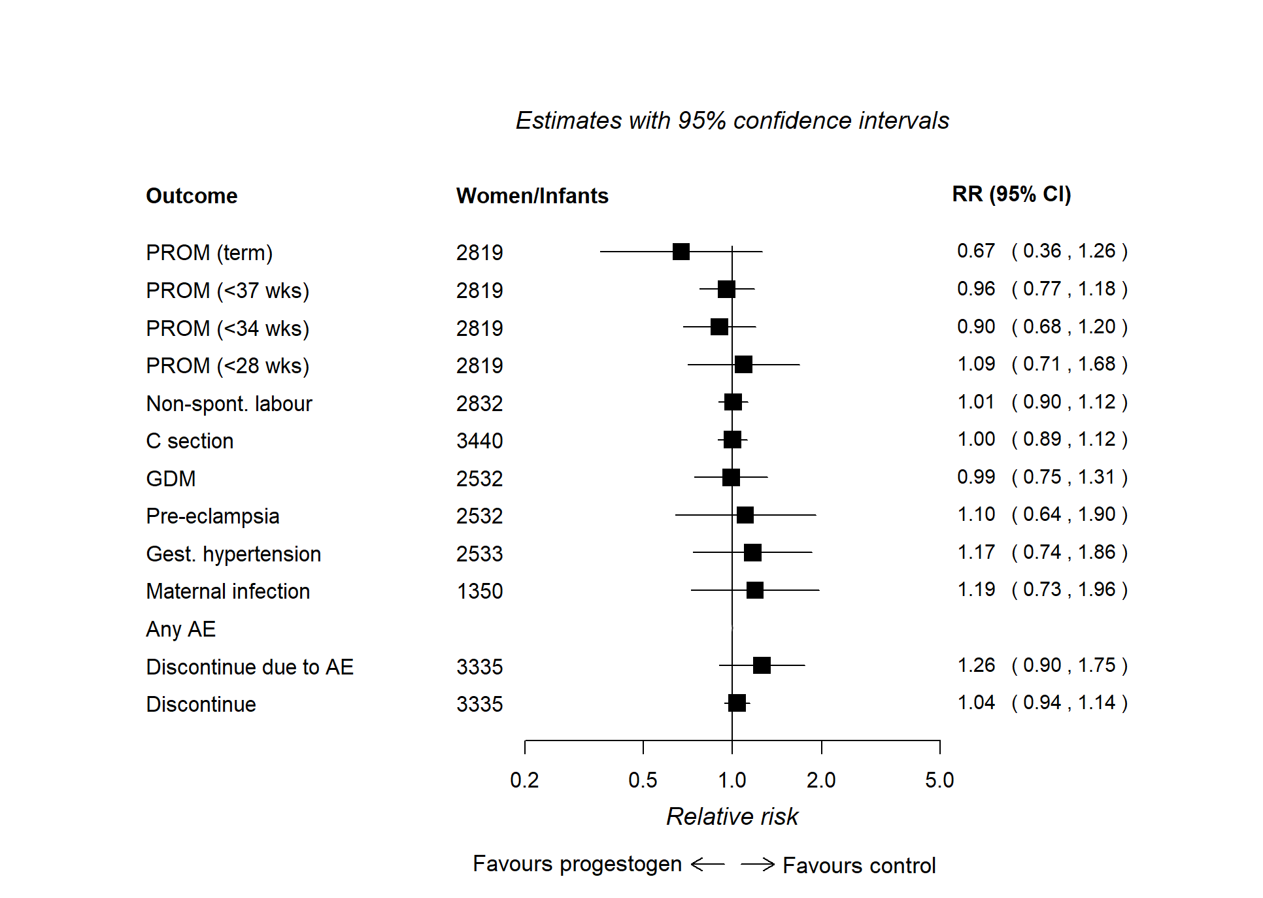
Appendix Figure 3: Singleton pregnancies maternal outcomes vaginal progesterone
(one-stage meta-analysis)
PROM (premature rupture of membranes), GDM (gestational diabetes mellitus), any AE (any adverse event/at least one side effect of treatment experienced), discontinuation due to AE (discontinuation of treatment due to adverse event/side effect), discontinue (discontinuation of treatment for any reason). No results for the “Any AE” meta-analysis are presented, as data were insufficient for the model to converge.

Appendix Figure 4: Singleton pregnancies maternal outcomes 17-OHPC (one-stage meta-analysis)
PROM (premature rupture of membranes), GDM (gestational diabetes mellitus), any AE (any adverse event, at least one side effect of treatment experienced), discontinuation due to AE (discontinuation of treatment for adverse event/side effect), Discontinue (discontinuation of treatment for any reason).

Appendix Figure 5: Singleton pregnancies main outcomes oral progesterone (one-stage meta-analysis)
PTB < 28 weeks is not shown as one-stage model failed to converge. SNC is not shown, as no data were available. Preterm birth <34 weeks and <37 weeks includes fetal death before this gestational time point. For maternal morbidity (any of maternal death, gestational diabetes, gestational hypertension, preeclampsia, maternal infection) there were no events in one trial (Rai/Rajaram 2008) and for perinatal deaths there were no events in the other trial (Glover 2011).

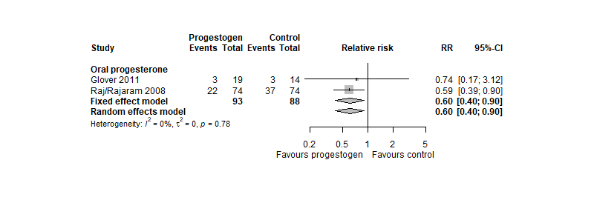
Appendix Figure 6: Singleton pregnancies preterm birth before 34 weeks oral progesterone
(two-stage meta-analysis)

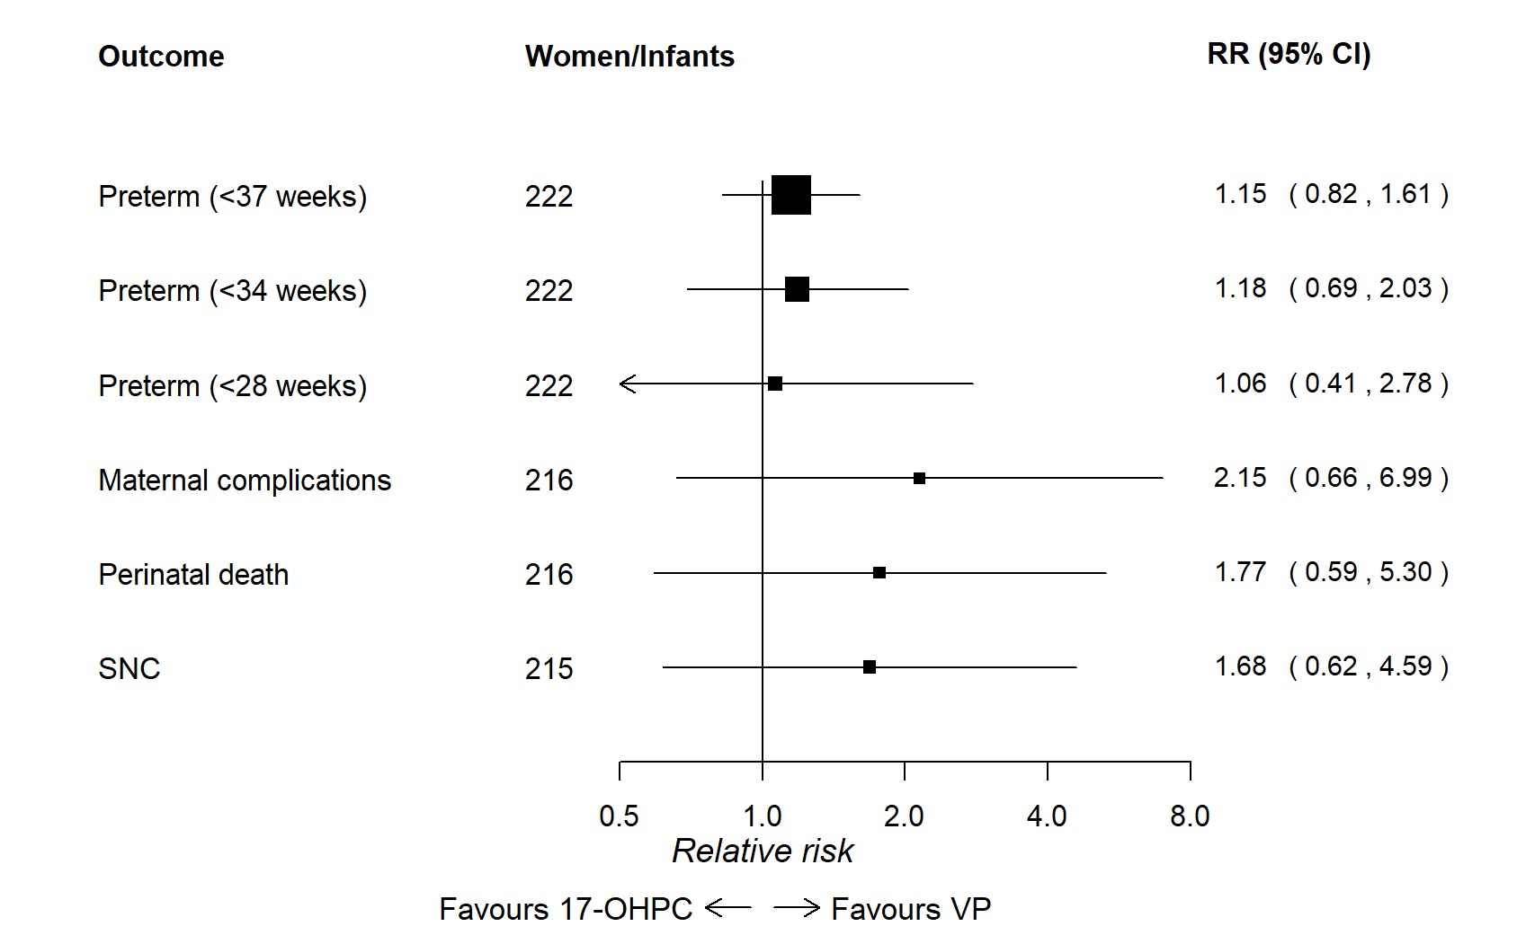
Appendix Figure 7: Singleton pregnancies main outcomes head to head trials comparing vaginal progesterone and 17-OHPC (one-stage meta-analysis). For 1 trial (Bagfi 2015), there were no events for preterm birth <28 weeks, maternal complications, perinatal death and SNC.
Appendix Figure 8: Singleton pregnancies 17-OHPC versus vaginal progesterone (network meta-analysis) Numbers of events: Preterm < 37 weeks: 17-OHPC=43, VP=41 events; Preterm < 34 weeks: 17-OHPC=23, VP=20; Preterm < 28 weeks: 17-OHPC=8, VP=7; Maternal complications: 17-OHPC=4, VP=7 ; Perinatal death: 17-OHPC=5, VP=7; SNC: 17-OHPC=6, VP=8.
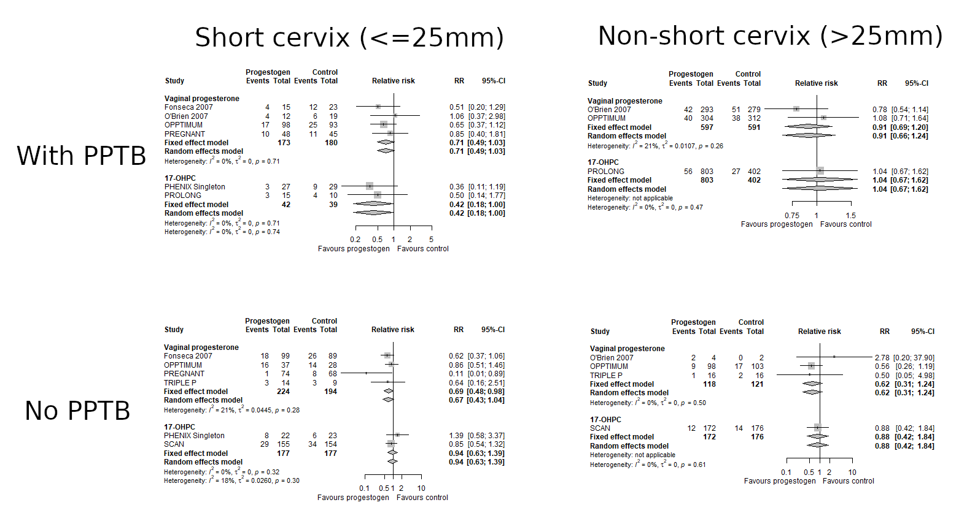

Appendix Figure 9 Analysis of subpopulations of participants defined according to categorised cervical length and presence of a previous PTB for the outcome of preterm birth <34 weeks. These plots are based on considerably fewer data than the main analysis owing to unmeasured/unknown values for cervical length meaning that 6 trials (4 for VP, 2 for 17-OHPC) cannot be included. Different trials contribute to different subpopulation analyses and there may be differences between trials other than the factors by which they are grouped.

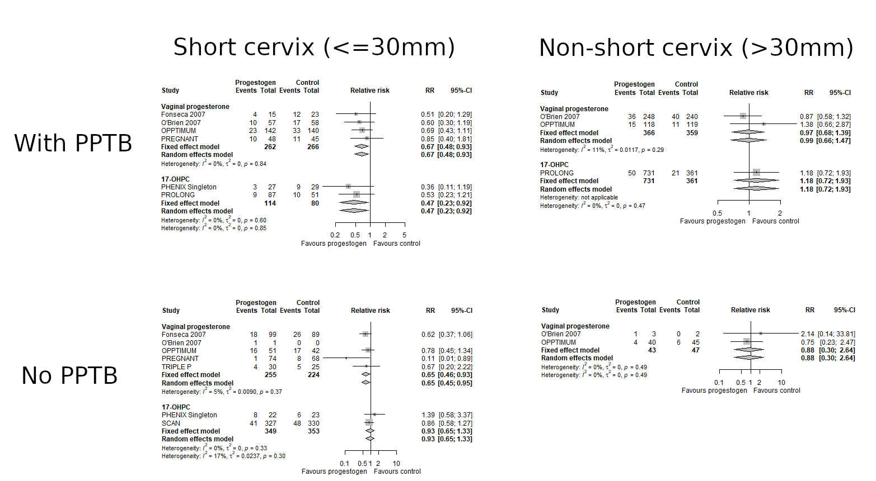
Appendix Figure 10: Analysis of subpopulations of participants defined according to categorised cervical length and presence of a previous PTB. These plots are based on considerably fewer data than the main analysis owing to unmeasured/unknown values for cervical length meaning that 6 trials (4 for VP, 2 for 17-OHPC) cannot be included. Different trials contribute to different subpopulation analyses and there may be differences between trials other than the factors by which they are grouped.

Appendix Figure 11: Network meta-analysis singleton pregnancies 17-OHPC versus vaginal progesterone restricted to women with a short cervix (≤25mm).
Appendix Figure 12: Network meta-analysis singleton pregnancies 17-OHPC versus vaginal progesterone restricted to women with a previous preterm birth.

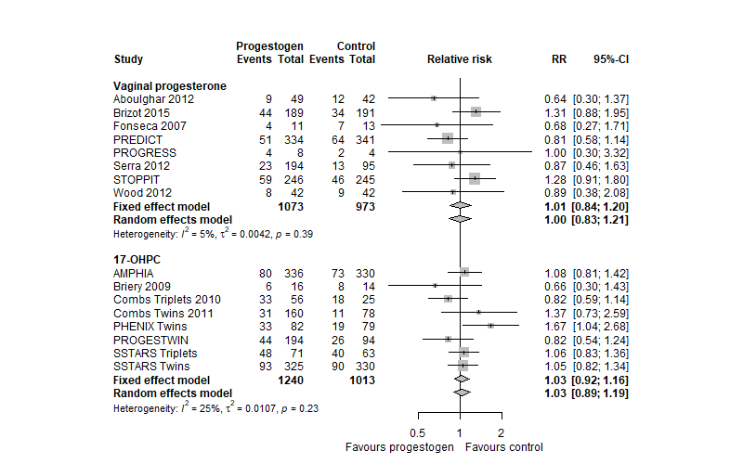
Appendix Figure 13: Multifetal pregnancies preterm birth before 34 weeks (two-stage meta-analyses).

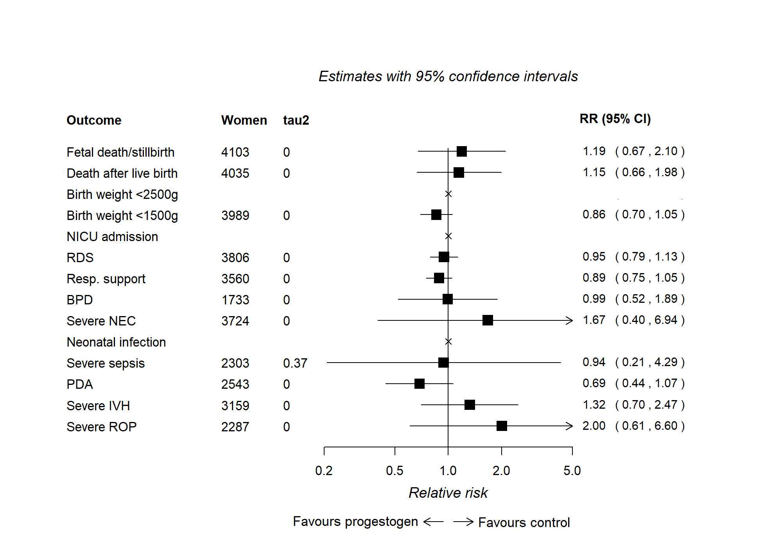
Appendix Figure 14: Multifetal pregnancies neonatal outcomes vaginal progesterone
(one-stage meta-analyses).
NICU (admission to neonatal Intensive or special care unit), RDS (respiratory distress syndrome), BDP (bronchopulmonary dysplasia), PDA (patent ductus arteriosis) Severe IVH (intraventricular haemorrhage) (grade III or IV), Severe ROP (retinopathy of prematurity) (stage 3 or worse). Severe NEC), Necrotising enterocolitis (grade II or III). Note that ‘x’ denotes that outcome is not estimable in a one-stage model (data are not sufficient for the model to converge).

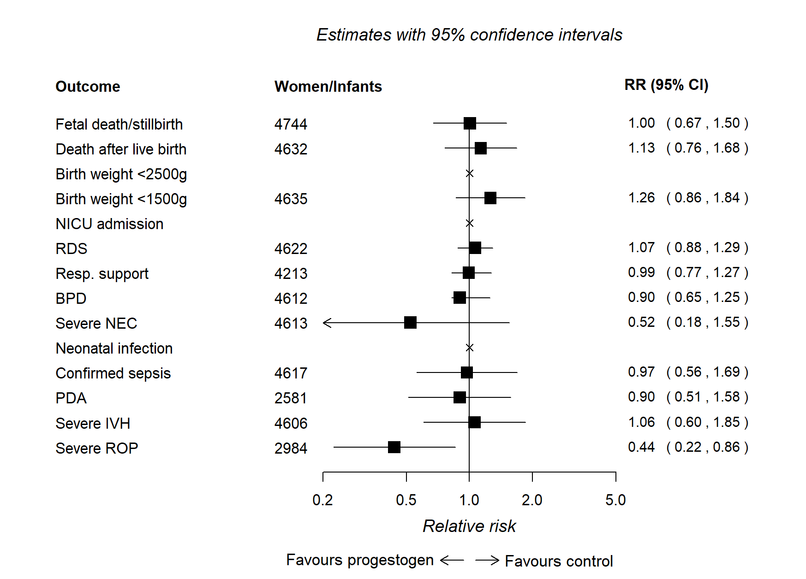
Appendix Figure 15: Mutifetal pregnancies neonatal outcomes 17-OHPC (one-stage meta-analyses).
NICU (admission to neonatal Intensive or special care unit, RDS (respiratory distress syndrome), BDP (bronchopulmonary dysplasia), PDA (patent ductus arteriosus) Severe IVH (intraventricular haemorrhage) (grade III or IV), Severe ROP (retinopathy of prematurity) (stage 3 or worse). Severe NEC (necrotizing enterocolitis) (grade II and III). Note that ‘x’ denotes that outcome is not estimable in a one-stage model (data are not sufficient for the model to converge).
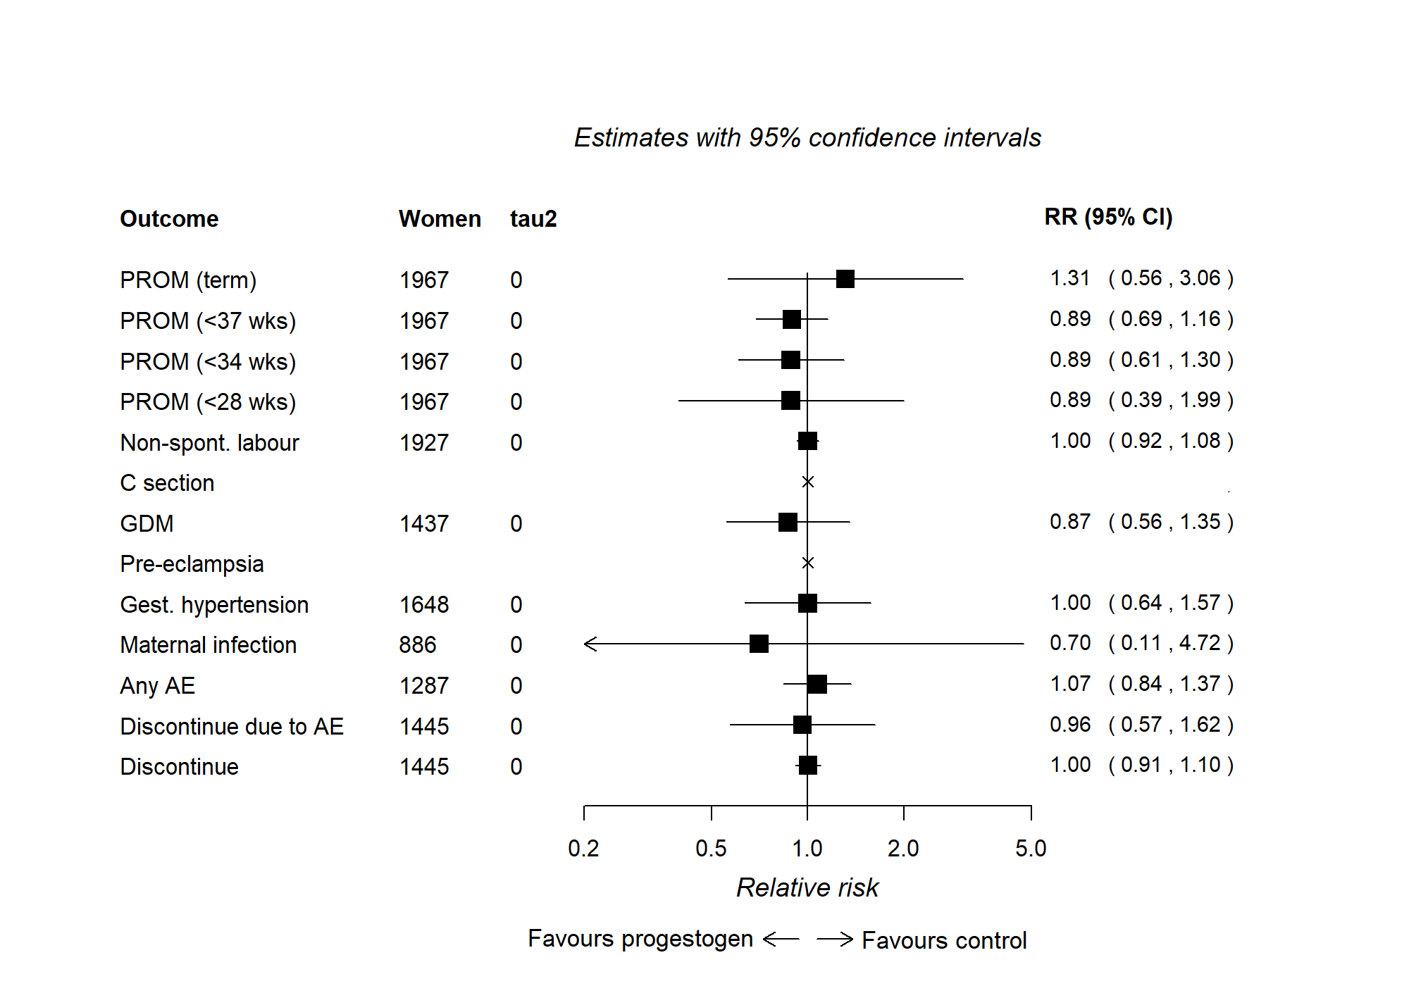
Appendix Figure 16: Mutifetal pregnancies maternal outcomes vaginal progesterone
(one-stage meta-analyses).
GDM: Gestational diabetes mellitus, any AE (adverse event) (at least one side effect of treatment experienced), discontinue: discontinuation of treatment for any reason. Note that ‘x’ denotes that outcome is not estimable in a one-stage model (data are not sufficient for the model to converge).

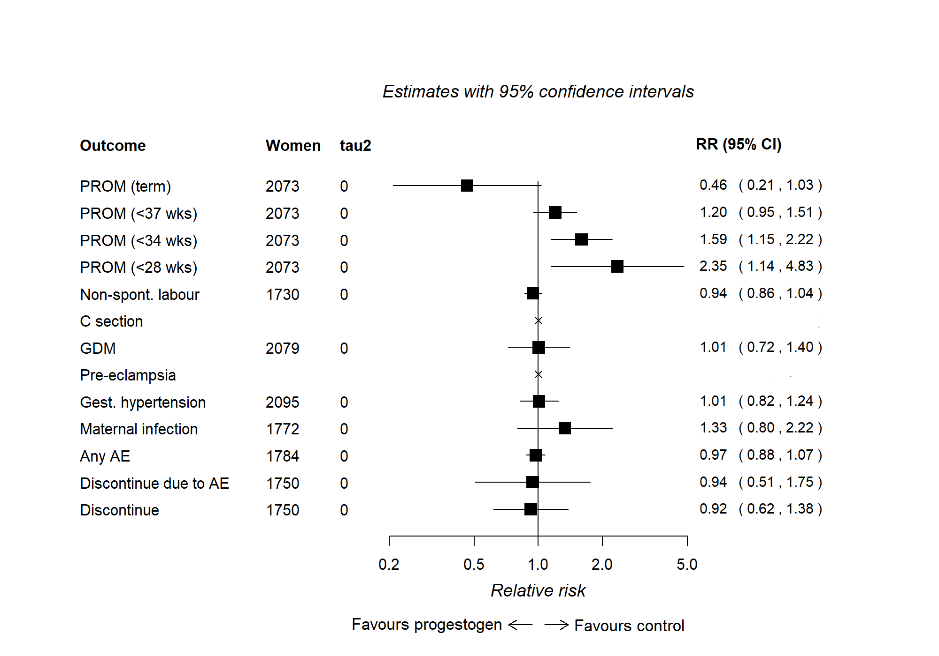
Appendix Figure 17: Multifetal pregnancies maternal outcomes 17-OHPC (one-stage meta-analyses).
GDM: Gestational diabetes mellitus, any AE (adverse event) (at least one side effect of treatment experienced), discontinue: discontinuation of treatment for any reason. Note that ‘x’ denotes that outcome is not estimable in a one-stage model (data are not sufficient for the model to converge).
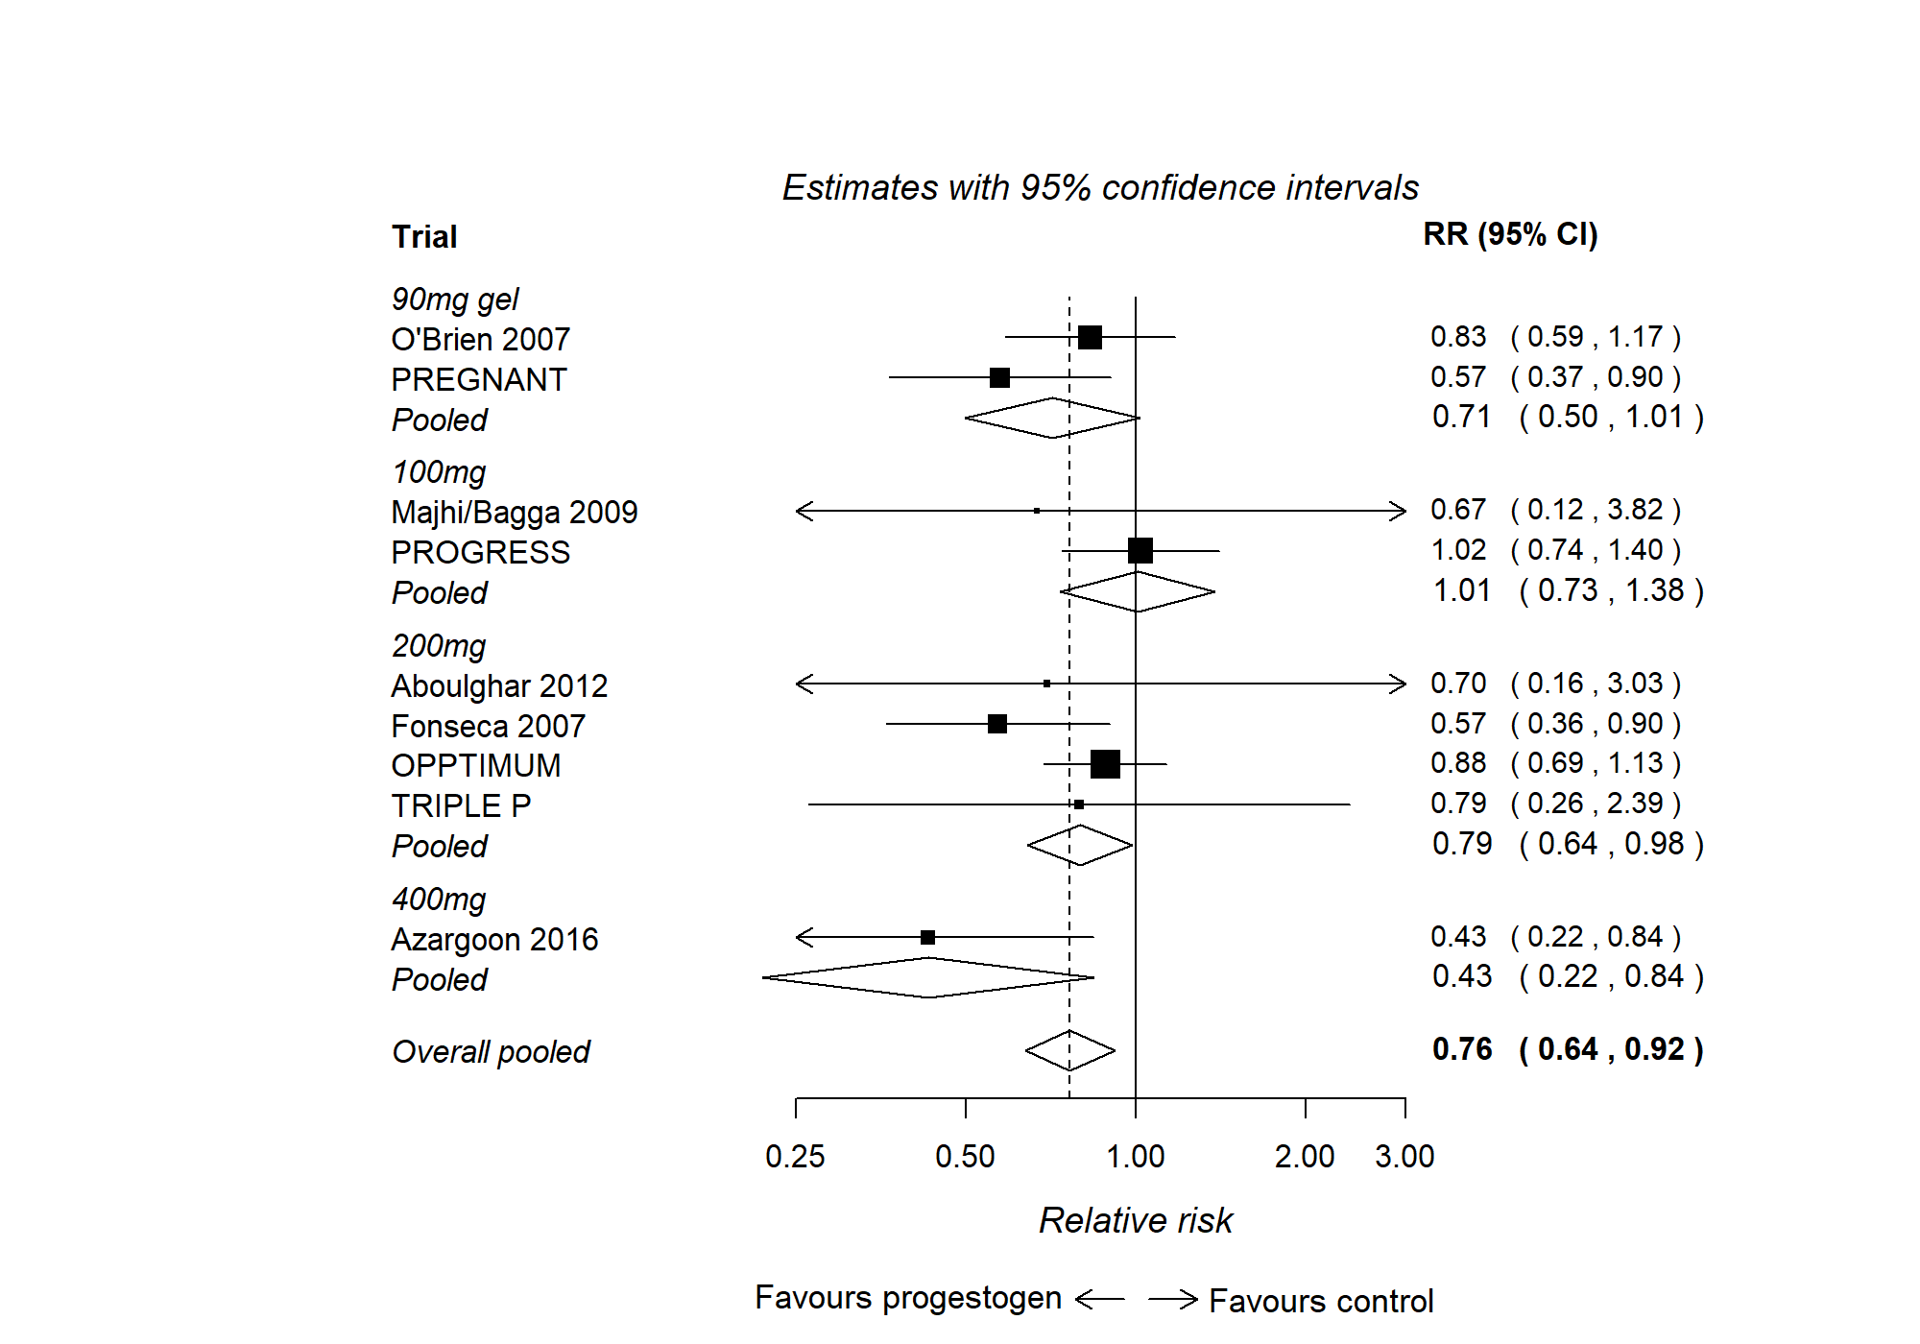
Appendix Figure 18: Subgroup analysis by planned vaginal progesterone dose in singleton pregnancies, preterm birth before 34 weeks.
This analysis was limited by small numbers and is at risk of confounding by other factors.
All 17-OHPC trials used the same dose and so no equivalent analysis was done.

Appendix Figure 19: Singleton pregnancies neonatal outcomes (sensitivity analyses).
SNC with RDS: Serious neonatal complications extended to include respiratory distress syndrome (RDS).
Individual neonatal complications extended to include any stage/grade of adverse event rather than the more severe stage/grades included in the main analyses:
Any NEC: All grades of NEC (necrotising enterocolitis)
Any IVH: All grades of IVH (intraventricular haemorrhage)
Any ROP: All grades of ROP (retinopathy of prematurity)

Sensitivity analyses incorporating aggregate data from trials that did not provide IPD
Sensitivity analyses incorporating aggregate data from trials that did not provide IPD were done using a two-stage approach. In the first step, estimates of effect were calculated for each trial using IPD for those trials that provided it and aggregate data extracted from publications for those that did not. These individual trial estimates were pooled in the second stage in the same way as a standard meta-analysis.

Appendix Figure 20: Sensitivity analysis VP in singleton pregnancies preterm birth before 34 weeks incorporating aggregate data from potentially eligible trials not supplying IPD.
Trials that did not provide IPD were unable to be checked and verified in the same way as those that did provide IPD. Eligibility is based only on trial reports and we were unable to confirm whether they trials are adequately randomised trials.
Appendix Figure 21: Sensitivity analysis VP in singleton pregnancies preterm birth before 37 weeks incorporating aggregate data from potentially eligible trials not supplying IPD.
Trials that did not provide IPD were unable to be checked and verified in the same way as those that did provide IPD. Eligibility is based only on trial reports and we were unable to confirm whether they trials are adequately randomised trials.

Appendix Figure 22: Sensitivity analysis 17-OHPC in singleton pregnancies preterm birth before 34 weeks incorporating aggregate data from potentially eligible trials not supplying IPD.
Trials that did not provide IPD were unable to be checked and verified in the same way as those that did provide IPD. Eligibility is based only on trial reports and we were unable to confirm whether they trials are adequately randomised trials.

Appendix Figure 23: Sensitivity analysis 17-OHPC in singleton pregnancies preterm birth before 37 weeks incorporating aggregate data from potentially eligible trials not supplying IPD.
Trials that did not provide IPD were unable to be checked and verified in the same way as those that did provide IPD. Eligibility is based only on trial reports and we were unable to confirm whether they trials are adequately randomised trials.

Appendix Figure 24: Sensitivity analysis VP in multifetal pregnancies preterm birth before 34 weeks incorporating aggregate data from potentially eligible trials not supplying IPD.
Trials that did not provide IPD were unable to be checked and verified in the same way as those that did provide IPD. Eligibility is based only on trial reports and we were unable to confirm whether they trials are adequately randomised trials.

PTB 34 71 183 321 36 11 0 26 123 194 524 163 27
SNC 71 181 320 34 11 0 26 122 192 524 163 27
Numbers contributing to curve construction for each 10mm band cervical length

Appendix Figure 25: Illustrative absolute risk for preterm birth before 34 and 37 weeks and for composite serious neonatal complications in singleton pregnancies calculated using the control group risk from all EPPPIC trials of VP and 17-OHPC, including all women with a measured cervix length and known prior preterm birth status.
Control group risks were modelled using a logistic regression of outcome against cervical length at randomisation (generally between 16 and 25 weeks gestation) and previous preterm birth. Curves were constructed from the results of these models for control group risk, and by applying a relative risk of 0.8 to the control group curves for the progesterone arm.

 | Cervix >25 mm  No PPTB | 253  (100.0) | 252  (99.6) | 243  (96.0) |  | 235  (92.9) | 217  (85.8) | 76  (30.0)
 | Cervix >25 mm  PPTB | 845  (100.0) | 843  (99.8) | 827  (97.9) |  | 789  (93.4) | 675  (79.9) | 109  (12.9)
 | Cervix ≤25 mm  No PPTB | 371  (100.0) | 360  (97.0) | 324  (87.3) |  | 308  (83.0) | 255  (68.7) | 73  (19.7)
 | Cervix ≤25 mm  PPTB | 216  (100.0) | 210  (97.2) | 193  (89.4) |  | 169  (78.2) | 130  (60.2) | 30  (13.9)
 |  | 20 | 24 | 28 | 32 |  | 36 | 40
 |  | Gestational Age (Weeks)

Appendix Figure 26: Illustrative Kaplan Meier curve analysis of time to birth categorised by cervical length and presence or absence of previous preterm birth in the absence of treatment for women with singleton pregnancies.
Includes data from the control arms of all EPPPIC trials of VP and 17-OHPC that provided data on measured cervix length and prior preterm birth status. (OPPTIMUM (2016), O’Brien (2007), TRIPLE P (2011), SCAN (2012), PREGNANT (2011) PHENIX singleton (2015), Fonesca (2007) and PROLONG (2019)). Women with cervix length > 25mm and no history of previous preterm birth are largely from the SCAN trial and have cervical length <30mm.

APPENDIX: Additional tables

Appendix Table1: Previous meta-analyses evaluating progestogens for prevention of preterm birth
Previous meta-analyses of progestogen for prevention of PTB
- Cochrane review with aggregate data (AD) meta-analysis (MA) reported that VP and 17-OHPC prolonged pregnancy and reduced neonatal mortality and short-term morbidity.⁽⁷⁾
- IPD-MA of RCTs of VP in women with a singleton pregnancy, short cervix (<25mm) in mid-trimester (5 RCTs, 974 women) reported strong evidence in favour of intervention.⁽⁸⁾
- IPD-MA of data from RCTS of VP in women with a multifetal pregnancy and a short cervix (6 RCTs, 303 women) reported evidence in favour of intervention. ⁽⁹⁾
- IPD-MA of trials in twin pregnancies (13 RCTs, 3768 women) reported that neither VP nor 17-OHPC reduced the risk of composite adverse perinatal outcome including PTB; subgroup analysis suggested some benefit in women with reduced cervical length.⁽¹⁰⁾
- IPD-MA of trials of 17-OHPC in triplet pregnancies (3 RCTs, 232) reported no significant impact of 17-OHPC on duration of pregnancy. ⁽¹¹⁾
- AD-MA of RCTs comparing VP and 17-OHPC (3 RCTs, 680 women) reported that VP was associated with lower rates of PTB before 34 weeks compared with 17-OHPC.⁽¹²⁾

Appendix Table 2: EPPPIC outcomes and covariates
MAIN OUTCOMES
Perinatal death: fetal death after trial entry; stillbirth; or death of infant before 28 days or hospital discharge following birth, whichever is longer.
Preterm birth:(separately <37, < 34, <28 weeks)# preterm birth or fetal death confirmed before cut-off date.
Serious neonatal complications (SNC) or perinatal death (fetal, stillbirth, neonatal death)$: bronchopulmonary dysplasia; severe intraventricular haemorrhage (grade III or IV); necrotising enterocolitis (stage II or III); confirmed sepsis; patent ductus arteriosus; retinopathy of prematurity (stage 3 or worse).
Maternal complications or death: gestational diabetes; hypertension; pre-eclampsia; maternal infection.
ADDITIONAL OUTCOMES
- Pre-labor spontaneous rupture of membranes (< 28, <34, < 37 weeks & >= 37 weeks, separately)
- Non-spontaneous onset of labour (medically induced or caesarean before labour)
- Mode of birth (vaginal/caesarean birth)
- Gestational diabetes
- Pre-eclampsia
- Gestational hypertension
- Maternal infection (chorioamnionitis during labor; intrapartum fever, postpartum fever)
- Other adverse events
- Discontinuation of treatment
- Fetal death/stillbirth (death of fetus after randomisation)
- Neonatal death (death up to 28 days or to hospital discharge following birth, whichever longer)
- Birth weight (low ≤ 2500g, very low ≤ 1500g)
- Admission to neonatal intensive or special care unit (NICU/SCU)
- Respiratory distress syndrome (as defined in the trial)
- Use of respiratory support (mechanical, CPAP, high flow nasal cannula)
- Bronchopulmonary dysplasia (as defined in trial)
- Necrotizing enterocolitis (severe stage II or III, all stages in sensitivity analysis)
- Neonatal infection (antenatal, early, late as defined in trial)
- Confirmed neonatal sepsis
- Patent ductus arteriosus (treated for)
- Intraventricular hemorrhage (severe grade III or IV, all grades in sensitivity analysis)
- Retinopathy of prematurity (stage 3 or worse, all stages in sensitivity analysis)
LONG TERM OUTCOMES
Intended longer-term outcomes (cerebral palsy, visual, hearing and intellectual impairment, epilepsy, developmental delay, growth, death) were collected in few trials and not analysed owing to lack of data.

POTENTIAL EFFECT MODIFIERS (participant-level maternal and pregnancy characteristics at trial entry)
- Previous preterm birth*
- Cervical length (continuous variable and categorised)
- Gestational age at randomisation/initiation of treatment
- Maternal age
- Chronic hypertension
- Pre-pregnancy diabetes
- Smoking during pregnancy
- Maternal body mass index (categorized using WHO definitions)
# We emphasised the results for PTB 34 weeks as these early PTB is relatively common in high-risk groups and are associated with high rates of perinatal morbidity and mortality. $SNC is positive if any event occurred. It is negative if no event occurred AND death and at least one outcome variable were recorded*We intended to examine previous spontaneous preterm birth as a potential effect modifier, but data were insufficient to distinguish reliably between prior PTB and SPTB for all women in all trials any prior preterm birth was analysed.
Appendix Table 3: Proportion of women included in trials of VP or 17-OHPC according to additional risk factors (preterm birth status and cervix length are provided in table 1 of the manuscript).
 | Singleton Pregnancy | Multifetal Pregnancy
 | Vaginal Progesterone | 17-OHPC | Vaginal Progesterone | 17-OHPC
 | N (%) | N (%) | N (%) | N (%)
Ethnicity
Black | 672 (17.6) | 821 (26.6) | 38 (1.8) | 223 (9.8)
Asian | 554 (14.5) | 55 (1.8) | 14 (0.7) | 72 (3.2)
Hispanic | 62 (1.6) | 381 (12.4) | 0 (0.0) | 170 (7.5)
Middle Eastern | 319 (8.4) | 0 (0) | 95 (4.6) | 306 (13.5)
Other | 265 (6.9) | 48 (1.6) | 177 (8.6) | 32 (1.4)
White | 1939 (50.8) | 1666 (54) | 524 (25.3) | 1278 (56.3)
Unknown | 5 (0.1) | 112 (3.6) | 1220 (59.0) | 189 (8.3)
Total | 3816 (100.0) | 3085 (100.0) | 2068 (100.0) | 2270 (100.0)
Smoking Status
Non-Smoker | 2604 (68.2) | 2678 (86.9) | 1816 (87.8) | 2061 (90.8)
Current Smoker | 460 (12.1) | 399 (12.9) | 237 (11.5) | 183 (8.1)
Unknown | 752 (19.7) | 6 (0.2) | 15 (0.7) | 26 (1.1)
Total | 3816 (100.0) | 3085 (100.0) | 2068 (100.0) | 2270 (100.0)
Pre-pregnancy Diabetes
No | 1759 (46.1) | 1256 (40.7) | 755 (36.5) | 1418 (62.5)
Yes | 26 (0.7) | 14 (0.5) | 9 (0.4) | 11 (0.5)
Unknown | 2031 (53.2) | 1813 (58.8) | 1304 (63.1) | 841 (37.0)
Total | 3816 (100.0) | 3085 (100.0) | 2068 (100.0) | 2270 (100.0)
Chronic Hypertension
No | 1803 (47.2) | 657 (21.3) | 435 (21.0) | 1743 (76.8)
Yes | 61 (1.6) | 0 (0) | 39 (1.9) | 41 (1.8)
Unknown | 1952 (51.2) | 2426 (78.7) | 1594 (77.1) | 486 (21.4)
Total | 3816 (100.0) | 3085 (100.0) | 2068 (100.0) | 2270 (100.0)
Maternal BMI
Underweight | 178 (4.7) | 127 (4.1) | 60 (2.9) | 73 (3.2)
Normal Weight | 1499 (39.3) | 1613 (52.3) | 775 (37.5) | 1046 (46.1)
Overweight | 918 (24.1) | 720 (23.4) | 305 (14.7) | 532 (23.4)
Obese | 799 (20.9) | 592 (19.2) | 185 (8.9) | 476 (21.0)
Unknown | 422 (11.1) | 31 (1) | 743 (35.9) | 143 (6.3)
Total | 3816 (100.0) | 3085 (100.0) | 2068 (100.0) | 2270 (100.0)

 | Singleton Pregnancy |  | Multifetal Pregnancy
 | Vaginal Progesterone | 17-OHPC | Vaginal Progesterone | 17-OHPC
Maternal Age at Baseline
n | 3789 | 3083 | 2048 | 2267
Mean | 29.23 | 27.57 | 31.27 | 31.21
SD | 5.89 | 6.1182 | 5.38 | 5.9
Median | 29 | 27 | 32 | 31
Min | 15 | 14 | 15 | 14
Max | 49 | 46 | 50 | 57

Table 4: Singleton pregnancies. One-stage analyses examining the impact of short cervix and previous SPPTB on the effectiveness of progestogens
 | Outcome | Interaction | Separate models for each parameter |  |  |  |  |  | Joint model
 |  |  | CL only (categorical) |  | CL only (continuous) |  | PPTB only |  | Categorical CL |  | Continuous CL
 |  |  | OR (95%CI) | p-value | OR (95%CI) | p-value | OR (95%CI) | p-value | OR (95%CI) | p-value | OR (95%CI) | p-value
17-OHPC | Death | Cervix length | 0.795 (0.249 - 2.54) | 0.699 | 1.01 (0.949 - 1.07) | 0.794 |  |  | 0.53 (0.128 - 2.19) | 0.38 | 1.01 (0.954 - 1.08) | 0.638
 |  | PPTB |  |  |  |  | 0.851 (0.321 - 2.26) | 0.746 | 0.492 (0.122 - 1.99) | 0.32 | 0.618 (0.161 - 2.37) | 0.482
 | Maternal complications | Cervix length | 1.02 (0.502 - 2.08) | 0.952 | 0.971 (0.926 - 1.02) | 0.220 |  |  | 1.07 (0.525 - 2.19) | 0.850 | 0.968 (0.922 - 1.02) | 0.195
 |  | PPTB |  |  |  |  | 1.14 (0.482 - 2.7) | 0.763 | 0.511 (0.259 - 1.01) | 0.052 | 0.744 (0.316 - 1.75) | 0.498
 | Preterm <28 | Cervix length | 1.31 (0.48 - 3.57) | 0.599 | 1.01 (0.959 - 1.05) | 0.833 |  |  | 1.29 (0.374 - 4.41) | 0.69 | 1.01 (0.957 - 1.06) | 0.776
 |  | PPTB |  |  |  |  | 1.16 (0.533 - 2.51) | 0.714 | 0.991 (0.289 - 3.39) | 0.988 | 0.845 (0.27 - 2.65) | 0.773
 | Preterm <34 | Cervix length | 0.769 (0.419 - 1.41) | 0.396 | 1.02 (0.994 - 1.06) | 0.118 |  |  | 0.647 (0.309 - 1.36) | 0.249 | 1.04 (0.998 - 1.08) | 0.061
 |  | PPTB |  |  |  |  | 0.869 (0.49 - 1.54) | 0.632 | 0.748 (0.36 - 1.55) | 0.437 | 0.65 (0.312 - 1.36) | 0.251
 | Preterm <37 | Cervix length | 0.927 (0.569 - 1.51) | 0.763 | 1.02 (0.99 - 1.05) | 0.199 |  |  | 0.828 (0.471 - 1.46) | 0.511 | 1.03 (0.996 - 1.06) | 0.095
 |  | PPTB |  |  |  |  | 0.845 (0.506 - 1.41) | 0.519 | 0.761 (0.448 - 1.29) | 0.311 | 0.617 (0.347 - 1.1) | 0.100
 | SNC | Cervix length | 1.10 (0.46 - 2.65) | 0.824 | 1.02 (0.976 - 1.06) | 0.406 |  |  | 1.29 (0.442 - 3.75) | 0.643 | 1.02 (0.968 - 1.07) | 0.494
 |  | PPTB |  |  |  |  | 1.46 (0.695 - 3.09) | 0.316 | 1.42 (0.48 - 4.18) | 0.529 | 1.04 (0.362 - 2.96) | 0.947
VP | Death | Cervix length | 1.09 (0.42 - 2.82) | 0.862 | 1.01 (0.967 - 1.05) | 0.688 |  |  | 1.18 (0.367 - 3.77) | 0.785 | 1.01 (0.962 - 1.06) | 0.661
 |  | PPTB |  |  |  |  | 2.28 (0.851 - 6.13) | 0.101 | 2.78 (0.804 - 9.61) | 0.106 | 2.28 (0.646 - 8.03) | 0.201
 | Maternal complications | Cervix length | 1.35 (0.642 - 2.83) | 0.430 | 0.98 (0.945 - 1.02) | 0.266 |  |  | 1.02 (0.453 - 2.28) | 0.968 | 0.992 (0.955 - 1.03) | 0.666
 |  | PPTB |  |  |  |  | 1.19 (0.589 - 2.42) | 0.622 | 1.24 (0.527 - 2.92) | 0.622 | 1.27 (0.541 – 3.0) | 0.581
 | Preterm <28 | Cervix length | 0.717 (0.309 - 1.67) | 0.440 | 1.01 (0.965 - 1.05) | 0.737 |  |  | 0.81 (0.34 - 1.93) | 0.635 | 1.00 (0.963 - 1.04) | 0.951
 |  | PPTB |  |  |  |  | 2.53 (1.23 - 5.2) | 0.012 | 1.96 (0.831 - 4.62) | 0.125 | 1.89 (0.765 - 4.65) | 0.168
 | Preterm <34 | Cervix length | 0.729 (0.435 - 1.22) | 0.229 | 1.01 (0.982 - 1.03) | 0.651 |  |  | 0.785 (0.435 - 1.42) | 0.421 | 1.00 (0.976 - 1.03) | 0.859
 |  | PPTB |  |  |  |  | 1.28 (0.795 - 2.07) | 0.308 | 1.15 (0.637 - 2.06) | 0.648 | 1.12 (0.602 - 2.09) | 0.720
 | Preterm <37 | Cervix length | 0.795 (0.498 - 1.27) | 0.338 | 1.01 (0.986 - 1.03) | 0.565 |  |  | 0.781 (0.473 - 1.29) | 0.333 | 1.01 (0.984 - 1.03) | 0.622
 |  | PPTB |  |  |  |  | 0.964 (0.679 - 1.37) | 0.840 | 0.895 (0.549 - 1.46) | 0.656 | 0.897 (0.541 - 1.49) | 0.673
 | SNC | Cervix length | 0.666 (0.34 - 1.31) | 0.237 | 1.03 (0.992 - 1.07) | 0.122 |  |  | 0.888 (0.404 - 1.95) | 0.767 | 1.03 (0.972 - 1.08) | 0.355
 |  | PPTB |  |  |  |  | 1.82 (0.932 - 3.54) | 0.079 | 2.01 (0.846 - 4.76) | 0.114 | 1.81 (0.63 - 5.19) | 0.270
+ Yellow highlight indicates all p-values less than 0.1.
Table 5: Singleton pregnancies: P-values for interactions between progestogen and covariates, for all outcomes and covariates
 | Outcome | BMI |  | Diabetes |  | Gestational age at randomisation |  | Hypertension |  | Maternal age |  | Smoking
 |  | OR (95%CI) | p-value | OR (95%CI) | p-value | OR (95%CI) | p-value | OR (95%CI) | p-value | OR (95%CI) | p-value | OR (95%CI) | p-value
VP | Maternal complications | 1.03  (1.02- 1.04) | < 0.001 | 0.114  (0.011 - 1.20) | 0.067 | 0.985  (0.96 – 1.00) | 0.178 | 0.792 (0.26 - 2.40) | 0.683 | 0.97  (0.93 – 1.0) | 0.149 | 0.63  (0.31 -1.30) | 0.196
 | Preterm (<28 weeks) | 1.01  (0.99 - 1) | 0.546 | 0.224  (0.021 -2.40) | 0.214 | 1.01  (0.98 – 1.00) | 0.610 | 0.597 (0.12 - 2.90) | 0.524 | 0.997  (0.95 -1.10) | 0.911 | 0.554  (0.24 -1.30) | 0.175
 | Preterm (<34 weeks) | 0.991  (0.98 - 1) | 0.232 | 0.594  (0.11 - 3.20) | 0.545 | 0.995  (0.98 – 1.00) | 0.498 | 0.568 (0.17 - 1.90) | 0.360 | 0.988  (0.96 – 1.0) | 0.469 | 0.736  (0.43 -1.30) | 0.266
 | Preterm (<37 weeks) | 0.994  (0.98 - 1) | 0.302 | 2.31  (0.46 – 12.00) | 0.308 | 0.999  (0.99 – 1.00) | 0.890 | 0.692 (0.24 – 2.00) | 0.495 | 1.01  (0.99 – 1.0) | 0.228 | 0.598  (0.39 -0.91) | 0.018
 | SNC | 1.00  (0.99 – 1.00) | 0.659 | 0.904  (0.16 - 5.20) | 0.911 | 1.0  (0.98 – 1.00) | 0.863 | 0.579 (0.12 - 2.80) | 0.501 | 1.0  (0.96 – 1.0) | 0.873 | 0.616  (0.28 -1.30) | 0.225
17-OHPC | Maternal complications | 1.03  (1 - 1.100) | 0.052 | 2.84  (0.2 – 40.00) | 0.438 | 0.994  (0.97 –1.00) | 0.575 | - | - | 1.01  (0.97 -1.10) | 0.640 | 1.29  (0.66 -2.60) | 0.458
 | Preterm (<28 weeks) | 0.958  (0.92 – 1.00) | 0.058 | 0.811  (0.05 – 13.00) | 0.883 | 0.999  (0.97 – 1.00) | 0.949 | - | - | 0.999  (0.94 -1.10) | 0.974 | 1.41  (0.49 – 4.0) | 0.522
 | Preterm (<34 weeks) | 1.00  (0.97 – 1.00) | 0.865 | 1.68  (0.16 – 18.00) | 0.667 | 1.01  (0.99 – 1.00) | 0.196 | - | - | 0.995  (0.96 – 1.0) | 0.798 | 1.02  (0.58 -1.80) | 0.949
 | Preterm (<37 weeks) | 1.01  (0.98 - 1) | 0.549 | 1.59  (0.11 – 23.00) | 0.734 | 1.01  (0.99 - 1.03) | 0.026 | - | - | 0.991  (0.96 – 1.0) | 0.516 | 1  (0.62 -1.60) | 0.988
 | SNC | 0.968  (0.93 - 1) | 0.131 | 0.785  (0.048 13.00) | 0.865 | 1.02  (0.99 – 1.00) | 0.208 | - | - | 1 .0  (0.95 -1.10) | 0.873 | 1.34  (0.58 -3.10) | 0.495
+ Yellow highlight indicates all p-values less than 0.1.

Table 6: Characteristics of trials included in EPPPIC
Vaginal progesterone trials
Trial | Country | Intervention  Comparator | Blinding | Main Inclusion criteria/ exclusion criteria | Singleton multifetal | CL  Measure | N women randomised | N women in IPD | N women missing | Prospective trial registration | Funding source  Sponsorship | Protocol Ethics
Aboulghar (2012)  Single centre | Egypt (Cairo) | Vaginal  Progesterone  400 mg suppository daily  18-24 to 37 weeks  Placebo | Un-blinded | Inclusion: First pregnancy IVF/ICSI, 18-24 weeks gestation, normal uterine, cervical and fetal anatomy.  Exclusion: MC and MA twins, triplet pregnancies or cervical cerclage. | Singleton  Twin | Yes  TVU | 313 | 303 | 6 LFU  1 excluded termination  3 no info | Registered after first participant recruited  ISRCTN06959967 | Egyptian IVF-ET Centre  Marcyrl (Industry)
PROGRESS  Crowther  (2017)  Multi centre | Australia | Vaginal  Progesterone  100 mg suppository nightly  20–24 to 34 weeks  Placebo | Double blinded | Inclusion: SPTB in preceding singleton pregnancy (where labor onset spontaneous or with cervical competence or following PPROM). Current pregnancy between 18–24 weeks gestation.  Exclusion: Current pregnancy with active vaginal bleeding requiring hospital admission at ≥18 weeks, PPROM, active labour, known lethal fetal anomaly or fetal demise, progesterone treatment after 16 weeks’ gestation. | Singleton  Twin | No | 787 | 787 | - | Yes  ISRCTN20269066 | National Health and Medical Research Council  University of Adelaide
Fonseca (2007)  Multi centre | International | Vaginal  progesterone  200 mg suppository nightly  24–25 to 34 weeks  Placebo | Double blinded | Inclusion: Short cervix (<=15 mm) 20–25 weeks gestation  Exclusion: Major fetal abnormalities, painful regular contractions, history of ruptured membranes or cervical cerclage | Singleton  Twin | Yes  TVU | 250 | 250 | - | Registered after trial completion  NCT00422526 | Fetal Medicine Foundation, King's College Hospital NHS Trust
Hassan  (2011)  Multi centre | International | Vaginal  progesterone  90 mg gel daily  20–24 to 37 weeks  Placebo | Double blinded | Inclusion: Short cervix (10–20 mm), singleton pregnancy, 19–24 weeks gestation and asymptomatic.  Exclusion: planned cerclage, acute cervical dilation, allergic reaction to progesterone, progesterone treatment within previous 4 weeks, chronic medical conditions that would interfere with study participation or evaluation, major fetal anomaly, uterine anatomic malformation, vaginal bleeding and known or suspected chorioamnionitis. | Singleton | Yes  TVU | 465 | 458 | 7 LFU | Yes  NCT00615550 | Columbia Laboratories  Inc  Juniper Pharmaceuticals Inc.
Majhi (2009)  Single centre | India Chandigarh | Vaginal  micronised progesterone  100 mg capsule nightly  20–24 to 36 weeks  Standard care | Un-blinded | Inclusion: Previous singleton SPTB due to spontaneous labour or PROM. Current pregnancy 16–24 weeks’ gestation.  Exclusion: multifetal gestation, congenital malformation in the fetus, current or planned cervical cerclage or with any associated medical disorder. | Singleton | No | 100 | 100 | - | Not registered | -
STOPPIT  Norman  (2009)  Multi centre | UK | Vaginal  progesterone  90 mg gel daily  24–34 weeks  Placebo | Double blinded | Inclusion: Twin pregnancy, gestation and chorionicity established by scan before 20 weeks’ gestation, 20-22 weeks gestation  Exclusion: Structural or chromosomal fetal abnormality at recruitment, planned cervical suture, planned elective delivery < 34 weeks’ gestation, planned intervention for TTTS < 22 weeks’ gestation or higher multiple pregnancies. | Twin | No | 500 | 500 | - | Registered after first participant recruited  ISRCTN35782581 | Chief Scientist's Office Scottish Executive  Greater Glasgow Health Board and University of Glasgow
OPPTIMUM  Norman  (2016)  Multi centre | UK | Vaginal  progesterone  200 mg suppository nightly  22–24 to 34 weeks  Placebo | Double blinded | Inclusion: Singleton pregnancy with any of previous SPTB, short cervix (≤25 mm), positive FFT or positive FFT plus any of prior second trimester loss, PPROM, or cervical procedure to treat abnormal smears, 18-24 weeks’ gestation.  Exclusion: significant congenital structural or chromosomal fetal anomaly, suspected or proven PROM at recruitment, prescription or ingestion of medications known to interact with progesterone, progesterone use beyond 18 weeks. | Singleton | Yes  TVU | 1228 | 1228 | - | Yes  ISRCTN14568373 | Medical Research Council  University of Edinburgh
O’Brien (2007)  Multi centre | International | Vaginal  progesterone  90 mg gel daily  18–23 to 37 weeks  Placebo | Double blinded | Inclusion: Singleton SPTB in most recent pregnancy, 18 - 45 years, 16–23 weeks gestation  Exclusion: History of adverse reaction to progesterone; progesterone treatment within 4 weeks before enrolment; chronic health condition or suspected malignancy, placenta previa or Mu¨ llerian duct anomaly; major fetal anomaly or known chromosomal disorder; multifetal gestation; cervical cerclage; preterm labor, PPROM, clinical chorioamnionitis, vaginal bleeding or history of PPTB without spontaneous preterm labour. | Singleton | Yes  TVU | 659  IPD has  + 9 from separate randomisation. | 637  17 LFU baseline data provided | 22 LFU  No data provided | Registered after first participant recruited  NCT00086177 | Columbia Laboratories  Inc  Juniper Pharma-ceuticals  Inc.
PREDICT  Rode  (2011)  Multi centre | Denmark & Austria | Vaginal  micronised progesterone  200 mg suppository daily  20–24 to 34 weeks  Placebo | Double blinded | Inclusion: Diamniotic twin pregnancy at 18–24 weeks, chorionicity assessed before 16 weeks’ gestation.  Exclusion: age <18 years, known allergy to progesterone or peanuts, history of hormone associated thromboembolic disorders, ROM, treatment for or signs of TTTS, intentional fetal reduction, known major structural or chromosomal fetal abnormality, known or suspected malignancy in genitals or breasts, known liver disease or higher-order multiples | Twin | Yes  TVU | 677 | 677 | - | Yes  NCT00329914 | The Danish Medical Research Council & Fetal Medicine Foundation  Rigshospitale, Denmark
Serra (2012)  Multi centre | Spain | Vaginal  Progesterone  (1) 2 x 200 mg suppository nightly  (2) 1 x 200 mg + 1 x placebo suppository nightly  20–34 weeks  Placebo | Double blinded | Inclusion: Dichorionic diamniotic twin pregnancy at 20 weeks gestation  Exclusion: elective cervical cerclage < 14 weeks gestation, history of hepatic problems or cholestasis, abnormal kidney function, abnormal liver enzymes, recurrent vaginal bleeding or infections, fetal anomalies, alcohol or illicit drug consumption, ≥ 10 cigarettes per day. | Twin | Yes  TVU | 294 | 290 | 4 LFU  No data provided | Registered after trial completion  NCT00480402 | Laboratorios Efﬁk S.A. Madrid, Spain  Instituto Valenciano de Infertilidad
Wood (2012)  Two centre | Canada (Calgary) | VaginalProgesterone  90 mg gel daily  16–21 to 36 weeks  Placebo | Double blinded | Inclusion: Multifetal gestation at 16–21 weeks  Exclusion: placenta previa, pre-existing hypertension, known major fetal anomaly, monoamniotic monozygotic multifetals, other health conditions, known progesterone sensitivity. | Twin  Triplet | Yes | 84 | 84 | - | Registered after first participant recruited  NCT00343265 | Calgary Health Region Perinatal Funding Competition  University of Calgary
Brizot (2015)  Single centre | Brazil  (São Paulo) | Vaginal  Progesterone  200 mg suppository nightly  18-21 to 34 weeks  Placebo | Double blinded | Inclusion: Naturally conceived diamniotic twin pregnancy, 18–21 weeks gestation, no history of preterm delivery, no major fetal abnormalities; no allergies to progesterone or peanuts; no contraindicated health conditions, uterine malformation or prophylactic cerclage.  Exclusion: major fetal abnormalities, ovular infection or being lost to follow up | Twin | Yes  TVU | 390 | 390 | - | Registered after first participant recruited  NCT01031017 | University of Sao Paulo
Azargoon (2016)  Single centre | Iran  (Tehran) | Vaginal  progesterone  400 mg suppository nightly  16–22 to 36 weeks  Placebo | Double blinded | Inclusion: At least one of SPPTB, cervix ≤ 28mm plus cerclage, uterine anomalies or uterine intramural myoma ≥7 cm; 16–22 weeks gestation  Exclusion: clinical evidence indicating amniotic fluid infection, sensitivity to progesterone, major fetal anomaly, multifetal gestation, polyhydramnios and contraindicated health conditions. | Singleton | Yes  TVU | 103 | 100 | 3 LFU  No data provided | Registered after first participant recruited  IRCT  201012273386N2 | Semnan University of Medical Sciences
TRIPLE-P  Van Os (2015)  Multi centre | Netherlands | Vaginal  micronised progesterone 200 mg suppository daily  22–34 weeks  Placebo | Double blinded | Inclusion: Cervix length ≤ 30 mm plus one of the following: nulliparous or multiparous without SPTB < 34 weeks gestation and pregnancy between 18–22 weeks gestation  Exclusion: Age <18 years, cervical cerclage, previous PTB < 34 weeks, preterm labor or known congenital malformations. | Singleton | Yes  TVU | 80 | 80 | - | Yes  NTR2078 | The Netherlands Organization for Health Research and Development (ZonMw)

Oral progesterone trials
Trial | Country | Intervention  Comparator | Blinding | Main Inclusion criteria/exclusion criteria | Singleton  Multifetal | CL  Measure | N women  Randomised | N women in IPD | N women missing | Prospective trial registration | Funding source  Sponsorship | Protocol  Ethics
Glover  (2011)  Single centre | USA (Ohio) | Oral  micronised progesterone  2 x 200 mg capsule daily  16–20 to 34 weeks  Placebo | Double blinded | Inclusion: Previous live singleton SPTB, pregnancy <20 weeks gestation  Exclusion: multifetal gestations, major fetal anomalies, progesterone use in current pregnancy, cervical cerclage and presence of placenta previa. | Singleton | Yes  TVU | 36 | 33 | 3 LFU  No data provided | Registered after trial completion  NCT01180296 | Fetal Medicine Foundation
Rai  (2009)  Single centre | India (Delhi) | Oral  micronised progesterone  100 mg capsule twice daily  18-24 to 36 weeks  Placebo | Double blinded | Inclusion: Asymptomatic women with a previous SPTB, 18 to 35 years old, 18-24 weeks gestation  Exclusion: first trimester bleeding, PPROM, multifetal pregnancy, fetal anomalies or active liver disease. | Singleton | Yes  TVU | 150 | 150 | - | No  Not registered | -

17 OHPC trials
Trial | Country | Intervention  Comparator | Blinding | Main Inclusion criteria/ exclusion criteria | Singleton  Multifetal | CL  Measure | N women randomised | N women in IPD | N women missing | Prospective trial registration | Funding source  Sponsorship | Protocol Ethics
PROGESTWIN  Awaad  (2015)  Single centre | Lebanon (Beirut) | Intramuscular injection  17-OHPC  250 mg weekly  16–20 to 36 weeks  Placebo | Double blinded | Inclusion: Twin pregnancy between 12–20 weeks, ≥ 18 years old.  Exclusion: fetal anomalies, elective cervical cerclage prior to 14 weeks of gestation or contraindicated health conditions. | Twin | No | 293 | 288 | 5 LFU  No data provided | Yes  NCT00141908 | Medical Practice Plan at the American University of Beirut
STTARS  Caritis  (2009)  Multi centre | USA | Intramuscular injection  17-OHPC  250 mg weekly  16–20 to 35 weeks  Placebo | Double blinded | Inclusion: Triplet pregnancy between 16–20 weeks gestation  Exclusion: serious fetal anomalies, two or more foetuses in one amniotic sac, suspected TTTS, ultra-sonographic growth discordance, cervical cerclage, major uterine anomaly, un-fractioned heparin therapy greater than 10,000 units/day, low molecular weight heparin therapy and major chronic medical diseases. | Triplet  Quad | Yes  TVU | 134 | 134 | - | Registered after first participant recruited  NCT00099164 | Eunice Kennedy Shriver NICHD  The George Washington University Biostatistics Centre
Combs (2010)  Multi centre | USA | Intramuscular injection  17-OHPC  250 mg weekly  16–24 to 34 weeks  Placebo | Double blinded | Inclusion: Trichorionic-triamniotic triplet pregnancy at 15–23 weeks and no major fetal anomalies.  Exclusion: symptomatic uterine contractions, ROM, contraindication to interventions prolonging pregnancy, contraindicated health conditions, women < 18 years of age or cervical cerclage | Triplet | Yes  TVU | 81 | 81 | - | Registered after first participant recruited  NCT00163020 | Center for Research and Education, Pediatrix Medical Group, Mednax  Obstetrix Medical Group

Combs (2011)  Multi centre | USA | Intramuscular injection  17-OHPC  250 mg weekly  16–24 to 34 weeks  Placebo | Double blinded | Inclusion: Dichorionic-diamniotic twin pregnancy between 15–23 weeks and no major fetal anomalies.  Exclusion: <18 years old, progestin intake after 15 weeks of gestation, symptomatic uterine contractions, rupture of the fetal membranes, contraindication to prolonging the pregnancy or contraindicated health conditions | Twin | Yes  TVU | 240 | 240 | 2 LFU  No data provided | Registered after first participant recruited  NCT00163020 | Center for Research, Education, and Quality, Pediatrix Medical Group, Mednax  Obstetrix Medical Group
SCAN  Grobman (2012)  Multi centre | USA | Intramuscular injection  17-OHCP  250 mg weekly  16–23 to 37 weeks  Placebo | Double blinded | Inclusion: Nulliparous with singleton pregnancy and short cervix (< 30 mm), pregnancy between 16–23 weeks gestation  Exclusion: selective fetal reduction, additional fetal pole/embryo at ≥ 12 weeks gestation, progestogen treatment ≥ 15 weeks, vaginal bleeding ≥ 16 weeks, amniotic membranes prolapsing beyond external os, PPROM, major fetal anomaly or aneuploidy, cervical cerclage, Mullerian abnormality, medical conditions increasing preterm delivery; prior cervical surgery or planned indicated preterm delivery | Singleton | Yes  EVU | 657 | 657 | - | Yes  NCT00439374 | Eunice Kennedy Shriver NICHD
AMPHIA  Lim  (2011)  Multi centre | Netherlands | Intramuscular injection  17-OHCP  250 mg weekly  16–20 to 36 weeks  Placebo | Double blinded | Inclusion: Multifetal pregnancy between 15–19 weeks gestation  Exclusion: PPTB < 34 weeks, serious congenital defects, death of ≥ 1 fetus, early signs of TTTS, or primary cerclage | Twin  Triplet  Quad | Yes  TVU | 671 | 671 | - | Registered after first participant recruited  ISRCTN  40512715 | The Netherlands Organization for Health Research and Development (ZonMw)

Meis (2003)  Multi centre | USA | Intramuscular injection  17-OHCP  250 mg weekly  16–20 to 36 weeks  Placebo | Double blinded | Inclusion: Previous SPTB, 15–20 weeks and 3 days gestation  Exclusion: multifetal gestation, fetal anomaly, progesterone or heparin treatment during current pregnancy, cervical cerclage, hypertension requiring medication or a seizure order. | Singleton | No | 463 | 463 | - | Not registered | National Institute of Child Health and Human Development
SSTARS  Rouse  (2007)  Multi centre | USA | 17-OHPC  Intra-muscular injection  250 mg weekly  16-20 to 35 weeks  Placebo | Double blinded | Inclusion: Twin pregnancy between 16-20 weeks gestation  Exclusion: serious fetal anomalies, spontaneous death of a fetus after 12 weeks, monoamnionic placenta, suspected TTTS, marked ultra-sonographic growth, cerclage, major uterine anomaly, > 10,000 units of unfractionated heparin/day, treatment with low-molecular-weight heparin, major chronic medical conditions and twin gestations as result of intentional fetal reduction | Twin | Yes  TVU | 661 | 661 | - | Registered after first participant recruited  NCT00099164 | Eunice Kennedy Shriver NICHD  The George Washington University Biostatistics Centre
Senat (2013)  PHENIX twins  Multi centre | France | Intra-muscular injection  17-OHCP  500 mg twice weekly  24-32 to 36 weeks  Standard care | Un-blinded | Inclusion: Twin pregnancy between 24–32 weeks gestation, cervix ≤ 25 mm and age ≥ 18 years.  Exclusion: cervical dilatation > 3 cm, PPROM, placenta previa, monochorial monoamniotic pregnancy, signs of TTTS, severe intrauterine growth restriction, major structural or chromosomal fetal abnormality, death of 1 fetus, maternal or fetal disease requiring PTB, progesterone therapy before inclusion, anticonvulsant treatment or intentional fetal reduction. | Twin | Yes  Ultrasound scan | 165 | 165 | - | Yes  NCT00331695 | Assistance Publique - Hôpitaux de Paris
PROGFIRST  unpublished  Multi centre | USA | 17-OHPC  Intra-muscular injection  250 mg weekly  16-20 to 36 weeks  Placebo | Double blinded | Inclusion: Previous SPTB and current pregnancy between 16-20 weeks gestation  Stopped early before owing to potential product issues | Singleton | No | 150 | 150 | - | No  Not registered | National Institute of Child Health and Human Development
Briery (2009)  Single centre | USA | Intra-muscular injection  17-OHPC  250 mg weekly  20-34 weeks  Placebo | Double blinded | Inclusion: Twin pregnancy between 20-30 weeks with intact membranes  Exclusion: Severe medical disorders, cervical dilation ≥ 1cm, intrauterine growth restriction, growth discordancy between twins, cerclage or uterine abnormalities. | Twin | Yes  TVU | 30 | 30 | - | No  Registered after first participant recruited  NCT00811057 | University of Mississippi Medical Centre
Winer (2015)  PHENIX  Multi centre | France | Intra-muscular injection  17-OHPC  500 mg weekly  20-32 to 36 weeks  Standard Care | Un-blinded | Inclusion: Asymptomatic singleton pregnancy with one of either previous SPTB, cervical surgery, a uterine malformation or prenatal exposure to DES and cervix length < 25mm, ≥ 18 years old and 20-32 weeks gestation  Exclusion: cervical dilation > 3cm, chorioamnionitis, PPROM, placenta previa, twin pregnancy, severe intrauterine growth restriction, major structural or chromosomal fetal abnormality, maternal or fetal disease requiring PTB, progestogen therapy before inclusion or anticonvulsant treatment. | Singleton | Yes  TVU | 105 | 105 | - | Yes  NCT00331695 | Assistance Publique - Hôpitaux de Paris
Blackwell (2019)  PROLONG  Multi-center | International | 17-OHPC  Intra-muscular injection  250mg weekly  16-20 to 36 weeks  Placebo | Double blinded | Inclusion: Singleton pregnancy with a previous singleton SPTB, ≥ 18 years and 16-20 weeks gestation  Exclusion: known major fetal anomaly, heparin treatment during current pregnancy, current or planned cervical  cerclage, hypertension requiring medication, a seizure disorder, or use of progesterone treatment in any form | Singleton | Yes  TVU | 1708 | 1708 | - | Yes  NCT01004029 | AMAG Pharmaceuticals

Trials comparing different types of progesterone
Trial | Country | Intervention  Comparator | Blinding | Main inclusion criteria Exclusion criteria | Singleton  Multifetal | CL  Measure | N women  randomised | N women in IPD | N women missing | Prospective trial registration | Funding source/ Sponsorship | Protocol  Ethics 5
Bafghi (2015)  Single centre | Iran  (Yazd) | Vaginal  Progesterone  200 mg suppository  Daily  16-20 weeks  17-OHPC  Intra-muscular injection  250mg weekly  16-20 to delivery | Un-blinded | Inclusion: Previous SPTB or  cervix <25mm (not both), 16-20 weeks gestation  Exclusion: any contraindicated health conditions. | Singleton | Yes  TVU | 78 | 78 | - | Registered after trial completion  IRCT  2015040921670N1 | Shahid Sadoughi University of Medical Sciences
Elimian (2016)  Single centre | USA (Oklahoma) | Vaginal progesterone  micronised progesterone 100mg suppository daily  16-21 to 37 weeks  17-OHPC  Intra-muscular injection  250 mg weekly  16-21 to 37 weeks | Un-blinded | Inclusion: Previous SPTB following spontaneous preterm labour or PPROM involving live singleton births, and current pregnancy between 16-21 weeks gestation  Exclusion: multifetal pregnancy, elective, planned or spontaneous fetal reduction, major fetal or uterine anomaly, fetal chromosomal abnormality, prior progesterone use or heparin during current pregnancy, maternal medical conditions or no ultra-sonographic evaluation < 21 weeks | Singleton | No | 174 | 146 | 28 LFU  (VP:13  17-OHPC: 15) | Registered after first participant recruited  NCT00579553 | University of Oklahoma

Appendix Table 7: Characteristics of unavailable trials
Vaginal progesterone trials
Trial | Country | Intervention  Comparator | Blinding | Main inclusion criteria  Exclusion criteria | Singleton  multiple | CL  measure | N | Prospective trial registration | Reason Unavailable
Akbari (2009)  (abstract)  Single centre | Iran (Khorramabad) | Vaginal Progesterone  100 mg daily  24–34 weeks  Standard care | - | Inclusion: Previous SPTB, prophylactic cerclage, uterine anomalies and 18-35 years old  Exclusion: PROM, fetal anomalies, cervix length dilation > 4cm, chorioamnionitis or sensitivity to progesterone. | Singleton | Yes  TVU | 150 | No  Not registered | Could not trace author
Da Fonseca (2003)  Single centre | Brazil  (São Paulo) | Vaginal Progesterone  100 mg nightly  24–34 weeks  Placebo | Double blinded | Inclusion: Previous SPTB, previous cerclage or uterine anomalies. | Singleton | - | 157 | No  Not registered | Data not available
Elsheikhah (2010)  (abstract)  Single centre | Egypt  (Cairo) | Vaginal Progesterone  200 mg daily  24–34 weeks  Placebo | - | Inclusion: Twin pregnancy | Twin | - | 100 | No  Not registered | Data not available
El-Refaie (2015)  Single academic centre plus private practice | Egypt  (Mansoura) | Vaginal Progesterone  400 mg daily  20–24 to 37 weeks  Standard care | Un-blinded | Inclusion: Dichorionic twin pregnancy, 20-24 weeks, cervix length between 20-25 mm, 20–35 years old and no symptoms or signs of preterm labour.  Exclusion: contraindication to progesterone therapy, major fetal structural or chromosomal abnormality, single fetal demise, fetal reduction, cervical cerclage, medical conditions that lead to preterm labour, PROM or vaginal bleeding. | Twin | Yes  TVU | 250 | No  Registered after completion | Declined to participate
Ahuja (2015)  Single centre | India  (Shimla) | Vaginal Progesterone  100 mg  24–28 to 34 weeks  Placebo | Double blinded | Inclusion: Previous SPTB, 24-28 weeks gestation  Exclusion: Uterine malformation, cervical length <15mm at 22-26 weeks, prophylactic cerclage operation, multiple gestation, fetal malformation, PROM, delivery within 2 weeks of progesterone therapy, therapeutic PTB and other medical disorders. | Singleton | Yes  TVU | 80 | No  Not registered | No response from author

Oral progesterone trials
Ashoush  (2017)  Single centre | Egypt  (Cairo) | Oral Progesterone  100mg capsules,  14-18 to 37 weeks  Placebo | Double blinded | Inclusion: Previous SPTB, 14-18 weeks gestation.  Exclusion: Persistent uterine contractions, progesterone use in current pregnancy, active liver disease, obstetric, medical or surgical complications indicating delivery, presence of fetal anomalies and PROM. | Singleton | Yes  TVU | 212 | No  Registered after first participant recruited | No response from author

17-OHPC trials
Study | Country | Intervention  Comparator | Blinding | Main inclusion criteria  Exclusion criteria | Singletonmultiple | CL  measure | N | Prospective trial registration | Reason unavailable
Hartikainen-Sorri (1980)  Single centre | Finland (Oulu) | 17-OHCP  Intramuscular injection  250 mg weekly  28–33 to 37 weeks  Placebo | Double blinded | Inclusion: Twin pregnancy between 28-33 weeks  Exclusion: No signs of preterm labour | Twin | Yes  - | 77 | No  Not registered | Old trial – data not available
Ibrahim (2010)  Single centre | Egypt (Cairo) | 17-OHCP  Intramuscular injection  250mg weekly  2nd trimester–36 weeks Saline | Double blinded | Inclusion: Previous SPTB and current pregnancy in 2nd trimester  Exclusion: History of medical disease during pregnancy, multiple pregnancy, abdominal or cervical cerclage, known fetal anomalies or scarred uterus. | Singleton | Yes  Abdominal ultrasound | 50 | No  Not registered | No response from author
Johnson (1975)  Single centre | USA (Baltimore) | 17-OHCP  Intramuscular injection  250mg weekly  16 to 37 weeks  Castor oil + benzyl benzoate | Double blinded | Inclusion: 2 previous SPTB, 2 SAs or (1 SPTB and 1 SA) in immediately preceding pregnancy. Current pregnancy between 16 and 24 weeks gestation. | Singleton  Twin | No | 50 | No  Not registered | Old trial – no data available
Moghtadaei (2008)  (abstract)  Single centre | Iran (Tehran) | 17-OHPC  Intra-muscular injection  250mg weekly  16-20 to 34 weeks  Placebo | Unclear | Inclusion: Women ≥ 35 years old | - | - | 260 | No  Not registered | No response from author
Saghafi (2011)  Single centre | Iran (Mashhad) | 17-OHPC  Intra-muscular injection 250mg weekly  16-37 weeks  Standard care | Un-blinded | Inclusion: Previous SPTB and no contraindication for continuing the pregnancy.  Exclusion: Women in active phase of delivery, PROM, preeclampsia, vaginal bleeding, maternal/fetal diseases for which the continuation of pregnancy was dangerous, symptoms of distress, and fetal anomalies. | Singleton | No | 100 | No  Not registered | No response from author
Jabeen (2012)  Single centre | Pakistan (Bahawalpur) | 17-OHPC  Intra-muscular injection  250mg weekly  16-20 to 36 weeks  Placebo | Double blinded | Inclusion: Previous SPTB and a current pregnancy between 16-20 weeks gestation  Exclusion: Multifetal gestation, known fetal anomaly or a current or planned cervical cerclage. | Singleton | No | 60 | No  Not registered | No response from author
Aflatoonian (2013)  Single centre | Iran (Yazd) | 17-OHPCIntra-muscular injection  250mg weekly,  16-36 weeks  Placebo | Double blinded | Inclusion: Assisted conception with pregnancy at 16 weeks gestation.  Exclusion: Multifetal pregnancies, history of preterm labour or previous abortion, history of chronic diseases and uterine anatomical problems. | Singleton | No | 99 | No  Registered after trial completion | Could not trace author
Yemini  (1985)  Single centre | Israel (Jerusalem) | 17-OHPC  Intra-muscular injection,  250mg weekly  18-24 to 37 weeks  Placebo | Double blinded | Inclusion: Immediately preceded by at least two preterm deliveries or by two spontaneous miscarriages.  Exclusion: Multiple pregnancies, diabetes, chronic renal disease and chronic hypertension. | Singleton | No | 80 | No  Not registered | Could not trace author

Trials comparing different types of progesterone
Study | Country | Intervention  Comparator | Blinding | Main inclusion criteria  Exclusion criteria | Singleton  multiple | CL  measure | N | Prospective trial registration | Reason Unavailable
Maher (2012)  Single centre | Saudi Arabia  (Khamis Mushayt) | Vaginal  Progesterone  90mg gel daily  14-18 to 36 weeks  Intra-muscular injection  17-OHPC  250mg weekly  14-18 to 36 weeks | Un-blinded | Inclusion: Previous mid-trimester SPTB or previous cerclage and current pregnancy between 14 and 18 weeks gestation.  Exclusion: fetal anomaly or loss, advanced cervical dilatation, membranes bulging into the vagina, history of PROM, short cervix (<25mm at 14-18 weeks of gestation), significant funneling, planned cervical cerclage, major chronic medical conditions, multiple pregnancy and any contraindication for progesterone therapy. | Singleton | Yes  Ultrasound scan | 518 | No  Not registered | Could not trace author
Pirjani (2016)  Single centre | Iran (Tehran) | Vaginal  Progesterone  400mg suppository daily 16-24 to 36 weeks  17-OHPC  250mg weekly  16-24 to 36 weeks | Un-blinded | Inclusion: cervix <25mm, gestational age between 16 and 24 weeks and no signs or symptoms of preterm labour.  Exclusion criteria: multiple pregnancy; allergic reaction to progesterone, planned cerclage, progesterone treatment within previous 4 weeks, chronic medical conditions, major fetal anomaly or known chromosomal abnormality; uterine anatomic abnormalities, cervical congenital malformations, vaginal bleeding; known or suspected clinical chorioamnionitis; cerclage or pessary and any other risk factors for PTB | Singleton | Yes  TVU | 304 | Yes | No response from author
El-Gharib (2013)  Single centre | Egypt (Tanta) | Vaginal  Micronised progesterone  200 mg pessary daily  20–24 to 36 weeks  Intramuscular injection  100 mg every 3rd day, 20–24 to 36 weeks | Un-blinded | Inclusion: Previous SPTB, cervix length ≥ 15 mm and uterine malformation. Gestational age between 20-24 weeks and maternal age between 20 and 34 years.  Exclusion: medical or obstetric conditions requiring termination of pregnancy, contraindication to progesterone or its use earlier in this pregnancy, congenital fetal anomalies and/or cervical cerclage. | Singleton | Yes  TVU | 160 | No  Not registered | Declined to participate

Appendix: EPPPIC study identification

Bibliographic searches of MEDLINE, Embase, CINAHL, and the Maternity and Infant Care Database (MIDIRS) were carried out in April 2017 and last updated in July 2019. An example MEDLINE search strategy is given below. The Cochrane Pregnancy and Childbirth Review Group specialized register was searched in April 2017. Trial registers (ClinicalTrials.gov, ISCTRN, and the WHO ICTRP portal) were also searched in April 2017 and updated in March 2018 to identify unpublished and/or ongoing trials. Authors of included trials were asked to identify any unpublished trials of which they were aware. References from recent relevant systematic reviews and IPD meta-analyses were checked for eligible trials.
Medline search strategy
Database: Ovid MEDLINE(R) Epub Ahead of Print, In-Process & Other Non-Indexed Citations, Ovid MEDLINE(R) Daily and Ovid MEDLINE(R) <1946 to Present>
Search Strategy:
--------------------------------------------------------------------------------
1 exp Progesterone/ (68227)
2 progesterone$.mp. (103366)
3 hydroxyprogesterones/ or 17-alpha-hydroxyprogesterone/ (4868)
4 17-hydroxyprogesterone caproate.mp. (63)
5 17-OHPC.mp. (48)
6 17OHPC.mp. (18)
7 17Pc.mp. (11)
8 progestins/ or 20-alpha-dihydroprogesterone/ or algestone/ or algestone acetophenide/ or allylestrenol/
or desogestrel/ or dydrogesterone/ or flurogestone acetate/ or gestrinone/ (12661)
9 20 alpha dihydroprogesterone.mp. (646)
10 20-alpha-dihydroprogesterone.mp. (646)
11 20 alpha-dihydroprogesterone.mp. (646)
12 20-alpha dihydroprogesterone.mp. (646)
13 algestone.mp. (171)
14 allylestrenol.mp. (154)
15 desogestrel.mp. (1802)
16 dydrogesterone.mp. (603)
17 flurogestone acetate.mp. (115)
18 gestrinone.mp. (264)
19 progestogen$.mp. (5291)
20 progestative$.mp. (248)
21 medroxyprogesterone acetate.mp. (7020)
22 1 or 2 or 3 or 4 or 5 or 6 or 7 or 8 or 9 or 10 or 11 or 12 or 13 or 14 or 15 or 16 or 17 or 18 or 19 or 20 or
21 (123754)

23 Premature Birth/ (10507)
24 Obstetric Labor, Premature/ (13369)
25 premature birth$.mp. (13486)
26 preterm birth$.mp. (13895)
27 pre-term birth$.mp. (356)
28 pre term birth$.mp. (356)
29 PTB.mp. (4521)
30 preterm labor$.mp. (5634)
31 pre-term labor$.mp. (97)
32 pre term labor$.mp. (97)
33 preterm labour$.mp. (1729)
34 pre-term labour$.mp. (134)
35 pre term labour$.mp. (134)
36 PTL.mp. (947)
37 premature labor$.mp. (2314)
38 premature labour$.mp. (793)
39 preterm rupture$.mp. (422)
40 pre-term rupture$.mp. (8)
41 pre term rupture$.mp. (8)
42 premature rupture$.mp. (7345)
43 preterm deliver$.mp. (9824)
44 pre-term deliver$.mp. (406)
45 pre term deliver$.mp. (406)
46 premature deliver$.mp. (2897)
47 (perinatal adj3 (outcome$ or morbidit$ or mortalit$)).ti,ab. (18841)
48 (neonatal adj3 (outcome$ or morbidit$ or mortalit$)).ti,ab. (19966)
49 (pregnancy adj3 (outcome$ or morbidit$ or mortalit$)).ti,ab. (26850)
50 (maternal adj3 (outcome$ or morbidit$ or mortalit$)).ti,ab. (23799)
51 (developmental adj3 (outcome$ or morbidit$ or mortalit$)).ti,ab. (3796)
52 23 or 24 or 25 or 26 or 27 or 28 or 29 or 30 or 31 or 32 or 33 or 34 or 35 or 36 or 37 or 38 or 39 or 40 or
41 or 42 or 43 or 44 or 45 or 46 or 47 or 48 or 49 or 50 or 51 (114515)
53 22 and 52 (2300)

54 randomized controlled trial.pt. (469461)
55 controlled clinical trial.pt. (94440)
56 randomized.ab. (411777)
57 placebo.ab. (191551)
58 drug therapy.fs. (2019667)
59 randomly.ab. (285289)
60 trial.ab. (431708)
61 groups.ab. (1756447)
62 54 or 55 or 56 or 57 or 58 or 59 or 60 or 61 (4164393)
63 exp animals/ not humans.sh. (4440485)
64 62 not 63 (3601842)

65 53 and 64 (820)
**********************************

Appendix: Formal specification of statistical models used in EPPPIC one-stage meta-analyses

Model parameters
i | Subscript to identify trials
j | Subscript to identify women/babies within trials
y | Continuous outcome (e.g. gestational age)
p | Probability of binary outcome (e.g. fetal death)
x | Treatment assigned (coded: 0 = placebo, 1 = progestogen)
z | Covariate value (e.g. maternal age)
u, v | Random effects
φ | Intercept parameter (e.g. control group risk of outcome)
θ | Treatment effect (log relative risk, log odds ratio or mean difference)
µ | Effect of covariate on outcome
γ | Treatment-covariate interaction
τ² | Heterogeneity

Impact of progestogen on outcome, no covariates
For the (log) relative risk of a binary outcome:
$$\begin{matrix}\log\left(p_{ij}\right)=\left(ϕ+v_{i}\right)+\left(θ+u_{i}\right)x_{ij} \\ \left(\begin{matrix}u_{i} \\ v_{i}\end{matrix}\right)\sim \left(\begin{matrix}τ_{θ}^{2} & ρτ_{θ}τ_{ϕ} \\ ρτ_{θ}τ_{ϕ} & τ_{ϕ}^{2}\end{matrix}\right)\end{matrix}$$
x_{ij} = 0 in placebo arm; = 1 in progestogen (of interest) arm. Note that there are correlated random trial intercepts and random treatment effects. This correlated model was chosen on the grounds of improved convergence when compared to models with independent intercepts by trial.
For continuous outcomes replace $\log\left(p_{ij}\right)$ with $E\left(y_{ij}\right)$, for a linear regression model.
For survival analysis replace $\log\left(p_{ij}\right)$ with ${\log\left(h_{ij}\left(t\right)\right)}_{}$, where h(t) is the hazard at time t.
Example R code:
glmer(outcome ~ factor(treat) + (1+treat|trial), family=binomial(link="log"))

Models with treatment-covariate interactions
To include a treatment covariate interaction the standard model above is extended to:
$$\begin{matrix}\log\left(\frac{p_{ij}}{1-p_{ij}}\right)=\left(ϕ+v_{i}\right)+\left(θ+u_{i}\right)x_{ij}+γx_{ij}z_{ij} \\ \left(\begin{matrix}u_{i} \\ v_{i}\end{matrix}\right)\sim \left(\begin{matrix}τ_{θ}^{2} & ρτ_{θ}τ_{ϕ} \\ ρτ_{θ}τ_{ϕ} & τ_{ϕ}^{2}\end{matrix}\right)\end{matrix}$$
Where z_{ij} is the covariate data (e.g. maternal age or presence/absence of a previous preterm birth). Continuous covariates were centred on the overall across-trials mean value, to stabilise models and to aid interpretation. Note that all interaction models were analysed in terms of log odds ratios to ensure model convergence.
Example R code:
glmer(outcome ~ factor(treat)*covariate + (1+treat|trial), family=binomial)

Network meta-analysis and progestogen comparison
A one-stage model network model was fitted for main outcomes. This has the same form as above:
$$\begin{matrix}\log\left(\frac{p_{ij}}{1-p_{ij}}\right)=\left(ϕ+v_{i}\right)+\left(θ+u_{i}\right)x_{ij} \\ \left(\begin{matrix}u_{i} \\ v_{i}\end{matrix}\right)\sim \left(\begin{matrix}τ_{θ}^{2} & ρτ_{θ}τ_{ϕ} \\ ρτ_{θ}τ_{ϕ} & τ_{ϕ}^{2}\end{matrix}\right)\end{matrix}$$
Except that x_{ij} is now a factor variable with a different level for each treatment group (e.g. 0 = placebo, 1 = vaginal progesterone, 2 = 17-OHPC). This model generates relative efficacy estimates for comparisons between all treatments. In the absence of any head-to-head comparisons of progesterones this is an indirect comparison (via placebo) only.
Example R code:
glmer(outcome ~ treat + (1+progest|trial),family=binomial)
Where treat is coded e.g. 0: placebo, 1: vaginal progesterone, 2: 17-OHPC
progest is coded: 0: placebo 1: any progestogen
[This ensures a common heterogeneity across all comparisons]

Network Meta-analysis
The network meta-analysis comparing 17-OHPC and VP was a Bayesian analysis conducted in BUGS using the code for dichotomous outcomes originally developed by Lu and Ades [19]. The code is presented in Table 1 below. The code is as developed by Lu and Ades, but removing code to handle deviance and fit, as this was not required. Analyses were performed using the BRugs library in R, and analyses were interpreted, and forest plots were produced, using R.
Analyses included all trials of VP vs placebo, 17-OHPC vs placebo and VP vs 17-OHPC. Analyses were performed for all main outcomes (in Table 1 of the paper), separately for both singleton and multiple gestation pregnancies. Additional analyses were performed restricted to women with a short cervix (≤25mm) or with a previous preterm birth.
Table 1: BUGS code for network meta-analyses
model{

# Standard model for MTC of binary data
# based on Ades, Welton, Lu

for (i in 1:N){

# basic model
r[i] ~ dbin(p[i],n[i])
logit(p[i]) <- mu[s[i]] + delta[i] * (1-equals(t[i],b[i]))
delta[i] ~ dnorm(md[i] , dpresci[i])

# adjustment for 3-arm trials
md[i] <- d[t[i]] - d[b[i]] + equals(m[i],3)*sw[i]
dpresci[i] <- dpresc * (1+equals(m[i],3)/3)
}

sw[1] <- 0
for (i in 2:N){
sw[i] <- (delta[i-1] -d[t[i-1]] + d[b[i-1]]) / 2
}

# priors

for (j in 1:NS){
mu[j] ~ dnorm(0,0.001)
}
d[1] <- 0
for (k in 2:NT){
d[k] ~ dnorm(0,0.001)
}

# inv-gamma
dpresc ~ dgamma( 0.1, 0.1)
hety <- 1 / dpresc

# pairwise ORs
for (c in 1:(NT-1)) {
for (k in (c+1):NT){
or[c,k] <- exp(d[k] - d[c])
lor[c,k] <- (d[k]-d[c])
}
}

# ranking treatments
for (z in 1:NT) {
rk[z] <- rank(d[],z) # assumes events are “bad”
best[z] <- equals(rk[z],1) #calculate probability that treatment z is best
}

Appendix: Linked qualitative study of women’s experience of taking progestogens during pregnancy

*Katherine C Smith, Lesley A Stewart, and Kay Dickersin
*corresponding author for the qualitative study, details are provided in the main IPD meta-analysis paper

Introduction
To complement the EPPPIC IPD meta-analysis, we undertook a small, exploratory and descriptive qualitative study in which we talked to women directly about their experience of using vaginal progesterone and injectable 17-OHPC and the impact this had on them. This work was carried out by members of the EPPPIC group based at Johns Hopkins University led by KCS, Director of the Johns Hopkins Centre for Qualitative Studies in Health and Medicine, and involved women who live in and around Baltimore, MD USA who had experienced a pregnancy with a high risk of preterm birth. Study procedures were reviewed and approved by the Johns Hopkins Bloomberg School of Public Health IRB (#7978).
Methods
We first performed a pragmatic (i.e., not expected to identify all scholarly materials) literature search to identify qualitative research studies relating to the use of progesterone prevent preterm birth. We used PubMed and Google Scholar to search for relevant literature and the search terms “progestogen AND preterm AND qualitative”, “progesterone AND preterm AND qualitative.” Our searches yielded no results that presented experiential or opinion data from women pertaining to our topic.
Because we identified no relevant previous published research we conducted a small qualitative study asking women to talk about their experiences. We conducted two focus groups and six in-depth interviews during winter 2017-18.
Data were gathered from 15 women (nine focus group participants and six individual interviewees) who had experienced a ‘high risk’ pregnancy (self-defined) within the past 5 years.
Data collection and analysis was led by KCS, who conducted the one-on-one interviews, and co-facilitated the focus groups with KD acting as second moderator. KCS undertook the analysis and write-up of the findings, in discussion with KD and LAS. The close involvement of all three members of the study team in data collection, analysis and interpretation was intended to bring different perspectives to each stage of the process, to keep the work relevant to the IPD meta-analysis, but not constrained by it in any way.
The focus groups included women who had experienced a pregnancy that had been defined as being at high-risk of preterm birth; one focus group with women who had taken progestogen during pregnancy and one focus group with women who had not. We subsequently conducted an additional six in-depth interviews with women who had taken progestogen during pregnancy to reduce the risk of preterm birth.
Given the exploratory nature of this research, we used convenience sampling (Robinson, 2014) to recruit to the focus groups and interviews, working with various clinical and community outreach channels around Baltimore, MD, USA. We structured our outreach with an intention of recruiting a sample that was socio-economically and ethnically diverse. We shared study information with the coordinator of Consumers United for Evidence Based Health Care (CUE), who identified local women’s and mothers’ support groups, midwifery organizations, and CUE members to assist with recruitment. Recruitment included sharing study details through organizations’ communication channels, including via social media and personal networks. To be eligible for inclusion, women had to have experienced a pregnancy that was considered at “high risk” of preterm birth. There was no restriction on whether women had a singleton or mutifetal pregnancy.
The qualitative data collection and analysis was intended to be primarily descriptive, with a phenomenological orientation (Sandelowski, 2000; Starks and Trinidad, 2007): the goal was to collate and examine women’s experiences with progestogen interventions, as well as concepts of high-risk pregnancy and decision making. Both the focus group guide and the individual interview questions focused on a woman’s understanding of her high-risk pregnancy status and how this related to the prescription of progestogen, the decision-making process about whether to take progestogen, experiences of taking progestogen, outcome concerns, and areas where the woman believed that further research was needed.
We initially planned to conduct four focus groups, but adjusted our data collection plans because scheduling focus groups with mothers of young children was extremely challenging, and we felt that the nature of the discussion lent itself to one-on-one interviews. We began our initial analysis as we completed the first focus group, as is recommended practice in qualitative research. The early engagement in informal analysis allowed us to identify ‘non decision’ as an important factor in women’s accounts, along with considerable negative implications of progestogens on the pregnancy experience, and shape our subsequent data collection accordingly.
Data collection plans were modified after the second focus group because we found that the women identified who had not taken progestogens had not actively considered and rejected this option, and thus had little to say about their perceptions of this option. We therefore moved forward focusing entirely on women who had used progestogen during a high-risk pregnancy. After the initial two focus groups, we also determined that we might gain more insight from individual accounts of pregnancy and progestogen interventions, rather than obtaining pregnancy narratives from those who may or may not have taken progesterone. We therefore conducted a further six one-on-one qualitative interviews, all with women who decided to take progesterone. Participants in the interviews and focus groups were paid $50 for their time.
Both the focus group guide and the individual interview questions focused on a woman’s understanding of her high-risk pregnancy status and how this related to the prescription of progestogen, the decision-making process about whether to take progestogen, experiences of taking progestogen, outcome concerns, and areas where the woman believed that further research was needed.
As data collection was being undertaken, focus groups and interview conversations were audio recorded and professionally transcribed. Transcripts were coded for discussions of attitudes about preterm birth, progestogen decision making, experiences of progestogen, concerns about progestogen, and thoughts about further research. As is often recommended in qualitative methods, analysis was led by the researcher who had conducted the data collection (KCS), with input from the rest of the research team (KD, LAS) around thematic development and interpretive summarizations.
All of the quotes from women reference the common use term “progesterone” meaning either progesterone or 17-OHPC.

Results
Using a pragmatic literature search, we found no published information about women’s experiences of using progestogens in pregnancies at risk of preterm birth.
Analyses excluded the data from the focus group that included four women who had experienced a high-risk pregnancy but had not used progestogen; although their pregnancies were considered to be high risk for preterm birth, these women had not actively considered using progestogen in the management of their pregnancy (or at least not that they could recall doing so). The discussion did not therefore provide insight into experiences of progestogen or decision-making about it. Analysis is therefore based on data collected from 11 women (five focus group participants and six women individually interviewed). Our findings from this small sample do not suggest that we had adequate representation from any group to claim “representativeness”. Although it was small, our sample was socio-economically and ethnically diverse including African American women and women of various religious and educational backgrounds. We included women who were privately insured as well as those whose pregnancy was covered through Veteran’s Affairs or Medicaid. We included a mix of women who had used progesterone vaginal pessaries and those who had received weekly injections of 17-OHPC. Nine women had a singleton pregnancy and two had a twin pregnancy. We included women who carried babies past 34 weeks as well as those who did not.
Our aim was, through description, to provide insight into the perceived value of progestogen, the extent to which women saw themselves as having made an active choice regarding intervention, women’s feeling of having ‘failed’ in their pregnancy because progestogen was viewed as necessary, and uncertainty about how progestogen works to prevent preterm birth. We also learned a great deal about the impact of progestogen interventions on pregnancy experiences, remaining concerns about unknown long-term risks for the baby, assessments of intervention success and implications of intervention cost – at least in the context of our Baltimore-area sample.

Preventing pre-term birth was very important to mothers
The women in this study described a variety of reasons why they sought to prevent going into labour before their due date. In some instances, women contextualized their feelings through experiences of prior pregnancies where early delivery had resulted in negative health outcomes for their child/children. Others described having seen the difficulties faced by children of siblings or friends who had spent time in the neonatal intensive care unit (NICU). Some women described having researched the potential problems for a baby (child) associated with preterm delivery.
“There’s so many things that can go wrong. There was another kid in the hospital at the same time, so they were born a few weeks before my son, a friend of mine, her kid went through a lot. She had GI issues and retina issues and all of this other stuff. So I know every day makes a huge difference.” (IDI #2)
[speaking about pregnancy prior to the one for which she took progestogen] “I was spontaneously pregnant with twins. I know that I had this big high risk for preterm labour and that twins brought an even higher risk and so I saw all the specialists and the high risk people and they talked about doing progesterone injections, but said that, “Oh no, it is contraindicated in twins.” So, they didn’t end up doing that. Long story short, my water broke at 23 weeks, they were born at 24 weeks and they passed away on the same day that they were born.” (FG #2)

Women generally did not feel that they had made a decision regarding progestogen
One of the central goals of this research was to better understand how women made decisions about whether or not to take progestogen (in either format) during a pregnancy that had been identified as high risk. We wanted to examine what possible outcomes and risks were prioritized and weighed in such decision making, whether women and their partners agreed, and when and how they sought information and clarifications from their clinicians. However, when we opened up discussions of decision-making about starting progestogen, we did not readily find such accounts. Rather, the women tended to convey that they did not feel that they had been presented with a decision to make regarding progestogen. They relayed being told that risk to their pregnancy was high, and therefore that taking progestogen was necessary to protect the pregnancy and the baby. The women described being given instructions, rather than having been presented with a decision to be made.
“I was literally there [and they said], “Hi, you’re pregnant. So, hi, we’re going to start you on the progesterone. We’ll get you set up.” (FG #2)
Some of the descriptions that women gave were of not being presented with any choice at all, and seemingly little to no information as to the reasons for taking progestogen or the possible implications for their pregnancy.
“I feel like it wasn’t a decision. I went in for what was supposed to be a routine ultrasound, and it was even a follow up, so my husband wasn’t there. Just taking a break from work, go get an ultrasound real quick, and then get back to my business. They were doing it and they were like, “You know, we’re going to have you to Labour and Delivery,” and I was like, “Oh, okay.” …And, they kept me there for two days and basically upon discharge, “These are your instructions.” And, part of the instruction was the [progestogen] suppository. (IDI #1)
“So, well she [gynecologist] wanted me to go on the shots. Yeah. She didn’t really suggest them. She kind of told me I should, I have to.” (IDI #2)
“It wasn't really a decision, like they told me to do it and I did. [then later in interview] I mean, for me, I probably would've liked for them to give me an overview on what was available research and why they were [trails off]... and I don't think they did that.” (IDI #3)
“A couple of my midwives were like, “Why? What are your concerns?” Like, they made me feel silly even questioning, like there are no health concerns.” (FG #2)
In other scenarios, women described feeling as if there really was no decision to make because any intervention that could assist carrying a baby to term and actions related to having a healthy baby was not something to which she felt that she needed to give any real thought.
“It was kind of for me a no-brainer to do it….. So, that’s why when they told me about progesterone to get the shots I was like, “Let’s start them.” I didn’t know any risk factors. I didn’t know anything. Nothing was really explained. I was just like-- I wanted to do it just because I wanted to attempt to hold him in as long as possible.” (FG #2)
We did not hear from women that clinicians conveyed any sense of uncertainty about treatment effectiveness. In other words, we learned that one of our initial, core goals for this research was based on an incorrect assumption, at least in this initial study conducted in one locality. We were not able to delve into the way that women (and their partners) weighed outcomes related to progestogen, because they had essentially not been involved in any active decision making process in this regard. Because neither the women nor the clinicians caring for them seemed to question whether or not progestogen would be effective in preventing a preterm birth and whether there were any trade-offs relating to possible harms, the women did not actively consider the pros and cons of the intervention.
Further, the women were not given a choice of progestogen route and formulation. Two women explicitly noted that they did not have a choice of the form of progestogen (one woman had used vaginal progesterone and one had had injections) provided to them during their pregnancy; the other women interviewed did not mention being given a choice of formulation. Both women who explicitly mentioned not having a choice expressed that would have like liked to have had such a choice.
“I was annoyed that they didn’t tell me the shots were an option…I don’t think that I called back and made them explain. I mean for me, I would have liked for them to give me an overview on what was available research and I don’t think that they did that.” (IDI #3)
“I wanted to ask her about going with the shot or the suppository. But from her [midwife] I couldn’t get any type of information. From the specialist more of a ‘I deal with the why, not the how. We looked into seeing if we could do the suppository, but the VA [Veterans’ Affairs] didn’t offer it.” (IDI #4)

Women expressed uncertainty about how and why progestogen was an appropriate intervention
The process of asking women to reflect on the use of progestogen during their pregnancy revealed not only that they generally did not feel that they had made an active decision regarding its use, but also that they were not certain as to why and how progestogen could prevent an early delivery. In several cases (an illustrative example follows) women’s descriptions tended to indicate that there had not been a discussion between the woman and any clinician as to the mechanisms by which progestogen might reduce the chance of preterm birth.
“I thought the progesterone was increasing the lining in the uterus. I didn’t know that it had anything to do with the cervix. So, when they did prescribe me that, I was like, “Well, I mean, maybe it’s because my progesterone is low and it thinks it’s time to have the baby, and that’s why I’m on it.” But, nobody really explained what it was doing. So, I think that would have also been helpful.” (IDI #1)
The lack of explicit discussion of the rationale for progestogen seemed to result in unanswered questions for some of the women in our study.
“I would assume it helped, but I don't know, and I was on prednisone again by the end of her [referring to her baby] pregnancy, so I wonder if the prednisone had anything to do with the preterm labour.” (IDI #2)
Beyond the personal uncertainties expressed by women as to how and why progestogen would work to prevent preterm birth, we also heard from one woman that her midwife expressed confusion or uncertainty as to how progestogen would work to prevent preterm birth, although she seemed to support the intervention.
“I talked to the midwife again and she says, "You know, that's why I sent you to the specialist because I don't really know how all of this works." I wound up later finding out she'd only had maybe one or two clients that had ever used progesterone.” (IDI #4)
Moreover, another woman recounted how her provider suggested that progestogen was unlikely to make a difference, and yet still presented progestogen as something that was necessary or expected during this pregnancy.
“I think actually he told me, "I don't think this is going to make a difference but you're supposed to do it," or something like that. Yeah, he made it sound like it was something you should do to check the box.” (IDI #3)
No woman (including IDI #3) suggested that any clinician expressed uncertainty as to whether she should take progestogen. Progestogen was presented to women as an expectation, given the nature of their pregnancy – even if was is not clear (at least to the women, and seemingly sometimes to the provider) why or even whether this would have an impact on carrying the pregnancy to term.

Progestogen is seen as a tool to help prevent one’s body from ‘failing’ the baby – but one with challenges
The desire for one’s body to be capable and sufficient to provide a healthy pregnancy such that there is no need to introduce anything ‘unnatural’ and potentially risky was common to many of the women’s accounts of their experience of pregnancy. Women described going to great lengths and making considerable sacrifices to avoid taking medicines that they saw as potentially presenting risk for the baby. These efforts stood somewhat in contrast to their experiences with progestogen. In light of this, taking progestogen was seen as both necessary and as resulting in a failure to keep the baby in a highly valued ‘pure’ environment.
[As context to having progestogen injections] “I am in the medical field, but when I'm pregnant I don't want to be taking anything extra, anything else. I've been killing myself the past year and a half not to go on this Remicade [for an ongoing, chronic condition]. I've been trying a ton of natural stuff because I just want my next pregnancy to not have any medication in the system.” (IDI #2)
Women’s descriptions of why they needed progestogen often included some reflection on their own body’s failure in relation to the goal of a healthy pregnancy. The most direct expression of this came from one woman who had a history of childhood cancer, which she prioritized in relation to her conceptualization of her pregnancy difficulties. She described a desire on her and her husband’s part to have a baby, and the progestogen as being a necessary tool to offset her ‘failure’, or a deficiency in her uterus. If progestogen is not effective, then treatment with it may result in harm (not benefit) if the woman is led to feel defective and inadequate.
“It was basically making up for a deficiency in the uterus. [later in the interview] I always saw the medication and stuff as a means to us getting what we wanted, and the failure in it was more like me.” (IDI #6)
Another woman reflected on her experiences with the health challenges of her older child and her thoughts about how she may have contributed to this due to some aspect of that pregnancy. Her approach to whether or not to take progestogen was grounded in a desire not to question whether she could have done any more for her baby.
“My son had jaundice and then he had epilepsy and stuff like that. So, I was like, “Did I do something wrong?” … So, I just tried to do the best that I could possibly do. So, at eighteen weeks when they told me I was two and a half centimeters dilated with Jacob, I was like, “What did I do?” So, I was like, “I want to make the best decision possible and I’m going to try to keep him in here as long as I can.” They told me that it was like no real guarantee that he would be full term, but they would try to just keep him in there as long as we could.” (FG #2)

Taking progestogen was not inconsequential for pregnant women
In the above section, we outlined how the introduction of progestogen to a woman’s pregnancy was often of psychological importance to her in relation to preventing preterm birth, even though it was introducing something potentially ‘unnatural’, which for several of the women in the study went against strong desires for their pregnancy. In addition, women’s discussions frequently included considerable discussion of progestogen having an extensive and consequential impact on her pregnancy experience. These experiences differed by the way in which progestogen was administered (although both forms had impactful effects), and we will therefore deal with each administration mode separately.

Experiences having injections were viewed negatively
Women who had had injections described the overall experience in very negative terms. Their accounts included graphic discussions of pain from the injection itself, the lasting pain afterwards, impact on mood during pregnancy and the inconvenience of the injection sessions. Every woman who had these weekly injections described this as a difficult process and one that was highly painful (e.g., related to the needle size, the slow speed with which the injection needed to be given, and pain at the injection site for some time following the procedure)
“But I was just like when you start it you’re all kind of like, “Yeah, I want to do this whatever it takes,” and then it’s like, “wait a minute,” especially me. I’m just poking with needles all the time. I’m just, like, one less needle. Especially a painful long one, you know? I think it’s the longest needle ever.” (FG #2)
Some women highlighted the compassion shown to them by the nurse delivering the injections, but the kind treatment was not sufficient for the women did not outweigh how painful the experience was for them.
“I mean the nurse was so wonderful. I love her. We tried like four different needle heads until we got one that worked that wasn't painful. And that didn't pull it back out…. It’s very, very, very painful…. Outside of just the welts and the itching and the discomfort I mean there were times I couldn’t sit down.” (IDI #4)
Several women (such as the one in the quote above) described a process where she and the nurse used trial and error to identify aspects of the injection process that could reduce the pain, inconvenience, and life impact of the injections. These adjustments included the size of the needle, the type of oil used in the injection solution, the site of the injection, the speed with which the injection was administered as well as the day and time when it was done. The adjustments can be seen as an acknowledgement on the part of the person administering the injection that this is not an optimal or easy process for the woman receiving it. Moreover, the pain frequently extended beyond the period during and immediately following intervention administration and into the woman and her family’s ongoing life.
“It burns really bad. And I’m really tired after I get them. I hate having to-- you know, to me I feel like the bed rest, sitting around, you know, not doing a lot, especially when you have other children.” (FG #2)
“So, it was very painful, and then in addition to that I had the sciatica at the site, so between the two I could barely walk.” (IDI #2)
Some women described feeling that their experiences with progestogens were not appreciated or taken seriously by their providers.
“I feel like all of my care providers were like, ‘There’s no side effects. Why would you even question it?’” (FG #2)
The progestogen injections served to change women’s enjoyment of their pregnancy, something that they valued, and felt in some ways was the experience that they were supposed to have.
“I mean, honestly, pregnancy is supposed to be something that you enjoy. I want to enjoy it, and I feel like that was taken away from me, like a good 60% of it was taken away from me because of these progesterone shots.” (IDI #2)
This final quote is essentially a summary of the woman’s overall negative experience of progestogen injections, which made her reluctant to even consider a future pregnancy, if progestogen were necessary.
“Yes. It’s miserable. I’m done. Like, I told my husband, ‘This experience this time [progestogen injections] is just like, you know, I hope you’re not asking me for any more. We can look at adoption. There’s a lot of nice kids out there that need a place.’ I’m just like being realistic.” (FG #2)

Experiences using a suppository were also negative
In contrast to the women who received progestogen injections, those who received progesterone via a suppository did not describe this as a painful process, but did describe it as something that was unpleasant and inconvenient.
“I know I did it right before bed, and then I think it might have been around lunchtime, because I remember having to do it at work and it was such a mess.” (IDI #1)
The unpleasant (and unusual) feeling of the suppository, and the mess on one’s clothes impacted what activities the woman felt that she could engage in. In these ways, the intervention had noteworthy impacts on life during pregnancy. Some participants highlighted the disagreeable aspects of using progesterone pessaries alongside descriptions of how such aspects could be (and were) managed.
“And, it’s just flat out disgusting. Suppositories aren’t fun anyway, but at this point I’ve injected and done everything else to my body, it’s really not that big of a deal…So, we wear different underwear and put different things on, and it’s just uncomfortable to feel that happening throughout the day. …it’s also just unnerving to have that happen all day long. [later in the interview] But the suppositories are like really knowing what that means and even thinking about what other... I think that would be really helpful, and really understanding what that’s about because most people don’t put stuff up there... and have to function.” (IDI #6)
Some of the women who took progesterone pessaries during pregnancy to prevent preterm labour had previous experience with this as a part of the IVF process, and thus although it was unpleasant and inconvenient, it was not new.
“I mean, they're gross, but I was already familiar with it and we were already like kind of scared to have sex anyway so it wasn't like that was going to…” (IDI #3)

Women largely discounted possible side effects of progestogen for them but were concerned about possible unknown side effects for baby long-term
“I feel like any woman would be like, the concern is more for the side effects for the child” (FG #2)
As discussed above, women did not describe an active and engaged decision process around the introduction of progestogen to their pregnancy. The focus groups and interviews did not reveal accounts of active consideration and weighing of one possible risk or benefit against another. The women did, however, include comments about what factors might have influenced them, had they had a choice. Moreover, their conceptualization that ‘it was a no-brainer’ to take progestogen, even given the negative experiences, speaks to the value for women of extending one’s pregnancy into the normal range.
“I think they would've had to have been very serious for me to stop taking it because I was like.. I mean, unless it was basically life threatening to me, I probably would've kept taking them.” (IDI #3)
“I mean, I think your hormones are like, “The baby matters the most.”” (FG #2)
In one instance, a woman attributed her decision not to take progestogen during her most recent pregnancy (an active choice in contrast to those described above, and her own experience with the pregnancy where she did take progestogen) to the emotional impacts that she felt progestogen had for her during pregnancy and the health issues faced by her one child (of three) with whom she took progestogen.
“I was so angry. I would get so mad… We started to realize that it was the shot because by Tuesday or Wednesday I was fine. I was like my normal self and then Thursday would come and it would be like BOOM. And I am like, I don’t know if I can take this. So, probably around the third trimester we started asking questions….. She [child born after progestogen during pregnancy] is the only one of my kids who has eczema. She is the only one in our extended family who has eczema. So, I was like, what in the world is that. Like, it has to be a reaction to this progesterone, this is what I am thinking” (IDI #4)
One woman compared her focus on the risks for the baby/pregnancy versus her husband’s concerns about her own health. She describes discounting fears for her own health, in contrast to that of the future child.
“I mean he (husband) was just heavily focused on nothing happening to me, and I just didn’t believe anything would, and I was just more concerned about could we actually have a child and would that child actually come out somewhat okay.” (IDI #6)
On the few occasions when women mentioned their own negative experiences as leading to doubts or regrets about the intervention, it was often accompanied by a self-chastisement or character critique.
“Because of these progesterone shots, because it was really painful. It was like when I sat, when I stood up. It wasn't just like in the moment and then it's gone. It's like maybe the last day I was okay, so, I mean, I don't know if it would be enough for me to be like "Listen, I don't want these shots," because that's a little bit selfish, and that's not my style, but it definitely is like "<whines> Do I have to take these shots?” (IDI #2)
The women’s fears regarding the risks of the intervention for the baby were less focused on the pregnancy or even the neonatal period, but rather were related to a concern about the lack of information about the possible long-term impacts for development or overall health for their future child. The perceptions of the women in this study, that women would overwhelmingly prioritize the baby’s health over their own is worth consideration in relation to careful conveyance of intervention efficacy information. The following quotes are from a part of the focus group discussion that became animated and involved all of the group participants.
“But my one concern was long term; you say you have research up to two years on the babies after progesterone and that’s good, but we don’t know long term.”
“Point out to me this group of six thousand eighteen-year-olds whose mom had this when they were pregnant.” Like, there isn’t-- there’s no such group. So, I’m always going to be a little bit worried.”
“Once your twelve-year-old is having developmental issues, they're [OB/GYNs] way out of the picture.”
“I think the only thing is, like, I’d like to see more research-- they probably can’t do this all the way yet, because they don’t have a long enough study of, like, long-term effects.”
”Yeah. I would agree.”
(exchange between several participants in FG #2)
The women noted, and expressed concern about the idea that the clinicians who prescribed progestogen during pregnancy would not be following the development of their children long-term. They were worried that there was a systemic disconnect such that possible negative outcomes would not be attributed (and therefore recognized), and that the evidence base in this regard was quite inadequate.

Women tended to assess progestogen’s effectiveness by whether it added gestational weeks
When the women talked about how they viewed the success of progestogen, they prioritized maintaining the pregnancy either for as long as possible, or to a minimum number of weeks. Women stressed the number of weeks as a goal, rather than any particular developmental milestone for the baby such as birthweight.
“It’s more the weeks than the weight, really.” (FG #2)
Several women described a ‘personal goal’ of keeping the pregnancy to at least a certain number of weeks, with each passing day being seen as an accomplishment.
“And, they basically said every day after that is a tick up in percentage on the viable outcome, and my sister had a baby at 28 weeks, so I know how bad that can look. My personal goal, I wanted to get to 32 or 34. I wanted that extra time.” (IDI #1)
“So, I actually started at 20 weeks this time and we’re hoping-- and I still ended delivering preterm, but not as fast as 20 weeks or-- you know, I did make it to 35 weeks with both of these pregnancies.” (FG #2)
Women referenced the challenge of not knowing during the pregnancy whether the intervention is ‘working’ other than the fact that on any given day, you are still pregnant.
“During the time, you can’t really tell how much it is helping, just the fact that you haven’t given birth.”
Another challenge is that the ultimate outcome is the absence of any number of health impacts that the women recognize as being associated with early delivery. The following quote relates to a woman trying to get her husband to understand the implications of their baby being born very early.
“I'm like, "It will not be fine. I have looked at the numbers and they are not good" and made him like sit on the phone and look up stuff for 29 weeks, 4 days and like look up like percentages and stuff.” (IDI #3)

Insurance coverage and cost need to be considered in the U.S. context
For the women in our study, factors related to insurance coverage were important context for the experience of taking progestogen during their high-risk pregnancy, as well as in one instance, the form in which it was delivered.
“Then we had this problem with how to pay for it because it is very expensive.” (IDI #4)
“Our coverage was such that it was actually okay, it was just expensive because even with the co-pay it’s an expensive drug and you’re using a lot, and there wasn’t a bulk option.” (IDI #6)
In the focus group, there was general agreement with the statement that regardless of the challenges that might be encountered, difficulties with insurance coverage would not stop women from taking progestogen, given the focus on protecting the pregnancy. This perspective adds to the importance of careful messaging around current understanding of the evidence of intervention efficacy.
R2: “Well, that’s the thing, right? I mean, no one’s going to say, “I’m not going to pay for my baby to live.”” [more general discussion]
R1: “That’s kind of how I felt, “I’m not going to pay for it if I don’t need it,” but then when you start dilating and you start contracting, you be like, “All right, I need it.”” (FG #2)
An insurance-related issue that emerged in the focus group was a delay that incurred while an insurer decided whether to cover the cost of progestogen. The discussion of delay also suggests that while women would not explicitly prioritize cost in making a decision about progestogen use, the reality is that cost is likely to have an impact on uptake.
“It took a little while for the insurance to make it go through….I remember in the beginning they didn’t cover the first 3, and then I had to kind of call and dispute it, but in the end [Insurance Company Name] did pay for it…. Actually, I think I ended up starting like a half a week later than I wanted just to make sure that my insurance would cover it.” (IDI #2)
Women’s discussion of experiences with progestogen differed somewhat in relation to the extent to which insurance coverage for the intervention (or its costs more broadly) factored into their experiences. Our sample was diverse in terms of insurance coverage, with some women having good private insurance, some being covered for their pregnancy by Medicaid, and one participant who was a veteran made use of the VA health system. Several women described the high cost of the progestogen, even with insurance covering much of the cost. In the focus group discussion, one of the participants referenced that she is still paying for the progestogen some months after the baby was born.
“I am insured, although I did have to pay, like, still a fair amount for the injections that I’m still paying off. So, it would be nice not to have to pay as much money. But it, you know, luckily, I didn’t have to really weigh out whether that would make me take it or not.” (FG #2)
Also relevant, some of the women in this study had a pregnancy that was the result of IVF, and the costs of progestogen, and engagement with insurance to get reimbursed, or costs covered was put into the context of high costs and coverage struggles of that process.

Discussion
This qualitative study aimed to gain insight into factors shaping decision-making related to use of progestogen, how women conceptualized what might be gained by taking it in terms of pregnancy outcomes, as well as any concerns that they had about the intervention and the experience of using progesterone pessaries or having injections of 17-OHPC. These experiential accounts were collected as a localized (conducted in one city), patient-centered descriptive study to complement the EPPPIC IPD meta-analysis. The goal was to provide some data from lived experience that might help place the quantitative results of the meta-analysis in context, provide insights around priorities for communication of the IPD findings to patient and clinician stakeholders, and potentially help inform the design of new research studies. Indeed, what the women viewed as important does appear to be different from what was measured in the trials.
We found that participants generally readily accepted their providers’ directives to use progestogen as an intervention, and were not actively considering whether it was appropriate for their pregnancy. Mothers expressed a great desire to avoid any harm to their baby from preterm birth, and they mentioned death, admission to the NICU, and short and long-term health consequences as factors in their thinking. Women were far less focused on possible harm to themselves from use of progestogen. Women reported being happy to do all they could to prevent preterm birth of their baby. Moreover, in retrospect, they were generally (but not universally) satisfied that they had taken progestogen, because they felt that this had been both necessary and effective in preventing preterm birth, and therefore was helpful to their baby.
Although the women in our study reported many negative factors associated with progestogen (high cost, painful injections and messy and inconvenient pessaries), they generally expressed positivity about having taken it, even without having felt like they had any real choice in the matter.
Participants reported not being informed of the pros and cons of taking progestogen and not making an active decision regarding its use during pregnancy. Women generally described their providers as essentially non-communicative about risks or issues pertaining to the use of progestogen during their pregnancies. Women’s descriptions suggested that they were not informed of the evidence of the potential benefits and harms of progestogen and differences between routes and formulations, nor were they told about how decisions about the form of progestogen prescribed are made, nor mechanisms to prevent preterm birth. Rather, the women we spoke with believed initially that there is strong evidence that progestogen prevents preterm birth almost all the time and this is the reason for prescribing it. Potential long-term effects on the mother or baby were believed to be negligible because of assumed benefit to the baby’s survival and health condition at birth.
Women were less concerned about possible effects of progestogen for themselves than for their babies, and at least one woman interviewed mentioned that her health was more of a concern for her partner than for her. While they also reported fear of unknown long-term consequences for their child, women believed that choosing to expose their baby to treatments of any sort was the mother’s responsibility.
Information provision is important during pregnancy and childbirth; [Sawyer et al., 2013] and we note that women need to receive information about short- and long-term potential benefits and harms of interventions such as progestogen if they are to exercise control over exposures to their baby. Our investigation is consistent with studies of other pregnancy and childbirth decisions that do not conform to current standards of shared decision making (Declercq et al., 2018) Women’s description of willingness to discount possible negative health implications of progestogen for themselves, as well as the current level of scientific consensus as to the efficacy of progestogen interventions to prevent preterm birth, provides a strong rationale for shared decision making (Barry and Edgman-Levitan, 2012). We propose that this should include an informed clinician presenting a decision to be made, with clear communication about the nature of the possible protection offered by progestogen, as well as any clinical uncertainty about the nature of such possible benefits or harms, in the context of the nature of the risk conditions. This could take the form of a high-quality, up-to-date decision aid, followed by a process of explicit shared decision making. It is worth noting that although we did not exclude women who experienced a non-viable pregnancy after progestogen, none of the women who agreed to participate in this study had this experience. Participants did discuss losing pregnancies, but not after taking progestogen.
The women in this study reported no access to reliable research data indicating uncertainty of the benefit and possible negative attributes of progestogen, and their expressed desire for data on long-term health impacts for children whose mothers took progestogen, suggests that this would be of likely interest.
Strengths and Limitations
Qualitative studies prioritize depth (of data and analysis) over breadth. We acknowledge, however, that this study includes a smaller than optimal sample of women, all of who were recruited in one region (the mid-Atlantic) of a single country (the U.S). Even from this small, initial study, however, we learned a great deal about the impact of progestogen interventions on pregnancy experiences, remaining concerns about unknown long-term risks for the baby, assessments of intervention success and implications of intervention cost – at least in the US context.
Recruiting eligible participants (mothers of young children) was a considerable challenge, particularly for focus groups. The challenges related to conducting focus groups includes needing to identify a limited number of times to conduct the research, and a location that can accommodate a group discussion. Given that our participants had young children, we also needed to have a space where we could also accommodate a babysitter. One of the advantages of adding individual interviews to the study was that the research team could meet women when and where it was convenient to them, and it was much easier to accommodate participants bringing their children with them to the interview, which facilitated participation. Otherwise, the sample was constructed to have some diversity in relation to race and ethnicity, income, insurance coverage, nature of pregnancy and family size.

Still, there is considerable room for further work that provides greater depth in all of these areas, as well as geography (e.g., we encourage including interviews with women whose native language is not English and geographical diversity). There would be value to exploring whether our findings are confirmed by others, for example a woman’s willingness to endure considerable pain, discomfort, and anxiety from progestogen injections provided that preterm birth is prevented. It would be particularly helpful to explore whether women who took progestogen, but whose baby did not survive hold similar views to those included in this study. The importance of health care system factors (specifically insurance coverage) provides a strong rationale for additional studies conducted in other settings. Such knowledge might well identify a preference for VP over 17-OHP It would also be helpful to understand the providers’ decision making process, including their understanding of why shared decision making is dispensable for this decision and any interprofessional differences between types of care providers.

References
Barry MJ, Edgman-Levitan S. Shared decision making—the pinnacle of patient-centered care. N Engl J Med. 2012;366:780-1.

De Clercq ER, Cheng ER, Sakala C. Does maternity care decision-making conform to shared decision- making standards for repeat cesarean and labor induction after suspected macrosomia? Birth. 2018; 45(3):236-244. doi: 10.1111/birt.12365. Epub 2018 Jun 22.
Robinson OC. ‘Sampling in interview-based qualitative research: A theoretical and practical guide’ Qual Res Psychol. 2014; 11:25-41.
Sandelowski M, ‘What ever happened to qualitative description?’ Res Nurs Health.2000; 23: 334-340.
Sawyer A, Rabe H, Abbott J, Gyte G, Duley L, Ayers S, ‘The Very Preterm Birth Qualitative Collaborative Group’. Parents' experiences and satisfaction with care during the birth of their very preterm baby: a qualitative study. BJOG: Int J Obstet Gynaecol. 2013;120(5):637-43.
Starks H, Trinidad SB, Choose your method: a comparison of phenomenology, discourse analysis, and grounded theory. Qual Health Res. 2007; 17(10):1372-80.

Exclusion criteria in additional to the counter inclusion criteria
Prospectively registered according to WHO clinical trials registry platform definition
: Ethics/protocol approved and documentation provided : Ethics/protocol approved but documentation not provided. Top line of ticks shows protocol availability second line shows ethics documents availability.
Cervix length was measured prior to randomization and captured as a category measurement used in eligibility screening. Cervix length was also measured after trial entry and a length measurement recorded. Not all women had both measurements. All measurements were made using TVU
The trial included a main randomization of 659 women and a separate randomization of 10 women with short cervix. The IPD includes both sets of randomized women, with 22 women LFU and 17 women for whom there is only baseline data
The IPD includes some women lost to follow up (8 in progesterone arm and 9 in the placebo arm, for which we have baseline data only) plus a subset of women with short cervix (4 in progesterone arm and 5 in the placebo arm) who were randomised separately
Cervix length was monitored according to the usual practice of the physician
Trials evaluating oral progesterone. TVU: transvaginal ultrasound; LFU: lost to follow-up; SPTB: spontaneous preterm birth; PROM: preterm rupture of membranes; TTTS: twin-to-twin transfusion syndrome; FFT: fetal fibronectin test; PPTB: previous preterm birth; EVU: endo-vaginal ultrasound
Exclusion criteria in addition to the counter inclusion criteria
Prospectively registered according to WHO clinical trials registry platform definition
: Ethics/protocol approved and documentation provided : Ethics/protocol approved but documentation not provided. Top line of ticks shows protocol availability second line shows ethics documents availability
Exclusion criteria in addition to the counter inclusion criteria
Prospectively registered according to WHO clinical trials registry platform definition
: Ethics/protocol approved and documentation provided : Ethics/protocol approved but documentation not provided
TVU: transvaginal ultrasound; LFU: lost to follow-up; SPTB: spontaneous preterm birth; PROM: preterm rupture of membranes; TTTS: twin-to-twin transfusion syndrome; FFT: fetal fibronectin test; PPTB: previous preterm birth; EVU: endo-vaginal progesterone
TVU: transvaginal ultrasound; LFU: lost to follow-up; SPTB: spontaneous preterm birth; PROM: preterm rupture of membranes; TTTS: twin-to-twin transfusion syndrome; FFT: fetal fibronectin test; PPTB: previous preterm birth
TVU: transvaginal ultrasound; LFU: lost to follow-up; SPTB: spontaneous preterm birth; PROM: preterm rupture of membranes; TTTS: twin-to-twin transfusion syndrome; FFT: fetal fibronectin test; PPTB: previous preterm birth
TVU: transvaginal ultrasound; LFU: lost to follow-up; SPTB: spontaneous preterm birth; PROM: preterm rupture of membranes; TTTS: twin-to-twin transfusion syndrome; FFT: fetal fibronectin test; PPTB: previous preterm birth

