Estimation of age of transition from children's to adult healthcare for young people with long term conditions using linked routinely collected healthcare data
Stuart Jarvis¹, Gerry Richardson², Kate Flemming³, Lorna Fraser¹
¹ Martin House Research Centre, Department of Health Sciences University of York, United Kingdom
² Centre for Health Economics, University of York, United Kingdom
³ Department of Health Sciences, University of York, United Kingdom

Abstract

Introduction
Healthcare transitions, including from children's to adult services, can be disruptive and cause a lack of continuity in care. Existing research on the child-adult healthcare transition often uses a simple age cut-off to assign transition status. This risks misclassification bias, reducing observed changes at transition (adults are included in the child group and vice versa) possibly to differing extents between groups that transition at different ages.

Objective
To develop and assess methods for estimating the transition point from children's to adult healthcare from routine healthcare records.

Methods
A retrospective cohort of young people (12 to 23 years) with long term conditions was constructed from linked primary and secondary care data in England. Inpatient and outpatient records were classified as paediatric or adult based on treatment and clinician specialities. Transition point was estimated using three methods based on record classification (First Adult: the date of first adult record; Last Paediatric: date of last paediatric record; Fitted: a date determined by statistical fitting). Estimated transition age was compared between methods. A simulation explored impacts of estimation approaches compared to a simple age cut-off when assessing associations between transition status and healthcare events.

Results
Simulations showed using an age-based cut-off at 16 or 18 years as transition point, common in research on transition, may underestimate transition-associated changes. Many health records for those aged <14 years were classified as adult, limiting utility of the First Adult approach. The Last Paediatric approach is least sensitive to this possible misclassification and may best reflect experience of the transition

Conclusions
Estimating transition point from routine healthcare data is possible and offers advantages over a simple age cut-off. These methods, adapted as necessary for data from other countries, should be used to reduce risk of misclassification bias in studies of transition in nationally representative data.

Estimation of age of transition from children's to adult healthcare for young people with long term conditions using linked routinely collected healthcare data

Introduction
There are many inevitable health and healthcare related transitions: between treatments, from hospital to home or - for the elderly - to nursing care. Transitions have the potential to be disruptive, result in discontinuities in care and increase the burden on those receiving care, their families and carers.(1-4)
The transition from children's to adult healthcare has been an area of research and policy interest in recent years.(5-16) This transition is likely to be most noticeable to children with long term conditions with frequent use of outpatient or inpatient services, for whom there is likely to be a change in ward visited and clinical staff seen.(17, 18) There are many concerns around the impact of this transition - including a lack of continuity in care, lack of familiarity among adult specialists with some of the health conditions and personal histories of the young people and potential gaps in services, such as physiotherapy, that were provided continuously during childhood.(17, 18)

A large body of research on the impacts of transition from children's to adult healthcare exists, including multiple systematic reviews, but has limitations due to difficulties in determining when children transition. Age at transition, although typically from age 16 to 19 years in the United Kingdom (17) and planned to be around age 18 years in the United States,(19) can vary widely, depending on health condition, severity and the availability and remit of local services.(17, 20, 21) Existing studies fall into two main types: (i) small studies from individual (or a small cluster of) clinics or insurance claims data(22) and (ii) population data studies.(20, 23)

Small, clinic based studies have the advantage that they normally have data to identify the point of transition for each individual, for example by using the date of leaving (paediatric clinics) or date of joining (adult clinics).(20) Insurance databases may contain similar data.(22) However, these studies may not be representative of the population of interest. For example, geographical variations, specialism in a subset of conditions or – particularly in healthcare systems that are not single-payer – differences between the socioeconomic status of individuals attending different clinics or covered by different insurers, may limit generalisability.

Large-scale population studies, using routinely collected data, can be nationally representative and have large samples.(24, 25) However, they often lack data on when individuals transition, so most studies use a simple age cut-off and the actual age of transition may not be reported at all.(26) This approach risks misclassification bias, which may lead to underestimation of any measured change at transition as the post-transition group includes individuals pre-transition and vice versa (27, 28). There may be systematic bias, e.g. between health conditions or socio-demographic groups, if transition age varies between these groups.(21) There have been attempts to use data to identify paediatric and adult care providers, but these approaches lack validation and may only be feasible in countries where these data are explicitly collected.(20, 21, 29-31)

The evidence base for the impact of transition from paediatric to adult health services would benefit from combining the scale and representativeness of routine data population studies with the ability of small studies to accurately determine transition point. This would enable better quality research into potential issues at transition. It would also enable evaluation of changes in service provision at transition using routine health data - changes in policy or service delivery are rarely evaluated before implementation, but could be evaluated retrospectively.(32-35)

This study aimed to determine the feasibility and implications of estimation of transition age from routinely collected health data. It had these specific objectives:
- Define a classification system for inpatient and outpatient records as paediatric, adult or unknown within a national healthcare dataset
- Develop and apply methods of estimating the transition point from these data
- Compare estimations of transition age from these methods
- Assess implications of using estimated transition ages when studying differences in pre- and post-transition outcomes, through simulated data

Methods

Ethical approval
The study was covered by general ethical approval (ref: 05/MRE04/87) for studies using Clinical Practice Research Datalink data for observational research approved by its Independent Scientific Advisory Committee (ISAC). This study was approved by ISAC (protocol ref: 19_215R).

Patient and Public Involvement
The Martin House Research Centre Family Advisory Board(36) was consulted before beginning this work, to understand how transition is experienced by families of children with life-limiting conditions and after completion of initial analyses to discuss the estimation methods used and the findings. This informed the choice of estimation methods used and the recommendation of a preferred estimation method (see Discussion).

Datasets
Data from the Clinical Practice Research Datalink (CPRD) dataset were used. The CPRD is a research dataset using records from primary care practices in England, chosen to provide a nationally representative sample of the population.(37) The CPRD offers different datasets based on records from different primary care database providers; in this study, GOLD data were requested. Primary care data (2000-2018), Hospital Episode Statistics (HES)(25) Admitted Patient Care (APC, 2000-2018), Outpatient (2000-2018) and Accident and Emergency (A&E, 2007-2018) records were requested from CPRD for individuals aged 12-23 years of age at any point from 1 January 2000 to 31 December 2018. CPRD linked the datasets using NHS number, sex, date of birth and postcode.(37)

Identification of long term conditions
Read codes (in primary care records) and International Classification of Diseases 10th Revision (ICD-10) (in inpatient and outpatient records)(38) were used to identify chronic and life-limiting conditions using previously developed coding frameworks (39-41) detailed in Supplementary Appendix 1. Chronic conditions were identified using a previously developed coding framework in which chronic conditions were defined as any health problem likely (i.e. in more than 50% of cases) to require follow-up (hospital admissions, outpatient visits, medications) for more than one year.(41, 42) Life-limiting conditions included conditions that shorten life, such as Duchenne Muscular Dystrophy, and conditions that threaten to shorten life, but may be cured, such as cancer.(43) The subdivision was used due to expected differences in care patterns - i.e. those with life-limiting conditions may have more outpatient contact and inpatient admissions as children and would experience a noticeable transition from children's to adult care and may transition later; some of those with non-life-limiting chronic conditions may have less outpatient contact and/or fewer inpatient admissions.

Cohort identification and sub-groups
A retrospective cohort was constructed including all children and young people who satisfied all of the following criteria:
- Had a life-limiting or other chronic condition recorded aged 12 to 23 years
- Were present in the CPRD dataset from at least 15 to 20 years of age
- Were no older than 15 years in 2007
Presence from age 15 to 20 years was required to make it likely there would be at least one year of records either side of transition, expected to commonly be from 16 to 19 years. Individuals might leave the dataset before age 20 years for a variety of reasons, including moving GP practice or death. A maximum age of 15 years in 2007 was required to make it likely that there would be childhood records classified as paediatric (most paediatric specialty codes were not present before 2007, as detailed below). Diagnoses recorded before age 12 years but never recorded again in ages 12-23 years were considered not relevant (either misdiagnoses, or conditions that had resolved). Individuals with any diagnoses in the life-limiting condition coding frameworks were assigned to a life-limiting condition group; individuals with a diagnosis matching a chronic condition were assigned to the chronic condition group. The condition groups were hierarchical: those with both life-limiting and chronic diagnoses were assigned to the life-limiting group. Individuals entered the cohort at age 12 years or, if later, at first appearance in the CPRD data; they left at age 23 or, if earlier, on leaving the CPRD dataset. (Figure 1).

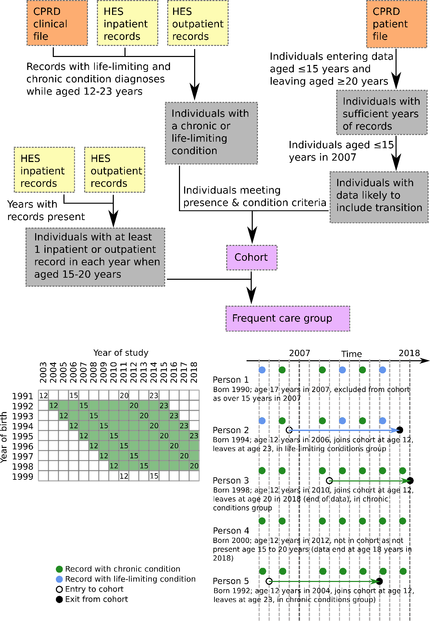
Figure 1: Cohort construction. Top: flow diagram showing use of primary care (CPRD) and hospital (HES) datasets. Bottom-left: matrix of year of birth versus study year, showing when individuals born in each year are potentially eligible (depending on diagnoses and continued presence in CRPD data) for cohort inclusion (green shading). Individuals must be aged 12-23 years, present from at least 15-20 years and no older than 15 years in 2007. Numbers in boxes indicate age in year. Bottom-right: example scenarios for inclusion and exclusion, including allocation to condition groups.

A subgroup was defined to include individuals with at least one secondary care record (inpatient or outpatient) in each year when aged 15 to 20 years - i.e. a group with frequent inpatient and/or outpatient appointments in the years in which transition was expected to take place. This group should have more data to estimate transition and be likely to feel the impacts of transition more strongly due to having a change in provider of regular hospital care. This groups is hereinafter referred to as the "Frequent Care group".

Data management
Data were managed using Microsoft SQL Server 2019.
Sex and year of birth were provided in CPRD data. Deprivation category (split into five groups from 1 - least deprived to 5 most deprived, using the Index of Multiple Deprivation 2010, based on the last known address of the individual(44)) was provided as linked data. Ethnic group (11 categories: Black African, Black Caribbean, Black Other, Chinese, Bangladeshi, Indian, Pakistani, Other Asian, White, Mixed or Other(45)) was recorded in the linked HES data, based on the census groups.(45) If an individual had more than one ethnic group recorded, it was set by CPRD to the most commonly recorded group, excluding unknown.(37) .

Estimation of transition point

Classification of care records as paediatric or adult
The estimation of a transition point from routine healthcare records requires the classification of records as either paediatric or adult. This information is not always explicit in the routine healthcare records, but both inpatient and outpatient records record the "treatment specialty" (the specialty under which treatment was provided) and the main specialty of the consultant in charge of care. These specialties are largely split into paediatric and adult groups from 2006/07 onwards, when a number of paediatric specialties were introduced to this dataset.(46)
Treatment and main consultant specialities were split into three categories: paediatric, adult and unclassified. This was initially based on specialty descriptions, then refined with some adult classifications being moved to undefined where, at the judgement of the authors, (i) the treatment specialty was unlikely to be the most common specialty for many individuals (e.g. Ear, Nose and Throat) and (ii) the specialty was frequently observed for children at ages under 14 years of age, which were considered unlikely to represent adult care.(17)
Classification of treatment and consultant main specialties as paediatric, adult or undefined is detailed in Supplementary Appendix II.

Approaches to estimating a transition point
Three main approaches were used to estimate transition age, with reference to suggestions identified in the literature(20) and following discussions with the Martin House Research Centre Family Advisory Board. These were:
- Setting the transition point as the last paediatric record (the "Last Paediatric" method)
- Setting the transition point as the first adult care record (the "First Adult" method)
- Setting the transition point such that it minimised the number of earlier records that were classified as adult and the number of later records that were classified as paediatric (the "Fitted" method)
Alternative approaches requiring a minimum number of adult records to be recorded to determine transition(20) were rejected as it was felt that these would discriminate between those with more and less frequent healthcare use (for example, if three adult records were required, a young person with three or more outpatient appointments each year would be judged to transition earlier than one with only one outpatient appointment each year, even if both transitioned at the same time).
The First Adult and Last Paediatric approaches are self-explanatory. For the Fitted approach, if an individual had N records in ascending date order then for each record, j (where j = 1,…,N), the following calculation was made, in which paed is 1 for a record classified as paediatric and 0 otherwise and adult is 1 for a record classified as adult and 0 otherwise:
$${Transition score}_{j}= \frac{\sum_{i=1}^{i=j-1}{{paed}_{i}+ \sum_{i=j+1}^{i=N}{{adult}_{i}}}}{N-1}$$
The transition point was the record with highest transition score. If there were ties then the mean date of the tied records was taken as the transition point.
In the event of a clear-cut transition, in which an individual had all records up to a point classified as paediatric and all records after that point classified as adult, the three methods are closely equivalent; differences become greater when there are either early or late records classified as adult or paediatric, respectively (Figure 1).

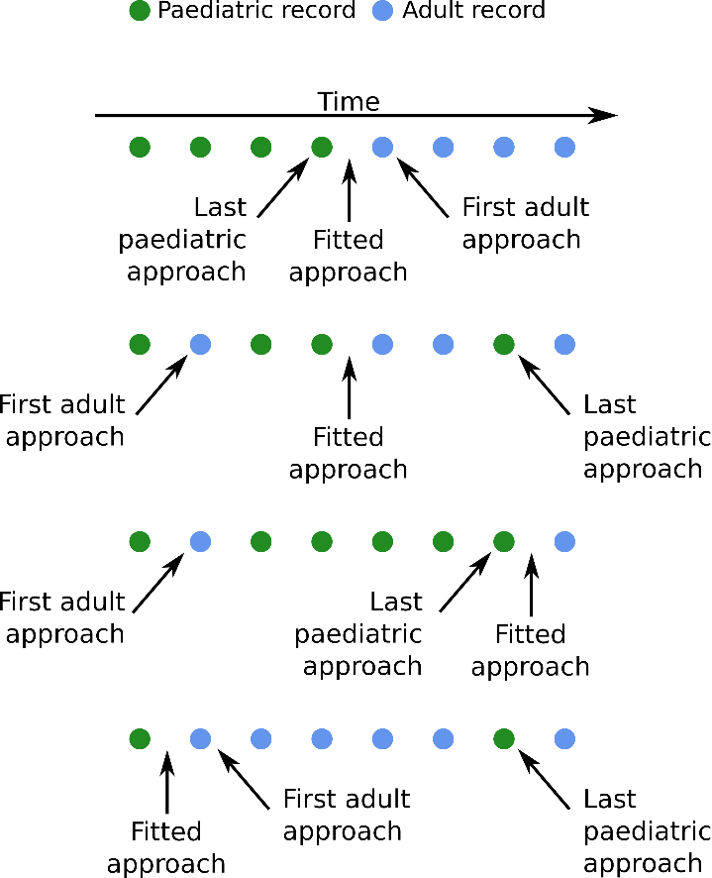
Figure 2: Estimation of transition points under different patterns of records (inpatient and outpatient) classified as paediatric or adult. For simplicity, no unclassified records are shown, as these do not influence estimation of transition point.

In all approaches, individuals had to have at least one paediatric and at least one adult record to have a transition point estimated. Individuals were then classified as in paediatric care in years before the year containing the transition point and in adult care in the year containing the transition point and later years (this on the basis that any disruption from transition to adult care begins with the transition).(12, 13, 17, 18)

Analyses

Cohort characteristics
The numbers of individuals in the cohort and in each sub-group were calculated and summarised graphically (Figure 3).

Record classification
The classification of records as either paediatric or adult was summarised by age and split by condition group and inpatient admissions and outpatient appointments.

Ability to estimate transition
The percentage of individuals in the cohort for whom a transition point could be determined (i.e. had at least one paediatric and one adult record) was calculated, for the whole cohort and the Frequent Care group, by year of birth.

Estimation of transition point
Age at transition was estimated for the whole cohort and the Frequent Care group, under the methods outlined above. These were presented graphically by method and density distributions of differences in transition age were compared pairwise between methods. Individuals for whom a transition point could not be estimated were excluded.

Impacts of estimating transition age from the data
Finally, a simulation was used to understand the possible impact of using different methods to estimate transition on an outcome that varied between paediatric and adult care.
Many healthcare outcomes of interest - for example, numbers of A&E visits, inpatient admissions, GP consultations or inpatient bed days are count data. Poisson distributions were used in the simulations as the source of notional outcome data pre- and post-transition, assumed to be counts of a healthcare event. A negative binomial distribution may be more realistic in many circumstances, to account for over dispersion, but adds complication by requiring not only specification of means for the pre- and post-transition distributions, but also their dispersion.(47) The pre-transition Poisson distribution mean was set to 2 (as a realistic mean for a healthcare event - GP consultations - in the population(48)) and the post-transition Poisson distribution mean was set to 2.4 (20% higher - clinically significant and also plausible at post-transition ages for GP consultations(48)).
Individuals in the cohort were each assigned five binary transition variables in each year, with 1 indicating adult and 0 indicating child, as follows:
- 0 in years prior to transition year as estimated by the Last Paediatric estimation method and 1 otherwise
- 0 in years prior to transition year as estimated by the First Adult estimation method and 1 otherwise
- 0 in years prior to transition year as estimated by the Fitted estimation method and 1 otherwise
- 0 in years prior to reaching age 16 years and 1 otherwise (i.e. transition set to age 16 years)
- 0 in years prior to reaching age 18 years and 1 otherwise (i.e. transition set to age 18 years)
Three outcome variables were assigned each year, one for each of the transition estimation methods. These were populated with counts drawn at random from the pre-transition Poisson distribution if the corresponding transition variable was 0 for that year and drawn from the post-transition distribution if the corresponding transition variable was 1 for that year (Table 1).

Table 1: Example (dummy) data for the simulation. Data are shown for a single individual, present from 2006 to 2013 aged 14 to 21 years. In each year the person has five binary transition variables, for the three estimation methods and transition set to age 16 and age 18 years. For this person, the First Adult approach estimates transition at 15 years, Last Paediatric approach estimates transition at 19 years and Fitted approach estimates transition at 17 years - indicated by 0 for children's care and 1 for adult care in the Trans_{FA}, Trans_{LP} and Trans_{Fit} variables, respectively. The three outcome variables have values drawn from the pre-transition Poisson distribution (P_{2.0}) where the corresponding transition variable is 0 and from the post-transition distribution (P_{2.4}) where the corresponding transition variable is 1. As a visual guide, post-transition observations are in bold type.
Year | Age | Trans_{FA} | Trans_{LP} | Trans_{Fit} | Trans₁₆ | Trans₁₈ | Outcome_{FA} | Outcome_{LP} | Outcome_{Fit}
2006 | 14 | 0 | 0 | 0 | 0 | 0 | P_{2.0} | P_{2.0} | P_{2.0}
2007 | 15 | 1 | 0 | 0 | 0 | 0 | P_{2.4} | P_{2.0} | P_{2.0}
2008 | 16 | 1 | 0 | 0 | 1 | 0 | P_{2.4} | P_{2.0} | P_{2.0}
2009 | 17 | 1 | 0 | 1 | 1 | 0 | P_{2.4} | P_{2.0} | P_{2.4}
2010 | 18 | 1 | 0 | 1 | 1 | 1 | P_{2.4} | P_{2.0} | P_{2.4}
2011 | 19 | 1 | 1 | 1 | 1 | 1 | P_{2.4} | P_{2.4} | P_{2.4}
2012 | 20 | 1 | 1 | 1 | 1 | 1 | P_{2.4} | P_{2.4} | P_{2.4}
2013 | 21 | 1 | 1 | 1 | 1 | 1 | P_{2.4} | P_{2.4} | P_{2.4}

Poisson regressions were then used to estimate associations between the count outcomes and the binary transition indicators, using only observations while aged 12 to 23 years and from the final two years of children's care and the first two years of adult care (as defined by the transition method used to assign outcomes - e.g. when comparing against the Last Paediatric method, years 2009-2012 would be used in Table 1). Used observations were restricted to this four year window as being of the most interest for identifying changes at transition (for example, data from ages 12 and 20 years might be of little interest for assessing impacts of a transition occurring at age 16 years, but data from ages 14, 15, 16 and 17 years would be more relevant). For each of the three outcome variables, five regressions were run, one each for each of the binary transition variables.
Individuals for whom a transition point could not be estimated were excluded from the simulation.
The sets of models were stratified by demographic variables (sex, deprivation category and ethnic group - the last collapsed to White and non-White due to small numbers) and condition group to explore the potential for systematic bias in using a fixed transition age. The Frequent Care group was also included as a sub group.
The process described above was repeated 10 000 times (with random draws each time from the appropriate Poisson distributions). The change in predicted events associated with transition according to the models was calculated as the mean across the 10 000 runs and the 95% confidence interval as the 2.5 and 97.5 percentiles.

Results

Cohort summary
There were 38352 individuals in the data who met the inclusion criteria (Figure 3); 1187 with life-limiting conditions and 37165 without life-limiting conditions but with other chronic conditions. 106 individuals who were eligible on other criteria were excluded due to death (and so leaving the dataset before age 20 years). Of these, 57 had chronic conditions recorded and 49 had life-limiting conditions recorded. 11376 had at least one inpatient or outpatient record in every year aged 15 to 20 years (Frequent Care group). 61% of young people in the cohort with a life-limiting condition were also in the Frequent Care group, compared to only 29% of cohort members with chronic conditions. There were more males than females in the cohort, but fewer males than females in the Frequent Care group. There were many cohort members with unknown ethnic group (27%) mainly due to these individuals lacking hospital records (the source of ethnic group data). In the Frequent Care group, with - by definition - hospital records, under 2% had unknown ethnic group. At least 67% of the whole cohort were known to be White; among those of known ethnic group 92% were White. The least deprived group was largest in the cohort, but the most deprived group was largest in the Frequent Care group.

Source data extract: 1 310 980 individuals
Remove those entering CPRD after age 15 or leaving (including death) before age 20 years
240 598 individuals

Remove those over 15 years in 2007
97 024 individuals
Remove those without a life-limiting or chronic condition diagnosis while aged 12 to 23 years

Cohort: 38 352 individuals
Deprivation group 1 (least deprived): 8421
Deprivation group 2: 7149
Deprivation group 3: 7406
Deprivation group 4: 7565
Deprivation group 5 (most deprived): 7800
Unknown: 20

Bangladeshi: 115
Black African: 198
Black Caribbean: 218
Black other: 167
Chinese: 40
Indian: 272
Mixed: 424
Pakistani: 357
Other Asian: 175
Other: 381
Mixed: 424
White: 25572
Unknown:10433

Males: 21420*
Females: 16930*
Unknown: ≤10

Life-limiting conditions: 1187
Other chronic conditions: 37165

Remove those without at least one inpatient or outpatient record each year when aged 15 to 20 years

Frequent Care group: 11 376 individuals
Deprivation group 1 (least deprived): 2170
Deprivation group 2: 1994
Deprivation group 3: 2157
Deprivation group 4: 2349
Deprivation group 5 (most deprived): 2696
Unknown: 10

Bangladeshi: 31
Black African: 79
Black Caribbean: 71
Black other: 65
Chinese: 13
Indian: 99
Mixed: 191
Pakistani: 121
Other Asian: 67
Other: 113
Mixed: 191
White: 10355
Unknown: 171

Males: 5340*
Females: 6030*
Unknown: ≤10

Life-limiting conditions: 725
Other chronic conditions: 10651

Figure 3: Cohort construction flow diagram showing inclusion criteria and data sources, with final sizes of cohort, Frequent Care group and the demographics in those groups. * indicates figures rounded to the nearest 10 to prevent disclosure of exact numbers with missing data.

Record classification
The classification of cohort member records is illustrated in Figure 4. Few records beyond age 19 years are classified as paediatric (although more in the life-limiting conditions group than in the chronic conditions group). Many records are classified as adult below 16 years of age (8% of all adult classifications were in records aged under 16 years). Inpatient records are more likely than outpatient records to be classified as paediatric below age 16 years, but make up only 14% of the total number of records.
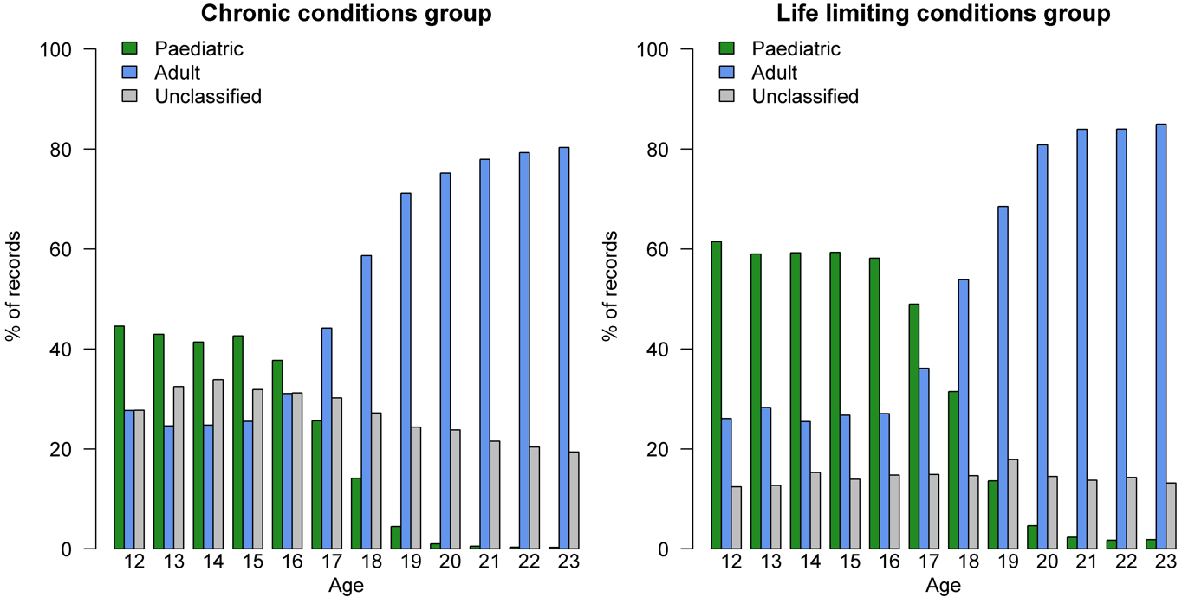
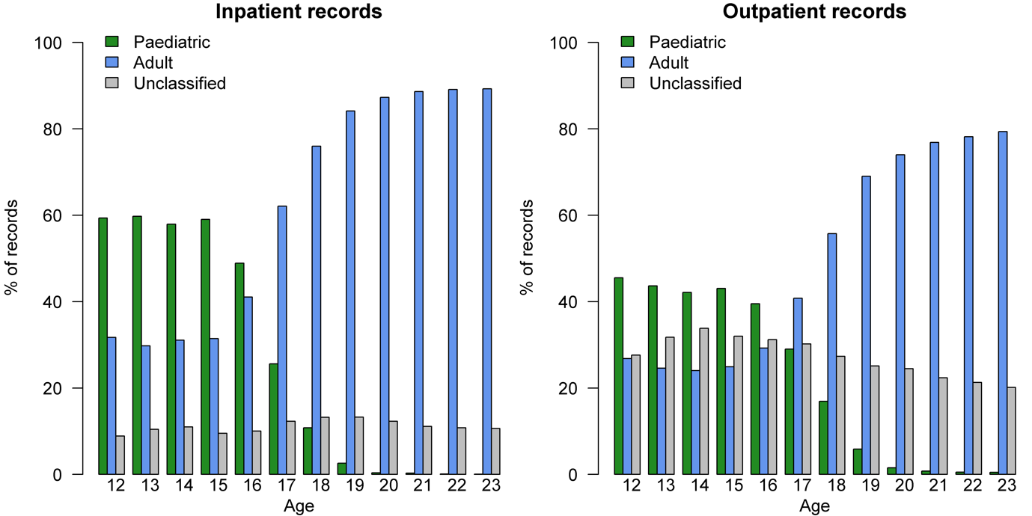Figure 4: Percentages of records classified as paediatric, adult or unclassified by age in the chronic conditions group (inpatient and outpatient records), the life-limiting conditions group (inpatient and outpatient records), among inpatient records (whole cohort) and among outpatient records (whole cohort).

Ability to estimate transition
The percentage of individuals for whom transition can be estimated (those with at least one paediatric record and at least one adult record) is illustrated in Figure 5. Transition can be estimated for more of those with life-limiting conditions than with chronic conditions and particularly so in the Frequent Care group - e.g .93% of those with life-limiting conditions in the Frequent Care group born in 1998 had an estimated transition point compared to 83% of those with life-limiting conditions in the whole cohort; for those with chronic conditions, corresponding figures are 64% (Frequent Care Group) and 37% (whole cohort).

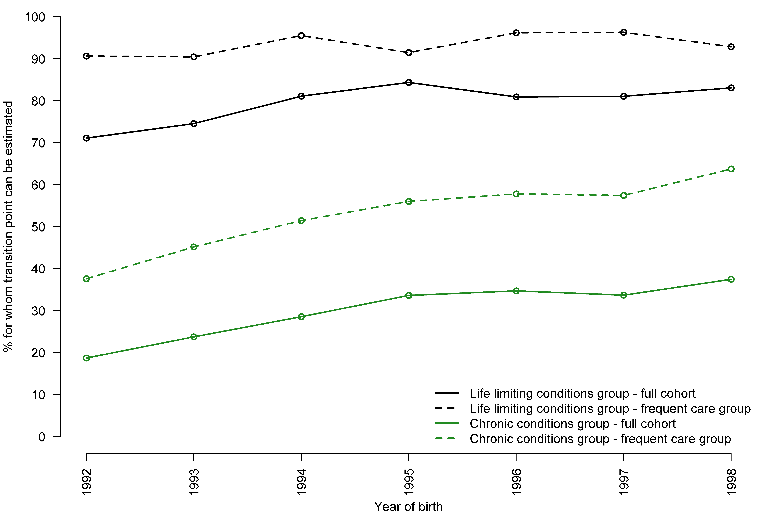
Figure 5: Proportions of children and young people for whom transition point can be estimated (i.e. the proportion having both paediatric and adult records). Split into chronic conditions and life-limiting conditions groups and further by whole cohort and Frequent Care group. Year of birth is limited to 1992 to 1998 as this defines the cohort (those born before 1992 were older than 15 years in 2007 and those born after 1998 had not reached 20 years in 2018 when the data end).

Estimation of transition point
Estimation methods are compared in Figure 6, for the whole cohort and Frequent Care group. Major differences for the whole cohort compared to the Frequent Care group are the higher number of late transitions (age 20 years or higher) when the First Adult approach is used and higher number of early transitions (age 13 years or lower) when the Last Paediatric approach is used. The First Adult approach estimates a large number (>20%) of early transitions for both the whole cohort and the Frequent Care group.

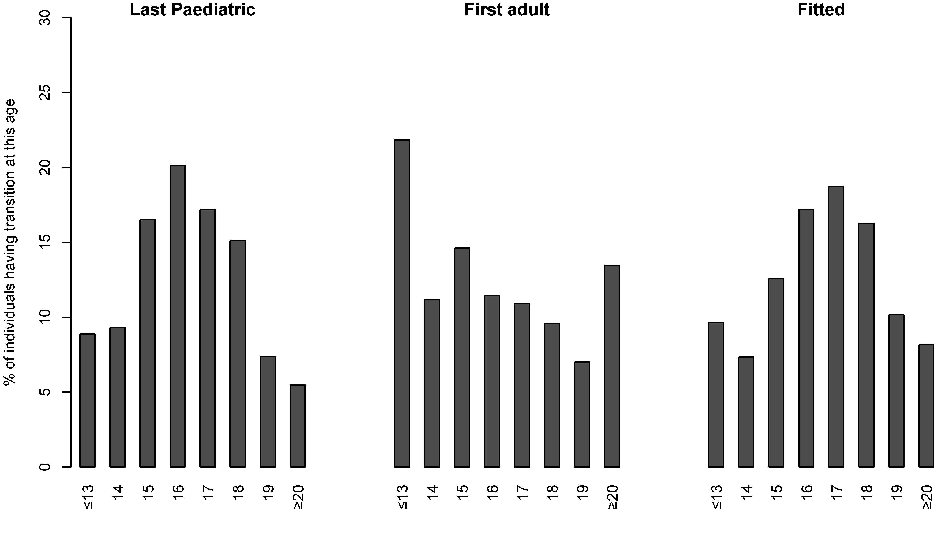
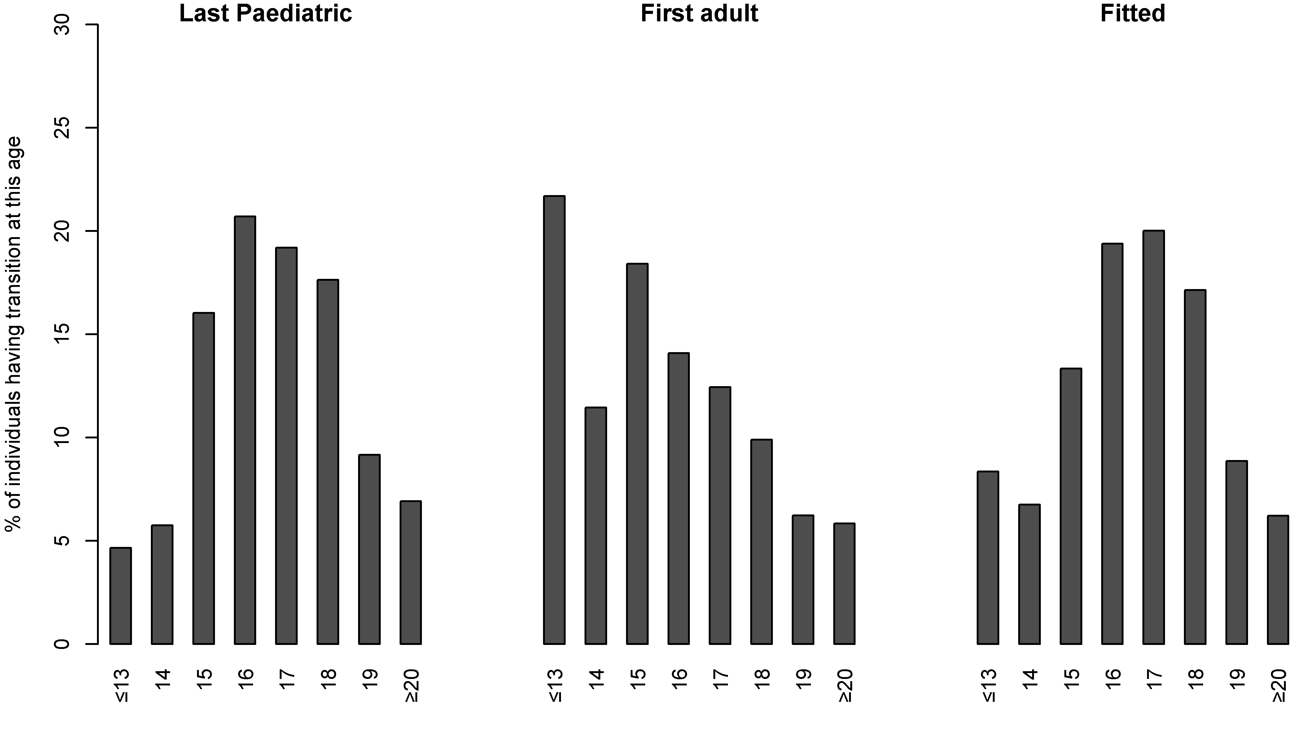
Figure 6: Distributions of age at transition points estimated using the three methods as a percentage of all individuals in the whole cohort (top panel) or Frequent Care group (lower panel)..
Distributions of differences in transition age estimated by the different methods are illustrated in Figure 7. Agreement between estimation methods is greater for the Frequent Care group than for the whole cohort (narrower distributions around 0 and a higher central peak close to 0), particularly when comparing the Last Paediatric and Fitted approaches. The Last Paediatric and Fitted approaches agree more closely than either do with the Last Adult approach.

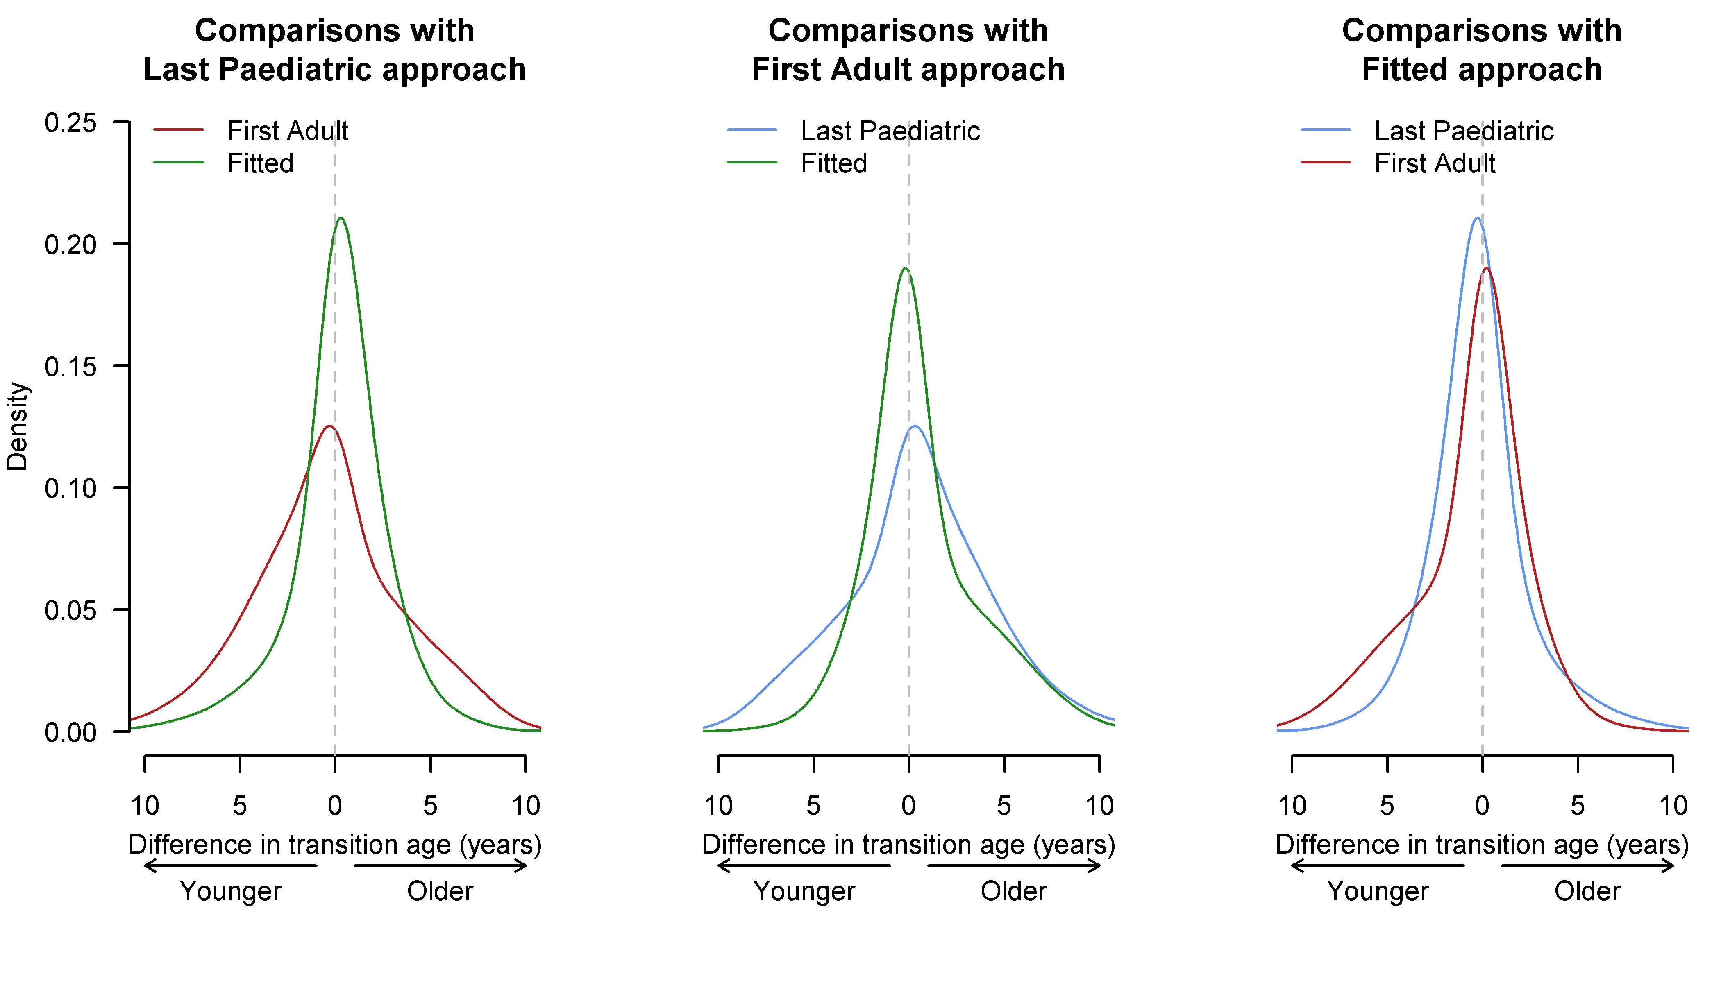
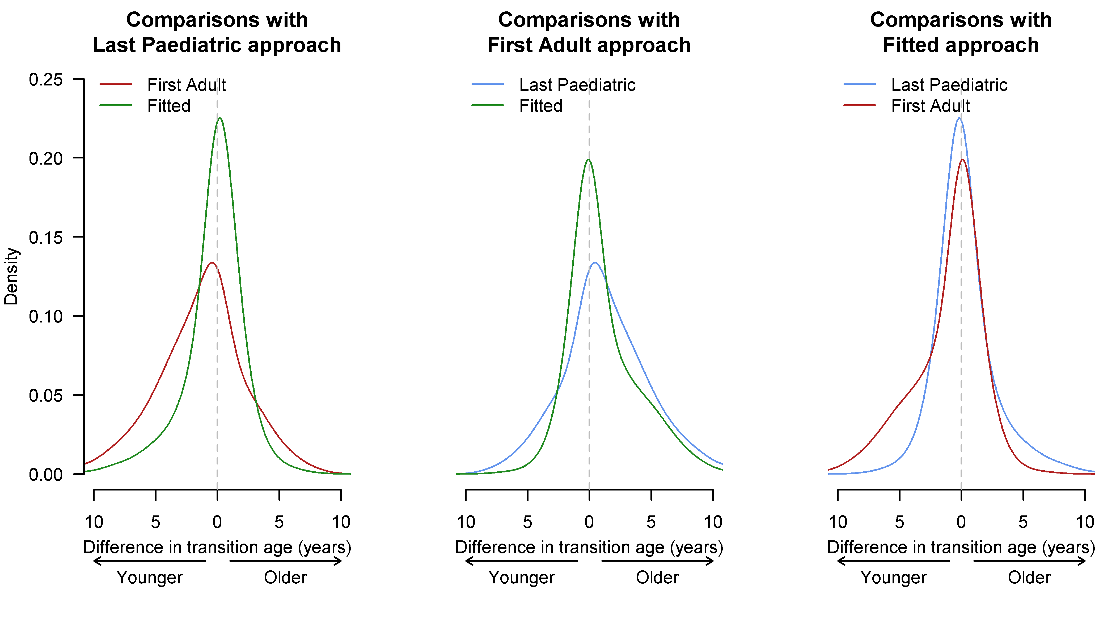
Figure 7: Density profiles for differences in age at estimated transition point between estimation methods, in pairwise comparisons. Top: whole cohort; Bottom: Frequent Care group.

Impacts of estimating transition point from the data
The results of the simulation, illustrating the potential impact of using the transition estimation methods set out above compared to a simple age cut-off at 16 or 18 years, are shown in Figure 8. Each panel shows the change in outcome event counts associated with transition for each of the methods with one of the estimation methods set as the 'true' transition (i.e. the outcome variable associated with that transition method is used - in Table 1, if the Last Paediatric approach is used as 'true' transition then Outcome_{LP} is used as the dependent variable in the regressions). Using a transition estimation method other than the one set as the 'true' transition point (e.g. using, from Table 1 Trans_{FA} as independent variable with Outcome_{LP} as dependent variable) results in underestimation of the transition effect. Depending on the estimate used as 'true' transition, use of a simple age cut-off underestimates the effect of transition by 70% or more in many cases. The Last Paediatric and Fitted Approaches underestimate by around 50-60% compared to each other. The First Adult Approach shows greatest underestimation compared to the Last Paediatric approach (75% or greater reductions).
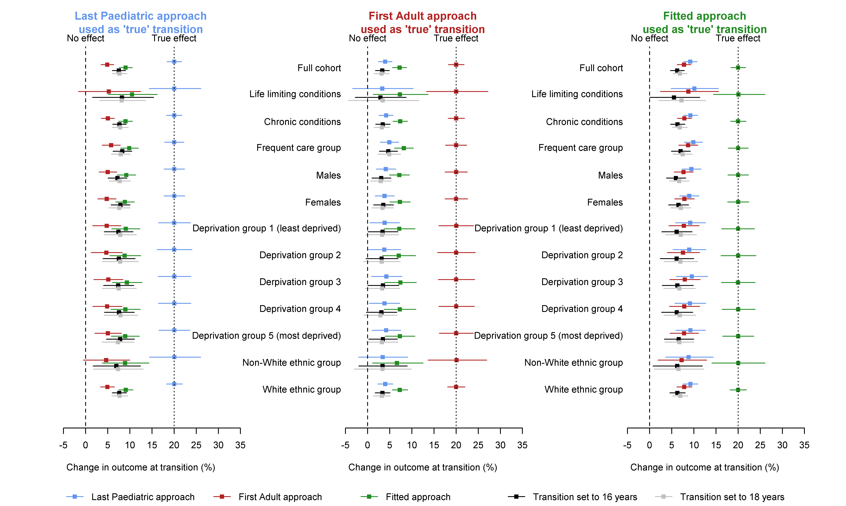
There is little evidence of differential bias between methods in sub groups of the cohort - underestimation is broadly similar between groups, at least within the confidence intervals with the studied data. However, the sample size in sub groups may be underpowered to detect any differences.
Figure 8: Observed changes associated with transition, from Poisson regressions of simulated outcomes for the whole cohort and indicated subgroups. Outcome counts post-transition were drawn from a Poisson distribution with mean 20% higher than the distribution used for pre-transition outcome counts. Change in outcome as measured by the model is shown for each estimation method and for transition assumed to be always at age 16 years or age 18 years. Horizontal bars show 95% confidence intervals.

Discussion
This study shows that the estimation of point of transition from paediatric to adult healthcare is feasible using national healthcare data from England. Estimating transition points from the data has advantages over using a simple age cut-off as it can provide greater sensitivity - the simulation shows that use of a simple age cut-off to assign transition status has the potential to markedly underestimate the association between transition status and an outcome, reducing point estimates of effect size by, in some cases, 70% or more. This is important for studying adverse outcomes associated with transition (e.g. increases in emergency inpatient admissions or A&E visits at transition) to help target interventions and also enables better differentiation between alternative care pathways in evaluations of interventions and policy changes.
Although transition estimation is feasible in many cases, for some individuals transition estimation is limited by an inability to correctly classify some records as paediatric or adult and/or a lack of secondary care records (Figure 5). Estimation is possible for many more individuals in the life-limiting conditions group than in the chronic conditions group and agreement between estimation methods is greater for those with at least one secondary care record each year (i.e. the Frequent Care group - those with more data on which to base the estimation, Figure 7).

Record classification and availability of children's' services
There are difficulties in classification of records using treatment specialty or consultant main specialty, with many records at ages likely to be pre-transition (i.e. under 14 years) classified as adult or unclassified. This is less of a problem for children with life-limiting conditions and for inpatient records. However, inpatient records make up only a small share of the available records and using these alone would prevent or limit transition estimation for young people with no or few inpatient records.
It appears that many children receive treatment from all-age rather than specialist children's services. Provision of paediatric services is known to vary,(49) but treatment centre information was not provided in the data, so could not be explored. Secondary care provision in the NHS in England may take place in specialist or teaching hospitals serving large communities (often large cities) and have paediatric and adult departments for many specialties or may take place in smaller District General Hospitals, which may not have as many separate adult and paediatric departments.(49, 50) It may be appropriate for a child to be treated in an all-age department in the local hospital rather than travelling further for a specialist paediatric service, depending on care needs, although there are concerns about training.(50) This has implications not only for estimating transition, but also, potentially, for care quality and outcomes (51-56) and may raise many of the same issues as transition itself.(17, 18)

Ability to estimate transition
Transition can be estimated for the majority of young people with life-limiting conditions, particularly for those with at least one inpatient or outpatient record each year. This is important as this group is most likely to experience any impacts of transition, being in receipt of frequent health care - often from a number of providers, many of whom change at transition.(17, 18). Estimation is possible for fewer of those with chronic (but non-life-limiting) conditions, mainly due to a lack of records, but also due to a lack of classifiable records. Even among those with a record in each year from 15 to 20 years of age only a maximum of 63% (for those born in 1998) of those with a non-life-limiting chronic condition could have a transition point estimated. This may be due to treatment in all-age services, as discussed above. Chronic conditions are a broad group and some conditions will have transition estimated much more readily than others due to differences in hospital use.(57, 58) Asthma, for example, was included, but for many young people this can be managed in primary care without hospital visits.(59) There is however an upward trend in the share of those with chronic conditions for whom transition can be estimated; estimation may be possible for more of those born after 1998 as more data become available.

Comparison of estimation methods
The transition methods cannot be compared against a gold standard (as none exists for these data(20)) but only against each other and with reference to the issues outlined above.
The First Adult approach is limited by the large number of records classified as adult at ages unlikely to represent adult care (e.g. under 14 years). One strategy to compensate for this might be to add an age cut-off below which a record cannot be classified as adult. The difficulty here is in where to apply that cut-off.(20) Also, for the First Adult approach, the large number of records in childhood that are classified as adult records would mean that the age cut-off would, for many individuals, simply become the estimated age of transition and make it similar to the simpler approaches of using a universal age cut-off. The limitations in record classification mean that the First Adult approach should not be used for these data.
The Fitted Approach will also be influenced by the presence of early adult records, but to a lesser extent, due to also taking into account later paediatric records.
The Last Paediatric approach is much less affected by early adult records - they have no direct relevance, although incorrect classification of a paediatric record as adult could move the last paediatric record to a younger age.
The estimation approaches should also be considered in relation to experience of care. While it is easy to imagine a child pre-transition being occasionally treated in adult services as discussed above, it seems much less likely that an adult, formally transitioned to adult care, would receive further treatment in a paediatric setting (although this is not completely unknown(27, 28)). There is an argument for favouring the Last Paediatric approach over the Fitted approach as it provides a transition point that is clearly defined by an experienced event (last paediatric appointment). It is at this point that access to familiar paediatric experts that the family and young person may have developed a relationship with over many years is withdrawn, so may have the most relevance to assessment of changes in healthcare use related to the changes at transition. The other approaches identify transition points at which the family and young person may still have access to the familiar paediatric services in addition to adult services. Discussions with the Martin House Research Centre Family Advisory Board suggest that this may reflect experience better than the Fitted Approach which places transition in the middle of that process. This - and its lower sensitivity to the presence young-age records classified as adult - suggests that the Last Paediatric method should be the favoured approach for these data.

Impact of estimation of transition
Use of a simple age cut-off appears likely to underestimate the association between transition status and an outcome, but the simulations do not provide evidence that it does this more for one group than another. It should be noted that some of the groups are small and this may mask differences, particularly for ethnic group where small numbers meant that only White and non-White groups were compared. There may also be systematic differences in transition age between particular conditions or by region, but there were insufficient data available in this study to explore this. Small groups with wider confidence intervals will, of course, be more likely to have confidence intervals including no effect if underestimation of effect size occurs. It is therefore possible that use of a simple age cut-off might result not only in underestimation of an association, but also in the conclusion that there is no statistically significant association at all.
There are also large differences in the simulation between the estimation methods, particularly between the Last Paediatric and First Adult approaches. The Fitted and Last Paediatric approaches do however give results more similar to each other than either compared to a simple age cut-off.
The transition estimates used as 'true' transition in the simulations will include their own errors (they will not be free of misclassification bias) and so the simulations are likely to provide an overestimate of the benefits of estimating transition. They do however highlight the importance of correctly assigning transition status.

Strengths and limitations
This study used a nationally representative sample of primary care and hospital data. Although developed using data from England, the methods are directly applicable to the other nations in the United Kingdom, with similar health services and healthcare records. The methods could be adapted to healthcare data from any country in there is a transition from paediatric to adult healthcare and in which records may be classified as paediatric or adult. Different healthcare systems, with different record information, may require different classification schemes, but the methods of estimating transition from classified records should be transferable. Different conclusions may be drawn about the most effective estimation approach in data for other countries, particularly if transition policy differs.
The Martin House Research Centre Family Advisory Board was consulted before and after analyses and helped to put the results in context and understand the real-world experience of transition and applicability of the possible methods. The estimation methods explored here arise from suggestions in the literature and discussions of healthcare transition with the Martin House Research Centre Family Advisory Board and were chosen to be meaningful with respect to young people's and families' experiences of transition.
There are also limitations, particularly in relation to the data. Splitting of main treatment specialty into paediatric and adult specialties only became widespread in England in 2007. This limits the ability to estimate transition for anyone reaching transition ages before this point as data may be incomplete. This was mitigated by excluding individuals older than 15 years in 2007, but at the expense of reducing sample size. Requirements on years present (15 to 20 years of age) also mean those who died before age 20 were excluded. Those that die before transition are not relevant to analysis of transition (as transition does not take place) but there is a significant number of young people with life-limiting conditions dying between ages 16 and 20 years, who may transition before death.(60) These (49, 4% of those with life-limiting conditions eligible for inclusion under other criteria) were excluded in this study, due to a pragmatic decision to construct a cohort for whom transition was likely to have taken place within years of available data, but there is no reason why the methods set out here could not also be applied to these individuals.
The data used also have potential issues with individuals entering and leaving the cohort due to changing GP practice from an included practice to an excluded practice. Individuals who moved practice between 15 and 20 years of age would be excluded from this study and may have different characteristics to those who remained at the same practice. Young people leaving home for work or higher education at 18 years may move GP practice and be lost from the data (possibly less of an issue for the group with life-limiting conditions for whom it may be more common to remain in the family home post-18).
Any comparison of post- and pre-transition care requires transition point to be defined, but there may not be a single well defined point of healthcare transition for all individuals.(27) As noted by the Centre's Family Advisory Board, there are a number of other disruptive transitions beyond healthcare, such as transitions in social care, education and availability of health related benefits and support.(61) This study, using healthcare data, was unable to explore any of these issues, but they should be kept in mind when studying effects of healthcare transition as alternative or additional potential causes of observed changes.

Future research
This study demonstrates the feasibility of using routinely collected healthcare data to estimate the transition point from paediatric to adult care, with potential to improve sensitivity when assessing changes in care events associated with the transition. These methods should be applied in future research evaluating the impacts of transition, enabling use of large, nationally representative datasets with reduced risk of misclassification bias. Comparisons should also be made with use of a simple age cut-off to assess impact across a range of real-world healthcare event outcomes. Beyond the UK, the approaches outlined here should be adapted and evaluated for data from other countries that include indications of paediatric of adult care in healthcare records.
The estimation methods could also be applied to other transitions, in healthcare and beyond, for any data that include records that can be classified into two or more states. They could be used to explore transitions between health states and stages of condition, using - for example - presence or absence of particular medications.

Conclusion
The estimation of the transition point from paediatric to adult healthcare from routine healthcare data is feasible and appears to offer advantages over the use of a simple age cut-off when assessing changes in outcomes associated with transition. Among approaches explored here, using the last paediatric record to define the transition is least sensitive to known limitations of the data and may better reflect the point at which transition is experienced. These methods should be used to enable studies of transition and transition interventions in nationally representative routinely collected healthcare data with reduced risk of misclassification bias.

Acknowledgements
The authors wish to acknowledge the role of the Martin House Research Centre Family Advisory Board in discussions on transition the proposed methods for estimating transition point.
Stuart Jarvis is funded by a National Institute for Health Research (NIHR) Doctoral Research Fellowship (award DRF-2018-11-ST2-013) for this research project. This publication presents independent research funded by the National Institute for Health Research (NIHR). The views expressed are those of the authors and not necessarily those of the NHS, the NIHR or the Department of Health and Social Care. Lorna Fraser is funded by a National Institute for Health Research (NIHR) Career Development Fellowship (award CDF-2018-11-ST2-002) for this research project. This publication presents independent research funded by the National Institute for Health Research (NIHR). The views expressed are those of the authors and not necessarily those of the NHS, the NIHR or the Department of Health and Social Care.

Conflicts of interest
The authors have no competing interests to declare.

Ethics Statement
The study was covered by general ethical approval (ref: 05/MRE04/87) for studies using Clinical Practice Research Datalink data for observational research approved by its Independent Scientific Advisory Committee (ISAC). This study was approved by ISAC (protocol ref: 19_215R).

Supplementary Appendices
Supplementary Appendix I contains details of the coding framework used to identify long term conditions (life-limiting conditions and non-life-limiting chronic conditions).
Supplementary Appendix II contains details of the classification system used to identify paediatric and adult records.

References
1. Müller C, Lautenschläger S, Meyer G, Stephan A. Interventions to support people with dementia and their caregivers during the transition from home care to nursing home care: A systematic review. International Journal of Nursing Studies. 2017;71:139-52. https://www.sciencedirect.com/science/article/pii/S002074891730086X
2. Scott M, Shaver N, Lapenskie J, Isenberg SR, Saunders S, Hsu AT, et al. Does inpatient palliative care consultation impact outcomes following hospital discharge? A narrative systematic review. Palliative medicine. 2019;34(1):5-15. https://doi.org/10.1177/0269216319870649
3. Rodrigues CR, Harrington AR, Murdock N, Holmes JT, Borzadek EZ, Calabro K, et al. Effect of Pharmacy-Supported Transition-of-Care Interventions on 30-Day Readmissions: A Systematic Review and Meta-analysis. Annals of Pharmacotherapy. 2017;51(10):866-89. https://doi.org/10.1177/1060028017712725
4. Murray J, Hardicre N, Birks Y, O’Hara J, Lawton R. How older people enact care involvement during transition from hospital to home: A systematic review and model. Health Expectations. 2019;22(5):883-93. https://doi.org/10.1111/hex.12930
5. Nightingale R, McHugh G, Kirk S, Swallow V. Supporting children and young people to assume responsibility from their parents for the self-management of their long-term condition: An integrative review. Child: Care, Health and Development. 2019;45(2):175-88. https://doi.org/10.1111/cch.12645
6. Straub DM, Tanner AE. Health-care transition from adolescent to adult services for young people with HIV. The Lancet Child & Adolescent Health. 2018;2(3):214-22. https://doi.org/10.1016/S2352-4642(18)30005-1
7. Dallimore DJ, Neukirchinger B, Noyes J. Why is transition between child and adult services a dangerous time for young people with chronic kidney disease? A mixed-method systematic review. PLOS ONE. 2018;13(8):e0201098. https://doi.org/10.1371/journal.pone.0201098
8. Kerr H, Price J, Nicholl H, O’Halloran P. Transition from children’s to adult services for young adults with life-limiting conditions: A realist review of the literature. International Journal of Nursing Studies. 2017;76:1-27. http://www.sciencedirect.com/science/article/pii/S0020748917301384
9. Coyne B, Hallowell SC, Thompson M. Measurable Outcomes After Transfer From Pediatric to Adult Providers in Youth With Chronic Illness. Journal of Adolescent Health. 2017;60(1):3-16. http://www.sciencedirect.com/science/article/pii/S1054139X1630177X
10. Coyne B, Hollen PJ, Yan G, Barcia J, Brayman K. Post-Transfer Predictors of Poor Outcomes in Pediatric Renal Transplant Recipients. Nephrology Nursing Journal. 2017;44(2):119-30. https://pubmed.ncbi.nlm.nih.gov/29165963/
11. Coyne I, Sheehan AM, Heery E, While AE. Improving transition to adult healthcare for young people with cystic fibrosis: A systematic review. Journal of Child Health Care. 2017;21(3):312-30. https://journals.sagepub.com/doi/abs/10.1177/1367493517712479
12. Coyne IT, Sheehan AM, Heery E, While AE. A systematic review of outcomes and experiences of transition from paediatric to adult healthcare services for young people with cystic fibrosis. Journal of Cystic Fibrosis. 2016;15 (Supplement 1):S106. https://www.sciencedirect.com/science/article/pii/S156919931630457X
13. Heery E, Sheehan AM, While AE, Coyne I. Experiences and Outcomes of Transition from Pediatric to Adult Health Care Services for Young People with Congenital Heart Disease: A Systematic Review. Congenital Heart Disease. 2015;10(5):413-27. https://onlinelibrary.wiley.com/doi/abs/10.1111/chd.12251
14. Sheehan AM, While AE, Coyne I. The experiences and impact of transition from child to adult healthcare services for young people with Type 1 diabetes: a systematic review. Diabetic Medicine. 2015;32(4):440-58. https://doi.org/10.1111/dme.12639
15. Rachas A, Lefeuvre D, Meyer L, Faye A, Mahlaoui N, de La Rochebrochard E, et al. Evaluating Continuity During Transfer to Adult Care: A Systematic Review. Pediatrics. 2016;138(1):e20160256. http://pediatrics.aappublications.org/content/138/1/e20160256.abstract
16. Campbell F, Biggs K, Aldiss SK, O'Neill PM, Clowes M, McDonagh J, et al. Transition of care for adolescents from paediatric services to adult health services. The Cochrane database of systematic reviews. 2016;4:Cd009794. https://www.cochranelibrary.com/cdsr/doi/10.1002/14651858.CD009794.pub2/
17. Care Quality Commission. From the pond into the sea. Children's transition to adult health services. London: Care Quality Commission. 2014. https://www.cqc.org.uk/sites/default/files/CQC_Transition%20Report.pdf
18. Lemer C. Annual report of the Chief Medical Officer 2012: our children deserve better: prevention pays. 2013. https://assets.publishing.service.gov.uk/government/uploads/system/uploads/attachment_data/file/255237/2901304_CMO_complete_low_res_accessible.pdf
19. White PH, Cooley WC. Supporting the Health Care Transition From Adolescence to Adulthood in the Medical Home. Pediatrics. 2018;142(5):e20182587. http://pediatrics.aappublications.org/content/142/5/e20182587.abstract
20. Shulman R, Cohen E, Benchimol EI, Nakhla M. Methods for Measuring the Time of Transfer from Pediatric to Adult Care for Chronic Conditions Using Administrative Data: A Scoping Review. Clinical Epidemiology. 2020;12:691-8. https://www.ncbi.nlm.nih.gov/pmc/articles/PMC7335294/
21. Wisk LE, Finkelstein JA, Sawicki GS, Lakoma M, Toomey SL, Schuster MA, et al. Predictors of timing of transfer from pediatric- to adult-focused primary care. JAMA Pediatr. 2015;169(6):e150951-e. https://pubmed.ncbi.nlm.nih.gov/26030515
22. Mannion ML, Xie F, Baddley J, Chen L, Curtis JR, Saag K, et al. Analysis of health care claims during the peri-transfer stage of transition from pediatric to adult care among juvenile idiopathic arthritis patients. Pediatric Rheumatology. 2016;14(1):49. https://doi.org/10.1186/s12969-016-0107-3
23. Jarvis SW, Roberts D, Flemming K, Richardson G, Fraser LK. Transition of children with life-limiting conditions to adult care and healthcare use: a systematic review. Pediatric Research. 2021. https://doi.org/10.1038/s41390-021-01396-8
24. Herrett E, Gallagher AM, Bhaskaran K, Forbes H, Mathur R, van Staa T, et al. Data Resource Profile: Clinical Practice Research Datalink (CPRD). International journal of epidemiology. 2015;44(3):827-36. http://www.ncbi.nlm.nih.gov/pmc/articles/PMC4521131/
25. Herbert A, Wijlaars L, Zylbersztejn A, Cromwell D, Hardelid P. Data Resource Profile: Hospital Episode Statistics Admitted Patient Care (HES APC). International journal of epidemiology. 2017;46(4):1093-i. https://doi.org/10.1093/ije/dyx015
26. Le Roux E, Mellerio H, Guilmin-Crépon S, Gottot S, Jacquin P, Boulkedid R, et al. Methodology used in comparative studies assessing programmes of transition from paediatrics to adult care programmes: a systematic review. BMJ open. 2017;7(1):e012338. http://bmjopen.bmj.com/content/7/1/e012338.abstract
27. Goodman DM, Hall M, Levin A, Watson RS, Williams RG, Shah SS, et al. Adults With Chronic Health Conditions Originating in Childhood: Inpatient Experience in Children's Hospitals. Pediatrics. 2011;128(1):5-13. https://pediatrics.aappublications.org/content/128/1/5.short
28. Okumura MJ, Campbell AD, Nasr SZ, Davis MM. Inpatient health care use among adult survivors of chronic childhood illnesses in the United States. Archives of pediatrics & adolescent medicine. 2006;160(10):1054-60. https://jamanetwork.com/journals/jamapediatrics/fullarticle/205584
29. Bollegala N, Benchimol EI, Griffiths AM, Kovacs A, Steinhart AH, Zhao X, et al. Characterizing the Posttransfer Period Among Patients with Pediatric Onset IBD: The Impact of Academic Versus Community Adult Care on Emergent Health Resource Utilization. Inflammatory bowel diseases. 2017;23(9):1483-91. https://academic.oup.com/ibdjournal/article/23/9/1483/4560708
30. Hale D, Hargreaves DS. G150 Predictors and outcomes of successful transition in diabetes: A national study of system performance using routine hospital administrative data. Archives of disease in childhood. 2017;102(Suppl 1):A61. http://adc.bmj.com/content/102/Suppl_1/A61.3.abstract
31. Zhao X, Bjerre LM, Nguyen GC, Mack DR, Manuel DG, Hawken S, et al. Health Services Use during Transition from Pediatric to Adult Care for Inflammatory Bowel Disease: A Population-Based Study Using Health Administrative Data. J Pediatr. 2018;203:280-7.e4. https://www.jpeds.com/article/S0022-3476(18)31146-6/abstract
32. Prior M, McManus M, White P, Davidson L. Measuring the “Triple Aim” in Transition Care: A Systematic Review. Pediatrics. 2014. http://pediatrics.aappublications.org/content/early/2014/11/18/peds.2014-1704.abstract
33. Gabriel P, McManus M, Rogers K, White P. Outcome Evidence for Structured Pediatric to Adult Health Care Transition Interventions: A Systematic Review. J Pediatr. 2017;188:263-9.e15. https://www.jpeds.com/article/S0022-3476(17)30759-X/abstract
34. Bhawra J, Toulany A, Cohen E, Moore Hepburn C, Guttmann A. Primary care interventions to improve transition of youth with chronic health conditions from paediatric to adult healthcare: a systematic review. BMJ open. 2016;6(5):e011871. http://bmjopen.bmj.com/content/6/5/e011871.abstract
35. Crowley R, Wolfe I, Lock K, McKee M. Improving the transition between paediatric and adult healthcare: a systematic review. Archives of disease in childhood. 2011;96. http://dx.doi.org/10.1136/adc.2010.202473
36. Martin House Research Centre. The Martin House Research Centre’s Public Involvement and EngagementStrategy: November2019 –December 2021. York: University of York; 2019. https://www.york.ac.uk/media/healthsciences/documents/research/public-health/mhrc/MHRC%20PPI%20Strategy%202019-2021.pdf
37. Clinical Practice Research Datalink. Hospital Episode Statistics (HES) Admitted Patient Care and CPRD Primary Care Data Documentation (Set 21). Medicines & Healthcare products Regulatory Agency; 2021. https://www.cprd.com/sites/default/files/Documentation_HES_APC_set21.pdf
38. World Health Organisation. International Statistical Classification of Diseases and Related Health Problems. 10 ed. Geneva, Switzerland: World Health Organisation; 1992. https://icd.who.int/browse10/2019/en
39. Jarvis S, Parslow RC, Hewitt C, Mitchell S, Fraser LK. GPs’ role in caring for children and young people with life-limiting conditions: a retrospective cohort study. British Journal of General Practice. 2020;70(693):e221. http://bjgp.org/content/70/693/e221.abstract
40. Fraser LK, Miller M, Hain R, Norman P, Aldridge J, McKinney PA, et al. Rising national prevalence of life-limiting conditions in children in England. Pediatrics. 2012;129(4):e923-9. http://www.ncbi.nlm.nih.gov/pubmed/22412035
41. Hardelid P, Dattani N, Davey J, Pribramska I, Gilbert R. Overview of child deaths in the four UK countries. London: Royal College of Paediatrics and Child Health; 2013. https://www.rcpch.ac.uk/sites/default/files/CHR-UK_-_Retrospective_Epidemiological_Review_of_All-cause_Mortality_in_CYP.pdf
42. Hardelid P, Dattani N, Gilbert R. Estimating the prevalence of chronic conditions in children who die in England, Scotland and Wales: a data linkage cohort study. BMJ open. 2014;4(8). http://bmjopen.bmj.com/content/4/8/e005331.abstract
43. Chambers L. A guide to children’s palliative care. 4 ed. Bristol: Together for Short Lives; 2018. https://www.togetherforshortlives.org.uk/wp-content/uploads/2018/03/TfSL-A-Guide-to-Children%E2%80%99s-Palliative-Care-Fourth-Edition-5.pdf
44. Indices of Deprivation 2007 [Internet]. Office for National Statistics. 2007. http://data.gov.uk/dataset/index_of_multiple_deprivation_imd_2007.
45. NOMIS. Census 2011 - Ethnic group by sex by age. NOMIS; 2013. https://www.nomisweb.co.uk/census/2011/dc2101ew
46. NHS Digital. Hospital Episode Statistics - Admitted Patient Care: Health & Social Care Information Centre; 2020. https://digital.nhs.uk/data-and-information/data-tools-and-services/data-services/hospital-episode-statistics/hospital-episode-statistics-data-dictionary
47. Bland M. Dealng with counts: Poisson regression and negative binomial regression. An introduction to medical statistics: Oxford University Press (UK); 2015. p. 240-4.
48. Hobbs FDR, Bankhead C, Mukhtar T, Stevens S, Perera-Salazar R, Holt T, et al. Clinical workload in UK primary care: a retrospective analysis of 100 million consultations in England, 2007-14. The Lancet. 2016;387(10035):2323-30. http://dx.doi.org/10.1016/S0140-6736(16)00620-6
49. Wolfe I, Sigfrid L, Chanchlani N, Lenton S. Child health systems in the United Kingdom (England). The Journal of pediatrics. 2016;177:S217-S42. https://www.jpeds.com/article/S0022-3476(16)30164-0/pdf
50. Mason DG, Shotton H, Wilkinson KA, Gough MJ, Alleway R, Freeth H, et al. Children&#039;s surgery: a national survey of consultant clinical practice. BMJ open. 2012;2(5):e001639. http://bmjopen.bmj.com/content/2/5/e001639.abstract
51. Taylor J, Booth A, Beresford B, Phillips B, Wright K, Fraser L. Specialist paediatric palliative care for children and young people with cancer: A mixed-methods systematic review. Palliative medicine. 2020;34(6):731-75. https://doi.org/10.1177/0269216320908490
52. Tiboni S, Bhangu A, Hall NJ, Panagiotopoulou IG, Chatzizacharias N, Rana M, et al. Outcome of appendicectomy in children performed in paediatric surgery units compared with general surgery units. British Journal of Surgery. 2014;101(6):707-14. https://doi.org/10.1002/bjs.9455
53. Whisker L, Luke D, Hendrickse C, Bowley DM, Lander A. Appendicitis in children: a comparative study between a specialist paediatric centre and a district general hospital. Journal of pediatric surgery. 2009;44(2):362-7. https://bmjpaedsopen.bmj.com/content/4/1/e000831
54. Somme S, To T, Langer JC. Effect of subspecialty training on outcome after pediatric appendectomy. Journal of pediatric surgery. 2007;42(1):221-6. https://www.sciencedirect.com/science/article/pii/S0022346806006828
55. Watson TA, Barber J, Woodley H. Paediatric gastrointestinal and hepatobiliary radiology: why do we need subspecialists, and what is new? Pediatric Radiology. 2021;51(4):554-69. https://doi.org/10.1007/s00247-020-04778-y
56. Negus S, Danin J, Fisher R, Johnson K, Landes C, Somers J, et al. Paediatric trauma imaging: Why do we need separate guidance? Clinical Radiology. 2014;69(12):1209-13. https://www.sciencedirect.com/science/article/pii/S0009926014003535
57. Wijlaars LPMM, Gilbert R, Hardelid P. Chronic conditions in children and young people: learning from administrative data. Archives of disease in childhood. 2016;101(10):881. http://adc.bmj.com/content/101/10/881.abstract
58. Wijlaars LPMM, Hardelid P, Guttmann A, Gilbert R. Emergency admissions and long-term conditions during transition from paediatric to adult care: A cross-sectional study using Hospital Episode Statistics data. BMJ open. 2018;8 (6) https://bmjopen.bmj.com/content/8/6/e021015
59. Thomas M, Kocevar VS, Zhang Q, Yin DD, Price D. Asthma-Related Health Care Resource Use Among Asthmatic Children With and Without Concomitant Allergic Rhinitis. Pediatrics. 2005;115(1):129. http://pediatrics.aappublications.org/content/115/1/129.abstract
60. Gibson-Smith D, Jarvis SW, Fraser LK. Place of death of children and young adults with a life-limiting condition in England: a retrospective cohort study. Archives of disease in childhood. 2020:archdischild-2020-319700. http://adc.bmj.com/content/early/2020/12/20/archdischild-2020-319700.abstract
61. Noyes J, Pritchard S, Pritchard A, Bennett V, Rees S. Conflicting realities experienced by children with life‐limiting and life‐threatening conditions when transitioning to adult health services. Journal of Advanced Nursing. 2018;74(12):2871-81. https://doi.org/10.1111/jan.13811

Abbreviations
APC - Admitted patient care
A&E - Accident and Emergency
CPRD - Clinical Practice Research Datalink
GP - General Practitioner
HES - Hospital Episodes Statistics
ICD-10 - International Classification of Diseases 10th Revision
ISAC - Independent Scientific Advisory Committee
NHS - National Health Service
NIHR - National Institute for Health Research
SQL - Structured Query Language

