The Rising Powers in Mozambique: Growing High Carbon Partnerships?

With the recent discovery of significant coal and gas resources, Mozambique has gained attention as an emerging energy frontier. Yet the impending coal and gas boom presents a range of logistical and political challenges for the southern African nation, which emerged from colonial rule in 1975 and civil war in 1992. In particular, recent offshore gas finds in the Rovuma Basin, on the northern border with Tanzania, could make Mozambique one of the world’s largest exporters of liquefied natural gas (LNG). Production is set for 2020, but by then analysts expect a glut on global gas markets, and infrastructure gaps are considerable. Nevertheless, the coal and gas rush will likely contribute to export growth while spurring investments in domestic power generation in the coming years. Rising Powers actors are deepening their role in Mozambique’s hydrocarbons industries, extending the possibilities of development-centred cooperation while pushing it onto a high-carbon energy pathway.

The Rise of Coal

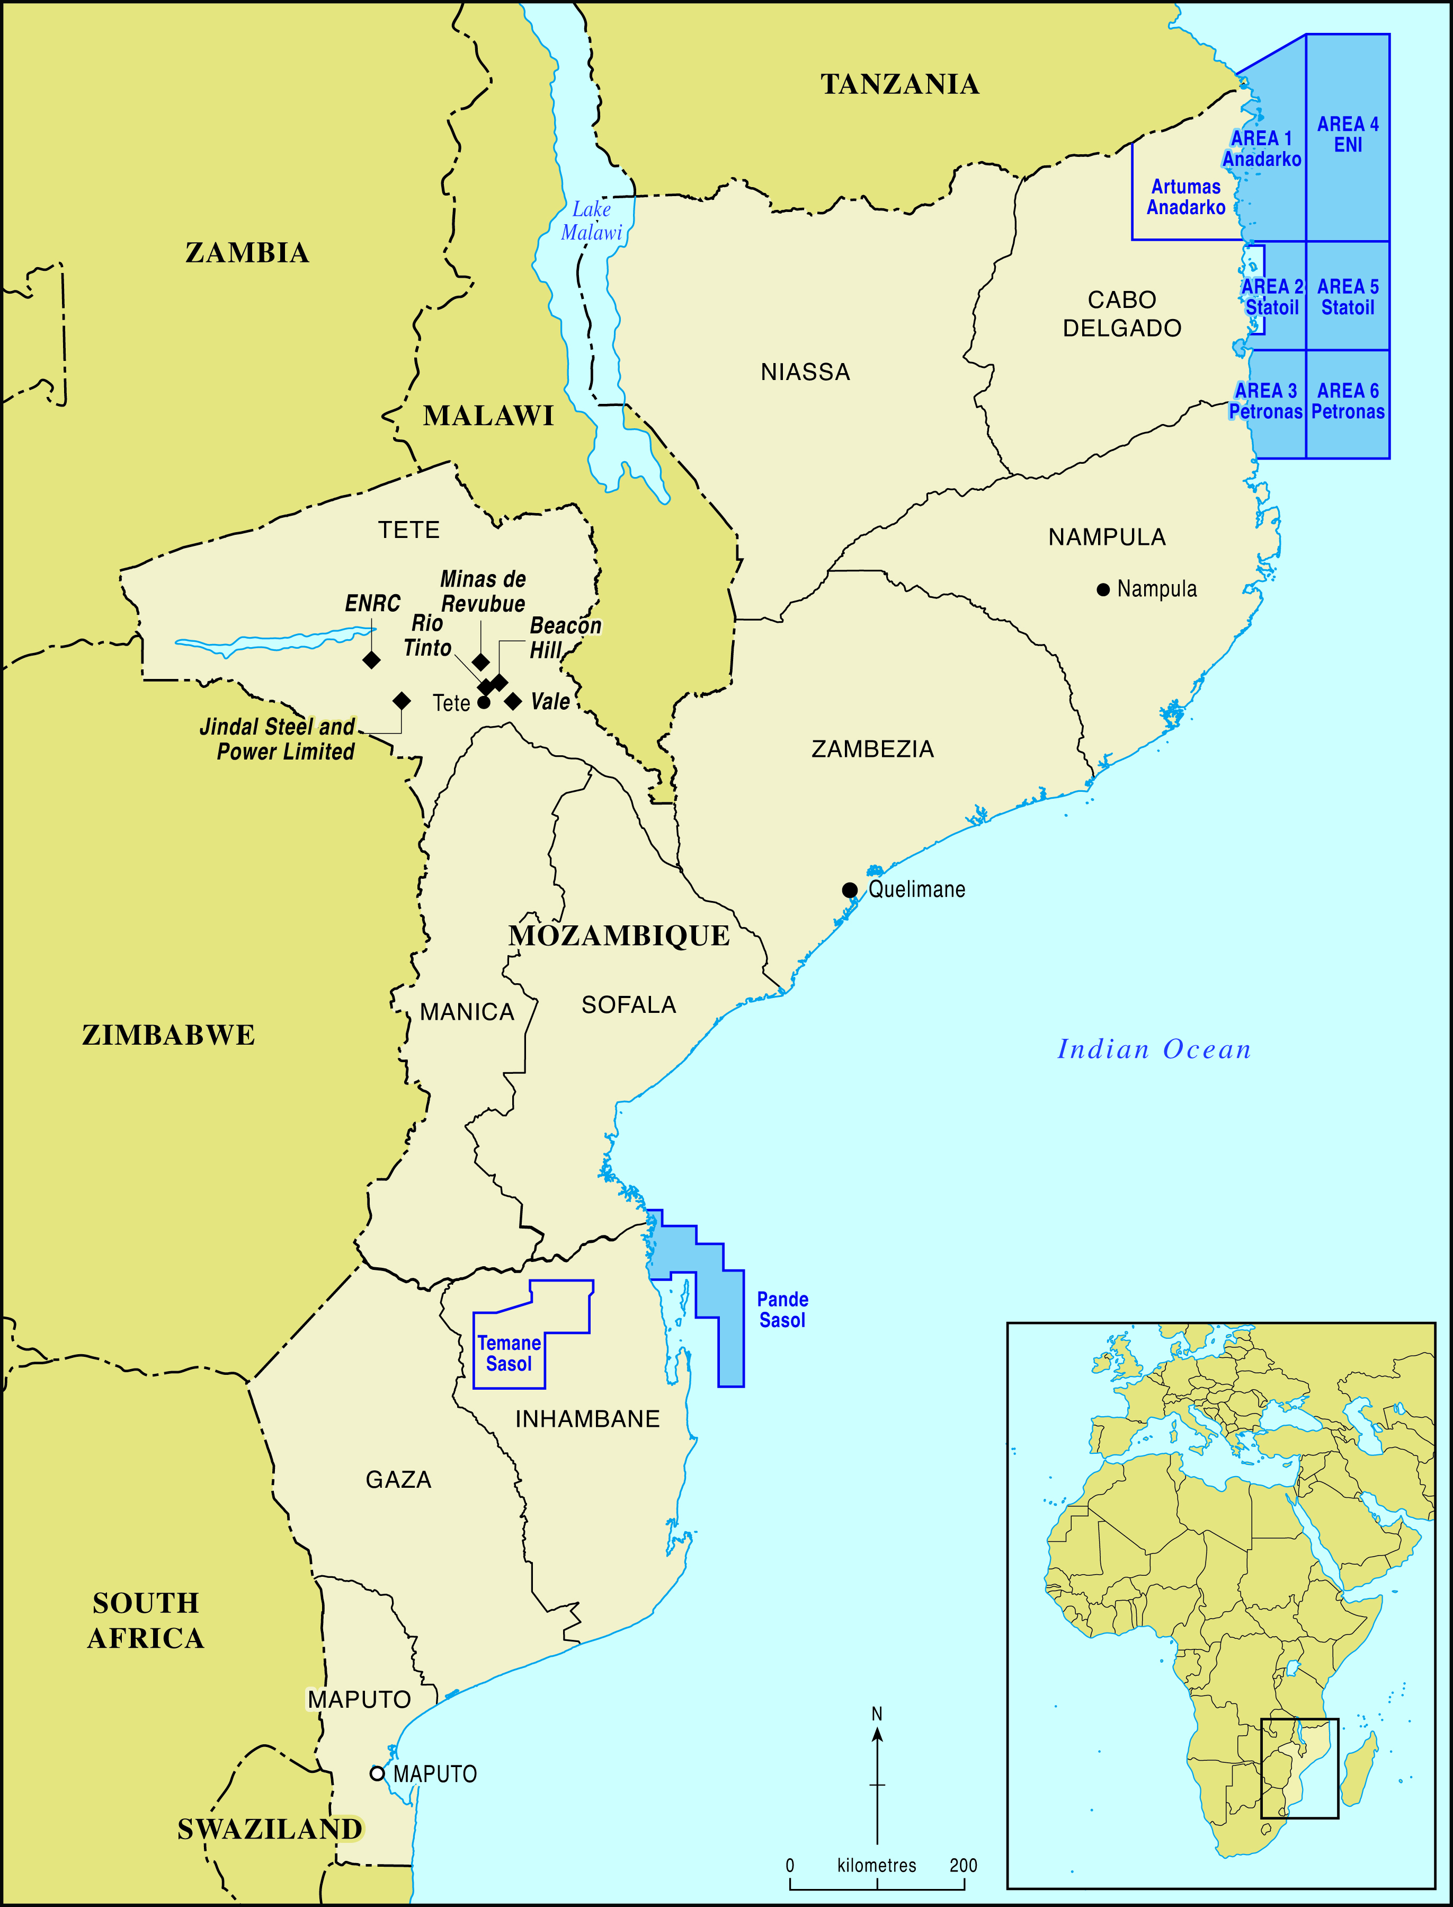
Mozambique is not a historically important minerals producer and did not appear on global mining companies’ radar until the past decade. This changed in 2008, when visiting geologists in the central province of Tete (see Figure 1) confirmed that the coal seam beneath Moatize basin is part of the world’s largest untapped coal deposit, with over 23 billion metric tonnes of coal—enough to fire all the coal plants in the USA for 25 years. The deposits contain coking coal, used in manufacturing steel. But the operations face severe infrastructure bottlenecks and have been hobbled by falling coal prices since 2013.

According to the IEA’s Africa Energy Outlook, Mozambique is now the second largest player in coal in Africa, after South Africa. But companies operating in the country depend on a colonial-era, multi-use, single track railway, known as the Sena line, to carry coal to the Beira port. Mozambican authorities rejected the idea of barging coal down the Zambezi River due to environmental concerns, so the main transport option to bring the coal to port is by railway. To foster export growth and sufficient economies of scale, capacity expansion and new infrastructure is needed. The preferred route is the Nacala Corridor, a 900 km railway crossing via Malawi, linking Tete’s mines with a new deep-water port at Nacala (see Figure 2).
Figure 1: Coal and gas extraction sites in Mozambique

Vale, the Brazilian mining giant, is the largest investor in Mozambique’s coal industry. In 2008, Vale opened its Moatize coal project to export coking coal to markets in India, China and Gulf States. It further plans to build a 300 MW coal-fired power station, with excess power for Mozambique’s power grid. An ‘early mover,’ Vale spent $2 billion to set up its Moatize operation, employing 3,600 workers in its construction in 2009-10 (World Bank, 2010).
Our Research: The Rising Powers, Clean Development & the Low Carbon Transition in Sub-Saharan Africa funded by the Economic and Social Research Council (ESRC): ES/J01270X/1. Fieldwork for the project was undertaken in Mozambique, South Africa, China, India and Brazil between 2012 and 2014 and involved a combination of semi-structured interviews and community-based research methods. Our research also involved the creation of a database of clean energy projects and investments in South Africa and Mozambique.

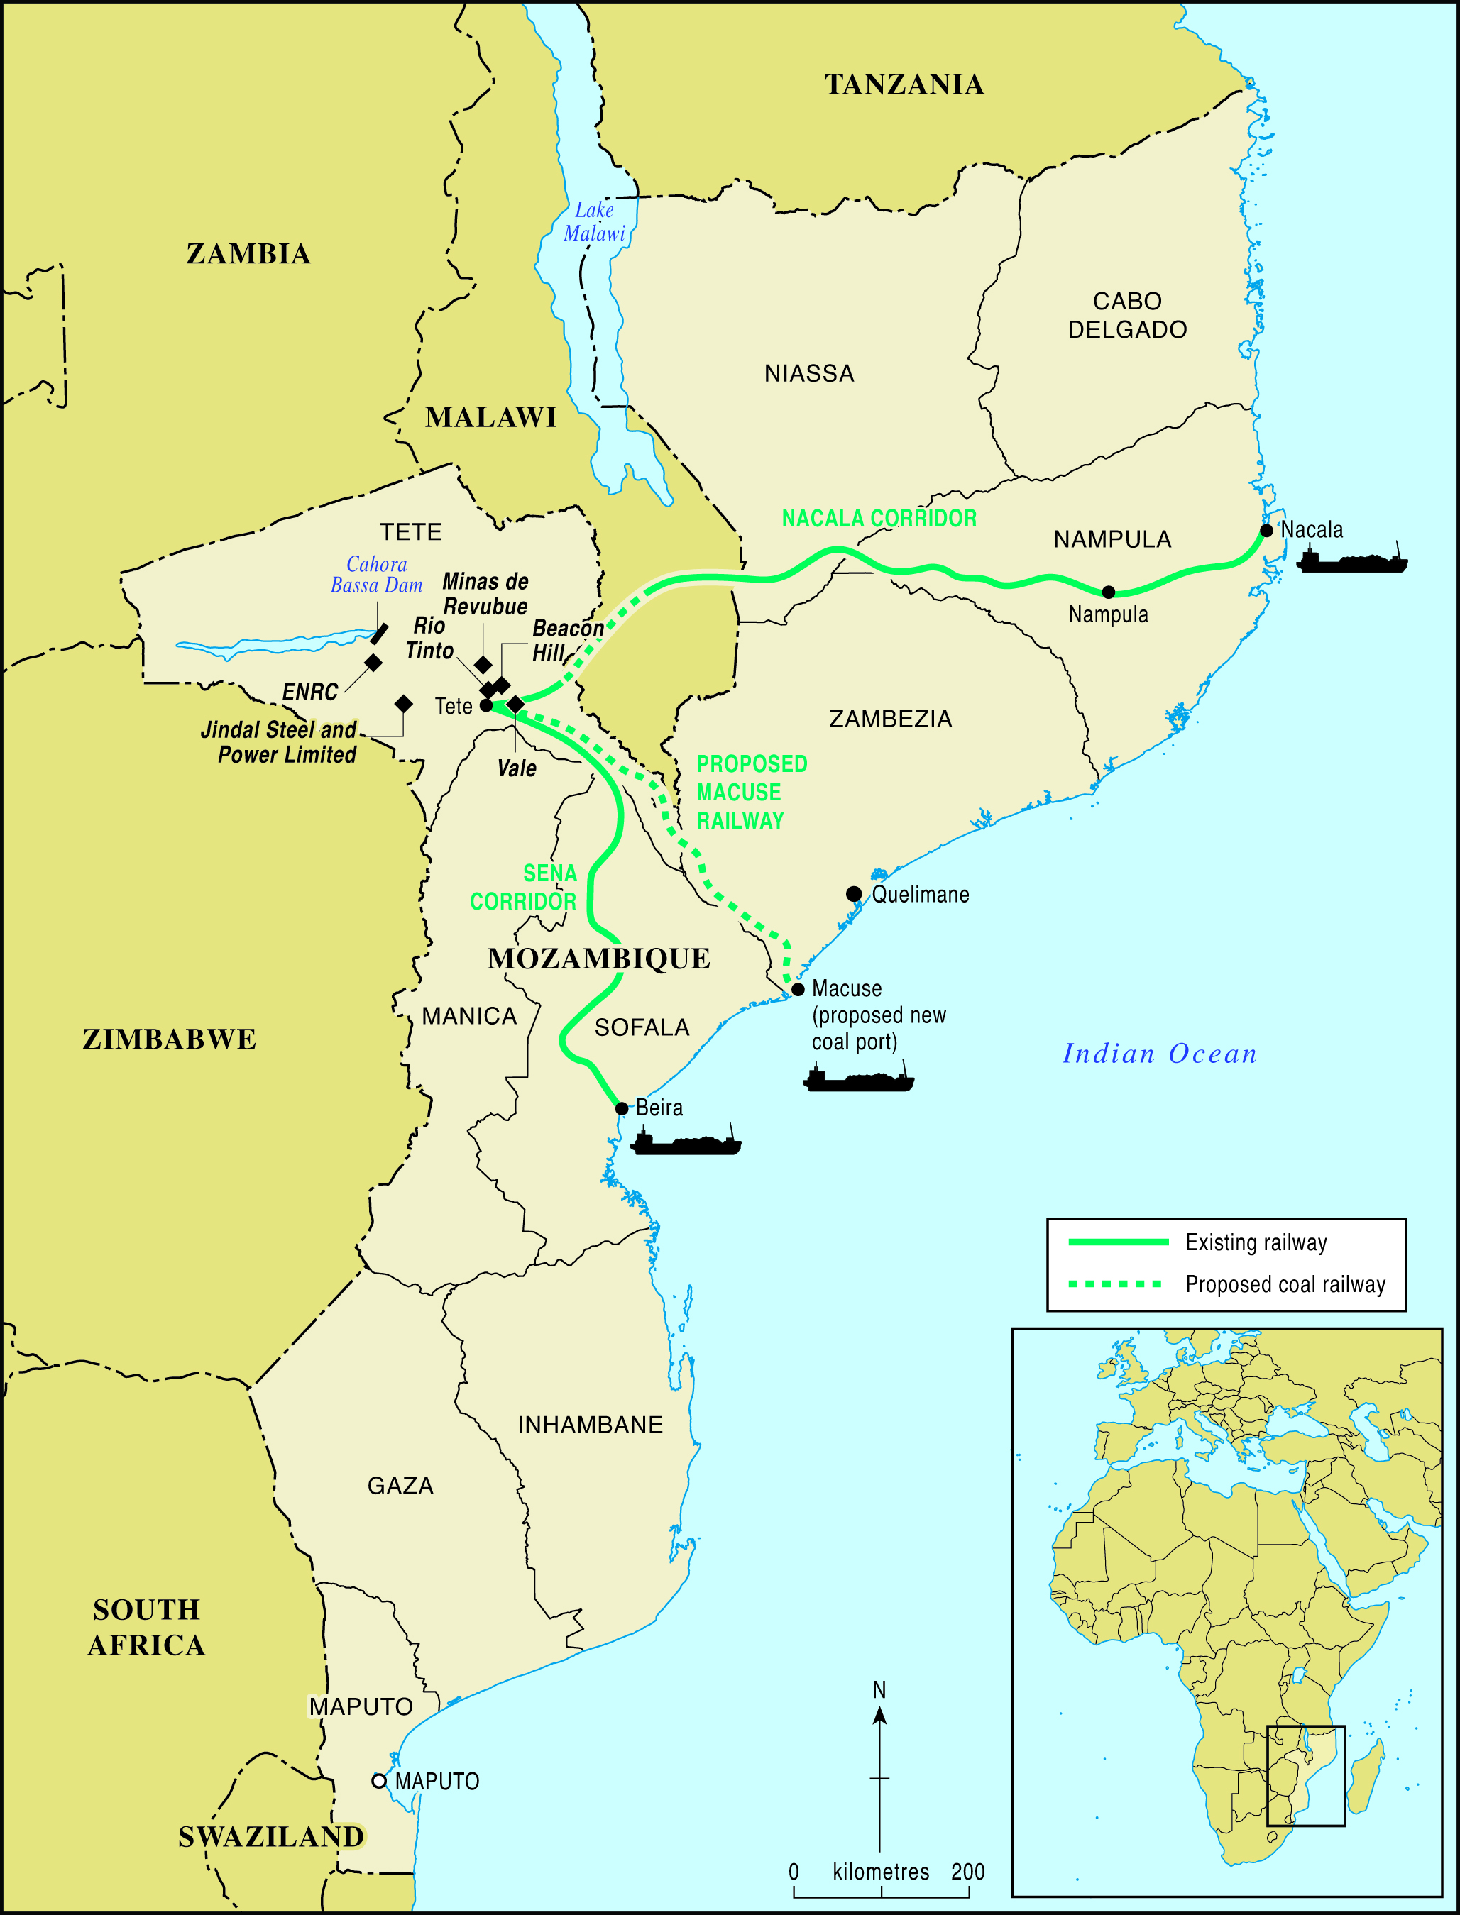
This figure is exceeded by Vale’s investment of $4.4 billion in the Nacala Corridor project. The port and coal terminal will be run by the Nacala Logistics Corridor (CLN), which is 80% owned by Vale and 20% by the Mozambican Ports and Railways Authority, CFM. Signalling ongoing shifts in the sector, in December 2014, Japanese commodities trading firm Mitsui agreed to invest almost $1 billion in Vale’s coal projects in Mozambique. Mitsui will pay $450m for a 15% stake in Vale’s Moatize mine, and invest a further $188m to fund its expansion. Mitsui will also dedicate $313m for a 50% stake in Vale’s subsidiary, which has been promoting the Nacala Corridor project (England, 2014).

The second major investor is Rio Tinto, the UK-Australian mining firm, which acquired the Australian company Riversdale and its coal concessions in Tete in 2011. Tata Steel of India owns a 35% stake in its largest concession, Benga mine. Rio Tinto unexpectedly ‘wrote down’ its assets in Mozambique by billions of dollars in 2013. In July 2014, Rio Tinto sold these coal assets to the Indian state-run International Coal Ventures (ICVL) for $50 million, three years after paying $3.7 billion for the mines. ICVL’s first shipment of coal from Beira port arrived in India in mid-November 2014.
Figure 2: Regional transport infrastructure supporting Mozambique’s coal industry

Apart from Tata Steel and ICVL, Indian investment in Tete’s coal resources appears to be expanding. India’s Jindal Steel and Power holds the Chirodzi concession in Tete. Jindal has invested $180 million in the project since 2012, and plans to build a 300 MW coal-fired power plant at the mine site. Recent falling oil prices have spurred further declines in coal prices. But Indian demand may keep Mozambique’s coal production afloat (Hanlon, 2014).

India’s coal reserves are substantial but of poor quality, and India stands accused of being one of the world’s largest emitters of carbon. Over the last decade, India began importing high-quality coal, currently around 80-100 mtpa (Dadwal, 2011). By 2020, coal imports are projected to nearly triple to 250 mtpa, amid the country’s plans to raise power generation capacity by 100,000 MW over the next decade. Similarly, India’s demand for natural gas is expected to nearly double, as climate change pressures push India toward replacing much of its coal-fired power generation with gas. Africa as a key energy supplier has acquired growing significance in India’s foreign and energy policy. India increasingly competes with China in creating linkages with Africa’s energy sector, aiming for distinctiveness in pursuing a model combining resource extraction with long-term industry development in the host country or region.

Developing Offshore Gas

Major offshore gas discoveries in Mozambique have created high expectations—within the country and internationally—about opportunities for the domestic economy and for supply to global markets. Mozambique and Tanzania are among the main sources of sub-Saharan gas supply growth, contributing 44% of the 170 bcm (billion cubic meters) increase in the region’s gas output (IEA, 2014).

In 2011, Italian and US energy companies ENI and Anadarko made vast offshore gas finds in the Rovuma Basin. Analysts project Mozambique will receive $115 billion in revenue from LNG exports between 2020 and 2040 (IEA, 2014). This presents an opportunity to expand investments in power generation, rural electrification, water and sanitation, along with transport, education and health. But it will require developing two greenfield LNG facilities, being led by ENI and Anadarko (IEA, 2014). Analysts at Business Monitor International (BMI) noted that the level of uncertainty surrounding these projects increased in late 2014, amid falling oil and gas prices. BMI predicts production from ENI’s floating LNG facility will be delayed to 2021, while Anadarko’s onshore LNG plant will not produce until 2022 (BMI, 2014).

Developing gas resources is capital-intensive, with cost estimates for the first phase of upstream and LNG development in Mozambique well above the country’s annual GDP (IEA, 2014). While favourably located—with proximity to Asian markets—local gas consumption is poorly developed. Moreover, the region where the LNG facilities are planned is remote, with little infrastructure, complicating all aspects of construction. The possibilities and pace of production will be shaped by multiple factors, including global demand for LNG.

The main market for Mozambican LNG is Asian countries, which seek to ensure a steady supply and are willing to risk price variations (Hanlon, 2014). Several large Asian importers are buying up blocks of the gas fields from ENI and Anadarko. These include companies from China (CNPC), India (ONGC, Bharat Petroleum and Oil India), Thailand (PTT), Japan (Mitsui) and Korea (KOGAS). IEA forecasts most East Africa LNG exports will go to Asian markets, with a small share going toward European demand (IEA, 2014). India currently imports much of its gas from Qatar, but negotiations are occurring for future LNG supplies from East Africa, including a MOU with the Mozambican government (Fauvet, 2014).

Key Findings

Mozambique has emerged as an important energy supply source, leading to a ‘scramble’ to gain access to its energy and mineral resources. Engagement in Mozambique’s energy resources by Rising Powers actors has the potential to evolve into south-south cooperation that extends beyond the energy trade into a longer-term and mutually beneficial partnership, including capacity building, human resources and infrastructure development. In particular, India’s large diaspora in Mozambique, and its common experience with colonialism, have created links which are set to expand in the future (Dadwal, 2011).

References

Business Monitor International (BMI) (2014) Mozambique's floating LNG projects progress as onshore LNG struggles, November 11th, http://www.businessmonitor.com/news-and-views/mozambiques-floating-lng-projects-progress-as-onshore-lng-struggles (Accessed January 2015).
Dadwal, SR (2011) India and Africa: Towards a Sustainable Energy Partnership. Johannesburg, South African Institute for International Affairs (SAIIA), Emerging Powers and Global Challenges Programme, Occasional Paper 75.
England, A (2014) Mitsui invests almost $1bn in Vale’s Mozambique coal projects, Financial Times, http://www.ft.com/cms/s/0/887f03b2-7fb4-11e4-b4f5-00144feabdc0.html#axzz3OuhvgTxU (accessed January 2015).
Fauvet, P (2014) India approves MoU with Mozambique on oil and gas, AllAfrica, October 31st, http://allafrica.com/stories/201410311429.html (accessed January 2015).
Hanlon, J (2014) Mozambique News Reports and Clippings, December 2nd.
International Energy Agency (IEA) (2014) Africa Energy Outlook, Paris: IEA.
World Bank (2010) Prospects for Growth Poles in Mozambique. Washington DC: World Bank Finance and Private Sector Development, Africa Region.

The project team: Marcus Power (PI), Harriet Bulkeley (Co-I), Joshua Kirshner (RA) (University of Durham); Peter Newell (Co-I), Adrian Smith (Co-I), Lucy Baker (RA) (University of Sussex); Gisela Prasad (Co-I) (Energy Research Centre, University of Cape Town); Wei Shen (Co-I) (Three Gorges University). This research project also involved collaboration with two international consultant partners: The Brazilian Centre for Strategic Studies and Management in Science, Technology and Innovation (CGEE) and the international development NGO Practical Action. Figures in this Research Finding Note were prepared by Chris Orton, Department of Geography, Durham University.

Please visit our project website: http://www.dogweb.dur.ac.uk/the-rising-powers/

For further information about the project please contact Professor Marcus Power:
Email: marcus.power@dur.ac.uk Telephone: +44 (0)191 334 1828

