Resolution of Non-Destructive Imaging by Controlled Acceleration Voltage in Scanning Electron Microscopy
Kelvin Elphick,^{1),a)} Bernardus D. Aditya,²⁾ Jiaqi Wu,²⁾ Michihiro Ohta ⁴⁾ and Atsufumi Hirohata ^{1),*}
¹⁾ Department of Electronic Engineering, University of York, York YO10 5DD, United Kingdom
²⁾ Department of Material Science and Engineering, City University of Hong Kong, Kowloon, Hong Kong S.A.R.
³⁾ Department of Electronic Engineering, City University of Hong Kong, Kowloon, Hong Kong S.A.R.
⁴⁾ Department of Electrical Engineering, Nagaoka University of Technology, Nagaoka 940-2118, Japan
^{a)} Present Address: Taiwan Semiconductor Manufacturing Company, Hsinchu 300-78, Taiwan, R.O.C.
* E-mail: atsufumi.hirohata@york.ac.uk
Abstract
A new method of non-destructive sub-surface interfacial characterisation has been developed recently, which can be useful for quality assurance of a buried interface in nanoelectronic devices, such as magnetic random access memory. Since the cell size of these devices have been reducing their sizes, it is important to evaluate the resolution of the non-destructive imaging. A sub nanometric layer of different materials such as W and Pt was grown underneath a capping layer with controlled thickness for the evaluation of their sizes in this study. This provides systematic experimental data to show that the technique is capable to resolve down to approximately 2 nm in the plane, which is sufficient for the device imaging.
Introduction
Recent development in nanoelectronic devices relies on over 20 layer stacking, which requires non-destructive evaluation of their interfaces for their process optimisation [1]. Especially three-dimensional sequential integration (3DSI) [2] and through silicon via (TSV) [3] have been developed recently allowing the integration of over 100 layers vertically. In nanoelectronics, spintronics is one of the mainstream studies for low power consumption with increasing processing and memory capacities [4],[5]. It has been reported that in a magnetic tunnel junction (MTJ) several factors such as barrier thickness and interfacial roughness can affect the performance [6],[7]. Devices can be tested using electrical measurements readily, however, limited information namely a tunnelling magnetoresistance (TMR) ratio can only be provided. To understand the difference in device performance microanalytic techniques are highly required to be linked to these transport properties [8].
Advanced analytic techniques are required for nanometric scale characterisations to improve device performance. Nowadays numerous characteristic techniques are available as shown in Fig. 1 [9]. There are four major methods for characterisation; microscopy, spectroscopy, scattering and reflection, and electrical measurements. The latter two methods offer macroscopic average of the device properties and their resolution depends on the diameter of the probe. For example, optical beam and electrical current can be used for ellipsometry and current-voltage (I-V) measurements. By using X-ray as a probe, of which diameter can be controlled by the slits used, typically at the order between µm and mm, measuring interfacial roughness by X-ray reflectivity (XRR), chemical compositions by X-ray photoelectron spectroscopy (XPS) and grazing incidence small angle X-ray scattering (GISAXS). By replacing the X-ray with α-ray and electron beam, Rutherford backscattering spectroscopy (RBS) and electron beam induced current (EBIC) can be measured, respectively. By considering the penetration depth of the probe, which requires sample milling etc., infrared (IR) light and helium ion can also be employed for attenuated total reflectance (ATR-IR) and helium ion microscopy (HIM). By reducing the sample dimensions further, X-ray tomography (XRT) can be achieved. For such microscopy, associated spectroscopic characterisation can also be employed, such as Auger electron spectroscopy (AES), energy dispersive X-ray spectroscopy (EDX), cathodoluminescence (CL) and secondary ion mass spectrometry (SIMS).
Cross-sectional transmission electron microscopy (TEM) is known as one of the most commonly used techniques to analyse the interfacial conditions. Although atomic information can be resolved, TEM involves a destructive preparation process via mechanical polishing or focused ion beam (FIB) methods. These sample preparation methods are time consuming and an experienced experimentalist is required to achieve a high yield. High energy Ga ion beam can also cause substantial damage to the sample [10]. Typical damage caused by the ion beam irradiation on a cross-sectional TEM sample prepared using FIB is shown in Fig. 2. The difficulty of the sample preparation using FIB is highly dependence on the substrate of a sample. Si and MgO are most commonly used substrates in thin film and device studies. Since MgO is an insulator, the charging effect limits the precision of ion beam milling process. It increases the possibility of destroying the specimen or results in inhomogeneous surface. Hence such sample preparation methods make it impossible to distinguish whether the defects were intrinsic or extrinsically caused during the sample preparation process. Additionally, the dimensions of a cross-sectional TEM sample are restricted by the electron beam penetration depth and a sample holder used. A sample with the thickness of < 80 nm and the diameter of approximately 2 mm is typically used for TEM observation. Yet the observable area is usually less than a micrometre, which makes it difficult to extract adequate information from the sample to correlate with macroscopic transport properties. To avoid such damages induced during the sample preparation, plan-view imaging can be employed for device characterisation. In combination with chemical analysis, this method can achieve in-plane characterisation with atomic resolution for samples with the total film thickness within the electron beam transparency. Note that these are destructive imaging techniques.
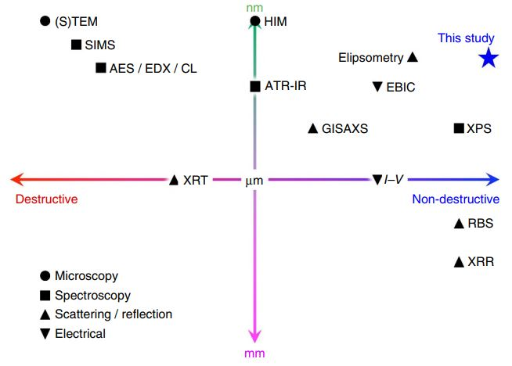
Fig. 1 Major techniques for evaluating a buried junction with respect to their resolution and destructiveness [9].
Fig. 2 Cross-sectional TEM specimen prepared using FIB.
To overcome such difficulty an efficient analytic technique needs to be carried out to fulfil the demand of sample characterisations. This study is based on the non-destructive technique developed using scanning electron microscopy (SEM) by Hirohata et al. in 2016 [9]. This technique was first used in characterise the interface in metallic spin-valve junctions using a controlled electron-beam acceleration voltage. It can also avoid the charging effect of the use of insulating substrates by spin coating a thin layer of conductive carbon particles on the sample surface. The non-destructive method was further improved by Jackson et al. in 2020 with combining EDX [11] and was applied to nanoparticles to reveal their synthesis process [12]. MTJ samples and in-situ imaging under transport measurements were also been demonstrated. The results showed that > 10 nm² Interfacial defects can be identified, and inhomogeneous current distributions can be imaged. The cylindrical diameter of the typical MTJs is in the range between 20 and 50 nm [4],[5]. In order to analyse such devices precisely, nanometric resolution is required. In this study we study the resolution of the non-destructive imaging technique to confirm the capability to resolve down to nanometric scale by varying the thickness of a capping layer over dispersed sub-nanometre thick heavy metal islands.
Experimental Procedures
Three samples were prepared using a high vacuum sputtering system (PlasmaQuest, HiTUS): (i) Ta (5)/Ru (5)/W (0.5)/Ta (5), (ii) Ta (5)/Ru (5)/W (0.5)/Ta (10) and (iii) Ta (5)/Pt (0.5)/Ta (60) (thickness in nm). Pt and W was chosen in this experiment as island growth can be achieved on a Si substrate using sputtering method [13], which were buried underneath a Ta capping layer with different thickness from 5 to 60 nm. A single layer of Pt or W was sputtered with a base pressure of 5x10⁻⁵ Pa on a 5 x 5 mm² single crystal Si(001) substrate with thermally oxidised surface. Note that HiTUS is capable to control the grain sizes by adjusting the Ar ion steering bias, resulting in the deposition rate [14]. The thickness of the Pt and W layer was varied with different deposition rate of 1.5 nm/s and 0.6 nm/s, respectively. The change in the sputtering rate varies the size of the Pt islands. Accordingly the resolution limitation of the non-destructive technique can be determined by imaging the smallest islands in the samples.
For SEM imaging, the acceleration voltage of the electron beam in SEM was precisely controlled to achieve the corresponding penetration into the layer above and below the buried W and Pt nano-islands to be investigated. The detailed procedures of the non-destructive imaging can be found in [9]. First, Monte Carlo simulation of electron trajectory in solid (CASINO) was used to estimate the penetration depth of incident electrons and the corresponding backscattered electrons (BSEs) to be generated in the sample structures as designed above [15]. The simulations show that BSEs can be generated in the vicinity of the nano-islands by introducing an electron beam accelerated at approximately 5.0 keV. The SEM images were obtained by JEOL JSM7800F Prime at the selected beam energies based on the simulations without using any energy filtering. After the lower-acceleration SEM image is subtracted by the higher-acceleration SEM images, buried interfaces can be revealed.
Results and Discussion
For the three samples with different capping layer thicknesses, CASINO Monte Carlo simulations were performed to estimate the electron beam acceleration voltages in SEM to be sensitive to the top and bottom of the W layers. As shown in Fig. 3, electron beam is found to reach the top of W at 0.9 keV and the bottom of W at 1.1 keV. By subtracting these data, we can image the buried W nano-islands dispersed, leading to the resolution of this technique.
(a) 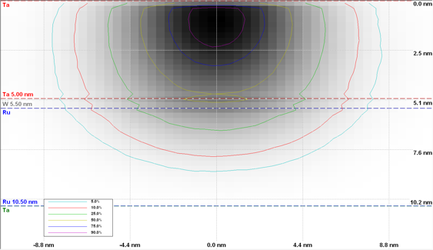 (b) 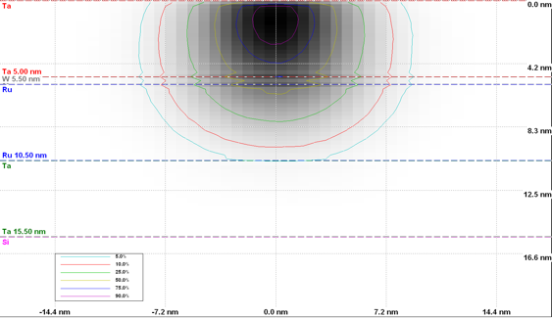
Fig. 3 CASINO simulations on Si/SiO₂//Ta (5)/Ru (5)/W (0.5)/Ta (5) (thickness in nm) to show electron penetration at the acceleration of (a) 0.9 and (b) 1.1 keV. The electron beam is introduced from the top to the Ta capping layer (red), W insertion (amber), Ru (blue), W seed layer (green) and Si substrate (purple). Threshold contours represent the probability of the electron beam to reach these layers; 50% (light blue), 40% (pink), 30% (light green), 20% (yellow), 10% (dark blue) and 5% (light purple).
The samples with 0.5 nm thick W insertion layer were observed using JEOL JSM7800F. The SEM images taken at 0.9 and 1.1 keV are taken using the pre-determined acceleration voltages which determined as above. According to the CASINO simulations, the SEM image taken at 0.9 keV contains ??, ??? and ???% of BSEs to be generated from the Ta capping layer, the W nano-islands and the Ru layer underneath, respectively. On the other hand, that at 1.1 keV contains ??, ??? and ????% of BSEs from the Ta, W and Ru layers, respectively. These results indicate that the subtraction of these two images can highlight the BSEs generated from the W islands. From our past studies, we found the difference in about 10% in the BSE generated from the W nano-islands, which are under investigation here, can reveal the structural details by subtracting two SEM images. As seen in Figs. 4(a) and (b), it is difficult to identify the W islands clearly in these images. Both images contain a carbon contaminated area induced by initial imaging, these areas are used to align the two images for subtraction using a Matlab program [11]. The subtracted SEM image of these two voltages is shown in Fig. 4(c). The white contrast as circled represents W islands due to more BSEs generated than the neighbouring layers, showing the grain size to be approximately (24 ~ 39) nm × (75 ~ 110) nm. These islands are used to estimate the resolution of the non-destructive method. In order to determine the resolution, ImageJ was used to analyse the diameter of the islands. Approximately 50 data points were acquired for each SEM image subtracted, revealing the minimum particle diameter is found to be 3.9 nm, respectively (see Table 1 and Supplemental Information).
(a) 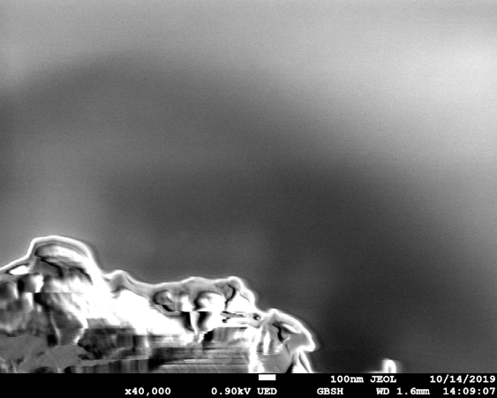 (b) 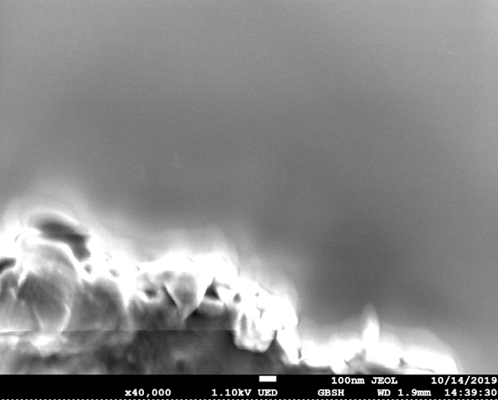
(c) 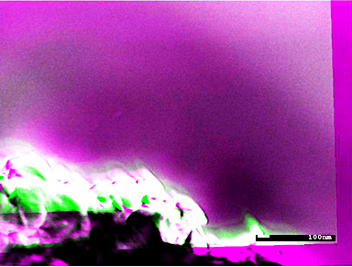
Fig. 4 SEM images of W insertion layer in Si/SiO₂//Ta (5)/Ru (5)/W (0.5)/Ta (5) (thickness in nm) imaged with the magnification of 40,000 at (a) 0.9 and (b) 1.1 keV. (c) Subtracted image between (a) and (b), showing the depth profile from green (above the W nano-islands) and magenta (below the W nano-islands). Black circles indicate the positions of the white contrast representing W islands.
Table 1 List of measured W and Pt nano-islands.
Capping layer material (thickness in nm) | Minimum feature size measured (nm)
Ta (5) | 3.9
Ta (10) | 8.4
Ta (60) | 12.2
Similarly subtracted images were taken for the W and Pt nano-islands through the 10 and 60 nm thick Ta capping layer as shown in Fig. 5. Figure 5(a) shows the subtracted SEM image between the acceleration of 1.4 and 1.5 keV to characterise the W nano-islands [see white contrast circled in Fig. 5(a), showing the grain size to be approximately (13 ~ 20) nmφ] dispersed under the 10 nm thick Ta cap, revealing the minimum particle diameter is found to be 8.4 nm, respectively (see Table 1 and Supplemental Information). Figure 5(b) shows the subtracted SEM image between the acceleration of 4.7 and 5.0 keV to characterise the Pt nano-islands [see white contrast circled in Fig. 5(b), showing the grain size to be approximately (18 ~ 26) nmφ] dispersed under the 60 nm thick Ta cap, revealing the minimum particle diameter is found to be 12.2 nm, respectively.
(a) 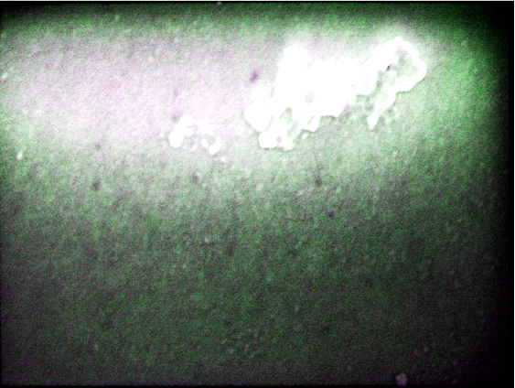 (b) 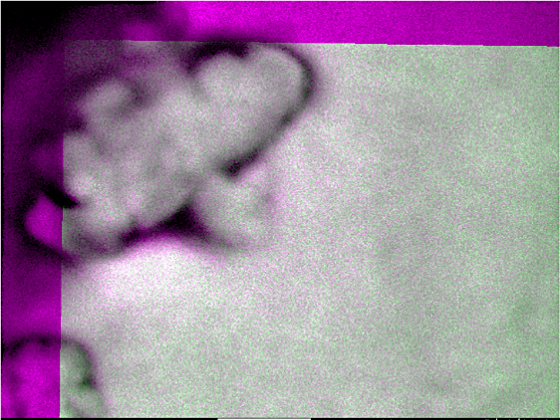
Fig. 5 Subtracted SEM images of W and Pt insertion layer in (a) Ta (5)/Ru (5)/W (0.5)/Ta (10) and (b) Ta (5)/Pt (0.5)/Ta (60) (thickness in nm), respectively. (a) is imaged with the magnification of 70,000 at 1.4 and 1.5 keV. (b) is imaged with the magnification of 200,000 at 4.7 and 5.0 keV, showing the depth profile from green (above the W nano-islands) and magenta (below the W nano-islands).
For further dispersion of the W and Pt islands for accurate evaluation of the imaging resolution, the sputtering bias voltages for plasma steering [14] were controlled for the samples with a 0.5 nm thick W insertion layer and a 60 nm thick cap. The SEM images are taken using the pre-determined acceleration voltages of 5.1 and 4.9 keV. The subtracted SEM images of these two voltages are shown in Figs. 6(a) and (b) in the same way as above for the sputtering voltages of 900 and 500 V, respectively. The sample for which sputtered at the steering bias of 900 V shows less contrast on the island, whilst the island growth can be clearly observed on those sputtered at 500 V. These images confirm the maximum and minimum particle diameters are found to be 2 nm to 3 nm, respectively.
(a)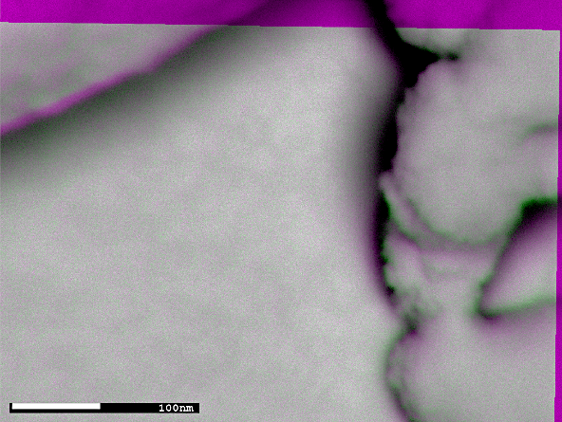 (b)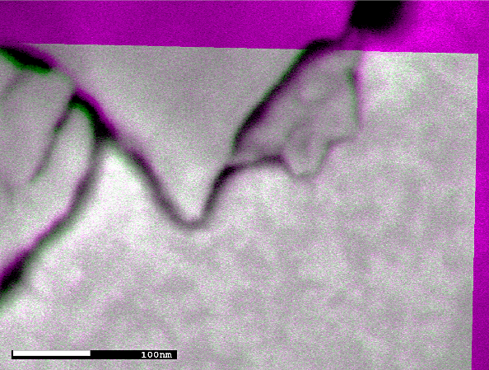
Fig. 6 Subtracted SEM images of the W islands in Si/SiO₂//Ta (5)/Ru (5)/W (0.5)/Ta (5) (thickness in nm) with sputtering bias voltages of (a) 900 and (b) 500 V. These images were taken using x200,000 magnification with the acceleration voltages of 1.4 keV and 1.5 keV, showing the depth profile from green (above the W nano-islands) and magenta (below the W nano-islands).
Based on the above evaluation, we conclude the minimum resolution of the non-destructive method is 2 nm underneath the overlayer of below 60 nm in thickness. In general, the resolution can be improved by reducing the thickness of the overlayer above the buried interface under investigation. However, the critical factor is the fine tuning of focus and contrast of the images for subtraction. In this study, we adjust the focus using some contaminations, film edges and surface features of the samples but for a nanoelectronic device we may need to use more reproducible and reliable method for fine focusing. The contrast is determined by the differences in the atomic numbers between atoms in the buried interface and the neighbouring layers in the first approximation. By controlling these parameters, we can improve the resolution of the non-destructive imaging.
Conclusion
Sub nanometric heavy metal layers dispersed under the controlled thick capping layers were imaged by the non-destructive method with a controlled electron beam acceleration in SEM. The minimum resolution is found to be approximately 2 nm underneath the overlayer of below 60 nm in thickness. This is ideal for the quality assurance of nanoelectronic devices and can be further improved by fine tuning the focus and contrast of imaging.
Acknowledgements
This work was partially supported by EPSRC-JSPS Core-to-Core Programme (EP/M02458X/1) and JST CREST (No. JPMJCR17J5). B.D.A and J.W. thanks to the support by the City University of Hong Kong, and M.O. appreciates the internship provided by the Nagaoka University of Technology.
References
- K. Sakuma (Ed.), 3D Integration in VLSI Circuits: Implementation Technologies and Applications (CRC Press, New York, 2018).
- P. Batude, L. Brunet, C. Fenouillet-Beranger, F. Andrieu, J.-P. Colinge, D. Lattard, E. Vianello, S. Thuries, O. Billoint, P. Vivet, C. Santos, B. Mathieu, B. Sklenard, C.-M. V. Lu, J. Micout, F. Deprat, E. Avelar Mercado, F. Ponthenier, N. Rambal, M.-P. Samson, M. Cassé, S. Hentz, J. Arcamone, G. Sicard, L. Hutin, L. Pasini, A. Ayres, O. Rozeau, R. Berthelon, F. Nemouchi, P. Rodriguez, J.-B. Pin, D. Larmagnac, V. Ripoche, S. Barraud, N. Allouti, S. Barnola, C. Vizioz, J.-M. Hartmann, S. Kerdiles, P. Acosta Alba, S. Beaurepaire, V. Beugin, F. Fournel, P. Besson, V. Loup, R. Gassilloud, F. Martin, X. Garros, F. Mazen, B. Previtali, C. Euvrard-Colnat, V. Balan, Mazzocchi, O. Faynot and M. Vinet, 3D Sequential Integration: Application-driven technological achievements and guidelines, 2017 IEEE International Electron Devices Meeting (IEDM); https://doi.org/10.1109/IEDM.2017.8268316.
- S. L. Burkett, M. B. Jordan, R. P. Schmitt, L. A. Menk and A. E. Hollowell, Tutorial on forming through-silicon vias, J. Vac. Sci. Technol. A 38, 031202 (2020); https://doi.org/10.1116/6.0000026.
- A. Hirohata, K. Yamada, Y. Nakatani, L. Prejbeanu, B. Diény, P. Pirro and B. Hillebrands, Review on spintronics: Principles and device applications, J. Magn. Magn. Mater. 509, 166711 (2020); https://doi.org/10.1016/j.jmmm.2020.166711.
- B. Dieny, I. L. Prejbeanu, K. Garello, P. Gambardella, P. Freitas, R. Lehndorff, W. Raberg, U. Ebels, S. O. Demokritov, J. Akerman, A. Deac, P. Pirro, C. Adelmann, A. Anane, A. V. Chumak, A. Hirohata, S.Mangin, M.Cengiz Onbasli, M.d'Aquino, G.Prenat1, G. Finocchio, L. Lopez Diaz, R. Chantrell, O. Chubykalo-Fesenko, P. Bortolotti, Opportunities and challenges for spintronics in the microelectronic industry, Nat. Electron. 3, 446 (2020); https://doi.org/10.1038/s41928-020-0461-5.
- R. C. Sousa, J. J. Sun, V. Soares P. P. Freitas, A. Kling, M. F. da Silva and J. C. Soares, Large tunneling magnetoresistance enhancement by thermal anneal, Appl. Phys. Lett. 73, 3288 (1998); https://doi.org/10.1063/1.122747.
- C. H. Shang, J. Nowak, R. Jansen and J. S. Moodera, Temperature dependence of magnetoresistance and surface magnetization in ferromagnetic tunnel junctions, Phys. Rev. B 58, 2917(R) (1998); https://doi.org/10.1103/PhysRevB.58.R2917.
- K. Elphick, K. Yoshida, T. Roy, T. Ichinose, K. Kunimatsu, T. Tsuchiya, M. Tsujikawa, Y. Nagai, S. Mizukami, M. Shirai and A. Hirohata, Lattice softening in metastable bcc Co_{x}Mn_{100-x}(001) ferromagnetic layers for a strain-free magnetic tunnel junction, http://arxiv.org/abs/2010.04493.
- A. Hirohata, Y. Yamamoto, B. A. Murphy and A. J. Vick, Non-destructive imaging of buried electronic interfaces using a decelerated scanning electron beam, Nat. Commun. 7, 12701 (2016); http://dx.doi.org/10.1038/ncomms12701.
- N. B. Bassim, B. T. De Gregorio, A. L. D. Kilcoyne, K. Scott, T. Chou, S. Wirick, G. Cody and R. M. Stroud, Minimizing damage during FIB sample preparation of soft materials, J. Microsc. 245, 288 (2012); https://doi.org/10.1111/j.1365-2818.2011.03570.x.
- E. Jackson, Y. Wu, W. Frost, J.-Y. Kim, M. Samiepour, K. Elphick, M. Sun, T. Kubota, K. Takanashi, T. Ichinose, S. Mizukami and A. Hirohata, Non-destructive imaging for quality assurance of MRAM junctions, J. Phys. D: Appl. Phys. 53, 014004 (2020); https://doi.org/10.1038/s41598-018-25638-8.
- K. Elphick, A. Yamaguchi, A. Otsuki, N. L. Hayagan and A. Hirohata, Non-destructive imaging on synthesised nano-particles, Materials 14, 613 (2021); https://doi.org/10.3390/ma14030613.
- P. Andreazza, C. Andreazza-Vignolle, J. P. Rozenbaum, A.-L. Thomann and P. Brault, Nucleation and initial growth of platinum islands by plasma sputter deposition, Surf. Coat. Technol. 151-152, 122 (2002); https://doi.org/10.1016/S0257-8972(01)01604-8.
- M. Vopsaroiu, G. Vallejo Fernandez, M. J. Thwaites, J. Anguita, P. J. Grundy and K. O’Grady, Deposition of polycrystalline thin films with controlled grain size, J. Phys. D: Appl. Phys. 38, 490 (2005); https://doi.org/10.1088/0022-3727/38/3/022.
- P. Hovington, D. Drouin, R. Gauvin, D. C. Joy and N. Evans, CASINO V2.42 – A fast and easy‐to‐use modeling tool for scanning electron microscopy and microanalysis users, Scanning 29, 92 (2007); https://doi.org/10.1002/sca.20000.

