Title: Science with Society: Evidence-based Guidance for Best Practices in Environmental Transdisciplinary Work
Authors: Cara Steger^{a,b,c*}, Julia A. Klein^{a,b,c}, Robin S. Reid^{c}, Sandra Lavorel^{d}, Catherine Tucker^{e}, Kelly A. Hopping^{f}, Rob Marchant^{g}, Tara Teel^{h}, Aida Cuni-Sanchez^{g}, Tsechoe Dorji^{i}, Greg Greenwood^{j}, Robert Huber^{k}, , Karim-Aly Kassam^{l}, David Kreuer^{m}, Anne Nolin^{n}, Aaron Russellº, Julia L. Sharp^{p}, Mateja Šmid Hribar^{q}, Jessica P. R. Thorn^{g,r}, Gordon Grant^{s}, Mohammed Mahdi^{t}, Martha Moreno^{u}, and Daniel Waiswa^{v}
*Corresponding Author Address: Cara.Steger@gmail.com. Cara Steger, NESB A245, Campus Delivery 1499, Fort Collins, Colorado 80523-1234.
Author Affiliations:
a Graduate Degree Program in Ecology, Colorado State University, Fort Collins, CO. USA. 80523-1499. Julia.Klein@colostate.edu
b Natural Resource Ecology Laboratory, Colorado State University, Fort Collins, CO. USA. 80523-1499.
c Department of Ecosystem Science & Sustainability, Colorado State University, Fort Collins, CO. USA. 80523-1476. robin.reid@colostate.edu.
d Laboratoire d’Ecologie Alpine, CNRS - Université Grenoble Alpes - Université Savoie Mont Blanc, 38000 Grenoble, France. sandra.lavorel@univ-grenoble-alpes.fr
e Department of Anthropology, University of Florida, Gainesville, FL 32611. tuckerc@ufl.edu
f Human-Environment Systems, Boise State University, Boise, ID 83725. kellyhopping@boisestate.edu
g York Institute of Tropical Ecosystems, University of York, Department of Environment and Geography, Wentworth Way, Heslington, York, North Yorkshire, YO10 5NG, UK jessica.thorn@york.ac.uk, a.cunisanchez@york.ac.uk, robert.marchant@york.ac.uk
h Department of Human Dimensions of Natural Resources, Colorado State University, Fort Collins, CO. USA. 80523-1480. tara.teel@colostate.edu
i Institute of Tibetan Plateau Research, Chinese Academy of Sciences Nongke Road No.6, Lhasa, 850000, Tibet Autonomouse Region, China. tsechoedorji@itpcas.ac.cn
j former Director, Mountain Research Initiative, Geography Department, University of Bern
k Agricultural Economics and Policy, Swiss Federal Institutes of Technology Zurich ETHZ, Sonneggstrasse 33 8092 Zürich. rhuber@ethz.ch
l Department of Natural Resources and the Environment & the American Indian and Indigenous Studies Program, Cornell University, Ithaca, NY. USA. 14853-3001. ksk28@cornell.edu
m Helmholtz Centre for Environmental Research – UFZ, Permoserstr. 15, 04318 Leipzig, Germany. david.kreuer@ufz.de
n Department of Geography, University of Nevada, Reno, NV 89557. anolin@unr.edu
o Global Green Growth Institute, Green Growth Planning and Implementation, Myanmar. russell.ajm@gmail.com
p Department of Statistics, Colorado State University, Fort Collins, CO 80523-1844. Julia.sharp@colostate.edu
q Anton Melik Geographical Institute, Research Centre of the Slovenian Academy of Sciences and Arts - ZRC SAZU, Novi trg 2, 1000 Ljubljana, Slovenia mateja.smid@zrc-sazu.si
r African Climate and Development Initiative (ACDI), University of Cape Town, Upper Campus, Geological Sciences Building Level 6, 13 Library Road, Rondebosch, 7700, Cape Town, South Africa jessica.thorn@uct.ac.za
s Pacific Northwest Research Station, USDA Forest Service, 3200 Jefferson Way, Corvallis, OR 97331, USA gordon.grant@oregonstate.edu
t Interdisciplinary association for development and the environment (Targa-AIDE), Rabat, Morocco aitmahdi@gmail.com
u Independent consultant, Siquatepeque, Honduras mlmoreno8@gmail.com
v Department of Geography, Geo-informatics & Climatic Sciences, Makerere University, P. O. Box 7062, Kampala - Uganda. .waiswa@caes.mak.ac.ug

Acknowledgements: This work was supported by the US National Science Foundation through the Mountain Sentinels Research Coordination Network (NSF #1414106) and the Center for Collaborative Conservation at Colorado State University. MSH would like to thank the Slovenian Research Agency for its financial support (Core Research Funding No. P6-010; Geography of Slovenia), and DK acknowledges support by the German Federal Ministry of Education and Research (BMBF—01LN1315A). In addition, we thank the many civil society organizations and communities that have contributed their precious time, resources, and insights to the transdisciplinary work informing this study. This research was reviewed and approved by Colorado State University’s Institutional Review Board (264-18H), and was conducted with free, prior and informed consent of all participants.

Abstract
Transdisciplinary research is a promising approach to address sustainability challenges arising from global environmental change, as it is characterized by an iterative process that brings together actors from multiple academic fields and diverse sectors of society to engage in mutual learning with the intent to co-produce new knowledge. We present a conceptual model to guide the implementation of environmental transdisciplinary work, which we consider a “science with society” (SWS) approach, providing suggested activities to conduct throughout a seven-step process. We used a survey with 168 respondents involved in environmental transdisciplinary work worldwide to evaluate the relative importance of these activities and the skills and characteristics required to implement them successfully, with attention to how responses differed according to the gender, geographic location, and positionality of the respondents. Flexibility and collaborative spirit were the most frequently valued skills in SWS, though non-researchers tended to prioritize attributes like humility, trust, and patience over flexibility. We also explored the relative significance of barriers to successful SWS, finding insufficient time and unequal power dynamics were the two most significant barriers to successful SWS. Together with case studies of respondents’ most successful SWS projects, we create a toolbox of 20 best practices that can be used to overcome barriers and increase the societal and scientific impacts of SWS projects. Project success was perceived to be significantly higher where there was medium to high policy impact, and projects initiated by practitioners/other stakeholders had a larger proportion of high policy impact compared to projects initiated by researchers only. Communicating project results to academic audiences occurred more frequently than communicating results to practitioners or the public, despite this being ranked less important overall. We discuss how these results point to three recommendations for future SWS: 1) balancing diverse perspectives through careful partnership formation and design; 2) promoting communication, learning, and reflexivity (i.e., questioning assumptions, beliefs, and practices) to overcome conflict and power asymmetries; and 3) increasing policy impact for joint science and society benefits. Our study highlights the benefits of diversity in SWS - both in the types of people and knowledge included as well as the methods used - and the potential benefits of this approach for addressing the increasingly complex challenges arising from global environmental change.
Keywords: social-ecological systems; collaborative environmental management; knowledge co-production; social learning; sustainability; science policy interface; science to action

1 Introduction to Transdisciplinary or Science with Society Approaches
Global environmental change is driven largely by human activities such as production and consumption patterns, population dynamics, and technological innovations, and has led to a wide array of intractable and interconnected sustainability challenges – including biodiversity loss, food and water insecurity, and pollution (IPBES 2019). As these challenges increasingly threaten environments and human well-being, science and society are turning to transdisciplinary work (TDW) to facilitate transitions to sustainability (Lang et al. 2012; Brandt et al. 2013; Wyborn et al. 2019; Norström et al. 2020). Environmental TDW is characterized by a reflexive research approach that brings together actors from diverse academic fields and sectors of society to engage in mutual learning, seeking solutions to social-ecological problems that advance both scientific and societal objectives (Klein et al. 2001; Lang et al. 2012; Jahn et al. 2012; Cundill et al. 2015; Scholz and Steiner 2015a; DeLorme et al. 2016). In this regard, TDW overlaps with a wide range of scientific domains (Knapp et al. 2019), including participatory action research (Lewin 1948; Freire 1970; Greenwood and Levin 2006; Bole et al. 2017), participatory spatial planning (Nared et al. 2015), citizen science (Bonney et al. 2014) or public participation in science (Shirk et al. 2012), and common pool/property resource governance (Ostrom 1990; Agrawal 2001). We briefly define and review the benefits of actor diversity, reflexivity, and mutual learning below.
Actor diversity is the foundation of TDW; scientists from multiple disciplines are needed (interdisciplinarity) as well as practitioners or other stakeholders from diverse work sectors and social worlds (Gibbons et al. 1994; Tress et al. 2005; Lang et al. 2012; Cundill et al. 2015). Heterogeneity among TDW participants along a range of characteristics (e.g., discipline or work sector, age, gender, ethnicity) ensures that multiple perspectives are represented and the full complexity of problems and solutions can be realized (Bernstein 2015; Hoffman et al. 2017; Kassam et al. 2018). This diversity contributes to the perceived credibility, salience, and legitimacy of TDW results (Middendorf and Busch 1997; Cash et al. 2003; Colfer 2005; Cundill et al. 2015), which can empower participants to take ownership over the TDW process and encourage them to apply new knowledge to sustainability problems on the ground (Daniels and Walker 1996; Lang et al. 2012; Balvanera et al. 2017).
Reflexivity is the practice of examining and questioning one’s beliefs, values, assumptions, and understandings in a particular context (Finlay 1998; Malterud 2001). Transdisciplinary work is reflexive in that it encourages participants to think critically about how their preconceived ideas and past experiences (both as individuals and as a group) might impact the framing of the problem, research process, communication, and implementation of results (Popa et al. 2015; van Kerkhoff and Pilbeam 2017; Cockburn and Cundill 2018). Reflexivity in TDW can reduce conflict arising from power asymmetries among participants or from differences in values, preferences, and behaviors (Mobjörk 2010; Cundill et al. 2019). For example, participatory evaluations that occur periodically throughout the TDW process allow participants to share perspectives, challenge dominant knowledge types, and communicate more easily across hierarchies that impede knowledge co-production and mutual learning (Roux et al. 2010; Fazey et al. 2014).
Mutual learning, also called multiple-loop social learning (Keen et al. 2005; Fazey et al. 2014; Fernández-Giménez et al. 2019), is related to reflexivity as it requires TDW participants to collectively explore the limits of current knowledge, exchange and generate new knowledge, and understand how this knowledge is situated in a particular social and cultural context (Lave and Wenger 1991; Scholz and Marks 2001; Baird et al. 2014; Westberg and Polk 2016; van Kerkhoff and Pilbeam 2017). Learning is portrayed as a series of loops (single, double, and triple) or types of change (conceptual, relational, and normative) that represent increasingly complex learning with different impacts to participant understanding and behavior (Baird et al. 2014). For example, single-loop learning may involve changing one’s ideas about the efficacy of particular actions (Armitage et al. 2008) or the direction and strength of cause-and-effect relationships (Fernández-Giménez et al. 2019), while double-loop learning occurs when learners call into question the assumptions that underlie their understanding of the system or problem (Keen and Mahanty 2006; Pahl-Wostl 2009). Triple-loop learning motivates changes to the norms and institutions governing the project or broader system (King and Jiggins 2002; Keen et al. 2005). Double and triple loop learning can facilitate transitions to sustainability by supporting the adaptive capacity of TDW participants (Berkes and Jolly 2002; Fazey et al. 2014; Fujitani et al. 2017) and building trusting relationships and systems thinking capacity among them (Pahl-Wostl and Hare 2004; Reed et al. 2010; Harris and Lyon 2013). Triple loop learning can also facilitate larger-scale system transformations (Pahl-Wostl 2009; Moore et al. 2014) when changes result in radical shifts in power structures and regulatory frameworks.
Efforts to describe an ideal TDW process have produced a series of conceptual frameworks, models, and guides (Carew and Wickson 2010; Jahn et al. 2012; Lang et al. 2012; Brandt et al. 2013; Mauser et al. 2013; Adams et al. 2014; Scholz and Steiner 2015b). Yet, the need for evidence-based best practices in TDW remains unfulfilled (Tress et al. 2003; Huber and Rigling 2014), limiting the potential for TDW to inform action on a wide range of global challenges. The pursuit of best practices implies that consistent approaches should be identified and widely adopted; however, we recognize the need for flexibility and adaptation given the highly context-specific nature of TDW. We do not consider a one-size-fits all approach desirable or even feasible for TDW, but we believe the development of guiding principles can help ensure quality and reproducibility and prevent the approach from becoming shallowly understood and applied (Jahn et al. 2012). Therefore, efforts to create guidelines for TDW should focus on providing a ‘toolbox’ of best practices that can be selected by participants according to their needs and desires without being overly prescriptive.
The purpose of this paper is to better understand the process and outcomes of environmental TDW. Specifically, we aim to contribute to a toolbox of best practices that provides practical, evidence-based guidance inclusive of the diversity of people and places where TDW occurs. This work advances current understanding of environmental TDW in several ways. First, we draw on knowledge and experiences from a global network of TDW researchers and practitioners, distinguishing this from guides that focus on one or a small number of projects. Second, we use mixed methods to conduct this synthesis, producing a robust and highly useful analysis that allows for more nuanced interpretation of practitioner experiences. Third, we examine how differences in respondent identity may influence their opinion of the most important barriers and best practices in TDW, thus providing important insights into how successful approaches might vary according to socio-cultural context.
During a workshop in 2015, we developed a conceptual model for knowledge co-production and mutual learning in TDW, an approach that we and others call “science with society” (hereafter “SWS”; Seidl et al. 2013; Cockburn and Cundill 2018). We used this conceptual model to guide the development of a survey that was administered to researchers, practitioners, and other stakeholders involved in environmental TDW projects worldwide. From this global survey, we examined perceived barriers and preferences for activities in the TDW process, and explored how different aspects of respondent diversity are associated with these perceptions and preferences. We focus on three aspects of diversity that have been shown to influence the collaborative process: geography (i.e., whether respondents work in the same place they live; Schmitt et al. 2010; Lang et al. 2012; Reid et al. 2016), positionality (i.e., researcher or non-researcher; Wiek et al. 2012; Brandt et al. 2013), and gender (Norström et al. 2020). We ask:
(1) How is the geography, positionality, and gender of respondents associated with their perceptions of barriers to TDW success and preferences for TDW activities?
(2) What characteristics of TDW case studies are associated with desired outcomes such as project success, policy impact, and learning?
In this paper, we describe the conceptual model (Section 2), followed by a description of our survey design and the analyses used to answer our research questions (Section 3). In Section 4, we report on demographic and geographic patterns of respondents (Section 4.1) and analyze their responses to the survey (Section 4.2). Throughout Section 4, we compare responses across the three types of respondents to address research question 1. In Sections 4.2.3 and 4.2.4, we synthesize case study results for research question 2. In the Discussion (Section 5), we draw on our conceptual model and the results of our survey to discuss some of the most critical barriers and best practices in environmental SWS as a resource to guide future successes in the SWS approach.
2 Theoretical Foundations: A Conceptual Model for Science with Society
In July 2015, we convened a workshop in Serre Chevalier, France with 20 researcher and practitioner partners from the Mountain Sentinels Collaborative Network (mountainsentinels.org) who have engaged in environmental SWS around the world. Drawing on peer-reviewed literature and experiences from workshop participants, we developed a new conceptual model to guide the implementation of SWS projects with a focus on knowledge co-production and social learning (Figure 1).. This model is similar to other frameworks and guides in the literature that seek to describe a collaborative process (Carew and Wickson 2010; Jahn et al. 2012; Lang et al. 2012; Brandt et al. 2013; Mauser et al. 2013; Scholz and Steiner 2015b). However, our model distinguishes itself through the inclusion of specific activities that are largely absent from other examples and which provide practical advice for future efforts. The model also differs from previous synthesis efforts that focus on distinct “scientific” and “societal” domains (Lang et al. 2012; Jahn et al. 2012), describing a spectrum where some TDW projects can focus almost entirely on practical solutions while other projects can focus narrowly on scientific insights and still be considered TDW (Miller et al. 2008; Brandt et al. 2013). The model presented here emphasizes that diverse actors are necessary throughout the entire process at a fully collaborative level, and that neither societal nor scientific needs should take precedence over the other – which distinguishes an SWS approach from other TDW projects. The SWS approach also contrasts with the more common approach of “science for society” in which science primarily contributes to society, rather than operating as a mutually beneficial and equal partnership (Owen et al. 2012; UNESCO 2019).
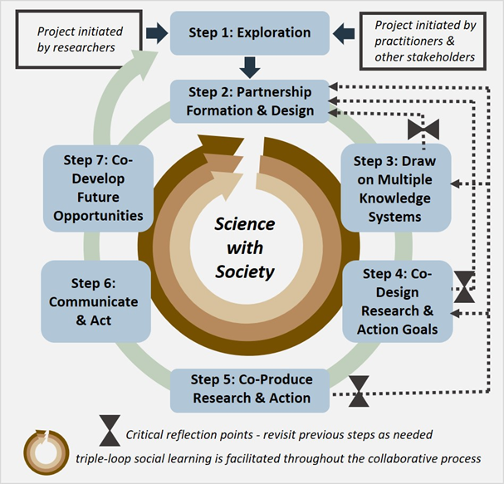
Figure 1. A seven-step model for science with society (SWS), which aims to facilitate knowledge co-production and social learning through a TDW process.
The structure of this conceptual model mirrors the ‘TD wheel’ (Carew and Wickson 2010), a heuristic emphasizing the cyclical and iterative nature of SWS as participants move through different phases. We underscore the need to draw on multiple knowledge systems and bring them into conversation with one another throughout the SWS process. In this regard, our model reflects the Intergovernmental Science-Policy Platform on Biodiversity and Ecosystem Services’ five-step process for conducting valuation studies for ecosystem services (Pascual et al. 2017) and the five core tasks for successful collaboration across diverse knowledge systems (Tengö et al. 2017). However, these models provide guidance to projects that are already in existence, whereas our model seeks to clarify that preliminary exploration of the system and partnership formation are integral for ensuring non-scientists are fully included in the design and ownership of an SWS project (Reid et al. 2016). Common across all these models is the expectation of continuity over time –a “finished” SWS project is ideally just the beginning of another turn of the TD wheel.
In our model, collaborative projects may be initiated by researchers, practitioners, or other stakeholders (i.e., concerned citizens or resource users), all of whom become project participants. Step 1 is an introductory and exploratory phase where participants exchange knowledge about the history and context surrounding the place and problem, and when pre-existing and potential partnerships are considered. Step 2 involves a team-building process, where participants co-design their partnership to ensure it addresses everyone’s concerns and interests. Step 3 requires explicitly incorporating diverse perspectives and worldviews through the participants involved in the collaboration so that the project can benefit from multiple types of knowledge. At Step 3, it is essential to evaluate the team composition and revisit partnership formation, if necessary. Step 4 is an iterative process of co-design, where participants develop the appropriate processes to achieve their desired outcomes. Again, it may be necessary to revisit previous steps to ensure relevant perspectives are included. Step 5 involves the co-production of both research and societally-relevant action, where participants conduct the co-designed research, analyze the results of different methods or activities, and discuss their findings within the group. If at this point it seems that some project objectives will not be met by the methods or activities taken in Step 5, it may be necessary to revisit previous steps. In Step 6, project outcomes and outputs are distributed and discussed outside of project participants, and action is taken based on these results. Step 7 requires participants to reflect on past experiences and prepare for future opportunities, though we highlight the need for ongoing reflection throughout the collaborative process. After Step 7, a new project can begin depending on the needs and interests of the groups involved.
3 Methods
3.1 Survey Design and Administration
We used the conceptual model described above to guide the development of a survey (Appendix A). We screened respondents to ensure they conducted SWS that matches our definition of: “sustained engagement between researchers (professional scientists or scholars) and practitioners (e.g., resource users, natural resource managers, policy makers)”. We asked respondents to draw on their overall SWS experience to rank the top three most important activities in each step, and to identify which of these steps they considered the most difficult to implement. Respondents selected the three most important skills and characteristics for successful SWS from a list of nine we had synthesized from the literature and personal experiences among workshop participants. Respondents then ranked the most significant barriers to successful SWS from a list of fifteen synthesized from the literature and expert experience, which we aggregated into nine general barriers during analysis (Appendix C). We asked respondents whether they had any recommendations for how to overcome these barriers.
In the second half of our survey, respondents identified their most successful SWS project and reported which of the 42 activities in our conceptual model they conducted during that project. Respondents described the context and outcomes of their most successful SWS project, including for example: how successful it was on a scale of 1 to 10, who initiated the project, how long they worked in the area before the project started, and how long it lasted. We asked respondents whether certain kinds of learning occurred (e.g., “Participants changed their ideas about which actions to take regarding the problem”), and coded these responses according to the three loops of social learning (Appendix C). Finally, we requested responses to a few questions about themselves (e.g., gender, research location, length of time conducting SWS). Throughout the survey, we left many of our terms (e.g., skills and characteristics, project success, policy impact) loosely defined so that respondents could interpret them in ways that were relevant to their own projects and contexts.
We administered the survey to researchers, practitioners, and other stakeholders involved in environmental SWS projects worldwide. The survey was offered in four languages: English, Spanish, French, and Chinese. We shared the survey link via Twitter as well as targeted emails to individuals, groups, and listservs. For example, we sent the survey to the Principal Investigators of 48 projects funded by the Belmont Forum and nine projects funded by the Coupled Natural Human Systems program at the U.S. National Science Foundation, as well as 87 other groups and individuals working in environmental SWS worldwide (Appendix B). We sent two to three reminder emails to each individual, group, and listserv to maximize responses and requested that project leaders encourage practitioners and other stakeholder partners to complete the survey.
3.2 Analysis
We analyzed quantitative survey responses using common statistical tests such as Chi-square or Fisher’s Exact tests, t-tests, Wilcoxon rank sum tests, and analysis of variance (ANOVA), as relevant for the sample size and combination of categorical, ordinal, or continuous data types. We used a Bonferroni adjustment to correct for multiple comparisons, resulting in stricter thresholds for significance depending on the number of tests used for different combinations of variables (i.e., p-values < 0.05). A description of data processing, tests, results, and adjusted significance thresholds can be found in Appendix C. All analyses were conducted in R (R Core Development Team 2019). For textual responses regarding solutions to SWS barriers, we used in vivo coding (Corbin and Strauss 2015) and inductive thematic analysis to analyze the results (Boyatzis 1998).
We used three metrics to assess whether each activity from our conceptual model could be considered a best practice in SWS: the activity’s perceived importance across respondent types (i.e., gender, geography, positionality), the frequency with which it was applied across all respondents’ most successful SWS projects, and its impact on project outcomes. Project outcomes included three variables: stated project success (on a scale of 1 to 10), level of policy impact (none, low, medium, or high), and levels of participant learning (none, single and/or double loop, triple loop, or all three loops). We focus on policy impact separately from other societally-oriented outcomes (e.g., local decision making, management activities) because it represents widespread systemic change. However, it is important to clarify that SWS approaches are appropriate for non-policy issues as well. Activities that were consistently ranked in the top three across all respondent types were considered “High Impact”, and those implemented in >70% of projects were considered “High Frequency” activities . Impacts on project outcomes were assessed using Bonferroni-adjusted p-values (Appendix C).
4 Results
The survey was available online from April 4 to October 22, 2018, and yielded 139 complete responses. An additional 29 responses were partially complete and used in our analysis where applicable (total n=168). The number of responses per question varied as responses were voluntary throughout the survey. First we will describe the demographics and geographic patterns of the respondents (Section 4.1). Then we will analyze their insights into the SWS process, including the most desired skills and characteristics for successful SES (Section 4.2.1), the most prominent barriers and strategies for overcoming them (Section 4.2.2), the elements of successful environmental SWS case studies (Section 4.2.3), and finally the best practices for environmental SWS (Section 4.2.4).
4.1 Characterizing Respondents from a Global Survey of Environmental SWS
4.1.1 Respondent Demographics
Respondents identified as women (n=68, 49%), men (n=61, 44%), and other (n=4, 3%). Most respondents identified as researchers only (n =100, 72%), 17 identified as practitioners only (12%), and one identified as a stakeholder only, and 16 identified as some combination of these (12%). Most responses were in English (n=117, 84%), followed by French (n=11), Spanish (n=9), and Chinese (n=2). Offering the survey in other languages may have improved the response rate from non-researchers in non-English speaking countries, as a larger proportion of non-English respondents identified as practitioners (36%) compared to English respondents (19%). However, there were low response rates from practitioners and other stakeholders, which may be related to ‘survey fatigue’ among these groups. For example, one researcher responded that they would not send the survey to their practitioner partners because they were awaiting practitioner responses to another survey.
In subsequent analyses, we consider respondents according to their positionality (researcher only n=100, non-researcher n=34); gender (women n=68, men n=61); and geography (regional n=82, external n=50) to assess whether these groups differ on particular aspects of the SWS process. Non-researchers include some researchers who also identify as practitioners or stakeholders. ‘Regional’ respondents conduct most or all of their research on the same continent where they are primarily located. We regret our sample size prevented including the four respondents who identify as other than a woman or man; however, these respondents were included in the positionality and geographic analyses. There were no associations between respondent gender, geography, or positionality; for example, there are not significantly larger numbers of men researchers (p=0.76) or regional women respondents (p=0.43).
4.1.2 Geographic Patterns of Respondents
Of the 132 location responses, the largest group of respondents was primarily located in North America (n=59, 45%), and nearly all of them (86%) conducted part of their research in North America (Figure 2a). The next largest group of respondents was based in Europe (n=39, 30%), and again most of them (n=33, 85%) conducted part of their research in Europe. Other respondents were based in Africa (n=18, 14%), South America (n=11, 8%), Asia (n=9, 7%), and Oceania (n=2, 2%). No respondents were based in Central America. The two most frequent cross-continental links were Europeans working in Africa (n=15, 11%) and North Americans working in Asia (n=11, 8%) (Figure 2a).
Respondents’ most successful SWS projects (n=135) took place in 70 countries (Figure 2b). While it was most common for projects to occur in a single country (n=102, 76%), other projects ranged from two to 52 countries (n=33, 24%). A notable subset of projects (n=19, 14%) took place across multiple continents. However, most projects occurred on the same continent where the respondent was primarily located (n=83, 62%). Of the 135 respondents that answered this question, the largest proportion worked in the United States (n=50, 37%). Our results are thus heavily biased towards respondents from North America and Europe, which may overshadow insights from other parts of the world.
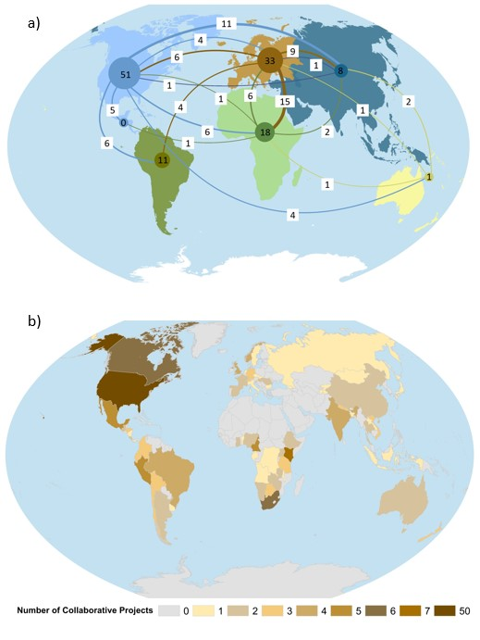
Figure 2. Distribution of respondents and collaborative project locations. a) Circles are colored according to continent and reflect the number of respondents working on the same continent where they are primarily located. Lines are colored by the primary locations of respondents, signifying when those respondents work on another continent. The number of cross-continental links are given in white boxes. Respondents can work in multiple locations and be represented by both circles and lines. b) Number of respondents’ most successful collaborative projects per country. Except for the 50 projects occurring in the US, the highest number of projects per country was seven.
4.2 Environmental SWS Insights From Survey Respondents
4.2.1 Skills and Characteristics for Successful Collaboration
Respondents selected three of the nine most important skills or characteristics that enhance the success of environmental SWS endeavors, resulting in 474 total selections. We conceptualize these in three tiers of relative importance (Figure 3). First tier skills and characteristics include flexibility (n=81, 18%), mutual respect (n=77, 17%), and collaborative spirit (n=72, 16%). Second tier skills and characteristics are humility (n=56, 12%), trust (n=53, 12%), and patience (n=43, 9%), while the third tier includes persistence (n=30, 7%), interdisciplinary training (n=25, 6%), and generosity (n=19, 4%). We present these results separated by respondent type in Figure 3, finding that a larger proportion of researchers considered flexibility an important characteristic for successful collaboration compared to non-researchers (p=0.008). Meanwhile, non-researchers tended to rank Tier 2 characteristics (humility, trust, and patience) more important than flexibility, though this is not a statistically significant difference.
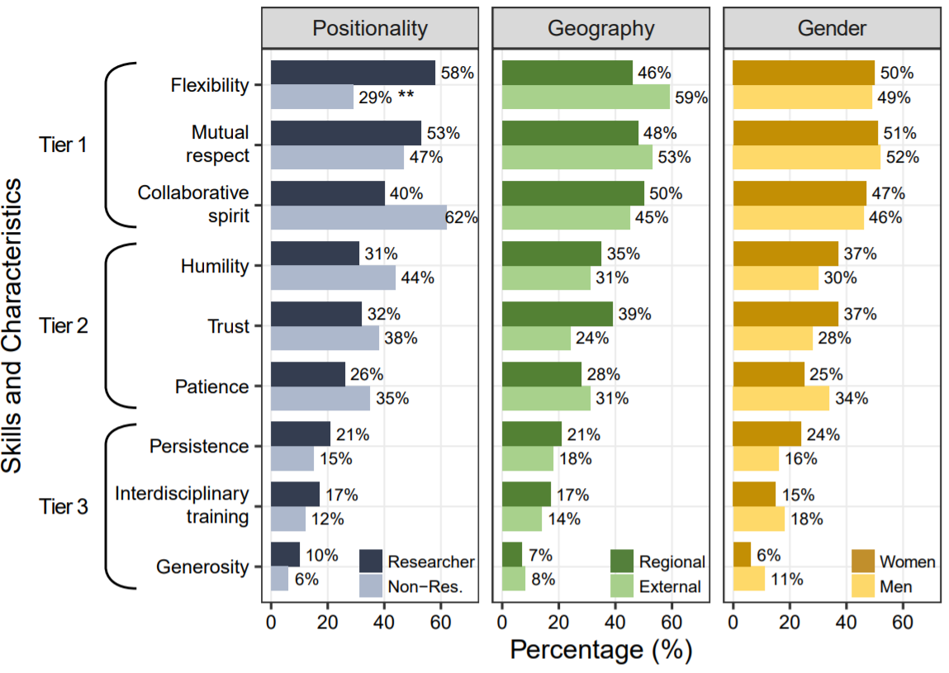
Figure 3. The proportion of respondents that considered each skill and characteristic important for successful SWS, separated by positionality (researcher or non-researcher), geography (regional or external), and gender (men or women). Each respondent selected three skills/characteristics, so proportions do not add to 100% for each respondent type. A larger proportion of researchers considered flexibility an important characteristic for successful collaboration compared to non-researchers (** indicates this difference is statistically significant).
4.2.2 Barriers to Successful Collaboration
All respondent types considered insufficient time and unequal power dynamics to be the two most important barriers (Figure 4). The least important barriers included disagreements over the approach taken, knowledge barriers (e.g., when certain participants rejected the validity of other forms of knowledge), the inability to take action based on results, and using an inappropriate method for the project purpose. In barriers of intermediate importance, clear groupings emerge among respondent types. For example, women, non-researchers, and regional respondents considered ineffective communication to be the third most important barrier, while men, researchers, and external respondents considered this the fifth most important barrier.
A subset of respondents (n= 65, 39%) provided advice for overcoming these barriers. The most common themes involved time (n=23, 35%), shared goals (n=20, 31%), communication (n=21, 32%), and strong leadership (n=21, 32%). SWS projects require time commitments from many people over many years, and respondents emphasized they should not be rushed, as time was considered necessary for building trusting relationships among participants. Several respondents proposed adjusting expectations from participants early on can help ensure people will set aside enough time to contribute meaningfully. Respondents also stressed that shared goals should be established early in the project, and clearly articulated and revised to ensure all participants agree on them as this can help sustain long-term motivation for the project. Constant and equitable communication was suggested to overcome conflict-related barriers like power asymmetry, divergent gender norms, and historical injustices. Respondents suggested that ensuring all participants’ voices are encouraged, heard, and respected can prevent miscommunication and reduce certain groups dominating the SWS process. Professional training or facilitation in conflict resolution was recommended to achieve this equitable communication. Finally, strong leadership was proposed to support long-term, equitable, and actionable SWS projects, both by managing logistics and ensuring that people are held accountable for their contributions to the project.
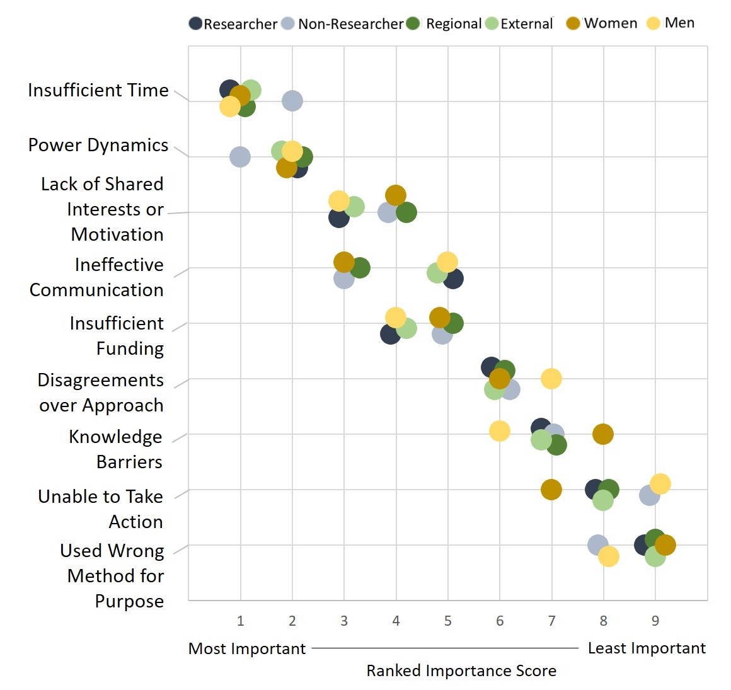
Figure 4. Nine barriers to successful SWS are listed on the vertical axis, and their weighted importance score is given on the horizontal axis, with one being the most important barrier. Dots are colored according to respondent gender (women or men), geography (regional or external), and positionality (researcher or non-researcher).
4.2.3 Elements of Successful SWS Projects
Case studies (n=139) of respondents’ most successful SWS projects occurred primarily in forest (n=42, 30%), mountain (n=36, 26%), urban (n=28, 20%), and/or grassland (n=24, 17%) systems. Respondents generally worked in the study area for less than three years before beginning their most successful project (n=64, 46%), though it was also common to work in the area for 4-9 years (n=37, 27%) or over 10 years (n=30, 22%) before beginning the project. Projects were initiated by either researchers (n=70, 50%), practitioners/stakeholders (n=46, 33%), or a mix of the two, and typically lasted less than three years (n= 81, 58%), with projects over 10 years uncommon (n=8, 6%). Most projects (n=86, 62%) used some form of qualitative or quantitative modeling. Aside from research institutions, participants often came from government (n=88, 63%) and non-profits/NGOs (n=83, 60%), though farmers (n=57, 41%) were also common collaborators. Most projects (n=96, 69%) produced at least one peer-reviewed publication, and feedback workshops with decision makers (n=82, 59%), maps (n=70, 50%), and news media products (n=64, 46%) were other frequent outputs. Our results did not indicate that certain types of collaborators or certain types of project outputs led to greater project success, learning, or policy impact. Further work is needed to identify whether there are ideal numbers or types of collaborators or products in SWS.
Perceived project success was generally high, with a mean of 7.25 (scale of 1-10; SD = 1.62) across all projects. Most projects reported at least one type of participant learning (n=104, 75%), where single and/or double-loop learning (n=61, 59%) was considerably more common than triple-loop learning (n=24, 23%) or all three loops (n=19, 18%). Most respondents reported projects with medium policy impact (n=53, 38%). We did not find any association between respondent type and project outcome; for example, researchers did not consider their projects to have higher policy outcomes than non-researchers (p=0.44). Mean project success was marginally higher in projects where some level of learning occurred, and project success was significantly higher in projects with medium to high policy impact (Figure 5a). All projects jointly initiated by a mix of researchers, practitioners, and/or other stakeholders had some level of policy impact, and projects initiated by practitioners and/or other stakeholders had a larger proportion of high policy impact compared to projects initiated by researchers only (p=0.01, Figure 5b). Notably, projects that produced policy briefs did not appear to achieve higher policy outcomes.
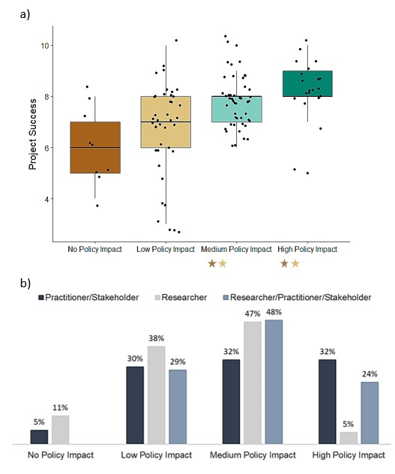
Figure 5. a) Perceived project success increases with perceived policy impact. Stars indicate that projects with no and low level policy impacts had significantly lower project success compared to projects with medium and high policy impacts. b) Projects initiated by practitioners and/or stakeholders had the largest proportion of perceived high policy impact.
4.2.4 Best Practices for Environmental SWS
We identified 20 priority activities for consideration as best practices in environmental SWS using three metrics: activities that were applied in >70% of respondents’ most successful projects (Table 4, Appendix C), their perceived importance as top three activities for all respondent types (Table 5, Appendix C), and their impact on project success, learning, and policy outcomes (Table 1). Nine activities stood out as meeting our criteria across multiple metrics (marked in bold in Table 1), and we propose that projects with limited resources might target these activities when implementing the seven-step SWS process. We do not claim that the remaining 22 activities are not useful, but we have insufficient evidence to call them best practices. Notably, no single activity was significantly associated with high policy impacts.
Within the exploration stage (Step 1), the top three most important activities were connecting with individuals who are well-informed, helpful, or who have extensive networks (A.1.3), identifying the concerns of the different groups (A.1.6), and assessing the context, history, or on-going initiatives surrounding the place or problem (A.1.1). These three activities were also frequently implemented (75-76% of projects), but did not show significant impact on learning or project success.
All respondent types considered partnership formation and design (Step 2) the most difficult step in the SWS process, agreeing that identifying shared interests (A.2.8) was the most important activity and identifying a diverse core leadership team (A.2.6) was the second most important activity. Identifying shared interests was frequently implemented in SWS case studies (77% of projects), while identifying a core leadership team was only implemented in 47% of projects. While conducting a smaller, preliminary project (A.2.2) was ranked relatively low across respondent types, men respondents considered it significantly more important than women (p=0.01). A larger proportion of men also indicated they would include interdisciplinary researchers compared to women (A.2.10, p=0.014).
Respondents agreed that expressing mutual respect (A.3.3) was the most important activity when drawing on multiple knowledge systems (Step 3), and this was the most frequently implemented activity across all steps (83% of projects). The second most important activity was trying to accommodate different processes for learning, understanding, and decision-making (A.3.5), but was only implemented in 54% of projects. Researchers considered sharing experiences with each other (A.3.4) significantly more important than non-researchers (p=0.01), who in fact ranked it lowest.
There was almost perfect agreement regarding the relative importance of all four activities in co-designing research and action (Step 4). Collaboratively defining the issue (A.4.1) was the most frequently implemented activity in this step (78% of projects). While collaboratively developing project goals (A.4.3) was slightly less common (67% of projects), it was also associated with higher project success (p=0.001) and learning outcomes (p=0.009). Collaborative development of research questions (A.4.4) was considered important and associated with higher project success (p=0.001) but was implemented in only 54% of projects.
Respondents considered collaboratively interpreting results (A.5.3) and fostering capacity to conduct the methods (A.5.5) to be important activities in Step 5, though women considered collaboratively interpreting results significantly more important on average than men (p=0.009). However, some respondent types (researchers, regional, and men) considered collaboratively developing outputs and outcomes (A.5.2) the most important activity in Step 5, and researchers ranked this activity significantly more important on average than non-researchers (p=0.001).
Holding workshops with decision makers (A.6.6) was the most important and most frequently implemented activity in Step 6 (75% of projects). Communicating results to the academic community was another frequently implemented activity (72%) even though it received the lowest importance rank across all respondent types. In fact, communicating results to academic audiences occurred more often than communicating results to practitioners (68%) and the public (57%), even though communicating results to practitioners (A.6.1) was considered the second most important activity in Step 6. Unsurprisingly, a larger proportion of researchers extended the results of their SWS project to academic audiences compared to non-researchers (A.6.2, p=0.005).
Respondents agreed that reflecting on strengths and weaknesses (A.7.4) was an important activity in Step 7; however, women respondents considered this significantly more important on average than men (p=0.001). Reflecting on the usefulness of outcomes/outputs (A.7.5) was another important activity, though men’s average ranking was significantly higher than women’s (p=0.002). Contrary to other respondent types, external respondents considered reflecting on the quality of outcomes and outputs (A.7.3) the most important activity, which was also one of the most frequently implemented activities in this step (67% of projects) and was associated with higher learning outcomes (p=0.0002). Researchers also considered reflecting on the quality of outputs and outcomes significantly more important on average than non-researchers (p=0.001). While it was ranked relatively low across respondent types, non-researchers considered assessing participants’ learning (A.7.1) to be significantly more important than did researchers (p=0.02); this activity was also associated with higher learning outcomes (p=0.0003), yet was only conducted in 35% of projects.
Table 1. Of the 42 proposed activities in our conceptual model, 20 emerged as best practices in environmental SWS based on their perceived importance, frequency of use, and impact on project success, learning, and policy outcomes. The nine activities which met our criteria across multiple metrics are highlighted in bold. As none of our proposed activities were associated with high policy impact, we do not include this category in the table. Activities are numbered for identification and are not meant to follow a particular order within each step.
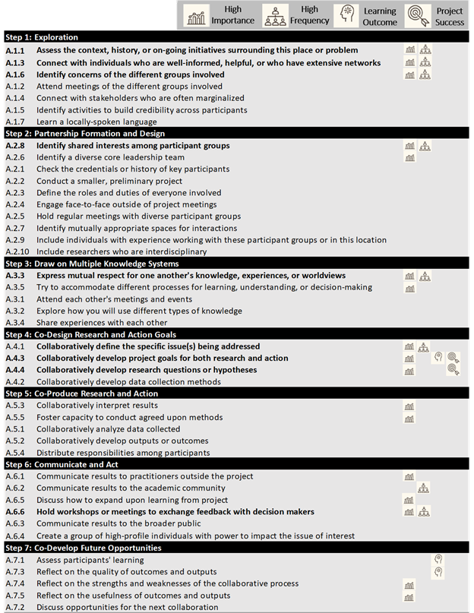
5 Discussion
Our results enable us to better understand the process and benefits of environmental SWS, and provide a set of specific activities for a toolbox of best practices. Transdisciplinary approaches are sometimes criticized for drawing on a broad and ill-defined set of methods for knowledge co-production (Brandt et al. 2013), but we believe this diversity is valuable and necessary given the highly context-specific nature of local knowledge (Berkes 2012). Below, we draw on our conceptual model and the results of our survey to discuss some of the most critical barriers and best practices in environmental SWS.
5.1 Balancing Diverse Perspectives through Careful Partnership Formation and Design
Our SWS conceptual model stresses the need to bring together diverse actors throughout the entire process without prioritizing scientific or societal objectives over the other. While we do not have recommendations for the ideal numbers or types of participants to involve, we know that this is a fundamental challenge in SWS. Indeed, survey respondents highlighted partnership formation and design as the most difficult step in the SWS process. The effective functioning of diverse teams is a considerable challenge that requires trusting and respectful relationships (Dietz et al. 2003) and shared vision and goals among team members (Balvanera et al. 2017; Hoffmann et al. 2017). Building trusting relationships is typically a time-intensive process (Enengel et al. 2012; Baker et al. 2020), requiring interpersonal skills and characteristics that are often not included in academic training (Wiek et al. 2011). Our results emphasize the importance of flexibility, mutual respect, and collaborative spirit, though non-researchers typically consider humility, trust, and patience more important than flexibility. While our survey had considerably more researcher respondents, we believe these differences highlight important rifts between scientifically- and societally-oriented actors that must be considered in the formation of SWS teams. For example, a long-term SWS project on pastoral development and wildlife conservation in southern Kenya and northern Tanzania found that humility was repeatedly cited by community members as an important trait to facilitate trusting relationships: scientists who showed up in modest vehicles, stayed for the full meeting, and walked with community members demonstrated their commitment to collaboration (Reid et al. 2016).
We also stress the importance of the exploratory Step 1, which can lay a foundation for effective partnership formation and design. This step is largely absent from other conceptual models and guides for SWS (but see Cockburn et al. 2016) that typically begin with problem definition, skipping over what we believe is a necessary, somewhat amorphous period where individuals and groups learn about each other and the broader social-ecological system. Step 1 can be a lengthy process, as almost a quarter of survey respondents worked in an area for a decade before initiating a SWS project. Note that we recommend detailed problem identification occurs in Step 4, so that a foundation of place-based understanding is established and diverse forms of knowledge have been brought to bear on the issue before it is collectively defined. Problem definition can be a laborious process, especially when disagreements emerge across knowledge types and need to be more thoroughly examined (Klein et al. 2014; Steger et al. 2020). The Swiss MOUNTLAND project sought to understand impacts of climate change and land use change on ecosystem services in the Swiss mountains, yet they struggled with more specific problem definition because stakeholder needs and interests changed throughout the course of the study. Scientists in charge of the project recommended allocating a longer time period for this process (Huber and Rigling 2014). Steps 1-3 in our model are designed to help stakeholders view the issues from multiple perspectives before determining the key concerns and thus prevent some of these issues. In the long term, this iterative engagement through partnership formation and research design sets the stage for more productive collaborative action.
Our results point to several activities that can facilitate this early exploration and project design. Identifying the concerns of different social groups involved and networking with individuals who are particularly well-informed, well-connected, and helpful are two best practices during the exploration phase. We also found that assessing the context, history, or on-going initiatives surrounding the place or problem is a critical activity at this point. There are many ways to elicit this kind of information, including through methods in participatory action research such as transect walks and photo-voice (Chambers 1994; Catalani and Minkler 2010), participatory scenario planning (Brand et al. 2013; Capitani et al. 2016; Thorn et al. 2020), participatory mapping (Kassam 2009), and ethnographic approaches like participant observation and life histories (Atkinson et al. 2001). For example, one SWS project in the Ethiopian highlands conducted group interviews with participatory mapping and ranking exercises to understand how local people perceived their changing landscape. They iteratively compared these results with remote sensing analyses until a collective understanding of environmental change was produced for the study area, laying a strong foundation for future collaborative work on the more specific issue of invasive shrubs (Steger et al. 2020).
The formation of a diverse core leadership team that also includes individuals with experience working in the study area are two important activities for creating an effective collaborative team (Lang et al. 2012; DeLorme et al. 2016; Hoffmann et al. 2017; Balvanera et al. 2017). It is equally necessary to identify shared interests and collaboratively define project goals among the different participant groups involved to help sustain motivation over an often lengthy collaborative process (Eigenbrode et al. 2007; Lang et al. 2012; Pohl et al. 2015; Hoffmann et al. 2017). For example, one SWS project on common-pool resources in Slovenia expanded their original project goals to include two funded workshops that trained local residents in how to properly construct and repair their traditional dry stone walls, which motivated local participants to value and contribute to the broader research endeavor (Šmid Hribar et al. 2018). These types of well-designed, concrete outcomes are particularly important for practitioners who seek tangible results rather than high-level policy recommendations, and can motivate continued interest in a project (Kueffer et al. 2012). Projects that do not respect participants’ time, resources, and motivation run the risk of burnout among participants; open communication and flexibility for scheduling activities may help to reduce this risk. Finally, logistics are an important and potentially under-realized aspect of partnership formation and design, as our results indicate that finding mutually appropriate spaces for team interactions is a best practice for environmental SWS. We encourage SWS projects to collectively identify mutually appropriate communication platforms as well, particularly for international projects that cross time zones and include stakeholders with different degrees of internet access.
5.2 Promoting Communication, Learning, and Reflexivity to Overcome Conflict and Power Asymmetries
Disagreement and conflicts among SWS participants are common (Lang et al. 2012; Cundill et al. 2019), and not always avoidable given the diversity of values, worldviews, and organizational structures involved (Jahn et al. 2012). Most SWS projects focus on mitigating conflict among participants, relying on strong leadership to anticipate and resolve disputes (Hoffmann et al. 2017). However, there is some evidence that conflict is necessary for learning to occur; a disorienting dilemma (Pennington et al. 2013) or cognitive struggle (Bransford et al. 2006) can challenge SWS participants’ understandings and pave the way for meaningful learning. An SWS project on rangeland management in the Western US described how, despite their data indicating a benefit to both forage quality and bird habitat, ranchers resisted implementing prescribed burns due to preconceived beliefs of wasted forage and unnecessary economic risk. This caused a conflict between ranchers and conservation stakeholders, which led to targeted group conversations about respecting diverse backgrounds and opinions and a joint agreement not to prioritize certain interests over others (Fernández-Giménez et al. 2019). Expressing mutual respect for one another’s knowledge, experiences, and worldviews in this way is a core tenet of SWS and may help avoid negative feelings despite occasional conflicts and disagreements throughout a project.
Clear and effective communication becomes a top priority when groups of people with divergent backgrounds, experiences, and values are brought together. Some scholars have cautioned SWS to actively avoid the academic trend of highly specialized language and jargon (Tress 2003; Brandt et al. 2013) to promote more accessible communication. However, these kinds of barriers to communication were not emphasized in our survey results; for example, learning a new language was considered the least important activity in Step 1 and engaging face-to-face outside of project meetings was also considered low priority. Rather, respondents emphasized the importance of equitable communication (e.g., making sure every voice is heard and respected) at regular intervals, which supports findings in the broader SWS literature (DeLorme et al. 2016). Professional facilitation appears to be a useful way to ensure that communication remains effective and equitable (Lang et al. 2012; Kragt et al. 2013; DeLorme et al. 2016). Our results also highlight the tendency for researchers to communicate their results to academic audiences more frequently than other stakeholder audiences, despite universal agreement across respondent types that communicating to outside practitioner groups was more important. These types of communication biases can prevent certain groups from benefitting from the SWS process by inhibiting their learning and empowerment. We encourage project leaders to set aside sufficient time and resources to communicate results to a wide range of audiences, and for funding agencies to recognize and support these efforts.
Learning throughout the SWS process is a highly desirable yet poorly understood and under-researched phenomenon (Armitage et al. 2008; Baird et al. 2014; Fernández-Giménez et al. 2019). Though additional research is urgently needed, our results point to a few activities that can encourage equitable and effective learning. When the partnership and project are being designed, it is important to accommodate a range of processes that will enable diverse participants to learn, understand, and reach a decision that is relevant to their particular socio-cultural context. For example, a project with coffee cooperatives in Honduras experimented with diverse modes of stakeholder interaction including group activities, discussions, and workshops, which resulted in learning among farmers as well as between farmers and researchers. This process rekindled interest in indigenous practices for chemical-free pest management, increasing farmers' ability to achieve organic certification and giving them a sense of empowerment in a previously top-down project that had not aligned with their cultural or economic interests (Castellanos et al. 2013). It is equally important to collectively discuss how to expand upon learning at the end of a project. We encourage future SWS projects to actively monitor and measure participants’ learning throughout the collaborative process, though we recognize that funding agencies and institutions must support long-term projects (i.e., over five years) or follow-up projects to facilitate this kind of assessment.
Power asymmetries are a widely acknowledged challenge in environmental SWS (Jahn et al. 2012; Mauser et al. 2013; Scholz and Steiner 2015a), as they can enable certain groups or individuals to achieve their objectives at the cost of others (Mobjörk 2010; Cundill et al. 2015). On-going learning assessments throughout the project can be useful tools for encouraging individual and group reflection and allowing the project to correct any imbalances that are emerging. Our conceptual model encourages on-going reflexivity in SWS participants, both as individuals and collectively, so that these power asymmetries can be identified and bridged through discussion and compromise (Fazey et al. 2014). For example, a project in Kenya used participatory scenario planning to help stakeholders identify trade-offs across economic sectors that might occur from building a new railway. These tools enabled participants to think more systematically about impacts to other sectors and to better understand one another’s perspectives, leading to greater team cohesion (Thorn et al. in review). We also emphasize the importance of fostering capacity to conduct the research, so that all team members have the tools to engage in the research if they choose and are not relegated to the sideline during critical parts of the collaborative process. A participatory mapping project in the Alaskan Arctic trained pairs of university students and community partners to conduct interviews and mapping exercises, thus fostering mutual learning and shared control over the data collection process (Kassam and the Wainwright Traditional Council 2001; Kassam 2009). These kinds of tools and facilitated discussions can help move past conflict and power asymmetries in SWS projects.
5.3 Increasing SWS Policy Impact for Joint Science and Society Benefits
Environmental SWS seeks solutions for multidimensional “wicked” problems that threaten the structure and functioning of social-ecological systems (Kates and Parris 2003; Rockström et al. 2009), and which require immediate and collaborative action. Though small-scale SWS can also be highly impactful (Balvanera et al. 2017), we focus on policy impact rather than other societal outcomes such as management or local decision making. This is because policy change is needed to shift the behaviors of large organizations and institutions – particularly when addressing problems that cross regional to global scales (Cundill et al. 2019). Yet significant social barriers exist between scientists and policy makers that prevent the use of scientific information in policy development and decision-making (Gano et al. 2007; Landry et al. 2003). Research shows that boundary organizations, which are formal institutions and organizations that work across the science-policy divide (Guston 2001), can help to overcome many of these barriers through the facilitation of stronger social networks (Crona and Parker 2011; Young et al. 2014; Suni et al. 2016). Communities of practice, typically more informal groups of people with a shared interest or passion (Wenger et al. 2002), are another promising institution for this type of work (Cundill et al. 2015). More research is needed to understand the social relationships that facilitate higher SWS policy impact, including how information flows within and across social networks (Borgatti and Foster 2003) and the role of formal and informal social networks like boundary organizations and communities of practice in SWS.
Survey respondents considered projects more successful when they were perceived to have medium to high policy impacts, emphasizing the importance of facilitating these outcomes. Our results indicate that policy impact is associated with the early stages of project formation, as projects initiated by practitioners and/or other stakeholders were more likely to have high policy impact compared to projects initiated by researchers only. The European Platform for Biodiversity Research Strategy (EPBRS) promotes early engagement of policy-makers through e-conferences on particular topics, which are then discussed at plenary meetings attended by policy makers and scientists seeking points of common understanding and interest for future research (Young et al. 2014). While none of the activities in our conceptual model were significantly associated with high policy impact, respondents highlighted the importance of holding workshops and meetings to exchange feedback with decision-makers. Other research has shown that policy makers on the periphery of projects, but who engage regularly with the core team (for example, through workshops), are more likely to use SWS results in their decision-making compared to policy makers who only see the final products (Crona and Parker 2011). This supports our finding that policy briefs do not appear to contribute to higher policy impact, despite assumptions in academia of the utility of this tool. Rather, the foundation for policy impact is laid early on in a project through iterative partnership and project design. We therefore encourage future SWS practitioners to avoid conflating project outputs like policy briefs or peer-reviewed articles with project outcomes.
While we recognize the need for increasing policy impacts from SWS projects, we also acknowledge that there will be times when it is not feasible to take action based on the results of a SWS process, despite participant intentions (Brandt et al. 2013). For example, a project in northern Switzerland failed to implement their results because local collaborators did not have the political mandate to affect regional development plans (van Zeijl-Rozema and Martens 2011). This barrier might be mitigated by careful partnership design that includes high-profile individuals with the power to impact the issue of interest, though this activity did not emerge as a best practice. Additionally, our results indicate that certain groups in SWS may be more likely to experience obstacles to taking action, as women ranked this a more significant barrier than men. These results reflect broader trends in gender discrimination, as women are often excluded from leadership positions throughout the world. In U.S. conservation organizations, women are more likely to occupy junior positions (Taylor 2015) and are routinely denied opportunities to participate in decision-making (Jones and Solomon 2019). We encourage environmental SWS participants to recognize and, where possible, resolve these imbalances to increase the impact of SWS for a broader range of people and places.
6 Conclusions
Transdisciplinarity has emerged as an increasingly necessary research approach in environmental sustainability. Our conceptual model of SWS seeks to expand upon existing models to foster deep, place-based understanding and equal benefits for both science and society. This emergent paradigm is particularly essential in this moment, as the world moves to recover and rebuild from COVID-19 and address systemic societal inequalities. The toolbox of 20 activities we present for consideration as best practices offer a path forward, though they require further experimentation across a broader range of social, cultural, and political ecological contexts given the limitations of our survey responses. We particularly encourage future work to focus on insights from non-Western contexts; the preliminary conditions that support projects initiated by non-researchers; the influence of disciplinary training and epistemological differences on SWS process and outcomes; and differences in project outcomes according to the scale of their funding. Further research is also needed into the social aspects of SWS – specifically, social networks and social learning – so that we can better facilitate SWS that fosters transitions to sustainability in the face of global environmental change.

References
Adams, M.S., Carpenter, J., Housty, J.A., Neasloss, D., Paquet, P.C., Service, C., Walkus, J. and Darimont, C.T., 2014. Toward increased engagement between academic and indigenous community partners in ecological research. Ecology and Society, 19(3): 5. http://dx.doi.org/10.5751/ES-06569-190305
Agrawal, A., 2001. Common property institutions and sustainable governance of resources. World Development 29(10): 1649-1672. https://doi.org/10.1016/S0305-750X(01)00063-8
Armitage, D., M. Marschke, and R. Plummer. 2008. Adaptive co-management and the paradox of learning. Global Environmental Change 18(1): 86–98. https://doi.org/10.1016/j.gloenvcha.2007.07.002
Atkinson, P., A. Coffey, S. Delamont, J. Lofland, and L. Lofland. 2001. Handbook of ethnography. Sage, London.
Baird, J., R. Plummer, C. Haug, and D. Huitema. 2014. Learning effects of interactive decision-making processes for climate change adaptation. Global Environmental Change 27: 51–63. https://doi.org/10.1016/j.gloenvcha.2014.04.019
Baker, Z., Ekstrom, J.A., Meagher, K.D., Preston, B.L. and Bedsworth, L., 2020. The social structure of climate change research and practitioner engagement: Evidence from California. Global Environmental Change, 63: 102074. https://doi.org/10.1016/j.gloenvcha.2020.102074
Balvanera, P., T. M. Daw, T. A. Gardner, B. Martín-López, A. V. Norström, C. Ifejika Speranza, M. Spierenburg, E. M. Bennett, M. Farfan, M. Hamann, J. N. Kittinger, T. Luthe, M. Maass, G. D. Peterson, and G. Perez-Verdin. 2017. Key features for more successful place-based sustainability research on social-ecological systems: a Programme on Ecosystem Change and Society (PECS) perspective. Ecology and Society 22(1): 14. https://doi.org/10.5751/ES-08826-220114
Berkes, F. 2012. Sacred ecology. Fourth edition. Routledge, New York, USA.
Berkes, F., and D. Jolly. 2002. Adapting to climate change: social-ecological resilience in a Canadian western Arctic community. Conservation Ecology 5(2):18. http://www.consecol.org/vol5/iss2/art18/
Bernstein, J. H. 2015. Transdisciplinarity: a review of its origins, development, and current issues. Journal of Research Practice 11(1): R1. http://jrp.icaap.org/index.php/jrp/article/view/510/412
Bole, D., Šmid Hribar, M. and P. Pipan. 2017. Participatory research in community development: A case study of creating cultural tourism products. AUC Geographica 52(2):1–12. https://doi.org/10.14712/23361980.2017.13
Bonney, R.; Shirk, J.L.; Phillips, T.B.; Wiggins, A.; Ballard, H.L.; Miller-Rushing, A.J.; Parrish, J.K. 2014. Next Steps for Citizen Science. Science 343: 1436–1437. DOI: 10.1126/science.1251554
Borgatti, S.P. and P.C. Foster. 2003. The network paradigm in organizational research: a review and typology. Journal of Management 29(6): 991-1013. https://doi.org/10.1016/S0149-2063(03)00087-4
Boyatzis, R. E. 1998. Transforming qualitative information: thematic analysis and code development. Sage, London.
Brand, F. S., R. Seidl, Q. B. Le, J. M. Brändle, and R. W. Scholz. 2013. Constructing consistent multiscale scenarios by transdisciplinary processes: the case of mountain regions facing global change. Ecology and Society 18(2): 43. http://dx.doi.org/10.5751/ES-04972-180243
Brandt, P., A. Ernst, F. Gralla, C. Luederitz, D. J. Lang, J. Newig, F. Reinert, D. J. Abson, and H. von Wehrden. 2013. A review of transdisciplinary research in sustainability science. Ecological Economics 92: 1–15. https://doi.org/10.1016/j.ecolecon.2013.04.008
Bransford, J., R. Stevens, D. Schwartz, A. Meltzoff, R. Pea, J. Roschelle, N. Vye, P. Kuhl, P. Bell, and B. Barron. 2006. Learning theories and education: toward a decade of synergy. In P. A. Alexander & P. H. Winne (Eds.), Handbook of educational psychology (2nd ed.,p. 209–244). Lawrence Erlbaum Associates Publishers, Mahwah, New Jersey.
Capitani C., K. Mukama, B. Mbilinyi, P. Munishi, N. Burgess, P.J. Platts, S. Sallu, and R. Marchant. 2016. From local scenarios to national maps: a participatory framework for envisioning the future applied to Tanzania. Ecology and Society 21(3):4. . http://dx.doi.org/10.5751/ES-08565-210304
Carew, A. L., and F. Wickson. 2010. The TD Wheel: a heuristic to shape, support and evaluate transdisciplinary research. Futures 42(10): 1146–1155. https://doi.org/10.1016/j.futures.2010.04.025
Cash, D. W., W. C. Clark, F. Alcock, N. M. Dickson, N. Eckley, D. H. Guston, J. Jäger, and R. B. Mitchell. 2003. Knowledge systems for sustainable development. Proceedings of the National Academy of Sciences 100(14): 8086 -8091. https://doi.org/10.1073/pnas.1231332100
Castellanos, E., C. Tucker, H. Eakin, H. Morales, J. Barrera and R. Diaz. 2013. Assessing the Adaptation Strategies of Farmers Facing Multiple Stressors: Lessons from the Coffee and Global Changes Project in Mesoamerica. Environmental Science and Policy 26: 19-28. https://doi.org/10.1016/j.envsci.2012.07.003
Catalani, C., and M. Minkler. 2010. Photovoice: a review of the literature in health and public health. Health Education & Behavior 37(3): 424–451. https://doi.org/10.1177/1090198109342084
Chambers, R. 1994. The origins and practice of participatory rural appraisal. World Development 22(7): 953–969. https://doi.org/10.1016/0305-750X(94)90141-4
Cockburn, J., and G. Cundill. 2018. Ethics in transdisciplinary research: reflections on the implications of ‘Science with Society.’ In CI Maclead, J Marx, P Mnyaka, and GJ Treharne. The Palgrave Handbook of Ethics in Critical Research (pp. 81–97). Springer, Switzerland. https://doi.org/10.1007/978-3-319-74721-7
Cockburn, J., M. Rouget, R. Slotow, D. Roberts, R. Boon, E. Douwes, S. O’Donoghue, C. Downs, S. Mukherjee, and W. Musakwa. 2016. How to build science-action partnerships for local land-use planning and management: lessons from Durban, South Africa. Ecology and Society 21(1):28. http://dx.doi.org/10.5751/ES-08109-210128
Colfer, C. J. P. 2005. The complex forest: communities, uncertainty and adaptive collaborative management. RFF Press and CIFOR, Washington, D.C., USA and Bogor, Indonesia.
Corbin, J., and A. Strauss. 2015. Basics of Qualitative Research. Sage, London.
Crona, B. I., and J. N. Parker. 2011. Network determinants of knowledge utilization: preliminary lessons from a boundary organization. Science Communication 33(4): 448–471. https://doi.org/10.1177/1075547011408116
Cundill, G., B. Harvey, M. Tebboth, L. Cochrane, B. Currie‐Alder, K. Vincent, J. Lawn, Robert. J. Nicholls, L. Scodanibbio, A. Prakash, M. New, P. Wester, M. Leone, D. Morchain, E. Ludi, J. DeMaria‐Kinney, A. Khan, and M. Landry. 2019. Large‐scale transdisciplinary collaboration for adaptation research: challenges and insights. Global Challenges 3(4): 1700132. https://doi.org/10.1002/gch2.201700132
Cundill, G., D. J. Roux, and J. N. Parker. 2015. Nurturing communities of practice for transdisciplinary research. Ecology and Society 20(2):22. http://dx.doi.org/10.5751/ES-07580-200222
Daniels, S. E., and G. B. Walker. 1996. Collaborative learning: improving public deliberation in ecosystem-based management. Environmental Impact Assessment Review 16: 71–102. https://doi.org/10.1016/0195-9255(96)00003-0
DeLorme, D. E., D. Kidwell, S. C. Hagen, and S. H. Stephens. 2016. Developing and managing transdisciplinary and transformative research on the coastal dynamics of sea level rise: Experiences and lessons learned on transdisciplinary research. Earth’s Future 4(5):194–209. https://doi.org/10.1002/2015EF000346
Dietz, T., E. Ostrom, and P. C. Stern. 2003. The struggle to govern the commons. Science 302(5652):1907-1912. https://doi.org/10.1126/science.1091015
Dyball, R., V. A. Brown, and M. Keen. 2007. Towards sustainability: Five strands of social learning. In A Wals. Social Learning Towards a Sustainable World: Principles, perspectives, and praxis (pp.181-194). Wageningen Academic, the Netherlands.
Eigenbrode, S. D., M. O’Rourke, J. D. Wulfhorst, D. M. Althoff, C. S. Goldberg, K. Merrill, W. Morse, M. Nielsen-Pincus, J. Stephens, and L. Winowiecki. 2007. Employing philosophical dialogue in collaborative science. BioScience 57(1): 55–64. https://doi.org/10.1641/B570109
Enengel, B., A. Muhar, M. Penker, B. Freyer, S. Drlik, and F. Ritter. 2012. Co-production of knowledge in transdisciplinary doctoral theses on landscape development—an analysis of actor roles and knowledge types in different research phases. Landscape and Urban Planning 105(1–2): 106–117. https://doi.org/10.1016/j.landurbplan.2011.12.004
Fazey, I., L. Bunse, J. Msika, M. Pinke, K. Preedy, A. C. Evely, E. Lambert, E. Hastings, S. Morris, and M. S. Reed. 2014. Evaluating knowledge exchange in interdisciplinary and multi-stakeholder research. Global Environmental Change 25: 204–220. https://doi.org/10.1016/j.gloenvcha.2013.12.012
Fernández-Giménez, M., D. Augustine, L. Porensky, H. Wilmer, J. Derner, D. Briske, and M. Stewart. 2019. Complexity fosters learning in collaborative adaptive management. Ecology and Society 24(2):29. https://doi.org/10.5751/ ES-10963-240229
Finlay, L., 1998. Reflexivity: an essential component for all research?. British Journal of Occupational Therapy, 61(10): 453-456. https://doi.org/10.1177/030802269806101005
Freire, P. 1970. Pedagogy of the oppressed. Bloomsbury publishing, USA.
Fujitani, M., A. McFall, C. Randler, and R. Arlinghaus. 2017. Participatory adaptive management leads to environmental learning outcomes extending beyond the sphere of science. Science Advances 3(6):e1602516. DOI: 10.1126/sciadv.1602516
Gano, G. L., J.E. Crowley, and D. Guston. 2007. “Shielding” the knowledge transfer process in human service research. Journal of Public Administration, 17: 39-60. https://doi.org/10.1093/jopart/muj013
Gibbons, M., C. Limoges, H. Nowotny, S. Schwartzman, P. Scott, and M. Trow. 1994. The new production of knowledge: the dynamics of science and research in contemporary societies. Sage, London.
Greenwood, D.J. and Levin, M., 2006. Introduction to action research: Social research for social change. Sage, London.
Guston, D. 2001. Boundary organizations in environmental policy and science: an introduction. Science, Technology, & Human Values 26: 299-408.
Harris, F and Lyon F. (2013) Transdisciplinary environmental research: building trust across professional cultures. Environ Sci Policy 31: 109-119. DOI 10.1016/j.envsci.2013.02.006
Hoffmann, S. C. Pohl, and J.G. Hering. 2017. Exploring transdisciplinary integration within a large research program: empirical lessons from four thematic synthesis processes. Research Policy 46(3): 678-692. https://doi.org/10.1016/j.respol.2017.01.004
Huber, R., and A. Rigling. 2014. Commitment to continuous research is a key factor in transdisciplinarity. Experiences from the Mountland Project. GAIA - Ecological Perspectives for Science and Society 23(3): 256–262. https://doi.org/10.14512/gaia.23.3.10
IPBES. 2019. Summary for policymakers of the global assessment report on biodiversity and ecosystem services of the Intergovernmental Science-Policy Platform on Biodiversity and Ecosystem Services. S. Díaz, J. Settele, E. S. Brondízio E.S., H. T. Ngo, M. Guèze, J. Agard, A. Arneth, P. Balvanera, K. A. Brauman, S. H. M. Butchart, K. M. A. Chan, L. A. Garibaldi, K. Ichii, J. Liu, S. M. Subramanian, G. F. Midgley, P. Miloslavich, Z. Molnár, D. Obura, A. Pfaff, S. Polasky, A. Purvis, J. Razzaque, B. Reyers, R. Roy Chowdhury, Y. J. Shin, I. J. Visseren-Hamakers, K. J. Willis, and C. N. Zayas (eds.). IPBES secretariat, Bonn, Germany. 56 pages. https://doi.org/10.5281/zenodo.3553579
Jahn, T., M. Bergmann, and F. Keil. 2012. Transdisciplinarity: between mainstreaming and marginalization. Ecological Economics (79): 1–10. https://doi.org/10.1016/j.ecolecon.2012.04.017
Jones, M. S., and J. Solomon. 2019. Challenges and supports for women conservation leaders. Conservation Science and Practice 1(6): e36. https://doi.org/10.1111/csp2.36
Kassam, K.A.S., Ruelle, M.L., Samimi, C., Trabucco, A. and Xu, J., 2018. Anticipating climatic variability: the potential of ecological calendars. Human Ecology, 46(2): 249-257. https://doi.org/10.1007/s10745-018-9970-5
Kassam, K-A. 2009. Biocultural diversity and indigenous ways of knowing: Human ecology in the Arctic. Calgary, AB: University of Calgary Press. https://dx.doi.org/10.2307/j.ctv6gqsbf
Kassam, K-A., & the Wainwright Traditional Council. 2001. Passing on the knowledge: Mapping human ecology in Wainwright, Alaska. Calgary, AB: Arctic Institute of North America.
Kates, R.W. T.M. and Parris. 2003. Long-term trends and a sustainability transition. Proceedings of the National Academy of Sciences, 100(14): 8062-8067. https://doi.org/10.1073/pnas.1231331100
Keen, M., and S. Mahanty. 2006. Learning in sustainable natural resource management: challenges and opportunities in the Pacific. Society and Natural Resources 19(6): 497–513. DOI: 10.1080/08941920600663896
Keen, M., V. A. Brown, and R. Dyball. 2005. Social learning in environmental management: towards a sustainable future. Routledge, London.
Klein, J. A., K. A. Hopping, E. T. Yeh, Y. Nyima, R. B. Boone, and K. A. Galvin. 2014. Unexpected climate impacts on the Tibetan Plateau: local and scientific knowledge in findings of delayed summer. Global Environmental Change 28: 141-152. https://doi.org/10.1016/j.gloenvcha.2014.03.007
Klein, J. T., W. Grossenbacher-Mansuy, R. Häberli, A. Bill, R. W. Scholz, and M. Welti. 2001. Transdisciplinarity: joint problem solving among science, technology, and society: an effective way for managing complexity. Birkhauser Verlag, Basel, Switzerland.
Knapp, C. N., R. S. Reid, M. E. Fernández-Giménez, J. A. Klein, and K. A. Galvin. 2019. Placing transdisciplinarity in context: a review of approaches to connect scholars, society and action. Sustainability 11(18): 4899. https://doi.org/10.3390/su11184899
Kragt, M.E., Robson, B.J. and Macleod, C.J., 2013. Modellers' roles in structuring integrative research projects. Environmental Modelling & Software, 39: 322-330. https://doi.org/10.1016/j.envsoft.2012.06.015
Kueffer, C., E. Underwood, G. H. Hadorn, R. Holderegger, M. Lehning, C. Pohl, M. Schirmer, R. Schwarzenbach, M. Stauffacher, and G. Wuelser. 2012. Enabling effective problem-oriented research for sustainable development. Ecology and Society 17(4):8. http://dx.doi.org/10.5751/ES-05045-170408
Landry, R., M. Lamari, and N. Amara. 2003. Extent and determinants of utilization of university research in public administration. Public Administration Review, 63(2):191-204.
Lang, D. J., A. Wiek, M. Bergmann, M. Stauffacher, P. Martens, P. Moll, M. Swilling, and C. J. Thomas. 2012. Transdisciplinary research in sustainability science: practice, principles, and challenges. Sustainability Science 7(S1): 25–43.
Lave, J., and E. Wenger. 1991. Situated learning: legitimate peripheral participation. Cambridge University Press, Cambridge, UK.
Lewin, K. (1948). Resolving social conflicts; selected papers on group dynamics. Harper, USA.
Malterud, K., 2001. Qualitative research: standards, challenges, and guidelines. The lancet, 358(9280): 483-488.
Mauser, W., G. Klepper, M. Rice, B. S. Schmalzbauer, H. Hackmann, R. Leemans, and H. Moore. 2013. Transdisciplinary global change research: the co-creation of knowledge for sustainability. Current Opinion in Environmental Sustainability 5(3–4): 420–431.
Middendorf, G., and L. Busch. 1997. Inquiry for the public good: democratic participation in agricultural research. Agriculture and Human Values 14: 45–57.
Miller, T. R., T. D. Baird, C. M. Littlefield, G. Kofinas, F. S. Chapin III, and C. L. Redman. 2008. Epistemological pluralism: reorganizing interdisciplinary research. Ecology & Society 13(2): 46. http://www.ecologyandsociety.org/vol13/iss2/art46/
Mobjörk, M. 2010. Consulting versus participatory transdisciplinarity: a refined classification of transdisciplinary research. Futures 42(8): 866–873.
Moore, M.-L., O. Tjornbo, E. Enfors, C. Knapp, J. Hodbod, J. A. Baggio, A. Norström, P. Olsson, and D. Biggs. 2014. Studying the complexity of change: toward an analytical framework for understanding deliberate social-ecological transformations. Ecology and Society 19(4): 54. http://dx.doi.org/10.5751/ES-06966-190454
Nared, J., Razpotnik, Visković N., Cremer-Schulte, D., Brozzi, R., Cortines Garcia, F. 2015. Achieving sustainable spatial development in the Alps through participatory planning. Acta geographica Slovenica 55(2): 363–373. http://dx.doi.org/10.3986/AGS.1631
Norström, A.V., C. Cvitanovic, M.F. Löf, S. West, C. Wyborn, P. Balvanera, A.T. Bednarek, E.M. Bennett, R. Biggs, A. de Bremond, and B.M. Campbell. 2020. Principles for knowledge co-production in sustainability research. Nature Sustainability 3: 182 – 190. .
Ostrom, E., 1990. Governing the commons: The evolution of institutions for collective action. Cambridge University Press, Cambridge, UK.
Owen, R., P. Macnaghten, and J. Stilgoe. 2012. Responsible research and innovation: From science in society to science for society, with society. Science and Public Policy, 39(6): 751-760.
Pahl-Wostl, C. 2009. A conceptual framework for analysing adaptive capacity and multi-level learning processes in resource governance regimes. Global Environmental Change 19(3): 354–365.
Pahl-Wostl, C., and M. Hare. 2004. Processes of social learning in integrated resources management. Journal of Community & Applied Social Psychology 14(3): 193–206.
Pascual, U., P. Balvanera, S. Díaz, G. Pataki, E. Roth, M. Stenseke, R. T. Watson, E. B. Dessane, M. Islar, and E. Kelemen. 2017. Valuing nature’s contributions to people: the IPBES approach. Current Opinion in Environmental Sustainability 26: 7–16.
Pennington, D. D., G. L. Simpson, M. S. McConnell, J. M. Fair, and R. J. Baker. 2013. Transdisciplinary research, transformative learning, and transformative science. BioScience 63(7): 564–573.
Pohl, C., G. Wuelser, P. Bebi, H. Bugmann, A. Buttler, C. Elkin, A. Grêt-Regamey, C. Hirschi, Q. B. Le, A. Peringer, A. Rigling, R. Seidl, and R. Huber. 2015. How to successfully publish interdisciplinary research: learning from an Ecology and Society Special Feature. Ecology and Society 20(2): 23. http://dx.doi.org/10.5751/ES-07448-200223
Popa, F., M. Guillermin, and T. Dedeurwaerdere. 2015. A pragmatist approach to transdisciplinarity in sustainability research: from complex systems theory to reflexive science. Futures 65: 45–56.
R Core Development Team. 2019. R: a language and environment for statistical computing. R Foundation for Statistical Computing, Vienna, Austria.
Reed, M., A. C. Evely, G. Cundill, I. R. A. Fazey, J. Glass, A. Laing, J. Newig, B. Parrish, C. Prell, and C. Raymond. 2010. What is social learning? Ecology and Society 15(4). https://www.jstor.org/stable/26268235
Reid, R.S., Nkedianye, D., Said, M.Y., Kaelo, D., Neselle, M., Makui, O., Onetu, L., Kiruswa, S., Kamuaro, N.O., Kristjanson, P. and Ogutu, J., 2016. Evolution of models to support community and policy action with science: Balancing pastoral livelihoods and wildlife conservation in savannas of East Africa. Proceedings of the National Academy of Sciences, 113(17): 4579-4584.
Rockström, J., W. Steffen, K. Noone, Å. Persson, F. S. Chapin, E. F. Lambin, T. M. Lenton, M. Scheffer, C. Folke, H. J. Schellnhuber, B. Nykvist, C. A. de Wit, T. Hughes, S. van der Leeuw, H. Rodhe, S. Sörlin, P. K. Snyder, R. Costanza, U. Svedin, M. Falkenmark, L. Karlberg, R. W. Corell, V. J. Fabry, J. Hansen, B. Walker, D. Liverman, K. Richardson, P. Crutzen, and J. A. Foley. 2009. A safe operating space for humanity. Nature 461(7263): 472-475. https://doi.org/10.1038/461472a
Roux, D.J., R.J. Stirzaker, C.M. Breen, E.C. Lefroy, and H.P. Cresswell, H.P., 2010. Framework for participative reflection on the accomplishment of transdisciplinary research programs. Environmental Science & Policy, 13(8): 733-741.
Schmitt, C. B., F. Senbeta, M. Denich, H. Preisinger, and H. J. Boehmer. 2010. Wild coffee management and plant diversity in the montane rainforest of southwestern Ethiopia. African Journal of Ecology 48(1): 78–86.
Scholz, R. W., and D. Marks. 2001. Learning about transdisciplinarity: where are we? Where have we been? Where should we go? In Klein, J. T., W. Grossenbacher-Mansuy, R. Häberli, A. Bill, R. W. Scholz, and M. Welti. (Eds) Transdisciplinarity: joint problem solving among science, technology, and society: an effective way for managing complexity (pp. 236–252). Birkhauser Verlag, Basel, Switzerland.
Scholz, R. W., and G. Steiner. 2015a. The real type and ideal type of transdisciplinary processes: part I—theoretical foundations. Sustainability Science 10(4): 527–544.
Scholz, R. W., and G. Steiner. 2015b. The real type and ideal type of transdisciplinary processes: part II—what constraints and obstacles do we meet in practice? Sustainability Science 10(4): 653–671.
Seidl, R., Brand, F.S., Stauffacher, M., Krütli, P., Le, Q.B., Spörri, A., Meylan, G., Moser, C., González, M.B. and Scholz, R.W., 2013. Science with society in the anthropocene. Ambio, 42(1): 5-12.
Shirk, J. L., H. L. Ballard, C. C. Wilderman, T. Phillips, A. Wiggins, R. Jordan, E. McCallie, M. Minarchek, B. V. Lewenstein, M. E. Krasny, and R. Bonney. 2012. Public participation in scientific research: a framework for deliberate design. Ecology and Society 17(2): 29.http://dx.doi.org/10.5751/ES-04705-170229
Šmid Hribar, M., J. Kozina, D. Bole, and M. Urbanc. 2018. Public goods, common-pool resources, and the commons: the influence of historical legacy on modern perceptions in Slovenia as a transitional society. Urbani izziv, 29(1): 96–109.
Steger, C., Nigussie, G., Alonzo, M., Warkineh, B., Van Den Hoek, J., Fekadu, M., Evangelista, P. and Klein, J., 2020. Knowledge coproduction improves understanding of environmental change in the Ethiopian highlands. Ecology and Society, 25(2): 2. https://doi.org/10.5751/ES-11325-250202
Suni, T., S. Juhola, K. Korhonen-Kurki, J. Käyhkö, K. Soini, and M. Kulmala. 2016. National Future Earth platforms as boundary organizations contributing to solutions-oriented global change research. Current Opinion in Environmental Sustainability 23: 63–68.
Taylor, D. E. 2015. Gender and racial diversity in environmental organizations: uneven accomplishments and cause for concern. Environmental Justice 8(5): 165–180.
Tengö, M., R. Hill, P. Malmer, C. M. Raymond, M. Spierenburg, F. Danielsen, T. Elmqvist, and C. Folke. 2017. Weaving knowledge systems in IPBES, CBD and beyond—lessons learned for sustainability. Current Opinion in Environmental Sustainability 26: 17–25.
Thorn, J. P. R., J. A. Klein, C. Steger, K. A. Hopping, C. Capitani, C. M. Tucker, A. W. Nolin, R. S. Reid, R. Seidl, V. S. Chitale, and R. Marchant. 2020. A systematic review of participatory scenario planning to envision mountain social-ecological systems futures. Ecology and Society 25(3):6. https://doi.org/10.5751/ES-11608-250306
Thorn, J. P. R., L. Wariungi, D. Olago, C. Sang, T. Ochieng, N. Burgess, B. Mwangi, and R. Marchant, R. In review. Land use scenarios and social-ecological responses along the SGR: Kenyan Case Study.
Tress, B., G. Tress, A. van der Valk, and G. Fry. 2003. Interdisciplinary and transdisciplinary landscape studies: potential and limitations. Delta Program, Wageningen.
Tress, B., G. Tress, and G. Fry. 2005. Defining concepts and the process of knowledge production. In Tress, B, G Tress, G Fry, and P Opdam. From landscape research to landscape planning: aspects of integration, education and application (pp. 13-26). Springer, the Netherlands.
UNESCO. 2019. “Science for Society.” https://en.unesco.org/themes/science-society
van Kerkhoff, L. and V. Pilbeam. 2017. Understanding socio-cultural dimensions of environmental decision-making: a knowledge governance approach. Environmental Science & Policy 73: 29-37.
van Zeijl-Rozema, A., and P. Martens. 2011. Integrated monitoring of sustainable development. Sustainability: The Journal of Record 4(4):199–202.
Wenger, E., R. McDermott, and W. Snyder. 2002. Cultivating communities of practice: a guide to managing knowledge. Harvard Business School Press, Cambridge, Massachusetts, USA.
Westberg, L., and M. Polk. 2016. The role of learning in transdisciplinary research: moving from a normative concept to an analytical tool through a practice-based approach. Sustainability Science 11(3): 385–397.
Wiek, A., L. Withycombe, and C. L. Redman. 2011. Key competencies in sustainability: a reference framework for academic program development. Sustainability Science 6(2): 203–218.
Wiek, A., Ness, B., Schweizer-Ries, P., Brand, F.S. and Farioli, F., 2012. From complex systems analysis to transformational change: a comparative appraisal of sustainability science projects. Sustainability Science 7(1): 5-24.
Wyborn, C., Datta, A., Montana, J., Ryan, M., Leith, P., Chaffin, B., Miller, C. and Van Kerkhoff, L., 2019. Co-producing sustainability: Reordering the governance of science, policy, and practice. Annual Review of Environment and Resources 44: 319-346.
Young, J., Waylen, K., Sarkki, S., Albon, S., Bainbridge, I., Balian, E., Davidson, J., Edwards, D., Fairley, R., Margerison, C., McCracken, D., Owen, R., Quine, C., Stewart-Roper, C., Thompson, D., Tinch, R., Van den Hove, S., Watt, A., 2014. Improving the science-policy dialogue to meet the challenges of biodiversity conservation: having conversations rather than talking at one-another. Biodiversity and Conservation 23: 387-404.

