The earliest evidence for crop cultivation during the Early Bronze Age in the southeastern Baltic

Gytis Piličiauskas^{1*}, Rokas Vengalis^{1*}, Karolis Minkevičius², Dalia Kisielienė³, Žilvinas Ežerinskis⁴, Justina Šapolaitė⁴, Raminta Skipitytė⁴ and Harry K. Robson⁵

¹Lithuanian Institute of History, Kražių st. 5, 01108 Vilnius, Lithuania
²Department of Archaeology, Vilnius University, Universiteto st. 7, 01513 Vilnius, Lithuania
³Laboratory of Quaternary Research, Nature Research Centre, Akademijos st. 2, 08412 Vilnius, Lithuania
⁴Center for Physical Sciences and Technology, Savanorių ave. 231, Vilnius 02300, Lithuania
⁵Department of Archaeology, BioArCh, University of York, York, North Yorkshire, YO10 5DD, UK

*Corresponding authors: gytis.piliciauskas@gmail.com (Gytis Piličiauskas) and rokasven@gmail.com (Rokas Vengalis)

Abstract
The Early Bronze Age (ca. 1800-1100 cal BC) is among one of the most poorly understood prehistoric periods in the southeastern Baltic region. Here, we present the multidisciplinary results obtained from the recent excavations undertaken at the site of Kvietiniai in western Lithuania, including radiocarbon (¹⁴C) measurements and the stable isotope analysis of charred barley (Hordeum vulgare) grains. Our results provide the earliest direct evidence for crop cultivation in the southeastern Baltic region (ca. 1300-1250 cal BC), and link it to an as yet poorly known cord-impressed coarse pottery tradition. Moreover, the Freshwater Reservoir Effect (FRE) of the nearby Minija River was calculated, ca. 2000 years today with a terminus ad quem of 780 ± 57 years during prehistory. Consequently, our findings have implications for understanding the cultural and economic development of the Bronze Age in the region, and demonstrate that crop cultivation was adopted ca. 1500 years after the initial integration of animal husbandry in the Early Neolithic.

Keywords Southeastern Baltic; Early Bronze Age; freshwater reservoir effect; crop cultivation; barley

1. Introduction
The Early Bronze Age (ca. 1800-1100 cal BC) is among one of the most poorly understood prehistoric periods in Lithuania. Since settlements and burials are rare, particularly from the younger phase of the period (ca. 1500-1100 cal BC), it has been suggested that the size of the population decreased (Grigalavičienė 1995; Luchtanas and Sidrys 1999). However, this is simply unsustainable. Whilst tempting to envisage a population collapse or indeed a population replacement, a lack of extensive investigations and site visibility are two of several possible contributing factors. Previous AMS radiocarbon (¹⁴C) dating coupled with the attribution of pottery to a particular cultural stage (i.e. the Early post-Corded Ware) have demonstrated that there are no known settlements from the younger phase of the period, ca. 1500 cal BC, onwards (Daugnora and Girininkas 2004; Rimantienė 2005; Piličiauskas 2018). Following a hiatus period, it is generally acknowledged that Fine-rusticated and Brushed Wares, associated with the Late Bronze Age and Early Iron Age throughout the region, emerged at ca. 700 cal BC (e.g. the sites of Kernavė, Kukuliškiai, Luokesa 1 and 2, Paveisininkai and Žalioji) (Menotti et al. 2005; Minkevičius et al. 2019; Piličiauskas 2018; Piličiauskas et al. 2012). Whilst it has been suggested that several sites (e.g. Kubilėliai, Varėnė 2 and Visėtiškės) date to the Early Bronze Age based on their pottery traditions (Brazaitis 2000; Piličiauskas 2018), which bear similarities with the Trzciniec culture of Belarus and Poland (ca. 1950-1200 cal BC; Czebreszuk et al. 1998), this is currently unproven by radiocarbon (¹⁴C) dating. Uncharred organic remains are absent, largely due to the poor conditions of preservation, whilst the recovered ceramics have never been directly dated. Furthermore, systematic sampling for the recovery of macrobotanical remains is lacking. Consequently, little is known about the Early Bronze Age of the southeastern Baltic, including the subsistence economy.

Previous research, including zooarchaeology as well as the stable isotope analysis of human bone collagen, and the organic residue analysis of ceramics, have recently demonstrated that animal husbandry, including dairy products, was introduced into the southeastern Baltic during the Early Neolithic Globular Amphora (hereafter GAC) and Corded Ware (hereafter CWC) cultures, ca. 3200-2800 cal BC (Piličiauskas et al. 2017a, b; Robson et al. 2019). Indeed, recent DNA studies of eastern European GAC and CWC individuals have revealed substantial genetic differences not only between these two groups (Mathieson et al. 2018; Tassi et al. 2017) but also between them and local hunter-gatherers (Haak et al. 2015; Jones et al. 2016; Mitnik et al. 2017; Saag et al. 2017). When combined with the archaeological evidence, the genetic data strongly implies that large-scale migration was responsible for the introduction of both the GAC and CWC peoples as well as animal husbandry into the eastern Baltic. In contrast with the zooarchaeological evidence, whilst it has been suggested that crop cultivation was introduced during the preceding Subneolithic period based on pollen evidence (see Alenius et al. 2013), ¹⁴C measurements obtained directly from macrobotanical remains are lacking, thus casting doubt about the reliability of its inception (Lahtinen and Rowley-Conwy 2013; Piličiauskas et al. 2017a). Furthermore, previous claims regarding the presence of Cannabis, Setaria italica and Triticum dicoccum seeds at the Subneolithic Šventoji sites (Rimantienė 1979, 1996, 2005) have not been corroborated by subsequent analysis and direct radiocarbon dating (Piličiauskas et al. 2017a). Prior to our research, the earliest evidence for crop cultivation in the southeastern Baltic is known from the Late Bronze Age sites of Kukuliškiai in western Lithuania and Turlojiškė in southern Lithuania, which have been dated to ca. 700-600 cal BC and ca. 1000-700 cal BC respectively (Antanaitis and Ogrinc 2000; Minkevičius et al. 2019; Piličiauskas et al. 2017b).

Throughout the majority of Europe, crop cultivation and animal husbandry dispersed as a single entity during the Neolithisation process (Price 2000; Whittle 1996). However, it would appear that this joint ‘package’ diverged prior to its introduction into the southeastern Baltic by GAC and CWC migrants at ca. 3200-2800 cal BC. The reasons for this are far from clear. Indeed, the highly productive forested environments with an abundance of wild resources may have ‘prevented’ the inception of agriculture whereby it was deemed less attractive compared with the raising of domesticated animals. Alternatively, agriculture may have been abandoned by these migrants given the colder climate and the time needed for their crops to adapt rather than human choice as has been recently proposed (Motuzaite Matuzeviciute 2018). However, in light of recent research on the earliest evidence of farming in adjoining Baltic regions (i.e. central and northern Baltic), a climatic influence seems highly unlikely. Indeed, barley (Hordeum vulgare) and wheat (Triticum sp.) grains are known from several sites in east-central Sweden and the Åland archipelago, situated north of the southeastern Baltic and dated to ca. 4000-3000 cal BC (Vanhanen et al. 2019).

In 2015, an opportunity to learn more about the culture and subsistence economy of the Early Bronze Age in the southeastern Baltic arose. Due to the construction of a gas pipeline, a rescue excavation was launched and led by one of us (RV) at the site of Kvietiniai. The site is presently situated in the Minija River valley in western Lithuania (Fig. 1). In total, an area of 1958 m² was investigated. Around 3300 artefacts dating to the Mesolithic, Neolithic, and Bronze Age periods were recovered from an unstratified habitation layer (between 20-30 cm in thickness), and from 93 features below it (Vengalis et al. 2016, 2020). Unfortunately animal remains were not well preserved being largely restricted to small (i.e. <1 cm) and unidentifiable burnt fragments. However, 10 cremation burials (within ceramic urns or separately in pits) were discovered that most likely belonged to a flat cemetery. Of the 10 cremation burials, one was radiocarbon dated to 728-388 cal BC (Poz-86016, 2375 ± 35 BP) demonstrating that the cemetery succeeded the earlier habitation layer, the latter of which was dated by typology and radiocarbon dating to ca. 1300-900 cal BC. Despite the general poor preservation of organic remains, ceramics were frequently encountered. In total, 2980 potsherds were recovered. Among the ceramic assemblage two wares predominated, represented by the CWC tradition as well as another ware; the latter of which was also cord-ornamented but technologically and stylistically very different to the CWC ceramics. Both pottery types were concentrated in two areas where the cultural layer was covered by a thin aeolian sand layer, and thus remained largely undisturbed and better preserved (Fig. 2). Given their scientific potential, we aimed to contextualise the ceramics and determine vessel function (the results of which are summarised elsewhere (Robson et al. 2019)). Moreover, a number of soil samples varying in volume were taken from numerous archaeological features as well as the habitation layer to recover any plant macroremains that may have been processed and consumed by the inhabitants of the site. Since this proved successful, we firstly identified the plant taxa present, and then undertook carbon and nitrogen stable isotope analysis on some of these charred cereal grains and seeds to ascertain the potential impacts of manuring. Further, a number of these charred cereal grains were directly radiocarbon dated to determine whether we were dealing with the earliest evidence for crop cultivation within the southeastern Baltic region. Lastly, additional materials (artefacts and ecofacts) were dated, whilst modern fish tissues were analysed to estimate the potential local Freshwater Reservoir Effect (FRE). As has been demonstrated elsewhere in Europe (e.g. Boudin et al. 2009; Philippsen 2013; Meadows et al. 2014), the amount of ¹⁴C in aquatic water bodies may differ compared with the atmosphere due to dissolved fossil carbon. For instance, this difference (or FRE) makes the ¹⁴C measurements of charred organic residues, formed principally or partly of aquatic products, too old, often in the order of several hundred years. Without estimation of the local FRE, direct radiocarbon dating of pottery (of charred organic residues) that had been used to process aquatic products will not yield reliable data.

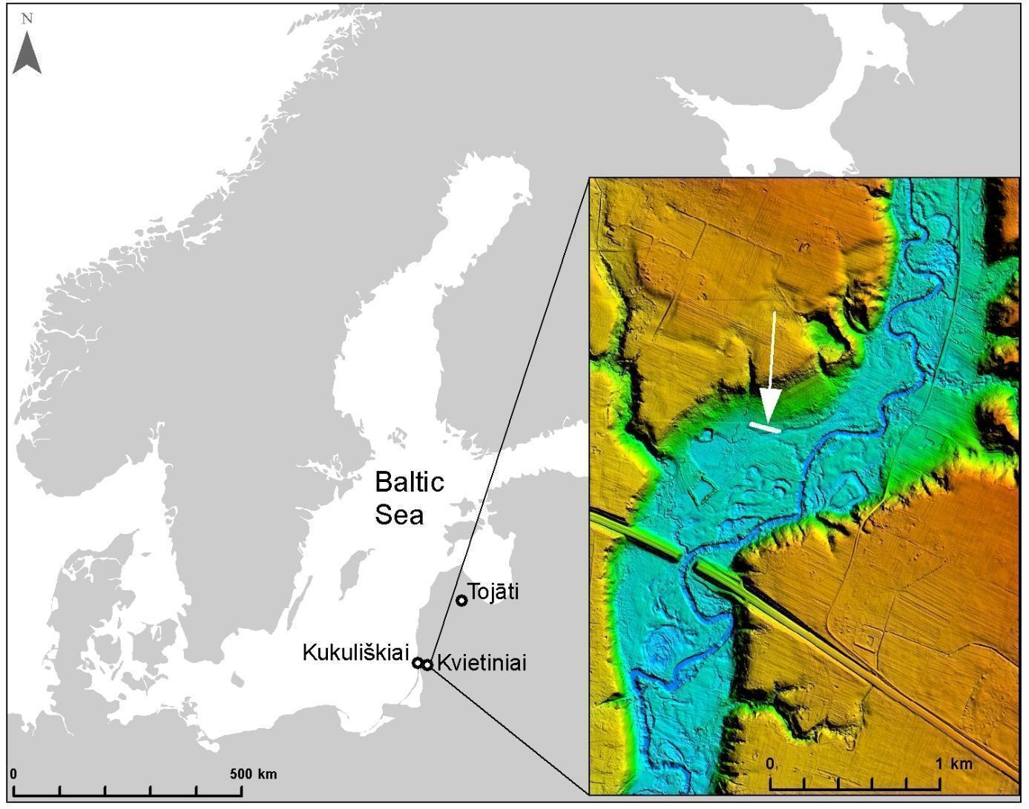
Fig. 1 Location of Kvietiniai and sites mentioned in the text in relation to Northern Europe. The insert shows a shaded relief map of the area surrounding Kvietiniai that was interpolated from LiDAR data. The excavated area is indicated by a white arrow.

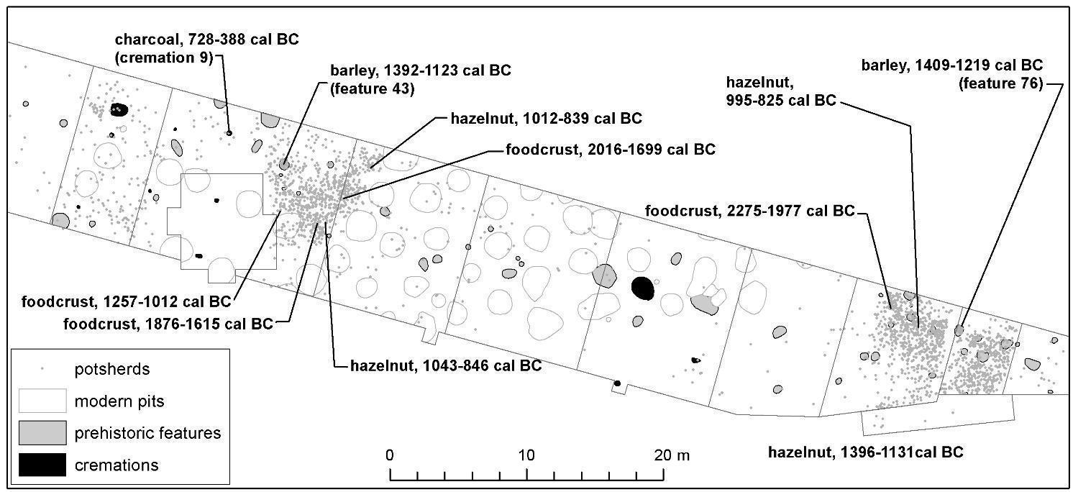
Fig. 2 The eastern part of the excavations at Kvietiniai with the sample locations and results of AMS radiocarbon (¹⁴C) dating.

2. Materials and methods
2.1. Sampling for AMS dating
Sample selection to ascertain the chronology of the site and contextualise this presumed previously unknown pottery tradition was a challenge. The Neolithic and Bronze Age ceramics were recovered from an unstratified layer. Whilst charcoal (from an undetermined wood taxa) was present within the features, pottery was either absent altogether or restricted to a very few sherds of different wares. Since paired dating from the same closed context was not possible, we decided to sample the charred organic residues (interior ‘foodcrusts’ or exterior ‘sooted residues’) adhering to the ceramic vessels. However, given the location of the site, on the bank of the Minija River, coupled with the previous molecular and isotopic analysis of ceramics, which demonstrated the presence of aquatic biomarkers in many of the vessels (Robson et al. 2019), it was highly likely that the ¹⁴C ages of any charred organic residues had been affected by an as yet unknown FRE. In total, four sherds were selected for radiocarbon dating. In addition, four charred hazelnut (Corylus sp.) shells and one charred barley grain were sampled. These were taken from the unstratified cultural layer as well as a number of features to ascertain when the site had been occupied. These results were combined with a previously published ¹⁴C result (Grikpėdis and Motuzaite Matuzeviciute 2018).

Taking the aforementioned into consideration, we were unable to measure the prehistoric FRE of the Minija River as the remains of aquatic organisms from Kvietiniai were lacking. To overcome, five fish that had been caught in July and October 2019 in the Minija River, located directly in front of the site (Fig. 1), were sampled. Although ¹⁴C ages vary both spatially and temporally as well as between species (Keaveney and Reimer 2012), the FRE of the modern fish enabled us to explain the large disparity between the ¹⁴C results obtained from the charred organic residues (see below).

2.2. AMS dating
AMS radiocarbon (¹⁴C) dating was undertaken at the Poznań Radiocarbon Laboratory (Poland) and the Mass Spectrometry Laboratory Centre for Physical Sciences and Technology, Vilnius (Lithuania). The standard acid-alkali-acid (AAA) pretreatment was used for the charred plant remains, hazelnut shells and wood charcoal as well as the bones or tissues from the five modern fish, whilst the HCl pretreatment was used solely for the charred organic residue samples as described elsewhere (see Brock et al. 2010). Collagen extraction was performed using the AAA method followed by gelatinisation (Molnár et al. 2013). The modern fish tissues were freeze-dried prior to analysis. In this study all radiocarbon ages were calibrated using the OxCal 4.2 software and IntCal13 atmospheric curve (Bronk Ramsey 2009; Reimer et al. 2013). Calibrated dates are presented at 95.4% probability in BC.

2.3. Macrobotanical analysis
Twenty-eight soil samples ranging from 1.3 to 13.5 L in volume (3.4 L per sample on average) were collected for macrobotanical analysis using purposive and judgmental sampling (Jones 1991) of archaeological features alongside blanked sampling (Pearsall 2015) of the cultural layer. These included samples from five cremation burials, six domestic pits, one hearth, and eight other features. Since the plant macroremains recovered from seven soil samples were previously analysed and published by Grikpėdis and Motuzaite Matuzeviciute (2018), we analysed the remaining 21 soil samples (74.5 L in total) in this study. Initially the soil samples were mixed with water and the floating fraction was retrieved using sieves with a mesh size of 200 μm. The material was left to dry and then sorted and identified under a binocular microscope between 10-120 x magnifications. The charred plant remains were identified by comparison with modern specimens of known taxa, which are housed at the Laboratory of Quaternary Research, Nature Research Centre (Vilnius), and through consultation of several atlases (Cappers et al. 2006; Grigas 1986; Neef et al. 2012). Plant name nomenclature followed Mirek et al. (2002) and Zohary et al. (2012).

2.4. Stable isotope analysis of plant macroremains
We measured the carbon (δ¹³C) and nitrogen (δ¹⁵N) stable isotope values of five charred plant macroremains, which were taken from Kvietiniai as well as various archaeological sites throughout Lithuania. The samples represented both wild (charred hazelnut (Corylus avellana) and water chestnut (Trapa natans) kernels) and domesticated plants (charred barley (Hordeum vulgare) grains). Measurements were undertaken at the Centre for Physical Sciences and Technology, Vilnius (Lithuania). An Elemental Analyser Flash EA1112 linked to a Thermo V Advantage Mass Spectrometer was used. The samples were oven-dried, and then manually homogenized using a mortar and pestle. Acid-Base-Acid (ABA) pre-treatment of the samples was not undertaken, as it has no significant effect on the δ¹³C or δ¹⁵N values (Fraser et al. 2013). Instrument precision on the repeated measurements of reference material was better than 0.15‰ for both carbon and nitrogen.

3. Results and discussion
3.1. Evidence for farming at the end of the Early Bronze Age
A total of 93 features were excavated at Kvietiniai. Of these, 28 were subjected to macrobotanical analysis. In two (Features 76 and 43), 11 charred barley grains were identified (Table 1; Fig. 3). Features 76 and 43 were situated 50 m from one another (Fig. 2). Feature 76 measured 0.8 x 0.6 x 0.3 m in size and was infilled with light grey humus sand analogous to the overlying archaeological layer. Twelve small-unornamented potsherds made from grog and 28 potsherds from granite-tempered vessels as well as two tiny fragments of burnt bone were found. The function of the pit is presently unclear. Feature 43 measured 0.8 x 0.7 x 0.15 m in size and was infilled with black sand with charcoal and unidentified fragments of calcined bones. Therefore, it has been interpreted as a hearth. Feature 43 contained a single flint flake and 24 pottery fragments. Of these, seven were identified as Corded Ware according to their clay mass (i.e. grog or invisible temper), while the remainder were fragments of granite-tempered vessels that mostly resembled the cord-impressed coarse pottery better known from the cultural layer at Kvietiniai (Fig. 4).

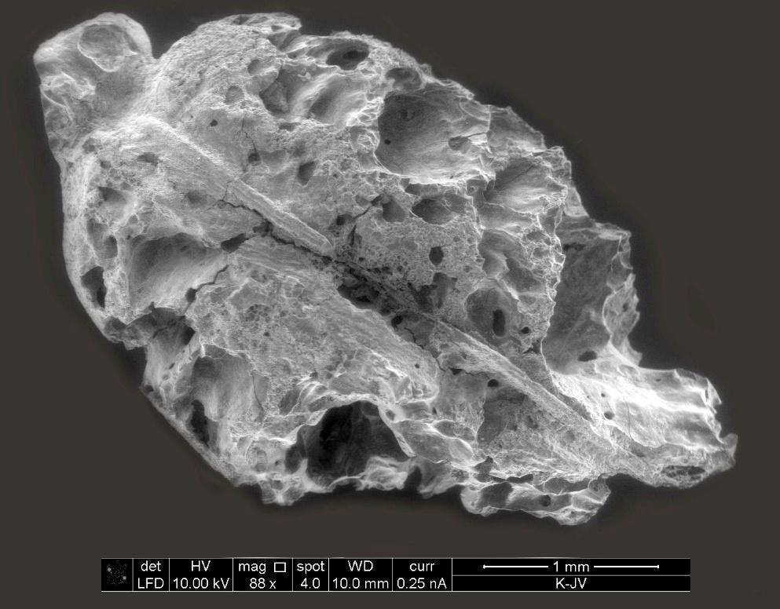
Fig. 3 SEM of the charred barley grain from Feature 76.

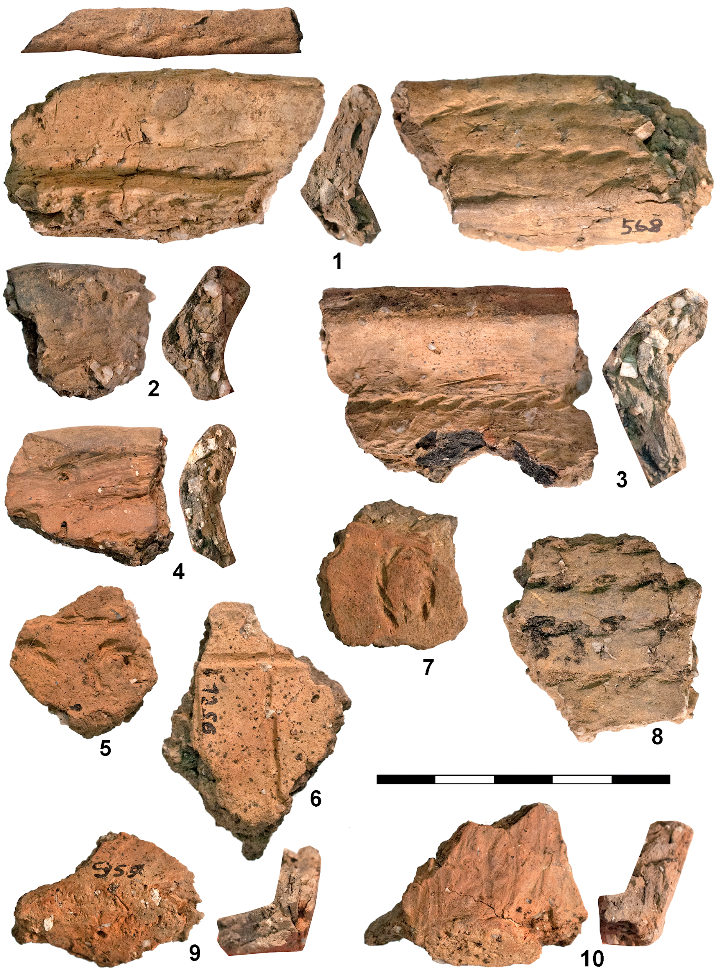
Fig. 4 Cord-impressed coarse pottery from the unstratified cultural layer at Kvietiniai.

Context no. | Identified remains | 5 (G) | 16 (D) | 18 (D) | 42 (P) | 60 (D) | 62 (P) | 65 (P) | 71 (P) | 76 (H) | 3362 (CL) | 41 (P)* | 43 (H) * | 57 (D) *
Volume floated (L) |  | 1.6 | 1.6 | 1.25 | 1.5 | 12.85 | 6.1 | 2.9 | 1.45 | 13.47 | 8.1 | 1.5 | 12 | 3
Taxon
Cultivated plants
Cerealia indet. | c | - | - | - | - | - | - | - | - | - | - | - | - | -
cf. Cerealia indet. | c fr | 1 | - | - | - | - | - | - | - | - | - | - | - | -
Hordeum vulgare | c | - | - | - | - | - | - | - | - | 1 | - | - | 1 | -
Hordeum vulgare | c fr | - | - | - | - | - | - | - | - | 2 | - | - | - | -
cf. Triticum/Hordeum sp. | c fr | - | - | - | - | - | - | - | - | - | - | - | 7 | -
Wild plants
Carex sp. | f | - | - | - | - | - | - | - | - | 1 | - | - | - | -
Carex hirta | f | - | - | - | 1 | - | - | - | - | - | - | - | - | -
Caryophyllaceae |  | - | - | - | - | - | - | - | - | - | - | - | 1 | -
Corylus avellana | f fr | 1 | - | 1 | 1 | 4 | 2 | 1 | 1 | 42 | 31 | - | 35 | -
Galium spurium | f | - | 2 | - | - | - | - | - | - | - | - | - | - | -
Lamiaceae |  | - | - | - | - | - | - | - | - | - | - | 1 | - | -
Lathyrus/Pisum sp. | s | - | - | - | - | - | - | - | - | - | - | - | - | 1
Malvaceae |  | - | - | - | - | - | - | - | - | - | - | - | 1 | -
Rosaceae |  | - | - | - | - | - | - | - | - | - | - | - | - | 1
Table 1 Charred plant remains from Kvietiniai. Abbreviations: CL = cultural layer; D = domestic pit; G = grave; H = hearth; P = pit; c = caryopses; fr = fragments; f = fruits; s = seeds. * denotes data that was first published in Grikpėdis and Motuzaite Matuzeviciute 2018.

No. | Sample description | Lab. code | ¹⁴C date (BP) ± error | cal BC (95.4%) | Vessel content after Robson et al. (2019)
1 | Interior foodcrust from a coarse ware potsherd, No. 1588 | FTMC-39-5 | 3714 ± 42 | 2275-1977 | Aquatic (full suite) + ruminant adipose (SRR%, Δ¹³C) + plant (ketones)
2 | Exterior sooted residue from a coarse ware potsherd, No. 1298 | FTMC-39-7 | 3530 ± 50 | 2016-1699 | Aquatic (full suite) + ruminant adipose (SRR%, Δ¹³C) + plant (MAGs, TAGs, DAGs)
3 | Interior foodcrust from a coarse ware potsherd, No. 1035 | FTMC-60-1 | 3408 ± 40 | 1876-1615 | Aquatic (full suite) + ruminant dairy (Δ¹³C) + ruminant adipose (SRR%) + plant (ketones)
4 | Charred barley (Hordeum vulgare) grain from feature 76 | Poz-85276 | 3050 ± 35 | 1409-1219
5 | Charred hazelnut shell from a cultural layer, No. 3334 | Poz-86015 | 3025 ± 35 | 1396-1131
6 | Charred barley (Hordeum vulgare) grain from feature 43 (hearth) | UBA-30600 | 3009 ± 39* | 1392-1123
7 | Interior foodcrust from a coarse ware potsherd, No. 732 | FTMC-39-6 | 2930 ± 39 | 1257-1012 | Ruminant adipose (SRR%)
8 | Charred hazelnut shell from a cultural layer, No. 3308 | Poz-86012 | 2800 ± 35 | 1043-846
9 | Charred hazelnut shell from a cultural layer, No. 3314 | Poz-86013 | 2785 ± 35 | 1012-839
10 | Charred hazelnut shell from a cultural layer, No. 3319 | Poz-86014 | 2755 ± 35 | 995-825
Table 2 AMS measurements obtained from the site of Kvietiniai. The ¹⁴C results of the charred organic residues that are too old due to the FRE are shaded. The modern fish were caught in 2019 in the Minija River directly in front of the site. *First published by Grikpėdis and Motuzaite Matuzeviciute (2018).

Site | Period | Sample type | %N | %C | δ¹⁵N | δ¹³C | C:N atomic
Daktariškė 5 | Subneolithic | Charred hazelnut kernel | 3.9 | 50.9 | 3.3 | -28.4 | 15.2
Šventoji 4 | Subneolithic | Charred water chestnut kernel | 3.7 | 65.0 | -1.4 | -25.6 | 20.7
Kvietiniai | Early Bronze Age | Charred barley grain, feature No. 76 | 2.2 | 48.7 | 2.7 | -25.7 | 25.8
Kernavė | medieval | Charred barley grain | 3.8 | 52.3 | 7.3 | -24.1 | 16.1
Kalgraužiai 2 | medieval | Charred hazelnut kernel | 1.0 | 46.5 | 1.7 | -26.7 | 54.3
Table 3 Stable isotope data obtained from the wild and domesticated plant macroremains sampled in this study. Note that all sites are located in Lithuania.

Barley grains from Features 76 and 43 were radiocarbon dated to the same period, 1409-1219 and 1392-1123 cal BC respectively (Table 2), which corresponds to the final phase of the Early Bronze Age according to the Lithuanian periodisation (Fig. 5). Prior to the Kvietiniai finds, directly dated crop macrofossils were only reported from Late Bronze Age sites. For example, the assemblage from Turlojiškė (ca. 908-485 cal BC) contained charred Panicum miliaceum (broomcorn millet) caryopses (Antanaitis-Jacobs et al. 2002), whilst a carbonized Hordeum vulgare (barley) grain, dated to 887-556 cal BC, was discovered at Kukuliškiai (Minkevičius et al. 2019). The absence of earlier evidence for crop cultivation is not surprising, as the hypothesis of pre-Bronze Age farming in the southeastern Baltic has already been deconstructed on several occasions (Lahtinen and Rowley-Conwy 2013; Piličiauskas 2016; Piličiauskas et al. 2017a).

Nevertheless, fragmentary archaeological and archaeobotanical data suggest a possibility of local small scale farming starting as early as the 2nd millennium BC. Firstly, it is evident that during the Late Bronze Age local crop cultivation was already well established which is characterised by a diverse crop package, intensive agriculture and permanent field cultivation (Lang 2007; Minkevičius et al. 2019). Besides, local communities were engaged in a producers’ economy since the Neolithic, even though the current data only attests for animal husbandry (Piličiauskas 2018). Thus, the possibility of Early Bronze Age crop cultivation ought not to be dismissed, as the apparent lack of evidence could be the result of the overall lack of systematic sampling. Secondly, the changes in settlement patterns could also indicate a shift towards an agricultural-based economy. While the majority of Neolithic sites in the southeastern Baltic are usually found on the banks of lakes and lagoons, Kvietiniai is situated in a river valley. Similarly, changing preferences for Early Bronze Age settlement location could indicate that access to fertile soils, grazing land, and freshwater resources played a vital role for the Bronze Age communities.

The possible selection of barley over other major cereals such as emmer or einkorn is not surprising at Kvietiniai. It is more tolerant to colder conditions and thus, could reach higher altitudes than wheat (Weisskopf and Fuller 2014). Data from the Åland Islands illustrates their suitability to harsher environments, and the prospect of higher yields might have facilitated the cultivation of barley even in the northernmost farming extreme of the Baltic Sea region (Vanhanen et al. 2019).

It is also worth noting that the scarcity of archaeobotanical data prevents us from drawing definitive conclusions on both the nature and scale of Early Bronze Age crop cultivation. It is only possible to compare the results from Kvietiniai to those of other Late Bronze Age sites. In doing so, it is apparent that they contrast sharply with the recently published Kukuliškiai material (Minkevičius et al. 2019). The site is located just 20 km west of Kvietiniai and dates to the end of the Bronze Age (ca. 700-600 cal BC), i.e. some five centuries after Kvietiniai. Here, in addition to the numerous Hordeum vulgare grains, the samples contained remains of Triticum aestivum/durum, T. dicoccum, T. cf. spelta, Lens culinaris, Pisum sativum and Vicia faba (Minkevičius et al. 2019). Differences in the quantity of the material and the range of taxa present in the samples could be explained by poor preservation conditions coupled with the limited sampling of selected features. However, drawing upon other lines of evidence (i.e. the organic residue analysis of ceramics and the stable isotope data) we would like to suggest an alternative interpretation. Ruminant adipose fats were identified in all of the sampled coarse pottery vessels (6/6), while aquatic biomarkers were identified in the majority (5/6). Only one vessel had been used to process/store ruminant dairy products (Robson et al. 2019). From these data we cannot confirm whether ceramic vessels were used for processing or storing any crop. Furthermore, the δ¹⁵N value of 2.7‰ obtained from a charred barley grain from Feature 76 is comparable with the data obtained from wild plants, and significantly lower compared with the δ¹⁵N value obtained from a charred barley grain (7.3‰) from the medieval site of Kernavė (Table 3). It has been previously demonstrated that the addition of animal manure to soil significantly increases the δ¹⁵N values of plants, whilst charring does not alter the isotopic composition (Kanstrup et al. 2012; 2014; Bogaard et al. 2013). Therefore, low δ¹⁵N values (below 4‰) of cultigens are generally interpreted, as evidence of extensive farming without the practice of manuring, and the data from Kvietiniai seemingly fits this pattern. However, the stable isotopic composition of a single Kvietiniai grain is far from definitive meaning that further stable isotopic measurements are required.

Therefore, it is possible that the assemblages from Kukuliškiai and Kvietiniai indicate two differing stages of agricultural development in the southeastern Baltic. Indeed, it would appear that agriculture could have made a significant developmental leap in the region over the course of ca. 300 years, from ca. 1000-700 cal BC. However, it is essential to note that archaeobotanical research in the southeastern Baltic is still in its infancy. Thus, even though there is currently no evidence to suggest that Early Bronze Age farming was of any greater importance, future research could alter our interpretations.

3.2. Linking farming with a culture: dating the cord-impressed coarse pottery
Radiocarbon dating of the charred barley grains did not show, however, who the early farmers were in a cultural sense or which other materials from Kvietiniai belonged to them. As we already mentioned previously, features with dated barley grains contained at least two asynchronous pottery types. The first one being Early Neolithic Corded Ware, which is well defined in the Eastern Baltic and dating to ca. 2800-2400 cal BC (Piličiauskas 2018), i.e. to a period much older compared to the dates of the barley grains at Kvietiniai (ca. 1300-1250 cal BC). The second one was a coarse pottery tradition with some cord-impressed vessels (Fig. 4). The coarse granite temper, the use of Z-twisted cord for ornamentation instead of S-twisted, ornamentation of the rim edge and interior surfaces, as well as the absence of beakers and pots with cordons was in sharp contrast with the Corded Ware tradition (Larsson 2009; Piličiauskas 2018). These features are associated with ceramics from the Bronze Age Trzciniec culture in eastern Lithuania (Piličiauskas 2018, Fig. 99), the pre-Roman Iron Age Cord-Impressed Pottery from stone-cist and early tarand-graves in northwestern Estonia (e.g. Lang 2007, Fig. 62:2), as well as ceramics from the as yet undated Tojāti site in western Latvia (Vankina 1980; Piličiauskas 2018, Fig. 93).

Direct ¹⁴C dating of cord-impressed coarse pottery in a similar manner to the plant remains was the only way in to clarify whether the cord-impressed coarse pottery and the charred barley grains at Kvietiniai are of the same age, and whether they are the remains from the same first farmer’s settlement. Stratigraphy and ceramic typology both help very little. Stratigraphic and typological evidence clearly demonstrates that the cord-impressed coarse pottery at Kvietiniai are older than the nearby cremations that were associated with ceramic urns or pits. The ceramic urns are of a completely different type compared with the coarse pottery from the cultural layer. The urns have a fine-rusticated surface, thicker walls, are of a larger size and different shape compared with the coarse settlement vessels. Furthermore, the cremations were dug into the cultural layer of older settlements lacking Early Iron Age Fine-rusticated Ware. Since a piece of charcoal from Cremation 9 has been directly dated to 728-388 cal BC (Vengalis et al. 2020), the cord-impressed coarse pottery must have been produced before this, i.e. during the Bronze Age.

The ¹⁴C results obtained for the four charred organic residues that were taken from coarse ware potsherds covered a wide timespan, from ca. 2250-1050 cal BC (Table 3). Three of them, in which the full suite of aquatic biomarkers (i.e. ω-(o-alkylphenyl)alkanoic acids with 18 to 22 carbon atoms as well as isoprenoid fatty acids (Cramp and Evershed 2014; Hansel et al. 2004)) were identified (Robson et al. 2019), met our expectations and were significantly older (ca. 2250-1650 cal BC) compared with the one that had been used to process ruminant adipose fat (ca. 1250-1050 cal BC). Since the production of stylistically homogeneous pottery over such a long period is unlikely (ca. 2250-1050 cal BC), the wide range of ¹⁴C ages is likely a reflection of the local FRE. Thus, a terminus ad quem of the reservoir age in the Minija River during prehistory (780 ± 57 years) was estimated by taking into account the difference between the oldest ¹⁴C date obtained from a coarse pottery vessel that had been used to process a mixture of aquatic and terrestrial resources (3714 ± 42 BP) and the youngest date obtained from a vessel of the same type that had been used to process terrestrial foodstuffs (2930 ± 39 BP).

Such a large FRE during prehistory was further confirmed by the modern fish tissue ¹⁴C results (Table 4). Bones and flesh from the same common roach (Rutilus rutilus) were dated to 1610 ± 41 and 1633 ± 41 BP respectively. A similar ¹⁴C result (1525 ± 49 BP) was obtained from the tissue of bleak (Alburnus alburnus) that had been caught at the same location, while the ¹⁴C ages of modern pike-perch (Sander lucioperca) and gudgeon (Gobio gobio) were even larger, 1937 ± 50 and 1980 ± 44 BP (Table 4). Whilst our results show ¹⁴C age differences between species, this may be the result of their differing diets. Common roach (Rutilus rutilus) and bleak (Alburnus alburnus) predominantly feed on insects supplemented by invertebrates, plankton, plant material and/or detritus. In comparison, pike-perch (Sander lucioperca) are a piscivorous fish, whilst gudgeon (Gobio gobio) consumes insect larvae, molluscs and crustaceans (Froese and Pauly 2019).

In order to estimate the reservoir age (R) of Minija River, the percentage of modern carbon in the freshwater fish (pMC_{A}) were recalculated into apparent ages in respect of the ¹⁴C content of the contemporaneous atmosphere (pMC_{T}) using the following equation (Philippsen 2013):

R = 8033 x ln(pMC_{T}/pMC_{A}).

For the pMC_{T}, a ¹⁴C concentration of 104 pMC measured from a tree ring from 2015 was used (Ežerinskis et al. 2018). The calculated apparent ¹⁴C ages of freshwater fish are given in Table 4. They vary between 1840 ± 49 and 2295 ± 44 ¹⁴C years and indicate a FRE of ca. 2000 ¹⁴C years for the modern Minija River. Since the Minija River basin was formed during the last glaciation, it largely collects water from morainic landscapes that are formed of carbonaceous till and whose carbonates may be the main source of fossil C causing the FRE. However, FREs in the order of several thousand years are not unusual in European freshwater bodies. For instance, a FRE of 2490 ± 200 ¹⁴C years was estimated for the Alster River in northern Germany (Philippsen 2013), whilst FREs of up to ca. 2700 and 2000 years have been calculated for lakes in Estonia and Sweden (Olsson and Kaup 2001; Olsson et al. 1969, 1970).

No. | Sample description | Lab. code | ¹⁴C concentration (pMC) | Conventional ¹⁴C age (BP) ± error | Apparent ¹⁴C age (BP) ± error
1 | Gudgeon (Gobio gobio) flesh, 6 cm in length | FTMC-60-4 | 78.15 ± 0.43 | 1980 ± 44 | 2295 ± 44
2 | Pike-perch (Sander lucioperca) flesh, 5 cm in length | FTMC-60-5 | 78.57 ± 0.48 | 1937 ± 50 | 2252± 50
3 | Common roach (Rutilus rutilus) flesh, 15 cm in length | FTMC-60-2 | 81.60 ± 0.42 | 1633 ± 41 | 1959 ± 41
4 | Common roach (Rutilus rutilus) bones, 15 cm in length | FTMC-60-2 | 81.93 ± 0.43 | 1610 ± 41 | 1925 ± 41
5 | Bleak (Alburnus alburnus) flesh, 9 cm in length | FTMC-60-3 | 82.71 ± 0.49 | 1525 ± 49 | 1840 ± 49
Table 4 Radiocarbon results from modern fish caught in 2019 in the Minija River directly in front of the Kvietiniai site. Conventional ¹⁴C ages are re-calculated using the ¹⁴C concentration of the contemporaneous atmosphere (104 pMC), which was measured for 2015 (Ežerinskis et al. 2018)

Whilst a single ¹⁴C result on a terrestrial interior foodcrust demonstrates that the cord-impressed coarse pottery was present between 1257-1012 cal BC, it was unclear how long it was in use for. Since post-Corded wares, dating to ca. 2400-1600 cal BC and well known from other sites in Lithuania (e.g. Daktariškė 5, Šventoji 9, 47), are absent in the ceramic assemblage from Kvietiniai, it may be assumed that all ¹⁴C measurements on terrestrial materials that are older than 1257-1012 cal BC and younger than ca. 1600 cal BC are congruent with the age of the cord-impressed coarse pottery. For instance, half of the ¹⁴C results obtained from hazelnut shells and barley have medians covering a period of 1312-1249 cal BC (Table 3), which are marginally older than the one ¹⁴C result obtained from the terrestrial foodcrust. However, the three ¹⁴C dates from settlement contexts that are younger than 1257-1012 cal BC complicate matters. Their medians cover a period of 953-896 cal BC. In Kvietiniai, some other ceramics, stylistically and technologically different to the comb-impressed ware, presumably younger, though older than the Early Iron Age Fine-rusticated Ware, were found. Therefore, it is unclear whether these results are related with the comb-impressed ware or with a younger, and as yet unidentified Bronze Age ceramic tradition. Based on the aforementioned, we can conclude that the cord-impressed coarse pottery was in use from ca. 1300-1100(900?) cal BC, during a time in which no other sites in western Lithuania are known and during a time when barley has been cultivated at Kvietiniai (Fig. 5).

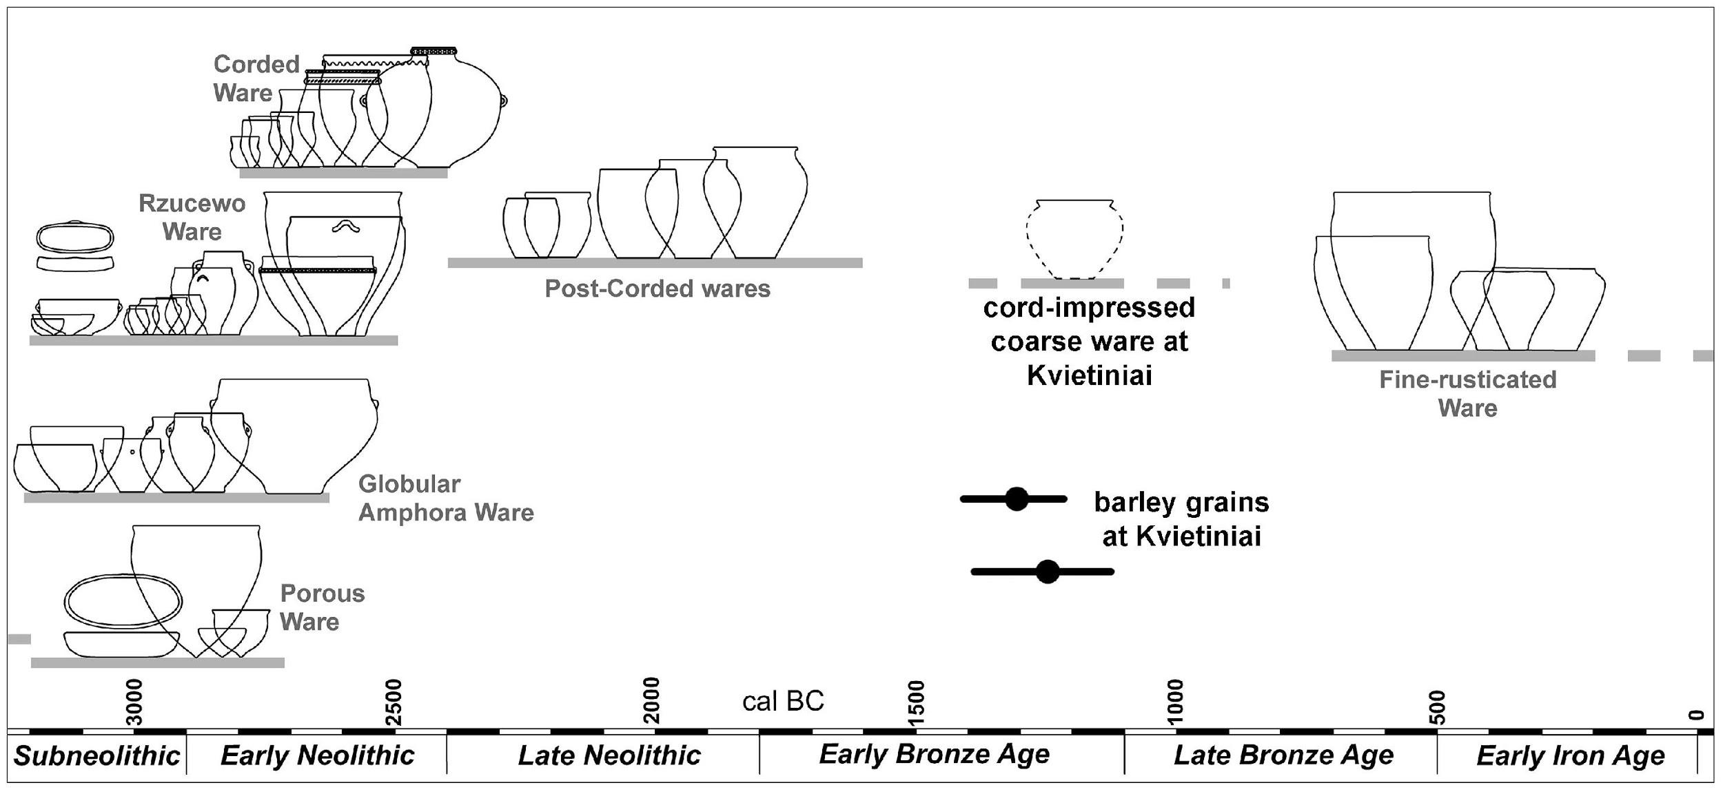
Fig. 5 The position of dated barley grains and cord-impressed coarse pottery from Kvietiniai in a pottery sequence of western Lithuania from 3200–0 cal BC. Note a large gap in the Bronze Age from which pottery and settlement sites are almost unknown.

4. Conclusions
- The recent excavations at the site of Kvietiniai in western Lithuania have substantially contributed to our knowledge concerning the earliest farming in the southeastern Baltic region. The presence of charred barley (Hordeum vulgare) grains, directly dated to ca. 1300-1250 cal BC, from the site of Kvietiniai contributes significantly to the growing body of research concerning the beginning of crop cultivation in the southeastern Baltic. Despite a hiatus of ca. 1500 years following the introduction of animal husbandry, our combined analysis (macrobotanical and stable isotope analysis) demonstrates that the introduction of cultigens was probably gradual and not pervasive. In light of our research animal husbandry and freshwater fishing continued throughout the Early Bronze Age, which was supplemented by small-scale agriculture, including the growing of barley. However, we fully acknowledge the low number of pottery and macrobotanical samples analysed to date as well as the absence of zooarchaeological data.

- Via ¹⁴C dating of charred organic residues adhering to ceramic vessels we were able to date the cord-impressed and granite tempered coarse ware found at Kvietiniai to ca. 1300-1100 cal BC. During this period barley appears to have been cultivated by these early Bronze Age peoples as opposed to the preceding peoples of the Corded Ware culture.

- In order to directly date the pottery that had presumably been used by the first farmers at Kvietiniai, a FRE of the nearby Minija River had to be considered. The FRE was calculated as having a terminus ad quem of 780 ± 57 years during prehistory and ca. 2000 years at the present. These data show that the organic residue analysis of pottery, especially of charred organic remains, should be performed prior to sampling for radiocarbon dating. Moreover, we emphasise the need for further research to determine local aquatic reservoir effects throughout the region, particularly from modern and ancient rivers.

- Large-scale rescue excavations in advance of infrastructure construction are in their infancy in the southeastern Baltic region. Through the application of modern excavation techniques as well as post-excavation analysis we will be able to further enhance our knowledge of the cultural and economic development of the southeastern Baltic from prehistory to the present.

References
Alenius, T.H., Mökkönen, T.O,, Lahelma, A., 2013. Early Farming in the Northern Boreal Zone: Re-assessing the History of Land Use in South-Eastern Finland through High-resolution Pollen Analysis. Geoarchaeology 28(1), 1-24. https://doi.org/10.1002/gea.21428

Antanaitis-Jacobs, I., Kisielienė, D., Stančikaitė, M., 2002. Macrobotanical and palynological research at two archaeological sites in Lithuania. Nordic archaeobotany-NAG 2000 in Umeå. Archaeology and Environment 15, 5-21.

Antanaitis, I., Ogrinc N., 2000. Chemical analysis of bone: Stable isotope evidence of the diet of Neolithic and Bronze Age people in Lithuania. Istorija 45, 3-12.

Bogaard, A., Fraser, R., Heaton, T.H.E., Wallace, M., Vaiglova, P., Charles, M., Jones, G., Evershed, R.P., Styring, A.K., Andersen, N.H., Arbogast, R.M., Bartosiewicz, L., Gardeisen, A., Kanstrup, M., Maier, U., Marinova, E., Ninov, L., Schafer, M., Stephan, E., 2013. Crop manuring and intensive land management by Europe's first farmers. Proceedings of the National Academy of Sciences 110(31), 12589-12594. https://doi.org/10.1073/pnas.1305918110

Boudin, M., Strydonck, M.V., Crombé, P., 2009. Radiocarbon dating of pottery food crusts: reservoir effect or not? The case of Swifterbant pottery from Doel “Deurganckdok” (Belgium). In: Crombé, P., Strydonck, M.V., Sergant J., Boudin M., Bats M. (Eds.), Chronology and Evolution in the Mesolithic of North-West Europe. Proceedings of an International Meeting, Brussels, May 30-June 1st 2007. Cambridge Scholars Publishing, Newcastle upon Tyne, pp. 753–772.

Brazaitis, D., 2000. Žalvario amžiaus medžiaga iš Visėtiškių pilkapyno ir jo aplinkos. Lietuvos archeologija 20, 109-110.

Brock, F., Higham, T., Ditchfield, P., Bronk-Ramsey, C., 2010. Current pretreatment methods for AMS radiocarbon dating at the Oxford Radiocarbon Accelerator Unit (ORAU). Radiocarbon 52(1), 103-112. https://doi.org/10.1017/S003382220004506

Bronk Ramsey, C., 2009. Bayesian analysis of radiocarbon dates. Radiocarbon 51(1), 337-360. https://doi.org/10.1017/S0033822200033865

Cappers, R.T.J., Bekker, R.M., Jans, J.E.A., 2006. Digital Seed Atlas of the Netherlands. Barkhuis Publishing, Eelde.

Cramp, L.J.E., Evershed, R.P., 2014. Reconstructing aquatic resource exploitation in human prehistory using lipid biomarkers and stable isotopes. In: Holland, H.D., Turekian, K.K. (Eds.), Treatise on Geochemistry: Archaeology and Anthropology (second ed.). Elsevier, Oxford/Amsterdam, pp. 319-339.

Czebreszuk, J., Górski, J., Ignaczak, M., Kadrow, S., Klochko, V.I., Kośko, A., Kovalyukh, N., Kryvaltsevich, M., Kurylenko, V.Y., Lysenko, S., Otroshchenko, V.V., Makarowicz, P., Skripkin, V., Taras, H., 1998. The Trzciniec area of the Early Bronze Age civilization: 1950-1200 BC. Baltic-Pontic studies 6. Adam Mickiewicz University Institute of Prehistory, Poznań.

Daugnora, L., Girininkas, A., 2004. Rytų Pabaltijo bendruomenių gyvensena XI-II tūkst. pr. Kr. Lietuvos veterinarijos akademijos leidykla, Kaunas.

Ežerinskis, Ž., Šapolaitė, J., Pabedinskas, A., Juodis, L., Garbaras, A., Maceika, E., Druteikienė, R., Lukauskas, D., Remeikis, V.,2018. Annual variations of ¹⁴C concentration in the tree rings in the vicinity of Ignalina Nuclear Power Plant. Radiocarbon 60(4), 1227-1236. https://doi.org/10.1017/RDC.2019.77

Fraser, R.A., Bogaard, A., Charles, M., Styring, A.K., Wallace, M., Jones, G., Ditchfield, P., Heaton, T.H.E., 2013. Assessing natural variation and the effects of charring, burial and pre-treatment on the stable carbon and nitrogen isotope values of archaeobotanical cereals and pulses. J Archaeol Sci 40, 4754-4766. https://doi:10.1016/j.jas.2013.01.032

Froese, R., Pauly, D., 2019. FishBase. World Wide Web electronic publication. www.fishbase.org, version (08/2019).

Grigas, A., 1986. Lietuvos augalų vaisiai ir sėklos. Mokslas, Vilnius.

Grigalavičienė, E., 1995. Žalvario ir ankstyvojo geležies amžiaus Lietuvoje. Mokslas, Vilnius.

Grikpėdis, M., Motuzaite Matuzeviciute, G., 2018. A review of the earliest evidence of agriculture in Lithuania and the earliest direct AMS date on cereal. Eur J Archaeol 21, 264-279. https://doi.org/10.1017/eaa.2017.36

Haak, W., Lazaridis, I., Patterson, N., Rohland, N., Mallick, S., Llamas, B., Brandt, G., Nordenfelt, S., Harney, E., Stewardson, K., Fu, Q., Mittnik, A., Bánffy, E., Economou, C., Francken, M., Friederich, S., Pena, R.G., Hallgren, F., Khartanovich, V., Khokhlov, A., Kunst, M., Kuznetsov, P., Meller, H., Mochalov, O., Moiseyev, V., Nicklisch, N., Pichler, S.L., Risch, R., Rojo Guerra, M.A., Roth, C., Szécsényi-Nagy, A., Wahl, J., Meyer, M., Krause, J., Brown, D., Anthony, D., Cooper, A., Alt, K.W., Reich, D., 2015. Massive migration from the steppe was a source for Indo-European languages in Europe. Nature 518, 284–285.

Hansel, F.A., Copley, M.S, Madureira, L.A.S., Evershed, R.P., 2004. Thermally produced o-(o-alkylphenyl) alkaloic acids provide evidence for the processing of marine products in archaeological pottery vessels. Tetrahedron Lett 45, 2999-3002. https://doi.org/10.1016/j.tetlet.2004.01.111

Jones, M., 1991. Sampling in palaeoethnobotany. In: van Zeist, W., Wasylikowa, K., Behre, K.-E. (Eds), Progress in old world palaeoethnobotany. Balkema, Rotterdam, pp. 53-62.
Kanstrup, M., Thomsen, I.K., Mikkelsen, P.H., Christensen, B.T., 2012. Impact of charring on cereal grain characteristics: linking prehistoric manuring practice to δ¹⁵N signatures in archaeobotanical material. Journal of Archaeological Science 39, 2533-2540.

Kanstrup, M., Holst, M.K., Jensen, P.M., Thomsen, I.K., Christensen, B.T., 2014. Searching for long-term trends in prehistoric manuring practice. δ¹⁵N analyses of charred cereal grains from the 4th to the 1st millennium BC. Journal of Archaeological Science 51, 115-125.

Keaveney, E.M., Reimer P.J., 2012.Understanding the variability in freshwater radiocarbon reservoir offsets: a cautionary tale. J Archaeol Sci 39, 1306-1316. https://doi: 10.1016/j.jas.2011.12.025

Lang, V., 2007. The Bronze and Early Iron Ages in Estonia. Estonian Archaeology 3. Tartu University Press, Tartu.

Lahtinen, M., Rowley-Conwy P., 2013. Early farming in Finland: was there cultivation before the Iron Age (500 B.C.?). European Journal of Archaeology 16, 660-684. https://doi.org/10.1179/1461957113Y.000000000040

Larsson, Å.M., 2009. Breaking and Making Bodies and Pots. Material and Ritual practices in Sweden in the Third Millennium BC. Aun 40. Uppsala University, Department of Archaeology and Ancient History, Uppsala.

Loze, I., 1992) Corded Pottery Culture in Latvia. Praehistorica 19, 313-320.

Luchtanas, A., Sidrys R.V., 1999. Bronzos plitimas rytiniame Pabaltĳo regione iki Kristaus. Archeologia Lituana 1, 15-55.

Mathieson, I., Alpaslan-Roodenberg, S., Posth, C., Szécsényi-Nagy, A., Rohland, N., Mallick, S., et al., 2018. The genomic history of southeastern Europe. Nature 555, 197–203.

Meadows, J., Lübke, H., Zagorska, I., Bērziņš, V., Ceriņa, A., Ozola, I., 2014. Potential freshwater reservoir effects in a Neolithic shell midden at Riņņukalns, Latvia. Radiocarbon 56(2), 823–32.

Menotti, F., Baubonis, Z., Brazaitis, D., Higham, T, Kvedaravičius, M., Lewis, H., Motuzaitė, G., Pranckėnaitė, E., 2005. The First Lake–dwellers of Lithuania: Late Bronze Age Pile Settlements on Lake Luokesas. Oxford Journal of Archaeology 24(4), 381-403. https://doi.org/10.1111/j.1468-0092.2005.00242.x

Minkevičius, K., Podėnas, V., Urbonaitė-Ubė, M., Ubis E., Kisielienė, D., 2019. New evidence on the southeast Baltic Late Bronze Age agrarian intensification and the earliest AMS dates of Lens culinaris and Vicia faba. Veget Hist Archaeobot 29, 327–338. https://doi.org/10.1007/s00334-019-00745-2

Mittnik, A., Wang, C.-C., Pfrengle, S., Daubaras, M., Zarina, G., Hallgren, F., Allmäe, R., Khartanovich, V., Moiseyev, V., Furtwängler, A., Valtueña, A.A., Feldman, M., Economou, C., Oinonen, M., Vasks, A., Tõrv, M., Balanovsky, O., Reich, D., Jankauskas, R., Haak, W., Schiffels, S., Krause, J., 2018. The genetic prehistory of the Baltic Sea region. Nat. Commun 9 (442), https://doi.org/10.1038/s41467-018- 02825-9.

Mirek, Z., Piękoś-Mirkowa, A., Ząjac, A., Ząjac, M., 2002. Flowering plants and pteridophytes of Poland. A checklist. Biodiversity of Poland, vol 1. W. Szafer Institute of Botany Polish Academy of Sciences, Kraków.

Molnár, M., Janovics, R., Major, I., Orsovszki, J., Gönczi, R., Veres, M., Leonard, A.G., Castle, S.M., Lange, T.E., Wacker, L., Hajdas, I., Jull, A.J.T., 2013. Status report of the new AMS ¹⁴C sample preparation lab of the Hertelendi Laboratory of the Environmental Studies (Debrecen, Hungary). Radiocarbon 55(2-3), 665-676. https://doi.org/10.2458/azu_js_rc.55.16394

Motuzaite Matuzeviciute, G., 2018. The Possible geographic margin effect on the delay of agriculture introduction into the East Baltics. Estonian Journal of Archaeology 22, 49-62. https://doi.org/10.3176/arch.2018

Neef, R., Cappers, R.T.J., Bekker, R.M., 2012. Digital Atlas of Economic Plants in Archaeology. Barkhuis & Groningen University Library, Groningen.

Olsson, I.U., El-Gammal S., Göksu Y., 1969. Uppsala natural radiocarbon measurements IX. Radiocarbon 11(2), 515-544.

Olsson, I.U., Klasson M., 1970. Uppsala radiocarbon measurements X. Radiocarbon 12, 281-284.

Olsson, I.U., Kaup E., 2001. The varying radiocarbon activity of some recent submerged Estonian plants grown in the early 1990s. Radiocarbon 43(2B): 809-820. https://doi.org/10.1017/S0033822200041485

Pearsall, D.M., 2015. Paleoethnobotany: A Handbook of Procedures. Left Coast Press, Walnut Creek.

Philippsen, B. 2013. The freshwater reservoir effect in radiocarbon dating. Heritage Science 1:24. https://doi.org/10.1186/2050-7445-1-24

Piličiauskas G., 2018. Virvelinės keramikos kultūra Lietuvoje 2800-2400 cal BC. Lietuvos istorijos institutas, Vilnius.

Piličiauskas, G., Lavento, M., Oinonen, M., Grižas, G., 2012. New 14C dates of Neolithic and Early Metal period ceramics in Lithuania. Radiocarbon 53(4), 629-643. https://doi.org/10.1017/S0033822200039096.

Piličiauskas, G., Heron, C., 2015. Aquatic Radiocarbon Reservoir Off sets in the Southeastern Baltic. Radiocarbon 57(4), 539-556.

Piličiauskas, G., Kisielienė, D., Piličiauskienė, G., 2017a . Deconstructing the concept of Subneolithic farming in the southeastern Baltic. Veget Hist Archaeobot 26(2):183-193. https://doi.org/10.1007/s00334-016-0584-9

Piličiauskas, G., Jankauskas, R., Piličiauskienė, G., Craig, O.E., Charlton, D., Dupras, T., 2017b. The transition from foraging to farming (7000-500 cal BC) in the SE Baltic: A re-evaluation of chronological and palaeodietary evidence from human remains. J Archaeol Sci: Reports 14, 530-542. https://doi.org/10.1016/j.jasrep.2017.06.004

Piličiauskas, G., Skipitytė, R., Heron, C., 2018. Mityba Lietuvoje 4500–1500 cal BC maisto liekanų keramikoje izotopinių tyrimų duomenimis. Lietuvos archeologija 44, 9-41.

Price, T.D., 2000. The Introduction of Farming in Northern Europe. In: Price, T.D. (Ed.), Europe’s First Farmers. Cambridge University Press, Cambridge, pp. 260-299.

Reimer, P.J., Bard, E., Bayliss, A., Beck, J.W., Blackwell, P.G., Bronk Ramsey, C., Buck, C.E., Cheng, H., Edwards, R.L., Friedrich, M., Grootes, P.M., Guilderson, T.P., Haflidason, H., Hajdas, I., Hatté, C., Heaton, T.J., Hoffmann, D.L., Hogg, A.G., Hughen, K.A., Kaiser, K.F., Kromer, B., Manning, S.W., Niu, M., Reimer, R.W., Richards, D.A., Scott, E.M., Southon, J.R., Staff, R.A., Turney, C.S.M., van der Plicht, J., 2013. IntCal13 and Marine13 radiocarbon age calibration curves
0–50,000 years cal BP. Radiocarbon 55 (4), 1869–1887. https://doi.org/10.2458/azu_js_rc.55.16947
Rimantienė, R., 1979. Šventoji. Narvos kultūros gyvenvietės. Mokslas, Vilnius.

Rimantienė, R., 1996. Šventosios 6-oji gyvenvietė. Lietuvos archeologija 14, 83-173.

Rimantienė, R., 2005. Die Steinzeitfischer an der Ostseelagune in Litauen. Litauisches Nationalmuseum, Vilnius.

Robson, H.K., Skipitytė, R., Piličiauskienė, G., Lucquin, A., Heron, C., Craig, O.E., Piličiauskas, G. 2019. Diet, cuisine and consumption practices of the first farmers in the south-eastern Baltic. Archaeological and Anthropological Sciences 11(8), 4011-4024. https://doi.org/10.1007/s12520-019-00804-9

Saag, L., Varul, L., Scheib, C.L., Stenderup, J., Allentoft, M.E., Saag, L., Pagani, L., Reidla, M., Tambets, K., Metspalu, E., Kriiska, A., Willerslev, E., Kivisild, T., Metspalu, M., 2017. Extensive farming in Estonia started through a sex-biased migration from the steppe. Curr. Biol. 27(14), 2185-2193. https://doi.org/10.1016/j.cub.2017.06.022.

Tassi, F., Vai, S., Ghirotto, S., Lari, M., Modi, A., Pilli, E., Brunelli, A., Rosa Susca, R., Budnik, A., Labuda, D., Alberti, F., Lalueza-Fox, C., Reich, D., Caramelli, D., Barbujani, G., 2017. Genome diversity in the Neolithic Globular Amphorae culture and the spread of Indo-European languages. Proceedings of the Royal Society B, doi: 10.1098/rspb.2017.1540.

Vanhanen, S., Gustafsson, S., Ranheden, H., Björck, N., Kemell, M., Heyd, V., 2019. Maritime Hunter-Gatherers Adopt Cultivation at the Farming Extreme of Northern Europe 5000 Years Ago. Scientific Reports 9(4756), https://doi.org/10.1038/s41598-019-41293-z

Vankina, L.V., 1980. Shnurovaja keramika na territorii Latvii. In: Mugurevich, E.S. (Ed.), Iz drevneishei istorii baltskih narodov. Zinatne, Riga pp. 47–58 (in Russian).

Vengalis, R., Juškaitis, V., Pilkauskas, M., Kozakaitė, J., 2016. Kvietinių senovės gyvenvietė ir pilkapynas. Archeologiniai tyrinėjimai Lietuvoje 2015 metais, 74-86.

Vengalis, R., Piličiauskas, G., Pilkauskas, M., Kozakaitė, J., Juškaitis, V., 2020. The large-scale rescue excavation of the multi-period site at Kvietiniai sheds light on the so far little explored Bronze Age in Western Lithuania. Archaeologia Baltica 27, 19–52.
Weisskopf, A., Fuller, D.Q., 2014. Barley: Origins and Development. In: Smith, C. (Ed.), Encyclopedia of Global Archaeology. Springer, New York, pp. 763-766.

Whittle, A., 1996. Europe in the Neolithic: The Creation of New Worlds. Cambridge World Archaeology, 2nd edition. Cambridge University Press, Cambridge.

Zohary, D., Hopf, M., Weiss E., 2012. Domestication of plants in the old world. The origin and spread of domesticated plants in southwest Asia, Europe, and the Mediterranean Basin. Oxford University Press, Oxford.

