Imputing Away the Ladder: Implications of Changes in GDP Measurement for Convergence Debates and the Political Economy of Development
Jacob Assa, The New School
Ingrid Harvold Kvangraven, University of York
Abstract
Although there is an important emerging literature critically assessing the political economy of GDP measurement, the implications for convergence debates of a GDP defined according to Western economies has not yet been scrutinized. This article addresses this gap by asking: Does the choice of output measure have an effect on the estimated rate of global convergence? To answer this question we examine the changes in national accounting standards from the early 1990s. Revisions to the System of National Accounts (SNA) - the international standard for constructing GDP - include several major changes to how production is measured, including the reclassification of financial intermediation services, R&D, and weapons systems as productive activities - all areas in which countries in the West have had an advantage in recent decades. In addition, there has been an increase in the proportion of imputations in the 1993 and 2008 revisions, which privileges economic structures of the West. Overall, we find that these changes have had the effect of boosting the GDP of the West relative to the rest of the world and thus to an underestimation of global convergence compared to previous measures of GDP. This is a particularly timely discussion, as future revisions of GDP are likely to include even more imputations. The paper also goes a step further and discusses the broader implications of the revision in GDP methodology for the political economy of development, including questions about voting shares in international institutions, and domestic policy incentives and epistemological debates about sustainable development.

Introduction
Although there is an important emerging literature critically assessing the political economy of GDP measurement, the implications for convergence debates of a GDP defined according to Western economies has not yet been scrutinized. This article addresses this gap by assessing the political economy implications of GDP measurements for development and by analyzing how the choice of output measure affects the estimated rate of global convergence. To do so, we examine the changes in national accounting standards from the early 1990s in the wider context of global economic restructuring. Starting in the 1980s and accelerating in the 1990s and 2000s, developed countries have experienced a structural transformation, with many manufacturing activities, and some services, outsourced to developing countries, and an increasing share of value-added concentrated in high-end service sectors such as banking, real-estate, insurance, intellectual property, research and development, as well as production of military weapons systems. Meanwhile, the key measure of growth - GDP - has been redefined in ways that favour these new areas of specialisation of developed economies, while developing countries are taking over the manufacturing mantle. More concretely, in 1993 and then again in 2008, the standards for measuring GDP (and by derivation, growth) have been changed in a direction which gives more weight to sectors dominant in countries in the West. While it may not be surprising that the System of National Accounts (SNA) framework - which determines how GDP is recorded - responds to changing economic structures in advanced economies, the implication of this for debates on global economic convergence has not yet been explored. We find that the changes have had a significant impact on the assessment of comparative growth among countries in the West and the Rest - kicking away the statistical ladder, so to speak. Had the changes in GDP not been made, the developing world would appear to have converged on the developed world to a larger extent. This paper does not engage in the ultimately normative discussion about how GDP should be measured, but rather lays out the implications of recent changes on the assessment of convergence.
To date most critiques of GDP focus on countries which have achieved a certain level of high income and seek to broaden the scope of GDP from a narrow economic view to a wider, well-being related framework, by questioning the measure for what it does not account for, such as unpaid labor, environmental degradation, happiness, freedom, welfare, rather than what it does measure. In fact, in the development literature, GDP is often considered at least to be ‘constrained by a consistent economic theory,’ in contrast to some of the measures that try to incorporate social and environmental goals into a broader measure of social and economic wellbeing (Felice 2015: 2). However, economic theory has had only a weak influence on the development of national accounting in general and GDP in particular (Bos 1995, Mitra-Khan 2011, Assa 2018), despite the fact that GDP remains the most used and most respected accounting measure (Seers 1972, van der Bergh and Verbruggen 2009, Felice 2015).
Changes to national accounting standards also have implications for theoretical and empirical debates about the source of such growth as well as serious real-world political economy implications. For example, the appearance of success in fast-growing countries can inspire other countries to imitate their policies. Depending on the measure of output used, different countries will appear to grow faster, given their particular economic structure. Furthermore, a country’s economic size relative to world output contributes to the determination of its voting rights in international organisations such as the World Bank and IMF, and its level of per capita GDP determines its eligibility for concessional foreign aid. Finally, output in both level and growth enters certain sensitive ratios such as debt-to-GDP and deficit-to-GDP, which are central to political debates as well as international treaties (such as the Maastricht Treaty establishing the Euro currency).
Section 2 discusses the political economy of GDP measurement generally, and the convergence debates specifically - debates where GDP is employed uncritically as a measure of growth. Section 3 documents the changes to the SNA in 1993 and 2008 and demonstrates how they have contributed to moving the developmental goal-post in favor of developed countries’ newly-found areas of specialisation, largely by adding more imputations to the measure of output. In Section 4 we build on Basu and Foley’s (2013) Narrow Measured Value Added (NMVA), which uses the criterion of whether net output in a certain sector is directly measurable or instead imputed from net income (NMVA includes only the former). This allows us to analyse groups of countries - both by region and by income level - and revisit some of the key convergence debates in light of the shifting goal-post of GDP. This is a particularly timely debate, as future revisions of GDP are likely to include more imputations in the form of ‘intangibles,’ thus intensifying the trend noted in this article (Corrado et al. 2017, Hulten and Nakamura 2017, Fraumeni et al. 2017). Section 5 examines the political economy implications of including imputations in GDP and demonstrates that the relative growth of countries’ NMVA paints a different picture of relative growth. This change in measure changes the convergence assessments of countries and regions, and also the timeline for some countries’ projected catch-up with the economic frontier. Both these factors play a key role in informing national and international policies, as the way growth is defined affects what is considered economic success. Section 6 concludes.

The Political Economy of GDP Convergence
While political economy scholarship has in recent years provided much-needed critical analyses of GDP as an objective indicator of progress (Irvine et al. 1979, Coyle 2014, Masood 2016, Lepenies 2016), the impacts of changes in GDP measurement on the convergence debates and the perception of progress in the non-Western world has largely gone unstudied (as also recognized by Mugge 2016). While political economists will highlight the social construction of economic indicators and the way they change over time, economists tend to point to reform in indicators as necessary ‘modernisation’ to keep the indicators in line with contemporary structures of the economy (e.g. Lequiller and Blader: 2014: 3). From the latter perspective, GDP has developed to reflect structural economic and political transformations, such as the rise of economic planning in the 1930s (Perlman and Marietta 2005) and contemporary financialization in recent times (Christophers 2012, Assa 2016). However, even to the extent that GDP has evolved with changing economic structures, it is always the economic structures that are prevalent in the West that are considered the appropriate yardstick. Despite a massive structural gap between economies at the ‘frontier’ and low-income countries, for example, all countries are expected to more or less comply with international standards of measurement of national accounts. This has been the case since colonial powers and governments of newly independent states institutionalized macroeconomic measurement systems of the West, which already then were often not well suited to the local economies (Jerven 2012b), leading to unreliable data (Jerven 2013, Woods 2014).
This article intervenes to address parts of this gap in the political economy literature, namely the implications of a political economy favoring Western economies driving the construction of GDP. The consequences stretch across a variety of axes, including domestic policy-making, voting rights in international institutions, and the convergence debates. This article touches on all those issues, but places particular emphasis on the latter.
The one thing that all sides in the convergence debates have in common is their use of the growth of GDP per capita as the main yardstick for assessing economic development. The traditional debate about convergence before the 1980s was largely about the ‘Great Divergence,’ which took place roughly between 1500 and 1950, between ‘the West’ (Western Europe and its former settler colonies in North America and Australasia) and ‘the Rest’, in terms of income per capita (Popov and Jomo 2018). According to the Maddison Project (2013), the ratio between the West and the Rest rose from 1:1 in 1500 to 6:1 in 1900. The disparity was roughly stable between the 1950s and 1970s, but increased, on average, during the Washington Consensus era, before falling slightly, but in an uneven manner. The ratio remained at around 6:1 throughout the 1900s.
By the 1980s, economists started empirically exploring the question of convergence and linking the findings to different growth theories (see for example Kormendi and Meguire 1985, Baumol 1986, DeLong 1988, Grier and Tullock 1989, Barro 1991, Barro and Sala-i-Martin 1992, Mankiw et al. 1992, Holtz-Eakin 1993). The neoclassical Solow (1956) and Swan (1956) models predict ‘absolute convergence’ - that poor countries with little capital will grow faster than rich countries with large capital stocks and that global economic convergence will therefore take place. Endogenous growth models contradicted this absolute convergence thesis, as they rely on the existence of externalities, human capital, and increasing returns, opening up the possibility of no convergence, or even divergence (see e.g. Romer 1986, Lucas 1990, Rebelo 1991). Therefore, it was widely believed in the 1990s that testing for convergence was also an exercise in testing competing growth theories.
While Pritchett (1997: 3) once wrote that divergence in living standards is ‘the dominant feature of modern economic history,’ there have been studies since then that suggest that some degree of convergence between poor and rich countries has taken place since the end of the 1990s especially among ‘clubs’ of countries. While some suggest that the Great Divergence is potentially about to end or even reverse (e.g. Nayyar 2013, Jomo 2018), the main consensus is still that there is no strong trend of gradual global convergence in income levels (Islam 2003, Popov and Jomo 2017, 2018, Johnson and Papageorgiou forthcoming).
Beyond the convergence debates, there are geopolitical and political economy implications related to the measurement of GDP (Coyle 2014). One reason countries may want to inflate their GDP is to show economic strength. For example, Petty and Gregory King in England, and Pierre de Boisguilbert and Marshall Vauban in France, all used their estimates of national income to demonstrate their countries’ fiscal strength, and their estimates were accompanied by calls for certain growth policies (Assa 2015). Furthermore, GDP became increasingly important in the 20th century, first to measure the recovery from the Great Depression, and then as a measure to show how the US was out-performing the Soviet Union during the cold war (Philipsen 2015). Today, the heated debates about the actual size of China’s GDP confirms that relative economic strength is still of utmost importance (Toma et al. 2017). It is still common practice among policy-makers and politicians to use economic indicators to assess policies - and often in comparison to other countries (Fougner 2008, Davis et al. 2012, Hansen and Porter 2012, Mügge 2016). Even when there are no formal implications, country-state rankings can induce domestic reforms (Cooley and Snyder, Kelley and Simmons 2015).
However, there could also be economic incentives for low-income countries to remain ‘low income’ in order to access concessional lending from the World Bank, the IMF and bilateral lenders or pay lower contributions to international organisations (consider also China’s late adoption of the World Bank’s International Comparison Program). While Jerven (2012a) finds that low-income and lower-middle income countries often make it a national priority to move up the income-ladder, which in turn is thought to attract funds from commercial banks and investors, the extent to which this is true for a given country at a given time will depend on the political and economic context. Furthermore, political leaders may have incentives to show to their populace that they can foster economic development, which a transition to a higher income-category could do. For example, before Nigeria revised its GDP in 2010, it had announced that middle-income status was a ‘political target’ (Jerven 2012a:140).
Given the rebalancing of the global economy towards ‘rising powers’, their politics of measurement may play a larger role in future harmonization efforts. As Mugge (2016) notes, the English literature on the politics of measurement in non-OECD countries is relatively sparse. For example, when it comes to measurement in China, the debates in English academic literature have largely been about whether Chinese growth statistics are plausible or not (e.g. Holz 2004, Klein and Özmucur 2004, Rawski 2001), rather than studying the politics of measurement of China’s economic output on its own terms. This is an important gap for future research.

Deregulating GDP
While there have long been critics of GDP as a measure of wider dimensions of human well-being such as happiness, unpaid care work (Folbre 2015, Waring 1990), environmental costs (Hickel 2019), human development (Stiglitz et al. 2010) and quality of life more generally (for example Fioramonti 2013, Fleurbaey and Blanchet 2013, Decancq and Schokkaert 2015, Jones and Klenow 2016, Tavernier et al. 2015, and Wesselink et al. 2007), this literature has not paid much attention to the significant changes in the methodology of constructing GDP in the past 25 years. Meanwhile, the studies of changes in GDP methodology that do exist focus on the general implications, or the specific implications for advanced economies (e.g. Assa 2016, Christophers 2011, Feldstein 2017), rather than the implications of GDP methodology for the convergence debates.
In 1993 and then again in 2008, there were reforms to the SNA that led to significant changes of the location of the so-called production boundary, which determines what is included in GDP and what is not. Many economic activities - financial intermediation, research and development and the production of weapons - were previously excluded from GDP as either non-productive or as constituting productive inputs to other outputs (hence deducted as intermediate consumption). The inclusion of these economic sectors in the production boundary since 1993 and 2008 has added disproportionately to the GDP of developed countries, which have in recent decades specialised in these activities and moved away from traditional pillars of development such as manufacturing and infrastructure-related services.

A full history of national accounting is beyond the scope of this paper, and has been treated elsewhere (Assa 2015, Bos 1995, Studenski 1958, Vanoli 2005). However, it is important to note that the measurement of the income and growth of nations has been historically and geopolitically contingent from its 17th century beginnings, with critical changes in the structure and substance of the measurements at each step along the way (Assa 2015, 2016). As Seers (1972) observed more than four decades ago: GDP is not a value-neutral measure at all. From the 1920s onwards, national governments took over control of the measurement of output, an endeavor that was previously carried out by individuals (Kendrick 1970, Bos 1995, Vanoli 2005). Along with this change in the institutional setup of measurement came a new focus on how much output nations could produce, rather than just on their income and expenditure (Vanoli 2005). Keynes played an important role in pushing for the publication of the national accounts in the form of Gross National Product, based on his demand for an output aggregate, which he argued needed to include government expenditures next to private consumption and investment, as well as add up to the total sum of taxable income (Keynes 1940, Mitra-Kahn 2011, Tily 2009).
The concept of production is defined in the most recent of the three approaches to calculating GDP, namely value-added. This concept – unlike the income or expenditures approaches to GDP - requires a production boundary to determine what is to be included in GDP. As the new discipline of national accounting became an international standard of the United Nations (UN) in 1953, the methodology was set by a group of chief government statisticians under the aegis of the UN Statistical Commission. At the end of the Cold War there was a second shift in the institutional responsibility for the System of National Accounts. While the UN had been the sole custodian of this standard up to that point, in 1993 the UN was joined by the World Bank, the International Monetary Fund (IMF), the Organization of Economic Co-operation and Development (OECD), and the European Union (EU) under the aegis of an inter-secretariat working group on national accounts (ISWGNA). In the first two institutions, voting shares are generally determined by proportion of financial contributions as well as economic weight, while the last two represent developed countries. This geopolitical shift also reflects a departure from the traditional role of national governments (directly or through the UN) as custodians of national statistics, towards a greater role for financial institutions, both national and international. In the revision process that led to SNA 2008, for example, nearly half of the 74 comments received in the consultation process were from central banks or regional banks, with the remainder coming from national statistical offices.
Following the institutional shift in power was a substantive change in the structure and definition of GDP, consisting of widely expanding the production boundary to include many activities that were hitherto considered either external to production or at most as intermediate inputs to it. Historically, these shifts in the production boundary have not been based on progress in economic theory but rather developed through a ‘techno-political process’ (Bos 1995, Christophers 2011, Assa 2016 and 2018). From a developing country perspective, the standards that have emanated from the SNA have been perceived as largely top-down (Ward 2004, Fioramonti 2014).
GDP has become more imputation-heavy with the revisions of the past decades. Imputing value-added from incomes differs in important ways from measuring it directly. In the latter case, both gross output and intermediate inputs are deflated using a price index (to account for inflation), and real value-added equals real gross output less real intermediate inputs. The deflation ensures that while the price of a car increases, for example, real value-added accounts for only the quantity of cars produced. When value-added is imputed based on net incomes (profits and wages), by contrast, the formula degenerates to deflating gross revenues and deflating costs, then deducting the latter from the former. There is no accounting for a quantity here, despite adjusting for inflation, since there is no direct measure of ‘output’ to begin with. Thus, quantity and price are inseparable for imputed services, since net income is a monetary concept by definition.
The rest of the section describes specific areas of change in the SNA revisions in 1993 and 2008, both on the consumption side (exemplified by financial intermediation) and the investment side (exemplified by intellectual property and military spending). As mentioned above, these changes have had differential impacts on developed and developing countries, as we will demonstrate with examples throughout the section.

Imputations affecting Consumption
In this section we consider how changes to how financial intermediation is measured affect the recorded value of consumption. The 1968 SNA treated the intermediation activities of banks - for which income is derived from interest differentials rather than explicit fees - as the input of a notional, or ‘imaginary,’ sector, and thus it was deducted from total value-added and did not affect GDP. While this statistical fiction of assigning banking output as an input to an imaginary sector was bizarre, the SNA 1993 went further and allocated the part of this income stream paid by households to final consumption (while treating the part paid by firms as intermediate consumption, again deducted from total value-added). In a stroke of a pen, this methodological change made finance (to households) productive (Christophers 2011).
In the process referred to as ‘financialisation’, often accompanied by deindustrialisation, many developed countries have moved away from manufacturing and towards financial and real-estate activities. Thus, the share of this imputation (known technically as Financial Intermediation Services Indirectly Measured or FISIM) has grown much faster in these countries than in developing countries. While in most OECD countries financial intermediation (paid for by households) adds between 1 and 2 percentage points to GDP, in the US this was 3.4% in 2011.
The SNA 2008 did away with the requirement that only interest on intermediated funds be included in GDP and required the inclusion of all loans and deposits used to impute FISIM (UN 2009, 583:A3.25). In other words, even banks’ own money could now be used to create such ‘production’, without the pretext of providing an intermediation service. As 80% of bank loans in the US go to finance the purchase of real-estate or financial assets rather than productive activities, the SNA 2008 also made speculation productive.
Since the 1970s, the importance of interest income for banks has declined, as much more of their revenues now come from fees (anything from overdraft charges, late fees, mortgage origination fees, to underwriting and foreign exchange fees). Although the fee income of banks is explicit (rather than implicitly estimated using the FISIM formula), the value-added of the financial sector based on these fees is still an imputation, based on deducting fees paid by banks from fees received by them. Together with similar charges in the real-estate and insurance industries, these so-called FIRE sectors (Finance, Insurance, and Real Estate) account for nearly a quarter of GDP in OECD economies in the 21st century.
The financialisation of the US economy and of other developed economies thus has far-reaching implications for the assessment of their growth rates, especially in comparison to developing countries where finance has not exploded in a similar manner. Figure 2 shows the weight of the FIRE sector in the US and Chinese economies, and Figure 3 shows the impact this differential has on their convergence when FIRE is included or excluded.

HERE Figure 1
HERE Figure 2

It is true that, in either case, China absolute per capita income places it in the middle-income group while the US is in the high-income group. However, as development and convergence also have a relative dimension, the role of imputation in assessing performance is important. The growth rate of China’s per capita GDP without the FIRE sector is 3 times that of the US, compared to only 2.5 times including FIRE. And if we excluded all impuatutations (using NMVA), the ratios are 9.2 vs. 6.3, respectively. This is a difference between China doubling its per capita income every 7.6 years or every 11 years, a key correlate of economic convergence.

Imputations affecting Investment
Both measures of military expenditure and intellectual property have been changed substantially over the past reforms of SNA. The SNA 68 did not include military expenditures on fixed assets as investment, except those related to constructing or modifying family dwellings for military personnel. By contrast, SNA 93 included all military expenditures “which could be acquired by civilian users for purposes of production and that the military uses in the same way” (UN 1993, 660:70). Thus docks, roads, airfields etc. were included, while weapons or vehicles and equipment solely used to launch them were still excluded. The idea was that the former were potentially also productive assets while the latter were only destructive in nature.
The 2008 SNA knocked down the boundary further, by doing away with this distinction, and included expenditures on weapons systems in government investment in fixed assets. This change inflated the GDP of weapons-producing countries. Looking at military expenditure in constant prices reveals how both high and middle-income countries have pulled far away from low income countries. The inclusion of weapons systems in GDP is thus inherently biased against the poorest countries (which may be large consumers of weapons, large and small, but produce very little of them), as shown in Figures A1-A3 in Annex III. To complicate things further, measurement practices may differ across countries (Mugge 2016). For example, while the US has historically included military expenditure in its GDP calculation, most other countries have not, thereby leading to an overstatement of US GDP (Lequiller and Blades 2006).
Furthermore, developed countries have a lead in activities resulting in intellectual property products (previously named “intangible produced assets”), including R&D, computer software and databases, entertainment, and literary and artistic originals. Before 2008, research and development activities - which are intended to improve efficiency and productivity and thus have the potential to increase future output - were treated as part of intermediate consumption, thus not included in GDP. The SNA 2008 changed this classification based on the idea that R&D increases the stock of knowledge and enables it to create new applications. This change has had a much bigger impact on the GDP of countries creating new technologies rather than those adapting them (Figures A4-A6 in Annex III).
While there is a wide variation among developed countries in terms of their spending on R&D as a percentage of GDP, the relationship is clearer among developing countries. Countries with average per capita GDP (2011-2015) of less than $11,500 spend just 0.3% of GDP on R&D. Below $23,000, only China ($11,962) and Brazil ($15,112) spend more than 1% (2% and 1.2% respectively). At income levels over $40,000, on the other hand, only a handful of countries spend small percentages, mostly oil-rich countries or tax havens (Oman, Bahrain, Saudi Arabia, Bermuda, UAE, Kuwait and Qatar). The rest of the $40,000 plus group average 2.3% R&D in GDP. Other changes to the classification of intellectual property products include the inclusion of databases under ‘computer software’ and the inclusion of copies, not just original IP products, as productive assets.

Redefining Growth
Each of the above revisions to the national accounting methodology has added disproportionally to the perceived output (as measured by GDP) of more developed countries. To see the combined effect of these methodological revisions on estimated growth rates, we now look at a selection of countries for which data is available in contemporaneous GDP series. The top panel of Table 1 shows that shifting to the new SNA had differential impacts even for the growth rates of developed countries (the years selected were the ones where data for all three SNAs was available for these countries). While these differences in average annual growth rates may seem small, their cumulative impact over 27 years is significant.

HERE Table 1

The differences are even more dramatic among developing countries and looking at cumulative growth rates over several years for which these countries all have data in both SNAs (bottom panel of Table 1). SNA 1993 not only benefited Korea but penalised Bangladesh and Bhutan. In the case of Bangladesh, the moderate increases in its 1992 household expenditure and business investment were outweighed by the 60% decrease in government expenditure.

HERE Figure 3
Looking at Korea’s convergence with the US in more detail is illustrative. Both countries have parallel data series for SNA 68 and SNA 93 from 1970-1997, allowing us to view the drastic impact of revising the SNA on their relative growth rates. Using as starting figures for 1970 data on per capita income from the Maddison Project ($2,989 for Korea and $23,958 for the US), Korea’s per capita income in 1970 was 1/8th (or 12.5%) that of the US. By 1997, it has grown to just under 40% according to SNA 68, but over 55% according to SNA 1993.

HERE Figure 4
In this case the move to SNA 93 favored Korea relative to the US. This can be disaggregated by the differential impact of the SNA revision on both countries, as is illustrated in Figure 6.

HERE Figure 5

However, even though the initial boost to US investment by changing to SNA 93 was bigger than the comparable increase in Korea, over time Korean R&D (which is recorded under investment) increased much faster as a % of GDP than in the US (see figure 7).

HERE Figure 6

Imputed Growth: GDP vs. Measured Value-Added
A wider analysis of the role of imputations in the measurement of output is discussed by Basu and Foley (2013) and Foley (2013). The delineating criteria in Basu and Foley (2013) is not that of productive vs. non-productive activities (reminiscent of classical political economy) but rather on which goods and services it is possible to directly measure value-added for, rather than impute based on incomes. Their measure - Narrow-Measured Value-Added (NMVA) - is an indicator that only includes industries with directly observable output. Such industries include agriculture; mining; utilities; construction; manufacturing; wholesale trade; retail trade; transportation and warehousing; storage and communications. Value-added in these sectors is measured as the monetary value (i.e. the quantity of goods and services times their price) of the actual output produced less the monetary value of the intermediate inputs used. For other industries, while efforts have been made to move to output-based measures, this is not entirely possible given the intangible nature of their outcomes. In GDP, value-added for these sectors is therefore imputed (partly or wholly) based on their net incomes (revenues less costs). This is based on the (implicit) market-centered assumption that where there is income there must be production. As Mazzucato (2018) demonstrates, this logic is circular. Income is earned from productive activities, and activities are considered productive since they earn income. This not only leaves-out unpaid activities, but also lets in unearned income, or what the classical political economists (and even Keynes) thought of as rentier income (earned from ownership, control or even monopolistic power).
At this point it is important to note that NMVA is far from perfect itself. While not including many imputations as GDP, it still shares some of its other weaknesses, such as not accounting for unpaid care work or the environmental costs of material production. Furthermore, it may be even farther away from a measure of welfare than GDP, since it does not even include expenditure on services such as health and education. Nonetheless, in the absence of consistent counter-factual data on pre-SNA-93 output for most countries, NMVA serves as a useful proxy for an indicator of output without imputations.
The inclusion of imputations such as financial services in GDP is one reason why this measure of output has diverged dramatically from aggregate employment in recent decades (Basu and Foley 2013, Assa 2016). This has manifested itself in spurious mysteries such as ‘jobless recoveries’, on the one hand, and ‘severe job-loss downturns’ - in which more jobs are lost than standard output-employment dynamics would predict. This distortion has created ‘productivity miracles’, since labor productivity is defined as output (GDP) divided by (labor) input. If the numerator is inflated, productivity may be overestimated. Annex I provides a formal analysis of productivity and why the current measure of productivity in the financial sector may be more of a statistical artefact than a real phenomenon.
Other industries where value-added is imputed include education and health, due to a lack of a direct measure of output. Value-added in these sectors is imputed based on total revenues minus total costs. Whether these sectors are productive or not is beyond the scope of this paper, but we note that this debate goes back to an issue raised by Nordhaus and Tobin (1972), who classify certain consumer and government outlays as instrumental expenditures, that is, intermediate rather than final. In their view, the costs of commuting to work, police and sanitation services, and national defense are deducted from total (final) output. Shaikh and Tonak (1994) likewise emphasise the difference between outcomes and outputs. The former can result from any activity - productive or not - while the latter result only from a production process. Thus, they reclassify military, bureaucratic and financial activities as social consumption rather than social wealth creation, arguing that these activities, “like personal consumption, actually use up social wealth in the performance of their functions.” In light of this, one could consider that the US healthcare sector accounts for a large part of GDP due to very high prices for medicine and insurance, as well as over-prescription of procedures and drugs, but its outcomes are worse than those of most other OECD countries. Following the Atkinson (2004) report that highlighted the issues with measuring public services such as education and health as outputs, the UK’s switch to an alternative measurement led to its ‘growth rate’ sinking by 0.25% (about half the difference between the UK and US growth performance at the time) (Mugge 2016).
The share of imputed value-added in the US has increased far more than in China, as is shown in Figure 8. In turn, this has had important consequences for convergence between the two countries, depending on whether one looks at GDP (which includes the imputations) or NMVA (which does not).

HERE Figure 7

Looking at China’s convergence with the US economy with and without imputations, both the initial gap and the rate of convergence are very different. Standard GDP shows China starting in 1990 with an economy one fifth that of the US, while in terms of NMVA it was more than a third. Furthermore, while China is said to have taken over the US in 2014 in PPP terms, when its economy was 17.3 trillion international dollars vs. 16.5 trillion in the US, excluding imputations convergence occurred already in 2008. This is in large part due to the differential impacts of the financial crisis of 2007-8, not just across countries, but also within developed economies. While US GDP contracted -0.1% and -2.5% in these two years, respectively, the US economy as measured by NMVA lost -1.2% and -6.8%, respectively, of measured output. Overall, the share of industries for which value-added is imputed (government, FIRE, and other services) has increased, but the increase was most dramatic in the West (defined as Western Europe, Australia, Canada, New-Zealand, the U.S. and Japan), where by 2009 more than half of GDP was thus imputed.

HERE Figure 8

Thus, the reclassification of several imputed sectors from intermediate inputs to final outputs has an inherent bias towards developed economies with a particular economic structure. The imputations’ bias towards richer countries can also be seen in the correlation between the log of per capita GDP (in PPPs) and the percentage of GDP that is imputed.

HERE Figure 9

Looking only at NMVA gives a very different picture of convergence in per capita income. Figure 10 shows the differences in convergence between the West and the Rest using the two GDP methodologies

HERE Figure 10

As Durlauf et al. (2005) discusses, growth convergence measured through econometric tests has become a significant research industry. To speak to this, we run simple regressions of both unconditional and conditional convergence with different measures of GDP to demonstrate the significance of recent changes. Tables 2 and 3 present the results of growth regressions for both unconditional and conditional convergence, using GDP and NMVA, respectively. The dependent variables in both tables are the average annual growth rates of per capita income from 1990 (the first year for which PPP data are available) until 2017. In table 2, only the initial level of income (output) in 1990 is taken as an independent variable, while in table 3, additional ‘conditions’ are included, such as the rate of population growth over the period, the average investment (gross capital formation), log of initial population (to account for economies of scale), and the log of initial human capital (enrollment in primary education).
HERE Table 2
HERE Table 3

In both cases, output measured by NMVA shows a stronger convergence compared to GDP. This is of course an average of many different countries in both groups. Looking at one country such as China has more dramatic results. NMVA per capita convergence between China and the US is 1.5 times faster than per capita GDP convergence. That means China’s per capita income would take 19 years to overtake the US’s but using NMVA instead would take only 15.

HERE Figure 11

As Figure 12 demonstrates, the convergence of NMVA not only starts from a higher level (with the rest comprising 19% of the West’s per capita income in 1990 as opposed to 14% with GDP), but also proceeds at a faster rate. The average annual growth rate of NMVA between 1990 and 2016 was 2.6% for the Rest and 0.7% for the West, compared to 3.1% and 1.2% using GDP, respectively. That is, NMVA per capita was growing 3.7 times faster in the developing world, compared with only 2.5 times faster for GDP. At this rate, per capita GDP of the Rest would converge with that of the West only in 77 years, as opposed to 66 years for NMVA.

HERE Figure 12

NMVA per capita grew 3.8% annually in the BRICs vs. 0.8% in the US. In both cases these rates are lower than total GDP (4.5% and 1.4% respectively), but in relative terms, the NMVA per capita growth of the BRICS was 4.5 faster than that of the US, compared to only a factor of 3.3 with standard GDP. Furthermore, the divergence between the two measures first declines in the 1990s when it averages around 4 percentage points, accelerates to 5 to 7 p.p. from 2001-2008, and even accelerates even more after the crisis to 9%.

HERE Figure 13

Political Economy Implications of Recent Reforms
How do the changes outlined above matter for the political economy of development, in concrete ways? In this section, we look specifically at how the change in GDP measurement impacts developing economies. At the international level, an obvious example of institutions in which GDP measurement matter are the IMF and the World Bank. How votes in these institutions are determined vary by agency, but economic weight is one of the factors. While Wade (2013) argues that the Western countries keep the lead in international organisations by deliberate manipulation of how votes are distributed, we identify a subtler bias. Reforming how GDP is measured to fit the strengths of Western economies also gives benefits to these same countries in institutions that rely on economic size in their determination of votes.
As Hansen and Muhlen-Schulte (2012: 455) argue, the use of indicators in global governance is by no means limited to knowledge sharing and learning, but amounts to a ‘mechanism of inclusion and exclusion from complex social hierarchies’.

HERE Figure 14

Changes in national accounting standards also have serious implications for admittance criteria to international organisations such as the EU. For example, the SNA 93 revision made the Greek government deficit look smaller, by inflating the denominator (GDP) compared to SNA 1968. More broadly, Greece’s economy has gone through structural changes with an increase in imputed value-added industries, surpassing measured value-added activities in 2009. As Figure 15 shows, German GDP received a modest boost of between 2 and 3% when it moved from SNA 68 to SNA 93 and also to SNA 2008. However, the GDP of Greece - recently considered an example of irresponsible economic policies - increased by nearly a quarter on the eve of adopting the euro (switching from SNA 68 to SNA 93), and a more modest increase when switching to SNA 2008. While it was the Greek government which was formally challenged for having manipulated its GDP figures by Eurostat (2004), the effects of this legal SNA change are still an illustrative example of how the SNA reforms can have important political economy implications.

HERE Figure 15
The boost to Greek GDP in the 1993 SNA reflects the increased importance ascribed to certain sectors in the ‘new economy’ literature, most prominently services and FIRE sectors (note that retail and wholesale trade also doubled in value under SNA 1993). Figure 16 shows the increases by industry for 1995, the last year for which SNA 68 data are available. Agriculture, mining, government and public services actually decreased in value in the new SNA. While these changes are important for the convergence debates as they alter the size of economies based on their economic structure, this has not been a subject of concern for economists studying convergence to date.

HERE Figure 16
HERE Figure 17

The rising proportion of imputation has inflated GDP, which is the denominator in the Deficit-to-GDP ratio, and as a result, Greek deficits look milder under SNA 93 than they would have under the earlier, SNA 68.

HERE Figure 18

Taking out all imputations (using NMVA), the picture is even more dramatic, as Figure 19 demonstrates.

HERE Figure 19

It appears likely that, had the EU considered the ratio of government deficit to NMVA rather than GDP in Greece, the country may not have been admitted to the Eurozone (given the Maastricht Treaty criteria of no more than 3% Deficit-to-GDP). GDP was similarly important for the calculation of debt relief for highly indebted poor countries (HIPC), where public debt in relation to GDP and other macroeconomic variables had a direct impact on debt relief was granted (Hjertholm 2003).
In addition, GDP growth plays an important role in the Sustainable Development Goals (SDGs), as over 8% of the indicators rely on GDP (19 of 232). For example, consider Goal 8 to ‘Promote sustained, inclusive and sustainable economic growth’. Target 8.1 calls for a 7% annual GDP growth rate per capita in the least developed countries. And while Target 8.2 is about achieving higher productivity through diversification, technological upgrading and innovation through focusing on high-value added and labor-intensive sectors, the indicator of this target is reduced to GDP growth per employed person. As shown in the previous section, there is no obvious connection between GDP and productivity or diversification, and therefore the indicator could be satisfied by routes that would not satisfy the target (e.g. through growth in the financial sector or increased production of primary commodities). Although governments in developing countries may not be directly incentivised by SDG goals and targets (see e.g. Horn and Grugel 2018), relying on standard GDP as an indicator for the SDGs is fraught with potential problems.
Economists have tirelessly tried to identify what drives economic growth, often by running regressions with GDP growth - in what Durlauf et al (2005) refer to as the ‘growth regression industry’. GDP thus also forms the epistemic basis for economic research and policy decisions. Indeed, the way growth is measured has important implications on the types of sectors that are considered growth-enhancing. For example, the IMF (2018) recently argued that the declining share of manufacturing jobs need not hurt growth and that services could be considered the new engine of growth. Such arguments must be theoretically and empirically scrutinised closely, as one can easily be misled by what drives development by using a biased measure of economic growth.
For countries that wish to demonstrate economic strength, how GDP is measured could have implications for the kinds of policies governments pursue to increase their GDP. This is in line with Speich’s (2011) observation that economic statistics are prominent agents of societal change, as they can shape what kinds of activities come in focus (see also Seers 1972). For example, while the measure of NMVA as explained above would likely motivate countries to focus their production on traditional sectors such as manufacturing, utilities, infrastructure and related services, standard GDP opens up a variety of routes through which countries can increase their GDP, including through financialisation.
In fact, there have been calls for the cultural analysis of the history of economic knowledge to be its own sub-field of economics, because we often take the epistemic practices of economic knowledge production for granted (Schatzki et al. 2001, Schabas 2002, Speich 2011). This history is of course closely related to national accounting and bookkeeping techniques. While economists and the public at large tend to see numbers as more precise than qualitative evidence of economic growth, there are many cases – especially with GDP – where producing one single number to represent economic output may obscure more than it clarifies (Jerven 2012b).

Conclusion
As with the evolution of economic theory and policy, macroeconomic indicators are fraught with conceptual and political debate that would benefit from broader debate among social scientists, and made accessible to the public. Given how central GDP is to economic reporting, economic research and generally for our perception of growth in the world, understanding how GDP is measured, how this has changed over time, and the implications of these changes for the convergence debates is crucial. Choices of measurement have fundamental distributive consequences (Mugge 2016).
Our findings are twofold: 1) the standards of measuring GDP have changed significantly and through an imperfect technocratic process over the past decades in ways that are not related to any particular economic theory; and 2) these changes have a substantial impact on the perceived growth rates and relative strengths of different countries in the world.
When it comes to the second point, this paper demonstrates that the changes made to GDP measurement over the past five decades systematically favor economic structures that are more likely to be found in advanced countries, thus making their growth rates look higher and their relative strengths larger. Without the imputed values of some service sectors, the non-Western world has in fact caught up with the West to a larger extent than what current version of GDP suggests. We therefore argue that changes in GDP measurement constitute a form of ‘imputing away convergence,’ by redefining growth according to the structure of production of advanced countries. By analysing convergence with the Narrow Measure Value Added (NMVA) measure , which is closer to previous versions of the SNA, this paper illustrates that developing economies would have higher growth with older measures of GDP, and that they are catching up with advanced economies at faster rates with this measure.
Furthermore, we find that the changes in GDP measurement have real and important political and economic effects. For example, developing economies are given smaller voting shares in international institutions than they would otherwise be able to demand based on the older measures of GDP, and the new versions of GDP may have made it possible for countries to join the EU, which otherwise may not have been admitted. As importantly, countries' growth through finance and real-estate bubbles may show rapid GDP growth (at least in the short run) without any real structural transformation, thus giving misleading incentives for other countries to follow suit. We hope this paper can contribute to an increase in transparency in changes to measures of production and their implications and make public the debate about how GDP is measured and reformed.

References
Assa, Jacob. 2018. Finance, social value, and the rhetoric of GDP. Finance and Society, 4(2): 144-58, November.
__________. 2016. The Financialization of GDP: Implications for economic theory and policy. Routledge Advances in Heterodox Economics, September 2016.
__________. 2015. Gross Domestic Power: Geopolitical Economy and the History of National Accounts, in Desai, R. and Zarembka, P. (Ed): Theoretical Engagements in Geopolitical Economy: Part A (Research in Political Economy Volume 30). Emerald Group, September 2015.
Atkinson Tony. 2004. Atkinson review: interim report–measurement of government out- put and productivity for the national accounts. London: Stationery Office.
Barro, Robert J. 1991. ‘Economic Growth in a Cross Section of Countries,’ Quarterly Journal of Economics 106: 407–443.
Barro, Robert J. and Xavier Sala-i-Martin. 1992. ‘Convergence,’ Journal of Political Economy 100: 223–51.
Basu, Deepankar and Duncan Foley. 2013. ‘Dynamics of output and employment in the US economy,’ Cambridge Journal of Economics 37 (5): 1077-1106.
Baumol, William J. 1986. ‘Productivity Growth, Convergence and Welfare: What the Long Run Data Show?’ American Economic Review 76: 1072–85.
Bos, Frits. 1995. Economic Theory and National Accounting. Statistics Netherlands Working Paper NA-075.
Chang, Ha-Joon. 2002. Kicking Away the Ladder: Development Strategy in Historical Perspective. London: Anthem Press.
Christophers, Brett. 2011. Making finance productive, Economy and Society, 40:1, 112-140, DOI: 10.1080/03085147.2011.529337
Ciccone, Antonio and Mark Jarocinksi. 2010. ‘Determinants of economic growth: will data tell?’ American Economic Journal: Macroeconomics 2(4): 223-47.
Cooley, Alexander and Jack Snyder. 2015. Ranking the World. Grading States as a Tool of Global Governance. New York: Cambridge University Press.
Corrado, Carol, Jonathan Haskel and Cecilia Jona‐Lasinio. 2017. ‘Public Intangibles: The Public Sector and Economic Growth in the SNA,’ The Review of Income and Wealth 63(2): 355-380.
Coyle, Diane. 2014. GDP: A Brief but Affectionate History. Princeton, NJ: Princeton University Press.
Davis, Kevin, Angelina Fisher, Benedict Kingsbury, and Sally Engle Merry. 2012. Governance by Indicators. Global Power through Classification and Rankings. New York: Oxford University Press.
Dawnson, John W., Joseph P. DeJuan, John J. Seater and E. Frank Stephenson. 2001. ‘Economic information versus quality variation in cross-country data,’ Canadian Journal of Economics 34(3): 998-1009.
Decancq, Koen and Erik Schokkaert. 2016. ‘Beyond GDP: Using Equivalent Incomes to Measure Well-Being in Europe,’ Social Indicators Research 126 (1): 21-55.
Durlauf, Steven, Paul Johnson and Jonathan Temple. 2005. ‘Growth econometrics,’ in Philippe Aghion and Steven Durlauf (eds.), Handbook of Economic Growth. Amsterdam: Elsevier, 555-667.
Eurostat. 2004. Report by Eurostat on the Revision of the Greek Government Deficit and Figures. Luxembourg: The European Commission.
Feldstein, Martin. 2017. ‘Underestimating the Real Growth of GDP, Personal Income, and Productivity,’ Journal of Economic Perspectives 31(2): 145–164.
Felice, Emanuele. 2015. ‘The Misty Grail: The Search for a Comprehensive Measure of Development and the Reasons for GDP Primacy,’ Munich Personal RePEc Archive Paper 61095.
Fioramonti, Lorenzo. 2013. Gross Domestic Problem. The Politics behind the World's Most Powerful Number. London: Zed Books.
Fleurbaey, Marc and Didier Blanchet. 2013. Beyond GDP. Oxford University Press, Oxford.
Folbre, Nancy. 2015. Valuing Non-market Work. UNDP Human Development Report Office. Available here: http://hdr.undp.org/sites/default/files/folbre_hdr_2015_final_0.pdf [Accessed 15.06.2018]
Foley, Duncan. 2013. ‘Rethinking Financial Capitalism and the “Information Economy,”’ Review of Radical Political Economics 45(3): 257 –268.
Fougner, Tore. 2008. ‘Neoliberal governance of states: the role of competitiveness indexing and country benchmarking,’ Millennium 37(2): 303–26.
Fraumeni, Barbara, Michael Christian and Jon Samuels. 2017. ‘The Accumulation of Human and Nonhuman Capital, Revisited,’ The Review of Income and Wealth 63(2): 381-410
Grier, Kevin B. and Gordon Tullock. 1989. ‘An Empirical Analysis of Cross-National Economic Growth, 1951–1980,’ Journal of Monetary Economics 24: 259–276.
Hansen, Krause H. and Muhlen-Schulte, A. 2012. ‘The power of numbers in global governance,’ Journal of International Relations and Development 15(4): 455–65.
Hansen, Krause H. and Porter, T. 2012. ‘What do numbers do in transnational governance?’, International Political Sociology 6(4): 409–26.
Hickel, Jason. 2019. ‘The Sustainable Development Index: Measuring the ecological efficiency of human development in the Anthropocene.’ Ecological Economics 167:106331.
Hjertholm, Peter. 2003. ‘Theoretical and empirical foundations of HIPC debt sustainability targets,’ Journal of Development Studies 39(6): 67–100.
Holz, Carsten A. 2004. ‘Deconstructing China's GDP statistics,’ China Economic Review 15: 164–202.
Holtz-Eakin, Douglas. 1993. ‘Solow and the States: Capital Accumulation, Productivity, and Economic Growth,’ National Tax Journal 46: 425–439.
Horn, Philipp and Jean Grugel. 2018. ‘The SDGs in middle-income countries: Setting or serving domestic development agendas? Evidence from Ecuador,’ World Development 109(C):73-84.
Hulten, Charles and Leonard Nakamura. 2017. ‘Expanded GDP for Welfare Measurement in the 21st Century’ In Corrado, Carol, Javier Miranda, Jonathan Haskel and Daniel Sichel (eds). Measuring and Accounting for Innovation in the 21st Century, University of Chicago Press.
IMF. 2018. World Economic Outlook, April 2018 Cyclical Upswing, Structural Change. Washington, DC: International Monetary Fund.
Islam, Nazrul. 2003. ‘What Have We Learnt From The Convergence Debate?’ Journal of Economic Surveys 17(3): 309-362.
Irvine, John, Ian Miles and Jeff Evans. 1979. Demystifying Social Statistics. London: Pluto Press.
Jerven, Morten. 2012a. ‘Briefing: For Richer, for Poorer: GDP Revisions and Africa’s Statistical Tragedy,’ African Affairs 112/446, 138-147.
____________. 2012b. ‘An unlevel playing field: national income estimates and reciprocal comparison in global economic history,’ Journal of Global History 7: 107-128.
____________. 2013. Poor Numbers. How We Are Misled by African Development Statistics and What to Do about It. Ithaca, NY: Cornell University Press.
Johnson, Paul and Chris Papageorgiou. Forthcoming. What Remains of Cross-Country Convergence? Journal of Economic Literature.
Johnson, Simon, William Larson, Chris Papageorgiou and Arvind Subramanian. 2009. ‘Is newer better? Penn World Table revisions and their impact on growth estimates,’ National Bureau of Economic Research Working Paper 15455.
Jones, Charles and Peter Klenow. 2016. ‘Beyond GDP? Welfare across Countries and Time,’ American Economic Review 106(9): 2426-2457.
Kelley, Judith G. and Beth A. Simmons. 2015 ‘Politics by number. Indicators as social pressure in international relations,’ American Journal of Political Science 59(1): 55–70.
Kendrick, John. 1970. 'The historical development of national accounts,' History of Political Economy, 2: 284-315.
Kenny, Charles and Andy Sumner. 2011. ‘How 28 poor countries escaped the poverty trap,’ The Guardian Poverty Matters blog, 12 July 2011. https://www.theguardian.com/global-development/poverty-matters/2011/jul/12/world-bank-reclassifies-28-poor-countries (accessed 13 April 2018).
Klein, Lawrence R. and Süleyman Özmucur. 2002. ‘The estimation of China's economic growth rate,’ Journal of Economic and Social Measurement 28: 187–202.
Kormendi, Roger C. and Philip G. Meguire. 1985. ‘Macroeconomic Determinants of Growth: Cross-country Evidence,’ Journal of Monetary Economics 16: 141–163.Kregel, Jan. 2008. ‘The discrete charm of the Washington consensus,’ Journal of Post Keynesian Economics 30(4): 541-560.
Lepenies, Philipp. 2016. The Power of a Single Number: A Political History of GDP. New York: Columbia University Press.
Lequiller, François and Derek Blades. 2006. Understanding National Accounts. Paris: OECD.
Lin, Justin Y. and David Rosenblatt. 2012. Shifting Patterns of Economic Growth and Rethinking Development. Washington D.C.: World Bank.
Lucas, Robert. 1990. ‘Why Doesn't Capital Flow from Rich to Poor Countries?’ The American Economic Review 80(2), Papers and Proceedings of the Hundred and Second Annual Meeting of the American Economic Association, 92-96.
Maddison Project 2013. The Maddison-Project, https://www.rug.nl/ggdc/historicaldevelopment/maddison/releases/maddison-project-database-2013
Mankiw, N. Gregory, Romer, David, and David Weil. 1992. ‘A contribution to the Empirics of Economic Growth,’ Quarterly Journal of Economics 107: 407–37.
Masood, Ehsan. 2016. The Great Invention: The Story of GDP and the Making and Unmaking of the Modern World. Pegasus Books.
Mazzucato, M. 2018. The Value Of Everything – Making and Taking in the Global Economy. Penguin: London.
Mazumdar, Debashis. 2016. “The Problems of Development Gap between Developed and Developing Nations: Is There Any Sign of Convergence?” in Ramesh Chandra Das (ed.) Handbook of Research on Global Indicators of Economic and Political Convergence. Hershey, PA: IGI Global.
Mitra-Khan, B.H. 2011. Redefining the Economy: How the 'Economy' was Invented 1620. Unpublished
doctoral thesis, City University London. Available at: <http://openaccess.city.ac.uk/1276>.
Accessed 9 February 2018.
Mügge, Daniel. 2016. ‘Studying macroeconomic indicators as powerful ideas,’ Journal of European Public Policy 23(3): 410-427.
Nayyar, Deepak (ed.). 2013. Catch Up: Developing Countries in the World Economy. New Delhi: Oxford University Press.
Ocampo, J.A., Jomo, K.S., and Vos, R. 2007. ‘Explaining growth divergence,’ in Ocampo, J.A. and Jomo, K.S. (eds.), Growth Divergences: Explaining Differences in Economic Performance. Hyderabad: Orient Longman.
Perlman, Mark and Morgan Marietta. 2005. ‘The politics of social accounting: public goals and the evolution of the national accounts in Germany, the United Kingdom and the United States.’ Review of Political Economy 17(2): 211–30.
Philipsen, Dirk. 2015. The Little Big Number: How GDP Came to Rule the World and What to do about It. Princeton, NJ: Princeton University Press.
Popov, Vladimir and K. S. Jomo. 2018. ‘Are developing countries catching up?’ Cambridge Journal of Economics 42:33-46.
Popov, Vladimir and K. S. Jomo. 2017. ‘Convergence? Developing countries in pursuit of growth,’ in Popov, V. and Dutkiewicz, P. (eds.), The Rest Beyond the West. Cheltenham: Edward Elgar.
Pritchett, Lant. 1997. ‘Divergence, Big Time,’ Journal of Economic Perspectives 11(3): 3-17.
Rawski, Thomas. 2001. ‘What is happening to China's GDP statistics?’ China Economic Review 12: 347–54.
Reinert, Erik. 2007. How Rich Countries Got Rich ... and Why Poor Countries Stay Poor. London, UK: Constable & Robinson
Rebelo, Sergio. 1991. ‘Long run policy analysis and long run growth,’ Journal of Political Economy 94: 1002-37.
Romer, Paul. 1986. ‘Increasing returns and long run growth,’ Journal of Political Economy 99: 500-21.
Schabas, Margaret. 2002. ‘Coming together: history of economics as a history of science,’ History of Political Economy, Ann. Suppl. 34: 208-25.
Schatzki, Theodore R., Karin Knorr Cetina and Eike von Savigny (eds). 2001. The practice turn in contemporary theory, New York: Routledge.
Seers, Dudley. 1972. ‘What are we trying to measure?’ The Journal of Development Studies 8(3): 21-36.
Shaikh, Anwar and E. Ahmet Tonak. 1994. Measuring the wealth of nations. Cambridge: Cambridge University Press.
Solow, Robert M. 1956. ‘A contribution to the theory of economic growth,’ Quarterly Journal of Economics 70: 65-94.
Speich, Daniel. 2011. ‘The use of global abstractions: national income accounting in the period of imperial decline,’ Journal of Global History 6: 7-28.
Stiglitz, Joseph, Amartya Sen and Jean-Paul Fitoussi. 2010. Report by the Commission on the Measurement of Economic Performance and Social Progress. Paris: INSEE.
Studenski, Paul. 1958. The Income of Nations. Washington Square: New York University Press.
Subramanian, A. and Roy, D. 2001. ‘Who can explain the Mauritian miracle: Meade, Romer, Sachs or Rodrik?’ u Working Paper 01/116.
Swan, Trevor W. 1956. ‘Economic growth and capital accumulation,’ Economic Record 32(63): 334-61.
Tavernier, J., P. Cuneo and C. Plateau. 2015. ‘Measurement of Quality of Life and Well-Being in France: The Drivers of Subjective Well-Being,’ Review of Income and Wealth 61(1): 25-33.
Tily, Geoff. 2009. “John Maynard Keynes and the Development of National Accounts in Britain, 1895-1941.” Review of Income and Wealth 55(2): 331-59
Toma, Sorin-George, Paul Marinescu, and Catalin Gradinaru. 2017. ‘In search of the global economy supremacy: China versus USA,’ Annals - Economy Series, Constantin Brancusi University, Faculty of Economics, vol. 1, pages 227-233, December.
UNDP. 2011. Middle Income Status Is Just Statistical Hypothesis. Enquirer, April 4, 2011. Available here: www.statsghana.gov.gh/docfiles/news/middle_income_status_is_just_statistical_hypothesis.pdf (accessed April 13 2018).
van der Bergh, J.C.J.M. and H. Verbruggen. 1999. ‘The GDP Paradox,’ Journal of Economic Psychology 30(2): 117-35.
Vanoli, A. 2005. A History of National Accounting, IOS Press, Amsterdam.
Wade, Robert. 2013. ‘The Art of Power Maintenance How Western States Keep the Lead in Global Organizations,’ Challenge 56(1): 5-39.
Wade, Robert. 2014. ‘Growth, Inequality and Poverty: Evidence, Arguments, and Economists,’ in Ravenhill (ed.) Global Political Economy (4th ed.)
Ward, Michael. 2004. Quantifying the World: UN Ideas and Statistics. New York: Indiana University Press.
Waring, Marilyn. 1990. If Women Counted: A New Feminist Economics. Harper Collins Publishers, San Francisco.or
Wesselink, Bart, Jan Bakkes, Aaron Best, Friedrich Hinterberger, and Patrick ten Brink. 2007. ‘Measurement Beyond GDP – Background Paper,’ Presented at Conference Measuring Progress, true wealth and the well-being of nations 19 & 20 November 2007, Brussels, Belgium.
Woods, Dawayne. 2014. ‘The use, abuse and omertà on the “noise” in the data: African democratisation, development and growth,’ Canadian Journal of Development Studies 35(1): 120–35.

Annex I: Measuring Productivity in the Financial Sector
As shown in Assa (2015, 2016), the FIRE sector in most OECD countries has no correlation (or in some cases a negative correlation) between its share of total value-added in the economy and its share of total employment, while most others sector have a positive correlation. The Goldman Sachs view mentioned above would interpret this anomaly as evidence of significant productivity increases in the financial sector, enabling it to produce far more output with less labor input. But this negative correlation could also be a symptom of a problem with the measurement of output for this sector. This is explained formally in Assa (2015):
- Sector i’s share of employment is $σ_{i}^{e}=\frac{N_{i}}{N}$, where $N_{i}$ is employment in sector I and N is the total employment in the economy
- Sector i’s share of output is $σ_{i}^{y}=\frac{Y_{i}}{Y}$, where $Y_{i}$ is output in sector i and Y is total output in the economy
- Sector i’s productivity is $P_{i}=\frac{Y_{i}}{N_{i}}$
- Average productivity in the economy is $P=\frac{Y}{N}$
If all sectors of the economy are productive, the relationship between sectoral employment shares and output shares would be mediated by each sector’s labor productivity relative to the average productivity:
$$σ_{i}^{e}\frac{P_{i}}{P}=σ_{i}^{y} (2)$$

where $σ_{i}^{e}$is sector i's share of employment, p is average productivity, $p_{i}$ is sector i's productivity, and $σ_{i}^{y}$ is sector i's share of output. This can be rearranged as follows:
$$σ_{i}^{e}=σ_{i}^{y}\frac{P}{P_{i}} (3)$$
Thus, a sector’s share of total employment should be related to its share of output through its productivity relative to the average productivity in the economy. Since the latter can never be negative (i.e. $\frac{P_{i}}{P} ≫0)$, there is indeed a problem with imputing superior productivity to the financial sector given the observed negative correlation between its share of value added and its share of employment.
Therefore, the reported productivity of the financial sector is more of a statistical artefact than a real phenomenon. To see why, rearranging (3) gives:
$$P_{i}=σ_{i}^{y}\frac{P}{σ_{i}^{e}} (4)$$
Since $σ_{i}^{y}$ is increasing but $σ_{i}^{e}$ is decreasing faster for the financial sector, its productivity based on standard national accounting is indeed too good to be true.

Annex II: Share of Imputed Sectors in GDP
TABLE A1 HERE

Annex III: Additional Figures
HERE Figure A1
HERE Figure A2
HERE Figure A3
HERE Figure A4
HERE Figure A5
HERE Figure A6

Annex IV: Convergence Regressions using Market Exchange Rates

HERE Table A2
HERE Table A3

Tables
Table 1: Average Annual and Cumulative GDP Growth Rates for Three SNA systems (ISIC 3.1), Selected Countries
 | Annual Growth Rate |  |  | Cumulative Growth
 | SNA 1968 | SNA 1993 | SNA 2008 | SNA 1968 | SNA 1993 | SNA 2008
1970-1996
Australia | 3.1% | 3.2% |  | 126% | 136%
Korea | 8.0% | 8.9% |  | 701% | 889%
Mexico | 3.6% | 3.6% | 3.6% | 157% | 157% | 157%
Turkey | 4.3% | 4.3% |  | 210% | 210%
USA | 2.5% | 2.9% | 2.9% | 98% | 122% | 124%
UK | 2.0% | 2.1% |  | 72% | 77%
Israel | 4.6% | 4.8% |  | 224% | 241%
1992-1997
Bangladesh | 4.2% | 3.9% |  | 28% | 26%
Bhutan | 5.4% | 4.5% |  | 37% | 30%
Korea | 5.9% | 6.1% |  | 41% | 43%

Table 2: Unconditional Convergence 1990-2017 (market exchange rates)
 | GDP | NMVA
Log per capita income in 1990 | -0.333 | -0.515
significance | *** | ***
R2 | 0.044 | 0.097

Table 3: Conditional convergence 1990-2017 (PPP exchange rates)
 | GDP |  | NMVA
Log per capita income in 1990 | -0.556 | *** | -0.726 | ***
Population growth | −0.219 | * | -0.118
Average Gross Capital Formation (%) | 0.100 | *** | 0.105 | ***
Log population in 1990 | 0.150 | ** | 0.160 | **
Log of enrollment in primary education 1990 | 1.080 | ** | 1.043 | **
R2 | 0.270 |  | 0.307
Source: Authors’ calculations based on data from UNSD and World Bank.

TABLE A1: Share of Imputed Sectors in GDP by Income Group (unweighted average)
 | 1970 | 2017
Low income | 18.5 | 24.7
Lower middle income | 26.6 | 29.9
Upper middle income | 28.7 | 35.8
High income | 31.6 | 45.9

Table A2: Unconditional Convergence 1970-2017

 | GDP | NMVA
Log per capita 1970 | -0.234 | -0.379
significance | *** | ***
R2 | 0.039 | 0.110

Table A3: Conditional Convergence 1970-2017
 | GDP |  | NMVA
PopGr | -0.736 | *** | -0.625 | ***
AvgSav7017 | 0.019 |  | 0.017
AvgGCF7017 | 0.081 | *** | 0.090 | ***
lnPop1970 | 0.068 |  | 0.072
AvgPrim7017 | 0.009 |  | 0.010
Log per capita 1970 | -0.486 | *** | -0.611 | ***
R2 | 0.417 |  | 0.472

Figures
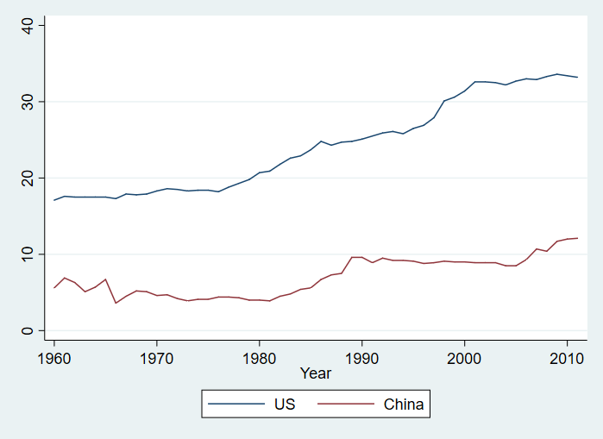
Figure 1: The Finance, Insurance and Real-Estate (FIRE) sectors as % of GDP in the US vs. China (constant prices)
Source: United Nations, Main Aggregates and Detailed Tables (MADT) database, Table 202, http://data.un.org/Data.aspx?d=SNA&f=group_code%3a202 (last accessed March 2020).

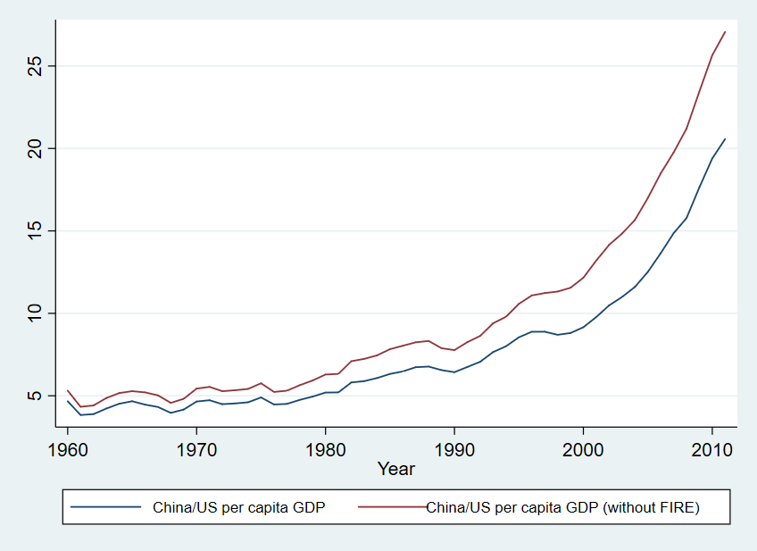
Figure 2: Impact of FIRE imputation on per capita GDP convergence between China and the US
Source: United Nations, Main Aggregates and Detailed Tables (MADT) database, Table 201, http://data.un.org/Data.aspx?d=SNA&f=group_code%3a201 (last accessed March 2020).
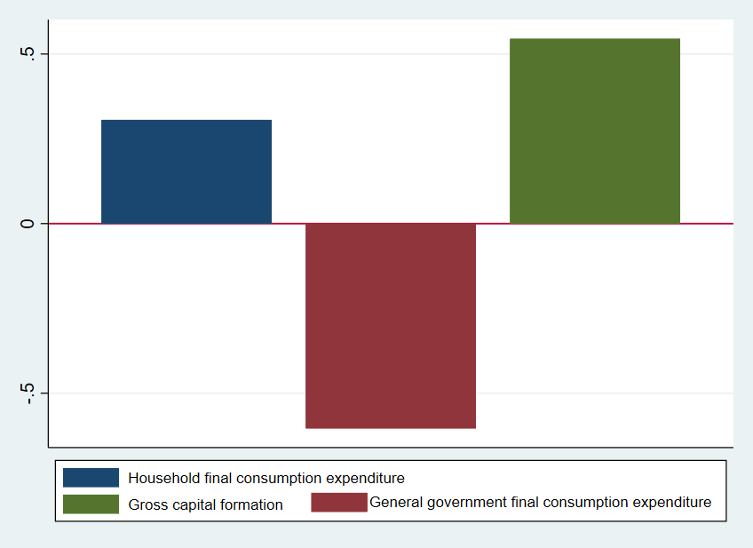
Figure 3: Breakdown by Expenditure of Changes in SNA on Bangladesh’s 1992 as % of Nominal GDP
Source: United Nations, Main Aggregates and Detailed Tables (MADT) database, Table 101, http://data.un.org/Data.aspx?d=SNA&f=group_code%3a101 (last accessed March 2020).

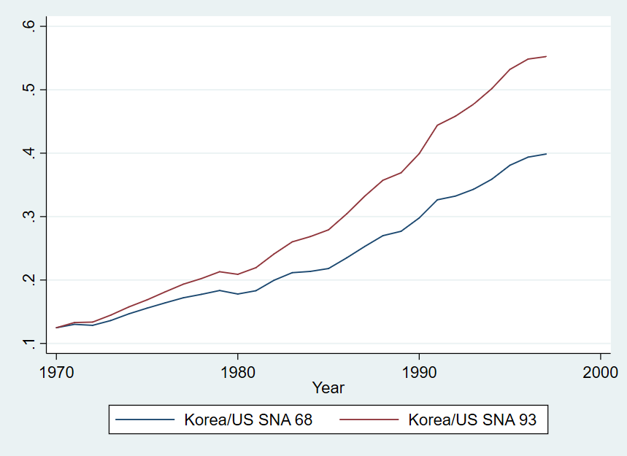
Figure 4: Korea-US Convergence under SNA 68 vs. SNA 93
Source: United Nations, Main Aggregates and Detailed Tables (MADT) database, Table 102, http://data.un.org/Data.aspx?d=SNA&f=group_code%3a102 (last accessed March 2020).

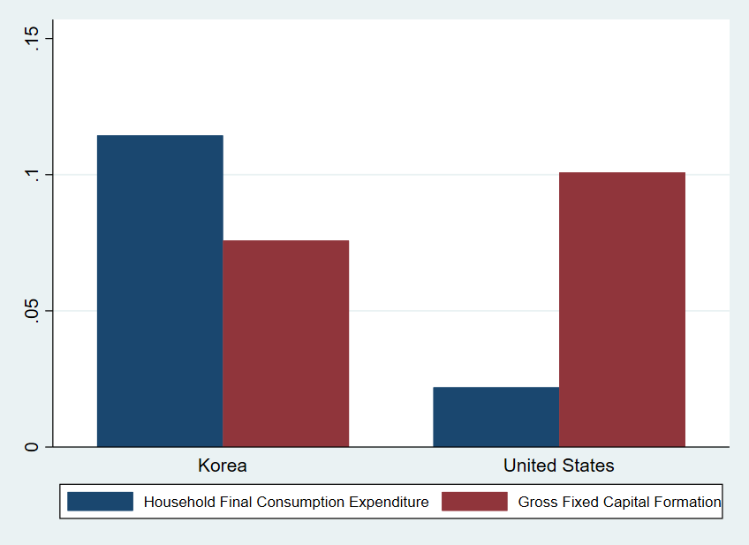
Figure 5: Average (1994-1996) Percentage Increase by Component, Change from SNA 68 to SNA 93
Source: United Nations, Main Aggregates and Detailed Tables (MADT) database, Table 101, http://data.un.org/Data.aspx?d=SNA&f=group_code%3a101 (last accessed March 2020).

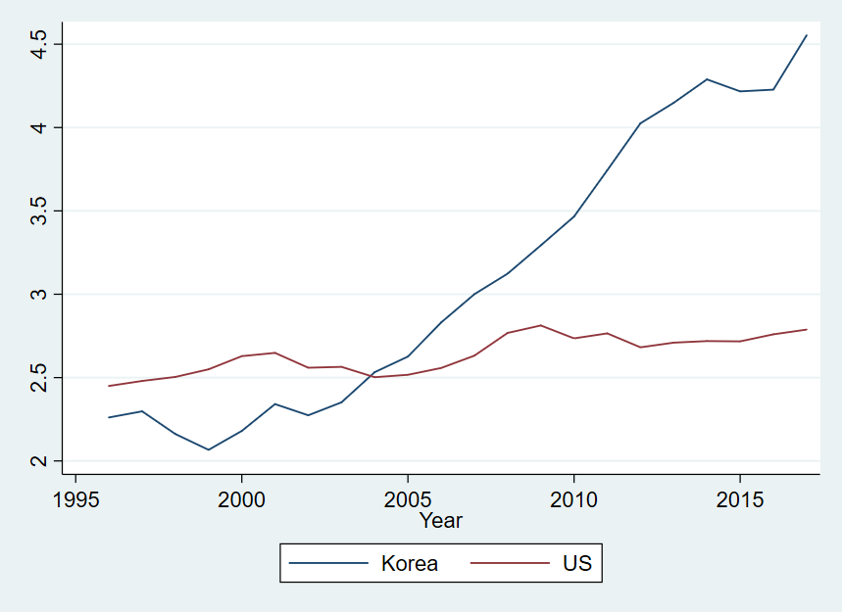
Figure 6: R&D as % of GDP, Korea and the US
Source: Authors’ calculations based on World Bank, World Development Indicators database, series GB.XPD.RSDV.GD.ZS. Accessed March 2020.

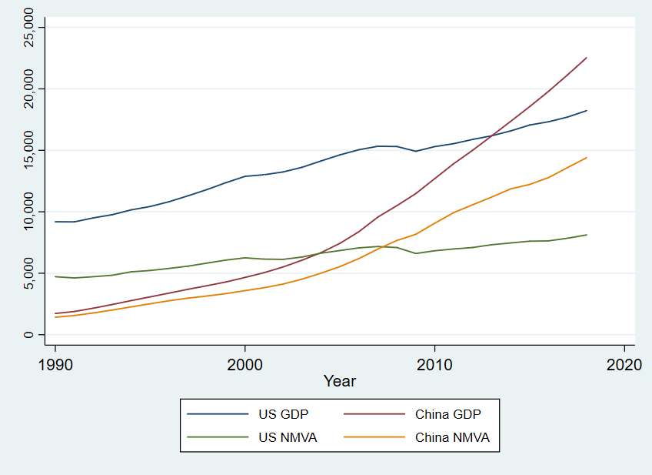

Figure 7: China-US Convergence (GDP and NMVA)
Source: Authors’ calculations based on GDP shares from the United Nations Main Aggregates Database (https://unstats.un.org/unsd/snaama/dnlList.asp) and GDP in $PPP from the World Bank.
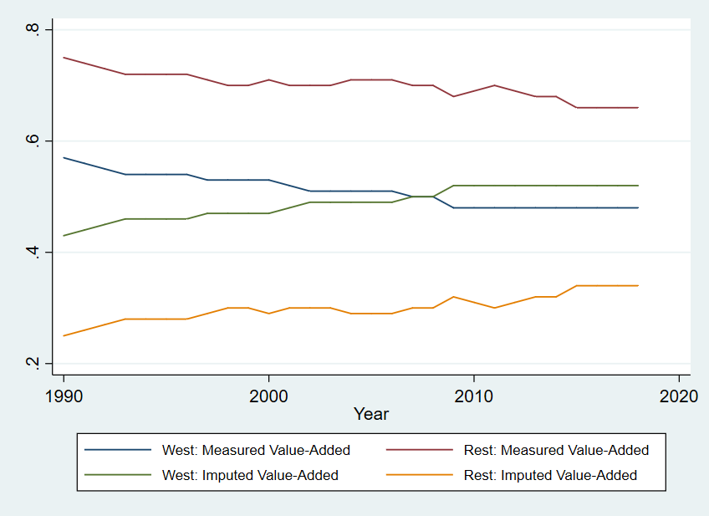
Figure 8: Measured and Imputed Value-Added as % of Total, West and the Rest, NMVA and GDP, 1990-2018
Source: Authors’ calculations based on GDP shares from the United Nations Main Aggregates Database (https://unstats.un.org/unsd/snaama/dnlList.asp) and GDP in $PPP from the World Bank.
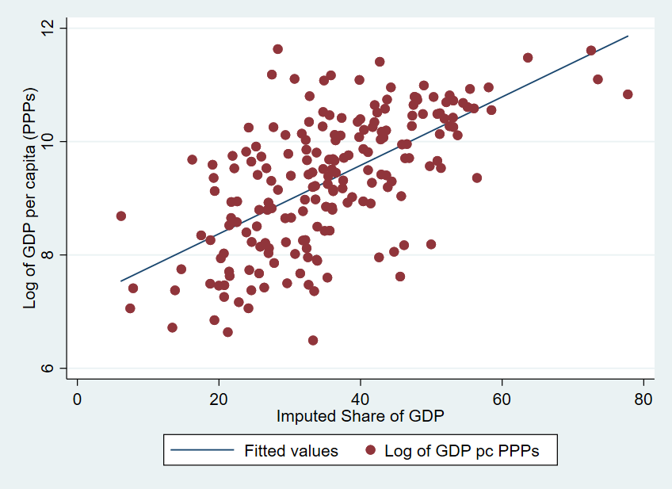
Figure 9: Share of Imputations in GDP and Log GDP per Capita, 2018

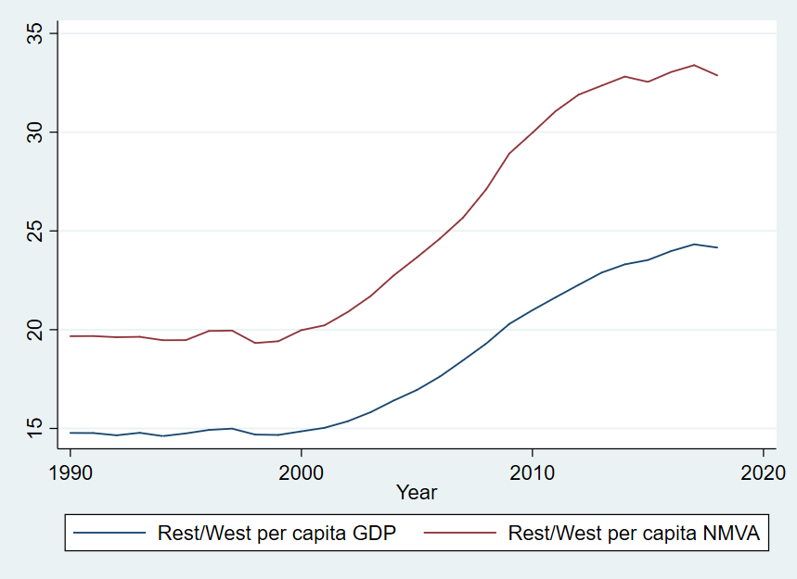
Figure 10: Per Capita Income in the Rest as % of the West, alternative measures
Source: Authors’ calculations based on GDP shares from the United Nations Main Aggregates Database (https://unstats.un.org/unsd/snaama/dnlList.asp) and GDP in $PPP from the World Bank.

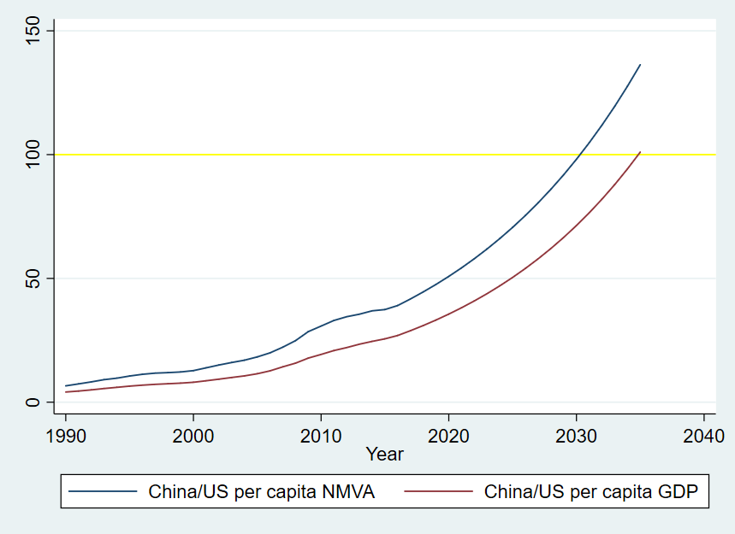
Figure 11: China-US Convergence in per capita output, alternative measures
Source: Authors’ calculations based on GDP shares from the United Nations Main Aggregates Database (https://unstats.un.org/unsd/snaama/dnlList.asp) and GDP in $PPP from the World Bank.

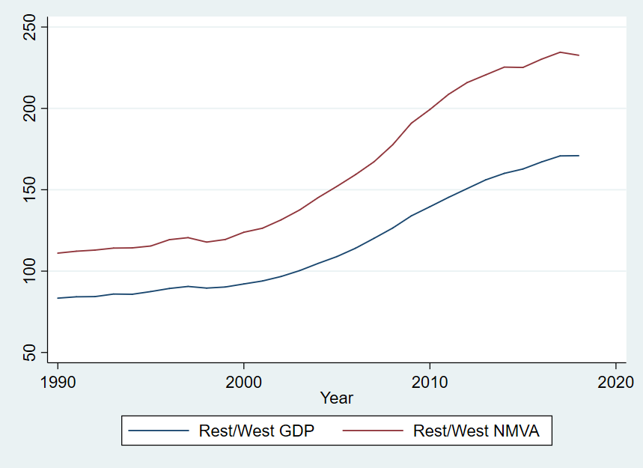
Figure 12: Convergence between the West and the Rest, GDP and NMVA
Source: Authors’ calculations based on GDP shares from the United Nations Main Aggregates Database (https://unstats.un.org/unsd/snaama/dnlList.asp) and GDP in $PPP from the World Bank.

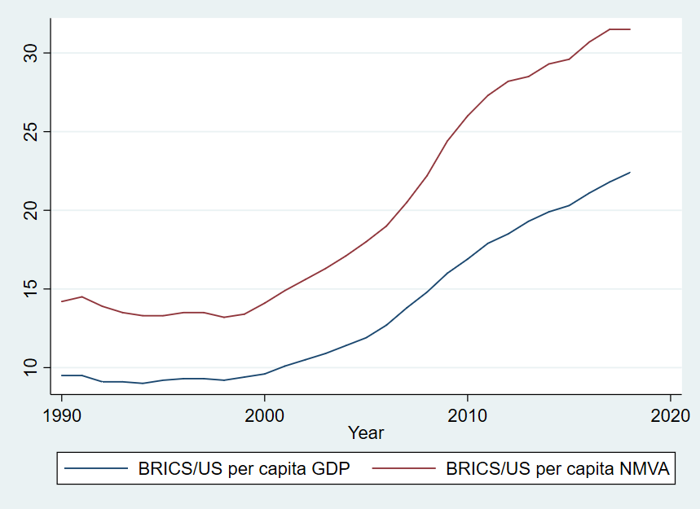
Figure 13: Per capita Convergence of BRICs to US
Source: Authors’ calculations based on GDP shares from the United Nations Main Aggregates Database (https://unstats.un.org/unsd/snaama/dnlList.asp) and GDP in $PPP from the World Bank.

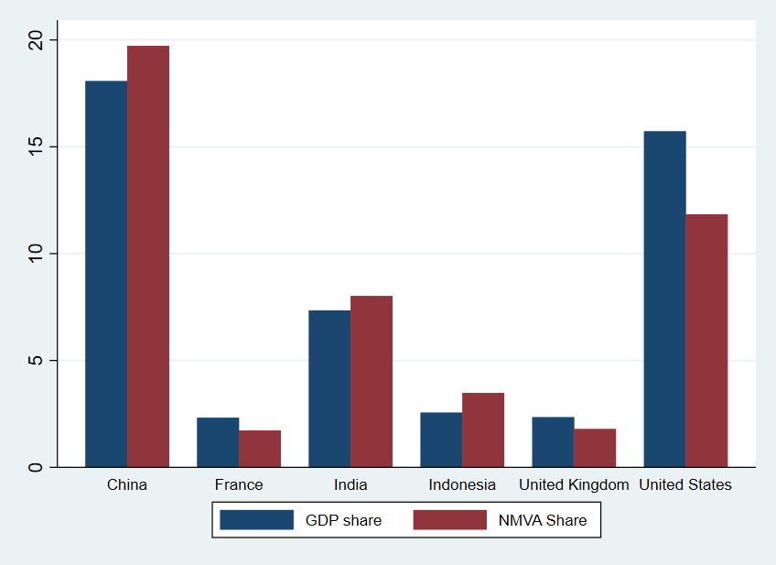
Figure 14: Alternative Shares of Global Economy, GDP vs. NMVA
Source: Authors’ calculations based on GDP shares from the United Nations Main Aggregates Database (https://unstats.un.org/unsd/snaama/dnlList.asp) and GDP in $PPP from the World Bank.

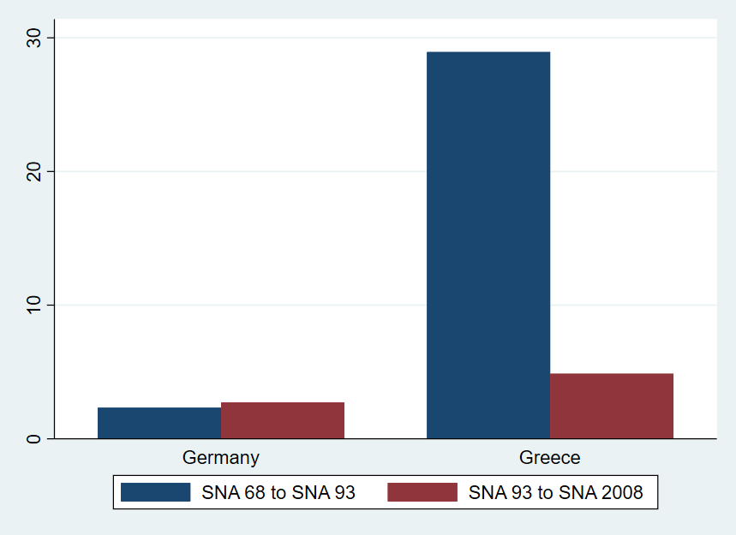
Figure 15: Percentage Impact of SNA Changes on Greek and German GDP in 1995
Source: United Nations, Main Aggregates and Detailed Tables (MADT) database, Table 101, http://data.un.org/Data.aspx?d=SNA&f=group_code%3a101 (last accessed March 2020).

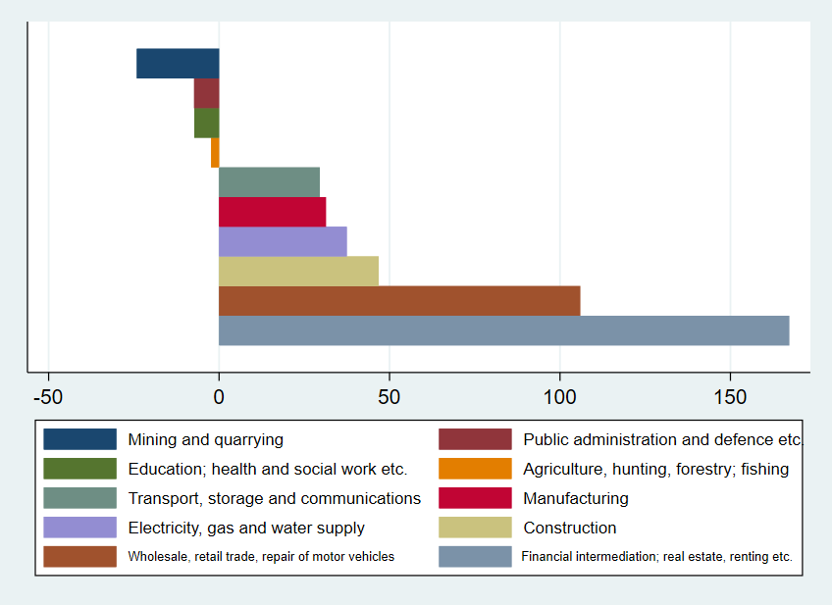
Figure 16: Percentage Change in Greek GDP by Sector from SNA 68 to 93
Source: United Nations, Main Aggregates and Detailed Tables (MADT) database, Table 201, http://data.un.org/Data.aspx?d=SNA&f=group_code%3a201 (last accessed March 2020).

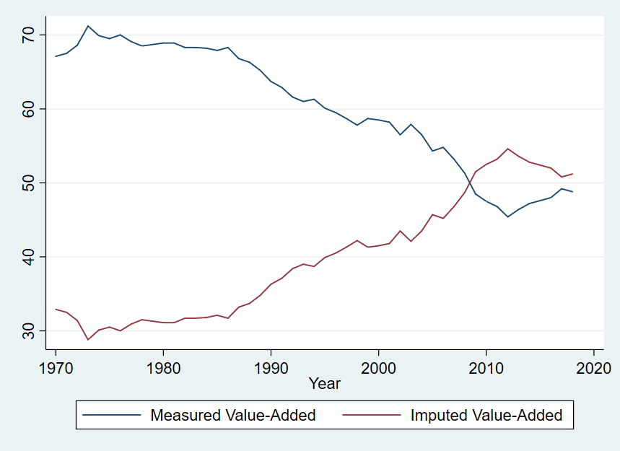
Figure 17: Imputed vs. Measured Value-Added as % of Greek GDP
Source: Authors’ calculations based on GDP shares from the United Nations Main Aggregates Database (https://unstats.un.org/unsd/snaama/dnlList.asp) and GDP in $PPP from the World Bank.

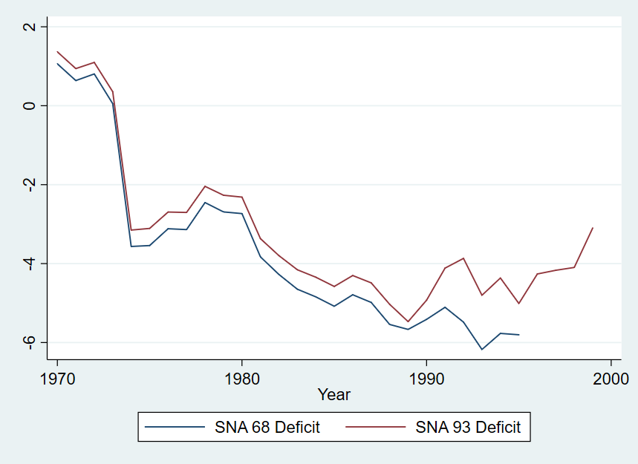
Figure 18: Greek Deficit, % of SNA 68 GDP vs. SNA 93 GDP
Source: United Nations, Main Aggregates and Detailed Tables (MADT) database, Table 202, http://data.un.org/Data.aspx?d=SNA&f=group_code%3a202 (last accessed March 2020).

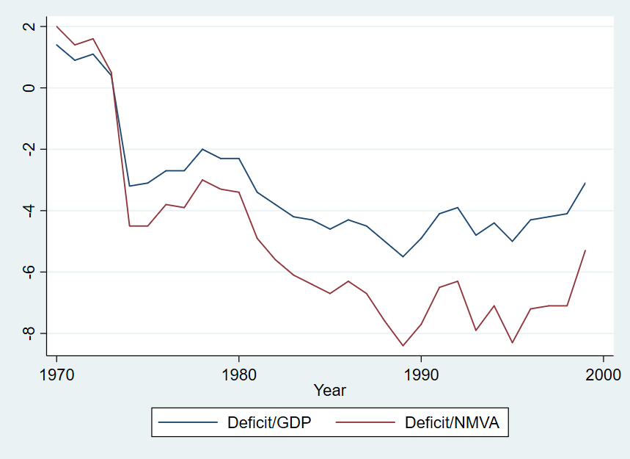

Figure 19: Greek Deficit, % of GDP vs. % of NMVA
Source: United Nations, Main Aggregates and Detailed Tables (MADT) database, Table 202, http://data.un.org/Data.aspx?d=SNA&f=group_code%3a202 (last accessed March 2020).

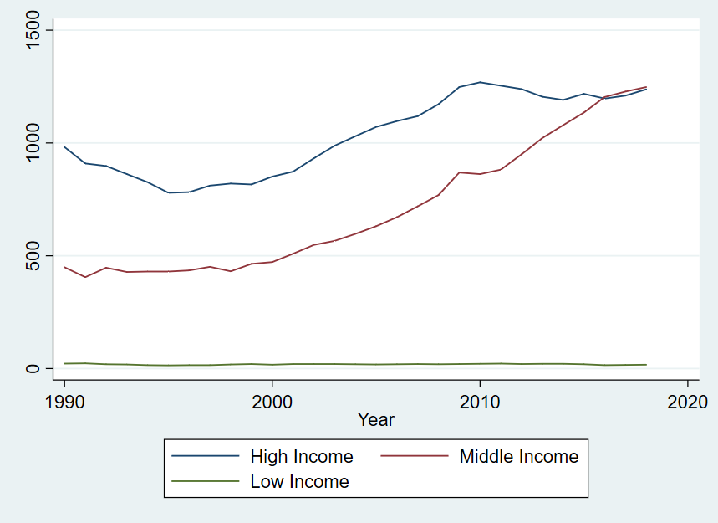
Figure A1: Military Expenditure by Income Group (billions of 2011 PPP$)
Source: Authors’ calculations based on World Bank, World Development Indicators database, series MS.MIL.XPND.GD.ZS. Accessed March 2020.

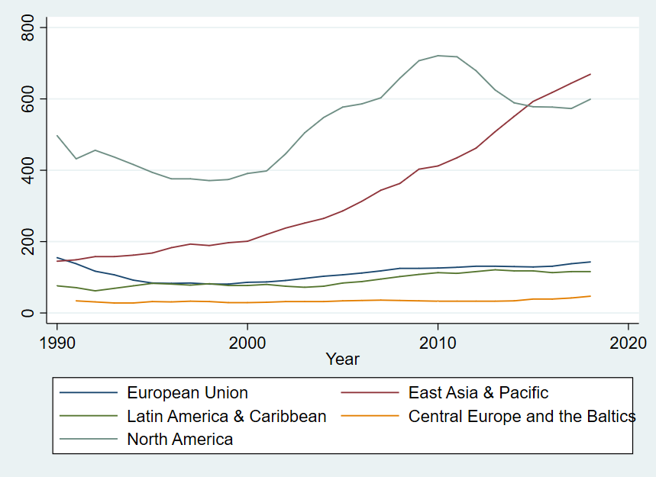
Figure A2: Military Expenditure by Region (billions of 2011 PPP$)
Source: Authors’ calculations based on World Bank, World Development Indicators database, series MS.MIL.XPND.GD.ZS. Accessed March 2020.

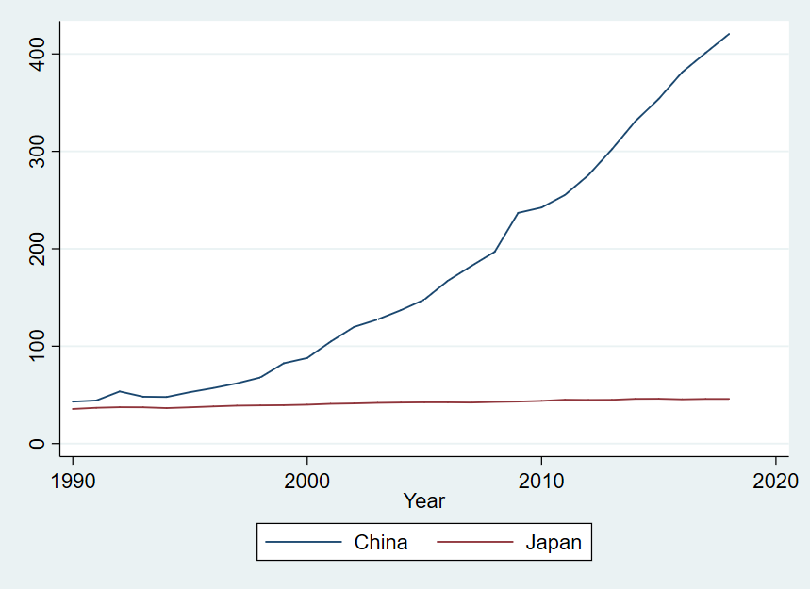
Figure A3: Military Expenditure of China and Japan (billions of 2011 PPP dollars, Constant Prices)
Source: Authors’ calculations based on World Bank, World Development Indicators database, series MS.MIL.XPND.GD.ZS. Accessed March 2020.

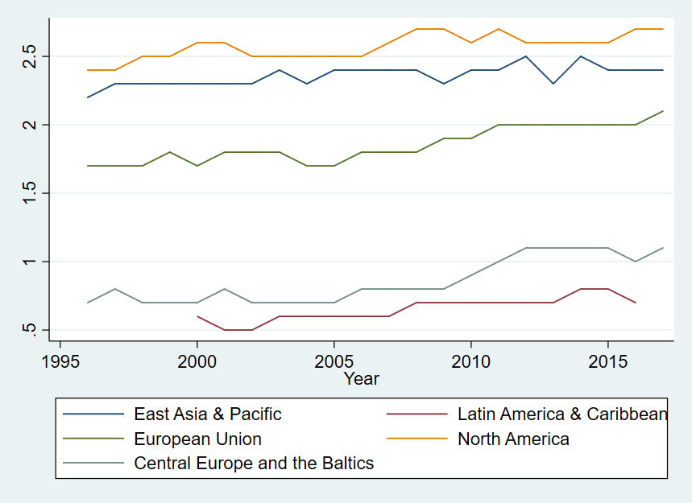
Figure A4: R&D as a % of GDP by Region
Source: Authors’ calculations based on World Bank, World Development Indicators database, series GB.XPD.RSDV.GD.ZS. Accessed March 2020.

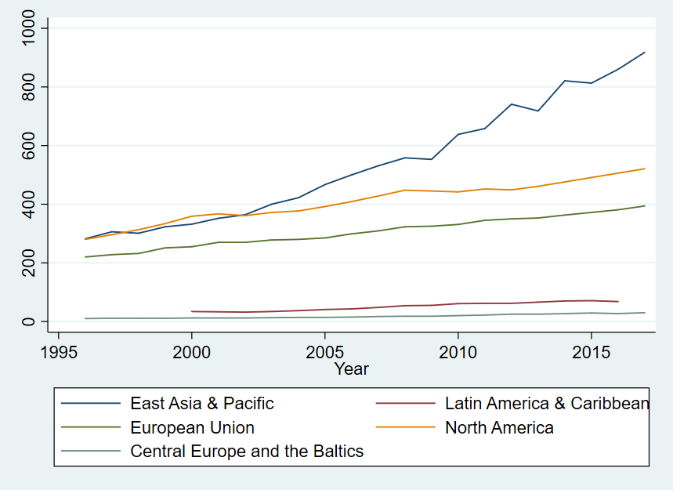
Figure A5: R&D in constant prices (billions of $PPP) by Region
Source: Authors’ calculations based on World Bank, World Development Indicators database, series GB.XPD.RSDV.GD.ZS. Accessed March 2020.

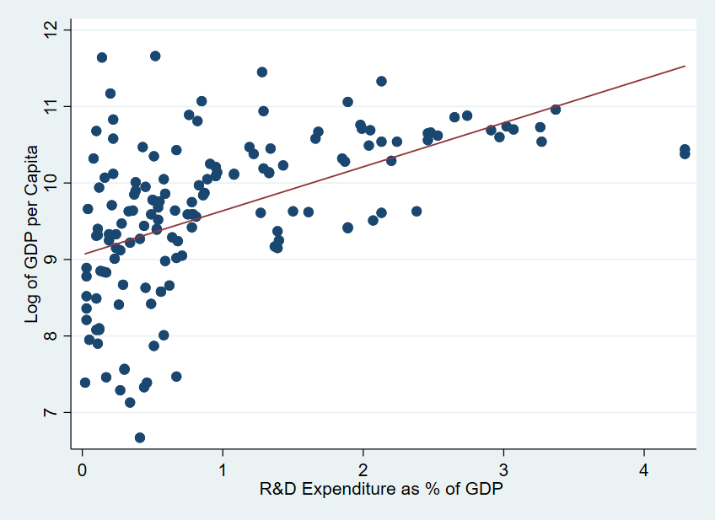
Figure A6: R&D Expenditure as % of GDP vs. log of Per Capita Income, 2013-2017 averages
Source: Authors’ calculations based on World Bank, World Development Indicators database, series GB.XPD.RSDV.GD.ZS and NY.GDP.PCAP.PP.KD. Accessed March 2020.

This also echoes Jerven’s (2012b) observation that the way we measure economic output tends to be in line with the Eurocentrism that pervades our field.
Ha-Joon Chang (2002) argued that countries in the West used a variety of development policies to get to where they are, but once there, preached the opposite policies to poorer countries. While we do not claim that developed countries deliberately manipulate the SNA in order to outpace developing countries, we use this analogy to illustrate how the changes have in fact moved the developmental goal-post beyond the sectors originally associated with industrialisation, such as manufacturing, mining, utilities and transport.
We are aware of NMVA’s limitations, including its limited acceptance and various critiques. However, the other option for a counterfactual - using existing series of SNA 1968 data - is severely limited by data availability, which makes any cross-country comparisons at the aggregate level impossible. We thus use NMVA as an imperfect proxy for a measure of value-added which has less impuations than GDP.
Many studies of convergence adjust GDP for purchasing power parities (PPPs) in order to correct for price differences between countries (e.g. Popov and Jomo 2018). While in principle PPP adjustments might be better for comparing conditions of living or material well-being between countries, it is a country’s GDP at market exchange that matters for its capacity to import, repay debts, and participate in international organizations. In addition, the use of PPP GDP arguably underestimates world income inequality, due to its use of rich country price structure to revalue GDP in poor countries, as it gives greater weight to those prices involved in the largest value of transactions (Wade 2014). Nonetheless, as most studies on convergence use PPPs, this paper will employ them as well for comparability purposes.
However, if we exclude China, the ratio per capita income in the West actually increased in the 1900s (Wade 2004).
Most of these studies focus on either ‘beta convergence,’ which looks at the coefficient in the regression equation for growth rates, or ‘sigma-convergence,’ which considers the standard deviation of the average per capita incomes of countries from the world average, or both (see for example Mauer 1995).
Here absolute convergence is due to the diminishing returns to capital implicit in the neoclassical production function, which leads to the prediction that the rate of return to capital is large when the stock of capital is small and vice versa.
For example, from the 1930s to 1960s, the USSR and Japan were the first major countries to achieve catch-up growth in income per capita, converging on Western countries (Popov and Jomo 2017) and in the second half of the 20th century, Korea, Taiwan, Japan, Singapore, and China have each exhibited catch-up growth and convergence with the West, even if on average there has not been a convergence between the West and the Rest (see e.g. Jomo et al. 1997 and Lin and Rosenblatt 2012). Meanwhile , many countries in Latin America and Africa experienced divergence with the West, especially during the 1980s and 1990s (Ocampo et al. 2007). Evidence also shows that developing countries, including the BRICs, experienced convergence with advanced countries during the commodity boom (Mazumdar 2016).
Every economics textbook explains how, to avoid double-counting, if the output of one producer is an input to another product, the former is deducted as ‘intermediate consumption’. For example, if the value of flour produced by the miller is added to the value of the bread sold by the baker, it would have been counted twice. Instead when bread is counted, only the ‘value-added’ by the baker - namely the baking - gets monetized.
Such overlap in years for which data is available under multiple SNA systems is limited. This is especially the case for countries which have never used SNA 1968, including many countries previously dubbed as being ‘in transition’ from command economies to market-based economies. The list includes the former USSR, other east-European countries, as well as China and Cuba. Even for non-Communist countries, data is limited, especially for developing countries.
It is important to bear in mind that the difference between any two numbers in the SNA accounts is the combination of changes to the methodology, which is the focus of this paper, and other changes, including improvements in the underlying raw data, changes to the series’ base year, etc. In practice it is difficult to disaggregate all these changes, and as a result, comparisons of growth in constant prices in this paper (those using MADT tables 102 and 202 as a source) should be interpreted with caution. This is less of an issue with the current price comparisons in this paper (using MADT tables 101 and 201) since there is no change of base year to affect the results.
Annex IV shows the results of convergence regressions using market-exchange rates from 1970-2017. These regressions likewise show a stronger convergence with narrow-measured value-added than with GDP.
This technical issue pales in comparison to the larger problem of assigning voting power to countries based on ANY measure of output.
There are also well-documented problems associated with GDP measurements in developing economies (Dawnson et al. 2001, Johnson et al. 2009, Ciccone and Jarocinksi 2010, Jerven 2012b). For example, in 2010 Ghana announced that it was revising the GDP estimates upwards by over 60%, and in 2011 Nigeria announced that it was making a similar upwards revision (Jerven 2012a). With Ghana’s statistical revision, it literally became a lower-middle income country overnight. While many in the development community saw this revision as good news that the African country is no longer as poor as people thought (see e.g. Kenny and Sumner 2011), the United Nations Development Program representative in Ghana argued that Ghana is still lagging behind on most development indicators and that the middle-income status is a ‘statistical hypothesis’ (UNDP 2011).

