Multiple-image arrays in face matching tasks with and without memory

Kay L. Ritchie¹, Robin S. S. Kramer¹, Mila Mileva², Adam Sandford³, and A. Mike Burton²

¹ School of Psychology, University of Lincoln, UK
² Department of Psychology, University of York, UK
³ Department of Psychology, University of Guelph-Humber, Canada

Corresponding author
KL Ritchie
kritchie@lincoln.ac.uk
School of Psychology,
University of Lincoln
Lincoln
LN6 7TS

Acknowledgements
The authors would like to thank Andrew Dowsett for contributing to the work presented here, Amy S. Hought for data collection for Experiment 2, Ellen Wheeler for data collection for Experiment 3, and Lily Bridgewater for data collection for Experiments 4.

Keywords
Face matching; face learning; variability

Abstract
Previous research has shown that exposure to within-person variability facilitates face learning. A different body of work has examined potential benefits of providing multiple images in face matching tasks. Viewers are asked to judge whether a target face matches a single face image (as when checking photo-ID) or multiple face images of the same person. The evidence here is less clear, with some studies finding a small multiple-image benefit, and others finding no advantage. In four experiments, we address this discrepancy in the benefits of multiple images from learning and matching studies. We show that multiple-image arrays only facilitate face matching when arrays precede targets. Unlike simultaneous face matching tasks, sequential matching and learning tasks involve memory and require abstraction of a stable representation of the face from the array, for subsequent comparison with a target. Our results show that benefits from multiple-image arrays occur only when this abstraction is required, and not when array and target images are available at once. These studies reconcile apparent differences between face learning and face matching and provide a theoretical framework for the study of within-person variability in face perception.
Introduction
We rely on faces to verify identity in a variety of situations ranging from buying alcohol to crossing borders. It is, therefore, important to understand how accurate we are at determining whether a photo-ID shows the person using it, and to identify potential ways to improve our performance in such tasks.

A large body of literature suggests that recognising familiar and unfamiliar faces entail some qualitatively different processes (Johnston & Edmonds, 2009; Megreya & Burton, 2006) and this could have serious practical implications. On the one hand, we are very good at recognising images of familiar identities even when these images are heavily distorted or degraded (e.g. Bruce, 1982, 1986; Burton, Wilson, Cowan, & Bruce, 1999). On the other hand, recognition of unfamiliar identities is much poorer even with images taken on the same day or in the same session (e.g. Bruce et al, 1999; Burton, White, & McNeill, 2010). This stark contrast between familiar and unfamiliar faces has been demonstrated using many different tasks and paradigms including face memory, search and sorting tasks (Jenkins, White, Van Montfort, & Burton, 2011; Klatzky & Forrest, 1984; Kramer, Hardy, & Ritchie, 2020) as well as face matching tasks where typically two images are presented side-by-side on a computer screen, and participants are asked to judge whether the photos show the same person or different people (Bruce, Henderson, Newman, & Burton, 2001; Bruce et al., 1999; Clutterbuck & Johnston, 2002, 2004; Megreya & Burton, 2008; Ritchie et al., 2015). While matching tasks have been generally used to approximate the process of checking photo-ID, the effect of familiarity has also been documented outside the lab with findings of poor performance when matching a live unfamiliar person to a photograph (Davis & Valentine, 2009; Kemp, Towell, & Pike, 1997; Megreya & Burton, 2008; Ritchie, Mireku, & Kramer, 2020). Moreover, all of this is true for many people who are employed to check photo-ID such as checkout assistants (Kemp et al., 1997), passport officers (White, Kemp, Jenkins, Matheson, & Burton, 2014) and police officers (Burton et al., 1999).

The difference between recognising familiar and unfamiliar faces has been attributed to the types of processing involved. We have seen the faces of familiar identities in a variety of contexts, situations and conditions, providing us with rich information about the many ways a single person might look. This way, we are able to isolate everything that is diagnostic of the person and discard any superficial image differences, leading to a more abstracted and image-independent processing for familiar faces. In Bruce and Young’s influential model (1986), familiar recognition is conceptualised through the use of Face Recognition Units (FRUs) which code structural information about known faces. FRUs must therefore store an abstracted, stable representation of a familiar person that is not influenced by simple image properties such as changes in head angle or expression.

Bruce (1994) first introduced the notion of stability from variation as a key familiarisation mechanism. Since then, a number of behavioural and computer modelling studies have shown that we can create and store stable representations of faces through exposure to within-person variability – that is multiple exposures to the same person showing naturally-occurring changes in their appearance. However, the same natural within-person variability that aids the recognition of familiar faces, can be detrimental to unfamiliar recognition which relies to a much greater extent on superficial image properties. This means that irrelevant differences in the physical properties of images or simple changes in clothing or accessories can be mistakenly regarded as evidence for differences in identity (Bindemann & Sandford, 2011; Graham & Ritchie, 2019; Kramer & Ritchie, 2016). In fact, recent research has suggested that the difference between familiar and unfamiliar face recognition may be due to our ability to use or tolerate within-person variability for familiar people (Burton, 2013; Burton, Jenkins & Schweinberger, 2011; Burton, Kramer, Ritchie, & Jenkins, 2016; Jenkins, White, Van Montfort, & Burton, 2011). It is therefore possible that exposure to this variability can help unfamiliar viewers to switch from image-based to a more abstracted processing by aggregating the variability information into a single identity representation.

A growing body of research has shown that exposure to within-person variability helps when learning a new identity and this has been supported by work using both behavioural and computer modelling data (Dowsett, Sandford, & Burton, 2016; Jones, Dwyer, & Lewis, 2017; Kramer, Young, & Burton, 2018; Longmore, Liu & Young, 2008; Longmore et al., 2017; Matthews, Davis, & Mondloch, 2018; Murphy, Ipser, Gaigg, & Cook, 2015; Ritchie & Burton, 2017; Robins, Susilo, Ritchie, & Devue, 2018). The benefits from access to multiple images of the same identity have been shown in adults’ as well as in children’s face learning (Matthews et al., 2018), with some evidence that children aged 6-13 need more variability than adults to learn a new person from video footage (Baker, Laurence, & Mondloch, 2017).

The amount of within-person variability is also an important factor in face learning. Ritchie and Burton (2017), for example, showed participants photos that were either high in variability (displaying changes in head angle, lighting, camera, age, hair style, etc) from a Google Images search, or photos that were low in variability, taken from a video of a single event (changes only in head angle and expression). After learning the identities from these images, participants’ performance was tested with a name-verification and a face matching task using novel images of the same identities. In both cases, participants who had learned from the high variability image set outperformed those who learned from the low variability set. These results suggest that exposure to variability is key to learning or abstracting a stable representation of a person.

Research on the benefits of within-person variability for face matching has been less consistent and conclusive. Unlike face learning, this is a purely perceptual task with no demands on memory. Some studies suggest that multiple images may help to improve performance on face matching. White et al. (2014) presented participants with arrays of two, three, or four images of the same person and asked them to match another image to the array. The multiple-image arrays gave rise to better performance than matching to a single image. In a different paradigm, participants were presented with a physical photograph of a target and asked to search through a pile of photos to find another image of the same person. On successive trials, participants were given an additional image of the same identity and their accuracy improved as the number of target images increased (Dowsett, Sandford, & Burton, 2016). Other recent studies, however, have failed the replicate these results with no benefits reported from exposure to arrays comprising a frontal and a profile view image (Kramer & Reynolds, 2018) or when matching a live person to a four-image array compared to a single image (Ritchie et al., 2020).

Therefore, when it comes to the key role of within-person variability for successful recognition, face learning and face matching tasks present somewhat dissimilar results. Exposure to variability helps learning a new identity, whereas results with matching are unclear. One possible explanation for this difference is that learning paradigms require the face to be memorised whereas matching paradigms present all stimuli simultaneously, without a memory component to the task. It is thus possible that exposure to variability, or multiple images, is only helpful when the task requires that a representation of the face be abstracted in order to be held in memory to make subsequent comparisons. This is supported by evidence for the benefits of within-person variability in face matching when images are presented one after the other, rather than simultaneously (Menon, White, & Kemp, 2015a).

Here, we compare face recognition accuracy in a purely perceptual simultaneous matching task and a memory-dependent sequential matching task. In a series of four studies, we manipulate the amount of within-person variability available, and the presentation order of multiple image arrays and comparison images, allowing us to determine why variability seems to be consistently aiding face learning but not face matching performance. It is possible that differences in results between previous studies are due to a difference in the amount of within-person variability shown in the arrays, with studies that have found a multiple-image benefit (e.g. White at al., 2014) perhaps displaying more variability in the arrays than those that have not found that effect (e.g. Ritchie et al., 2020). However, if the difference in the utility of variability between face learning and matching is due to the memory component of learning tasks, then we would expect variability to facilitate performance in only sequential matching tasks. Like learning tasks, sequential matching tasks may require variability to be incorporated into a stable identity representation.

Experiment 1 investigates the effect of array variability on face matching performance in a simultaneous task. Experiment 2 compares performance in simultaneous versus sequential matching tasks. Finally, Experiments 3 and 4 compare performance on two different sequential tasks – one that allows for variability to be integrated into a single mental representation and one that does not.

Experiment 1 – array variability
The evidence to date is mixed as to whether multiple images improve matching performance (Menon et al., 2015; Ritchie et al., 2020; Sandford & Ritchie, under review; White at al., 2014), and so it could be that these experiments used arrays of differing degrees of variability, resulting in different effects. In this first experiment, we investigated the effect of array variability on face matching performance. We constructed high and low variability arrays from an existing image set (Ritchie & Burton, 2017). Participants compared a target image to either a high or low variability array, and we also tested accuracy in a one-to-one condition. It is possible that multiple-image arrays only facilitate face matching when the arrays are high in variability.

Method
Participants
Thirty-one participants took part in this experiment (7 male, mean age: 22 years, range: 17-40 years). All participants were students or other members of the University of York. All participants gave informed consent, and the study was granted ethical approval by the University of York Psychology Ethics Committee.

Stimuli and Procedure
The stimuli were images from a previous set of high and low variability ambient images used for face learning research (Ritchie & Burton, 2017). The set comprised five high and four low variability images of each of ten Australian celebrities (five female), specifically chosen to be unfamiliar in the UK. The high variability images were downloaded from a Google Images search for each identity and varied in head angle, expression, lighting, age, etc. The low variability images were screenshots from single interview videos, allowing for variation in head angle and expression, but now taken seconds apart under the same lighting and with the same camera (see Figure 1).

For the matching task, we constructed four-image arrays from the high variability (Google Images) images, and the low variability (video screenshots) images. All four images in each array always showed the same person. In half of the face matching trials, participants were presented with two images side by side on the screen (one-to-one condition). For half of the one-to-one trials, the image on the left of the screen was from the high variability set, and from the low variability set in the other half of the trials. The image on the right was either a match (an image from the high variability set showing the same identity) or a mismatch ( a foil image showing a different identity that matched the verbal description of the target identity, e.g., young man, dark hair). In the other half of the trials, participants were presented with a four-image array paired with either a match or a foil image (four-to-one condition). The multiple-image array was from the high variability set in one half of the trials and from the low variability set in the other. It was always presented on the left of the screen (see Figure 1), and participants were informed in the four-to-one condition that these four images showed the same person. The comparison (match or mismatch) image was presented on the right and participants were prompted with on-screen instructions to respond via keypresses to indicate whether the comparison image showed the same person as displayed on the left of the screen. Each participant completed a total of 40 trials – 20 in the one-to-one condition (half with a high variability image, half with a match image) and 20 in the four-to-one condition (half with a high variability image array, half with a match image). Each identity was seen once in each condition (high/low variability, one/four images, match/mismatch).
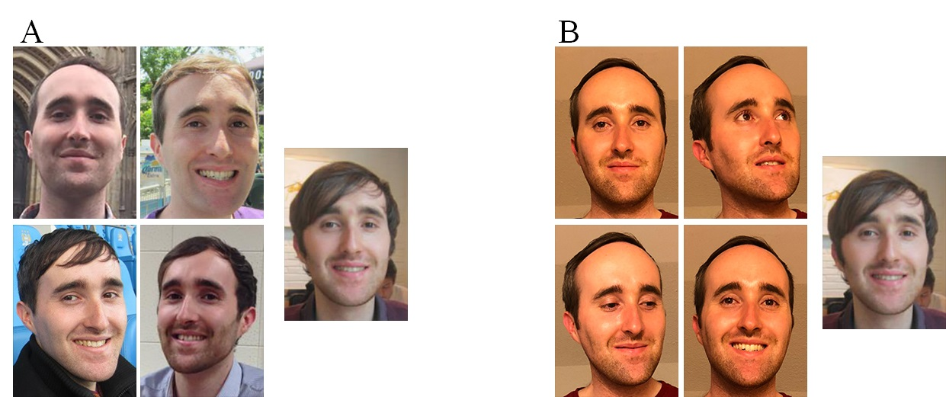
Figure 1. Example stimuli used in Experiment 1. A) High variability array match trial. B) Low variability array match trial. (Copyright restrictions prevent publication of the images used in the experiment. Images in Figure 1, also in Figures 3 and 6, are illustrative of the experimental stimuli and depict someone who did not appear in the experiments but has given permission for the images to be reproduced here).

Results
Previous research has found that performance on match and mismatch trials is not correlated (Megreya & Burton, 2007), and many studies have found that experimental manipulations affect performance on match or mismatch trials, but rarely both (e.g. Megreya & Burton, 2006, 2007; Menon et al., 2015; Ritchie & Burton, 2017; White et al., 2014). Therefore, for all experiments reported here, match and mismatch trial accuracy are analysed separately. In addition to traditional frequentist hypothesis testing, we included Bayes factors using JASP (JASP Team, 2020), which allowed us to quantify the extent to which the data support the alternative hypothesis (BF₁₀). Bayes factors for the simple main effects analyses do not take into account the full ANOVA, and so indicate simple strengths of differences between conditions. Mean accuracy for Experiment 1 is shown in Figure 2. No participants in any of the experiments indicated familiarity with any of the stimulus identities.

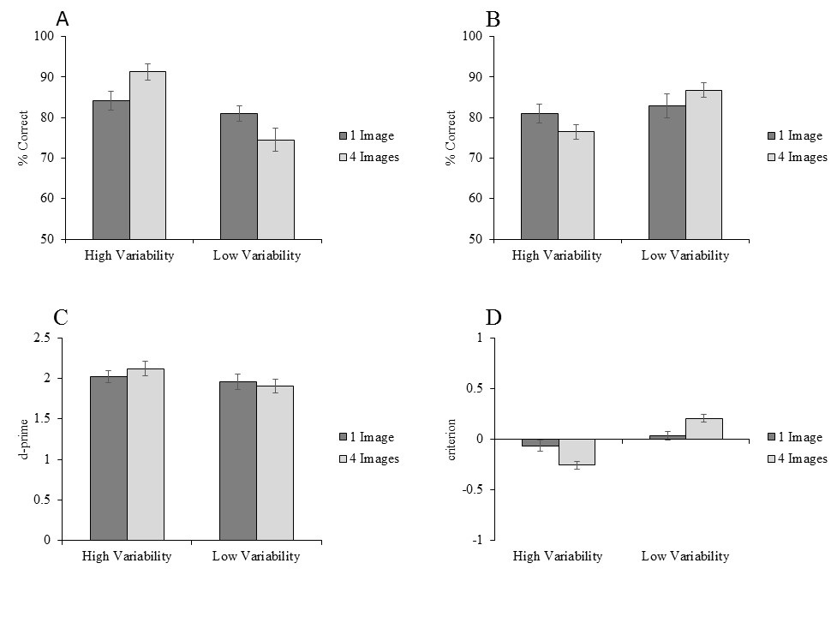
Figure 2. Data for Experiment 1. A) Match trials. B) Mismatch trials. C) d-prime. D) criterion. Error bars show the within-subjects standard error (Cousineau, 2005).

First, for match trials, a 2 (variability: high, low) x 2 (number of images: 1, 4) within subjects ANOVA showed a significant main effect of variability F(1,30) = 32.63, p < .001, η_{p}² = .52, BF₁₀ = 9.46, a non-significant main effect of number of images F(1,30) = 0.02, p = .888, η_{p}² < .01, BF₁₀ = 0.74, and a significant interaction F(1,30) = 9.22, p = .005, η_{p}² = .24 BF₁₀ = 0.28. Simple main effects showed a significant improvement in performance with high compared to low variability images for four-image arrays F(1,60) = 35.00, p < .001, η_{p}² = .37 BF₁₀ = 17,014.43, but not for one-to-one match trials F(1,60) = 1.29, p = .261, η_{p}² = .02, BF₁₀ = 0.46, meaning there was no difference in matching performance when the single comparison image came from the high or the low variability set of images. Simple main effects also showed an effect of number of images for both high variability images F(1,60) = 5.00, p = .029, η_{p}² = .08 BF₁₀ = 2.08, and low variability images F(1,60) = 4.13, p = .047, η_{p}² = .06, BF₁₀ = 1.16, such that four-image arrays helped when they were high in variability (1 image M = 84.19%, 4 images M = 91.29%), but hindered when they were low in variability (1 image M = 80.97%, 4 images M = 74.52%).

For mismatch trials, there was a significant main effect of variability F(1,30) = 7.54, p = .010, η_{p}² = .20, BF₁₀ = 9.47, a non-significant main effect of number of images F(1,30) = 0.02, p = .888, η_{p}² < .01, BF₁₀ = 0.19, and a significant interaction F(1,30) = 6.95, p = .013, η_{p}² = .19, BF₁₀ = 1.72. Simple main effects showed a significant effect of variability for four-image arrays F(1,60) = 14.18, p < .001, η_{p}² = .19, BF₁₀ = 30.32, where accuracy was poorer with high variability image arrays (M = 76.45%) than with low variability arrays (M = 86.77%). There was a non-significant effect of variability for one-to-one match trials F(1,60) = .05, p = .824, η_{p}² = .03, BF₁₀ = 0.33 meaning there was no difference in performance on mismatch trials when the single comparison image came from the high or the low variability set of images. The simple main effects for number of images for the high and low variability images were both non-significant (both ps > .05, both BF₁₀ < 1; see Figure 2).

We can also analyse the data using signal detection measures. Here, hits correspond to correct match trials, and false alarms to incorrect mismatch trials (see Figure 2, lower panels). For d-prime (d’) values, there was a non-significant main effect of variability F(1,30) = 1.79, p = .192, η_{p}² = .06, BF₁₀ = 0.46, a non-significant main effect of number of images F(1,30) = 0.05, p = .831, η_{p}² < .01, BF₁₀ = 0.19, and a non-significant interaction F(1,30) = 0.57, p = .457, η_{p}² = .02, BF₁₀ = 0.29. For criterion values (a measure of bias), there was a significant main effect of variability F(1,30) = 43.90, p < .001, η_{p}² = .59, BF₁₀ = 22,278.74, a non-significant main effect of number of images F(1,30) = 0.05, p = .825, η_{p}² < .01, BF₁₀ = 0.19, and a significant interaction F(1,30) = 14.47, p < .001, η_{p}² = .33, BF₁₀ = 63.71. Simple main effects showed a significant effect of number of images for high variability images F(1,60) = 6.67, p = .012, η_{p}² = .10, BF₁₀ = 2.39, whereby participants were more biased toward responding “match” with four high variability images (M = -.26) than one image (M = -.06). Simple main effects also showed a significant effect of number of images for low variability images F(1,60) = 4.98, p = .029, η_{p}² = .08, BF₁₀ = 4.42, whereby participants were more biased toward responding “mismatch” with four low variability images (M = .20) than one image (M = .04).

In this experiment, using four-image arrays, we have shown that for match trials, high variability arrays improve performance, and low variability arrays impair performance, as compared to one-to-one matching trials. For mismatch trials, however, high variability arrays impaired performance compared to low variability arrays, and there was no benefit for high variability four-image arrays over single images. Taken together, these results suggest that there is no evidence for an increase in overall accuracy (match and mismatch trials taken together as in d’) with multiple-image arrays. These results are aligned with two recent studies which showed no overall benefit of variability when the array and the target are presented simultaneously (Ritchie et al., 2020; Sandford & Ritchie, under review).

Experiment 2 – simultaneous vs sequential matching
This experiment investigated the effect of four-image arrays in simultaneous and sequential matching. The simultaneous and sequential tasks have different task demands, being purely perceptual- and memory-based respectively. This allows us to investigate the effect of variability on these two different processes. If memory is important for the multiple-image advantage, then we should see that four-image arrays produce higher matching accuracy only in a sequential and not a simultaneous matching task.

Method
Participants
Forty participants took part (6 male, mean age: 20 years, range: 18-27 years). All participants were students or other members of the University of Lincoln. All participants gave informed consent, and the study was granted ethical approval by the University of Lincoln School of Psychology Research Ethics Committee.

Stimuli and procedure
The stimuli here were of 80 identities (40 female), including the Australian celebrities used in Experiment 1. All images were high in variability. As in Experiment 1, we used a matching task with either a single image or a four-image array which were paired with an image of the
same identity in match trials and with an image of a foil identity in mismatch trials. Each identity was presented once, with a random assignment of identities to conditions across participants (keeping the number of males and females in each condition equal). Each participant completed two separate face matching blocks - one simultaneous and one sequential. For the simultaneous block, the array or single target image was presented on the left with the comparison image (match or foil) on the right (as in Experiment 1). In the sequential block, the target image/array was displayed first for 4 s, followed by a blank screen for 2 s, followed by the comparison (match or foil) image which remained on screen until the participant responded (see Figure 3). All images and arrays were centred on the screen for the sequential procedure. The order of blocks was counterbalanced across participants. Each block contained 40 trials: 10 single image match, 10 single image mismatch, 10 four-image array match, 10 four-image array mismatch. For the simultaneous block, the array or single target image was presented on the left with the comparison image (match or foil) on the right (as in Experiment 1). In the sequential block, the target image/array was displayed first for 4 s, followed by a blank screen for 2 s, followed by the comparison (match or foil) image which remained on screen until the participant responded (see Figure 3). All images and arrays were centred on the screen for the sequential procedure.

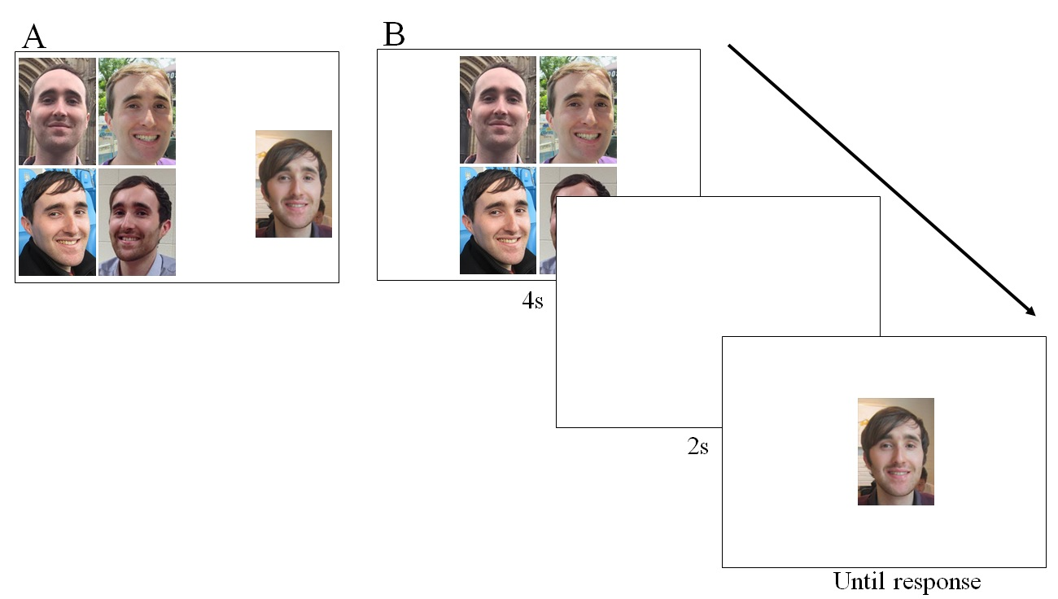Figure 3. Procedure for Experiment 2. A) Simultaneous match trial. B) Sequential match trial.

Results
Here, we analysed the data using a 2 (number of images: 1,4) x 2 (presentation type: simultaneous, sequential) ANOVA separately for match and mismatch trials. Figure 4 shows the results of Experiment 2.
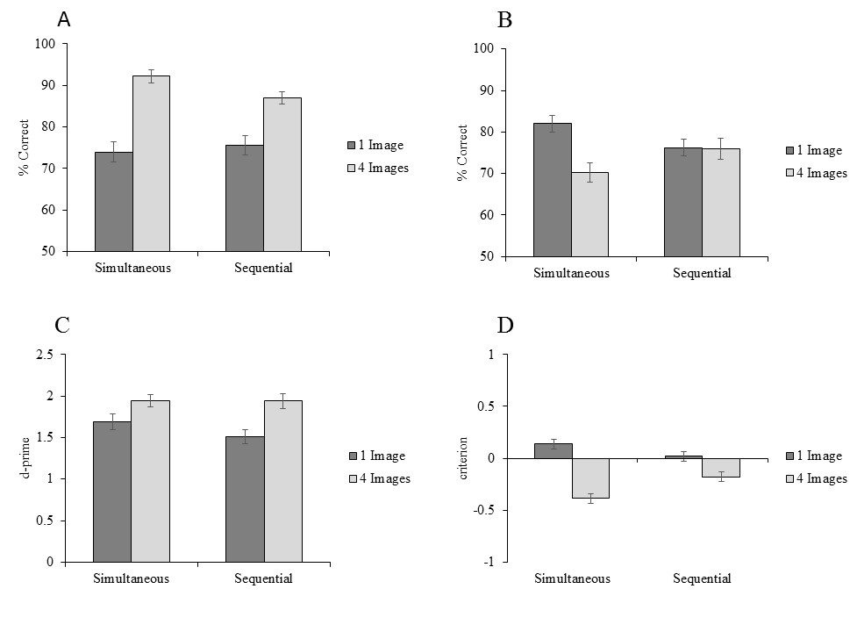
Figure 4. Results of Experiment 2 using single images and four-image arrays in both simultaneous and sequential face matching tasks. A) Match trials. B) Mismatch trials. C) d-prime. D) criterion. Error bars show the within-subjects standard error (Cousineau, 2005).

For match trials, there was a significant main effect of number of images F(1,39) = 68.70, p < .001, η_{p}² = .64, BF₁₀ = 3.75 x 10⁹, with significantly higher accuracy for four images (M = 89.63%) than one image (M = 74.75%). There was a non-significant main effect of presentation type F(1,39) = 0.92, p = .343, η_{p}² = .02, BF₁₀ = 0.23, and a non-significant interaction F(1,39) = 2.30, p = .137, η_{p}² = .06, BF₁₀ = 0.61.

For mismatch trials, there was a significant main effect of number of images F(1,39) = 5.55, p = .024, η_{p}² = .12, BF₁₀ = 3.39, a non-significant main effect of presentation type F(1,39) < 0.001, p = .975, η_{p}² < .01, BF₁₀ = 0.17, and a significant interaction F(1,39) = 4.85, p = .034, η_{p}² = .11, BF₁₀ = 3.59. Simple main effects showed a significant effect of number of images for simultaneous F(1,78) = 10.39, p = .002, η_{p}² = .12, BF₁₀ = 60.53 but not sequential trials F(1,78) < 0.001, p = .951, η_{p}² < .001, BF₁₀ = 0.23. For mismatch trials, performance was higher with one image (M = 82.00%) compared to four images (M = 70.25%). As in Experiment 1, we see that four images help for match trials but harm for mismatch trials when presented simultaneously with the target image. In contrast, when the array is shown prior to the comparison image, we see an advantage for four images in match trials without the accompanying decrease in performance in mismatch trials.

Signal detection analyses showed a similar pattern of results. A 2 (number of images: 1, 4) x 2 (presentation type: simultaneous, sequential) ANOVA on d’ values showed a significant main effect of number of images F(1,39) = 11.24, p = .002, η_{p}² = .22, BF₁₀ = 48.61, a non-significant main effect of presentation type F(1,39) = 0.95, p = .336, η_{p}² = .02, BF₁₀ = 0.26 and a non-significant interaction F(1,39) = 0.83, p = .368, η_{p}² = .02, BF₁₀ = 0.57. d’ values were higher with four images (M = 1.94) than one image (M = 1.60).

For criterion values, there was a main effect of number of images F(1,39) = 43.82, p < .001, η_{p}² = .53, BF₁₀ = 2.69 x 10⁷, a non-significant main effect of presentation type F(1,39) = 1.05, p = .312, η_{p}² = .03, BF₁₀ = 0.21 and a significant interaction F(1,39) = 6.96, p = .012, η_{p}² = .15, BF₁₀ = 16.47. Simple main effects showed an effect of number of images at both simultaneous F(1,78) = 40.28, p < .001, η_{p}² = .34, BF₁₀ = 4.02 x 10⁷ and sequential trial types F(1,78) = 5.64, p = .020, η_{p}² = .07, BF₁₀ = 4.14 whereby participants were more likely to respond “match” to four compared with one image. Simple main effects also showed a significant effect of presentation style only for four images F(1,78) = 7.57, p = .007, η_{p}² = .09 whereby participants were more likely to respond “match” for the simultaneous presentation (M = -.12) than the sequential presentation (M = -.08).

Paired samples t-tests were run to analyse performance in the single image condition. There was a non-significant difference between one-to-one matching performance for both match (t(39) = 0.41, p = 1, BF₁₀ = 0.18) and mismatch trials (t(39) = 2.06, p = .092, although the Bayes factor provided some evidence for a difference BF₁₀ = 1.14). Therefore, in this experiment, there was no detrimental effect of presenting the one-to-one matching task sequentially as opposed to simultaneously.

This experiment has demonstrated that four-image arrays presented simultaneously with the comparison image produce a benefit on match trials but a cost on mismatch trials, whereas four-image arrays presented sequentially with (before) the target image produce the benefit at match trials without the corresponding deficit at mismatch trials. This suggests that the multiple-image benefit can be found when there is a substantial memory component to the task (sequential) but not when the task is purely perceptual (simultaneous). Of course, even the simultaneous matching task requires some memory as participants look from the array images to the target image, engaging visual short-term memory (e.g. Henderson, Pollatsek, & Rayner, 1987). Here we mean that our sequential matching task has a more substantial memory component lasting seconds, as opposed to the milliseconds it takes to execute an eye movement. Therefore, we argue that our sequential matching task engages memory and forces the abstraction of a representation of the face as in a learning task.

Our results are in accord with research on face learning (e.g. Murphy et al., 2015; Ritchie & Burton, 2017; Robins et al., 2018) which has shown an advantage of seeing multiple variable images when learning a new identity. In the learning paradigms, there is a delay between learning and test, meaning that participants must extract a representation of the identity and store that, in order for it to be compared to subsequent images during the test phase. If the variability advantage is due to the memory component of the task, this explains why we do not find a variability advantage both in Experiment 1 and in the simultaneous condition of this experiment, and elsewhere (Ritchie et al., 2020), as the simultaneous matching task does not have a memory component. If memory is key to the variability advantage, then we should only see the benefit of the multiple-image array when the array is presented first in the sequence, before the target image, and not after. We address this in our final two experiments.

Experiment 3 – sequential presentation varying the order of array and comparison image

We hypothesise that the variability advantage found above in a sequential matching task relies on the task having a memory component. This is also the case for the variability advantage found elsewhere in the face learning literature, as learning tasks require memory. If this is the case, then we should see this advantage only when we present the array first in a sequential matching task as this will require participants to abstract a unified identity representation from the variability that is inherent in different images of the same person. Therefore, in this experiment, we vary the order of the target image/array and the comparison (match/foil) image.

Method
Participants
Fifty new participants took part (12 male, mean age: 23 years, range: 18-61 years). All participants were students or other members of the University of Lincoln. All participants gave informed consent, and the study was granted ethical approval by the University of Lincoln School of Psychology Research Ethics Committee.

Stimuli and procedure
The stimuli were images of a new set of 80 identities. These were celebrities from different countries, specifically chosen to be unfamiliar to our participants in the UK. For each identity, we downloaded five images and one image of a foil identity from Google Images. For the four-image array conditions, the four images were randomly picked from the five images of the identity, with the remaining image used as the match comparison image. The 80 identities were randomly assigned to conditions, and each identity was seen only once by each participant.

Participants completed two blocks of trials, ‘array first’ and ‘array second’, counterbalanced across participants. Each block contained 40 trials: 10 single image match, 10 single image mismatch, 10 four-image array match, 10 four-image array mismatch. The ‘array first’ block was identical to the sequential matching procedure described in Experiment 2. The target image/array was presented first for 4 s, followed by a blank screen for 2 s, followed by the comparison (match or foil) image which stayed on screen until the participant responded. In the ‘array second’ block, the order of the target image/array and the comparison image was swapped so that the comparison image was displayed for 4 s, followed by a blank screen for 2 s, followed by the target image/array until response.

Results
Figure 5 shows mean performance across conditions in Experiment 3. We analysed match and mismatch trials separately, using a 2 (array order: array first, array second) x 2 (number of images: 1, 4) within subjects ANOVA.
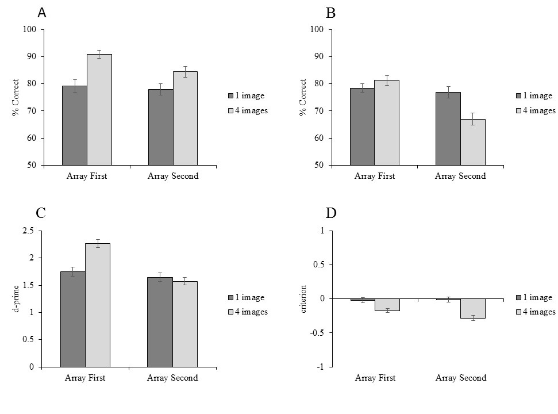
Figure 5. Results of Experiment 3 presenting the array first or second in a sequential matching task. A) Match trials. B) Mismatch trials. C) d-prime. D) criterion. Error bars show the within-subjects standard error (Cousineau, 2005).

The ANOVA for match trials showed a non-significant main effect of array order F(1,49) = 3.12, p = .084, η_{p}² = .06, BF₁₀ = 0.93, a significant main effect of number of images F(1,49) = 30.53, p < .001, η_{p}² = .38, BF₁₀ = 2.34 whereby participants were more accurate with four (M = 87.60%) compared to one image (M = 78.60%), and a non-significant interaction F(1,49) = 2.23, p = .142, η_{p}² = .04, BF₁₀ = 0.56.

The ANOVA for mismatch trials showed a significant main effect of array order F(1,49) = 14.15, p < .001, η_{p}² = .22, BF₁₀ = 517.71, a non-significant main effect of number of images F(1,49) = 4.00, p = .051, η_{p}² = .08, BF₁₀ = 0.70, and a significant interaction F(1,49) = 20.95, p < .001, η_{p}² = .30, BF₁₀ = 57.23. Simple main effects showed a non-significant effect of number of images when the array was presented first F(1,98) = 1.58, p = .212, η_{p}² = .02, BF₁₀ = 0.58, but a significant effect of number of images when the array was presented second F(1,98) = 19.36, p < .001, η_{p}² = .16, BF₁₀ = 65.20 with poorer performance with a four-image array (M = 67.00%) than a single image (M = 76.80%). Simple main effects also showed a non-significant effect of array order with one image F(1,98) = 0.41, p = .523, η_{p}² < .001, BF₁₀ = 0.27, but a significant effect of array order with four-image arrays F(1,98) = 31.99, p < .001, η_{p}² = .25, BF₁₀ = 16,165.33 with poorer performance when the array was presented second (M = 67.00%) compared to first (M = 81.20%).

Signal detection analysis showed a similar pattern of results. An ANOVA on d’ values showed a significant main effect of array order F(1,49) = 13.13, p < .001, η_{p}² = .21, BF₁₀ = 831.073, a significant main effect of number of images F(1,49) = 10.28, p = .002, η_{p}² = .17, BF₁₀ = 1.92, and a significant interaction F(1,49) = 14.89, p < .001, η_{p}² = .23, BF₁₀ = 35.02. Simple main effects showed an effect of number of images only when the array was presented first F(1,98) = 25.14, p < .001, η_{p}² = .20, BF₁₀ = 1,995.71 with higher sensitivity for four images (M = 2.27) compared to one (M = 1.75). The simple main effect was non-significant when the array was shown second F(1,98) = 0.53, p = .468, η_{p}² = .01, BF₁₀ = 0.26. Simple main effects also showed an effect of array order with four images in the array F(1,98) = 26.82, p < .001, η_{p}² = .21, BF₁₀ = 94,114.22, with poorer performance when the array was presented second (M = 1.57) compared to first (M = 2.27) . The simple main effect of ‘array order’ when the array consisted of just one image was non-significant F(1,98) = 0.59, p = .444, η_{p}² = .01, BF₁₀ = 0.28.

For criterion values, there was a non-significant main effect of array order F(1,49) = 1.51, p = .225, η_{p}² = .03, BF₁₀ = 0.27 and a significant main effect of number of images F(1,49) = 19.43, p < .001, η_{p}² = .28, BF₁₀ = 6,941.18 whereby participants were more likely to respond ‘match’ with four-image arrays (M = -.23) than one image (M = -.02). The interaction was non-significant F(1,49) = 2.35, p = .132, η_{p}² = .05 BF₁₀ = 0.51.

These results demonstrate that match trial performance improved with four images when the array was presented first, without a deficit in mismatch performance. When the array was presented second, although match performance increased, mismatch performance was poorer than with one image. This was confirmed by signal detection analyses which showed no overall benefit in sensitivity when the array was presented second, but a clear benefit when the array came first. This experiment suggests that multiple-image arrays only provide a benefit to performance when the array is shown before the target image, requiring memory, and not when it is displayed after the target image. This suggests that the variability advantage found in Experiment 3 above, and in the face learning literature (e.g. Murphy et al., 2015; Ritchie and Burton, 2017; Robins et al., 2018) is due to the memory component of the task, forcing participants to abstract a representation of the person from the variable images in order to compare a subsequent image to that representation. When the array was presented second in the current experiment, a representation had not been abstracted from variability, but simply relied on a single image, and the variability shown in the array was not helpful. This is similar to the effects reported in Experiments 1 and 2, and elsewhere (Ritchie et al., 2020), whereby an array presented simultaneously with the target image does not result in an overall benefit to performance.

In order to strengthen our conclusions about the importance of memory for the variability advantage, we sought to replicate our results using a different paradigm and a different set of images.

Experiment 4 – applying the array order manipulation to a new task
This experiment further examined the effect of the presentation order of the array and the comparison image. Here we used an adaptation of the sequential matching paradigm used in Dowsett, Sandford, and Burton (2016). This allowed us to investigate whether the variability advantage is still found in a different face matching paradigm which includes a memory component.

Method
Participants
Forty-five participants took part (3 male, mean age: 20 years, range: 18-25 years). All participants were students or other members of the University of Lincoln. All participants gave informed consent, and the study was granted ethical approval by the University of Lincoln School of Psychology Research Ethics Committee.

Stimuli and procedure
The stimuli used in this experiment were a subset of 60 of the 80 identities used in Experiment 3. Participants completed six blocks, where we manipulated the number of images in the array as well as the presentation order of the array and comparison image. The task was designed to be similar to a computerised version of the task used with physical cards by Dowsett, Sandford, and Burton (2016) and is also akin to the paradigm used in a recent study by Sandford and Ritchie (under review).

Blocks 1-3 showed a sequential matching task with the array appearing before the target image, with the size of the array increasing across blocks. Blocks 4-6 showed a sequential matching task with the array appearing after the target image, again with the size of the array increasing across blocks. Blocks 1 and 4 showed a one-to-one sequential matching task. Blocks 2 and 5 showed a two-image array paired with a single comparison image, and blocks 3 and 6 showed a three-image array paired with a single comparison image.

In every block, the first image/array was shown for 5s, followed by a blank screen for 1s, and then the target image/array was presented until response. The array images were shown at the bottom of the screen (image 1 on the left, image 2 in the middle, and image 3 on the right), and the target was shown at the top centre (see Figure 6). Each block showed half match and half mismatch trials. Participants completed Blocks 1-3 (array first) then 4-6 (array second), or 4-6 then 1-3 (counterbalanced across participants). Identities were randomly assigned to blocks, with each identity appearing once in Blocks 1-3 and once in Blocks 4-6.
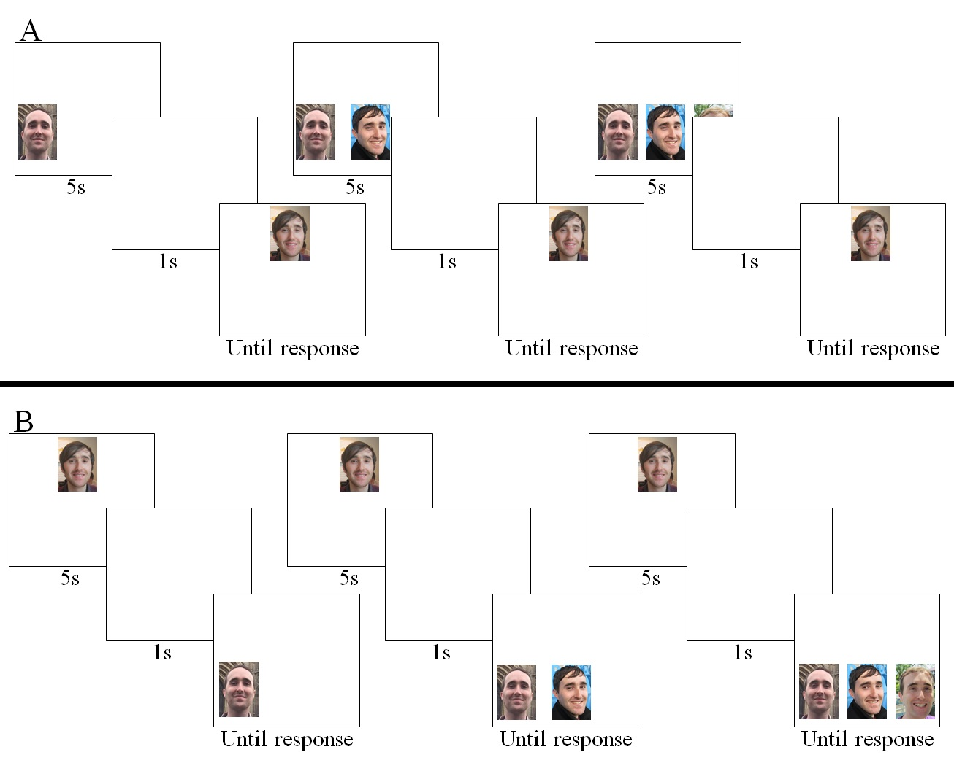
Figure 6. Schematic of the paradigm used in Experiment 4. A) Array first conditions (Blocks 1-3). B) Array second conditions (Blocks 4-6). Left) One-to-one match trial. Middle) Two-image array match trial. Right) Three-image array match trial.

Results
We analysed match and mismatch trials separately using a 2 (array order: array first, array second) x 3 (number of images: 1, 2, 3) within subjects ANOVA. Figure 7 shows the results of Experiment 4.
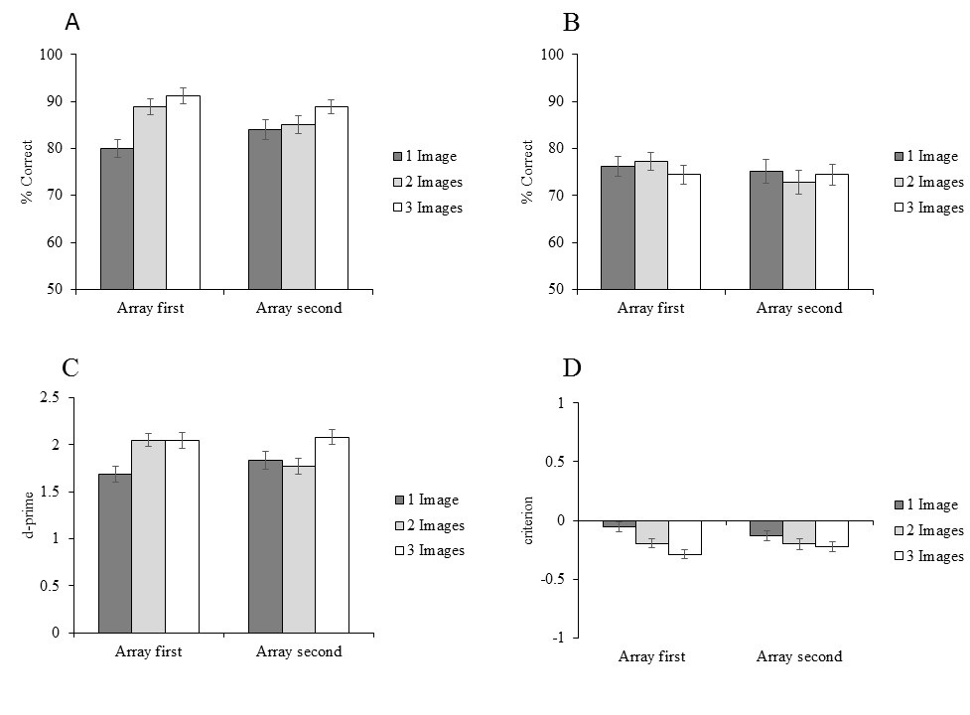
Figure 7. Results of Experiment 4 presenting the increasing numbers of array images first or second in a sequential matching task. A) Match trials. B) Mismatch trials. C) d-prime. D) criterion. Error bars show the within-subjects standard error (Cousineau, 2005).

The ANOVA for match trials showed a non-significant main effect of array order F(1,44) = 0.28, p = .599, η_{p}² = .01, BF₁₀ = 0.15, a significant main effect of number of images F(2,88) = 15.35, p < .001, η_{p}² = .26. BF₁₀ = 5,510.41, and a significant interaction F(2,88) = 3.12, p < .01, η_{p}² = .07, BF₁₀ = 1.52. Simple main effects showed a non-significant effect of number of images when the array was presented second F(1,176) = 2.71, p = .102, η_{p}² = .03, BF₁₀ = 0.68, but a significant effect of number of images when the array was presented first F(1,176) = 14.29, p < .001, η_{p}² = .14, BF₁₀ = 22,546.40. Tukey HSD tests showed a significant improvement in accuracy when the array presented first contained two images (M = 88.89%) or three images (M = 91.11%) compared to a single image (M = 80.00%), both ps < .05. No other comparisons were significant (ps > .05).

The ANOVA for mismatch trials showed a non-significant main effect of array order F(1,44) = 0.84, p = .364, η_{p}² = .02, BF₁₀ = 0.24, a non-significant main effect of number of images F(2,88) = 0.17, p = .844, η_{p}² < .001, BF₁₀ = 0.05, and a non-significant interaction F(2,88) = 0.74, p = .480, η_{p}² = .02, BF₁₀ = 0.12.

An ANOVA on d’ values showed a non-significant main effect of array order F(1,44) = 0.16, p = .691, η_{p}² < .001, BF₁₀ = 0.14, and a significant main effect of number of images F(2,88) = 5.55, p = .005, η_{p}² = .11, BF₁₀ = 5.81, with Tukey’s HSD tests showing higher sensitivity with three images (M = 2.06) compared to one (M = 1.76) or two images (M = 1.91), ps < .05. There was a non-significant interaction F(2,88) = 3.07, p = .051, η_{p}² = .07, BF₁₀ = 0.72.

For criterion values, there was a non-significant main effect of array order F(1,44) = 0.02, p = .888, η_{p}² < .001, BF₁₀ = 0.13, a significant main effect of number of images F(2,88) = 7.51, p < .001, η_{p}² = .15, BF₁₀ = 15.12, and a non-significant interaction F(2,88) = 1.20, p = .306, η_{p}² = .03, BF₁₀ = 0.19. Tukey’s HSD tests showed significantly more bias for arrays containing two (M = -.20) and three images (M = -.26) than single images (M = -.09), ps < .05. This shows a tendency to respond “match” more for multiple-image arrays. No other comparisons were significant, ps > .05.

In this final experiment, using a different paradigm, we find that presenting a multiple-image array helps on match trials, without harming performance on mismatch trials, only when that array is displayed before and not after the target image. Other than the lack of an overall benefit in terms of sensitivity here compared to Experiment 3, these results show the same pattern as observed in our previous experiments.

General Discussion
Across the four experiments presented here, we see a clear pattern of results whereby multiple-image arrays lead to improved face matching performance in sequential matching tasks. This effect is only present when the array is presented before and not after the target image. We do not find the multiple image advantage for simultaneous face matching tasks. These results reconcile the differences between the face learning literature which shows that exposure to within-person variability and multiple images help with face learning (e.g. Dowsett, Sandford, & Burton, 2016; Longmore et al., 2017; Matthews et al., 2018; Murphy et al., 2015; Ritchie & Burton, 2017) but do not necessarily help face matching (Kramer & Reynolds, 2018; Ritchie et al., 2020; Sandford & Ritchie, under review). Learning paradigms require a representation of the identity to be abstracted from multiple images and held in memory until the time of testing. Likewise, our sequential matching paradigm (Experiments 2-4) requires a representation of the identity to be abstracted from the array, held in memory, and compared to the target image. When we present the array and the target image simultaneously (Experiments 1 and 2), or the target image before the array (Experiments 3 and 4), we do not see a multiple-image benefit, as there is either no memory component or only a single image to be held in memory.

There are two different mechanisms that could potentially account for the improvement in face matching with access to multiple naturally varying images of the same person. The first follows from the Bruce and Young model (1986) and the concept of FRUs. Here, information from the multiple-image array is aggregated together in a way that preserves what is diagnostic of the identity, while ignoring superficial image differences, to form a stable mental representation that can easily support recognition. An alternative explanation, however, is that by increasing the number of images available to participants, we are also increasing the chance of finding an image that is particularly similar to the comparison image (i.e., a closest match). This will also lead to an improvement in accuracy but superficial image characteristics might still be attended to and taken into consideration. The results from our simultaneous and sequential matching tasks might help us differentiate between these two strategies. While both mechanisms could be used in a sequential task, there is no need to create a mental representation of the identity in a simultaneous task. We can see all images at the same time, therefore the set up of a simultaneous task might instead encourage participants to adopt a closest match strategy. Since our results show a multiple image advantage in sequential tasks only, they provide support for the concept of stability from variation where different images of the same person are integrated into a single identity representation. This is consistent with previous work by Menon et al. (2015b) who presented participants with two images and either instructed them that they belonged to the same person (to encourage integration) or that they belonged to two different people (to stop integration). Differences between these two conditions were only found using a sequential (but not a simultaneous) task, again, suggesting that a closest match strategy is more likely to be used in a simultaneous matching task.

It is important to consider what form a ‘stable mental representation’ of an identity might take. When a set of similar items are presented, it has been shown that viewers extract summary information, a process referred to as ‘ensemble coding’. Viewers incorrectly report having seen an image which represents the mean of the set (also referred to as the average, or prototype) when that image was in fact never displayed. This has been shown for circles (Ariely, 2001) as well as faces (e.g. de Fockert & Wolfenstein, 2009; Neumann, Schweinberger, & Burton, 2013). We have previously shown that viewers extract the mean from images of faces, whether presented simultaneously or sequentially (Kramer, Ritchie, & Burton, 2015). We have also argued, however, that face averages do not consistently improve face matching accuracy (Ritchie et al, 2020; Ritchie, White et al., 2018) and do not give rise to higher likeness ratings than specific exemplars (Ritchie, Kramer & Burton, 2018). Therefore, we do not suggest here that a stable mental representation of an identity must necessarily constitute a simple ‘average’ or prototype. Instead, it seems likely that robust representations of a familiar faces incorporate both abstractive and instance-specific information.

In addition to this finding, Experiment 1 manipulated the amount of variability in the arrays. It is possible that previous experiments that found a multiple-image advantage in simultaneous face matching (White at al., 2014) simply presented more variability in their arrays than the experiments that did not (Ritchie et al., 2020; Sandford & Ritchie, under review). Experiment 1, however, showed no overall benefit of either low or high variability arrays on face matching performance. Therefore, the amount of variability likely does not explain the differences between previous results. Nevertheless, assuming that a closest match strategy is more likely to be used in such a situation, then the conflicting results from these studies could simply be due to subtle differences in the image sets used.

Three recent studies have looked at the utility of providing multiple images when searching for a face in an array or a crowd. Dunn, Kemp, and White (2018) showed participants one or four images of a target identity for 3 s, and then had participants search for a new image of the person in an array of faces. Searching for unfamiliar people was improved, both in terms of higher accuracy and faster reaction times, when participants had seen four compared to only one image of the target. Two subsequent studies had participants search for unfamiliar people in videos of crowds, and presented the image(s) of the target identity simultaneously with the crowd video (Kramer, Hardy, & Ritchie, 2020; Mileva & Burton, 2019). Mileva and Burton (2019) found that providing participants with three ID-document images of the target improved search performance over one image, with no further increase when 16 images were provided. Kramer et al. (2020) also found an increase in performance with three recent images of the target compared to one. Here, we find that multiple images improve face matching performance in a sequential task (akin to Dunn et al., 2018). We do not find here that arrays improve face matching when the array and the target are presented simultaneously, but both Mileva and Burton (2019) and Kramer et al. (2020) do find that arrays help with searching for faces in crowds when the array and the crowd video are presented simultaneously. This difference in results may be due to the different nature of the tasks, with searching being a much more difficult and complex task, perhaps inherently involving an aspect of memory, where participants may try to memorise the target images then view the video. In fact, Mileva and Burton (2019) lend some support for this idea in an experiment which gave participants as a reference a video of the target rotating their head. The authors report “Informally, we observed that searchers typically froze the target video while searching the CCTV clip, suggesting that two simultaneous moving displays impose too high a load to be useful” (Mileva & Burton, 2019, p. 11). Neither in the search studies nor the studies presented in this paper can we rule out that participants also found high variability arrays to be too high a load to be useful. In fact, our observed change in bias in simultaneous matching tasks for high variability images (Experiments 1 and 2) may speak to this in that participants may have been overwhelmed by the variability in the array and so simply responded ‘match’ more often than ‘mismatch’.

Our results should be viewed within the context of the wider literature on face learning, face matching, and representations of familiar and newly learned identities. It is evident from the face learning literature that exposure to variability does give rise to a representation that is stable enough to support recognition of new images of the newly learned people. However, we argue that exposure to variability is not sufficient to produce fast “learning” in order to help in a simultaneous matching task. Our results suggest that exposure to variability is only helpful for face processing tasks which require an element of memory, where the learning and test stimuli are presented sequentially. Future research should establish the limits of this variability advantage using different short-term and long-term memory tasks.

Supplementary Material
The data for all four experiments is available at [Cognition to add URL].

References
Ariely, D. (2001). Seeing sets: Representation by statistical properties. Psychological Science, 12, 157–162. DOI: 10.1111/1467-9280.00327

Baker, K. A., Laurence, S., & Mondloch, C. J. (2017). How does a newly encountered face become familiar? The effect of within-person variability on adults’ and children’s perception of identity. Cognition, 161, 19-30. DOI: 10.1016/j.cognition.2016.12.0120010-0277

Bindemann, M., & Sandford, A. (2011). Me, myself and I: Different recognition rates for three photo-IDs of the same person. Perception, 40, 625–627. DOI: 10.1068/p700

Bruce, V. (1982). Changing faces: Visual and non-visual coding processes in face recognition. British Journal of Psychology, 73, 105–116. DOI: 10.1111/j.2044-8295.1982.tb01795.x
Bruce, V. (1994). Stability from variation: The case of face recognition. Quarterly Journal of Experimental Psychology, 47, 5–28. DOI: 10.1080/14640749408401141

Bruce, V. (1986). Influences of familiarity on the processing of faces. Perception, 15(4), 387-397. DOI: 10.1068/p150387

Bruce, V., Henderson, Z., Greenwood, K., Hancock, P. J. B., Burton, A. M., & Miller, P. (1999). Verification of face identities from images captured on video. Journal of Experimental Psychology: Applied, 5(4), 339–360. DOI: 10.1037/1076-898X.5.4.339

Bruce, V., Henderson, Z., Newman, C., & Burton, A. M. (2001). Matching identities of familiar and unfamiliar faces caught on CCTV images. Journal of Experimental Psychology: Applied, 7(3), 207–218. DOI: 10.1037//1076-898X.7.3.207

Bruce, V., & Young, A. (1986). Understanding face recognition. British Journal of Psychology, 77, 305–327. DOI: 10.1111/j.2044-8295.1986.tb02199.x

Burton, A. M. (2013). Why has research in face recognition progressed so slowly? The importance of variability. Quarterly Journal of Experimental Psychology, 66(8), 1467–1485. DOI: 10.1080/17470218.2013.800125

Burton, A. M., Jenkins, R., & Schweinberger, S. R. (2011). Mental representations of familiar faces. British Journal of Psychology, 102(4), 943–958. DOI: 10.1111/j.2044-8295.2011.02039.x

Burton, A. M., Kramer, R. S. S., Ritchie, K. L., & Jenkins, R. (2016). Identity from variation: Representations of faces derived from multiple instances. Cognitive Science, 40, 202-223. DOI: 10.1111/cogs.12231

Burton, A. M., White, D., & McNeill, A. (2010). The Glasgow face matching test. Behavior Research Methods, 42(1), 286-291. DOI: 10.3758/BRM.42.1.286

Burton, A. M., Wilson, S., Cowan, M., & Bruce, V. (1999). Face recognition in poor-quality video: Evidence from security surveillance. Psychological Science, 10(3), 243-248. DOI: 10.1111/1467-9280.00144

Clutterbuck, R., & Johnston, R. A. (2002). Exploring levels of face familiarity by using an indirect face-matching measure. Perception, 31, 985–994. DOI: 10.1068/p3335

Clutterbuck, R., & Johnston, R. A. (2004). Matching as an index of face familiarity. Visual Cognition, 11(7), 857–869. DOI: 10.1080/13506280444000021

Cousineau, D. (2005). Confidence intervals in within-subjects designs: A simpler solution to Loftus and Masson’s method. Tutorials in Quantitative Methods for Psychology, 1(1), 42-45.

Davis, J. P., & Valentine, T. (2009). CCTV on trial: Matching video images with the defendant in the dock. Applied Cognitive Psychology, 23(4), 482–505. DOI: 10.1002/acp.1490

de Fockert, J., & Wolfenstein, C. (2009). Rapid extraction of mean identity from sets of faces. Quarterly Journal of Experimental Psychology, 62, 1716–1722. DOI: 10.1080/17470210902811249

Dowsett, A. J., Sandford, A., & Burton, A. M. (2016). Face learning with multiple images leads to fast acquisition of familiarity for specific individuals. Quarterly Journal of Experimental Psychology, 69(1), 1–10. DOI: 10.1080/17470218.2015.1017513

Dunn, J. D., Kemp, R. I., & White, D. (2018). Search templates that incorporate within-face variation improve visual search for faces. Cognitive Research: Principles and Implications, 3, 37. DOI: 10.1186/s41235-018-0128-1

Graham, D. L., & Ritchie, K. L. (2019). Making a spectacle of yourself: The effect of glasses and sunglasses on face perception. Perception. Advance online publication. DOI: 10.1177/0301006619844680

Henderson, J. M., Pollatsek, A., & Rayener, K. (1987). Effects of foveal priming and extrafoveal preview on object identification. Journal of Experimental Psychology: Human Perception and Performance, 13, 449–463. DOI: 10.1037/0096-1523.13.3.449

JASP Team (2020). JASP (Version 0.14) [Computer software].

Jenkins, R., White, D., Van Montfort, X., & Burton, A. M. (2011). Variability in photos of the same face. Cognition, 121(3), 313–323. DOI: 10.1016/j.cognition.2011.08.001

Johnston, R. A., & Edmonds, A. J. (2009). Familiar and unfamiliar face recognition: A review. Memory, 17(5), 577-596. DOI: 10.1080/09658210902976969

Jones, S. P., Dwyer, D. M., & Lewis, M. B. (2017). The utility of multiple synthesized views in the recognition of unfamiliar faces. Quarterly Journal of Experimental Psychology, 70(5), 906-918. DOI: 10.1080/17470218.2016.1158302
Kemp, R., Towell, N., & Pike, G. (1997). When seeing should not be believing: Photographs, credit cards and fraud. Applied Cognitive Psychology, 11(3), 211–222. DOI: 10.1002/(SICI)1099-0720(199706)11:3<211::AID-ACP430>3.0.CO;2-O

Klatzky, R. L., & Forrest, F. H. (1984). Recognizing familiar and unfamiliar faces. Memory and Cognition, 12(1), 60–70. DOI: 10.3758/BF03196998

Kramer, R. S. S., Hardy, S. C., & Ritchie, K. L. (2020). Searching for faces in crowd chokepoint videos. Applied Cognitive Psychology, 34(2), 343-356. DOI: 10.1002/acp.3620

Kramer, R. S. S., & Reynolds, M. G. (2018). Unfamiliar face matching with frontal and profile views. Perception, 47(4), 414–431. DOI: 10.1177/0301006618756809

Kramer, R. S. S., & Ritchie, K. L. (2016). Disguising superman: How glasses affect unfamiliar face matching. Applied Cognitive Psychology, 30, 841–845. DOI: 10.1002/acp.3261

Kramer, R. S. S., Ritchie, K. L., & Burton, A. M. (2015). Viewers extract the mean from images of the same person: A route to face learning. Journal of Vision, 15(4):1, 1-9. DOI: 10.1167/15.4.1

Kramer, R. S. S., Young, A. W., & Burton, A. M. (2018). Understanding face familiarity. Cognition, 172, 46–58. DOI: 10.1016/j.cognition.2017.12.005

Longmore, C. A., Liu, C. H., & Young, A. W. (2008). Learning faces from photographs. Journal of Experimental Psychology: Human Perception and Performance, 34(1), 77–100. DOI: 10.1037/0096-1523.34.1.77

Longmore, C. A., Santos, I. M., Silva, C. F., Hall, A., Faloyin, D., & Little, E. (2017). Image dependency in the recognition of newly learnt faces. Quarterly Journal of Experimental Psychology, 70, 863–873. DOI: 10.1080/17470218.2016.1236825

Matthews, C. M., Davis, E. E., & Mondloch, C. J. (2018). Getting to know you: The development of mechanisms underlying face learning. Journal of Experimental Child Psychology, 167, 295-313. DOI: 10.1016/j.jecp.2017.10.012

Megreya, A. M., & Burton, A. M. (2006). Unfamiliar faces are not faces: Evidence from a matching task. Memory & Cognition, 34(4), 865–876. DOI: 10.3758/BF03193433

Megreya, A. M., & Burton, A. M. (2007). Hits and false positives in face matching: A familiarity-based dissociation. Perception & Psychophysics, 69(7), 1175-1184. DOI: 10.3758/BF03193954

Megreya, A. M., & Burton, A. M. (2008). Matching faces to photographs: Poor performance in eyewitness memory (without the memory). Journal of Experimental Psychology: Applied, 14(4), 364–372. DOI: 10.1037/a0013464

Menon, N., White, D., & Kemp, R. I. (2015a). Variation in photos of the same face drives improvements in identity verification. Perception, 44(11), 1332-1341. DOI: 10.1177/0301006615599902

Menon, N., White, D., & Kemp, R. I. (2015b). Identity-level representations affect unfamiliar face matching performance in sequential but not simultaneous tasks. The Quarterly Journal of Experimental Psychology, 68(9), 1777-1793. DOI: 10.1080/17470218.2014.990468

Mileva, M., & Burton, A. M. (2019). Face search in CCTV surveillance. Cognitive Research: Principles and Implications, 4, 37. DOI: 10.1186/s41235-019-0193-0

Murphy, J., Ipser, A., Gaigg, S., & Cook, R. (2015). Exemplar variance supports robust learning of facial identity. Journal of Experimental Psychology: Human Perception and Performance, 41, 577–581. DOI: 10.1037/xhp0000049

Neumann, M. F., Schweinberger, S. R., & Burton, A. M. (2013). Viewers extract mean and individual identity from sets of famous faces. Cognition, 128, 56–63. DOI: 10.1016/j.cognition.2013.03.006

Ritchie, K. L., & Burton, A. M. (2017). Learning faces from variability. Quarterly Journal of Experimental Psychology, 70(5), 897-905. DOI: 10.1080/17470218.2015.1136656

Ritchie, K. L., Kramer, R. S. S., & Burton, A. M. (2018). What makes a face photo a ‘good likeness’? Cognition, 170, 1-8. DOI: 10.1016/j.cognition.2017.09.001

Ritchie, K. L., Mireku, M. O., & Kramer, R. S. S. (2020). Face averages and multiple images in a live matching task. British Journal of Psychology, 111(1), 92-102. DOI: 10.1111/bjop.12388

Ritchie, K. L., Smith, F. G., Jenkins, R., Bindemann, M., White, D., & Burton, A. M. (2015). Viewers base estimates of face matching accuracy on their own familiarity: Explaining the photo-ID paradox. Cognition, 141, 161-169. DOI: 10.1016/j.cognition.2015.05.002

Ritchie, K. L., White, D., Kramer, R. S. S., Noyes, E. Jenkins, R., & Burton, A. M. (2018). Enhancing CCTV: Averages improve face identification from poor‐quality images. Applied Cognitive Psychology, 32, 671-680. DOI: 10.1002/acp.3449

Robins, E., Susilo, T., Ritchie, K. L., & Devue, C. (2018, July 23). Within-person variability promotes learning of internal facial features and facilitates perceptual discrimination and memory. DOI: 10.31219/osf.io/5scnm

Sandford, A. L. R., & Ritchie, K L. (under review). Unfamiliar face matching, within-person variability, and multiple-image arrays.

White, D., Burton, A. M., Jenkins, R., & Kemp, R. (2014). Redesigning photo-ID to improve unfamiliar face matching performance. Journal of Experimental Psychology: Applied, 20(2), 166-173. DOI: 10.1037/xap0000009

White, D., Kemp, R. I., Jenkins, R., Matheson, M., & Burton, A. M. (2014). Passport officers’ errors in face matching. PLoS ONE, 9, e103510. DOI: 10.1371/journal.pone.0103510

