Experimental taphonomy of fish bone from warm and cold water species: Testing the effects of amino acid composition on collagen breakdown in modern fish bone using thermal maturation experiments
Virginia L. Harvey^{1,2}*, Roy A. Wogelius², Phillip L. Manning² and Michael Buckley^{1,2}

¹Manchester Institute of Biotechnology, Department of Earth and Environmental Sciences, 131 Princess Street, University of Manchester. M1 7DN. UK
²Interdisciplinary Centre for Ancient Life (ICAL), The University of Manchester, Department of Earth & Environmental Sciences, School of Natural Sciences, Manchester M13 9PL, UK
*Corresponding author: virginia.harvey@manchester.ac.uk

Author Contributions
VLH conceived and designed the initial idea and experimental design, with input from RAW, PLM and MB. VLH obtained all specimens and ran all experiments. VLH arranged and analysed the data, with input from RAW. VLH wrote the manuscript and designed all figures with contributions from RAW, PLM and MB.
Declaration of interest statement
Declarations of interest: none.
Abstract
Decay experiments have the potential to provide useful analogues in the interpretation of archaeological remains. Previous studies have focused on how physical properties or processing methods can influence fish bone distributions within archaeological sites. However, the means by which intrinsic chemical properties of fish bone, such as baseline collagen type I [‘collagen (I)’] chemistry, may affect both biomolecule and whole bone degradation has not been the focus of any prior study. The variation of facies and resulting impact on taphonomy is not a new concept, but an understanding of the discrete relationship between temperature and the breakdown of collagen (I) in bone material has not been well explored. Here, modern fish bone powder is subjected to differential scanning calorimetry (DSC), thermogravimetric analysis (TGA) and water-immersed heat experiments. This is to test whether taxa with less thermally stable collagen (I) configurations, such as cold-water species with reduced proline and hydroxyproline concentrations (Pro+Hyp), will generate collagen breakdown products (TOC and TN) more rapidly than those with more thermally stable arrangements, such as warm-water fish with typically increased Pro+Hyp. Our results show that bone collagen (I) in the cold-water fish species in this study (cod and herring with lower Pro+Hyp concentrations) display significantly increased decomposition rates than collagen (I) from the warm-water fishes in this study (amberjack and tilapia with higher Pro+Hyp concentrations), given the same experimental conditions (heating in water at 75°C for up to eight days). Initial reaction rate estimates, based on TOC and TN product concentrations, suggest that cod bone (15.6% Pro+Hyp) reacts ~9 times faster than tilapia bone (20.3% Pro+Hyp). We suggest that the primary influencer of collagen (I) stability in bone is the concentration of Pro+Hyp residues and not a function of physical bone structure. Our results suggest that a reduction in collagen (I) stability is likely to lead to a decrease in whole bone stability following deposition, due to the intimate association between organic and inorganic phases of bone. Therefore, species composition based upon bone remains may vary in archaeological and palaeontological sites, as a function of the thermal stability of collagen (I).
Key words: Fish bone, collagen, heat experiments, DSC, diagenesis, taphonomy
1. Introduction
Taphonomy seeks to identify the interplay between organismal biology and environmental chemistry, which often combine to control the preservation of bone and soft-tissues in the archaeological and geological record. Decay experiments can assist in the elucidation of taphonomic processes through controlled laboratory experiments (e.g. Nicholson, 1996a; Nicholson, 1996b; Willis and Boehm, 2014; Sansom, 2017). As such, experimental taphonomy is critical to identifying forensic analogues and in better constraining the preservation observed for both archaeological and palaeontological samples. For such taphonomic experiments to be effective, they must deliver insight into the governing factors that determine the preservation of bone and its chemistry. To date, much attention has focused on mammalian bone (e.g. Roberts et al., 2002; Fernández-Jalvo et al., 2014; White and Booth, 2014), but there is a growing field of research concentrating on the properties of fish bone and how their taphonomy may impact zooarchaeological and palaeontological assemblages (Nicholson, 1992; Szpak, 2011; Cohen et al., 2012; Willis and Boehm, 2014; Guiry et al., 2016; Guiry, 2019).
Ancient fish remains, thousands and even millions of years old, can be studied to aid in the reconstruction of past environments (Finney et al., 2010; Harvey et al., 2018; Barrett, 2019), cultural activities (Rick et al., 2019), and also the historic diet and subsistence practices of past communities (Grealy et al., 2016). An understanding of how past processing/cooking methods (Zohar et al., 2008; Disspain et al., 2016), and physical bone properties (shape, size, strength, hardness, density, etc.) (Nicholson, 1992; Lam and Pearson, 2005) can affect the distribution of fish remains in archaeological sites have been well documented. However, far less attention has been directed towards how chemical properties might affect bone and biomolecule degradation or preservation bias in fishes. This is despite the fact that fish bones are more susceptible to taphonomic processes than those of other vertebrates due to their ultrastructure and chemistry, which makes them less likely to be recovered in archaeological deposits (Nicholson, 1996a; Szpak, 2011).
Fishes are unique in their substantial morphological and ecological diversity as a consequence of their 400+ million years of evolution (Hughes et al., 2018). They have adapted to survive multiple aquatic realms, from freezing temperatures (-2 °C) at the poles to warm temperatures (30 °C+) at the equators. This evolutionary plasticity has required both genotypic and phenotypic adaptations that include modifications to their underlying bone chemistry. Bone is a beautifully adept biological composite comprising an inorganic phase (calcium phosphate with a carbonated hydroxyapatite-like structure, termed bioapatite), an organic phase [primarily the protein collagen type I, hereafter referred to as ‘collagen (I)’], lipids and water (Glimcher, 1976; Posner et al., 1984). Collagen (I) contributes over 90% of the organic component of bone and is responsible for approximately 20% by mass (Pasteris et al., 2008). Compared to mammalian bone, fish bone contains relatively less mineral (Biltz and Pellegrino, 1969), and is composed of more loosely-mineralised collagen (I) (Lee and Glimcher, 1991), leading to increased vulnerability of post-mortem degradation (Szpak, 2011). The skeleton of euteleost fishes (and therefore over half of all extant vertebrate species) are characterised by acellular bone, where the bone matrix is devoid of osteocytes (Parenti, 1986). However, there are some species of fish (mainly lower teleosts) that retain the primitive condition of osteocyte-containing cellular bone, similar to all other vertebrate classes (mammals, birds, reptiles, amphibians), or have reacquired the cellular state through independent evolution (e.g. salmoniformes) (Davesne et al., 2019). Although the composition of cellular and acellular bone is significantly different, the mechanical advantages have been shown to be comparable (Cohen et al., 2012), with one exception whereby acellular bone appears to be less efficient in mineral regulation and homeostasis than cellular bone (Davesne et al., 2019).
In terms of the organic phase of bone, the collagen (I) molecule is formed of a robust triple-helix, composed of three long amino acid α-chains in either an (α1)₂α2 or α1α2α3 heterotrimeric arrangement in fish (Piez, 1965), with two non-helical regions (telopeptides) at either end of the helix (Ramachandran and Kartha, 1955; Rich and Crick, 1955). The amino acid glycine (Gly; G) takes every third position in the α-chains through a (Gly-Xaa-Yaa)_{n} repeating sequence, with the Xaa and Yaa positions most commonly occupied by proline (Pro; P) and its hydroxylated form, hydroxyproline (Hyp). Gly is the smallest amino acid, which allows the three α-chains to pack tightly around a common axis improving stability (Rich and Crick, 1955). Yet it is the concentrations of the amino acids Pro and particularly Hyp that have the most stabilising effect on the triple helix (Gustavson, 1956; Burge and Hynes, 1959; Piez and Gross, 1960; Piez, 1965; Haug et al., 2004; Brodsky and Persikov, 2005), due to extensive hydrogen bonding both with water (Burjanadze and Kisiriya, 1982) and between α-chains (Fraser et al., 1979), and hydroxyl group bonding with bioapatite, the mineral phase of bone (Pasteris et al., 2004) for which Hyp is mainly responsible. Collagen (I) with increased concentrations of Pro and Hyp (Pro+Hyp) therefore has significantly higher thermal stability (Szpak, 2011). Namely, mammal collagen (I) contains a higher abundance of Pro+Hyp than the collagen (I) of any fish species, which is required to increase the denaturation temperature in these warm-blooded animals (Sarabia et al., 2000; Szpak, 2011). Additionally, a number of studies have demonstrated that warm-water fishes have a statistically higher abundance of Pro+Hyp in their collagen (I) compared to cold-water fishes (Piez and Gross, 1960; Piez, 1965; Haug et al., 2004; Szpak, 2011). Recognising this, Szpak (2011) collated the published melting points of demineralised collagen (I) against Hyp concentration for numerous fish species (amongst other vertebrates), and generally found a much lower collagen (I) melting point in cold-water compared to warm-water fish species, with the melting point for mammals broadly higher still. He went further to suggest that the comparative lack of Hyp in fish compared to mammal bone collagen (I) “implies that the former is more unstable and prone to dissolution than the latter. For this reason, fish bone collagen would be more prone to chemical leaching than mammalian bone collagen, and this effect may be even more pronounced at sites in colder climates.” This statement suggests that the chemical dissimilarities in collagen (I) between warm- and cold-water species may be distinct enough to impact its rate of degradation following bone deposition.
In this study a series of experiments were undertaken to test if collagen (I) in bone samples from cold-water fishes broke down measurably quicker than that from warm-water fishes, as a function of collagen (I) Pro+Hyp concentrations. We hypothesise that, should any differences be significant, species with less thermally stable collagen (I) configurations (typically cold-dwelling species with reduced Pro+Hyp), will generate collagen (I) breakdown products more rapidly than those with more thermally stable arrangements (typically warm-water fish collagen (I) with increased Pro+Hyp), given the same experimental conditions. We aim to better understand whether bone remains from cold-water fishes are more vulnerable to decay than bones from warm-water species (potentially a new taphonomic control), given the same depositional environment (facies). The results will enable this study to evaluate the degree to which baseline collagen (I) chemistry influences its stability in bone. This is a factor of huge significance in the fields of archaeology where preserved collagen (I) is widely targeted for ¹⁴C radiocarbon dating (Harvey et al., 2016), collagen fingerprinting (Harvey et al., 2018), stable isotope analyses (Guiry, 2019), and as a means of relative ageing through decay assessments (Buckley et al., 2017).
2. Methods
2.1 Specimens and samples
Fresh, whole or filleted carcasses of five fish species were ethically collected from local markets, restaurants and laboratories for analysis (Table 1; Supplementary Table S1). Species were targeted based on: (i) the availability of published, complete collagen (I) sequences for the species or genus (required for the assessment of amino acid composition), (ii) the concentration of Pro+Hyp in the collagen (I) sequences, (iii) climate information (temperate/subtropical/tropical), and (iv) the availability of species in the UK fish market.
Table 1: List of fish species used in this study including climate/habitat information, bone structure, and collagen (I) structure (COL1A3 chain present [Y] or absent [N]), and chemistry (% Pro+Hyp as calculated using Mega-X software)
Common Name | Taxonomy | Climate | Optimal Temp. | Habitat | Bone structure | α3? | % Pro+Hyp
Atlantic cod | Gadus morhua  (Gadiformes,  Gadidae) | Temperate | 0–15 °C | Marine/ Brackish | Acellular | Y | 15.6
Atlantic herring | Clupea harengus  (Clupeiformes,  Clupeidae) | Temperate | 1–18 °C | Marine/ Brackish | Cellular | N | 16.9
Rainbow trout | Oncorhynchus mykiss  (Salmoniformes,  Salmonidae) | Temperate/ Subtropical | 10–24 °C | Anadromous | Cellular | Y | 16.6
Japanese amberjack | Seriola quinqueradiata  (Perciformes,  Carangidae) | Subtropical/ Tropical | 18–24 °C | Marine/ Brackish | Acellular | Y | 18.6
Nile tilapia | Oreochromis niloticus  (Perciformes,  Cichlidae) | Tropical | 14–33 °C | Freshwater/ Brackish | Acellular | Y | 20.3
Of the taxa with published and complete collagen (I) sequences during the time of analysis (n=60; Supplementary Table S2), two cold-water (temperate; Atlantic cod and Atlantic herring) and two warm-water (subtropical/tropical; Japanese amberjack and Nile tilapia) species were selected that had relatively low and high Pro+Hyp concentrations respectively (Table 1). A small number of species with published sequences had more extreme Pro+Hyp concentrations, such as the polar black rockcod (Notothenia coriiceps; 14.9% Pro+Hyp) or the subtropical sheepshead minnow (Cyprinodon variegatus; 20.9% Pro+Hyp) yet these species would have been extremely difficult to source fresh in the UK and so were not chosen for this study. A fifth species, rainbow trout (Oncorhynchus mykiss), was selected for analysis because its climate (temperate/subtropical), optimal survival temperature (10–24 °C) and Pro+Hyp concentration (16.6%) are mid-range compared to the cold-water and warm-water species pairs.

Climate, optimal temperature and habitat information was recovered from FishBase (Froese and Pauly, 2019), following Szpak (2011). One specimen of each species was obtained, with the exceptions of trout (n=2) and herring (n=4), to account for their smaller body sizes. Although these samples sizes are low, collagen (I) has a relatively slow rate of evolution (~1 amino acid substitution every 1 million years in fishes [Harvey, 2020], and even slower rates in other vertebrates [Buckley, 2018]), and there are no known cases of intraspecific variation of collagen (I) amino acid sequences. Details on the cellular or acellular nature of the bone from each species was taken from Witten (1997); Mathews (2012) and Davesne et al. (2019).
Collagen (I) sequences encompassing the triple-helical region of the molecule were extracted from BLASTP (Basic Local Alignment Search Tool for proteins) (Madden, 2002), and concatenated in order of their α-chains (α1–α3) following methods in Harvey (2020) (detailed in Supplementary Table S3). All species have an α3 (I) chain with the exception of herring (Table 1). Amino acid compositions were calculated as a percentage of the total collagen (I) sequence per species using Mega-X software (Kumar et al., 2018) (Supplementary Table S4). Two sequences for each α-chain were present on BLASTP for rainbow trout so an average percentage concentration was taken for each amino acid (the difference in Pro+Hyp concentrations between these two variations =<0.1%). It is most likely that these two variations, or isoforms, are due to the fact this species is tetraploid, and may therefore carry two variations of the gene that codes for each α-chain (Harvey, 2020), with each being susceptible to independent evolutionary substitutions. Therefore, an average of these two chains is likely to best represent the true amino acid composition of the bone collagen in rainbow trout. Three members of the Seriola (amberjack) genus (S. dumerili, S. lalandi dorsalis and S. rivoliana) have full collagen (I) sequences published, whereas there is no sequence present for Japanese amberjack (S. quinqueradiata). Therefore, the Pro+Hyp concentrations in the three published sequences (<0.1% different from one another) were averaged alongside the probability-matched sequence for S. quinqueradiata, extracted from tandem mass spectrometric analysis (LC-MS/MS) of a sample of bone for this species. Through an error tolerant search using Mascot (Perkins et al., 1999), following Harvey et al. (2018), S. quinqueradiata significantly matched 97% of the entire sequences for S. lalandi dorsalis, S. dumerili and S. rivoliana (very high sequence coverage for this technique, whereby typical coverage is in the region of 60–70%; Buckley et al., 2011). All Pro+Hyp alterations suggested by the searches were made to the S. quinqueradiata sequence prior to averaging (Supplementary S1; Supplementary Table S3). Note that for all species in this study we do not distinguish between Pro and Hyp as this is not possible using published sequences where both appear as ‘P’. Instead, we work under the supported premise that an increase in Pro residues between the collagen (I) of different species also signifies an increase in Hyp, as shown by Szpak (2011), whereby the concentrations of each are significantly different in warm- and cold-water fishes. Approximately 40–45% of ‘P’ residues are Hyp and 55–60% are Pro in fish bone collagen (I) (Szpak, 2011).
2.2 Bone preparation and maceration
Specimens were frozen at -20 °C prior to maceration. Each specimen was then defrosted overnight (18:00–8:00) and skeletons dissected out using a clean, disinfected scalpel for each specimen. As much flesh was removed as possible in each dissection. Heads were discarded in this analysis due to the increase in maceration time they would incur, which could have acted to decrease protein abundance in the rest of the skeleton. Each skeleton was placed in a separate beaker, immersed in tap water and positioned in a standard water bath at 37 °C. Maceration time differed between species due to skeleton size (Supplementary Table S1). Species with larger skeletons, such as amberjack, required longer maceration times (~4.5 days) than species with smaller skeletons, such as herring (~2 days). Specimens undergoing maceration were checked twice per day (8:00 and 18:00) and removed from maceration when all flesh had either fallen from the bones or could be removed by running under a warm tap, and when vertebrae could be separated easily from one another. Bones were air dried in a fume hood overnight and frozen at -20 °C until required.
2.3 Thermogravimetric analysis (TGA)
Bone samples from two of the five species, cod (lowest Pro+Hyp concentration, 15.6%) and tilapia (highest Pro+Hyp concentration, 20.3%) were selected for thermogravimetric analysis (TGA) in order to screen samples for their suitability for differential scanning calorimetry (DSC). Approximately 20 mg of bone powder was obtained per species. For this, one vertebra from an individual of each species was defrosted on the day of analysis, roughly chopped using sterilised pincer cutters and then ground to a powder using a mortar and pestle. The resulting bone powder was left to air dry in a fume hood for 1 h, each kept in isolation to prevent sample cross-contamination.
Bone powder (8.5 ± 1.0 mg) was weighed into a 100 μL aluminium crucible and loaded by autosampler into a Mettler-Toledo TGA/DSC 1 instrument. Each sample was then heated from 30 °C to 600 °C at a rate of 10 °C/min and under a nitrogen gas flow of 100 mL/min. The data were then analysed using STARe SW 10.00 Mettler-Toledo software.
2.4 Differential scanning calorimetry (DSC)
Approximately 20 mg of bone powder was obtained from each of the five fish species for DSC analysis, as above. Samples of 18.0 ± 2.0 mg were weighed and sealed in 100 μL aluminium crucibles and analysed using a PerkinElmer DSC8000 equipped with a refrigerated-circulating bath and run under a nitrogen gas flow of 20 mL/min. Samples were loaded by autosampler, held at the base temperature (10 °C) for 2 minutes and then heated at a rate of 10 °C per minute to an upper temperature of 300 °C. Samples were kept at this upper temperature for 2 min to complete the run. Data were analysed using Pyris™ software v10.1.
2.5 Heat experiments
Powdered fish bone samples were heated in triplicate at 75 °C for one of ten different timeframes (0 h, 6 h, 24 h, 48 h, 72 h, 96 h, 120 h, 144 h, 168 h, and 192 h). Collagen (I) has previously been seen to denature as a two-step process and so the temperature of 75 °C was selected for this study because it is between the lower (~30–70 °C, representing denaturation in demineralised collagen) and higher steps (~120–150 °C, representing denaturation and melting in non-demineralised collagen) (Bonar and Glimcher, 1970; Notbohm et al., 1992; Wang et al., 2001), whilst being under the temperature of a rolling boil that will have required additional health and safety considerations.
Bone samples were defrosted on the day of analysis and individuals of the same species were combined to ensure enough bone mass was available for analysis (~3.5 g/species). Bones (vertebrae, ribs, fin rays) were processed to a powder using a sterilised pestle and mortar. Bone powder was processed so that is was visually similar between species, however the granulometry was not recorded. Powdered bone was used over whole bone in order to control for any effects of bone surface area on collagen degradation, considering the vast size differences of the fish species. For example, Atlantic herring has a maximum published length of 45 cm and weight of 1.1 kg compared to Japanese amberjack at 150 cm and 40 kg respectively (Froese and Pauly, 2019). Samples were weighed into standard 15 mL centrifuge tubes by recording the tube weight first and then adding the bone powder to the final concentration of 8.1 ± 0.2 mg/1 mL of Milli-Q ultrapure water. Milli-Q water was used over tap water to help reduce any additional effects of decomposition through microbial attack. Tubes were closed and briefly vortexed to ensure mixing before being placed in a pre-heated Lab Companion BS-21 shaking water bath (equipped with a stainless-steel lid to reduce vapour loss) at 75 °C and at an agitation speed of 50 repetitions per minute (rpm). Upon entry, tube lids were unscrewed but placed loosely on top to avoid a build-up of pressure. Thirty tubes were prepared in this way for each species, allowing for a triplicate analysis at the ten different time steps. Control tubes (without any bone powder but otherwise treated under the same conditions) were also prepared for each time step.
Following the required time period, sample tubes were closed and removed from the water bath. When cooled, each tube was topped up with MilliQ water to the starting volume, to account for any evaporation that would have artificially increased elemental concentrations (the maximum amount of water added to any sample was 0.8 mL in the 192 h conditions). The supernatant was then filtered into a plastic universal tube using a 15 mL syringe equipped with a 0.22 μm syringe filter and 1 mL was frozen as backup. Note that tubes at 0 h were not heated at all and were immediately processed as above. Original bone samples in their tubes were left to air-dry in a fume hood until a constant weight and the percentage bone weight loss was recorded (Supplementary Table S5).
2.6 Chemical analyses
Total organic carbon (TOC) and total nitrogen (TN) analyses were chosen as proxies to monitor the biomolecular decomposition of fish bone during the heat experiments. Bone apatite, a carbonate-containing variety of hydroxyapatite [Ca₁₀(PO₄)₆(OH)₂], does not contain either organic C or N, whereas the dominant collagen (I) protein contains both elements (a third of all amino acids are Gly [C₂H₅NO₂], with the remainder typically Pro [C₅H₉NO₂] and Hyp [C₅H₉NO₃]). TOC has been used previously as a method of assessing organic content in archaeological bones (Metcalfe et al., 2009), and for monitoring degradation in the food chemistry industry (Barbati et al., 2008). Lipids can be present at high concentrations in fish bone and are formed of C, H and O with variations in the relative quantities of C and H depending on the type of lipid, of which fish have complex compositions (Toppe et al., 2007). As there is no N in these lipids, TN analysis was chosen as a proxy for protein-only degradation, as has been demonstrated previously by von Endt and Ortner (1984) and Dong et al. (2014). Quantifying the C and N concentrations in the samples was achieved using a Shimadzu TOC-V analyser equipped with a TN unit.

TOC
Each sample was introduced to a furnace whereby any containing carbon (inorganic carbon [IC] plus TOC) was converted to CO₂. A stream of zero-grade air (atmospheric air with all CO₂ removed) then carried the flow to an infra-red detector. A spectral peak was produced, relative to the concentration of carbon in the sample, and the area under this peak was calibrated (potassium phthalate standards for total carbon [TC] and sodium carbonate standards for IC) to define the total carbon concentration in the sample. The sample was then mixed with hydrochloric acid (HCl) and sparged with zero-grade air to then remove any IC from the sample as CO₂. This CO₂ was then measured as above and IC was subtracted from TC to give TOC.

TN
Upon introduction to the furnace, any N content within each sample was converted to nitrogen monoxide (NO) and carried using a zero-grade air flow into an electronic dehumidifier before being transported into the chemiluminescence gas analyser. The NO detection signal from this analyser generated a spectral peak that was directly proportional to TN concentration in the sample as calibrated by potassium nitrate standards.
See Supplementary Table S5 for the raw data for all samples and calibrations for TOC and TN.
3. Results
3.1 TGA and DSC
The DSC thermograms (stacked for ease of comparison) for the five species of fish show very similar patterns to one another, with one obvious endothermic peak at ~126 °C (Figure 1; Supplementary Figures S1–S5). In all samples, the start of the phase transition occurs at ~110 °C and completes at ~145 °C.
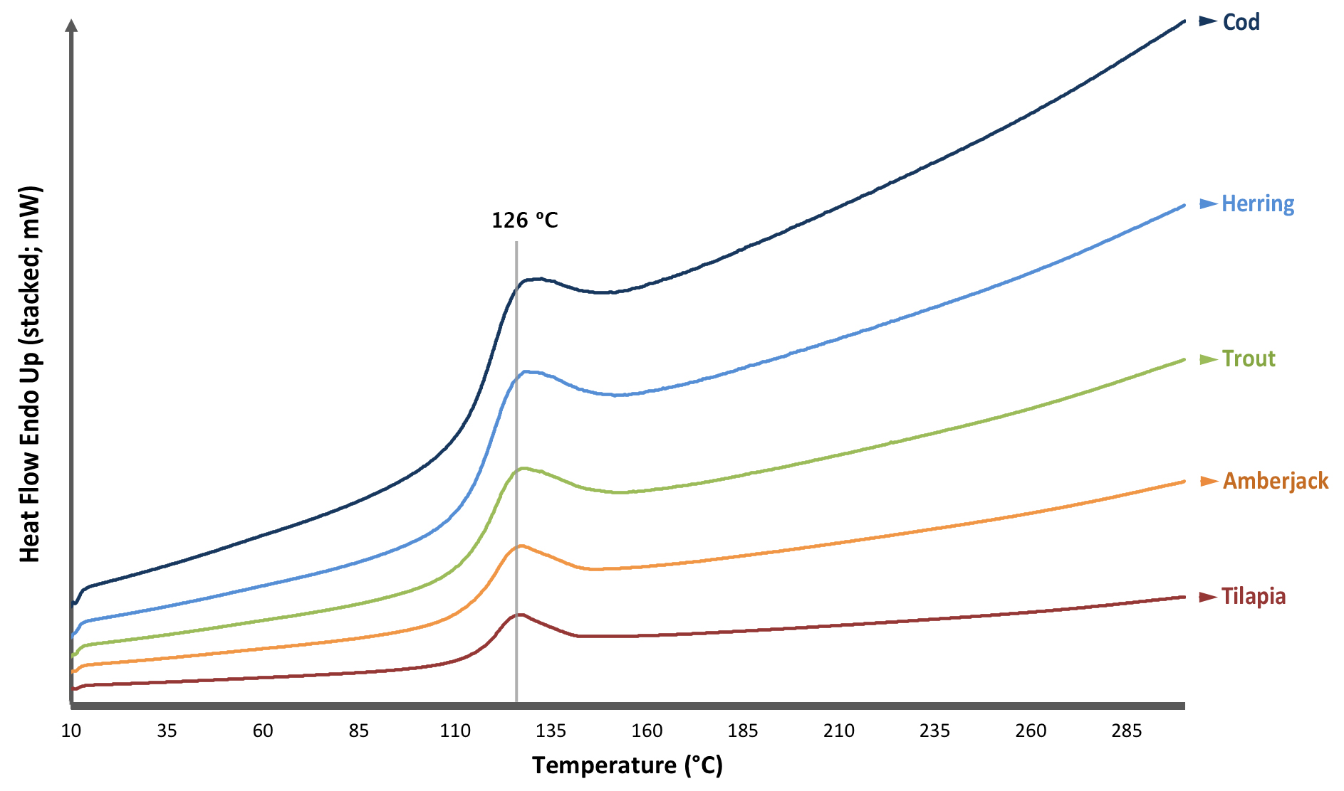
Figure 1: DSC thermogram of powdered whole fish bone from five different species, stacked on the same graph for ease of comparison. The vertical line (grey) at 126 °C demonstrates the peak of the phase transition (endothermic peak) in all samples. The thermogram is plotted ‘endo up’ to show the positive heat flow for the endothermic process.
TGA thermograms of powdered whole bone from the two test species, cod and tilapia, do not show a specific mass loss event at ~126 °C but otherwise show two main degradation steps occurring between 35–200 °C and 200–600 °C (Supplementary Figures S6–S7). At 126 °C the bone sample of cod was at ~90% of its original weight, and tilapia was at ~93%.
3.2 TOC and TN analyses
In all samples, the concentrations of both TOC and TN increased significantly with increased time at 75 °C (Figure 2, 3; Supplementary Table S5). Furthermore, the TOC and TN concentrations in bone samples of the cold-water species, cod (Pro+Hyp=15.6%) and herring (Pro+Hyp=16.9%) became significantly higher than those of the warm-water species, amberjack (Pro+Hyp=18.6%) and tilapia (Pro+Hyp=20.3%), with increased time at 75 °C, as referenced by the lack of overlap in the 95% confidence interval (CI) error bars. This same trend can also be observed when applying 99% CI error bars (Supplementary Figures S8–9).
The TOC and TN concentrations in the samples from trout (Pro+Hyp=16.6%) grouped most closely with herring, in accordance with its very similar Pro+Hyp concentration. Interestingly, the concentration of TOC in the control samples (no bone) increased a small amount with increased time at 75 °C, most likely as a consequence of carbon-containing phthalate contaminants from the plastic universal tubes. However, the values of all control samples were negligible compared to the bone samples (Figure 2), and the same trend was not seen in TN (Figure 3). There were also no significant changes to the inorganic carbon (IC) concentrations in any of the samples, which remained extremely low (<5 mg/L) throughout the experiment (Supplementary Table S5).
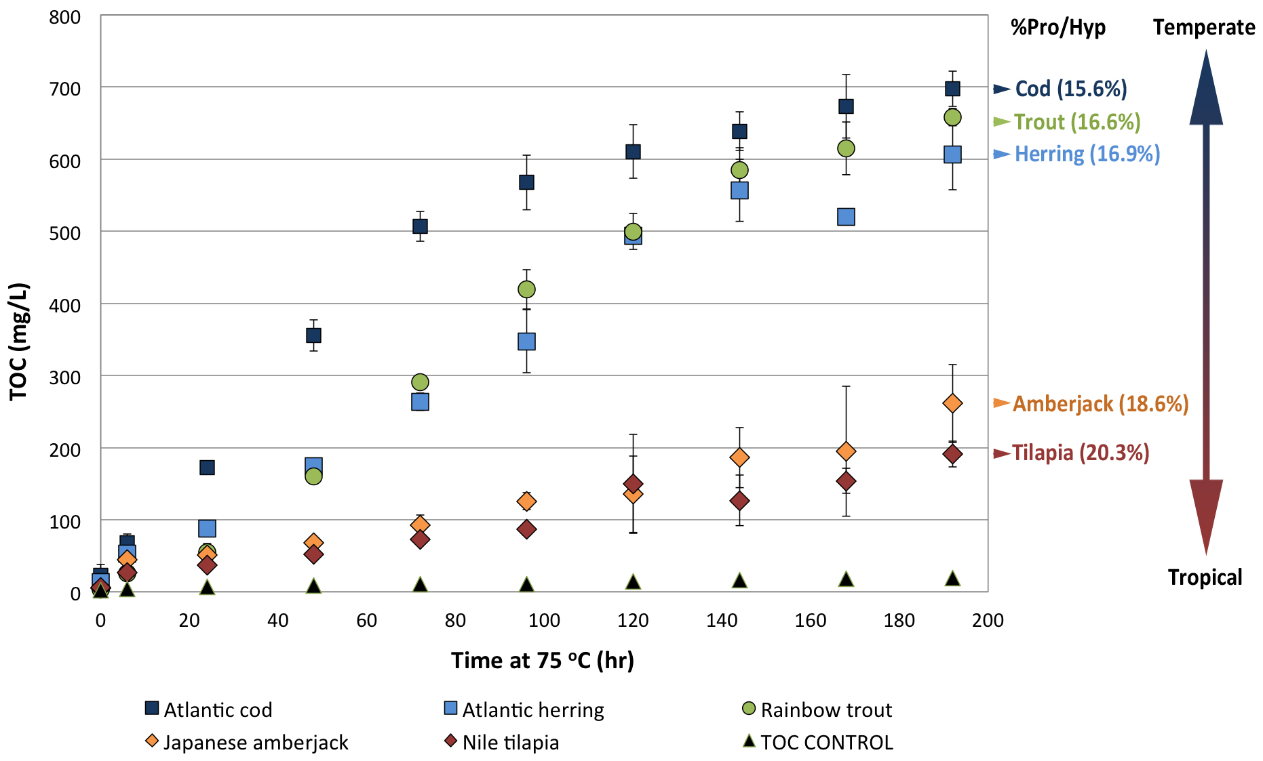
Figure 2: Total organic carbon (TOC) concentration in heated fish bone samples as a factor of time at 75 °C. Each point on the graph for the five species represents the average of a triplicate analysis. Error bars represent the 95% confidence intervals (CIs).

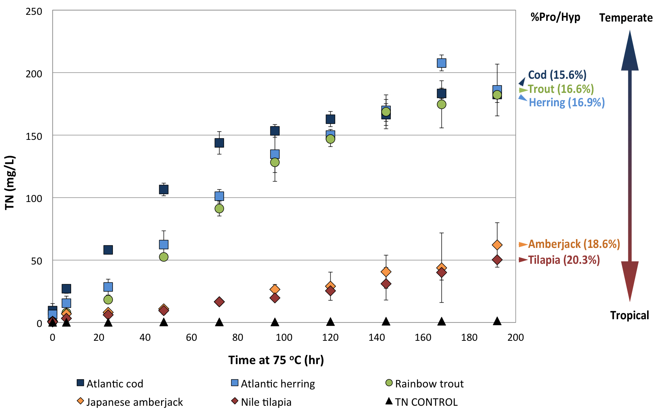
Figure 3: Total nitrogen (TN) concentration in heated fish bone samples as a factor of time at 75 °C. Each point on the graph for the five species represents the average of a triplicate analysis. Error bars represent the 95% confidence intervals (CIs).
3.3 Pseudo-zero-order rate calculations
A reaction rate law cannot yet be applied to these data as (i) the precise reaction that is taking place remains unknown, (ii) the analyses deal with product increase and not reactant loss in a complex system, and (iii) there appears to be an exponential fall-off in rate that may relate to the reaction approaching equilibrium, but accounting for this would require knowledge of the detailed thermodynamics of the reaction taking place in order to compute the change in reaction affinity. However, during the first half of the experiment (0–72 h), the concentration of TOC and TN in all species increases in a linear fashion with time at 75 °C, which is consistent with zero-order kinetics often seen in decomposition reactions (Vaughan and Wogelius, 2013). A useful index for understanding preliminary rate estimates can be achieved by calculating the pseudo-zero-order rate constants. For this, linear trend line calculations were assigned to the first five data points in each species (0–72 h), normalised to zero by subtracting the baseline concentrations at 0 h (Supplementary Figures S10–11). Beyond 72 h into the experiments, concentrations of TOC and TN as a function of time begin to curve in the colder water species (cod, herring and trout). This is presumably because these quicker reactions approach equilibrium more rapidly than the warm-water species (amberjack and tilapia), which do not appear to have deviated from their linear trends before the end of the experiment at 192 h. The fitted trend lines on the TOC analysis data show that cod bone (y = 6.7476) has a degradation rate that is 7.0 times greater than tilapia bone (y = 0.9655) (Supplementary Figure S10). Using the TN data, cod bone (y = 1.9235) has a degradation rate that is 8.9 times greater than tilapia bone (y = 0.2168) (Supplementary Figure S11).
4. Discussion
4.1 DSC and TGA
The phase change peak at ~126 °C on the DSC thermograms for all species most likely represents the denaturation and melting of collagen (I) (Figure 1) (Kubisz and Mielcarek, 2005; Yamashita et al., 2002). Denaturation temperatures for collagen (I) vary widely depending on taxa [i.e. fish, mammals; (Szpak, 2011)], source [i.e. bone, skin, fish scales; (Kittiphattanabawon et al., 2005; Kozlowska et al., 2015)], and on the water content of the material (Torres et al., 2012; Miles and Avery, 2011). However, similar DSC phase transition temperatures have been reported that are consistent with the present study. For example, Wang et al. (2014) reported a phase change temperature of ~120 °C in collagen (I) extracts from Amur sturgeon (Acipenser schrenckii). Additionally, studies by both Yamashita et al. (2002) and Wang and Feng (2005) indicated the denaturation of human and bovine bone collagen (respectively) occurred only when temperatures exceeded 120 °C, suggesting moderately higher denaturation temperatures in collagen (I) from these species compared to fish, a trend that is compatible with their higher Pro+Hyp concentrations. In line with this, Kronick and Cooke (1996) showed the denaturation temperature of bovine bone collagen (I) to be 155 °C when scanned with a DSC at 5 °C/min, and 65 °C in bovine skin collagen (I), with the difference between the two indicative of the strong interactions that collagen (I) has with bone apatite (Yamashita et al., 2002). Other studies show two-phase transitions when heating collagen (I). For example, Torres et al. (2012) declare a primary denaturalisation peak for collagen (I) at ~70 °C in Amur sturgeon scales, relating to the uncoiling of the triple helix, and a secondary peak at ~120 °C, due to further unfolding of each individual α-chain into random coils. Multiple other studies on fish collagen (I) have found very low denaturation temperatures of ~30 °C when testing demineralised collagen (I) (Kittiphattanabawon et al., 2005; Wang et al., 2013; Kozlowska et al., 2015), thereby removing the action of the collagen-apatite stabilising bonds (Collins et al., 2002; Pasteris et al., 2004). The single thermal transition apparent in this study is in the same position in all species, beginning at ~110 °C, completing at ~145 °C, with a thermal transition maximum of ~126 °C. Thus, the DSC results suggest that all the samples behave alike under the influence of rapid temperature increase (10 °C/min), regardless of collagen (I) Pro+Hyp concentration. This result also fits with a study by Nielsen-Marsh et al. (2000), who found that DSC thermal transition temperatures did not denote a correlation with histological deterioration or any alteration to bone mineral or organic components in both modern and archaeological bone. Finally, the DSC thermograms do not show a lower temperature phase change at ~30–60 °C, which suggests the bone collagen (I) resisted denaturation until temperatures reached over 100 °C, perhaps signifying the conservation of protein to apatite bonds in the samples, despite them being powdered.
The TGA thermograms of bone powder from cod (cold-water) and tilapia (warm-water) showed very similar results to one another, with no obvious differences that can be related to collagen (I) chemistry (Supplementary Figures S6–7). There were two main weight loss events in both samples, occurring between 35–200 °C (11.2% mass loss in cod; 8.5% mass loss in tilapia), likely as a result of a loss of water, and 200–600 °C (19.2% mass loss in cod; 22.2% mass loss in tilapia), likely related to the combustion of collagen (I) (León-Mancilla et al., 2016).
4.2 TOC and TN chemical analyses
The observed increase in concentrations of TOC and TN with time at 75 °C signifies the degradation of endogenous biomolecules (proteins and lipids) in the bone samples. Lipids, devoid of N, can only have contributed to the TOC analysis, whereas proteins, containing both C and N, will have contributed heavily to the TOC analysis and will have been the overriding influence on the N elemental analysis (von Endt and Ortner, 1984). The fact the same trend for TOC can be seen in TN suggests that any differing lipid content between the bones of each species does not substantially influence the correlation (Figures 2–3).
Collagen (I) is responsible for ~90% of the organic phase of bone (Collins et al., 2002), and therefore represents the main contributing protein to both the TOC and TN concentrations in the analyses. The significantly higher concentrations of TOC and TN in the samples from cold-water species compared to warm-water species can be attributed directly to the lower concentration of Pro+Hyp residues in the collagen (I) (an average of 16.2% compared to 19.0% in the warm-water species tested) (Table 1). A reduction in the concentration of these amino acids, which play an important role in stabilising the collagen (I) triple helix and its association with bioapatite (Collins et al., 2002; Burjanadze and Kisiriya, 1982; Fraser et al., 1979; Pasteris et al., 2004), causes a direct and significant reduction in the stability of the collagen (I) at 75 °C. Specifically, our results show that cod bone (lowest Pro+Hyp concentration) is reacting 8.9 times faster than tilapia bone (highest Pro+Hyp concentration), based on TN concentrations, which are likely to be primarily reflecting collagen (I) breakdown (Supplementary Figure S11). When observing TOC concentrations that may be influenced by the presence of lipids, the rate of the reaction associated with cod bone is 7.0 times faster than tilapia bone (Supplementary Figure S10). These values, and particularly that for TN, highly support the hypothesis that Pro+Hyp concentrations have a direct effect on collagen (I) stability in experimentally heated fish bone.
During the heat experiments, the average ratio of TOC to TN in the samples can be seen to change depending on the species and the length of time at 75 °C. If the TOC to TN ratio were to be solely dependent on the degradation of collagen (I), which can be represented by the formula (Gly-Pro-Hyp)_{n}, then we would expect a relative concentration of 4 organic C atoms for every 1 N atom (4:1) throughout the experiment. However, we see that the two warm-water species (tilapia and amberjack) have elevated ratios of ~8:1 at the beginning of the experiment, dropping to ~4:1 by the end. Conversely, the cold-water species (cod and herring) have reduced ratios of ~3:1 at the start of the experiment, which either stay stable or rise to 4:1 by the end. The mid-range species, rainbow trout, maintains a stable ratio of ~4:1 throughout the duration of the experiment (Supplementary Table S5). It is curious that the ratios for the species within each group (warm-water; cold-water) are similar to one another. However, the likely explanation for these results relates to relative lipid concentrations (see Szpak, 2011), which could have worked to artificially increase TOC concentrations particularly at the beginning of the experimentation due to the lower melting point of lipids compared to proteins. This trend has been seen previously (Barbati et al., 2008), whereby the presence of fatty acids in non-defatted meat and bone meal by-products enhanced the proportion of C and decreased the proportion of N in samples heated to 280 °C for up to 120 h, with the greatest effect occurring towards the beginning of the experiment. Again, the fact that the same correlation can be seen in both the TOC (Figure 2) and TN (Figure 3) analyses suggests that there are lipids present in this experiment which, although likely to be somewhat influencing the TOC analysis at the beginning of the experiments, do not substantially affect the overriding trend.
The species selected for this analysis encompassed both cellular (containing osteocytes; n=2) and acellular (devoid of osteocytes, n=3) structural bone types (Table 1). Yet, this variable does not appear to affect the degree of collagen (I) stability in each species, with the TOC and TN concentrations in all taxa positioned as would be expected by their Pro+Hyp concentrations regardless of bone type. For example, tilapia (acellular) has the highest abundance of collagen (I) Pro+Hyp (20.3%) and displays the lowest concentrations of TOC and TN from the heat experiments, followed by amberjack (acellular; 18.6%), and trout and herring (both cellular), have near-identical Pro+Hyp concentrations of 16.6% and 16.9% respectively. Finally, cod (acellular) has the lowest abundance of collagen (I) Pro+Hyp (15.6%) and displays the highest concentrations of TOC and TN. Should the type of bone structure have a substantial influence on collagen (I) degradation we would expect the acellular and cellular species to group together in the elemental concentration graphs (Figures 2–3). Therefore, despite the fact that the composition of cellular and acellular bone is significantly different, with the latter also less efficient in mineral regulation and homeostasis (Davesne et al., 2019), they carry similar advantages in terms of both their mechanics (Cohen et al., 2012), and their collagen stability (this study).
A further variable that may have had an effect on bone collagen (I) stability is its triple-helical construction in each species, whereby our analysis contained one species, herring, with the (α1)₂α2 collagen (I) heterotrimeric arrangement, as opposed to the α1α2α3 arrangement in the other four species (Table 1). It has been suggested in the literature that the α3 chain acts to reduce the denaturation temperature of the collagen (I) molecule, making it more susceptible to degradation (Saito et al., 2001). However, again we see no effect of the presence or absence of a collagen α3 (I) chain on the stability of the bone collagen (I) in this experiment, as evidenced by the close positioning of herring (α3 chain absent) with trout (α3 chain present) in line with their comparable Pro+Hyp concentrations (Figures 2–3). If the presence of the α3 (I) chain indeed alters the denaturation temperature of the collagen (I) molecule, as suggested by Saito et al. (2001), our results indicate that this effect is negligible compared to the effect of Pro+Hyp concentration.
4.3 Taphonomic significance to archaeology and palaeontology
To allow for the correct interpretations of zooarchaeological and sub-fossil samples, it is essential to understand the relevant physical, cultural and chemical factors that might influence vertebrate remains post-deposition (Szpak, 2011). In terms of the latter, it is clear from the results presented here that chemical characteristics of fish bone play a role in how the organic phase (collagen) deteriorates during thermal maturation experiments, which could carry huge implications for multiple archaeological disciplines, where collagen analysis is instrumental in understanding absolute (Bayliss, 2009) and relative (Buckley et al., 2017) bone age, taxonomic identification (Buckley et al., 2009; Harvey et al., 2018), and possible diet (Guiry, 2019). Collagen chemistry may, in turn, affect the relative abundance of fish species in archaeological deposits, a taphonomic artefact whereby fish bones have been noted to decay quicker than mammal bones (higher Pro+Hyp concentrations) of comparable size (Nicholson, 1996a; Nicholson, 1996b). Although it is possible that this could also be due to differences in the degree of bone mineralisation between different vertebrate types (Biltz and Pellegrino, 1969), it is also likely to be a direct consequence of collagen chemistry (this study). Within fishes, differences have been found in bone preservation both between species (Nicholson, 1996a), and within species (i.e. different skeletal elements; Nicholson, 1992, Lubinski, 1996). Moreover, this phenomenon has not been explained by differences in fish bone density (Nicholson, 1992), bone size/surface area (Nicholson, 1996a), the cellular or acellular nature of fish bone (Szpak, 2011; this study), or the presence or absence of an α3 (I) chain in the collagen triple helix (this study). Instead, our results show that collagen chemistry, pivoting on Pro+Hyp concentration, is the most direct and influencing factor that determines the rate of collagen (I) decay in fish bone in this study. It is important to highlight the fact that our study experimentally measures degradation at 75 °C in a laboratory setting, designed to act as an analogue of long-term deposition. It is clear this is not a realistic temperature that archaeological deposits would be subjected to, with the exception of bones that have been cooked prior to deposition. There is evidence in the literature to suggest that thermal maturation can act, to some extent, as an analogue of diagenesis, with similar processes occurring, including collagen loss, increasing crystallinity and increasing porosity (Roberts et al., 2002). However, for this study the extent of the analogy remains to be tested.
The organic and inorganic phases of bone are intrinsically linked through the aforementioned range of complex bonding interactions. Taphonomic processes before and during diagenesis impact both the organic and inorganic phases of bone simultaneously, with the two mutually protective fractions enabling long-term survival of bone in burial environments (Kendall et al., 2018). Disruptions to this relationship, through biological or chemical interactions, makes the bone more susceptible to diagenetic forces (Turner-Walker, 2008) but also potentially to taphonomic overprint. The breakdown of collagen (I), therefore, is likely to increase the breakdown rate of apatite by exposing reactive surface sites and changing fluid chemistry. We see this in the results of this experiment, where the average percentage weight loss for bone samples heated at 75 °C for 192 h is greater in the cold-water species (average loss of 34.4%) compared to the warm water species (average loss of 18.9%), with rainbow trout falling mid-range (26.8% loss) (Supplementary Table S5). Of the five species in our analysis, cod collagen (I) contains the lowest concentration of Pro+Hyp (Table 1), and shows the fastest breakdown into by-products (8.9 times faster than in tilapia), meaning the bones of this species are likely to be more vulnerable to identical taphonomic processes. Through experiments with demineralised modern bone, Eastoe (1957) noted that the rigidity of the gelatin extracted from cod bone was considerably lower than from the bones of other fishes. However, we note here that in terms of ichthyoarchaeological remains, the Pro+Hyp concentration of collagen (I) from all species within a deposit needs to be correlated with Pro+Hyp concentration before relative degradation levels can be ascertained. Indeed, it is unlikely that an archaeological assemblage will contain both cold- and warm-water fish species, but it is important to note that the species selected for this study do not represent the full range of Pro+Hyp concentration for each climate category but rather were chosen as ‘extremes’ to test the hypothesis. Importantly, there are species that are commonly found in archaeological association with each other that have significantly different Pro+Hyp concentrations. For example the Northern pike, Esox lucius, is a cold-dwelling species with a Pro+Hyp concentration of 18.6%, the same as the warm-water amberjack (Supplementary Table S6), and pike remains are often found together with cod remains (15.6% Pro+Hyp) in temperate archaeological sites (e.g. Fuller et al., 2012; Harvey et al., 2018). Additionally, of the taxa with published and complete collagen (I) sequences (n=60; Supplementary Table S2), the species listed as ‘temperate’ following FishBase (Froese and Pauly, 2019) vary by almost 5% in Pro+Hyp concentration, from cod (15.6% Pro+Hyp) to the mummichog (Fundulus heteroclitus, 20.5% Pro+Hyp). For those listed as ‘tropical’, Pro+Hyp concentration varies by 2.6% from the tiger tail seahorse (Hippocampus comes, 17.9% Pro+Hyp) to the shortfin molly (Poecilia mexicana, 20.5% Pro+Hyp (Supplementary Table S6). Of course, in these two latter examples, we would not expect bone remains from these species to be associated with each other archaeologically, or even to be preserved in the archaeological record at all as they are not key target species. However, we give these examples to illustrate the range of Pro+Hyp concentrations that can be present in the collagen (I) of species from the same climate categories. Moreover, these ranges are currently based on only 60 published sequences, whereas the sequencing of more collagen (I) genes may uncover even greater variation in Pro+Hyp concentration between taxa, as well as other significant variations between species often found together in archaeological contexts.
Finally, the loss of collagen (I) has also been observed to cause a reduction in the concentration of DNA in bone (Campos et al., 2012; Sosa et al., 2013). If this were the case then it could follow that species with lower collagen (I) Pro+Hyp concentrations may exhibit increased rates of DNA loss compared to species with higher concentrations, although this remains to be empirically tested. This close relationship between collagen and DNA further supports the intrinsic nature of bone biochemistry and its influence on the taphonomic pathway a bone might take after deposition, with direct relevance to both archaeology and palaeontology, as well as wildlife forensics.
With these observations in mind, it may be tempting to revisit and reinterpret data from previous studies. However this risks applying an oversimplified view to an archaeological assemblage, which may lead to misinterpretation. For example, with regards to bone identification through either morphological identification or collagen fingerprinting, we may expect the remains of species with higher concentrations of collagen (I) Pro+Hyp, such as pike, to be relatively more enriched in collagen (I) compared to species with lower concentrations, such as cod, and the bones themselves to potentially be more numerous, given the same deposition environments. Indeed, this was the case in a study on Lithuanian fish remains identified by collagen fingerprinting whereby pike made up the largest proportion of collagen-containing samples (28%) across seven sites, compared to cod at 2% (Harvey et al., 2018). However, there are a multitude of factors that ultimately determine bone survival into the archaeological record that this present study does not account for, including cultural choice, bone size, surface area and burial conditions across sites. This research represents a primary scoping study into the role of collagen (I) chemistry on taphonomy in fish bone and our data strongly indicates that the two are linked. It may be appropriate for site experts to reassess old datasets with the outcomes of our study in mind, and current and future assemblage analyses are also likely to benefit from our conclusions. However, what is required now is further experimentation designed to test the importance of Pro+Hyp concentration on protein and whole bone breakdown, as applied to archaeological contexts.
4.4 Future directions
This study is a primary foray into the relationship between collagen chemistry and its rate of decay. Our decay experiments allowed for the investigation of taphonomic degradation in fish bone, in both a controlled environment and on a measured timescale. As with all studies, there are a number of complementary experiments that would be useful to pursue which, although not possible within the scope of this study, would further explore the effects of Pro+Hyp concentration on fish bone diagenesis. Namely, testing the effects of: (i) long-term burial studies and/or different burial temperatures to test the strength of the analogy to archaeological deposits, (ii) chemically removing lipids from samples prior to DSC, TGA and heat experiments, (iii) examining whole bone samples and determining how endogenous biomolecules behave following the same heat experiments (although see von Endt and Ortner [1984], who show that N concentration is directly affected by bone size), (iv) burning, charring or roasting in a dry oven to test against the effects of hydrolysis and observe any differences between fish processing methods (see Roberts et al., 2002), (v) including bones from other vertebrate classes, namely mammals with significantly higher Pro+Hyp concentrations, (vi) measuring microbial controls on the rate of collagen (I) decay in different fish species, and (vii) including individual age at death to account for age in the resistance of collagen (I) degradation (see Hoke et al., 2019). It would also be advantageous for future studies to clarify the total concentrations of Pro and Hyp individually as well as to investigate the precise reaction that is taking place in order to extract a rate law and calculate the activation energy of the reaction. Finally, future studies could also seek to clarify any relationships between collagen (I) amino acid sequences and DNA preservation. Our results showed highly significant trends despite relatively low sample sizes per condition (n=3). However, increasing the sample size would work to reduce the confidence interval error bars on Figures 2–3, and could be considered as a future step.
Due care was taken in the preparation of bone samples prior to experimentation, with factors such as time after death, number of times frozen/defrosted and the state of the carcasses (filleted/un-filleted) considered and/or reduced where possible (Supplementary Table S1). Karr and Outram (2015) tested the effects of environment, storage and protection on bone fracture morphology in modern cow bones and found that frozen samples (-20 °C) preserve better than frozen/thawed (-20–22 °C), refrigerated (2 °C) and room temperature samples (22 °C), even after 60 weeks. They found that freezing with the flesh on is likely to maintain moisture content and reduce degradation further. Of course, diagenesis experiments work best with a reduction of all such possible variables, however this would require the rearing of whole specimens in-house and was therefore not possible for this current study, but could be considered for future experiments.
5. Conclusions
Concentrations of TOC and TN in samples of powdered fish bone in water increased significantly with increased time at 75 °C, signifying a breakdown of endogenous biomolecules. In the TOC analysis, the presence of lipids (carbon-containing) may have influenced organic C concentration towards the beginning of the experiment but does not substantially influence the correlation, as shown by the mirroring trends in the TN analysis, which reflects only protein (i.e. collagen) degradation. The results of the thermal maturation experiments demonstrate that collagen (I) in bone samples from the cold-water fishes in this study breaks down measurably quicker at 75 °C than that from the warm-water fishes, primarily as a factor of collagen (I) Pro+Hyp concentration. Quantified, we see that the reaction takes place 8.9 times faster in cod bone (15.6% Pro+Hyp) compared to tilapia bone (20.3% Pro+Hyp), based on TN concentrations. As the organic and inorganic phases of bone are understood to undergo simultaneous decay processes during diagenesis, we speculate based on our results that bones from species with lower collagen (I) Pro+Hyp concentrations (typically cold-water species, such as cod) could degrade quicker than those with higher Pro+Hyp concentrations (typically warm-water species, such as tilapia), within identical taphonomic environments. We hypothesise through our results that the bones of species with less thermally stable collagen (I) configurations (i.e. reduced Pro+Hyp) may preserve less well through time than bones of species with more thermally-stable compositions (i.e. increased Pro+Hyp) if they are subjected to identical taphonomic processes. However, we note that long-term burial studies are required to test the strength of the analogy between thermal maturation studies and archaeological deposits. Although predicted, our results are more statistically significant (99% confidence interval error bars) than was originally anticipated would have been the case. These observations carry large implications for how we view and interpret modern experimental data (e.g. decay rates) as well as zooarchaeological and paleontological assemblages. The thermal stability of collagen (I) from different fish species offers a new parameter that may need to be accounted for when reconstructing both extant and extinct vertebrate communities.
Acknowledgements
Sincere thanks go to Dr. John Waters (Department of Earth and Environmental Sciences) and Martin Jennings (Department of Chemistry) for their help with DSC and TGA at the University of Manchester. Our gratitude is also extended to Alastair Bewsher (Department of Earth and Environmental Sciences, University of Manchester) for his time in acquiring the C and N results. Special thanks go to the Manchester-based restaurant, Umezushi, for access to Seriola quinqueradiata specimens, and to Professor Stefano Mariani from Liverpool John Moores University for his excellent suggestions of where to source this difficult specimen. We also extend our gratitude to Dr. Holly Shiels (The Shiels Laboratory) for donating Oncorhynchus mykiss specimens. Finally, this work would not be possible without the generous support of the University of Manchester Dean's Award scholarship funding to VLH as well as support from the Royal Society for fellowship funding (grant no. UF120473) to MB.
References

