**SupplementaryMethods1.** Searchstrategies

**SupplementaryFigure1.** Flow chart

**SupplementaryTable1.** Characteristics of included studies

**SupplementaryFigure2.** ROC curve

**SupplementaryTable2.** References

**SupplementaryMethods1. Search strategies**

**MEDLINE (OvidSP)**

1. EPDS.af.

2. Edinburgh Postnatal Depression.af.

3. Edinburgh Depression Scale.af.

4. or/1-3

5. Mass Screening/

6. Psychiatric Status Rating Scales/

7. "Predictive Value of Tests"/

8. "Reproducibility of Results"/

9. exp "Sensitivity and Specificity"/

10. Psychometrics/

11. Prevalence/

12. Reference Values/

13. Reference Standards/

14. exp Diagnostic Errors/

15. Mental Disorders/di, pc [Diagnosis, Prevention & Control]

16. Mood Disorders/di, pc [Diagnosis, Prevention & Control]

17. Depressive Disorder/di, pc [Diagnosis, Prevention & Control]

18. Depressive Disorder, Major/di, pc [Diagnosis, Prevention & Control]

19. Depression, Postpartum/di, pc [Diagnosis, Prevention & Control]

20. Depression/di, pc [Diagnosis, Prevention & Control]

21. validation studies.pt.

22. comparative study.pt.

23. screen*.af.

24. prevalence.af.

25. predictive value*.af.

26. detect*.ti.

27. sensitiv*.ti.

28. valid*.ti.

29. revalid*.ti.

30. predict*.ti.

31. accura*.ti.

32. psychometric*.ti.

33. identif*.ti.

34. specificit*.ab.

35. cut?off*.ab.

36. cut* score*.ab.

37. cut?point*.ab.

38. threshold score*.ab.

39. reference standard*.ab.

40. reference test*.ab.

41. index test*.ab.

42. gold standard.ab.

43. or/5-42

44. 4 and 43

**PsycINFO (OvidSP)**

1. EPDS.af.

2. Edinburgh Postnatal Depression.af.

3. Edinburgh Depression Scale.af.

4. or/1-3

5. Diagnosis/

6. Medical Diagnosis/

7. Psychodiagnosis/

8. Misdiagnosis/

9. Screening/

10. Health Screening/

11. Screening Tests/

12. Prediction/

13. Cutting Scores/

14. Psychometrics/

15. Test Validity/

16. screen*.af.

17. predictive value*.af.

18. detect*.ti.

19. sensitiv*.ti.

20. valid*.ti.

21. revalid*.ti.

22. accura*.ti.

23. psychometric*.ti.

24. specificit*.ab.

25. cut?off*.ab.

26. cut* score*.ab.

27. cut?point*.ab.

28. threshold score*.ab.

29. reference standard*.ab.

30. reference test*.ab.

31. index test*.ab.

32. gold standard.ab.

33. or/5-32

34. 4 and 33

**Web of Science (Web of Knowledge)**

#1. TS=(EPDS OR “Edinburgh Postnatal Depression” OR “Edinburgh Depression Scale”)

#2. TS=(screen* OR prevalence OR “predictive value*” OR detect* OR sensitiv* OR valid* OR revalid* OR predict* OR accura* OR psychometric* OR identif* OR specificit* OR cutoff* OR “cut off*” OR “cut* score*” OR cutpoint* OR “cut point*” OR “threshold score*” OR “reference standard*” OR “reference test*” OR “index test*” OR “gold standard” OR “reliab*”)

#2 AND #1

*Databases=SCI-EXPANDED, SSCI, A&HC*

**SupplementaryFigure1.** Flow chart

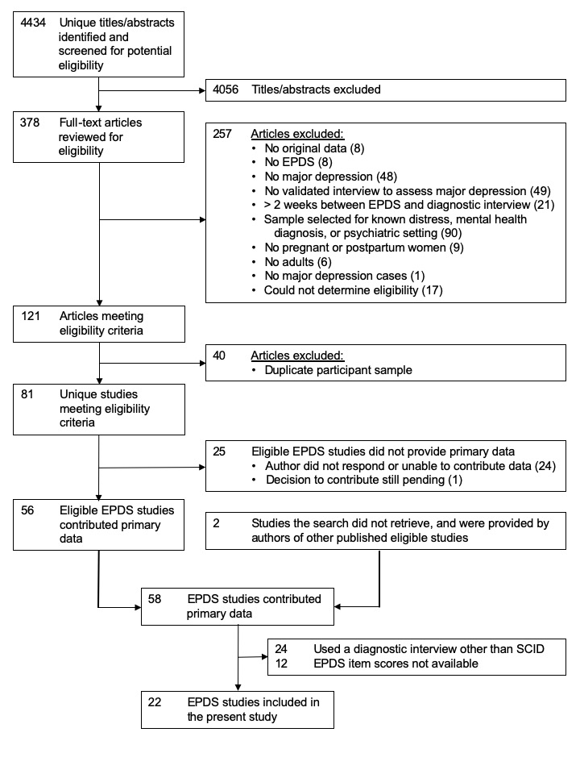

**SupplementaryTable1. Characteristics of included studies**

|  |  |  |  |  |  |
| --- | --- | --- | --- | --- | --- |
| **First Author, Year** | **Country** | **Recruited Population** | **Classification System** | **Total N** | **Major Depression** |
| **N (%)** |
| **Barnes, 20091** | UK | Socially disadvantaged mothers at 2 months postpartum | DSM-III-R | 347 | 25 (7) |
| **Beck, 20012** | USA | Postpartum mothers | DSM-IV | 150 | 18 (12) |
| **de Figueiredo, 20153** | Brazil | Postpartum women enrolled in prenatal care outpatient services in a Brazilian city | DSM-IV | 241 | 94 (39) |
| **Green, 20184** | Kenya | Pregnant and postpartum women receiving maternity services | DSM-V | 161 | 7 (4) |
| **Helle, 20155** | Germany | Mothers with very low birthweight and normal weight infants between 4 and 6 weeks postpartum | DSM-IV | 224 | 12 (5) |
| **Howard, 20186** | UK | Pregnant women recruited from an inner-city London maternity service | DSM-IV | 527 | 130 (25) |
| **Ing, 20177** | Thailand | Postpartum migrant and refugee women | DSM-IV | 625 | 5 (1) |
| **Kettunen, 20178a** | Finland | Postpartum women recruited from antenatal clinics | DSM-IV | 134 | 65 (49) |
| **Leonardou, 20099** | Greece | Postpartum women recruited from private and public maternity wards on their second day postpartum | DSM-III-R | 81 | 4 (5) |
| **Nakić Radoš, 201310** | Croatia | Women between 6 and 8 weeks postpartum | DSM-IV-TR | 272 | 10 (4) |
| **Phillips, 200911** | Australia | Postpartum mothers with unsettled infants | DSM-IV | 158 | 42 (27) |
| **Prenoveau, 201312** | UK | Postpartum women at 10 months recruited from mixed health centres | DSM-IV | 219 | 20 (9) |
| **Rochat, 201313** | South Africa | Women recruited from their antenatal appointment at a primary health care clinic between 26 and 34 weeks of pregnancy | DSM-IV | 104 | 50 (48) |
| **Smith-Nielsen, 201814b** | Denmark | Postpartum women | DSM-V | 320 | 118 (37) |
| **Stewart, 201315** | Malawi | Pregnant women attending an antenatal clinic in rural Malawi | DSM-IV | 186 | 34 (18) |
| **Tandon, 201216** | USA | Pregnant and postpartum women enrolled in home visitation programs | DSM-IV | 89 | 25 (28) |
| **Tendais, 201417** | Portugal | Pregnant women recruited in an obstetrics outpatient unit | DSM-IV | 141 | 18 (13) |
| **Töreki, 201318** | Hungary | Women at 12 weeks antenatal | DSM-IV | 219 | 7 (3) |
| **Töreki, 201419** | Hungary | Women between 6 and 8 weeks postpartum | DSM-IV | 265 | 8 (3) |
| **Tran, 201120** | Vietnam | Pregnant and postpartum Vietnamese women recruited from the commune health centre | DSM-IV | 359 | 52 (14) |
| **Turner, 200921** | Italy | Women from a regional epilepsy center in Italy between 5 and 8 weeks postpartum | DSM-IV-TR | 29 | 2 (7) |
| **Vega-Dienstmaier, 200222** | Peru | Women up to 12 months postpartum | DSM-IV | 306 | 19 (6) |

a The primary study used a case-control design but was unable to provide statistical weights to reflect sampling procedures.

b This study was not retrieved at the time of electronic database search.



**SupplementaryFigure2** ROC Curve

**SupplementaryTable2 references**

1. Barnes JS, Senior R, MacPherson K. The utility of volunteer home‐visiting support to prevent maternal depression in the first year of life. *Child Care Health Dev*. 2009;35:807-16.
2. Beck CT, Gable RK. Comparative analysis of the performance of the Postpartum Depression Screening Scale with two other depression instruments. *Nurs Res*. 2001;50:242-50.
3. de Figueiredo FP, Parada AP, Cardoso VC, Batista RF, da Silva AA, Barbieri MA, de Carvalho Cavalli R, Bettiol H, Del-Ben CM. Postpartum depression screening by telephone: a good alternative for public health and research. *Arch Womens Ment Health*. 2015;18:547-53.
4. Green EP, Tuli H, Kwobah E, Menya D, Chesire I, Schmidt C. Developing and validating a perinatal depression screening tool in Kenya blending Western criteria with local idioms: A mixed methods study. *J Affect Disord*. 2018;228:49.
5. Helle N, Barkmann C, Bartz-Seel J, Diehl T, Ehrhardt S, Hendel A, Nestoriuc Y, Schulte-Markwort M, Von Der Wense A, Bindt C. Very low birth-weight as a risk factor for postpartum depression four to six weeks postbirth in mothers and fathers: Cross-sectional results from a controlled multicentre cohort study. *J Affect Disord*. 2015;180:154-61.
6. Howard LM, Ryan EG, Trevillion K, Anderson F, Bick D, Bye A, et al. Accuracy of the Whooley questions and the Edinburgh Postnatal Depression Scale in identifying depression and other mental disorders in early pregnancy. *Br J Psychiatry*. 2018;212:50-6.
7. Ing H, Fellmeth G, White J, Stein A, Simpson JA, McGready R. Validation of the Edinburgh Postnatal Depression Scale (EPDS) on the Thai-Myanmar border. *Trop Doct.* 2017;47:339.
8. Kettunen P, Hintikka J. Psychosocial risk factors and treatment of new onset and recurrent depression during the post-partum period. *Nord J Psychiatry*. 2017;71:355.
9. Leonardou AA, Zervas YM, Papageorgiou CC, Marks MN, Tsartsara EC, Antsaklis A, Christodoulou GN, Soldatos CR. Validation of the Edinburgh Postnatal Depression Scale and prevalence of postnatal depression at two months postpartum in a sample of Greek mothers. *J Reprod Infant Psychol*. 2009;27:28-39.
10. Nakić Radoš S, Tadinac M, Herman R. Validation study of the Croatian version of the Edinburgh Postnatal Depression Scale (EPDS). *Suvrem Psihol*. 2013;16:203-18.
11. Phillips J, Charles M, Sharpe L, Matthey S. Validation of the subscales of the Edinburgh Postnatal Depression Scale in a sample of women with unsettled infants. *J Affect Disord.* 2009;118:101-12.
12. Prenoveau J, Craske M, Counsell N, West V, Davies B, Cooper P, Rapa E, Stein A. Postpartum GAD is a risk factor for postpartum MDD: the course and longitudinal relationships of postpartum GAD and MDD. *Depress Anxiety*. 2013;30:506-14.
13. Rochat TJ, Tomlinson M, Newell ML, Stein A. Detection of antenatal depression in rural HIV-affected populations with short and ultrashort versions of the Edinburgh Postnatal Depression Scale (EPDS). *Arch Womens Ment Health*. 2013;16:401-10.
14. Smith-Nielsen J, Matthey S, Lange T, Væver MS. Validation of the Edinburgh Postnatal Depression Scale against both DSM-5 and ICD-10 diagnostic criteria for depression. *BMC Psychiatry*. 2018;18:393.
15. Stewart RC, Umar E, Tomenson B, Creed F. Validation of screening tools for antenatal depression in Malawi—A comparison of the Edinburgh Postnatal Depression Scale and Self Reporting Questionnaire. *J Affect Disord*. 2013;150:1041-7.
16. Tandon SD, Cluxton-Keller F, Leis J, Le HN, Perry DF. A comparison of three screening tools to identify perinatal depression among low-income African American women. *J Affect Disord*. 2012;136:155-62.
17. Tendais I, Costa R, Conde A, Figueiredo B. Screening for depression and anxiety disorders from pregnancy to postpartum with the EPDS and STAI. *Span J Psychol*. 2014;17.
18. Töreki A, Andó B, Keresztúri A, Sikovanyecz J, Dudas RB, Janka Z, Kozinszky Z, Pál A. The Edinburgh Postnatal Depression Scale: translation and antepartum validation for a Hungarian sample. *Midwifery*. 2013;29:308-15.
19. Töreki A, Andó B, Dudas RB, Dweik D, Janka Z, Kozinszky Z, Keresztúri A. Validation of the Edinburgh Postnatal Depression Scale as a screening tool for postpartum depression in a clinical sample in Hungary. *Midwifery*. 2014;30:911-8.
20. Tran TD, Tran T, La B, Lee D, Rosenthal D, Fisher J. Screening for perinatal common mental disorders in women in the north of Vietnam: a comparison of three psychometric instruments. *J Affect Disord*. 2011;133:281-93.
21. Turner K, Piazzini A, Franza A, Marconi AM, Canger R, Canevini MP. Epilepsy and postpartum depression. *Epilepsia.* 2009;50:24-7.
22. Vega-Dienstmaier JM, Mazzotti GS, Campos MS. Validation of a Spanish version of the Edinburgh postnatal depression scale. *Actas Esp Psiquiatr*. 2002;30:106-11.