Testing the precision of spatial memory representations using a change-detection task: Effects of viewpoint change
Edward Heywood-Everett, Daniel H. Baker, Tom Hartley*
Department of Psychology and York Biomedical Research Institute, University of York, UK
Short title/running head: Viewpoint change and precision of spatial memory
*Correspondence should be addressed to:
Tom Hartley
Department of Psychology
University of York
Heslington UK
Tel: +44 (0) 1904 322903
Email: tom.hartley@york.ac.uk
Acknowledgements: EH-E was supported by a University of York, Department of Psychology Studentship.
The data that support the findings of this study are openly available https://osf.io/p6gzt/ and https://osf.io/j7a8p/
The version of record has been published and is available in the Journal of Cognitive Psychology (28/12/20) doi: 10.1080/20445911.2020.1863414.
Keywords: Allocentric, Egocentric, Psychophysics, Virtual Environment, Change Detection, Spatial Memory, Viewpoint Rotation.
Abstract

The brain encodes spatial information in at least two distinct ways: egocentric representations encode locations relative to the observer, whereas allocentric representations encode locations relative to the environment. Both inform spatial memory, but the extent to which they influence behaviour varies depending on the task. In two preregistered experiments we used a psychophysical approach to measure the precision of spatial memory while varying ego- and allocentric task demands. Participants attempted to detect the changed location of one of four objects when seen from a new viewpoint. In both experiments (one using a Same/Different task, the other a 2AFC task), psychophysically-determined change detection thresholds showed a monotonic but non-linear increase as the degree of viewpoint change increased. Our findings were consistent with a preregistered model which shows how, governed by distinct ego- and allocentric contributions, the precision of spatial memory changes lawfully as a function of viewpoint shift.

Introduction
Spatial memory allows mobile organisms to act adaptively in complex environments that extend, temporally and spatially, beyond the range of their senses. The way in which the environment and salient objects and locations within it are represented in memory can take different forms, each of which may be suited to specific situations. Extensive neuroscientific and neuropsychological evidence indicates a distinction, in humans and other mammals, between egocentric and allocentric representations (see e.g., Burgess, 2008; Ekstrom et al., 2014; Galati et al., 2000; Hartley et al., 2014). Egocentric representations are supported by neurons in parietal, sensory and motor cortices, which have spatial receptive fields that are anchored with respect to the body or parts of the body. Allocentric representations are supported by neurons in the medial temporal lobe with spatial receptive fields that are anchored to the environment, and thus insensitive to changes in viewpoint. It is argued that these different forms of spatial representation have distinct functional advantages, with egocentric representation being well-suited to guiding action in the immediate environment over short timescales, and allocentric representation being well-suited to long-term memory and navigation (Burgess, 2006; Goodale & Milner, 1992;).
Although they may make distinct functional contributions to spatial behaviour, ego- and allocentric representations are unlikely to be wholly independent; as spatial information is initially encoded by perceptual systems in egocentric form, it must be translated into allocentric form in order to represent environmental locations in memory. Conversely when motor systems need to draw on allocentric information in the control of behaviour, it first must be converted back to an egocentric representation before being used. Mechanistic neural-level models are able to explain this hierarchical interaction by postulating an intermediate transformation circuit (in retrosplenial cortex) which mediates the translation. (Bicanski & Burgess, 2018; Byrne et al., 2007).
From a psychological perspective, the coexistence and likely interdependence of ego- and allocentric systems makes it challenging to interpret the source of information present in spatial behaviour since it can be difficult to isolate their contributions to a given task. Yet understanding, distinguishing and quantifying these contributions is potentially important, not just for theories of spatial memory, but also in a clinical context where failures of spatial memory can be symptomatic of underlying disease processes. Notably, because Alzheimer’s Disease typically affects the medial temporal lobe in its earliest stages, a decline in allocentric spatial memory may give an early indication of disease pathology (Moodley et al., 2015; Serino et al., 2014).
Previous work has established that both forms of representation can contribute to performance on laboratory tasks involving memory for objects’ locations. A common approach has been to ask participants to remember the locations of an array of objects before being asked to complete a spatial task, such as indicating which object has moved, or pointing to an object’s previous location, from a novel viewpoint (Burgess et al., 2004; Easton & Sholl, 1995; Greenauer & Waller, 2008; C. A. Holmes et al., 2018; M. C. Holmes & Sholl, 2005; King et al., 2002; Mou et al., 2006; Negen et al., 2018; Newcombe & Huttenlocher, 1992; Simons & Wang, 1998; Waller & Hodgson, 2006; Wang & Simons, 1999; Wraga et al., 2000, 2005; Zhang et al., 2011). These tasks are revealing due to the way viewpoint changes differentially affect different forms of memory representation. Specifically, in order to remain valid while the objects are obscured, egocentric representations of unseen targets must be updated to reflect participants’ bodily movements. This spatial updating process relies on idiothetic self-motion cues from visual, vestibular and proprioceptive information. By making these cues unavailable or invalid it is possible to selectively disrupt viewpoint-dependent contributions to spatial memory from the egocentric system. By contrast, because viewpoint-independent representations encode locations with respect to the environment, the information in the allocentric system should remain valid even in the absence of spatial updating. Studies show enhanced performance when the appearance of the array of objects is consistent with spatial updating cues (i.e., a viewpoint-dependent contribution to spatial memory; Wang & Simons, 1999), but they also indicate a viewpoint-independent contribution where spatial updating is unavailable (Burgess et al., 2004). Note that while in real-world tasks, the physical sensations of motion undoubtedly play an important role in spatial updating, the distinct contributions of viewpoint-independent and viewpoint dependent memory can be inferred in purely visual tasks using virtual environments presented on computer displays (King et al., 2002; Lambrey et al., 2012; Spiers et al., 2001; Tu et al., 2017). For example, in King et al. (2002) a patient with damage to the hippocampus showed profound impairment of memory for object locations in a virtual environment that was apparent only when tested from a different viewpoint from that used at encoding.
Beyond the simple dissociation of viewpoint-dependent and independent forms of memory, there are clear indications that performance in spatial memory tasks can be parametrically affected by the degree of viewpoint change: notably, the spatial accuracy of responses is reduced as viewpoint at test is rotated away from viewpoint at encoding (Diwadkar & McNamara, 1997; Shelton & McNamara, 2001) with increased viewpoint rotations having been found to encourage the use of allocentric cues and activation of allocentric-associated brain regions (Schmidt et al., 2007; Zhao & Warren, 2015). These results suggest that a more detailed understanding of the contributions of ego- and allocentric systems to behaviour can be gained by investigating the relationship between the degree of viewpoint change and the accuracy of spatial responses in memory tasks.
This parametric approach connects with recent developments in investigations of working memory where the precision of responses is increasingly used to investigate capacity constraints. Some authors argue that visual working memory capacity is limited by a common resource that, rather than being limited to a fixed number of items, can be allocated to the fidelity with which each item’s properties (such as colour and location) are stored (Alvarez & Cavanagh, 2004; Awh et al., 2007; Bays & Husain, 2008; Bays et al., 2009; Ma & Wilken, 2004). In this context, psychophysical techniques provide a sensitive means to measure the precision of memory representations in visuo-spatial change detection tasks (e.g., Brady & Alvarez, 2015; Jiang et al., 2000; Luck & Vogel, 1997; Luck et al, 1994 ; Luck & Vogel, 2013, see Brady et al., 2011 for review). However, spatial working memory tasks have typically been concerned with 2D stimulus arrays in which the participant’s viewpoint remains fixed; in most cases such tasks can shed little light on the way in which different forms of spatial representation contribute to working memory.
A notable exception is a recent study by Aagten-Murphy and Bays (2019), which investigated the precision of spatial memory responses to 2D arrays when a persistent landmark was present in the display. In this paradigm, although the participant’s viewpoint is fixed, the landmark can be thought of as providing an allocentric cue (i.e., allowing for the encoding of each object’s spatial relationship to its surroundings), which - when it is present and stable - can improve spatial precision, or – if it is shifted – can be placed in conflict with egocentric memory. Consistent with this, stimulus locations near to a landmark were remembered with greater precision than locations further away from a landmark when it remained persistent and stable, and responses were shifted when the landmark was moved between presentation and testing. The results were interpreted as indicating independent contributions of ego- and allocentric representation to the precision of spatial responses, and the authors developed a mathematical model describing the way that ego- and allocentric contributions are combined in the precision of responses in their task.
These intriguing results align with the neuroscientific and psychological research described above in suggesting that ego- and allocentric representations make distinct contributions to spatial memory. However, the precision of spatial memory has yet to be investigated with 3D arrays in more realistic situations in which viewpoint varies systematically between presentation and testing. In these circumstances, we might expect responses to be guided principally by viewpoint-dependent egocentric representations when the viewpoint remains fixed, with an increasing contribution of viewpoint-independent allocentric representation with larger unpredictable viewpoint shifts between encoding and retrieval.
To characterise the relationship between viewpoint change and the precision of spatial memory, in the current study we develop a change detection task in which participants remember the locations of an array of objects in a virtual environment over a brief delay. We adopt a psychophysical approach to measure spatial change detection thresholds while parametrically varying the degree of viewpoint change between presentation and testing. We then fit a preregistered model to participant data in order to distinguish and quantify ego- and allocentric contributions to spatial precision as it varies with viewpoint.

Methods

Overview
In two experiments, described in more detail below, participants were asked to make judgements about the locations of objects in an array within a virtual environment displayed on a standard PC monitor (see Figure 1A). In each task, participants first viewed the object array for six seconds (presentation) from a standard viewpoint and then, after a brief delay, saw the objects from a new viewpoint before making a spatial judgement (testing). To probe the effect of viewpoint changes between presentation and testing, the viewpoint used to render the scene at testing was manipulated across trials (see Figure 1B), with the degree of viewpoint change being selected at random on each trial. Thus, participants could not anticipate at presentation the viewpoint they would encounter at testing.
Experiment 1 (Figure 1B) used a Same/Different (S/D) spatial change detection task. Between presentation and testing, the array was left unchanged on half of trials, selected at random (‘Same’ trials), or (for the remaining ‘Different’ trials) a single object was moved by a distance controlled by an adaptive staircase (described below), with participants being asked to respond ‘Same’ or ‘Different’.
Experiment 2 (Figure 1C) used a two-alternative forced choice (2AFC) spatial change detection task. Between presentation and testing, an adaptive staircase controlled the degree of spatial distortion (the distance a single selected object was moved) applied to an array of 4 objects.
Our objective in employing two experiments was to provide a degree of internal replication, to determine whether results would generalize to different spatial judgements and to compare tasks, thus both experiments were piloted and preregistered prior to any data collection and the order of reporting below is arbitrary (see https://osf.io/p6gzt/ and https://osf.io/j7a8p/).

Participants
All participants were recruited via the University of York’s Department of Psychology participant recruitment system. For Experiment 1, twelve participants were recruited and two were subsequently excluded (see exclusion criteria, below), leaving ten participants in the analysed data (10 female, mean age 19.7, SD 1.16). For Experiment 2, thirteen participants were recruited and three were subsequently excluded leaving ten participants in the analysed data (10 female, mean age 19.5, SD 0.71). Participants received course credit for participation and gave their written informed consent in line with guidance from the University of York Department of Psychology Ethics committee.

Task and Materials
All testing took place in a quiet testing room in the Department of Psychology, University of York. The task and stimuli were rendered and controlled by custom software programmed in the Unity3d game engine in C# running on an HP Z400 computer and displayed on a 20” ‘Elite Display 232’ monitor. The Unity engine allows us to specify environment and object locations in realistic 3D coordinates that are then accurately rendered to the screen as if seen from a particular viewpoint (see Figure 1A).
The virtual environment (see Figure 1A) consisted of a 10m diameter, circular room lit with contrasting colour lighting and containing generic objects next to the walls to provide directional cues. Participants viewed a 4m diameter table top from a distance of 1m (i.e., 3m from centre). When the participant viewed the array from a rotated angle, the degree of rotation was either 0, 5, 15, 45 or 135 degrees relative to the initial viewpoint which remained fixed across all trials. The viewpoint rotations were chosen to avoid rotations that might be susceptible to non-spatial or idiosyncratic strategies (for example advantages at 90 and 180 degrees; Mou & McNamara, 2002).

Experiment 1: Same/Different
Experiment 1 (see Figure 1B) used a same/different spatial change detection task with an adaptive staircase controlling spatial change. At Presentation participants viewed an array of 4 objects (simple 3D geometric shapes with distinct geometry and contrasting colours selected from a pool of 10) arranged in a random spatial configuration for 6 seconds (‘Sample Scene’). The screen dimmed over 0.5 seconds, remained black for 1 second before fading back over 0.5 seconds. At Testing, the participant viewed a new scene (‘Test Scene’) with their viewpoint shifted by 0, 5, 15, 45, or 135 degrees around the centre of the table for 6 seconds. Both the degree of view rotation and its direction (clockwise or anticlockwise) was selected randomly for each trial. In ‘Same’ trials – the object locations did not change between presentation and testing; in ‘Different’ trials, one randomly selected object was moved. The magnitude of this change was controlled using an adaptive staircase procedure described in more detail below. The participant then viewed the Test Scene for 6 seconds before being prompted to respond ‘Same’ or ‘Different’ by pressing the ‘s’ or ‘d’ key on the keyboard.

Experiment 2: 2AFC
As in Experiment 1, at Presentation on each trial participants in Experiment 2 (Figure 1C) viewed a Sample Scene, tabletop with 4 objects arranged in a random spatial configuration for 6 seconds. The screen dimmed over 0.5 seconds, remained black for 1 second before fading back over 0.5 seconds. At Testing one object was selected at random and moved, by a distance specified by an adaptive staircase forming a new spatially distorted configuration. Participants viewed this Test Scene with their viewpoint shifted by 0, 5, 15, 45, or 135 degrees around the centre of the table for 6 seconds. Two objects (including the target object and a foil, selected at random) were then highlighted and the participant was then allowed up to 8 seconds to choose which object had moved by clicking with the mouse.
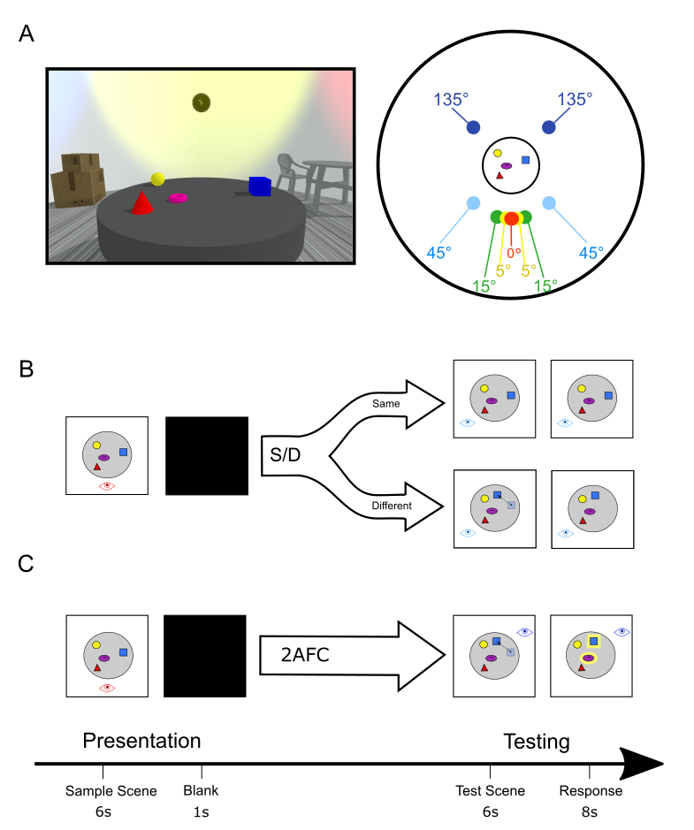
Figure 1 Task and Materials. A (left) The testing environment from participant perspective at 0° view rotation used at Presentation (right) environment layout and viewpoints; coloured circles mark the viewpoints used at Testing. Red: 0° rotation, yellow ± 5° rotation, green: ±15° rotation, light blue ±45° rotation, dark blue ±135° rotation. B Experiment 1, trial structure for Same/Different task, see text for detailed description. At Testing. participants view the object array from one of the viewpoints shown in A (right). In Different trials (50%) one of the objects in the array is moved between presentation and testing. Participants judge whether the array is the same or different to the one they encountered at Presentation.. C Experiment 2, trial structure for Two Alternative Forced Choice task. At Testing participants view the object array from one of the viewpoints shown in A (right). On every trial one of the objects is moved between presentation and testing. The moved object is highlighted along with one other object selected at random. Participants indicate which of the highlighted objects has been moved.

Adaptive staircase procedure
In order to focus the majority of trials around participants’ precision thresholds (corresponding to 75% correct responses), in each experiment, an adaptive staircase procedure was used to determine the amount of spatial distortion (i.e., distance moved by selected object in spatially distorted arrays) based on participant performance in each view rotation condition. Each level of the staircase referenced a specific distance in 15 logarithmically-spaced steps between 0.05m to 0.9m, with the largest distortion being limited by the edges of the display. The staircase level, specifying the current spatial distortion, changed following a 3 down 1 up procedure (the level of spatial distortion was reduced after 3 consecutive correct responses and increased after a single incorrect response). A reversal was recorded whenever responses led to a change in the direction of progression from a sequence of successively smaller distortions to a larger distortion or vice versa. Staircases completed when they reached 14 reversals (Experiment 1) or 7 reversals (Experiment 2). Independent staircases controlled each view rotation condition, such that the degree of spatial distortion on each trial was determined by the staircase level based on previous trials at the same view rotation condition.
In order to expedite the threshold estimation process, the number of steps moved after each response was initially large and gradually reduced over successive reversals: 6 steps until the first reversal, 4 steps until the second reversal, 2 steps until the third reversal, and single steps thereafter.
To avoid biasing participants’ Same/Different criterion, in Experiment 1 a single staircase was used for each viewpoint condition starting at the largest level of spatial distortion; pilot work suggested that when beginning the task, trials involving very small spatial changes would be easily misinterpreted as a ‘Same’ trials. The experiment finished when all five staircases were completed or if the session duration exceeded 2 hours (two participants exceeded the time limit in Experiment 1).
In Experiment 2, a pair of staircases were used for each viewpoint condition. One staircase began with the smallest spatial distortion level and one began at the largest spatial distortion level. The experiment finished when all ten staircases were completed or if the session duration exceeded 2 hours (one participant exceeded the time limit in Experiment 2).
On each trial, matched spatial arrays were generated randomly. Initially, four of ten possible objects with distinct geometry and contrasting colours were selected randomly without replacement. Objects were placed at pseudo-random locations by first specifying evenly spaced locations on a circle of radius 1m around the centre of the table, and then applying a random global rotation of the array and individual radial (between 0.01m and 0.5m) and angular displacements (between 0° and 45°) to each object. A matched distorted array was then created by moving a single object, selected at random, by the distance determined by the staircase while avoiding distortions that resulted in the overlap of two objects or objects appearing beyond the table top. Finally, the matched pair of arrays was shuffled so that either array could appear at Presentation, with its partner being used at Testing.

Data Analysis
To estimate each participant’s spatial precision threshold (see Figure 2A) we counted the number of correct responses made at each staircase level. We then fit a logistic function (equation 1) to the data from each viewpoint condition using a maximum likelihood approach with the Nelder-Mead simplex algorithm (as implemented in ‘fminsearch’; MATLAB ver. R2019a). The logistic function is defined as:
$f\left(x\right)= 0.5+0.5(\frac{1}{1+e^{-k\left(x-x_{o}\right)}})$ (1)
Briefly, the logistic function (f) allows us to calculate the probability that a particular proportion of responses will be correct at each staircase level (x) given parameters governing its threshold (x₀) and slope (k). The fitting procedure systematically varies these parameters, calculating at each iteration the overall likelihood of the data from a given participant and condition (expressed as log-likelihood) and stopping when the likelihood is maximized. These fitted parameters, which describe the threshold and slope of the psychometric curve under which the observed data is most likely, were then recorded for further analysis.
For clarity below we have converted the k parameter to equivalent Weibull beta values, so that increasing values indicate steeper psychometric functions (which we refer to as “slope”). We also recorded the log-likelihood of the data given the fitted curve and calculated the log-likelihood of the data under a baseline model in which the observed proportion of responses was constant across all levels of spatial distortion. These likelihoods were used to calculate a Bayes Factor indicating the relative likelihood of the data under the two different models, which could be used as a measure of fit across participants/conditions where different numbers of observations were available (Wagenmakers, 2007). We report Bayes Factors (${BF}_{10}$) where applicable below and in full in the supplementary material. Change detection thresholds were converted from meters to decibels (see supplementary material for more information).
To allow for a clear comparison between experiments 1 and 2 our main analyses (reported below) focus on the parameters derived from the psychometric curves and the underlying proportion of correct responses. For experiment 1 we additionally carried out a d’ analysis (see supplementary material) to ensure our main results were not affected by response biases.

Procedure
Before beginning the experiment, participants undertook a 10-minute practice session. Performance on the 0° condition at the easiest staircase level, was recorded and analysed, and exclusion criteria applied. They then completed the experimental protocol (i.e., completed all staircase reversals) in two sessions, each approximately 1.5 hours including breaks (around 3 hours total for each data collection). Data from each of these sessions was combined for analysis (an average of 514.8 trials per participant).

Participant exclusion criteria
We preregistered our intention to exclude participants who performed below 66% percent correct in 0° trials during the practice session from further participation. We determined, based on pilot work, that this level of performance would be indicative of exceptionally poor spatial memory, failure to understand task instructions, or a lack of motivation or cooperation. However, all recruited participants passed this exclusion criteria.

Data Exclusion Criteria
If a precision threshold was estimated far outside the testing range (above 10dB), this indicated that we were unable to effectively model a participant’s performance in that condition and all data associated with this participant was excluded. Three participants failed to meet these criteria and we were unable to effectively estimate their threshold in the 135° viewpoint condition. Their data were excluded from the analysis. Note that this limit is a slight deviation from our preregistered plan in which we had specified a more conservative cut off, corresponding to the maximum distortion distance in our testing range (0.9m, 5.12 dB). This change was based on unexpectedly poor performance in the 135° condition (which would have resulted in excessive data exclusion), and because we found acceptable fits of the psychometric function were nonetheless obtained in all participants.

Results
Participants’ responses in both experiments were well-described by the logistic function (see supplementary material for individual participant Bayes factors). In each case, the accuracy of responses increased with the degree of spatial distortion applied to the studied array forming a sigmoid curve as illustrated, for a representative participant, in Figure 2A. In all cases (i.e., in each participant and viewpoint condition) the fitted curve described the data better than the model described by the null hypothesis, with the large majority of Bayes Factors classified as ‘Strong’ or ‘Very strong’ (Kass & Raftery, 1995; BF₁₀ > 20 for 69/100 comparisons).
Using the fitted sigmoid we obtained each participant’s spatial change detection thresholds, corresponding to the degree of spatial distortion required to obtain 75% accuracy at each level of viewpoint change. The average parameters for the best fitting sigmoid curves are summarized in Table 1.

Table 1, showing average psychophysical sigmoid parameters in each condition in Experiment 1 and 2. Slopes are expressed as equivalent Weibull beta values.
 | Experiment : Same/Different |  |  | Experiment 2: 2AFC
Viewpoint | Mean Threshold dB (SD) |  | Mean Slope (SD) |  | Mean Threshold dB (SD) |  | Mean Slope (SD)
0° | -8.81 (2.37) | 2.10 (1.59) |  | -12.11 (2.99) |  | 1.81 (1.19)
5° | -5.49 (2.53) | 2.50 (1.54) |  | -9.94 (1.63) |  | 1.99 (0.70)
15° | -3.73 (2.05) | 1.76 (1.31) |  | -5.99 (2.96) |  | 1.57 (0.72)
45° | -1.02 (2.84) | 1.55 (2.09) |  | 1.14 (3.1) |  | 0.98 (0.64)
135° | 3.01 (2.03) | 1.66 (0.97) |  | 4.91 (1.68) |  | 1.81 (1.29)

Spatial Precision Thresholds and View Rotation

Differences between conditions
We predicted that, across participants, thresholds would a) depend on the degree of view rotation and b) would be higher for larger view rotations (greater distortion required to correctly detect moved object). In line with these predictions, in both experiments, the average threshold showed a monotonic increase in precision thresholds (poorer performance) as viewpoint increased as seen in Figure 2. This pattern was also seen when analysing the results from Experiment 1 as d’ statistics (see supplementary material) indicating no evidence of response bias . Separate repeated measures ANOVA for each experiment showed a significant effect of viewpoint on thresholds in both experiments (Experiment 1 [F( 4,36 ) = 102.30 , p<0.001], Experiment 2 [F( 4,36 ) = 43. 55 , p<0.001]).
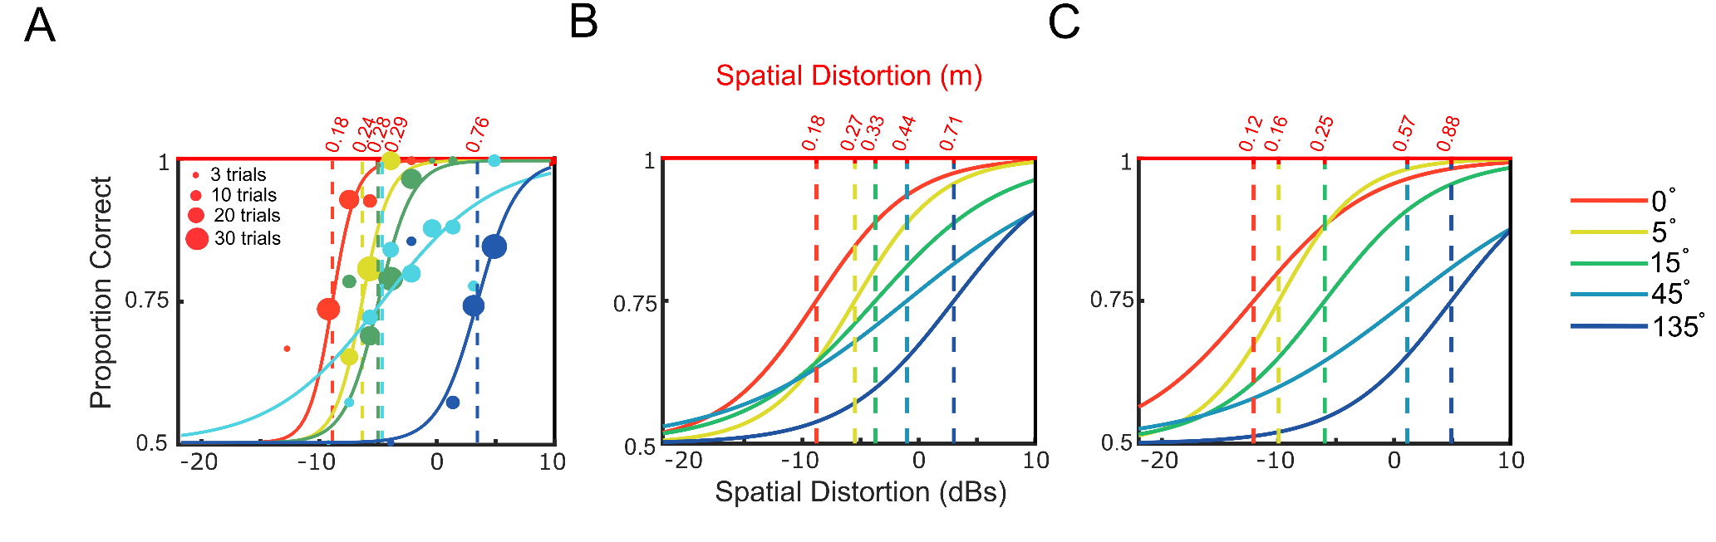
Figure 2 psychophysical sigmoid curves for each view condition. Different viewpoint conditions are shown as with different coloured curves as shown in the legend. A. Representative data from a single participant (Experiment 1). Circle symbols indicate proportion correct at a specific staircase level corresponding to spatial distortion applied (in dB relative to 0.5m, black x-axis, bottom), with the size of each circle indicates the number of trials recorded at that level. Dotted lines show the estimated threshold level at 75% performance (with the corresponding spatial distortion in metres, red x-axis, top). B, Experiment 1, Same/Different task, group average sigmoid curves (created by averaging fitted threshold and slope values for each condition (see also Table 1). C. 2AFC task, group average sigmoid curves.

Comparing monotonic ordering to chance
Since we had anticipated that these effects would be monotonic but likely non-linear in nature, we carried out an additional pre-planned permutation-based analysis to determine, for each experiment, whether there was a monotonic increase in threshold across increasing viewpoint shifts. Specifically, to determine whether the average Spearman’s correlation (over participants) was statistically significantly greater than would be expected under the null hypothesis (no monotonic relationship), we shuffled the threshold data from each participant (i.e., randomizing viewpoint labels) 10,000 times, calculating the cross-participant mean Spearman's correlation for each permutation, using the 95th percentile (single-tailed) of this distribution as the critical value in a comparison with the experimental results. We found that the observed non-parametric correlations were statistically significantly above chance in both experiments (Experiment 1: mean ρ observer = .94, mean ρ critical = .26, p<0.0001; Experiment 2: mean ρ observed = .95, mean ρ critical = .26, p<0.0001) indicating a consistent monotonic increase in thresholds with increases in viewpoint change.

Threshold differences between experiments
Using independent 2-tailed t-tests, we compared average threshold levels at each viewpoint between experiments (Table 2). We can see that there are significant differences between the thresholds measured in each method at the 0°, 5° and 135° conditions and no significant differences at 15° and 45°. Participants in the 2AFC task significantly outperformed those in the S/D task in the low viewpoint change conditions but performed significantly worse in the high viewpoint change condition.
Table 2, 2-tailed t-tests comparing thresholds obtained in Same/Different and 2AFC tasks for each viewpoint condition.
 | Fitted Threshold (dB)
 | Experiment 1 | Experiment 2
 | Same/Different | 2AFC
Viewpoint | Mean (SD) | Mean (SD) | df | t | p
0° | -8.81 (2.37) | -12.11 (2.99) | 18 | -2.73 | 0.014*
5° | -5.49 (2.53) | -9.94 (1.63) | 18 | -4.68 | 0.000**
15° | -3.73 (2.05) | -5.99 (2.96) | 18 | -1.98 | 0.063
45° | -1.02 (2.84) | 1.14 (3.1) | 18 | 1.62 | 0.122
135° | 3.01 (2.03) | 4.91 (1.68) | 18 | 2.27 | 0.036*

Effect of viewpoint on slope of psychometric function
Although we had no strong prior hypothesis concerning the effect of viewpoint on the slope of the psychometric function, we recorded and analysed these data (Figure 3) which give an indication of the way that the consistency of responses changes around the threshold, and might be interpreted in terms of participants’ certainty or uncertainty about judgements under different degrees of spatial distortion. Comparing these values using an exploratory repeated measures one-way ANOVA we found no statistically significant differences in either Experiment 1 or Experiment 2 (Experiment1: F(4,36) =2.08 (p = 0.10 ), Experiment 2: F(4,36) = 2.84 (p = 0.20)). However, the non-monotonic numerical pattern is strikingly similar in showing the shallowest slopes for the 45° condition in both experiments (a pattern which is also evident in Figure 2).
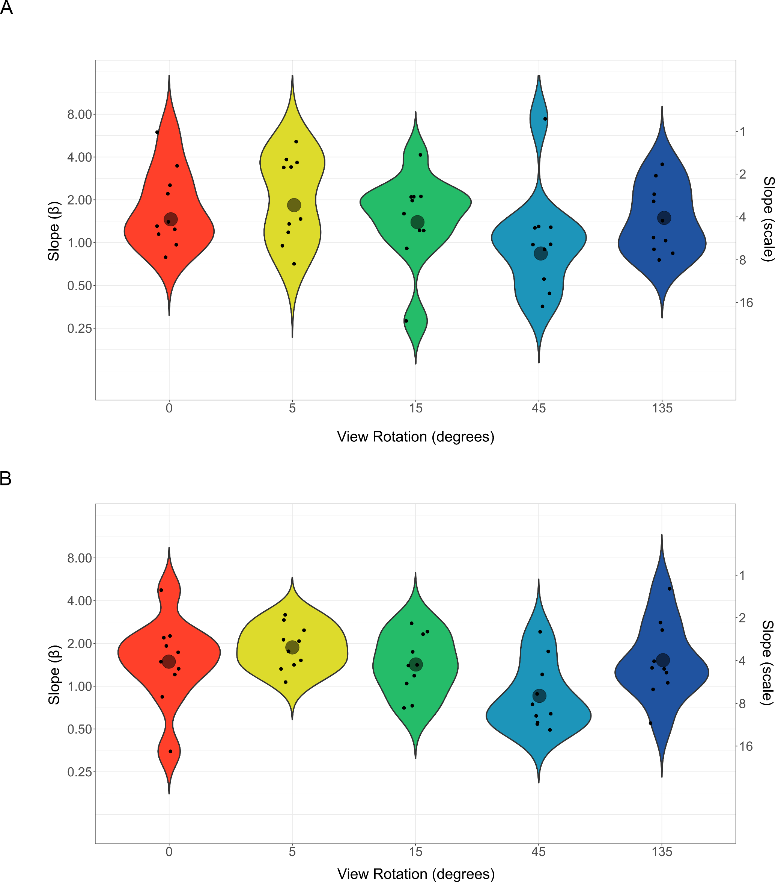
Figure 3, Distribution of estimated psychometric slope parameter as Weibull beta (left axis) and logistic scale (right axis). High beta values indicate steeper sloping sigmoid curves. Small points indicate individual participant estimates, larger grey circle indicates group geometric mean estimate for each condition. A Experiment 1. B Experiment 2.

Modelling spatial precision as a function of viewpoint shift
Across view conditions in both experiments, each participant reliably produced a similar pattern of results (see Figure 4). Spatial precision thresholds were lowest (i.e., performance was best) in the 0° viewpoint shift condition and increased monotonically as the angle between viewpoints at presentation and testing increased. Thresholds seemed to plateau beyond the 45° viewpoint shift. To quantify the relationship between view-dependent and view-independent contributions to the task, we modelled the relationship between spatial precision thresholds and viewpoint change conditions with a single function which we had preregistered (see https://osf.io/p6gzt/ and https://osf.io/j7a8p/). The model is defined as:
$f\left(θ\right)=a{\left(1-\frac{θ}{π}\right)}^{b}+c$ (2)
This function describes a family of curves relating spatial change detection thresholds to viewpoint change (see Figure 4). Its three parameters distinguish viewpoint specific, viewpoint-dependent and viewpoint-independent features; a governs the intercept with the y axis which represents the spatial precision in the 0° rotation condition (i.e., viewpoint-specific performance).; b determines the rate of change as viewpoint at test is rotated away from viewpoint at encoding for smaller viewpoint changes (i.e., viewpoint-dependent performance); c is the asymptote of the curve as the viewpoint change tends to 180°, (i.e., the viewpoint-independent limit of precision under large and unpredictable changes in perspective). Note that parameter a is always negative, reflecting the decrease in threshold seen at smaller viewpoint changes.
Although the model is intended primarily as a descriptive one, the arrangement of equation 2 is intend to highlight the way the model characterizes the view-threshold function in terms of the sum of two theoretically-motivated components, one, $a{\left(1-\frac{θ}{π}\right)}^{b}$, arising from a view-sensitive representation and the other, c, arising from a view-invariant representation.
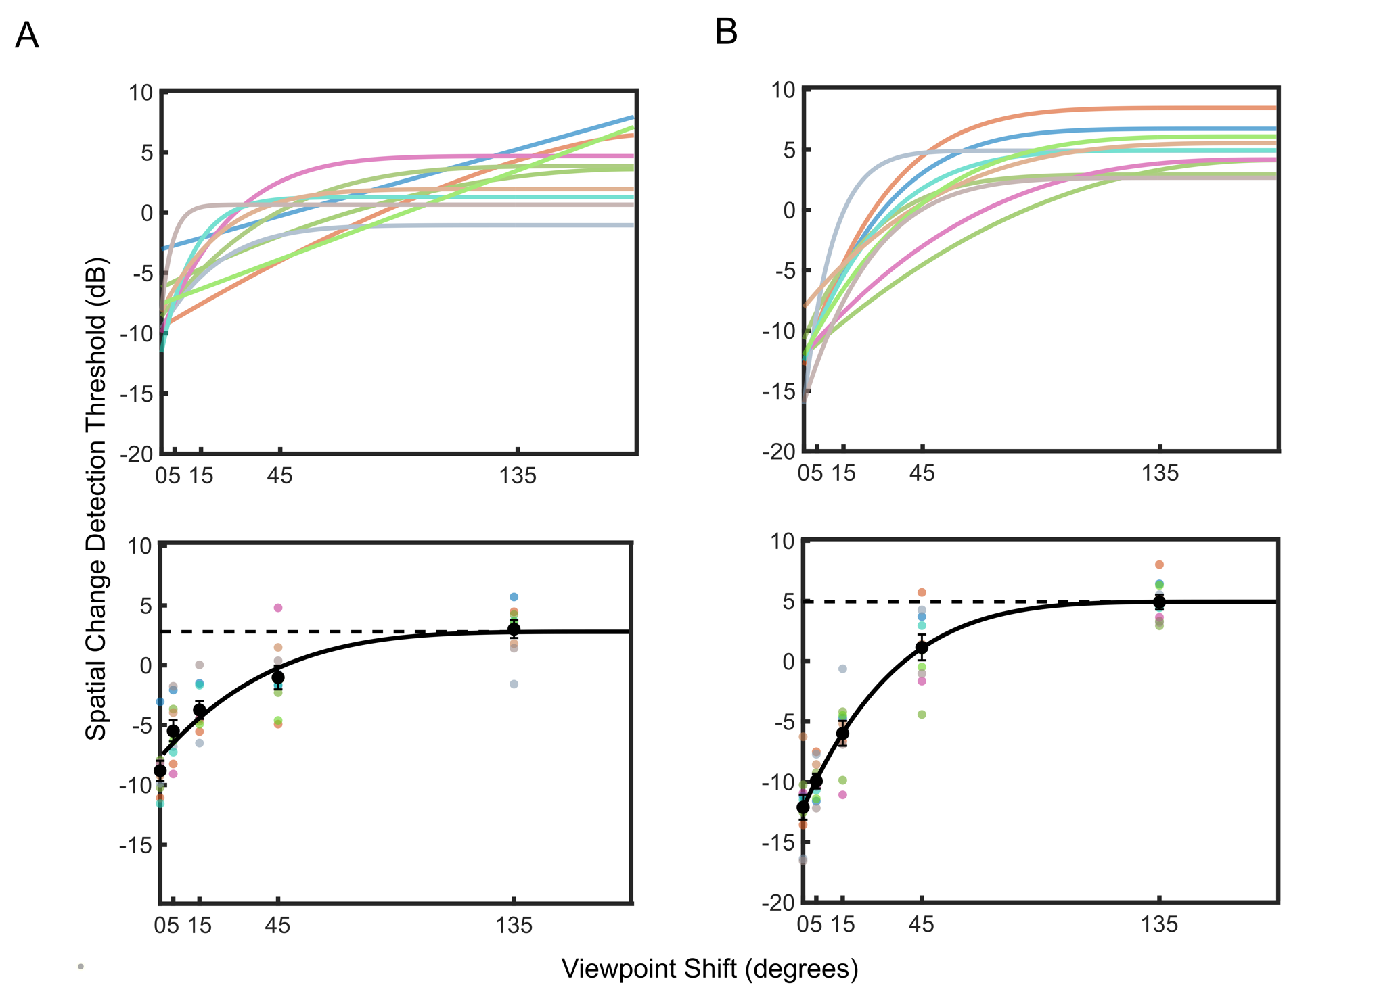Figure 4; Relationship between viewpoint shift and threshold in individual participants, data and fitted model (equation 2). A Experiment 1 (Same/Different task) B Experiment 2 (2AFC task). Upper graphs show the fitted model for each individual participant. Lower graphs show group average model fit (i.e., taking the mean parameter values over participants). Coloured points on the graph represent individual participant thresholds at each viewpoint, with the colour scheme corresponding to the curves in the upper panel. The dotted line represents the asymptotic plateau, the level of ability in the largest view rotation condition. This is described by parameter c in the fitted model.
Figure 4 shows the fit of the model to each individual participant’s thresholds (using ‘lsqcurvefit’ as implemented in Matlab ver. R2019a). Briefly, this involves varying parameters a, b and c systematically to find the curve that minimizes the sum (over viewpoints) of the squared distances between the observed data and the model.
In both experiments the model provides a reasonably good fit to the threshold data, although the fits in Experiment 1 are numerically poorer (Experiment 1: mean RMS error = 1.14 dB , Experiment 2: mean RMS error = 0.97 dB) and qualitatively, for three participants the fitted model suggests a nearly linear change, with the value of the b parameter approaching 1, deviating from the anticipated curve with asymptote. In direct comparison (Figure 5) we see statistically significant differences in the a parameter value between experiments (a; t(18) = -4.76 p < .001). However, there were no significant differences between experiments for parameters b or c (b; t(10.71) = -0.715 p > 0.05, c; t(18) = 0.23 p >0.05).
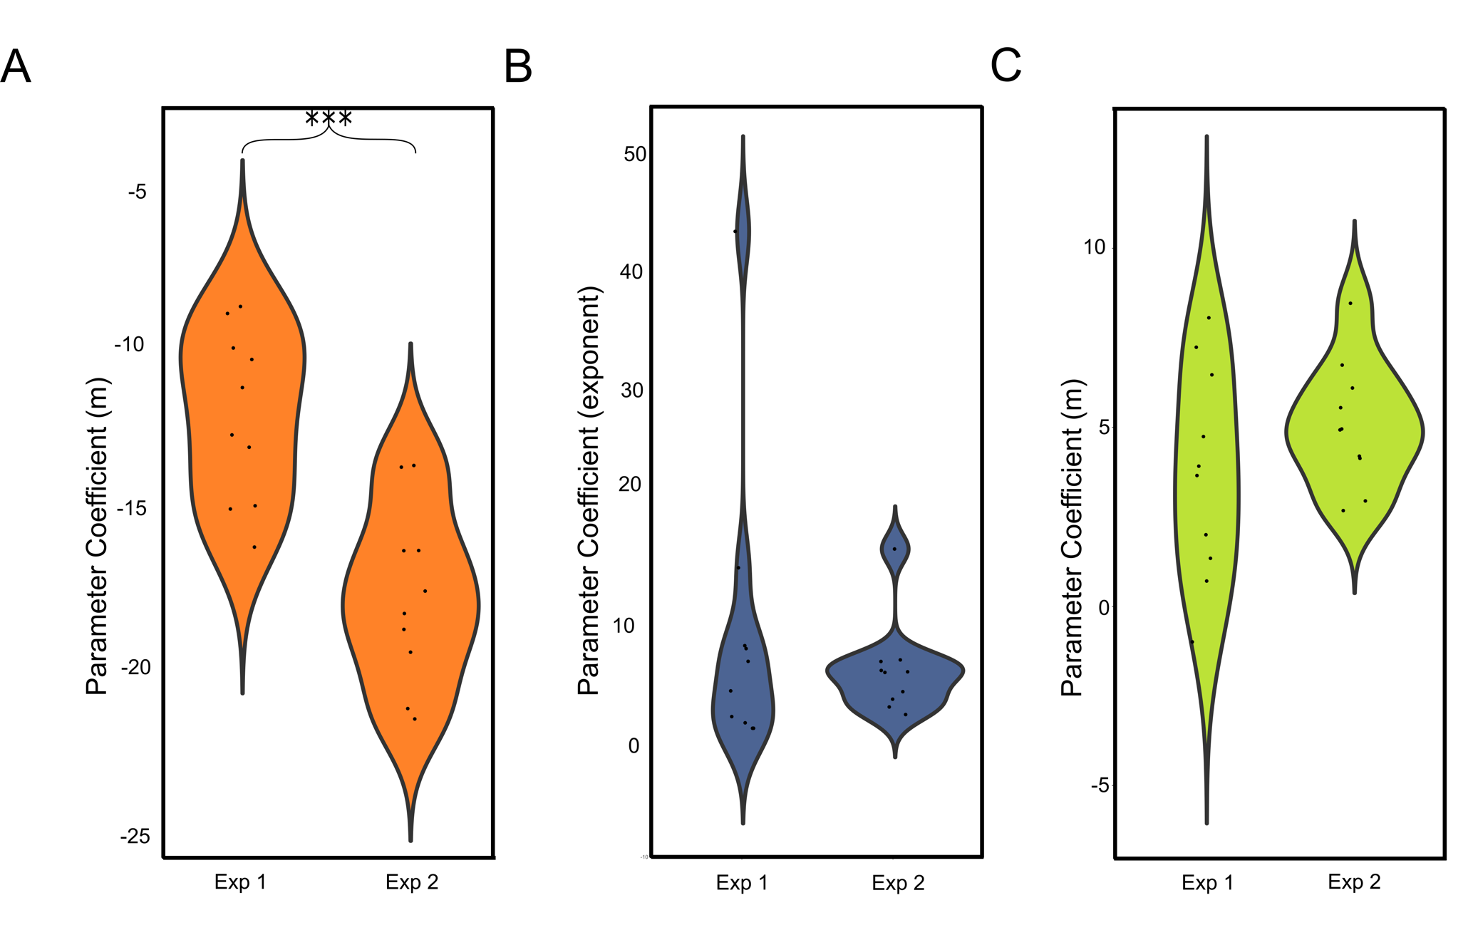Figure 5 Distribution of model parameters. Small black dots represent individual participant coefficients. From left to right graphs show parameters a, b and c. Parameter a determines the intercept – the threshold spatial ability when the position at encoding is the same as the position at testing. Parameter b, describes the rate of change between precision in low viewpoint rotation conditions to precision in high viewpoint rotation conditions. Parameter c defines the asymptotic threshold representing the viewpoint-independent limit of spatial precision. *** indicates a significant difference in the a parameter for experiments 1 and 2, p<0.001.

Discussion
Our aim in the current study was to elucidate the relationship between changes in viewpoint and the precision of spatial memory. In order to do this, we first needed to develop a new experimental paradigm with which we could measure spatial change detection thresholds for an array of objects in a virtual 3D space while manipulating the degree of viewpoint change between presentation and testing. We found that a psychometric function was an appropriate model for estimating performance in both a Same/Different (Experiment 1) and 2AFC tasks (Experiment 2). Using psychometric functions fit to participant data, wee were able to estimate spatial change detection thresholds in all conditions, showing that as viewpoint shift increased from 0° to 135°, thresholds increased monotonically but not linearly. In each task, participants required increasingly large changes to the location of a single object within an array before they could reliably detect the distortion. This pattern of results, present in all participants, and the curvilinear relationship between viewpoint shift and spatial change detection threshold was well described by a preregistered model that separated and parameterised viewpoint-specific, viewpoint-dependent and viewpoint-independent components.
In this account, the high precision of responses in conditions where the viewpoint is fixed between presentation and testing (0° rotation, described by parameter a in our model) results from the unimpeded operation of viewpoint-specific egocentric representations (such as view matching, see e.g., Waller & Hodgson, 2006). When the viewpoint remained unchanged participants could detect the movement of a single object within a four-item array as small as 17.4cm on average. As the viewpoint at testing rotated away from viewpoint at presentation, thresholds increase towards a plateau for viewpoint changes beyond 45° (rising to 78.7cm on average). The viewpoint-dependent decay in precision across increasing shifts in perspective (governed by parameter b in our model), is perhaps consistent with the operation of a mental rotation process for small viewpoint shifts which introduces an accumulating error. However, the plateau itself (described by parameter c in the model) does not appear to result from a process that transforms and manipulates purely egocentric representations, since in that case we might expect to see error continue to accumulate linearly for larger viewpoint shifts. Instead, we interpret it as the limit of viewpoint-independent performance supported by allocentric representations, when little to no valid contribution from egocentric spatial representations is available.
This task and analysis adds to the evidence that ego- and allocentric systems make distinct contributions to spatial working memory (e.g., Aagten-Murphy & Bays, 2019). Together they offer a means to distinguish and quantify these contributions, which may have applications in identifying and monitoring disorders that differentially affect the distinct brain systems that underpin memory for object locations, as well as in understanding individual differences in healthy people.

Comparison between tasks
Had there been no difference in the precision of memory representations in the two tasks then under assumptions in standard signal detection theory, we might still have expected to see a constant difference in the thresholds observed at each viewpoint. This is because the 2AFC task involves the comparison of two locations (each subject to noise/imprecision which is combined when generating responses) whereas the S/D task involves only a single location (for example see Makovski et al., 2010). However, our results show a different pattern: thresholds show a greater dynamic range as viewpoint is varied in the 2AFC task than in the S/D task. This we believe could be due to a combination of measurement issues (the S/D provides a noisier estimate of thresholds) and ecological factors (the S/D task is more effective in eliciting allocentric encoding strategies).
On the first point, we note that the 2AFC task is better suited to the use of a psychophysical staircase design, since it is possible to make a spatial change on every trial (each yielding valid information about the psychophysical function), whereas the interpretation of responses is ambiguous for Same trials in the S/D task.
On the second point, the S/D task has potentially greater ecological validity when estimating allocentric memory, in that participants are instructed to judge whether the entire array has changed (i.e., an explicitly allocentric judgement), whereas the 2AFC task encourages participants to pay attention to the individual objects (potentially at the expense of their allocentric relationships).
The comparison of Experiments 1 and 2 is consistent with a role for both factors in determining the threshold-viewpoint function. First, we were better able to fit performance in the 2AFC task (Experiment 2) with our model. This might reflect the benefit of using a less noisy method to elicit unambiguous psychophysical judgements. Second, the S/D task showed significantly higher spatial precision (i.e., lower change detection thresholds) in the most viewpoint-independent condition (135°), and significantly lower spatial precision in the two most viewpoint-dependent conditions (0° and 5°). Together with a significantly higher a parameter in our model (indicating somewhat reduced sensitivity to spatial changes in the 0° condition), these findings that are consistent with the idea that the S/D task encouraged greater use of allocentric encoding strategies. Overall, while the S/D task may afford strategies that allow for somewhat better performance under view-shift conditions, the 2AFC task appears to be better suited to rapid and reliable estimation of spatial precision and the greater dynamic range of the resulting threshold-viewpoint function may make it more suitable for distinguishing ego- and allocentric contributions in the presence of noise, although thresholds may not indicate maximum possible sensitivity to allocentric change. In similar vein, we should note that both tasks may favour allocentric strategies relative to everyday settings, in that the large majority of trials involve an unexpected change of viewpoint, which the participant can anticipate even if the size and direction of the change is unpredictable.

Additional findings
One interesting and unanticipated quirk of our results emerged from the analysis of the slope of psychometric functions across different viewpoint shifts. Although the differences in slopes observed in different viewpoint conditions did not reach statistical significance, the non-monotonic pattern of slopes is striking and in both experiments the shallowest slopes are seen in the 45 degree viewpoint condition (rather than the more extreme 0 degree or 135 degree conditions, see Figures 2 and 3). We speculate that this might reflect increased uncertainty resulting from conflict between ego- and allocentric systems, perhaps resolved through some form of Bayesian cue combination (see e.g., (Deneve & Pouget, 2004; Xu et al., 2017; Zhao & Warren, 2015); in this account, at much smaller viewpoint shifts responses would be dominated by high-precision egocentric information, and at much larger viewpoint shifts allocentric responses would be dominated by low-precision allocentric information, but at intermediate shifts, around 45° in the current tasks, the two systems would be in tension, providing conflicting influences on the response, and increasing uncertainty.
Another difference between view conditions was increasingly poorer fits to the psychophysical curve as viewpoint rotation increased. This noise indicates that our manipulation of spatial distortion did not account for as much variance in task performance. This may be due to the fact that with increasing viewpoint change, reorientation becomes increasingly reliant on cues related to the spatial configuration of the array (Sargent et al., 2008, 2010). Depending on the random configuration from one trial to the next, the configuration itself could impact on the success of accurate reorientation and recognition, independently of memory for the individual object locations.

Theoretical implications and conclusions
Overall, our data indicate that spatial change detection thresholds arise through a process combining a fixed, viewpoint-independent contribution and a view-dependent contribution that increases sensitivity to spatial changes for smaller shifts in viewpoint. In our descriptive model this combination is achieved by simply adding components corresponding to egocentric and allocentric contributions, but it is important to recognize that this additive description, while capturing the behavioural outcome, may not reflect the complexity of the underlying neural mechanisms. In particular, our model might suggest that ego- and allocentric representations contribute independently to behaviour, but at a mechanistic level this is unlikely because allocentric representations must ultimately be derived from egocentrically-encoded sensory information (Bicanski & Burgess, 2018; Byrne et al., 2007). This implies any task requiring viewpoint-independent representation can never be entirely process pure, and that limitations (e.g., noise, biases, spatial resolution) of the egocentric code must be inherited by the allocentric code whereas the converse does not apply for viewpoint-specific tasks. Any such limits will thus impose an “egocentric bottleneck”, at least affecting the initial encoding of allocentric information. It is conceivable that allocentric representations could be cleaned-up by integrating information from different cues (for example, in an allocentric representation, the information about the location of one object might serve to constrain the representation of another). A further consideration is that the process of translating between ego and allocentric representations at encoding and retrieval may itself impose limits on the precision of the underpinning representation. At a mechanistic level, the resolution of cue conflicts in behaviour (i.e., between responses driven by allo- and egocentric- representations) is likely to involve complex dynamic interactions between neurons representing different ego- and allocentric locations (c.f., Jeffery et al., 2016).
In short, a more complete understanding of ego- and allocentric contributions to spatial memory will depend on more detailed, mechanistic modelling of tasks like those we have developed. Our results provide some useful constraints on the behavioural predictions of such models. The methods provide a useful empirical technique for quantifying the precision of spatial memory for the locations of objects in virtual stimulus arrays and distinguishing ego- and allocentric contributions to precision which, our model indicates, respond lawfully to changes in 3D viewpoint.

References
Aagten-Murphy, D., & Bays, P. M. (2019). Independent working memory resources for egocentric and allocentric spatial information. PLOS Computational Biology, 15(2), e1006563. https://doi.org/10.1371/journal.pcbi.1006563
Alvarez, G. A., & Cavanagh, P. (2004). The capacity of visual short-term memory is set both by visual information load and by number of objects. Psychol. Sci., 15(2), 106–111. https://doi.org/10.1111/j.0963-7214.2004.01502006.x
Awh, E., Barton, B., & Vogel, E. K. (2007). Visual working memory represents a fixed number of items regardless of complexity. Psychol. Sci., 18(7), 622–628. https://doi.org/10.1111/j.1467-9280.2007.01949.x
Bays, P. M., & Husain, M. (2008). Dynamic Shifts of Limited Working Memory Resources in Human Vision. Science, 321(5890), 851–854. https://doi.org/10.1126/science.1158023
Bays, Paul M, G., C., Raquel F., & Husain, M. (2009). The precision of visual working memory is set by allocation of a shared resource. Journal of Vision, 9(10). https://jov.arvojournals.org/article.aspx?articleid=2122354
Bicanski, A., & Burgess, N. (2018). A neural-level model of spatial memory and imagery. Elife, 7. https://doi.org/10.7554/eLife.33752
Brady, T. F., & Alvarez, G. A. (2015). No evidence for a fixed object limit in working memory: Spatial ensemble representations inflate estimates of working memory capacity for complex objects. Journal of Experimental Psychology: Learning, Memory, and Cognition, 41(3), 921–929. https://doi.org/10.1037/xlm0000075
Brady, T. F., Konkle, T., & Alvarez, G. A. (2011). A review of visual memory capacity: Beyond individual items and toward structured representations. J. Vis., 11(5), 4. https://doi.org/10.1167/11.5.4
Burgess, N. (2006). Spatial memory: How egocentric and allocentric combine. Trends Cogn. Sci., 10(12), 551–557. https://doi.org/10.1016/j.tics.2006.10.005
Burgess, N. (2008). Spatial Cognition and the Brain. Annals of the New York Academy of Sciences, 1124(1), 77–97. https://doi.org/10.1196/annals.1440.002
Burgess, N., Spiers, H. J., & Paleologou, E. (2004). Orientational manoeuvres in the dark: Dissociating allocentric and egocentric influences on spatial memory. Cognition, 94(2), 149–166. https://doi.org/10.1016/j.cognition.2004.01.001
Byrne, P., Becker, S., & Burgess, N. (2007). Remembering the past and imagining the future: A neural model of spatial memory and imagery. Psychol. Rev., 114(2), 340–375. https://doi.org/10.1037/0033-295X.114.2.340
Deneve, S., & Pouget, A. (2004). Bayesian multisensory integration and cross-modal spatial links. Journal of Physiology-Paris, 98(1), 249–258. https://doi.org/10.1016/j.jphysparis.2004.03.011
Diwadkar, V. A., & McNamara, T. P. (1997). Viewpoint Dependence in Scene Recognition. Psychol. Sci., 8(4), 302–307. https://doi.org/10.1111/j.1467-9280.1997.tb00442.x
Easton, R. D., & Sholl, M. J. (1995). Object-array structure, frames of reference, and retrieval of spatial knowledge. J. Exp. Psychol. Learn. Mem. Cogn., 21(2), 483–500. https://doi.org/10.1037//0278-7393.21.2.483
Ekstrom, A. D., Arnold, A. E. G. F., & Iaria, G. (2014). A critical review of the allocentric spatial representation and its neural underpinnings: Toward a network-based perspective. Frontiers in Human Neuroscience, 8. https://doi.org/10.3389/fnhum.2014.00803
Galati, G., Lobel, E., Vallar, G., Berthoz, A., Pizzamiglio, L., & Le Bihan, D. (2000). The neural basis of egocentric and allocentric coding of space in humans: A functional magnetic resonance study. Exp. Brain Res., 133(2), 156–164.
Goodale, M. A., & Milner, A. D. (1992). Separate visual pathways for perception and action. Trends Neurosci., 15(1), 20–25.
Greenauer, N., & Waller, D. (2008). Intrinsic array structure is neither necessary nor sufficient for nonegocentric coding of spatial layouts. Psychonomic Bulletin & Review, 15(5), 1015–1021. https://doi.org/10.3758/PBR.15.5.1015
Hartley, Tom, Lever, C., Burgess, N., & O’Keefe, J. (2014). Space in the brain: How the hippocampal formation supports spatial cognition. Philos. Trans. R. Soc. Lond. B Biol. Sci., 369(1635), 20120510. https://doi.org/10.1098/rstb.2012.0510
Holmes, C. A., Newcombe, N. S., & Shipley, T. F. (2018). Move to learn: Integrating spatial information from multiple viewpoints. Cognition, 178, 7–25. https://doi.org/10.1016/j.cognition.2018.05.003
Holmes, M. C., & Sholl, M. J. (2005). Allocentric Coding of Object-to-Object Relations in Overlearned and Novel Environments. Journal of Experimental Psychology: Learning, Memory, and Cognition, 31(5), 1069–1087. https://doi.org/10.1037/0278-7393.31.5.1069
Jeffery, K. J., Page, H. J. I., & Stringer, S. M. (2016). Optimal cue combination and landmark-stability learning in the head direction system. The Journal of Physiology, 594(22), 6527–6534. https://doi.org/10.1113/JP272945
Jiang, Y., Olson, I. R., & Chun, M. M. (2000). Organization of visual short-term memory. J. Exp. Psychol. Learn. Mem. Cogn., 26(3), 683–702.
Kass, R. E., & Raftery, A. E. (1995). Bayes Factors. Journal of the American Statistical Association, 90(430), 773–795. JSTOR. https://doi.org/10.2307/2291091
King, J. A., Burgess, N., Hartley, T., Vargha-Khadem, F., & O’Keefe, J. (2002). Human hippocampus and viewpoint dependence in spatial memory. Hippocampus, 12(6), 811–820. https://doi.org/10.1002/hipo.10070
Lambrey, S., Doeller, C., Berthoz, A., & Burgess, N. (2012). Imagining Being Somewhere Else: Neural Basis of Changing Perspective in Space. Cerebral Cortex, 22(1), 166–174. https://doi.org/10.1093/cercor/bhr101
Luck, S J, & Vogel, E. K. (1997). The capacity of visual working memory for features and conjunctions. Nature, 390(6657), 279–281. https://doi.org/10.1038/36846
Luck, S. J., Hillyard, S. A., Mouloua, M., Woldorff, M. G., Clark, V. P., & Hawkins, H. L. (1994). Effects of spatial cuing on luminance detectability: Psychophysical and electrophysiological evidence for early selection. Journal of Experimental Psychology: Human Perception and Performance, 20(4), 887–904. https://doi.org/10.1037/0096-1523.20.4.887
Luck, Steven J, & Vogel, E. K. (2013). Visual working memory capacity: From psychophysics and neurobiology to individual differences. Trends Cogn. Sci., 17(8), 391–400. https://doi.org/10.1016/j.tics.2013.06.006
Ma, W. J., & Wilken, P. (2004). A signal detection account of visual short-term memory for orientation and spatial frequency. J. Vis., 4(8), 389–389. https://doi.org/10.1167/4.8.389
Makovski, T., Watson, L. M., Koutstaal, W., & Jiang, Y. V. (2010). Method matters: Systematic effects of testing procedure on visual working memory sensitivity. Journal of Experimental Psychology. Learning, Memory, and Cognition, 36(6), 1466–1479. https://doi.org/10.1037/a0020851
Moodley, K., Minati, L., Contarino, V., Prioni, S., Wood, R., Cooper, R., D’Incerti, L., Tagliavini, F., & Chan, D. (2015). Diagnostic differentiation of mild cognitive impairment due to Alzheimer’s disease using a hippocampus-dependent test of spatial memory. Hippocampus, 25(8), 939–951. https://doi.org/10.1002/hipo.22417
Mou, W., & McNamara, T. P. (2002). Intrinsic frames of reference in spatial memory. J. Exp. Psychol. Learn. Mem. Cogn., 28(1), 162–170.
Mou, W., McNamara, T. P., Rump, B., & Xiao, C. (2006). Roles of egocentric and allocentric spatial representations in locomotion and reorientation. J. Exp. Psychol. Learn. Mem. Cogn., 32(6), 1274–1290. https://doi.org/10.1037/0278-7393.32.6.1274
Negen, J., Heywood-Everett, E., Roome, H. E., & Nardini, M. (2018). Development of allocentric spatial recall from new viewpoints in virtual reality. Dev. Sci., 21(1). https://doi.org/10.1111/desc.12496
Newcombe, N., & Huttenlocher, J. (1992). Children’s early ability to solve perspective-taking problems. Developmental Psychology, 28(4), 635–643. https://doi.org/10.1037/0012-1649.28.4.635
Sargent, J., Dopkins, S., Philbeck, J., & Chichka, D. (2010). Chunking in spatial memory. J. Exp. Psychol. Learn. Mem. Cogn., 36(3), 576–589. https://doi.org/10.1037/a0017528
Sargent, J., Dopkins, S., Philbeck, J., & Modarres, R. (2008). Spatial memory during progressive disorientation. J. Exp. Psychol. Learn. Mem. Cogn., 34(3), 602–615. https://doi.org/10.1037/0278-7393.34.3.602
Schmidt, D., Krause, B. J., Weiss, P. H., Fink, G. R., Shah, N. J., Amorim, M.-A., Müller, H.-W., & Berthoz, A. (2007). Visuospatial working memory and changes of the point of view in 3D space. NeuroImage, 36(3), 955–968. https://doi.org/10.1016/j.neuroimage.2007.03.050
Shelton, A. L., & McNamara, T. P. (2001). Systems of spatial reference in human memory. Cogn. Psychol., 43(4), 274–310. https://doi.org/10.1006/cogp.2001.0758
Simons, D. J., & Wang, R. F. (1998). Perceiving Real-World Viewpoint Changes. Psychol. Sci., 9(4), 315–320. https://doi.org/10.1111/1467-9280.00062
Spiers, H. J., Burgess, N., Maguire, E. A., Baxendale, S. A., Hartley, T., Thompson, P. J., & O’Keefe, J. (2001). Unilateral temporal lobectomy patients show lateralized topographical and episodic memory deficits in a virtual town. Brain, 124(Pt 12), 2476–2489.
Tu, S., Spiers, H. J., Hodges, J. R., Piguet, O., & Hornberger, M. (2017). Egocentric versus Allocentric Spatial Memory in Behavioral Variant Frontotemporal Dementia and Alzheimer’s Disease. Journal of Alzheimer’s Disease, 59(3), 883–892. https://doi.org/10.3233/JAD-160592
Wagenmakers, E.-J. (2007). A practical solution to the pervasive problems ofp values. Psychonomic Bulletin & Review, 14(5), 779–804. https://doi.org/10.3758/BF03194105
Waller, D., & Hodgson, E. (2006). Transient and enduring spatial representations under disorientation and self-rotation. J. Exp. Psychol. Learn. Mem. Cogn., 32(4), 867.
Wang, R. F., & Simons, D. J. (1999). Active and passive scene recognition across views. Cognition, 70(2), 191–210.
Wraga, M., Creem, S. H., & Proffitt, D. R. (2000). Updating displays after imagined object and viewer rotations. Journal of Experimental Psychology: Learning, Memory, and Cognition, 26(1), 151–168. https://doi.org/10.1037/0278-7393.26.1.151
Wraga, M., Shephard, J. M., Church, J. A., Inati, S., & Kosslyn, S. M. (2005). Imagined rotations of self versus objects: An fMRI study. Neuropsychologia, 43(9), 1351–1361. https://doi.org/10.1016/j.neuropsychologia.2004.11.028
Xu, Y., Regier, T., & Newcombe, N. S. (2017). An adaptive cue combination model of human spatial reorientation. Cognition, 163, 56–66. https://doi.org/10.1016/j.cognition.2017.02.016
Zhang, H., Mou, W., & McNamara, T. P. (2011). Spatial updating according to a fixed reference direction of a briefly viewed layout. Cognition, 119(3), 419–429. https://doi.org/10.1016/j.cognition.2011.02.006
Zhao, M., & Warren, W. H. (2015). How You Get There From Here: Interaction of Visual Landmarks and Path Integration in Human Navigation. Psychological Science, 26(6), 915–924. https://doi.org/10.1177/0956797615574952

Supplementary Materials for
Testing the precision of spatial memory representations using a change-detection task: Effects of viewpoint change
Edward Heywood-Everett, Daniel H. Baker, Tom Hartley*

Calculation of decibel values
The following function is used to convert distances in meters into equivalent decibel values:
$$C_{dB}=20 × \log_{10}(\frac{C}{C_{0}})$$
$C_{dB}$ = spatial change (distortion) in decibels.
C = spatial change (distortion) in this trial in meters.
$C_{0 }$= 0.5 This is the decibel reference value (ie 0dB = 0.5m). We chose to use 0.5m as during the pilot testing this corresponds to an approximately average level of performance in the task.

Bayes Factors
 | Experiment 1: Bayes Factors
Participant | 0° | 5° | 15° | 45° | 135°
1 | 1438.60 | 2.60 | 2.80 | 1.24 | 2.44
3 | 34.97 | 39.17 | 398.24 | 4.05 | 4.86
4 | 17.59 | 1132.60 | 187.60 | 8.30 | 1.58
5 | 44.63 | 8.69 | 21.47 | 3.15 | 20.94
6 | 321.09 | 16788.18 | 113.54 | 4992.62 | 283.73
7 | 206.45 | 37.22 | 65.57 | 1.43 | 6.00
8 | 40.06 | 11.85 | 1.26 | 6.08 | 3.62
10 | 52.44 | 524.06 | 9.67 | 2.78 | 3.55
12 | 379077.36 | 20222.15 | 5807.40 | 22.44 | 54.66
13 | 5.86 | 224.65 | 35.37 | 4.38 | 1.72
 | Experiment 2: Bayes Factors
Participant | 0° | 5° | 15° | 45° | 135°
14 | 7372.55 | 1035.91 | 53.85 | 320.58 | 31.37
16 | 387.10 | 1071.41 | 685.07 | 11.52 | 2.43
17 | 251.09 | 140646.86 | 434.50 | 152.98 | 75.40
18 | 58090.18 | 9367.31 | 7399.87 | 41.55 | 123.90
20 | 4.02 | 245.11 | 1092.20 | 36.98 | 17.90
22 | 6404.80 | 208.10 | 28.47 | 15.04 | 21.42
25 | 3684.98 | 2929.09 | 718.48 | 7.21 | 276.54
26 | 89774.44 | 124531.04 | 226.03 | 120.42 | 60.58
27 | 5748.44 | 374.87 | 53420.57 | 3.68 | 12.73
29 | 55.77 | 36668.24 | 3002.64 | 30.06 | 110.69
Table S2 showing Bayes factors for each participant/condition in Experiment 1 and Experiment 2 respectively. These describe a likelihood ratio of two different models: a model described by the null hypothesis (model 0) - a constant level of performance unaffected by the amount of spatial distortion, and the experimental hypothesis (model 1) i.e., that the data are described by a psychophysical ogive. The Bayes Factor (BF₁₀) describes the likelihood of model 1/model 0 given the data. Kass and Rafferty (1995) classify the likelihood strength based on this value as follows,${BF}_{10}$ = 1-3.2 : ‘Barely worth mentioning’, 3.2-10 : ‘Substantial’, 10-100 : ‘Strong’, >100 : ‘Decisive’.

Experiment 2: Same/Different Task D prime analysis
In order to facilitate comparisons between results from the Same/Different task and the 2AFC task, we chose to calculate thresholds using proportion correct and fitting psychometric curves in both tasks (see methods/results sections). This is a fairly typical analysis for yes/no type experiments when used in conjunction with staircases. However, it involves calculating proportion correct by binning responses according to the current staircase level. This makes the treatment of Same trials somewhat ambiguous because there is no spatial distortion in the stimulus itself to make the participant aware of the current level of the active staircase in intermixed trials.
To account for possible response bias we calculated a d’ value for each participant in each condition. This involved calculating a z-score across all of the false alarm target absent (Same) trials for a given viewpoint condition (around 50% of all trials), and subtracting this from the z-scores for the hit rates of each target present (Different) condition (e.g. staircase level of spatial distortion). This showed an appropriate range of d’ scores over the testing range. Participants’ d’ scores were higher at higher staircase levels, meaning that the stimulus was easier to differentiate from noise when there was a larger spatial distortion. Consistent with our main analysis (see Figure 2), increasing viewpoint rotation shifted the d’ functions rightwards, meaning that a greater spatial distortion was required to reach a given performance level.
We also calculated each participant’s response criterion across the testing range as the mean of the summed z-scores (C = -(z(hit) + z(FA))/2). However, given that the false alarm rate is constant across all staircase levels (because we pooled data from all target absent trials), these functions are effectively inverted d’ scores and are therefore not informative (see lower row of Figure S1). This is one reason why proportion correct values are typically presented when using staircase designs, as we have done here in our main analysis.

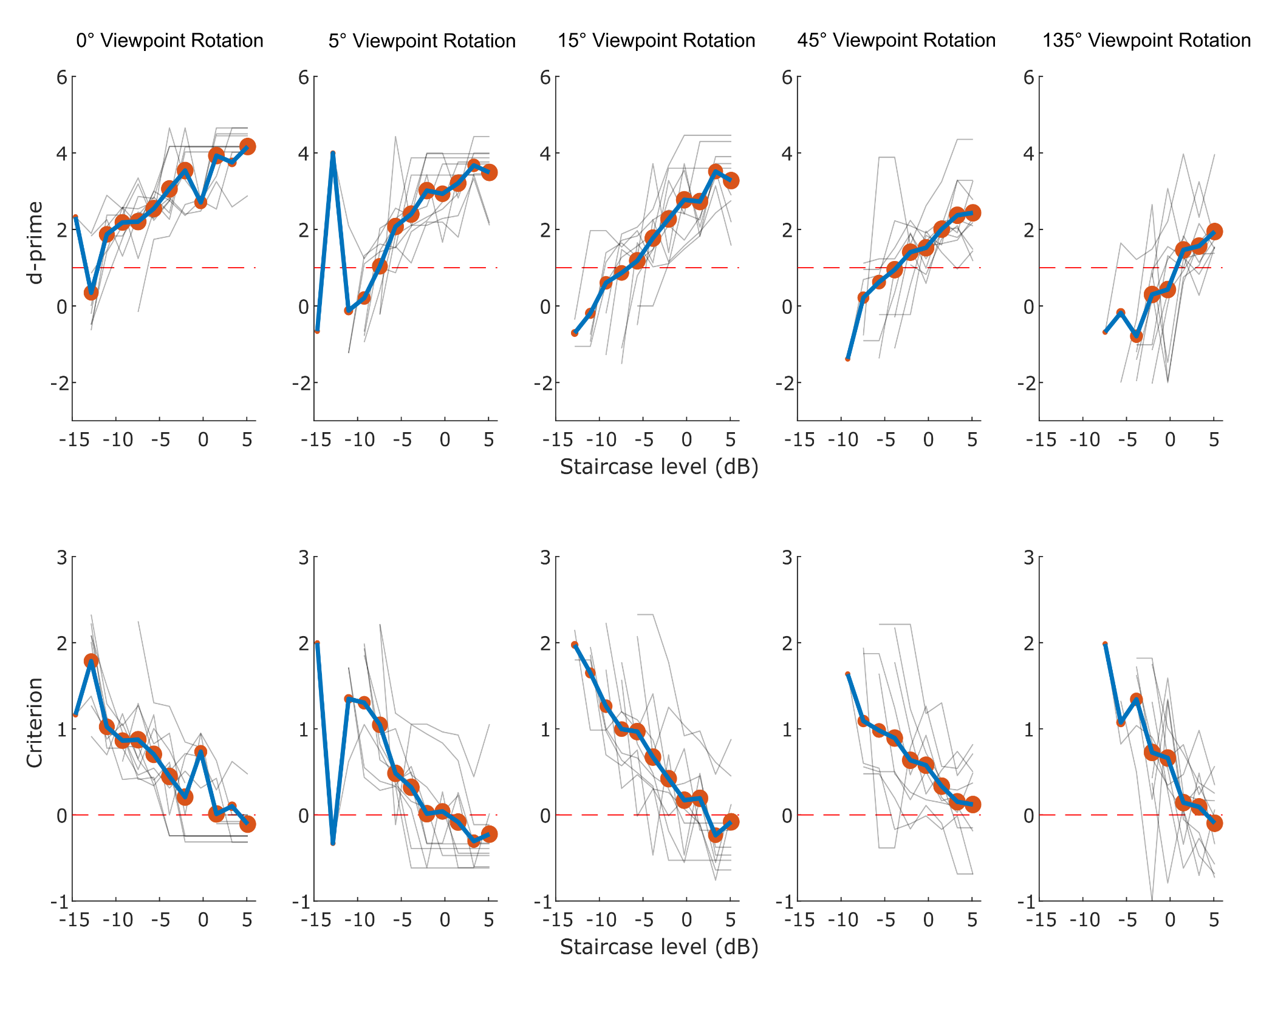
Figure S3, showing levels of d’ (top) and response criterion (bottom) in each participant (faded grey line). The circles show the mean level of d’ and criterion respectively, averaged across all data points for each staircase level tested. Circle size represents number of data points. The bold line is a line plotted through these points.

