Sustainable single-stage solid-liquid extraction of hesperidin and rutin from agro-products using Cyrene®

Roxana Alina Milescu,¹ Mateus Lodi Segatto,² Aylon Stahl,² Con Robert McElroy,¹ Thomas James Farmer,¹ James Hanley Clark^{1*} and Vânia Gomes Zuin^{1,2.3*}
¹ Green Chemistry Centre of Excellence, Department of Chemistry, University of York, Heslington, North Yorkshire, YO10 5DD, United Kingdom
² Institute of Sustainable and Environmental Chemistry, Leuphana University Lüneburg, Universitätsallee 1, C13.204, Lüneburg, Germany
³ Department of Chemistry, Federal University of São Carlos, Rod. Washington Luís, km 235, São Carlos, 13565-905, Brazil
* Corresponding author: vania.zuin@leuphana.de
* Corresponding author: james.clark@york.ac.uk

Abstract
Hesperidin and rutin are two sought-after natural flavonoids, traditionally extracted from abundant natural citrus fruits and tea leaves using large amounts of ethanol or methanol solvent. Recent trends in extractions have focused on minimising the use solvent and creating simpler cost-effective processes. This study aims to apply the concept of chemical valorisation in the context of a circular economy, by using agro-industrial waste and bio-based alternatives to traditional solvents which are of environmental concern. We use minimum amounts of solvent/sample (5 mL/0,25 or 0.5 g) to extract the hesperidin and rutin in a single-stage solid-liquid extraction. Thirty individual solvents and HSPiP were applied to find the best solvents/blends for extraction. The type of solvent, sample preparation, maceration time and extraction temperature were studied. Results showed that the bio-based solvent Cyrene® is very effective when mildly heated to 65 ºC (up to 91%) or mixed with water. Adding water to Cyrene forms its geminal diol hydrate, this enhancing the solubility and extraction of hesperidin and rutin up to ten times than of the original pure ketone form. Quantitative sustainability metrics from the CHEM21 Toolkit demonstrated our extraction methodology is both environmentally friendly and offers future potential of isolation of other flavonoids.

Keywords: Cyrene®, sustainable extraction, green chemistry, sustainable chemistry, circular economy, solid-liquid extraction

Introduction
The 17 UN Sustainable Development Goals propose prosperity while tackling climate change and environmental protection.¹ ‘’Zero hunger’’ and ‘’no poverty’’ goals go hand-in-hand with ‘’responsible consumption and production’’ and could be achieved by an increase in agricultural productivity, sustainable food production and preventing or minimizing food waste. Simply disposing of food waste is neither green nor sustainable nor is it an efficient way to manage this resource.¹ Currently, food waste is either used as animal feed, ploughed back into the land, incinerated, composted, sent to anaerobic digestion and/or fermentation or disposed of in the landfill in many countries.² The scale on which the food loss takes place is dependent on several factors that are individual to each country, region and type of agro-product. While in developed countries, food residues are caused mainly by commercial and consumer behaviour, agriculture-based countries such as Brazil have a substantial fraction of losses generated in food production, much of which consists of unavoidable waste.³ Nowadays food-associated industries are challenged to be more ecological, economical and innovative. Considering the movement towards sustainable development, led by UN’s Sustainable Development Goals, informed and monitored by Green and Sustainable Chemistry,⁴ potential arises from the use of unavoidable food residues in a sustainable chemical environment.⁵ The concept of waste biorefineries integrated into food processing factories to increase value within the food supply chain is one that is gaining interest. The Circular Economy Action Plan of European Commission proposes to revise the EU waste directive to better reflect the requirements of a circular economy and establish a waste hierarchy: prevention, reuse, recycling, recovery and disposal.⁶ Food residues contain several substances that can be used within or exterior to the food chain, especially biopolymers, platform chemicals and bioactive compounds.⁷ The extraction and formulation of biologically active substances from natural matrices have been garnering attention due to an increase in the demand on novel health-enhancing products, as well as preservatives for food and packaging industries.⁸ The Green Chemistry principles⁹ and the Principles of Green Natural Product Extraction¹⁰ promote the use of renewable feedstocks and bio-solvents in sustainable extractions. Such principles and activities aid in meeting the challenges of the 21st century, to protect both environment and consumers. ‘’Green extraction is based on the discovery and design of extraction processes which will reduce energy consumption, allow the use of alternative solvents and renewable natural products, and ensure a safe and high-quality extract/product”.¹⁰ The authors have sought to define the green extract as ‘’obtained in such a way to have the lowest possible impact on the environment and whose eventual recycling would have been planned for (co-products, biodegradability)’’.¹⁰
Brazil is the world leader in citrus production, with a corresponding associated citrus waste of 9.4 million tons per annum.¹¹ This is principally from activities such as juicing the fruit, resulting in 50 wt% waste.¹² Citrus peel waste represents a renewable feedstock for chemicals such as the solvents d-limonene and p-cymene, as well as pectin, cellulose, bio-oil, sugars and flavonoids, such as hesperidin. Hesperidin can be found in a higher concentration in the citrus peels more than in juice or seeds^{13, 14} and presents inhibitory effect against the development of neurodegenerative diseases such as Parkinson’s, Alzheimer’s, Huntington’s diseases,^{15, 16} cardiovascular diseases and others, due to its anti-inflammatory, antioxidant, lipid-lowering and insulin-sensitizing properties.^{17, 18} Hesperidin has a strong affinity to the main viral and cellular targets outperforming antiviral drugs chloroquine (relatively toxic in high doses) and hydroxychloroquine (less toxic than chloroquine, but presents side effect of retinopathy).¹⁹ This could indicate hesperidin as a very promising prophylaxis and treatment drug for COVID-19 and its mutations, attracting a lot of recent interest.¹⁹⁻²²
Like citrus, another globally consumed agro-product is tea, which had total worldwide production of 6.3 Mtons (2018).²³ Green and black tea crops consist 98% of Camellia sinensis, a species that contain compounds such as catechins, quinic acid, kaempferol and derivatives of quercetin, like rutin.²⁴ This flavonoid is useful in the treatment of vascular diseases (e.g. haemorrhoids, internal bleedings and varicose veins) and has potential to act as an antioxidant.²⁵ Rutin has also been indicated recently as a potential SARS-CoV-2 inhibitor.^{26, 27} However, the major drawback associated with both hesperidin and rutin is their poor bioavailability because of their low aqueous solubility, limited membrane permeability or poor stability in an acidic environment.^{28, 29}
Extracting hesperidin and rutin from plant sources has been demonstrated by conventional methods such as solid-solvent extraction,³⁰⁻³³ or Soxhlet extraction^{34,35} and non-conventional extraction procedures: microwave-assisted extraction,³⁶ ³⁷ ultrasound-assisted extraction,³⁸ solar hydro-distillation,³⁹ enzymes⁴⁰ and sCO₂.^{41, 42} Among these processes, solid-liquid extraction is most common and is generally used as a reference against which to benchmark newly developed methodologies. Solid-liquid extraction represents the process where a solute is extracted using a liquid (maceration). The liquid enriches with active compounds (based on osmosis) and disperses into the liquid via diffusion.⁴³ The main objective of a solid-liquid extraction is to extract the maximum amount of the active compounds in the minimal volume of solvent. Generally, a single-stage extraction can not meet these conditions and a repeated (multistage) extraction is used.⁴⁴ In many cases, large amounts of solvent are needed in multi-stage extractions and the yields of bioactive products obtained are low.⁴⁵ One of the goals to increase the extraction yield is raising the solvent capacity to dissolve the compound of interest by changing temperature or mixing solvents. Extraction yield of any substance depends on solubility, therefore the choice of solvents used in extraction experiments must be performed according to analyte’s physical-chemical properties. Ethanol and methanol are most frequently used in organic solid-liquid extractions of hesperidin and rutin due to their availability and low cost. ^{28, 33, 46, 47} Ethanol is highly flammable, volatile and causes serious eye irritation. Methanol is also volatile and flammable yet more toxic than ethanol, causing kidney failure, permanent blindness by destructing the optic nerve and even death.⁴⁸ Using the CHEM21 green solvent guide, methanol is ranked by CHEM21 as ‘’recommended’’, despite its health issues, because the current occupational exposure limits for methanol are relatively high.⁴⁹ Ethanol and methanol are ranked as ‘’problematic’’ when they were scored for their safety, both of them being highly flammable. However, a ‘’recommended’’ overall score was given when the other scoring systems (health and environment) were considered. Cyrene is ranked as ‘’problematic’’ due to its high boiling point which means that Cyrene’s recycling is energy intensive.
The needs of modern society are protected by constantly revised chemical legislation and the EU’s regulation, REACH, which are adapted to identify and restrict the toxic or environmentally hazardous substances.⁵⁰ Current regulations are urging industries to use bio-based solvents because they have low toxicity, they are environmentally benign and therefore classified as green solvents. When a bio-based solvent is used, the cycle of bio-based carbon is closed: at the end of life, if not recycled, these biobased compounds are usually incinerated or lost to the atmosphere as carbon dioxide, which in turn is fixed during photosynthesis, allowing for the carbon to be reincorporated back into bio-based solvents.⁶ In this study, we use a wide range of solvents, from alcohols to polar aprotic solvents and water and aim to find the solvent with a high yield and also environmentally friendly. In this study, we use for the first time the bio-based polar aprotic solvent Cyrene® in a solid-liquid extraction of hesperidin and rutin from citrus waste and tea leaves. Dihydrolevoglucosenone, Cyrene®, was first reported as a solvent by GCCE, University of York, UK in 2014⁵¹ and is produced from cellulose, via levoglucosenone (Figure 1)⁵¹ using the highly selective Furacell™ process.⁵²
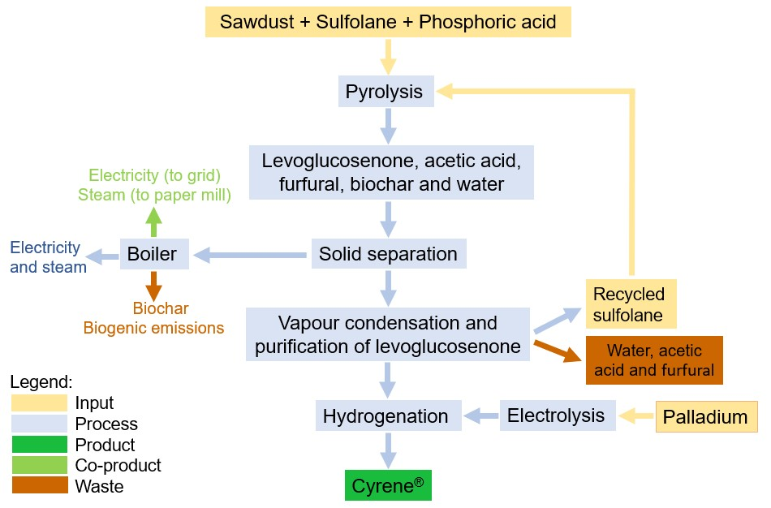
Figure 1 - Scheme to manufacture Cyrene® using Furacell™ process. Adapted with permission from Richardson, D. E.; Raverty, W. D., Predicted environmental effects from liquid emissions in the manufacture of levoglucosenone and Cyrene (TM). Appita 2016, 69 (4), 344-351 and J. Mellentine, A. DeVierno, L.N. Grice, J. Whitford, Turning lignocellulose waste into solvent with lower carbon footprint, 252nd American Chemical Society National Meeting & Exposition, 2016.

Cyrene is a bio-based solvent with a higher density (1.25 g/mL) and a higher boiling point (227 °C), but less toxic than the traditional dipolar aprotic solvents N-methyl pyrrolidinone (NMP), N,N’-dimethylformamide (DMF) and N,N’-dimethylacetamide (DMAc). Cyrene successfully replaced the traditional and toxic aprotics in many applications such as organic syntheses, polymer production, graphene and carbon nanotubes dispersions, extractions and MOFs synthesis.^{51, 53-64} Cyrene is less toxic, it is biodegradable (99% in 14 days), presents no mutagenicity and it only causes eye irritation, receiving a European Chemicals Agency (ECHA) level 7 certification.^{57, 65} Recently, the biotechnology company Circa Group has received authorisation from ECHA to manufacture or import up to 100 tonnes/year of its bio-based solvent Cyrene in the European Union, after receiving REACH Annex VIII approval.⁶⁶

Experimental section

Materials

The oranges were obtained from a local producer in São Paulo, Brazil. The fruits were unpeeled with a sharp knife, dried, milled and stored in a jar protected from the light and humidity. Black tea was purchased from a local supermarket, milled and stored until extraction. Deionised water (DI) was provided in-house by the laboratory. Pure standards of hesperidin and rutin and Cyrene® were purchased from Merck. All the other solvents used in this work were of reagent grade and supplied by the local lab at Federal University of São Carlos, Brazil.

Hansen Solubility Parameters to predict solvent-bioactive compounds interactions

Theoretical and empirical Hansen Solubility Parameters (HSPs) were used to calculate the best extraction parameters for pure solvents and their mixtures, applying different temperatures. This tool is the most used solubility model because of its simple formulas, easy illustration, and abundant reported data.⁶⁷ Hansen Solubility Parameters (HSP) were chosen to predict the solubility of hesperidin and rutin in different solvents by mapping the three values (dispersion interactions δ_{D}, dipolarity δ_{P} and the hydrogen bonding ability δ_{H}) in a three-dimensional ‘’Hansen space’’.^{67, 68}
To test the solubility of hesperidin and rutin, 1 mL of each solvent was used to dissolve 1 mg of each compound (analytical standard). To calculate the empirical Hansen solubility parameters, scores from 1 to 5 were given based on the dissolution of the standards by visual comparison (see Figure SI 2). Solvents were given the score ‘’1’’ and ‘’2’’ showed a good solubility and hence a clear solution; scores ‘’3’’ and ‘’4’’ were given to samples which became cloudy and the score ‘’5’’ for the cloudy solutions with solids at the bottom of the vial. The obtained scores were inserted into the HSPiP software and an empirical Hansen Solubility Parameters sphere generated for each analyte, and their R₀, δ_{D}, δ_{P} and δ_{H} are calculated. This spherical model (Hansen solubility sphere) defined by good solvents, leaving out the ones which did not dissolve the analyte. Therefore, it is possible to predict new solvents or mixtures, based on their Hansen parameters, which can dissolve the analytes (inside the sphere). Based on the Hansen sphere, the relative energy difference ‘’RED’’ can be calculated to determine the ability of a solvent to dissolve a solute. A RED ˂ 1 suggests a high solvent–solute affinity, a RED ˃ 1 suggests a low affinity, and a RED = 1 suggests the boundary condition. The RED is obtained according to the following equation:
$RED={ R_{a}}/{R_{0}}$ (eq. 1)
where ‘’R₀’’ is the radius of Hansen sphere and ‘’R_{a}’’ is the distance from a given solvent position to the centre of the sphere centre (the core, the substance target). R_{a} can be calculated from the equation below:
$R_{a}=\sqrt{4{\left(δ_{D}^{solvent}-δ_{D}^{solute}\right)}^{2}+{\left(δ_{P}^{solvent}-δ_{P}^{solute}\right)}^{2}+{\left(δ_{H}^{solvent}-δ_{H}^{solute}\right)}^{2}}$ (eq. 2)
The interaction radius (R₀) is determined experimentally using a set of solvents with different solubility parameters. A good solvent has the R_{a} value smaller than R₀ and a bad solvent R_{a} larger than R₀ value. The best solubility is obtained when the distance between the solubility parameters of polymer and solvent is the smallest.
As for binary and tertiary mixtures, weighted means are employed to calculate the δ_{X} of the resulting solvents for each parameter, taking in account the % (v/v) of substances, according to the following equation:
$δ_{X}=\left(δ_{X}^{solvent A }× φ^{solvent A }\right)+ \left(δ_{X}^{solvent B}× φ^{solvent B }\right)+ \left(δ_{X}^{solvent C }× φ^{solvent C }\right)$
(eq. 3)
where ‘’δ_{X}’’ represents Hansen parameters (δ_{D}, δ_{P} or δ_{H}) of the new binary solvent system; ‘’φ’’ is the volumetric fraction of each solvent and solvents ‘’A, B and C’’ stand for the solvents mixed. Note that for binary mixtures, the summand for solvent C is null. For calculating the optimum concentration in a mixture of two or three solvents, Microsoft Excel 2016’s “Solver” tool was used to determine the parameters to minimize R_{a} between the tested combination and the solute’s empirical Hansen Solubility Parameters, thus giving the optimal theoretical concentration of each solvent utilised in each mixture.

Hesperidin and rutin extraction from plant-derived sources

For hesperidin extraction in this study, a sample of 250 mg of orange peel waste was dispersed in 5 mL of the solvent and then stirred using a homogenizer (IKA Ultra-Turrax® T10 basic) for 2 minutes at 14,450 rpm and room temperature (RT extraction). The same procedure was used for rutin extraction from black tea, with 500 mg of biomass homogenised in 5 mL of solvent.
Hot extraction was performed by heating the solid-solvent mixture at 65 ºC for 2 hours, then homogenised for 2 minutes at 14,450 rpm. The amounts of sample and solvent are as used above (250 mg of dried orange peel in 5 mL of the solvent for hesperidin and 500 mg of dried tea leaves in 5 mL of solvent for rutin).
A less energy-consuming technique was also tested for some of the solvent mixtures (fast-hot extraction), by heating the solvent up to 65 ºC and then adding it to the sample, followed by the same homogenisation procedure (2 minutes at 14,450 rpm).
The sample-solvent mixtures were centrifuged at 3100 g and 10 ºC for 10 minutes and filtered using a 0.45 µm PTFE filter for further analysis.

Quantitative characterisation by UHPLC

Liquid chromatography was used to detect and quantify the analytes hesperidin and rutin in extracts from orange waste and black tea, respectively. UHPLC (Ultra-High-Performance Liquid Chromatography) system Waters ACQUITY H-class UPLC® coupled with Photodiode Array UV (PDA) set to 280 nm (hesperidin) and 355 nm (rutin) was used with CSH C18 column (Waters,1.7 µm, 2.1x100 mm) and water (A) and methanol (B) mobile phase at 0.3 mL/min, column temperature of 35ºC (hesperidin) and 40ºC (rutin) and injection of 1 µL. The gradient elution for hesperidin was: 90% A, 0 min; 80% A, 2min; 72.5% A, 7min; 0% A, 8 min. The gradient elution for rutin was: 85% A, 0 min; 82.9% A, 7 min; 0% A, 8 min.
Calibration curves were prepared using analytical standards of hesperidin and rutin. 1.62 mg of hesperidin standard was weighed, dissolved into 5 cm³ of methanol (stock solution of 324 mg L⁻¹) and further diluted to give 256, 188, 120 and 52 mg L⁻¹ solutions. Rutin was weighed (2.75 mg) and dissolved into 2.75 cm³ of methanol, giving a stock solution of 1000 mg L⁻¹, which was then diluted to give 500, 250, 100, 50 and 10 mg L⁻¹ solutions. Standard solutions were injected into UHPLC system to give calibration curves for hesperidin (slope 4272.1; intercept -5822.9; R² 0.9986) and rutin (slope 4170.4; intercept -6344.1; R² 0.9986). The extraction yield was calculated using the following equation:
$Y={C×v}/{m }$ (eq. 4)
where ‘’Y’’ is the extraction yield in mg g⁻¹, ‘’C’’ is the concentration in mg L⁻¹, ‘’v’’ is the extraction volume in litres and ‘’m’’ is the sample mass in milligrams.

CHEM21 – a quantitative green chemistry evaluator
This study describes an approach for applying green chemistry metrics, to evaluate the greenness of the new methodology for extraction of flavonoids. The CHEM21 toolkit ensures a holistic approach to metrics, permitting direct comparison of processes or syntheses.⁶⁹ The toolkit allows the user to a) assess/demonstrate the ‘’green credentials’’ of their research, b) benchmark by giving a baseline to compare their results to, and c) monitor, measure and evaluate new methodologies to ensure that solving one problem does not give rise to others in the process.⁶⁹ The key parameters of the metrics toolkit are life cycle assessment (LCA), solvents, renewability, health and safety, critical elements, catalysis, chemical of concern, waste, efficiency and energy.

Results and discussion

Solubility tests and empirical HSPs

HSPiP 5th Edition 5.0.03 was used to find the best solvents to dissolve hesperidin and rutin based on their theoretical solubility parameters, with a predictive role only. Selecting appropriate extraction solvents by combining computer high throughput screening and experimental studies can save not only reagents, time and money, but contribute to creating innovative processes, including business models which need less material and energy for the same service. Thus, the design, development and utilisation of alternative solvents can contribute to both green and sustainable analysis and extraction in larger scales to obtain value-added products from natural sources, with excellent analytical efficiency criteria that mean the use of biobased and fully biodegradable materials.
The partial solubility parameters of the two bioactive compounds were created using the molecular descriptor SMILES and converted to HSP using the software HSPiP version 5.0.03 (see Figure SI 1). The parameters obtained for hesperidin and rutin were calculated as δ_{D}=19.6, δ_{P}=10.3, δ_{H}=13.9 and δ_{D}=19.6, δ_{P}=10.6, δ_{H}=10.4 respectively.
The candidate solvents from Table 1 were mapped in Hansen space after they were assigned scores based on in vitro test and the HSP spheres were calculated using HSPiP software (Figure 2a and b). The solvents used in this study were classified following the Chem21 green solvent guide.⁴⁹

Table 1 – Solvents employed in this work, their polarity and classification according to Chem21 green solvent guide.⁴⁹
Solvents polarity
Polar protic |  | Polar aprotic |  |  | Non-polar
1-Butanol (BuOH) |  | Ethyl acetate |  |  | Cyclohexane
Ethanol (EtOH) |  | Methyl Ethyl Ketone (MEK) |  |  | Heptane
Methanol (MeOH) |  | Cyrene |  |  | d-Limonene
2-Propanol |  | Acetonitrile (MeCN) |  |  | Toluene
Water (H₂O) |  | Dimethyl sulfoxide (DMSO) |  |  | α-Pinene
Acetic Acid |  | Methylene Chloride (DCM) |  |  | Hexane
Acetic Anhydride |  | Tetrahydrofuran (THF) |  |  | 1,4-Dioxane
Ethylene Glycol (EG) |  | Acetone |  |  | Carbon Tetrachloride
Formic Acid |  | Dimethylacetamide (DMAc) |  |  | Chloroform
 |  | Dimethylformamide (DMF) |  |  | Diethyl Ether
 |  |  |  |  | Benzene
Recommended | Problematic |  | Hazardous | Highly Hazardous

The hesperidin sphere calculated after mapping the solvents (Figure 2a) and the scores has the core values ±[1.25, 0.65, 0.50] and a fit of 0.956 and empirical Hansen parameters of δ_{D}=17.3, δ_{P}=21.2 and δ_{H}=18.1. DMSO has the smallest distance from the solute in the Hansen space (RED value of 0.713), suggesting the greatest affinity for hesperidin, followed by DMF, methanol, DMAc, ethylene glycol and formic acid. Although methanol and ethanol are widely used for the extractions, it is for the most part the polar aprotic solvents that come closest in proximity. Cyrene partially dissolved hesperidin at room temperature (Figure SI 3a in black circle), but fully dissolved it at 65 °C (Figure SI 3b in black circle), showing a clear solution. Ethanol is widely used to extract hesperidin and multiple stages of extraction are generally used, due to the partial solubility of hesperidin in this solvent. In the present study, ‘’good solvents’’ were considered to be only those which completely dissolved the analytical standards. Ethanol partially dissolves the analytical standards at room temperature or when heated up to 65 °C (Figure SI 3b) and the solution shows high turbidity. The table with the RED values of these solvents is seen in the Supplementary Material accompanying the manuscript (Table SI 1).
The Hansen sphere calculated for rutin has a fit= 0.995 and the core values ±[0.30, 0.85, 0.35]. The Hansen parameters of the solute, rutin, in this case, are δ_{D}=20.3, δ_{P}=13.5 and δ_{H}=18.3. In this case, HSP predicted DMF as the best solvent to dissolve rutin, with the smallest RED value (0.768), followed by DMSO, ethanol, ethylene glycol, DMAc, Cyrene, butanol and methanol (Table SI 2).

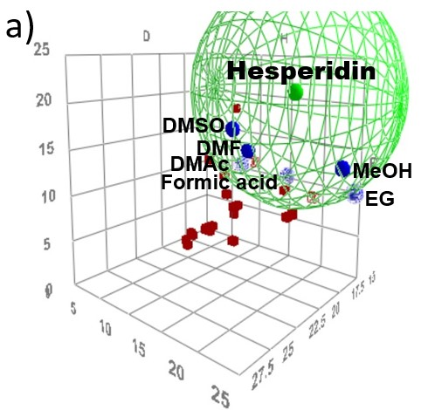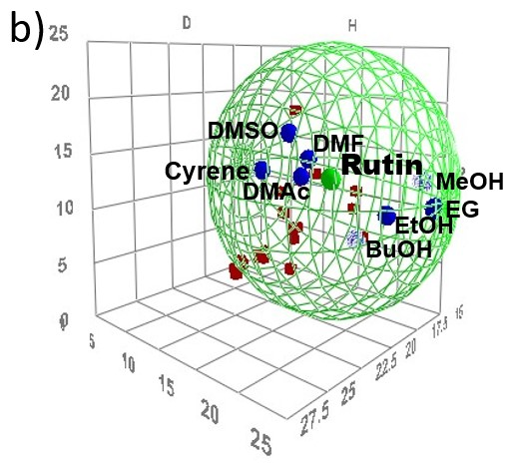

Figure 2 - Recommended solvents mapped in Hansen space with solubility sphere of hesperidin (a) and rutin (b)

A data fit of 1.0 and small values of the core are ideal.⁷⁰ Both 0.956 and 0.995 are reasonable fit values for hesperidin and rutin. The core values represent the ± values for the δ_{D,} δ_{P} and δ_{H} parameters around the best fit which are considered ‘’close’’ to the best fit.⁶⁷ The core values attempt to show how much the centre of the sphere can move in different directions without incurring high penalties. A good fit is considered ±0.25 in all three parameters, while a bad one at least ±0.75. The fit for hesperidin is bad with a large value (±1.20) of dispersion cohesion solubility parameter (δ_{D}). This means that the number of test solvents did not cover a wide-enough range in that parameter. A data fit could be improved to 1.0 ( with the good solvents are included in the sphere and all the bad ones are outside of it) by using the MVol correction. For hesperidin’s case, an MVol of 102.5 for Cyrene was manually introduced (Cyrene is not present in the actual data set) and the fit forced in the software. The value ‘’limit’’ 7 was the best in this case with a core ±[0.4, 0.65, 0.35] but with a worse fit, only 0.727 and a smaller sphere. The newly created sphere results in a number of good solvents outside the sphere (Figure SI 3).
Being limited in the number of available solvents, another approach was explored. To improve the values of the core and the fit and find solvents with higher theoretical solubility for both analytes, mixtures of solvents primarily selected from the initial list were trialled. HSP was used to predict solvation behaviour for varying ratios of chosen solvents to find blends with high potential for this application. Binary and ternary systems were tested and added to the initial sphere. The full table of binary solvent systems and their optimal composition with their calculated R_{a} can be seen in Table SI 3. For the tertiary mixtures, those with Cyrene were preferred to test this unusual solvent ability combined with other compounds to give interesting solvent proprieties (Table SI 4).
A new sphere (Figure 3a) has been created for hesperidin when the new binary solvent systems were added with new parameters δ_{D}= 15.54, δ_{P}=17.12, δ_{H}=13.66. For rutin (Figure 3b), the new sphere including binary solvent system has the following parameters δ_{D}= 21.74, δ_{P}=13.48, δ_{H}=19.70.
In this study, the mixtures of Cyrene and water were calculated as mixtures of the two individual solvents (Figures 3a and 3b). However, Cyrene’s geminal diol is produced when Cyrene reacts with water, hydrating the ketone⁵⁸ The new resulting geminal diol has its own place in the Hansen sphere (Figures 3c and 3d), different than Cyrene-water mixtures calculated previously. HSPs of geminal diol was calculated using ‘’DIY’’ (Do It Yourself) tool of the same version of HPSiP (Figure SI 4). After introducing its SMILES string, the software calculated the Hansen parameters as: δ_{D}=19.4, δ_{P}=11.2 and δ_{H}=15.9.
The R_{a} distance between the individual solvents and the spere’s centre for hesperidin (δ_{D}=17.3, δ_{P}=21.2 and δ_{H}=18.1) and rutin’s (δ_{D}=20.3, δ_{P}=13.5 and δ_{H}=18.3) from Figure 2 are presented in Table 2:

Table 2 - The distance from the position of the individual solvents to the centre of the sphere centre (R_{a}) calculated for both hesperidin and rutin
Hesperidin |  |  | Rutin
Pure solvents | R_{a} |  | Pure solvents | R_{a}
DMSO | 9.5 |  | Cyrene's geminal diol | 3.78
Cyrene's geminal diol | 11.07 |  | DMSO | 9.41
MeOH | 11.13 |  | EtOH | 10.21
EtOH | 12.82 |  | EG | 10.45
EG | 12.92 |  | Cyrene | 11.6
Cyrene | 14.45 |  | MeOH | 11.95
Acetic Acid | 15.06 |  | Acetic Acid | 13.71
Acetone | 15.9 |  | Acetone | 15.1
MEK | 18.02 |  | MEK | 16.38
Ethyl Acetate | 19.51 |  | Ethyl Acetate | 16.48
d-Limonene | 23.81 |  | d-Limonene | 19.27
H₂O | 25.01 |  | H₂O | 25.97

Table 2 shows only the chosen greener solvents used in this study. The smallest R_{a} values for hesperidin are of DMSO, followed by Cyrene’s geminal diol. For rutin’s case, Cyrene’s geminal diol has the smallest distance, having the potential of being the best to dissolve rutin.

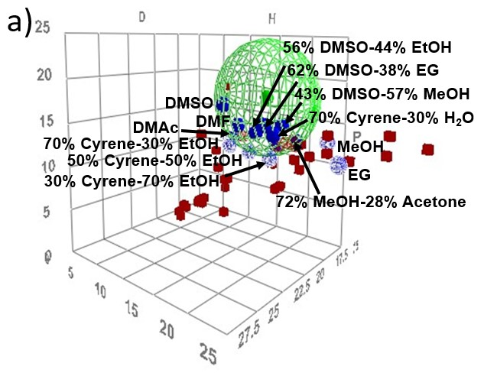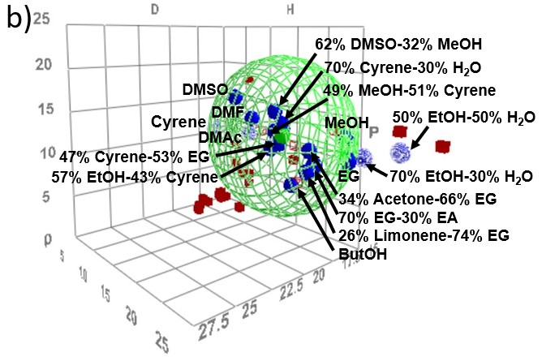

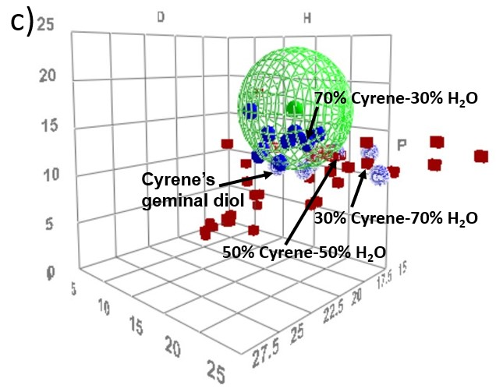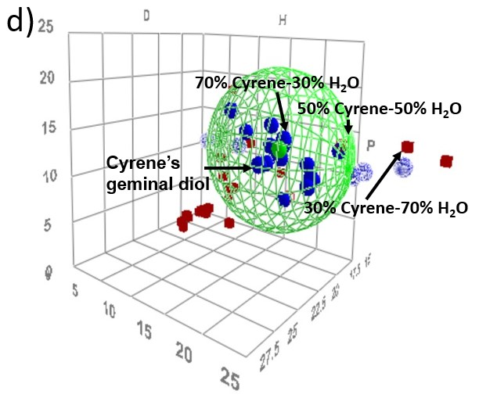

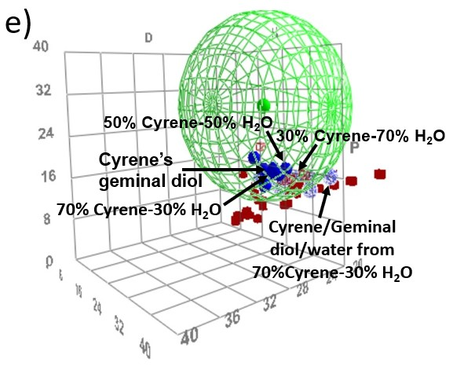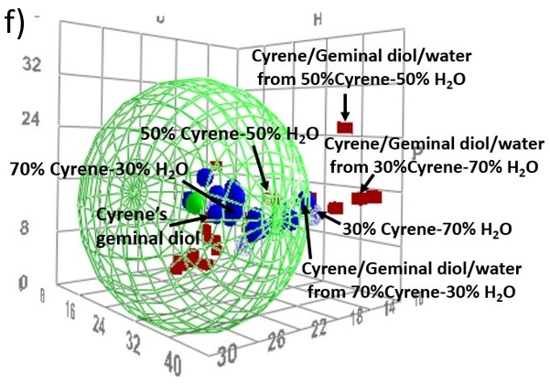

Figure 3 - The new Hansen spheres of hesperidin (a) and rutin (b) when adding the new mixtures of solvents (% v/v). Cyrene’s geminal diol was plotted with Cyrene-water mixtures separately for hesperidin (c) and rutin (d) to observe their distinct positions in Hansen space. New ternary mixtures of Cyrene/geminal diol/water (obtained from the same Cyrene-water mixtures from c) and d) have been included in Hansen sphere for hesperidin (e) and rutin dissolution (f). All mixtures are expressed in % v/v.

HSPiP software can calculate fractions of different solvents in a mixture but does not predict the reactivity of the two individual molecules to generate a new one, hence different parameters and positions in Hansen sphere for mixtures of Cyrene-water and the geminal diol (Figures 3 c, d). The mixtures Cyrene-water contain a mixture of pure Cyrene, pure water and newly formed geminal diol, as a result of the reaction between the Cyrene and water (Section 3.3). The resulting ternary mixtures contain different concentrations of the three components (Table 3), as a function of the amount of water and Cyrene present in the mixture. The density of the geminal diol is unknown; we attempt to calculate the Hansen Solubility Parameters from the mole fraction of the constituents in the ternary mixture from Table 3 and the known Hansen parameters of Cyrene, water and geminal diol. As seen in Figures 3 e and f, when the new ternary mixtures are added, new spheres (with different scale) have been created for both, hesperidin and rutin, with bigger cores and new RED values for all the solvents and mixtures involved. A small sphere can be obtained if a ‘’limit’’ is applied; however, a larger sphere is advantageous if the user wants to find other viable solvents for hesperidin and rutin dissolution and extraction (bigger Hansen sphere, more solvents can fit inside of it). For rutin, the newly created sphere predicts geminal diol as the best solvent for its dissolution, with the smallest value RED (Table SI 9), while for hesperidin the DMSO-EG remains the best-predicted mixture.
The full tables for hesperidin and rutin with the mixtures of solvents and geminal diol with their Hansen parameters are shown in Tables SI 5 and SI 6. The Hansen parameters created for the three new ternary systems of Cyrene/geminal diol/water can be seen in Table SI 7 and SI 8. From all the shown solvent systems, the best pure, binary and tertiary solvents were tested further as extraction media for hesperidin from orange waste and rutin from black tea sample.

Extraction studies
The single-stage extraction experiments to obtain the selected bioactive compounds were performed using pure solvents listed in tables SI 1 and SI 2 and solvent mixtures off the tables SI 3 and SI 4. All the concentrations are expressed in % v/v. The results of the extractions of hesperidin from orange waste are shown in Figure 4. Ethanol-water mixture and Cyrene-water 70-30% were used in this study for comparative purpose; flavonoid glycosides are usually soluble in alcohol and water-alcohol mixtures due to polarity granted by the conjugated sugar molecules.⁷¹
As seen in Figure 4, all Cyrene-water mixtures out-performed the 70% EtOH-30% H₂O mixture (in black dashed circle), at room temperature and at 65 °C, up to three times. In a previous study, a 60-40% EtOH-H₂O mixture showed a much lower yield of hesperidin, of only 2.7 mg/g after a solid-liquid extraction performed at 50 °C.⁷² The optimal hesperidin extracting experiments at room temperature are pure DMSO (30.58 mg g⁻¹) and the mixtures MeOH-DMSO (30.10 mg g⁻¹, R_{a}=7.48), DMSO-EtOH (29.73, R_{a}=9.01), followed by DMSO-EG (26.93, R_{a}=7.2), Cyrene-Acetic Acid-H₂O (21.43, R_{a}=9.37) and 70% Cyrene-30% H₂O (20.71, R_{a}=7.7). It was previously reported that DMSO showed three times higher yield than methanol and six times higher than ethanol from a solvent extraction process.⁴⁶ The smaller the value of R_{a} was theoretically expected to be the solvent with the best result. Other factors contribute to the solubilization/extraction of the analyte, however, R_{a} values can be used to guide the search for efficient extracting media, as can be seen in results mentioned above.

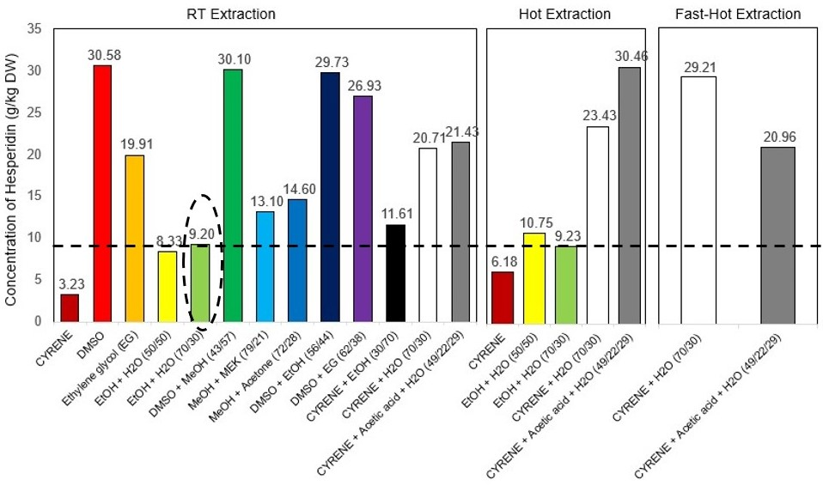
Figure 4 - The extraction yield of hesperidin (mg g-1) from RT, hot and fast hot extraction, determined using UHPLC compared to the ‘’standard’’ (70% EtOH-30% H₂O mixture in the black dashed circle). All extractions are executed in one stage.
Cyrene presents a low extraction capacity, with only 3.23 mg g⁻¹, due to its higher density (1.25 g cm⁻³). The viscosity of Cyrene is lowered by increasing the temperature (hot extraction and fast hot extraction methods) and mixing it with other solvents (3.4. section). The selected solvents for this test were pure Cyrene, EtOH-H₂O, Cyrene-H₂O and Cyrene- H₂O-Acetic Acid. By increasing the temperature (hot extraction method), all the yields showed improvement (except for 70% EtOH-30% H₂O disused in 3.4. section), with an increment of 91.3% for Cyrene, 42.1% for Cyrene-H₂O-Acetic Acid, 29.1% for 50% H₂O-50% EtOH and 13% for Cyrene-H₂O when the process was carried out at room temperature.
To enhance the energy efficiency of hot extractions, the two-best hot-methodology experiments were selected for investigating a reduced time and energy-consuming method, named fast-hot extractions. For 70% Cyrene-30% H₂O mixture, this method presented even better results showing that the extraction phenomena are not time-dependent for the solvent. Differently, Cyrene-H₂O-Acetic Acid mixture decreased extraction yield compared to the two-hour experiment. The result for Cyrene-H₂O mixture is comparable with pure DMSO and suggests that the latter pure solvent could easily be replaced by a mixture of another solvent with water. Moreover, when mixing Cyrene and water a new solvent is generated (discussed later in section 3.3) with improved properties than of pure Cyrene.
The results for rutin extraction from black tea are shown below (Figure 5). The best yields at room temperature are seen with Cyrene-water mixtures: 30% H₂O-70% Cyrene (1.53 mg g⁻¹, Ra= 4.87) and 70% H₂O-30% Cyrene (1.52 mg g⁻¹, Ra= 15.49). Interestingly, the mixture 30% H₂O-70% Cyrene did not dissolve the rutin standard, gaining a score of 5 in Hansen space, but has proved to be efficient in extraction from the dried tea leaves, probably due to the slightly heating of the sample during the homogenisation, which enhanced the dissolution of flavonoid in solution. It has been observed that rutin (standard) dissolves easily at a higher temperature (65 °C). The minimum yields achieved for this test are 63% Ethylene Glycol-34% Acetone (0.43, R_{a}= 8.18), Cyrene-MeOH (0.34, R_{a}= 7.95) and EtOH-Cyrene (0.09, R_{a}= 8.22). The contrasts between the yield and Ra values can be seen in rutin’s case too. The biggest difference can be seen in the case of Cyrene-water mixtures due to the formation of different geminal diols with distinct properties.³³

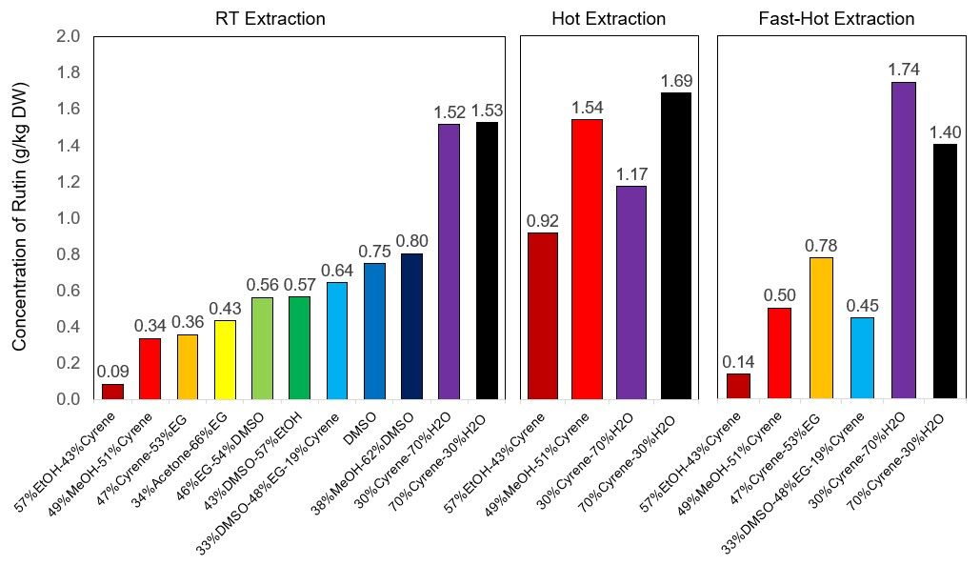
Figure 5 - The concentration of rutin (mg g⁻¹) from room temperature (RT) extraction, “hot extraction” (65 ºC) and “fast hot” extraction determined using UHPLC. All extractions were realised in single stages.

Similar to hesperidin, hot and fast-hot procedures were employed for rutin extraction from black tea. Mixtures of Cyrene with MeOH, EtOH and H₂O were investigated.
At room temperature the mixtures Cyrene-H₂O did not show differences in the extraction process (70% Cyrene-30% H₂O - 1.53 mg g⁻¹, as compared to 30% Cyrene-70% H₂O - 1.52 mg g⁻¹). On the contrary, increasing Cyrene’s content within a mixture in hot extraction results in increasing yield when Cyrene is in a higher amount than water (70% Cyrene-30% H₂O - 1.69 mg g⁻¹, as compared to 30% Cyrene-70% H₂O - 1.17 mg g⁻¹). This could result in the two-hour maceration time when the viscosity of Cyrene lowers down and the diffusion of the bioactive compounds into the 70% Cyrene in water is superior that in 30% Cyrene in H₂O. This means that Cyrene is a better solvent than water in this case. When heating the same Cyrene-water mixtures in a fast-hot extraction, the inverse trend is observed, with 30% Cyrene-70% H₂O - 1.74 mg g⁻¹ superior to as compared to 70% Cyrene-30% H₂O - 1.40 mg g⁻¹. In this procedure, the maceration time is of only 2 minutes, when the bioactive compounds do not have enough time to diffuse from the solid into the mostly Cyrene mixture. In this case, the 70% H₂O-30% Cyrene is showing superior extracting capacity than 70% Cyrene-30% H₂O.

Water influence on hesperidin and rutin dissolution

When water is added to Cyrene, the extraction is improved for hesperidin and rutin (Figures 6 a and b). Improved dissolution properties Cyrene-water systems were previously reported for organic compounds such as caffeine, salicylic acid, ibuprofen, aspirin, ferulic acid and mandelic acid.⁵⁸ In such systems, it has been shown that water reacts with Cyrene, in a readily reversible manner to form a germinal diol.⁵⁸ In the present study, the Cyrene/water/geminal diol mixtures created a continuum of green solvents with controllable solubilisation properties for hesperidin and rutin. The mixtures of Cyrene and water extracted up to three times more hesperidin than pure Cyrene (Figure 6a). With rutin, a comparison could not be made due to the high viscosity of pure Cyrene, which did not filtrate through the membrane. However, both 30% and 70% Cyrene in water systems gave the extraction yields for rutin (Figure 6B).

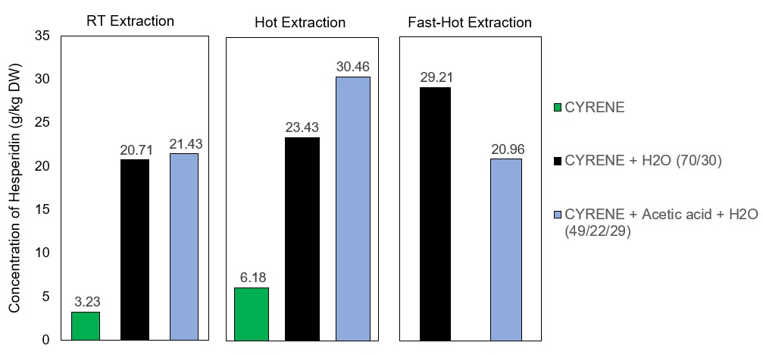
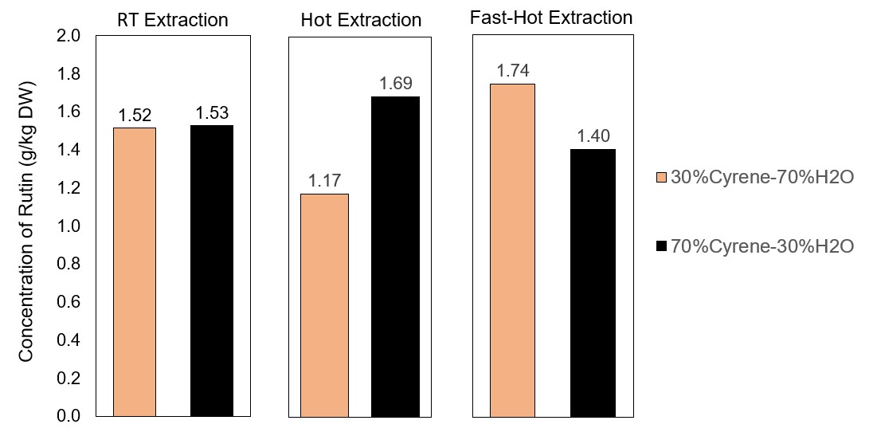
Figure 6 - The influence of water on dissolution and extraction of hesperidin (a) and rutin (b) using Cyrene®

As stated, the mixtures of Cyrene and water also contain and the newly formed geminal diol to give a ternary solvent system in different proportions. For the Cyrene water systems employed in this work, the relative molar loadings have been given in Table 3. As such, these different ternary systems affect the dissolution and extraction of flavonoids dramatically.
Table 3 - The concentration of Cyrene, water and geminal diol found in the mixtures Cyrene-water used in this study (30% Cyrene-70% H₂O, 50% Cyrene- 50% H₂O and 70% Cyrene-30% H₂O). The values are calculated based on the data from Ref.⁵⁸
%v/v Cyrene in water | wt% Cyrene in water | Mol %  Cyrene | Mol % Geminal diol | Mol %  H₂O
30 | 34.9 | 0.74 | 6.79 | 92.47
50 | 55.6 | 2.8 | 13.17 | 84.03
70 | 74.5 | 17.54 | 17.54 | 64.91

The 70% Cyrene-30% H₂O mixture dissolved and extracted hesperidin up to ten more times than pure Cyrene, which means that geminal diol formed in the solution is a better solvent than pure Cyrene. For rutin’s case, no massive difference is spotted between 30% Cyrene-70% H₂O and 70% Cyrene-30% H₂O at room temperature, which could mean that a maximum of 30% Cyrene in water is necessary to dissolve rutin. After this concentration, lowering the viscosity with increasing the temperature improves the extraction results.
Based on the published results, the geminal diol formation decreases with the increasing of temperature⁵⁸ and Cyrene is favoured in a solution at 65 °C.

Temperature influence on dissolution and extraction of hesperidin and rutin

To study the effect of higher temperatures in extraction yields of hesperidin from orange waste, a temperature of 65 °C was considered suitable for altering important physical-chemical properties of the solvents such as viscosity, miscibility and surface tension. The need for a higher temperature to dissolve hesperidin has been noted before.^{33, 71, 73} Previously, the authors have used this method to lower the viscosity of Cyrene in membrane fabrication technology, where the solvent interactions have dominated over the polymer-polymer interactions.⁵⁴
The solubility of bio-active compound hesperidin was found to increase with temperature in all the solvents investigated. For mixtures involving ethanol and water, only 50-50% shows a slight increase in hesperidin extraction upon heating. For Cyrene, heating gives twice the yield than that at room temperature (Figure 4).
The Cyrene-water mixtures dissolve and extract the hesperidin from orange peel waste differently, depending on the amount of the two, with 70-30% Cyrene-H₂O extracting the almost double amount of the hesperidin at room temperature (95.7% increase). The same Cyrene-H₂O mixture is two times better than EtOH-H₂O mixture when using the same concentration and temperature conditions. Cyrene-H₂O improved the extraction capacity from 20.71 g kg⁻¹ to 23.43 and 29.21 g kg⁻¹ at higher temperature processes (Figure 6). Ethanol-H₂O showed an insignificant increase of yield from 9.20 to 9.23 g kg⁻¹ at a higher temperature. This proves that the temperature has a superior impact on a mixture containing Cyrene due to its higher density than ethanol. This can be translated as lowering the viscosity with the increasing of temperature of Cyrene makes it a better solvent than ethanol.
Temperature-dependent solubility of bioactive compound rutin shows a similar trend as hesperidin, where the increased temperature improves the extraction capacity for mixtures where Cyrene is involved (Figure 5). The Cyrene mixtures with water, ethanol and methanol have shown up to eleven times better extraction capacity when heated up. The results obtained in the current study could be useful in greener crystallisation/purification methodologies and formulation development of bioactive compounds hesperidin and rutin.

Evaluation of greenness profile using CHEM21 Metrics Toolkit

CHEM21 metrics toolkit was used to measure the sustainability of the present method of extracting natural flavonoids. As ethanol has shown poor extraction ability in the present study, a previous environmentally friendly methodology using a mixture of ethanol and water (60-40% v/v)⁷² has been used as baseline here to direct comparison of the proposed method used in this study.
After showing potential at Zero Pass, the new method using Cyrene-water for hesperidin extraction, First Pass was used.⁶⁹ The experimental of the baseline method and the method used in this study are shown in the Appendices 2 and 3 and the results are listed in Table SI 9.
Many of the metrics applied were designed for reaction chemistry, thus did not generate meaningful data, However as the new method of extraction of hesperidin from orange peel uses minimum quantities of dried sample and solvent compared to the established methodology, this was reflected in a number of metrics. A mass-based yield was determined from the reaction mass efficiency (RME) which is 0.27% for the ‘’baseline’’ method which uses ethanol-water mixture as extractor, compared to 2.92% for the new method using a mixture of Cyrene with water, making the newly discovered solvent mixture more efficient in hesperidin and rutin extraction. This is also born out by the PMI which shows a significantly lower mass input per g of hesperidin isolated for this method (805 g g⁻¹) as compared to the base line (3237 g g⁻¹).
The key parameters of the metrics toolkit are life cycle assessment (LCA), solvents, renewability, health and safety, critical elements, catalysis, chemical of concern, waste, efficiency and energy.
a) LCA process - LCA has been used to evaluate the quantity impact over the solvent’s life cycle. The Furacell™ process to produce Cyrene presents a global warming potential lower than NMP synthesis and is leading towards being greenhouse gas neutral (Figure SI 5).⁷⁴ Circa Group has won the prestigious Environmental Leader award, top product 2019 for its bio-based and biodegradable solvent. Cyrene ‘’replaces an otherwise toxic substance with a natural, gentler alternative without compromising quality or function. This product has the potential to change the solvent landscape for the better”.⁷⁵
b) Solvents - They are a critical issue as they constitute a large mass input in the process. In the current method only 5 cm³ Cyrene-water mixture was used. Coupled with improved extraction yield, this represents a significant reduction in process mass intensity (PMI) (Appendices 2 and 3 and Table SI 9).
c) Renewability - Solvent recovery and recycling can have a positive effect on the environment and a single solvent systems is favoured in this case.⁷⁶ In the old method, ethanol can be easily recovered through a rotary evaporatioyn.⁷² Cyrene and water can be easily separated. However, the distillation of Cyrene is energy intensive and requires the application of significant reduced pressure in order to allow distillation at a low enough temperature to ensure thermal decomposition does not take place.
d) Health and safety - It is mandatory under European law to assess for any explosion risk and classify the work area.⁷⁷ Ethanol is widely used in many applications, but it is highly flammable liquid and vapour (H225) and causes serious eye irritation. Also, ethanol is listed as T2 temperature class (‘’an explosive atmosphere is not likely to occur in normal operation but, if it does occur, will persist for a short period only’’)⁷⁷ by ATEX (European Directives for controlling explosive atmospheres). The solvent used in this study, Cyrene is 99% biodegradable, non-flammable, it has low-toxicity, no mutagenicity, although does cause eye irritation.^{52, 57} Water, however, is non-toxic.
e) Waste - The wet waste can be reused to extract other chemicals after both extractions.
f) Efficiency and energy - In this study a mildly heating of Cyrene-water mixture led to a higher efficiency in extractions of flavonoids (up to eleven times than the baseline method). Recovery through distillation however will result in increased energy demands.
As seen in Table S9, the raw material used in the ethanol-water method uses 5g per extraction, while in the proposed method of Cyrene-water, we use 20 times less material per extraction (250 mg). The higher power used for homogenisation in the case of Cyrene-water extraction process of 14,450 rpm combined with a very short time used (2 minutes) is more advantageous than a lower power for a longer time used in an old method (120 rpm for 4 hours). The drawback of using Cyrene in the extraction of hesperidin and rutin in this study is the increase of temperature to 65 °C and the time needed to heat up the solvents or the mixture of sample with solvents to this temperature. However, less time would be more advantageous and taken into consideration for future extractions.
As with all green metrics analysis, the impacts of different methodologies need to be examined holistically. Although energy requirements are greater with Cyrene-water systems, the quantity of solvent used (PMI) renewability, waste and health and safety considerationsfor this process suggests it is greener than the current baseline. The use of the bio-derived Cyrene for extraction and water for analysing in the process is an important step towards improving the sustainability of the process.

Conclusions
Based on the circular bio-economy concept, this work aimed at finding new paths towards the development of new methods for the analysis and extraction of valuable bioactive compounds present is plant-derived materials as agro-industrial waste, focusing on bio-based, more efficient, sustainable and greener solvents. We used in this study a new and simple process with a minimum amount of solvent in one-stage extraction which resulted in a high-quality extract. To evaluate the sustainability of the proposed methodology, CHEM21 metric tools were used in this study. The new single-stage extraction using Cyrene and mixtures with Cyrene showed up to three times better extraction capacity than using ethanol-water mixtures at the same conditions and up to eleven times when compared to an older methodology using ethanol-water mixture (29.2 mg/g for 70% Cyrene-30% H₂O at 65 °C compared to 9.2 mg/g for 70% EtOH-30% H₂O at RT or 65 °C and only 2.7 mg/m for a 60% EtOH-40% H₂O at 50 °C). When using mixtures Cyrene and water, the results show an increase to ten times than using pure Cyrene the capacity due to the formation of geminal diols with distinct properties. A mildly increased temperature of pure Cyrene improved the capacity of extracting these bioactive compounds until 91%, due to changes in viscosity and matrix accessibility. Although, improving the energy efficiency of the process and reducing energy consumption are currently being considered.
In this study, Hansen’s solubility parameters have proved to be a useful tool to predict optimum solvents and mixtures of solvents for the solubilisation of natural products and their extraction from complex matrices, as orange waste and black tea. As a novel bio-solvent, Cyrene shows more than promising features useful for designing greener and more sustainable methods for crystallisation, purification, extraction and formulation of bioactive compounds from natural sources. As aimed, the application of HSP combined with the use of bio-based solvents as an alternative to replacing petroleum-based solvents and further experimental validation offered important advantages such as simplicity, rational use of time and resources, contributing to materialize a circular economy model in chemistry, keeping processes as simple as possible as well as promoting a reflection about the role of waste as starting material in the current and future industrial processes.

Acknowledgements

We thank Circa Group and RenewChem for funding this research work.
This study was part-funded by the Coordenação de Aperfeiçoamento de Pessoal de Nível Superior - Brazil (CAPES) - Finance Code 001, CNPq and FAPESP (process numbers: 14/50827-1; 2017/25015-1; 2018/11409-,0).

Supporting information

Electronic Supporting Information is available online, and contains a figure of Cyrene sample and the Plant FC5 in Tasmania; two images of the in-vitro dissolution tests; two images of HSPiP demonstration of the calcultation of Hansen parametrs of hesperidin and rutin and geminal diol; six tables of the solvents and mixtures of solvents including geminal diol with their Hansen parametrs calculated for both hesperidin and rutin; two tables of binary and ternary mixtures and their calculated R_{a} for hesperidin and rutin, a figure and a table of the forced fit for hesperidin and the new RED values of the solvents; a figure of the footprint of Cyrene’s production; a figure of description of the green metrics used in this study with a table containing the comparative results of green metrics from the Appendix 2 and 3 based on an old method compared to the newly proposed method and accompanied by the description of the green metrics used.

References
1. The 17 UN sustainable development. Accessible from: https://sustainabledevelopment.un.org/ (Accessed 15.05.2020).
2. Girotto, F.; Alibardi, L.; Cossu, R., Food waste generation and industrial uses: A review. Waste Management 2015, 45, 32-41. DOI: 10.1016/j.wasman.2015.06.008.
3. Godfray, H. C. J.; Beddington, J. R.; Crute, I. R.; Haddad, L.; Lawrence, D.; Muir, J. F.; Pretty, J.; Robinson, S.; Thomas, S. M.; Toulmin, C., Food Security: The Challenge of Feeding 9 Billion People. Science 2010, 327 (5967), 812-818. DOI: 10.1126/science.1185383.
4. Kummerer, K.; Clark, J. H.; Zuin, V. G., Rethinking chemistry for a circular economy. Science 2020, 367 (6476), 369-370. DOI: 10.1126/science.aba4979.
5. Matharu, A. S.; de Melo, E. M.; Houghton, J. A., Opportunity for high value-added chemicals from food supply chain wastes. Bioresource Technology 2016, 215, 123-130. DOI: 10.1016/j.biortech.2016.03.039.
6. Clark, J. H.; Farmer, T. J.; Herrero-Davila, L.; Sherwood, J., Circular economy design considerations for research and process development in the chemical sciences. Green Chemistry 2016, 18 (14), 3914-3934. DOI: 10.1039/c6gc00501b.
7. Zuin, V. G.; Ramin, L. Z., Green and Sustainable Separation of Natural Products from Agro-Industrial Waste: Challenges, Potentialities, and Perspectives on Emerging Approaches. Topics in Current Chemistry 2018, 376 (1). DOI: 10.1007/s41061-017-0182-z.
8. Zuin, V. G.; Segatto, M. L.; Ramin, L. Z., Plants as resources for organic molecules: Facing the green and sustainable future today. Current Opinion in Green and Sustainable Chemistry 2018, 9, 1-7. DOI: 10.1016/j.cogsc.2017.10.001.
9. Anastas, P. T.; Williamson, T. C., Green chemistry: An overview. Green Chemistry: Designing Chemistry for the Environment 1996, 626, 1-17.
10. Chemat, F.; Vian, M. A.; Cravotto, G., Green Extraction of Natural Products: Concept and Principles. International Journal of Molecular Sciences 2012, 13 (7), 8615-8627. DOI: 10.3390/ijms13078615.
11. Lin, C. S. K.; Pfaltzgraff, L. A.; Herrero-Davila, L.; Mubofu, E. B.; Abderrahim, S.; Clark, J. H.; Koutinas, A. A.; Kopsahelis, N.; Stamatelatou, K.; Dickson, F.; Thankappan, S.; Mohamed, Z.; Brocklesby, R.; Luque, R., Food waste as a valuable resource for the production of chemicals, materials and fuels. Current situation and global perspective. Energy & Environmental Science 2013, 6 (2), 426-464. DOI: 10.1039/c2ee23440h.
12. Lopez, J. A. S.; Li, Q.; Thompson, I. P., Biorefinery of waste orange peel. Critical Reviews in Biotechnology 2010, 30 (1), 63-69. DOI: 10.3109/07388550903425201.
13. Montero-Calderon, A.; Cortes, C.; Zulueta, A.; Frigola, A.; Esteve, M. J., Green solvents and Ultrasound-Assisted Extraction of bioactive orange (Citrus sinensis) peel compounds. Scientific Reports 2019, 9. DOI: 10.1038/s41598-019-52717-1.
14. Coll, M. D.; Coll, L.; Laencina, J.; Tomas-Barberan, F. A., Recovery of flavanones from wastes of industrially processed lemons. Zeitschrift Fur Lebensmittel-Untersuchung Und-Forschung a-Food Research and Technology 1998, 206 (6), 404-407. DOI: 10.1007/s002170050282.
15. Hajialyani, M.; Farzaei, M. H.; Echeverria, J.; Nabavi, S. M.; Uriarte, E.; Sobarzo-Sanchez, E., Hesperidin as a Neuroprotective Agent: A Review of Animal and Clinical Evidence. Molecules 2019, 24 (3). DOI: 10.3390/molecules24030648.
16. Gao, X.; Cassidy, A.; Schwarzschild, M. A.; Rimm, E. B.; Ascherio, A., Habitual intake of dietary flavonoids and risk of Parkinson disease. Neurology 2012, 78 (15), 1138-1145. DOI: 10.1212/WNL.0b013e31824f7fc4.
17. Li, C. Y.; Schluesener, H., Health-promoting effects of the citrus flavanone hesperidin. Critical Reviews in Food Science and Nutrition 2017, 57 (3), 613-631. DOI: 10.1080/10408398.2014.906382.
18. Arts, I. C. W.; Hollman, P. C. H., Polyphenols and disease risk in epidemiologic studies. American Journal of Clinical Nutrition 2005, 81 (1), 317S-325S.
19. Meneguzzo, F.; Ciriminna, R.; Zabini, F.; Pagliaro, M., Review of Evidence Available on Hesperidin-Rich Products as Potential Tools against COVID-19 and Hydrodynamic Cavitation-Based Extraction as a Method of Increasing Their Production. Processes 2020, 8 (5). DOI: 10.3390/pr8050549.
20. Wu, C. R.; Liu, Y.; Yang, Y. Y.; Zhang, P.; Zhong, W.; Wang, Y. L.; Wang, Q. Q.; Xu, Y.; Li, M. X.; Li, X. Z.; Zheng, M. Z.; Chen, L. X.; Li, H., Analysis of therapeutic targets for SARS-CoV-2 and discovery of potential drugs by computational methods. Acta Pharmaceutica Sinica B 2020, 10 (5), 766-788. DOI: 10.1016/j.apsb.2020.02.008.
21. Singh, S.; Sk, M. F.; Sonawane, A.; Kar, P.; Sadhukhan, S., Plant-derived natural polyphenols as potential antiviral drugs against SARS-CoV-2viaRNA-dependent RNA polymerase (RdRp) inhibition: anin-silicoanalysis. Journal of Biomolecular Structure & Dynamics. DOI: 10.1080/07391102.2020.1796810.
22. Mahdian, S.; Ebrahim-Habibi, A.; Zarrabi, M., Drug repurposing using computational methods to identify therapeutic options for COVID-19. Journal of Diabetes and Metabolic Disorders. DOI: 10.1007/s40200-020-00546-9.
23. Food and Agriculture Organization of the United Nations (FAO). Crops 2018.
24. Shevchuk, A.; Jayasinghe, L.; Kuhnert, N., Differentiation of black tea infusions according to origin, processing and botanical varieties using multivariate statistical analysis of LC-MS data. Food Research International 2018, 109, 387-402. DOI: 10.1016/j.foodres.2018.03.059.
25. Luca, S. V.; Macovei, I.; Bujor, A.; Miron, A.; Skalicka-Wozniak, K.; Aprotosoaie, A. C.; Trifan, A., Bioactivity of dietary polyphenols: The role of metabolites. Critical Reviews in Food Science and Nutrition 2020, 60 (4), 626-659. DOI: 10.1080/10408398.2018.1546669.
26. Shawky, E.; Nada, A. A.; Ibrahim, R. S., Potential role of medicinal plants and their constituents in the mitigation of SARS-CoV-2: identifying related therapeutic targets using network pharmacology and molecular docking analyses. Rsc Advances 2020, 10 (47), 27961-27983. DOI: 10.1039/d0ra05126h.
27. Das, P.; Majumder, R.; Mandal, M.; Basak, P., In-Silico approach for identification of effective and stable inhibitors for COVID-19 main protease (M-pro) from flavonoid based phytochemical constituents ofCalendula officinalis. Journal of Biomolecular Structure & Dynamics. DOI: 10.1080/07391102.2020.1796799.
28. Gullon, B.; Lu-Chau, T. A.; Moreira, M. T.; Lema, J. M.; Eibes, G., Rutin: A review on extraction, identification and purification methods, biological activities and approaches to enhance its bioavailability. Trends in Food Science & Technology 2017, 67, 220-235. DOI: 10.1016/j.tifs.2017.07.008.
29. Gil-Izquierdo, A.; Gil, M. I.; Tomas-Barberan, F. A.; Ferreres, F., Influence of industrial processing on orange juice flavanone solubility and transformation to chalcones under gastrointestinal conditions. Journal of Agricultural and Food Chemistry 2003, 51 (10), 3024-3028. DOI: 10.1021/jf020986r.
30. Ligor, M.; Kornysova, O.; Maruska, A.; Buszewski, B., Determination of Flavonoids in Tea and Rooibos Extracts by TLC and HPLC. Jpc-Journal of Planar Chromatography-Modern Tlc 2008, 21 (5), 355-360. DOI: 10.1556/jpc.21.2008.5.7.
31. Chebil, L.; Humeau, C.; Anthoni, J.; Dehez, F.; Engasser, J. M.; Ghoul, M., Solubility of flavonoids in organic solvents. Journal of Chemical and Engineering Data 2007, 52 (5), 1552-1556. DOI: 10.1021/je7001094.
32. Victor, M. M.; David, J. M.; Cortez, M. V. M.; Leite, J. L.; da Silva, G. S. B., A High-Yield Process for Extraction of Hesperidin from Orange (Citrus sinensis L. osbeck) Peels Waste, and Its Transformation to Diosmetin, A Valuable and Bioactive Flavonoid. Waste and Biomass Valorization. DOI: 10.1007/s12649-020-00982-x.
33. Anwer, M. K.; Al-Shdefat, R.; Jamil, S.; Alam, P.; Abdel-Kader, M. S.; Shakeel, F., Solubility of Bioactive Compound Hesperidin in Six Pure Solvents at (298.15 to 333.15) K. Journal of Chemical and Engineering Data 2014, 59 (6), 2065-2069. DOI: 10.1021/je500206w.
34. Chua, L. S., A review on plant-based rutin extraction methods and its pharmacological activities. Journal of Ethnopharmacology 2013, 150 (3), 805-817. DOI: 10.1016/j.jep.2013.10.036.
35. Ciric, A.; Prosen, H.; Jelikic-Stankov, M.; Durdevic, P., Evaluation of matrix effect in determination of some bioflavonoids in food samples by LC-MS/MS method. Talanta 2012, 99, 780-790. DOI: 10.1016/j.talanta.2012.07.025.
36. Angiolillo, L.; Del Nobile, M. A.; Conte, A., The extraction of bioactive compounds from food residues using microwaves. Current Opinion in Food Science 2015, 5, 93-98. DOI: 10.1016/j.cofs.2015.10.001.
37. Nayak, B.; Dahmoune, F.; Moussi, K.; Remini, H.; Dairi, S.; Aoun, O.; Khodir, M., Comparison of microwave, ultrasound and accelerated-assisted solvent extraction for recovery of polyphenols from Citrus sinensis peels. Food Chemistry 2015, 187, 507-516. DOI: 10.1016/j.foodchem.2015.04.081.
38. Ameer, K.; Shahbaz, H. M.; Kwon, J. H., Green Extraction Methods for Polyphenols from Plant Matrices and Their Byproducts: A Review. Comprehensive Reviews in Food Science and Food Safety 2017, 16 (2), 295-315. DOI: 10.1111/1541-4337.12253.
39. Hilali, S.; Fabiano-Tixier, A. S.; Ruiz, K.; Hejjaj, A.; Nouh, F. A.; Idlimam, A.; Bily, A.; Mandi, L.; Chemat, F., Green Extraction of Essential Oils, Polyphenols, and Pectins from Orange Peel Employing Solar Energy: Toward a Zero-Waste Biorefinery. Acs Sustainable Chemistry & Engineering 2019, 7 (13), 11815-11822. DOI: 10.1021/acssuschemeng.9b02281.
40. Puri, M.; Sharma, D.; Barrow, C. J., Enzyme-assisted extraction of bioactives from plants. Trends in Biotechnology 2012, 30 (1), 37-44. DOI: 10.1016/j.tibtech.2011.06.014.
41. Liza, M. S.; Rahman, R. A.; Mandana, B.; Jinap, S.; Rahmat, A.; Zaidul, I. S. M.; Hamid, A., Supercritical carbon dioxide extraction of bioactive flavonoid from Strobilanthes crispus (Pecah Kaca). Food and Bioproducts Processing 2010, 88 (C2-3), 319-326. DOI: 10.1016/j.fbp.2009.02.001.
42. Toledo-Guillen, A. R.; Higuera-Ciapara, I.; Garcia-Navarrete, G.; de la Fuente, J. C., Extraction of Bioactive Flavonoid Compounds from Orange (Citrus sinensis) Peel Using Supercritical CO2. Journal of Biotechnology 2010, 150, S313-S314. DOI: 10.1016/j.jbiotec.2010.09.292.
43. Azmir, J.; Zaidul, I. S. M.; Rahman, M. M.; Sharif, K. M.; Mohamed, A.; Sahena, F.; Jahurul, M. H. A.; Ghafoor, K.; Norulaini, N. A. N.; Omar, A. K. M., Techniques for extraction of bioactive compounds from plant materials: A review. Journal of Food Engineering 2013, 117 (4), 426-436. DOI: 10.1016/j.jfoodeng.2013.01.014.
44. Berk, Z., Food Process Engineering and Technology, chapter 11 Extraction. 3rd ed.; 2018; pp 289-293.
45. Bellete, B. S.; Ramin, L. Z.; Porto, D.; Ribeiro, A. I.; Forim, M. R.; Zuin, V. G.; Fernandes, J. B.; Silva, M., An Environmentally Friendly Procedure to Obtain Flavonoids from Brazilian Citrus Waste. Journal of the Brazilian Chemical Society 2018, 29 (5), 1123-1129. DOI: 10.21577/0103-5053.20180020.
46. Mahato, N.; Sinha, M.; Sharma, K.; Koteswararao, R.; Cho, M. H., Modern Extraction and Purification Techniques for Obtaining High Purity Food-Grade Bioactive Compounds and Value-Added Co-Products from Citrus Wastes. Foods 2019, 8 (11). DOI: 10.3390/foods8110523.
47. Zuin; V.G.; Ramin, L. Z.; Segatto, M. L.; Stahl, A. S.; Zanotti, K.; Forim, M. R.; Silva, M. F. F.; Fernandes , J. B., To separate or not to separate: what is necessary and enough for a green and sustainable extraction of bioactive compounds from Brazilian citrus waste. Pure Appl. Chem. : 2020; Vol. 92, pp 1–14. DOI: DOI: https://doi.org/10.1515/pac-2020-0706
48. Kruse, J. A., Methanol and Ethylene Glycol Intoxication. Critical Care Clinics 2012, 28 (4), 661-+. DOI: 10.1016/j.ccc.2012.07.002.
49. Prat, D.; Wells, A.; Hayler, J.; Sneddon, H.; McElroy, C. R.; Abou-Shehada, S.; Dunn, P. J., CHEM21 selection guide of classical- and less classical-solvents. Green Chemistry 2016, 18 (1), 288-296. DOI: 10.1039/c5gc01008j.
50. REACH regulation of the identification and restriction of toxic or environmentally hazardous substances. Available from: https://echa.europa.eu/regulations/reach/legislation, reach regulation (Accessed 14.03.2020).
51. Sherwood, J.; De Bruyn, M.; Constantinou, A.; Moity, L.; McElroy, C. R.; Farmer, T. J.; Duncan, T.; Raverty, W.; Hunt, A. J.; Clark, J. H., Dihydrolevoglucosenone (Cyrene) as a bio-based alternative for dipolar aprotic solvents. Chemical Communications 2014, 50 (68), 9650-9652. DOI: 10.1039/c4cc04133j.
52. Richardson, D. E.; Raverty, W. D., Predicted environmental effects from liquid emissions in the manufacture of levoglucosenone and Cyrene (TM). Appita 2016, 69 (4), 344-351.
53. Wilson, K. L.; Murray, J.; Jamieson, C.; Watson, A. J. B., Cyrene as a bio-based solvent for HATU mediated amide coupling. Organic & Biomolecular Chemistry 2018, 16 (16), 2851-2854. DOI: 10.1039/c8ob00653a.
54. Milescu, R. A.; McElroy, C. R.; Farmer, T. J.; Williams, P. M.; Walters, M. J.; Clark, J. H., Fabrication of PES/PVP Water Filtration Membranes Using Cyrene (R), a Safer Bio-Based Polar Aprotic Solvent. Advances in Polymer Technology 2019, 2019. DOI: 10.1155/2019/9692859.
55. Camp, J. E., Bio-available Solvent Cyrene: Synthesis, Derivatization, and Applications. Chemsuschem 2018, 11 (18), 3048-3055. DOI: 10.1002/cssc.201801420.
56. Wilson, K. L.; Murray, J.; Jamieson, C.; Watson, A. J. B., Cyrene as a Bio-Based Solvent for the Suzuki-Miyaura Cross-Coupling. Synlett 2018, 29 (5), 650-654. DOI: 10.1055/s-0036-1589143.
57. Zhang, J.; White, G. B.; Ryan, M. D.; Hunt, A. J.; Katz, M. J., Dihydrolevoglucosenone (Cyrene) As a Green Alternative to N,N-Dimethylformamide (DMF) in MOF Synthesis. Acs Sustainable Chemistry & Engineering 2016, 4 (12), 7186-7192. DOI: 10.1021/acssuschemeng.6b02115.
58. De Bruyn, M.; Budarin, V. L.; Misefari, A.; Shimizu, S.; Fish, H.; Cockett, M.; Hunt, A. J.; Hofstetter, H.; Weckhuysen, B. M.; Clark, J. H.; Macquarrie, D. J., Geminal Diol of Dihydrolevoglucosenone as a Switchable Hydrotrope: A Continuum of Green Nanostructured Solvents. Acs Sustainable Chemistry & Engineering 2019, 7 (8), 7878-7883. DOI: 10.1021/acssuschemeng.9b00470.
59. Sangon, S.; Supanchaiyamat, N.; Sherwood, J.; McElroy, C. R.; Hunt, A. J., Direct comparison of safer or sustainable alternative dipolar aprotic solvents for use in carbon-carbon bond formation. Reaction Chemistry & Engineering 2020, 5 (9), 1798-1804. DOI: 10.1039/d0re00174k.
60. Hughes, L.; McElroy, C. R.; Whitwood, A. C.; Hunt, A. J., Development of pharmaceutically relevant bio-based intermediates though aldol condensation and Claisen-Schmidt reactions of dihydrolevoglucosenone (Cyrene (R)). Green Chemistry 2018, 20 (19), 4423-4427. DOI: 10.1039/c8gc01227j.
61. Iemhoff, A.; Sherwood, J.; McElroy, C. R.; Hunt, A. J., Towards sustainable kinetic resolution, a combination of bio-catalysis, flow chemistry and bio-based solvents. Green Chemistry 2018, 20 (1), 136-140. DOI: 10.1039/c7gc03177g.
62. Vastano, M.; Pellis, A.; Machado, C. B.; Simister, R.; McQueen-Mason, S. J.; Farmer, T. J.; Gomez, L. D., Sustainable Galactarate-Based Polymers: Multi-Enzymatic Production of Pectin-Derived Polyesters. Macromolecular Rapid Communications 2019, 40 (22). DOI: 10.1002/marc.201900361.
63. Brouwer, T.; Schuur, B., Dihydrolevoglucosenone (Cyrene), a Biobased Solvent for Liquid–Liquid Extraction Applications. ACS Sustainable Chemistry & Engineering 2020, 8 (39), 14807-14817. DOI: 10.1021/acssuschemeng.0c04159.
64. Gharib, D. H.; Malherbe, F.; Moulton, S. E., Debundling, Dispersion, and Stability of Multiwalled Carbon Nanotubes Driven by Molecularly Designed Electron Acceptors. Langmuir 2018, 34 (40), 12137-12144. DOI: 10.1021/acs.langmuir.8b02878.
65. Substance information/ substance info (1S,5R)-6,8dioxabicyclo(3,2,1,)octan-4-one. Available from: https://echa.europa.eu/substance-information/-/substanceinfo/100.234.612. (Accessed 23.08.2020).
66. Press release. Circa receives green light to sell non-toxic, bio-based and biodegradable solvent in EU. Available at: https://www.sustainabilityconsult.com/news/361-press-release-circa-receives-green-light-to-sell-non-toxic-bio-based-and-biodegradable-solvent-in-eu, cyrene annex Vlll. Accessed 20.03.2020.
67. Hansen, C. M., UNIVERSALITY OF SOLUBILITY PARAMETER. Industrial & Engineering Chemistry Product Research and Development 1969, 8 (1), 2-&. DOI: 10.1021/i360029a002.
68. Hansen, C. M.; Smith, A. L., Using Hansen solubility parameters to correlate solubility of C-60 fullerene in organic solvents and in polymers. Carbon 2004, 42 (8-9), 1591-1597. DOI: 10.1016/j.carbon.2004.02.011.
69. McElroy, C. R.; Constantinou, A.; Jones, L. C.; Summerton, L.; Clark, J. H., Towards a holistic approach to metrics for the 21st century pharmaceutical industry. Green Chemistry 2015, 17 (5), 3111-3121. DOI: 10.1039/c5gc00340g.
70. Gharagheizi, F., New procedure to calculate the Hansen solubility parameters of polymers. Journal of Applied Polymer Science 2007, 103 (1), 31-36. DOI: 10.1002/app.23874.
71. Ferreira, O.; Pinho, S. P., Solubility of Flavonoids in Pure Solvents. Industrial & Engineering Chemistry Research 2012, 51 (18), 6586-6590. DOI: 10.1021/ie300211e.
72. de la Rosa, J. D. P.; Ruiz-Palomino, P.; Arriola-Guevara, E.; Garcia-Fajardo, J.; Sandoval, G.; Guatemala-Morales, G. M., A Green Process for the Extraction and Purification of Hesperidin from Mexican Lime Peel (Citrus aurantifolia Swingle) that is Extendible to the Citrus Genus. Processes 2018, 6 (12). DOI: 10.3390/pr6120266.
73. Liu, L. X.; Chen, J., Solubility of hesperetin in various solvents from (288.2 to 323.2) K. Journal of Chemical and Engineering Data 2008, 53 (7), 1649-1650. DOI: 10.1021/je800078j.
74. Mellentine, J.; DeVierno, A.; Grice, L. N.; Whitford, J., Turning lignocellulose waste into solvent with lower carbon footprint 252nd American Chemical Society National Meeting & Exposition: 2016.
75. Press release. Circa Group's Renewable Solvent Wins Environmental Leader's Top Product 2019 Award. Available at: https://sustainabilityconsult.com/news/385-press-release-circa-group-s-renewable-solvent-wins-environmental-leader-s-top-product-2019-award. Accessed 26.03.2020.
76. Raymond, M. J.; Slater, C. S.; Savelski, M. J., LCA approach to the analysis of solvent waste issues in the pharmaceutical industry. Green Chemistry 2010, 12 (10), 1826-1834. DOI: 10.1039/c003666h.
77. ATEX directive. Explosive atmospheres in the workplace. Available at: https://www.hse.gov.uk/fireandexplosion/atex.htm#whatatex. Accessed 20.08.2020.

For Table of Contents Only

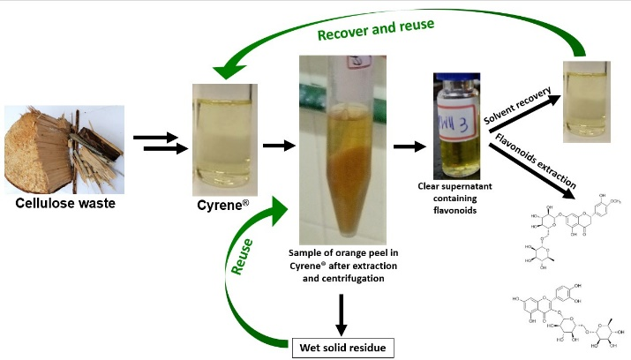

Cyrene® extracts more hesperidin and rutin when blended with water and can be recovered and reused.

