Perspective for Special Issue Richard J. K. Taylor
University of York, York YO10 5DD, UK

Abstract: This article gives a personal overview of a research career lasting from 1970 at the University of Sheffield to 2020 at the the University of York with stops at Syntex California, University College London, The Open University and The University of East Anglia in between. Selected research group highlights are summarised and placed in context. The Perspective concludes with some reminiscences and reflections about an academic research career in the UK over the past 50 or so years.

In the final year of my Chemistry B.Sc. degree at the University of Sheffield I applied for a place on a Teacher Training course and thought that the rest of my working life was secured. Then one day, I was walking down Brook Hill and I bumped into one of our most charismatic chemistry lecturers, Dr. Neville Jones. Neville asked me if I had considered a career in chemistry research (I hadn’t) and suggested that he would be keen to discuss possible PhD topics with me if I was interested. I had enjoyed my final year research project with Dr. Chris Falshaw and so I chatted to friends about this alternative future. Eventually I did go for discussions with Neville, accepted his offer of a PhD place, and deferred the Teacher Training place. At this point the Head of Organic Chemistry tried to persuade me that a position in his lab was much preferable but I continued with Neville as my first choice – a decision I have never regretted for a minute!

Neville’s main research interests were concerned the synthesis and properties of steroid analogues – elaborated, oxidised versions of the parent hydrocarbon cholestane 1 (Figure 1). The steroid family had long fascinated academics and pharmaceutical companies, particularly after the structural elucidation of the sex hormones (e.g. estrone and testosterone) in the1930s. By the 1960s, the use of steroid-based birth control pills had led to a major societal change. Figure 1 shows the synthetic progesterone analogue Norethisterone 2 which was first synthesised by Carl Djerassi at the Syntex company and, in combination with a synthetic estrogen Mestranol, marketed as Ortho-novum in 1963. Synthetic steroid analogues also found many other medical applications; for example, the corticosteroid analogue Dexamethasone 3 has been used since 1958 to treat inflammation, skin complaints, allergies, and many other conditions including chronic obstructive lung disease – and in 2020 this last application was extended to COVID-19 patients on ventilators with great success.

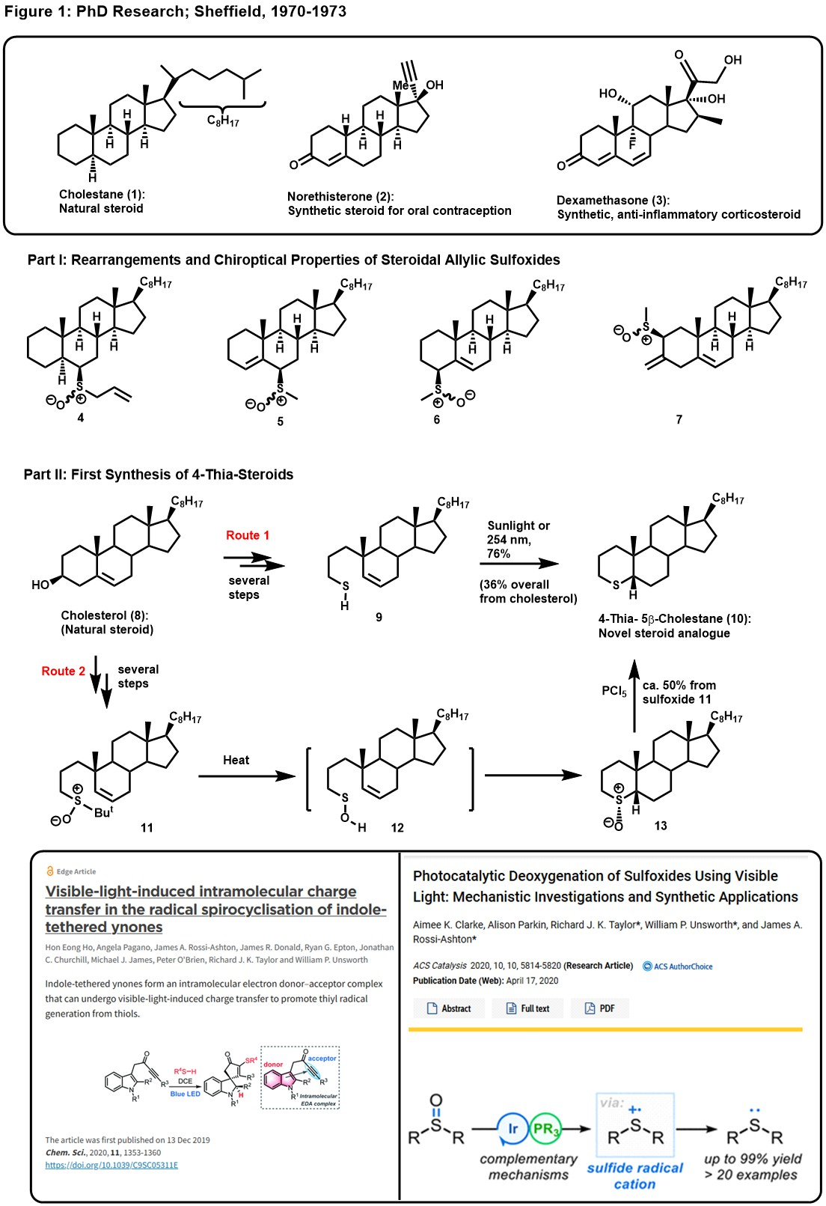

My first PhD project involved the synthesis of a range of steroidal allylic sulfoxides (e.g. 4-7) in order to study their optical properties (Optical Rotatory Dispersion / Circular Dichroism) and their sulfoxide-sulfenate rearrangements.¹ It soon became apparent that my interests lay towards the synthetic aspects of research and I was given a new project – to devise the first synthesis of steroids in which the A-ring contained a sulfur atom in place of C-4 (e.g. 10). Eventually, a route was devised starting from cheap cholesterol 8 and proceeding by way of the thiol 9. The first time thiol 9 was prepared it was a sunny day in Sheffield and an extremely efficient photochemical cyclisation occurred in the isolation flask producing the target 4-thia-5β-cholestane 10 as a beautifully crystalline compound. Unfortunately, I was never able to repeat this visible light transformation (I will make no comment on the weather in Sheffield) and UV irradiation was required to obtain a reproducible route to compound 10. Meanwhile, to avoid the problematic irradiation, and to indulge my new-found interest in sulfenic acids, a second route was devised. Cholesterol was converted into sulfoxide 11 by a multi-step route; heating 11 generated the transient sulfenic acid 12 which underwent rapid intramolecular alkene addition to produce the required sulfoxide 13. Sulfoxide 13 could be isomerised to give the 5α-series, oxidised to the corresponding sulfone, or reduced to sulfide 10, as shown, using PCl₅ (in a rather “messy” process). So, although the thiasteroid research was successful, there were two difficult steps - thiol addition to an alkene and sulfoxide reduction to a sulfide. I note with amusement that these two processes have been addressed in 2020 publications from our laboratories;^{3,4} just 50 years too late to help improve the Sheffield routes!

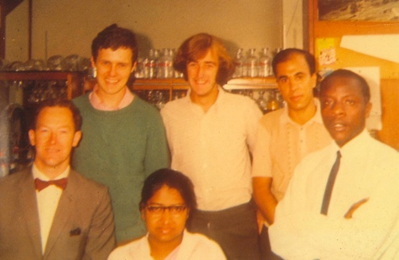

Neville Jones and his research groups in Sheffield in:

1970 (L to R: Neville, Kevin Wyse, RJKT, Essam Helmy, Jerome Msonthi and Rajeswary Mageswaran)
and
1973 (L to R: John Blenkinsopp, RJKT, Douglas Hill, Neville with Derek Lewton and Simon Knox at the front).

Whilst writing up my PhD Thesis, I reactivated the Teacher Training application. Then we had a visit from an earlier PhD student of Neville’s, Dr. Roger Grayshan; Roger had just returned from a period of postdoctoral research at the Syntex company in Palo Alto, California. Syntex was renowned for its steroid research, referred to earlier. Roger told us what a marvellous time he had there, both in terms of chemistry and in terms of exploring California and further afield. He said that, in his opinion, the best postdoctoral supervisor at Syntex would be Dr. Ian Harrison and that he would be able to send Dr. Harrison a letter of recommendation. Roger also mentioned that Syntex were working on a new family of natural compounds called prostaglandins that had the potential to be as pharmaceutically important as the steroids - I was convinced! So in 1973, I headed West to California, and as Roger Grayshan predicted, had a wonderful year there. Syntex was a very academic company; Ian Harrison had published the first synthesis of rotaxanes from there in 1967 and John Moffatt invented the Moffatt oxidation in Palo Alto. Syntex also hosted many invited lecturers and had stellar chemistry consultants who visited once or twice a year (Corey, Stork, Sondheimer etc.). It was close to Stanford University (Eugene van Tamelen, James Collman, Carl Djerassi etc.), the Linus Pauling Institute and many start-up companies such as Zoëcon and Alza, which were also carrying out fundamental organic chemistry. Ian Harrison was an inspirational mentor. In addition to his internationally-recognised rotaxane research, he was the discoverer of the anti-inflammatory drug Naproxen (Naprosyn, Aleve), the inventor of the Chromatotron (preparative, centrifugally accelerated, radial, thin-layer chromatograph) and the author (with his wife Shuyen Harrison) of the “Compendium of Organic Synthetic Methods”.

My research project, as I had hoped, involved the synthesis of novel prostaglandins (PGs) for medicinal evaluation. The PGs are a family of closely related compounds that occur in almost every human tissue and exhibit many biological effects, particularly in reproductive, respiratory, gastrointestinal, cardiac, and blood-clotting processes. The PGs were isolated in 1935 by von Euler in Sweden but it was not until 1962 that the structures were determined by Bergström and Samuelsson at the Karolinska Institute in Stockholm where they were shown to be biosynthesised from the C-20 fatty acid, Arachidonic acid (see later). Around the same time, John Vane, at the Royal College of Surgeons in London, was discovering the many the biological roles of PGs. Bergström, Samuelsson and Vane jointly received the 1982 Nobel Prize in Physiology or Medicine for their research on prostaglandins. These studies had energised the synthetic organic chemists with the first total syntheses of PGs reported by E. J. Corey’s group in the USA in 1969. Syntex were interested in obtaining metabolically stable and biologically selective analogues of the PGs and my project (Figure 2a) was to use my sulphur expertise to prepare and evaluate analogues of one of the parent prostaglandins, PGF_{1α} 14, and so a series of compounds with a sulfur atom in place of the C-9 and C-11 carbon atoms of the natural product were designed. It was hoped that the sulfoxide derivatives (e.g. 15) would mimic the hydroxyl group of the natural compounds. The 11-thia-derived sulfoxide 15, along with the corresponding sulfoxide diastereomer and sulfone, were successfully prepared via a short synthetic sequence.⁵ In addition, some closely related 9-thia-PG analogues were synthesised using a novel acetylenic ketone procedure to introduce the lower side chain (16 +17 →18).⁶ I should note that acetylenic ketones have proved to be very valuable units in our recent synthetic ventures (see later).

During one of Syntex’s regular consultancy sessions, I presented my research to the assembled group. Afterwards one of the most distinguished consultants, Professor Franz Sondheimer, asked me what I had organised for the the future. On hearing of my lack of definite plans, my desire to return to the UK (and renewed thoughts about a teaching career), Franz suggested that I should write to him about securing a postdoctoral position at University College London (UCL). This was quickly organised and after a marvellous 12 months in Palo Alto, I returned to a postdoctoral position in London and a flat in Muswell Hill close to Alexandra Palace (more of which shortly). Franz had previously worked for Syntex before moving to the Weizmann Institute in Israel and then on to Cambridge and then UCL as a Royal Society Research Professor. His main research contributions after leaving Syntex were in annulene chemistry, particularly the study of higher analogues of benzene to explore their synthetic accessibility, spectroscopic properties and stability (aromatic or anti-aromatic according to Hückel’s rule). By the time I arrived at UCL (1974) most of the fundamental studies in this area had been completed and the list of synthetic targets was getting rather esoteric. My challenge was to prepare biphenylene analogues in which one ring had been expanded to resemble [16]-annulene (19). The closest I got (Figure 2b) was compound 22 prepared by a double Wittig reaction (20 + 21) followed by a Glaser/Eglinton alkyne coupling using Cu(II).⁷ This was a rather clumsy synthesis to a product of minor interest – but these studies gave me an enduring interest in MnO₂ oxidations (used to prepare aldehydes such as 21), Wittig reactions and organocopper chemistry.
While in London, I started thinking about a permanent job and decided that I wanted to continue in a research-based career (school teaching was no longer an option). I had interviews at Allen and Hanburys (Ware) and Pfizer (Sandwich) but then I saw a lectureship advertised at the Open University (OU) in Milton Keynes. As this was the only University chemistry post on offer in England that year, I applied. Eventually, I turned down an industrial offer for a (much-lower paid) lecturer’s job at the OU in Milton Keynes. The years at the OU were marvellous from a personal viewpoint, and the OU, and my colleagues there, gave me a great training in teaching, scientific writing and communication skills. Back then, the OU recorded their TV programmes at Alexandra Palace in North London (close to my old flat in Muswell Hill) and radio programmes at the BBC studios in Marylebone, central London. Also, when I started at the OU they did not have any Chemistry labs and UCL kindly let me carry out my (now independent) research there. Trips to London were therefore frequent and also enabled me to meet Ginny (my future wife, who worked at the Wellcome Foundation on Euston Road - but that is another story!).
My years at the OU also providing time to plan and launch an independent research programme; initial research involved double Wittig reactions⁸ and then the development of novel phosphonate reagents 23⁹ and 24¹⁰ for the conversion of carbonyl compounds into α,β-unsaturated acids under relatively mild conditions (the development of reagent 24 stimulated an ongoing interest in dianion chemistry). Before long, the OU opened their brand new chemistry labs in Milton Keynes and my first two PhD students, Andy Dixon and Richard Batten, were appointed (they were the OU’s first two chemistry PhDs when they successfully graduated in 1981!). Special thanks must go to Dr. Roger Newton who entrusted one of Glaxo’s valuable SERC (forerunner to the EPSRC) PhD CASE awards to an unknown synthetic organic chemist at a new university; I very much hope that the current generation of industrialists are equally supportive to new appointees. The first publication from research carried out in Milton Keynes, which subsequently became popular, was a mild method for removing TBDMS-protecting groups using N-bromosuccinimide (which is selective in the presence of other acid-labile alcohol protecting groups, Figure 3, 25 → 26).¹¹

By 1975/76 the prostaglandin family had expanded considerably (Figure 3b). Biosynthetic studies had earlier established that the parent prostaglandins were formed in the body from polyunsaturated fatty acids such as Arachidonic acid (27) but further biological research had shown that other novel compounds were also produced by this biosynthetic manifold. Most notably, Thromboxane (TXA₂, 28) and Prostacyclin (PGI₂, 29) were shown to be formed by enzymes in the blood and they proved to have diametrically opposing biological properties. Thus, TXA₂ (28) is a potent promotor of platelet aggregation, whereas PGI₂ (29) is a potent vasodilator and inhibitor of platelet aggregation; the balance between 28 and 29 is therefore crucial in the blood clotting process. These studies suggested that TXA₂ (28) and PGI₂ (29) might have useful therapeutic applications but unfortunately their use in this way is extremely limited due to their very short half-lives (approx. 30 seconds and 2 minutes, respectively). Many synthetic organic chemists realised that these discoveries presented an opportunity to design and prepare stable analogues of the natural products for biological screening. Our plan was to use my sulfur expertise to prepare dithia-TXA₂ (30) and to prepare PGI₂ analogue 31, trusting that the presence of an oxane rather than an oxolane heterocyclic system would confer additional stability. In order to achieve these objectives, it was first necessary to develop the key methodology to construct the basic framework of the target systems. Given my interest in copper chemistry mentioned earlier, we eventually settled on the conjugate addition of organocopper reagents to cyclic enones (32 → 33), where possible using in situ enolate alkyation¹² to introduce the second side chain (32 → 35). Thus, Richard Batten developed the chemistry leading to the sulfur systems 34¹³ and Andy Dixon mastered the route to cyclopentanones 36.¹⁴ This copper methodology was then applied to the successful synthesis of dithia-TXA₂ (30), completed with financial support from the SERC who provided my first research council grant (used to support Dr. Simon Lane),¹⁵ and to the synthesis of homo-PGI₂ analogue 31 and related analogues.¹⁶
1979 marked the next move – from Milton Keynes to Norwich, from the OU to UEA, and from a predominantly teaching department to one which had an international reputation in organic synthesis thanks to Professors Alan Katritzky and Sandy McKillop and their colleagues. My research group started to expand and although part of the effort was concentrated on completing routes to dithia-TXA₂ (30)¹⁵ plus novel thromboxane, prostacyclin and prostaglandin analogues, new projects were devised. One such project, which blossomed very quickly, was again inspired by the Arachidonic acid cascade (Figure 4). Around 1979, a new group of biologically-active Arachidonic acid metabolites were structurally identified as being hydroxylated, acyclic derivatives, typified by Leukotriene B₄ (37). The leukotrienes are intimately involved in inflammation, allergies and asthma and leukotriene antagonists quickly became prime pharmaceutical targets. We therefore initiated a project to prepare novel leukotriene analogues for biological screening; two “bridged” examples are shown, the benzene derivative 38, prepared using dianion chemistry,¹⁷ and the thiophene analogue 39, prepared using palladium-catalysed coupling in the key step¹⁸ (palladium-catalysed processes, and the development of new Pd catalysts,¹⁹ became another lasting research group theme). The leukotrienes inspired another long-standing interest – the development of stereocontrolled routes to polyenes of biological interest. Key discoveries in this area (Figure 4), several made by a PhD student called Mark Furber, involved: (i) the addition of organolithium reagents to pyrylium salts (40) to generate C-2 addition intermediates 41 which undergo electrocyclic ring-opening on warming to room temperature to generate 2Z,4E-dienals 42;²⁰ (ii) the addition of organocuprate reagents to two equivalents of ethyne to generate dienylcuprate intermediates 43 which could be trapped by a variety of electrophiles to produce conjugated Z,Z-dienes 44;²¹ (iii) the addition of Grignard or organolithium reagents to silylated glutaconaldehydes (e.g. 45) with hydrolysis of the intermediate 46 giving 2E,4E-dienals 47.²² With these novel stereoselective routes to dienes in hand, a range of natural products of biological interest were prepared including the Navel Orangeworm Pheromone (48) and Sarmentine (49) - and Ben Borer’s synthesis of Leukotriene B₄ (37) itself.²⁰⁻²²

The Arachidonic acid cascade work produced another bonus. Having devised a range of methods for preparing substituted thia-cyclohexanes en route to thia-thromboxane analogues (see Figure 3), we realised that we had a potential synthetic entry into substituted cyclopentenones by use of the Ramberg-Bäcklund reaction (RBR) as shown in Figure 4.²³ This novel approach was quickly validated (50 → 52). The readily-available enones 50 were efficiently converted into iodides 51 by treatment with trimethylsilyl iodide in ethylene glycol. Next, the RBR of α-iodo-sulfones 51 followed by removal of the ketal protecting group under mildly acidic conditions efficiently produced the non-conjugated cyclopentenones 52. In addition, the use of stronger acidic conditions generated the corresponding conjugated cyclopentenones and this methodology was then applied to prepare the antimicrobial natural product, Tetrahydrodicranenone B (53).²³ It became evident that the RBRs on α-iodo-sulfones 51 proceeded very rapidly and Alan Sutherland discovered that, at low temperature (–78 ºC), base-treatment generated the intermediate episulfone (e.g. 51a → 54); episulfone 54 was fully characterised, including by X-ray crystallography, and was readily converted into the corresponding alkene on further base-treatment or thermolysis.²⁴ Although episulfones had been proposed as the key intermediates in the RBR, this study provided the first unambiguous evidence that the RBR does indeed proceed via episulfone intermediates. We also established that episulfones can be prepared by the oxidation of episulfides²⁵ and that episulfone α-anions are readily prepared and synthetically useful.²⁶ These fundamental discoveries led us to develop a major programme to investigate the synthetic potential of the RBR and of isolated episulfones and to apply these findings in target synthesis.²⁷ This research programme continued for a number of years with major advances being made after the move to York (see later), in particular in natural product (e.g. Varitriol 55) and target synthesis (e.g. trans-Carbovir 56) areas.²⁸

The UEA period also stimulated a number of collaborations. Joint research projects with my colleague Dr. Alan Haines on the design and preparation of novel glucosidase inhibitors and potential AIDS drugs introduced our research group to the specialised protocols needed for carbohydrate synthesis.²⁹ These skills proved invaluable after moving to York, when Dr. Paul Murphy and I undertook a collaboration with Professor Rod Hubbard and Chiroscience to prepare novel Sialyl Lewis^{x} analogues as potential cell adhesion inhibitors.³⁰ In addition, also in York, Frank Griffin, Dr. Graeme McAllister and Duncan Paterson combined the RBR and carbohydrate expertise to develop a new route to C-glycopeptides and C-linked disaccharides (e.g. the conversion of sulfone 57 into C-Gentiobioside 58).³¹
However, I am jumping ahead too quickly. The period at UEA also marked the initiation of another research programme to develop synthetic routes to newly-discovered bioactive natural products, particularly those with antibiotic and anti-cancer potential. Attention was focussed on structures posing a synthetic challenge in terms of architecture and functionality which required the development of new methodology to complete short and efficient synthetic routes to the target compounds that could easily be adapted to prepare a range of structural analogues for biological screening; such projects were often carried out together with motivated industrial collaborators. The first target was the anti-cancer agent Rocaglamide (59), and this challenge introduced me to a young undergraduate project student, Andy Parsons, who later became a much-valued colleague. Rocaglamide was successfully prepared by Andy Davey and Dr. Marcel Schaeffer with financial support from Ciba-Geigy in Switzerland (and with generous advice from Prof. Ralph Raphael, who was then Head of Organic Chemistry at Cambridge).³² Soon afterwards, in collaboration with Prof. Sandy McKillop at UEA and Dr. Norman Lewis from SmithKline Beecham, the design of a synthetic route to the novel antibiotic Aranorosin (60) and analogues was initiated and completed by Bob Watson.³³
In 1993, the next move followed – from Norwich to York, to another beautiful city with a supportive and collegiate Chemistry Department. Many exciting years followed as the Chemistry Department at York, renowned for its research in physical organic chemistry (R.O.C Norman, Bruce Gilbert, John Lindsay Smith, Peter Hanson, Barry Thomas, John Vernon etc.), enhanced its presence in synthetic organic, supramolecular and organometallic chemistry. With Prof. Bruce Gilbert as Head of Department, Dr. Andy Parsons (‘93), Dr. Peter O’Brien (‘96), Dr. Victor Chechik (‘99), Dr. Dave Smith (‘99), Dr. Anne Routledge (2001) and Dr. Ian Fairlamb (2001) soon arrived. The subsequent appointments of Dr. Paul Clarke, Dr. Martin Fascione, Prof. Mike North, Dr. Will Unsworth, Dr. Chris Spicer and Dr. Alyssa-Jennifer Avestro has continued to strengthen the organic research expertise and to broaden its horizons.
This Preface is becoming rather lengthy and so, with apologies to all involved, I will condense our research over the next 20-30 years into a few paragraphs! The natural product adventures continued (Figure 5) with Alisamycin (61) and related members of the Manumycin (62) family of anti-cancer natural products (where we first got seriously involved in asymmetric synthesis, another enduring interest),³⁴ Preussomerin K (63),³⁵ Kainic Acid (64),³⁶ Apicularen (65),³⁷ Inthomycins (66) and Oxazolomycins (67),³⁸ Paeonilactone B (68),³⁹ Dictyosphaeric Acid A (69),⁴⁰ Grandisine B (70),⁴¹ Janoxepin (71),⁴² Spirobacillene A (72)⁴³ and Phacelocarpus 2-pyrone A (73)⁴⁴ being just some of the projects that fascinated us during this period.

The design and implementation of synthetic routes to target compounds inevitably highlights the need for new synthetic methods which improve on existing procedures (reducing the number of steps, increasing the yield, removing toxic or environmentally suspect reagents, improving selectivity etc.). The projects outlined in Figure 5 stimulated a number of investigations during the York period, some of which are summarised in Figure 6. In one project, initiated by Dr. Xudong Wei, Tandem Oxidation Processes (TOP, Figure 6a) were designed to produce a range of aliphatic, alicyclic and heterocyclic compounds directly from alcohols. These environmentally advantageous procedures have been widely used by other academic laboratories and in the pharmaceutical industry.⁴⁵ In such oxidative processes, which are particularly well-suited to unstable aldehyde intermediates, two, three or more conventional reactions are carried out in a single operation, improving efficiencies and overall yields in a range of useful synthetic transformations. Early studies involved the oxidation of alcohols using manganese dioxide followed by in situ Wittig elaboration of the intermediate carbonyl compounds (e.g. 74 → 75); related tandem oxidation / cyclopropanation procedures (e.g. 76 → 77) have also been developed. Tandem oxidation procedures involving the trapping of intermediate aldehydes with amines are also straightforward (e.g. 78 → 79) and a version which also incorporates hydride reducing agents [NaBH₄ or polymer-supported cyanoborohydride (PSCBH)] enables oxidation / trapping / reduction to be carried out in a single operation. This latter procedure was applied to convert cinnamyl alcohol (78) and 1-(N-methylaminomethyl)naphthalene (81) directly into the topical antifungal agent Naftifine (82) in 72% overall yield. A number of other TOP variants have been developed, some utilising alternative starting materials and oxidants; for example, the direct conversion of α-hydroxy-ketone 83 and 1,2-diaminobenzene (84) into the substituted quinoxaline 85 can be accomplished efficiently using a palladium-catalysed aerial oxidation procedure with only 2 mol% Pd(OAc)₂. In addition to quinoxalines, TOP procedures have also been employed to prepare a range of related heterocycles (e.g pyrazines, dihydropyrazines, piperazines, and triazines).⁴⁵

A second project, with Steve Raw as the driving force, concerned the design of novel pericyclic cascade routes to pyridines and complex nitrogen polycycles (Figure 6b).^{46,47} For example, a conceptually novel Tethered Imine–Enamine (TIE) approach was developed for the direct conversion of 1,2,4-triazines into highly substituted pyridines (e.g. 86 → 87) via inverse electron demand Diels–Alder reactions. This new procedure, which avoids the need for a discrete aromatisation step, was employed to prepare a range of poly-substituted pyridines (e.g. 87a) and used as the cornerstone of an efficient synthetic route to several members of the Louisianin family of antibacterial / anticancer natural products (e.g. 88).⁴⁶ Similarly, a triple Diels-Alder (DA) sequence (DA / retro-DA / intramolecular DA) cascade was developed to generate complex and novel nitrogen-containing polycyclic cage compounds 90 from triazines 86 and allylamines 89 via a single synthetic operation.⁴⁷

A third project (Figure 6c), initiated by Dr. Alexis Perry, utilised inexpensive copper(II) catalysts to access a range of useful heterocyclic building blocks by the radical cross-dehydrogenative coupling of linear precursors.⁴⁸ These copper(II)-mediated procedures, which are simple to perform, are run open to the air, and are moisture insensitive, were initially developed to prepare oxindoles 92 from acyclic anilides 91 and then extended to prepare thio-oxindoles 93, and spirocyclic oxindoles 94 and 95. This methodology was then applied to prepare bis-oxindoles 96 (via double spirocyclisation) and to a formal total synthesis of the vasopressin V2 receptor antagonist Satavaptan 97. Subsequent studies used the copper(II)-mediated procedures to obtain 3,4-dihydro-1H-quinolin-2-ones 98, 1,2,3,4-tetrahydroquinolines 99, acridanes 100, 2-quinolones 101 and 3H- and 1H-indoles 102 and 103.

Another rewarding project from this period, carried out in collaboration with Professor Ian Fairlamb, involved the development of new palladium catalysts and pre-catalysts for the Stille and Suzuki cross-coupling reactions of benzylic, vinylic and allylic halides (Figure 6d).⁴⁹ Serendipity, and the observational skills of Catherine Crawforth, were crucial to the discovery of trans-bromo(N-succinimidyl)-bis(triphenylphosphine)palladium(II) (104) but it proved to be an excellent cross-coupling catalyst which is widely used in academia and industry and is marketed by the Aldrich Company (cat. no: 643742). In our groups, we have used catalyst 104 for a number of cross-coupling processes including 106 → 107, an important reaction in the Inthomycin (66) / Oxazolomycin (67) project.^{38,49} Further studies demonstrated the unusually high efficiency of a range of palladium catalysts bearing one or more imidate ligands in Stille and Suzuki–Miyaura cross-couplings involving allylic and benzylic electrophiles. For example, the corresponding succinimide-based palladium complex AsCat (105) was used to catalyse Stille cross-coupling reactions with benzyl chlorides at room-temperature and was also employed for the key macrocyclisation step involving a Stille / allylic acetate coupling (106 → 107) in the total synthesis of Phacelocarpus 2-pyrone A (73).⁴⁴

I have included one further Figure to cover the most recent research carried out in York as part of a collaboration with Dr. Will Unsworth, first as a post-doctoral researcher and then as a colleague, over the period 2010 to the present day. This collaboration, parts of which were reliant on major contributions from Prof. Peter O’Brien, Dr. Jason Lynam, Prof. Rebecca Goss (St Andrews), Profs. Shu-Li You and Chao Zheng (Shanghai), together with Dr. Sarah Chambers, Dr. Aimee Clarke, Dr. Graeme Coulthard, Dr. James Cuthbertson, Dr. James Donald, Ryan Epton, Dr. Hon Ho, Nantachai Inprung, Dr. Michael James, Dr. Christiana Kitsiou, Dr. John Liddon, Dr. Matthew Lloyd, Dr. Jon Osler, Dr. Wade Petersen, and James Rossi-Ashton, is summarised in Figure 7. The initial research involved the development of new chemistry, particularly Direct Imine Acylation (DIA, illustrated) to access the novel marine metabolite ‘Upenamide 111.⁵⁰ The DIA methodology was also utilised to prepare a range of natural product targets including Evodiamine (112), Elaeokanidine A (113), Dievodiamine (114) and Lasubine II (115).⁵¹ Other targets included the Cedaramycins (116 and 117) and Pyxidatol C (118) which required the development of rhodium-catalysed C-H activation processes⁵² and the Cope rearrangement of gem-dimethyl-substituted divinylcyclopropanes,⁵³ respectively. The ‘Upenamide project also led to a growing interest in the design of improved routes to prepare spirocyclic compounds for biological screening. Silver- and copper-catalysed dearomative spirocyclisations of acetylenic ketones (first mentioned in Figure 2) were developed as an efficient means to this end and modifications were developed to enable enantioselective versions and continuous-flow processes (using solid-supported catalysts).⁵⁴ Related ynone cyclisation procedures have also been developed to prepare other heterocyclic systems such as indolizidines, quinolizidines and indoles (starting from pyrroles).⁵⁵ More recently still, photochemical processes for the spirocyclisation of ynones have been developed which rely on the in situ formation of intramolecular charge-transfer intermediates.⁵⁶ The ultimate extension of the methodology just described has been the development, using both experimental and computational studies, of catalyst-selective syntheses where a given starting material (e.g. ynone 119 or diazo-ketone 120) can be converted selectively into a range of different products simply by changing the catalyst and / or the reaction conditions.⁵⁷

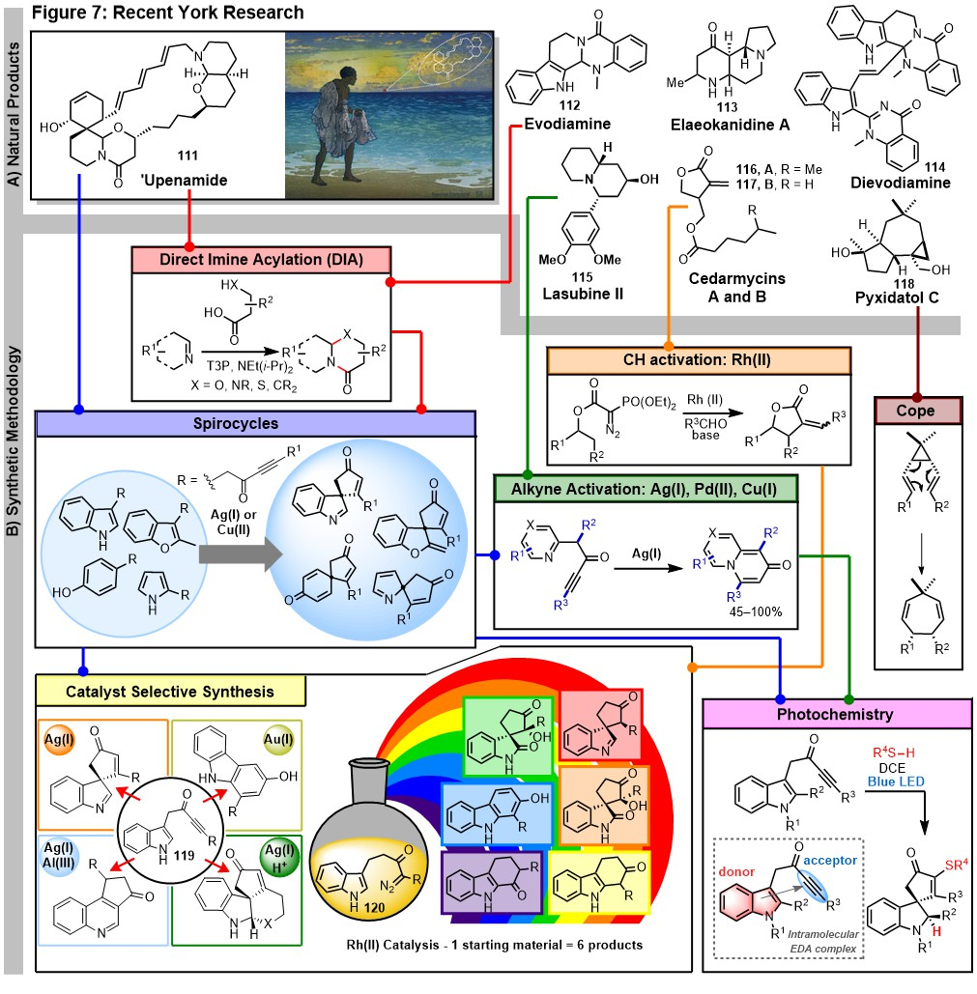
Concluding remarks
I apologise if this Perspective appears self-indulgent but I hope that some of the chemistry and the insights prove interesting to some of the readers. My main worry, however, is that I did not have space to mention all of the research projects and therefore many of the research group members and collaborators have not so far been mentioned in the text or in the references (so let’s correct that!⁵⁹⁻⁶¹). I must also give special mentions to Dr. Graeme McAllister (who joined my group at York as a PDRA in 1999 and has continued to collaborate over the years, to ensure safety and good research practice in our labs, and to carry out microanalyses for the Department), and to Dr. Adrian Whitwood (who has carried out many crucial X-ray structure determinations for us in York).

I must also make it clear that many of the outstanding research advances outlined in this article came from members of the research group and my collaborators, and not from me. This revelation will not surprise my academic colleagues – it is how any successful, collaborative research group must operate! I should also note with great pride that many of my research group have gone on to highly successful careers and senior positions in industry and academia (and one has recently been appointed to a Vice Chancellorship).

Looking back over a research career of 50+ years brings many special memories – different labs in different countries, inspirational co-workers and colleagues (many of whom became permanent friends), successful research projects (and less successful ones), supportive industrial collaborators, and special conferences (such as the Oxford/Cambridge International Synthesis Conference, the Royal Society of Chemistry Heterocyclic Group meetings in Grasmere, International Society of Heterocyclic Chemistry meetings, numerous Tetrahedron meetings etc.). So what conclusions can I draw from these experiences? First, the overwhelming advantages that can be gained by working in collegiate chemistry departments where colleagues help one another and enhance each others’ research programmes. Second, the importance of a happy and talented research group of undergraduates, MSc and PhD students, postdoctoral fellows and overseas visitors. Third, the positive role that can be played by collaborators, both academic and industrial. And of course, the crucial availability of well-funded labs and research council / industrial support to pay for the research posts and consumable costs. Most of all, however, I realise the importance of luck – the unplanned meeting that changes your life choice, the unexpected research result that generates a new programme, the industrialist or biologist who presents you with a challenging synthetic target, or the colleague who provides a mechanistic explanation you had not seen and launches a new series of investigations. Planning research programmes is essential, but serendipity can take you to unenvisioned places (as it did for the Princes of Serendip⁶²).

Finally, a big thank you to all of the authors of the papers in this Special Issue. Given the problems presented by Covid-19 in all aspects of life, including organising teaching and research from a distance, I am truly grateful for the time spent preparing these publications. Thanks too to Professor Angela Russell for her invaluable encouragement and assistance with this Special Issue, and to Peter O’Brien and Will Unsworth for their helpful comments on this article, and to Will for preparing Figure 7.

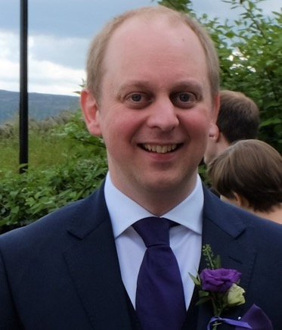
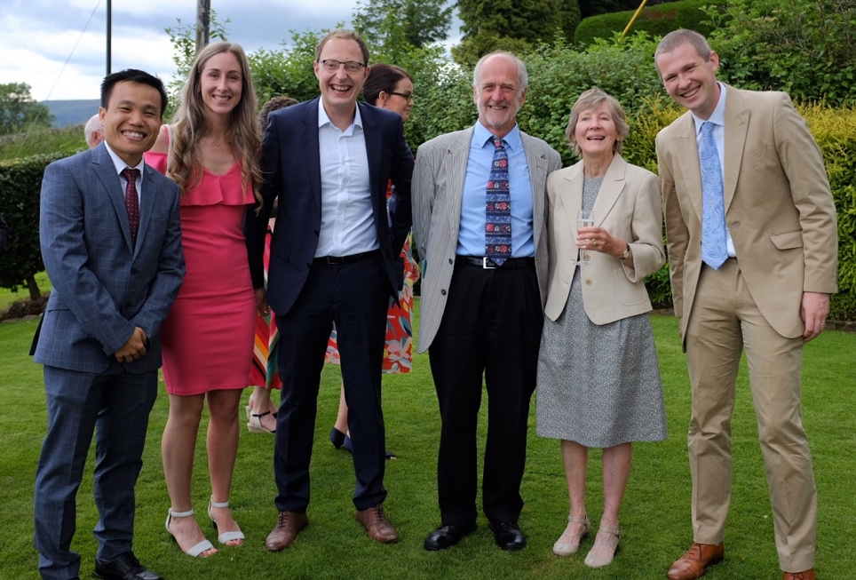
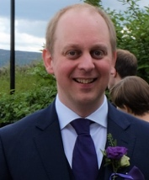

Hon Ho, Aimee Clarke, James Rossi-Ashton, Richard Taylor, Ginny Taylor and Will Unsworth at the wedding of James Donald (inset) in 2019.

References

1. D. N. Jones, E. Helmy, R. J. K. Taylor and A. C. F. Edmonds, Chem. Comm., 1401-1403 (1971);
D. N. Jones, J. Blenkinsopp, A. C. F. Edmonds, E. Helmy and R. J. K. Taylor,
J. Chem. Soc., Perkin Trans. 1, 2602-2613 (1973)
D. N. Jones, J. Blenkinsopp, A. C. F. Edmonds, E. Helmy and R. J. K. Taylor,
J. Chem. Soc., Perkin Trans. 1, 937-941 (1974).

2. D. N. Jones, D. A. Lewton, J. D. Msonthi and R. J. K. Taylor,
J. Chem. Soc., Perkin Trans. 1, 2637-2645 (1974).

3. H. E. Ho, A. Pagano, J. A. Rossi-Ashton, J. R. Donald, R. G. Epton, J. C. Churchill, M. J. James, P. O’Brien, R. J. K. Taylor and W. P. Unsworth,
Chem. Sci., 11, 1353-1360 (2020).
4. A. K. Clarke, W. P. Unsworth, R. J. K. Taylor and J. A. Rossi-Ashton,
ACS Catalysis, 10, 5814-5820 (2020).
5. I. T. Harrison, R. J. K. Taylor and J. Fried,
Tetrahedron Lett., 1165-1168 (1975).
6. R. J. K. Taylor and I. T. Harrison,
Tetrahedron Lett., 4793-4796 (1976).
7. F. Sondheimer and R. J. K. Taylor,
J. Org. Chem., 46, 4594-4595 (1981).
8. R. J. K. Taylor, Synthesis, 564-565 (1977);
R. J. K. Taylor, Synthesis, 566-567 (1977).

9. R. J. K. Taylor and L. Lombardo,
Synthesis, 131-132 (1978).
10. R. J. K. Taylor and L. Lombardo,
Synth. Commun., 463-468 (1978).
11. R. J. Batten, A. J. Dixon, R. J. K. Taylor and R.F. Newton,
Synthesis, 234-236 (1980).
12. R. J. K. Taylor,
Synthesis, 364-392 (1985).

13. R. J. Batten, J. D. Coyle and R. J. K. Taylor,
Synthesis, 910-911 (1980);
R. J. Batten, J. D. Coyle and R. J. K. Taylor,
J. Chem. Soc., Perkin Trans. 1, 1177-1182 (1982).
14. A. J. Dixon, R. J. K. Taylor and R. F. Newton,
J. Chem. Soc., Perkin Trans. 1, 1407-1410 (1981).
15. G. Casy, S. Lane and R. J. K. Taylor,
J. Chem. Soc., Perkin Trans. 1, 1397-1404 (1986);
S. Lane, S. J. Quick and R. J. K. Taylor,
J. Chem. Soc., Perkin Trans. 1, 893-898 (1985).
16. A.J. Dixon, R. J. K. Taylor, R. F. Newton and A. H. Wadsworth,
Tetrahedron Lett., 327-330 (1982);
A. J. Dixon, R. J. K. Taylor, R. F. Newton, A. H. Wadsworth and G. Klinkert,
J. Chem. Soc., Perkin Trans. 1, 1923-1932 (1982);
S. Cook, D. Henderson, R. J. K. Taylor, J. Saunders and P. G. Strange,
J. Chem. Soc., Perkin Trans. 1, 1825-1831 (1987);
K. A. Richardson, J. Saunders and R. J. K. Taylor,
Tetrahedron Lett., 26, 1171-1174 (1985);
E. W. Collington, H. Finch, J. G. Montana and R. J. K. Taylor,
J. Chem. Soc., Perkin Trans. 1, 1839-1846 (1990).
17. M. Furber, R. J. K. Taylor and S. C. Burford,
J. Chem. Soc., Perkin Trans. 1, 1573-1578 (1987).
18. P. T. de Sousa and R. J. K. Taylor,
Synlett, 755-757 (1990);
S. J. Phythian, R. J. K. Taylor and J. R. Bantick,
J. Chem. Soc., Perkin Trans. 1, 194-195 (1990).

19. C. M. Crawforth, S. Burling, I. J. S. Fairlamb, R. J. K. Taylor and A. C. Whitwood, Chem. Commun., 2194-2195 (2003);
I. J. S. Fairlamb, R. J. K. Taylor, J. L. Serrano, G. Sánchez,
NJC, 30, 1655-1704 (2006).

20. M. Furber and R. J. K. Taylor,
J. Chem. Soc., Chem. Comm., 782-783 (1985);
J. M. Herbert, E. F. de Medeiros and R. J. K. Taylor,
J. Chem. Soc., Perkin Trans. 1, 2725-2730 (1991);
Y. Y. Belosludtsev, B. C. Borer and R. J. K. Taylor,
Synthesis, 320-322 (1991);
P. Charoenying, K. Hemming, D. McKerrecher and R. J. K. Taylor,
J. Het. Chem., 33, 1083-1089 (1996).
B. C. Borer and R. J. K. Taylor,
Synlett, 117-118 (1992).
21. M. Furber, R. J. K. Taylor and S. C. Burford,
Tetrahedron Lett., 26, 2731-2734 (1985);
M. Furber, R. J. K. Taylor and S. C. Burford,
J. Chem. Soc., Perkin Trans. 1, 1809-1815 (1986).

22. N. Lewis, P. W. McKen and R. J. K. Taylor,
Synlett, 898-900 (1991).

23. G. Casy and R. J. K. Taylor,
J. Chem. Soc., Chem. Comm., 454-455 (1988);
G. Casy and R. J. K. Taylor,
Tetrahedron, 45, 455-466 (1989).

24. A. G. Sutherland and R. J. K. Taylor,
Tetrahedron Lett., 25, 3267-3270 (1989);
S. M. Jeffery, A. G. Sutherland, S. M. Pyke, A. K. Powell and R. J. K. Taylor,
J. Chem. Soc., Perkin Trans. I, 2317-2327 (1993);
R. A. Ewin, W. A. Loughlin, S. M. Pyke, J. C. Morales and R. J. K. Taylor,
Synlett, 660-662 (1993).

25. P. Johnson and R. J. K. Taylor,
Tetrahedron Lett., 38, 5873-5876 (1997).

26. A. E. Graham, W. A. Loughlin, M. H. M. Moore, S. M. Pyke, G. Wilson and R. J. K. Taylor,
J. Chem. Soc., Perkin Trans. 1, 661-667 (1996).
27. R. J. K. Taylor,
Chem. Commun., 217-227 (1999);
G. Casy and R. J. K. Taylor,
Organic Reactions, 62, 357-475 (2003);
P. Evans and R. J. K. Taylor,
Eur. J. Org. Chem., 1740-1754 (2006).

28. G. D. McAllister, J. E. Robinson and R. J. K. Taylor,
Tetrahedron, 63, 12123-12130 (2007);
A. Grumann, H. Marley and R. J. K. Taylor,
Tetrahedron Lett., 36, 7767-7768 (1995).

29. J. C. Briggs, A. H. Haines and R. J. K. Taylor,
J. Chem. Soc., Chem. Comm., 1039-1041 (1992);
P. A. Fowler, A. H. Haines and R. J. K. Taylor, E. J. T. Chrystal and M. B. Gravestock,
Carbohydrate Research, 377-381 (1993);
Z.-X. Guo, A. H. Haines, S. M. Pyke, S. G. Pyke, and R. J. K. Taylor,
Carbohydrate Research, 264, 147-153 (1994);
J. C. Briggs, A. H. Haines and R. J. K. Taylor,
J. Chem. Soc., Perkin Trans. 1, 27-32 (1995).

30. P. V. Murphy, R. E. Hubbard, D. T. Manallack, J. G. Montana and R. J. K. Taylor,
Tetrahedron Lett., 38, 3273-3276 (1998);
P. V. Murphy, R. E. Hubbard, D. T. Manallack, J. G. Montana and R. J. K. Taylor,
Bioorg. Med. Chem., 6, 2421-2439 (1998).

31. F. K. Griffin, D. E. Paterson and R. J. K. Taylor,
Angew. Chemie, Int. Ed. Engl., 38, 2939-2942 (1999);
F. K. Griffin, P. V. Murphy, D. E. Paterson and R. J. K. Taylor,
Eur. J. Org. Chem., 1305-1322 (2002)
F. K. Griffin, D. E. Paterson and R. J. K. Taylor,
Eur. J. Org. Chem., 1323-1336 (2002);
G. D. McAllister, D. E. Paterson and R. J. K. Taylor,
Angew. Chemie, Int. Ed. Engl., 42, 1387-1391 (2003);
S. Jeanmart and R. J. K. Taylor,
Tetrahedron Lett., 46, 9043-9048 (2005);
R. J. K. Taylor, G. D. McAllister and R. W. Franck,
Carbohydrate Research, 341, 1298-1311 (2006).

32. A. E. Davey and R. J. K. Taylor,
J. Chem. Soc., Chem. Comm., 25-27 (1987);
A. E. Davey, A. F. Parsons and R. J. K. Taylor,
J. Chem. Soc., Perkin Trans. 1, 1853-1858 (1989);
A.E. Davey, M. J. Schaeffer and R. J. K. Taylor,
J. Chem. Soc., Perkin Trans. 1, 2657-2666 (1992).

33. A. McKillop, R. J. K. Taylor, R. J. Watson and N. Lewis,
J. Chem. Soc., Chem. Comm., 1589-1591 (1992).
A. McKillop, L. McLaren, R. J. K. Taylor, R. J. Watson and N. Lewis,
J. Chem. Soc., Perkin Trans. 1, 1385-1393 (1996).

34. L. Alcaraz, G. Macdonald, J. P. Ragot, N. Lewis and R. J. K. Taylor,
J. Org. Chem., 63, 3526-3527 (1998);
J. J. C. Grové, X. Wei and R. J. K. Taylor,
Chem. Commun., 421-422 (1999);
L. Alcaraz, G. Macdonald, J. Ragot, N. J. Lewis and R. J. K. Taylor,
Tetrahedron, 55, 3707-3716 (1999);
R. J. K. Taylor, L. Alcaraz, I. Kapfer-Eyer, G. Macdonald, X. Wei and N. J. Lewis,
Synthesis, 775-790 (1998);
X. Wei and R. J. K. Taylor,
J. Org. Chem., 65, 616-620 (2000).

35. J. P. Ragot, M.-L. Alcaraz and R. J. K. Taylor,
Tetrahedron Lett., 39, 4921-4924 (1998);
J. P. Ragot, C. Steeneck, M.-L. Alcaraz and R. J. K. Taylor,
J. Chem. Soc., Perkin Trans. 1, 1073-1082 (1999);
E. Quesada , M. Stockley, J. P. Ragot, M. E. Prime, A. C. Whitwood and R. J. K. Taylor,
Org. Biomol. Chem., 2, 2483- 2495 (2004).

36. A. J. Bird, R. J. K. Taylor and X. Wei,
Synlett, 1237-1238 (1995);
A. D. Campbell, T. M. Raynham and R. J. K. Taylor,
Chem. Commun., 245-246 (1999);
A. D. Campbell, T. M. Raynham and R. J. K. Taylor,
J. Chem. Soc., Perkin Trans. 1, 3194-3204 (2000).

37. A. Lewis, I. Stefanuti, S. A. Swain, S. A. Smith and R. J. K. Taylor,
Tetrahedron Lett., 42, 5549-5552 (2001);
A. Lewis, I. Stefanuti, S. A. Swain, S. A. Smith and R. J. K. Taylor,
Org. Biomol. Chem., 1, 104-116 (2003).

38. M. R. Webb, C. Donald and R. J. K. Taylor,
Tetrahedron Lett., 47, 549-552 (2006);
M. R. Webb, M. S. Addie, C. M. Crawforth, J. W. Dale, X. Franci, M. Pizzonero, C. Donald and R. J. K. Taylor,
Tetrahedron, 64, 4778-4791 (2008).
R. Bastin, J. W. Dale, M. G. Edwards, J. P. N. Papillon, M. R. Webb and R, J. K. Taylor,Tetrahedron, 67, 10026-10044 (2011).

39. M. G. Edwards, M. N. Kenworthy, R. R. A. Kitson, M. Scott and R. J. K. Taylor,
Angew. Chemie Int. Ed., 47, 1935-1937 (2008);
M. G. Edwards, M. N. Kenworthy, R. R. A. Kitson, A. Perry, M. Scott, A. C. Whitwood and R. J. K. Taylor,
Eur. J. Org. Chem., 4769-4783 (2008);
R. R. A. Kitson, A. Millemaggi and R. J. K. Taylor,
Angew. Chemie Int. Ed., 48, 9426-9451 (2009);
R. R. A. Kitson, R. J. K. Taylor and J. L. Wood,
Org. Lett. 11, 5338-5341 (2009).

40. C. W. Barfoot, A. R. Burns, M. G. Edwards, M. N. Kenworthy, M. Ahmed, S. E. Shanahan and R. J. K. Taylor,
Org. Lett., 10, 353-356 (2008);
A. R. Burns, G. D. McAllister, S. E. Shanahan and R. J. K. Taylor,
Angew. Chemie Int. Ed., 49, 5574-5577 (2010).

41. J. D. Cuthbertson, A. A. Godfrey and R. J. K. Taylor,
Org. Lett., 13, 3976-3979 (2011);
J. D. Cuthbertson and R. J. K. Taylor,
Angew. Chem. Int. Ed. 52, 1490-1493 (2013).

42. R. G. Doveston, R. Steendam, S. Jones and R. J. K. Taylor,
Org. Lett. 14, 1122–1125 (2012);
R. G. Doveston and R. J. K. Taylor,
Tetrahedron Lett. 53, 2533-2536 (2012).

43. W. P Unsworth, J. D. Cuthbertson and R. J. K. Taylor,
Org. Lett., 15, 3306-3309 (2013).
44. T. O. Ronson, M. H. H. Voelkel, R. J. K. Taylor and I. J. S. Fairlamb,
Chem. Commun., 51, 8034-8036 (2015);
T. O. Ronson, M. J. Burns, M. H. H. Voelkel, K. J. Evans, J. M. Lynam, R. J. K. Taylor and I. J. S. Fairlamb,
Chem. Eur. J., 21, 18905-18909 (2015);
T. O. Ronson, R. J. K. Taylor and I. J. S. Fairlamb,
Tetrahedron, 71, 989-1009 (2015).

45. X. Wei and R. J. K. Taylor,
Tetrahedron Lett., 39, 3815-3818 (1998);
L. Blackburn and R. J. K. Taylor,
Org. Lett., 3, 1637-1639 (2001);
K. A Runcie and R. J. K. Taylor,
Chem. Commun., 974-975 (2002);
H. Kanno and R. J. K. Taylor,
Tetrahedron Lett., 43, 7337-7340 (2002);
L. Blackburn, C. Pei and R. J. K. Taylor,
Synlett, 215-218 (2002);
C. Wilfred and R. J. K. Taylor,
Synlett, 2004, 1628-1630 (2004);
R. S. Robinson and R. J. K. Taylor,
Synlett, 1003-1005 (2005);
E. Quesada, S. A. Raw, M. Reid, E. Roman and R. J. K. Taylor,
Tetrahedron, 62, 6673-6680 (2006);
G. D. McAllister, M. F. Oswald, R. J. Paxton, S. A. Raw and R. J. K. Taylor,
Tetrahedron, 62, 6681-6694 (2006);
For a review see: R. J. K. Taylor, M. Reid, J. Foot and S. A. Raw,
Acc. Chem. Res., 38, 851-869 (2005).

46. S. A. Raw and R. J. K. Taylor,
Chem. Commun., 508-509 (2004);
Y. F. Sainz, S. A. Raw and R. J. K. Taylor,
J. Org. Chem. 70,10086-10095 (2005);
N. Catozzi, M. G. Edwards, S. Raw, P. Wasnaire and R. J. K. Taylor,
J. Org. Chem. 74, 8343-8354 (2009).

47. S. Raw and R. J. K. Taylor,
J. Amer. Chem. Soc., 126, 12260-12261 (2004);
W. J. Bromley, M. Gibson, S. Lang, S. A. Raw, A. C. Whitwood and R. J. K. Taylor,
Tetrahedron, 63, 6004-6014 (2007);
P. H. Geyelin, S. A. Raw and R. J. K. Taylor,
Arkivoc, xi, 37-45 (2007).

48. A. Perry and R. J. K. Taylor,
Chem. Commun., 3249-3251 (2009);
J. E. M. N. Klein, A. Perry, D. S. Pugh and R. J. K. Taylor,
Org. Lett,. 12, 3446-3449 (2010);
D. S. Pugh, J. E. M. N. Klein, A. Perry and R. J. K. Taylor,
Synlett, 934-938 (2010);
C. L. Moody, V. Franckevičius, P. Drouhin, J. E. M. N. Klein and R. J. K. Taylor,
Tetrahedron Lett., 53, 1897-1899 (2012);
T. E. Hurst, R. M. Gorman, P. Drouhin, A. Perry and R. J. K. Taylor,
Chem. Eur. J., 20, 14063-14073 (2014);
P. Drouhin, T. E. Hurst, A. C. Whitwood and R. J. K. Taylor,
Org. Lett., 16, 4900-4903 (2014);
P. Drouhin and R. J. K. Taylor,
Eur. J. Org. Chem., 2333-2336 (2015);
T. E. Hurst, R. Gorman, P. Drouhin and R. J. K. Taylor,
Tetrahedron, 74, 6485-6496 (2018);
For related approaches see J. R. Donald, R. J. K. Taylor and W. F. Petersen,
J. Org. Chem., 82, 11288−11294 (2017) and
W. F. Petersen, R. J. K. Taylor and J. R. Donald,
Org. Lett., 19, 874-877 (2017).

49. C. M. Crawforth, S. Burling, I. J. S. Fairlamb, R. J. K. Taylor and A. C. Whitwood,
Chem. Commun., 2194-2195 (2003);
I. J. S. Fairlamb, R. J. K. Taylor, J. L. Serrano, G. Sánchez,
NJC, 30, 1655-1704 (2006);
M. J. Burns, I. J. S. Fairlamb, A. R. Kapdi, P. Sehnal and R. J. K. Taylor,
Org. Lett., 9, 5397-5400 (2007);
T. O. Ronson, J. R. Carney, A. C. Whitwood, R. J. K. Taylor and I. J. S. Fairlamb,
Chem. Commun., 51, 3466-3469 (2015).

50. W. P. Unsworth, C. Kitsiou and R. J. K. Taylor,
Org. Lett., 15, 258-261 (2013);
W. P. Unsworth, K. A. Gallagher, M. Jean, L. J. Diorazio and R. J. K. Taylor,
Org. Lett., 15, 262-265 (2013);
W. P. Unsworth and R. J. K. Taylor,
Org. Biomol. Chem., 7250 - 7261(2013);
W. P. Unsworth, G. Coulthard, C. Kitsiou and R. J. K. Taylor,
J. Org. Chem., 79, 1368-1376 (2014);
C. Kitsiou, W. P. Unsworth, G. Coulthard, R. J.K. Taylor
Tetrahedron, 70, 7172-7180 (2014);
T. O Ronson; C. Kitsiou; R. J. K. Taylor and W. P. Unsworth,
Tetrahedron, 72, 6099-6106 (2016);
S. J. Chambers, G. Coulthard, W. P. Unsworth, P. O’Brien and R. J. K. Taylor,
Chem. Eur. J., 22, 6496-6500 (2016);
J. A. Rossi-Ashton, R. J. K. Taylor and W. P. Unsworth,
Org. Biomol. Chem., 15, 7527-7532 (2017);
W. P. Unsworth and R. J. K. Taylor,
Synlett, 27, 2051-2064 (2016).
For earlier studies see: J. P. Schmidt, S. Beltrán-Rodil, R. J. Cox, G. D. McAllister, M. Reid, and R. J. K. Taylor,
Org. Lett. 9, 4041-4044 (2007).
A. N. Cayley, K. A. Gallagher, C. Ménard-Moyon, J. P. Schmidt, L. J. Diorazio and R. J. K. Taylor,
Synthesis 3846-3856 (2008).

51. W. P Unsworth, C. Kitsiou and R. J. K. Taylor,
Org. Lett., 15, 3302-3305 (2013);
J. D. Cuthbertson, W. P. Unsworth, C. L. Moody and R. J. K. Taylor,
Tetrahedron Lett., 56, 3123-3126 (2015);
M. J. James, N. Grant, P. O’Brien, R. J. K. Taylor and W. P. Unsworth,
Org. Lett., 18, 6256-6259 (2016).

52. J. D. Osler, W. P. Unsworth and R. J. K. Taylor,
Org. Biomol. Chem., 11, 7587-7594 (2013);
J. D. Osler, W. P. Unsworth and R. J. K. Taylor,
Synlett, 27, 70-74 (2016).

53. M. G. Lloyd, R. J. K. Taylor and W. P. Unsworth,
Org. Lett., 16, 2772-2775 (2014);
M. G. Lloyd, M. D'Acunto, R. J. K. Taylor, and W. P. Unsworth,
Tetrahedron, 71, 7107-7123 (2015);
M. G. Lloyd, M. D'Acunto, R. J. K. Taylor, and W. P. Unsworth,
Org. Biomol. Chem., 14, 1641-1645 (2016);
A. K. Clarke, W. P. Unsworth and R. J. K. Taylor,
Tetrahedron, 74, 5374-5382 (2018).

54. M. J. James, J. D. Cuthbertson, P. O'Brien, R. J. K. Taylor and W. P. Unsworth,
Angew. Chem. Int. Ed., 54, 7640-7643 (2015);
M. J. James, R. E. Clubley, K. Y. Palate, T. J. Procter, A. C. Wyton, P. O'Brien, R. J. K. Taylor and W. P. Unsworth,
Org. Lett., 17, 4372–4375 (2015);
A. K. Clarke, M. J. James, P. O’Brien, R. J. K. Taylor and W. P. Unsworth,
Angew. Chem. Int. Ed., 55, 13798-13802 (2016);
J. T. R. Liddon, A. K. Clarke, R. J. K. Taylor and W. P. Unsworth,
Org. Lett., 18, 6328-6333 (2016);
A. K. Clarke, J. T. R. Liddon, J. D. Cuthbertson, R. J. K. Taylor and W. P. Unsworth,
Org. Biomol. Chem., 15, 233-245 (2017);
J. T. R. Liddon, J. A. Rossi-Ashton, R. J. K. Taylor and W. P. Unsworth,
Org. Lett., 20, 3349-3353 (2018);
H. E. Ho, M. J. James, T. C. Stephens, T. C. Payne P. O’Brien, R. J. K. Taylor and W. P. Unsworth,
ACS Catalysis, 9, 504-510 (2019);
D. S. Gkotsi, H. Ludewig, S. V. Sharma, J. Connolly, J. Dhaliwal Y. Wang, W. P. Unsworth, R. J. K. Taylor, M. M.W. McLachlan, S. Shanahan, J. H. Naismith, and R. J. M. Goss,
Nature Chemistry, 11, 1091-1097(2019).

55. H. E. Ho, M. J. James, P. O’Brien, R. J. K. Taylor and W. P. Unsworth,
Org Lett., 20, 1439-1443 (2018);
A. K. Clarke, J. M. Lynam, R. J. K. Taylor and W. P Unsworth,
ACS Catalysis, 8, 6844-6850 (2018);
A. K. Clarke, H. E. Ho, J. A. Rossi-Ashton, R. J. K. Taylor and W. P. Unsworth,
Chem. - Asian J. 14, 1900 –1911 (2019);
J. A. Rossi-Ashton, A. K. Clarke, R. J. K. Taylor and W. P. Unsworth,
Org. Lett., 22, 1175-1181 (2020);
J. A. Rossi-Ashton, A. K. Clarke, J. R. Donald, C. Zheng, R. J. K. Taylor, W. P. Unsworth, S.-L. You,,
Angew. Chem. Int. Ed., 59, 7598-7604 (2020).

56. H. E. Ho, A. Pagano, J. A. Rossi-Ashton, J. R. Donald, R. G. Epton, J. C. Churchill, M. J. James, P. O’Brien, R. J. K. Taylor and W. P. Unsworth,
Chem. Sci., 11, 1353-1360 (2020).

57. J. T. R. Liddon, M. J. James, A. K. Clarke, P. O’Brien, R. J. K. Taylor and W. P. Unsworth,
Chem. Eur. J., 22, 8777-8780 (2016);
J. T. R. Liddon, J. A. Rossi-Ashton, A. K. Clarke, J. M. Lynam, R. J. K. Taylor and W. P. Unsworth,
Synthesis, 50, 4829-4836 (2018);
R. G. Epton, A. K. Clarke, R. J. K. Taylor, J. M. Lynam and W. P. Unsworth,
Eur. J. Org. Chem. 5563–5571 (2019).

58. M. J. James, P. O’Brien, R. J. K. Taylor and W. P. Unsworth,
Angew. Chem. Int. Ed., 55, 9671-9675 (2016).

59. For leading references on other natural product targets see:
M. R. Kling, G. A. McNaughton-Smith and R. J. K. Taylor,
J. Chem. Soc., Chem. Comm., 1593-1595 (1993);
E. C. L. Gautier, N. J. Lewis, A. McKillop and R. J. K. Taylor,
Tetrahedron Lett., 35, 8759-8760 (1994);
S. D. Edwards, T. Lewis and R. J. K. Taylor,
Tetrahedron Lett., 40, 4267-4270 (1999);
P. N. Collier, A. D. Campbell, I. Patel and R. J. K. Taylor,
Tetrahedron, 58, 6117-6125 (2002);
L. M. Murray, P. A. O’Brien and R. J. K. Taylor,
Org. Lett., 5, 1943-1946 (2003);
O. Krebs and R. J. K. Taylor,
Org. Lett., 7, 1063-1066 (2005);
J. Lubkoll, A. Millemaggi, A. Perry and R. J. K. Taylor,
Tetrahedron, 66, 6606-6612 (2010);
D. R. Hookins, A. R. Burns and R. J. K. Taylor,
Eur. J. Org. Chem., 451-454 (2011);
P. G. E. Craven and R. J. K. Taylor,
Tetrahedron Lett. 53, 5422-5425 (2012);
P. O'Brien, D. Burns, S. Mommer, R. J. K. Taylor, A. C. Whitwood, S. Hachisu,
Org. Lett. 15, 394-397 (2013).

60. For leading references on other methodology / biological papers see:
M. R. Huckstep, R. J. K. Taylor and M. P. L. Caton,
Tetrahedron Lett., 27, 5919-5922 (1986);
A. W. Hall, S. R. Simmons, P. G. Strange and R. J. K. Taylor,
J. Med. Chem., 30, 1879-1887 (1987);
R. J. K. Taylor, S. M. Turner, D. C. Horwell, O. W. Howarth, M. F. Mahon and K. C. Molloy,
J. Chem. Soc., Perkin Trans. 1, 2145-2150 (1990);
R. J. K. Taylor, K. Wiggins and D. H. Robinson,
Synthesis, 589-590 (1990);
C. M. Beels, M. J. Coleman and R. J. K. Taylor,
Synlett, 479-480 (1990);
A. D. Baxter, P. J. Murray and R. J. K. Taylor,
Tetrahedron Lett., 33, 2331-2334 (1992);
A. J. Davies, D. I. C. Scopes, R. J. K. Taylor, and A. H. Wadsworth,
Bioorg. Med. Chem. Lett., 481-484 (1992);
B. C. Borer, E. Lippmaa, M. Lopp, T. Pehk, A. Paju and R. J. K. Taylor,
Tetrahedron Asymmetry, 1527-1532 (1993);
M. P. Gamble, G. M. P. Giblin, J. G. Montana, P. O'Brien, T. P. Ockendon and R. J. K. Taylor,
Tetrahedron Lett., 37, 7457-7450 (1996);
R. M. Carman, N. Kanizaj and R. J. K. Taylor,
Aus. J. Chem., 50, 515-515 (1997);
E. C. L. Gautier, A. E. Graham, A. McKillop, S. P. Standen and R. J. K. Taylor,
Tetrahedron Lett., 38, 1881-1884 (1997);
N. Phillipson, M. S. Anson, J. G. Montana and R. J. K. Taylor,
J. Chem. Soc., Perkin Trans. 1, 2821-2829 (1997);
J. C. McManus, T. Genski, J. S. Carey and R. J. K. Taylor,
Synlett, 369-371 (2003);
X. Franci, S. L. X. Martina, J. E. McGrady, M. R. Webb, C. Donald and R. J. K. Taylor,
Tetrahedron Lett., 44, 7735-7740 (2003);
G. L. Young, S. A. Smith and R. J. K. Taylor,
Tetrahedron Lett., 45, 3797-3801 (2004);
A. Bundu, N. G. Berry, C. D. Gill, C. L. Dwyer, A.V. Stachulski, R. J. K. Taylor and J. Whittall,
Tetrahedron: Asymmetry, 16, 283-293 (2005);
C. W. Barfoot, J. E. Harvey, M. N. Kenworthy, J. P. Kilburn, M. Ahmed and R. J. K. Taylor,
Tetrahedron, 61, 3403-3417 (2005);
V. Franckevičius, J. D. Cuthbertson, M. Pickworth, D. S. Pugh and R. J. K. Taylor,
Org. Lett. 13, 4264–4267 (2011);
M. Lüthy and R. J. K. Taylor,
Tetrahedron Lett. 53, 3444-3447 (2012);
L. Vitellozzi, G. D. McAllister, T. Genski and R. J. K. Taylor,
Synthesis, 48, 48-56 (2016).

61. Thanks also to other research group members: Thorsten Anger, Wendy Bray, Rod Bruce, Fiona Chan, Janet Dean, Philomena Enright, Andrew Gold, Marie-Blanche Harnois, Lee Harrison, Pauline Lowry, Mark Luszniak, Laura Manicassamy, Subhrangsu Roy, Matthias Schopohl, Stamatis Vassiliou and Stewart Wood.

62. https://en.wikipedia.org/wiki/The_Three_Princes_of_Serendip

Graphical Abstract

