The 2020 Chinese Report of

The Lancet Countdown on Health and Climate Change

Wenjia Cai*, Chi Zhang, Hoi Ping Suen, Siqi Ai, Yuqi Bai, Junzhe Bao, Bin Chen, Liangliang Cheng, Xueqin Cui, Hancheng Dai, Qian Di, Wenxuan Dong, Jingde Dou, Weicheng Fan, Xing Fan, Tong Gao, Yang Geng, Dabo Guan, Yafei Guo, Yixin Hu, Junyi Hua, Cunrui Huang, Hong Huang, Jianbin Huang, Tingting Jiang, Kedi Jiao, Gregor Kiesewetter, Zbigniew Klimont, Pete Lampard, Tiantian Li, Chuanxi Li, Ruiqi Li, Qiwei Li, Hualiang Lin, Borong Lin, Qiyong Liu, Xiaobo Liu, Zhidong Liu, Zhu Liu, Yufu Liu, Zhao Liu, Huan Liu, Shuhan Lou, Chenxi Lu, Yong Luo, Wei Ma, Alice McGushin, Yanlin Niu, Chao Ren, Zhehao Ren, Zengliang Ruan, Wolfgang Schöpp, Jing Su, Ying Tu, Jie Wang, Qiong Wang, Yaqi Wang, Yu Wang, Nick Watts, Congxi Xiao, Yang Xie, Hui Xiong, Mingfang Xu, Lei Xu, Bing Xu, Jun Yang, Lianping Yang, Le Yu, Yujuan Yue, Shaohui Zhang, Zhongchen Zhang, Jiyao Zhao, Liang Zhao, Zhe Zhao, Mengzhen Zhao, Jingbo Zhou, Peng Gong*

（These authors contributed equally to this report: Wenjia Cai, Chi Zhang and Hoi Ping Suen）

Word Count: 8109 words (including headline findings, excluding executive summary, title, outline, list of figures, panels and abbreviations, figure captions and references)
List of Figures, Panels and Abbreviations 4
List of Figures 4
List of Abbreviations 5
Executive summary 7
The Lancet Countdown in China 7
The impacts of climate change on health and the response to climate change for health in China 7
Policy recommendations from the 2020 Chinese Lancet Countdown Report 8
Introduction 10
Section 1: Climate Change Impacts, Exposures, and Vulnerability 12
Indicator 1.1: Health and heat 12
Indicator 1.1.1: Exposure of vulnerable populations to heatwaves 12
Indicator 1.1.2: Heatwave-related mortality 13
Indicator 1.1.3: Change in labour capacity 14
Indicator 1.2: Health and extreme weather events 15
Indicator 1.2.1: Wildfires 15
Indicator 1.2.2: Cyclones 16
Indicator 1.3: Climate-sensitive infectious diseases 16
Conclusion 17
Section 2: Adaptation, planning, and resilience for health 18
Indicator 2.1: Adaptation planning and assessment 18
Indicator 2.2: Adaptation delivery and implementation 19
Indicator 2.2.1: Detection, preparedness, and response to health emergencies 19
Indicator 2.2.2: Air conditioning - benefits and harms 20
Conclusion 21
Section 3: Mitigation actions and health co-benefits 22
Indicator 3.1: The energy system and health 22
Indicator 3.2: Clean household energy 23
Indicator 3.3: Air pollution, transport, and energy 24
Indicator 3.4: Sustainable and healthy transport 26
Conclusion 27
Section 4: Economics and finance 27
Indicator 4.1: The economic impact of climate change and its mitigation 27
Indicator 4.1.1: Economics of heat-related mortality 27
Indicator 4.1.2: Economic cost of heat-related labour productivity loss 28
Indicator 4.1.3: Economic costs of air pollution-related premature deaths 29
Indicator 4.2: Investing in a low-carbon economy 30
Indicator 4.2.1: Healthy energy investments 30
Indicator 4.2.2 Employment in low-carbon and high-carbon industries 31
Indicator 4.3: Pricing greenhouse-gas emissions from fossil fuels 32
Indicator 4.3.1: Fossil fuel subsidies 32
Indicator 4.3.2: Coverage and strength of carbon pricing 32
Conclusion 33
Section 5: Public and political engagement 34
Indicator 5.1: Media coverage of health and climate change 34
Indicator 5.2: Individual engagement in health and climate change 35
Indicator 5.3: Coverage of health and climate change in scientific journals 36
Conclusion 37
Conclusion: The 2020 Chinese Lancet Countdown Report 37
References 40

List of Figures, Panels and Abbreviations

List of Figures
Figure 1: The pathways between climate change and human health. 12
Figure 2: Change in the number of heatwave exposure for each person ≥65 in China, relative to the 1986-2005 average. (A) Country-level results; (B) Provincial-level results in 2019. 13
Figure 3: Heatwave-related mortality in China. (A) Trend of heatwave-related mortality 1990-2019 (B) Heatwave-related mortality in different provinces in 2019. 14
Figure 4: Heat-related work hours lost in China. (A) Annual potential work hours lost due to heat per person employed in each industry from 2000 to 2019. (B) Total work hours lost in different provinces in 2019. 15
Figure 5: Annual average change in exposure to wildfire per capita in different provinces of China during 2016-2019, compared to 2001-2005 16
Figure 6. The key rising health risks from climate change in each province in China. 18
Figure 7: Provincial comprehensive health emergencies management ability index in China. 20
Figure 8: Prevented fraction of heatwave-related mortality due to household air conditioning use and energy consumption of urban household air conditioning in China 21
Figure 9: Household Energy Consumption in China. (A) Household energy consumption per capita from 2000 to 2017, total (left axis) vs electricity (right axis). (B) Per capita household energy consumption by fuel type from 2000 to 2017. 23
Figure 10: Distribution of annual average PM_{2.5} concentrations of China’s cities. 25
Figure 11: Premature deaths attributable to exposure to ambient fine particulate matter (PM₂·₅) in 2015 and 2018, by key sources of pollution in China. 25
Figure 12: The air pollution emissions intensity of road transport in China from 2000 to 2018 for CO, HC, NOx and PM. 26
Figure 13: Monetised value of heat-related mortality, by region in China 28
Figure 14: Economic costs of heat-related labour productivity loss, (A) National-level results, by year and industry, in billions of 2015 US$ (B) Provincial-level results in 2015, relative to GDP 29
Figure 15: Economic costs of premature deaths caused by air pollution, (A) National-level result, by year and industry, in billions of 2015 US$ (B) Provincial-level result in 2015, relative to GDP 30
Figure 16: Investment in power sector construction from 2008 to 2019 31
Figure 17: Employment in renewable energy and fossil-fuel extraction sectors 32
Figure 18: Fossil fuel and electricity consumption subsidies in China, 2010-2018 32
Figure 19: Carbon prices in eight pilot markets in China 33
Figure 20: Coverage of climate change and health and climate change on Weibo between 2008 and 2019 35
Figure 21: Proportion of health and climate change co-queries out of total climate change queries in tier-1, tier-2 and other cities 36
Figure 22: Coverage of climate change- and health and climate change- related journals in Chinese and English between 2008 and 2019. (A) Climate change only. (B) Health and climate change. 37
Figure 23: An overview of indicator trend in the 2020 China Lancet Countdown assessment report. 38

List of Abbreviations
Abbreviation | Definition
APPCAP | Air Pollution Prevention and Control Action Plan
CDC | Chinese Center for Disease Control and Prevention
CDP | Carbon Disclosure Project
CMA | China Meteorological Administration
CNKI | China National Knowledge Infrastructure
CO | Carbon Monoxide
CO2e | Carbon dioxide equivalent
COVID-19 | Corona Virus Disease
DAYLs | Disability-Adjusted Life Years
EDGAR | Emissions Database for Global Atmospheric Research
ETS | Emission Trading Scheme
GDP | Gross domestic product
GHG | Greenhouse Gas
GJ | Gigajoules
GVA | Gross Value Added
HC | Hydrocarbon
H-NAP | Health National Adaptation Plan
IEA | International Energy Agency
kWh | Kilowatt-hour
MOHURD | Ministry of Housing and Urban-Rural Development
NDRC | National Development and Reform Commission
NOx | Nitrogen Oxide
PM | Particulate Matter
PM2.5 | Particulate matter with an aerodynamic diameter equal to or less than 2.5 micrometres (μm)
PV | Photovoltaics
RR | Relative Risk
TPES | Total Primary Energy Supply
TWh | Terawatt hours
UN SDGs | United Nations Sustainable Development Goals
VC | Vectorial Capacity
VSL | Value of Statistical Life
WBGT | Wet Bulb Globe Temperature
WHL | Work Hours Lost
WHO | World Health Organization
WMO | World Meteorological Organization
YLL | Years of life lost
μg/m3 | Micrograms per cubic metre

Executive summary

The Lancet Countdown in China

Left un-mitigated, climate change poses a catastrophic risk to human health, demanding an urgent and concerted response from every country. As the home to one fifth of the world’s population and the largest carbon dioxide emitter in the world, China’s interventions here are of pivotal importance, both to human health and to the warming planet. As in other countries, climate change mitigation and adaptation would bring immense health benefits for China’s 1.4 billion people, and building these considerations into any COVID-19 recovery strategy will ensure it improves human wellbeing both today, and in the future. Decisions made over the coming months and years, will determine the course of climate change policy for decades.

To meet this challenge, Tsinghua University, partnering with University College London and 17 Chinese and international institutions has produced the Chinese Lancet Countdown report, focusing at the national level, and building on the work of the global Lancet Countdown: Tracking Progress on Health and Climate Change. Drawing on the international methodologies and frameworks, this report aims to more completely understand and track the links between public health and climate change at the national level. This work is one part of the Lancet Countdown’s broader efforts to develop regional expertise and understanding, and comes at the same time as the launch of the Lancet Countdown Regional Centre in Asia, based at Tsinghua University. Uniquely, the data and results in this report are presented at the provincial level where possible, in order to facilitate the targeted response strategies for local decision-makers.

The impacts of climate change on health and the response to climate change for health in China

Taken as a whole, the work of the 19 institutions, 77 experts, and 23 indicators can be understood to convey two key messages.

1. The health impacts from climate change in China are accelerating, posing an unacceptably high level of health risk if global temperatures continue to rise. Every province is affected, each with its unique health threats, and targeted response strategies should be made accordingly.

The effects of climate change, manifested in rising temperatures, more intense extreme weather events, and shifting vector ecology, are being felt in China, today. Heatwave-related mortality has risen by a factor of four, from 1990 to 2019, reaching 28,000 deaths in the year that’s past. The monetised cost of this is equivalent to the average annual income of 1.4 million people in China. Elderly people, who face a 10.4% higher risk of dying during heatwave days, endured an average of 21 more heatwave days in 2019 compared to the 1986-2005 baseline. For outdoor workers, their potential heat-related labour productivity loss reached 0.5% of total national work hours, costing 1% of China’s GDP, equivalent to its annual fiscal expenditure on science and technology. Driven in-part by rising temperatures and a changing climate, the advent of more extreme wildfires, and the spread of dengue fever will in-turn lead to profound health impacts.

Different regions have unique health threats, requiring a targeted response – 15 provinces have experienced at least a 10% rise over the past two decades in four or more of the six health impact indicators reported. Importantly, a number of highly populated and economically advanced provinces, such as Henan and Shandon, are faced with health risks that are larger and more rapidly accelerating than others.

2. Impressive and concerted improvements have been made across a number of sectors in China, however the gap in China’s response to the health impacts of climate change remains large.

In certain sectors, China has taken large steps to address climate change. Solar power generation is growing at an unprecedented rate of 26.5% per year, rising to 26.8 GW of newly installed capacity in 2019. Investments in low-carbon energy are now nine times greater than those in fossil fuels (rising from a 1:1 ratio in 2008) and, providing 4.1 million jobs in 2018, renewable energy now employs more people in China than fossil fuel extraction industries. As a result of strong policy measures, severe air pollution has also decreased, with a 40% reduction in annual average PM_{2.5} concentration in cities from 2014 to 2018, resulting in 90,000 fewer PM_{2.5}-related premature deaths annually. Showing leadership at the subnational level, three provinces already have a provincial health and climate change plan in place, with four more underway.

However, whilst these changes have been rapid, further, far greater shifts are necessary to mount a response that is of the scale required to minimise the rising health burdens of climate change, both in China and around the world. Whilst renewable energy is rising, coal stills holds a 59% share of total primary energy supply in China. Fossil fuel subsidies were $41.9 billion in 2018, without considering the negative externalities of fossil fuels’ contribution to the estimated US$ 10.7 billion economic losses due to premature mortality from PM_{2.5} air pollution. Although there have been substantial reductions in air pollution, 42% of China’s population still live in areas failing to meet the interim air quality guideline from WHO and almost all cities have PM_{2.5} concentrations above the recommended annual average of 10 μg/m³. The health impacts of climate change are not adequately recognised or addressed, as climate change is not referenced in the Healthy China Action Plan (2019-2030), and China is yet to introduce a standalone national adaptation plan for health. Taking a broader perspective, media coverage and individual engagement in health and climate change remain low, with a limited spread of knowledge and engagement. China will need to scale up progress in all sectors in order to bend the rising curve of the health risks from climate change.

Policy recommendations from the 2020 Chinese Lancet Countdown Report

Based on the data and findings of the 2020 Chinese Lancet Countdown report, five recommendations are proposed to key stakeholders in health and climate change in China:

1. Enhance inter-departmental cooperation. Climate change is a challenge that demands an integrated response from all sectors. Although China commits to integrate health into all policies, substantial inter-departmental cooperation among health, environment, energy, economic, financial and education authorities are urgently needed.

2. Strengthen health emergency preparedness. Although the level of health emergency preparedness in China would be greatly enhanced after COVID-19, knowledge and findings on current and future climate-related health threats still lack due attention and should be fully integrated into the emergency preparedness and response system, so that future health service, medical supplies and infrastructure needs could be planned ahead.

3. Support research and raise awareness. Additional financial support should be allocated to health and climate change research in China, enhancing knowledge of health system adaptation and the benefits of mitigation. Media and academia are important drivers of the public and politicians' awareness on the topic, and in order to fully engage, the Government of China should build into an update of Healthy China Action Plan (2019-2030) that addresses the health risks of climate change as soon as possible.

4. Increase climate change mitigation. Rapid coal phase-out is necessary to decarbonise China’s energy system and continue China’s progress on air pollution reduction. Fossil fuel subsidies must also be phased out in order to reflect the true cost of ongoing fossil fuel use and to avoid undermining the effect of China’s Emissions Trading Scheme, due to take effect in 2021.

5. Ensure the recovery from COVID-19 protects health now, and in the future. Decisions made as part of China’s efforts to recover from COVID-19 will shape the public’s health for years to come. The longer-term prospects for lives, livelihoods, and a sustainable economy will be put in jeopardy if these interventions do not prioritise climate change.

Introduction

Climate change threatens the health and wellbeing of populations in every country.¹ China is particularly vulnerable to these health impacts, with large proportions of the population exposed to rising sea levels, climate-sensitive infectious diseases such as dengue fever, yellow fever, and chikungunya, and significant increases in both wildfires and heatwaves.²
As the world’s second largest economy, and the country with the largest population and total carbon dioxide emissions, China is a key global stakeholder in the response to the health effects of climate change, with progress benefiting not only benefit the health of the 1.4 billion people in China, but also the health of populations around the world. However, the interlinkages of public health and climate change has yet to receive due attention from the Chinese government. For example, the recently adopted Healthy China Action Plan (2019-2030), a public health agenda for the building of a comprehensive health system in China, contains no mention of climate change.³ With the United Nations Framework Convention on Climate Change (UNFCCC) Paris Agreement due for implementation and the deadline for the achieving the Sustainable Development Goals (SDGs) just a decade away, interventions taken in 2020 will be pivotal.⁴⁻⁶At the same time, the world has been disrupted by a global pandemic, from which the impacts will be felt for years to come. Moving forward, it is clear that the development of national and international COVID-19 stimulus packages must align with the goals and principles of both the Paris Agreement and the SDGs, in order to ensure a sustainable recovery.
Tracking the progress on health and climate change at the national Chinese level, will not only enhance understanding of these interlinkages, but also evaluate the adequacy of its response and highlight the benefit of aligning environmental and social policy. To deliver this, Tsinghua University has developed the inaugural Chinese Lancet Countdown report, in collaboration with University College London and 17 Chinese and international institutions. It serves as the first endeavor to track China’s progress across all of the dimensions of heath and climate change, mirroring the approach and methods employed by the global Lancet Countdown report. This work will be developed over time, with an iterative and adaptive approach adopted that sees continual improvement in the indicators and methods considered. In its first year, the report presents 23 indicators across five domains: climate change impacts, exposures, and vulnerability; adaptation planning and resilience for health; mitigation actions and health co­benefits; economics and finance; and public and political engagement (Panel 1).
Where possible, the data sources and methodologies have been improved, to provide higher special resolution (including down to the provincial level) or information more relevant and appropriate for the Chinese context. This report presents the context and results for each of the 23 indicators, with a complete description of the methods, data, limitations, and future improvements provided for each indicator in the Appendix, an essential companion to this report.

Panel 1: The China Lancet Countdown Indicators
Climate change impacts, exposures, and vulnerability
- 1.1: Health and heat
  - 1.1.1: Exposure of vulnerable populations to heatwaves
  - 1.1.2: Heatwave-related mortality
  - 1.1.3: Change in labour capacity
- 1.2: Health and extreme weather events
  - 1.2.1: Wildfires
  - 1.2.2: Cyclones
- 1.3: Climate-sensitive infectious diseases
Adaptation, planning, and resilience for health
- 2.1: Adaptation planning and assessment
- 2.2: Adaptation delivery and implementation
  - 2.2.1: Detection, preparedness, and response to health emergencies
  - 2.2.2: Air conditioning - benefits and harms
Mitigation actions and health co-benefits
- 3.1: Energy system and health
- 3.2: Clean household energy
- 3.3: Air pollution, transport, and energy
- 3.4: Sustainable and healthy transport
Economics and finance
- 4.1: The economic impact of climate change and its mitigation
  - 4.1.1: Economics of heat-related mortality
  - 4.1.2: Economics cost of heat-related labor productivity loss
  - 4.1.3: Economic costs of air pollution
- 4.2: Investing in a low-carbon economy
  - 4.2.1: Investment in new coal and low-carbon energy and energy efficiency
  - 4.2.2: Employment in low-carbon and high-carbon industries
- 4.3: Pricing greenhouse-gas emissions from fossil fuels
  - 4.3.1: Fossil fuel subsidies
  - 4.3.2: Coverage and strength of carbon pricing
Public and political engagement
- 5.1: Media coverage of health and climate change
- 5.2: Individual engagement in health and climate change
- 5.3: Coverage of health and climate change in scientific journals

Section 1: Climate Change Impacts, Exposures, and Vulnerability

Climate change interacts with each of the social and environmental determinants of good health, impacting lives and livelihoods through a myriad of different pathways. These have been described in-full in previous reports and are summarised in Figure 1.¹ This section attempts to understand this, tracking the ways in which climate change has influenced the health of Chinese people, through heat and heatwave (indicators 1.1.1-1.1.3), extreme weather events (indicators 1.2.1 and 1.2.2) and the climate-sensitive infectious diseases (indicator 1.3). Given China’s unique vulnerabilities and long coastline in the tropics, an additional indicator tracking exposure to cyclones (indicator 1.2.2) has been included in this report.

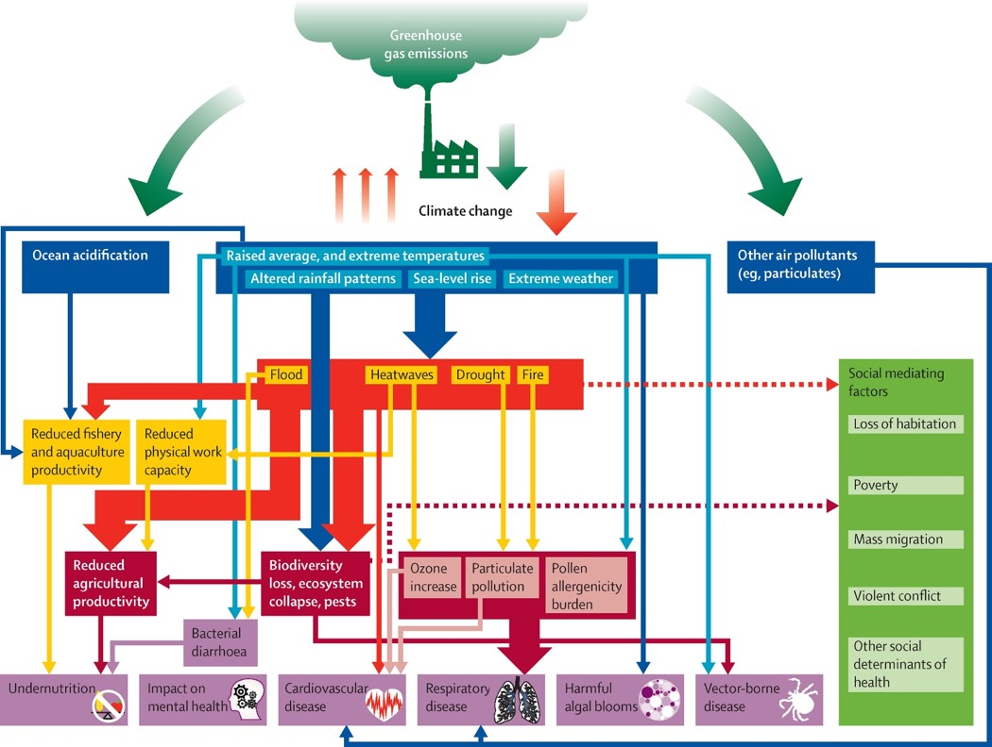
Figure 1: The pathways between climate change and human health. Figure taken from Watts et al. (2015).¹

Indicator 1.1: Health and heat

Indicator 1.1.1: Exposure of vulnerable populations to heatwaves

Headline finding: In 2019 there were an additional 3.54 billion days of heatwave exposure affecting China’s over 65 population – the equivalent of every person in this age group experiencing 21 additional days of heatwave in a single year.

Heat and heatwave exposure can often be fatal for elderly populations, owing to a range of factors, including a higher prevalence of chronic disease and medication use, through to an impaired physiological and behavioural response.⁷ Against a 1986-2005 baseline, this indicator tracks the number of days of heatwave exposure experienced by people aged over 65 from 2000 to 2019, using gridded temperature and population data.^{8,9} Here, a heatwave is defined as a period of three or more consecutive days where the daily maximum temperature was greater than the 92.5th percentile of the distribution of the baseline daily maximum temperature, a definition found to best capture the health effects of heatwave events in China.¹⁵ A full description of the methodology and data can be found in the Appendix.

Nationally, heatwave exposure has been rising steadily, from 0.22 billion days in 2000 to a record high of 3.54 billion days in 2019, the equivalent of almost every person aged over 65 enduring 21 additional days of heatwave (Figure 2). Looking closer, each elderly person in Hong Kong experienced 38 more heatwave days in 2019, the highest among all provinces, followed by Hainan (31 days) and Yunnan (26 days).

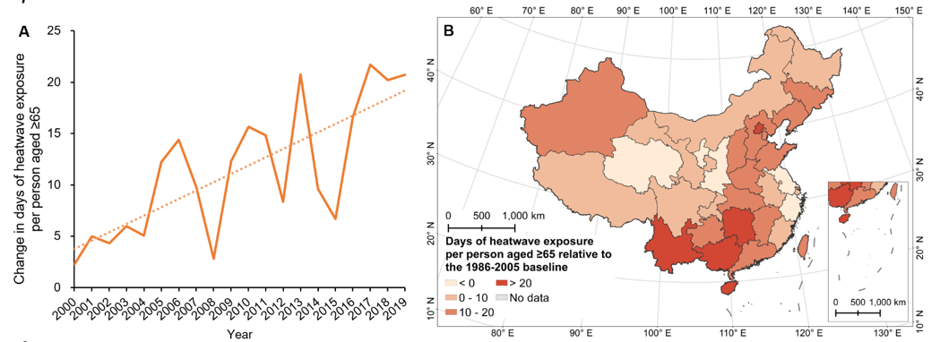
Figure 2: Change in the number of heatwave exposure for each person ≥65 in China, relative to the 1986-2005 average. (A) Country-level results; (B) Provincial-level results in 2019.

Indicator 1.1.2: Heatwave-related mortality

Headline finding: Heatwaves were responsible for an estimated 26,800 deaths in China in 2019, with the mortality rate rising by an additional 1,000 deaths every 1.2 years over the past decade and the greatest burden felt in East and South Central China.

In their most extreme form, heatwaves result in excess mortality, usually seen in the exacerbation of cardiovascular and respiratory disease.⁹ This indicator evaluates heatwave-related mortality across all age groups, using gridded population and temperature data, the heatwave definition as described in indicator 1.1.1, and location-specific exposure-response curves, with methods described in the Appendix.^{8,10-12}

There were around 26,800 heatwave-related deaths in China in 2019, with the rising trend becoming increasingly apparent over recent years (Figure 3). Taking a five-year moving average, it took 3.8 years for every increase of 1,000 annual heatwave-related deaths from 1990 to 2009, but just 1.2 years to achieve the same increase from 2010 to 2019. Among the provinces, heatwave-related mortality was highest in Shandong, followed by Henan and Anhui, all of which located are located in East and South Central China.

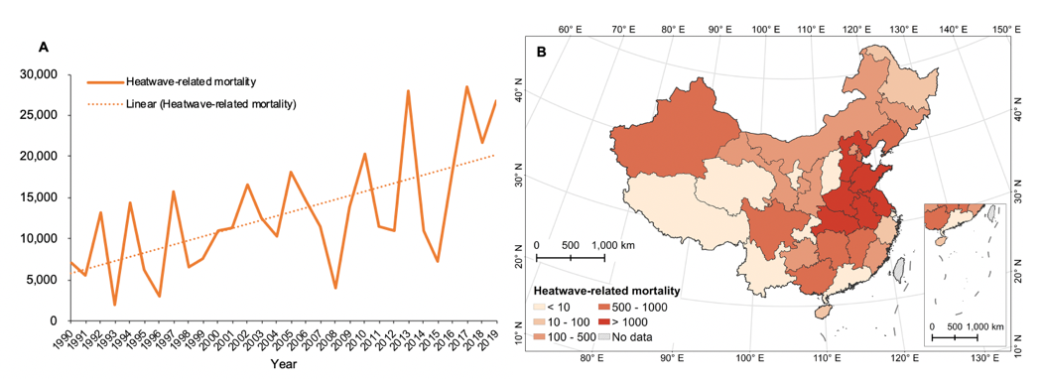
Figure 3: Heatwave-related mortality in China. (A) Trend of heatwave-related mortality 1990-2019 (B) Heatwave-related mortality in different provinces in 2019.

Indicator 1.1.3: Change in labour capacity

Headline finding: Chinese workers experienced potential heat-related productivity losses of an estimated 9.9 billion hours in 2019 – 0.5% of total national work hours for that year. Almost a quarter of these losses occurred in Guandong Province.

There is clear consensus from biometeorological studies that increased heat stress from climate change will reduce labour productivity, leading to socioeconomic burden.^{2,13,14} Indicator 1.1.3 focuses on this phenomena, applying wet bulb globe temperature work loss functions to primary industry (agriculture, forestry, animal husbandry, and fishery), secondary industry (manufacturing, construction and mining), and tertiary industry (catering, finance and other services), as described in the global Lancet Countdown report and in the Appendix.¹⁵

In 2019, the potential total work hours lost in China were over 9.9 billion – 4.8% higher than in 2000 and representing 0.5% of total national work hours. Labour capacity loss per worker in the primary industry worsened by 6.2% annually from 2000, reaching 36 hours (or 4.5 workdays) in 2019 (Figure 4). Nearly a quarter (2.4 billion hours) of these potential losses occurred in Guangdong, the most populous and economically-developed province, that accounts for 11% of China’s GDP. Each primary and secondary industry worker in Guandong potentially lost an average of 14.3 days and 5.2 days respectively, resulting in substantial losses to wages, productivity, and livelihoods.

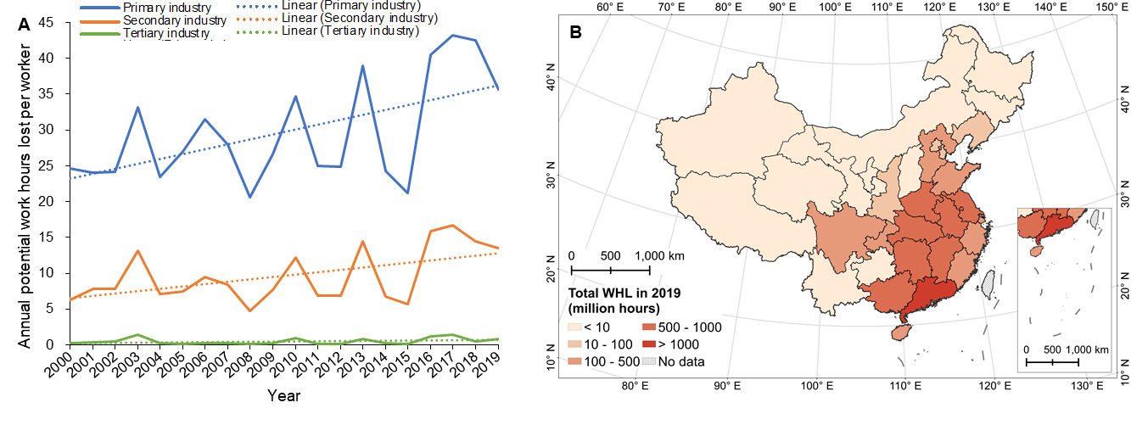
Figure 4: Heat-related work hours lost in China. (A) Annual potential work hours lost due to heat per person employed in each industry from 2000 to 2019. (B) Total work hours lost in different provinces in 2019.

Indicator 1.2: Health and extreme weather events

Indicator 1.2.1: Wildfires

Headline finding: Over 2016-2019, 24 Chinese provinces saw an increase in the annual days of population exposure to wildfires compared to 2001-2005. These increases were greatest in Northern and Northeastern China.

Wildfire causes direct thermal injuries and death, as well as excess morbidity and mortality from smoke-related exacerbations of acute and chronic respiratory symptoms.² Here, change in population exposure to wildfire is estimated by overlaying satellite data with population data and counting the number of days wildfires occur per grid cell, with densely urban areas excluded.^{10,16} The annual mean days of exposure were calculated for four time periods: 2001-2005, 2006-2010, 2011-2015 and 2016-2019. Nationally, total exposure increased in the first three periods, and decreased in the last one, likely owing to increased urbanisation. However, at the provincial level, 24 of 34 provinces experienced an increase in annual person-days exposed to wildfire in 2016-2019 compared to 2001-2005. The largest increase was observed in Northern and Northeastern provinces, including Heilongjiang, Jilin and Tianjin province (Figure 5), implying a stronger need for strengthened wildfire monitoring and control.

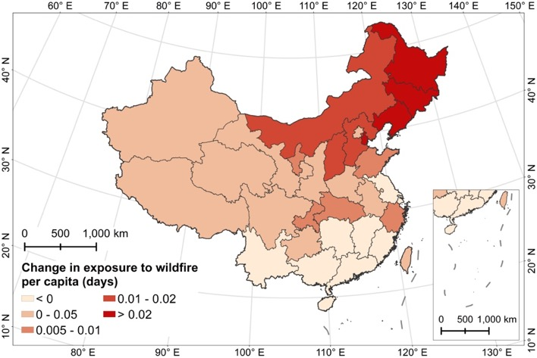
Figure 5: Annual average change in exposure to wildfire per capita in different provinces of China during 2016-2019, compared to 2001-2005

Indicator 1.2.2: Cyclones

Headline finding: China has experienced a significant increase in the occurrences of severe and ‘super’ typhoons from 2000 to 2019, compared against a stable baseline.

China’s extended Eastern coastline is affected by tropical cyclones, which can cause injury and death, spread of infectious diseases, and mental health impacts.¹⁷⁻²² Unique to the Chinese Lancet Countdown report, this indicator tracks cyclone exposure and damage, using national data.^{23,24} The tropical cyclones are described in terms of frequency, intensity and spatial-temporal distribution at the provincial level. The trend in occurrence of tropical cyclones for each intensity grading is calculated for 2000 to 2019 compared with an extended 1980-1999 baseline. Compared to the baseline, a statistically significant increase has been detected in the occurrence of severe and super typhoons from 2000 to 2019, while the occurrence of tropical depressions and tropical storms have significantly decreased. Due to better adaptation interventions, the damages caused by tropical cyclones to hotspot provinces such as Fujian and Zhejiang in East China have significantly decreased over this period (Appendix Figure 7-13).

Indicator 1.3: Climate-sensitive infectious diseases

Headline finding: Vectorial capacity for the transmission of Dengue Fever through Aedes aegypti and Aedes albopictus has increased by 37% and 14% respectively since the 1960s.

Dengue is a notable climate-sensitive vector-borne infectious disease, with climate suitability for the transmission of this virus rising in every world region. This indicator focuses on the change in vectorial capacity of the Aedes aegypti (A. aegypti) and A. albopictus (A. albopictus) mosquitos to transmit dengue, which is expressed as the average number of daily cases resulting from one infected case and is influenced by daily temperature. The method for calculating vectorial capacity remains the same as described in the 2019 Lancet Countdown report and by Rocklöv et al. (2019).²⁵ Compared to 1961-1965 the climate suitability for the transmission of dengue in 2014-2015 has risen by 37% and 14% for A. aegypti and A. albopictus respectively. In turn, there has been considerable and continuous national growth in both the incidence and disability-adjusted life years (DALYs) lost in China. In 2017, the all-age incidence rate and DALYs rate of dengue fever increased by 5.7 and 4.7 times compared with that of 1990, reaching 183.8 and 1.8 per 100,000 respectively.²⁶

Conclusion
Overall, this section provides clear evidence that the health impacts of climate change are rising rapidly and are experienced in unique ways, across all parts of China. Different regions have their unique health threats and need targeted response, with Figure 6 providing a composite assessment of this diversity across the country. In two provinces, Henan and Shandong, all six indicators reported here have worsened by at least 10% between 2000 and 2019. These two provinces alone account for around 14% of China’s population and national GDP.²⁷ Most of the highly populated and economically developed provinces in Eastern and Northern China have more than four indicators that have risen by at least 10%, implying that a large proportion of Chinese people and economy is at risk. These findings provide strong justification for more ambitious adaptation and mitigation interventions to protect health, indicators for which are tracked in the following sections.

The above-mentioned findings are by no means an exhaustive list of the impacts of climate change on human health in China. Greater resolution will be required across all provinces, and a number of core indicators will need to be further developed, including those focused on sea-level rise, other extreme weather events, other climate-sensitive diseases, allergies, and mental health.²⁸

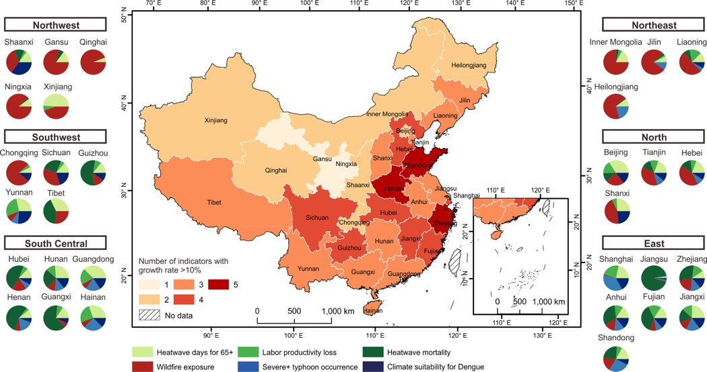
Figure 6. The key rising health risks from climate change in each province in China.
Each province is colored by the number of indicators with growth rate larger than 10% between 2000 and 2019. Each color in the pie chart represents one of the indicators tracked. With each indicator weighted equally, the size of the slice is proportional to the changing rates of the different health risks.

Section 2: Adaptation, planning, and resilience for health

The health impacts of climate change highlighted in section 1 require a concerted response from all sectors of society, which aims to reduce GHG emissions, and adapt to the effects that are already present. China attaches great importance to climate change and the Central Government issued the National Plan in Response to Climate Change in 2007, which begun to recognize the health impacts of climate change. At provincial and municipal levels, China is also increasingly developing climate change adaptation strategies for health. These measures mainly focus on the health impacts of extreme weather events such as heatwaves, floods and droughts; however, without the guidance of a national adaptation plan for health, China’s ability to cope with climate change varies greatly from region to region. The second section draws on a selection of indicators from the global report across two domains: Adaptation planning and assessment (indicators 2.1), and Adaptation delivery and implementation (indicators 2.2.1 and 2.2.2). A third indicator domain, climate information services for health, is under development and is considered in the Appendix.

Indicator 2.1: Adaptation planning and assessment

Headline finding: China has no standalone national adaptation plan for health; however, three provinces have a provincial plan in place in 2020, with a further four under development. Six provinces have completed a comprehensive assessment of health and climate change impacts and vulnerabilities.

The World Health Organization (WHO) identifies a Health National Adaptation Plans (H-NAP), including the assessment of specific climate change impacts and vulnerabilities as important first steps in managing country-specific health risks, with approximately 50 countries across the world having completed these two steps.² Whilst China as a whole, has a broad range of adaptation strategies in which health is referenced to some extent, there is no integrated assessment for health adaptation. For the purposes of this study, and in order to track China’s efforts in adaptation planning and assessment at the provincial level, a Health and Climate Change Survey for China, which adapts the design of the WHO’s Health and Climate Change Survey,²⁹ was conducted in May 2020, led by Sun Yat-sen University and China’s CDC. The full details of this survey, as well as further data, analysis and caveats can be found in the Appendix.

Of the 17 provinces that completed the survey, three provinces (Guangdong, Shanghai and Sichuan) declared that there was a provincial health and climate change plan in place and a further four provinces indicated that plans under development. Four provinces also stated their provincial health departments and meteorological departments were in close collaboration on health and climate change planning and strategy. The lack of a mechanism for multi-sectoral cooperation (all respondents), government funding (82%) and national surveillance systems (82%) were identified as the main constraints to developing climate change adaptation plans for health.

Turning from health adaptation planning, to vulnerability assessments, six out of the 17 provinces reported that a comprehensive assessment of climate change and health had been completed. Within these assessments, the effects of heatwave were among the most readily analysed health risk. Notably, human health has begun to be included as a chapter in the Green Book Series of Annual National Assessment on Climate Change in China in 2014 and 2019.

Despite these provincial and national assessment findings, limited progress has been made in influencing health policymaking, and in allocating human and financial resource allocation. As a matter of priority, China needs to strengthen leadership and establish longer-term funding to ensure a comprehensive national adaptation plan that protect health against climate change.³⁰

Indicator 2.2: Adaptation delivery and implementation

Indicator 2.2.1: Detection, preparedness, and response to health emergencies

Headline finding: Clear regional differences were found provinces’ ability to manage health emergencies. East China reported a higher ability index than other regions in China, and Jiangsu scored the highest, with an index score of 69.7 out of 100.

Climate change affects human health by diseases transmissions and climate-related extreme events such as heatwaves, floods, cyclones and wildfires. The ability to detect and rapidly respond to a health emergency is essential for minimising the impact of outbreaks of infectious diseases as well as climate-related extreme events.³¹ Although similarities are seen in each of the health emergency management systems across China’s provinces, there is great variation between them, with differing capacities to respond to the health impacts of climate change. For this indicator, a comprehensive index system derived from Check-up for China’s cities was created, designed to be used by provincial governments and consisting of indicators of risk exposure and preparedness, detection and response, and resource support and social participation. Index components include urban population density, completeness of emergency planning for public health emergencies, constructing of an infectious disease reporting system, and the number of health care institutions and health practitioners per 1,000 population. All indicator components, data sources and weightings are described in full in the Appendix. Drawing primarily on the most recent data available from 2018, the average index score for health emergencies management across all provinces was 48.1 (out of a possible 100). Results revealed that the indexes were generally higher in East China than in other regions, with Jiangsu (69.7), Shandong (68.9) and Beijing (60.9) scoring the highest in their ability to manage health emergencies (Figure 7).

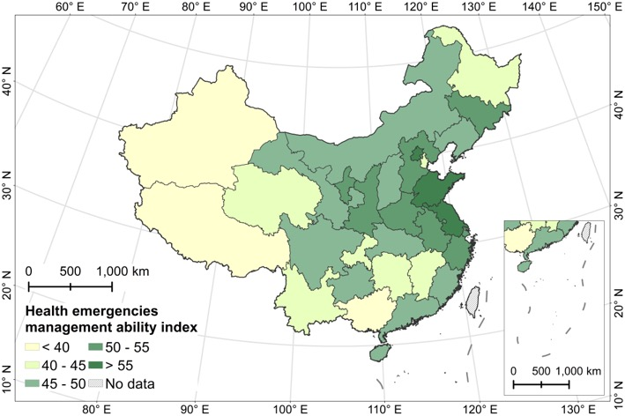
Figure 7: Provincial comprehensive health emergencies management ability index in China.

Indicator 2.2.2: Air conditioning - benefits and harms

Headline finding: The use of air conditioning provides significant protective benefits against heat-related mortality, while simultaneously substantially increasing energy consumption and CO₂ emissions, with the latter rising by almost 1000% from 6.2 to 58.5 million tons per year from 2000 to 2016.

Access to air conditioning can protect people from heat-related morbidity and mortality,³² however it also confers harms through its contribution to CO₂ and particulate matter (PM_{2.5}) emissions if its electricity source is from fossil fuels. Air conditioning also emits waste heat, contributing to the urban heat island effect and can leak hydrofluorocarbons, powerful GHGs. Therefore, other measures, focused on improving access to urban greenspace and building designs that improve energy efficiency and passive cooling are also necessary. Using data from the International Energy Agency (IEA) and the relative risk described in the 2019 global Lancet Countdown report, this indicator calculates the prevented fraction of heatwave-related deaths due to household air conditioning use, with full methods and caveats presented in the Appendix.

As a result of increased household air conditioning use, the prevented fraction of heatwave-related mortality due to air conditioning in China doubled between 2000 and 2016, to 45% in 2016 (Figure 8). However, the increasing use of air conditioning also led to a concerning rise in energy consumption and CO₂ emissions. Between 2001 and 2015, the per capita energy consumption of Chinese urban household air conditioning increased from 16.4 to a remarkable 96.6 kWh and air conditioning-related CO₂ emissions increased by almost a factor of ten, from 6.2 to 58.5 million tons per year (Figure 8) Given that other interventions are available to improve health, these trends are deeply concerning, and demonstrate the risks posed by the rapid adoption of technologies with significant lock-in potential worsening GHG emissions over the longer term.

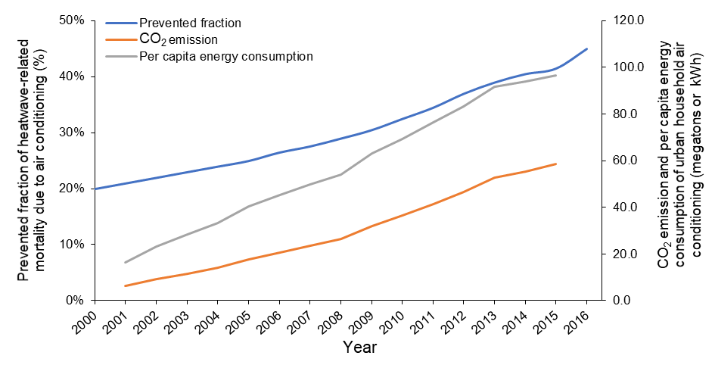
Figure 8: Prevented fraction of heatwave-related mortality due to household air conditioning use and energy consumption of urban household air conditioning in China

Conclusion

There is a clear and present need for adaptation to the effects of climate change experienced today, and expected in the future. This section has considered both the broad and cross-cutting importance of planning and assessment for all of the health risks of climate change, as well as one specific adaptation intervention in the form of air conditioning, with more to follow in subsequent years. These indicators suggest that China’s current efforts are still in their initial stages, with varying degrees of progress seen across the provinces. Given the variation in geographic and socio-economic context, as well as the climate change-related health risks faced, there is a need for more localized planning, as well as an integrated national assessment to minimise China’s public health risks from climate change.

Section 3: Mitigation actions and health co-benefits

Robust and accelerated climate change mitigation will not only limit the effects of temperature rise (section 1), but also lead to direct positive impacts on human health. These improvements are found through a range of sectors of the economy, resulting in cleaner air, healthier diets, and more physical activity. For example, measures such as the phase-out of small and outdated factories, and the promotion of clean fuels in the residential sector from 2013-2017, resulted in some 210,000 avoided premature deaths due to air pollution in China, in 2017.³³ Further research increasingly supports these findings, suggesting that further reductions in fossil fuels combustion will further reduce air pollution, seeing significant benefits for human health, and supporting China’s transition towards sustainable development.^{34,35} ³⁶

Under the Paris Agreement, the Chinese government has pledged to peak its emissions by 2030.³⁷ However, global emissions have continued to rise in recent years, reaching 55.3 Gt CO₂e in 2018. Limiting temperature rise to “well below 2°C” will require further ambition both globally, and within China.³⁸ China has experienced rapid economic development over recent decades, whilst GHG emissions have increased at a slower rate, leading to a reduction in the carbon intensity of its economic system of 36% from 2000 to 2019.^{39,40} In absolute terms, after a five year period of remaining relatively flat, China’s GHG emissions have dropped from 11.6 Gt CO₂e in 2017 to 10.3 Gt CO₂e in 2018. After surging with an average annual growth rate of 10% since 2000, China’s CO₂ emissions peaked in 2013 (10.1 GtCO₂) and had decreased during 2014-2016⁴¹, and rebounded since 2017 from 9.7 GtCO₂ and increased to 9.9 GtCO₂ in 2018 ⁴².COVID-19 has seen CO₂ emissions in China drop dramatically in the first quarter of 2020, with a 6.9% reduction when comparing January-April 2019 with 2020.⁴² Recovery measures that are consistent with the Paris Agreement will ensure continued progress to reduce GHG emissions and improve health. This section tracks Chinese efforts to reduce GHG emissions, and the associated co-benefits by sector. For this inaugural report, four indicators are presented in total, tracking energy and health (indicator 3.1), clean household energy (indicator 3.2), air pollution, (indicator 3.3) and sustainable and healthy transport (indicator 3.4). These will be further expanded on in subsequent years, with every effort made to include additional sectors of the economy and more directly capture the attribution to climate change, and to health outcomes.

Indicator 3.1: The energy system and health

Headline finding: The downward trend of coal consumption in China was reversed after 2016, with total primary energy supply from coal rising to 80.2 EJ in 2018. Wind and solar power generation also continues to rise rapidly and renewable energy represented 13.4% of China’s total power generation in 2019.

The energy system emits more CO₂ than any other sector in China, and is responsible for a significant proportion of the burden of disease seen from air pollution. This indicator reports on key areas required to reduce the carbon intensity of China’s energy system – coal phase-out and zero-carbon emission electricity – using data from the Energy Statistical Yearbook of China.

Driven by effective air pollution control,^{43,44} total primary energy supply (TPES) from coal in China decreased from 2013 to 2016. However, this downward trend has been reversed in each subsequent year, in large part due to the launch of economy stimulus policies, with TPES of coal increasing to 80.2 EJ in 2018.²⁷ Given the early importance of a rapid phase-out of coal-fired power, and readily available technologies which are healthier and more cost-effective, this is particularly concerning.

More positively, the national share of low-carbon electricity continues to grow, rising from 17% in 2000 to 31% in 2019.³⁹ Promisingly, in 2019, renewable energy (solar and wind power) accounted for 13.4% of total electricity generation, and within this, solar generation continues to grow at an unprecedented rate of 26.5% per year. China’s newly installed capacity of solar and wind energy in 2019 reached 26.8 and 25.7 GW, respectively, which is equivalent to adding one modern wind farm and one modern solar farm of 70 MW every day to its grids.

Indicator 3.2: Clean household energy

Headline finding: Further work is required to increase the use of clean and healthy energy within households. Fossil fuels accounted for over 74% of energy for cooking in urban households in 2018, while biomass still contributed 61.4% of total household energy in rural areas in 2013.

The access and use of clean energy in China have rapidly increased since 2000, which is essential for social development and health and well-being.⁴⁵ This indicator reports on household energy consumption using data compiled by the National Bureau of Statistics, as well as fuel used for household hot water and cooking, with data collected by the Tsinghua University Building Energy Conservation Research Center. Per capita household energy consumption has increased significantly, by 215% from 3.9 GJ in 2000 to 12.2 GJ in 2017 (Figure 9A), with electricity use as a share of total household energy consumption rising from 10% in 2000, to 20% in 2018. Meanwhile, household fossil fuel consumption made modest progress, while remaining high and accounting for over 74% of urban cooking energy in China (Figure 9B). In rural households, biomass remains the primary source of energy, accounting for 61.4% of household energy in 2013, increasing the health burden from household air pollution.⁴⁶ Replacing gas-fired, coal-fired and biomass cookers with electric cookers presents a substantial opportunity for household energy structure in China, reducing both household GHG emissions and air pollution.⁴⁷

Figure 9: Household Energy Consumption in China. (A) Household energy consumption per capita from 2000 to 2017, total (left axis) vs electricity (right axis). (B) Per capita household energy consumption by fuel type from 2000 to 2017.

Indicator 3.3: Air pollution, transport, and energy

Headline finding: Ambient PM_{2.5} pollution in urban China has decreased by nearly 28% from 2015 to 2019, leading to a reduction of 90,000 premature deaths attributable to air pollution over this time period. However, 42% of the Chinese population remains exposed to annual average PM_{2.5} concentrations above 35 μg/m³.

As the most important global environmental risk factor for premature mortality, ² China has adopted an ambitious response to deliver cleaner air. Here, PM_{2.5} concentrations in cities are presented, taking daily measured PM_{2.5} data from 367 cities as reported on Data Center of Ministry of Ecology and Environment of China.⁴⁸ Premature mortality attributable to ambient PM_{2.5} by sector and region is also estimated, integrating data from the IEA and the Chinese statistical yearbook into the GAINS model (as described in the global Lancet Countdown report) to estimate PM_{2.5} exposure and then mortality based on integrated exposure-response functions.⁴⁹

The implementation of China’s clean air policy (e.g., Air Pollution Prevention and Control Action Plan (APPCAP) ) have seen over 367 cities achieve an almost 28% reduction in air pollution from 2015 to 2019 (Figure 9).^{43,44,50} Correspondingly, the deaths attributable to ambient PM_{2.5} pollution had declined by 10% from 2015 to 830,000 deaths in 2018. However, approximately 42% of the Chinese total population were exposed to air pollution concentrations above the WHO’s first interim air quality target (35 μg/m³ of annual mean PM_{2.5} concentration, the worst of the three interim targets presented) in 2018.^{51,52}Industrial and agricultural sectors were responsible for 53% of total ambient premature deaths in 2018, followed by transport (10%) and residential (8%) (Figure 11). At the regional level, East China has the highest premature deaths, where agriculture and industry sectors have a dominant contribution to PM_{2.5}, followed by South Central China. With the exception of a few cities in Tibet,⁴⁸ all Chinese cities continued to have PM_{2.5} concentrations above the WHO recommended annual average of 10 μg/m³. China has an opportunity to continue to reduce its population exposure to air pollution over the coming years, by aligning its economic recovery from COVID-19 with its air pollution policies, the priorities of the Paris Agreement and the SDGs. However, if the recovery measures implicitly increase the use of fossil fuels in China, given the exacerbating effects of future climate change to pollutant accumulation, these short-term improvements made to reduce air pollution in China will likely be reversed.^{53,54}

Figure 10: Distribution of annual average PM_{2.5} concentrations of China’s cities.
The white dot represents the median Q2; The black rectangle is the range from the lower quartile Q1 to the upper quartile Q3; The external shape of the black rectangle is kernel density estimation, of which the vertical length represents dispersion degree and the horizontal width denotes city frequency in a certain pollutant concentration.
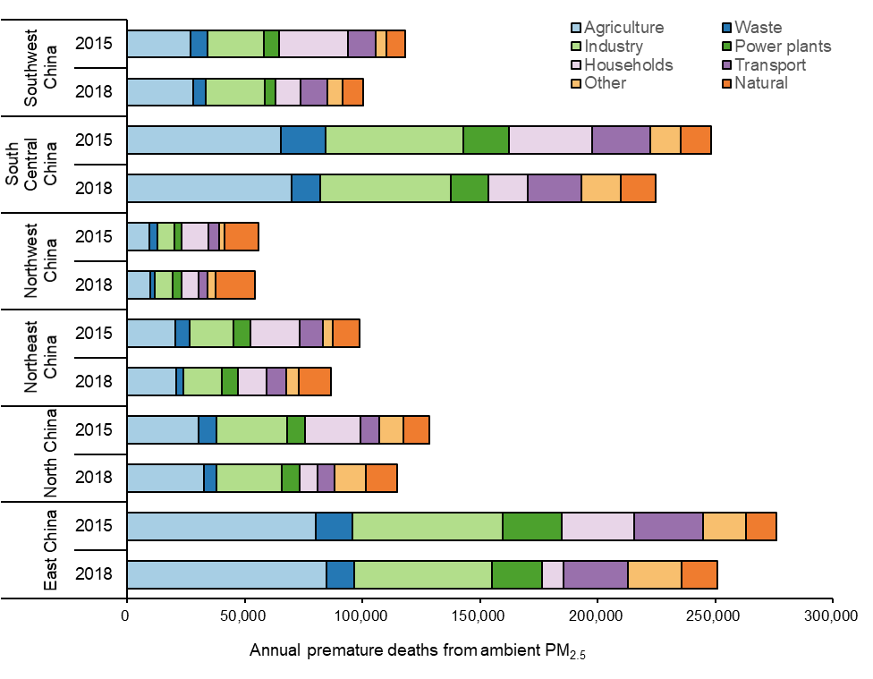
Figure 11: Premature deaths attributable to exposure to ambient fine particulate matter (PM₂·₅) in 2015 and 2018, by key sources of pollution in China.

Indicator 3.4: Sustainable and healthy transport

Headline finding: The emissions intensity of road transport in China, represented by average emissions per vehicle, has dropped from 2000 to 2018 by over 90% for four major air pollutants.

As well as emitting large amounts of CO₂, fossil fuel combustion for road transport emits other harmful pollutants, including hydrocarbon (HC) carbon monoxide (CO), nitrogen oxide (NO_{x}) and PM, threatening public health, particularly in densely populated areas of China. In this indicator, the emission intensity of road transport, calculated by the ratio of emission and vehicle ownership, determines the average emission for the whole fleet, including electric, hybrid and natural gas vehicles. Data is taken from the China Vehicle Environmental Management Annual Reports and the National Bureau Statistics of China.^{57,27} The emission intensity for CO, HC, NOx and PM has decreased by 92%, 91%, 91%, and 94% respectively from 2000 to 2018 in China, reflecting effective emissions control of road transport (Figure 12). For NOx and PM, per vehicle emission 2000-2018 have reduced from 0.24 and 0.03 tons per vehicle to 0.02 and 0.002 tons per vehicle respectively. Over this time period the emission intensity in Beijing, Shanghai and Guangdong decreased by 42%, 44%, and 71% respectively. The upgrade of emissions standards has played significant role in this decrease, alongside ongoing modal shift.⁵⁵ The number of electric vehicles (EV) reached 3.1 million in China in 2019, growing on average by 600,000 annually from 2014. This level of growth is impressive, comparing to the average annual growth of 260,000 between 2014 and 2019 in the US (the next biggest market for EVs).⁵⁶ Again, in recent months, the response to COVID-19 has resulted in significant reductions in transport activities and NO_{x} emissions, but has also led to unexpected increase in PM caused by an increase in ozone pollution.⁵⁷

Figure 12: The air pollution emissions intensity of road transport in China from 2000 to 2018 for CO, HC, NOx and PM.

Conclusion
The indicators in this section highlight both the impressive progress China has made in mitigating climate change, as well as the health benefits it has experienced as a result, with significant reductions in air pollution seen in recent years. However, these indicators also make clear that there is little room for complacency, with significant further effort required in order to be consistent with the Paris Agreement’s long-term target. Coal remains the predominant source of fuel for power generation, as well as a major contributor to air pollution and ill health, and is a clear target for early and rapid phase-out.

Section 4: Economics and finance

This section tracks the economics of climate change impacts, and the financial and economic implications of addressing climate change in China. Mounting evidence suggests that the health cost of inaction on climate change is high,⁵⁸ and that the health benefits of climate change mitigation alone could far exceed the mitigation cost in many sectors and many regions in China.^{59,60} The financial case is clear, with cost-effective interventions available to allow increased ambition to address climate change for health, in China. The seven indicators in this section are divided into two domains: the economic impact of climate change and its mitigation (indicator 4.1); and the economics of the transition to zero-carbon economies, including investments in a low carbon economy (indicator 4.2), as well as pricing greenhouse gas emissions from fossil fuels (indicator 4.3).

Indicator 4.1: The economic impact of climate change and its mitigation

Indicator 4.1.1: Economics of heat-related mortality

Headline finding: The economic cost of heat-related mortality in China reached to US$13.6 billion in 2019, approximately 13.6 times the level in 1993, and equivalent to the average income of 1.3 million Chinese people.

This indicator tracks the monetised value of heatwave-related mortality by province in China, using a mean value of statistical life (VSL) produced for China, of US$ 3.2 million ($2015).⁶¹ At a country level, the annual cost of heat-related mortality increased from US$1.0 billion to $13.6 billion from 1993 to 2019 (Figure 13). This value is equivalent to the income of more than 1.3 million of people in 2019. These costs have been greatest in East China, reaching US$ 6.1 billion in 2018 and 0.11% of regional GDP (led by Shandong at US$ 5.0 billion and 0.38% of regional GDP).

Figure 13: Monetised value of heat-related mortality, by region in China

Indicator 4.1.2: Economic cost of heat-related labour productivity loss

Headline finding: The economic costs of heat-related labour capacity loss reached US$126 billion (1.14% of China’s GDP) in 2017, compared to US$33 billion (0.47%) in 2007. The highest losses as a proportion of provincial GDP were felt in Guangdong (1.65%), Hainan (1.41%), and Guangxi (1.22%).

This indicator measures the total annual economic costs of heat-related labour capacity losses (indicator 1.1.3). It estimates direct losses (resulting from first-order losses of labour capacity in a particular industry) and indirect losses (higher-order losses in other industries that have dependencies on industries that experienced direct losses) under an input-output analytical framework.⁶²⁻⁶⁴ Absolute economic costs of labour productivity loss in 2017 were US$126 billion (1.14% of GDP), nearly four times the costs experienced in 2007 and equivalent to the scale of national fiscal expenditure on science and technology or on environmental protection, (Figure 14A). In 2015 nearly 70% of the total costs were indirect costs, which were concentrated largely in the secondary industry (manufacturing, construction, utilities and mining). The regional distribution of economic costs (in terms of shares in regional GDP) is consistent with China’s geographical climate patterns, with South Central China suffering higher costs than other regions (Figure 14B). The top three provinces with the greatest costs in 2015 were Guangdong (1.65% of GDP), Hainan (1.41%) and Guangxi (1.22%), each of which are southern provinces with warm and humid climates.

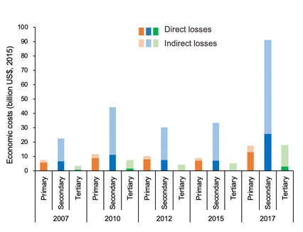
A

Figure 14: Economic costs of heat-related labour productivity loss, (A) National-level results, by year and industry, in billions of 2015 US$ (B) Provincial-level results in 2015, relative to GDP

Indicator 4.1.3: Economic costs of air pollution-related premature deaths

Headline finding: The economic costs of premature deaths due to ambient PM_{2.5} pollution have fallen over time in China. As a proportion of GDP, they have decreased by 21% from 2015(0.11%) to 2018, however still make up the equivalent of 0.09% of China’s GDP in 2018.

As reported in indicator 3.3, ambient air pollution continues to be a significant contributor to mortality in China. Diverging from the global Lancet Countdown report, this indicator estimates the economic costs of this premature mortality by considering the annual labour productivity loss that it results in, using an input-output model as described in indicator 4.1.2 and in the Appendix. This does not fully or adequately capture the economic costs of air pollution-related mortality, which will need to be developed into future forms of this indicator.

Figure 14 makes these changes over time clear, reflecting the mirroring the air pollution mortality seen above. The annual economic costs that resulted from premature mortality due to ambient PM_{2.5} pollution decreased by 1.1% from US$10.8 billion (2015) to US$10.7 billion (2018). In 2018, these costs represented approximately 0.09% of China’s GDP, a value which potentially rises to 1% of GDP when morbidity is also considered.⁶³ In 2018, the indirect costs resulting from inter-industrial dependencies comprised 64% of the total costs, mostly in the secondary industry. Provinces surrounding Beijing, undertaking excessive and inefficient capacities from Beijing, suffered greatest costs (in terms of shares in regional GDP) from air pollution-related premature deaths.
A
B
Figure 15: Economic costs of premature deaths caused by air pollution, (A) National-level result, by year and industry, in billions of 2015 US$ (B) Provincial-level result in 2015, relative to GDP

Indicator 4.2: Investing in a low-carbon economy

Indicator 4.2.1: Healthy energy investments

Headline finding: China’s investment in new coal-fired electricity capacity continued to decline again in 2019, continuing the downward trend observed since 2015. Low-carbon investments are now nine-fold higher than those of coal, with renewable investments reaching US$86.4 billion in 2019.

In parallel to indicator 3.1, this indicator tracks the financial aspects of mitigation in the energy system, considering investments in coal, low-carbon energy, and energy efficiency, taking data from the National Energy Administration.⁶⁵ The investment in new coal-fired power generation of China declined from US$ 31.7 billion in 2008 to US$ 9.3 billion in 2019.⁶⁶ Correspondingly, the ratio between investment in low-carbon energy (including hydro and nuclear power) and new coal power has risen sharply, from 1:1 in 2008 to 9:1 in 2019. Investment in renewable energy reached US$86.4 billion in 2019, largely due to investments in solar PV, which peaked in at US$76.1 billion in 2017 and then declined in the following two years (Figure 16).⁶⁷ Investment in wind also increased – to US$17.3 billion in 2019.^{68,69} To support expanded renewable energy development, investment in the overall power grid itself also continues to be high: US$ 81.5 billion in 2018 and US$71.6 billion in 2019.

Figure 16: Investment in power sector construction from 2008 to 2019

Indicator 4.2.2 Employment in low-carbon and high-carbon industries

Headline finding: For the second consecutive year, the renewable energy sector has employed more people in China than fossil fuel extraction industries, providing 4.1 million jobs in 2018.

China leads employment in renewable energy worldwide, with 4.1 million jobs in 2018, and a steady rise since 2012 (with employment falling slightly, by 2.7% from 2017 to 2018). For the second year running, this number has been higher than employment in fossil fuel extraction industries, which decreased by 6% from 2017 to 3.88 million in 2018. In 2018, the solar energy industry provided 2.9 million jobs in China, contributing to 70.1% of total jobs in the renewable energy sector (Figure 17). These upward trends now see an enormous 35% of total renewable energy jobs globally, found in China. The data for this indicator is taken from the REN21 Renewables 2019 Global Status Report, CEIC Data and the Chinese National Bureau of Statistics.^{27,70,71}
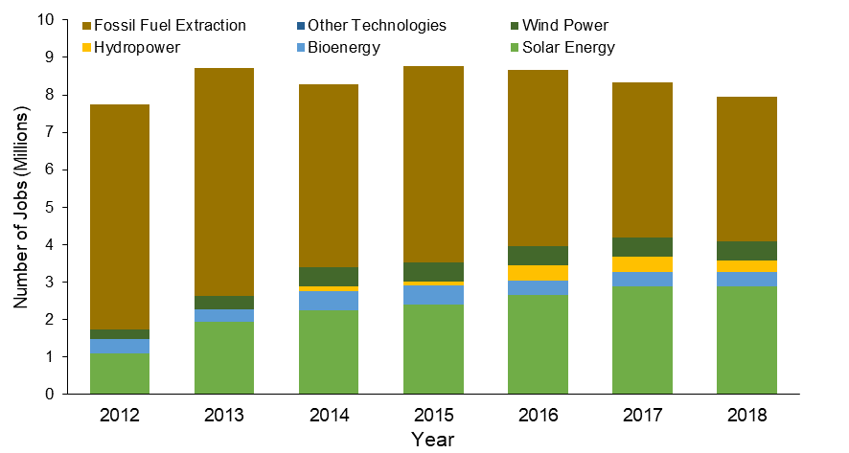
Figure 17: Employment in renewable energy and fossil-fuel extraction sectors

Indicator 4.3: Pricing greenhouse-gas emissions from fossil fuels

Indicator 4.3.1: Fossil fuel subsidies

Headline finding: Downward trends in fossil fuel consumption subsidies have reversed in recent years and were US$41.9 billion in 2018 – more than 10% higher than 2017 subsidies, and more than 100% higher than the 2015 level.

Fossil fuel consumption subsidies distort the prices in the energy market. They wrongly provide fossil fuels with a competitive advantage over clean energy and neglect the negative externalities and costs to the environment, climate and human health. This indicator tracks the absolute value of fossil fuel consumption subsidies in China, as well as China’s share of total global subsidies, using data from the IEA.⁷² Fossil fuel subsidies declined between 2011 and 2015, but rebounded to US$41.9 billion in 2018 – a 10% rise from 2017 and more than 100% higher than 2015 level (Figure 18). This reversal is the result of substantial increases in subsidies for coal power plants, whose profitability deteriorated severely over recent decades. Of all the countries with fossil fuel subsidies reported by IEA, China ranked third in 2018, behind only Iran and Saudi Arabia, two of the world’s major oil producers.

Figure 18: Fossil fuel and electricity consumption subsidies in China, 2010-2018
Note: The number on top of each bar represents the rank of fossil fuel subsidy of China in the world on the corresponding year.

Indicator 4.3.2: Coverage and strength of carbon pricing

Headline finding: Pilot carbon pricing instruments already cover 11% of China’s emissions in 2019, however prices remain well below what is consistent with the Paris Agreement, from US$0.56/tCO₂ to US$11.4/tCO₂.

An effective price on carbon is an important policy tool to incentivise and guide the transition to a low-carbon economy, and meet the goals of the Paris Agreement.⁷³ This indicator tracks the coverage and strength of carbon pricing in China, with data and methods described in the Appendix.^{74,75} The carbon prices in eight pilot carbon emission trading markets in China varied from US$0.24/tCO₂ to US$13.0/tCO₂ over the last six years (Figure 19). The real-time carbon prices depend on the supply and demand of carbon quota in each pilot market.⁷⁵ In 2019, the annual average carbon prices ranged from US$11.4/tCO₂ in Beijing to US$0.56/tCO₂ in Chongqing and Shenzhen. However, these prices continue to be much lower than the price of US$40-80/tCO₂ by 2020, required to be consistent with “well below 2°”.⁷⁶ The carbon emissions covered by eight pilot markets are 1,330Mt CO₂e in 2019, representing 11% of China’s total emissions and 53% of emissions in these provinces. With the introduction of China’s National emissions trading scheme (ETS) in 2021, the total coverage of carbon pricing would increase to 33% of China’s emissions. Currently, all the pilot markets in China are still in their early stage, and do not generate regular revenues.

Figure 19: Carbon prices in eight pilot markets in China

Conclusion
In line with expansive air pollution reduction efforts, the economic costs associated with its lost labour productivity have declined slightly over recent years. However, elsewhere, the economic costs of increasingly worsening heat and heatwave are rising, both in the form of increased mortality and decreased labour capacity. Although China has already enacted a range of policies to transition to a low-carbon economy, more decisive intervention is required to phase out fossil fuel subsidies and enhance the carbon price signals. Without this, the risk of short-term investment decisions which lock-in longer-term fossil fuel energy systems is high.

Section 5: Public and political engagement

Despite the fact that the health impacts of climate change are already being felt in China, there are yet to be responses more than sufficient seen at either the national or provincial level. In certain instances, increased public engagement in health and climate change by a range of stakeholders has exerted pressure on governments, driving enhanced mitigation and adaptation efforts.⁵ This section tracks engagement with health and climate change for the media (indicator 5.1), individuals (indicator 5.2) and academia (indicator 5.3). Always seeking to expand, the engagement in health and climate change of the Chinese government will be explored in next year’s report.

Indicator 5.1: Media coverage of health and climate change

Headline finding: Media engagement in health and climate change remains low in China, with 67 posts across five key media accounts in 2019.

This indicator adopts a novel approach to assessing the engagement of the media with health and climate change. As of March 2020, the number of Internet users in China reached 904 million.⁷⁷ The social media platform, Weibo’s monthly active users reached 516 million and daily active users reached 222 million at the end of 2019.⁷⁸ Five accounts – @People’s Daily, @The Beijing News, @Caixin, @Health News, @China Science Daily – were selected and analysed based on their size, influence, variety (aiming to achieve a range of official, commercial, and professional media). Data was drawn from posts published from these accounts to Weibo and analysed using keywords as described in the global Lancet Countdown report, and a full description of the methods, data, and search terms is included in the Appendix.

From 2010 to 2019, the total number of posts discussing climate change increased from 87 in 2010 to 997 in 2019, equivalent to 2.7 posts per day or 2% of the total number of daily posts across these five media accounts. Within these, the proportion that then referred to public health was low, at 5.7% in 2010, rising slightly to 6.7% in 2019. A spike seen in 2013 was related to increased awareness of air pollution and its links with health and climate change, corresponding with the initiation of the APPCAP. With only 67 health and climate change posts across all five accounts in 2019, and zero posts from Health News since 2014, it is clear that far more needs to be done to make the links between public health and climate change in the media.

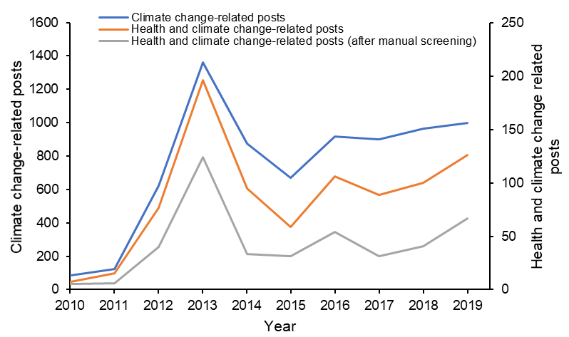
Figure 20: Coverage of climate change and health and climate change on Weibo between 2008 and 2019

Indicator 5.2: Individual engagement in health and climate change

Headline finding: More work is required to engage individuals on the links between these two issues, with very few people making the connection between public health and climate change on Baidu.

Individuals’ search preferences provide an insight in to the degree of public engagement on a topic.⁷⁹ This indicator provides an analysis of search queries for health and climate change over the past three years, identified by keyword matching, on Baidu™.⁸⁰ Baidu takes more than 66% of market share of search engine in China. ⁸¹ It also has more than 1.1 billion monthly active users which covers most of population in China. ⁸² Due to the widespread use of Baidu, the query data from Baidu can well reflect the individual engagement of people in China. Compared with other methods like surveys, query data from Baidu is easily to collect and has a broad coverage of people. All data is anonymised and no queries can be associated with an individual. All data is anonymised and no queries can be associated with an individual. A full description of the keywords used, as well as a full explanation of the methods and analysis can be found in the AppendixAppendix.

A clear increase is seen in search queries for climate change from 2017 to 2019, however queries relating to health and climate change were seldom co-searched by users. In 2019, 1 in 500 of all climate change queries had some relation to health. Conversely, only 1 in 200,000 of all health queries had any relation to climate change. Further analysis suggests that co-searching for health and climate change increased somewhat for cities with higher populations and levels of economic development, as compared to the Chinese population overall.

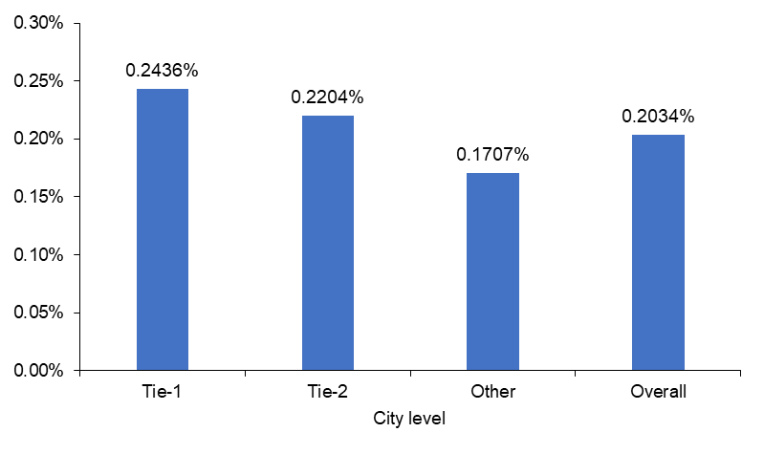
Figure 21: Proportion of health and climate change co-queries out of total climate change queries in tier-1, tier-2 and other cities

Indicator 5.3: Coverage of health and climate change in scientific journals

Headline finding: A total of 15 articles in Chinese and 30 articles in English were published by Chinese authors in 2019 compared with 12 and 3 publications respectively in 2008.

This indicator tracks engagement in health and climate change by Chinese researchers in scientific journals. The inclusion of climate-related keywords and their co-occurrence with health-related keywords in scientific publications was tracked using the advanced search function in CNKI for Chinese articles and in both Ovid Medline and Ovid Embase databases for English articles published by Chinese authors. Full details of these search strategies are provided in the Appendix. In CNKI, a total of 26,849 climate change-related academic journal articles between 2008 and 2019 were collected, of which 0.83% (222) were health-related. From 2010 to 2019, articles focused on health and climate change decreased slightly, from a high-point of 29 in 2018 to 15 in 2019.

A different picture is seen when searching English-based articles with Chinese authors in Ovid Embase and Ovid Medline database, with 932 climate-related publications by recorded between 2008 and 2019, and 17.7% (165) focusing on health and climate change. Between 2008 and 2019 the number of Chinese health and climate change articles these databases recorded increased from three articles published in 2008 to 30 in 2019, although this still represents a small proportion of the 734 health and climate change articles published globally in 2019. Despite slow progress, awareness in local scientific community is rising and it is expected to grow over time.

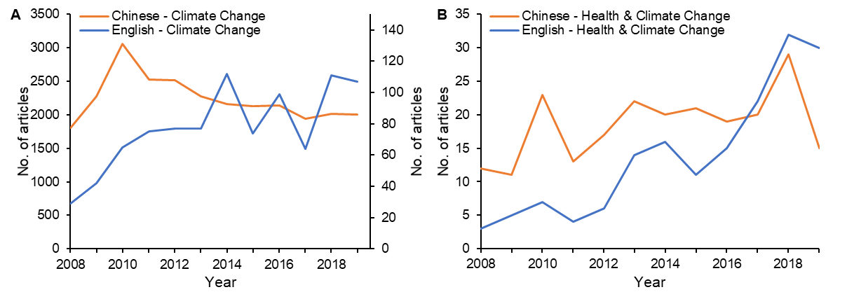
Figure 22: Coverage of climate change- and health and climate change- related journals in Chinese and English between 2008 and 2019. (A) Climate change only. (B) Health and climate change.

Conclusion

Engagement in health and climate change by all sectors is an essential component of initial and sustained mitigation and adaptation efforts. In China, the quantity of health and climate change engagement from the media, individuals, and academia has remained stubbornly flat, with small increases seen in certain sectors. These trends are at odds with those seen internationally, and delivering against the commitments of the Paris Agreement will require an expanded understanding of the links between social and environmental systems, in the media, in academia, and the general public.

Conclusion: The 2020 Chinese Lancet Countdown Report

The inaugural Chinese Lancet Countdown report tracks 23 indicators of health and climate change, at the national, regional and provincial level. Its findings represent the work of some 77 experts from 19 institutions, and the report is the first complete picture of the health impacts of climate change, and the responses undertaken in China. The indicators here will be continually improved on, with new concepts and datasets built in on an annual basis. To this end, the collaboration is committed to an iterative approach, and is open to input from technical experts and academic institutions across China.

It is evident that the health risks from climate change tracked here (including heat, extreme weather events and climate-sensitive diseases) are increasing rapidly in China. Whilst everyone is affected, vulnerable populations including those living in poverty, with social disadvantage, the elderly, those working outdoors are particularly at risk. In 2019, every elderly person endured the equivalent of an average of 21 more days of heatwave, implying enormous health risks. In the same year, across all age groups, heatwave-related mortality reached 26,800, with the resulting economic loss estimated to be $US13.6 billion.

Progress in adaptation and mitigation has been mixed. On one hand, there is no standalone National Health Adaptation Plan and very few provincial-level assessments of climate change and health risks have been undertaken. Similarly, previous reductions in coal use and fossil fuel subsidies have been reversed. Slow progress across all sectors is in part due to a lack of engagement in health and climate change within the media, academia, the public, and government.

On the other hand, China has made remarkable progress in renewable energy development and air pollution control. Ninety percent of investment in new power generation now goes to non-fossil fuel energy. Employment in renewable energy industries in China is higher than in any other country and accounts for a third of the global total. Air pollution continues its downward trend in China, leading to a 10% decrease in PM_{2.5}-related mortality and US$400 million saved. A National ETS that covers 33% of China’s emissions is being set up and is expected to enter into force in 2021.

Figure 23 provides a complete overview of these risks and responses over time, exploring the health impacts of climate change (left) and China’s responses to climate change for health (right) using the indicators described in this report. For each indicator, an index is created, ranging from 0 to 1.0, with the colour in each block representing its score. Darker colours indicate a more concerning impact, and a more ambitious response. For some indicators, such as coal phase-out, clean household energy use and reduction of fossil fuel subsidies, an index score of 1.0 means the best possible response, for example, 100% coal phase out. For other indicators, it is hard to define the best possible future, such as employment in low-carbon industries and carbon pricing. In this case, index score 1.0 represents the best score over the 20-year period. A comprehensive explanation for each indicator displayed in the figure can be found in the Appendix and this figure will be updated with each subsequent report.

Figure 23: An overview of indicator trend in the 2020 China Lancet Countdown assessment report. The sun-shaped symbol highlights indicators for which the best possible response can be clearly defined, whereas for the remaining indicators 1.0 represents the best score over the 20-year period.

Immediate and ambitious responses to climate change will save lives in China. Conversely, delay and hesitation will impede the realisation of the Healthy China goals, affecting the health and wellbeing of the 1.4 billion Chinese people. Although the COVID-19 pandemic has led to a range of reflections, reforms, and changes to social and health policy, these discussions have yet to include a serious consideration of the linkages between climate change and health. Without this, there is a risk that the recovery plans of one health crisis – COVID-19 – will exacerbate the long-term risks of another health crisis – climate change.

Acknowledgements
We thank the Wellcome Trust for financial and strategic support, without which this research would not be possible. We would also like to thank Margaret Chan (Tsinghua University) for her invaluable comments and advice.

References

1. Watts N, Adger WN, Agnolucci P, et al. Health and climate change: policy responses to protect public health. Lancet 2015; 386(10006): 1861-914.
2. Watts N, Amann M, Arnell N, et al. The 2019 report of The Lancet Countdown on health and climate change: ensuring that the health of a child born today is not defined by a changing climate. The Lancet 2019; 394(10211): 1836-78.
3. Healthy China Action Plan (2019-2030). 2019. http://www.gov.cn/xinwen/2019-07/15/content_5409694.htm (accessed May 8, 2020).
4. UNFCCC. Paris Agreement. In: https://unfccc.int/process-and-meetings/the-paris-agreement/the-paris-agreement, editor. accessed May 8, 2020; 2015.
5. IPCC. Global warming of 1.5°C. An IPCC Special Report on the impacts of global warming of 1.5°C above pre-industrial levels and related global greenhouse gas emission pathways, in the context of strengthening the global response to the threat of climate change. Geneva, Switzerland: World Meteorological Organization, 2018.
6. United Nations. Transforming our World: The 2030 Agenda for Sustainable Development. New York: United Nations, 2015.
7. Mayrhuber EA-S, Dückers MLA, Wallner P, et al. Vulnerability to heatwaves and implications for public health interventions – A scoping review. Environmental Research 2018; 166: 42-54.
8. Copernicus Climate Change Service (C3S). ERA5: Fifth generation of ECMWF atmospheric reanalyses of the global climate. Copernicus Climate Change Service Climate Data Store (CDS).
9. Xu Z, FitzGerald G, Guo Y, Jalaludin B, Tong S. Impact of heatwave on mortality under different heatwave definitions: A systematic review and meta-analysis. Environment International 2016; 89-90: 193-203.
10. Chambers J. Hybrid gridded demographic data for the world, 1950-2020. 1.0 ed. Zenodo; 2020.
11. Ma W, Chen R, Kan H. Temperature-related mortality in 17 large Chinese cities: how heat and cold affect mortality in China. Environ Res 2014; 134: 127-33.
12. Yang J, Yin P, Sun J, et al. Heatwave and mortality in 31 major Chinese cities: Definition, vulnerability and implications. Sci Total Environ 2019; 649: 695-702.
13. Kjellstrom T, Freyberg C, Lemke B, Otto M, Briggs D. Estimating population heat exposure and impacts on working people in conjunction with climate change. Int J Biometeorol 2018; 62(3): 291-306.
14. Dunne JP, Stouffer RJ, John JG. Reductions in labour capacity from heat stress under climate warming. Nat Clim Chang 2013; 3(6): 563-6.
15. Watts N, Amann M, Arnell N, et al. The 2018 report of the Lancet Countdown on health and climate change: shaping the health of nations for centuries to come. The Lancet 2018; 392(10163): 2479-514.
16. NASA. Near Real-Time and MCD14DL MODIS Active Fire Detections. 2020. https://earthdata.nasa.gov/active-fire-data (accessed May 23th 2020).
17. Doocy S, Dick, A., Daniels, A., & Kirsch, T. D. . The human impact of tropical cyclones: a historical review of events 1980-2009 and systematic literature review. Plos Currents 2013; 5.
18. Zheng J, Han W, Jiang B, Ma W, Zhang Y. Infectious Diseases and Tropical Cyclones in Southeast China. International journal of environmental research and public health; 14.5 (2017): 494.(5).
19. Jiao K, Hu W, Ren C, Xu Z, Ma W. Impacts of tropical cyclones and accompanying precipitation and wind velocity on childhood hand, foot and mouth disease in Guangdong Province, China. Environmental Research 2019; 173(JUN.): 262-9.
20. Lowe SR, Joshi S, Pietrzak RH, Galea S, Cerdá M. Mental health and general wellness in the aftermath of Hurricane Ike. Soc Sci Med 2015; 124: 162-70.
21. Scaramutti C, Salas-Wright CP, Vos SR, Schwartz SJ. The Mental Health Impact of Hurricane Maria on Puerto Ricans in Puerto Rico and Florida. Disaster Med Public Health Prep 2019; 13(1): 24-7.
22. Taioli E, Tuminello S, Lieberman-Cribbin W, et al. Mental health challenges and experiences in displaced populations following Hurricane Sandy and Hurricane Harvey: the need for more comprehensive interventions in temporary shelters. J Epidemiol Community Health 2018; 72(10): 867-70.
23. Ying M, Zhang W, Yu H, et al. An Overview of the China Meteorological Administration Tropical Cyclone Database. Journal of Atmospheric & Oceanic Technology 2014; 31(2): 287-301.
24. Tropical cyclone data center of China Meteorological Administration: Path of tropical cyclone. 2020. http://tcdata.typhoon.org.cn/ (accessed May 23 2020).
25. Rocklöv J, Tozan Y. Climate change and the rising infectiousness of dengue. Emerging Topics in Life Sciences 2019; 3(2).
26. IHME. Global Burden of Disease Study 2017 Data Resources 2019; Seattle, Washington: Institure for Health MEtrics and Evaluation,(http://ghdx.healthdata.org/gbd-2017).
27. National Data. National Bureau of Statistics of China 2020; http://data.stats.gov.cn/english/(Accessed: May 5, 2020).
28. Chan EYY, Ho JY, Hung HHY, Liu SD, HCY L. Health impact of climate change in cities of middle-income countries: the case of China. Br Med Bull 2019; 130(1): 5-24.
29. WHO. WHO Health and Climate Change Survey Report: Tracking Global Progress. Geneva, Switzerland: World Health Organization, 2019.
30. Zhong S, Huang C. Climate change and human health: Risks and responses (in Chinese). Chin Sci Bull 2019; 64(19): 2002-10.
31. WHO. Operational framework for building climate resilient health systems. Geneva, Switzerland: World Health Organization, 2015.
32. Bouchama A, Dehbi M, Mohamed G, Matthies F, Shoukri M, Menne B. Prognostic factors in heat wave related deaths: a meta-analysis. Archives of internal medicine 2007; 167(20): 2170-6.
33. Zhang Q, Zheng YX, Tong D, et al. Drivers of improved PM2.5 air quality in China from 2013 to 2017. Proceedings of the National Academy of Sciences of the United States of America 2019; 116(49): 24463-9.
34. Zhang S, Worrell E, Crijns-Graus W, et al. Modeling energy efficiency to improve air quality and health effects of China’s cement industry. Applied Energy 2016; 184: 574-93.
35. Markandya A, Sampedro J, Smith SJ, et al. Health co-benefits from air pollution and mitigation costs of the Paris Agreement: a modelling study. Lancet Planetary Health 2018; 2(3): E126-E33.
36. Kan HD, Chen RJ, Tong SL. Ambient air pollution, climate change, and population health in China. Environment International 2012; 42: 10-9.
37. Gallagher KS, Zhang F, Orvis R, Rissman J, Liu Q. Assessing the Policy gaps for achieving China's climate targets in the Paris Agreement. Nat Commun 2019; 10(1): 1256.
38. UNEP. Emission Gap Report 2019. Nairobi, Kenya: https://www.unenvironment.org/interactive/emissions-gap-report/2019/, 2019.
39. China Energy Statistical Yearbook Beijing: National Bureau of Statistics of China, China Statistics Press; 2001-2018.
40. Statistical Bulletin of National Economic and Social Development 2018-2019. National Bureau of Statistics of China. 2019-2020.
41. Shan Y, Guan D, Zheng H, et al. China CO 2 emission accounts 1997–2015. Scientific data 2018; 5: 170201.
42. Liu Z, Deng Z, Ciais P, et al. COVID-19 causes record decline in global CO2 emissions. 2020.
43. State Council. Circular of the State Council on Issuing the Air Pollution Prevention and Control Action Plan. 2013. http://www.gov.cn/zwgk/2013-09/12/content_2486773.htm (accessed May 5, 2020).
44. State Council. Circular of the State Council on Issuing the Three-Year Action Plan for Winning the Blue Sky Defense Battle. 2018. http://www.gov.cn/zhengce/content/2018-07/03/content_5303158.htm (accessed May 5, 2020).
45. Venkataraman C, Sagar AD, Habib G, Lam N, Smith KR. The Indian National Initiative for Advanced Biomass Cookstoves: The benefits of clean combustion. Energy for Sustainable Development 2010; 14(2): 63-72.
46. Wu SM, Zheng XY, Wei C. Measurement of inequality using household energy consumption data in rural China. Nature Energy 2017; 2(10).
47. BERC. 2017 Annual Report on China Building Energy Efficiency. Beijing, China: Building Energy Conservation Research Center, 2017.
48. Data Center of Ministry of Ecology and Environment of China. Daily air quality of Chinese cities. https://datacenter.mee.gov.cn/websjzx/queryIndex.vm.
49. Amann M, Bertok I, Borken-Kleefeld J, et al. Cost-effective control of air quality and greenhouse gases in Europe: Modeling and policy applications. Environmental Modelling & Software 2011; 26(12): 1489-501.
50. Huang J, Pan X, Guo X, Li G. Health impact of China's Air Pollution Prevention and Control Action Plan: an analysis of national air quality monitoring and mortality data. The Lancet Planetary health 2018; 2(7): e313-e23.
51. Yang S, Fang D, Chen B. Human health impact and economic effect for PM_{2.5} exposure in typical cities. Applied Energy 2019; 249: 316-25.
52. Maji KJ, Ye WF, Arora M, Shiva Nagendra SM. PM_{2.5}-related health and economic loss assessment for 338 Chinese cities. Environ Int 2018; 121(Pt 1): 392-403.
53. Yu S, Xia J, Yan Z, et al. Loss of work productivity in a warming world: Differences between developed and developing countries. Journal of Cleaner Production 2019; 208: 1219-25.
54. Horton DE, Skinner CB, Singh D, Diffenbaugh NS. Occurrence and persistence of future atmospheric stagnation events. Nat Clim Chang 2014; 4(8): 698-703.
55. Limits and Measurement Methods for Emissions from Light-Duty Vehicles. Ministry of Ecology and Environment of the People's Republic of China 2018.
56. National Private Vehicle Ownership The Ministry of Public Security of the People's Republic of China 2020.
57. Lv Z, Wang X, Deng F, et al. The Negative Effects of Local Vehicular Emission Reduction on Aggravated Haze during the COVID-19 in Beijing. Preprint Submitted 2020 (Needs to be confirmed by 9th June).
58. Xie Y, Dai H, Dong H, Hanaoka T, Masui T. Economic Impacts from PM2.5 Pollution-Related Health Effects in China: A Provincial-Level Analysis. Environmental Science & Technology 2016; 50(9): 4836-43.
59. Tian X, Dai H, Geng Y, et al. Toward the 2-degree target: Evaluating co-benefits of road transportation in China. Journal of Transport & Health 2019; 15: 100674.
60. Zhang X, Jin Y, Dai H, Xie Y, Zhang S. Health and economic benefits of cleaner residential heating in the Beijing–Tianjin–Hebei region in China. Energy Policy 2019; 127: 165-78.
61. Partridge I, Gamkhar S. A methodology for estimating health benefits of electricity generation using renewable technologies. Environment International 2012; 39(1): 103-10.
62. Xia Y, Guan D, Jiang X, Peng L, Schroeder H, Zhang Q. Assessment of socioeconomic costs to China’s air pollution. Atmospheric Environment 2016; 139: 147-56.
63. Xia Y, Guan D, Meng J, Li Y, Shan Y. Assessment of the pollution-health-economics nexus in China. Atmospheric Chemistry and Physics 2018; 18(19): 14433-43.
64. Xia Y, Li Y, Guan D, et al. Assessment of the economic impacts of heat waves: A case study of Nanjing, China. Journal of Cleaner Production 2018; 171: 811-9.
65. NEA. The National Energy Administration of PRC. 2019 National Power Industry Statistics 2020; NEA: Beijing, China, : http://www.nea.gov.cn/2020-01/20/c_138720881.htm.
66. 2019 National Power Industry Statistics. The National Energy Administration of PRC 2020; 2019: http://www.nea.gov.cn/2020-01/20/c_138720881.htm.
67. China Statistical Year Book 2019 (in Chinese). National Bureau of Statistics of China, Beijing: China Statistics Press; 2020.
68. China Renewable Energy Outlook 2019. Beijing: China National Renewable Energy Center, 2020.
69. Wind Economic Database 2020. In: Wind Information Co. Lhwwcceeh, editor. Shanghai; 2020.
70. Murdock HE, Gibb D, André T, et al. Renewables 2019 Global Status Report. https://wwwren21net/gsr-2019/ 2019.
71. CEIC. China Employment in Fossil Fuel Extraction CEIC Global Economic Data, Indicators, Charts & Forecasts [Online] 2012-2019; Available at: https://www.ceicdata.com/zh-hans/china/no-of-employee-by-industry-monthly/no-of-employee-petroleum-coking--nuclear-fuel; https://www.ceicdata.com/zh-hans/china/no-of-employee-by-industry-monthly/no-of-employee-coal-mining--dressing.
72. Agency IE. Fossil-fuel consumption subsidies by country. 2018. https://www.iea.org/data-and-statistics/charts/fossil-fuel-consumption-subsidies-by-country-2018.
73. Zapf M, Pengg H, Weindl C. How to Comply with the Paris Agreement Temperature Goal: Global Carbon Pricing According to Carbon Budgets. Energies 2019; 12(15): 2983.
74. JRC. GHG (CO2, CH₄, N₂O, F-gases) emission time series 1990-2012 by region/country. 2016.
75. WBG. Carbon Pricing Dashboard. In: Group WB, editor. Washington, DC, USA; 2019.
76. International Bank for Reconstruction and Development, International Development Association, WBG. Report of the high-level commission on carbon prices. Washington, DC, USA: World Bank Group, 2017.
77. CNNIC. CNNIC: The 45th Statistical Report on Internet Development in China in 2020-Netizen Scale, 2020.
78. Technology S. Monthly active users on Weibo reach 516 million and the barriers to competition remain solid. 2020. https://tech.sina.com.cn/i/2020-02-26/doc-iimxxstf4598954.shtml.
79. Archibald CL, Butt N. Using Google search data to inform global climate change adaptation policy. Climatic Change 2018; 150(3): 447-56.
80. Vaughan L, Chen Y. Data mining from web search queries: A comparison of google trends and baidu index. Journal of the Association for Information Science and Technology 2015; 66(1): 13-22.
81. StatCounter. Search Engine Market Share China. 2020. https://gs.statcounter.com/search-engine-market-share/all/china2020).
82. Baidu I. Baidu Announces First Quarter 2019 Results. 2020. http://ir.baidu.com/news-releases/news-release-details/baidu-announces-first-quarter-2019-results2020).

