The 2020 Report of

The Lancet Countdown on Health and Climate Change

Nick Watts, Markus Amann, Nigel Arnell, Sonja Ayeb-Karlsson, Jessica Beagley, Kristine Belesova, Maxwell Boykoff, Peter Byass, Wenjia Cai, Diarmid Campbell-Lendrum, Stuart Capstick, Jonathan Chambers, Samantha Coleman, Carole Dalin, Meaghan Daly, Niheer Dasandi, Shouro Dasgupta, Michael Davies, Claudia Di Napoli, Paula Dominguez-Salas, Paul Drummond, Robert Dubrow, Kristie L. Ebi, Matthew Eckelman, Paul Ekins, Luis E. Escobar, Lucien Georgeson, Su Golder, Delia Grace, Hilary Graham, Paul Haggar, Ian Hamilton, Stella Hartinger, Jeremy Hess, Shih-Che Hsu, Nick Hughes, Slava Jankin Mikhaylov, Marcia P. Jimenez, Ilan Kelman, Harry Kennard, Gregor Kiesewetter, Patrick Kinney, Tord Kjellstrom, Dominic Kniveton, Pete Lampard, Bruno Lemke, Yang Liu, Zhao Liu, Melissa Lott, Rachel Lowe, Jaime Martinez-Urtaza, Mark Maslin, Lucy McAllister, Alice McGushin, Celia McMichael, James Milner, Maziar Moradi-Lakeh, Karyn Morrissey, Simon Munzert, Kris A. Murray, Tara Neville, Maria Nilsson, Maquins Odhiambo Sewe, Tadj Oreszczyn, Matthias Otto, Fereidoon Owfi, Olivia Pearman, David Pencheon, Ruth Quinn, Mahnaz Rabbaniha, Elizabeth Robinson, Joacim Rocklöv, Marina Romanello, Jan C. Semenza, Jodi Sherman, Liuhua Shi, Marco Springmann, Meisam Tabatabaei, Jonathon Taylor, Joaquin Trinanes,

Joy Shumake-Guillemot, Bryan Vu, Paul Wilkinson, Matthew Winning,

Peng Gong*, Hugh Montgomery*, Anthony Costello*

* Denotes Co-Chair

**Word Count**: 18,002

Table of Contents

List of Figures, Tables and Panels 3

List of Figures 3

List of Tables 4

List of Panels 4

List of Abbreviations 6

Executive Summary 8

The Emerging Health Profile of the Changing Climate 8

A Growing Response from Health Professionals 10

The Next Five Years: A Joint Response to Two Public Health Crises 11

Introduction 13

Expanding and strengthening a global monitoring system for health and climate change 14

Section 1: Climate Change Impacts, Exposures, and Vulnerability 19

1.1 Health and Heat 19

Indicator 1.1.1: Vulnerability to Extremes of Heat 20

Indicator 1.1.2: Exposure of Vulnerable Populations to Heatwaves 20

Indicator 1.1.3: Heat-Related Mortality 21

Indicator 1.1.4: Change in Labour Capacity 23

1.2 Health and Extreme Weather Events 25

Indicator 1.2.1: Wildfires 25

Indicator 1.2.2: Flood and Drought 26

Indicator 1.2.3: Lethality of Extreme Weather Events 27

1.3 Climate-Sensitive Infectious Diseases 30

Indicator 1.3.1: Climate Suitability for Infectious Disease Transmission 30

Indicator 1.3.2: Vulnerability to Mosquito-Borne Diseases 31

1.4 Food Security and Undernutrition 32

Indicator 1.4.1: Terrestrial Food Security and Undernutrition 32

Indicator 1.4.2: Marine Food Security and Undernutrition 34

Indicator 1.5: Migration, Displacement and Sea Level Rise 35

Conclusion 37

Section 2: Adaptation, Planning, and Resilience for Health 38

2.1 Adaptation Planning and Assessment 39

Indicator 2.1.1: National Adaptation Plans for Health 39

Indicator 2.1.2: National Assessments of Climate Change Impacts, Vulnerabilities, and Adaptation for Health 40

Indicator 2.1.3: City Level Climate Change Risk Assessments 40

Indicator 2.2: Climate Information Services for Health 41

2.3 Adaptation Delivery and Implementation 42

Indicator 2.3.1: Detection, Preparedness and Response to Health Emergencies 42

Indicator 2.3.2: Air Conditioning Benefits and Harms 42

Indicator 2.3.3: Urban Green Space 45

Indicator 2.4: Spending on Adaptation for Health and Health-Related Activities 46

Conclusion 47

Section 3: Mitigation Actions and Health Co-Benefits 49

3.1 Energy System and Health 50

Indicator 3.1.1: Carbon Intensity of the Energy System 50

Indicator 3.1.2: Coal Phase-Out 51

Indicator 3.1.3: Zero-Carbon Emission Electricity 53

Indicator 3.2: Clean Household Energy 53

Indicator 3.3: Premature mortality from ambient air pollution by sector 56

Indicator 3.4: Sustainable and Healthy Transport 57

3.5 Food, Agriculture, and Health 58

Indicator 3.5.1: Emissions from Agricultural Production and Consumption 58

Indicator 3.5.2: Diet and Health Co-Benefits 59

Indicator 3.6: Mitigation in the Healthcare Sector 61

Conclusion 63

Section 4: Economics and Finance 64

4.1 Health and Economic Costs of Climate Change and its Mitigation 65

Indicator 4.1.1: Economic Losses due to Climate-Related Extreme Events 65

Indicator 4.1.2: Costs of Heat-Related Mortality 65

Indicator 4.1.3: Loss of Earnings from Heat-Related Labour Capacity Reduction 66

Indicator 4.1.4: Economics of the Health Impacts of Air Pollution 67

4.2 The Economics of the Transition to Zero-Carbon Economies 69

Indicator 4.2.1: Investment in New Coal Capacity 69

Indicator 4.2.2: Investments in Zero-Carbon Energy and Energy Efficiency 70

Indicator 4.2.3: Employment in Renewable and Fossil Fuel Energy Industries 71

Indicator 4.2.4: Funds Divested from Fossil Fuels 72

Indicator 4.2.5: Net Value of Fossil Fuel Subsidies and Carbon Prices 73

Conclusion 75

Section 5: Public and Political Engagement 76

Indicator 5.1 Media Coverage of Health and Climate Change 77

Indicator 5.2: Individual Engagement in Health and Climate Change 79

Indicator 5.3: Coverage of Health and Climate Change in Scientific Journals 80

Indicator 5.4: Government Engagement in Health and Climate Change 81

Indicator 5.5: Corporate Sector Engagement in Health and Climate change 84

Conclusion 85

Conclusion: The 2020 Report of the Lancet Countdown 86

References 87

# List of Figures, Tables and Panels

## List of Figures

Figure 1: Change in days of heatwave exposure relative to the 1986-2005 baseline in the over 65 population. 20

Figure 2: Global heat-related mortality for populations over the age of 65, from 2000-2018. 21

Figure 3: Annual heat-related mortality in the over 65 population, averaged from 2014 to 2018. 22

Figure 4: Population-weighted mean changes in extremely high and very high fire danger days in 2016-2019 compared with 2001-2004 25

Figure 5: Change in climate suitability for infectious diseases 30

Figure 6: Change in crop growth duration for maize, soybean, spring wheat, winter wheat, and rice, relative to the 1981-2010 global average. 33

Figure 7: Number of people exposed to 1m and 5m of global mean sea level rise by country. 35

Figure 8: Global proportion of households with air conditioning 43

Figure 9: Urban greenness in capital cities >1 million inhabitants in 2019. 45

Figure 10: Adaptation and Resilience to Climate Change (A&RCC) spending for financial years 2015/16 to 2018/19 by WHO Region 46

Figure 11: Carbon intensity of Total Primary Energy Supply (TPES) for selected regions and countries, and global CO2 emissions by fuel type, 1971-2019. 50

Figure 12: Share of electricity generation coal in selected countries and regions, and global coal generation 51

Figure 13: Household energy usage 54

Figure 14: Estimated net effect of housing design and indoor fuel burning on premature mortality due to air pollution in 2018. 54

Figure 15: Premature deaths attributable to exposure to ambient fine particulate matter (PM₂·₅) in 2015 and 2018 56

Figure 16: Per capita fuel use for road transport 57

Figure 17: Agricultural production and consumption emissions 2000-2017 58

Figure 18: Deaths attributable to high red meat consumption 1990-2017 by WHO region. 59

Figure 19: National per capita healthcare GHG emissions against the Healthcare Access and Quality Index for 2015. 61

Figure 20: Monetised value of heat-related mortality represented as the number of people to whose income this value is equivalent, on average, for each WHO region. 65

Figure 21: Annual monetised value of YLLs due to anthropogenic PM2.5 exposure 67

Figure 22: Annual investment in coal-fired capacity 2006-2019 69

Figure 23: Annual Investment in energy supply and efficiency. 70

Figure 24: Cumulative divestment – Global total and in healthcare institutions. 72

Figure 25: Net carbon prices; net carbon revenues; and net carbon revenue as a share of current national health expenditure, across 75 countries, 2016 and 2017 73

Figure 26: Average monthly coverage of (a) health and climate change and (b) climate change in 61 newspapers (36 countries), 2007-2019. 77

Figure 27: Scientific journal articles relating to health and climate change, 2007-2019. 80

Figure 29: Reference to health in the NDCs by WHO region. 82

Figure 30: Proportion of healthcare sector companies referring to climate change, health, and the intersection of health and climate change in Communication on Progress reports, 2011-2019. 83

## List of Tables

Table 1: Work hours lost (WHL) due to heat. 23

Table 2: Detection and attribution studies linking recent extreme weather events to climate change from 2015 to 2020. 27

## List of Panels

Panel 1: Health, Climate Change, and COVID-19……………………………………………………………..............……15

Panel 2: The Lancet Countdown Indicators……………………………………………………………………..............……16

Panel 3: Quantifying the Links between Climate Change, Human Health, and Extreme Events……………………………………………………………………………………………………………….............…………………27

Panel 4: For a Greener NHS………………………………………………………………………………..............…………..……60

# List of Abbreviations

A&RCC – Adaptation & Resilience to Climate Change

CDP – Carbon Disclosure Project

CFU – Climate Funds Update

CO2 – Carbon Dioxide

CO2e – Carbon Dioxide Equivalent

COP – Conference of the Parties

ECMWF – European Centre for Medium-Range Weather Forecasts

EE MRIO – Environmentally-Extended Multi-Region Input-Output

EJ – Exajoule

EM-DAT – Emergency Events Database

ERA – European Research Area

ETS – Emissions Trading System

EU – European Union

EU28 – 28 European Union Member States

FAO – Food and Agriculture Organization of the United Nations

GBD – Global Burden of Disease

GDP – Gross Domestic Product

GHG – Greenhouse Gas

GNI – Gross National Income

GtCO2 – Gigatons of Carbon Dioxide

GW – Gigawatt

GWP – Gross World Product

HIC – High Income Countries

IEA – International Energy Agency

IHR – International Health Regulations

IPC – Infection Prevention and Control

IPCC - Intergovernmental Panel on Climate Change

IRENA - International Renewable Energy Agency

LMICs – Low- and Middle-Income Countries

LPG – Liquefied Petroleum Gas

Mt – Metric Megaton

MtCO2e – Metric Megatons of Carbon Dioxide Equivalent

MODIS – Moderate Resolution Imaging Spectroradiometer

MRIO – Multi-Region Input-Output

NAP – National Adaptation Plan

NASA – National Aeronautics and Space Administration

NDCs - Nationally Determined Contributions

NHS – National Health Service

NOx – Nitrogen Oxide

NDVI – Normalised Difference Vegetation Index

OECD – Organization for Economic Cooperation and Development

PM2.5 – Fine Particulate Matter

PV – Photovoltaic

SDG – Sustainable Development Goal

SIDS – Small Island Developing State

SDU – Sustainable Development Unit

SSS – Sea Surface Salinity

SST – Sea Surface Temperature

tCO2 – Tons of Carbon Dioxide

tCO2/TJ – Total Carbon Dioxide per Terajoule

TJ – Terajoule

TPES – Total Primary Energy Supply

TWh – Terawatt Hours

UN – United Nations

UNFCCC – United Nations Framework Convention on Climate Change

UNGA – United Nations General Assembly

UNGD – United Nations General Debate

VC – Vectorial Capacity

WHO – World Health Organization

WMO – World Meteorological Organization

# Executive Summary

The Lancet Countdown is an international collaboration, established to provide an independent, global monitoring system dedicated to tracking the emerging health profile of the changing climate.

The 2020 report presents 43 indicators across five sections: climate change impacts, exposures, and vulnerability; adaptation, planning, and resilience for health; mitigation actions and health co-benefits; economics and finance; and public and political engagement. This report represents the findings and consensus of the 35 leading academic institutions and UN agencies that make up the Lancet Countdown, and draws on the expertise of climate scientists, geographers, and engineers; of energy, food, and transport experts; and of economists, social and political scientists, data scientists, public health professionals, and doctors.

## The Emerging Health Profile of the Changing Climate

Five years ago, countries committed to limit warming to “well below 2°C”, as part of the landmark Paris Agreement. Five years on, global CO2 emissions continue to rise steadily, with no convincing or sustained abatement, and a resultant 1.2°C of global average temperature rise. Indeed, the five hottest years on record have occurred since 2015.

The changing climate has already produced significant shifts in the underlying social and environmental determinants of health, at the global level. Indicators in all of the domains of *impacts, exposures and vulnerabilities* that the collaboration tracks are worsening. Here, concerning, and often accelerating trends are seen for each of the human symptoms of climate change monitored, with the 2020 indicators presenting the most worrying outlook reported since the Lancet Countdown was first established.

These effects are often unequal, disproportionately impacting populations who have contributed the least to the problem. This reveals a deeper question of justice, whereby climate change interacts with existing social and economic inequalities and exacerbates long-standing trends within and between countries. An examination of the causes of climate change reveals similar issues, and many carbon-intensive practices and policies lead to poor air quality, poor food quality, and poor housing quality, which disproportionately harms the health of disadvantaged populations.

Vulnerable populations experienced an additional 475 million heatwave exposure events globally, which is in turn reflected in excess morbidity and mortality, with a 53.7% increase in heat-related deaths over the last 20 years, up to a total of 296,000 deaths in 2018 (Indicators 1.1.2 and 1.1.3). The high cost in terms of human lives and suffering is associated with impacts on economic output, with more than 80 billion hours of potential labour capacity lost in 2019 (Indicators 1.1.3 and 1.1.4). China, India, and Indonesia are among the worst affected countries, experiencing potential labour capacity losses equivalent to 4-6% of their annual gross domestic product (Indicator 4.1.3). In Europe, the monetised cost of heat-related mortality was equivalent to 1.2% of its gross national income, or the average income of 11 million European citizens (Indicator 4.1.2).

Turning to extremes of weather, advancements in climate science increasingly allow for greater accuracy and certainty in attribution, with studies from 2015 to present day demonstrating the fingerprints of climate change in 76 floods, droughts, storms, and temperature anomalies (Indicator 1.2.3). Further, 114 countries experienced an increased number of days where people were exposed to very high or extremely high wildfire risk up to present day (Indicators 1.2.1). Correspondingly, 67% of global cities surveyed expect climate change to seriously compromise their public health assets and infrastructure (Indicator 2.1.3).

The changing climate has down-stream effects, impacting broader environmental systems, which in turn harms human health. Global food security is threatened by rising temperatures and increases in the frequency of extreme events, with a 1.8-5.6% decline in global yield potential for major crops observed from 1981 to present day (Indicator 1.4.1). The climate suitability for infectious disease transmission has been growing rapidly since the 1950s, with a 15% increase for dengue from *Aedes albopictus* globally, and similar regional increases for malaria and *Vibrio* (Indicator 1.3.1). Projecting forward based on current populations, between 145 million and 565 million people face potential inundation from sea level rise (Indicator 1.5).

Despite these clear and escalating signs, the global response to climate change has been muted and national efforts continue to fall far short of the commitments made in the Paris Agreement. The carbon intensity of the global energy system has remained almost flat for 30 years, with global coal use increasing by 74% over this time (Indicators 3.1.1 and 3.1.2). The reduction in global coal use that had been observed since 2013 has now reversed for the last two consecutive years as coal use rose by 1.7% from 2016 to 2018. The health burden here is substantial – over one million deaths occur every year as a result of air pollution from coal-fired power, and some 390,000 of these as a result of particulate pollution in 2018 (Indicator 3.3). The response in the food and agricultural sector has been similarly concerning. Emissions from livestock grew by 16% from 2000 to 2017, 82% of which came from cattle (Indicator 3.5.1). This mirrors increasingly unhealthy diets seen around the world, with excess red meat consumption contributing to some 990,000 deaths in 2017 (Indicator 3.5.2). Five years on from when countries reached agreement in Paris, a concerning number of indicators are showing an early, but sustained reversal of previously positive trends identified in past reports (Indicators 1.3.2, 3.1.2 and 4.2.3).

## A Growing Response from Health Professionals

Despite limited economy-wide improvement, relative gains have been made in a number of key sectors, with a 21% annual increase in renewable energy capacity from 2010 to 2017, and low-carbon electricity now responsible for 28% of capacity in China (Indicator 3.1.3). However, the indicators presented in the 2020 report of the Lancet Countdown suggest that some of the most significant progress can be seen in the growing momentum of the health profession’s engagement with climate change, globally. Doctors, nurses, and the broader profession have a central role to play in health system adaptation and mitigation, in seeking to understand and maximise the health benefits of any intervention, and in communicating the need for an accelerated response.

In the case of national health system adaptation, this change is underway. Impressively, health services in 86 countries are now connected with their equivalent meteorological services to assist in health adaptation planning (Indicator 2.2). At least 51 countries have developed national health adaptation plans, which is coupled with a sustained 5.3% rise in health adaptation spending globally, reaching US$18.4 billion in 2019 (Indicators 2.1.1 and 2.4).

The healthcare sector – responsible for 4.6% of global greenhouse gas emissions – is taking early but significant steps to reduce its own emissions (Indicator 3.6). In the United Kingdom, the National Health Service has declared an ambition to deliver a ‘net-zero health service’ as soon as possible, building on a decade of impressive progress that achieved a 57% reduction in ‘delivery of care’ emissions from 1990, and a 22% reduction when considering its supply chain and broader responsibilities. Elsewhere, the Western Australian Department of Health used its 2016 *Public Health Act* to conduct Australia’s first Climate and Health Inquiry, and the German Ministry of Health has restructured to include a new department on Climate, Sustainability and Health Protection. This progress is becoming more evenly distributed around the world, with 73% of countries making explicit reference to health and wellbeing in their national commitments under the Paris Agreement, and 100% of countries in South East Asia and the East Mediterranean doing so (Indicator 5.4). Similarly, Least Developed Countries and Small Island Developing States are providing increasing global leadership within the UN General Debate on the connections between health and climate change (Indicator 5.4).

Individual health professionals and their associations are responding as well, with health institutions committing to divest over US$42 billion worth of assets from fossil fuels (Indicator 4.2.4). In academia, there has been a nine-fold increase in publication of original scientific articles on health and climate change from 2007 to 2019 (Indicator 5.3).

These shifts are being translated into the broader public discourse. From 2018 to 2019, the coverage of health and climate change in the media has risen by 96% around the world, outpacing the increased attention in climate change overall, and reaching the highest observed point to-date (Indicator 5.1). Just as it did with advancements in sanitation and hygiene and with tobacco control, growing and sustained engagement from the health profession over the last five years is now beginning to fill a crucial gap in the global response to climate change.

## The Next Five Years: A Joint Response to Two Public Health Crises

December 12, 2020, marks the anniversary of the 2015 Paris Agreement, with countries set to update their national commitments and review them every five years. These next five years will be pivotal. In order to reach the 1.5°C target and maintain temperature rise “well below 2°C”, the 56 gigatons of CO2e currently emitted annually will need to drop to 25 Gt CO2e within only 10 years (by 2030). In effect, this requires a 7.6% reduction every year, representing a five-fold increase in current levels of national government ambition. Without further intervention over the next five years, the reductions required increase to 15.4% every year, moving the 1.5°C target out of reach.

The need for accelerated efforts to tackle climate change over the next five years will be contextualised by the impacts of, and the global response to, COVID-19. With the loss of life from the pandemic and from climate change measured in the hundreds of thousands, the potential economic costs measured in the trillions, and the broader consequences expected to continue for years to come, the measures taken to address both of these public health crises must be carefully examined, and closely linked. In May 2020, over 40 million health professionals wrote to global leaders, emphasising this point. These health professionals are well placed to act as a bridge between the two issues, and considering the clinical approach to managing a patient with COVID-19 may be useful in understanding the ways in which these challenges should be jointly addressed.

In an acute setting, a high priority is placed on rapidly diagnosing and comprehensively assessing the situation. Likewise, further work is required to understand the problem, including: which populations are vulnerable to both the pandemic and to climate change; how global and national economies have reacted and adapted, and the health and environmental consequences of this; and which aspects of these shifts should be retained to support longer term sustainable development. Secondly, appropriate resuscitation and treatment options are reviewed and administered, with careful consideration of any potential side-effects, the goals of care, and the life-long health of the patient. Economic recovery packages that prioritise out-dated fossil fuel-intensive forms of energy and transport will have unintended side-effects, unnecessarily adding to the seven million people that die every year from air pollution. Instead, investments in health imperatives such as renewable energy and clean air, active travel infrastructure and physical activity, and resilient and climate-smart healthcare, will ultimately be more effective.

Thirdly, attention turns to secondary prevention and long-term recovery, seeking to minimise the permanent effects of the disease and prevent its recurrence. Many of the steps taken to prepare for unexpected shocks such as a pandemic are similar to those required to adapt to the extremes of weather and new threats expected from climate change. This includes the need to identify vulnerable populations, assess the capacity of public health systems, develop and invest in preparedness measures, and emphasise community resilience and equity. Indeed, without considering the current and future impacts of climate change, efforts to prepare for future pandemics will likely be undermined.

At every step and in both cases, acting with a level of urgency proportionate to the scale of the threat, adhering to the best-available science, and practising clear and consistent communications is paramount. The consequences of the pandemic will contextualise governments’ economic, social, and environmental policies over the next five years, a period that is crucial in determining whether temperatures will remain “well below 2°C”. Unless the global response to COVID-19 is aligned with the response to climate change, the world will fail to meet the target laid out in the Paris Agreement, damaging public health both in the short-term and in the long-term.

# Introduction

The world has already warmed by over 1.2°C compared to pre-industrial levels, resulting in profound, immediate, and rapidly worsening health impacts, and moving dangerously close to the agreed limit of maintaining temperatures “well below 2°C”.1-4 These are seen on every continent, with the ongoing spread of dengue fever across South America; the cardiovascular and respiratory effects of record heatwaves and wildfires in Australia, California, and Western Europe; and the undernutrition and mental health impacts of flood and drought in China, Bangladesh, Ethiopia, and South Africa.5-8 In the long-term, climate change threatens the very foundations of human health and wellbeing, with the Global Risks Report registering it as one of the five most damaging or likely global risks, every year, for the last decade.9

It is clear that human and environmental systems are inextricably linked, and that any response to climate change must harness, rather than damage these connections.10 Indeed, a response commensurate to the size of the challenge – which prioritises health system strengthening, invests in local communities, and ensures clean air, safe drinking water, and nourishing food – will provide the foundations for future generations to not only survive, but to thrive.11 Recent evidence suggests that increasing ambition from current climate policies to those which would limit warming to 1.5°C by 2100 would generate a net global benefit of US$264 to $610 trillion.12 The economic case is further strengthened when the benefits of a healthier workforce and of reduced healthcare costs are considered.13-15

The present-day impacts of climate change will continue to worsen without meaningful intervention. These tangible, if less-visible, public health impacts have so far resulted in a delayed and inadequate policy response. By contrast and on a significantly shorter time-scale, COVID-19, the disease caused by severe acute respiratory syndrome coronavirus 2 (SARS-CoV-2), has rapidly developed in to a global public health emergency. Since it was first detected in December 2019, the loss of life and livelihoods has occurred with staggering speed. However, as for climate change, much of the impact is expected to unfold over the coming months and years, and is likely to disproportionately affect vulnerable populations as both the direct impacts of the virus, and the indirect effects of the response to the virus are felt throughout the world. Panel 1 takes stock of this, and draws a number of lessons and parallels between climate change and COVID-19, focusing on the response to, and recovery from the two health crises.

The Lancet Countdown exists as an independent, multi-disciplinary collaboration dedicated to tracking the links between public health and climate change. It brings together 35 academic institutions and UN agencies from every continent, and structures its work across five key domains: climate change impacts, exposures, and vulnerability; adaptation planning and resilience for health; mitigation actions and their health co-benefits; economics and finance; and public and political engagement (Panel 2). The 43 indicators and conclusions presented in this report are the cumulative result of the last eight years of collaboration, and represent the consensus of its 86 climate scientists; geographers; engineers; energy, food, and transport experts; economists; social and political scientists; public health professionals; and doctors.

Where the pandemic has direct implications for an indicator being reported (and where accurate data exists to allow meaningful comment), these will be discussed in-text. Beyond this, the 2020 report of the Lancet Countdown will maintain its focus on the connections between public health and climate change, and the collaboration has worked hard to ensure the continued high quality of its indicators, with only minor amendments and omissions resulting from the ongoing disruptions.

## Expanding and strengthening a global monitoring system for health and climate change

The Lancet Countdown’s work draws on decades of underlying scientific progress and data, with the initial indicator set selected as part of an open, global consultation that sought to identify which of the connections between health and climate change could be meaningfully tracked.16 Proposals for indicators were considered and adopted based on a number of criteria, including: the existence of a credible underlying link between climate change and health that was well described in the scientific literature; the availability of reliable and regularly updated data across expanded geographical and temporal scales; the presence of acceptable methods for monitoring; and the policy relevance and availability of actionable interventions.

An iterative and adaptive approach has seen substantive improvements to the vast majority of this initial set of indicators, as well as the development of a number of additional indicators. Given this approach, and the rapidly evolving nature of the scientific and data landscape, each annual update replaces the analysis from previous years. The Appendix describes the methods, data sources, and improvements for each indicator in full, and is an essential companion to the main report.

The 2020 report of the Lancet Countdown reflects an enormous amount of work refining and improving these indicators, conducted over the last 12 months, including an annual update of the data.

A number of key developments have occurred, including:

* The strengthening and standardisation of methods and datasets for indicators that capture heat and heatwave; flood and drought; wildfires; the climate suitability of infectious disease; food security and undernutrition; health adaptation spending; food and agriculture; low-carbon healthcare; the economics of air pollution; and engagement in health and climate change from the media, the scientific community, and individuals.
* Improved or expanded geographical or temporal coverage of indicators that track: heat and heatwave; labour capacity loss; flood and drought; the climate suitability of infectious disease; climate change risk assessments in cities; use of healthy household energy; and household air pollution.
* The development of new indicators, exploring: heat-related mortality; migration and population displacement; access to urban green space; the health benefits of low-carbon diets; the economics of extremes of heat and of labour capacity loss; net carbon pricing; and the extent to which the UNFCCC’s Nationally Determined Contributions (NDCs) engage with public health.

This continued progress has been supported by the Lancet Countdown’s Scientific Advisory Group and the creation of a new, independent Quality Improvement Process, which provides independent expert input on the indicators prior to the formal peer review process, adding rigour and transparency to the collaboration’s research. In every case, the most up-to-date data available is presented, with the precise nature and timing of these updates varying depending on the data source. This has occurred despite the impact of COVID-19, which has only impacted on the production of a small sub-set of indicators for this report.

The Lancet Countdown has also taken a number of steps to ensure that it has the expertise, data, and representation required to build a global monitoring system. Partnering with Tsinghua University and Universidad Peruana Cayetano Heredia, the collaboration launched two new regional offices for South America (in Lima), and for Asia (in Beijing), as well as the development of a new partnership to build capacity in West Africa. This expansion is coupled with ongoing work to develop national and regional Lancet Countdown reports: in Australia, in partnership with the Medical Journal of Australia; in the European Union, in partnership with the European Environment Agency; in China; and in the United States. At the same time, a new data visualisation platform has been launched, allowing health professionals and policymakers to investigate the indicators in this report. (lancetcountdown.org/data-platform).

Future work will be concentrated on supporting these regional and national efforts, on building communications and engagement capacity, on developing new indicators (with a particular interest in developing indicators related to mental health and to gender), and on further improving existing indicators. To this end, the continued growth of the Lancet Countdown depends on the dedication of each of its composite experts and partners, continued support from the Wellcome Trust, and ongoing input and offers of support from new academic institutions willing to build on the analysis published in this report.

Panel 1: Health, Climate Change, and COVID-19

As of the 31st of July 2020, the COVID-19 pandemic has spread to 188 countries, with over 17,320,000 cases confirmed, and over 673,800 deaths recorded.17 The scale and extent of the suffering, and the social and economic toll will continue to evolve over the coming months, with its effects likely felt for years to come.18 The relationship between the spread of existing and novel infectious diseases, and worsening environmental degradation, deforestation and land-use change, and animal ill-health have long been analysed and described. Equally, both climate change and COVID-19 act to exacerbate existing inequalities within and between countries.19-21

As a direct consequence of the pandemic, an 8% reduction in greenhouse gas (GHG) emissions is projected for 2020, which would be the most rapid one-year decline on record.22 Crucially, these reductions do not represent the decarbonisation of the economy required to respond to climate change, but simply the freezing of economic activity. Equally, the 1.4% reduction which followed the 2008 global financial crisis was followed by a rebound, with emissions rising by 5.9% in 2010. Likewise, it is unlikely that the current fall in emissions will be sustained, with any reductions potentially outweighed by a shift away from otherwise ambitious climate change mitigation policies. However, this need not be the case.22 Over the next five years, considerable financial, social, and political investment will be required to continue to protect populations and health systems from the worst effects of COVID-19, to safely restart and restructure national and local economies, and to rebuild in a way that prepares for future economic and public health shocks. Harnessing the health co-benefits of climate change mitigation and adaptation will ensure the economic, social, and environmental sustainability of these efforts, while providing a framework that encourages investment in local communities and health systems, as well as synergies with existing health challenges.23

Multiple, ‘ready-to-go’ examples of such alignment are available, such as commonalities seen in future pandemic preparedness and effective health adaptation climate-related impacts.24 In the latter, decision-making under deep uncertainty necessitates the use of the principles of flexibility, robustness, economic low-regrets, and equity to guide decisions.25,26 At the broader level, poverty reduction and health system strengthening will both stimulate and restructure economies, and are among the most effective measures to enhance community resilience to climate change.27

Turning to mitigation, at a time when more and more countries are closing down the last of their coal-fired power plants and oil prices are reaching record lows, the fossil fuel sector is expected to be worse affected than renewable energy.22 If done with care and adequate protection for workers, government stimulus packages are well placed to prioritise investment in healthier, cleaner forms of energy. Finally, the response to COVID-19 has encouraged a re-thinking of the scale and pace of ambition. Health systems have restructured services practically overnight to conduct millions of general practitioner and specialist appointments online, and a sudden shift to online work and virtual conferencing has shifted investment towards communications infrastructure instead of aviation and road transport.28,29 A number of these changes should be reviewed, improved on, and retained over the coming years.

It is clear that a growing body of literature and rhetoric will be inadequate, and this work must take advantage of the moment, to combine public health and climate change policies in a way that addresses inequality directly. The UNFCCC’s COP26 – postponed to 2021, in Glasgow – presents an immediate opportunity for this, to ensure the long-term effectiveness of the response to COVID-19 by linking the recovery to countries’ revised commitments (Nationally Determined Contributions) under the Paris Agreement. It is essential that the solution to one economic and public health crisis does not exacerbate another, and in the long-term, the response to COVID-19 and climate change will be most successful when they are closely aligned.

|  |  |  |
| --- | --- | --- |
| **Working Group** | **Indicator** | |
| **Climate Change Impacts, Exposure, and Vulnerability** | 1.1: Health and Heat | 1.1.1: Vulnerability to Extremes of Heat |
| 1.1.2: Exposure of Vulnerable Populations to Heatwaves |
| 1.1.3: Heat-Related Mortality |
| 1.1.4: Change in Labour Capacity |
| 1.2: Health and Extreme Weather Events | 1.2.1: Wildfires |
| 1.2.2: Flood and Drought |
| 1.2.3: Lethality of Weather-Related Disasters |
| 1.3: Climate-Sensitive Infectious Diseases | 1.3.1: Climate Suitability for Infectious Disease Transmission |
| 1.3.2: Vulnerability to Mosquito-Borne Diseases |
| 1.4: Food Security and Undernutrition | 1.4.1: Terrestrial Food Security and Undernutrition |
| 1.4.2: Marine Food Security and Undernutrition |
| 1.5: Migration, Displacement and Sea-Level Rise | |
| **Adaptation, Planning, and Resilience for Health** | 2.1: Adaptation Planning and Assessment | 2.1.1: National Adaptation Plans for Health |
| 2.1.2: National Assessments of Climate Change Impacts, Vulnerability, and Adaptation for Health |
| 2.1.3: City-Level Climate Change Risk Assessments |
| 2.2: Climate Information Services for Health | |
| 2.3: Adaptation Delivery and Implementation | 2.3.1: Detection, Preparedness and Response to Health Emergencies |
| 2.3.2: Air Conditioning Benefits and Harms |
| 2.3.3: Urban Green Space |
| 2.4: Spending on Adaptation for Health and Health-Related Activities | |
| **Mitigation Actions and Health Co-Benefits** | 3.1: Energy System and Health | 3.1.1: Carbon Intensity of the Energy System |
| 3.1.2: Coal Phase-Out |
| 3.1.3: Zero-Carbon Emission Electricity |
| 3.2: Clean Household Energy | |
| 3.3: Premature Mortality from Ambient Air Pollution by Sector | |
| 3.4: Sustainable and Healthy Transport | |
| 3.5: Food, Agriculture, and Health | 3.5.1: Emissions from Agricultural Production and Consumption |
| 3.5.2: Diet and Health Co-Benefits |
| 3.6: Mitigation in the Healthcare Sector | |
| **Economics and Finance** | 4.1: The Health and Economic Costs of Climate Change and Benefits from Mitigation | 4.1.1: Economic Losses due to Climate-Related Extreme Events |
| 4.1.2: Costs of Heat-Related Mortality |
| 4.1.3: Loss of Earnings from Heat-Related Labour Capacity Loss |
| 4.1.4: Costs of the Health Impacts of Air Pollution |
| 4.2: The Economics of the Transition to Zero-Carbon Economies | 4.2.1: Investment in New Coal Capacity |
| 4.2.2: Investments in Zero-Carbon Energy and Energy Efficiency |
| 4.2.3: Employment in Low-Carbon and High-Carbon Industries |
| 4.2.4: Funds Divested from Fossil Fuels |
| 4.2.5: Net Value of Fossil Fuel Subsidies and Carbon Prices |
| **Public and Political Engagement** | 5.1: Media Coverage of Health and Climate Change | |
| 5.2: Individual Engagement in Health and Climate Change | |
| 5.3: Coverage of Health and Climate Change in Scientific Journals | |
| 5.4: Government Engagement in Health and Climate Change | |
| 5.5: Corporate Sector Engagement in Health and Climate Change | |

Panel 2: The Indicators of the 2020 report of the Lancet Countdown

# Section 1: Climate Change Impacts, Exposures, and Vulnerability

A changing climate threatens to undermine the last 50 years of gains in public health, disrupting the wellbeing of communities, and the foundations on which health systems are built.30 Its effects are pervasive, and impact the food, air, water, and shelter that society depends on, extending across every region of the world and every income group. These effects act to exacerbate existing inequities, with vulnerable populations within and between countries affected more frequently, and with more lasting impact.3

Section 1 of the 2020 report tracks the links between climate change and human health along several exposure pathways, from the climate signal through to the resulting health outcome. This section begins by examining a number of dimensions of the effects of heat and heatwave, ranging from exposure and vulnerability, through to the effects on labour capacity, and on mortality (Indicators 1.1.1-1.1.4). The indicator on heat mortality has been developed for 2020, and while ongoing work will strengthen these findings in subsequent years, it complements existing indicators on exposure and vulnerability, and represents an important step forward.

The second cluster of indicators navigate the effects of extreme weather events, tracking wildfire risk and exposure, flood and drought, and the lethality of extreme weather events (Indicators 1.2.1-1.2.3). The wildfire indicator now tracks wildfire risk as well as exposure, the classification of drought has been updated to better align with climate change trends, and an overview of the attribution of climate change to the health impacts of certain extreme weather events is presented for the first time presented. The climate suitability and associated population-vulnerability of several infectious diseases are monitored, and so too are the evolving impacts of climate change on terrestrial and marine food security (Indicators 1.3.1-1.4.2), with the consideration of regional variation providing more robust estimates of the effects of temperature rise on crop yield potential. Another new indicator closes this section, tracking population exposure to sea level rise in the context of migration and displacement, alongside the resulting health impacts and the policy responses (Indicator 1.5).

## 1.1 Health and Heat

Exposure to high temperature and heatwave results in in a range of negative health impacts, from morbidity and mortality due to heat stress and heat stroke, to exacerbations of cardiovascular and respiratory disease.31,32 The worst affected are the elderly, those with disability or pre-existing medical conditions, those working outdoors or in non-cooled environments and those living in regions already at the limits for human habitation.33 The following indicators track the vulnerability, exposure, and impacts of heat and heatwave in every region of the world.

### Indicator 1.1.1: Vulnerability to Extremes of Heat

*Headline finding: Vulnerability to extremes of heat continue to rise in every region of the world, led by populations in Europe, and with those in the Western Pacific, South East Asia and Africa all seeing an increase of more than 10% since 1990.*

This indicator re-examines the index results presented in the 2019 report, and introduces a more comprehensive index of heat vulnerability, which combines heatwave exposure data with data on the population susceptibility and the health system’s ability to cope.30

As a result of aging populations, high prevalence of chronic disease and rising levels of urbanisation, since 1990, European and the Eastern Mediterranean populations have been the most vulnerable to extremes of heat, with vulnerabilities of 40.6% and 38.7% respectively in 2017. However, no region of the world is immune, with vulnerability worsening everywhere, and has risen since 1990 in Africa (28.4% to 31.3%), South-East Asia (28.3% to 31.3%) and the Western Pacific (33.2% to 36.6%). By taking into account health system strengthening and heat wave exposure across these regions, this vulnerability indicator can be more usefully built in to one which captures population risk. This has been done for the 2020 report (see Appendix), demonstrating trends similar to those seen above, with risk rising in every region. This index will be further developed over the course of 2020, and presented in-full alongside a broader suite of risk indicators, in future reports.

### Indicator 1.1.2: Exposure of Vulnerable Populations to Heatwaves

*Headline finding: A record 475 million additional heatwave exposures affecting vulnerable populations were observed in 2019, representing some 2.9 billion additional days of heatwave experienced.*

Figure 1 presents the change in days of heatwave exposure since 1980, relative to a historic 1986-2005 baseline. It highlights a dramatic rise since 2010, driven by the combination of increasing heatwave occurrences and aging populations. In 2019 there were 475 million additional exposure events. Expressed as the number of days a heatwave was experienced, this breaks the previous 2016 record by an additional 160 million person-days.

Indicator 1.1.2 tracks heatwave exposure of vulnerable populations, now updated to make use of the latest climate data and a hybrid population dataset.34-36 This indicator has undergone several additional improvements (detailed in full, in the Appendix) in order to best capture heatwave exposure in every region of the world, including an improved definition of heatwave; the quantification of exposure-days to capture changing frequency and duration; and improved estimates of demographic breakdown.

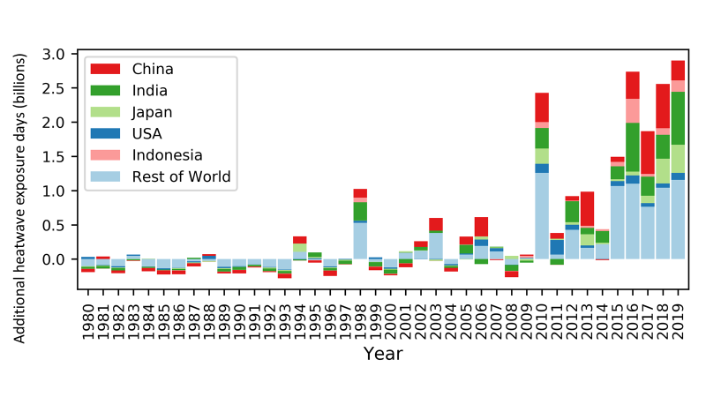

Figure 1: Change in days of heatwave exposure relative to the 1986-2005 baseline in the over 65 population.

### Indicator 1.1.3: Heat-Related Mortality

*Headline finding: In the past two decades, heat-related mortality in the over-65 population has increased by 53.7%, reaching 296,000 deaths in 2018, with the majority occurring in Japan, eastern China, northern India, and central Europe.*

This metric, newly created for the 2020 report, tracks global heat-related mortality in populations over 65. Using methods originally described by the World Health Organization (WHO), it applies the exposure-response function and optimum temperature described by Honda et al (2014) to the daily maximum temperature exposure of the over 65 population to estimate the attributable fraction and thus the heat-related excess mortality.37,38 Daily maximum temperature data is taken from ERA5 and gridded population data was taken from a hybrid of NASA GPWv4 and ISIMIP population data, with a full methodology described in the Appendix. 34-36

This indicator estimates that global average annual heat-related mortality in the over 65 population has increased by 53.7% from 2000-2004 to 2014-2018, with a total of 296,000 deaths in 2018 (Figure 2 and Figure 3). With the largest populations, China and India were greatest affected, with over 62,000 and 31,000 heat-related deaths respectively, followed by Germany (over 20,000), the USA (almost 19,000), Russia (18,600), and Japan (over 14,000). At over 104,000 deaths, Europe was the most affected of the WHO regions. Importantly, the effects of temperature on mortality vary by region, and are modified by local factors including population urban green space, and inequality both within and between countries.39,40 Work has begun to develop a future form of this indicator, which builds in more localised exposure-response functions, as they become available.

Figure 2: Global heat-related mortality for populations over the age of 65, from 2000-2018.

Figure 3: Annual heat-related mortality in the over 65 population, averaged from 2014 to 2018.

### Indicator 1.1.4: Change in Labour Capacity

*Headline finding: Rising temperatures were responsible for an excess of 100 billion potential work-hours hours lost globally in 2019 compared to 2000, with India’s agricultural sector among the worst affected.*

This indicator tracks the effects of heat exposure on working people, with impact expressed as potential work hours lost.41 It has been updated to capture construction, alongside service, manufacturing, and agriculture sectors, drawing climate data from the ERA5 models, with methods and data described in full in the Appendix and previously.35,42-45

Across the globe a potential 302 billion work hours were lost in 2019 – 103 billion hours greater than in 2000. Thirteen countries represent approximately 80% of the global hours lost in 2019 (Table 1), with India experiencing by far the greatest loss (39% of total global work hours lost in 2019) and Cambodia the highest impact per capita loss. Agricultural workers experience the worst of these effects in many countries in the world, whereas the burden is often on those in construction in high-income countries such as the USA.

Table 1: *Work hours lost (WHL) due to heat. These estimates are* assuming all agricultural and construction work was in the shade or indoors – the lower bounds of potential work hours lost. Work hours lost per person are estimated for the population over 15.

|  |  |  |  |  |
| --- | --- | --- | --- | --- |
| Country | WHL 2000 (billions) | WHL 2019 (billions) | % of Global WHL, 2019 | WHL per person, 2019 |
| Global | 199.0 | 302.4 | 100% | 52.7 |
| India | 75.0 | 118.3 | 39.1% | 111.2 |
| China | 33.4 | 28.3 | 9.4% | 24.5 |
| Bangladesh | 13.3 | 18.2 | 6.0% | 148.0 |
| Pakistan | 9.5 | 17.0 | 5.6% | 116.2 |
| Indonesia | 10.7 | 15.0 | 5.0% | 71.8 |
| Vietnam | 7.7 | 12.5 | 4.1% | 160.3 |
| Thailand | 6.3 | 9.7 | 3.2% | 164.4 |
| Nigeria | 4.3 | 9.4 | 3.1% | 66.7 |
| Philippines | 3.5 | 5.8 | 1.9% | 71.4 |
| Brazil | 2.8 | 4.0 | 1.3% | 23.3 |
| Cambodia | 1.7 | 2.2 | 0.7% | 202.2 |
| USA | 1.2 | 2.0 | 0.7% | 7.1 |
| Mexico | 0.9 | 1.7 | 0.6% | 17.4 |
| Rest of world | 28.7 | 58.3 | 19.3% | 27.5 |

## 1.2 Health and Extreme Weather Events

Extreme weather events, including wildfires, floods, storms, and droughts, affect human health in a variety of ways, with the frequency and intensity of such events shifting as a result of climate change. Death and injury as a direct result of an extreme event is often compounded by effects that are mediated through the environment – for example, the exacerbation of respiratory symptoms from wildfire smoke, or the spread of vector- and water-borne diseases following a flood or drought. Finally, impacts are mediated through social systems – for example, the disruption to health services, and the mental ill-health that can result from storms and fires.3,46 The following indicators track population risk and exposure to wildfires, changes in meteorological flood and drought, and the lethality of extreme weather events.

### Indicator 1.2.1: Wildfires

*Headline finding: 114 countries experienced an increase in the number of days people were exposed to ‘very high’ or ‘extremely high’ fire danger risk for the four-year period ending 2019. At the same time, 128 countries experienced an increase in population exposure to wildfires.*

For the 2020 report, analysis on the effects of wildfires has been developed to track the average number of days people are exposed to very high and extremely high wildfire risk annually, as well as the change in actual population wildfire exposure across the globe, using both model-based risk to wildfires and satellite-observed exposure. Climatological wildfire risk is estimated by combining fire danger indices (FDI ≥ 5) with climate and population data for every 0.25° x 0.25° grid cell.34,47 For wildfire exposure, satellite-observed active fire spots were detected using the Moderate Resolution Imaging Spectroradiometer (MODIS), and then aggregated and spatially joined with gridded global population data on a global 10 km resolution grid, with urban areas excluded.34,48 A full description of the methodology can be found in the Appendix.

Increased wildfire risk was observed in 114 out of 196 countries for the period 2016-2019 compared to 2001-2004, with the most prominent increases occurring in Lebanon, Kenya and South Africa (Figure 4). Considering area-weighted rather than population-weighted change, Australia, devastated by the 2019-2020 fire season, had one of the largest increases in wildfire risk. Over the same time period, this risk translated into an additional 194,000 daily exposures to wildfires happening annually, around the world, and 128 countries experiencing an increase in this metric. Driven by the record-breaking 2017 and 2018 fires, the USA experienced one of the largest increases globally, with over 470,000 additional annual daily exposures to wildfires occurring from 2001-2004 to 2016-2019.

Figure 4: Population-weighted mean changes in extremely high and very high fire danger days in 2016-2019 compared with 2001-2004. Large urban areas with population density ≥ 400 persons/km2 are excluded.

### Indicator 1.2.2: Flood and Drought

*Headline finding: 2019 saw over twice the global land surface area affected by excess drought compared with the historical baseline.*

Climate change alters hydrological cycles, tending to make dry areas drier and wet areas wetter.27 By altering rainfall patterns and increasing temperatures, climate change affects the intensity, duration and frequency of drought events.3,49 Drought poses multiple risks for health, threatening drinking water supplies and sanitation, crop and livestock productivity, enhancing the risk of wildfires and potentially leading to forced migration.50 At the same time, altered precipitation patterns increase the risk of localised flood events, resulting in direct injury, the spread of infectious diseases and impacts on mental health.51

In the 2020 report, meteorological drought is tracked through using the Standardised Precipitation-Evapotranspiration Index (SPEI), which takes into account both precipitation and temperature, as well as its impact on the loss of soil moisture. This measures significant increases in the number of months of drought compared with an extended historical baseline, from 1950-2005, in order to account for periodic variations such as those generated by the El Niño Southern Oscillation.52 A full explanation of the methodology and additional analysis are in the Appendix.

Since the turn of the century, the area affected by excess number of months in drought has increased globally, with more exceptional drought events affecting all populated continents in 2018.Areas that experienced unusually high number of months under excess drought in 2018 include Europe, the Eastern Mediterranean region, and specifically, Mongolia.

### Indicator 1.2.3: Lethality of Extreme Weather Events

*Headline finding: Long term increasing trends in the number of weather-related disasters from 1990 to 2019 were accompanied by increasing trends in the number of people affected by these disasters, in the countries where health expenditure has reduced or minimally increased over the last two decades.*

The links between climate change and the health impacts of extreme weather events are presented in two ways for this indicator. The first studies long-term trends in the occurrence of such events along with the change in the number of people affected, and the resultant mortality. The methods and data for this are similar to that used in previous reports, and described in full in the Appendix.53,54 Recognising that an increase in the variability and intensity of these events is also expected, the second part considers the attribution of climate change to individual extreme events in recent years, and the effects that a selection of events have had on the health of populations (Table 2 and Panel 3).

There are clear, statistically significant trends in the number of occurrences of weather-related disasters, however insufficient evidence in either direction with respect to the number of deaths or number of people affected per event. Within the sub-set of countries demonstrating a reduction, or minimal increase in healthcare expenditure from 2000-2017, a significant increase in the number of people affected is identified. By contrast, in countries with the greatest increase in healthcare expenditure, the number of people affected by extreme weather events has declined despite an increasing frequency of events. One possible explanation for this could be the adaptive effects of health system strengthening. This relationship will be further explored, considering variables such as expenditure for specific healthcare functions and excess deaths in addition to the immediate event-related deaths.

Table 2: Detection and attribution studies linking recent extreme weather events to climate change from 2015 to 2020.

|  |  |  |  |
| --- | --- | --- | --- |
| Event type | Anthropogenic influence increased event likelihood or strength | Anthropogenic influence decreased event likelihood or strength | Anthropogenic influence not identified or uncertain, or had varied effects (*) |
| **Heat**  36 studies  32 events | **2015:** India; Pakistan; China; Indonesia; Europe;8,55 Egypt; Japan; Southern India and Sri Lanka; Australia; Global.8,56  **2016:** Southern Africa; Thailand; Asia; Global.  **2017:** Australia;57 USA; South Korea; Western Europe;58 China; Euro-Mediterranean.  **2018:** Northeast Asia;Iberia;  Europe.  **2019:** France;59 Western Europe.60  **2020:** Australia.61 |  | **2015-2016:** India.62 |
| **Cold and frost**  9 studies  8 events | **2016:** Australia. | **2015:** USA.  **2016:** China**.**  **2018:** North America;63 UK. |  |
| **Drought and reduced precipitation**  26 studies  24 events | **2015:** USA; Canada; Ethiopia; Indonesia; Australia.  **2016:** Southern Africa;Thailand.  **2017:** East Africa; USA;China**.**  **2018:** South Africa;64 China; USA |  | **2015:** Brazil;65 Nigeria; Ethiopia.66  **2016:** Brazil; USA; Somalia;67 Western Europe.  **2017:** Kenya.68 USA.  **2019:** Australia.61 |
| **Wildfire**  5 studies  6 events | **2015:** USA.  **2016:** Australia; Western North America.  **2018:** Australia.  **2020:** Australia.61 |  | **2017:** Australia. |
| **Heavy precipitation and flood**  23 studies  19 events | **2015:** China; USA.  **2016:** France;69 China; Louisiana, USA.70  **2017:** Bangladesh; Peru; Uruguay; China.  **2018:** USA; Japan.6,71 | **2018:** China. | **2015:** India.  **2016:** Germany;69 Australia;  **2017:** Bangladesh.72  **2018:** Mozambique, Zimbabwe and Zambia; Australia; India;73 China.* |
| **Storms**  8 events  8 studies | **2015:** UK;74 Western North Pacific75  **2017:** USA.76  **2018:** USA.77  **2019:** USA.78 |  | **2016:** USA.  **2018:** Western Europe.79 |
| **Marine heat and melting sea ice**  10 events  13 studies | **2015:** Northern Hemisphere.  **2016:** USA; Australia; Coral Sea;7,80 North Pole;7,81 Gulf of Alaska and Bering Sea; Central Equatorial Pacific.  **2018:** Tasman Sea; Bering Sea. |  | **2015:** Central Equatorial Pacific.  **2016:** Eastern Equatorial Pacific. |
| **Total events and studies** | **76 events, 81 studies** | **5 events, 6 studies** | **28 events, 27 studies** |

Events have been listed according to the year in which they ended. In some countries and regions multiple events in the same year were studied. References are in Herring et al, 2016,8 Herring et al, 2018,7 Herring et al, 2019,5 Herring et al 2020,6 or listed separately. Adapted from the Bulletin of the American Meteorological Society.

Panel 3: Quantifying the Links between Climate Change, Human Health, and Extreme Events

Formal statistical methods, grouped as detection and attribution studies (D&A) are already used widely in other sectors, and are increasingly deployed to quantify the extent to which climate change has had observed impacts on population health and health systems.82-84 However, recent D&A studies focusing on the changing likelihood and intensity of extreme events are generally limited to meteorological events in high- and upper-middle income countries. Further development of this body of literature offers an essential and unique way of improving understanding of current impacts and future risks of climate change on lives and livelihoods, guiding evidence-based management and adaptation.

The following three case studies illustrate the linkage of D&A studies of meteorological events to the resulting health impacts.

**1. Reduced sea ice in the Arctic Region**

The Arctic Region is warming two to three times faster than the global annual average, with observable impacts for Arctic communities, but limited data on the health consequences.85 Extreme weather events, shifting migration patterns, and warmer and shorter winters now threaten food security and vital infrastructure.

The winter of 2017-18 heralded warm temperatures and an extreme ‘low ice year’ in the Bering Sea.86 Sea ice extent was the lowest in recorded and reconstructed history: an estimated two in 1800-year event compared with pre-industrial levels. One study suggested that climate change was responsible for 90% of the attributable risk , and that this level may become the mean within 20 years.87

This had multiple detrimental effects on communities in Western Alaska, although the health impacts have rarely been measured. These communities generally depend on sea ice for transportation, hunting and fishing, coastal buffering from storms, and a host of other ecosystem services. During this period of record-low sea ice, a range of events occurred, from the loss of power, and damage to the water treatment plant in Little Diomede to a fatal accident that resulted from open water-holes along a previously frozen travel corridor on the Kuskokwim River.88-90

**2. Northern European Heatwaves in 2018 and 2019**

During the summer of 2018, parts of northern Scandinavia experienced record-breaking daily temperatures more than 5°C warmer than in 1981-2010, an occurrence that evidence suggests was made five times more likely as a result of climate change.91 In Sweden, the Public Health Agency estimated an excess mortality of 750 deaths between July and August, with more than 600 of these attributed to higher temperatures when compared with the same weeks in 2017.92

Countries across Western Europe and Scandinavia again experienced record-breaking temperatures in 2019, with several countries exceeding 40°C for 3-4 days during June and July. Attribution studies suggest climate change was responsible for a 10-fold increase in the likelihood of the event occurring, and a 1.2-3°C increase in temperature of these events, with almost 1,500 deaths in France and 400 deaths in the Netherlands.60,93,94

**3. Japan Heatwave 2018**

The summer of 2018 in Japan saw a combination of a national emergency resulting from extreme precipitation, followed closely by record-breaking temperatures. The event had roughly a 20% probability of occurring in today’s world compared with a zero probability in a world without climate change.95,96 Another attribution study compared modest and extreme heatwave days with a 1941-79 baseline, concluding that the probability of the defined heatwave event was 1.5 times higher for 1980-2018 and 7-8 times higher for 2019-2050. This hot summer had large health implications. In 2018, there were an estimated 14,200 heat-related deaths in Japan’s over 65 population – over 3,000 more deaths than the previous record set in 2010, and 8,100 greater than the 2000-2004 average (Indicator 1.1.3).

## 1.3 Climate-Sensitive Infectious Diseases

### Indicator 1.3.1: Climate Suitability for Infectious Disease Transmission

*Headline finding: Changing climatic conditions are increasingly suitable for the transmission of numerous infectious diseases. From 1950 to 2018, the global climate suitability for the transmission of dengue fever increased by 8.9% for A. aegypti, and 15.0% for A. albopictus. In the last 5 years, suitability for malaria transmission in highland areas was 38.7% higher in the WHO African region and 149.7% higher in the WHO Western Pacific Region compared to a 1950s baseline.*

Climate change is affecting the distribution and risk of many infectious diseases to humans, including vector-, food- and water-borne diseases.3 Using three different models, this indicator tracks the change in climate suitability for the transmission of infectious diseases of particular global significance: dengue; malaria; and pathogenic *Vibrio* bacteria (*V. parahaemolyticus*, *V. vulnificus*, and non-toxigenic *V. cholerae*). In the case of *Aedes aegypti* and *A. albopictus,* temperature-driven process-based mathematical models were used to capture the vectorial capacity (VC) for the transmission of dengue.97 Change in the climate suitability for *Plasmodium falciparum* malaria is modelled based on empirically derived thresholds of precipitation, temperature and relative humidity.97,98 Highland areas (≥1500m above sea-level) are highlighted in the model, as increasing temperatures are eroding the effect altitude once had as a barrier to malaria transmission, resulting in more favourable conditions in densely populated highland areas, as seen in Ethiopia.99 In the case of pathogenic *Vibrio* species, which cause a range of human infections including gastroenteritis, wound infections, septicaemia, and cholera, recent changes in climate suitability were compared with a 1980s baseline globally, as well as for one region each in Europe (Baltic), the Northeast Atlantic coast of the USA and the Pacific North West coast of North America.100-102 Full descriptions of the context of these diseases, the methodology of the models, and additional analysis can be found in the Appendix.

Climate suitability for disease transmission is rising globally, for all diseases being tracked. 2018 was particularly favourable for the transmission of dengue, with a global rise of 8.7% and 14.5% above the 1950s baseline for *A. aegypti* and *A. albopictus*, respectively (Figure 5). Although average suitability for dengue remains low in Europe, 2018 was the most suitable year yet recorded for both vector species in this region (25.8% and 40.7% for *A. aegypti* and *A. albopictus*, respectively). There have been significant increases in the environmental suitability for the transmission of falciparum malaria in highland areas of four of the five malaria-endemic regions, with an increase of 38.7% in the African Region and 149.7% in the Western Pacific Region in 2015-2019 compared to a 1950s baseline (Figure 5). The coastal area suitable for *Vibrio* infections in the past five years has increased at northern latitudes (40-70° N) by 50.6% compared to a 1980s baseline. Regionally, the area of coastline suitable for *Vibrio* has increased by 61.2% and 98.9% for the Baltic and USA Northeast respectively. In 2019, for the second consecutive year, the entirety of the Baltic coastline was suitable for disease transmission.

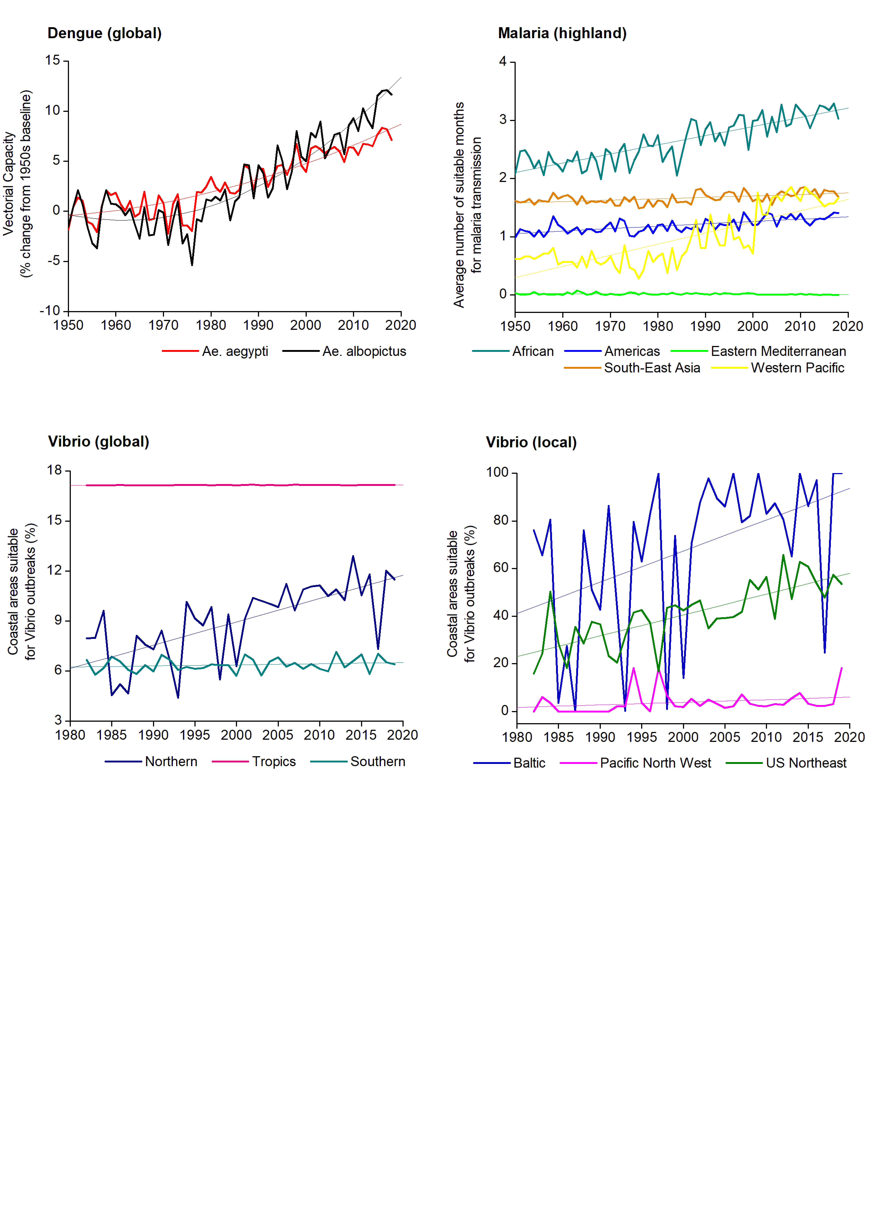

Figure 5: Change in climate suitability for infectious diseases: dengue (A. aegypti); malaria (highland regions ≥1500m); and Vibrio species.

### Indicator 1.3.2: Vulnerability to Mosquito-Borne Diseases

*Headline finding: Following a sharp decline over the last decade, 2016 to 2018 saw small up-ticks in national vulnerability to dengue outbreaks in four out of six WHO regions, with further data required to establish a trend.*

As discussed above, climate change is expected to facilitate the expansion of *Aedes* mosquito vectors that transmit dengue. Improvements in public health services may counteract these threats in the short- to medium-term, however climate change will continue to make such efforts increasingly difficult and costly.103 This indicator tracks vulnerability to mosquito-borne disease by combining the above indicator on climate suitability for the transmission of dengue, with countries’ health system core capacities as outlined by the International Health Regulations (IHR), which have been shown to be an effective predictor of protection against disease outbreak.104 The methods used here remain unchanged from previous reports, and are described in the Appendix in full.97,105

From 2010, a substantial decline in vulnerability for the four most vulnerable WHO regions, is seen around the world, reflecting significant improvements in their core health capacities. However, from 2016 to 2018, this trend begins to halt, and then reverse, with further data required to confirm any long-term shift.

## 1.4 Food Security and Undernutrition

Whilst the global food system still produces enough to feed a growing world population, poor management and distribution has resulted in a lack of progress on the second Sustainable Development Goal (SDG) on hunger, as the global number of under-nourished people projected to rise to over 840 million in 2030.106

Climate change threatens to exacerbate this further, with increasing temperatures, climatic shocks and ground-level ozone impacting crop yields, and with sea surface temperature (SST) and coral bleaching impacting marine food security.107 These effects will be experienced unequally, disproportionately affecting countries and populations already facing poverty and malnutrition, and exacerbating existing inequalities. The following two indicators monitor these changes, tracking the change in crop yield potential and SST.

### Indicator 1.4.1: Terrestrial Food Security and Undernutrition

*Headline finding: Crop yield potential for maize, winter wheat, soybean, and rice has followed a consistently downward trend from 1980 to 2019, with reductions of 5.6%, 2.1%, 4.8% and 1.8% seen respectively.*

Here, crop yield potential is characterised by “crop growth duration” (the time taken to reach a target sum of accumulated temperatures), over its growing season. If this sum is reached early then the crop matures too quickly and yields are lower than average, with a reduction in crop growth duration therefore representing a reduction in yield potential.108 This indicator tracks the change in the crop growth duration for four key staple crops: maize, wheat, soybean, and rice at the individual country level and globally, using a similar approach to previous reports, which has been improved to provide more accurate local estimates, and now uses ERA5 data.36

The yield potential of maize, winter wheat, soybean, and rice continue to decline globally and for most individual countries, with this indicator demonstrating that it is increasingly difficult to continue to increase or even maintain global production due to the changing climate. In 2019, the reduction in crop growth duration relative to baseline, was 7.9 days (5.6%), 4.9 days (2.1%), 6.1 days (4.8%), and 2 days (1.8%) for maize, winter wheat, soybean, and rice respectively (Figure 6). For maize, most countries in the world experienced a decline, with large areas of South Africa, the USA, and Europe experiencing reductions in their crop growing seasons of over 20 days – a reduction of over 14% of the global average crop duration. This compounds the current negative impacts of weather and climate shocks, made more frequent and more extreme by climate change, that are hampering localised efforts to reduce undernutrition.

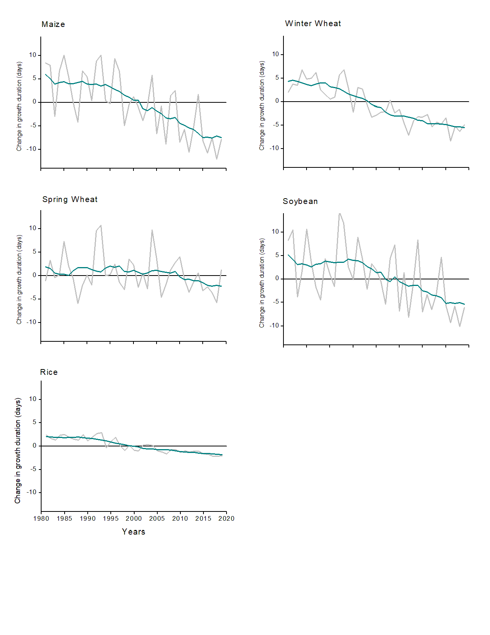

Figure 6: Change in crop growth duration for maize, soybean, spring wheat, winter wheat, and rice, relative to the 1981-2010 global average.

### Indicator 1.4.2: Marine Food Security and Undernutrition

*Headline finding: Average sea surface temperature rose in 46 of 64 investigated territorial waters between 2003-2007 and 2015-2019, presenting a risk to marine food security.*

A large proportion of the global population, especially in low- and middle-income countries is highly dependent on fish sources of protein.109 Additionally, omega-3 is important in the prevention of ischaemic heart disease and diets low in seafood omega-3 fatty acids, a risk factor to which over 1.4 million deaths globally were attributed in 2017.110 Sea surface temperatures, rising as a consequence of climate change, impair marine fish capacity and capture through a number of mechanisms, including the bleaching of coral reefs and reduced oxygen content, putting populations at risk.111 This indicator tracks SST in territorial waters of 64 countries located in 16 Food and Agriculture Organization (FAO) fishing areas.112-114

Comparing 2003-07 and 2015-19 time periods, average SST rose in 46 of the 64 investigated areas, with a maximum increase of 0.87°C observed in the territorial waters of Ecuador. Farm-based fish consumption has increased consistently over the last four decades, with a corresponding decline in capture-based fish consumption, exacerbated in part by these evolving temperature trends.111 Between 1990 and 2017, diets low in seafood ω3 increased by 4.7% at global level with more than 70% of the countries experiencing an increase in exposure to this risk factor, increasing the mortality risk from ischemic heart disease.

## Indicator 1.5: Migration, Displacement and Sea Level Rise

*Headline finding: Without intervention, between 145 million and 565 million people living in coastal areas today will be exposed to and affected by future sea level rise.*

Through its impacts on extreme weather events, land degradation, food and water security, and sea level rise (SLR), climate change is influencing human migration, displacement, and relocation with human health consequences.115,116 Left unabated, average estimates for global mean sea level rise (GMSLR) range from 1-2.5 metres (m) by the end of the century, with projections rising as high as 5m when taking into account regional and local coastal variation.117,118 This indicator, newly introduced for the 2020 report, tracks current population exposure to future SLR and provides a measure of the extent to which health or well-being are considered in national policies which connect climate change and human mobility.

Population exposure to GMSLR of 1m and 5m was determined using a Coastal Digital Elevation Model (CoastalDEM) and current population distribution data, with a full description of this new indicator outlined in the Appendix.119,120 Based on today’s population distributions, 1m of GMSLR could expose 145.5 million of the world’s current population to potential inundation, rising to 565 million people with 5m of SLR (Figure 7). A range of SLR-related health impacts are likely to be experienced, with changes in water and soil quality and supply, livelihood security, disease vector ecology, flooding, and saltwater intrusion.121,122 The health consequences of these effects will depend on a variety of factors, including both *in situ* and migration adaptation options.123-125 These effects could be moderated if countries begin to prepare. A review in 2019 identified 43 national policies, across 37 countries, connecting climate change and migration, and 40 of these policies across 35 countries explicitly referencing health or wellbeing. The policies commonly accept that mobility could be domestic and international, although mention of immobility was lacking.

|  |
| --- |
| Exposure to 1m Global Mean Sea Level Rise |
| Exposure to 5m Global Mean Sea Level Rise |

Figure 7: Number of people exposed to 1m and 5m of global mean sea level rise by country.

## Conclusion

The indicators that comprise Section 1 of the 2020 report describe a warming world that is affecting human health both directly and indirectly, and putting already vulnerable populations at higher risk. Metrics of exposure and vulnerability to extreme weather are complemented by trends of worsening global yield potential and climatic suitability for the transmission of infectious disease. Subsequent reports will continue to develop the methods and data underlying these indicators, with a particular focus on the creation of a new indicator on mental health, and the exploration of the gender dimensions of existing indicators.

Correlating climate change and mental health is challenging for a number of reasons, including local and global stigma and underreporting, differences in health systems, and variation in cultural understandings of wellbeing. In part because of this, the literature has focused on extremes of heat, with investigations reporting correlations between higher temperatures and heatwaves, and the risk of violence or suicide. Proposed reasons for this association vary from the effects of disrupted sleep through to short-term agitation.126,127 Stronger evidence exists outlining the links between extreme weather events and mental ill-health, with emerging research describing the impact of a loss of access to the environment and ecosystem services.128

Taken as a whole, the data described in Section 1 provides a compelling justification for an accelerated response. There are clear limits to adaptation, necessitating increasingly urgent interventions to reduce GHG emissions. How communities, governments, and health systems will be able to moderate the impacts of a changing climate is discussed in Section 2 and Section 3.

# Section 2: Adaptation, Planning, and Resilience for Health

With a growing understanding of the human costs of a warming climate, the need for adaptation measures to protect health is now more important than ever. The current COVID-19 pandemic makes clear the challenges experienced by health systems around the world, when faced with large unexpected shifts in demand, without sufficient adaptation or integration of health services across other sectors.129 As this public health crisis continues, and is compounded by climate-attributable risks, rapid and proactive interventions are crucial in order to prepare for and build resilience to both the health threats of climate change and of pandemics.130

Heavily determined by regional hazards and underlying population health needs, the implementation of adaptation and resiliency measures require localised planning and intervention. National adaptation priorities must take into account subnational capacities, as well as the distribution of vulnerable populations and inequality, locally. As health adaptation interventions are being increasingly introduced, evidence of their success often remains mixed.131 Measuring the impact of these long-term interventions at the global scale presents particular challenges, and the indicators in this section aim to monitor adaptation progress through the lens of the WHO Operational Framework for Building Climate Resilient Health Systems.24 The adaptation indicators expand beyond the health system to focus on the following domains: planning and assessment (Indicators 2.1.1-2.1.3), information systems (Indicator 2.2), delivery and implementation (Indicators 2.3.1-2.3.3), and spend (Indicator 2.4). As is often the case in adaptation, several of these indicators rely on self-reported data on adaptation plans, assessments, and services, which also presents challenges. Where possible, efforts have been made to validate this data.

Numerous indicators in this section have been further developed for the 2020 report and one new indicator is presented. The data on national health adaptation planning and assessments (Indicators 2.1.1 and 2.1.2) has been presented in greater detail, whilst calculations of the effectiveness of air conditioning as an intervention (Indicator 2.3.2) have been improved using more recent evidence. The definition of health-related adaptation spending (Indicator 2.4) has been expanded to capture activities that are closely health-related, in a variety of non-health sectors. Importantly, a new indicator, focusing on the use of urban green spaces as an adaptive measure with numerous health benefits, has been introduced in this year’s report (Indicator 2.3.3).

## 2.1 Adaptation Planning and Assessment

Adaptation planning and risk management is essential across all levels of government, with national strategy and coordination linked to sub-national and local implementation and delivery.132 In every case, risk assessments are an important first step of this process.

The following three indicators track national- and city-level adaptation plans and assessments, using data from the WHO Health and Climate Change Survey and the CDP Annual Cities Survey.133,134 Information on the data and methods for each are presented in the Appendix. Data from the WHO survey has not been updated for this year, and hence further qualitative analysis has been conducted to investigate the barriers to adaptation.

### Indicator 2.1.1: National Adaptation Plans for Health

*Headline finding: 51 out of 101 of countries surveyed have developed national health and climate change strategies or plans. However, funding remains a key barrier to implementation, with less than 10% of countries reporting to have the funds to fully implement their plans.*

National governments identified financing as one of the main barriers to the implementation of national health and climate change plans.30,134 Of the countries with these plans, only four report having adequate national funding available to fully implement them. This highlights the importance of access to international climate finance for governments from low-resource settings. Despite this, less than half of national health authorities from low and lower-middle income countries (17 out of 35 LLMICs) report having current access to climate funds from mechanisms such as the Global Environment Facility, the Adaptation Fund, the Green Climate Fund (GCF) or other donors. The GCF, which so far has not funded a single health sector project for the 10th year running, is now looking to align its programming to incorporate health and wellbeing co-benefits in light of, and in response to COVID-19. While not yet accredited to submit and implement projects, WHO became a GCF Readiness Partner in 2020, giving WHO the ability to support countries in their efforts to develop health components of National Adaptation Plans and to strengthen health considerations related to climate change.

A second key barrier to the implementation of national health and climate strategies is a lack of multisectoral collaboration within government. Progress on cooperation across sectors remains uneven, with 45 out of 101 countries reporting the existence of a memorandum of understanding between the health sector and the water and sanitation sector, on climate change policy. However, less than a third of countries have a similar agreement with the agricultural, or social service sectors. Furthermore, only about a quarter of countries reported agreements in places between health and the transport, household energy or electricity generation sectors. This represents a significant missed opportunity to recognise the health implications of national climate policies and to promote activities that maximise health benefits, avoid negative health effects and evaluate the associated health savings that may result.

### Indicator 2.1.2: National Assessments of Climate Change Impacts, Vulnerabilities, and Adaptation for Health

*Headline finding: Just under half of 101 countries surveyed have conducted a national vulnerability and adaptation assessment for health, with further investment required to adequately fund these vital components of health system resilience.*

Strengthening all aspects of a health system allows it to protect and promote the health of a population in the face of known and unexpected stressors and pressures. In the case of climate change, this requires a comprehensive assessment of current and projected risks, and population vulnerability. This indicator focuses on national-level vulnerability assessments and the barriers faced by national health systems.134

Similar to the lack of funding highlighted above, it is clear that vulnerability assessments for health are also under-resourced. Indeed, conducting vulnerability assessments were among the top three adaptation priorities identified as being underfunded by national health authorities, alongside the strengthening of surveillance and early warning systems, and broader research on health and climate change. This was thought to be particularly true for sub-national assessments and for those designed to be particularly sensitive to the needs of vulnerable population groups.

### Indicator 2.1.3: City Level Climate Change Risk Assessments

*Headline finding: Of the 789 global cities surveyed, 76% have either already completed or are currently undertaking climate-change risk assessments, with 67% expecting climate change to seriously compromise their public health assets and services, a substantial increase from 2018.*

Cities are home to more than half of the world’s population, produce 80% of global gross domestic product (GDP), consume two thirds of the world’s energy, and represent a crucial component of the local adaptation response to climate change.135 As such, this indicator captures cities that have undertaken a climate change risk or vulnerability assessment, as well as their expectations on the vulnerability of their public health assets. First presented in the 2017 report of the Lancet Countdown and since improved to include further public health-specific questions, data for this indicator is sourced from the CDP’s 2019 survey of 789 global cities: a 33% increase in survey respondents from 2018.133,136

In 2019, 62% of cities had completed a climate-change risk or vulnerability assessment, and a further 28% of city assessments were either in the process of doing so, or will have completed one within the next two years. While some selection bias likely exists, it is important to note that a growing number of risk assessments are being completed by cities in low-income countries (63% of cities in LICs in 2019), highlighting the beginning of adaptation where it is arguably most needed. The survey also reveals a core driving factor in these assessments - some 67% of cities report that their vital public health infrastructure would be seriously compromised by climate change.

## Indicator 2.2: Climate Information Services for Health

*Headline finding: The number of countries with meteorological services providing climate information to the health sector has continued to grow, increasing from 70 to 86 counties over the past 12 months.*

The use of meteorological services in the health sector is an essential component of adaptation. This indicator tracks the collaboration between these two parts of government, using data reported by national meteorological and hydrological services to the World Meteorological Organization (WMO).137 Further detail is provided in the Appendix.

A total of 86 national meteorological and hydrological services of WMO member states reported providing climate services to the health sector, an increase of 16 from the 2019 report of the Lancet Countdown.30 By WHO region, 19 of the countries reporting were from Africa, 16 from the Americas, seven from the Eastern Mediterranean Region, 23 from Europe, eight from South East Asia, and 13 from the Western Pacific Region. Of the 86 positive respondents, 66 reported being ‘highly engaged’ with their corresponding health service, alongside other sectors such as agriculture, water, and electricity generation. As detailed in Indicator 2.1.1, multi-sector collaborations present governments with the opportunity to support a fully integrated adaptation approach to the risks of climate change.

## 2.3 Adaptation Delivery and Implementation

### Indicator 2.3.1: Detection, Preparedness and Response to Health Emergencies

*Headline finding: In preparation for a multi-hazard public health emergency, 109 countries have reported medium to high implementation of a national health emergency framework.*

The International Health Regulations (IHR) are an instrument of international law designed to aid the global community in preventing and responding to potential public health emergencies.105 This indicator focuses on core capacity eight (C8), which evaluates the degree to which countries have implemented a national health emergency framework by assessing levels of planning, management and resource allocation.105 The national health emergency framework applies to all public health events and emergencies, air pollution, extreme temperatures, droughts, floods, and storms. The IHR core capacities are also important components of the response to infectious disease threats, with similar capacities and functions considered when assessing preparedness to a pandemic such as COVID-19.138 The results of this survey are provided in full, in the Appendix.

In 2019, 166 out of 194 WHO member states completed the assessment portion related to C8, 16 fewer than in 2018. Of these, 109 countries have reported having medium to high degrees of implementation of multi-hazard preparedness and capacity, a 10% increase compared to 2018 data. The level of implementation varies by region, with medium-to-high levels reported in over 85% of countries in the Americas, Western Pacific, and Europe, 60% of Eastern Mediterranean and South East Asian countries, but only 26% of African countries. Despite disparities here, capacities have increased across all regions, and the global average increased from 59% in 2018 to 62% in 2019.

### Indicator 2.3.2: Air Conditioning Benefits and Harms

*Headline finding: Between 2016 and 2018, the world’s air conditioning stock continued to rise, further contributing to climate change, air pollution, peak electricity demand and urban heat islands, whilst also conferring protection against heat-related illness.*

Air conditioning represents one of a number of effective indoor cooling mechanisms for preventing heat-related illness and mortality.139 However, in 2018, air conditioning accounted for an enormous 8.5% of total global electricity consumption, contributing to, if sourced from fossil fuels, CO2 emissions, fine particulate matter (PM2·5) emissions, and ground-level ozone formation, with the potential to leak hydrofluorocarbons which act as powerful GHGs. On hot days, air conditioning can be responsible for more than half of peak electricity demand locally, and emits waste heat that contributes to the urban heat island effect.140,141 Further research is needed to determine if the overall harms of air conditioning outweigh its benefits. However, increased air conditioning use in response to the warming climate could result in around 1,000 additional air-pollution-related deaths every summer in the eastern USA by 2050.142

International programs and organisations, including Sustainable Energy for All, the Kigali Cooling Efficiency Program, and the International Energy Agency (IEA), are working to develop solutions to provide efficient indoor cooling that protects vulnerable populations against heat-related illness whilst minimising the health-associated harms. Such measures include building designs with improved insulation, energy efficiency measures, and improved ventilation, as well as increasing urban green space, detailed in Indicator 2.3.3. Recent evidence suggests that simple electric fans could also be an effective stay-at-home measure against most heatwaves during the COVID-19 pandemic.143

This indicator draws on data provided by the IEA, and includes an improved calculation of the prevented fraction of deaths from air conditioning, making use of an updated meta-analysis which builds on the previously available 2007 assessment, with full detail described in the Appendix.139,144

Between 2016 and 2018, the world’s air conditioning stock (residential and commercial) increased from 1.74 to 1.90 billion units and the proportion of households with air conditioning increased from 31.1% to 33.0%: a 56.7% rise since 2000 (Figure 8). Correspondingly, the global prevented fraction of heatwave related mortality increased from 23.6% in 2016 to 25.0% in 2018, but global emissions from air conditioning electricity consumption increased from 1.04 to 1.07 GtCO2 (2% of total global emissions), highlighting the need for sustainable cooling methods in the face of a warming climate.

Figure 8: Global proportion of households with air conditioning (red line), prevented fraction of heatwave-related mortality due to air conditioning (blue line), and carbon dioxide emissions from air conditioning (green line), 2000-2018.

### Indicator 2.3.3: Urban Green Space

*Headline finding: Urban green space is an important measure to reduce population heat exposure, with 8.5% of global urban centres having a very high or exceptionally high degree of greenness in 2019, and over 156 million people living in urban centres with concerningly low levels.*

Access to urban green space provides benefits to human health by reducing exposure to air and noise pollution, relieving stress, providing a setting for social interaction and physical activity, and reducing all-cause mortality.145,146 In addition, green space sequesters carbon and provides local cooling benefits which disrupt urban heat islands, providing both climate change mitigation and heat adaptation benefits. As access can often disproportionately benefit the most privileged in society, it is important that careful consideration is given to how green spaces are designed and distributed, ensuring safety and equitable access.147,148

This indicator, new in the 2020 report, quantifies urban green space exposure for 2019 in the 467 urban centres of over one million inhabitants, as defined by the Global Human Settlement (GHS).149,150 It is based on remote sensing of green vegetation through the satellite-based normalised difference vegetation index (NDVI), which measures the reflectance signature of visible red and near-infrared parts of spectrum of green plants, providing an indication of the level of green coverage of the earth surface. The maximum NDVI for all seasons was used to define the average level of greenness of each urban area. A full description of the methodology can be found in the Appendix.

In 2019, only 8.5 % of global urban centres had very high to exceptionally high levels of greenness, with five capital cities – Colombo, Washington DC, Dhaka, San Salvador, and Havana – highlighted (Figure 9). Concerningly, 9.9% of urban centers, home to over 156 million people and including 21 capital cities, lie at the opposite end of the spectrum, with very low levels of urban green space.40

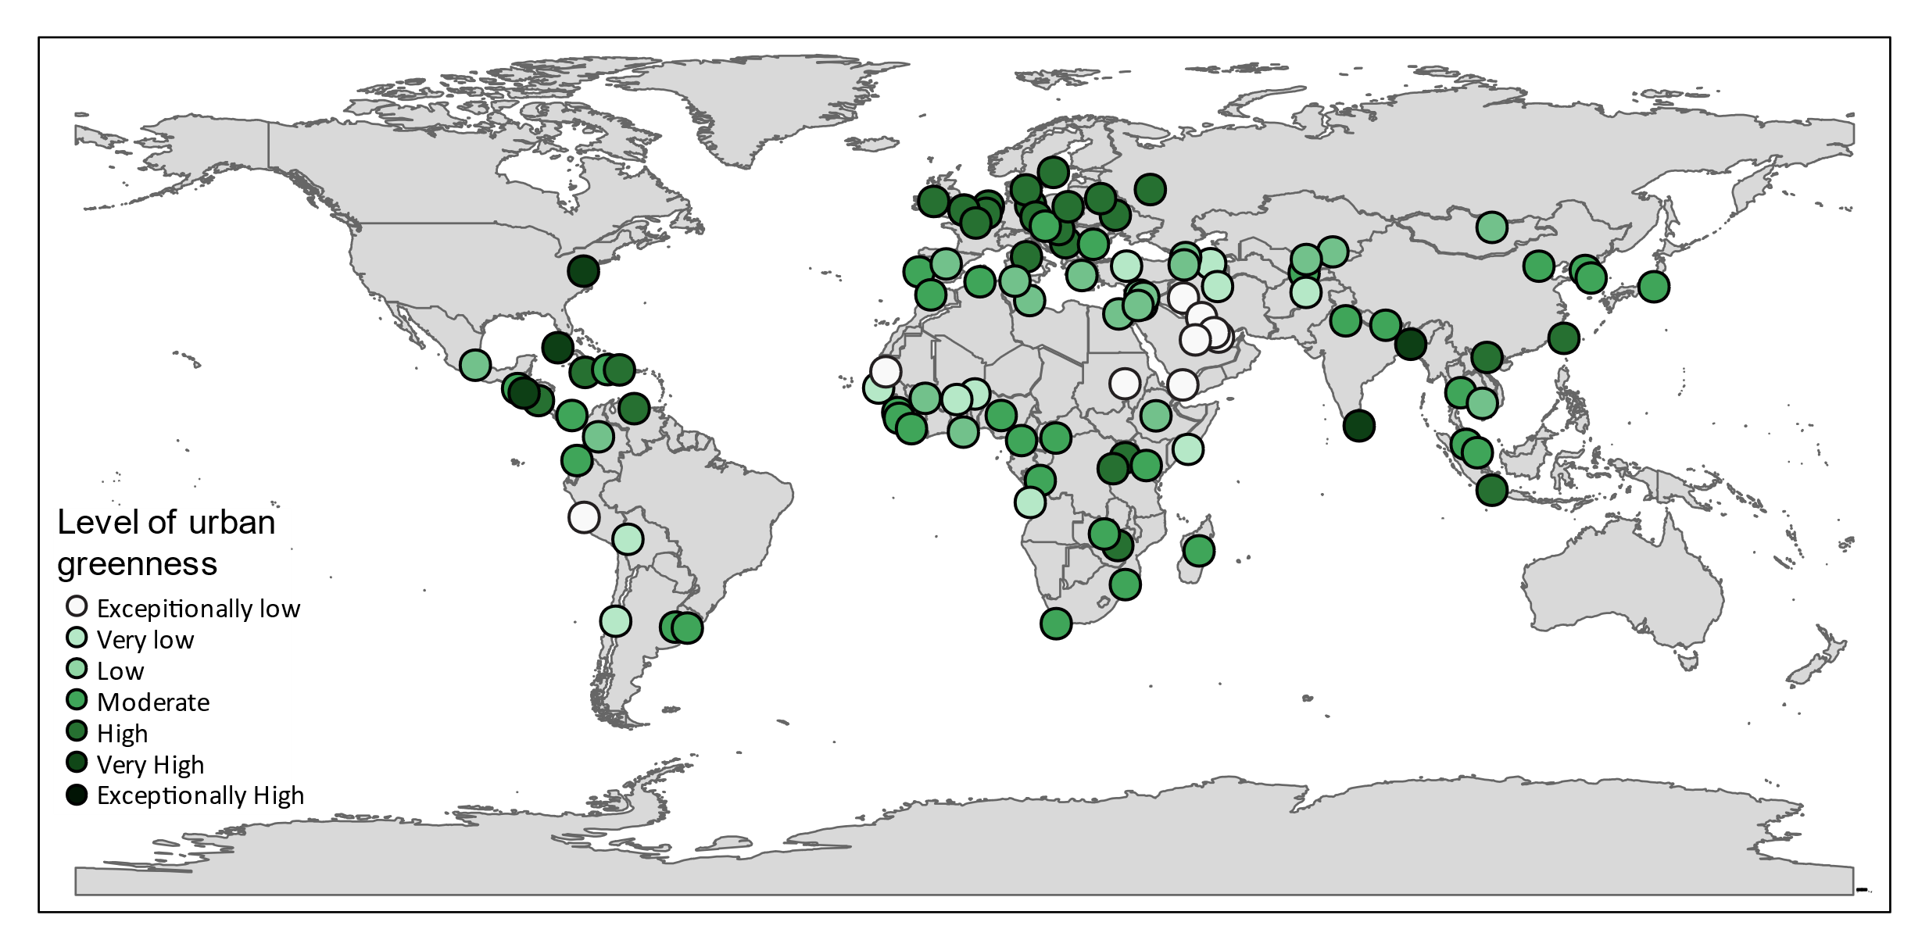

Figure 9: Urban greenness in capital cities >1 million inhabitants in 2019.

## Indicator 2.4: Spending on Adaptation for Health and Health-Related Activities

*Headline finding: At US$18.43 billion in 2019, global spending on health adaptation rose to 5.3% of total adaptation spending, while health-related spending remained flat at approximately 28.4% from 2015 to 2019.*

As noted in the evaluation of national adaptation plans (Indicator 2.1.1), inadequate financial resource poses the largest barrier to the implementation of adaptation measures. This indicator tracks health and health-related adaptation spending within the Adaptation and Resilience to Climate Change dataset from the data research firm, kMatrix, which includes spend data from 191 countries.151 Health-specific spend is that which occurs within the formal healthcare sector. For the 2020 report, an enhanced definition of health-related spending was developed through an expert review workshop to more accurately categorise spend. It captures adaptation spending within other sectors (agriculture & forestry, the built environment, disaster preparedness, energy, transportation, waste, or water) that have a direct impact on one or more of the basic determinants of health (food, water, air, or shelter), with a demonstrated link to health outcomes in the literature. A full description of the methodology can be found in the Appendix.

Climate change adaptation spending within the healthcare sector increased by 12.7% to US$18.43 billion in 2018/19, compared to 2017/18 data (Figure 10). As a share of all adaptation spending globally, health adaptation spending is now at 5.3% in 2018/19, above 5% for the first time. The wider measure of health-related adaptation spending increased by 7.2% to US$99.9 billion in 2018/19, although as a share of global adaptation spending, it has remained more or less constant: 28.4% in 2015/16 and 28.5% in 2018/19.

Grouped by WHO region, spending for health adaptation varies from US$0.48 per capita in Africa to US$5.92 in the Americas, remaining below US$1 per capita in South East Asia. Again, taking the broader health-related adaptation spend, a wider variation, ranging from US$2.63 (Africa) to US$30.82 (Americas), is evident.

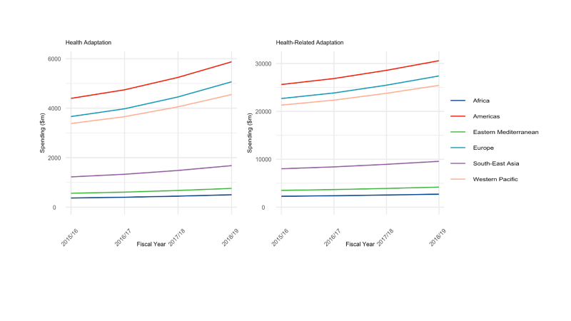

Figure 10: Adaptation and Resilience to Climate Change (A&RCC) spending *for financial years 2015/16 to 2018/19 by WHO Region. A) Health A&RCC spending ($m), B) Health-related A&RCC adaptation spending ($m).*

## Conclusion

The indicators presented in this section continue to move in a positive direction, with growing recognition of the impacts of climate change within the health community. However, there is much more work to do, with a need to move from planning to implementation, and to better engage with other sectors of society in adaptation interventions (Indicators 2.1.2, 2.1.2, and 2.2). The IHR core capacity scores show a need for support across many African and Eastern Mediterranean countries (Indicator 2.3.1), requiring additional engagement and resource.

Global spending trends have shown promise over recent years for health and health-related adaptation (Indicator 2.4), however governments remain unable to fully implement their national health adaptation plans (Indicator 2.1.1). The findings here reiterate the need to strengthen underlying health systems and create multi-sectoral alignment to protect human health, particularly for the most vulnerable populations. COVID-19 has dramatically altered the pattern of healthcare demand, with health systems restructuring services overnight.152 While the full impact of these changes are unclear, the rapid introduction of new online and telemedicine services brings many synergies with efforts to reduce the emissions of the healthcare sector, and with those to increase service delivery resilience. As governments continue to respond to the public health and economic effects of COVID-19, it will be important to align these priorities and ensure that enhanced preparedness for future pandemics also confers increased capacity to respond to climate change.

# Section 3: Mitigation Actions and Health Co-Benefits

In 2018, GHG emissions rose to an unprecedented 51.8 GtCO2e (55.3 GtCO2e including land use change), with fossil fuel emissions from transport, power generation, and industry accounting for 72%.153 The vast majority of the growth in emissions, the economy, and the demand for energy occurred in low- and middle-income countries, despite global economic headwinds.154

COVID-19 has had a profound effect on the global economy and on emissions. Ongoing volatility makes the projections of any long-term effects challenging, although daily CO2 emissions were 17% lower in April 2020 compared with April 2019, with some countries experiencing emissions reductions of up to 26%.155 Current estimates suggest that global emissions will fall by 8% in 2020 as a result of both the economic downturn, and restrictions to local and international travel.22,155 As efforts to revitalise the economy take effect, aligning such interventions with those necessary to mitigate climate change will allow governments to generate a synergistic response, improving public health in the short-term and in the long-term.

If carefully planned and implemented, these interventions will yield major health benefits, underlining the importance of a “health in all policies” approach.156,157 Highlighting this practice, the following section tracks climate change mitigation efforts in the sectors most relevant to public health: power generation and air pollution (Indicators 3.1.1-3.1.3 and 3.3); household energy and buildings (Indicator 3.2); transport (Indicator 3.4); diets and agriculture (Indicators 3.5.1 and 3.5.2); as well as mitigation within the healthcare sector (Indicator 3.6). New in the 2020 report are indicators of the national emissions from agricultural consumption (Indicator 3.5.1) as well as the associated premature mortality from unhealthy and emissions-intensive diets (Indicator 3.5.2). The methodologies of each of the existing indicators have also improved, particularly Indicator 3.6, which, based on feedback, has been revised to better estimate emissions from the healthcare sector.

Importantly, this section must be interpreted with the understanding that enhanced ambition is urgently required, and that countries will need to increase the strength of their mitigation commitments within the Paris Agreement’s NDCs by a factor of three to achieve a 2°C target, and by a factor of five for 1.5°C.153

## 3.1 Energy System and Health

### Indicator 3.1.1: Carbon Intensity of the Energy System

*Headline finding: The carbon intensity of the global primary energy supply has remained flat for the last three decades. Whilst in 2017 it was at its lowest since 2006, it still remained 0.4% higher than 1990 levels.*

As fossil fuel combustion in the energy system continues to be the biggest source of GHG emissions, mitigation in this area is key to meeting the commitments of the Paris Agreement. This indicator tracks the carbon intensity of the global energy system, expressed as the CO2 emitted per terajoule of total primary energy supply (TPES), with methods and data described in the Appendix.158,159

The carbon intensity of the global energy system has barely altered in almost 30 years: in 2017 it was 0.4% higher than in 1990 (Figure 11). Regional values have changed substantially, however, with reductions in the carbon intensity of the USA and north and western Europe now 12% and 20% lower than 1990 levels. China’s carbon intensity of TPES remains high at 72 tCO2/TJ, however it is decreasing, and in 2017 was 4% lower than its peak in 2013. Early statistics for 2020 suggest that global demand for all fossil fuels has reduced in the first quarter due to COVID-19, and will continue to decline across the year, with resulting reductions in emissions.22 However, without targeted intervention, emissions could rebound, as they did following the 2008-2009 global financial crisis, where a 1.4% decrease in CO2 emissions in 2009 was offset by a 5.9% rise in 2010.160

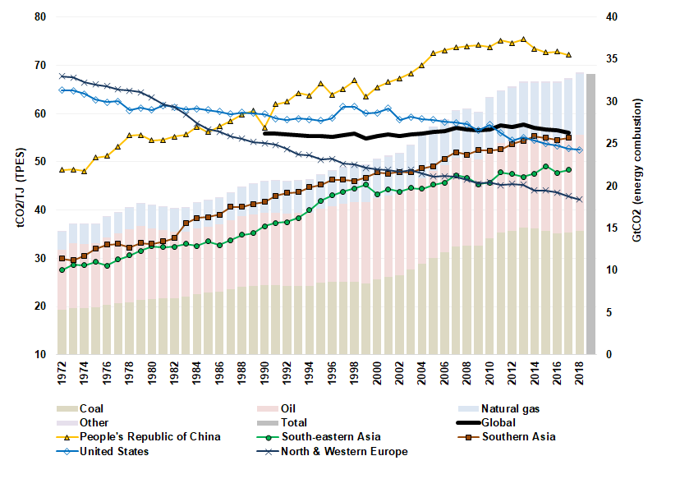

Figure 11: Carbon intensity of Total Primary Energy Supply (TPES) *for selected regions and countries, and global CO2 emissions by fuel type, 1971-2019. Carbon intensity trends are shown by trend line (primary axis) and global emissions by stacked bars (secondary axis). This carbon intensity metric estimates the tonnes of CO2 for each unit of total primary energy supplied (tCO2/TJ). For reference, carbon intensity of fuels (tCO2/TJ) are as follows: coal 95-100, oil 70-75, and natural gas 56.*

### Indicator 3.1.2: Coal Phase-Out

*Headline finding: Global energy supply from coal in 2018 increased by 1.2% from 2017 and was 74% higher than in 1990.*

Coal combustion continues to be the largest contributor to emissions from the energy sector, and is a major contributor to premature mortality due to air pollution (Indicator 3.3). The phase-out of coal-fired power is therefore an important first step in the mitigation of climate change. This indicator reports on progress towards a global phase-out, tracking the TPES from coal, as well as coal’s share of total electricity generation, with methods provided in full in the Appendix.161

Global coal use for energy increased by 1.2% from 2017 to 2018, and while it remains below its 2014 peak, it has increased by 74% overall since 1990. China, responsible for 52% of global coal consumption, has driven the rise in recent years, counteracting a 2017-2018 reduction in coal use from other major economies such as Germany (-6%), the USA (-4.2%), Australia (-3.3%), and Japan (-1.2%). Importantly, Figure 12 makes clear that this is not the full picture: China’s share of coal in its power generation is falling rapidly, from 80% in 2007, to 66% in 2018, as it moves to other sources to meet rising demand for electricity. Likewise, northern and western Europe have seen falls in their share of coal power, from 21% in 2013 to 13% in 2018.

As a result of the COVID-19 pandemic, as well as cheap oil and continued growth in renewables, global demand for coal fell by almost 8% in the first quarter of 2020, where it is expected to remain throughout the year.22 Additionally, Austria and Sweden closed their last coal-fired power plants in April 2020, with other countries soon to follow.162

Figure 12: Share of electricity generation coal in selected countries and regions, and global coal generation. *Regional shares of coal generation are shown by the trend lines (primary axis) and total coal generation by the bars (secondary axis). Global share of generation from coal is shown with the thick black line. Data series are shown to at least 2017 and extended to 2018 where data allows.*

### Indicator 3.1.3: Zero-Carbon Emission Electricity

*Headline finding: The average annual growth rate in power generation from wind and solar was 21% globally and 38% in China, from 2010 to 2017, with all forms of low-carbon energy responsible for 33% of total generation, globally.*

Continued growth in renewable energy, particularly wind and solar, is key to displacing fossil fuels. This indicator tracks electricity generation (in TWh) and the share of total electricity generation from all low-carbon sources (nuclear and all renewables, including hydro) as well as renewables (wind and solar, excluding hydro and biomass). A full description of the methods and data can be found in the Appendix.161

Low-carbon electricity generation continues to rise, growing by 10% from 2015 to 2017, to then account for 33% of total generation. China experienced a 21% increase over the same period, reaching 1800 TWh and 28% of all electricity produced.

Focussing on wind and solar energy reveals a similar picture, with a global annual rate of 21% between 2010 and 2017. China saw an even higher growth rate of approximately 38% per year, due to a rapid increase in solar, reaching 425 TWh in 2017. Despite this, its share of renewable energy generation remains relatively small at 6.5%; comparable to India’s at 5%. Contrary to the decline in demand for fossil fuels, the IEA expect renewable energy demand to increase in 2020, due to low operational costs compared to fossil fuel sources, but further policy support is necessary in order to continue this growth.22,163

## Indicator 3.2: Clean Household Energy

*Headline finding: Primary reliance on healthy fuels and technology for household cooking continued to rise, reaching 63% in 2018. However total consumption of zero emission energy for all household needs remains low, at 26%.*

The use of unhealthy and unsustainable fuels and technologies for cooking, heating and lighting in the home contributes both to GHG emissions and to dangerous concentrations of household air pollution.164 Primary reliance on such fuels and technologies for cooking is particularly problematic, resulting in recurrent direct exposure to high concentrations of poor quality air, causing over 3.8 million premature deaths every year.165 This disproportionately affects women and children, who in many cultural contexts spend more time in the home, may be in charge of food preparation, and face threats to their safety associated with the gathering of cooking fuels.164

This indicator draws on national surveys collected by the WHO across 194 countries, to track the proportion of the population using clean fuels and technologies for cooking, defined those whose emission rate targets meeting WHO air quality guidelines. It also tracks zero-emission energy usage in the residential sector, measured as fuels with both zero GHG and zero particulate emissions at the point of use (mainly electricity and renewable heating) using data from the IEA.161

In 2018, 63% of the global population relied primarily on clean fuels and technologies for cooking, an increase of 26% since 2000. In China, this proportion increased from 43% in 2000 to 64% in 2018, while in Viet Nam it increased from 13% to 64% over the same period (Figure 19). However, little progress has been made in Sub-Saharan Africa, where only 15% of households rely on clean fuels and technology for cooking. Importantly, overall use of zero emission energy in the home (for all sources, including heating and lighting) remains low, at 26% globally, increasing by only 2% per year since 2010 (Figure 13).

This section of the report is continuously evolving to understand the health co-benefits of mitigation efforts, and is now able to present findings from a new indicator under development, that tracks mortality from household air pollution. Taking data on fuel and stove types used for cooking as well as typical housing ventilation characteristics, this indicator calculates household fine particulate matter (PM2.5) exposure, both from cooking and from air pollution infiltrating from outside. A full explanation of the methods is described in the Appendix. Here, the estimated effect of household factors on deaths attributable to PM2.5 pollution in 2018 are presented for selected countries (Figure 14). In the middle-income countries assessed, the use of solid fuels for cooking is combined with poor housing ventilation to increase mortality from PM2.5 exposure. For other mostly high-income countries, housing design and extract ventilation are preventing ambient air pollution from entering the home. Combined with the use healthy cooking fuels, this results in a net negative effect on total (both household and ambient) PM2.5 attributable mortality, demonstrating a clear co-benefit of mitigation.

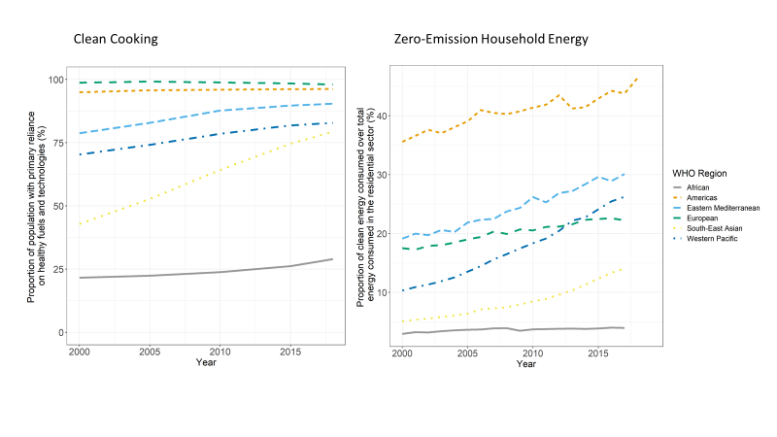

Figure 13: Household energy usage: proportion of population with primary reliance on healthy fuels and technology for cooking by WHO region 2000-2018 (left); and proportion of clean energy consumption in the global residential sector, 2000-2016 (right). Proportion is measured as fuels with no emissions at point of use (not generation) over total residential sector consumption. Electricity comprises 75% of total clean energy use in 2016.

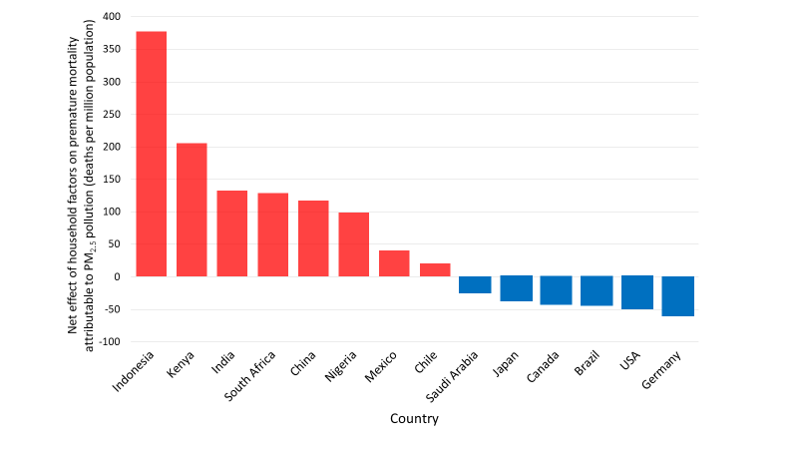

Figure 14: Estimated net effect of housing design and indoor fuel burning on premature mortality due to air pollution in 2018.

## Indicator 3.3: Premature mortality from ambient air pollution by sector

*Headline finding: Premature deaths from ambient particulate pollution attributed to coal use are rapidly declining, from 440,000 in 2015 to 390,000 in 2018. However, total deaths from ambient particulate pollution have increased slightly over this time period, from 2.95 million to 3.01 million, highlighting the need for accelerated intervention.*

Many of the leading contributors to global GHG emissions also contribute to ambient air pollution, disproportionately impacting on the health of low-socioeconomic communities.166 Indeed, some 91% of deaths from ambient air pollution come from LMICs.167 This indicator tracks the source-attributable premature mortality from outdoor ambient air pollution. The methods remain unchanged and are described in the Appendix.168,169

Trends in air pollution mortality vary by world region, with decreases in Europe and China as a result of the implementation of emission control technologies and reductions in the use of raw coal in the power and residential sectors.170 The overall number of deaths attributable to ambient PM2.5 in 2018 is estimated at 3.01 million, a slight increase from 2.95 million deaths in 2015. Nonetheless, the total and per-capita deaths attributable to coal combustion have decreased from roughly 440,000 in 2015 to fewer than 390,000 in 2018 (Figure 15). Decreases are also seen in the contribution from biomass burning to ambient PM2.5 deaths(about 410,000 deaths in 2015 decreasing to 360,000 in 2018), mostly due to increasing access to cleaner household fuels, although 2.6 billion people still rely on fuelwood combustion in the home.171

If measures to respond to the economic fall-out from COVID-19 are aligned with the priorities of the Paris Agreement, transient reductions in air pollution following the sudden halt in economic activities and road transport, could become more permanent, resulting in further improvements in health and air quality in 2020 and into the future.

Figure 15: Premature deaths attributable to exposure to ambient fine particulate matter (PM₂·₅) in 2015 and 2018*, by key sources of pollution in WHO-specified regions. Coloured bars: attributable deaths with constant 2015 population structure, diamonds: totals for 2018 when considering demographic changes.*

## Indicator 3.4: Sustainable and Healthy Transport

*Headline finding: While fossil fuels continue to dominate the transport sector, the use of electricity rose by 18.1% from 2016 to 2017, and the global electric vehicle fleet increased to more than 5.1 million in 2018 (rising by 2 million in only 12 months).*

The transition to ultra-low emissions vehicles is another essential component of climate change mitigation. In addition, policies that reduce overall vehicle use and increase walking and cycling will yield the greatest benefits in terms of reductions in GHG emissions and air pollution, as well as the health benefits of increased physical activity.172 Well-designed public transport and active travel infrastructure can also help reduce inequality and improve mobility for those who otherwise have limited travel options.173 For the 2020 report, global trends in fuel use for road transport are monitored, with methods and data available in the Appendix.174

Global per-capita road transport fuel use increased by 0.5% from 2016 to 2017, with the rate of growth slowing slightly from previous years (Figure 16). Although fossil fuels continue to contribute the vast majority of total fuel use, the use of clean fuels is growing at a much faster pace. Total fossil fuel use for transport increased by 1.7% between 2016 and 2017, compared with 18.1% growth in electricity. From 2017 to 2018, the global electric vehicle fleet grew by an enormous 64.5%, rising above 5.1 million in 2018. In line with this rapid growth, there are now more than 5.2 million charging stations available for passenger vehicles and another 157,000 fast-chargers available for buses worldwide.

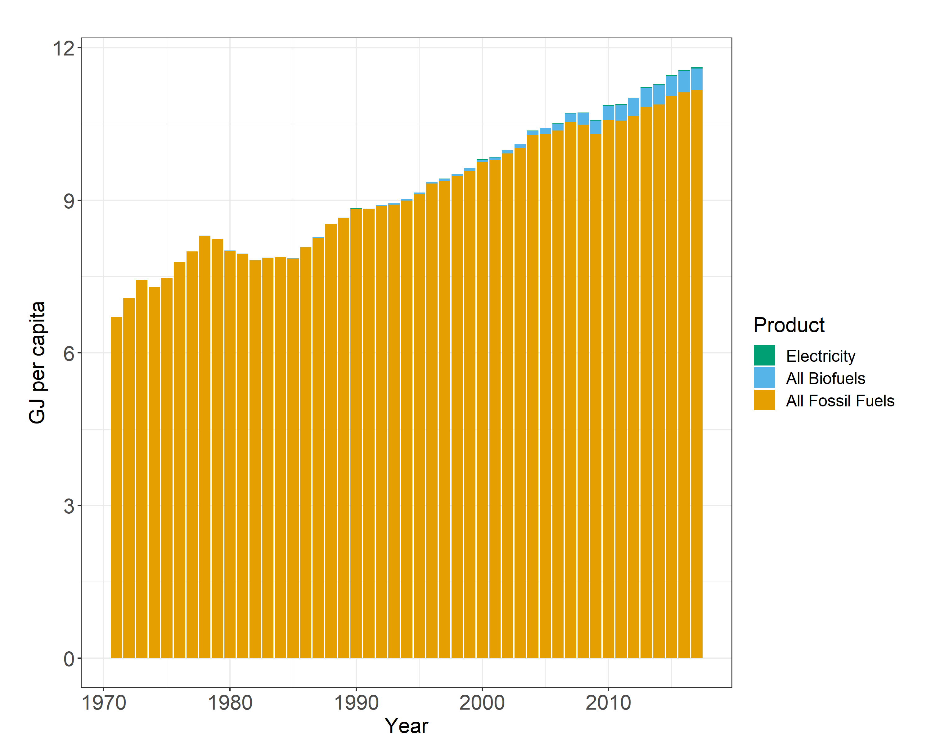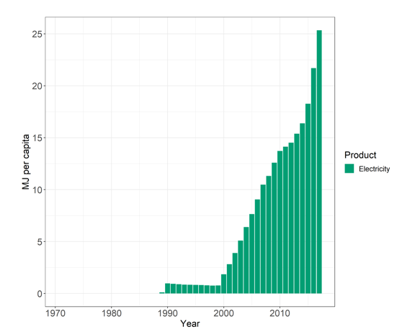

Figure 16: Per capita fuel use for road transport*: A) All fossil fuels, biofuels, electricity; B) Electricity only. NB. The varying scales in y-axes.*

## 3.5 Food, Agriculture, and Health

### Indicator 3.5.1: Emissions from Agricultural Production and Consumption

*Headline finding:**Ruminant livestock continue to dominate agriculture’s contribution to climate change, responsible for 56% of its total emissions, and 93% of all livestock emissions globally. This represents a 5.5% increase in the per capita emissions from beef consumption since 2000, which is particularly concerning, given the sharp rise in population over this time period, and the health impacts of excess red meat consumption.*

The food system is responsible for 20-30% of global GHG emissions, with the majority originating from meat and dairy livestock.175 Improved for the 2020 report, agricultural emissions from countries’ production and consumption (adjusting for international trade) are tracked using data from the FAO, with a full description of methods and data provided in the Appendix.176-178 While countries’ emissions are typically measured on a production basis, it is their consumption that generates the demand, and results in diet-related health outcomes.

Overall emissions from livestock production have increased by 16% since 2000 to over 3.2 billion tonnes of CO2e in 2017. Ruminants contribute 93% of total livestock emissions, with non-dairy cattle contributing 67% of this. Moving to consumption emissions, beef industry products dominate, both in absolute and per-capita terms (Figure 17). Average beef consumption emissions were 402 kg CO2e per person in 2017, compared to 380 kg CO2e per person in 2000.

Ultimately, effective mitigation will maximise human health while reducing food and agricultural emissions, however no one diet is applicable everywhere, and there are important nuances and variations to be considered across regions and countries. Excessive consumption of red meat brings significant health consequences, as outlined below, and less emissions-intensive plant-based sources are important alternatives, particularly in Europe and the Americas, where per capita emissions are high. In other parts of the world, sustainable farming and agricultural practices are being implemented to meet the nutritional requirements of rapidly growing populations while also keeping emissions low.179

Figure 17: Agricultural production and consumption emissions 2000-2017 calculated using FAO trade data*: per capita production (solid line) and consumption (dotted line) emissions by WHO region (left); Global agricultural consumption emissions by commodity (right).*

### Indicator 3.5.2: Diet and Health Co-Benefits

*Headline finding: The global number of deaths due to excess red meat consumption has risen to 990,000* *in 2017, a 72% increase since 1990.*

Unhealthy diet is one of the leading risk factors for premature death, both globally and in most regions.110 Combined with a range of food-system-wide interventions, it is possible to achieve dietary change consistent with the Paris Agreement and the SDGs, by reducing reliance on red meat consumption and prioritising healthier alternatives, with a variety of diets and choices available depending on the region, individual, and cultural context.180,181 New to the 2020 report, this indicator presents the change in deaths attributable to dietary risks, by focusing in on one particular area – the consumption of excess red meat. Here, it links food consumption from the FAO’s food balance sheets with dietary and weight-related risk factors, with a full description of methods and data presented in the Appendix.112,182

Globally, diet and weight-related risk factors accounted for 8.8 million deaths in 2017, which represented 19% of total mortality, with little overall change since 1990. The regions with the largest ratio of diet-related deaths include the Eastern Mediterranean (28%), Europe (25%), and the Americas (22%).High red meat consumption was responsible for 990,000 deaths globally in 2017 (Figure 18). The greatest contribution to this total came from the Western Pacific, where red meat consumption was responsible for an estimated 411,500 deaths (3.3% of all deaths) and, while there has been an overall improvement in dietary risk factors in Europe, the share of all deaths attributable to red meat consumption still accounts for 3.4% (306,800 deaths) .

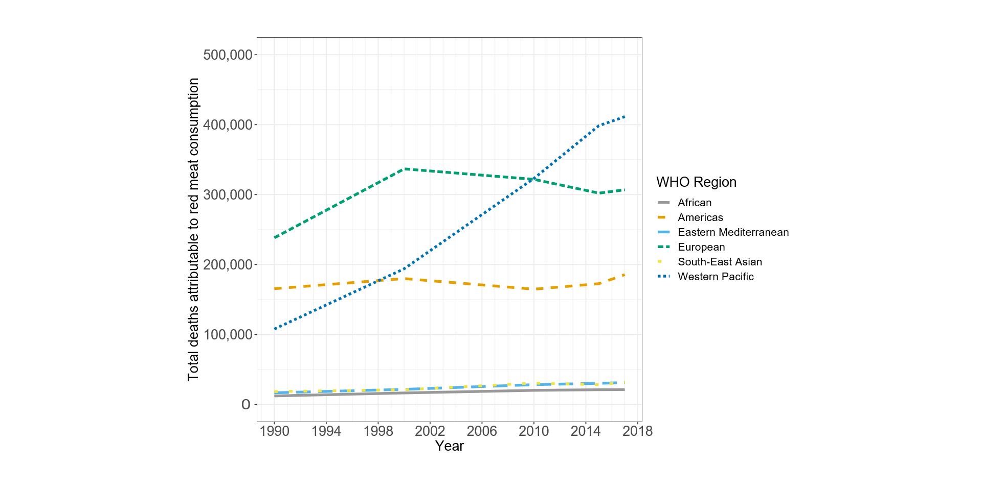

Figure 18: Deaths attributable to high red meat consumption 1990-2017 by WHO region.

## Indicator 3.6: Mitigation in the Healthcare Sector

*Headline finding: The healthcare sector was responsible for approximately 4.6% of global GHG emissions in 2017, with substantial variations in per capita emissions and healthcare access and quality.*

Healthcare is among the most important sectors in managing the effects of climate change and, simultaneously, it has an important role to play in reducing its own carbon emissions (Panel 4). Emissions from the global healthcare sector are modelled using environmentally extended multi-region input-output (EE MRIO) models combined with WHO healthcare expenditure data.183-187 Based on external review and feedback, the methodology improvements include adjustments in the EE MRIO satellite accounts that reflect recent shifts in emissions intensities, particularly in the energy sector, with a full description of methods and additional analysis in the Appendix.

In updated results to 2017, the healthcare sector contributed approximately 4.6% of global GHG emissions, a rise of 6.1% from 2016. On a per capita level, comparing emissions alone fails to capture vital differences in health outcomes among countries, including access to care. Similarly, increases in emissions in a single country over time may reflect additional healthcare spending that improves population health. Figure 19 plots per capita healthcare GHG emissions against the Healthcare Access and Quality (HAQ) Index.184 There is a clear positive relationship between the two, up to 400 kgCO2e per person. Above this point, countries achieve very similar HAQ levels with vastly different emissions profiles. For example, France, Japan, and the USA have very high HAQ attainment, with per capita emissions ranging from 350 kgCO2e, through to 1,220 kgCO2e, and 1,720 kgCO2e respectively, suggesting that much of healthcare can achieve high-quality patient outcomes, with significantly reduced emissions.

Figure 19: National per capita healthcare GHG emissions against the Healthcare Access and Quality Index for 2015.

Panel 4: For a Greener NHS

With over 1.5 million employees, England’s National Health Service (NHS England) is the largest single employer in Europe and is the largest single-payer healthcare system in the world, with an annual budget of £134 billion. While providing high-quality healthcare to a population of almost 56 million, NHS England contributes 4-5% of the country’s total GHG emissions. Accountable to both NHS England and Public Health England, the Sustainable Development Unit was founded in 2008 to ensure the health service met its commitments under the UK Climate Change Act. Since then, the NHS has achieved impressive reductions in GHG emissions whilst maintaining high standards of care and reducing costs.188 In January 2020, NHS England announced its commitment to become the world’s first ‘net zero health system’, alongside its new campaign “For a greener NHS”.189 A new baseline of NHS England’s current carbon footprint was quantified, identifying the different sources of emissions using a hybrid model of bottom-up measurements of direct emissions (on-site fossil fuel use, fleet and transport, and anaesthetic gases) and energy use and top-down MRIO-based measurements to estimate other indirect emissions (including upstream energy system emissions, pharmaceutical procurement, and patient use of metered dose inhalers). NHS England is now working to develop a strategy for how and when Net Zero emissions can be achieved.

## Conclusion

The trends over the past year show a concerning lack of progress in a number of sectors, including a continued failure to reduce the carbon intensity of the global energy system, a rise in the use of coal-fired power, and rising agricultural emissions and premature deaths from excess red meat consumption. This is in-part counteracted by the growth of renewable energy and improvements in low-carbon transport. While these continue to rise at a pace, it is important to consider that they are starting from a low baseline.

In many cases, it is likely that 2020 will be an inflection point for a number of indicators presented over the coming decade, with the direction of future trends yet to be seen.. Ensuring that the recovery from the pandemic is synergistic with the long-term public health imperative of responding to climate change will be vital in the coming months, years, and decades.

# Section 4: Economics and Finance

Section 1 described the emerging human symptoms of climate change, while Sections 2 and 3 detailed efforts to adapt and mitigate against the worst of these effects. In turn, Section 4 examines the financial and economic dimensions of both the impacts of climate change, and efforts to respond.

The Intergovernmental Panel on Climate Change (IPCC) estimate limiting warming to 1.5°C would require annual investment in the energy system equivalent to around 2.5% of global GDP, through to 2035.85 Such investment would both limit the cost of the damage from climate change (up to US$4 trillion per year by 2100 from a 3°C world as compared to a 2°C world) and generate a range of other economic benefits (including the creation of new technologies and industries) and health benefits from avoiding the effects of climate change current carbon-intensive activities. Once such factors are considered, the overall economic implications of limiting warming to 1.5°C are likely to be positive – particularly if policy responses are accelerated as soon as possible to a level commensurate with the scale of the challenge. Recent estimates suggest that investment to “bend the curve” from the world’s current path, to a limited temperature rise of 1.5°C by 2100, would generate global net benefit of US$264-610 trillion (3.1-7.2 times of the size of the global economy in 2018).12

The global economy will look substantially different following the recovery from the COVID-19 pandemic. As governments around the world grapple with the challenge of restarting their economies, it will be important to ensure these efforts are aligned with the response to climate change. If the enormous fiscal stimulus that will be required is directed away from high-carbon, and towards low-carbon infrastructure and activities, an opportunity to permanently bend the curve presents itself. Metrics examining these core concepts are currently tracked in this report, allowing future data to reveal the long-term effect of COVID-19 on the low-carbon economy.

The nine indicators in this section fall into two broad domains. The first is the health and economic costs of climate change and its mitigation (Indicators 4.1.1 to 4.1.4). This includes two new indicators for the 2020 report, on the economics of heat-related mortality and the potential reduction in earnings from heat-related labour capacity loss (Indicators 4.1.2 and 4.1.3). The second domain examines the economics of the transition to zero-carbon economies (Indicators 4.2.1 to 4.2.5), which is fundamental to the improvement of human health and wellbeing. This theme also includes a new indicator, (Indicator 4.2.5), which merges three indicators presented in previous reports (on fossil fuel subsidies, the strength and coverage of carbon prices, and carbon pricing revenues) to examine the “net” carbon prices in place around the world.

## 4.1 Health and Economic Costs of Climate Change and Benefits from Mitigation

### Indicator 4.1.1: Economic Losses due to Climate-Related Extreme Events

*Headline finding****:*** *Economic losses from climate-related extreme events in 2019 were* *nearly five times greater in low-income economies than high-income economies, and with just 4% of these losses insured, compared to 60% in high-income economies.*

Section 1 presented the evidence linking the impacts of climate change to human health and wellbeing. The loss of physical infrastructure (agricultural land, homes, health infrastructure) due to such events will further exacerbate these health impacts. This indicator tracks the total annual economic losses (insured and uninsured) that result from climate-related extreme events. The methodology is described in full in the Appendix, which has changed compared to previous years.190,191

In 2019 there were 236 recorded climate-related extreme events, with absolute economic losses totalling US$132 billion. Although most of these losses occurred in high-income economies, when normalised by GDP, the value of total economic losses in low-income countries is nearly five times greater. In addition, while 60% of losses in high-income economies were insured, this reduces to 3-5% for other income groups. It is important to note that, when normalised by GDP, relative economic losses have been decreasing, while the number of total extreme events is increasing, suggesting that adaptation and prevention are reducing their impacts.192

### Indicator 4.1.2: Costs of Heat-Related Mortality

*Headline finding: In 2018, the monetised value of global heat-related mortality reached 0.37% of Gross World Product, compared to 0.23% in 2000. Europe suffered the most in 2018, with costs equal to the average income of 11 million of its citizens, and 1.2% Gross National Income.*

As Indicator 1.1.3 highlights, rising temperatures and extremes of heat are resulting in worsening morbidity and mortality for populations around the world. The 2020 report introduces a new indicator, which considers the economic impact of this, by tracking the monetised value of global heat-related mortality. To do so, it makes use of the value of a statistical life (VSL), drawing on estimates produced for the Organisation for Economic Co-operation and Development (OECD) for those countries, making use of a fixed ratio of VSL to gross national income (GNI) for non-OECD countries, and applying this to the heat-related mortality data from Indicator 1.1.3.193,194 To address any distributional effects, and more accurately capture the economic harm that climate change presents to low- and middle-income countries, two indices have been calculated. The value of mortality is presented as a proportion of total GNI, and as the average income per person this loss would be equivalent to, in a given country and region. A full description of the methods, data, caveats and further analysis are described in the Appendix.

As global heat-related mortality increased from 2000, so too did the monetised cost of these deaths. At a global level and represented as a proportion of Gross World Product (GWP), the cost increased from 0.23% in 2000 to 0.37% in 2018. Due the high number of heat-related deaths, Europe was the worst affected, reaching a cost equivalent to the income of 11 million of its citizens in 2018 (led by Germany at 1.9 million, Figure 20), and 1.2% of regional GNI. While the value in terms of proportion of GNI for the Western Pacific and South East Asia were comparatively low at 0.43% and 0.19% respectively, these impacts are more substantial when considered against the average income in those regions.

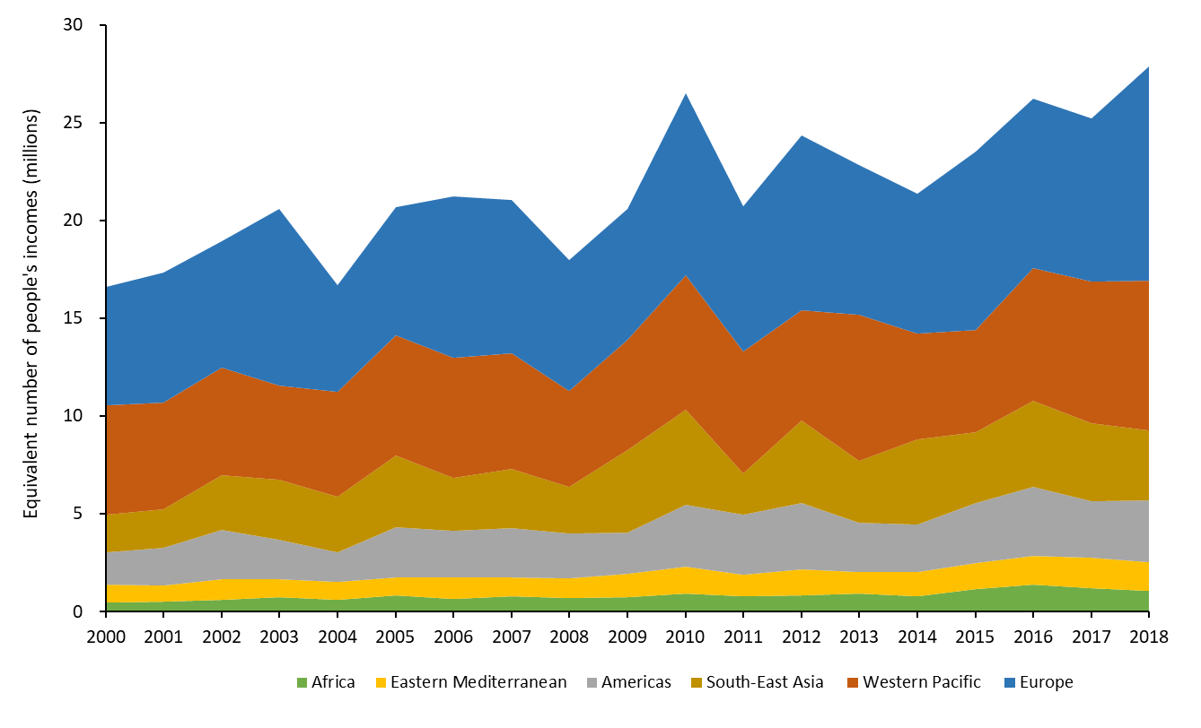

Figure 20: Monetised value of heat-related mortality *represented as the number of people to whose income this value is equivalent, on average, for each WHO region.*

### Indicator 4.1.3: Loss of Earnings from Heat-Related Labour Capacity Reduction

*Headline finding: Rising temperatures make outdoor labour increasingly difficult, often resulting in public health and economic consequences for a wide range of occupations. If borne out, the heat related reduction in labour capacity experienced would result in earnings losses equivalent to an estimated 4-6% of GDP in lower-middle income countries tracked.*

Higher temperatures, driven by climate change, are affecting people’s ability to work (Indicator 1.1.4). This new indicator considers the loss of earnings that could result from such reduced capacity, compounding the initial cause of ill health and impacting on wellbeing. It adopts the outputs of Indicator 1.1.4 for 25 countries, selected by the impact their workers experience and for geographical coverage, and combines these with data on average earnings by country and sector held in the International Labor Organization (ILO) databases.42 These estimates will be modified by a variety of factors, ranging from whether or not sick leave was taken, the presence of workers sick pay rights, and the availability of shade. A full description of the methods and additional analysis is provided in the Appendix.

When taken as a share of GDP, low- and lower middle-income countries are the hardest hit, with losses predominantly seen in agriculture, despite this being on average the lowest paid of the sectors considered. By 2015, averaged estimated earnings losses reached the equivalent of 4-6% of GDP for lower-middle income countries tracked including Indonesia, India, and Cambodia, and between 0.6-1% for upper-middle income countries, including China, Brazil, and Mexico.

### Indicator 4.1.4: Economics of the Health Impacts of Air Pollution

*Headline finding:**Across Europe, ongoing reductions in particulate air pollution from human activity were seen from 2015 to 2018. If held constant, this improvement alone would lead to an annual average reduction in years of life lost to the current population worth $8.8 billion.*

As described in Indicator 3.3, global mortality due to ambient PM2.5 pollution has risen from around 2.95 million in 2015 to 3.01 million in 2018. However, due to improvements in air quality, including the closure of coal power stations, premature mortality due to air pollution in Europe has decreased over the same period. This indicator captures the cost of that change in the European Union (EU) by placing an economic value on the Years of Life Lost (YLL) that result from exposure to PM2.5 from anthropogenic sources, with the methods and data described in full in the Appendix.195

If the population of the EU in 2015 were to experience anthropogenic PM2.5 emissions at 2018 levels instead of levels experienced in 2015, consistently over the course of their lives, the total average economic value of the reduction in YLLs would be around $8.8 billion (€9.85 billion), every year. Despite this, 2018 PM2.5 levels are still damaging to cardiovascular and respiratory systems, and the total annual average cost to the current population would still be $116 billion (€129 billion). Based on 2018 levels of air pollution, the average life lost per person in the EU is 5.7 months, but this loss of life is estimated at over 8 months per person for Poland, Romania, Hungary, Italy and Belgium (Figure 21).

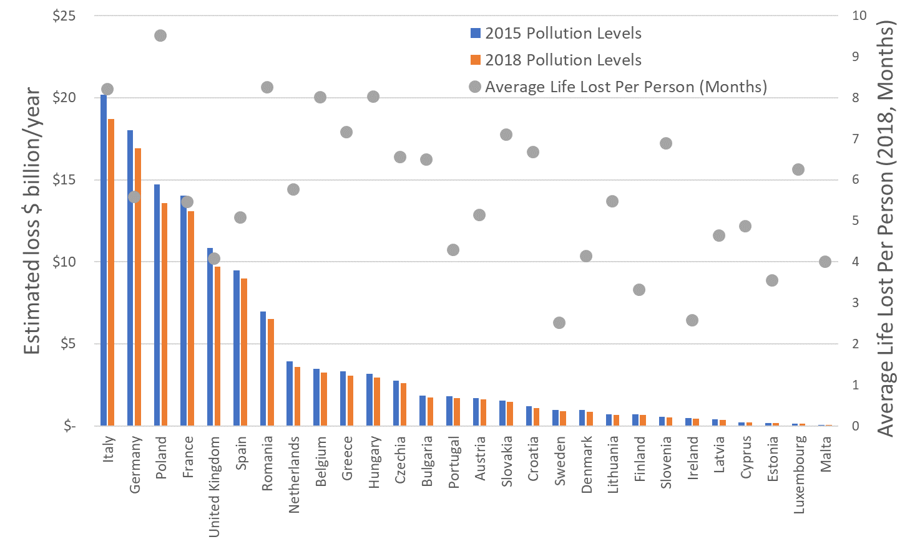

Figure 21: Annual monetised value of YLLs due to anthropogenic PM2.5 exposure, and average months of life lost per person (2018 pollution levels).

## 4.2 The Economics of the Transition to Zero-Carbon Economies

### Indicator 4.2.1: Investment in New Coal Capacity

*Headline finding: Largely driven by China, investment in new coal capacity has been declining since 2011 and reduced by 6% from 2018 to 2019. Despite this, global coal capacity continues to increase, with fewer coal plant retirements than additions for every year tracked.*

As identified in Section 3, coal phase-out is essential, not only for the mitigation of climate change, but also for the reduction of premature mortality due to air pollution. Taking data from the IEA, this indicator points to future coal use, tracking investment in new coal-fired power generation. The data represents ‘ongoing’ capital spending, with investment in a new plant spread evenly from the year new construction begins, to the year it becomes operational.196 For the 2020 report, data is presented for key countries and regions, alongside the global trend. Further details on the methods and data are found in the Appendix.

Following the trend since 2011, global investment reduced a further 6% between 2018 and 2019. With a 27% reduction in investments over these two years, China has been driving this decline. Final Investment Decisions (FIDs, the point at which the project’s future development is approved) have reached their lowest point in 40 years, with a further 11% reduction in investment forecast for 2020 – driven by declining investment in Asia, in part as a result of COVID-19. However, despite a substantial decline in actual investment, FIDs in China increased in 2019 compared to 2018, and, with the approval of 8 GW of new capacity, reached 2019 levels by March 2020. Additionally, with fewer coal plant retirements than additions in 2019 (and in every year presented), there was an overall increase in global capacity.

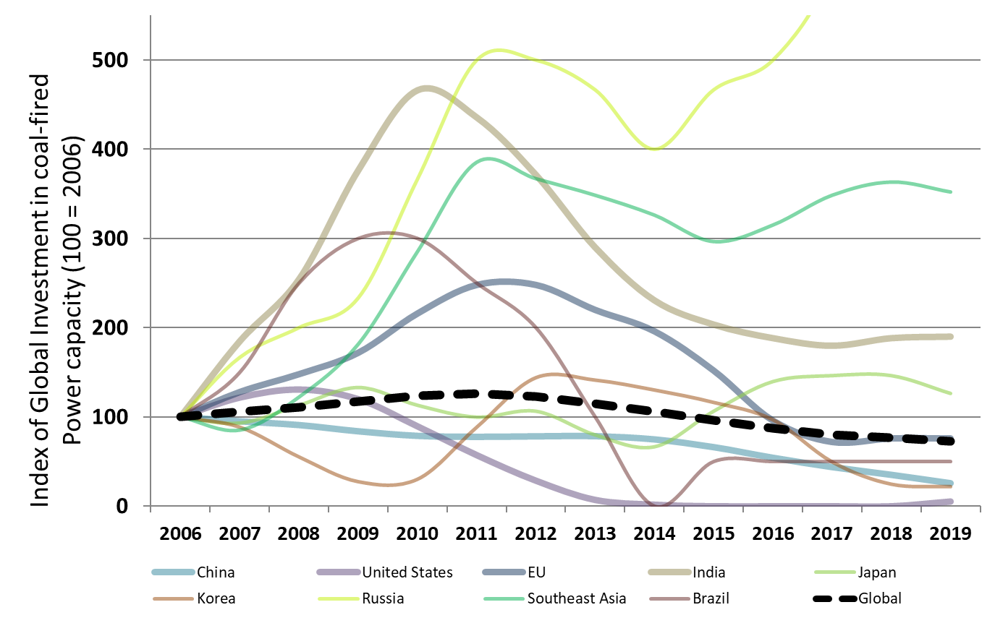

Figure 22: Annual investment in coal-fired capacity 2006-2019 (an index score of 100 corresponds to 2006 levels).

### Indicator 4.2.2: Investments in Zero-Carbon Energy and Energy Efficiency

*Headline finding:**Progress towards zero-carbon energy has stalled in recent years, and investments in zero-carbon energy and energy efficiency have not risen since 2016, and are a long way from the doubling by 2030 required to be consistent with the Paris Agreement.*

This indicator monitors annual global investment in these areas, as well as investment in all fossil fuels, complementing and providing a wider context to Indicator 4.2.1, above. Data is sourced from the IEA, and the methodology remains the same as the 2019 report of Lancet Countdown, with hydropower now considered separately and all values presented in US$2019.196

Since 2016, investment in global energy supply and energy efficiency has remained relatively stable at just under US$1.9 trillion, with fossil fuel supply consistently accounting for around half this value, and all renewables and energy efficiency combined maintaining a share of 32%. For a pathway consistent with 1.5°C of warming this century, annual investments must increase to US$4.3 trillion by 2030, with investment in renewable electricity, electricity networks and storage, and energy efficiency accounting for at least 50%.197

As a result of the COVID-19 pandemic, short-term disruption and long-term reassessments of likely returns mean that total energy investment is estimated to reduce by 20% in 2020 – the largest fall ever recorded – with oil and gas supply investment to be reduced by a third. Renewable investment is likely to fare better than fossil fuel capacity, with investment in zero-carbon energy (nuclear, hydropower and other renewables) and energy efficiency projected to jump from 32% to 37% of investment in 2020, due to falling investments in fossil fuels.196 Stimulus plans focussed on boosting energy efficiency and renewable energy will be essential to ensure that the power generation system is on track to meet the SDGs and the goals of the Paris Agreement.163

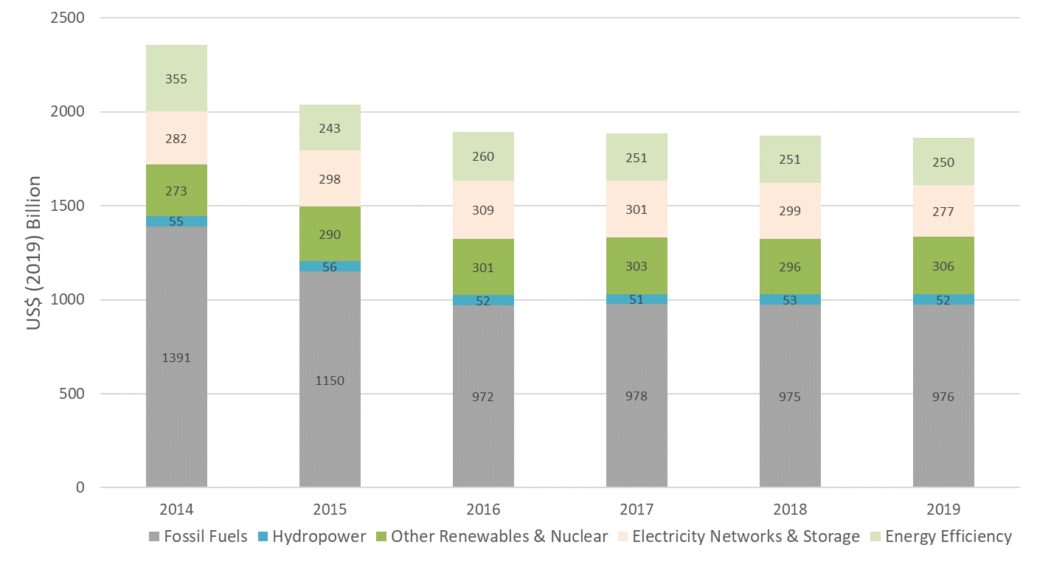

Figure 23: Annual Investment in energy supply and efficiency.

### Indicator 4.2.3: Employment in Renewable and Fossil Fuel Energy Industries

*Headline finding: Renewable energy provided 11 million jobs in 2018, a 4.2% rise from 2017. Whilst still employing more people overall, employment in fossil fuel extraction declined by 3% from 2018 to 2019.*

There is mounting evidence that employees in some fossil-fuel extractive industries, particularly coal mining, and populations living in close proximity, suffer a greater incidence of certain illnesses, such as chronic respiratory diseases, cancers and congenital anomalies.198,199 Combined with increased job certainty, a managed transition of employment opportunities away from fossil fuel-related industries, and towards low-carbon industries will result in improved occupational health of employees within the energy sector. This indicator tracks global direct employment in fossil fuel extraction industries (coal mining and oil and gas exploration and production) and direct and indirect (supply chain) employment in renewable energy for the most recent year available, with a full description of the methods and data available in the Appendix.200-202

Around 11 million people globally were employed directly or indirectly by the renewable energy industry in 2018, representing an increase of 4.2% from 2017. Solar photovoltaic (PV) continues to provide the largest share of jobs, at over 3.6 million, with employment also rising in wind, bioenergy, and other technologies. Fossil fuel extraction industries continue to employ more people globally than all renewable energy industries, although the number of jobs in 2019 are slightly lower than in 2018, at 12.7 million compared with 13.1 million.

As the demand for fossil fuels declines, planned efforts, including retraining and job placement is important to ensure the ongoing employment of those currently working in fossil fuel extraction industries. The same will be true as part of the response to COVID-19, with structured re-training and deployment programmes for renewable energy potentially forming an important component of a recovery plan. Indeed, the IEA estimates that such a strategy, which accelerates the deployment of low-carbon electricity sources, expands electricity grid access and energy efficiency, and delivers cleaner transport, would create an additional nine million jobs a year, globally over the next three years.163

### Indicator 4.2.4: Funds Divested from Fossil Fuels

*Headline finding: The global value of new funds committed to fossil fuel divestment in 2019 was US$4.01 trillion, of which health institutions accounted for around US$19 million. This represents a cumulative sum of US$11.51 trillion since 2008, with health institutions accounting for US$42 billion.*

By encouraging investors to reduce their financial interests in the fossil fuel industry, divestment efforts both remove the ‘social license to operate’ and guard against the risk of losses due to ‘stranded assets’ in a world in which demand for fossil fuels rapidly reduces.203,204 This indicator tracks the total global value of funds divested from fossil fuels, and the value of divested funds coming from health institutions, using data provided by 350.org, with annual data and full methodology described in the Appendix.205

From 2008 to the end of 2019, 1,157 organisations, with cumulative assets worth at least US$11.51 trillion have committed to fossil fuel divestment. Of these, only 23 are health institutions, including the World Medical Association, the British Medical Association, the Canadian Medical Association, the UK Faculty of Public Health, the Royal College of General Practitioners, the Royal Australasian College of Physicians, Gundersen Health System, the Berlin Doctors Pension Fund, and the Royal College of Emergency Medicine, with total assets of approximately US$42 billion. The annual value of new funds committed to divesting increased from US$2.14 trillion in 2018 to US$4.01 trillion in 2019. However, divestment from health institutions has slowed, with US$19 million divested in 2019, compared to US$867 million in 2018, owing primarily to divestment from particularly large institutions in previous years.

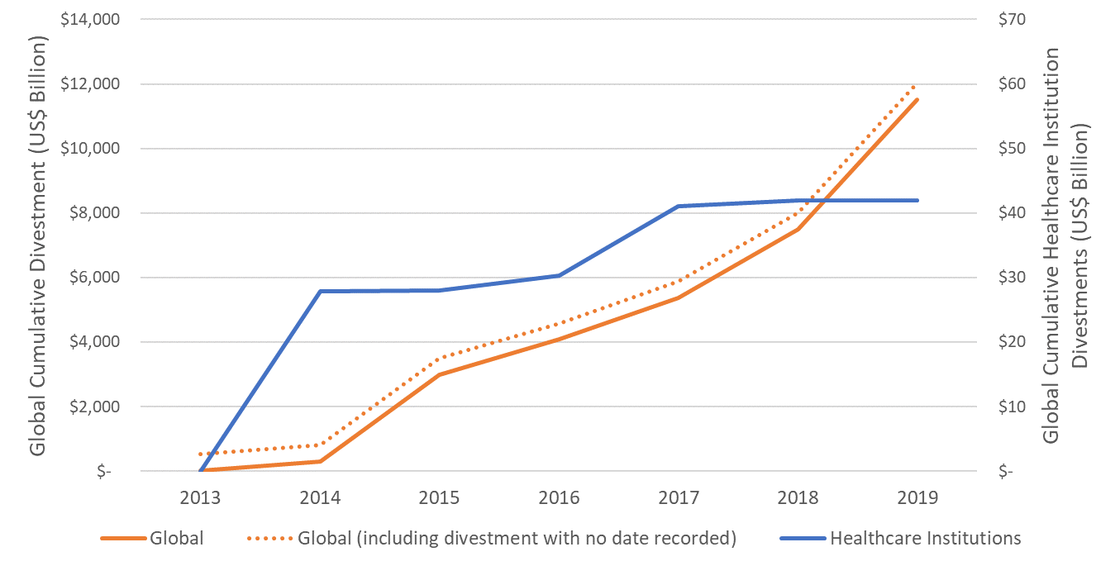

Figure 24: Cumulative divestment – Global total and in healthcare institutions.

### Indicator 4.2.5: Net Value of Fossil Fuel Subsidies and Carbon Prices

*Headline finding: 58 out of 75 countries reviewed were operating with a net-negative carbon price in 2017. The resulting net loss of revenue was in many cases equivalent to substantial proportions of the national health budget.*

Placing a price on GHG emissions provides an incentive to drive the transition towards a low-carbon economy.206,207 It also allows for a closer reflection of the true cost of emissions-intensive practices, particularly fossil fuel use, capturing some of the negative externalities resulting from their impact on health. However, not all countries explicitly set carbon prices, and in some cases the strength of any carbon price may be undermined by the opposing influence of subsidies on fossil fuel production and consumption.208,209

Indicator 4.2.5 has been created for the 2020 report by combining previous indicators on fossil fuel subsidies and carbon pricing. It calculates “net” economy-wide average carbon prices and associated net carbon revenue to government. The calculations are based on the value of overall fossil fuel subsidies, the revenue from carbon pricing mechanisms, and the total CO2 emissions of the economy. Data on fossil fuel subsidies are calculated based on analysis from the IEA and OECD.210,211 Together these sources cover 75 countries and account for around 92% of global CO2 emissions. Carbon prices and revenues are derived from data in the World Bank Carbon Pricing Dashboard and include international, national and subnational mechanisms within countries, 38 of which overlap with those covered by subsidy data and thus form part of this analysis.212 A full description of the methodology, other data sources, and the methods for integrating them, can be found in the Appendix.

Most of the 75 countries in 2016 and 2017 had net-negative carbon prices (61 and 58 respectively), and only 25% with a price above zero in both years, resulting from substantial subsidies for fossil fuel production and consumption (Figure 25). The median net carbon revenue was negative – a pay-out of US$0.7 billion, with some countries providing net fossil fuel subsidies in the tens of billions of dollars each year. In many cases these subsidies are equivalent to substantial proportions of the national health budget – greater than 100% in eight of the 75 countries in 2017. Of the 38 countries that had formal carbon pricing mechanisms in place in 2017, 21 nonetheless had net-negative carbon prices.

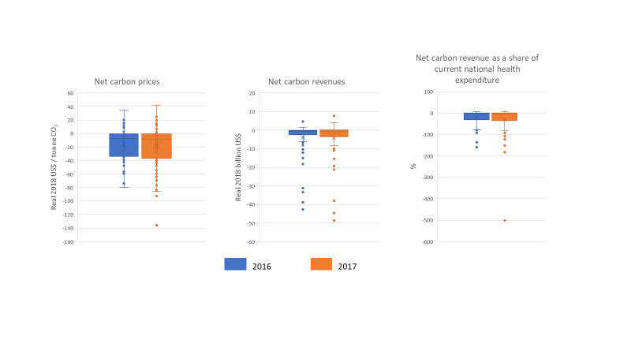

Figure 25: Net carbon prices; *net carbon revenues; and net carbon revenue as a share of current national health expenditure, across 75 countries, 2016 and 2017. Boxes show the interquartile range (IQR), horizontal lines inside the boxes showing the medians. The means are shown by crosses. The brackets represent the range from minimum to maximum, however points are represented as outliers beyond this range if they are 1.5 times the IQR below the 1st quartile, or above the 3rd quartile.*

## Conclusion

The economic and financial dimensions of public health and climate change are central to any comprehensive mitigation and adaptation effort. This section has covered both the health and economic costs of climate change, as well as indicators of progress underlying a transition to a low-carbon economy. It has developed a number of new metrics to inform this and will continue to expand the geographical coverage and reach of these in subsequent reports.

The outlook presented here is mixed. On the one hand, investment in new coal capacity continues to decline, and employment in renewable energy continues to rise. On the other hand, composite indicators of net carbon pricing reveal that government policies are often mis-coordinated, resulting in inefficiencies and disrupted price signals. The full economic impacts of COVID-19 will continue to play out over the course of a number of years, leaving a lasting impact on the world. Indeed, the nature and extent of the economic impact and response to this pandemic will play a defining role in determining whether or not the world meets its commitments under the Paris Agreement. It is for this reason that strong investment in mitigation and adaptation technologies and interventions is more important now than ever before, leading to healthier and more prepared hospitals, economies, and populations.

# Section 5: Public and Political Engagement

As previous sections make clear, the health impacts of climate change are multiplying, hitting hardest those who have contributed least to rising global temperatures. The public are voicing concern as individuals, and as members of Indigenous communities, and new social movements, urging greater ambition from those with the power to curb carbon emissions.213-220

This section tracks engagement in health and climate change across multiple parts of society, including the media, by individuals, scientists, governments, and the corporate sector. For each of these, methods used in previous Lancet Countdown reports have been enhanced, increasing the sensitivity and specificity of health and climate change engagement in each.

The media, and national newspapers in particular, are central to shaping public perceptions of climate change.221-224 The media indicator (Indicator 5.1) tracks newspaper coverage of health and climate change in 36 countries, with additional analysis provided for China’s *People’s Daily,* the official voice of the government and China’s most influential newspaper, and content analysis of newspaper coverage in India and the USA.225,226

Individual engagement (Indicator 5.2) is tracked through the use of Wikipedia, an online information source that has outpaced traditional encyclopaedias in terms of reach, coverage and comprehensiveness.227-231

Reintroduced in 2020 with a revised methodology, the scientific indicator (Indicator 5.3) tracks academic engagement with health and climate change in peer-reviewed journals, the premier source of high-quality research that provides evidence used by the media, government, and the public.228,232,233

The fourth indicator (Indicator 5.4) focuses on the governmental domain, a key arena for driving the global response to climate change. It tracks government engagement in health and climate change at the UN General Assembly, where the UN General Debate provides a platform for national leaders to address the global community.234,235 New to the 2020 report, it also examines engagement with health in the NDCs which underpin the UN Framework Convention on Climate Change (UNFCCC) 2015 Paris Agreement.4,236,237

The final indicator (Indicator 5.5) focuses on the corporate sector, which, through its behaviour and wider political influence is central to the transition to a low-carbon economy.238-240 This indicator tracks engagement with health and climate change in healthcare companies within the UN Global Compact, the world’s biggest corporate sustainability framework.241

## Indicator 5.1 Media Coverage of Health and Climate Change

*Headline finding: While total climate change coverage increased substantially from 2018 to 2019, the rise was even greater for health and climate change coverage, which increased by 96% over this period, and has increased substantially from 2007 to 2019.*

This indicator tracks coverage of health and climate change from 2007 to 2019 in 36 countries, together with separate analyses of China’s People’s Daily and the content of coverage in leading newspapers in India and the USA. Full descriptions of the methods, data sources and further analyses are presented in the Appendix.

Across the 36 countries, an increasing proportion of newspaper articles on climate change refer to human health. From 2018 to 2019, health and climate change coverage increased by 96%, outpacing the increase in overall climate change coverage (74%). From 2007 to 2019, the average monthly number of newspaper articles on health and climate change increased by 57% compared to a 23% increase in articles on climate change. Overall, the coverage for health and climate change only makes up 16% of all climate change coverage in the 2007-19 period (Figure 26).

Coverage of health and climate change peaked in months that coincided with COP15 in 2009 (Copenhagen) and COP21 in 2015 (Paris). It rose again in late 2018 and remained high across 2019, corresponding with the time of the rise of the School Climate Strikesand a series of extreme weather events, including the Californian and southern Australian wildfires.

The analysis was based on key word searches for health and climate change in 61 newspapers (English, German, Portuguese, Spanish) selected to provide a global spread of higher-circulation papers. The search strategy was revised for the 2020 report in order to exclude false positives whilst retaining true positive articles.

Figure 26: Average monthly coverage of (a) health and climate change and (b) climate change in 61 newspapers (36 countries), 2007-2019.

Additionally, coverage of health and climate change in *Renmin Ribao*, the Chinese language edition of *People’s Daily,* was tracked using keyword searches, algorithm-based natural language processing and manual screening. Between 2008 and 2019, 2% of articles on climate change were related to health. Health-related coverage spiked in 2013 with coverage of the health threats of air pollution and heatwaves.242

The content of coverage of health and climate change was analysed in India (the *Times of India* and the *Hindustan Times*) and the USA (the *New York Times* and the *Washington Post*) from July-September and November-December 2019, chosen to include periods of extreme weather (monsoons, drought) and COP25.30 The newspapers form part of the ‘elite press’ which, via their influence on the country’s political and economic elites, have an influence on the policy agenda.243-248

Three broad themes were identified in articles linking health and climate change. The dominant theme was the health impacts of climate change, discussed in 68% of articles. References were often to broad health impacts (e.g. “few countries are likely to suffer from the health effects of climate change as much as India”, *Hindustan Times*, 14 November). More specific connections were also made to climate-related stressors (e.g. extreme weather events, wildfires, population displacement) and health sequelae (e.g. vector-borne disease, mental ill-health).

The second theme relates to the common causes and co-benefits of addressing climate change and health, discussed in 39% of articles. Air pollution was the most frequently highlighted. Co-benefits of lifestyle changes to protect health and reduce emissions were also noted. The third theme focused on adaptation, discussed in 12% of articles. For example, the *Times of India*, 10 December, noted that “all levels of government need to prioritize building health system resilience to climate change”. In addition, a small group of articles (six across the corpus) made a link between health and climate change with respect to activism and protest.

The relative prominence of the three main themes in the 2019 analysis matches that for 2018 and the *Times of India* again gave greater emphasis to common causes and co-benefits than the other newspapers.30

For this indicator, articles were searched by health and climate change keywords and manually screened; the final sample of 209 articles was independently coded using the template developed for the 2018 analysis.30,249

## Indicator 5.2: Individual Engagement in Health and Climate Change

*Headline finding: Individual information-seeking about health and climate change increased by 24% from 2018 to 2019, driven primarily by initial interest in health.*

Wikipedia usage provides a digital footprint of individual information-seeking.250,251 This indicator tracks individuals’ engagement in health and climate change, by capturing visits to pairs of articles, for example, an individual clicking from a page on human health to one on climate change. Using data from the Wikimedia Foundation on the English version of Wikipedia (representing around 50% of global traffic to all Wikipedia language editions), this indicator is based on 6,902 articles related to health and 1,837 articles related to climate change.252,253 Methods, data sources and further analyses are described in the Appendix.

In both 2018 and 2019, individuals typically visited articles on either health or climate change, with little co-click activity between them, and when they were linked, the majority (75%) of co-visits started from a health-related page. While the overall number of health and climate change co-views is low, it increased by 24% across from 2018 to 2019, pointing to a rising individual engagement in the links between these two topics. In both years, co-clicks increased in months coinciding with key events in climate politics. As well as the 2019 COP, co-clicks from articles on climate change to health in 2019 spiked in September at the time of Greta Thunberg’s speech at the UN's Climate Action Summit.254

## Indicator 5.3: Coverage of Health and Climate Change in Scientific Journals

*Headline finding: There was a nine-fold increase in original research on health and climate change between 2007 and 2019, a trend driven by research led by scientists in high-income countries.*

Between 2007 and 2019, 5,579 published academic articles referred to links between climate change and health. The period saw a nine-fold increase in original research (primary studies and evidence reviews) and a three-fold increase in research-related articles (editorials, reviews, comments, letters). Since 2011, original research has now surpassed research-related articles, with new research representing 61% of total scientific output in 2019 (Figure 27).

Consistent with observations in Section 1 (see Panel 3), the overall increase in research on health and climate change was primarily led by scientists based in high-income countries. USA-led and UK-led research made up 27% and 15% of the total output for 2007 to 2019, and respectively, 26% and 15% in 2019. Major contributions to 2019 output also come from the Netherlands (8%) and Switzerland (7%). Increases were also evident for China, South Africa, and India.

Across the period, articles on health and climate change represented only a small proportion (9%) of total articles on climate change. However, the increase in articles relating to health and climate change was greater than for overall climate change output.

This indicator is based on key word searches for health and climate change in OVID Medline and OVID Embase using the comprehensive indexing systems and thesaurus of Medical Subject Headings (MeSH) for Medline and Emtree for Embase. Methods, data sources and further analyses are described in the Appendix.

Figure 27: Scientific journal articles relating to health and climate change, 2007-2019.

## Indicator 5.4: Government Engagement in Health and Climate Change

*Headline finding: National governments are increasingly paying attention to health and climate change. Small island developing states are leading this trend at the UN General Debate, and poorer and more climate-vulnerable countries are more likely to reference health in their NDCs, with 95% of the least developed countries making these references.*

This indicator examines engagement with health and climate change in the UN General Debate (UNGD) and with health in the NDCs committed to as part of the 2015 Paris Agreement.4,234 The indicator is based on a key word search of the United Nations General Debate corpus, with algorithm-based natural language processing applied to the official English versions of the statements.255,256 References to health-related terms (e.g. ‘health’, ‘illness’, ‘disease’ and ‘malnutrition’) and climate-related health exposures were examined in the 185 countries registering their NDCs in the UNFCCC repository by March 2020, with a total of 2,159 pages of text analysed. Building on previous analyses, this indicator analyses not only references, but the prominence they are given in the text.237,257 Methods, data sources and further analyses are described in the Appendix.

As part of the annual UN General Assembly, the UNGD provides a global forum for national leaders to discuss issues they consider important. Health has been a long-standing issue, whilst engagement with climate change was limited until the late 1980s (Figure 28). From the mid-2000s, national leaders began to focus on the connections between health and climate change, with the proportion rising rapidly from 2007 and peaking in 2014 at 24%.

Engagement in health and climate change continues to be led by the small island developing states (SIDS), particularly in the Western Pacific Region. In contrast, engagement remained low among the more powerful global actors, particularly those with the highest CO₂ emissions (USA, China, and the EU). For the third consecutive year, President Donald Trump’s statement on behalf of the USA failed to make a single reference to climate change, let alone to climate change and health linkages. However, 2019 did see growing engagement with climate change and health by other high-income nations (including Australia, Canada, Germany, and Spain) and by low-income countries, particularly in the African Region (for example Burkina Faso, Botswana, Côte d’Ivoire, Niger, and Togo).

At the 2019 UNGD, the majority of health and climate change references focused on the health impacts of climate change. For example, Dominica highlighted the impacts of climate change on SIDS’, including “rising sea levels, violent tropical storms and hurricanes, periods of severe drought alternating with floods and forest fires, new plant diseases, and vector-borne disease such as chikungunya and Zika present an existential threat.” Similarly, Tonga’s UNGD statement discussed how extreme weather events linked to climate change “are increasingly more intense, inflicting damage and destruction on our communities and ecosystems and putting the health of our peoples at risk.”

The 2019 UNGD also saw discussion of adaptation and resilience to “upgrade and climate-proof our health-care facilities” (Nauru), improve “the quality of health care and the durability of health-care systems in the face of the climate crisis” (Palau) and build “climate change resilience in our sectoral policies and strategies for health, transport, agriculture and pastoral production” (Niger).

The second part of this indicator focuses on health within the NDCs, assessing both the references and their prominence within the text. Here, some 73% of NDCs included considerations of public health. At the WHO regional level, all countries in the South East Asian and Eastern Mediterranean Regions discuss these links (Figure 29). At the country level, references to health are particularly common among Least Developed Countries (95%). In contrast, the European Union (representing the contributions of 28 countries) and the USA NDCs have none.

Figure 29: Reference to health in the NDCs by WHO region. The European region (which consists of 53 countries) is adjusted for the single NDC representing 28 EU countries; treating the EU as one country would increase the regional proportion to 60%.

A range of health dimensions were highlighted in the NDCs, including the direct impacts of climate change on health and health-related infrastructure. For example, in their respective NDCs, Morocco notes that climate change would increase deaths “by 250,000 annually between 2030 and 2050 due to malnutrition, malaria, diarrhea and heat-related stress” and Cambodia discusses the effects of climate change on “death, injury, psychological disorders and damage to public health infrastructure”. There are also references to the co-benefits of interventions; for example, Saint Lucia refers to “human health benefits” among “co-benefits associated with its mitigation efforts”.

Among the NDCs considering health and climate change, extreme weather events (e.g. floods, drought) and food security were most commonly cited, with 52% discussing these links. The proportion was highest in the NDCs from countries in South East Asia, and lowest in Europe. Examples include Sri Lanka’s NDC, which warns of its “water borne diseases” which “can increase due to extreme heat and drought” and Nepal’s NDC which describes “an increased frequency of extreme weather events such as landslides, floods and droughts resulting to the loss of human lives”.

## Indicator 5.5: Corporate Sector Engagement in Health and Climate change

*Headline finding: engagement in health and climate change increased to 24% in 2019 among healthcare companies in the UN Global Compact, although this engagement continues to lag behind other sectors.*

The UN Global Compact (UNGC) is a UN-supported platform, created to promote environmental and social responsibility in the business sector.258 It represents over 10,000 companies from more than 160 countries.241 Focusing on the healthcare sector, Figure 30 tracks engagement in health and climate change in the UNGC Communication on Progress reports that companies submit each year.

Analysis was based on key word searches of health-related and of climate change-related terms in 20,775 annual reports in the UNGC database, and engagement in health and climate change was identified using natural language processing. 241 Methods, data sources and further analyses are described in the Appendix.

This indicator points to an increase in healthcare sector engagement in 2019, with 24% of companies referring to the links between climate change and health (Figure 30). However, other sectors have higher levels of engagement, including the energy sector and real estate investment sector.

**

Figure 30: Proportion of healthcare sector companies referring to climate change, health, and the intersection of health and climate change in Communication on Progress reports, 2011-2019.

## Conclusion

Public and political engagement is essential to curb fossil fuel consumption and hold global temperature rise to below 1.5°C.259 Section Five has examined indicators of engagement relating to the media, the public, the scientific community, national government and the corporate sector. Taken together, the analyses point to two broad trends.

Firstly, engagement with health and climate change continues to increase. Between 2007 and 2019, newspaper coverage increased by over 50% and scientific journal output by over 500%. Across 2018 and 2019, the proportion of Wikipedia users searching for articles that linked health and climate change also increased. There is evidence of dynamic and reinforcing relationships between these domains. Media coverage increased at times of heightened political engagement and public engagement. September 2019, and Greta Thunberg’s speech at the UN Climate Action Summit in particular, also saw a spike in individual engagement in health and climate change, as captured by Wikipedia use.

However, beneath these trends are persisting inequalities in wealth and political influence. In both the UNGD and the NDCs, engagement in health and climate change is led by countries and regions that are suffering most from a changing climate to which they have contributed least. At the same time, the science of health and climate change continues to be led by higher-income, high-emitting countries, which are the most responsible for climate change.218,260

Secondly, in absolute terms, climate change continues to be framed in ways that pay little attention to its health dimensions. One in six newspaper articles on climate change discuss its health dimensions; less than one in ten scientific articles do so; as do less than one in four healthcare companies signed up to sustainable business practices. In the political domain, health and climate change are rarely connected by government leaders in their speeches at the UN’s major global forum and, while most NDCs refer to health, countries with high per capita carbon emissions – including EU countries and the USA – do not. Nonetheless, in key domains of engagement, the health dimensions of climate change are increasingly recognised, with media and scientific coverage increasing more rapidly than for climate change as a whole.

In conclusion, despite the fact that underlying inequalities in the drivers and impacts of climate change remain, there is evidence that health is becoming increasingly central to public and political engagement.

# Conclusion: The 2020 Report of the Lancet Countdown

With global average temperature rise having reached 1.2°C above pre-industrial times, the indicators contained in the 2020 report provide insights into the health impacts of climate change today, and in the future. Extremes of heat hit vulnerable populations the hardest, with some 296,000 deaths occurring as a result of high temperatures in 2018 (Indicator 1.1.3)

The climate suitability for the transmission of a range of infectious diseases – dengue fever, malaria, and *Vibrio* bacteria– have demonstrated sustained rises across the world (Indicator 1.3.1). This is occurring at the same time as crop yield potential is falling for each of the major crops tracked, with dire consequences anticipated for food-insecure populations (Indicator 1.4.1).

And yet, the global response has remained muted. The carbon intensity of the global energy system has remained flat over the past three decades, and global coal use for energy has increased by 74% over the same period (Indicators 3.1.1 and 3.1.2). This has resulted in an estimated 390,000 deaths from particulate air pollution generated by coal fired power, with total global deaths for all ambient sources exceeding 3.01 million in 2018 (Indicator 3.3). In the agricultural sector, emissions from livestock grew by 16% from 2000 to 2017, with some 990,000 deaths occurring globally from excess red meat consumption in 2017 (Indicators 3.5.1 and 3.5.2).

In the face of this, the response from the health profession continues to gain momentum. Spending on health system adaptation continued its previous upward trend, rising by 5.3% in 2019, to $18.4 billion (Indicator 2.4). A nine-fold increase in original research on health and climate change has occurred in just over 10 years, and, in half that time, health institutions with total assets of $42 billion have divested their holdings from fossil fuel industries (Indicators 5.3 and 4.2.3). Led by low-income countries, more governments are linking health and climate change in their annual UN General Debate speeches and their NDCs under the Paris Agreement.

The public health and financial effects of COVID-19 will be felt for years to come, and efforts to protect and rebuild local communities and national economies will need to be robust and sustained. Despite concerning indicators across each section of this report, the 2021 UN climate change conference presents an opportunity for course correction, and revitalised Nationally Determined Contributions. The window of opportunity is narrow, and if the response to COVID-19 is not fully and directly aligned with countries’ national climate change strategies, the world will be unable to meet its commitments under the Paris Agreement, damaging health and health systems today, and in the future.

# References

1. McMichael AJ, Haines JA, Slooff R, et al. Climate change and human health: an assessment / prepared by a Task Group on behalf of the World Health Organization, the World Meteorological Association and the United Nations Environment Programme; editors: A. J. McMichael ... [et al.]. Geneva: World Health Organization; 1996.

2. NASA Goddard Institute for Space Studies. GISS Surface Temperature Analysis (GISTEMP v4). 2020. https://data.giss.nasa.gov/gistemp/ (accessed 28 April 2020).

3. Smith KR, Woodward A, Campbell - Lendrum D, et al. Human Health: Impacts, Adaptation, and Co-Benefits. Climate Change 2014: Impacts, Adaptation, and Vulnerability Part A: Global and Sectoral Aspects Contribution of Working Group II to the Fifth Assessment Report of the Intergovernmental Panel on Climate Change. Cambridge, United Kingdom and New York, New York: Cambridge University Press; 2014: 709-54.

4. United Nations Framework Convention on Climate Change. Decision1/CP.21, Adoption of the Paris Agreement, FCCC/CP/2015/10/Add.1 (January 29, 2016), paras 23 and 24. 2016. http://unfccc.int/resource/docs/2015/cop21/eng/10a01.pdf (accessed April 6, 2020.

5. Herring SC, Christidis N, Hoell A, Hoerling MP, Stott PA. Explaining Extreme Events of 2017 from a Climate Perspective. *Bulletin of the American Meteorological Society* 2019; **100**(1): S1-S117.

6. Herring SC, Christidis N, Hoell A, Hoerling MP, Stott PA. Explaining Extreme Events of 2018 from a Climate Perspective. *Bulletin of the American Meteorological Society* 2020; **101**(1): S1-S128.

7. Herring SC, Christidis N, Hoell A, Kossin JP, III CJS, Stott PA. Explaining Extreme Events of 2016 from a Climate Perspective. *Bulletin of the American Meteorological Society* 2018; **99**(1): S1-S157.

8. Herring SC, Hoell A, Hoerling MP, Kossin JP, III CJS, Stott PA. Explaining Extreme Events of 2015 from a Climate Perspective. *Bulletin of the American Meteorological Society* 2016; **97**(12): S1-S145.

9. World Economic Forum. The Global Risks Report 2020. Cologny, Switzerland: World Economic Forum, 2020.

10. Ecosystems and Human Well-being: Current State and Trends, Volume 1. In: Hassan R, Scholes R, Ash N, eds. The Millennium Ecosystem Assessment Series. Washington, DC and Covelo, CA, USA, and London, UK: Island Press; 2005.

11. United Nations General Assembly. Resolution adopted by the General Assembly on 25 September 2015 Transforming our world: the 2030 Agenda forSustainable Development New York, NY, USA: United Nations; 2015.

12. Wei Y-M, Han R, Wang C, et al. Self-preservation strategy for approaching global warming targets in the post-Paris Agreement era. *Nature communications* 2020; **11**(1): 1-13.

13. Kjellstrom T, Briggs D, Freyberg C, Lemke B, Otto M, Hyatt O. Heat, Human Performance, and Occupational Health: A Key Issue for the Assessment of Global Climate Change Impacts. *Annu Rev Public Health* 2016; **37**: 97-112.

14. Sampedro J, Smith SJ, Arto I, et al. Health co-benefits and mitigation costs as per the Paris Agreement under different technological pathways for energy supply. *Environ Int* 2020; **136**: 105513.

15. Vandyck T, Keramidas K, Kitous A, et al. Air quality co-benefits for human health and agriculture counterbalance costs to meet Paris Agreement pledges. *Nat Commun* 2018; **9**(1): 4939.

16. Watts N, Adger WN, Ayeb-Karlsson S, et al. The Lancet Countdown: tracking progress on health and climate change. *The Lancet* 2017; **389**(10074): 1151-64.

17. Johns Hopkins Center for Systems Science and Engineering. COVID-19 Dashboard. 2020. https://coronavirus.jhu.edu/map.html (accessed 31 July 2020).

18. Strauss D. BoE is financing UK’s coronavirus measures, Bailey acknowledges. Financial Times. 2020.

19. Hopman J, Allegranzi B, Mehtar S. Managing COVID-19 in Low- and Middle-Income Countries. *JAMA* 2020; **323**(16): 1549-50.

20. Ji Y, Ma Z, Peppelenbosch MP, Pan Q. Potential association between COVID-19 mortality and health-care resource availability. *The Lancet Global Health* 2020; **8**(4): e480.

21. Raju E, Ayeb-Karlsson S. COVID-19: How do you self-isolate in a refugee camp? *International Journal of Public Health* 2020.

22. IEA. Global Energy Review 2020. Paris, France: International Energy Agency, 2020.

23. Hallegatte S, Hammer S. Thinking ahead: For a sustainable recovery from COVID-19. 2020. https://www.preventionweb.net/news/view/71103 (accessed 23 May 2020).

24. WHO. Operational framework for building climate resilient health systems. Geneva, Switzerland: World Health Organization, 2015.

25. Audia C, Visman E, Fox G, et al. Decision-making heuristics for managing climate-related risks: The FREE framework. In: Conway D, ed. Climate Risk in Africa: Adaptation and Resilience. London, UK: Palgrave Macmillan; 2020.

26. Ranger N, Reeder T, Lowe J. Addressing ‘deep’uncertainty over long-term climate in major infrastructure projects: four innovations of the Thames Estuary 2100 Project. *EURO Journal on Decision Processes* 2013; **1**(3-4): 233-62.

27. IPCC. Climate Change 2014. Impacts, Adaptation, and Vulnerability. Working Group II Contribution to the Fifth Assessment Report of the Intergovernmental Panel on Climate Change. Cambridge and New York, 2014.

28. Lord Deben, Baroness Brown of Cambridge. Building a resilient recovery from the COVID-19 crisis. 2020 (accessed 23 March 2020).

29. NHS. GP online consultations. 2020. https://www.nhs.uk/using-the-nhs/nhs-services/gps/gp-online-and-video-consultations/ (accessed 23 May 2020).

30. Watts N, Amann M, Arnell N, et al. The 2019 report of The *Lancet* Countdown on health and climate change: ensuring that the health of a child born today is not defined by a changing climate. *The Lancet* 2019; **394**(10211): 1836-78.

31. Szekely M, Carletto L, Garami A. The pathophysiology of heat exposure. *Temperature (Austin, Tex)* 2015; **2**(4): 452.

32. Xu Z, FitzGerald G, Guo Y, Jalaludin B, Tong S. Impact of heatwave on mortality under different heatwave definitions: A systematic review and meta-analysis. *Environment International* 2016; **89-90**: 193-203.

33. Campbell S, Remenyi TA, White CJ, Johnston FH. Heatwave and health impact research: A global review. *Health & place* 2018; **53**: 210-8.

34. NASA Socioeconomic Data and Applications Center (SEDAC) Gridded Population of the World (GPWv4). Available at https://beta.sedac.ciesin.columbia.edu/data/collection/gpw-v4. 2020.

35. The Inter-Sectoral Impact Model Intercomparison Project (ISIMP). Input data set: Historical, gridded population. Available at https://www.isimip.org/gettingstarted/input-data-bias-correction/details/31/. 2020.

36. Copernicus Climate Change Service (C3S). ERA5 hourly data on single levels from 1979 to present. Available at https://doi.org/10.24381/cds.adbb2d47. 2020.

37. Honda Y, Kondo M, McGregor G, et al. Heat-related mortality risk model for climate change impact projection. *Environ Health Prev Med* 2014; **19**(1): 56-63.

38. WHO. Quantitative risk assessment of the effects of climate change on selected causes of death, 2030s and 2050s. 2014.

39. Guo Y, Gasparrini A, Armstrong BG, et al. Temperature Variability and Mortality: A Multi-Country Study. *Environ Health Perspect* 2016; **124**(10): 1554-9.

40. Sera F, Armstrong B, Tobias A, et al. How urban characteristics affect vulnerability to heat and cold: a multi-country analysis. *International Journal of Epidemiology* 2019; **48**(4): 1101-12.

41. Kjellstrom T, Freyberg C, Lemke B, Otto M, Briggs D. Estimating population heat exposure and impacts on working people in conjunction with climate change. *International Journal of Biometeorology* 2018; **62**(3): 291-306.

42. ILO. ILOSTAT database. Geneva, Switzerland: International Labour Organization; 2020.

43. Hempel S, Frieler K, Warszawski L, Schewe J, Piontek F. A trend-preserving bias correction–the ISI-MIP approach. 2013.

44. Lange S. EartH2Observe, WFDEI and ERA-Interim data Merged and Bias-corrected for ISIMIP (EWEMBI). *GFZ Data Services* 2016.

45. Lange S. Bias correction of surface downwelling longwave and shortwave radiation for the EWEMBI dataset. 2018.

46. Black C, Tesfaigzi Y, Bassein JA, Miller LA. Wildfire smoke exposure and human health: Significant gaps in research for a growing public health issue. *Environmental toxicology and pharmacology* 2017; **55**: 186-95.

47. Copernicus Climate Change Service (C3S). Fire danger indices historical data from the Copernicus Emergency Management Service. Available at https://doi.org/10.24381/cds.0e89c522. 2020.

48. NASA EarthData. Active Fire Data. Available at https://earthdata.nasa.gov/earth-observation-data/near-real-time/firms/active-fire-data. 2020.

49. Dai A. Drought under global warming: a review. *WIREs Climate Change* 2011; **2**(1): 45-65.

50. Stanke C, Kerac M, Prudhomme C, Medlock J, Murray V. Health effects of drought: a systematic review of the evidence. *PLoS currents* 2013; **5**.

51. Du W, FitzGerald GJ, Clark M, Hou X-Y. Health Impacts of Floods. *Prehospital and Disaster Medicine* 2010; **25**(3): 265-72.

52. Mukherjee S, Mishra A, Trenberth KE. Climate Change and Drought: a Perspective on Drought Indices. *Current Climate Change Reports* 2018; **4**(2): 145-63.

53. Centre for Research on the Epidemiology of Disasters. EM-DAT The International Disaster Database. Available at https://emdat.be/. 2020.

54. World Health Organization. Global Health Observatory. Available at https://apps.who.int/nha/database/Select/Indicators/en. 2020.

55. World Weather Attribution. European heatwave, July 2015. 2015. https://www.worldweatherattribution.org/european-heat-wave-july-2015/ (accessed 27 April 2020).

56. World Weather Attribution. 2015 – a record breaking hot year. 2015. https://www.worldweatherattribution.org/record-hot-year-2015/ (accessed 27 April 2020).

57. King A, Kirkpatrick S, Oldenborgh GJv. Extreme heat in southeast Australia, February 2017. 2017. https://www.worldweatherattribution.org/extreme-heat-australia-february-2017/ (accessed 16 April 2020).

58. Otto F, Oldenborgh GJv, Vautard R, Schwierz C. Record June temperatures in western Europe. 2017. https://www.worldweatherattribution.org/european-heat-june-2017/ (accessed 2020 2020).

59. Oldenborgh GJv, Philip S, Kew S, et al. Human contribution to record-breaking June 2019 heatwave in France. 2019. https://www.worldweatherattribution.org/human-contribution-to-record-breaking-june-2019-heatwave-in-france/ (accessed 16 April 2020).

60. Vautard R, Boucher O, Oldenborgh GJv, et al. Human contribution to the record-breaking July 2019 heatwave in Western Europe. 2019. https://www.worldweatherattribution.org/human-contribution-to-the-record-breaking-july-2019-heat-wave-in-western-europe/ (accessed 16 April 2020).

61. van Oldenborgh GJ, Krikken F, Lewis S, et al. Attribution of the Australian bushfire risk to anthropogenic climate change. *Nat Hazards Earth Syst Sci Discuss* 2020; **2020**: 1-46.

62. World Weather Attribution. Record high temperatures in India, 2016. 2016. https://www.worldweatherattribution.org/india-heat-wave-2016/ (accessed 27 April 2020).

63. Oldenborgh GJv, Vries Hd, Vecchi G, Otto F, Tebaldi C. A cold winter in North America, December 2017 to January 2018. 2018. https://www.worldweatherattribution.org/winter-in-north-america-is-cold-dec-2017-jan-2018/ (accessed 16 April 2020).

64. Otto FEL, Wolski P, Lehner F, et al. Likelihood of Cape Town water crisis tripled by climate change. 2018. https://www.worldweatherattribution.org/the-role-of-climate-change-in-the-2015-2017-drought-in-the-western-cape-of-south-africa/ (accessed 16 April 2020).

65. Otto FEL, Haustein K, Uhe P, et al. Factors Other Than Climate Change, Main Drivers of 2014/15 Water Shortage in Southeast Brazil. *Bulletin of the American Meteorological Society* 2015; **96**(12): S35-S40.

66. World Weather Attribution. Ethiopia drought, 2015 – a livelihood crisis. 2015. https://www.worldweatherattribution.org/ethiopia-drought-2015/ (accessed 27 April 2020).

67. Oldenborgh GJv, Wiel Kvd, Philip S, et al. Rapid analysis of drought in Somalia, 2016. 2017. https://www.worldweatherattribution.org/somalia-drought-2016-2017/ (accessed 27 April 2020).

68. Uhe P, Philip S, Kew S, et al. Attributing drivers of the 2016 Kenyan drought. *International Journal of Climatology* 2018; **38**(S1): e554-e68.

69. van Oldenborgh GJ, Philip S, Aalbers E, et al. Rapid attribution of the May/June 2016 flood-inducing precipitation in France and Germany to climate change. *Hydrol Earth Syst Sci Discuss* 2016; **2016**: 1-23.

70. van der Wiel K, Kapnick SB, van Oldenborgh GJ, et al. Rapid attribution of the August 2016 flood-inducing extreme precipitation in south Louisiana to climate change. *Hydrol Earth Syst Sci* 2017; **21**(2): 897-921.

71. Oldenborgh GJv, Otto F, Singh R, Tebaldi C, Kew S, Philip S. Extreme rainfall in Japan, 2018 – a quick look. 2018. https://www.worldweatherattribution.org/a-quick-look-at-the-extreme-rainfall-in-japan/ (accessed 16 April 2020).

72. Philip S, Sparrow S, Kew SF, et al. Attributing the 2017 Bangladesh floods from meteorological and hydrological perspectives. *Hydrol Earth Syst Sci* 2019; **23**(3): 1409-29.

73. Mishra V, Shah HL. Hydroclimatological Perspective of the Kerala Flood of 2018. *Journal of the Geological Society of India* 2018; **92**(5): 645-50.

74. Otto FEL, Wiel Kvd, Oldenborgh GJv, et al. Climate change increases the probability of heavy rains in Northern England/Southern Scotland like those of storm Desmond—a real-time event attribution revisited. *Environmental Research Letters* 2018; **13**.

75. Zhang W, Vecchi GA, Murakami H, et al. Influences of Natural Variability and Anthropogenic Forcing on the Extreme 2015 Accumulated Cyclone Energy in the Western North Pacific. *Bulletin of the American Meteorological Society* 2016; **97**(12): S131-S5.

76. van Oldenborgh GJ, van der Wiel K, Sebastian A, et al. Attribution of extreme rainfall from Hurricane Harvey. *Environmental Research Letters* 2017; **12**.

77. Reed KA, Stansfield AM, Wehner MF, Zarzycki CM. Forecasted attribution of the human influence on Hurricane Florence. *Science Advances* 2020; **6**(1): eaaw9253.

78. Oldenborgh GJv, Wiel Kvd, Philip S, et al. Rapid attribution of the extreme rainfall in Texas from Tropical Storm Imelda. 2019. https://www.worldweatherattribution.org/rapid-attribution-of-the-extreme-rainfall-in-texas-from-tropical-storm-imelda/ (accessed 16 April 2020).

79. Vautard R, Oldenborgh GJv, Otto F, et al. Stormy January over western Europe, 2018. 2018. https://www.worldweatherattribution.org/the-stormy-month-of-january-2018-over-western-europe/ (accessed 16 April 2020).

80. World Weather Attribution. Great Barrier Reef bleaching, 2016. 2016. https://www.worldweatherattribution.org/great-barrier-reef-bleaching-march-2016/ (accessed 18 May 2020).

81. Oldenborgh GJv, Macias-Fauria M, King A, et al. Unusually high temperatures at the North Pole, winter 2016. 2016. https://www.worldweatherattribution.org/north-pole-nov-dec-2016/ (accessed 28 April 2020).

82. Bindoff N, PA S, AchutaRao KM ea. Detection and Attribution of Climate Change: from Global to Regional. Climate Change 2013: The Physical Science Basis Contribution of Working Group I to the Fifth Assessment Report of the Intergovernmental Panel on Climate Change; 2013.

83. Ebi KL, Ogden NH, Semenza JC, Woodward A. Detecting and attributing health burdens to climate change. *Environmental health perspectives* 2017; **125**(8): 085004.

84. Stone D, Auffhammer M, Carey M, et al. The challenge to detect and attribute effects of climate change on human and natural systems. *Climatic Change* 2013; **121**(2): 381-95.

85. IPCC. Global warming of 1.5°C. An IPCC Special Report on the impacts of global warming of 1.5°C above pre-industrial levels and related global greenhouse gas emission pathways, in the context of strengthening the global response to the threat of climate change. Geneva, Switzerland: World Meteorological Organization, 2018.

86. Stabeno PJ, Bell SW. Extreme Conditions in the Bering Sea (2017–2018): Record‐Breaking Low Sea‐Ice Extent. *Geophysical Research Letters* 2019; **46**(15): 8952-9.

87. Thoman RL, Bhatt US, Bieniek PA, et al. The Record Low Bering Sea Ice Extent in 2018: Context, Impacts, and an Assessment of the Role of Anthropogenic Climate Change. *Bulletin of the American Meteorological Society* 2020; **101**(1): S53-S8.

88. Bethel Search and Rescue Report. 2017.

89. Macarthur A. Father’s body recovered, five rescued after family falls through Kuskokwim on New Year’s Eve. 2018.

90. Waldholz R. In western Alaska, there’s water where there should be ice. 2018.

91. World Weather Attribution. Heatwave in northern Europe, summer 2018. 2018.

92. Åström C, Bjelkmar P, Forsberg B. High mortality during the 2018 heatwave in Sweden. *Lakartidningen* 2019; **116**.

93. BBC. Summer heat killed nearly 1,500 in France, officials say. 2019. https://www.bbc.co.uk/news/world-europe-49628275 (accessed 20 May 2020).

94. Meijer B. Heatwave caused nearly 400 more deaths in Netherlands: stats agency. 2019. https://www.reuters.com/article/us-weather-netherlands/heatwave-caused-nearly-400-more-deaths-in-netherlands-stats-agency-idUSKCN1UZ0GA?il=0 (accessed 20 May 2020).

95. Imada Y, Watanabe M, Kawase H, Shiogama H, Arai M. The July 2018 high temperature event in Japan could not have happened without human-induced global warming. *SOLA* 2019: 15A-002.

96. Shimpo A, Takemura K, Wakamatsu S, et al. Primary factors behind the heavy rain event of July 2018 and the subsequent heat wave in Japan. *SOLA* 2019: 15A-003.

97. Harris I, Osborn TJ, Jones P, Lister D. Version 4 of the CRU TS monthly high-resolution gridded multivariate climate dataset. *Scientific Data* 2020; **7**(1): 109.

98. Koninklijk Nederlands Meteorologisch Instituut. KNMI Climate Explorer. Available at https://climexp.knmi.nl/. 2020.

99. Lyon B, Dinku T, Raman A, Thomson MC. Temperature suitability for malaria climbing the Ethiopian Highlands. *Environmental Research Letters* 2017; **12**(6): 064015.

100. Martinez-Urtaza J, Trinanes J, Abanto M, et al. Epidemic Dynamics of Vibrio parahaemolyticus Illness in a Hotspot of Disease Emergence, Galicia, Spain. *Emerging Infectious Diseases* 2018; **24**(5): 852-9.

101. Martinez-Urtaza J, van Aerle R, Abanto M, et al. Genomic Variation and Evolution of Vibrio parahaemolyticus ST36 over the Course of a Transcontinental Epidemic Expansion. *mBio* 2017; **8**(6).

102. Wang H, Tang X, Su YC, Chen J, Yan J. Characterization of clinical Vibrio parahaemolyticus strains in Zhoushan, China, from 2013 to 2014. *PLoS One* 2017; **12**(7): e0180335.

103. Ebi KL, Nealon J. Dengue in a changing climate. *Environmental Research* 2016; **151**: 115-23.

104. Semenza JC, Sewe MO, Lindgren E, et al. Systemic Resilience to Cross‐border Infectious Disease Threat Events in Europe. *Transboundary and emerging diseases* 2019.

105. WHO. International Health Regulations (‎2005)‎: implementation status of IHR core capacities, 2010-2017. Geneva, Switzerland: World Health Organization, 2018.

106. FAO. The state of food security and nutrition in the world. Rome, Italy: Food and Agriculture Organization of the United Nations, 2020.

107. Porter JR, Xie L, Challinor AJ, et al. Food Security and Food Production Systems. Climate Change 2014: Impacts, Adaptation, and Vulnerability Part A: Global and Sectoral Aspects Contribution of Working Group II to the Fifth Assessment Report of the Intergovernmental Panel on Climate Change. Cambridge, United Kingdom and New York, NY, USA; 2014.

108. Craufurd PQ, Wheeler TR. Climate change and the flowering time of annual crops. *Journal of Experimental Botany* 2009; **60**(9): 2529-39.

109. FAO. The State of World Fisheries and Aquaculture 2018 - Meeting the sustainable development goals. Rome: Food and Agriculture Organization of the United Nations, 2018.

110. GBD 2017 Diet Collaborators, Afshin A, Sur PJ, et al. Health effects of dietary risks in 195 countries, 1990-2017: a systematic analysis for the Global Burden of Disease Study 2017. *Lancet (London, England)* 2019; **0**(0).

111. FAO. Impact of climate change on fisheries and aquaculture: synthesis of current knowledge, adaptation and mitigation options. Rome, Italy: Food and Agriculture Organization of the United Nations, 2018.

112. FAO. New Food Balance Sheets. 2020. http://www.fao.org/faostat/en/#data/FBS (accessed 19 February 2020).

113. NASA NEO NEO. Sea surface temperature (1 month – AQUA/MODIS). 2017. https://neo.sci.gsfc.nasa.gov/view.php?datasetId=MYD28M (accessed 23 September 2019).

114. NOAA. NOAA Coral Reef Watch Version 3.1 Daily Global 5-km Satellite Coral Bleaching Degree Heating Week Product. Washington DC: National Oceanic and Atmospheric Administration; 201.

115. McMichael C. Climate change-related migration and infectious disease. *Virulence* 2015; **6**(6): 548-53.

116. Schwerdtle P, Bowen K, McMichael C. The health impacts of climate-related migration. *BMC medicine* 2018; **16**(1): 1.

117. Kulp SA, Strauss BH. New elevation data triple estimates of global vulnerability to sea-level rise and coastal flooding. *Nature communications* 2019; **10**(1): 1-12.

118. Lindsey R. Climate Change: Global Sea Level. 2019.

119. Bright EA, Rose AN, Urban ML, McKee J. LandScan 2017 High-Resolution Global Population Data Set: Oak Ridge National Lab.(ORNL), Oak Ridge, TN (United States), 2018.

120. Kulp SA, Strauss BH. CoastalDEM: a global coastal digital elevation model improved from SRTM using a neural network. *Remote sensing of environment* 2018; **206**: 231-9.

121. Hauer ME, Fussell E, Mueller V, et al. Sea-level rise and human migration. *Nature Reviews Earth & Environment* 2019: 1-12.

122. Luber G, Knowlton K, Balbus J, et al. Human health. *Climate change impacts in the United States: the third National Climate Assessment* 2014: 220-56.

123. Ayeb-Karlsson S, Kniveton D, Cannon T. Trapped in the prison of the mind: Notions of climate-induced (im)mobility decision-making and wellbeing from an urban informal settlement in Bangladesh. *Palgrave Communications* 2020: forthcoming.

124. Dannenberg AL, Frumkin H, Hess JJ, Ebi KL. Managed retreat as a strategy for climate change adaptation in small communities: public health implications. *Climatic change* 2019; **153**(1-2): 1-14.

125. Schütte S, Gemenne F, Zaman M, Flahault A, Depoux A. Connecting planetary health, climate change, and migration. *The Lancet Planetary Health* 2018; **2**(2): e58-e9.

126. Page LA, Hajat S, Kovats RS. Relationship between daily suicide counts and temperature in England and Wales. *The British Journal of Psychiatry* 2007; **191**(2): 106-12.

127. Thompson R, Hornigold R, Page L, Waite T. Associations between high ambient temperatures and heat waves with mental health outcomes: a systematic review. *Public health* 2018; **161**: 171-91.

128. Cunsolo A, Ellis NR. Ecological grief as a mental health response to climate change-related loss. *Nature Climate Change* 2018; **8**(4): 275.

129. Legido-Quigley H, Asgari N, Teo YY, et al. Are high-performing health systems resilient against the COVID-19 epidemic? *The Lancet* 2020; **395**(10227): 848-50.

130. Phillips CA, Caldas A, Cleetus R, et al. Compound climate risks in the COVID-19 pandemic. *Nature Climate Change* 2020; **10**(7): 586-8.

131. UNEP. The Adaptation Gap Report 2018. Health Report. Nairobi: United Nations Environment Program, 2018.

132. Mimura N, Pulwarty RS, Duc DM, et al. 2014:Adaptation planning and implementation. In: Field CB, Barros VR, Dokken DJ, et al., eds. Climate Change 2014: Impacts,Adaptation, and Vulnerability Part A: Global and Sectoral Aspects Contribution of Working Group II to the Fifth Assessment Report of the Intergovernmental Panel on Climate Change

Cambridge, United Kingdom and New York, NY, USA: Cambridge University Press; 2014: 869-98.

133. CDP. Annual Cities Survey Data. In: CDP, editor. London, UK; 2020.

134. WHO. WHO Health and Climate Change Survey Report: Tracking Global Progress. Geneva, Switzerland: World Health Organization, 2019.

135. WBG. Urban Development. 2020. https://www.worldbank.org/en/topic/urbandevelopment/overview (accessed 28 April 2020).

136. Watts N, Amann M, Arnell N, et al. The 2018 report of the Lancet Countdown on health and climate change: shaping the health of nations for centuries to come. *The Lancet* 2018; **392**(10163): 2479-514.

137. WMO. Country Profile Database. 2019.

138. Kandel N, Chungong S, Omaar A, Xing J. Health security capacities in the context of COVID-19 outbreak: an analysis of International Health Regulations annual report data from 182 countries. *The Lancet* 2020; **395**(10229): 1047-53.

139. Bouchama A, Dehbi M, Mohamed G, Matthies F, Shoukri M, Menne B. Prognostic factors in heat wave related deaths: a meta-analysis. *Archives of internal medicine* 2007; **167**(20): 2170-6.

140. Salamanca F, Georgescu M, Mahalov A, Moustaoui M, Wang M. Anthropogenic heating of the urban environment due to air conditioning. *Journal of Geophysical Research: Atmospheres* 2014; **119**(10): 5949-65.

141. Waite M, Cohen E, Torbey H, Piccirilli M, Tian Y, Modi V. Global trends in urban electricity demands for cooling and heating. *Energy* 2017; (127): 786-802.

142. Abel DW, Holloway T, Harkey M, et al. Air-quality-related health impacts from climate change and from adaptation of cooling demand for buildings in the eastern United States: An interdisciplinary modeling study. *PLOS Medicine* 2018; **15**(7): e1002599.

143. Hospers L, Smallcombe JW, Morris NB, Capon A, Jay O. Electric fans: A potential stay-at-home cooling strategy during the COVID-19 pandemic this summer? *Science of The Total Environment* 2020: 141180.

144. Miettinen OS. Proportion of disease caused or prevented by a given exposure, trait or intervention. *American journal of epidemiology* 1974; **99**(5): 325-32.

145. Markevych I, Schoierer J, Hartig T, et al. Exploring pathways linking greenspace to health: Theoretical and methodological guidance. *Environmental Research* 2017; **158**: 301-17.

146. Fong KC, Hart JE, James P. A Review of Epidemiologic Studies on Greenness and Health: Updated Literature Through 2017. *Current Environmental Health Reports* 2018; **5**(1): 77-87.

147. Sreetheran M, Van Den Bosch CCK. A socio-ecological exploration of fear of crime in urban green spaces–A systematic review. *Urban Forestry & Urban Greening* 2014; **13**(1): 1-18.

148. Wolch JR, Byrne J, Newell JP. Urban green space, public health, and environmental justice: The challenge of making cities ‘just green enough’. *Landscape and urban planning* 2014; **125**: 234-44.

149. NASA LP DAAC. MOD13Q1.006 Terra Vegetation Indices 16-Day Global 250m.

150. Florczyk AJ, Melchiorri M, Corbane C, et al. Description of the GHS Urban Centre Database 2015. Brussels, Belgium: European Commission - DG Joint Research Centre, 2019.

151. kMatrix Ltd. Adaptation and Resilience to Climate Change dataset. 2020.

152. Fisk M, Livingstone A, Pit SW. Telehealth in the Context of COVID-19: Changing Perspectives in Australia, the United Kingdom, and the United States. *J Med Internet Res* 2020; **22**(6): e19264.

153. UNEP. Emissions Gap Report 2019. Nairobi: United Nations Environment Programme, 2019.

154. WBG. Global Economic Prospects: Slow Growth, Policy Challenges. Washington, DC, USA: World Bank Group; 2020.

155. Le Quéré C, Jackson RB, Jones MW, et al. Temporary reduction in daily global CO2 emissions during the COVID-19 forced confinement. *Nature Climate Change* 2020.

156. Lelieveld J, Evans JS, Fnais M, Giannadaki D, Pozzer A. The contribution of outdoor air pollution sources to premature mortality on a global scale. *Nature* 2015; **525**(7569): 367.

157. Sellers S, Ebi KL, Hess J. Climate change, human health, and social stability: addressing interlinkages. *Environmental health perspectives* 2019; **127**(04): 045002.

158. IEA. World Energy Outlook 2019. Paris: IEA, 2019.

159. IEA. IEA Statistical Report. Paris: IEA, 2020.

160. Peters GP, Marland G, Le Quéré C, Boden T, Canadell JG, Raupach MR. Rapid growth in CO2 emissions after the 2008–2009 global financial crisis. *Nature Climate Change* 2012; **2**(1): 2-4.

161. IEA. World Extended Energy Balances. UK Data Service; 2020.

162. Bergen T. Sweden and Austria close their last coal plants. 2020. https://inhabitat.com/sweden-and-austria-close-their-last-coal-plants/.

163. IEA. Sustainable Recovery: World Energy Outlook Special Report. Paris, France: International Energy Agency, 2020.

164. Roth GA, Abate D, Abate KH, et al. Global, regional, and national age-sex-specific mortality for 282 causes of death in 195 countries and territories, 1980–2017: a systematic analysis for the Global Burden of Disease Study 2017. *The Lancet* 2018; **392**(10159): 1736-88.

165. WHO. Burden of disease from Household Air Pollution for 2016. Geneva, Switzerland: World Health Organization, 2018.

166. Hajat A, Hsia C, O'Neill MS. Socioeconomic Disparities and Air Pollution Exposure: a Global Review. *Current environmental health reports* 2015; **2**(4): 440-50.

167. WHO. Ambient air pollution database, 2018 update. Geneva, Switzerland: World Health Organization, 2018.

168. Amann M, Bertok I, Borken-Kleefeld J, et al. Cost-effective control of air quality and greenhouse gases in Europe: Modeling and policy applications. *Environmental Modelling & Software* 2011; **26**(12): 1489-501.

169. IEA. World Energy Outlook 2018. Paris, France: International Energy Agency, 2018.

170. Zhang Q, Zheng Y, Tong D, et al. Drivers of improved PM2.5 air quality in China from 2013 to 2017. *Proceedings of the National Academy of Sciences* 2019; **116**(49): 24463-9.

171. IEA. SDG7: Data and Projections. Paris: International Energy Institute, 2019.

172. Milner J, Hamilton I, Woodcock J, et al. Health benefits of policies to reduce carbon emissions. *BMJ* 2020; **368**: l6758.

173. International Transport Forum. Income Inequality, Social Inclusion and Mobility. Paris, France: Organisation for Economic Co-operation and Development, 2017.

174. IEA. Global EV Outlook. Paris: International Energy Institute, 2019.

175. Food Climate Research Network Foodsource: Food systems and greenhouse gas emissions. 2020. https://foodsource.org.uk/31-what-food-system%E2%80%99s-contribution-global-ghg-emissions-total (accessed 30 April 2020).

176. Carlson KM, Gerber JS, Mueller ND, et al. Greenhouse gas emissions intensity of global croplands. *Nature Climate Change* 2017; **7**(1): 63-8.

177. FAO. FAOSTAT. 2020.

178. Herrero M, Havlík P, Valin H, et al. Biomass use, production, feed efficiencies, and greenhouse gas emissions from global livestock systems. *Proceedings of the National Academy of Sciences* 2013; **110**(52): 20888-93.

179. Global Alliance for Improved Nutrition. GAIN Briefing Paper Series 2 - Animal-source foods for human and planetary health. Geneva, Switzerland: Global Alliance for Improved Nutrition (GAIN), 2020.

180. Springmann M, Clark M, Mason-D’Croz D, et al. Options for keeping the food system within environmental limits. *Nature* 2018; **562**(7728): 519-25.

181. Willett W, Rockstrom J, Loken B, et al. Food in the Anthropocene: the EAT-Lancet Commission on healthy diets from sustainable food systems. *The Lancet* 2019; **393**(10170): 447-92.

182. FAO. Food balance sheets: a handbook. Rome, Italy: Food and Agriculture Organization of the United Nations; 2001.

183. Dietzenbacher E, Los B, Stehrer R, Timmer M, De Vries G. The construction of world input–output tables in the WIOD project. *Economic Systems Research* 2013; **25**(1): 71-98.

184. Fullman N, Yearwood J, Abay SM, et al. Measuring performance on the Healthcare Access and Quality Index for 195 countries and territories and selected subnational locations: a systematic analysis from the Global Burden of Disease Study 2016. *The Lancet* 2018; **391**(10136): 2236-71.

185. Stadler K, Wood R, Bulavskaya T, et al. EXIOBASE 3: Developing a time series of detailed environmentally extended multi‐regional input‐output tables. *Journal of Industrial Ecology* 2018; **22**(3): 502-15.

186. WBG. Consumer price index (2010 = 100). 2020. https://data.worldbank.org/indicator/FP.CPI.TOTL?end=2017&locations=US&start=2000.

187. WHO. Current health expenditure by financing schemes, in Global Health Expenditure Database. In: Organization WH, editor.; 2020.

188. NHS England, Public Health England. Reducing the use of natural resources in health and social care. London: NHS England, 2018.

189. NHS England. Greener NHS campaign to tackle climate ‘health emergency’. 2020. https://www.england.nhs.uk/2020/01/greener-nhs-campaign-to-tackle-climate-health-emergency/ (accessed 26 April 2020).

190. Swiss Re Institute. Sigma explorer. Zurich, Switzerland: Swiss Re; 2020.

191. WBG. World Development Indicators. Washington, DC, USA: World Bank Group, 2020.

192. NatCatSERVICE. Relevant weather-related loss events worldwide 1990-2018. Munich, Germany: Munich Re, 2020.

193. OECD. Mortality Risk Valuation in Environment, Health and Transport Policies. OECD Publishing; 2012.

194. WBG. GNI (current US$). Washington, DC, USA: World Bank Group; 2020.

195. European Commission. Part III: Annexes to Impact Assessment Guidelines. Brussels, Belgium: European Commission, 2009.

196. IEA. World Energy Investment 2020. In: IEA, editor. Paris, France; 2020.

197. IRENA. Transforming the energy system. Abu Dhabi: International Renewable Energy Agency, 2019.

198. Balise VD, Meng C-X, Cornelius-Green JN, Kassotis CD, Kennedy R, Nagel SC. Systematic review of the association between oil and natural gas extraction processes and human reproduction. *Fertility and Sterility* 2016; **106**(4): 795-819.

199. Cortes-Ramirez J, Naish S, Sly PD, Jagals P. Mortality and morbidity in populations in the vicinity of coal mining: a systematic review. *BMC public health* 2018; **18**(1): 721.

200. IBISWorld. IBISWorld Industry Report: Global Coal Mining. Los Angeles, CA: IBISWorld, 2019.

201. IBISWorld. IBISWorld Industry Report: Global Oil & Gas Exploration & Production. Los Angeles, CA: IBISWorld, 2020.

202. IRENA. Renewable Energy and Jobs: Annual Review 2020. Abu Dhabi, United Arab Emirates: International Renewable Energy Agency, 2020.

203. Halcoussis D, Lowenberg AD. The effects of the fossil fuel divestment campaign on stock returns. *The North American Journal of Economics and Finance* 2019; **47**: 669-74.

204. Hunt C, Weber O. Fossil fuel divestment strategies: Financial and carbon-related consequences. *Organization & Environment* 2019; **32**(1): 41-61.

205. 350.org. Divestment Commitments. 2020. https://gofossilfree.org/divestment/commitments/ (accessed 14 April 2019).

206. Stiglitz JE. Addressing climate change through price and non-price interventions. *European Economic Review* 2019; **119**: 594-612.

207. Zapf M, Pengg H, Weindl C. How to Comply with the Paris Agreement Temperature Goal: Global Carbon Pricing According to Carbon Budgets. *Energies* 2019; **12**(15): 2983.

208. Coady D, Parry I, Le N, Shang B. Global fossil fuel subsidies remain large: an update based on country-level estimates: International Monetary Fund, 2019.

209. Gençsü I, McLynn M, Runkel M, et al. Phase-out 2020: Monitoring Europe’s fossil fuel subsidies: ODI and Climate Action Network,, 2017.

210. IEA. Fossil fuel subsidies. 2019. https://www.iea.org/weo/energysubsidies/ (accessed 25th November 2019).

211. OECD. OECD Companion to the Inventory of Support Measures for Fossil Fuels 2018. Paris, France: OECD Publishing; 2018.

212. WBG. Carbon Pricing Dashboard. 2019. https://carbonpricingdashboard.worldbank.org/ (accessed 25th November 2019).

213. Berkes F. Sacred ecology. New York, NY: Routledge; 2008.

214. Duyck S, Lennon E. National Human Rights Institutions and the 2018 Talanoa Dialogue: showcasing that climate action should be human rights-based. 2018. https://nbn-resolving.org/urn:nbn:de:0168-ssoar-59529-7 (accessed April 5, 2020.

215. Jamison A. Climate change knowledge and social movement theory. *Wiley Interdisciplinary Reviews: Climate Change* 2010; **1**(6): 811-23.

216. Pew Research Center. Climate change still seen as the top global threat, but cyberattacks a rising concern. 2019. https://www.pewresearch.org/global/2019/02/10/climate-change-still-seen-as-the-top-global-threat-but-cyberattacks-a-rising-concern/ (accessed April 5, 2020.

217. Poortinga W, Whitmarsh L, Steg L, Böhm G, Fisher S. Climate change perceptions and their individual-level determinants: A cross-European analysis. *Global environmental change* 2019; **55**: 25-35.

218. Ripple WJ, Wolf C, Newsome TM, Barnard P, Moomaw WR. World scientists’ warning of a climate emergency. *BioScience* 2019; **70**(1): 8-12.

219. Thackeray SJ, Robinson SA, Smith P, et al. Civil disobedience movements such as School Strike for the Climate are raising public awareness of the climate change emergency. *Global Change Biology,* 2020; **26**: 1042-4.

220. United Nations Framework Convention on Climate Change. Local communities and indigenous peoples platform: Proposals on operationalization based on the open multi-stakeholder dialogue and submissions [online]. 2017. http://unfccc.int/resource/docs/2017/sbsta/eng/06.pdf (accessed April 5, 2020.

221. Boykoff MT. Who speaks for the climate?: Making sense of media reporting on climate change. Cambridge: Cambridge University Press; 2011.

222. Carvalho A, Burgess J. Cultural circuits of climate change in UK broadsheet newspapers, 1985–2003. *Risk Analysis: An International Journal* 2005; **25**(6): 1457-69.

223. Gavin NT. Addressing climate change: a media perspective. *Environmental Politics* 2009; **18**(5): 765-80.

224. Happer C, Philo G. The role of the media in the construction of public belief and social change. *Journal of social and political psychology* 2013; **1**(1): 321-36.

225. Hassid J. Controlling the Chinese Media: An Uncertain Business. *Asian Survey* 2008; **48**(3): 414-30.

226. Wang H, Sparks C, Huang Y. Measuring differences in the Chinese press: A study of People’s Daily and Southern Metropolitan Daily. *Global Media and China* 2018; **3**(3): 125-40.

227. Alexander DD. The top 500 sites on the Web. 2018. https://www.alexa.com/topsites.

228. Bornmann L. Scientific peer review. *Annual review of information science and technology* 2011; **45**(1): 197-245.

229. Mesgari M, Okoli C, Mehdi M, Nielsen FÅ, Lanamäki A. “The sum of all human knowledge”: A systematic review of scholarly research on the content of Wikipedia. *Journal of the Association for Information Science and Technology* 2015; **66**(2): 219-45.

230. Schroeder R, Taylor L. Big data and Wikipedia research: social science knowledge across disciplinary divides. *Information, Communication & Society* 2015; **18**(9): 1039-56.

231. Wikimedia Statistics. https://stats.wikimedia.org/v2/#/all-projects (accessed April 5, 2020.

232. Lewis J, Williams A, Franklin B. A compromised fourth estate? UK news journalism, public relations and news sources. *Journalism studies* 2008; **9**(1): 1-20.

233. Molek-Kozakowska K. Popularity-driven science journalism and climate change: A critical discourse analysis of the unsaid. *Discourse, Context & Media* 2018; **21**: 73-81.

234. General Assembly of the United Nations. United Nations General Debate of the 74th session of the General Assembly 24-27 September 2019. 2019. https://gadebate.un.org/generaldebate74/en/ (accessed April 7, 2020.

235. Peterson MJ. General Assembly. In: Weiss TG, Daws S, eds. The Oxford Handbook on the United Nations. Oxford, UK: Oxford University Press; 2018.

236. Brandi C, Dzebo A, Janetschek H, Lambert C, Savvidou G. NDC-SDG Connections. 2017. https://klimalog.die-gdi.de/ndc-sdg (accessed April 5, 2020.

237. Wiley E, Tcholakov Y, Pétrin-Desrosiers C, Al-Qodmani L. Health in intended nationally determined contributions (INDCS). 2015. https://www.researchgate.net/publication/289451213_health_in_intended_nationally_determined_contributions_indcs_executive_summary/citation/download (accessed April 5, 2020.

238. Jeswani HK, Wehrmeyer W, Mulugetta Y. How warm is the corporate response to climate change? Evidence from Pakistan and the UK. *Business Strategy and the Environment* 2008; **17**(1): 46-60.

239. World Economic Forum. Two Degrees of Transformation. Businesses are coming together to lead on climate change. Will you join them? 2019. https://www.weforum.org/reports/two-degrees-of-transformation-businesses-are-coming-together-to-lead-on-climate-change-will-you-join-them.

240. Wright C, Nyberg D. Climate change, capitalism, and corporations: Cambridge University Press; 2015.

241. United Nations Global Compact. https://www.unglobalcompact.org/ (accessed 13.04.19.

242. State Council of China. Air pollution prevention and control action plan. 2013. http://www.gov.cn/jrzg/2013-09/12/content_2486918.htm (accessed April 1, 2020.

243. Auerbach Y, Bloch-Elkon Y. Media framing and foreign policy: The elite press vis-a-vis US policy in Bosnia, 1992–95. *Journal of Peace Research* 2005; **42**(1): 83-99.

244. Billett S. Dividing climate change: global warming in the Indian mass media. *Climatic change* 2010; **99**(1-2): 1-16.

245. Boykoff MT, Boykoff JM. Balance as bias: global warming and the US prestige press. *Global environmental change* 2004; **14**(2): 125-36.

246. Nagarathinam S, Bhatta A. Coverage of climate change issues in Indian newspapers and policy implications. *Current Science* 2015; **108**(11): 1972-3.

247. Schäfer MS, Ivanova A, Schmidt A. What drives media attention for climate change? Explaining issue attention in Australian, German and Indian print media from 1996 to 2010. *International Communication Gazette* 2014; **76**(2): 152-76.

248. Shehata A, Hopmann DN. Framing Climate Change. *Journalism Studies* 2012; **13**(2): 175-92.

249. Brooks J, McCluskey S, Turley E, King N. The Utility of Template Analysis in Qualitative Psychology Research. *Qualitative Research in Psychology* 2015; **12**(2): 202-22.

250. Segev E, Sharon AJ. Temporal patterns of scientific information-seeking on Google and Wikipedia. *Public Understanding of Science* 2017; **26**(8): 969-85.

251. Yoshida M, Arase Y, Tsunoda T, Yamamoto M. Wikipedia page view reflects web search trend. Proceedings of the ACM Web Science Conference; 2015; 2015. p. 1-2.

252. Wulczyn E, Taraborelli D. Wikipedia clickstream. figshare. 2015.

253. Zachte E. WikiStats. Page Views for Wikipedia, Both Sites, Normalized. 2019. https://stats.wikimedia.org/EN/TablesPageViewsMonthlyCombined.htm. (accessed April 5, 2020.

254. United Nations. UN Climate Action Summit 2019. 2019. https://www.un.org/en/climatechange/un-climate-summit-2019.shtml (accessed April 5, 2020.

255. Baturo A, Dasandi N, Mikhaylov SJ. Understanding state preferences with text as data: Introducing the UN General Debate corpus. *Research & Politics* 2017; **4**(2): 2053168017712821.

256. Jankin Mikhaylov S, Baturo A, Dasandi N. United Nations General Debate Corpus. In: Jankin Mikhaylov S, editor. V5 ed: Harvard Dataverse; 2017.

257. World Health Organization. Health in the NDCs. Geneva, Switzerland: World Health Organization, 2019.

258. United Nations Global Compact. Corporate sustainability in the world economy. New York: UN Global Compact, 2008.

259. Institute for Global Environmental Strategies Allto University, D-mat Ltd. 1.5-Degree Lifestyles: Targets and options for reducing lifestyle carbon footprints. Technical Report. 2019. https://www.iges.or.jp/en/pub/15-degrees-lifestyles-2019/en (accessed April 5, 2020.

260. Pretty J. The consumption of a finite planet: well-being, convergence, divergence and the nascent green economy. *Environmental and Resource Economics* 2013; **55**(4): 475-99.