Dating Skipsea Mound, East Yorkshire
Elaine Jamieson, Phil Stastney and Jim Leary. University of Reading

Summary

In the winter of 2015/16, as part of the Leverhulme Trust funded project ‘Extending Histories: from Medieval Mottes to Prehistoric Round Mounds’, staff from the University of Reading carried out archaeological investigations at Skipsea Castle in the East Riding of Yorkshire. Radiocarbon dates obtained from two soil cores taken through the castle motte indicate that the large earthen mound may have originated in the Middle Iron Age, sometime after 401-233 cal BC (95% confidence), and is therefore possibly 1,500 years older than previously thought. This paper presents the results of that work and includes a short discussion on the implications of the new dating evidence.

Introduction

Located in the gently undulating landscape of Holderness are the impressive earthwork remains of Skipsea Castle (Scheduled Monument Number: 1011212), thought to have been constructed soon after the Norman Conquest by Drogo de la Beauvrière, the first of the lords of Holderness (English 1991, 9). The motte-and-bailey castle is situated immediately north of the hamlet of Skipsea Brough (NGR: TA 1621 5507), at the head of a former post-glacial lake named Skipsea Bail Mere. This is an area formed primarily from glacial deposits of clay, sand and gravel overlying Cretaceous Chalk (British Geological Survey 2016), with lakes and marshland once a common feature of the landscape. The castle remains consist of a huge earthen mound which stands over 13m high and is surrounded by an unusual oval ditch and outer bank (Fig 1). The fragmentary remains of a large horseshoe-shaped enclosure extend over the low-lying area to the south of the mound, and to the west, occupying a boulder clay ridge, is a crescent-shaped enclosure of around 3.5ha which has previously been interpreted as a castle bailey or the location of the medieval planted settlement of Skipsea Brough (Atkins nd, 6-12; Ainsworth et al. 2001, 5-6; Butler 1984, 45-6).
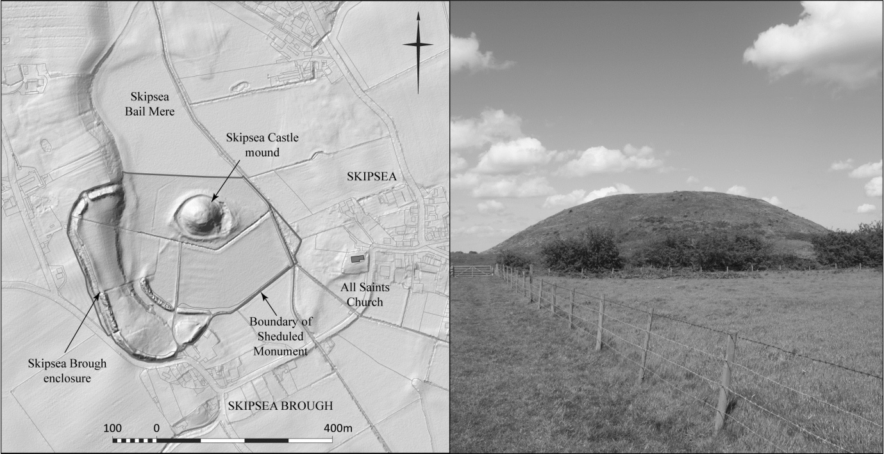 Photograph: © Jim Leary

Fig 1: Plan showing the castle remains at Skipsea, East Yorkshire. Photograph looking north towards Skipsea mound. Map based on lidar data supplied by the Environment Agency.

The mound at Skipsea was selected for investigation as part of the University of Reading research project ‘Extending Histories: from Medieval Mottes to Prehistoric Round Mounds’ (2015-17) (Leary et al. 2018). It had previously been identified as a site with possible prehistoric antecedents (Ainsworth et al. 2001), based on its impressive size, low-lying watery location and the abundance of prehistoric activity from the surrounding area. This includes a Late Bronze Age looped bronze spearhead and a socketed bronze axe recovered as surface finds from the vicinity of Skipsea Brough, their edge of wetland location suggestive of possible ritual deposition (Radley 1967, 18). However, with very little archaeological evidence from the castle itself, there was no firm evidence to support the suggestion of an early date for the mound. The new fieldwork involved drilling down through the mound to the old ground surface and removing a sequence of sleeved soil cores. Once removed, the core sleeves were then taken back to the laboratory, cut open and small specialist samples removed for palaeoenvironmental analysis and scientific dating. A detailed analytical survey was also undertaken of the upstanding earthwork remains with a view to identifying evidence for phasing in the mound’s construction (Fig 2).

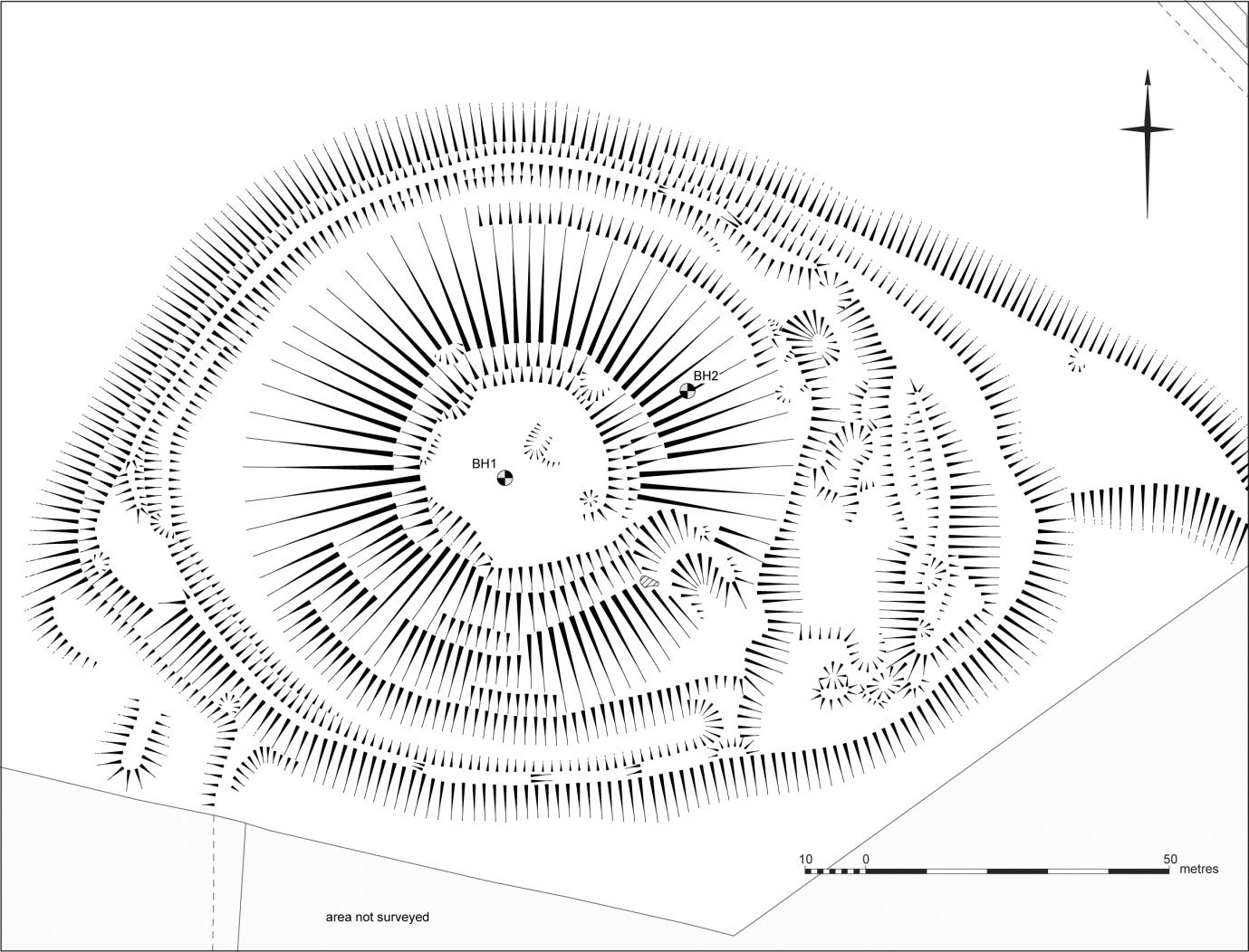

Fig 2: Hachure plan of Skipsea mound at 1:500 scale (reduced) showing borehole locations. BH1 was drilled to a maximum depth of 8.00m below ground level (bgl) and BH2, positioned part way down the motte, was drilled to a maximum depth of 6.00m bgl.

The Skipsea cores

In November 2015 two boreholes were drilled from the present ground surface of the mound to the top of the underlying geology (see Fig 2). Beneath the mound in situ glaciofluvial deposits were encountered at an elevation of between 10.24m and 10.97m OD, which is significantly higher than the adjacent alluvium and indicates these deposits would likely have formed an ‘island’ in the surrounding wetlands. Interestingly, with the possible exception of two sandy layers immediately beneath the present topsoil, the mound makeup itself does not appear to derive from the underlying gravel and sand deposits. Given its nature, a more likely parent material would seem to be the Till found either side of the former Bail Mere (BGS 2016). The top metre of sandy material may represent a superficial levelling deposit, possibly relating to the creation of a substantial building platform on the mound’s summit in the later medieval period.

Small specialist samples were taken from various points within the cores where charcoal fragments were observed or where organic-rich deposits with the potential to contain macroscopic plant remains were encountered. The main purpose of these samples was to obtain material suitable for radiocarbon dating and to recover any biological or cultural remains. That said, none of the samples taken from the mound makeup deposits in either borehole contained any identifiable botanical remains, except for a single fragment of Quercus (oak) from BH1. Samples taken from the palaeosol beneath the mound in BH2 contained occasional fragments of charcoal (some of which were recognisable as Acer campestre (field maple), Alnus glutinosa (alder) and Quercus (oak)), but pollen preservation and concentrations were extremely poor in all the samples and were therefore deemed unsuitable for pollen analysis.

Radiocarbon dating

A total of 12 samples of charcoal recovered from the cores were submitted for AMS radiocarbon dating, ten of which returned dates and are presented in Table 1. A total of six dates (SUERC-68673, SUERC-70561, SUERC-70565, SUERC-68674, SUERC-68678 and SUERC-70566) were obtained from the palaeosol in BH2. These dates were found to be significantly different (χ2 (5) = 11.1, p <0.05), indicating that these determinations are not likely to be estimating a single date and are almost certainly from multiple pieces of charcoal (Stuiver and Reimer 1993; Ward and Wilson 1978). The dates obtained on these samples intersect with the ‘Halstatt Plateau’ in the radiocarbon calibration curve, resulting in a calibrated date range spanning the entire period between c. 800-500 cal BC. Nevertheless, these dates would appear to indicate a genuine concentration of deposits dating to the Iron Age, and would seem to suggest occupation or activity at the site during that time.

Very little datable material was recovered from the mound makeup deposits, and the date ranges obtained display a considerable spread. This would indicate either the incorporation of much older residual charcoal within the mound, the downward movement of younger, intrusive charcoal fragments, or a combination of both. Two of the three samples (SUERC-70558 and SUERC-70559) were from very small samples recovered from the upper 2m of the mound makeup, and could plausibly have been introduced by down-washing or bioturbation. The sandy deposits in the upper metre of BH2 may reflect a later modification, with the organic material possibly originating from this later stratum. The remaining date (401-233 cal BC at 95% confidence) is based on a larger sample (SUERC-68671) more deeply buried in the mound and is therefore less likely to be intrusive, but could nevertheless still be residual.

Table 1: Radiocarbon dates from Skipsea mound

Location Lab. No Material δ¹³C Radiocarbon Calibrated date
age BP (95% confidence)
Old ground surface
BH2 SUERC-68674 charcoal fragments -23.2 2531±27 796-547 cal BC
(indet.)
BH2 SUERC-68678 charcoal fragments -23.2 2480±27 772-490 cal BC
(indet.)
BH2 SUERC-70560 charcoal fragments -25.0 2628±23 889-771 cal BC
(indet.)
BH2 SUERC-70561 charcoal -24.8 2709±33 916-806 cal BC
(Acer campestre)
BH2 SUERC-70565 charcoal fragments -25.1 2583±33 818-568 cal BC
(indet.)
BH2 SUERC-70566 charcoal fragments -24.3 4106±33 2866-2505 cal BC
(indet.)

Lower mound makeup
BH1 SUERC-68671 charcoal fragments -24.9 2283±25 401-233 cal BC
(indet.)
Upper mound makeup
BH2 SUERC-70558 charcoal -25.0 920±33 cal AD 1027-1187
(Quercus)
BH2 SUERC-70559 charcoal fragments -25.0* 7008±33 5986-5810 cal BC
(indet.)

Discussion

The evidence from the radiocarbon results at Skipsea raises two possibilities: a) the concentration of charcoal in the palaeosol reflects the date of burial for the old ground surface and therefore the start of mound construction, sometime in the Middle Iron Age; or alternatively, b) there was a significant time lag between the likely Iron Age activity on the old ground surface and the start of the construction of the mound, during which time no later charcoal or other datable remains accumulated on the surface. Both these interpretations would imply previously unrecognised Middle Iron Age activity at Skipsea. It must be asked however: how likely is it that no later charcoal or other datable remains would have accumulated on the old ground surface? If Skipsea mound was constructed wholly in the post-Conquest period it would imply around 1,500 years between identified activity events. Recent analysis of a number of large round mounds has suggested a close correlation between the date of organic material from the old ground surface and the earliest phase of mound construction (Leary et al. 2013a; Leary et al. 2013b; Jamieson and Stastney 2016). It may therefore seem improbable that no later datable material would have accumulated on the old ground surface at Skipsea prior to the start of mound construction, if entirely medieval in date. That said, the limitations of working on evidence from cores has to be acknowledged, and is well documented (see Canti and Meddens 1998).

If we accept the first proposed hypothesis, the charcoal fragment recovered from within the makeup of the mound at Skipsea, immediately above the old ground surface, would indicate a terminus post quem for the start of mound construction sometime after 401-233 cal BC (95% confidence). This would suggest a possible short gap between periods of Iron Age activity on the site. However, if correct, it would place the mound within the context of the distinctive square barrow funerary rite which dominates accounts of the Iron Age in East Yorkshire. Recent analysis of radiocarbon dates for Iron Age burials excavated at Wetwang Slack, East Yorkshire, indicate that burial at this funerary complex began in 295-205 cal BC (95% probability), with the less precise dates from the nearby Garton Slack indicating burial started there in 440-200 cal BC (68% probability) (Jay et al. 2012, 180-1). The radiocarbon age for the start of mound construction at Skipsea would therefore fit comfortably within this range. The barrows in East Yorkshire’s Iron Age cemeteries were relatively small in scale however, with the largest mounds no more than 12m in diameter and standing around 1.2m high (Stead 1991, 7). This is in stark contrast to the mound at Skipsea which measures 85m in diameter and is over 13m in height. Therefore, if Iron Age in date, the mound at Skipsea would represent the largest monument of its type in Britain, and one of the very largest in Europe. That said, the function and purpose of the mound at Skipsea remains unclear and it will take further investigations for this to be satisfactorily resolved.

Conclusions

The possible discovery of an Iron Age monumental mound in East Yorkshire necessitates a comprehensive rethinking of the archaeological remains at Skipsea, along with a re-appraisal of Iron Age activity in the region. It is unlikely that such a monument stood in isolation, and the surface discovery of pottery dated to the Late Bronze Age or Iron Age (found in the south-eastern part of the Skipsea Brough enclosure), along with Late Bronze Age and Early Iron Age metalwork from the vicinity, hints at more extensive later prehistoric activity in the area (Atkins nd, 17; Radley 1967, 18). It seems clear therefore, that further investigations at Skipsea are required if a better understanding of the nature and chronology of the site is to be obtained.

Acknowledgements

The authors extend thanks to the landowner Mr. John Warkup, for allowing access to the site. We are also grateful to the Historic England Inspector Keith Emerick for his support and for providing Scheduled Monument Consent for the coring work. Thanks must also go to Elaine Dunbar from the Scottish University Environmental Research Centre in East Kilbride for undertaking the radiocarbon dating work, and to Kevin Williams of QUEST for his help with the fieldwork.

Funding?

Bibliography

Ainsworth, A., Oswald, A. and Pearson, T. 2001. Skipsea Castle, East Riding of Yorkshire: Conservation Statement. York: English Heritage
Atkins, C. nd. Skipsea Castle, North Humberside. A survey of the earthworks. Archaeology Unit: Humberside County Council
BGS 2016. Lexicon of Named Rock Units. www.bgs.ac.uk/lexicon
Butler, R. 1984. Skipsea Brough. Archaeological Journal 141, 45-6
English, B. 1991. The Lords of Holderness 1086-1260. Hull: Hull University Press
Jamieson, E. and Stastney, P. 2016. Extending Histories: from Medieval Mottes to Prehistoric Round Mounds: Bramber Castle, West Sussex. Interim Report. University of Reading unpublished report
Jay, M., Haselgrove, C., Hamilton, D., Hill, J.D and Dent, J. 2012. Chariots and context: new radiocarbon dates from Wetwang and the chronology of Iron Age burials and brooches in East Yorkshire. Oxford Journal of Archaeology 31 (2), 161-89
Leary, J., Jamieson, E., Stastney, P. 2018. Exploring the large round mounds of England. Current Archaeology 337, 18-24
Leary, J., Canti, M., Field, D., Fowler, P., Marshall, P. and Campbell, G. 2013a. The Marlborough Mound, Wiltshire. A Further Neolithic Monumental Mound by the River Kennet. Proceedings of the Prehistoric Society 79, 1-27
Leary, J., Field, D. and Campbell, G. 2013b. Silbury Hill. The largest prehistoric mound in Europe. Swindon: English Heritage
Radley, J. 1967. Provisional List of Yorkshire Spear-heads. Yorkshire Archaeological Journal 42, 15-19
Stead, I.M. 1991. Iron Age Cemeteries in East Yorkshire. London: English Heritage
Stuiver, M. and Reimer, P.J. 1993. Extended 14C database and revised CALIB radiocarbon calibration program. Radiocarbon 35, 215-30
Ward, G.K. and Wilson, S.R. 1978. Procedures for comparing and combining radiocarbon age determinations: a critique. Archaeometry 20, 19-31

