**Emotions and voting behavior in self-determination referendums**

**The case of New Caledonia in 2018**

Sylvain Brouard, Sciences Po - CEVIPOF[1]

Pavlos Vasilopoulos, University of York

Samuel Gorohouna, University of New Caledonia

Christoph Hönnige, University of Hannover

Eric Kerrouche, CNRS Sciences Po Bordeaux - Centre E. Durkheim

ELECTORAL STUDIES, *ACCEPTED PRE-PROOF VERSION*

Abstract

In this article, we examine the impact of emotions on an independence referendum. New Caledonia – a French Pacific territory with 270,000 inhabitants – held a self-determination referendum in November 2018, in which 56% of the voters opted to remain a part of France. We conducted a post-referendum survey with 1,496 respondents that included a specific battery to measure emotions as well as control variables. We find that experiencing anger with the national status of the territory increases the probability of voting for independence, while experiencing pride reduces it. These results remain after controlling for partisan, ethnic and national identification, expected effects of independence as well as sociodemographic factors. Moreover, emotions and identity interact and increase the effect of (the lack of) national identification. Beyond the effects of the traditional control variables, the results suggest that knowledge about voting behavior in independence referendum is transferable to decolonization in Pacific Islands.

KEYWORDS: Referendum; Emotions; Independence; Pacific Islands; Decolonization

**1. Introduction**

In a context characterized by a resurgence of calls for statehood based on national identity, a new wave of independence referendums have been taking place, from Scotland via Catalonia to Bougainville. Scholars and observers usually underscore the substantive salience of the issue for citizens (Altman, 2017, Nadeau et al., 1999), as the resulting electoral decision often has a one-off nature and the outcome is typically irreversible. [2] Moreover, independence referendums may entail a strong emotional component as they deal with matters of identification with a state or nation on both sides of the debate (Nadeau et al., 1999, Liñeira et al., 2017). In comparison with most ordinary elections, independence referendums are characterized by the high intensity of citizens’ emotional engagement (Liñeira et al., 2017). As this has not previously been specifically investigated, our paper is precisely interested in the emotional component of decision-making in referendums.

Although independence referendums are far from new – with more than one hundred having been organized since 1945 – they have rarely been analyzed in electoral studies, with the two notable exceptions of Quebec (Clarke et al., 2004; Nadeau et al., 1999) and Scotland (Liñeira et al., 2017; Liñeira & Henderson 2019). Beyond this, self-determination referendums beyond Europe and North America have been neglected thus far. This may pose a problem as mechanisms and concepts that work well in established Western democracies may not be easily transferable beyond this context, as the literature on political culture suggests (Corbett, 2015; Dalton and Shin, 2006; Fraenkel and Grofman, 2005; Levine, 2016).

The referendum on the independence from France organized on November 4, 2018 in New Caledonia is an opportunity to investigate whether the existing explanations about electoral behavior in an independence referendum apply in the cultural context of Pacific Islands and decolonization, as well as analyzing the effect of emotions. To answer our research question, we conducted a post-referendum observational survey in 2018 with 1,496 respondents in New Caledonia.

**2. Electoral behavior in self-determination referendums**

The determinants of electoral behavior during independence referendums partially differ from ordinary referendums. They are not characterized by the low information or low salience contexts associated with many other referendums (Clarke et al., 2004; Nadeau et al., 1999). National independence is a particularly salient issue to many voters.

Voters’ identification is considered particularly consequential in electoral behavior, especially in independence referendums (Liñeira et al., 2017; Liñeira & Henderson 2019; Nadeau et al., 1999). This might relate to ethnicity on the one hand, or perceived nationality on the other. Both aspects might play a role independently, especially in the case of the separation of a colony from a mother state. The population of colonies is typically a mix of descendants of the original population and settlers (and outlaws) from the mother state.

Party identification also matters in an independence referendum (Clarke et al., 2004; Liñeira & Henderson 2019). Since the seminal work of Campbell et al. (1960), electoral studies have consistently found evidence for the effect of party identification on electoral behavior. In many political systems where independence is an issue, party systems tend to be structured – among others – along the cleavage about independence. Therefore, partisan identification reflects preferences about independence. However, party identification may also matter in another way. An independence referendum is a situation of strong uncertainty about the consequences of choices and information-seeking is very costly. In order to reduce uncertainty and costs, voters take cues from their environment. For their followers, parties provide inexpensive and reliable cues to help them to choose (Clarke et al., 2004). Of course, these cues are biased information towards the party’s preferred outcomes, aiming to activate political predisposition as well as party identification (Hobolt, 2006).

In addition to identities, risk attitudes and cost-benefit perceptions also play a major role in electoral behavior in independence referendums. Specifically, given that these types of referendums are rare, the potential consequences of independence are very difficult to evaluate in each case and are subject to inconsistent information from the various political groups. Independence referendums clearly fit the characterization of a choice between a ‘yes’ vote leading to an unpredictable change and a ‘no’ vote preserving a predictable status quo (Bowler and Donovan, 1998; Morisi, 2016). Empirical evidence of a status quo bias (Christin et al., 2002) usually linked to the asymmetry of the electoral choice itself in referendums is enhanced when the issue is independence (Liñeira & Henderson 2019). In this context, some scholars stress the role of risk attitudes in independence vote choice, whether directly or indirectly (Liñeira & Henderson 2019; Nadeau et al., 1999). The uncertainty associated with independence repels risk-adverse voters to support it. The expectations regarding the consequences of a possible independence have been extensively investigated (Nadeau et al., 1999; Clarke et al., 2004). More negative expectations about the impact of a possible independence are usually expected to increase support for the extant status quo.

**3. Emotions and political behavior in self-determination referendums**

In addition to the well-known determinants of voting behavior in self-determination referendum laid out in the previous section, we also consider the role of emotional reactions towards the current national status of the territory in the outcome of the referendum. Emotions refer to rapid pre- and post-conscious appraisals of the environment and the state of oneself, which allow instantaneous action (LeDoux, 1998; Marcus, 2013). A recent stream of research offers evidence that emotions play a powerful role in political behavior, affecting decision-making criteria as well as rendering specific electoral outcomes more appealing than others (Banks, 2014; Brader, 2006; Marcus et al., 2019, 2000; Rico et al., 2017; Valentino et al., 2018; Vasilopoulos et al., 2018a, 2018b; Vasilopoulou and Wagner, 2017).

Three emotions have been found to be particularly influential on political behavior: fear, anger, and enthusiasm. These distinct emotional reactions are elicited by different appraisals of one’s environment and – once triggered – they evoke different decision-making strategies and behavioral outcomes.

Fear (or anxiety) arises in threatening or novel situations that entail harm for the individual and where a person does not have confidence in one’s own resources in terms of effectively addressing the threat (Lazarus, 1991; Lerner and Keltner, 2001). Anxiety is associated with increased information-seeking over the threatening stimulus and increased openness to seek novel behavioral strategies (Marcus et al., 2000). However, at the same time, anxiety increases perceptions of risk, and consequently it incites the adoption of risk-aversive strategies to avert the threat (Lerner and Keltner, 2001). In the realm of politics, a broad stream of research has found that – in line with its information-seeking qualities – anxiety increases the motivation to seek out political information and leads citizens to break away from their longstanding dispositions and political attachments in favor of contemporaneous considerations (Brader, 2006; Marcus et al., 2000; Valentino et al., 2008). At the same time, through its risk-aversive behavioral qualities, anxiety makes citizens less likely be swayed by radical and risk-taking policies that challenge the status quo (Marcus et al., 2019; Vasilopoulos et al., 2018a).

Anger is elicited in situations that entail harm for the individual, while there is a clear attribution of responsibility and confidence in one’s resources for effectively dealing with the threatening stimulus (Carver and Harmon-Jones, 2009; Frijda, 1986). Anger is associated with risk-seeking, aggressive and punitive tendencies, even if these entail increased cognitive or material costs for the individual. In the domain of political behavior, anger has been found to be associated with reduced motivation to gather political information, especially information that contravenes one’s extant political beliefs (Suhay and Erisen, 2018; Valentino et al., 2018). Further, anger has been shown to boost risky options when it comes to voting in EU referendums. Garry (2014) illustrates that experiencing anger during the 2012 Irish referendum for fiscal compact campaign was associated with support for the risky option of rejecting the compact, while anxiety had the opposite effect.

At the same time, anger has been found to increase the impact of political dispositions on political decision-making. For instance, in an experimental study, Valentino et al. (2018) report that anger mobilized voters scoring high in sexism to vote for Donald Trump in the 2016 US election. Similarly, Marcus et al. (2019) found that anger galvanized popular support for the far-right National Front in France, especially among those who had an authoritarian predisposition. In contrast to anxiety, other studies report a positive effect of anger for risky and punitive political outcomes. In a UK sample, Vasilopoulou and Wagner (2017) showed a positive association between anger and the willingness to leave the European Union, being less likely to be affected by cost-benefit considerations. Finally, Vasilopoulos et al. (2018b) found that – ceteris paribus – anger increased the propensity to vote for the French National Front at the expense of mainstream political parties.

On the other hand, enthusiasm is a positive emotion elicited after the successful execution of tasks (Marcus et al., 2000). Some treat enthusiasm as a distinct effect compared with other positive emotions such as pride – which is elicited by retrospective appraisals of successful outcomes – or hope, which is evoked by future prospects for successful outcomes (Lazarus, 1991). Nonetheless, a large stream of research treats enthusiasm as one general emotional dimension, pointing to evidence that affective labels such as pride, hope, or joy are essentially undifferentiated by individuals and rather form one common affective dimension (Marcus et al., 2017; Marcus and Brader, 2011; Wojcieszak et al., 2016). Behaviorally, enthusiasm mobilizes the individual to keep investing resources in the pursuit of a cherished goal and it fosters reliance on past practices (Marcus et al., 2000). In this sense, despite being a positive emotion, enthusiasm is behaviorally similar to anger (Carver and Harmon-Jones, 2009). This has also been shown in the realm of political behavior, where – similar to anger – enthusiasm has been found to increase reliance on political dispositions and spur participatory actions (Brader, 2006; Marcus et al., 2000; Wojcieszak et al., 2016).

Consequently, we anticipate that emotional reactions towards the current status should be associated with vote preferences in the independence referendum, even after controlling for individual differences in socioeconomic status, identity concerns, and considerations on the impact of independence. Specifically, based on the risk-taking and action-oriented qualities of anger, we anticipate that experiencing anger with the status quo should be associated with an increased propensity to vote in favor of independence. On the other hand, we refrain from forming a hypothesis concerning the role of fear in the referendum, as the association could proceed in two contrasting directions: on the one hand, fear with the current status should render one more prone to voting in favor of independence; while on the other hand, as fear renders a person less prone to confrontation and risk-taking, experiencing fear should be demobilizing for choosing independence. Furthermore, we anticipate that being proud to belong to the mother country should be – ceteris paribus – negatively associated with voting in favor of independence. Specifically, we are interested in testing the following hypotheses:

*H1: Experiencing anger with the current status will be associated with a higher propensity to vote for independence.*

*H2: Experiencing pride with the current status will be associated with a lower propensity to vote for independence.*

On top of these effects, we anticipate that voters’ emotions affected the referendum outcome *indirectly* through activating relevant dispositions. As previously mentioned, both anger and enthusiasm have been found to boost the impact of dispositions on the vote. Consequently, we anticipate that experiencing anger should render those without a sense of a strong identity with the mother country even more likely to vote in favor of independence. At the same time, we expect that enthusiasm should be especially mobilizing to vote against independence among those who strongly identify with the mother country. In sum, we are interested in testing the following hypotheses:

*H3: : Feeling angry with the current status will be associated with a higher propensity to vote for independence among those who do not identify with the mother country.*

*H4: Feeling proud of the current status status will be associated with a lower propensity to vote for independence among those who identify with the mother country.*

**4. The 2018 New Caledonian self-determination referendum**

New Caledonia is an archipelago of islands with about 270,000 inhabitants, located 1,000 kilometers east of Australia in the Pacific Ocean. Since 1853, it has been included in the territories under French administration. Violent conflicts between some tribes of the native Kanak inhabitants and French administration or newcomers from European origin have periodically occurred. The last one lasted between 1984 and 1988 was halted by both sides’ approval of the Matignon Agreements in 1988 (Mrgudovic, 2012). In these agreements, new institutions and policies were established to share power and redistribute resources between communities and areas. An independence referendum was due to take place ten years after the agreement was agreed upon. Nevertheless, in 1998 anti- and pro-independence parties agreed to postpone the referendum to preserve peace. They signed a new deal – the Noumea Accord – which 72% of the voters in New Caledonia approved in a referendum, with a 74% turnout rate. In addition to the new powers granted to local institutions and the creation of a Caledonian citizenship, both sides agreed to the organization of up to three new independence referendums. The first one was conducted on November 4, 2018, thirty years after the Matignon Agreement. The others will follow before the end of 2020 and 2022, respectively.

This was not the first referendum on independence, as two others had previously been organized in New Caledonia. The 1958 referendum on the new constitution of Fifth Republic (approved by 98% of the valid votes, with a 77% turnout rate) had a double meaning as a rejection would have induced the automatic independence of the territory. During the 1984-1988 turmoil, another independence referendum was organized in 1987 despite the boycott of the pro-independence parties. Almost 98% of the valid votes were in favor of remaining with France, with a 59% turnout.

The context of the 2018 referendum was different as all major parties strongly campaigned for it and only small radical pro-independence parties and groups (Labour Party, collectif de Gossanah, etc.) called for a boycott. The Noumea Accord excluded some categories of French citizens residing in New Caledonia from voting. Among the complex rules on voter eligibility, two stand out: first, French citizens born in New Caledonia needed to have been living in New Caledonia for the last three years and be registered on the voting lists; and second, French citizens born outside New Caledonia needed to have been living in New Caledonia since the end of 1994. As a result, almost 36,000 French citizens living in New Caledonia (17% of the electorate) were excluded.[3]

The results of early polls were strongly in favor of remaining in the French Republic. In the final weeks of the campaigns, anti-independence parties took a large victory for the remain vote for granted and focused on making future policy changes on this ground. Pro-independence parties intensely mobilized their followers and asked them to display the flag and the colors of the independent Kanaky as much as possible to rally around it. Pro-independence parties tried to assuage the fear of the consequences of an immediate independence by underscoring that a ‘yes’ vote would not end support from France. The turnout was the highest ever (81% of the eligible voters) and 44% of the valid votes were in favor of independence. Therefore, New Caledonia remains a part of France at present.

**5. Data and methodology**

We designed a post-electoral survey to examine the effects of emotion, ethnic and national identification, party identification and cost-benefit expectations, as well as sociodemographic characteristics on the independence referendum in New Caledonia in 2018. The survey was administered by the local polling company Quid Novi between November 6, 2018 and December 20, 2018. Respondents were contacted by phone. As with nearly all surveys in France, sampling was conducted with a quota method (Gschwend, 2005). Given the specificity of New Caledonia, the quota method was based on six features: age, gender, occupation, ethnic background, municipality (including neighborhood for the metropolitan area of the main city Noumea) and type of residence, stratified into six areas of residency. The sample closely approximates the population in terms of demographics. The full sample has 1,496 respondents. Given that not all French citizens of New Caledonia were allowed to participate in the referendum, in the analysis we only use a sub-sample comprising citizens who were eligible to vote, i.e. French citizens born in New Caledonia (who had live there for at least three years and had already enrolled on the electoral lists) and French citizens not born in New Caledonia but living there since at least November 1994. The sub-sample has 1,302 respondents.

The dependent variable is the reported vote in the 2018 New Caledonia referendum.[4] As displayed in Table 1, it is coded ‘1’ if the respondent voted for independence and ‘0’ if the respondent voted against independence. Regarding the main independent variables, emotional reactions were measured using three variables asking respondents on a scale ranging from ‘0’ (not at all) to ‘10’ (extremely) the extent to which they feel (a) fear (b) anger and (c) pride when thinking about “New Caledonia as a part of the French Republic”. Two issues are worth discussing here. First, the question does not measure emotional reactions in general but associates these reactions with the issue at stake, namely New Caledonian independence. The reason is that we aim to investigate how voters’ emotional reactions toward independence were associated with their political choice and their decision-making criteria. This methodological choice draws on similar research designs that ask respondents how they feel regarding specific issues, candidates, or legislation proposals (Garry, 2014; Marcus et al., 2000; Marcus et al., 2019; Valentino and Neuner, 2017; Vasilopoulou and Wagner, 2017; Erisen et al., 2020). Second, the questions are designed not to be affected by the outcome of the referendum but rather to measure how people feel thinking about New Caledonia as part of France. The fact that emotional reactions were measured after the referendum is a limitation of the research design. Nonetheless, past research suggests that emotional reactions to varius stimuli such as terror attacks or economic crises exhibit a fair degree of stability over a timespan of months or even years (Rico et al., 2017; Vasilopoulos and Brouard, 2020).

The extent to which a respondent feels French was measured on a five-point scale ranging from ‘1’ (not at all) to ‘5’ (very strongly) and collapsed into a trichotomous variable. We also rely on several control variables. Partisan identification is measured using the usual CSES template. Given that there are many parties in New Caledonia, we distinguish respondents identifying themselves with a pro-independence party from those close to an anti-independence party and those without any partisan identification. Furthermore, we included sociotropic concerns with an item asking respondents whether the situation of New Caledonia would be better, the same or worse if New Caledonia became independent. Finally, we control based on the level of political interest (with a four-item scale) and the level of risk tolerance (general willingness to take risk on a five-item scale). On top of these variables, our dataset also contains several standard demographic variables including age, gender, occupation and level of education. It also includes a variable indicating whether or not respondents feel that they belong to nine (ethnic) communities, replicating the question used in the Caledonian census and collapsed to four categories.



*Table 1. Descriptive statistics*

**6. Results**

Since the dependent variable is a dummy variable, we built two logistic regression models. Model 1 includes the three emotional items and the whole set of control variables: four sociodemographic variables (age, gender, education, occupation), ethnicity, partisan and national identification, political interest, risk tolerance as well as belief over the impact of a possible New Caledonian independence on the situation for New Caledonia. Model 2 interacts the three emotional items with national identification. We report the results of both models in Table 2.

Beginning with Model 1, the findings indicate that – ceteris paribus – among the control variables, the effects of gender, age, diploma, occupation, political interest and risk tolerance are not statistically significant. Beyond this, the other control variables have the expected effects. On the one hand, negative sociotropic expectations regarding the consequences of independence reduce the likelihood of voting ‘yes’ to independence compared with the baseline of anticipating positive cost-benefits. When respondents moderately or strongly identify themselves as French, the propensity to vote for the New Caledonian independence significantly decreases. When respondents have no partisan identification or are close to an anti-independence party, the likelihood of voting for independence is lower than when respondents strongly identify themselves as being close to the pro-independence parties. On the other hand, having a Kanak ethnic background strongly increases the propensity to vote in favor of independence (compared with a European respondent).



*Table 2, part 1: Demographic, attitudinal, and emotional correlates of voting for independence in the 2018 referendum in New Caledonia*



Exponentiated coefficients; Standard errors in parentheses

*p* < 0.05, ** *p* < 0.01, *** *p* < 0.001; *ref = reference category[5]*

*Table 2, part 2: Demographic, attitudinal, and emotional correlates of voting for independence in the 2018 referendum in New Caledonia[6]*

The results from Model 1 also suggest that experiencing anger towards the status of New Caledonia as part of the French Republic is associated with an increased probability of having voted for independence, despite controlling for individual differences among the remaining variables. A one-point increase in anger is on average associated with a 0.7-point increase in the likelihood of voting for independence. This finding is in line with our theoretical expectation (H1) that due to its action-oriented and risk-taking qualities, anger should be positively associated with voting for independence. It is noteworthy that fear does not exert a significant influence on the propensity to vote for independence. Moreover, in line with our expectations (H2), Model 1 also displays evidence that experiencing pride evoked by the status of New Caledonia as part of the French Republic is associated with voting against independence: a one-point increase in pride is on average associated with a 0.8-point decrease in the likelihood of voting for independence.

We now move on to test hypotheses 3 and 4, which anticipate that emotional reactions should moderate the impact of French identity on the referendum vote. In order to test these hypotheses, in Model 2 we assess the impact of the variables included in Model 1 with three interaction terms between each emotion and the extent to which a respondent feels that they are a French citizen. The interaction coefficient size and level of significance does not allow us to adequately understand the interactive effect (Brambor et al., 2006). Consequently, Figures 1 and 2 present the average marginal effect of anger and pride according to the level of French identification, respective. The figures were generated on the basis of Model 2, and the results illustrate that emotional reactions moderated the effect of identifying as a French citizen on the probability of having voted for independence. Specifically, as expected according to hypothesis 4, the negative effect of identifying as a French citizen on voting for independence is amplified when pride increases: a one-point increase in the level of pride on a 0-10 scale reduces the likelihood of voting ‘leave’ by 1.2% and 1.5% on average for respondents who moderately and strongly or very strongly identify themselves as French, respectively. Pride does not influence the voting propensity of respondents who only identify with France weakly or not at all. By contrast, angrier respondents who only identify with France weakly or not at all become more likely to have voted for independence: a one-point increase in the level of anger on a 0-10 scale increases the likelihood of voting ‘leave’ by 1.7% on average. Nevertheless, the average marginal effect is less precisely estimated. Anger does not significantly affect respondents identifying themselves moderately, strongly and very strongly as French citizens.

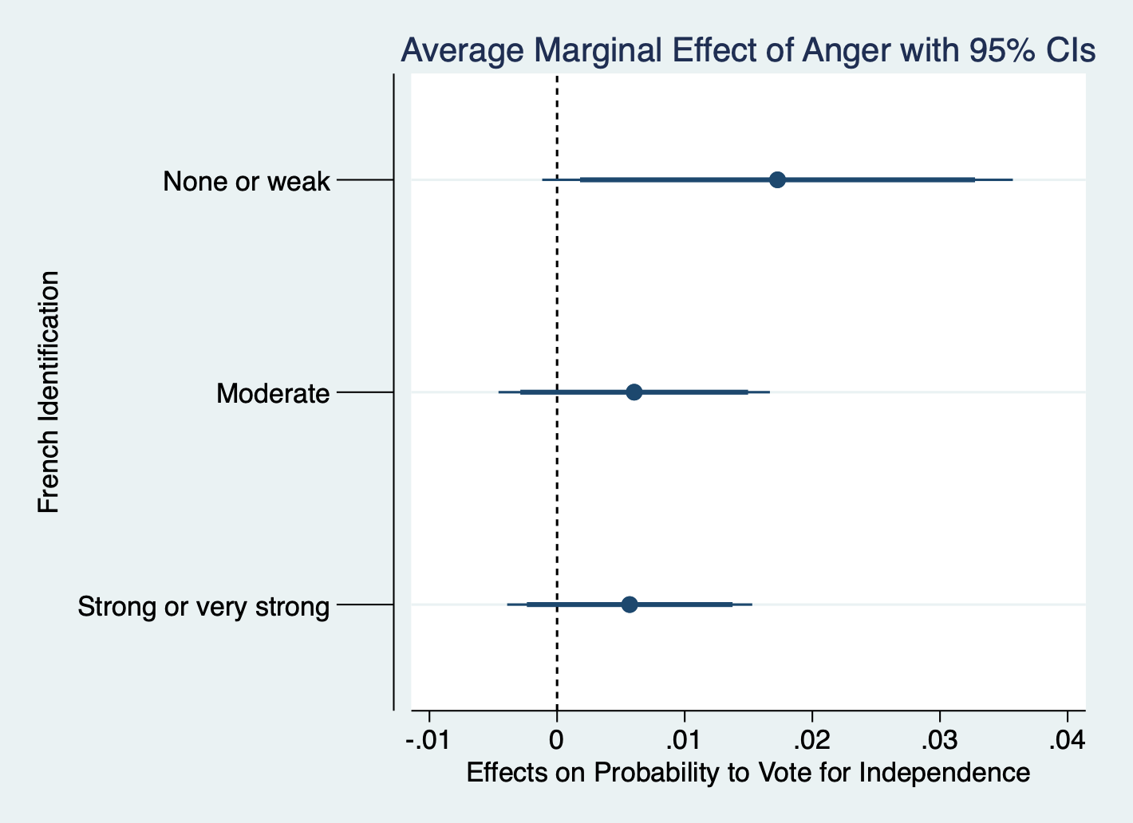

*Note: the thin and thick bars represent 95% and 90% confidence intervals.*

*Figure 1: Average marginal effects of anger towards the current status of New Caledonia on the independence vote conditional on the feeling of being a French citizen*

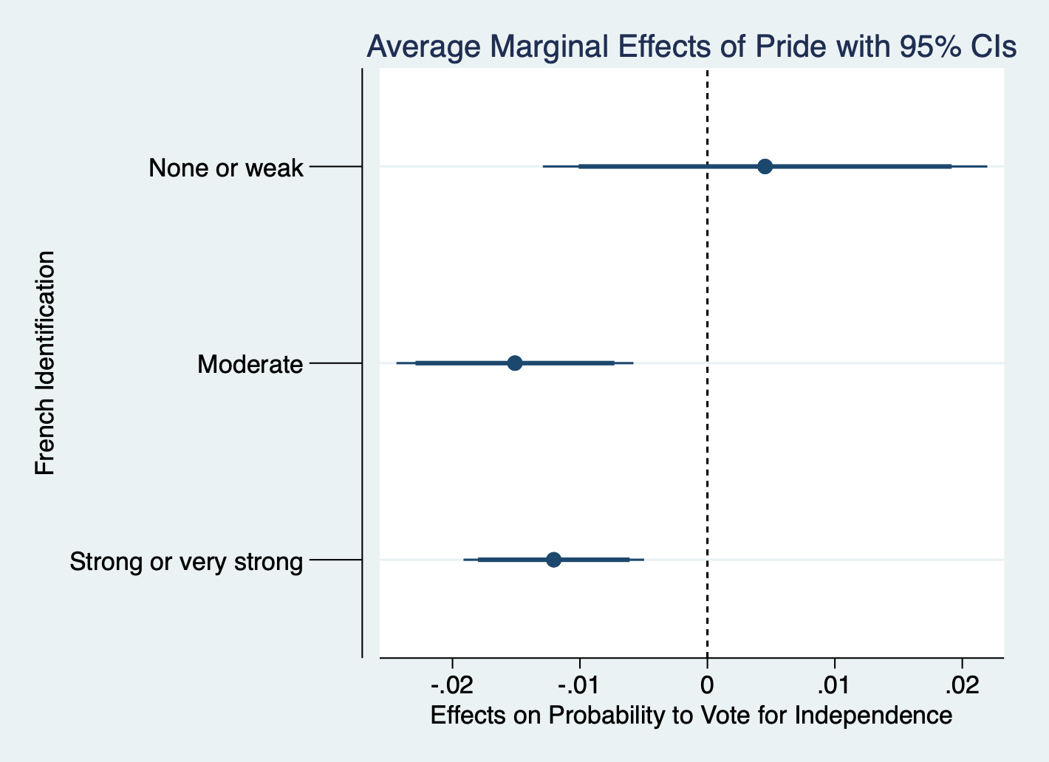

*Note: the thin and thick bars represent 95% and 90% confidence intervals.*

*Figure 2: Average marginal effects of pride towards the current status of New Caledonia on the independence vote conditional on the feeling of being a French citizen*

**7. Conclusion**

The number of referendums has increased over the years (Altman 2017) and with it the number of independence referendums. The desire for independence among ethnic and language minorities remains an important issue within Europe, but also beyond. The topic still lacks research, as the reasons for independence remain to some extent idiosyncratic. This article has analyzed several factors driving the independence vote in New Caledonia with a sample of 1,496 respondents from the 174.000 New Caledonian citizens allowed to vote for the 2018 self-determination referendum. We focus on pride and anger as emotions to explain voting behavior, but also control for traditional explanations of voter identification and expected economic consequences.

The central finding is that anger and pride about New Caledonia being a part of the French territory affects the voting behavior. Being angry about the status quo increases the likelihood to vote for independence, being proud about the status quo decreases the likelihood. Furthermore, emotions interact with national identity: if a voter identifying strongly as French is proud, the effect also gets stronger. Our findings thus add to the increasing literature looking at emotions in voting in referenda and elections (Brummel, 2020; Bruter and Harrison 2017; Clarke et al., 2017; Garry, 2013; Magni, 2017; Valentino et al., 2018; Vasilopoulos et al., 2018a; Vasilopoulou and Wagner, 2017). In general, our findings are in line with previous research arguing that emotions – and especially anger – play a role in decision-making, but are often conditioned by other variables (Garry, 2013; Petersen, 2010, Magni, 2017). Beyond that, some well-established variables play out as expected: supporters of pro-independence parties were more likely to vote for it, voters who belong to the indigenous Kanak ethny also more commonly voting for independence, and voters who identify as French did so less commonly. Moreover, voters are less likely to vote for independence if they think that the situation would economically worsen for New Caledonia. These results suggest that the reasons for voting for independence are transferable beyond cultural contexts, as other authors find effects of these variables in other referendum votes as well (Clarke et al., 2017, Colombo and Kriesi 2016, Hobolt, 2006). Future research on referendums should therefore identify more variables which interact with emotions.

Our findings have implications for our understanding of voting behavior on independence referendums in other contexts such as Catalonia or Scotland (Muñoz and Tormos, 2015; Muro and Vlaskamp, 2016). Quite often, the side supporting the status quo brings forward a campaign that focuses on arguments of economic stability. These campaigns have limitations, as ethnic and national identification as well as emotions also play a strong role. Even if independence campaigns might paint independence as the “sunny uplands”, the most rational strategy for an independence movement is to increase the identity with the new nationality as much as possible and combine this with a campaign that is at least to some extent negative regarding the current national status.

However, fueling emotion might be a dangerous strategy for the post-referendum period. Loser’s acceptance of a referendum outcome is even more important in an independence referendum, than in ordinary democratic elections as today’s losers may not be reasonably confident to be tomorrow’s winners (c.f. Brummel, 2020). Not only policy consent plays a role for this (Nadeau and Blais 1993), but recent research has shown that high flaring emotions are also negatively associated with losers consent (Nadeau et al., 2019). It might determine the future of a community between civil war and peace. The violence that erupted in East Timor after the 1999 self-determination referendum is a dramatic reminder of this risk when voters choose independence. The civil war like political climate following the 1987 referendum in New Caledonia also exemplified, how lack of loser’s consent imperils the status quo even it was supported a majority of voters.

**References**

Altman D., 2017. The Potential of Direct Democracy: A Global Measure (1900–2014). Social Indicators Research 133(3), 1207-1227. doi:10.1007/s11205-016-1408-0

Banks, A.J., 2014. Anger and racial politics: The emotional foundation of racial attitudes in America. Cambridge University Press, Cambridge.

Bowler, S., Donovan, T., 1998. Demanding Choices. University of Michigan Press. https://doi.org/10.3998/mpub.15428

Brader, T., 2006. Campaigning for hearts and minds: How emotional appeals in political ads work. University of Chicago Press, Chicago.

Brambor, T., Clark, W.R., Golder, M., 2006. Understanding Interaction Models: Improving Empirical Analyses. Political Analysis 14, 63–82. https://doi.org/10.1093/pan/mpi014

Brummel L., 2020. ‘You Can’t Always Get What You Want’: The effects of winning and losing in a referendum on citizens’ referendum support. Electoral Studies 65, 102-155. doi:https://doi.org/10.1016/j.electstud.2020.102155

Bruter M., Harrison S., 2017. Understanding the emotional act of voting. Nature Human Behaviour. 1(1), 24. doi:10.1038/s41562-016-0024

Campbell, A., Converse, P.E., Miller, W.E., Stokes, D.E., 1960. The American Voter, University. ed. Chicago.

Carver, C.S., Harmon-Jones, E., 2009. Anger Is an Approach-Related Affect: Evidence and Implications. Psychological Bulletin 135, 183–204.

Christin, T., Hug, S., Sciarini, P., 2002. Interests and information in referendum voting: An analysis of Swiss voters, European Journal of Political Research.

Clarke, H.D., Kornberg, A., Stewart, M.C., 2004. Referendum Voting as Political Choice: The Case of Quebec. British Journal of Political Science 34, 345–355. https://doi.org/10.1017/S0007123404000092

Clarke H.D., Goodwin M., Whiteley P., 2017. Why Britain voted for Brexit: An individual-level analysis of the 2016 referendum vote. Parliamentary Affairs 70(3), 439-464. doi:10.1093/pa/gsx005

Colombo C., Kriesi H., 2017. Party, policy – or both? Partisan-biased processing of policy arguments in direct democracy. Journal of Elections, Public Opinion and Parties 27(3), 235-253. doi:10.1080/17457289.2016.1254641

Corbett, J., 2015. “Everybody knows everybody”: practising politics in the Pacific Islands. Democratization 22, 51–72. https://doi.org/10.1080/13510347.2013.811233

Dalton, R.J., Shin, D.C., 2006. Citizens, Democracy, and Markets Around the Pacific Rim. Congruence Theory and Political Culture. Oxford University Press, Oxford.

Fieldhouse E., Prosser C., 2018. The limits of partisan loyalty: How the Scottish independence referendum cost Labour. Electoral Studies 52, 11-25. doi:https://doi.org/10.1016/j.electstud.2018.01.002

Fraenkel, J., Grofman, B., 2005. Introduction – Political Culture, Representation and Electoral Systems in the Pacific Islands. Commonwealth & Comparative Politics 43, 261–275. https://doi.org/10.1080/14662040500304783

Frijda, N.H., 1986. The emotions. Cambridge University Press, Cambridge.

Garry J., 2013. Emotions and voting in EU referendums. European Union Politics 15(2), 235-254. doi:10.1177/1465116513514780

Gschwend, T., 2005. Analyzing Quota Sample Data and the Peer-review Process. French Politics 3, 88–91. https://doi.org/10.1057/palgrave.fp.8200068

Hobolt, S.B., 2006. How Parties Affect Vote Choice in European Integration Referendums. Party Politics 12, 623-647.

Lazarus, R.S., 1991. Emotion and adaption. Oxford University Press.

LeDoux, J., 1998. The emotional brain: The mysterious underpinnings of emotional life. Simon and Schuster, New York.

Lerner, J.S., Keltner, D., 2001. Fear, anger, and risk. Journal of Personality and Social Psychology 81, 146–159. https://doi.org/10.1037/0022-3514.81.1.146

Levine, S., 2016. Pacific ways: Government and politics in the Pacific islands. Victoria University Press, Wellington.

Liñeira, R., Henderson, A., Delaney, L., 2017. Voters’ Response to the Campaign: Evidence from the Survey, in: Keating, M. (Ed.), Debating Scotland: Issues of Independence and Union in the 2014 Referendun. Oxford University Press, Oxford.

Liñeira, R., Henderson A., 2019. Risk Attitudes and Independent Vote Choice. Political Behavior. pp. 1-20. <https://doi.org/10.1007/s11109-019-09560-x>

Magni G., 2017. It’s the emotions, Stupid! Anger about the economic crisis, low political efficacy, and support for populist parties. Electoral Studies 50, 91-102. doi:https://doi.org/10.1016/j.electstud.2017.09.014

Marcus, G.E., 2013. Political psychology: Neuroscience, genetics and politics. Oxford University Press, Oxford.

Marcus, G.E., Neuman, W.R., Mackuen, M., 2000. Affective intelligence and political judgment. University of Chicago Press, Chicago.

Marcus, G.E., Neuman, W.R., MacKuen, M.B., 2017. Measuring Emotional Response: Comparing Alternative Approaches to Measurement. Political Science Research and Methods 5, 733–754. https://doi.org/10.1017/psrm.2015.65

Marcus, G.E., Valentino, N.A., Vasilopoulos, P., Foucault, M., 2019. Applying the Theory of Affective Intelligence to Support for Authoritarian Policies and Parties. Political Psychology 40, 109–139. https://doi.org/10.1111/pops.12571

Marcus, T., Brader, G.E., 2011. Emotion and Political Psychology, in: Huddy, L., Sears, D.O., Levy, J.S. (Eds.), The Oxford Handbook of Political Psychology. Oxford University Press, Oxford, pp. 165–204.

Morisi, D., 2016. Voting under uncertainty: the effect of information in the Scottish independence referendum. Journal of Elections, Public Opinion and Parties 26, 354–372. https://doi.org/10.1080/17457289.2016.1178648

Mrgudovic, N., 2012. Evolving approaches to sovereignty in the French Pacific. Commonwealth & Comparative Politics 50, 456–473. https://doi.org/10.1080/14662043.2012.729730

Muñoz, J., Tormos, R., 2015. Economic expectations and support for secession in Catalonia: between causality and rationalization. European Political Science Review 7, 315–341. https://doi.org/10.1017/S1755773914000174

Muro, D., Vlaskamp, M.C., 2016. How do prospects of EU membership influence support for secession? A survey experiment in Catalonia and Scotland. West European Politics 39, 1115–1138. https://doi.org/10.1080/01402382.2016.1149993

Nadeau R., Bélanger É., Atikcan E., 2019. Emotions, cognitions and moderation: understanding losers’ consent in the 2016 Brexit referendum. Journal of Elections, Public Opinion and Parties. April, 1-20. doi:10.1080/17457289.2019.1604528

Nadeau, R., Blais, A., 1993. The Effect of Participation on Losers’ Consent. British Journal of Political Science 23, 553–563.

Nadeau, R., Martin, P., Blais, A., 1999. Attitude Towards Risk-Taking and Individual Choice in the Quebec Referendum on Sovereignty. British Journal of Political Science 29, 523–539. https://doi.org/10.1017/S0007123499000241

Petersen M.B., 2010. Distinct Emotions, Distinct Domains: Anger, Anxiety and Perceptions of Intentionality. The Journal of Politics 72(2), 357-365. doi:10.1017/S002238160999079X

Suhay, E., Erisen, C., 2018. The Role of Anger in the Biased Assimilation of Political Information. Political Psychology 39, 793–810. https://doi.org/10.1111/pops.12463

Valentino, N.A., Hutchings, V.L., Banks, A.J., Davis, A.K., 2008. Is a Worried Citizen a Good Citizen? Emotions, Political Information Seeking, and Learning via the Internet. Political Psychology 29, 247–273. https://doi.org/10.1111/j.1467-9221.2008.00625.x

Valentino, N.A., Wayne, C., Oceno, M., 2018. Mobilizing sexism the interaction of emotion and gender attitudes in the 2016 us presidential election. Public Opinion Quarterly. https://doi.org/10.1093/poq/nfy003

Vasilopoulos, P., Marcus, G.E., Foucault, M., 2018a. Emotional Responses to the Charlie Hebdo Attacks: Addressing the Authoritarianism Puzzle. Political Psychology 39, 557–575. https://doi.org/10.1111/pops.12439

Vasilopoulos, P., Marcus, G.E., Valentino, N.A., Foucault, M., 2018b. Fear, Anger, and Voting for the Far Right: Evidence From the November 13, 2015 Paris Terror Attacks. Political Psychology. https://doi.org/10.1111/pops.12513

Vasilopoulou, S., Wagner, M., 2017. Fear, anger and enthusiasm about the European Union: Effects of emotional reactions on public preferences towards European integration. European Union Politics 18, 382–405. https://doi.org/10.1177/1465116517698048

Wojcieszak, M., Bimber, B., Feldman, L., Stroud, N.J., 2016. Partisan News and Political Participation: Exploring Mediated Relationships. Political Communication 33, 241–260. https://doi.org/10.1080/10584609.2015.1051608

**Appendix**

Replication of the analysis including respondents with missing data (DK) for some independent variables.





Exponentiated coefficients; Standard errors in parentheses

*p* < 0.05, ** *p* < 0.01, *** *p* < 0.001; *ref = reference category, DK = Don’t know*

*Table A1: Demographic, attitudinal, and emotional correlates of voting for independence in the 2018 referendum in New Caledonia[7]*

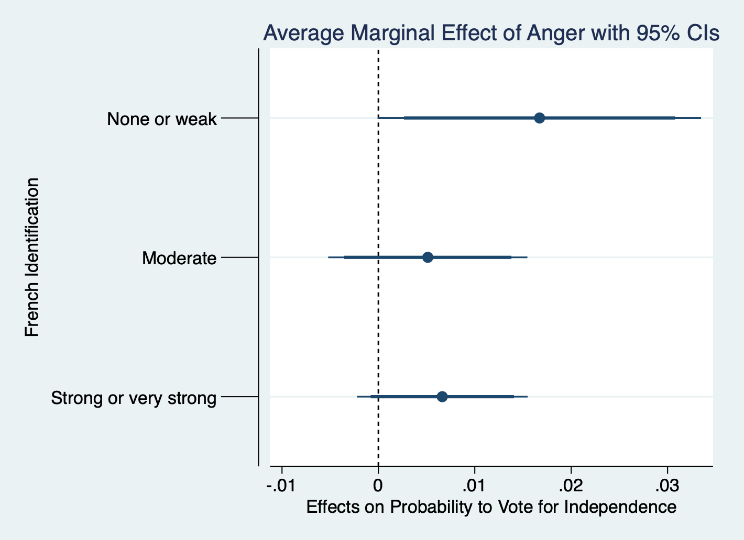

*Figure A1: Average marginal effects of anger towards the current status of New Caledonia on the independence vote conditional on the feeling of being a French citizen*

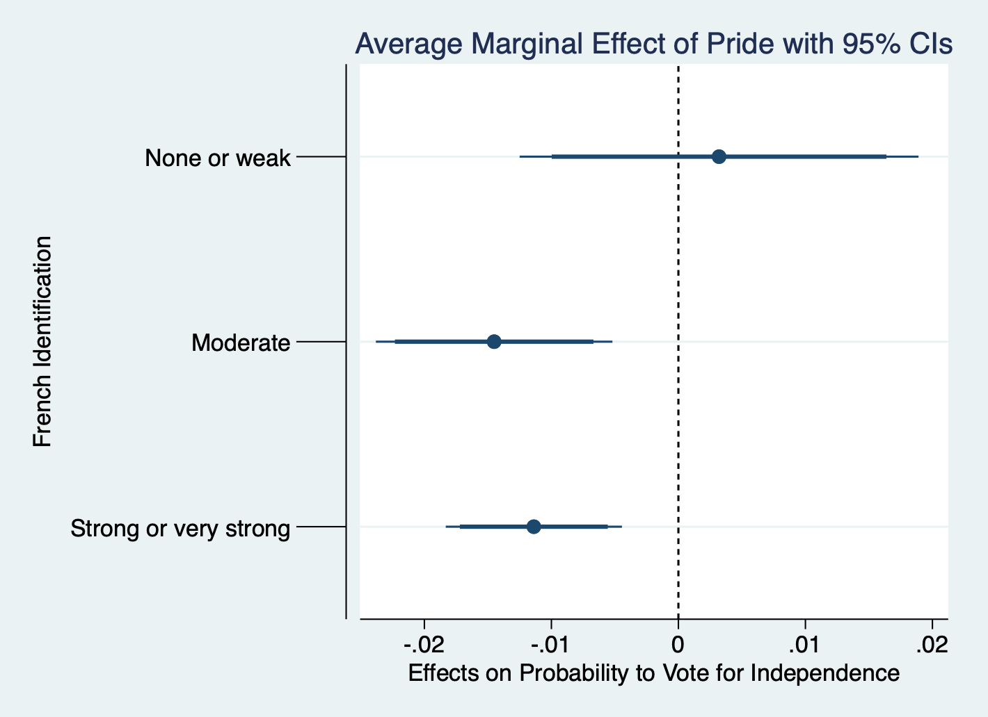

*Figure A2: Average marginal effects of pride towards the current status of New Caledonia on the independence vote conditional on the feeling of being a French citizen*

1. Corresponding author:

   Sylvain Brouard,

   98 rue de l’université,

   75007 Paris

   sylvain.brouard@sciencespo.fr
2. For example, electoral turnout peaked in Quebec and Scotland at the independence referendum (94% in 1995 and 85% in 2014, respectively).
3. We took this into account in our survey as we have a full sample and a sub-sample of eligible voters.
4. In the model presented, respondents with missing data are excluded from the analysis. In the appendix, we replicate the analysis including respondents with missing data in independent variables. The results of the two analyses are similar.
5. In the appendix we present the results also showing the category “Don’t know”
6. Table entries are odds ratios (with the standard errors of the logistic regression coefficients in parentheses). Odds ratios higher than 1 indicate an increase in the probability of having voted forthe independence of New Caledonia, while odds ratios lower than 1 indicate a decrease in the probability of having voted for the independence of New Caledonia. Source: CEVIPOF – Quid Novi Survey.
7. Table entries are odds ratios (with the standard errors of the logistic regression coefficients in parentheses). Odds ratios higher than 1 indicate an increase in the probability of having voted forthe independence of New Caledonia, while odds ratios lower than 1 indicate a decrease in the probability of having voted for the independence of New Caledonia. Source: CEVIPOF – Quid Novi Survey.