Nuclear Magnetic Resonance and Computational Study of trans-µ²:η², η²-1,3-butadiene-bis(trichloroplatinate(II))†
Imelda H. Silalahi^{a,b,}*, Alex P. Heyam^{a,}*, Christopher P. Goultª, Pedro Aguair^{a,c},
Peter B. Karadakov^{a,}* and Duncan W. Bruce^{a,}*
ª Department of Chemistry
University of York
Heslington
YORK YO10 5DD (UK)
Tel: (+44) 1904 324085
E-mail: duncan.bruce@york.ac.uk

^{b} Department of Chemistry
University of Tanjungpura
Jalan Prof. H. Hadari Nawawi,
PONTIANAK 78124
INDONESIA
E-mail: imelda.h.silalahi@chemistry.untan.ac.id

^{c} Present address:
Département de Chimie
Complexe des sciences
Université de Montréal
1375 Avenue Thérèse-Lavoie-Roux
Montréal (Québec)
H2V 0B3
CANADA

† Dedicated with great respect and affection to Pierre Dixneuf from Rennes, France, both for his outstanding contributions to organometallic chemistry over many years and also for having a truly visionary approach to the power and benefits of international links and collaboration.
Abstract:

The complex bis(tetrabutylammonium) trans-µ²:η², η²-1,3-butadiene-bis(trichloroplatinate(II)), identified from its X-ray single crystal structure, is formed when tetrabutylammonium hexachloroplatinate(IV) is irradiated in solution. In principle, the complex can exist in one of four conformers (combining cis and trans-isomers of the butadiene and syn and anti-arrangements of the two PtCl₃– moieties) and DFT calculations suggest that three of these ought to be stable in solution in CDCl₃. However, dissolving the anti, trans-conformer (identified both from the crystallography and ¹³C{¹H} MAS-NMR spectroscopy) in solution leads to the formation of a second conformer, identified by a combination of NMR experiments, in amounts that depend on the solvent used. Then, on standing in solution, a third species forms that contains a single PtCl₃– moiety. The identification and interconversion of these various species are discussed.
Graphic Abstract:

Introduction

Zeise's salt was one of the first organometallic complexes prepared nearly 200 years ago¹ and yet since that time, the reactivity of alkene complexes of the Group 10 metals has remained hugely topical. For example, palladium mediates many commercial applications of the use of alkenes, while platinum was involved in very early examples of C–H activation chemistry² and perhaps its most important catalytic application is in hydrosilylation chemistry where mechanistic questions still remain.³ Other, more contemporary areas of platinum -alkene catalysis relate to subjects such as hydroamination⁴ and cyclization reactions.⁵ As such and in the context of the utility of third-row congeners to provide mechanistic pointers, continued insights into aspects of stability and reactivity remain valuable and of direct interest to the wide research community in the area.

Thus, recently, we reported the very unexpected preparation of the anion trans-µ²:η², η²-1,3-butadiene-bis(trichloroplatinate(II)) (Fig. 1), formed via photolysis of solutions of [NBu₄]₂[PtCl₆] through a Shilov-type mechanism coupled with a Hoffmann elimination. We were able to determine its structure with precision for the first time using single crystal X-ray methods.⁴ Prepared as its potassium salt many years ago,⁶ its structure was proposed following a detailed study using infrared and Raman spectroscopy⁷ although a later crystallographic determination as its Me₃EtN⁺ salt provided very little information.⁸ Thus, as shown in Figure 1, the butadiene is s-trans with an anti-arrangement of the PtCl₃– moieties.

Despite the formally conjugated nature of its double bonds, the extent of delocalization in free butadiene is small. A combination of rotational spectroscopy and theory showed that in s-trans-butadiene the C=C bond is longer (1.338 Å) than the C=C bond in ethene by only 0.007 Å, while the C–C bond is shorter by 0.016 Å (at 1.454 Å) than that of a typical sp³-sp³ C–C single bond.⁵ Coordination, however, has a more profound effect on the bond lengths and, for example, a C=C distance of 1.403(7) Å and a C–C distance of 1.453(7) Å were found in 1. The comparison with the C=C bond distances in [Fe(CO)₃(η⁴-butadiene)] (ca 1.4196 Å)¹¹ and in Zeises's salt (1.375(4) Å)¹⁰ is interesting with extensive back-bonding in the former and very much less in the latter. If it is assumed that the extent of π-back bonding in Zeise's salt and in 1 are quite similar (which is entirely reasonable given the Pt^{II} oxidation state in both) then there is evidently much greater delocalization in the coordinated butadiene in 1 compared to the parent ligand.

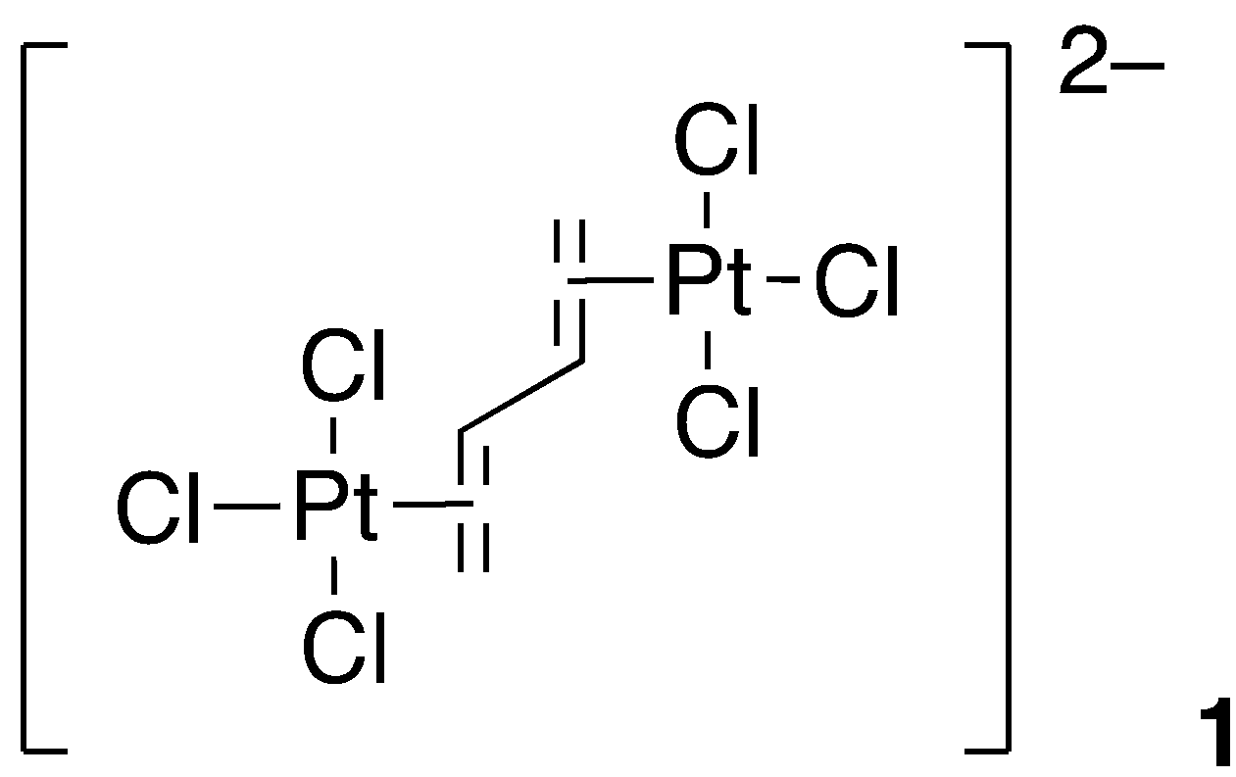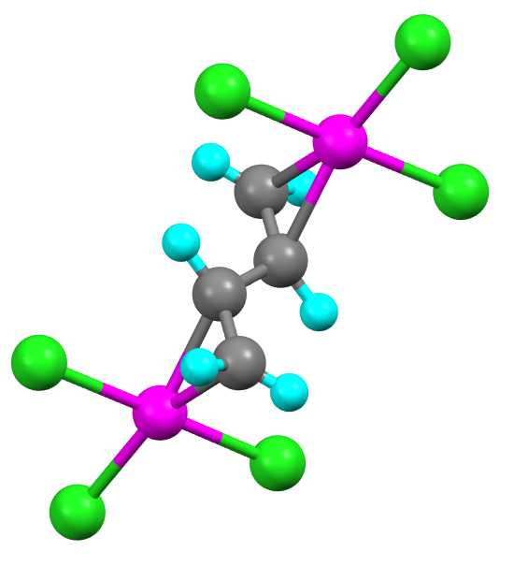
Figure 1 Molecular structure of the [Cl₃Pt(µ²:µ²-1,3-butadiene)PtCl₃]^{2–} dianion

While the anti, trans-conformer shown in Figure 1 was obtained consistently over several single crystal structure determinations, there are four possible conformers for this complex anion, some of which are found by NMR spectroscopy when the salt is placed into solution. The structure and occurrence of these conformers has been studied by a range of NMR methods supported by calculation, the results of which are now discussed.

Materials and Methods

Instrumentation

¹H NMR spectra were recorded using either Jeol ECS400 and Jeol ECX400 spectrometers operating at 400 MHz, a Bruker Avance 500 MHz spectrometer, or a Bruker Avance Neo 700 MHz spectrometer equipped with a nitrogen-cooled cryoprobe. Solid-state ¹³C{¹H} NMR spectra were acquired on a Bruker AVHDIII 400 MHz solids spectrometer (operating frequency 100.61 MHz for ¹³C) using a 4 mm probe. The magnetic field was referenced externally by recording the ¹³C{¹H} spectrum of a sample of adamantane and setting the downfield resonance to δ = 38.4 ppm. The samples were finely ground and packed between boron nitride plugs into a 4 mm ZrO₂ rotor fitted with a Kel-F drive cap. Cross-polarization, magic-angle spinning experiments were used to measure the ¹³C{¹H} spectra, which were processed using Bruker TopSpin 3.6.1 pl7. Two-dimensional (¹H, ¹H) and (¹H, ¹³C) spectra were recorded on the 700 MHz instrument at 298 K, and were referenced to the solvent signal. Selective TOCSY experiments (Bruker pulse program seldigpzs) used a DIPSI2 cycle and a mixing time of 120 ms. The 2D NOESY experiment used a mixing time of 2 s and a recycle delay of 3s, while the 1D selective NOESY experiments (Bruker pulse program selnogpzs.2) used a mixing time of 1.5 s and a recycle delay of 3 s. ¹⁹⁵Pt{¹H} and (¹H, ¹⁹⁵Pt) HSQC spectra were recorded on the 500 MHz spectrometer, and ¹⁹⁵Pt-NMR spectra were referenced to K₂[PtCl₆] in D₂O. Two-dimensional ¹⁹⁵Pt-¹H spectra were acquired using hmqcgpqf pulse program via heteronuclear zero and double quantum coherence with decoupling during acquisition using gradient pulses for selection. The processing of all spectra was carried out using either MestreNova or Topspin software.

Results and Discussion

The molecule 1,3-butadiene can exist as one of two conformers, s-trans and s-cis, and with two PtCl₃– moieties bound, the normal modes of alkene coordination would allow for four different conformers with the two Pt centers coordinated to the same (syn) or opposite (anti) faces, respectively (Figure 2). As noted above, isolation and characterization by X-ray methods always gave a single conformer, anti, trans (Fig. 2, 1.1) whereas solution NMR spectroscopy (see below) showed evidence for other conformers. Therefore, as a first step to understanding conformational preference, the relative energies of the four conformers (1.1 to 1.4) were calculated.

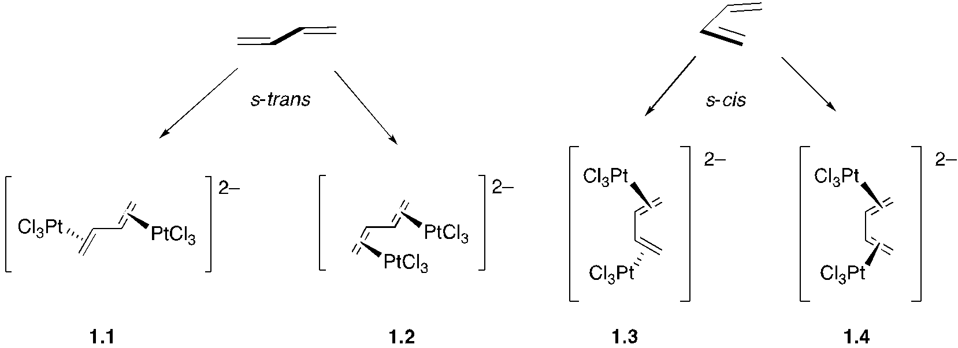
Figure 2 The conformers of platinum(II)-1,3-butadiene complexes

Quantum Chemical Calculations of the Different Conformers of Complex 1

In order to determine the energetically preferred species and obtain theoretical estimates of their properties, series of density functional theory (DFT) calculations on the conformers of the η²;η²-1,3-butadiene-bis(trichloroplatinate(II)) and 1,3-butadiene-trichloroplatinate(II) complexes were carried out using Gaussian 16.¹²

The geometries of the conformers were optimized at the PBE0-D3(BJ)/def2-TZVPP level of theory in chloroform, accounting for the solvent by means of the Gaussian 16 default self-consistent reaction field (SCRF) method, the polarizable continuum model (PCM) using the integral equation formalism variant (IEFPCM), with tighter convergence criteria, 'QConv=VeryTight' and 'SC=QConv=12'. Dispersion corrections were added through the empirical D3 corrections suggested by Grimme, with Becke-Johnson (BJ) damping; the def2-TZVPP basis includes effective core potentials (ECPs) for platinum and has been shown to work very well in the DFT context.¹³ All geometry optimizations were carried out under the 'VeryTight' convergence criteria; in all calculations use was made of the very dense 'SuperFine' integration grid. Analytical vibrational frequencies were calculated to ensure that the optimized geometries corresponded to local minima on the respective potential energy surfaces and to obtain the Gibbs free energies of the conformers. NMR shielding tensors were then calculated at the PBE0-GIAO/def2-TZVPP level of theory (PBE0 with gauge-including atomic orbitals), in chloroform, at the PBE0-D3(BJ)/def2-TZVPP optimized geometries in the same solvent. All optimized geometries and the corresponding isotropic NMR shieldings for all nuclei, which are related to their chemical shifts, are provided in the Supplementary Information. The geometry optimizations of the η²;η²-1,3-butadiene-bis(trichloroplatinate(II)) dianion produced three conformers, of the anti-trans- (1.1), anti-cis- (1.3) and syn-trans- (1.2) types. A preliminary smaller-basis PBE0-D3(BJ)/def2-SVP geometry optimization produced a fourth higher-energy syn-cis-conformer (1.4), but the PBE0-D3(BJ)/def2-TZVPP geometry optimization started from this syn-cis-conformer went back to the anti-trans-conformer (1.1), following rotation about the central carbon-carbon bond.

The optimized geometries for 1.1 to 1.3 in chloroform are shown in Figure 3, with the energies and geometric parameters being collected in Tables 1 and 2. The data, which will be considered again in the light of solution evidence from NMR spectroscopy, suggest that conformers 1.1 and 1.3 are the most stable and conformer 1.2 the least stable. Evidently the difference in stability between 1.1 and 1.2 arises from the electrostatic interactions between the charged moieties.

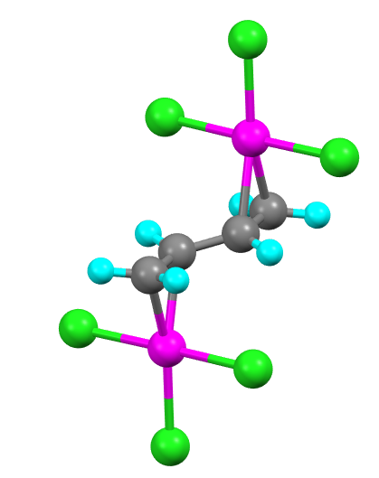  1.1 | 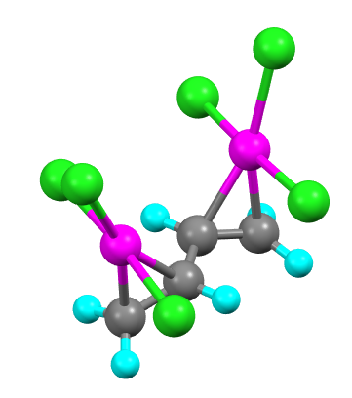  1.2
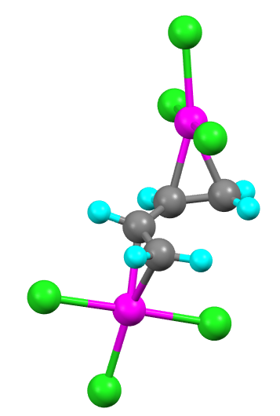
1.3
Figure 3 PBE0-D3(BJ)/def2-TZVPP optimized geometries of conformers 1.1 – 1.3 in chloroform.

Table 1: Energies, Gibbs free energies and lowest harmonic vibrational frequencies of conformers 1.1 – 1.3 (a = anti; s = syn, t = trans, c = cis) and of 1,3-butadiene-trichloroplatinate(II) conformers 2.1 and 2.2 calculated at the PBE0-D3(BJ)/def2-TZVPP level of theory in chloroform. Relative energies and Gibbs free energies of isomers 1.2 and 1.3 with respect to isomer 1.1, and of 2.2 with respect to 2.1, are also shown.
Conformer | E / Hartree | ΔE / kJ mol⁻¹ | G / Hartree | ΔG / kJ mol⁻¹ | ν / cm⁻¹
1.1 (a,t) | −3155.576967 | 0.0 | −3155.528730 | 0.0 | 36.4
1.2 (s,t) | −3155.570900 | 15.9 | −3155.520447 | 21.7 | 34.4
1.3 (a,c) | −3155.574354 | 6.9 | −3155.524525 | 11.0 | 53.1
2.1 (t) | −1655.722069 | 0.0 | −1655.668939 | 0.0 | 70.3
2.2 (c) | −1655.717173 | 12.9 | −1655.664708 | 11.1 | 46.8

Table 2: Key bond distances and angles from the geometries of the conformers of 1.1 – 1.3 and of 2.1 and 2.2 optimized at the PBE0-D3(BJ)/def2-TZVPP level of theory in chloroform and from the crystal structure of isomer 1.1.
Conformer | r(Pt-C)/Å | r(C=C)/Å | r(C-C)/Å | a (C=C-C)/° | Torsion (C=C-C=C)/°
1  (crystal structure) | 2.068 | 1.423 | 1.464 | 120.7 | 180.0
1.1 (a,t) | 2.105/2.155 | 1.400 | 1.466 | 123.5/122.9 | 178.0
1.2 (s,t) | 2.092/2.147 | 1.405 | 1.469 | 121.8 | 129.2
1.3 (a,c) | 2.109/2.153 | 1.397 | 1.471 | 126.5 | 9.9
2.1 (t) | 2.154/2.102 | 1.331/1.403 | 1.458 | 122.4/124.4 | 162.8
2.2 (c) | 2.148/2.107 | 1.328/1.400 | 1.466 | 124.7/125.3 | 29.4

Theoretical results clearly identify the anti-trans conformers as the most stable ones, consistent with X-ray data, with small differences in ΔE and ΔG between 1.1 and 1.3, and with the energy difference with 1.2 arising mainly from electrostatic effects. For example, whereas 1.1 and 1.3 show torsion angles in the alkene unit close to those in trans- and cis-1,3-butadiene, respectively, the torsion angle in the syn-trans conformer 1.2 is 129.2°. The lowest harmonic vibrational frequencies of all conformers are small which suggests relatively flat potential energy surfaces around the optimal geometries.

As expected, the geometry optimizations of the 1,3-butadiene-trichloroplatinate(II) anion produced two conformers, involving trans- (2.1) and cis- (2.2) 1,3-butadiene moieties. The optimized geometries for 2.1 and 2.2 in chloroform are shown in Figure 4, with the energies and geometric parameters being collected in Tables 1 and 2.

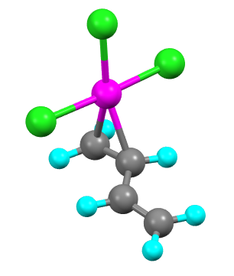  2.1 | 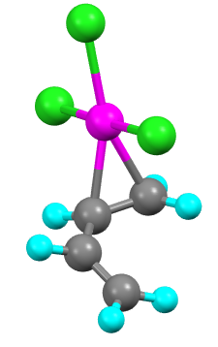  2.2
Figure 4 PBE0-D3(BJ)/def2-TZVPP optimized geometries of 1,3-butadiene-trichloroplatinate(II) conformers 2.1 and 2.2 in chloroform.

¹H-NMR Spectra of Complex 1

¹H NMR spectra (labelling scheme in Figure 5) of freshly dissolved complex 1 show that a mixture of species is present, regardless of the solvent used (Figure 6) and six signals are seen between 4 and 6 ppm, representing two different species. Deduced using coupling constants and multiplicities, the H(X, X’) protons have chemical shifts around 5.7 ppm, while H(A, A’) falls in the range 4.3-4.9 ppm, and H(M, M’) falls between 3.9 and 4.5 ppm. The ratio of the two species varies between solvents: it is approximately 100:30 in CDCl₃, 100:8 in CD₂H₂, and 100:1 in acetone-d6.

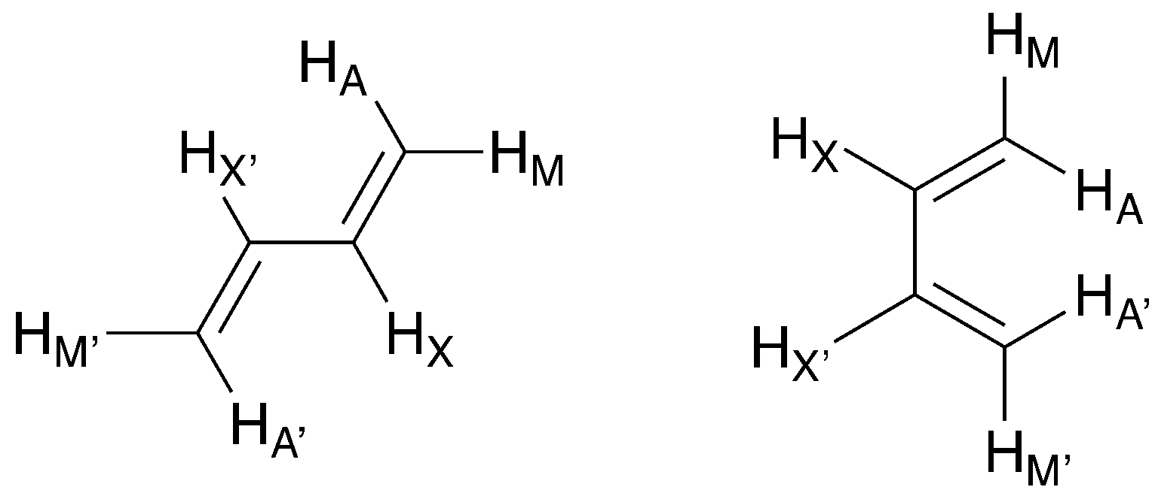
Figure 5 Labelling of the hydrogen atoms used in the ¹H NMR spectra assignment.

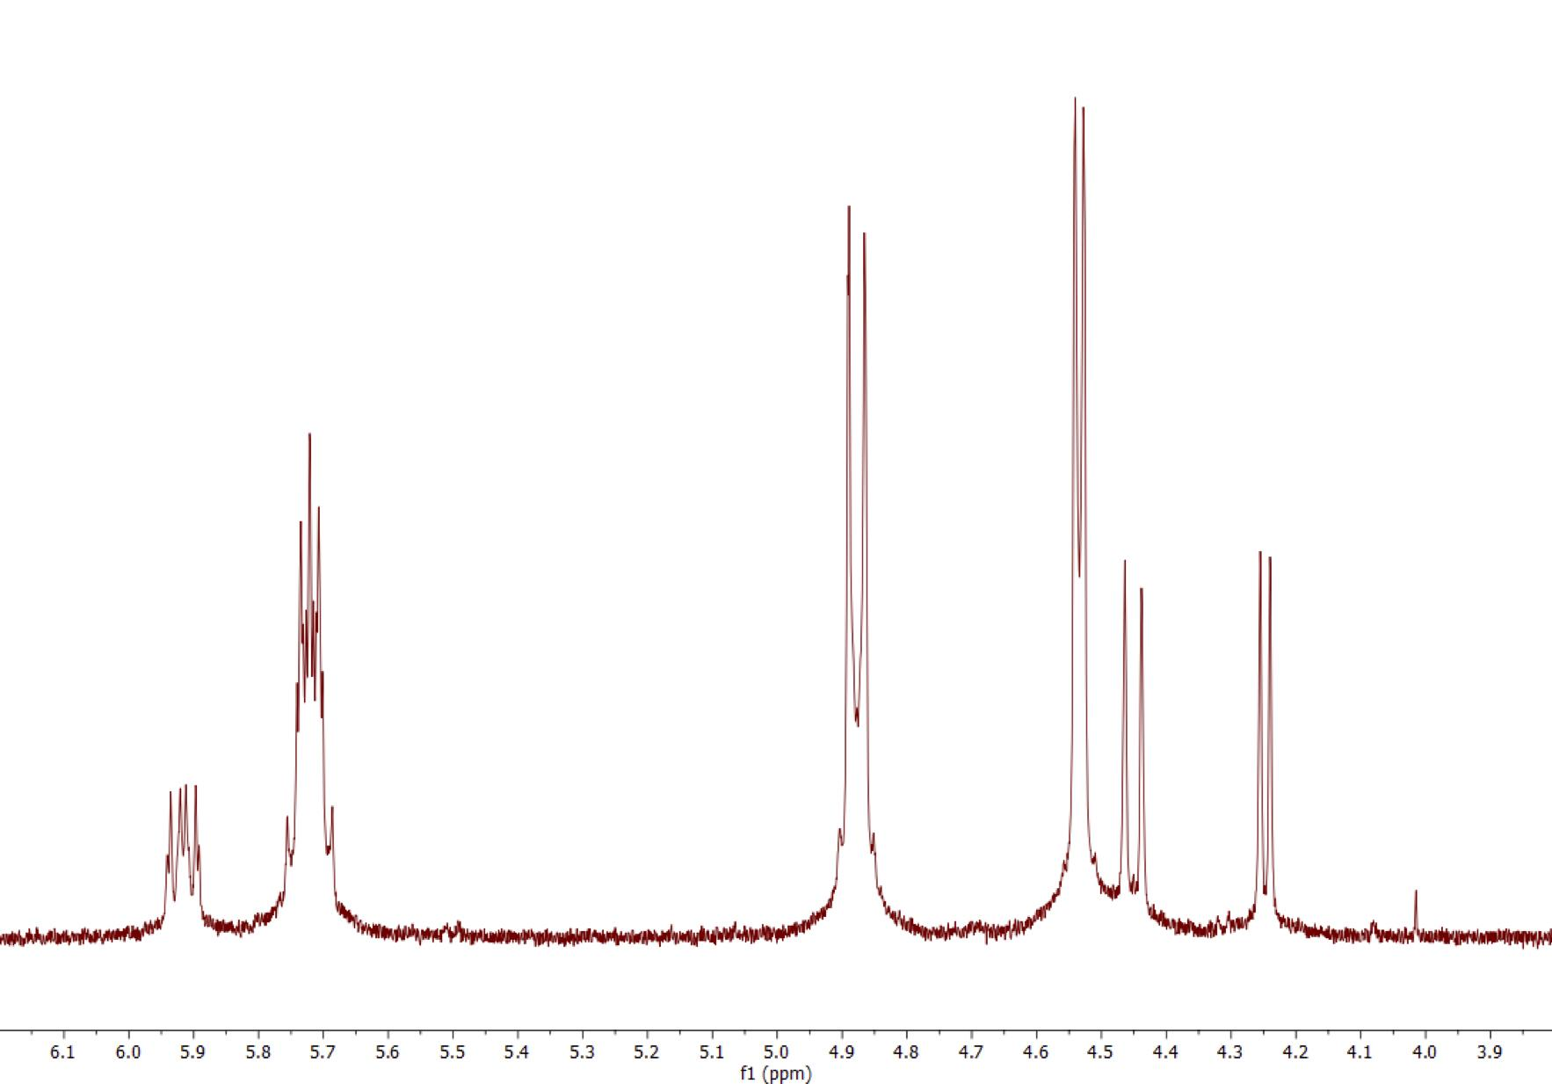 (a)
B
B
B
A
A
A
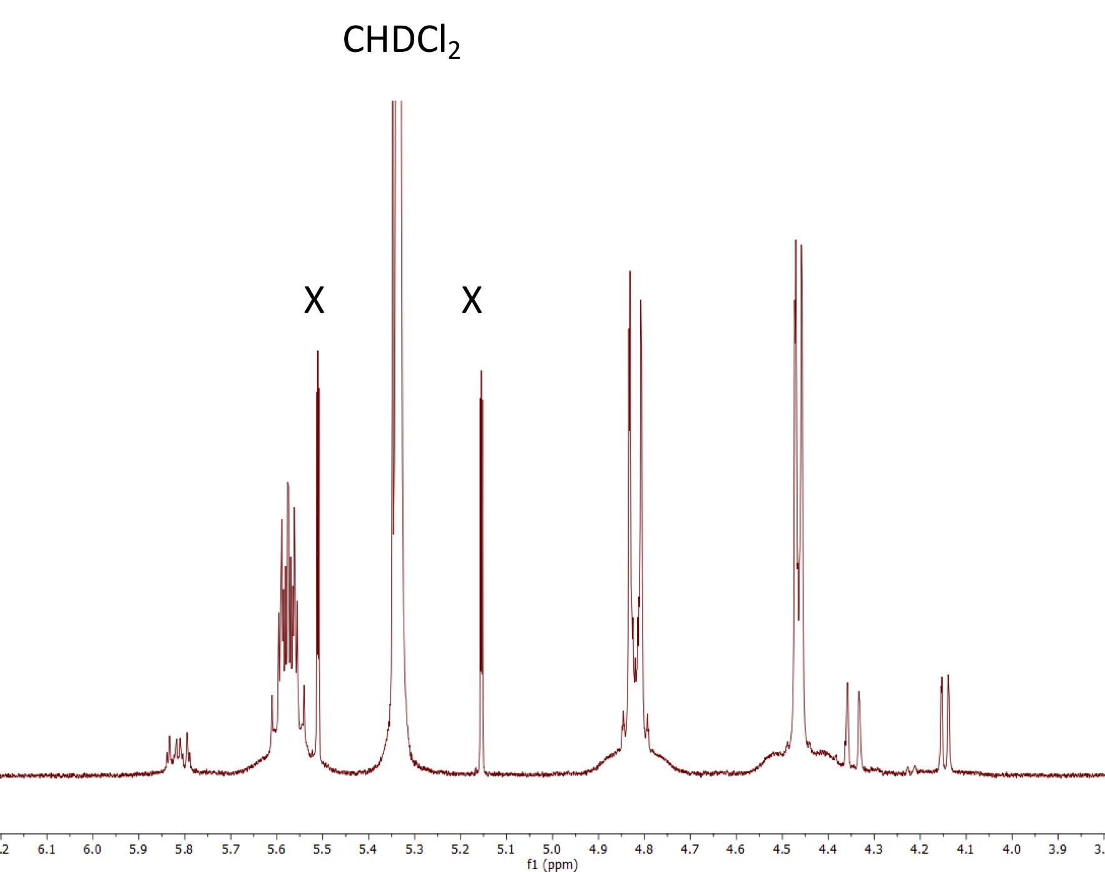 (b)
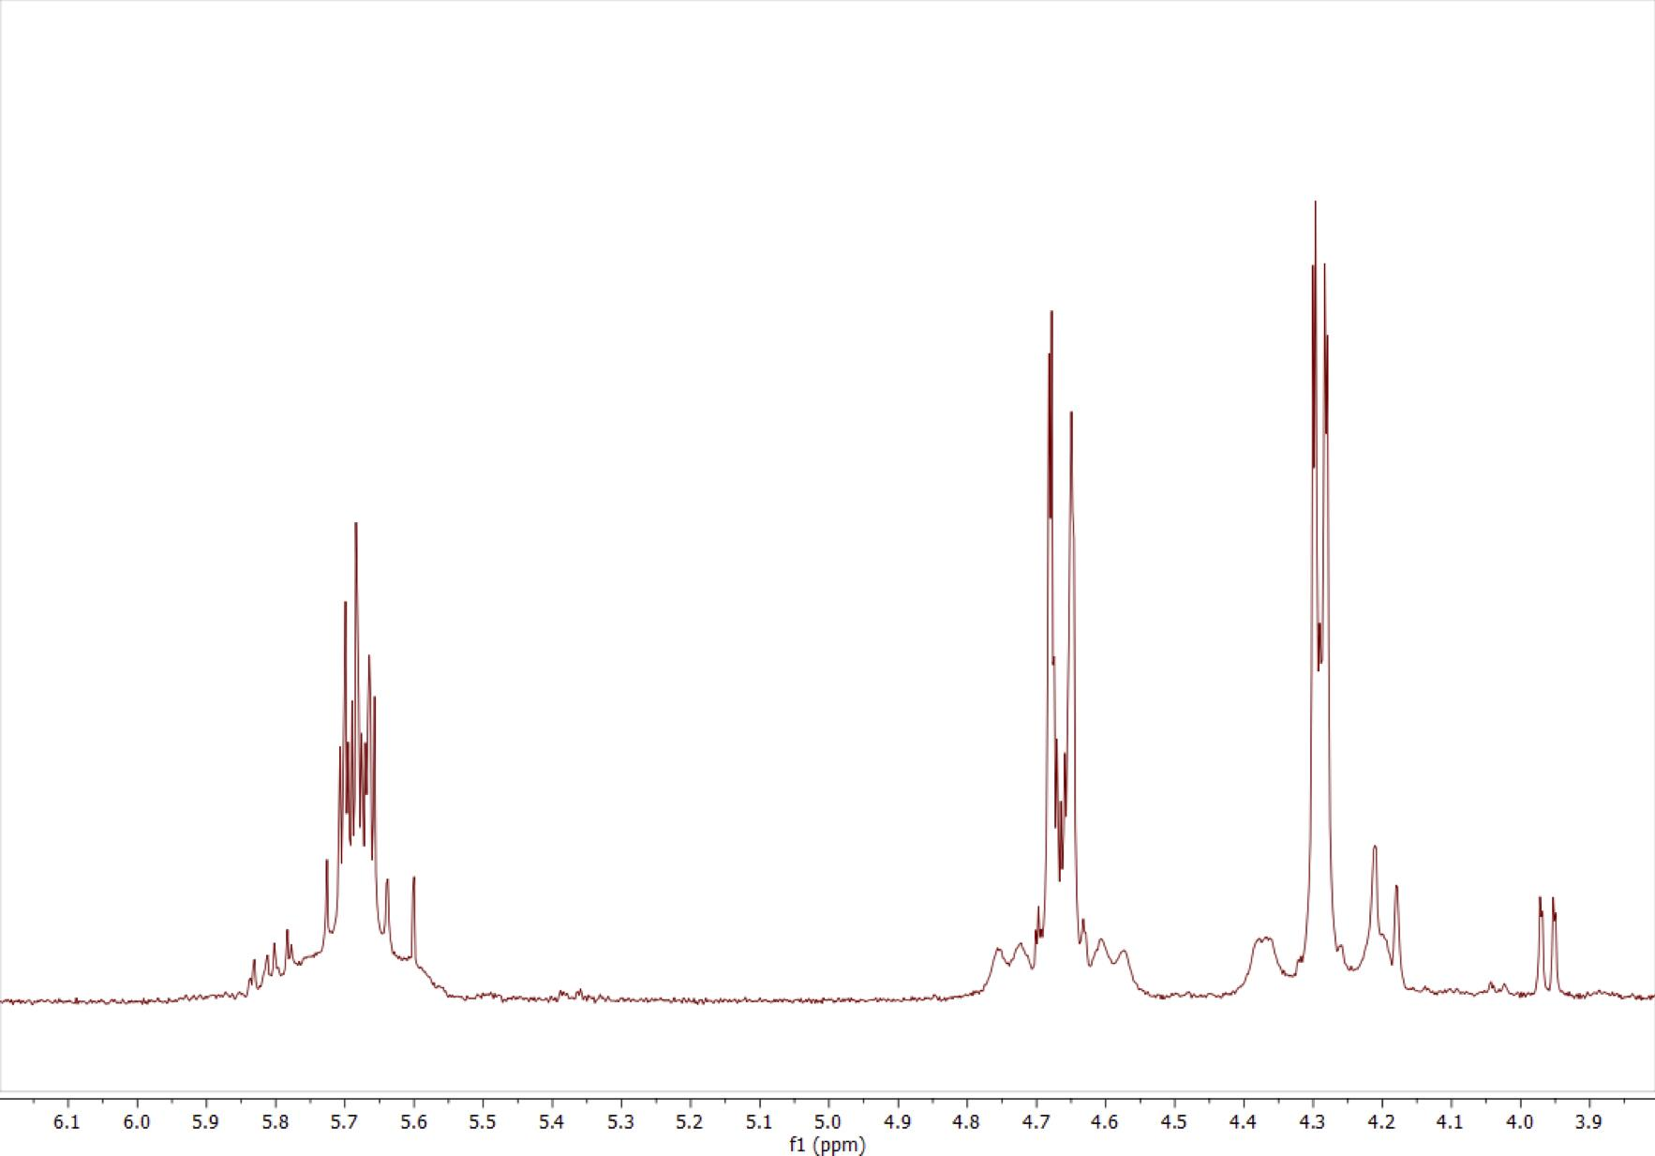 (c)
Figure 6 ¹H NMR spectra (400 MHz) of 1 dissolved in (a) CDCl₃; (b) CD₂Cl₂ (X = ¹³C satellites); and (c) acetone-d6, all plotted with the x-axis on the same scale.

The most abundant species (labelled A in Figure 6) shows a doublet at δ = 4.57 ppm with an apparent J = 7.0 Hz and another doublet at δ = 4.91 ppm with an apparent J = 12.9 Hz (the peaks are distorted due to the strong coupling of H_{X} to H_{X’}, so the true coupling constant cannot be measured directly from this spectrum). In addition, there is a complex, second-order multiplet at δ = 5.75 ppm. Similar chemical shifts and couplings are observed in the other solvents and are collected in Table 3.

The resonances at δ = 4.43 and 4.78 ppm (Figure 6b; CD₂Cl₂) show a broadening at their base associated with coupling to ¹⁹⁵Pt (I = 1/2, ca 33%), while in Figure 6c in acetone -d6, this is better resolved; note that no coupling is apparent in CDCl₃. From the acetone spectrum (Figure 6c), J_{Pt–H(A)} is approximately 58 Hz, while J_{Pt–H(M)} is evaluated at 65 Hz. These are rather similar to the value of 66.8 Hz found for Zeise's salt.¹⁴

Table 3: Chemical shifts (δ) and apparent coupling constant (J) of the butadiene protons recorded
in CD₂Cl₂ at 295 K, acetone-d6 and CDCl₃ at 298 K.
 | δ / ppm (CD₂Cl₂) |  | δ / ppm (acetone-d⁶) |  | δ / ppm (CDCl₃)
 | 1.1 | 1.3 | 1.1 | 1.3 | 1.1 | 1.3
δ (H_{X,} H_{X’}) | 5.53 | 5.78 | 5.67 | 5.80 | 5.75 | 5.94
δ (H_{A,} H_{A’}) | 4.78 | 4.30 | 4.65 | 4.19 | 4.91 | 4.48
δ (H_{M,} H_{M’}) | 4.43 | 4.18 | 4.28 | 3.95 | 4.57 | 4.28
 | Apparent J / Hz
³J(H_{A,} H_{X}) = ³J(H_{A’,} H_{X’}) | 12.8 | 13.2 | 12.8 | 13.2 | 13.2 | 13.5
³J(H_{M,} H_{X}) = ³J(H_{M’,} H_{X’}) | 7.1 | 7.6 | 6.4 | 7.6 | 7.9 | 8.5
²J(H_{A,} H_{M}) = ²J(H_{A’,} H_{M’}) | 1.2 | Unseen | 1.2 | 0.8 | 0.8 | 0.3

To determine the conformation, the ³J(H_{X}, H_{X’}) coupling constant was measured using a (¹H, ¹³C) HSQC experiment without decoupling in the direct dimension. As the most common isotopomers have ¹³C at only one site, the chemical equivalence between the two protons is broken and the multiplet is simplified. This gave ³J(H_{X}, H_{X’}) = 11.2 Hz, consistent with a trans geometry. The other coupling constants then represent ³J_{MX} (7.9 Hz – cis coupling) and ³J_{AX} (13.2 Hz – trans coupling). Evidence for the trans geometry is also provided by 2D NOESY data (Figure 7b), which show that H_{X} protons are in close proximity to H_{A} protons (more precisely, between H_{X} and H_{A’}, and between H_{X’} and H_{A}). It is reasonable to assume that these signals correspond to the trans, anti-conformer (1.1), consistent with the most stable geometry in all of the calculations above and the conformer determined consistently by crystallography.

In CDCl₃, the second set of signals (labelled B in Figure 6) are approximately 30% of the intensity of the first and again show two doublets (δ = 4.28, 4.48 ppm) and a second-order multiplet (δ = 5.94 ppm). The apparent coupling constants of the doublets are 7.5 and 12.7 Hz, respectively and from the coupled HSQC, the ³J(H_{X}, H_{X’}) coupling constant was measured to be 2.9 Hz, consistent with a cis geometry. Supporting this, no NOE is observed between H_{X} and H_{A} in the NOESY spectrum (Figure 7). Taking into account the energies calculated from DFT, this species most likely represents the cis, anti-conformer (1.3). The intensity of these signals precluded observation of coupling to ¹⁹⁵Pt.

When the complex was stored in solution in the dark for 17 days, the ratio of the two species changed, and a number of new signals appeared (Figure 8; spectra recorded in CD₂Cl₂ and acetone-d⁶ are in the Supplementary Information) as Figure S3), suggesting that the original two species were converting into one or more additional forms. In order to determine the identity and conformation of the different species in solution, 1D and 2D NMR experiments were carried out on a sample dissolved in CDCl₃. This led to the assignment shown in Figure 8.

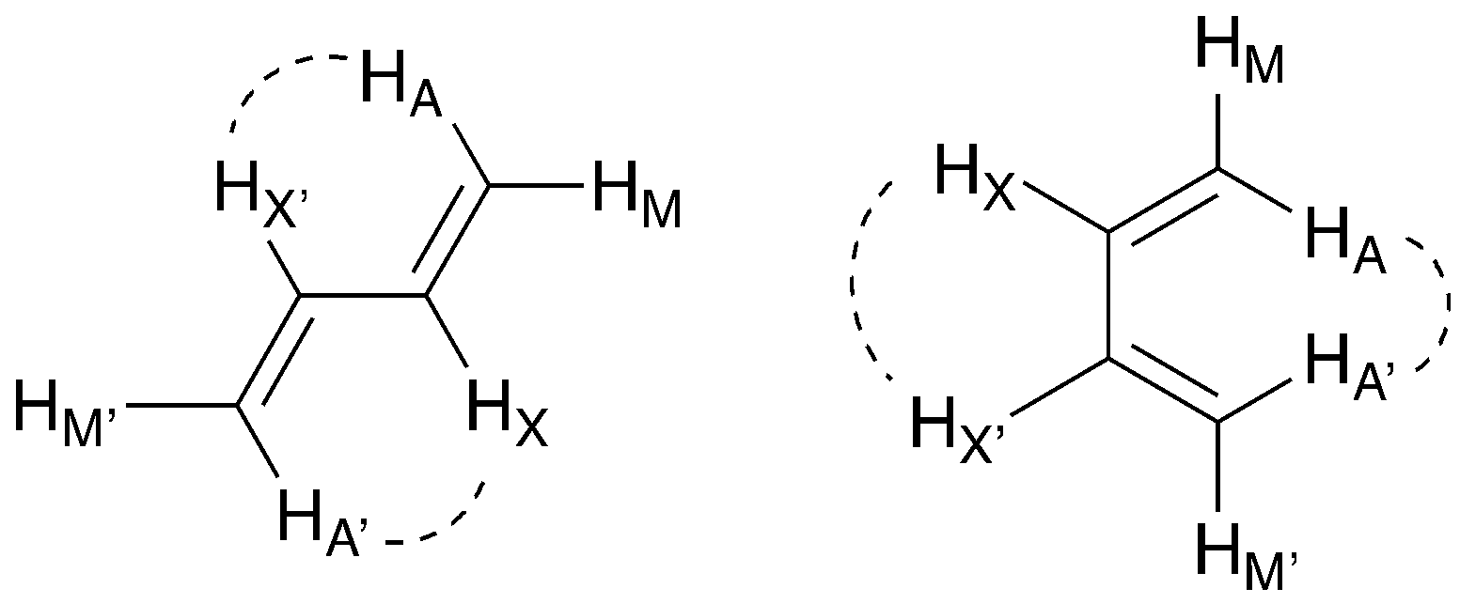 (a)
(b)
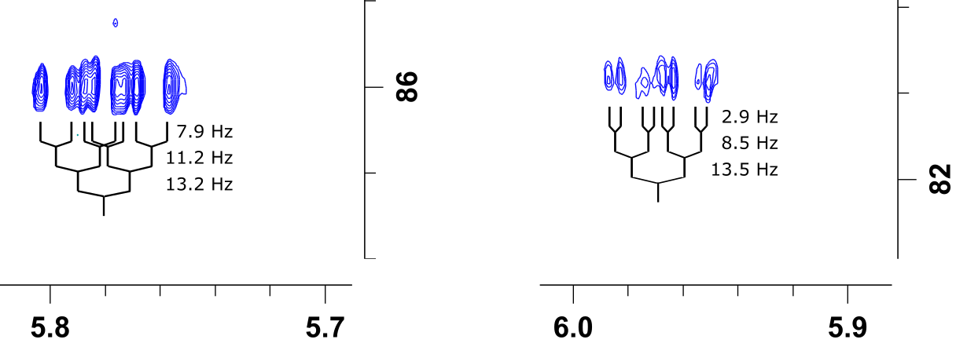 (c)
Figure 7: (a) Characteristic NOEs for the trans and cis conformations of butadiene; (b) 2D NOESY spectrum of complex 1 in CDCl₃ at 298 K. The 1D proton spectrum is shown on each axis. Dashed boxes show the regions where (H_{X}, H_{A’}) and (H_{X’}, H_{A}) cross peaks could be observed for each species. Both possible cross peaks are present for species A (conformer 1.1), providing evidence for a trans conformation. No cross peaks are observed for species B (conformer 1.3), indicating a cis conformation. Species C shows 2 of the 4 expected cross peaks, suggesting a trans conformation. Note that the spectrum also shows evidence for slow exchange between states A and C, and that some negative cross peaks arise through a combination of exchange and NOE; (c) Regions from a high-resolution HSQC (without ¹³C decoupling during acquisition) of compound 1 in CDCl₃. H_{X} multiplets for conformer 1.1 (left) and 1.3 (right) are shown, together with couplings. The presence of a single ¹³C in the molecule breaks the symmetry of the two H_{X} sites, allowing simple multiplets to be observed and couplings measured.

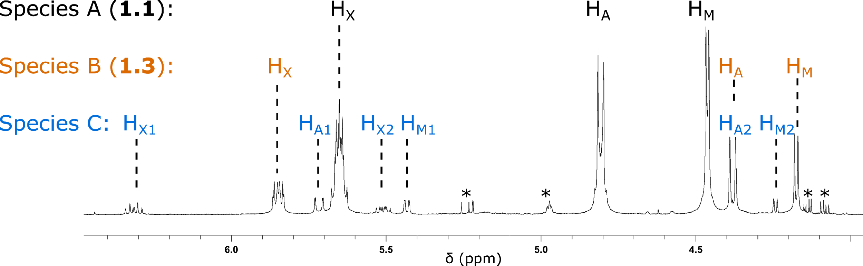
Figure 8: ¹H NMR spectrum of complex freshly dissolved in CDCl₃ after storage as a solid. The most abundant species is labelled A, the next most abundant as B, the newly formed state is C.

The additional signals in the stored samples can be divided into two groups. One set (marked * in Figure 8) give no signals in 2D spectra and cannot be assigned. However, selective TOCSY and COSY spectra show that six of the new peaks (Species C in Figure 8) originate from a single species (Figure 9, Figure S4). All of these signals are simple multiplets, suggesting they represent a conformation of the complex in which all protons have distinct chemical environments. The relative concentration of the three states started at a ratio A : B : C of 68.5 : 21.9 : 9.6, but after further ageing had changed to 56.5 : 18.6 : 24.8, which is global terms is a loss of A in favor of formation of C., with relatively little net change in B.

The chemical shifts and couplings for the minor species are tabulated below (Table 4). The H_{X2}, H_{A2} and H_{M2} hydrogens have similar chemical shifts to the same hydrogens in the other states, but the chemical shifts of the hydrogens assigned as H_{X1}, H_{A1} and H_{M1} have increased by approximately 1 ppm.

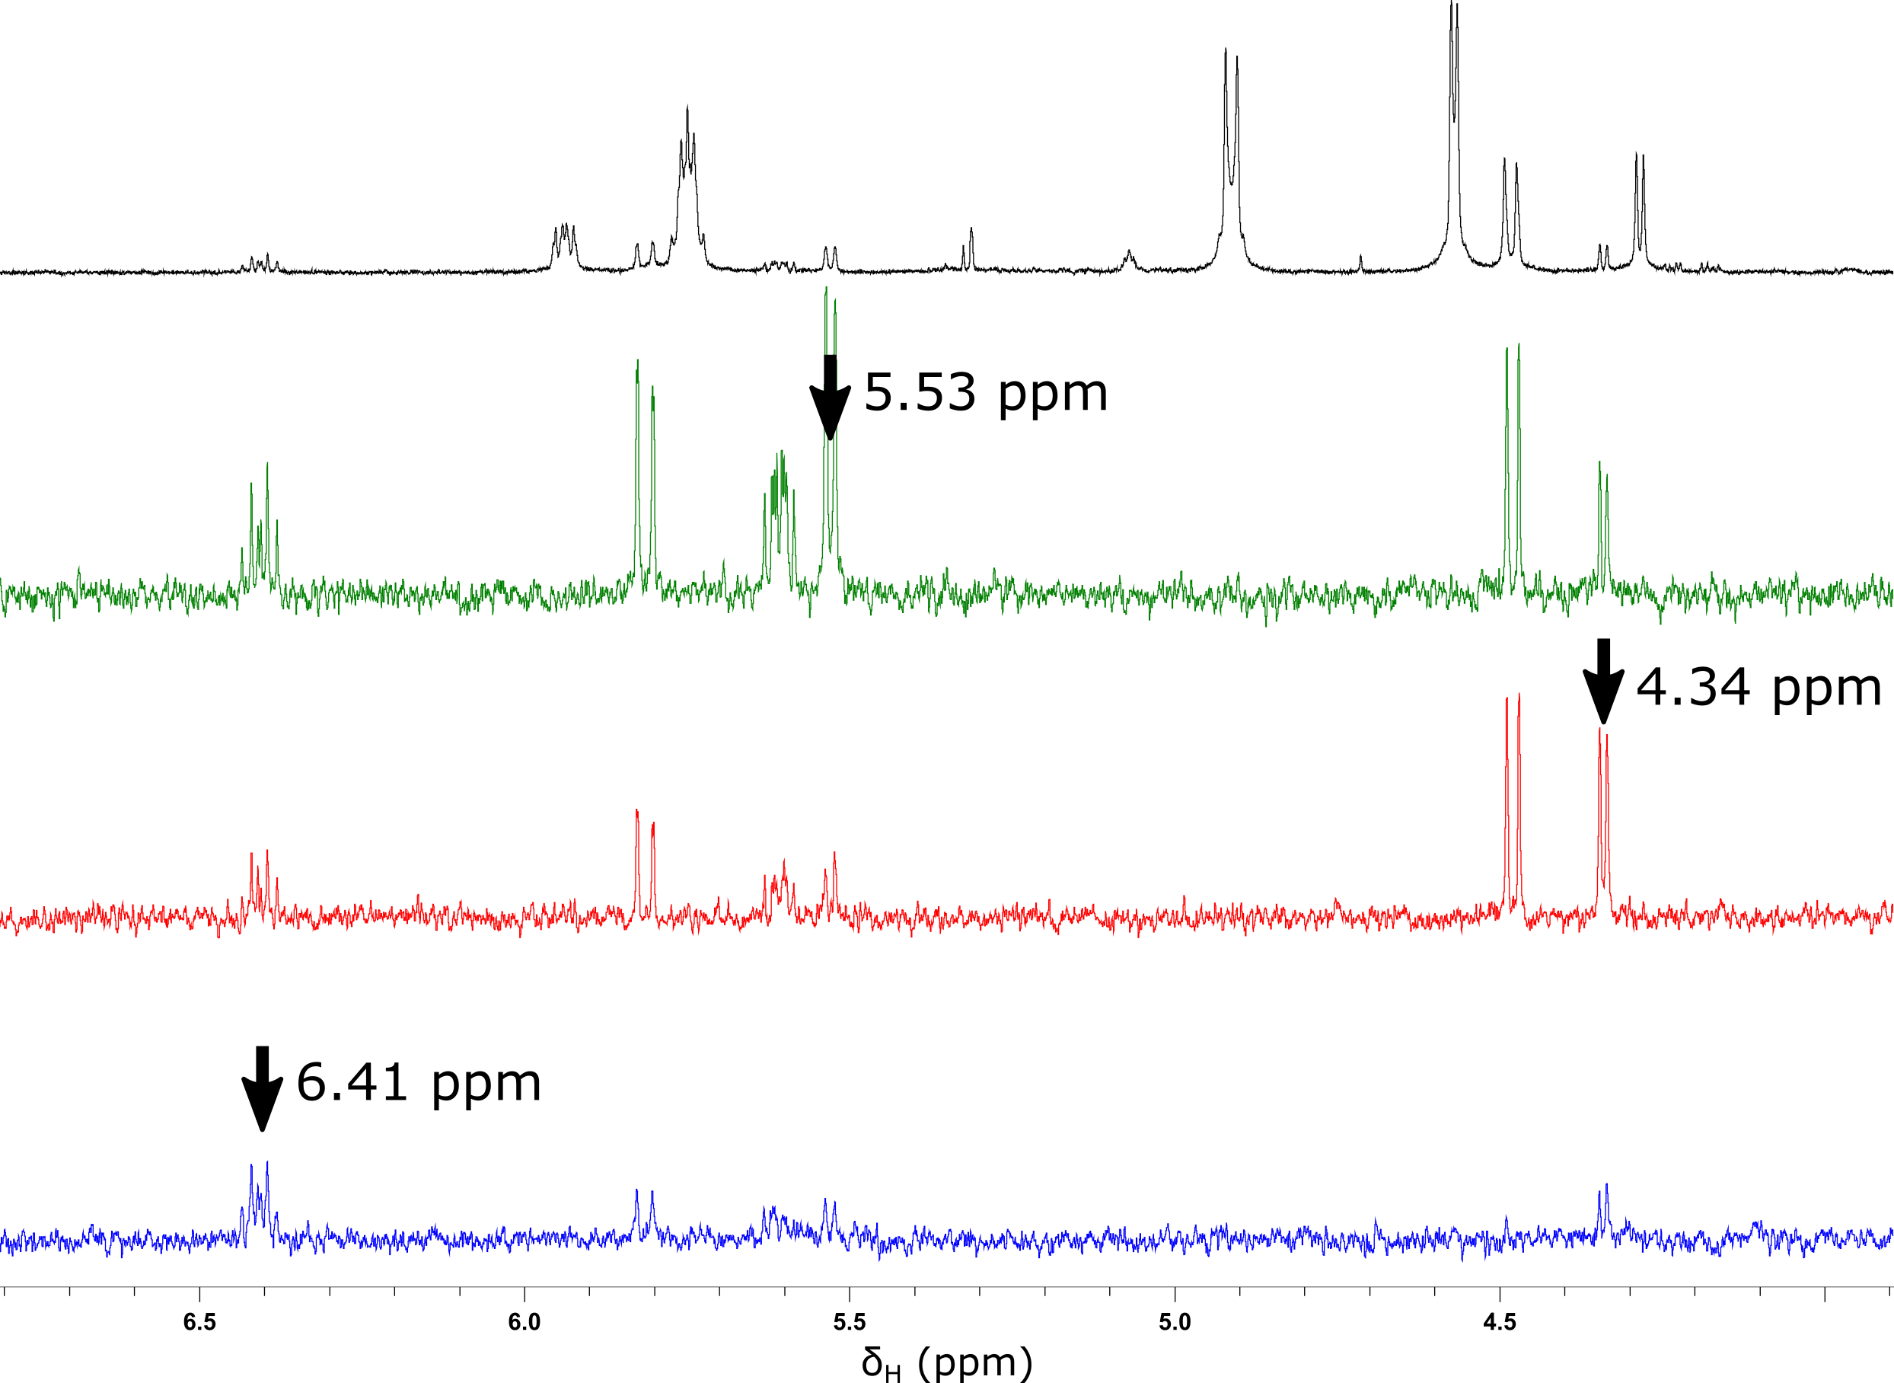
Figure 9: ¹H NMR spectrum of complex 1 in CDCl₃ at 298 K in black, followed by selective TOCSY spectra (arrows indicate the excitation frequency).

Table 4: Chemical shifts (δ) and coupling constant (J) of the minor species recorded in CDCl₃ at 298 K.
 | δ / ppm |  | J / Hz
A₁ | 5.81 | X₁-A₁ | 17.1
M₁ | 5.53 | X₁-M₁ | 10.0
X₁ | 6.41 | X₁-X₂ | 10.5
A₂ | 4.48 | A₁-M₁ | 1.6
M₂ | 4.34 | X₂₋A₂ | 13.1
X₂ | 5.61 | X₂-M₂ | 7.0

The data collected suggest that the unsymmetric conformer most likely represents a trans-like conformation of butadiene. Thus, the ³J(X₁, X₂) coupling of 10.5 Hz is more similar to the 11.2 Hz ³J(X, X’) coupling in the symmetric trans, anti-conformer 1.1 than to the 2.9 Hz coupling in the cis, anti-conformer 1.2. In addition, 1D and 2D NOESY spectra (Figure 7, Figure S5) show weak NOEs between protons X₂ and A₁, and between X₁ and A₂, although these are only just above the noise level and are partly missing in the 2D experiment. However, no NOEs are observed between X₁ and X₂ or between A₁ and A₂, as would be predicted for a cis conformation. It should be noted that the NOESY also shows slow exchange between the unsymmetric conformer and the most populated trans, anti-conformer, causing the appearance of cross peaks which represent exchange plus NOE.

The asymmetry of the third state implies that the equivalence of the two ethenyl units is broken and so to investigate further, ¹³C chemical shifts of the three states were compared to literature data. Poor signal-to-noise prevented direct measurement of this spectrum and so a projection of the HSQC onto the ¹³C axis is shown as Figure 9.

These data show that for one half of the minor species C, the ¹³C chemical shifts are similar to those of the identified anti, trans- (A, 1.1) and anti, cis- (B, 1.3) conformers, while for the other two carbons they increase dramatically by roughly 50 ppm. Comparison with the literature shows that the terminal =CH₂ carbon of free butadiene has a chemical shift of 117.5 ppm in CDCl₃, whereas the other =CH– carbon has a shift of 138.1 ppm – extremely close to the experimental values of 117.0 and 140.1 ppm in the above spectrum.¹⁵ The ¹H chemical shifts associated with these down-field shifted carbons are also increased, but do not match those of the free diene as precisely: the measured values are 5.53 ppm (M₁), 5.81 ppm (A₁) and 6.41 ppm (X₁) against values of 5.06, 5.16 and 6.27 ppm for the free diene. Thus, it is proposed that Species C has lost a PtCl₃– unit to form the unsymmetric monoanion 2 shown in Figure 10 and it is then likely that two PtCl₃– units come together to form the dimeric dianion [Pt₂Cl₆]^{2–} as there is no evidence of decomposition to Pt metal in these stored solutions. Calculations (vide supra) suggest that the trans-isomer is more stable than the cis, which is consistent with the experimental data from the NMR experiments.

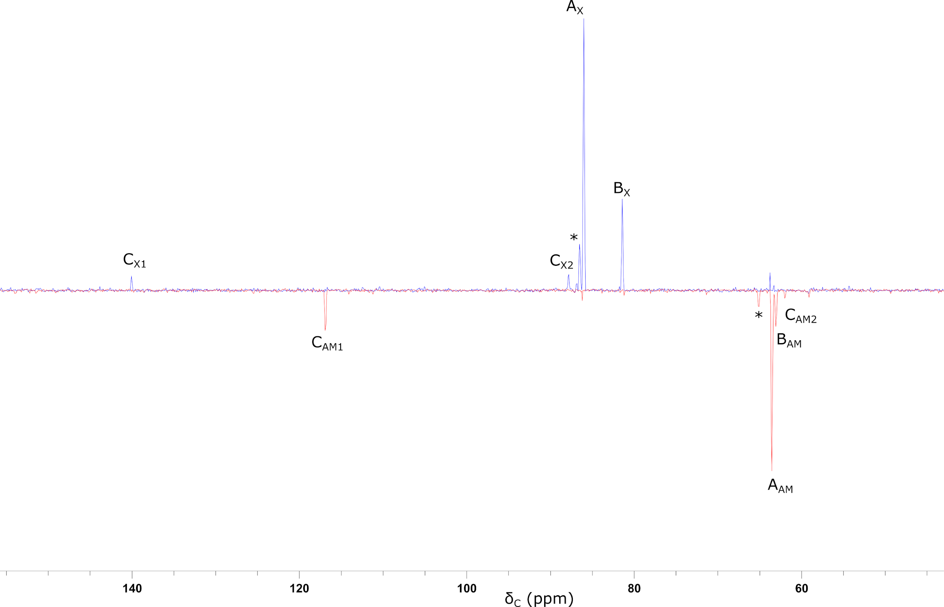 (a)
(b)
Figure 9 (a) ¹³C projection of HSQC spectrum of aged complex 1 in CDCl₃. Only the region between 4 ppm and 6.5 ppm in the proton dimension was used for the projection. Peaks marked with * do not show coupling in COSY spectra and cannot be assigned; (b) ¹H spectrum of a solution-aged sample of 1 at 700 MHz in CDCl₃ showing evidence of coupling to ¹⁹⁵Pt for hydrogen M₂ and X₂ and its absence for A₁, X₁ and M₁.

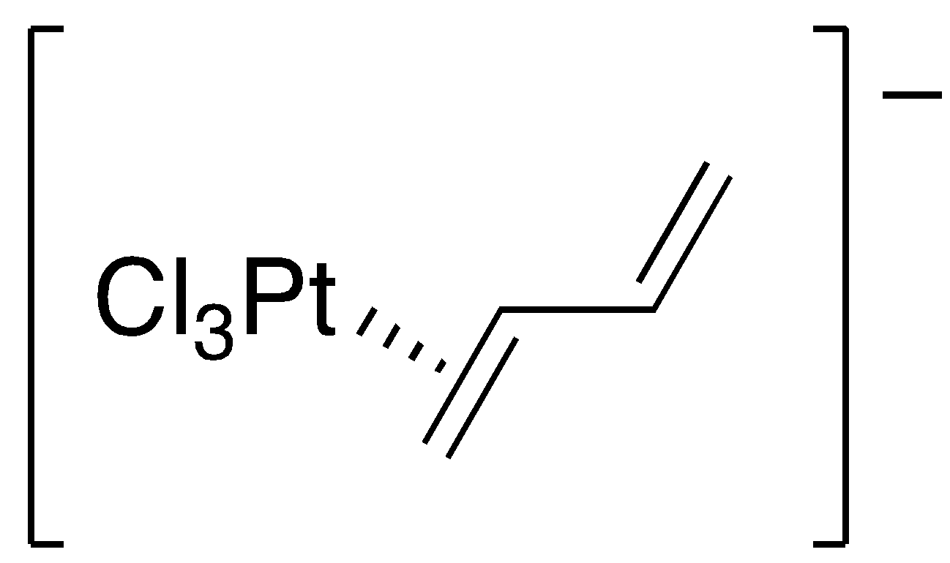
Figure 10 Proposed structure of the unsymmetric complex C, consistent with the observed NMR data.

Support for this proposal comes from two observations. First is that on ageing a solution of 1 in acetone-d6, over time significant quantities of 2 are generated and so a ¹H NMR spectrum was recorded at 700 MHz (Figure 9b). Here it was possible to observe coupling to ¹⁹⁵Pt for M₂ and X₂ (A₁ and A₂ are masked by overlapping) while there is evidently no coupling to ¹⁹⁵Pt for M₁ and X₁, thus supporting the proposed identity of 2. Owing to the possibility for interaction with the 6p_{z} and 5d_{z2} orbital, the chemical shift in complexes of Pt^{II} is very solvent-dependent. The Pt in [Pt₂Cl₆]^{2–}resonates is found at δ = –1171 ppm in D₂O and δ = –1164 ppm in CD₂Cl₂. Recording the ¹⁹⁵Pt NMR spectrum of the same aged solution showed a resonance at δ = –1072 ppm, which is attributed as the dimeric chloro-bridged complex.

¹⁹⁵Pt NMR

The spectra, recorded in acetone-d6, are shown in Figures 11 and 12. The 1-D spectrum clearly showed a signal at δ = −2521 ppm, while the two-dimensional spectra revealed another signal at δ =−2591 ppm. The chemical shift at −2521 ppm correlated to the hydrogen resonances at δ = 5.6, 4.6 and 4.4 ppm thus it was assigned to the platinum in conformer 1.1 while the signal at −2591 ppm correlated with hydrogens resonating at δ = 5.8, 4.3 and 4.1 ppm that corresponded to the platinum in conformer 1.3. The shifts are in the range expected for olefin-platinum(II) complexes (−2370 to −3640 ppm)¹² and are very similar to that found for Zeise’s salt was reported to be in the range δ = −2791 to −2743 ppm depending on the cation and the solvent used.¹⁶⁻¹⁸

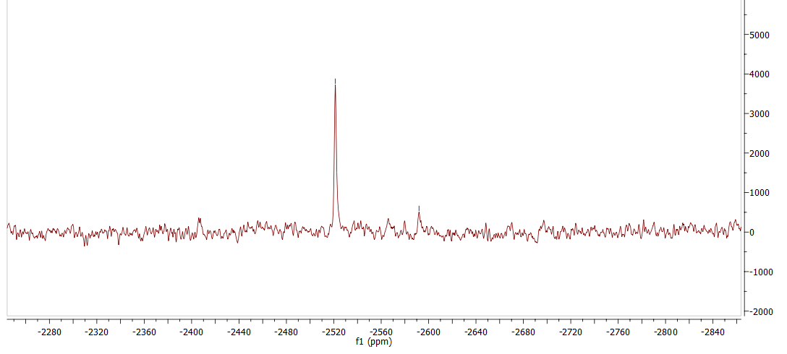
Figure 11: ¹⁹⁵Pt{¹H} NMR spectrum (107 MHz) of the complex 1 in acetone-d6 at 298 K.

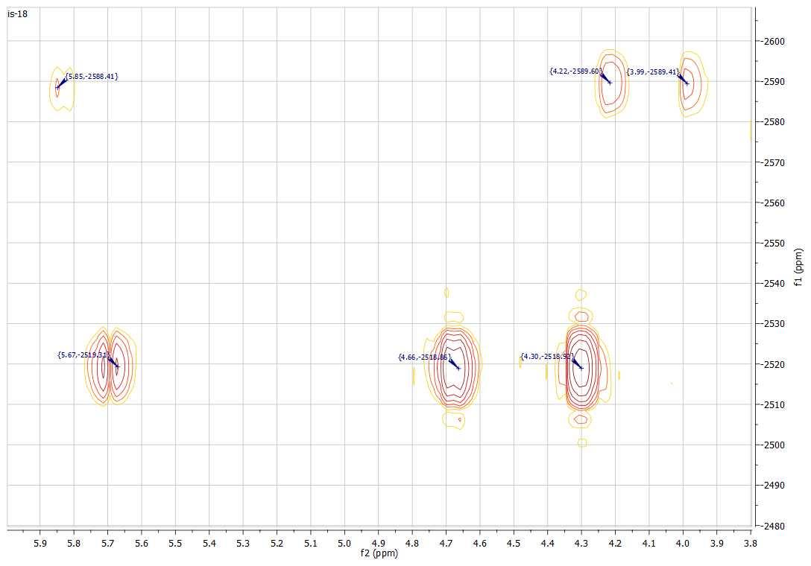
Figure 12: 2D ¹⁹⁵Pt-¹H NMR spectra (107 MHz) of the complex 1 in acetone-d6 at 298 K.

¹³C{¹H} MAS-NMR Spectra

In the course of the study of 1, the complex was prepared on many occasions and the X-ray single crystal structure was determined several times with the anti, trans-conformer always being found. However, while the NMR spectra acquired above used materials that had been crystallized and found to be pure by combustion analysis, it was not absolutely possible to be sure that these crystalline materials also contained 1 as a single, anti, trans-conformer. This is potentially important for as noted above, on dissolution and recording of ¹H NMR spectra, at least two conformers are immediately apparent in solution and the possibility that the crystalline (as opposed to single-crystalline) material contains more than one conformer cannot be excluded. Therefore, crystalline material from three different preparations, portions of which had been used in solution NMR experiments, were combined and the solid-state ¹³C{¹H} NMR spectrum was acquired (Figure 13).

At a rate of 10 kHz, the spinning speed is greater than the anisotropy of each environment in the complex and so the spectrum does not exhibit side bands and is readily interpreted. It shows a collection of resonances in the approximate range δ = 15-30 ppm for three of the alkyl carbons of the NBu₄⁺ cation and another resonance at δ ≈ 60 ppm corresponding to the methylene of the butyl group next to the quaternary nitrogen. There are then two resonances at δ = 65.11 ppm and δ = 86.57 ppm that correspond to the bound butadiene ligand, with the former resonance being assigned as arising from the terminal methylene carbon and the other the internal methine carbon. This assignment is consistent with the chemical shifts in [Fe(CO)₃(cis-butadiene)] which are 41.96 and 85.86 ppm for the methylene and methine hydrogens, respectively.¹⁹ The presence of a single set of signals is consistent with the presence of a single conformer as found by X-ray crystallography.

Spectra were also acquired at two other spinning speeds (3 and 4 kHz), in which spinning side bands were observed. These spectra are found in the Supplementary Information.

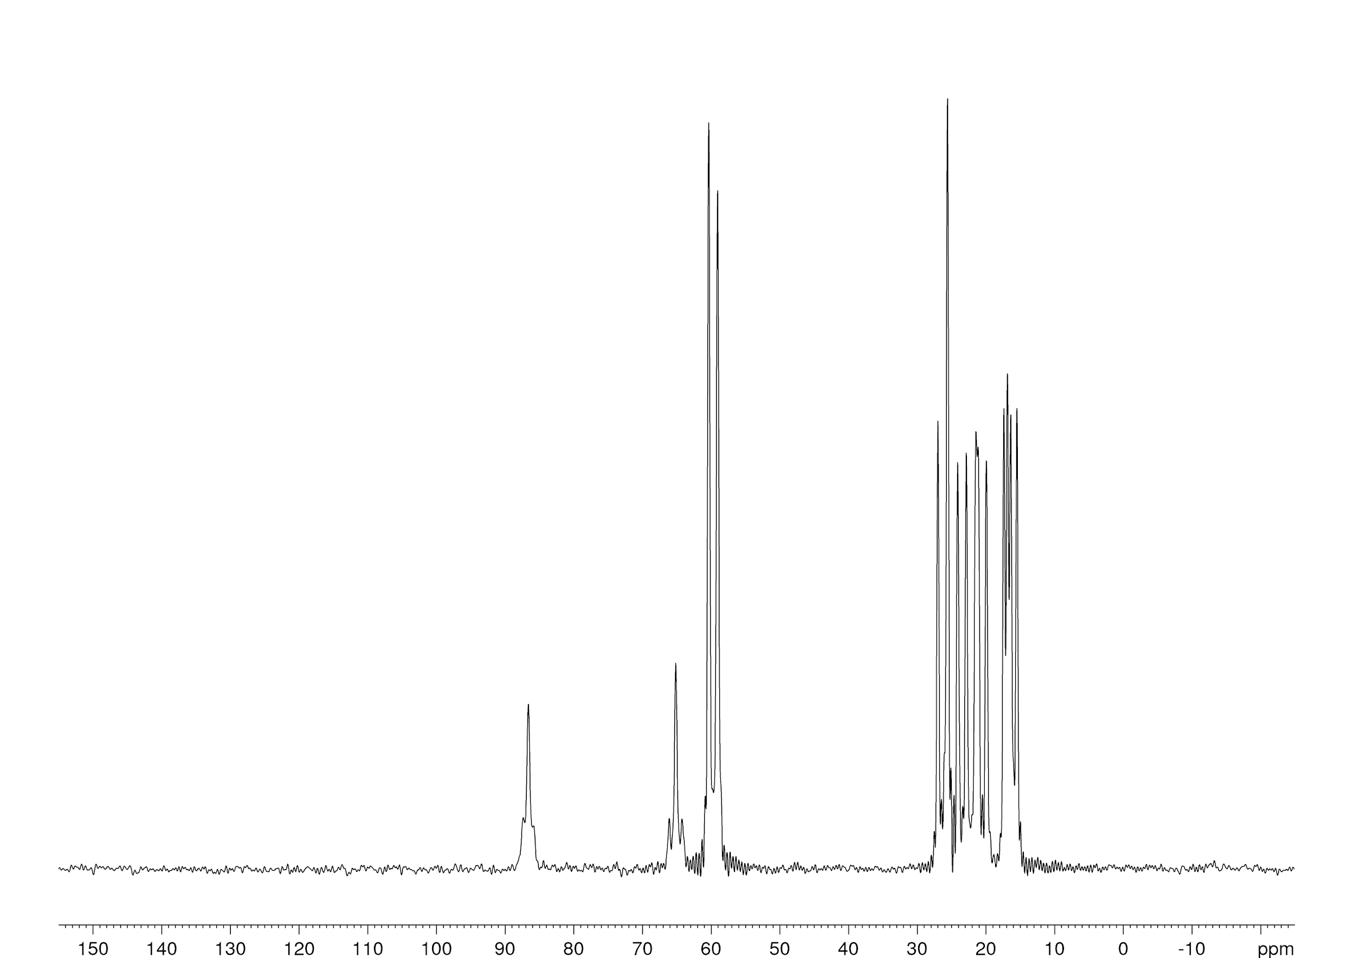
Figure 13 ¹³C{¹H} MAS-NMR spectrum (100.6 MHz) of 1 at a spinning speed of 10 kHz.

Discussion

As noted earlier, in an unusual photochemically induced process, [NBu₄]₂[PtCl₆] reacts to extrude a C4 unit from the cation, reduce the Pt^{IV} to Pt^{II} and hence form the complex that is the subject of this work, namely trans-µ²:η², η²-1,3-butadiene-bis(trichloroplatinate(II)) – 1. On crystallization on multiple occasions, single crystal X-ray methods showed that the solid state of this complex is found as the trans, anti-conformer (1.1), despite the possible existence of three other conformers. Studied by DFT methods, only two of the other three conformers appeared stable in solution (trans, syn – 1.2 and cis, anti – 1.3), with the sterically crowded cis, syn-conformer (1.4) rotating during minimization to give 1.1. The calculated stabilities in chloroform were 1.1 > 1.3 > 1.2. Characterization of the crystalline complex by ¹³C{¹H} MAS-NMR spectroscopy also shows only conformer 1.1.

On dissolution in CD₂Cl₂, CDCl₃ or acetone-d6, ¹H NMR spectroscopy immediately shows the presence of two distinct species, whose relative proportions depends on the solvent used, being most abundant in CDCl₃ (100:30) and least abundant in acetone-d6 (100:1). By analyzing the measurable couplings and complementing these data with NOESY experiments, it was possible to identify the more abundant conformer as having a trans-geometry of the butadiene fragment and informed by the calculated relative stabilities, this was assigned as the trans, anti-conformer 1.1. The same NMR experiments identified the other species as having a cis arrangement of the butadiene and with calculations implying that the cis, syn-conformer (1.4) was unstable with respect to 1.1, then the second species was identified as the cis, anti-conformer 1.3. At no point in this work was there evidence for the formation of 1.2 and while some spectra did show small amounts of other material in solution, the signals were insufficiently intense to identify them.

However, while the identities of the two species formed on dissolution of the crystalline material are clear enough, what is not clear is how conformer 1.3 forms seemingly so readily from 1.1.

It was then observed that on standing over several days on solution, extra signals appeared in the ¹H NMR spectra of solutions of 1 of which six were more intense. Three of these signals appeared at chemical shifts similar to the hydrogens of conformers 1.1 and 1.3, but the others, while similar in appearance, were shifted downfield by ca 1 ppm. COSY and selective TOCSY experiments showed that all six hydrogens belonged to the same species. Acquisition of the ¹³C spectrum via an HSQC experiment then showed that while the chemical shifts of the carbon atoms associated with the higher-field set of signals were as expected for an η²-alkene complex of Pt^{II}, the chemical shift of the other two carbons was reminiscent of free butadiene. This led to the assignment of the new species (2) as butadiene with only one of its double bonds bound to a PtCl₃– moiety, the other having dissociated. NOESY spectra implied a trans geometry for the double bond, which is consistent with the calculations above, which predicted the trans form (2.1) being more stable than the cis (2.2).

What the NMR spectra also showed was that there was a slow exchange between 1.1 and 2, and 1.3 and 2 and also 1.1 and 1.3. It is perhaps these observations that give a clue to the formation of 1.3 on dissolution of crystalline 1.1 and ultimately of 2. Thus, simple rotation about the formal C–C single bond in 1.1 would lead to the conformer 1.4, which calculation suggests is unstable in chloroform. However, were that rotation to take place, then a species akin to 1.4 would be approached which would be sterically extremely crowded. The steric strain would be most easily relieved by rotation in the opposite direction (effectively a libration about the C–C bond), but conceivably the strain could also be relieved if a PtCl₃– unit were to dissociate. Such a dissociation could have two consequences. First, dissociation could be total, which would lead to the formation of 2 and [Pt₂Cl₆]^{2–}, detected as noted above, while another possibility is that while still in an intimate state, what is now complex 2 could isomerize its butadiene backbone before the PtCl₃– moiety re-coordinates to form 1.3. Thus, the re-coordination would be consistent with the observed direct exchange between 1.1 and 1.3 perhaps suggesting that the in intermediate state of 2 plus 'PtCl₃–' the species remain in intimate contact. Exchange between 2 and both 1.1 and 1.3 would then reflect the alternative pathway where PtCl₃– 'escapes' during this process forming 2, suggesting that perhaps the intermediate direct exchange between 1.1 and 1.3 may imply that there are two closely related mechanisms. Interestingly, what is in effect an equivalent reverse reaction was observed by Steinborn et al., who showed that the dimeric anion [Pt₂Cl₆]^{2–} was cleaved by alkynes (as opposed to the alkene in this paper) to give monomeric species [PtCl₃(η²-alkyne)]–.²⁰ Furthermore, it may well be the case that this exchange and isomerization of 1.1 is promoted by the solvent binding to the vacant coordination site on PtCl₃– unit as on dissolution, the amount of 1.3 relative to 1.1 is solvent-dependent, decreasing as CDCl₃ > CD₂Cl₂ > acetone-d6.

To probe this aspect further and as detailed in the Supplementary Information, the loss of a PtCl₃– moiety from 1.1 is calculated to be endergonic by ca 78 kJ mol^{–1}, which is reduced to 62.0 kJ mol^{–1} if the PtCl₃– is stabilized by binding (through Cl) of a molecule of CHCl₃. Of course, the complete reaction also sees formation of [Pt₂Cl₆]^{2–} which is enthalpically and entropically favorable, but despite this the overall Gibbs free energy change remains positive, reducing only slightly to 53.9 kJ mol^{–1}. In reality, while these calculations were performed in a CHCl₃ solvent field, it is possible that there are some quite specific discrete solvent-solute interactions at play that we are unable to capture with the current standard computational approach and so we draw no conclusions from these calculations.

Conclusion

While reported many years ago, the diplatinum(II) complex trans-µ²:η², η²-1,3-butadiene-bis(trichloroplatinate(II)) (1) was characterized fully very recently having been formed in a photochemically initiated reaction between the NBu₄⁺ cation and [PtCl₆]^{2–}. A study of 1 by ¹H, ¹³C and ¹⁹⁵Pt NMR spectroscopy and supported by DFT calculations, shows that of the four possible conformers (1.1 to 1.4), only three are likely to exist in solution. While X-ray single crystallography and ¹³C{¹H} MAS-NMR spectroscopy show the presence of a single conformer (anti, trans – 1.1) in the solid state, ¹H NMR spectroscopy shows both 1.1 and 1.3 (identified by selective decoupling and 2D experiments) in solution. The relative proportions of 1.1 and 1.3 are dependent on the solvent used (greatest amount of 1.3 in CDCl₃ and then CD₂Cl₂ with the least observed in acetone-d6). Then, with time, a new species appears with six different hydrogens. This is assigned to a trans-butadiene with one PtCl₃– moiety coordinated (2), identified one the basis of ¹H and (particularly) ¹³C chemical shifts, and by the observation of coupling to ¹⁹⁵Pt in only one half of the molecule. A mechanism for the formation of 1.3 from 1.1 and form formation of 2 is proposed, supported by the observation of exchange processes in 2D NMR experiments. It is anticipated that this insight will be of wider interest and benefit to those concerned with mechanistic aspects of platinum and palladium chemistry.

Acknowledgement

IHS thanks the Indonesian Ministry of Education Directorate General of Higher Education (DIKTI) for a scholarship and the authors thank Dr Jason Lynam and Professor Ian Fairlamb (York) for valuable discussions and Dr Linda McAllister for preliminary calculations.

References

- Zeise, W.C. Von der Wirkung zwischen Platinchlorid und Alkohol, und von den dabei entstehenden neuen Substanzen, Ann. Phys. Chem., 1831, 97, 497–541.
- Shteinman, A.A. Shilov alkane platinum chemistry: 45 years, J. Organomet. Chem., 2015, 793, 34-40; Labinger, J.A.; Bercaw, J.E. Mechanistic Studies on the Shilov system: A retrospective, J. Organomet. Chem., 2015, 793, 47-53.
- See e.g. Rivero-Crespo, M.; Oliver-Meseguer, J.; Kapłónska, K.; Kústrowski, P.; Pardo, E.; Pedro Cerón-Carrasco, J.; Leyva-Pérez, A. Cyclic metal(oid) clusters control platinum catalysed hydrosilylation reactions: from soluble to zeolite and MOF catalysts, Chem. Sci., 2020, 11, 8113–8124.
- Bender, C.F.; Brown, T.J.; Widenhofer, R.A. Mechanism of the Platinum(II)-Catalyzed Hydroamination of 4-Pentenylamines, Organometallics, 2016, 35, 113-125.
- Nguyen, H.; Gagné, M. R. Enantioslecrtive Cascade Clyclization/protodemetalation of Polyenes with N₃Pt²⁺ catalysts, ACS Catal., 2014, 4, 855-859; McCulley, C.H.; Geier, M.J.; Hudson, B.M.; Gagné, M.R.; Tantillo, D.J. Biomimetic Platinum-Promoted Polyene Polycyclizations: Influence of Alkene Substitution and Pre-cyclization Conformations, J. Am. Chem. Soc., 2017, 139, 11158-11164.
6. Slade, P. E.; Jonassen, H. B., Olefin Coordination Compound. III. Coordination Compounds of Butadiene with Platinum (II), Palladium (II) and Copper (I) Halides. J. Am. Chem. Soc. 1957, 79, 1277.
7. Grogan, M. J.; Nakamoto, K., Far-Infrared Spectra of Metal-Olefin Complexes. Inorg. Chim. Acta 1967, 1 (2), 228.
8. V.C.Adam; Jarvis, J. A. J.; Kilbourn, B. T.; Owston, P. G., Crystal and Molecular Structure of the Butadiene Complex [NMe₃Et]₂[Pt₂Cl₆(C₄H₆)]²⁻. Chem. Commun. 1971, 467.
9. Silalahi, I. H.; Sethi, N. K.; Shafikov, M. Z.; Chechik, V.; Whitwood, A. C.; Bruce, D. W., Unexpected, photochemically induced activation of the tetrabutylammonium cation by hexachloroplatinate(IV). Chem. Commun. 2018, 54 (97), 13682-13685.
10. Craig, N. C.; Groner, P.; McKean, D. C., Equilibrium Structures for Butadiene and Ethylene: Compelling Evidence for π-Electron Delocalization in Butadiene. J. Phys. Chem. A 2006, 110 (23), 7461-7469.
11. Hobgood, R. T.; Goldstein, J. H., Proton magnetic resonance studies of butadiene-1,3 and some of its derivatives. J. Mol. Spectrosc. 1964, 12 (1), 76-86.
12. Frisch, M. J.; Trucks, G. W.; Schlegel, H. B.; Scuseria, G. E.; Robb, M. A.; Cheeseman, J. R.; Scalmani, G.; Barone, V.; Petersson, G. A.; Nakatsuji, H.; Li, X.; Caricato, M.; Marenich, A. V.; Bloino, J.; Janesko, B. G.; Gomperts, R.; Mennucci, B.; Hratchian, H. P.; Ortiz, J. V.; Izmaylov, A. F.; Sonnenberg, J. L.; Williams; Ding, F.; Lipparini, F.; Egidi, F.; Goings, J.; Peng, B.; Petrone, A.; Henderson, T.; Ranasinghe, D.; Zakrzewski, V. G.; Gao, J.; Rega, N.; Zheng, G.; Liang, W.; Hada, M.; Ehara, M.; Toyota, K.; Fukuda, R.; Hasegawa, J.; Ishida, M.; Nakajima, T.; Honda, Y.; Kitao, O.; Nakai, H.; Vreven, T.; Throssell, K.; Montgomery Jr., J. A.; Peralta, J. E.; Ogliaro, F.; Bearpark, M. J.; Heyd, J. J.; Brothers, E. N.; Kudin, K. N.; Staroverov, V. N.; Keith, T. A.; Kobayashi, R.; Normand, J.; Raghavachari, K.; Rendell, A. P.; Burant, J. C.; Iyengar, S. S.; Tomasi, J.; Cossi, M.; Millam, J. M.; Klene, M.; Adamo, C.; Cammi, R.; Ochterski, J. W.; Martin, R. L.; Morokuma, K.; Farkas, O.; Foresman, J. B.; Fox, D. J. Gaussian 16, Wallingford, CT, 2016.
13. Weigend, F.; Ahlrichs, R., Balanced basis sets of split valence, triple zeta valence and quadruple zeta valence quality for H to Rn: Design and assessment of accuracy. Phys. Chem. Chem. Phys. 2005, 7 (18), 3297-3305.
14. Fritz, H. P.; Schwarzh.Ke; Sellmann, D., Spectroscopic investigations on organometallic compounds. 39. ¹H NMR spectra of Zeise salt and some homologues. J. Organomet. Chem. 1966, 6 (5), 551-&amp;.
15. van Eikema Hommes, N. J. R.; Clark, T., Regression formulae for ab initio and density functional calculated chemical shifts. Journal of Mol. Model. 2005, 11 (3), 175-185.
16. Pregosin, P. S.; Venanzi, L. M., Comments on interpretation of NMR parameters in some platinum-olefin complexes Helv. Chim. Acta 1975, 58 (6), 1548-1551.
17. Plutino, M. R.; Otto, S.; Roodt, A.; Elding, L. I., Reaction mechanism for olefin exchange at chloro ethene complexes of platinum(II). Inorg. Chem. 1999, 38 (6), 1233-1238.
18. Goggin, P. L.; Goodfellow, R. J.; Haddock, S. R.; Taylor, B. F.; Marshall, I. R. H., Platinum-195 chemical shift in some platinum(0) and platinum(II) complexes and its relationship to their structure J. Chem. Soc., Dalton Trans. 1976, (5), 459-467.
19. Schumann, H., Carbon-13 spin-lattice relaxation in organometallic complexes. J. Organomet. Chem. 1991, 421 (2), C7-C11.
20. Steinborn, D.; Tschoerner, M.; von Zweidorf, A.; Sieler, J.; Bögel, H., Synthesis and characterization of alkyne complexes analogous to Zeise's salt — [K(18-cr-6)][PtCl₃(^{n}PrCCH)], the first complex of platinum(II) with a terminal alkyne. Inorg. Chim. Acta 1995, 234 (1), 47-53.

