Assessing the intra-crystalline approach to amino acid geochronology of Neogloboquadrina pachyderma (sinistral)
Lucy Wheeler ^{a*}, Kirsty Penkman ª, Hans Petter Sejrup ^{b}
ª Department of Chemistry, University of York, York, YO10 5DD, UK
^{b} Department of Earth Science, University of Bergen, Allègaten 41, N-5007 Bergen, Norway

* corresponding author: lw944@york.ac.uk

Keywords: amino acid racemisation, amino acid racemization, geochronology, foraminifera, closed system, IcPD, Neogloboquadrina pachyderma

Highlights:
- Isolation of intra-crystalline proteins in foraminifera
- Aspartic acid, glutamic acid and alanine D/L show good relationship with age
- Bleaching reduces variability of D/L values for younger material
- Conversion of A/I values to D/L values is successful for several amino acids

Abstract
While amino acid (AA) geochronology has been widely applied to foraminiferal biomineral proteins, there has been limited assessment of the potential of isolating an ‘intra-crystalline’ fraction of proteins to improve the reliability of AA geochronology for foraminifera. In this study, bleaching experiments were carried out on the foraminifer Neogloboquadrina pachyderma (sinistral) from an independently dated core from the south eastern Norwegian Sea spanning the last 120 ka. Results show that this species contains a bleach-resistant fraction of biomineral proteins, and that this intra-crystalline fraction may behave as a closed system. Racemisation in both the intra-crystalline and whole-protein fractions was found to systematically increase with time.
Isoleucine epimerisation showed reliable trends with depth when analysed by ion exchange chromatography (IEC); analysis by reverse-phase liquid chromatography (RP-HPLC) resulted in reliable age-D/L relationships for aspartic acid, glutamic acid and alanine.
Isolating the intra-crystalline fraction with a 48 hour bleach treatment reduces the influence of contamination in younger material. Therefore this paper recommends that the intra-crystalline approach is used when analysing Neogloboquadrina pachyderma (sinistral) for AA geochronology, especially for younger samples. Material-specific regression equations developed in this study successfully convert IEC A/I to RP-HPLC D/L values for aspartic acid, glutamic acid and alanine, enabling integration of geochronologies developed using different methods for this class of biomineral.

1. Introduction

Amino acid (AA) geochronology relies on the retention of biomineral proteins in a closed system for the duration of diagenesis (Brooks et al., 1990; Collins and Riley, 2000). In certain biominerals, the majority of biomineral protein exists as an inter-crystalline “mesh” between inorganic crystallites (Towe, 1980; Gries et al., 2009). As this inter-crystalline protein is exposed to the external environment, it is susceptible to leaching, contamination or fluctuating environmental conditions, which can influence the rate of protein diagenesis and confound the interpretation of AA geochronology (Sykes et al., 1995).
These inter-crystalline proteins are vulnerable to oxidation, which can be exploited experimentally by exposure to an oxidising agent such as NaOCl (bleaching) (Sykes et al., 1995; Penkman et al., 2008). Conversely, intra-crystalline proteins form part of the crystal matrix (Towe, 1980; Berman et al., 1988; Miller et al., 2000) and therefore may be better protected from external influences than inter-crystalline protein. Any residual protein remaining after oxidation is operationally defined as intra-crystalline (Sykes et al., 1995), although depending on the biomineral structure this fraction may also contain well-protected inter-crystalline protein (e.g. chitin in ostracods (Bright and Kaufman, 2011a)). The adherence of a biomineral’s intra-crystalline protein to a closed system depends on the biomineral’s structure and relationship to the organic fraction. Investigations of a range of biominerals have found that this intra-crystalline protein diagenesis (IcPD) approach provides more reliable chronological information than the whole-shell approach in various mollusc shells (Penkman et al., 2008; Demarchi et al., 2013b; Ortiz et al., 2015, 2019) coral (Hendy et al., 2012; Tomiak et al., 2013), ostrich eggshell (Brooks et al., 1990; Crisp et al., 2013) and enamel (Dickinson et al., 2019), while some other biominerals have shown little or no improvement with the IcPD approach (Penkman et al., 2008; Bright and Kaufman, 2011b; Ortiz et al., 2017).
Foraminifera are single-celled organisms found worldwide mainly in marine and estuarine sediments, with widespread applications in Quaternary palaeo-environmental reconstructions (Boudagher-Fadel, 2015). Due to the abundance of foraminiferal shells (tests) in marine environments, amino acid racemisation of foraminifera has been identified as a technique potentially well suited to dating marine sediments (Sejrup et al., 1984; Kaufman, 2006). AA geochronology was first applied to foraminifera in the early 1970s (Wehmiller and Hare, 1971; Bada and Schroeder, 1972; Bada et al., 1973), and has since been applied to a wide range of species of foraminifera (see Kaufman et al., 2013).
While targeted bleaching treatments have been used to remove suspected contamination during preparation of foraminiferal tests for AAR (Hearty et al., 2004; Nicholas, 2012; Kaufman et al., 2013), in-depth studies of the IcPD approach are limited (Stathoplos and Hare, 1993; Watson, 2019). In this study we compare the whole-protein and IcPD approaches to AAR on Neogloboquadrina pachyderma (sinistral) (hereafter Nps), a species of planktonic foraminifer ubiquitous in the polar waters of both hemispheres (Spindler, 1996). Nps has been the subject of detailed investigations of its racemisation properties (Sejrup et al., 1984; Macko and Aksu, 1986; Sejrup and Haugen, 1992; Kaufman et al., 2008, 2013; Adler et al., 2009; Kosnik et al., 2013; West et al., 2019). Early work on Nps used only sonication to clean tests (Sejrup et al., 1984; Macko and Aksu, 1986; Sejrup and Haugen, 1992), while more recent protocols have added a pre-treatment with a weak oxidising agent to remove labile and/or exogenous amino acids (Kaufman et al., 2008, 2013; Adler et al., 2009; West et al., 2019). However the IcPD approach has not yet been fully applied to this species of foraminifer. This study therefore aims to test whether an intra-crystalline protein fraction can be isolated from Nps through bleaching, and whether the IcPD approach provides more a reliable chronology than the whole-shell approach for this biomineral.
Early AA geochronology carried out on Nps focused on isoleucine epimerisation (Sejrup et al., 1984; Macko and Aksu, 1986; Sejrup and Haugen, 1992) as the two epimers, L-Ile and D-Aile, can be separated using ion-exchange liquid chromatography (IEC) without the use of chiral columns or derivatising agents (Schroeder and Bada, 1976). However, the development of reverse-phase liquid chromatographic (RP-HPLC) techniques have enabled the enantiomeric separation of a wider range of amino acids (Kaufman and Manley, 1998; Powell et al., 2013); more recent studies on Nps using RP-HPLC have focused on the racemisation of Asx and Glx (e.g. Kaufman et al., 2008, 2013). For simplicity the term “racemisation” will be used to refer collectively to racemisation or epimerisation of amino acids in this paper, as both involve inter-conversion at the α-C of an amino acid.
Whitacre et al. (2017) developed regression equations to convert isoleucine epimerisation (A/I) results from IEC to equivalent RP-HPLC D/L values for five amino acids (Asx, Glx, Ala, Val, Ile) for bivalve, eggshell, gastropod and whole-rock samples. This enables IEC data to be compared with data obtained by RP-HPLC for these biominerals. Pooled equations were developed for application to biominerals not included in the original study. As both separation techniques were used in the analysis of material in this study, in addition we evaluate the methods developed by Whitacre et al. to extend them to these foraminifer tests.
This study therefore seeks to answer three key research questions: 1. Does Nps have an intra-crystalline fraction of biomineral protein that can be isolated by exposure to NaOCl, and if so, what is the ideal duration of this treatment (Section 3.1)?; 2. Does analysis of the intra-crystalline fraction of amino acids show an improvement in the dating performance of these amino acids, compared with the whole-protein fraction of amino acids (Section 3.2)?; 3. Can A/I values measured by IEC be confidently converted to D/L values for other amino acids for Nps (Section 3.3)?

2. Materials and Methods

2.1. Location
MD99-2288 and MD99-2289 are two giant piston cores taken from the same location (64°39 N 04°12 E) in the Nyegga region of the Vøring Plateau, in the mid-Norwegian continental margin (Fig. 1), raised during the 1999 IMAGES V cruise (Hjelstuen et al., 2010). The cores are 32.21 m and 23.69 m long respectively. They were taken at a water depth of 1262 m on the northern escarpment of the Storegga Slide, a site of semi-regular submarine landslides taking place over the last 2.5 Ma (Bryn et al., 2005). Sedimentation on the Vøring Plateau is largely controlled by the advance and retreat of the Scandinavian Ice Sheet and its impact on regional ocean currents (Dahlgren and Vorren, 2003). Current bottom-water temperatures in the Norwegian Sea measure approximately -0.5°C to -1°C (Hovland et al., 2005). Palaeotemperature estimates for the Norwegian Sea suggest that bottom-water temperatures have fluctuated by up to 2-4°C between glacial and interglacial periods (Sejrup and Haugen, 1992; Bauch et al., 2000; Dwyer et al., 2000) due to changes in North Atlantic deep water formation in the northern Norwegian Sea (Sarnthein and Altenbach, 1995).
In general there is a reduction in racemisation rates in glacial as compared to interglacial periods (e.g. Miller et al., 1997; Penkman et al., 2011; Ortiz et al., 2015), but as the purpose of this study is to compare protein fractions and amino acids between samples with the same diagenetic history, these temperature fluctuations will not impact the interpretation of these results.
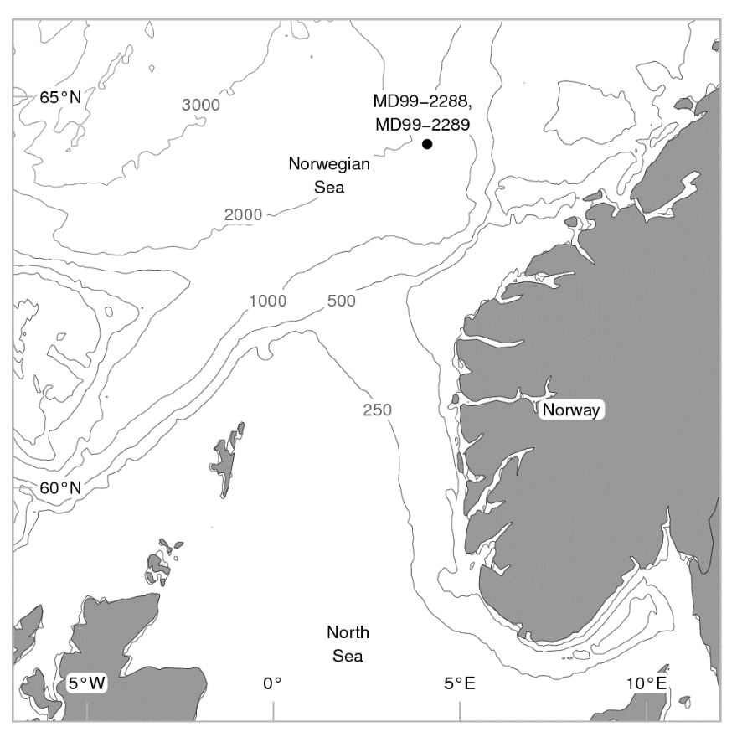
Fig. 1 – Location of MD99-2288 and MD99-2289 IMAGES cores in the Norwegian Sea. Isobath depths in metres; bathymetry data from NOAA.

2.2 Age model
MD99-2288 and MD99-2289 were matched by magnetic susceptibility and spliced at 2303.5 cm (MD99-2288)/2270.0 cm (MD99-2289) (Brendryen, 2011); therefore the established chronology for MD99-2289 was applied to MD99-2288 with a 33.5 cm correction. Chronological control for the core MD99-2289 is provided by AMS radiocarbon dating between 120 and 1300 cm (Berstad, 2003; Becker et al., 2018), correlation between the NGRIP δ¹⁸O record and XRF core scanning results for Ca and Ti/K from 1441 to 1863 cm (Brendryen et al., 2010; Brendryen, personal communication 2019), and one identified tephra zone, the Faroe Marine Ash Zone II, at 1064 cm and 26.69 ± 0.39 ka BP (Nilsen, 2014). An age depth model was constructed for the 120-1863 cm range of the spliced core using the Bayesian age modelling R package “Bacon” (v. 2.3.7) (Blaauw and Christeny, 2011) using the Marine13 calibration curve (Reimer et al., 2013) and a 405 year reservoir correction for the ¹⁴C ages as used by Becker et al. (2018). As no uncertainties were provided for the NGRIP tie points, a 1.2 ka uncertainty was applied to the model based on calculated uncertainties for NGRIP chronology (Svensson et al., 2008). While this may result in an underestimation of the age uncertainty in the latter half of the core, it is sufficient to explore the racemisation trends for Nps protein in this study. The output of the model (Fig. 2) shows a dramatic increase in sedimentation rate at ca. 1250 cm ( ~ 30 ka). The radiocarbon ages used and modelled ages for each sampling depth can be found in the supplementary information.
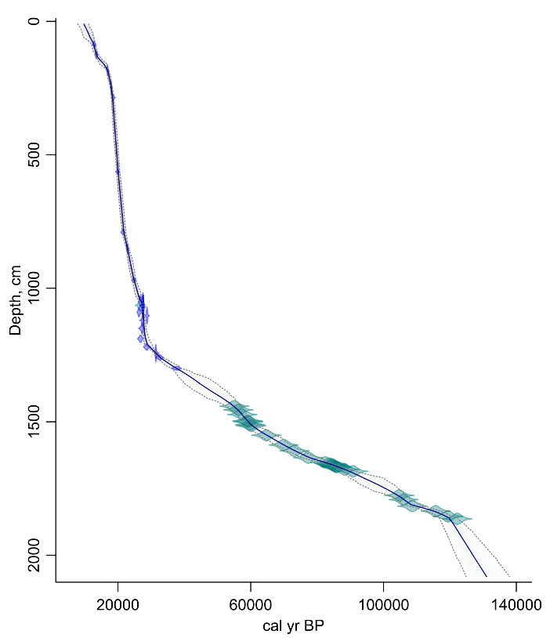
Fig. 2 – Bayesian age depth model (Blaauw and Christeny, 2011) for 120-1863 cm of core MD99-2289. Radiocarbon ages are shown in blue; NGRIP tie points and tephra zones are shown in teal. The dark blue line shows the model’s weighted mean age. Dashed lines represent the model’s 95% probability intervals.

2.3 Preparation of foraminifera
Foraminifera were collected at regular intervals from the >150 μm fraction of both cores. While records of the core from which each sample was collected have unfortunately been lost, it is assumed for this study that samples between 10-2200 cm were taken from MD99-2289 and samples between 2300-2985 cm were from MD99-2288 (Brendryen, personal communication 2019). A full record of samples taken can be found in the supplementary information. For IEC analysis, 100 to 150 individuals were pooled for each analytical sample, while 30 to 50 individuals were pooled for RP-HPLC. All samples were cleaned by sonication according to Miller et al., (1983).

2.3.1. Isolation of the intra-crystalline fraction
To initially determine the stability of the intra-crystalline fraction of Nps biomineral proteins during prolonged oxidation, foraminiferal samples were taken from three depths (250 cm, 500 cm and 1450 cm) for extended bleaching experiments. Oxidation treatments using NaOCl (bleach) were carried out on Nps between 24 hours and 336 hours (1450 cm) or 360 hours (250 cm and 500 cm).
30-50 μL NaOCl (12% w/v) was added to each sample; samples were shaken every 24 hours to aid penetration of the bleach into the biomineral. At the end of the bleaching period the bleach was pipetted off, the sample rinsed six times with ultrapure water and once with HPLC-grade methanol, then air dried prior to demineralisation. Samples analysed by IEC were dried for 15 minutes at 60°C; samples analysed by RP-HPLC were dried for 5-10 minutes at 110°C. This difference in procedure reflects the standard protocols of the different laboratories in which the analyses were carried out: IEC at the University of Bergen and RP-HPLC at the University of York.

2.3.2. Analysis of racemisation trends in Nps
Based on the results of the extended oxidation experiments (Sec 2.3.1), a 48 hour NaOCl exposure was chosen to prepare the rest of the “bleached” samples in this study. To assess differences between the diagenesis of the whole-protein and intra-crystalline protein fractions of Nps, unbleached and bleached samples from a range of depths throughout the cores were analysed. Depending on the amount of material available at each depth, 1-3 replicate samples were prepared for each treatment.
Procedural blanks were collected and analysed for each experiment to quantify background levels of amino acid contamination; due to the sample sizes used, corrections for contaminants identified in the blanks were not necessary.

2.4 Amino acid analysis
Only the total hydrolysable amino acid (free and bound amino acids; THAA) fraction was analysed to conserve material. Samples were demineralised with 8 μL 7 M HCl, with addition of a further 8 μL HCl if necessary to complete demineralisation. Samples were hydrolysed by heating at 110°C for 22 hours in nitrogen-flushed vials, then dried at 80°C for 15 minutes prior to rehydration for analysis by IEC, or dried overnight under vacuum prior to rehydration for analysis by RP-HPLC.
Separation of the hydrolysed amino acids was carried out either using IEC (at the University of Bergen) or RP-HPLC (at the University of York). During hydrolysis asparagine and glutamine are irreversibly hydrolysed to aspartic acid and glutamic acid respectively; therefore these amino acids are analytically indistinguishable and reported as Asx and Glx (Hill, 1965). The fluorescent derivatising agent o-phthaldialdehyde (OPA), used in both methods, does not allow for the detection of proline or hydroxyproline (Miller and Brigham-Grette, 1989), while the OPA derivative of lysine is prone to degradation during separation (Brückner et al., 1994); therefore these amino acids are not reported for either method.

2.4.1. Separation by ion exchange liquid chromatography (IEC)
For analysis using IEC, the internal standard norleucine was added with the 7 M HCl used for demineralisation. Samples were rehydrated with 100 μL pH 2 buffer before being separated on an automatic amino acid analyser with post-column OPA derivatisation and fluorometric detection according to the methods of Sejrup and Haugen (1992). Due to the poor separation of Ser and Thr by IEC, these two amino acids are reported together for this technique. The only amino acid for which chiral information is available using IEC is Ile; this is reported as A/I.

2.4.2. Separation by reverse-phase high performance liquid chromatography (RP-HPLC)
For analysis using RP-HPLC, samples were rehydrated with 8-10 μL rehydration fluid (2.38 M HCl, 0.171 mM NaN₃, 9.97 mM internal standard L-homo-arginine). The rehydrated samples underwent pre-column derivatisation with OPA and the chiral thiol N-isobutyryl-L-cysteine (IBLC), followed by chiral separation and fluorometric detection following a modified method of Kaufman and Manley (1998) using an Agilent 1100 Series HPLC fitted with a C₁₈ HyperSil BDS column. The D-Arg peak co-eluted with another compound in all RP-HPLC chromatograms; therefore Arg D/L values are not reported and D-Arg has been excluded from total amino acid concentrations as in other studies using RP-HPLC (Powell et al., 2013).

2.4.3 Data screening
A range of diagnostic criteria can be used to assess the integrity of AAR data, such as Ser, Thr or Gly abundance (e.g. Miller and Brigham-Grette, 1989; Sejrup and Haugen, 1992; Kaufman, 2000), expected depth or age trajectories (Wehmiller et al., 1976; Kosnik and Kaufman, 2008), covariance between concentrations or D/L values for different amino acids (e.g. Kaufman, 2000; Preece and Penkman, 2005), and the variability of replicate samples (Kosnik and Kaufman, 2008). Cut-offs for sample exclusion are determined empirically, and are therefore potentially somewhat subjective, but it is important that exclusion criteria, once determined, are applied uniformly to the data set to minimise systematic bias (Kaufman, 2006). D/L values lying far above or below the general trend could be indicative of a compromised sample, but as some natural variability due to reworking or intrusion is inevitable (McCarroll, 2002) only extreme outliers were excluded from this study.
The following screening criteria were chosen:
- High concentrations of Gly (>50%), which indicate contamination resulting from human handling (Sejrup and Haugen, 1992). High Ser and Thr concentrations were also considered, but poor separation of Ser and Thr using IEC precluded using these amino acids as criteria.

- Deviation of increasing trend of A/I values for IEC, and D/L values of Asx, Glx and Ala (the three amino acids with the best chromatographic separation) for RP-HPLC.
Outliers were identified and excluded from the dataset according to the criteria listed in Table 1. On average, 6.0% of samples were excluded from the data set using these criteria. A full list of the samples excluded and the criteria used to exclude each sample is available in the supplementary information.

 | IEC |  | RP-HPLC
Unbleached (U) or bleached (B) | U | B | U | B
1. > 50% Gly | 0 | 0 | 2* | 2*
3. Deviation of D/L from depth trend | 5 | 4 | 3 | 3
Total samples analysed | 69 | 75 | 53 | 51
% Removed | 7.2 | 5.1 | 5.7 | 5.9
Table 1 – Screening criteria used to identify outliers and total number of samples excluded by each criterion for each analytical method. *Only one of two analytical replicates found to have >50% Gly, indicating issues with chromatographic separation rather than contamination.

2.5 IEC A/I to RP-HPLC D/L conversion
Whitacre et al. (2017) developed linear regressions to convert IEC A/I data into D/L values for five amino acids (Asx, Glx, Ala, Val, Ile) equivalent to those measured by RP-HPLC. Biomineral-specific equations were found to minimise errors associated with the conversion by accounting for variations in diagenetic patterns and chromatographic separation between biominerals; however “pooled” regressions were also developed for use with sample types not represented in the original study:
$$\log_{2}\left(Asx D/L\right)= 0.36 ×\log_{2}(A/I)-0.3$$
$$\log_{2}\left(Glx D/L\right)= 0.64 ×\log_{2}(A/I)-0.5$$
$$\log_{2}\left(Ala D/L\right)= 0.62 ×\log_{2}(A/I)+0.22$$
$$\log_{2}\left(Val D/L\right)= 0.94 ×\log_{2}(A/I)-0.22$$
$$\log_{2}\left("RP" Ile A/I\right)= 0.996 ×\log_{2}(A/I)-0.034$$
As foraminifera were not included in the original study, the pooled regressions were used to convert IEC A/I values into predicted Asx, Glx, Ala, Val D/L and RP-HPLC equivalent Ile A/I values, and compared with the values actually measured by RP-HPLC, in order to test the efficacy of the pooled equations for Nps.
New linear regressions were then carried out on log₂-transformed Nps data. Unlike the data used by Whitacre et al. (2017), analyses carried out in this study were not paired, as this comparison had not been the original intention of the study. Therefore average D/L values for each depth and bleaching treatment were used to develop the regressions. This means that the errors associated with the derived conversions are likely to be higher in this study. No significant differences between separate regressions run on bleached and unbleached material were found, so pairs of IEC and RP-HPLC data where the depth and bleaching treatment were the same were combined to increase the sample size for the models. Between 30 and 32 averaged D/L values were used for each regression. Following Whitacre et al. (2017) the following criteria were used to assess the quality of each model: the adjusted R² value, 1 and 2σ prediction uncertainties, and the Akaike information criterion (AICc), a measure of model quality which penalises for overparameterisation. All statistical analysis was carried out using the statistical programming language “R” version 3.6.2. Analytical scripts are included as supplementary information.

3. Results and discussion

3.1 Testing oxidation times

3.1.1. The effect of bleaching on amino acid concentration
If Nps biomineral contains an intra-crystalline protein fraction resistant to oxidation, then bleaching via exposure to NaOCl should cause an initial decrease in the total hydrolysable amino acid concentration ([THAA]), followed by a plateau once the intra-crystalline fraction has been isolated.
The presence of amino acids after the longest bleaching duration shows that Nps contains a bleach-resistant intra-crystalline protein fraction (Fig. 3), as has been observed in other species of foraminifera (Watson, 2019). While the variability of [THAA] in the extended Nps bleaching experiments is high, the similarity between unbleached and bleached [THAA] suggests that the majority of the inter-crystalline protein fraction has been lost by 18 ka, as has been observed in other biominerals (Sykes et al., 1995; Penkman et al., 2008; Ortiz et al., 2015, 2017).
The samples with much higher than average [THAA] (>0.9 nmol / foram) at 250 cm (and seen in some unbleached samples at other depths, see Section 3.2.1) may be due to some between-shell variability in the survival of inter-crystalline protein (as seen in gastropods (Penkman et al., 2008), although given that each sample in this study consists of 100 individual tests this interpretation is unlikely. An alternate explanation may be due to modern laboratory contamination; however if this was the case these samples would have a correspondingly low A/I value, which is not seen (Fig. 5). This variability is therefore most likely due to the challenges in accurately measuring amino acid concentration, especially at very small sample sizes (Powell, 2012).

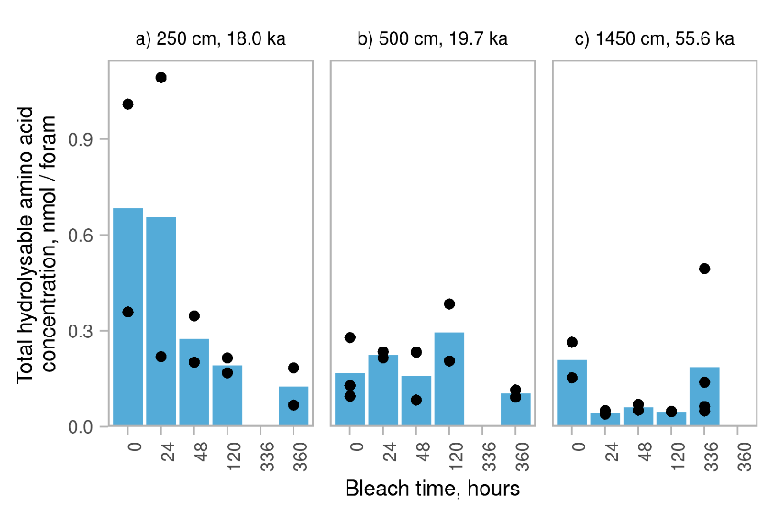
Fig. 3 – Trends in concentration of total hydrolysable amino acids ([THAA]) with increasing bleach time for Nps at three core depths: a) 250 cm, b) 500 cm and c) 1450 cm. Dots show individual replicates; bars show means of all replicates at each time and depth point. Where data are absent, this is because experiments of this duration were not carried out.

3.1.2. The effect of bleaching on amino acid composition
The biomineral protein of Nps is dominated by Asx and Gly, with smaller contributions from Ser + Thr, Ala, Glx, Val, Leu and Ile (Fig. 4). Phe, His, Arg and Tyr were not resolved using IEC, but observed in small amounts (total contribution from all four amino acids 11 ± 3 %) in samples analysed by RP-HPLC (see supplementary information). This composition is consistent with other foraminifera (King and Hare, 1972; Weiner and Erez, 1984; Robbins and Brew, 1990). The high abundance of Asx indicates the presence of acidic proteins involved in biomineral formation (Weiner, 1979), while Gly and Ala likely represent silk-like proteins found in other biominerals (Pereira-Mouriès et al., 2002; Gotliv et al., 2003).
Differences in the composition of amino acids between the whole-shell and intra-crystalline fractions have been found in some mollusc shells (Penkman et al., 2008; Demarchi et al., 2013b; Ortiz et al., 2015; Pierini et al., 2016), indicating the presence of different proteins in different fractions of those biominerals. Other biominerals do not have significant differences between the two fractions (e.g. ostracods (Ortiz et al., 2013), ostrich eggshell (Crisp et al., 2013)). The composition of amino acids is quite variable for Nps, especially for Ser + Thr and Gly, confounding a clear assessment of the effect of bleaching on composition, with no clear patterns emerging from the extended bleaching treatment (Fig. 4). The apparent stability of both the concentration and composition of the intra-crystalline amino acid pool over extended exposure to bleach suggests that this fraction is oxidation resistant.

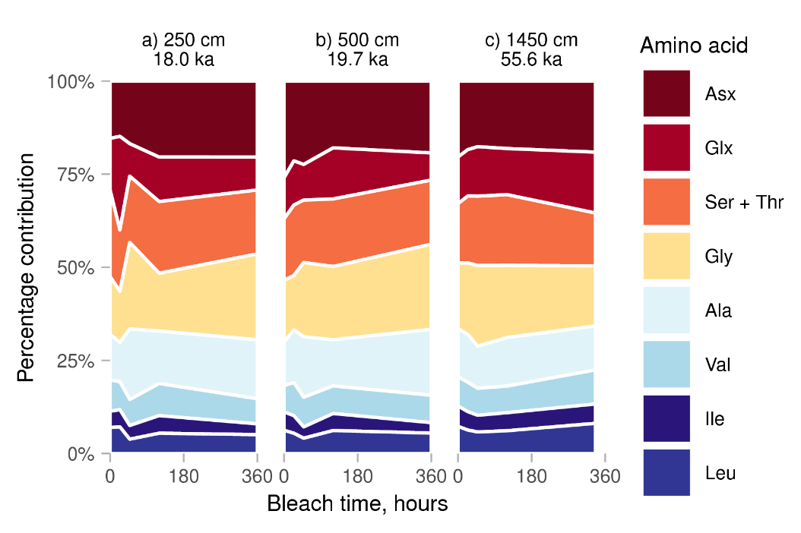
Fig. 4 – The effect of increasing exposure to bleach on total hydrolysable amino acid (THAA) composition of Nps tests at three core depths (analysed using IEC). While there is some variability in the THAA composition in the first 48 hours of bleach exposure, no clear compositional changes are caused by oxidation. Due to poor separation of Ser from Thr using IEC, these amino acids are reported together. (For interpretation of the references to colour in this figure legend, the reader is referred to the web version of this article.)

3.1.3. The effect of bleaching on A/I values
Differences in A/I or D/L values between the inter- and intra-crystalline fractions of biominerals may be due to the loss of more highly racemised short-chain peptides and free amino acids from an open-system inter-crystalline fraction (Penkman et al., 2008). Free amino acids in a biomineral are more highly racemised than peptide-bound amino acids due to the accelerated rate of racemisation at the terminal positions of peptides (Crisp et al., 2013; Tomiak et al., 2013). Therefore, if this fraction is more susceptible to leaching (diffusive loss) from inter-crystalline sites than intra-crystalline sites, unbleached material will show “suppressed” A/I or D/L values compared with bleached material. This pattern has also been observed in some molluscs (e.g. Penkman et al., 2008; Demarchi et al., 2013b; Ortiz et al., 2015; Pierini et al., 2016) and ostrich eggshell (Crisp et al., 2013).
As the extended bleaching experiments for Nps were analysed by IEC only, the only amino acid for which racemisation data are available is Ile. At 250 cm the A/I value increases slightly between 24 and 48 hours and then plateaus (Fig. 5a), indicating that bleach-induced racemisation is not taking place. Due to the variability of the data there is no clear effect of bleaching onA/I at 500 and 1450 cm (Fig. 5b, c); however, lower A/I values in unbleached Nps are also seen in the down-core trend for ages greater than ~60 ka (Fig. 8). This suggests that the remaining inter-crystalline protein may behave as an open system even after the initial loss of protein during early stages of diagenesis; this may be due to the progressive generation of highly racemised free amino acids via hydrolysis.

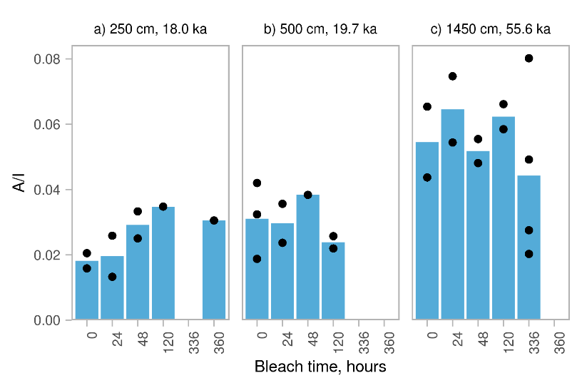
Fig. 5 – Trends in A/I value with increasing bleach time for Nps at a) 250 cm, b) 500 cm and c) 1450 cm. Dots show individual replicates; bars show means of all replicates at each time and depth point. Where data are absent, this is because experiments of this duration were not carried out, with the exception of 360 hours at 500 cm, where none of the samples had resolved A-Ile peaks. An increase in A/I is observed between 24-48 hours at 250 cm, while bleaching has no clear effect on A/I at 500 cm and 1450 cm.
Based on the results of these extended bleaching experiments, a 48 hour NaOCl exposure was chosen for the rest of the samples in the study, as this treatment is sufficient to isolate the intra-crystalline fraction of amino acids in Nps.

3.2 Comparison of down-core diagenetic trends in racemisation between unbleached and bleached Nps
Samples of Nps were taken for analysis by IEC and RP-HPLC at regular intervals down the cores to enable a more detailed investigation of any amino acid trends and to compare the behaviour of the whole-protein and intra-crystalline fractions for this class of biomineral. A full list of intervals sampled can be found in the supplementary information.

3.2.1. Trends in concentration and composition
There is substantial variability in both the [THAA] and composition of amino acids for both unbleached and bleached samples through the cores (Fig. 6, Fig. 7). In general, the concentration of bleached samples is slightly lower than concentration of unbleached samples (Fig. 6), indicating that the majority of protein in naturally-aged Nps is in the intra-crystalline fraction. With the exception of a few relatively young samples having higher than average [THAA], the concentration of amino acids appears to be relatively stable over the timescale represented by this core.
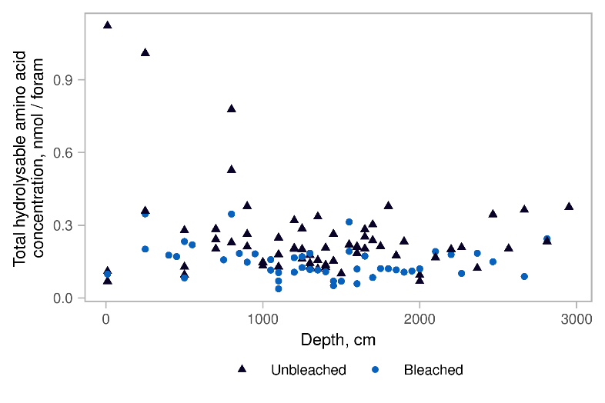
Fig. 6 – Down core trends in total hydrolysable amino acid concentration of bleached and unbleached Nps tests (analysed using RP-HPLC)

As was seen in the extended bleaching experiments, there is no clear difference between the composition of whole-protein and intra-crystalline protein fractions of Nps (Fig. 7). Neither fraction shows a systematic change in amino acid composition down core. This indicates that both the whole-shell and intra-crystalline fractions remain relatively stable during diagenesis. While some work has found differential loss of acidic proteins from a range of planktonic species within ~300 ka (Robbins and Brew, 1990), this trend is not seen here over the 120 ka studied.

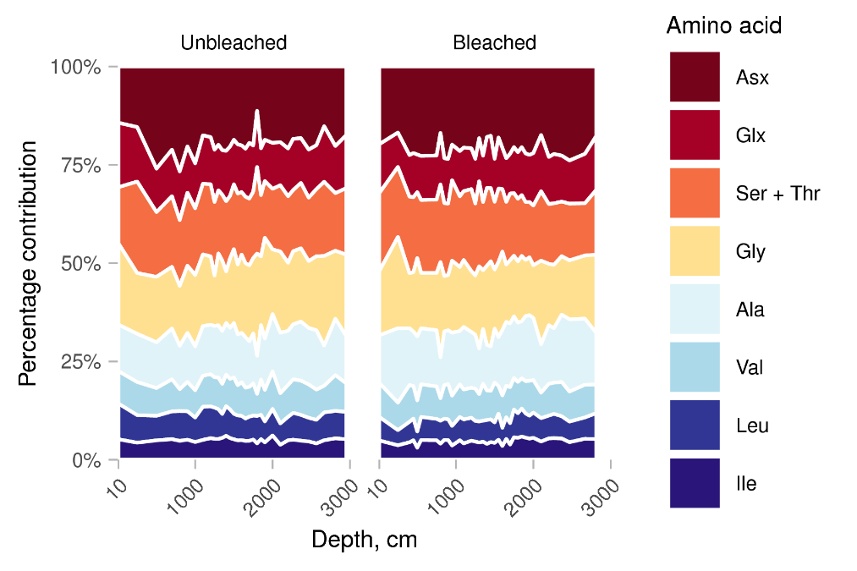
Fig. 7 – Down-core compositions of unbleached and bleached (48 h) Nps tests analysed by IEC, showing a relatively stable composition of both the whole and intra-crystalline fractions of amino acids. Due to poor separation of Ser from Thr using IEC, these amino acids are reported together. (For interpretation of the references to colour in this figure legend, the reader is referred to the web version of this article.)

3.2.2. Trends in racemisation
As determined by IEC, the A/I value of Nps increases with age, with the rate of racemisation slowing over time in both bleached and unbleached samples (Fig. 8). Due to the change in sedimentation rate at ~ 30 ka in the cores (see Fig. 2), plots of D/L against age and depth are included to show more clearly the trends in racemisation during the younger section of the core (Fig. 8, 9, 10). In the first ~ 60 ka (1550 cm) of the core, the extent of racemisation for bleached and unbleached Nps are similar, with bleached Nps having a slightly higher degree of racemisation (Fig. 10, presented separately for clarity). Older than ~60 ka, the levels of racemisation are lower for unbleached Nps than bleached Nps. This may be due to the loss of free amino acids from the unbleached biomineral, effectively “suppressing” the rate of racemisation (see section 3.1.3).

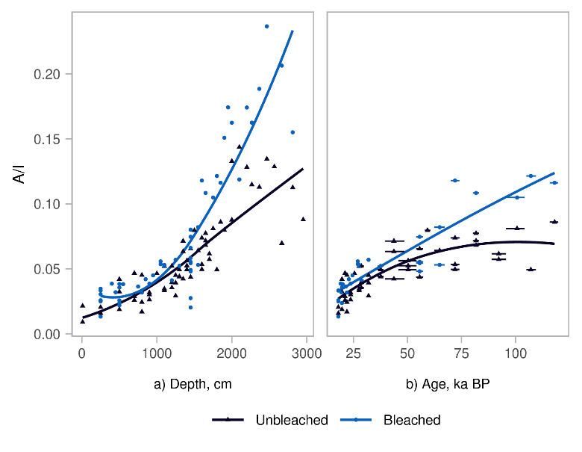
Fig. 8 – Downcore trends in A/I for Nps analysed by IEC: a) A/I against depth showing samples taken between 10-2951.5 cm (corrected depth); b) A/I against age for samples taken between 120-1863 cm, the range of the age model for the core (see Fig. 2). Horizontal lines show 1σ age error from age model. Bleached samples were subjected to 48 h NaOCl exposure. A locally weighted smoothing (loess) function has been applied (solid line) to highlight the differences between the racemisation trends for bleached and unbleached Nps.

Of the amino acids analysed using RP-HPLC, Asx and Glx showed the clearest racemisation trends (Fig. 9i, ii). While previous studies of amino acid racemisation in Nps using RP-HPLC have focused on Asx and Glx only (Kaufman et al., 2008, 2013), Ala also showed clear trends in racemisation in this core after ~25 ka (Fig. 9iv), suggesting that Ala could be used to provide additional chronological control for Nps in older material.
For most amino acids separated by RP-HPLC, the D/L values were similar between bleached and unbleached Nps, with bleached material having slightly higher D/L values in older (> 60 ka) samples, suggesting some loss of highly-racemised free amino acids from the inter-crystalline fraction (Fig. 9). Ser has substantially higher D/L values (Fig. 9, 10iii) in the bleached samples. This may be due a result of Ser having a higher abundance in the free amino acid pool as a result of the lability of Ser-X peptide bonds (Hill, 1965) results in a greater “suppression” of Ser racemisation than other amino acids in the whole-protein fraction. As L-Ser is a common laboratory contaminant, the increase in Ser D/L on bleaching may also be in part due to the removal of exogenous amino acids.
As also seen in studies of the kinetics of amino acid racemisation in other biominerals (Penkman et al., 2008; Demarchi et al., 2011, 2015), Ser racemises the most quickly of all the amino acids due to its ability to racemise in-chain (Demarchi et al., 2013a), plateauing at ~ 30 ka at a D/L of around 0.3 for bleached samples (Fig. 9 and 10 iii). This plateau may be due to the comparative instability of Ser (Bada et al., 1978) resulting in apparent “steady-state” behaviour of racemisation as the rates of Ser racemisation and decomposition converge (Schroeder and Bada, 1977). Asx, Glx and Ala show a similar trend to Ile, with rapid initial racemisation in the first ~30 ka followed by a slowing of the observed rate of racemisation (Fig. 9 and 10 i, ii, iii). This “two-stage” racemisation pattern is consistent with observations of racemisation kinetics in foraminifera (Wehmiller and Hare, 1971; Harada and Handa, 1995; Kaufman, 2006), and with other biominerals (see Clarke and Murray-Wallace, 2006).

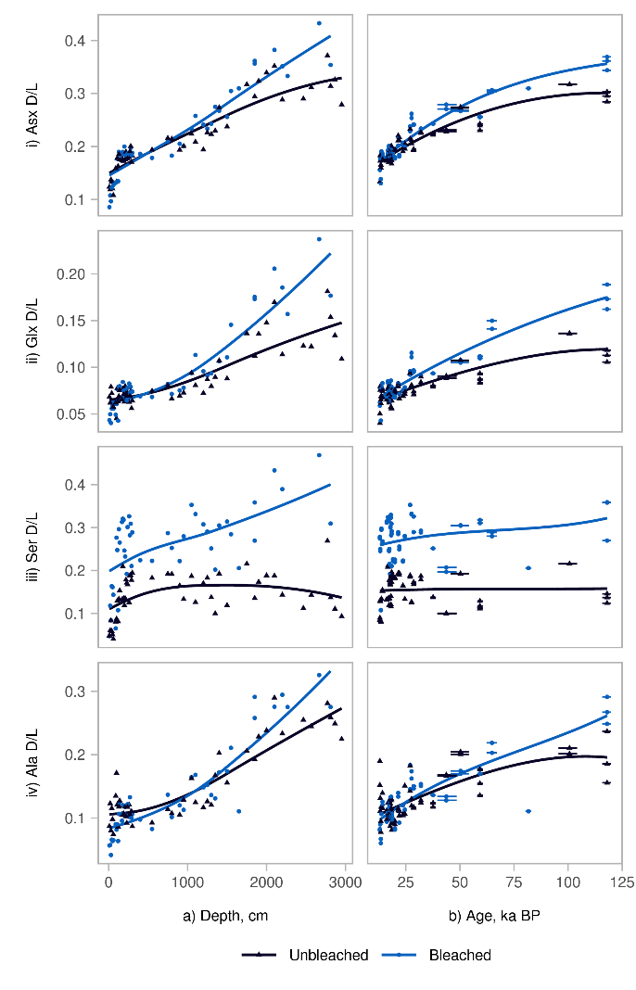
Fig. 9 – Trends in racemisation for four amino acids (i) Asx, ii) Glx, iii) Ser, iv) Ile) analysed by RP-HPLC. a) D/L against depth showing samples taken between 10-2951.5 cm (corrected depth); b) D/L against age for samples taken between 120-1863 cm, the range of the age model for the core (see Fig. 1). Horizontal lines show 1σ age error from age model. All four amino acids have higher D/L values for bleached than unbleached Nps in older samples. Bleached samples were subjected to 48 h NaOCl exposure. A locally weighted smoothing (loess) function has been applied to highlight the differences between the racemisation trends for bleached and unbleached Nps.

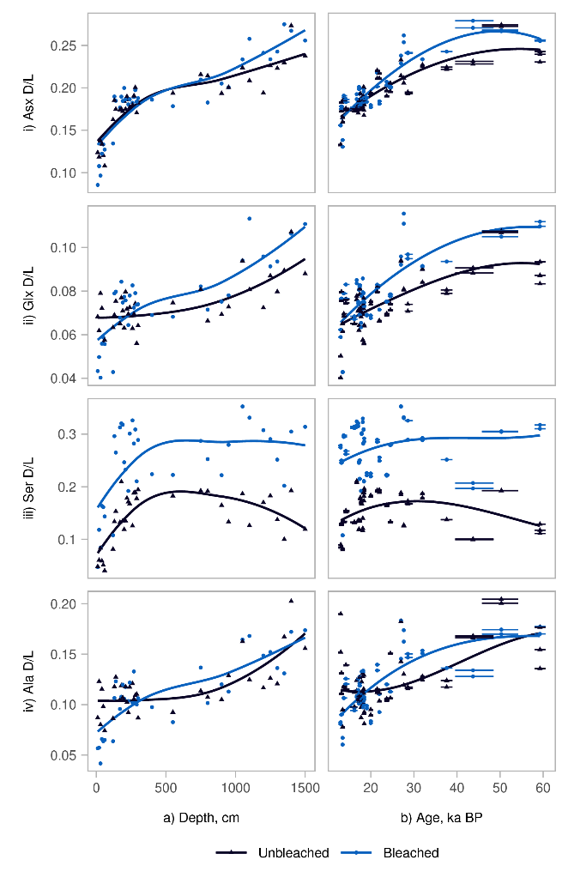
Fig. 10 – Trends in racemisation for four amino acids analysed by RP-HPLC for the youngest part of the core, (10-60 ka, 10-1500 cm) of the core: a) D/L against depth; b) D/L against age. Horizontal lines show 1σ age error from age model. During this early stage of racemisation D/L values are similar between bleached and unbleached Nps for Asx, Glx and Ala. Bleached samples were subjected to 48 h bleach exposure. A locally weighted smoothing (loess) function has been applied to highlight the differences between the racemisation trends for bleached and unbleached Nps.

Of these three amino acids, Asx racemises the most quickly in Nps, reaching a D/L of ~ 0.3 by 120 ka, while Glx racemises more slowly, reaching a D/L of ~ 0.15 over the same period. The apparent racemisation rate of Ala is intermediate, reaching a D/L of ~ 0.2 by 120 ka. This order of apparent racemisation rate (Ser > Asx > Ala > Glx ~ Ile) is consistent with the results of high-temperature decomposition experiments carried out on other biominerals (e.g. Kimber and Griffin, 1987; Ortiz et al., 2017; Dickinson et al., 2019). Studies of Asx and Glx racemisation trends in heated and naturally-aged planktonic foraminifera have found that Asx racemises more quickly than Glx (Hearty et al., 2004; Kaufman, 2006; Kaufman et al., 2013); however a study of P. obliquiloculata investigating a wider range of amino acids found that Ile racemised more quickly than Glx, in contrast to the results of this study, which observed similar apparent racemisation rates between Ile and Glx (Harada and Handa, 1995).
If the intra-crystalline fraction better approximates a closed system than the whole-protein fraction, then there should be fewer environmental influences on racemisation in the intra-crystalline fraction, resulting in lower variability between D/L values at any given horizon for bleached samples (Penkman et al., 2008). For Nps, bleaching results in a decrease in variability between similar-age samples during early stages of diagenesis (Fig. 11). This result is consistent with the reduced effect of bleaching on total amino acid concentration in older material (Section 3.1.1), suggesting that the majority of the inter-crystalline protein is leached from the biomineral during early stages of diagenesis. While these reductions in variability on bleaching are not seen in older material, the observed increase in D/L values in the intra-crystalline fraction suggest that the IcPD approach also limits the effects of leaching and contamination in older samples.

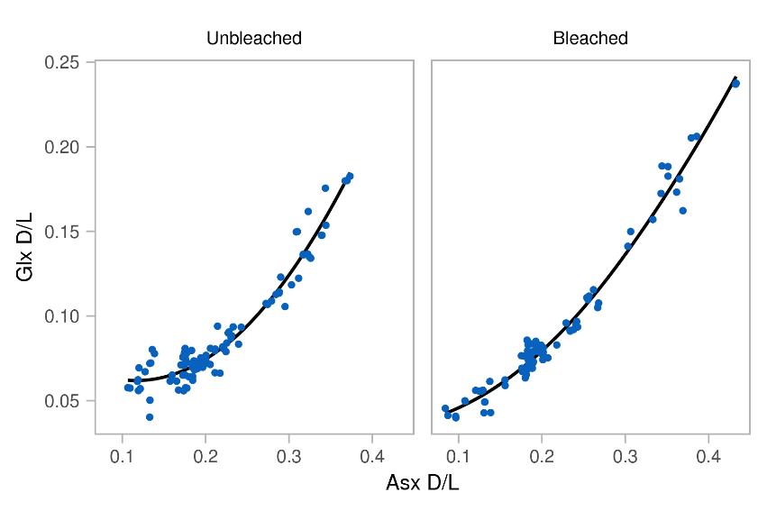
Fig. 11 – Covariance of Asx and Glx D/L for bleached and unbleached Nps analysed by RP-HPLC, showing decreased variability of D/L values on bleaching for young material (Asx D/L < 0.2). A locally weighted smoothing (loess) function has been applied to show the general trends of the data.

3.3 IEC A/I to RP-HPLC D/L conversions
Conversion from IEC Ile A/I and equivalent RP-HPLC amino acid D/L was carried out using the pooled regressions developed by Whitacre et al. (2017), as well as Nps-specific regressions derived using the Nps data set. Due to the poor separation of L-Ile and D-Aile using RP-HPLC (Powell et al., 2013; Wehmiller, 2013), direct comparison between IEC Ile A/I and RP-HPLC Ile A/I was not possible using this data set.
When applied to the Nps data set, the 2σ prediction uncertainty for the pooled regressions were ±23 to 42% depending on the amino acid, similar to the ranges found by Whitacre et al. for other biominerals (Table 2). While Whitacre et al. (2017) found that creating material-specific models reduced the 2σ prediction uncertainty compared with pooled regressions, this has not been observed for Nps – perhaps due to the use of averaged rather than paired analyses. For Asx, Glx and Ala the 2σ prediction uncertainty was ±24-35% when using the Nps-specific regression. Conversely, Val and Ile had much higher 2σ prediction uncertainties for the Nps-specific regression, highlighting the poorer chiral separation of both Val and Ile by RP-HPLC for this biomineral (Fig. 12, Table 2). The pooled regressions did, however, slightly overestimate Asx, Glx and Ala D/L values (Fig. 12).

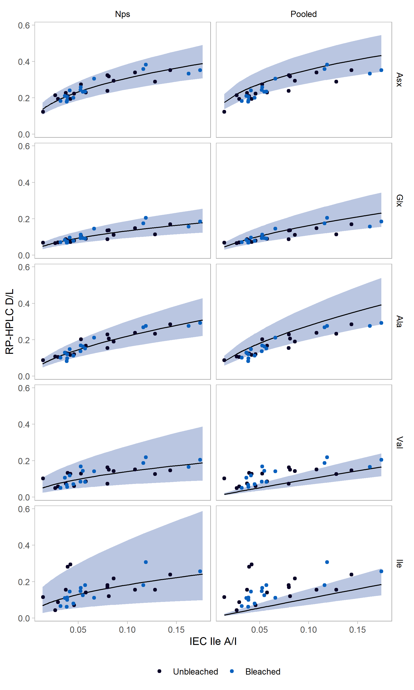
Fig. 12 – Relationship between IEC Ile A/I and RP-HPLC amino acid D/L values, modelled by log₂-transformed linear regressions. Lines represent the Nps-specific and pooled linear regressions; shaded envelopes are 2σ prediction uncertainties using a “dummy” data set for the Nps-specific regressions (as used by Whitacre et al. (2017)) and the Nps data set for the pooled regressions.

 | Pooled regression |  |  |  | Nps-specific regression
 | 1σ PU | 2σ PU | AICc | Success rate (%) | Slope | ± | Intercept | ± | R² | 1σ PU | 2σ PU | AICc
Asx | 0.24 | 0.24 | -239 | 69 | 0.41 | 0.03 | -0.35 | 0.14 | 0.83 | 0.23 | 0.24 | -24
Glx | 0.41 | 0.42 | 126 | 94 | 0.51 | 0.05 | -1.22 | 0.2 | 0.76 | 0.36 | 0.38 | 3
Ala | 0.33 | 0.33 | -16 | 78 | 0.59 | 0.05 | -0.21 | 0.2 | 0.84 | 0.33 | 0.35 | -2
Val | 0.39 | 0.40 | 43 | 31 | 0.51 | 0.10 | -1.13 | 0.4 | 0.44 | 0.77 | 0.82 | 48
Ile | 0.41 | 0.42 | 59 | 27 | 0.49 | 0.13 | -0.82 | 0.6 | 0.31 | 0.98 | 1.05 | 57
Table 2 – Results of linear regressions using log₂ transformed A/I and D/L values. PU refers to the prediction uncertainty calculated using the Nps data set for the pooled regression, and a “dummy” data set for the Nps-specific regression (as used by Whitacre et al. (2017)). Success rate refers to the proportion of predicted ranges which included the D/L value measured by RP-HPLC.

The results of this analysis show that the Nps-specific regressions can confidently convert Nps IEC A/I values into equivalent D/L values for Asx, Glx and Ala over the ranges tested, with similar prediction uncertainty ranges as for the pooled regressions developed by Whitacre et al. (2017). Due to the poor separation of Val and Ile for Nps it was not possible to validate the regressions for these amino acids. Due to the overestimation of Asx, Glx and Ala D/L values using the pooled regressions and the similar prediction uncertainties between the Nps-specific and pooled regressions, we recommend that the Nps-specific regressions developed in this paper are used to convert Nps A/I values to D/L Asx, Glx and Ala values.

4. Conclusions
Bleaching experiments show that Nps tests contain an intra-crystalline fraction of amino acids which is resistant to extended exposure to bleach. A 48 hour treatment with 12% w/v NaOCl isolates the intra-crystalline fraction in Nps, with a greater proportion of amino acids being removed by bleaching in younger samples. Bleaching results in slightly increased Ile, Asx, Glx and Ala D/L values in older samples, indicating that the inter-crystalline fraction of amino acids behaves as an open system during diagenesis. Additionally the variability of D/L values is lower for bleached Nps than unbleached Nps in samples where Asx D/L < ca. 0.2. This suggests that the IcPD approach limits the influences of leaching on racemisation trends for younger Nps, while older material may also benefit from bleaching by minimising the potential impact of contamination.
Given this dataset, it is therefore recommended that a bleaching step is included during the preparation of Nps foraminifera for amino acid dating, if sufficient sample mass is present to compensate for the reduction in concentrations caused by oxidation of the inter-crystalline fraction.
IEC A/I values were successfully converted to RP-HPLC D/L values for Asx, Glx and Ala in Nps using material-specific regression equations with a ±24-38% 2σ prediction uncertainty depending on the amino acid.

Acknowledgements
Funding for this study was provided by the Marie Curie Foundation (to HPS & KP ) with additional funding for KP provided by the Leverhulme Trust (PLP-2012-116). This study is part of a project that has received funding from the European Research Council (ERC) under the European Union’s Horizon 2020 research and innovation programme (grant agreement No. 865222).
Many thanks to Vigdis Clausen-Hope for technical support, Matthew Kosnik for assistance with linear regression modelling, Natasha Barlow for help with the geological context of the material, to Jo Brendryen for supplying the NISP tie points used in the age model, and to Jo Brendryen and Haflidi Haflidason for additional information about the cores used in this study. The authors are grateful to Kirsty High for her comments on the draft manuscript, and to José Ortiz and an anonymous reviewer for their reviews, which greatly improved the manuscript.

Data Availability: All amino acid data from this study will be made available through the NOAA repository upon publication: ftp://ftp.ncdc.noaa.gov/pub/data/paleo/aar/.

References

Adler, R.E., Polyak, L., Ortiz, J.D., Kaufman, D.S., Channell, J.E.T., Xuan, C., Grottoli, A.G., Sellén, E., Crawford, K.A., 2009. Sediment record from the western Arctic Ocean with an improved Late Quaternary age resolution: HOTRAX core HLY0503-8JPC, Mendeleev Ridge. Glob. Planet. Change 68, 18–29. https://doi.org/10.1016/j.gloplacha.2009.03.026
Bada, J.L., Jolla, L., Man, E.H., 1973. Racemization of isoleucine in cores from Leg 15 Site 148. Initial Reports Deep Sea Drill. Proj. 947–951.
Bada, J.L., Schroeder, R.A., 1972. Racemization of Isoleucine in Calcareous Marine Sediments: Kinetics and Mechanism. Earth Planet. Sci. Lett. 15, 1–11.
Bada, J.L., Shou, M., Man, E.H., Schroeder, R.A., 1978. Decomposition of hydroxy amino acids in foraminiferal tests; kinetics, mechanism and geochronological implications. Earth Planet. Sci. Lett. 41, 67–76. https://doi.org/10.1016/S0065-2881(08)60234-5
Bauch, H.A., Erlenkeuser, H., Jung, J.A., Thiede, J., 2000. Surface and deep water changes in the subpolar North Atlantic during Termination II and the last interglaciation. Paleoceanography 15, 76–84.
Becker, L.W.M., Sejrup, H.P., Hjelstuen, B.O., Haflidason, H., Dokken, T.M., 2018. Ocean-ice sheet interaction along the SE Nordic Seas margin from 35 to 15 ka BP. Mar. Geol. 402, 99–117. https://doi.org/10.1016/j.margeo.2017.09.003
Berman, A., Addadi, L., Weiner, S., 1988. Interactions of Sea-Urchin Skeleton Macromolecules With Growing Calcite Crystals - a Study of Intracrystalline Proteins. Nature 331, 546–548. https://doi.org/10.1038/331546a0
Berstad, I.M., 2003. Quaternary climate variability in the eastern Nordic Sea region inferred from speleothems and deep-sea cores. University of Bergen, Norway.
Blaauw, M., Christeny, J.A., 2011. Flexible paleoclimate age-depth models using an autoregressive gamma process. Bayesian Anal. 6, 457–474. https://doi.org/10.1214/11-BA618
Boudagher-Fadel, M., 2015. An introduction to planktonic foraminifera, in: Biostratigraphic and Geological Significance of Planktonic Foraminifera. UCL Press, pp. 1–28.
Brendryen, J., 2011. A detailed chronological, sedimentological and tephrostratigraphical framework of a high resolution sediment core record from the Eastern Norwegian Sea spanning the two last glacial-interglacial cycles. University of Bergen.
Brendryen, J., Haflidason, H., Sejrup, H.P., 2010. Norwegian Sea tephrostratigraphy of marine isotope stages 4 and 5: Prospects and problems for tephrochronology in the North Atlantic region. Quat. Sci. Rev. 29, 847–864. https://doi.org/10.1016/j.quascirev.2009.12.004
Bright, J., Kaufman, D.S., 2011a. Amino acid racemization in lacustrine ostracodes, part I: Effect of oxidizing pre-treatments on amino acid composition. Quat. Geochronol. 6, 154–173. https://doi.org/10.1016/j.quageo.2010.11.006
Bright, J., Kaufman, D.S., 2011b. Amino acids in lacustrine ostracodes, part III: Effects of pH and taxonomy on racemization and leaching. Quat. Geochronol. 6, 574–597. https://doi.org/10.1016/j.quageo.2011.08.002
Brooks, A.S., Hare, P.E., Kokis, J.E., Miller, G.H., Ernst, R.D., Wendorf, F., 1990. Dating Pleistocene Archeological Sites by Protein Diagenesis in Ostrich Eggshell. Science (80-. ). 248, 60–64.
Brückner, H., Haasmann, S., Langer, M., Westhauser, T., Wittner, R., Godel, H., 1994. Liquid chromatographic determination of D- and L-amino acids by derivatization with o-phthaldialdehyde and chiral thiols. J. Chromatogr. A 666, 259–273. https://doi.org/10.1016/0021-9673(94)80388-9
Bryn, P., Berg, K., Forsberg, C.F., Solheim, A., Kvalstad, T.J., 2005. Explaining the Storegga Slide. Mar. Pet. Geol. 22, 11–19. https://doi.org/10.1016/j.marpetgeo.2004.12.003
Clarke, S.J., Murray-Wallace, C. V., 2006. Mathematical expressions used in amino acid racemisation geochronology-A review. Quat. Geochronol. 1, 261–278. https://doi.org/10.1016/j.quageo.2006.12.002
Collins, M J, Riley, M.S., 2000. Amino acid racemization in biominerals: the impact of protein degradation and loss, in: Goodfriend, G. a, Collins, Matthew J., Fogel, M.A., Macko, S.A., Wehmiller, J.F. (Eds.), Perspectives in Amino Acid and Protein Geochemistry. Oxford University Press, New York.
Crisp, M.K., Demarchi, B., Collins, M.J., Morgan-Williams, M., Pilgrim, E., Penkman, K.E.H., 2013. Isolation of the intra-crystalline proteins and kinetic studies in Struthio camelus (ostrich) eggshell for amino acid geochronology. Quat. Geochronol. 16, 110–128. https://doi.org/10.1016/j.quageo.2012.09.002
Dahlgren, K.I.T., Vorren, T.O., 2003. Sedimentary environment and glacial history during the last 40 ka of the Vøring continental margin, mid-Norway. Mar. Geol. 193, 93–127. https://doi.org/10.1016/S0025-3227(02)00617-5
Demarchi, B., Clements, E., Coltorti, M., van de Locht, R., Kröger, R., Penkman, K.E.H., Rose, J., 2015. Testing the effect of bleaching on the bivalve Glycymeris: A case study of amino acid geochronology on key Mediterranean raised beach deposits. Quat. Geochronol. 25, 49–65. https://doi.org/10.1016/j.quageo.2014.09.003
Demarchi, B., Collins, M.J., Bergström, E., Dowle, A., Penkman, K.E.H., Thomas-Oates, J., Wilson, J., 2013a. New Experimental Evidence for In-Chain Amino Acid Racemization of Serine in a Model Peptide. Anal. Chem. 85, 5835–5842. https://doi.org/10.1021/ac4005869
Demarchi, B., Rogers, K., Fa, D.A., Finlayson, C.J., Milner, N., Penkman, K.E.H., 2013b. Intra-crystalline protein diagenesis (IcPD) in Patella vulgata. Part I: Isolation and testing of the closed system. Quat. Geochronol. 16, 144–157. https://doi.org/10.1016/j.quageo.2012.08.001
Demarchi, B., Williams, M.G., Milner, N., Russell, N., Bailey, G., Penkman, K.E.H., 2011. Amino acid racemization dating of marine shells: A mound of possibilities. Quat. Int. 239, 114–124. https://doi.org/10.1016/j.quaint.2010.05.029
Dickinson, M.R., Lister, A.M., Penkman, K.E.H., 2019. A new method for enamel amino acid racemization dating: A closed system approach. Quat. Geochronol. 50, 29–46. https://doi.org/10.1016/j.quageo.2018.11.005
Dwyer, G.S., Cronin, T.M., Baker, P.A., Rodriguez-Lazaro, J., 2000. Changes in North Atlantic deep-sea temperature during climatic fluctuations of the last 25,000 years based on ostracode Mg/Ca ratios. Geochemistry, Geophys. Geosystems 1. https://doi.org/10.1029/2000GC000046
Gotliv, B.A., Addadi, L., Weiner, S., 2003. Mollusk shell acidic proteins: In search of individual functions. ChemBioChem 4, 522–529. https://doi.org/10.1002/cbic.200200548
Gries, K.I., Kröger, R., Kübel, C., Fritz, M., Rosenauer, A., 2009. Investigations of voids in the aragonite platelets of nacre. Acta Biomater. 5, 3038–3044. https://doi.org/10.1016/j.actbio.2009.04.017
Harada, N., Handa, N., 1995. Amino acid chronology in the fossil planktonic foraminifera, Pulleniatina obliquiloculata from Pacific Ocean. Geophys. Resarch Lett. 22, 2353–2356.
Hearty, P.J., O’Leary, M.J., Kaufman, D.S., Page, M.C., Bright, J., 2004. Amino acid geochronology of individual foraminifer (Pulleniatina obliquiloculata) tests, north Queensland margin, Australia: A new approach to correlating and dating Quaternary tropical marine sediment cores. Paleoceanography 19, 1–14. https://doi.org/10.1029/2004PA001059
Hendy, E.J., Tomiak, P.J., Collins, M.J., Hellstrom, J., Tudhope, A.W., Lough, J.M., Penkman, K.E.H., 2012. Assessing amino acid racemization variability in coral intra-crystalline protein for geochronological applications. Geochim. Cosmochim. Acta 86, 338–353. https://doi.org/10.1016/j.gca.2012.02.020
Hill, R.L., 1965. Hydrolysis of Proteins. Adv. Protein Chem. 20, 37–107. https://doi.org/10.1016/S0065-3233(08)60388-5
Hjelstuen, B.O., Haflidason, H., Sejrup, H.P., Nygård, A., 2010. Sedimentary and structural control on pockmark development-evidence from the Nyegga pockmark field, NW European margin. Geo-Marine Lett. 30, 221–230. https://doi.org/10.1007/s00367-009-0172-4
Hovland, M., Svensen, H., Forsberg, C.F., Johansen, H., Fichler, C., Fosså, J.H., Jonsson, R., Rueslåtten, H., 2005. Complex pockmarks with carbonate-ridges off mid-Norway: Products of sediment degassing. Mar. Geol. 218, 191–206. https://doi.org/10.1016/j.margeo.2005.04.005
Kaufman, D.S., 2006. Temperature sensitivity of aspartic and glutamic acid racemization in the foraminifera Pulleniatina. Quat. Geochronol. 1, 188–207. https://doi.org/10.1016/j.quageo.2006.06.008
Kaufman, D.S., 2000. Amino acid racemization in ostracodes, in: Goodfriend, G. a, Collins, M.J., Fogel, M.L., Macko, S.A., Wehmiller, J.F. (Eds.), Perspectives in Amino Acid and Protein Geochemistry. Oxford University Press, New York, pp. 145–160.
Kaufman, D.S., Cooper, K., Behl, R., Billups, K., Bright, J., Gardner, K., Hearty, P.J., Jakobsson, M., Mendes, I., O’Leary, M.J., Polyak, L., Rasmussen, T., Rosa, F., Schmidt, M., 2013. Amino acid racemization in mono-specific foraminifera from Quaternary deep-sea sediments. Quat. Geochronol. 16, 50–61. https://doi.org/10.1016/j.quageo.2012.07.006
Kaufman, D.S., Manley, W.F., 1998. A new procedure for determining DL amino acid ratios in fossils using reverse phase liquid chromatography. Quat. Sci. Rev. 17, 987–1000. https://doi.org/10.1016/S0277-3791(97)00086-3
Kaufman, D.S., Polyak, L., Adler, R.E., Channell, J.E.T., Xuan, C., 2008. Dating late Quaternary planktonic foraminifer Neogloboquadrina pachyderma from the Arctic Ocean using amino acid racemization. Paleoceanography 23, 1–11. https://doi.org/10.1029/2008PA001618
Kimber, R.W.L., Griffin, C. V., 1987. Further evidence of the complexity of the racemization process in fossil shells with implications for amino acid racemization dating. Geochim. Cosmochim. Acta 51, 839–846. https://doi.org/10.1016/0016-7037(87)90097-4
King, K.J., Hare, P.E., 1972. Species effects in the epimerization of L-isoleucine in fossil planktonic foraminifera. Carnegie Inst. Washingt. Yearb. 71, 596–598.
Kosnik, M.A., Kaufman, D.S., 2008. Identifying outliers and assessing the accuracy of amino acid racemization measurements for geochronology: II. Data screening. Quat. Geochronol. 3, 328–341. https://doi.org/10.1016/j.quageo.2008.04.001
Kosnik, M.A., Kaufman, D.S., Hua, Q., 2013. Radiocarbon-calibrated multiple amino acid geochronology of Holocene molluscs from Bramble and Rib Reefs (Great Barrier Reef, Australia). Quat. Geochronol. 16, 73–86. https://doi.org/10.1016/j.quageo.2012.04.024
Macko, S.A., Aksu, A.E., 1986. Amino acid epimerization in plantonic foraminifera suggests slow sedimentation rates for Alpha Ridge, Arctic Ocean. Nature 322, 730–732. https://doi.org/10.1038/324227a0
McCarroll, D., 2002. Amino-acid geochronology and the British Pleistocene: Secure statigraphical framework or a case of circular reasoning? J. Quat. Sci. 17, 647–651. https://doi.org/10.1002/jqs.690
Miller, G.H., Brigham-Grette, J., 1989. Amino acid geochronology: Resolution and precision in carbonate fossils. Quat. Int. 1, 111–128. https://doi.org/10.1016/1040-6182(89)90011-6
Miller, G.H., Hart, C.P., Roark, E.B., Johnson, B.J., 2000. Isoleucine epimerization in eggshells of the flightless Australian birds Genyornis and Dromaius, in: Goodfriend, G. a., Collins, M.J., Fogel, M.L., Macko, S.A., Wehmiller, J.F. (Eds.), Perspectives in Amino Acid and Protein Geochemistry. Oxford University Press, Oxford, pp. 161–181.
Miller, G.H., Magee, J.W., Jull, A.J.T., 1997. Low-latitude glacial cooling in the Southern Hemisphere from amino-acid racemization in emu eggshells. Lett. to Nat. 385, 241–244. https://doi.org/10.1038/255243a0
Miller, G.H., Sejrup, H.P., Mangerud, J., Andersen, B.G., 1983. Amino acid ratios in Quaternary molluscs and foraminifera from western Norway: correlation, geochronology and paleotemperature estimates. Boreas 12, 107–124. https://doi.org/10.1111/j.1502-3885.1983.tb00442.x
Nicholas, W.A., 2012. Aminostratigraphy of semi-enclosed basins. University of Wollongong.
Nilsen, T.E., 2014. Kronologi, askestratigrafi og utbredelse av store askeutbrudd fra de siste 40 ka i kjerne MD99-2289 fra Norskehavet. University of Bergen.
Ortiz, J.E., Gutiérrez-Zugasti, I., Sánchez-Palencia, Y., Torres, T., González-Morales, M., 2019. Quaternary Geochronology Protein diagenesis in archaeological shells of Littorina littorea (Linnaeus , 1758) and the suitability of this material for amino acid racemisation dating. Quat. Geochronol. 54, 11. https://doi.org/10.1016/j.quageo.2019.101017
Ortiz, J.E., Gutiérrez-Zugasti, I., Torres, T., González-Morales, M., Sánchez-Palencia, Y., 2015. Protein diagenesis in Patella shells: Implications for amino acid racemisation dating. Quat. Geochronol. 27, 105–118. https://doi.org/10.1016/j.quageo.2015.02.008
Ortiz, J.E., Torres, T., Pérez-González, A., 2013. Amino acid racemization in four species of ostracodes: Taxonomic, environmental, and microstructural controls. Quat. Geochronol. 16, 129–143. https://doi.org/10.1016/j.quageo.2012.11.004
Ortiz, J.E., Torres, T., Sánchez-Palencia, Y., Ferrer, M., 2017. Inter- and intra-crystalline protein diagenesis in Glycymeris shells: Implications for amino acid geochronology. Quat. Geochronol. 41, 37–50. https://doi.org/10.1016/j.quageo.2017.05.007
Penkman, K.E.H., Kaufman, D.S., Maddy, D., Collins, M.J., 2008. Closed-system behaviour of the intra-crystalline fraction of amino acids in mollusc shells. Quat. Geochronol. 3, 2–25. https://doi.org/10.1016/j.quageo.2007.07.001
Penkman, K.E.H., Preece, R.C., Bridgland, D.R., Keen, D.H., Meijer, T., Parfitt, S.A., White, T.S., Collins, M.J., 2011. A chronological framework for the British Quaternary based on Bithynia opercula. Nature 476, 446–449. https://doi.org/10.1016/j.quascirev.2012.10.046
Pereira-Mouriès, L., Almeida, M.J., Riberio, C., Peduzzi, J., Barthélemy, M., Milet, C., Lopez, E., 2002. Soluble silk-like organic matrix in the nacreous layer of the bivalve Pinctada maxima. Eur. J. Biochem. 269, 4994–5003.
Pierini, F., Demarchi, B., Turner, J., Penkman, K.E.H., 2016. Pecten as a new substrate for IcPD dating: The quaternary raised beaches in the Gulf of Corinth, Greece. Quat. Geochronol. 31, 40–52. https://doi.org/10.1016/j.quageo.2015.10.006
Powell, J., 2012. Evaluating measurement uncertainty in amino acid racemisation analysis: towards a new chronology. University of York.
Powell, J., Collins, M.J., Cussens, J., MacLeod, N., Penkman, K.E.H., 2013. Results from an amino acid racemization inter-laboratory proficiency study; design and performance evaluation. Quat. Geochronol. 16, 183–197. https://doi.org/10.1016/j.quageo.2012.11.001
Preece, R.C., Penkman, K.E.H., 2005. New faunal analyses and amino acid dating of the Lower Palaeolithic site at East Farm, Barnham, Suffolk. Proc. Geol. Assoc. 116, 363–377. https://doi.org/10.1016/S0016-7878(05)80053-7
Reimer, P.J., Bard, E., Bayliss, A., Beck, J.W., Blackwell, P.G., Ramsey, C.B., Buck, C.E., Cheng, H., Edwards, R.L., Friedrich, M., Grootes, P., Guilderson, T.P., Haflidason, H., Hajdas, I., Hatte, C., Heaton, T.J., Hoffman, D.L., Hogg, A.G., Hughen, K.A., Kaiser, K.F., Kromer, B., Manning, S.W., Niu, M., Reimer, R.W., Richards, D.A., Scott, E.M., Southon, J.R., Staff, R.A., Turney, C.S.M., van der Plicht, J., 2013. Intcal13 and Marine13 Radiocarbon Age Calibration Curves 0–50,000 Years Cal Bp. Radiocarbon 55, 1869–1887. https://doi.org/10.2458/azu_js_rc.46.4183
Robbins, L.L., Brew, K., 1990. Proteins from the organic matrix of core-top and fossil planktonic foraminifera. Geochim. Cosmochim. Acta 54, 2285–2292. https://doi.org/10.1016/0016-7037(90)90052-M
Sarnthein, M., Altenbach, A. V., 1995. Late Quaternary changes in surface water and deep water masses of the Nordic Seas and north-eastern North Atlantic: a review. Geol. Rundschau 84, 89–107. https://doi.org/10.1007/BF00192244
Schroeder, R.A., Bada, J.L., 1977. Kinetics and mechanism of the epimerization and decomposition of threonine in fossil foraminifera. Geochim. Cosmochim. Acta 41, 1087–1095. https://doi.org/10.1016/0016-7037(77)90103-X
Schroeder, R.A., Bada, J.L., 1976. A review of the geochemical applications of the amino acid racemization reaction. Earth Sci. Rev. 12, 347–391. https://doi.org/10.1016/0012-8252(76)90011-8
Sejrup, H.P., Haugen, J.E., 1992. Foraminiferal amino acid stratigraphy of the Nordic Seas: geological data and pyrolysis experiments. Deep Sea Res. Part A, Oceanogr. Res. Pap. 39. https://doi.org/10.1016/S0198-0149(06)80022-1
Sejrup, H.P., Miller, G.H., Brigham-Grette, J., Lovlie, R., Hopkins, D., 1984. Amino acid epimerisation implies rapid sedimentation rates in Arctic Ocean cores. Nature 311, 276–279.
Spindler, M., 1996. On the salinity tolerance of the planktonic foraminifer Neogloboquadrina pachygerma from Antarctic sea ice. Proc. NIPR Symp. Polar Biol. 9, 85–91.
Stathoplos, L., Hare, P.E., 1993. Bleach removes labile amino acids from deep sea planktonic foraminiferal shells. J. Foraminifer. Res. 23, 102–107.
Svensson, A., Andersen, K.K., Bigler, M., Clausen, H.B., Dahl-Jensen, D., Davies, S.M., Johnsen, S.J., Muscheler, R., Parrenin, F., Rasmussen, S.O., Röthlisberger, R., Seierstad, I., Steffensen, J.P., Vinther, B.M., 2008. A 60 000 year Greenland stratigraphic ice core chronology. Clim. Past 4, 47–57. https://doi.org/10.5194/cp-4-47-2008
Sykes, G.A., Collins, M.J., Walton, D.I., 1995. The significance of a geochemically isolated intracrystalline organic fraction within biominerals. Org. Geochem. 23, 1059–1065. https://doi.org/10.1016/0146-6380(95)00086-0
Tomiak, P.J., Penkman, K.E.H., Hendy, E.J., Demarchi, B., Murrells, S., Davis, S.A., McCullagh, P., Collins, M.J., 2013. Testing the limitations of artificial protein degradation kinetics using known-age massive Porites coral skeletons. Quat. Geochronol. 16, 87–109. https://doi.org/10.1016/j.quageo.2012.07.001
Towe, K.M., 1980. Preserved Organic Ultrastructure: An Unreliable Indicator for Palaeozoic Amino Acid Biogeochemistry, in: Hare, P.E., Hoering, T.C., King, K.J. (Eds.), Biogeochemistry of Amino Acids. John Wiley & Sons, Ltd., New York, pp. 65–74.
Watson, E., 2019. Amino acid racemization of planktonic foraminifera: Pretreatment effects and temperature reconstructions. University of Delaware.
Wehmiller, J.F., 2013. Interlaboratory comparison of amino acid enantiomeric ratios in Pleistocene fossils. Quat. Geochronol. 16, 173–182. https://doi.org/10.1016/j.quageo.2012.05.008
Wehmiller, J.F., Hare, P.E., 1971. Racemisation of Amino Acids in Marine Sediments. Science (80-. ). 173, 907–911. https://doi.org/10.1126/science.124.3230.1026
Wehmiller, J.F., Hare, P.E., Kujala, G.A., 1976. Amino acids in fossil corals: racemization (epimerization) reactions and their implications for diagenetic models and geochronological studies. Geochim. Cosmochim. Acta 40, 763–776. https://doi.org/10.1016/0016-7037(76)90029-6
Weiner, S., 1979. Aspartic acid-rich proteins: Major components of the soluble organic matrix of mollusk shells. Calcif. Tissue Int. 29, 163–167. https://doi.org/10.1007/BF02408072
Weiner, S., Erez, J., 1984. Organic matrix of the shell of the foraminifer, Heterostegina depressa. J. Foraminifer. Res. 14, 206–212. https://doi.org/10.2113/gsjfr.14.3.206
West, G., Kaufman, D.S., Muschitiello, F., Forwick, M., Wollenburg, J., Regan, M.O., 2019. Amino acid racemization in Quaternary foraminifera from the Yermak Plateau. Geochronology 1, 53–67.
Whitacre, K.E., Kaufman, D.S., Kosnik, M.A., Hearty, P.J., 2017. Converting A/I values (ion exchange) to D/L values (reverse phase) for amino acid geochronology. Quat. Geochronol. 37, 1–6. https://doi.org/10.1016/j.quageo.2016.10.004

