Financial subordination and uneven financialisation in 21st century Africa

Ingrid Harvold Kvangraven, University of York, ingrid.kvangraven@york.ac.uk (Corresponding author)
Kai Koddenbrock, University of Frankfurt,
Ndongo Samba Sylla, Rosa Luxemburg Foundation, Dakar

Abstract

The financialization debate has not paid enough attention to the African continent. The continent’s populations and governments have found creative ways of dealing with the capitalist world market and political power relations since decolonization in the late 1950s. However, several forms of structural dependence and subordination persist. We ask in this article how the global process of financialization has unfolded across the continent and what it means for relations of dependence. We understand financialization as the global expansion of financial practices, and, in particular, the financial sector, that followed the end of the Bretton Woods era. We consider to what extent it has occurred at all in the four case study countries of Mauritius, Nigeria, Zambia and South Africa. The empirical analysis of aggregate country data shows that financialization is, at best, an uneven and patchy process on the continent, not a general structural shift in the way capital accumulation is organized. Rather, where financialization occurred, it appears to have diversified the relations of dependence that states, corporations and populations have found themselves in.

Introduction
Financialization has become a buzzword, and hotly debated, over the past decade. How it works specifically in relation to African countries’ political economy has, however, been left relatively unexplored. We provide a primarily descriptive overview of the financial sector on the continent at large, with particular attention to the four case study countries of South Africa, Nigeria, Mauritius and Zambia whose external debt to private actors is comparatively high. We do this in conversation with Epstein’s (2005) signature definition of financialization as the increasing role of financial motives, markets, actors and institutions in the operation of domestic and international economies. The study of financialization matters for community development in Africa to the extent that it ordinarily entails reorganizing social relationships of production, exchange and consumption as well as weakening traditional solidarities in line with the preferences of the financial sector.

Our analysis of aggregate data reveals that financialization is by no means a uniform process across the region. In some cases the expansion of financial practices occurs through novel financial instruments such as local currency bonds or debt to commercial banks, while in other cases ‘traditional’ ways of using finance to extract profits from the continent predominate, such as through foreign direct investment (FDI) or through banking sectors dominated by foreign actors. Overall, we find that the degree to which financialization is occurring (if at all), and the nature of financial subordination, differs substantially across the region in general, and particularly across our four case study countries.

The debate on financialization and financial subordination: an overview
While money and finance have always been at the heart of capitalist accumulation, the debate about financialization often includes claims that, structurally and systemically, we have arrived at a new stage of capitalism - ‘finance capitalism’ - that operates differently to the capitalisms of yesteryear (Christophers, 2015). Some have cast doubt on the relative rise of the financial sector. This is because after the crisis, large multinational corporations (MNCs) have amassed significant retained earnings, which makes them less dependent on banks (Ivanova, 2019). Contemporary MNCs ‘have evolved into financial centers’ themselves (Ivanova, 2019: 710). For Ivanova, these changes are just shifting expressions of the capitalist compulsion to secure corporate profits. Strategies have shifted, but the underlying profit imperative has remained the same (ibid). The debate about whether there have been secular changes in the relations of capitalist accumulation, or whether we are simply witnessing cyclical changes, is not yet settled (Bonizzi et al., 2020).

Staying clear of these thornier questions, we adopt a modest approach in this article by using financialization as a concept to describe the global expansion of financial practices and, more concretely, the expansion of the financial sector. We are especially interested in the period that followed the end of the Bretton Woods regime which was characterized by fixed exchange rates and limited capital mobility. This is in conversation with Epstein’s (2005) signature definition that financialization refers to the increasing importance of financial markets, motives, institutions, and elites in the operation of the economy and its governing institutions, both at the national and international levels. Krippner’s (2005) early work on the financialization of the US economy focused on the increasing profits of the financial sector relative to others. Since then, conceptual debates have abounded alongside calls to return to empirical analysis (Karwowski, 2019). This focus on the empirics is what we do in the present article.

The financialization debate has branched out in all kinds of directions and, increasingly, the implications for the Global South are being considered (for an early review see Bonizzi, 2013). There are a range of empirical differences between economies in terms of how financialization manifests itself. In advanced economies, financialization has been associated with rising levels of household indebtedness, for example. For developing economies, important constraints include policy space and structural imbalances – in terms of both power and production. Recognizing this differentiation, an instructive research strand has emerged in recent years that analyses financialization in the Global South as ‘subordinate financialization’.

This financial subordination literature draws upon the theory of imperialism, dependency theory and Post-Keynesian debates on currency hierarchies and liquidity premia. While still somewhat ambiguous, the term ‘subordination’ denotes the need for actors in the Global South to react and adapt to actors, practices and financial flows originating in the Global North. Subordination in this sense is close to Theotonio dos Santos’s (1970: 231) classic definition of dependency as economic development being conditioned by the expansion of another economy. The most recent contributions have focused on the need to react to the ‘wall of money’ (Vishnoi, 2019), global liquidity (Bonizzi et al., 2019) or ‘hot money’ (Bortz, 2016). This is particularly relevant in times of unimpeded capital flows coupled with quantitative easing and low interest rates in the Global North.

Analyses have become increasingly fine-grained. They have moved beyond well-known arguments about ‘original sin’ (countries' inability to borrow abroad in their own currency at affordable rates) and resulting US dollar denominated debt traps with exchange rate and interest rate risks (Tavares, 1985; Eichengreen et al., 2005). Local currency debt, private sector debt and the ‘financial inclusion’ of households have come into view. Kaltenbrunner and Painceira (2018), for example, trace how Brazil’s US Dollar dependency influences household level debt. The financial subordination perspective also analyses the locations of firms in global production networks and their relations to financial markets (Bonizzi et al., 2020). Countries with more developed industry will be able to attract financial flows for productive purposes, while countries in the periphery attract financial flows to primary commodity or low-tech sectors, as well as for speculation (Bortz, 2016).

Financial subordination in Africa: an overview
One of the first critiques of ‘financial subordination’ avant la lettre in de-colonizing West Africa, was Nkrumah’s (1965) analysis of the (post-) colonial banking sector. Nkrumah argued that political independence might have been reached but that economic colonialism persisted, for example, in the foreign dominance of the still highly concentrated banking sectors. We take a fresh look at this diagnosis in the four case study countries. Nkrumah’s perspective – harkening back to Lenin and other early theorists of imperialism – was picked up by Samir Amin (1976; 1974), who saw the monetary problem of underdeveloped countries in the workings of their foreign-dominated banking system. According to Amin, in auto-centric (i.e. self-determined) societies possessing policy space, financial institutions transform savings into long-term investments, while in peripheral countries, they are used for short-term financing of the economy or for state expenditure. These insights have not lost relevance. As we demonstrate in our case studies, domestic African financial sectors still show these characteristics, some of which are unfavorable and ensure structural dependence (Amin 2011; Taylor 2016).

Four decades of financial liberalization, marketization and intrusion
We see three main ways in which financial practices and motives have spread and broadened. They are through financial liberalization, marketization of new financial instruments, and the intrusion of financial corporations into previously public, not-for profit governmental policy areas or household level financial activity.
The expansion of financial practices and flows started with the financial liberalization agenda pushed by the IMF and the World Bank in the 1980s. This agenda was a departure from the development framework prevalent during the ‘dirigiste’ period (1960-1980). During this period African governments promoted industrialization and economic development through domestic resource mobilization and an active role for the state. The financial liberalization agenda marked a ‘paradigm shift’ (Mkandawire, 1999: 323) built on the ‘financial repression’ literature (McKinnon, 1973; Shaw, 1973). In the African context and elsewhere, the financial liberalization agenda consisted essentially of the elimination of credit and interest rate controls, the privatization of the banking sector, easier entry into the domestic financial sector and the liberalization of capital flows. One consequence of this, as we will see, is the increase in degree of connectedness, both in terms of foreign investment and debt flows. Free trade agreements and bilateral investment treaties have often led to more liberalization of the capital account vis-à-vis partner countries (Waibel, 2009). Beyond the crusade against ‘financial repression’, the development of ‘missing markets’ - like stock markets - was another item of the financial liberalization package of the Bretton Woods Institutions (Yartey and Adjasi, 2007:3). In advanced economies, financial liberalization has been associated with an increase in the size of the financial sector relative to the real economy. The next section will explore to what extent that is the case in Africa.
Starting in the 2000s financial practices spread and brought new financial instruments and actors. These included households in new kinds of financialized relationships under the catchy labels of ‘financial integration’ and ‘financial inclusion’ (see e.g. Dafe, 2019). We call this marketization (Godechot, 2016). African governments increasingly integrated into the circuits of money and finance capital by issuing foreign and locally denominated governments bonds. International financial institutions have made bold claims about the poverty reducing powers of financial inclusion policies. Emerging evidence suggests that increased indebtedness among the poor results from making credit widely available in communities with few profitable investment opportunities and without tackling structural issues of poverty, low productivity and unemployment. (see e.g. Bateman and Chang, 2012; dos Santos and Kvangraven, 2017; Mader, 2018). Destructive effects of financial inclusion policies, with regard to community development, have recently been documented in South Africa (Bateman, 2019) and Kenya (Bateman et al., 2019).
The third observable form of financialization has been the increasing intrusion of financial actors and profit motives into the non-financial economic sphere. This includes intrusion into, for example, product markets, not–for-profit projects and policies for social provision (for example the delivery of public goods), and international development agendas. This trend also involves finance’s command over the ‘real economy’, both in quantitative terms (i.e. financial flows oversizing flows of real goods and services) as well as in qualitative orientation (i.e. banking and financial systems oriented towards the financing of speculative activities rather than long-term economic growth and development).
The generalization of the extractive and short-term rationality of global finance works to increase its share of the global economic pie intensively. This happens through squeezing production and trade activities, and through the creation of new investment markets. The new markets are often created through full or partial privatization of public services worldwide (e.g Bayliss and Van Wayenberge, 2018). Also relevant here, especially for community development, are the discussions about the financialization of public goods, of housing, of public infrastructures, of epidemics, of development policy, of ‘everyday life’ etc. (Lauerman and Vossos, 2019; Staritz et al, 2018; Gabor, 2018; Clapp and Isakson, 2018).

Today: Quantitative and qualitative changes to financial flows
At the aggregate level, the most important development we can observe is the increase in financial flows in general and the shift from public to private actors involved in these transactions. Financial flows in sub-Saharan Africa have become increasingly dominated by private flows, including migrant remittances and foreign direct investment (FDI) (AfDB et al, 2017). For example, the stock of inward FDI as a share of GDP nearly increased threefold between 1990 and 2000, from 9.7% to 27.2%. It stood around 40% in 2017 (see table 1). Although sub-Saharan Africa represents a very small share of global FDI flows, for most African countries, FDI as a share of GDP or of domestic investment, constitutes a major mechanism of global economic and financial integration.

Table 1: Inward FDI stock by regional groupings (% GDP)
 | 1980 | 1990 | 2000 | 2007 | 2010 | 2017
Sub-Saharan Africa | 7.1 | 9.7 | 27.2 | 26.9 | 31.7 | 39.6
Developing economies | 10.9 | 12.8 | 23.5 | 27.9 | 28.0 | 32.5
Developing economies: Africa | 7.3 | 10.8 | 23.3 | 27.5 | 31.2 | 40.3
Developing economies: America | 5.3 | 9.6 | 22.1 | 26.9 | 30.9 | 37.0
Developing economies: Asia | 15.5 | 14.9 | 24.1 | 28.4 | 26.5 | 30.7
Developing economies excluding China | 12.3 | 13.7 | 25.2 | 33.5 | 35.1 | 45.3
LDCs (Least developed countries) | 5.2 | 6.6 | 18.3 | 19.3 | 24.6 | 30.9
Transition economies |  | 0.2 | 14.1 | 34.0 | 32.9 | 37.8
World |  | 9.6 | 22.5 | 30.9 | 29.9 | 40.6

Source: UNCTAD online data on Foreign Direct Investment, accessed October 2019

The composition of sub-Saharan African public external debt has also changed dramatically over recent years, with declining concessionality (the grant element of the loan) and a relative increase in borrowing from non-traditional official and private lenders (Mustapha and Prizzon 2018; Bonizzi et al. 2019). Because of debt relief through multilateral initiatives, the region’s debt-to-GDP ratio was trending downwards until 2012. But because of increased borrowing and exchange rate depreciation since then, it has gone on to increase from 37 to 56% of GDP between 2012 and 2016 (World Bank, 2018).

The composition of lenders, investors and trading partners on the African continent has also shifted from being dominated by European and American actors, to what Taylor (2016) has called ‘diversified dependence’ as actors from China and elsewhere have become important. China’s presence in Africa can be traced to its demand for commodities. It received 11% of all African exports in 2017, making it the region’s largest trading partner. This is also reflected in a dramatic increase in Chinese investment flows in the region and loans to African governments (Christensen and Schanz, 2018).

Beyond changes in bilateral debt, other substantial changes regarding debt instruments have occurred. Here, we can observe why Olivier Godechot argues ‘financialization is marketization’, i.e. the ‘growing amount of social energy devoted to the trade of financial instruments on financial markets’ (2016: 1). Between September 2006 and June 2017, 16 sub-Saharan African countries issued Eurobonds, most of them for the first time. The market for African government bonds expanded substantially, African state debt becomes marketized and thus financialised. African countries’ sovereign bonds have now been included in the major international bond indices, as have the private issues that have followed the official ones (Bonizzi et al., 2019). In the mid-2000s to the early to mid-2010s, this borrowing boom was often associated with an ‘Africa Rising’ narrative (e.g. The Economist, December 3rd, 2011; for a critique see Sylla, 2014), and often presented as profitable investment opportunities for foreign investors. By the mid-2010s, however, it was becoming increasingly clear that the borrowing boom on the continent, and elsewhere in the developing world, was largely driven by global liquidity. This was starting to contract, as was the commodity boom, which was coming to an end (see e.g. Shin, 2012; Gevorkyan and Kvangraven, 2016; Presbitero et al., 2016; Alves and Toporowski, 2019).

In order to go beyond this aggregate picture of Africa’s external debt, some researchers have started using the distinction between financially connected and not-connected countries, drawing inspiration from the definition of ‘commodity dependence’ by UNCTAD. This heuristic distinction speaks well to our understanding of financialisation as the increase in spread and breadth of financial practices. Indeed, the difference in debt composition between these two groups is substantial, with the ‘financially connected’ group experiencing a decline in the importance of official debt in their external debt, and a rise in private and non-guaranteed debt (PNG) and PNG bonds (World Bank, International Debt Statistics). There has been an increased presence of the private sector in African debt, both on the borrower and creditor side - for financially ‘connected’ countries. Between 2000 and 2017, the importance of private non-guaranteed debt increased from 9% to 36% for that group. 86% of that debt is commercial bank debt, while private sector bonds have also increased over the period (from 0.3% of total external debt to 5%). However, for the financially non-connected group, PNG bonds made up 0% of the external debt during the same period, and commercial bank debt remained stable at 6% of total external debt. The increase in private actors is a part of the trend towards increased financial integration of countries into the global economy, as public and private African debt has become accessible to global investors.

Local currency bond markets also belong to the list of ‘missing markets’ to be marketized in sub-Saharan Africa as a part of the intrusion of financial profitability motives into previously non-marketized realms. Though they had been high on the agenda in international financial reform circles already in the 1990s (Hardie and Rethel, 2018), there was renewed focus on their development at the G20 Cannes Summit in 2011. Since then, the IMF and the World Bank have promoted the local-currency bond markets as a tool for financial deepening that is thought to lead to growth and stability (Goyal et al., 2011, IMF and World Bank, 2013). They identify an increase in such bonds to be important for a sustainable market-oriented debt management strategy and an important generator of economic growth (IMF and World Bank, 2013; IMF, 2016; Gabor, 2018).

Local currency bond markets have since developed, reaching 21% of GDP for the continent on average recently, but the growth has been uneven across the region (Dafe et al., 2018). Despite increases in domestic debt issuances and financial deepening, the stock of government securities in Africa is significantly lower than in other developing countries, allegedly due to the lack of developed capital markets (Berensmann et al., 2015). In sub-Saharan Africa countries, government securities made up around 90% of total outstanding local currency denominated bonds in 2010, which is an indicator of the shallowness of the market. African local currency bond markets tend to be marked by illiquidity, very few corporate securities, and narrow, bank-dominated investor bases (Essers et al., 2015). Nonetheless, while interest rates on external debt tends to channel financial flows out of African countries, interest payments on domestic debt may remain in the hands of domestic actors. Furthermore, foreign investor participation in local currency bond markets may broaden the investor base and can give a boost to domestic bond market development. However, it may also increase volatility of international capital flows and attract speculative investors searching for high yields (Berensmann et al., 2015).

While new financial securities/debt markets demonstrate that forms of financialisation have occurred on the continent, one of the traditional channels of profit repatriation has shown more drastic developments: the mundane practice of FDI. Despite the focus generally laid on Africa’s external debt, it must be stressed that FDI income is more significant economically than interest payments on external debt. For example, between 2000-2016, 28 African countries representing 85% of sub-Saharan Africa’s GDP, cumulated annual flows of FDI income of 500 billion USD, compared to 100 billion USD for the cumulated annual flows of interest payments on external debt. Commercial payments, profits and capital repatriations from foreign investors as well as external debt payments are also important sources of illicit financial flows (Ndikumana and Boyce 2011; Kar and Cartwright-Smith 2010; African Union/Economic Commission for Africa 2015).

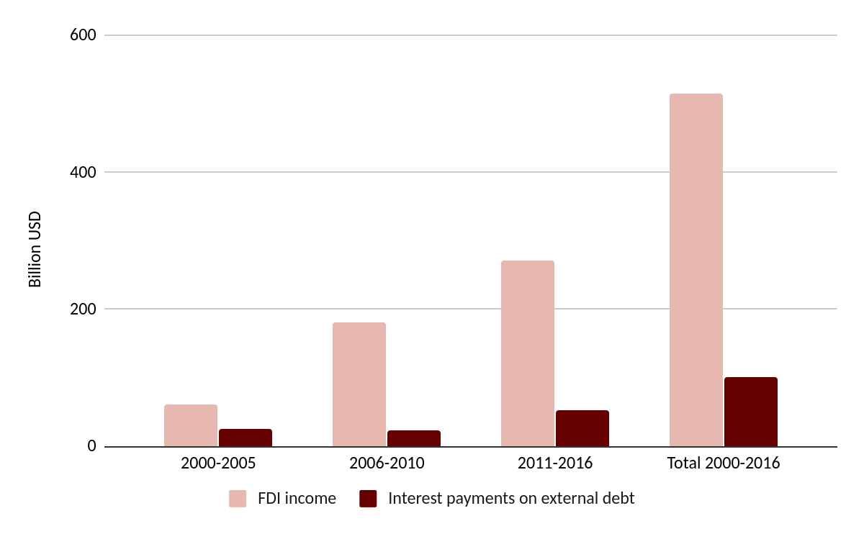
Figure 1: Interest payments on external debt and FDI income for 28 SSA countries (Nigeria and South Africa included), in billion USD. Source: World Development Indicators (World Bank)

To sum up, on the one hand, the African continent has witnessed a massive increase in FDI flows in recent decades. In line with our understanding of financialization as an expansion of the financial sector, this represents a simple quantitative change of amount: FDI flows have increased. On the other hand, new markets for financial instruments have been created in the fields of foreign-denominated and local currency denominated government bond markets. The changes are qualitative in nature. Not only have new kinds of financial instruments been marketized, but we can also observe a shift towards an increased relative role of private lenders in lieu of public ones in those African economies that can be seen as ‘financially connected’.

Case Studies: Financialization as a patchy and uneven process
In this section, we further disaggregate the continental data and the analysis distinguishing between financially connected and non-financially connected African countries by focusing on four countries: Mauritius, Nigeria, South Africa and Zambia. Our case study countries are among the most ‘financially connected’ countries on the continent, according to the amount of external debt held by private sector actors in 2017. We will explore to what extent they are ‘financializing’ and we link this back to the financial subordination perspective, which focuses on the qualitative aspect of these new practices i.e. which dependencies they bring, with a particular focus on domestic credit creation and the banking sector more broadly.

South Africa, Mauritius, Nigeria and Zambia have different profiles in terms of financial integration into the global economy. The fact that Mauritius is a rich African tax haven and financial platform and Nigeria and South Africa are the biggest African economies also makes them of particular interest.

As we highlight below, financialization is not taking place across the board. It is a highly uneven and patchy process. What has remained the same, is these four countries’ financial subordination with a lack of credit for productive activities, oligopolistic and mostly foreign dominated banking sectors.

Financial Market Development and the Real Economy
One quantitative measure of financialization is financial depth, which in turn is judged based on various measures of money supply as a share of GDP. Liquid liabilities to GDP is one way of measuring this. As figure 2 illustrates, the financial depth of Nigeria and Zambia is considerably lower than Mauritius and South Africa, and Mauritius is the only economy among the four with a steady increase in financial depth over time. Indeed, the ebb and flow of financial depth in Nigeria, South Africa and Zambia appear to be cyclical rather than secular.
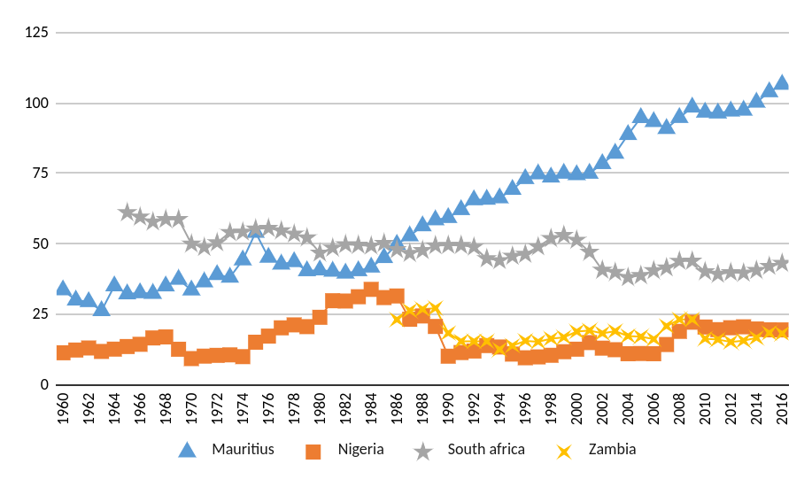
Figure 2: Liquid Liabilities to GDP. Source: World Bank, Global Financial Development

Another quantitative measure of financialization is the size of the financial sector relative to the real economy, which can for example be measured by assets of both banks and non-bank financial institutions as a share of GDP (Powell 2013).

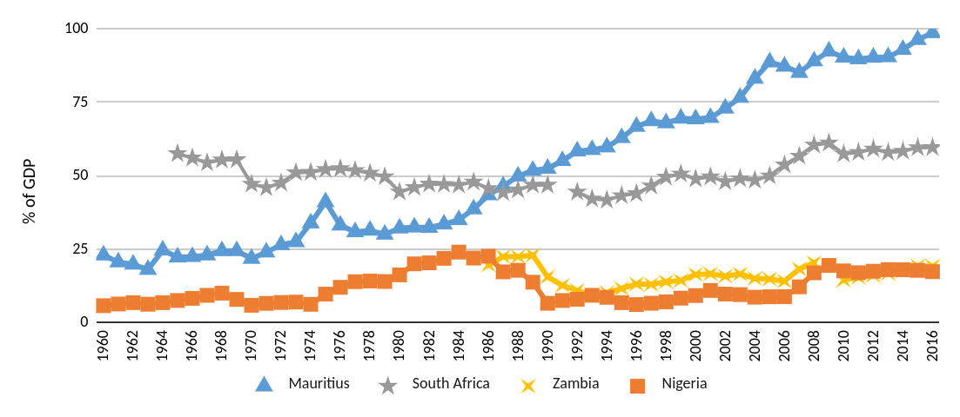
Figure 3: Financial System Deposits to GDP. Source: World Bank, Global Financial Development

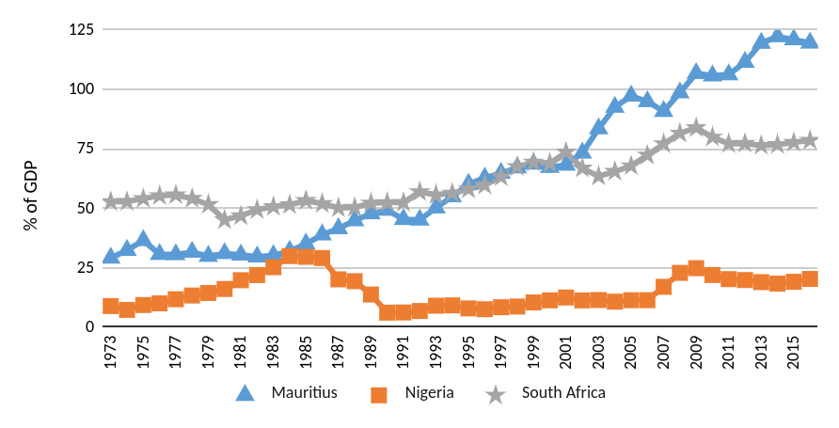
Figure 4: Deposit Money Bank Assets to GDP. Source: World Bank, Global Financial Development

Figure 3 and 4 indicate that there is a substantial difference between the case study countries with respect to their degree of financialization, with South Africa and Mauritius clearly financializing, and Nigeria and Zambia showing no such secular trend.

Other interesting differences relate to the share of financial assets and portfolio investments relative to other assets. Data from the Global Financial Development database illustrates that while South Africa has seen an explosion in the amount of portfolio investment (though direct investment is still higher), there is no such trend in the other countries. Generally, portfolio investment in these countries appear to move cyclically rather than secularly, although, notably, South Africa, Mauritius and Nigeria do show a clear trend towards increased capital account volatility since the 1990s (see also IMF Balance of Payments Statistics).

Furthermore, while there has been an increase in domestic credit provided by the financial sector as well as domestic credit to the private sector in Mauritius and South Africa, this has not been the case in Zambia and Nigeria, again suggesting that the domestic financial systems of Nigeria and Zambia are not financializing (see figures 5 and 6).

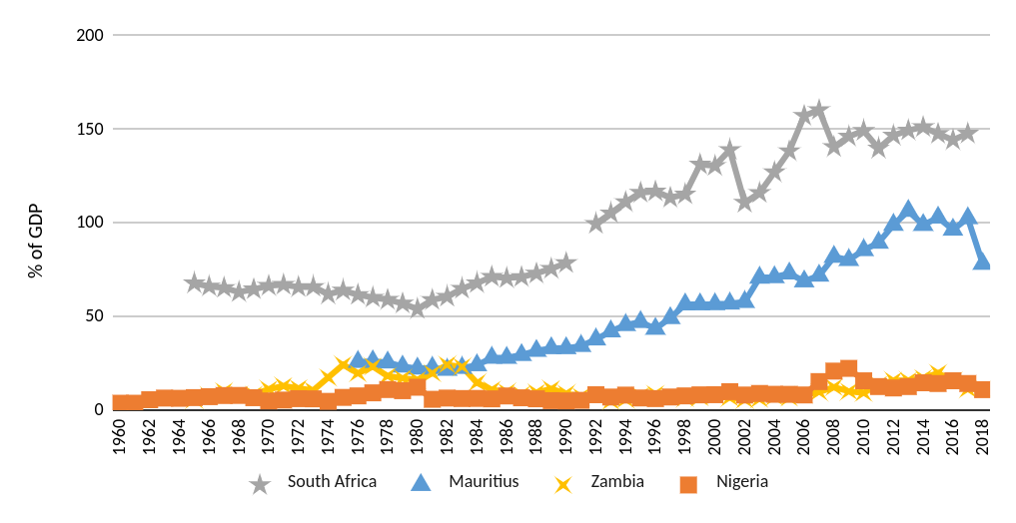
Figure 5: Domestic Credit Provided by Financial Sector. Source: IMF, International Financial Statistics.

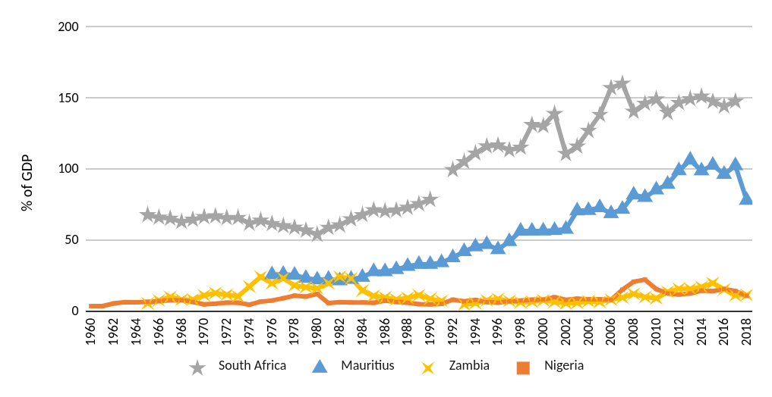
Figure 6: Domestic credit to private sector. Source: IMF, International Financial Statistics

As figure 7 illustrates, productive lending to GDP has increased for South Africa and Mauritius since the 1980s (although South Africa’s ratio has flattened since 2009), but the financial system does not appear to be working to spur production in Zambia and Nigeria, suggesting that the real economy is under-financed (in line with Amin’s assessment of financially dependent economies). Similarly, data from the World Bank Global Financial Development database illustrates that firms in Zambia and Nigeria are unlikely to access credit from the traditional banking sector and that over 40% of firms in Nigeria and Mauritius identify access to finance as a major constraint (approximately 20% of South African and Zambian firms said the same according to the same database).

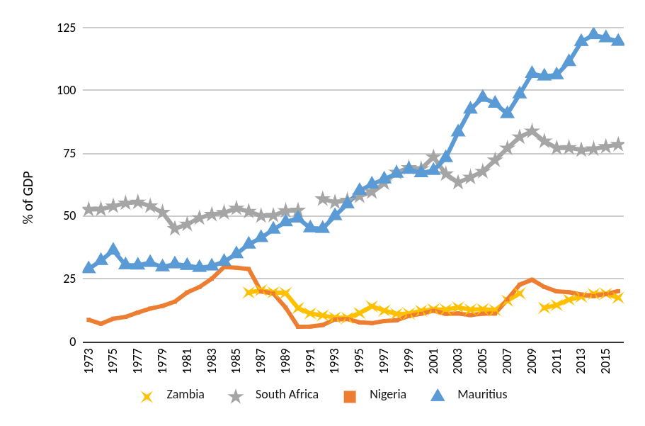
Figure 7: Deposit money banks’ claims on domestic non-financial sector to GDP. Source: World Bank Financial Structure Dataset

As mentioned, one aspect of the development of missing markets in Africa, was the development of stock markets. African stock exchanges, despite their quick proliferation since the 1980s, are characterized by a low number of listed firms, low market capitalization and low liquidity. The major exception to the rule is the Johannesburg Stock Exchange which had a total market capitalization of 1 trillion USD in 2017, that is 73% of the total continental market capitalization (Schiereck et al., 2018: 24). Despite their relative underdevelopment, African stock exchanges provide good returns on investment, with many of them having already been crowned ‘best performer of the year’ (Yartey and Adjasi, 2007:3).

Banking Sector Development: In A Subordinate Position?
During the colonial period, foreign banks were the main agents which ensured the peripheral monetary and financial integration of the continent within the world capitalist system (Nkrumah, 1965). They were not interested in the economic development of the colonies where they were operating. Their role was rather to finance (export) products needed by the metropolitan centers and to facilitate the repatriation of capital and the income of metropolitan enterprises (Amin, 1976; Uche, 2012). This ‘extractivist’ financial pattern has continued for most African countries after their achievement of formal independence despite efforts to nationalize the banking sector during the ‘dirigiste’ period.

The restructuring of the banking sector since the 1980s has generally been associated with the liquidation of public development banks, a greater openness to foreign banks and an increase in the degree of oligopoly (Mkandawire, 1999; Fowowe, 2011; Nyantakyi and Sy 2015). With regard to credit policy, ease of entry, and the share of public banks in bank assets, the financial sector in sub-Saharan Africa on average (excluding Ethiopia) became more liberalized compared to those of South-East Asia and Latin America (Abiad et al., 2008; Rashid, 2013).

Theoretically, the increased presence of foreign banks could increase competition in domestic markets and thereby widen access and lower costs. However, in practice foreign bank entry to developing countries has tended to shift (productive) lending from small and medium sized enterprises over to household lending and to increase cross-border fragilities (dos Santos, 2012). Despite international financial institutions recognizing the fragility associated with the presence of foreign banks in the wake of the 2008 financial crisis, these institutions have continued to tailor their conditionalities to minimize domestic regulatory challenges and encourage the entry of foreign banks (Gabor, 2012).

According to the Global Financial Development database, while the percentage of foreign banks among total banks is very high in Zambia and Mauritius (around 75%), it is relatively low for South Africa and Nigeria (around 25%). Considering the competition in the banking sector can help us further understand that sector in these countries. The H-statistic suggests that Zambia and South Africa have seen an increase in the degree of monopolies in their banking sectors, while the Lerner Index indicates that the banking sector in all four countries has become less competitive. However, the banks’ net interest margin as well as their non-interest income to total income has remained fairly stable over time.
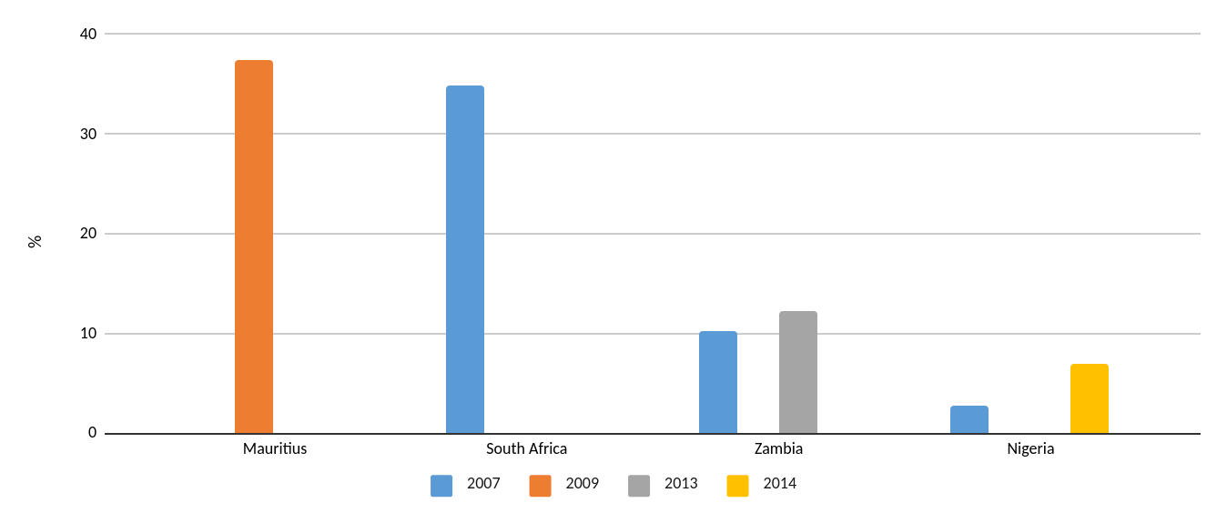

Figure 8: Firms using banks to finance investments (%). Source: World Bank, Global Financial Development.

While this brief data analysis does not present definite evidence of the banking sector becoming more subordinate, it does suggest that they operate from a subordinate position. For example, Mauritius and Zambia’s banking sectors are especially heavily dominated by foreign banks (and by just a few of them), in line with Nkrumah’s (1965) observation over half a century ago. Generally, all four countries have banking sectors with high bank concentration. For Zambia and Nigeria in particular, very few firms are able to use banks to finance investments (around 10% for Zambia, around 5% for Nigeria), while in South Africa and Mauritius only 30% of firms are able to use banks to finance investments (figure 8). This is in line with dos Santos’s (2012) observation that a large presence of foreign banks in developing countries’ banking sectors tends to be associated with a low prioritization of financing of domestic firms.

The degree of banking sector orientation toward household lending demands further exploration. While in advanced economies, financialization has been characterized by rising levels of household indebtedness, this is not a characteristic that can be observed at the aggregate for these four countries. However, when dealing with low-income and middle-income economies with large degrees of poverty and low degrees of access to formal banks, we would need to investigate the effects of microfinance initiatives to get a better understanding of the degree of household financialization and its impact on community development. For example, while loans to households from commercial banks to GDP has fallen in Zambia, outstanding loans to microfinance institutions have skyrocketed, according to the IMF’s Financial Access Survey. A similar observation can be made in relation to South Africa, where there has been a fall in the aggregate amount of household debt since 2008 (IMF Financial Access Survey). Yet we know from in-depth case studies that microfinance in South Africa has led to unsustainable levels of indebtedness in pockets of communities in the country, especially affecting the poorest (ECI Africa 2015; Bateman 2019). A closely linked topic, also relevant for community development, is the financialization of land and housing. Financial practices and motives constitute a growing threat for the right to adequate housing. South Africa, as the most financialized African country, provides a good case. Beyond their limited access to affordable mortgage loans, which have become a new asset class for the financial sector, poor and middle class communities in South Africa are sometimes evicted from their neighborhood following asset bubbles and high rents prices, two phenomena linked to the corporate intrusion in the housing sector (Migozzi 2019; Karwowski 2018).

Conclusion
The basic argument of this article is that there is no easy answer to how ‘financialization’ works specifically on the political economy of African countries which are characterized by a longstanding structure of economic dependency, exposure to foreign financial flows and oligopolistic and foreign-dominated banking systems.
Indeed, the extent to which African economies are ‘financializing’ depends on the economy in question. Financial liberalization, as an ongoing global project of financial systems restructuring, has taken place across the region and across sectors since the 1980s. Yet, the brief empirical case studies presented show that there is substantial variety between countries.

For the four countries with the highest amount of external debt held by private sector actors (one indicator of connectedness to global capital markets), Mauritius was the only one with a steady increase in financial depth over time. Indeed, the ebb and flow of financial depth in Nigeria, South Africa and Zambia appear to be cyclical rather than secular, and Nigeria and Zambia in particular are relatively under-financed by traditional measures, despite their increase in financial ‘connectedness’.

The banking sectors of our case countries suggest that several countries experience continued dominance of foreign banks. This confirms that the old characteristics of subordination, observed by Nkrumah, Amin, and others are still a strong trend. This includes the lack of ability of the case study countries to build financial systems that transform savings into long-term investments in the real economy, and address the under-financing of domestic firms.

Some African countries have developed local currency bond markets and have seen an increase in investment in their external debt by private sector actors, which may lead to increased vulnerability and volatility, associated with financialization as a destabilizing force in the region. The increasing dependence on global liquidity is a new source of vulnerability that many African countries have become exposed to as the result of financial integration. This is most relevant for ‘financially-connected’ African countries.

The increasing global push for financial inclusion of non-banked African populations requires further investigation, though some worrying cases of household indebtedness have already been identified. More generally, there is much to be explored with regard to how the spread of financial practices and motives weakens community development in Africa in areas such as housing, food, healthcare, education and infrastructure building.

References
Abiad, A., Detragiache, E., and Tressel, T. (2008) A New Database of Financial Reforms, IMF Staff Papers, 1– 28, IMF, Washington, USA.
AfDB, OECD, UNDP (2017) African Economic Outlook 2017. Entrepreneurship and Industrialization, AfDB, OECD, UNDP.
African Union/Economic Commission for Africa (2015) Illicit Financial Flow. Report of the High Level Panel on Illicit Financial Flows from Africa, Commissioned by the AU/ECA Conference of Ministers of Finance, Planning and Economic Development.

Alves C. and Toporowski. J. (2019) Growth of international finance and emerging economies: Elements for an alternative approach, PSL Quarterly Review, 72, (288): 3-26.

Amin, S. (1976) Unequal Development: An Essay on the Social Formations of Peripheral Capitalism, Monthly Review Press, New York.

Amin, S. (2011) Maldevelopment: Anatomy of a Global Failure, Pambazuka Press, Oxford, UK.

Bateman, M. (2019) The rise of microcredit ‘control fraud’ in post-apartheid South Africa: from state-enforced to market-driven exploitation of the black community, Review of African Political Economy, 46 (161), 387-414.

Batemand, M. and Chang, H.J. (2012) Microfinance and the Illusion of Development: From Hubris to Nemesis in Thirty Years, World Economic Review 1(1), 13-36.

Bayliss, K. and Van Wayenberge, E. (2018) Unpacking the Public-Private Partnership Revival, Journal of Development Studies 54(4), 577-593.

Berensmann, K., Dafe, F. and Volz, U. (2015) Developing local currency bond markets for long-term development financing in Sub-Saharan Africa, Oxford Review of Economic Policy, 31(3-4), 350-378.

Bonizzi, B. (2013) Financialization in Developing and Emerging Countries, International Journal of Political Economy, 42(4), 83-107.

Bonizzi, B. Laskaridis, C. and Toporowski. J. (2019) Global Liquidity, the Private Sector and Debt Sustainability in Sub-Saharan Africa, Development and Change 50(5), 1430–1454.

Bonizzi, B. Kaltenbrunner, A. and Powell, J. (2020) Subordinate Financialization in Emerging Capitalist Economies, in P. Mader, D. Mertens and N. van der Zwan (eds), The International Handbook of Financialization, Routledge, Oxfordshire.

Bortz, P.G. (2016) Inequality, Growth and ‘Hot Money’, Edward Elgar, Cheltenham.

Clapp, J. and Isakson, S.R. (2018) Risky Returns: The Implications of Financialization in the Food System, Development and Change, 49(2), 437-460.
Christensen, B.V. and Schanz, J. (2018) Central banks and debt: emerging risks to the effectiveness of monetary policy in Africa? BIS Papers 99, Bank for International Settlements, Basel.

Christophers, B. (2015) The limits to financialization, Dialogues in Human Geography 5(2), 183-200.

Dafe, F. Essers, D. and Volz, U. (2018) Localising sovereign debt: The rise of local currency bond markets in sub-Saharan Africa, The World Economy 41(12), 3317-3344.

Dafe, F. (2019) Ambiguity in international finance and the spread of financial norms: the localization of financial inclusion in Kenya and Nigeria, Review of International Political Economy, 27(3), 500-524.

Dos Santos, T. (1970) The Structure of Dependence, The American Economic Review, 60(2), 231-236.

Dos Santos, P. (2012) A Policy Wrapped in ‘Analysis’: The World Bank’s Case for Foreign Banks, in K. Bayliss, B. Fine and E.V. Wayenberge (eds) The Political Economy of Development: The World Bank, Neoliberalism and Development Research, Pluto Press, London.

Dos Santos, P. and Kvangraven, I.H. (2017) Better than Cash, but Beware the Costs: Electronic Payments Systems and Financial Inclusion in Developing Economies, Development and Change 48(2), 205-227.

ECI Africa (2005) The Evolution of the South African Microfinance Sector from 1992 to 2004: The role of the Microfinance Regulatory Council, ECI Africa, Nairobi.

Eichengreen, B. Hausmann, R. and Panizza, U. (2005) The Pain of Original Sin, in B. Eichengreen and R. Hausmann, eds, Other People’s Money, Chicago University Press, Chicago.
Epstein, G. (2005) Financialization and the World Economy. Edward Elgar Publishing, Cheltenham, UK.

Essers D., Blommestein H., Cassimon D., and Flores P.I. (2015) Local currency bond market development in Sub-Saharan Africa: a stock-taking exercise and analysis of key drivers, Emerging Markets Finance and Trade, 52(5), 1167-1194.
Fowowe, B. (2011) Financial liberalization in sub-Saharan Africa: what do we know?, Journal of Economic Surveys, 27(1), 1-37.

Gabor, D. (2012) The IMF’s rethink of global banks: critical in theory, orthodox in practice, Governance, 28(2), 199–218.

Gabor, D. (2018) Goodbye (Chinese) shadow banking, hello market-based finance, Development and Change 49(2), 394-419.

Gevorkyan, A.V. and Kvangraven, I.H. (2016) Assessing Recent Determinants of Borrowing Costs in Sub-Saharan Africa, Review of Development Economics 20(4), 721-738.

Godechot, O. (2016) Financialization is marketization! A study of the respective impacts of various dimensions of financialization on the increase in global inequality, Sociological Science, 3, 495-519.

Goyal, R, C. Marsh, N. Raman, Wang, S. and Ahmed, S. (2011) Financial Deepening and International Monetary Stability, IMF Staff Discussion Note 11/16, International Monetary Fund, Washington DC.

Hardie, I. and Rethel. L (2018) Financial structure and the development of domestic bond markets in emerging economies, Business and Politics 1-27.

IMF and World Bank (2013) Local Currency Bond Markets – A Diagnostic Framework, Washington DC.

IMF (2016) Development of Local Currency Bond Markets: Overview of Recent Developments and Key Themes, Staff Note for the G20 IFAWG, Seoul 20 June 2016, International Monetary Fund, Washington DC.

Ivanova, M.N. (2019) Inequality, financialization, and the US current account deficit, Industrial and Corporate Change, 28(4), 707–724.

Kaltenbrunner A. and Painceira J.P. (2018) Subordinated financial integration and financialization in emerging capitalist economies: the Brazilian experience, New Political Economy, 23(3), 290-313.
Kar, D. and Cartwright-Smith, D. (2010) Illicit Financial Flows from Africa: Hidden Resource for Development, Global Financial Integrity, Washington, DC.
Karwoski, E. (2018) Corporate financialization in South Africa: From investment strike to housing bubble, Competition and Change 22(4), 413-436.

Karwowski, E. (2019) How financialization undermines democracy, Development and Change vol 50 n°5: 1466-1481.

King, R. G. and Levine, R. (1993) ‘Finance and Growth: Schumpeter (May be Right),’ Quarterly Journal of Economics 108(3), 717–737.

Krippner, G.R. (2005) Financialization of the American economy, Socio-Economic Review 3(2), 173–208.
Lauerman, J and Vossos, T. (2019) Investors cash in on Ebola bonds that haven’t paid out, Bloomberg, 14 August, accessed at: https://www.bloomberg.com/news/articles/2019-08-14/ebola-bond-pays-investors-millions-while-congo-battles-outbreak (18 August 2020).
Mader, P. (2018) Contesting financial inclusion, Development and Change, 49(2), 461-483.
McKinnon, R. (1973) Money and Capital in Economic Development, Brookings Institution, Washington, DC.
Mecagni, M. Marchettini, D. and Maino, R. (2015) Evolving Banking Trends in Sub-Saharan Africa. Key Features and Challenges, IMF, Africa Department, Washington DC.
Migozzi, J. (2019) Selecting spaces, classifying people: the financialization of housing in the South African city, Housing Policy Debate, 30(4), 640-660.
Mkandawire, T. (1999) The political economy of financial reform in Africa, Journal of International Development 11(3), 321-342.

Mustapha, S. and Prizzon, A. (2018) Africa’s rising debt: How to avoid a new crisis, ODI Briefing Note. Overseas Development Institute, London.
Ndikumana, L. and Boyce, J.K. (2011) Africa odious debt: how foreign loans and capital flight bled a continent, Zed Books, London.
Nkrumah, K. (1965) Neocolonialism: The last Stage of Imperialism, Thomas Nelson & Sons, Ltd., London.
Nyantakyi, E.B. and Sy. M. (2015) The Banking System in Africa: Main Facts and Challenges, Africa Economic Brief, 6(5), 1-16.

Powell, J. (2013) Subordinate financialization: a study of Mexico and its non‐ financial corporations, PhD Thesis. SOAS, University of London, London.

Presbitero, A.F., Ghura, D., Adedeji, O.S. and Njie, L. (2016) Sovereign bonds in developing countries: drivers of issuance and spreads’, Review of Development Finance 6(1), 1–15.

Rashid, H. (2013) Does financial market liberalization promote financial development?: evidence from Sub-Saharan Africa in J.E. Stiglitz, J. L. Yifu, eds, The Industrial Policy Revolution II: Africa in the 21st Century, Palgrave MacMillan, London, pp.321-349.

Schiereck, D., Freytag, A., Grimm, M., Bretschneider, W. H. (2018) Public corporations in Africa: A continental survey on stock exchanges and capital markets performance, Jena Economic Research Papers, No. 2018-013, Friedrich Schiller University Jena, Germany.
Shaw, E. S. (1973) Financial Deepening in Economic Development, Oxford University Press, Oxford.
Shin, H. (2012) Global Banking Glut and Loan Risk Premium, IMF Economic Review 60, 155–92.

Staritz, C., Newman, S. Troster B. and Plank. L (2018) Financialization and global commodity chains: distributional implications for cotton in Sub-Saharan Africa, Development and Change 49(3), 815–842.

Sylla, N. (2014) From a marginalised to an emerging Africa? A critical analysis, Review of African Political Economy 41(1), 7-25.

Tavares, M. (1985) A retomada da hegemonia Americana, Revista de Economia Política. 5(2), 5–16.

Taylor, I. (2016) Dependency redux: why Africa is not rising, Review of African Political Economy 43(147), 8-25.
Uche, C. (2012) Financial sector liberalization in developing countries, International Trade Center, Geneva.

UNCTAD (2014) The State of Commodity Dependence, United Nations Conference on Trade and Development, Geneva.

Vishnoi, A. (2019) Wall of Money is heading for Emerging Markets IIF says, Bloomberg, March 5th, 2019, accessed at: https://www.bloomberg.com/news/articles/2019-03-05/-wall-of-money-is-heading-for-emerging-markets-iif-says (28 January 2020).
Waibel, M. (2009) BIT by BIT – the silent liberalisation of the capital account, in C. Binder, U. Kriebaum, A. Reinisch and S. Wittich, eds, International Investment Law for the 21st century – Essays in Honour of Christoph Schreuer, Oxford, pp. 497-518.
Williamson, J. and Mahar. M (1998) A survey of financial liberalization, Essays in International Finance, 211, November, Princeton University Press, New Jersey.

World Bank (2018) Africa's Pulse, 17, World Bank Group, Washington DC.

Yartey, C.A. and Adjasi. C.K. (2007) Stock Market Development in Sub-Saharan Africa: Critical Issues and Challenges, IMF Working Paper 07/209, Washington DC.

Financial liberalization, defined as ‘the process of giving the market the authority to determine who gets and grants credit and at what price’, was supposed to be the antidote to ‘financial repression’- a situation where ‘the government decides who gives and gets credit and at what price’ (Williamson and Mahar, 1998, p. 2).
Most of the current African stock markets were created after 1980. Before that, only seven stock exchanges existed, while now there are thirty in operation (Schiereck et al, 2018, p. 3-4).
With public external debt levels on the rise, the IMF has identified that the number of countries at high risk of debt distress in the region has more than doubled (Mustapha and Prizzon, 2018).
Sovereign borrowing usually paves the way for subsequent private flows (Mecagni et al, 2014). In such cases, the sovereign bond serves as a benchmark for corporate issuances. Often, the sovereign issues complement domestic bond issuances. In line with this, corporate bonds have also been issued by several African countries, including Angola, Ghana, Nigeria, and South Africa.
See e.g. Cohn, 2013, ‘Bond yields too low? There’s always Rwanda,’ Reuters 05.03.2013 or Kenny, 2013. ‘How to Save Your 401(k): Invest in Africa,’ Businessweek 21.10.2013.
Inspired by Bonizzi et al. (2019) and UNCTAD’s (2014) definition of ‘commodity dependence’, we define countries as financially connected (FC) if their reliance on concessional debt is less than 60% of total external debt. Note that all African countries are financially integrated with the global capitalist system, for example through their banking systems. There are ways of being financially connected other than through borrowing money in hard currency from external private entities, for example through foreign direct investment. Using other measures of financial connectedness will therefore inevitably lead to different groupings of countries. Nonetheless, for our purpose of seeing how debt dynamics have changed on the continent, this categorization is a helpful one.
FDI income denotes the returns foreign (direct) investors make on their investments each year.
Angola, Benin, Botswana, Burkina Faso, Cabo Verde, Cameroon, Congo Republic, Cote d’Ivoire, Eswatini, Ethiopia, Ghana, Kenya, Lesotho, Madagascar, Malawi, Mali, Mauritius, Mozambique, Niger, Nigeria, Rwanda, Senegal, Sierra Leone, South Africa, Tanzania, Togo, Uganda, Zambia. These 28 countries represented 85% of SSA nominal GDP in 2016.
According to the World Bank’s International Debt Statistics, in 2017, these countries’ external debt held by the private sector was at 70% (Mauritius), 51% (Nigeria), 42% (South Africa) and 40% (Zambia), which are the four highest ratios on the continent.
This is what King and Levine (1993) refer to as financial development.
In terms of bank-based finance and its relation to the real economy, banks’ claims on domestic non-financial sector to GDP is a good indicator, as this ratio excludes claims on the financial sector and international claims, by definition limiting itself to what is generally considered productive lending (Powell 2013: 154).
For example, the financial sectors of Cote d’Ivoire and Mozambique were much more liberalized than those of Brazil, China and India in the mid-2000s.
Based on a neoclassical understanding of competition, the World Bank defines the H-statistic as follows: ‘A measure of the degree of competition in the banking market. It measures the elasticity of banks revenues relative to input prices. Under perfect competition, an increase in input prices raises both marginal costs and total revenues by the same amount, and hence the H-statistic equals 1. Under a monopoly, an increase in input prices results in a rise in marginal costs, a fall in output, and a decline in revenues, leading to an H-statistic less than or equal to 0.’ Read more here: https://datacatalog.worldbank.org/h-statistic
Higher values of the Lerner index indicate less bank competition. More here: https://datacatalog.worldbank.org/lerner-index

