Age-estimate evidence for a complex Middle to Late Pleistocene fluvial terrace aggradation spanning more than a 100-kyr interglacial–glacial cycle at Sutton Cross, eastern England

H. E. Langfordª, H. Griffiths*, D. J. Horne^{b}, D. H. Keen*, K. E. H. Penkman^{c}

ª Department of Geography, Birkbeck University of London, Malet Street, London WC1E 7HX, UK
^{b} School of Geography, Queen Mary, University of London, Mile End Road, London E1 4NS, UK
^{c} BioArCh, Department of Chemistry, University of York, York, YO10 5DD, UK

*Deceased

At Sutton Cross, eastern England, an undated River Nene 2nd Terrace was known to record a complex sequence of late Middle to Upper Pleistocene deposits. Amino acid geochronology was carried out for samples from four separate facies associations in order to provide a chronostratigraphic framework for this complex deposit. Each sample comprised three specimens of Bithynia tentaculata opercula. The intracrystalline protein decomposition results confirmed the sedimentary stratigraphic interpretation previously proposed for the site, i.e. that fossiliferous sediments yielding fully temperate Mollusca and Ostracoda faunas are equivalent in age to marine isotope stage (MIS) 7. Palaeotemperature reconstructions based on the Ostracoda fauna (July: +14 to +26°C; January: −4 to +5/+3°C) embrace those of today at this location (July: +17°C; January +3°C). The sedimentary succession at Sutton Cross comprises vertically aggraded packages with a probable maximum age of MIS 8 and minimum age of MIS 2. This aggradation pattern (and age range) is also common to downstream sedimentary successions at Whittlesey, and is counterintuitive to the traditional terrace stratigraphy approach that expects laterally aggrading downstepping packages. The preservation of sediments of MIS 7 age and older at Sutton Cross with no evidence of glacial overriding places constraints on recently proposed late Middle Pleistocene regional ice limits.

Keywords:
amino acid racemization (AAR)
intracrystalline protein decomposition (IcPD)
palaeotemperature reconstruction
fluvial sedimentology
River Nene 2nd Terrace
Middle Pleistocene
marine isotope stage (MIS) 7

1. Introduction
This article presents new amino acid racemization (AAR) age-estimate and palaeotemperature data for a previously described (Langford, 1992, 1999, 2012a, 2018; Langford et al., 2004a), but undated, late Middle to Upper Pleistocene sedimentary succession at Sutton Cross (National Grid Reference TL 108 989), near Wansford, in the lower River Nene catchment, eastern England (Fig. 1a). Sutton Cross lies 8.5 km west of Peterborough on the eastern side of the subdued NE–SW trending Jurassic escarpment. The site investigated occupies a River Nene 2nd Terrace (BGS, 1978; Harrisson, 1981) to the east of the Southorpe dry valley that links the catchments of the rivers Welland and Nene (BGS, 1978, 1984). This erosional feature exposed the Lincolnshire Limestone quarried to build Peterborough and Ely cathedrals (https://en.wikipedia.org/wiki/Barnack). Kellaway and Taylor (1953) interpreted this feature as a subaerial glacial meltwater channel, an interpretation adopted by Langford (1999, 2004), but Langford (2012a, 2018) later suggested erosion by spillover from a proglacial lake occupying the Welland catchment. Gibbard et al. (2018), however, map the eastern side of the dry valley as a north–south trending ice-marginal push moraine based on digital elevation modelling (DEM). The southern end of the dry valley emerges where the northerly course of the middle Nene turns abruptly eastward, at the eastern end of the buried Tixover channel. The Tixover channel has been interpreted as part of a pre-Anglian (Elsterian/MIS 12) drainage system (Kellaway and Taylor, 1953; Boreham and Langford, 2006).
The established tripartite River Nene terrace system (Horton, 1989) was determined by surface mapping (Taylor, 1963; BGS, 1972, 1976, 1978, 1984; Booth, 1981, 1982; Harrisson, 1981) and stratigraphically grouping the alluvial remnants identified according to altitude. This fluvial terrace stratigraphy approach is a long established practice in British Pleistocene research (Trimmer, 1953; see Bridgland (1994) and Gibbard (1994) for historical reviews of River Thames research). McMillan and Merritt (2009) describe these alluvial remnants as morpho-lithogenetic units, but Rose (2009) notes that implicitly age in such grouping tends to increase with altitude, and he therefore advocates the term morphostratigraphy.
The River Nene 2nd Terrace has not been dated directly but was assigned a Middle Devensian (Weichselian/MIS 4–3) age by Castleden (1980), an Ipswichian (Eemian/MIS 5e) age by Horton (1989), and age ranges of MIS 10–8 by Bridgland et al. (1991), MIS 8–6 by Boreham et al. (2010) and MIS 9–7 by Rose (2015). Maddy (1999) assigned River Nene 2nd Terraces to the Grendon Member of the Nene Valley Formation and attributed their age to MIS 7. Langford (2004, 2012a, 2018) argued that aggradation of many 3rd and 2nd terraces of the middle and lower Nene may have been in response to drainage network reorganization in MIS 8. Such differences in stratigraphic interpretation raise the question of whether the River Nene terrace system (Horton, 1989) adequately delineates Pleistocene alluvial remnants within the catchment (Bridgland et al., 1990). This question also can be raised for the terrace sequences of the River Test (Hatch et al., 2017) and River Axe (Brown et al., 2015) of southern and southwest England respectively, and is reinforced by temporally complex aggradations recorded beneath some mapped fluvial terrace surfaces (Green et al., 1996; Smith, 1999; West et al., 1999; Langford et al., 2007; Boreham et al., 2010).
At Sutton Cross 5.5 m of River Nene 2nd Terrace (Fig. 1b) deposits unconformably overlie the Lower Lincolnshire Limestone Member (BGS, 1984); their surface lies at between 14 and 15 m Ordnance Datum (OD) and their base at about 9 m OD (Langford, 1999). These 2nd Terrace deposits were investigated in 1991 when exposures were available in a borrow pit created to supply sand and gravel for the construction of the Castor–Ailsworth bypass (A47; Fig. 1b). Langford (1992) provided details of seven species of mammal fossil found at the site and later (1999) described the sedimentary succession, including palaeoecology based on Mollusca and Ostracoda, with a summary presented in Langford et al. (2004a). A complex late Middle to Upper Pleistocene sedimentary stratigraphy was determined for the succession at Sutton Cross, encompassing three glacial and two interglacial stages (Langford, 2012a, 2018), but this lacked robust bio- or chronostratigraphy. Newly obtained AAR age-estimate data on Bithynia tentaculata opercula from fully temperate faunal assemblages are reported here that provide a coherent and reliable chronostratigraphical interpretation of the sedimentary succession at Sutton Cross. These AAR data provide the first reliable age estimate for the River Nene 2nd Terrace and consequently have implications for the interpretation not only of the fluvial terrace sequence, but also the related marine deposits of the area, as well as interpretations of late Middle Pleistocene ice margins and drainage network reorganization. In addition, palaeotemperature reconstructions have been undertaken for the first time on a fully temperate freshwater Ostracoda fauna from a River Nene 2nd Terrace.

2. Methods
2.1 Sedimentology
Langford (1999) adopted a sedimentological approach for studying the River Nene 2nd Terrace at Sutton Cross using the principle of facies analysis (Reading, 1986, 1996) informed by the hierarchy of bounding surfaces and two- and three-dimensional facies architecture (Miall, 1985; Walker, 1990; Collinson, 1996). Exposed sections were generally cleaned and detailed sedimentary logs (Fig. 2a), supported by photographs (Fig. 3) and sketches, were recorded either at critical points or at the deepest part of the exposure, using lithofacies coding (Table 1) adapted from Miall (1977) and Dardis et al. (1984).

2.2 Clast lithology
Samples were collected from cleaned faces of recently exposed sections, and overlying material from a suitably sized area was removed in order to avoid contamination. Individual facies were sampled where appropriate (e.g. sufficient proportion of gravel). Multiple samples were collected from some facies in order to monitor within-facies variation. Sample size ranged from 1.6 kg to > 20 kg and clasts ≥ 11.2 mm were used for analysis. Each count was divided into five lithological categories:
1 flint (including varieties of chert, such as Rhaxella and jasper);
2 limestone (including Carboniferous limestone, Chalk and nodular Chalk, sandy limestone);
3 sandstone and quartz (including quartz-rich igneous and metamorphic, and possibly Jurassic quartz-rich nodules);
4 ironstone;
5 other (including shell and bone fragments, Jurassic clay nodules and fossils, and indeterminate lithologies).
The flint category (except for the minor chert component) provides information on post-Anglian (Elsterian/MIS 12) degradation of the land surface. The limestone category provides information on local material (except for the rare Carboniferous and chalk clasts) and possibly on the extent of fluvial and local slope erosion. The sandstone and ironstone categories provide information on material derived from the west and possibly on periods of fluvial stability without large influxes of material associated with slope and fluvial erosion.

2.3 Palaeoecology
Samples were collected from cleaned faces of recently exposed sections, and overlying material from a suitably sized area was removed in order to avoid contamination. Sample size ranged from 1 to 5 kg. Molluscs and ostracods were picked (from samples supplied by HEL), sorted and identified by the late David Keen and the late Huw Griffiths, respectively, and are described in detail by Langford (1999) and more briefly by Langford et al. (2004a). We accept their taxonomic opinions, except where a reviewer has recommended correction. Methods of analyses were not explained in the material they provided but it is assumed they followed standard procedures (Sparks, 1961; Griffiths et al., 1996).

2.4 Palaeotemperature reconstruction
The Mutual Ostracod Temperature Range (MOTR) method (Horne, 2007; Horne and Mezquita, 2008; Horne et al., 2012) reconstructs mean January and mean July air temperatures. For the MOTR the most up-to-date published calibrations (mean monthly temperature ranges in °C) were used (Horne et al., 2012) except for those for Ilyocypris bradyi and Ilyocypris gibba, which are based on unpublished analysis of verified North American distributions of those species, and that for Fabaeformiscandona caudata, which has been revised (unpublished) in light of verified North American records.

2.3 Amino acid racemization
The current technique of amino acid analysis developed for geochronological purposes (Penkman et al., 2008) combines a reverse-phase high-pressure liquid chromatography (RP-HPLC) method of analysis (Kaufman and Manley, 1998) with the isolation of an 'intracrystalline' fraction of amino acids by bleach treatment (Sykes et al., 1995). This results in the analysis of the ratios of d- and l-forms (d/l) of multiple amino acids from the chemically protected (closed system) protein within the biomineral, thereby enabling both decreased sample sizes and increased reliability of the analysis. Amino acid data obtained from the intracrystalline fraction of the calcitic Bithynia opercula indicate that this biomineral is a particularly robust repository for the original protein (Penkman et al., 2011, 2013) and therefore has been targeted in this study.
All samples were prepared using the procedures of Penkman et al. (2008) to isolate the intracrystalline protein by bleaching. Two subsamples were then taken from each operculum; one fraction was directly demineralized and the free amino acids analysed (referred to as the 'free' amino acids, FAA, F), and the second was treated to release the peptide-bound amino acids, thus yielding the ‘total’ hydrolysable amino acid fraction (THAA, H*). Samples were analysed in duplicate by RP-HPLC, with standards and blanks run alongside samples. During preparative hydrolysis, both asparagine and glutamine undergo rapid irreversible deamination to aspartic acid and glutamic acid respectively (Hill, 1965). It is therefore not possible to distinguish between the acidic amino acids and their derivatives and they are reported together as Asx and Glx respectively.
The d/l values of aspartic acid/asparagine, glutamic acid/glutamine, serine, alanine and valine (d/l Asx, Glx, Ser, Ala, Val) as well as the [Ser]/[Ala] value are then assessed to provide an overall estimate of intracrystalline protein decomposition (IcPD). In a closed system, the amino acid ratios of the FAA and the THAA subsamples should be highly correlated, enabling the recognition of compromised samples (e.g. Preece and Penkman, 2005). The d/l of an amino acid will increase with increasing time, whereas the [Ser]/[Ala] value will decrease. Each amino acid racemizes at different rates, and therefore is useful over different timescales. The d/l of Ser is less useful as a geochronological tool for samples of this age, but is presented here because aberrant values are useful indications of contamination.

3. Results
Langford (1999) identified nine facies associations characterized by combinations of dominant and subordinate sedimentary facies (Table 2). Facies association nomenclature includes an amendment adopted in Langford (2012a) following revision of the data and another amendment as a result of this study, i.e. former facies associations SC2 and SC3 are now SC3a and SC2 respectively, and former facies associations SC4–SC6 are now SC3b, SC4a and SC4b and SC7–SC9 are now SC5a–c (Table 3). Representative sedimentary logs 1–5 are presented in Fig. 2b and the two-dimensional facies architecture, stratigraphy and areal extent for each facies association are sketched in Fig. 4. Logs 1–5 are constructed to represent each of the facies associations in a spatial context, thus: log 1 represents facies associations SC1 and SC2 and the stratigraphy at the northern end of section G; log 2 represents facies associations SC5b and SC5c in section D and the northern half of section C; log 3 represents facies associations SC4a and SC4b north of section F to midway along section G; log 4 represents facies associations SC3a–SC4a and the stratigraphy between sections B and F; log 5 represents facies associations SC3a–SC4a and SC5c and the stratigraphy at section A. Vertical scale is a guide to thickness and altitudinal envelopes of each facies association only. In the following, sedimentary description, clast lithology (Table 4), palaeoecology (where appropriate) and genetic interpretation are summarized for each facies association from Langford (1992, 1999) and Langford et al. (2004a). New age-estimate and palaeoclimate data are included with the relevant facies association. The robustness of the genetic and stratigraphic interpretations is discussed in section 4.

3.1 Facies association SC1—pebbly, matrix-supported diamicton
A pebbly, matrix-supported stratified diamicton (PDms), with a clay-rich matrix at the base becoming sandier towards the top, rests unconformably on the Jurassic Lower Lincolnshire Limestone Member (LLL; logs C5 and G3, Fig. 2a; log 1, Fig. 2b; Figs 3a,b and 4). Pockets and bands of structureless (Fm) and laminated (Fl) clay and silt are present locally. Sharp, erosional, discontinuities (in places planar horizontal) separate centimetre-scale laterally and vertically stacked diamictic units (Fig. 3b). A sharp, irregular, erosional contact dipping to the west separates the upper sandier component from the lower clay-rich component. A maximum thickness of about 1 m was recorded, with aggradation from about 9.5 to about 10.5 m OD. This facies association is restricted spatially to north of log G1 (Fig. 4). Although not quantified the clast lithology comprised solely friable LLL clasts and very occasional reworked chalk-rich diamicton clasts, present locally on the interfluve to the north to northeast. Microscopic analysis indicated an absence of Quaternary flora and fauna and that the sand fraction was dominated by quartz and limestone. Horizontally stratified (Sh) white sands underlie facies PGcs at the base of log G1 (Fig. 2a; log 1, Fig. 2b; Figs 3e and 4). Microscopic examination determined that quartz grains comprise almost the whole of the fine- to medium-grained sand fraction, distinguishing them from underlying facies PDms and overlying facies association SC2 (containing common sand-size grains of ironstone) sediments. Derivation from Jurassic Grantham Formation sands (Palmer, 1987) could be possible, which occur only to the west and south of the site.
The erosional discontinuities of the diamicts, evidence of waterlain stratified fines (Fl) and deposition of suspended sediment (Fm) and the overall normal grading suggest accumulation by fine-grained to sandy cohesive flow units entering a low-energy/standing water body. The absence of contemporary flora and fauna suggests cold-climate processes on a south-facing bedrock slope. The white Sh facies most likely represents transition from a still/low-energy setting to a fluvial depositional environment.

3.2 Facies association SC2—pebbly, stratified gravels
Facies association SC2 (logs G1, G2, C5 and G3, Fig. 2a; log 1, Fig. 2b; Figs 3c and 4), with a recorded maximum thickness of 3.4 m and aggradation from about 10.5 to about 14 m OD, is dominated by pebbly, poorly stratified, clast-supported subplanar gravel sheets (PGcs) and pebbly, trough cross-stratified gravel (PGt). Locally trough cross-stratified sands (St) and fines (Fl) occur within PGt. Shallow scour channels (Miall, 1977, 1985; Bryant, 1983a) infilled by massive sand (Ss) occur at the top of facies PGcs, where sand drapes (Sm) and mud drapes (Fm) also are present. Upwardly convex depositional surfaces and laterally extensive discontinuities are present but are not common. At log G3, open framework gravel horizons are interbedded with closed framework gravels, and a rare example of planar cross-stratified gravel (PGp) corresponds with tabular foreset bedding formed at the downstream apex of a bar (Bryant, 1983b). There is a relatively high clayey silt component in the matrix, and secondary deposition of clay minerals on clast surfaces is common. Horizons rich in black carbon-coated clasts (CCC) occur extensively, associated with relative enrichment of ironstone clasts (Fig. 3d). Locally PGp stratification and PGt channel trends observed in three dimensions indicate flow from the west–northwest. Sediments of this facies association are restricted spatially to north of log C4 and north of the junction between sections F and G but south of log G1 (Fig. 4). Clast lithology (samples CL1 and CL2, Table 4) is dominated by limestone (40–55%) and flint (24–32%), with relatively high values for the sandstone category (13–19%). The clast size of ironstone tends to be small at source and hence it is underrepresented in the size fraction used here (≥ 11.2 mm diameter).
Facies PGcs is considered to represent longitudinal bar formation (Miall, 1977) and the two-dimensional internal facies architecture suggests accumulation under conditions similar to an arctic proglacial discharge regime by the successive accretion of diffuse gravel sheets (Hein and Walker, 1977; Miall, 1985; Bryant, 1983a). Preservation of facies Ss, Sm and Fm indicates the presence of accretionary surfaces (Bryant, 1983b), although distinctive horizons of well-imbricated pebbles in a closed framework are not apparent. Evidence of convex-upward constructional surfaces, considered by Ramos and Sopeña (1983) to represent longitudinal bars, supports the presence of accretionary surfaces. Facies PGt represents accumulation within channels of the same depositional environment (Miall, 1977, 1985; Bluck, 1982; Bryant, 1983a) through reworking of bar sediments, possibly by recurrent high flow events (Bryant, 1983b). Alternations of open and closed framework gravels indicate rapid depositional events accompanying a sharp reduction in flow competency, followed by clast-by-clast accretion processes (Miall, 1977) or coalescence by bar migration (Bluck, 1982). Normal grading in the openwork gravels represents waning flow conditions.

3.3 Facies association SC3a—massive sand to silt with lenses of stratified sands and gravels
Alternating bands of structureless ferruginous sand (Sm) and clayey silt (Fm) predominate (Fig. 3f) in facies S–Fm, unconformably overlying LLL (logs C1 and E2, Fig. 2a; Fig. 4) or overlying pebbly, openwork, clast-supported gravel (PGcm), containing abundant Unio sp. shells (log C2, Fig. 2a; log 4, Fig. 2b; Fig. 4). Locally, lenses of horizontally stratified sands (Sh) and clayey silts (Fl) and planar cross-stratified sands (Sp) and gravel (Gp) occur. Facies Fm was observed extensively at the top of facies association SC3a in sections A, B, E and F (Fig. 2a). Between log C3 and the junction of sections F and G (Fig. 2a), extensive phases of stratified white sands were observed (Fig. 3i), with stratification often picked out by ironstone particles, interbedded with S–Fm (Fig. 4). They form low-angle, metre-scale cross-stratified bedsets with an apparent dip to the west. The sediments of facies association SC3a were observed in three dimensions to infill a northeast– southwest trending channel eroded into the underlying LLL to a depth of about 1.5 m between log C2 and 50 m to the northwest of section A; flow direction towards the southwest is indicated by the three-dimensional architecture. Maximum thickness of about 2 m was recorded for facies association SC3a (log C2), with aggradation from about 9 to about 11.5 m OD. Facies association SC3a is restricted to the south of log C4 (Fig. 4).
A variable depositional environment, comprising the sandy bedforms (SB) and overbank fines (OF) architectural elements of Miall (1985), is indicated by the facies architecture of the northeast–southwest trending channel infill. Ferruginous fines represent the OF element and indicate areas of diffuse overbank spreads (Lewin et al., 2016) occupied during high-water stages only. Intercalated lenses of PGp–Sp (SB element) record higher energy conditions of either a migratory main stream or a floodplain drainage network (e.g. accessory channel; Lewin et al., 2016). Individual lenses rarely exceed 1 m wide, and the width of intercalated lenses is rarely more than 2 m, suggesting a tributary or floodplain channel network setting rather than deposits of a main stream. Silt and sand with subordinate gravel dominate but later in the succession the widespread occurrence of Fm indicates an extensive quiet-water phase, or a more distal position to the active stream. Towards the north this Fm facies is overlain by low-angle stratified bedsets comprising a white sand phase interdigitated with S–Fm, The extent (over 5 m wide between sections C and G) of these lateral accretion (LA architectural element of Miall (1985) bedsets suggests a main-stream setting, possibly on a point bar of a single-thread, sinuous stream (Maddy et al., 1998).
Mammalian fossils occur within this facies association, including the skull and antler of giant deer (Megaloceros giganteus Blumenbach), a metatarsal of red deer (Cervus elephus Linné) and proximal radii of Bos or Bison. Fragments of large bivalves occur scattered throughout facies S–Fm (Fig. 3f), and rip-up clasts containing mollusc shells (Table 5; Langford, 1992) occur within the coarser grained lenses. The fluvial molluscan assemblage is typical bedload fauna of a temperate river with high amounts of dissolved calcium carbonates, e.g. Ancylus fluviatilis, Pisidium henslowanum and Pisidium moitessierianum. Corbicula fluminalis, Belgrandia marginata and P. moitessierianum are thermophilous species indicative of temperate conditions. The percentage land molluscan fauna is relatively high (average 18% for four samples) and is typical of riparian and marshland habitats, e.g. Vallonia spp., Troculus hispidus and Zonitoides nitidus, with shaded habitats represented by, e.g., Clausilia sp. and Azeca goodalli. A sample from the upper part of facies association SC3a at log A2 (Fig. 2a) contained abundant ostracods (Table 6) as well as Chara tubes and oospores. The assemblage of six ostracod species from facies association SC3a is consistent with the molluscan evidence of a freshwater river with some aquatic vegetation, but also shows evidence of input from springs or spring-fed streams. Candona neglecta is ecologically wide-ranging from lakes to springs, Ilyocypris bradyi has a preference for springs and spring-fed waters, and Prionocypris zenkeri is typical of slow-flowing streams with rich aquatic vegetation but is also associated with springs; Heterocypris salina is suggestive of raised salinity, but it also occurs in fresh waters including springs; the two tentatively identified Potamocypris species, on the other hand, prefer ponds, lakes and slow-flowing vegetated waters (Meisch, 2000).
Four taxa identified with confidence to species level in the SC3a assemblage were used for the MOTR reconstructions (I. bradyi, C. neglecta, H. salina and P. zenkeri; see Table 7 for their calibrated temperature ranges). The result indicates mean monthly air temperature ranges of +14 to +26°C in summer (July) and –4 to +5°C in winter (January).
Chiral amino acid analyses were undertaken on three individual Bithynia tentaculata opercula from facies association SC3a. These IcPD results are presented in Table 8 and Fig. 5. The samples from facies association SC3a (Table 8: NEaar 12631–3, SuC1Bto1–3) tend to have the highest amino acid d/l values, which is consistent with its lower stratigraphic position. In Fig. 5 the Sutton Cross dataset is compared with a range of data for British interglacial sites (Penkman et al., 2011, 2013). Ala is the most useful amino acid for discriminating over these timescales. The opercula samples from this facies association show levels of IcPD higher than most MIS 5e sites, and relatively low levels of protein decomposition compared with MIS 9 sites. This therefore indicates an age for these opercula between early MIS 7 and early MIS 5e.

3.4 Facies association SC3b—pebbly, subplanar gravel sheets and stratified gravel and sand
Facies association 3b (sections A, C, E and F, Fig. 2a; logs C–E, Fig. 2b; Fig. 4), which has a maximum recorded thickness of about 1.5 m and aggraded from about 10 to 12 m OD, can be divided into two components (logs A1, A2, C1, E1, E2 and F, Fig. 2a): PGt/PGp–St/Sp and PGcs. The latter (Fig. 3g) dominates and comprises pebbly, with common cobbles, poorly stratified, predominantly closed framework, clast-supported subplanar gravel sheets. Erosional contacts, marked by gravel lags (Bryant, 1983b), are common. Small-scale channels, i.e. with an apparent width of < 5 m and depth < 50 cm, infilled by varying combinations of Gt, Gp, St and Sp, and sometimes characterized by reactivation surfaces, are present within PGcs. Locally planar cross-bedding indicates stream flow from west to east. The lower contact (with facies association SC3a) is generally sharp and planar. A high clayey silt component in the matrix is evident and secondary deposition of clay minerals on clast surfaces is common. Facies PGt/PGp–St/Sp comprises pebbly, with occasional cobbles, trough and planar cross-stratified gravels and sands that infill larger channels within PGcs. These channels have an apparent width greater than 5 m, and were observed at logs A2 and E2 where the channels incised 60–70 cm into the underlying facies association SC3a. Three-dimensional reconstruction at sections E and F (Fig. 2a) indicates that the channels trend northeast–southwest. Facies association SC3b occurs southwards from log C4 and north of the junction of sections F and G but south of log G1 (Fig. 4). Clast-lithology analysis (samples CL3–CL9, Table 4) shows an upward decrease in limestone content in log A1 (Fig. 2a) and an increase in flint, although the samples C8 and C9 from log C1 show the reverse of this trend. There is a noticeable difference in the spatial distribution of ironstone, with greater amounts being present in the samples from section C, and a notable upward increase in the sandstone category at section A (sample C6; and also sample C7 from a temporary face between logs A2 and E2).
The two components, facies PGt–St and PGcs, can be recognized as the channels (CH) and GB architectural elements, respectively, of Miall (1985). The CH elements incised into facies association SC3a sediments pass vertically into GB elements, indicating initial infilling of northeast–southwest trending channels and subsequent bar development. Facies PGs (the GB element), however, appears to represent a bar-top environment in a west–east axial stream activated during high-stage conditions. The smaller scale channels within PGcs infilled by varying combinations of Gt, Gp, St and Sp, and sometimes characterized by reactivation surfaces, represent either slough-channel fills (Bryant, 1983a,b) or avalanche-front cross-stratification at the downstream apex of bars (Picard and High, 1973). Facies PGt/PGp–St/Sp represents channelized influx from a northeast–southwest trending tributary during high-energy events (Smith, 1970; Picard and High, 1973; Bluck, 1979; Miall, 1977, 1985; Bryant, 1983a,b, 1991). Thus the contrasting flow directions within facies association SC3b suggest a confluence setting. This is supported by the clast-lithology evidence from log A1 (Table 4), which indicates dominance of local bedrock at the base (tributary influx) waning upwards as influx from the main stream increases.
Mammal fossil bones are present in facies association SC3b, but are not common. A distal metatarsal of Cervus elephus was found at log A2. Pockets of mud containing mollusc shells also occur (Table 5). The molluscan faunal assemblage indicates a similar habitat to that of facies association SC3a. The percentage reductions in B. tentaculata, C. cf. fluminalis, Pisidium amnicum, Pisidium supinum, P. henslowanum, P. moitessierianum and land taxa may hint at more of a wetland habitat with permanent presence of water. One of the SC3b Mollusca samples from section A also yielded ostracods (Table 6). The assemblage, which is more diverse (10 species) than that from SC3a, includes the same taxa with the exception of the two Potamocypris species, and is likewise consistent with the interpretation of a vegetated freshwater river. There are similarities to the fauna reported from the downstream area of a calcareous coastal stream in Wales (Griffiths et al., 1996). The additional presence of Psychrodromus olivaceus (and possibly Ilyocypris gibba) reinforces the indications of springs or spring-fed waters provided by P. zenkeri and I. bradyi, while Fabaeformiscandona caudata is characteristic of lakes but also occurs in spring-fed ponds (Meisch, 2000). Trajancypris clavata and Tonnacypris lutaria, on the other hand, are indicative of temporary ponds and could represent specimens washed in from the river floodplain, although the latter is also recorded from spring-fed waters (Meisch, 2000). Once again H. salina hints at slightly raised salinity.
The same four taxa as in the SC3a assemblage plus four additional species were used in the SC3b assemblage MOTR reconstruction (I. gibba, F. caudata, P. olivaceus and T. lutaria). The result (Table 7) is very similar to that for SC3a: +14 to +26°C in summer (July) and −4 to +3 in winter (January).
Chiral amino acid analyses were undertaken on three individual B. tentaculata opercula from facies association SC3b (Table 8: NEaar 12634–6, SuC2Bto1–3); NEaar 12635b did not yield enough material for the THAA sample concentrations to be above the limits of detection, and as there is no THAA data for this sample it plots on the x-axis of Fig. 5. The Ala d/l data for these opercula plot within the region of sites correlated with MIS 7, but consistently show less decomposition than those from facies association SC3a and so appear to be younger (later in MIS 7), which is consistent with the higher stratigraphical position of facies association SC3b.

3.5 Facies association SC4a—interbedded stratified gravels and sands and pebbly, massive gravel
Facies association SC4a, with a maximum recorded thickness of over 1.5 m comprises pebbly, with occasional cobbles, trough cross-stratified (PGt) to massive, clast-supported gravels (PGcm) interbedded with medium- to coarse-grained, pale yellow, trough cross-stratified sands (St) (logs A1, A2, C1–C3, E2 and G1, Fig. 2a; logs C–E, Fig. 2b; Figs 3g and 4). Transitions from planar cross-stratified gravel (PGp) to sand (Sp), from Sp to St and from Sp to Sh, medium- to coarse-grained sands occur within individual beds. Incision between 1 and 1,5 m down to about 11 m OD and aggradation to over 13 m OD are evident. Three-dimensional facies architecture based on observations at sections A, B, C and G indicates a series of major channels trending northeast–southwest, coincident with the tributary axial trend shown by facies associations SC3a and SC3b, with a flow direction to the southwest. The contacts between individual units making up the channel-fill sequences are invariably erosional, with the basal, concave-upward erosional surface often containing a cobble lag, overlain by pebbly gravel. Other units, both sand and gravel, within the same channel-fill sequence sometimes display concave-upward erosional surfaces at their base. In sections oblique to the channel trend, the upper contacts of individual sand or gravel units locally display upward-convex upper surfaces. Gravel lags occur locally within major sand phases, and muddy and sandy drapes occur locally within PGcm. Clast lithology is dominated by limestone (67–70%) and flint (21–23%) (samples CL10 and CL11, Table 4), and rip-up clasts of mud containing shells are present at the base of the earliest unit (Table 5).
This facies association conforms to the CH architectural element of Miall (1985), and comprises primarily GB and SB elements. The frequency of major channel incisions suggests a regular pattern of events, perhaps associated with a spring flood (Bryant, 1983b). Each channel sequence is characterized by incision and deposition of a gravel phase, whereas later events within each channel sequence are preceded by sand on an erosional surface, overlain by gravel. Occasionally only a gravel lag separates the sand phases of separate events. Local preservation of convex-upward surfaces suggests longitudinal bar development (Ramos and Sopea, 1983) within PGcm. The lack of downstream avalanche-slope terminations precludes an interpretation as transverse bars (Miall, 1977). There is, however, a lack of Ss facies and slough-channel fills usually associated with longitudinal bars (Bryant, 1983a,b), which develop during the emergent stage. This may be explained by the erosional nature of the lower bounding surfaces, or by the fact that the bars were never emergent, a consideration supported by the lack of a clayey silt component in the matrix. The lack of evidence for bar emergence and the lack of a clayey silt component in the matrix indicate deposition in a principal sediment dispersal route (Bryant, 1983b). The coarsening trend from earlier to later channel sequences indicates increasingly higher energies. Transition from Gp to Sp, Gt to St, etc., within individual units represents reworking of bar material and infilling of minor channels (Bryant, 1983b), under increased flow conditions and under normal flow conditions. Waning flow conditions are evident locally in the form of silt and sand drapes. A braided stream environment in an arctic proglacial discharge regime is suggested (Hein and Walker, 1977; Miall, 1977, 1985; Bryant, 1983a,b; Ramos and Sopeña, 1983).
The assemblage of the single small sample for mollusc analysis is similar to those from facies associations SC3a and SC3b (Table 5).
Chiral amino acid analyses were undertaken on three individual B. tentaculata opercula from facies association SC4a (Table 8: NEaar 12640–2, SuC4Bto1–3). One of the samples (NEaar 12641) from facies association SC4a falls somewhat away from the trendline in Fig. 5, potentially indicating non-closed-system behaviour in this operculum, and so caution should be applied in interpretation. Overall the Ala data suggest reworking from facies association SC3b because of their similar decomposition.

3.6 Facies association SC4b—pebbly, subplanar gravel sheets
Facies association SC4b appears to represent a minor depositional phase (logs E1, E2, F and G1–G3, Fig. 2a; logs A, C and D, Fig. 2b; Fig. 4) that is present above facies associations SC2, SC3b and SC4a in sections E, F and G. Thickness, lateral extent and sedimentary structures were difficult to determine because of post-depositional deformation and post-depositional decalcification. The base of the facies association is represented by the development of pebbly, poorly stratified, clast-supported subplanar gravel sheets (PGcs), containing ironstone-rich ribbons and bands (Fig. 3h). These are overlain by stratified sands (Sp and Sh) and minor, pebbly, planar cross-stratified gravel (PGp). All of the latter have been deformed cryogenically to a greater or lesser extent (Fig. 3k). The areal extent and three-dimensional geometry indicated from observations at sections E, F and G suggest deposition within a northwest–southeast trending channel, which deepens to the west so that only the eastern margin was present at the relevant sedimentary logs recorded (Fig. 4. The lower contact (with facies associations SC2, SC3b and SC4a) is generally sharp, planar to subplanar, but locally slightly deformed. In places facies PGcs appears to rest on depositional surfaces of facies association SC4a.
As in facies associations SC2, facies PGcs suggests the successive accretion of diffuse gravel sheets (Hein and Walker, 1977; Bryant, 1983a,b), and the overlying Sp and Sh could be interpreted to represent either accumulation at higher topographic levels (Miall, 1977) in the middle reaches of an axial valley (Bryant, 1983b) or diminishing energy levels associated with a more distal setting (Bryant, 1991), with the eventual abandonment of the area by the main axial river system.
Chiral amino acid analyses were undertaken on three individual B. tentaculata opercula from facies association SC4b (Table 8: NEaar 12637–9, SuC3Bto1–3). All three samples show compromised behaviour in one or more amino acids (as depicted for Ala in Fig. 5), likely to indicate that the post-depositional decalcification and cryogenic deformation experienced by these sediments has resulted in mineral diagenesis of the opercula. Therefore no age estimation is possible from these samples.

3.7 Facies association SC5a—pebbly, matrix-supported gravel
A pebbly, massive, matrix -supported gravel (PGmm) with a maximum thickness of 1 m was recorded (logs A1 and A2, Fig. 2a; log E, Fig. 2b; Fig. 4)) and aggradation from about 12.5 to over 13.5 m OD. The matrix is dark red (10 R3/4), and angular flint clasts predominate (sample CL12, Table 4). Concentrations of pebbles at the base give the appearance of crude horizontal stratification (PGm(s)). The lower contact is upwardly concave (Fig. 3l), sharp and erosive. The areal extent of facies association SC5a at this site was limited to sections A and B (Fig. 4), but trial pits excavated in the field to the west of the Ermine Street (Fig. 2a) revealed the same facies, and it was observed along the site boundary to the south of section A.
The matrix-supported nature of this facies suggests deposition by debris floods (Miall, 1977). The sharp erosive contact and the channel form evident by the contact with facies association SC4a at section B (Figures 2a and 3l), together with the lack of a muddy matrix component, indicate aqueous transport (Rust, 1984). Crude horizontal stratification at the base of this facies supports this conclusion, and overall the facies architecture may suggest transport by turbulent flow (Brennand, 1994). The low limestone and high flint content of the clast lithology assemblage, together with the red coloration, indicate derivation from a decalcified source (Bryant, 1983a). The areal extent indicates deposition in a northwest–southeast trending channel or depression, and that the thickest part of the sequence may lie to the southwest of the site.

3.8 Facies association SC5b—deformed gravels and sands in structureless muds
A maximum thickness of over 1 m, with aggradation occurring between about 13 and 14 m OD (logs D and C5, Fig. 2a; log B, Fig. 2b; Fig. 4), was observed for facies association SC5b, comprising deformed pockets of sand (Sd) and gravel (PGd) in an olive grey (10Y5/2 to 10Y4/2) clay (Fd), including pockets of reddened (decalcified) sand and gravel. The clay is reminiscent of a local outcropping ‘soft’ mudrock bed within the Jurassic Blisworth Clay Formation (BGS, 1984). The pattern of deformation is complex (Fig. 3m), including diapiric intrusion by Fd and upward mobilization of the underlying facies association SC2 gravel, forming type 2, 4 and 6 cryoturbation structures of Vandenberghe (1988; cited in Ballantyne and Harris, 1994). Facies Fd with scattered pockets of Sd and PGd represents the earliest phase of this facies association and is thickest in section C (Fig. 2a). Between log C5 and section D it contains a network of veins formed by deposition of secondary Ca. Relatively undeformed lenses of St (Fig. 3j) within Fm appear in section D (Fig. 2a) and indicate an apparent north–south axial trend, but locally Sr indicates a flow direction from the northwest. Upwards, at the western end of section D and northern end of section G, Fm transitions to Fd and another, deformed, sand phase occurs at the top of the succession. The undeformed sand lenses and the uppermost sand phase do not include reworked reddened sand of facies association SC4b. Thus facies association SC5b appears to coarsen upwards (towards the northwest) and appears to occupy a north–south trending depression from between logs C3 and C4 northwards. It is absent from most of section G and therefore may deepen to the east, i.e. only the western edge of the depression was exposed at this site (Fig. 4). The lower contact is irregular and obscured because of the deformation affecting this and the underlying facies association SC4b.
Overall facies association 5b appears to represent diffuse overbank sediments deposited in a roughly north–south trending depression with later influx of sandy bedload deposits by shallow active channels (Jopling and Walker, 1968; Miall, 1977, 1985; G. F. Dardis, personal communication, 1998) from the northwest. Extensive cryogenic deformation has obliterated the evidence for depositional process. The similarity in appearance between facies Fd and Jurassic Blisworth Clay suggests liberation of bedrock material, perhaps by cold-climate slope processes (Lowe and Walker, 1984; Summerfield, 1991). The presence of Fm (and Fd) suggests deposition from suspension in a still water or low-energy subaqueous environment in a pre-existing shallow depression on the floodplain. The network of secondary Ca deposits probably is related to rooting systems of plants (e.g. Chara) growing within this depression. Facies PGd and Sd in the lower part probably result from cryogenic deformation incorporating underlying facies association SC2 and SC4b sediments. The influxes of sand later in the succession probably represent proximity to the main channel or commencement of higher energy events within the system. Preservation of non-deformed channel-fill lenses indicates that deformation was not due to loading (i.e. wet-sediment deformation), and suggests post-depositional cryogenic deformation that was probably controlled by differences in the physical properties between Fm and the overlying and underlying sand and gravel. For example, facies Fm would impede drainage and water in fine-grained sediments freezes at lower temperatures than water in coarse-grained material (Ballantyne and Harris, 1994).
Small samples from logs C5 and D were collected for mollusc analysis (Table 5). The samples are dominated by high percentages of B. tentaculata and V. piscinalis and by high numbers of B. tentaculata opercula. It is possible that the molluscan fauna is contemporaneous with the sediments sampled but reworking from earlier deposits cannot be ruled out.

3.9 Facies association SC5c—pebbly, deformed limestone-rich gravel
Facies association SC5c has a maximum recorded thickness of 1 m, with aggradation occurring from about 14 to more than 15 m OD (logs E1, E2, F, C4, C5 and G1–G3, Fig. 2a; logs A, B and D, Fig. 2b; Fig. 4), and comprises a pebbly, massive, clast- to matrix-supported gravel (PGmc–m) with a highly convoluted contact where it directly overlies facies association SC4b (Fig. 3n); reminiscent of the type 3 and 4 cryoturbation structures described by Vandenberghe (1988; cited in Ballantyne and Harris, 1994). Where facies SC5c overlies facies association SC5b the contact is highly irregular and locally obscure. Sediments of facies association SC5c are limited in areal extent to the northern part of the site (Fig. 4), and appear to have accumulated in the same north–south trending channel of facies association SC5b. Clast lithology analysis (sample C13, Table 4) indicates that it is rich in limestone (76%) and that flint is a common component (15%).
The lack of detailed evidence of the internal facies architecture precludes meaningful interpretation of the depositional process. The high limestone content indicates liberation of local bedrock material and extensive cryogenic deformation, if synformational, could indicate deposition under cold climatic conditions, possibly in a braided stream environment. Colluvial processes cannot be ruled out but the lack of mud is more indicative of an aqueous depositional environment (Lowe and Walker, 1984; Rust, 1984; Summerfield, 1991; Ballantyne and Harris, 1994).

4. Discussion
4.1 Palaeotemperature reconstruction
Mean monthly palaeotemperatures reconstructed using the MOTR method on faunas from facies associations SC3a and SC3b (July: +14 to +26°C; January: −4 to +5/+3°C) embrace those of today at this location (July: +17°C; January +3°C); actual palaeotemperatures could have been anywhere within the reconstructed ranges, so they may have been similar to today, or a few degrees warmer or colder. They also embrace the combined (‘mutual mutual’) coleopteran Mutual Climatic Range and MOTR palaeotemperature reconstruction for the MIS 7 channel B in the Whittlesey 1st Terrace (adjacent to the King’s Dyke site, Fig. 1) sedimentary succession (July: +16 to +21°C; January: −1 to +3°C), the only other Corbicula-bearing fluvial deposit so far recorded in the River Nene catchment (Langford et al., 2014a).

4.2 Amino acid age determination
The d/l Asx, Glx, Ala and Val values for opercula from facies association SC3a (Table 8) provide a reliable age estimate of MIS 7 (Fig. 5), and are the oldest within the set of samples analysed. Data for opercula from facies association SC3b indicate a MIS 7 age for d/l Asx, Ala and Val. For d/l Glx, which is a slow racemizer and so has poorer resolution over younger timescales, the data fall within the MIS 5e envelope. This supports the suggestion (section 3.4) that facies association SC3b is likely to date from later in MIS 7 than facies SC3a. Although there is non-closed system behaviour from one sample from facies association SC4a, the IcPD data for the other opercula (Table 8) are consistent with derivation from underlying facies association SC3b rather than from the earlier SC3a. As the opercula from facies association SC4b were compromised, they provide no dating information.

4.3 Genetic and stratigraphic interpretation
Genetic interpretation of facies association SC1 as a slope deposit entering a body of standing or low-energy water is intuitive, informed by the overall cohesive nature of the sediments and the dominance of friable clasts from the local bedrock. Lack of evidence for contemporary flora within the deposit suggests reduction of vegetation under a cold-climate (Lowe and Walker, 1984). Unfortunately data are insufficient to provide a more robust interpretation. The presence of white Sh below facies association SC2 at log G1 (Fig. 2a), however, may indicate that the overall coarsening upwards reflects fluvial channel migration and that periodic floodwaters triggered cohesive flow processes on a strath terrace surface. It was the realization that sand-size grains of ironstone are apparently absent in this white Sh facies that led to the reappraisal of the earlier stratigraphical interpretation (Table 3), i.e. that the present facies association SC2 did not overlie the present facies association SC3a.
It is generally perceived that in lowland Britain Pleistocene fluvial gravel aggradations represent cold-stage deposits, when the reduction of vegetation and presence of permafrost provided the potential for increased sediment supply produced by slope processes on valley sides (Murton and Belshaw, 2011; Rose, 2015). Hence river-terrace models are linked to climate (e.g. Bridgland,and Allen, 1996) and coarse-grained deposits within fluvial terraces to periglacial conditions (Vandenberghe, 2011). As there is no specific type of river associated with periglacial conditions (Vandenberghe, 2001), then there is no specific type of periglacial deposit (Vandenberghe and Woo, 2002), and this needs to be taken into account when considering the robustness of arctic analogue comparisons. Facies association SC2 is considered to have accumulated in an arctic proglacial discharge regime, and the lack of diversity in architectural elements would suggest a tributary environment (Bryant, 1983b). Alternatively the low facies diversity may be attributable to accumulation in an arctic nival setting (Bryant, 1983b), by the superposition of bars that were active only during the high-stage spring flood event. Similarly, the high clayey silt component of the matrix could point to deposition of gravel sheets at higher topographic levels of a braid plain that are active only during high-stage events, with the clayey silt being deposited from suspension during the falling stage (Miall, 1977). As Bryant (1983b) points out though, such a sequence may be recorded by the preferential preservation of the lowest parts of sedimentary cycles deposited by meandering gravel-bed streams (Bluck, 1971).
British lowland Quaternary interglacial deposits are generally perceived as being dominated by fine sediments, which are products of stable meandering or anastomosing rivers (Gibbard and Lewin, 2002). In their review of historic research of British interglacial deposits these authors noted that the most common sediment was organic mud. Inorganic fines, sands and rare gravels were recorded at some sites, but these tended to be in the second half of the interglacial, whereas organic muds predominated in the first half of the interglacial (Gibbard and Lewin, 2002). As these authors acknowledge, this is a simplistic picture biased by historical research objectives focusing on palaeoecological reconstruction and limited study of the sediments that contain such data. The interglacial deposits at Sutton Cross are therefore atypical because there is an absence of organic mud, although it could be claimed that they represent the second half of an interglacial. They are also atypical because lateral accretion units are not a common element of the facies architecture of facies associations SC3a and SC3b, as might be expected for an active meandering river (Gibbard and Lewin, 2002), and as previously recorded in interglacial deposits of the River Nene at Whittlesey (Langford et al., 2014a, 2017).
The sedimentary facies architecture of facies association SC3a is atypical of overbank deposits often described as mud-dominated and often depicted as mud bounding lenticular sand bodies (e.g. Day et al., 2008; Nichols, 2009). The predominance of sand in the lower part of the succession could suggest a proximal (to the main stream) setting in terms of diffuse overbank spreads or a shifting spillage routeway. In either case the main stream would have lain to the northeast of the site. Alternatively the sandy nature of the lower part of facies association SC3a could record frequent migration of a tributary stream or the northeast–southwest trending channel could be part of a meander loop (with flow to the southwest). If the latter the scale of the SB elements suggests that an underfit stream would occupy the channel. The overall facies architecture, however, does not reflect lateral aggradation of a sinuous stream (Gibbard and Lewin, 2002). At the top of the sequence the LA elements could suggest a fan feature in a confluence setting rather than bar formation in a main stream.
Reinterpretation of facies association SC3b as a bar-top depositional environment in a temperate stream confluence setting is favoured for the following reasons: with the exception of facies PGt–St, there is no indication of an erosional contact with underlying facies SC3a; a tributary setting is favoured for facies association SC3a; and a confluence setting is a possible explanation for accumulation of the LA elements. In addition: the clast-lithology data indicate increasing fluvial maturity upwards; the molluscan palaeoecology, although broadly similar to that of facies association SC3a, is sufficiently different to suggest a differing depositional environment, such as a bar-top setting adjacent to a permanent stream; the age-estimate data suggest a slightly younger age than underlying facies association SC3a. The sedimentology, however, is equivocal, as exemplified by the following alternative interpretations: (i) Bryant (1991), citing Bluck (1979), considers that this sequence is typical of the lower and intermediate levels of the tiered segment of outwash plains; (ii) a braid plain setting could be indicated by avalanche-front cross-stratification developed on the lee face of bars (Smith, 1970; Picard and High, 1973), the presence of slough-channel fills (Bryant, 1983a,b) and the high clayey silt component of facies PGcs suggestive of lateral channel expansion and deposition of gravel sheets at higher topographic levels active only during high-stage conditions; (iii) the facies architecture could be compatible with an arctic proglacial discharge regime (Bryant, 1983a,b), with facies PGt–St representing high-magnitude spring flood events.
It is envisaged that facies association SC4a accumulated in a northeast–southwest trending, tributary setting, with energy conditions increasing from earlier to later channel cut-and-fill sequences. An alternative explanation is that the CH elements developed as major transverse channels on a braid plain trending northwest–southeast. The evidence available, however, indicates incision of facies association SC4a into and bounded by pre-existing facies.
The northwest–southeast trend of facies association SC4b indicates a switch in transport direction, and abandonment of the area by the tributary. A resumption of a transport pathway associated with facies association SC2 is therefore assumed. Facies PGcs appears to rest on depositional surfaces of underlying facies association SC4a, which suggests a near conformable contact. The disturbance of facies architecture by widespread post-depositional decalcification and cryogenic deformation makes genetic interpretation, and hence comparison with arctic analogues, difficult.
Evidence of an intensive and extensive decalcification event (Figs 2b and 3i) was recorded in sections B–D, F and G (Fig. 2a). It is evident that this event post-dates deposition of facies association SC4b but must pre-date the cryogenic conditions that deformed decalcified facies association SC4b sediments. The sharp erosive upwardly concave lower contact and clast lithology of facies association SC5a (Fig. 3l) demonstrate that this facies reworked pre-existing decalcified deposits. Although it is assumed to be older, the exact relationship with facies associations SC5b and SC5c is unknown. Facies association SC5b demonstrably post-dates the decalcification event and pre-dates the cryogenic deformation. Although intensively and extensively deformed, preserved elements of the sedimentary architecture of facies association SC5b are typical of mud-bounded sand lenses in overbank deposits. The influx of sandy phases in the later stages of facies association SC5b together with the gravels of facies association SC5c could be part of a coarsening upward sequence representing either channel switching or lateral expansion of a braided stream depositional system. Syndepositional deformation or post-depositional deformation associated with facies association SC5c affected underlying sediments differently. Underlying facies association SC4b sediments experienced only slight ductile deformation, although types 3 and 4 cryoturbation structures (Vandenberghe, 1988) are evident at the contact with facies association SC5c, and locally includes cut-off and rotation of involutions (Fig. 3k). Sediments of facies association SC5b, however, have experienced intensive deformation, including cryoturbation structures types 2, 3, 4 and 6 (Vandenberghe, 1988), and the incorporation of sediments from facies associations SC2 and SC4b as isolated pockets in Fd.
The IcPD data reported here provide a meaningful chronostratigraphy for the sedimentary succession at Sutton Cross (Fig. 5). A reliable MIS 7 age is indicated for facies associations SC3a and SC3b (Table 8 and Figs 4 and 5), with a later MIS 7 age suggested for the latter. These data affirm the sedimentary stratigraphic interpretation of Langford (2012a, 2018) for the fossiliferous sediments yielding fully temperate Mollusca and Ostracoda faunas. If the extensive decalcification event (Table 3 and Figs 2b and 3i) is attributable to weathering under fully temperate climatic conditions then this is constrained by the IcPD data and subsequent cryogenic deformation to the Ipswichian (Eemian/MIS 5e) Interglacial. The extensive downcutting recorded by facies association SC4a (Figs 3g and 4) is constrained by the IcPD data to a maximum MIS 7 age and by the decalcification event to a minimum MIS 5e age. The cold-climate attributes suggested by the sedimentology of facies associations SC4a and SC4b indicate that both probably accumulated in MIS 6 (Table 3 and Fig. 4). The age of facies associations SC5a–c (Table 3 and Fig. 4) is constrained by the decalcification event to a maximum of MIS 5e, but the accompanying cryogenic deformation (Fig. 3k,m,n) indicates that an age in MIS 5d–2 is more probable. The ages of facies associations SC1 and SC2 (Table 3 and Fig. 4) remain problematic, although overlying facies association SC4a (Fig. 3h) constrains them to a minimum of MIS 6. An age in MIS 6 would imply erosion of MIS 7 facies associations SC3a and SC3b sediments, but there is no evidence of this in the observed clast lithology of facies association SC1 (Langford, 1999). For facies association SC1, a maximum age of MIS 12 is indicated by the presence of clasts of reworked chalk-rich diamicton, considered to be Anglian (Elsterian/MIS 12) in age (Horton, 1989; Maddy, 1999). As the sedimentology suggests accumulation under cold-climate conditions, an age in MIS 10 or 8 is preferred for aggradation of facies associations SC1 and SC2 (Table 3 and Fig. 4).

4.4 Stratigraphical and palaeogeographical implications
These IcPD age estimates provide the first reliable chronostratigraphic data for the River Nene 2nd Terrace and imply a maximum age of MIS 7 for the terrace surface and a minimum age of MIS 7 for commencement of fluvial activity at this topographical level. Extrapolating a MIS 7 age to the 2nd Terrace as a whole, however, is not straightforward, because:
1 there are no other reliably dated and detailed sedimentological and palaeoecological records of River Nene 2nd Terrace deposits available for comparison (Fig. 6);
2 the sedimentary evidence suggests a complex depositional record, with an age of MIS 5d–2 for the terrace surface and a minimum age of MIS 8 for commencement of fluvial activity (Table 3 and Fig. 4);
3 a similarly aged and equally complex sedimentary succession underlies a River Nene 1st Terrace at Whittlesey (adjacent to the King’s Dyke site, Fig. 1a; Table 9; Langford et al., 2007, 2014a,b, 2017; Briant et al., 2018).
Stratigraphical extrapolation to the River Nene terrace system as a whole is also not straightforward because:
1 there are few dated sites with detailed sedimentological and palaeoecological records (Fig. 6);
2 of the complexity and vertical patterns of aggradation at Sutton Cross, in the Whittlesey 1st Terrace sequence and at King’s Dyke (Fig. 1a), where the sedimentary record of the marine March Gravel (Baden-Powell, 1934; Horton, 1989) is similarly aged (Table 9; Langford et al., 2004b);
3 the mapped River Nene terrace system does not adequately represent the four post-Anglian interglacial–glacial cycles of the Middle–Late Pleistocene record (Bridgland et al., 1991);
4 the established terrace stratigraphy does not take into account a number of geomorphological features identified by Castleden (1980) and Langford (1999, 2012a, 2018).
In addition to the seven sites with detailed sedimentological and palaeoecological records shown in Fig. 6, there are two records from the Northampton (Fig. 1a) area of the upper River Nene (Great Billing, SP 8103 6301 (Brown, 1967; Morgan, 1969) and Stanwick, SP943701–SP954703 (Briant et al., 2008)). Of these nine sites, one is a fluvial 3rd Terrace that overlies the fluvial to marine Woodston Beds (Fig. 1a), one is the complex 2nd Terrace at Sutton Cross, four are fluvial 1st Terrace (Great Billing and Stanwick, as well as Eye Quarry (TF 237 023–TF 240 021; Briant et al., 2004a) and Pode Hole (TF 261 033–TF 265 033; Briant et al., 2004); Fig. 1a), one is the complex Whittlesey 1st Terrace sequence, one is estuarine mapped as March Gravel (Northam Pit, TF 230 036; Keen et al., 1990) and one is the complex King’s Dyke sequence mapped as March Gravel. All but the Northam Pit sites have reported age-estimate data; five of them are located downstream of Peterborough (Fig. 1a); four of them record near-coastal, estuarine or marine conditions somewhere within the succession. To provide some idea of the paucity of data represented by these sites, apart from the original mapping records of the British Geological Survey, there are 28 published records associated with the 3rd Terrace and 44 associated with the 2nd Terrace from downstream of Aldwincle (TL 0050 8189; approximately 16 km upstream of Elton in Fig. 1); i.e. 2.8% of the published records have detailed sedimentological and paleoecological data and 2.08% have age-estimate data (this information is derived from a database being prepared by HEL for a future publication; Aldwincle is the upstream limit of the River Nene 3rd Terrace and conveniently divides the lower and middle from the upper River Nene).
The complex vertically stacked depositional records at the Sutton Cross, Whittlesey 1st Terrace and King’s Dyke sites are counterintuitive to that to be expected from the traditional approach used by Taylor (1963) and Horton (1989), i.e. of mapping disparate sand and gravel bodies on valley sides and floors and grouping them according to altitude. Fluvial terrace stratigraphy using such an approach assumes laterally aggrading downstepping packages, particularly for sequences embracing more than one interglacial–glacial cycle (Bridgland, 1994; Rose, 2009).
When data do not comply with the expected pattern the question arises as to whether or not the mapped fluvial terrace system accurately delineates the Pleistocene development of the catchment. The terrace system of the River Axe in southwest England, with its one major and one minor terrace, has long been regarded as anomalous (Brown et al., 2015). In this case lithological control combined with responses to uplift and climate has produced a compound major terrace representing aggradation of fluvial and colluvial fluxes spanning at least three glacial–interglacial cycles (MIS 10–2). Hence, although surface mapping may have accurately delineated the landscape of the catchment, insight into the Pleistocene development of the catchment required detailed sedimentology and multiple age-estimate data.
In light of this anomaly is it possible that surface mapping has accurately delineated Pleistocene fluvial terraces in the landscape but not the Pleistocene development of the River Nene catchment? If this is the case then, because the terrace system does not adequately represent the four post-Anglian interglacial–glacial cycles of the Middle–Late Pleistocene record, one or more of the established terraces would be more complex than originally envisaged, as reasoned in the reconstructions by Bridgland et al. (1991), Boreham et al. (2010) and Rose (2015), and as we encountered in the complexity of the sedimentary succession at Sutton Cross. The fact that there are similarly aged and equally complex 2nd and 1st terrace sequences, however, suggests that the terrace system may not have been mapped accurately, or the mapped features are open to different subjective stratigraphical interpretation. A study of the River Test terrace system in southern England by Hatch et al. (2017) demonstrates the uncertainty inherent in stratigraphical grouping when relying on surface mapping data alone. Their study implemented a range of sedimentological techniques as well geophysical survey and multiple age-estimate data. As a result Hatch et al. (2017) reassigned some deposits to a different terrace grouping and found that long profiles constructed using bedrock height and sediment thickness were more coherent than using surface data alone.
Consideration of Fig. 6 demonstrates the uncertainties inherent in the 2nd Terrace database (referred to above) for downstream of Aldwincle (derived from Taylor, 1963; Castleden, 1980; Harrisson, 1981; Horton et al., 1974; Horton, 1989). In this database, surface heights of between 5 and 9 m above the modern floodplain are adopted from Taylor (1963) and Ordnance Survey spot heights are used for floodplain elevation where such data are absent. It is important to understand the distinction between the two envelopes depicted in Fig. 6: the dark grey envelope represents the range of heights (altitude) at which the surface of the 2nd Terrace could be expected to occur according to the long-profile location; the light grey envelope represents a subjectively determined 2nd Terrace long profile showing surface height and sediment thickness, using 13 of the 35 records with sediment thickness data (not all records described reaching bedrock). Of the 44 records, four of them record surface height only and five record a range of surface heights, three of which extend into the range of surface heights for the 3rd Terrace. Nine 2nd Terrace surface heights plot above the surface height (dark grey) envelope and 16 of them plot below, i.e. over 50% of the surface height records plot outside the surface height envelope. Sixteen of the 35 records with sediment thickness occupy or lie within the long profile (light grey) envelope, ten plot or start above the envelope and nine of them plot or extend below, i.e. more than 50% of sediment thickness records lie wholly or partly outside the subjectively reconstructed 2nd Terrace long profile. A notable feature of Fig. 6 is that it demonstrates that the fluvial activity at the base of the MIS 11 Woodston Beds (Fig. 1a) was occurring in the same altitudinal space as the River Nene 2nd Terrace.
Whether or not the River Nene terrace system is accurately delineated in the catchment landscape, the original data need to be reassessed and remapping and additional sedimentary studies undertaken taking into account the geomorphological features identified by Castleden (1980) and Langford (1999, 2012a, 2018). Advances in surveying techniques such as light detection and ranging (LiDAR) and data management techniques such as DEM (Wehr and Lohr, 1999; Heritage and Hethrington, 2007; Ferraccioli et al., 2014; Stein et al., 2017), providing that adequate ground-truthing has been undertaken, will make it possible to delineate landscape elements more accurately (morpho-lithogenetic units of McMillan and Merritt, 2009). Advances in chronology (Penkman et al., 2011, 2013; Demarchi et al., 2011; Chiverrell et al., 2018; Duller and Roberts, 2018; Jenkins et al., 2018; Rade et al., 2018) will make it possible to establish a reliable, objective chronostratigraphy for these landscape elements (morphostratigraphy of Rose, 2009; e.g. Egberts et al., 2020).
The IcPD age-estimate data reported here also provide an important constraint on our understanding of late Middle Pleistocene ice advances into the region. Gibbard et al. (2018) depict an extensive MIS 6 ice lobe occupying the area of the Cambridgeshire Fens, i.e. most of the area of Fig. 1a, with ice-marginal features beyond Sutton Cross, at least as far west as a line from Elton to Uffington (Fig. 1a). The sedimentary succession at Sutton Cross, however, records the presence of MIS 7 deposits (facies associations SC3a and SC3b), and probably older (i.e. facies associations SC1 and SC2), with no evidence of glacial overriding (e.g. shearing of pre-existing substrate deposits) and no evidence of subglacial or proglacial deposits at this topographical level. These data corroborate those of Langford et al. (2007, 2014a,b, 2017) for the Whittlesey 1st Terrace, which also includes reliably dated MIS 7 and older deposits showing no evidence of glacial overriding. In addition, nowhere in Horton et al.’s (1992) account of the Woodston Beds is there any evidence of glacial overriding; Horton et al. (1992) date them to MIS 9 but Schreve (2001) and Penkman (2005) date them to MIS 11, either way, they are demonstrably older than MIS 6.
There is evidence in the Whittlesey 1st Terrace sequence of a south flowing major gravel-bed river in MIS 6 (Langford, 2012a,b, 2018; Langford et al., 2017), suggesting impoundment of The Wash at that time. If the obstruction was by ice then there is no evidence that it advanced as far west as Whittlesey. Indeed, in the adjacent King’s Dyke Quarry, Langford (1999, 2012a, 2018) and Langford et al. (2004b, 2007) report an optically stimulated luminescence (OSL) date of 158 ± 14 ka for fluvial sands that pre-date extensive cryogenic deformation, i.e. these deposits are contemporaneous with the MIS 6 glacial advance depicted by Gibbard et al. (2018) and nowhere in the 4.5 m sedimentary succession, with its base at about 3.5 m OD, is there evidence of glacial overriding.
It is relevant here to consider an OSL date of 141 ± 9.4 ka (Shfd 15030; Evans et al., 2018) as evidence for ice impinging on the North Norfolk coast at Stiffkey (Fig. 1a) during MIS 6 (Fig. 7), which implies that the Tottenhill (Fig. 1a) Sand and Gravel Member (and hence Gibbard et al.’s (2018) MIS 6 Tottenhill Glaciation) dates to this time, i.e. at the lower end of the range of OSL dates reported by Lukas et al. (2017). The OSL date from King’s Dyke lends some support to this timing because it is similar to the earlier date from Stiffkey but pre-dates cryogenically deformed (type 2 cryoturbations of Vandenberghe, 1988) gravels. The gravels could correlate with those of the MIS 6 major gravel-bed river in the Whittlesey 1st Terrace succession in which post-depositional ice-wedge casting was observed (HEL, personal observation, 2003); i.e. the age of these gravels may correlate with the younger Stiffkey OSL date. If that is the case then Whittlesey was ice-free at that time and the MIS 6 ice advance was less extensive than that envisaged by Gibbard et al. (2018).

5. Conclusions
Amino acid geochronology was undertaken on three B. tentaculata opercula from each of the facies associations SC3a, SC3b, SC4a and SC4b. The IcPD data for facies association SC3a, representing tributary and associated overbank deposits with fully temperate molluscan and ostracod faunas, indicate an unequivocal correlation with MIS 7. Facies association SC3b also yielded fully temperate mollusc and ostracod faunas, and is interpreted as a bar-top depositional environment at a confluence setting. Slight differences in the IpCD levels for facies association SC3b suggest a younger age in MIS 7. Reconstructed palaeotemperatures for facies associations SC3a and SC3b are consistent with a fully temperate climate and with those from another MIS 7 fluvial site at Whittlesey.
Together with the sedimentary evidence indicating a complex depositional record, with an age of MIS 5d–2 for the terrace surface and a minimum age of MIS 8 for commencement of fluvial activity, and the pattern of vertically aggraded sedimentary packages, this chronology places important constraints on the stratigraphical interpretation of the River Nene terrace system. The sequence recorded at Sutton Cross, as well as those at King’s Dyke and the Whittlesey 1st Terrace, suggest fluvial aggradations at various altitudes on a palimpsest landscape within the catchment of the River Nene. This indicates that the traditional terrace stratigraphy approach, which has underpinned British Pleistocene research for more than 150 years, is not universally applicable to British fluvial records. Indeed, in light of the data from Sutton Cross, King’s Dyke and Whittlesey 1st Terrace, as well as other temporally complex sequences, it may be more appropriate to adopt the null hypothesis in future research: that disparate sand and gravel bodies on valley sides and floors are not necessarily correlated genetically or temporally according to altitude, and may form part of a palimpsest landscape. The complexity of the sedimentary succession at Sutton Cross and at other sites demonstrates the importance of detailed sedimentology and palaeoecological analyses as well as multiple age estimates in fully determining genesis and establishing a reliable stratigraphy.
The sedimentary record at Sutton Cross also places important constraints on regional palaeogeographical reconstructions. For example, the evidence from Sutton Cross, Whittlesey 1st Terrace and King’s Dyke suggests that regional MIS 6 ice limits were less extensive than recently proposed.

Acknowledgements
Funding by the Geologists’s Association Wiley Fund for the amino acid analyses is greatly appreciated. Thanks for technical support from Sheila Taylor and Sam Presslee. The comments of editor Jonathan Lee, Becky Briant, Oliver Wakefield and an anonymous reviewer are gratefully acknowledged.

References
Baden-Powell, D.F.W., 1934. On the March Gravel at March, Cambridgeshire. Geological Magazine 71, 193–219.
Ballantyne, C.K., Harris, C., 1994. The Periglaciation of Great Britain. Cambridge University Press, Cambridge.
BGS, 1972. Geological Survey of Great Britain (England and Wales): 1:25,000 sheet, Peterborough, Solid and Drift Edition. British Geological Survey, Keyworth.
BGS, 1976. British Geological Survey (England and Wales): Kettering Sheet 171, Solid and Drift Edition, 1:50,000 Series. British Geological Survey, Keyworth, Nottingham.
BGS, 1978. British Geological Survey (England and Wales): Stamford Sheet 157, Solid and Drift Edition, 1:50,000 Series. British Geological Survey, Keyworth, Nottingham.
BGS, 1984. British Geological Survey (England and Wales): Peterborough Sheet 158, Solid and Drift Edition, 1:50,000 Series. British Geological Survey, Keyworth, Nottingham.
Bluck, B.J., 1979. Structure of coarse grained braided stream alluvium. Transactions of the Royal Society of Edinburgh 70, 181–221.
Bluck, B.J., 1982. Texture of gravel bars in braided streams. In: Hey, R.D., Bathurst, J.C., Thorne, C.R. (eds), Gravel-bed Rivers. Wiley, Chichester. pp. 339–355.
Boreham, S., Langford, H.E., 2006. The Milton Formation and Late Cenozoic drainage development of the English Midlands: a comment on Belshaw, Hackney and Smith (2005). Quaternary Newsletter 108, 14–23.
Boreham, S.B., White, T.S., Bridgland, D.R., Howard, A.J., White, M.J., 2010. The Quaternary history of the Wash fluvial network, UK. Proceedings of the Geologists’ Association 121(4), 393–409.
Booth, S.J., 1981. The sand and gravel resources of the country between Stamford, Lincolnshire, and Peterborough, Cambridgeshire. Description of 1:25,000 sheets TF00 and TF10. Mineral Assessment Report, Institute of Geological Sciences, 80.
Booth, S.J., 1982. The sand and gravel resources of the country around Whittlesey, Cambridgeshire. Description of 1:25,000 sheets TF 20 and TL 29. Mineral Assesment Report of the Institute of Geological Sciences, No. 93, 109 pp.
Brennand, T.A., 1994. Macroforms, large bedforms and rhythmic sedimentary sequences in subglacial eskers, south-central Ontario: implications for esker genesis and meltwater regime. In: Dardis, G.F., McCabe, A. M. (eds), Subglacial Processes, Sediments and Landforms. Sedimentary Geology 91, 9–56.
Briant, R.M., Coope, G.R., Bateman, M.D., Preece, R.C., Griffiths, H.I. 2004a. Eye Quarry (TF237023 to TF240021). In: Langford, H.E., Briant, R.M. (eds), Nene Valley, Field Guide, Quaternary Research Association, Cambridge, pp. 116–129.
Briant, R.M., Coope, G.R., Bateman, M.D., 2004b. Pode Hole Quarry, Thorney (TF261033 to TF265033). In: Langford, H.E., Briant, R.M. (eds), Nene Valley, Field Guide, Quaternary Research Association, Cambridge, pp. 130–144.
Briant, R.M., Gibbard, P.L., Boreham, S., Coope, G.R., Preece, R.C., 2008. Limits to resolving catastrophic events in the Quaternary fluvial record: a case study from the Nene Valley, Northamptonshire, UK. Special Publication 296, Geological Society, London, pp. 79–104.
Briant, R.M., Brock, F., Demarchi, B., Langford, H.E., Penkman, K.E.H., Schreve, D.C., Schwenninger, J.L., Taylor, S., 2018. Improving chronological control for environmental sequences from the last glacial period. Quaternary Geochronology 43, 40–49.
Bridgland, D.R., 1994. Quaternary of the Thames. Geological Conservation Review Series, Joint Nature Conservation Committee. Chapman & Hall, London.
Bridgland, D.R., Allen, P., 1996. Arevised model for terrace formation and its significance for the early middle Pleistocene terrace aggradations of north-east Essex, England. In: Turner, C. (Ed.), The Early Middle Pleistocene in Europe. Balkema, Rotterdam, pp. 121–134.
Bridgland, D.R., Keen, D.H., Davey, N.D.W., 1991. The Pleistocene sequence in the Peterborough district: possible correlation with the deep-sea oxygen isotope record. In: Lewis, S.G., Whiteman, C.A., Bridgland, D.R. (eds), Central East Anglia and the Fen Basin, Field Guide. Quaternary Research Association, London, pp. 209–212.
Brown, A.E., 1967. Great Billing. Bulletin of the Northants Federation of Archaeological Sciences 2, 5–6.
Brown, A.G., Basell, L.S., Toms, P., 2015. A stacked Late Quaternary fluvio-periglacial sequence from the Axe valley, southern England with implications for landscape evolution and Palaeolithic archaeology. Quaternary Science Reviews,116. 106–121.
Bryant, I.D., 1983a. Facies sequences associated with some braided river deposits of late Pleistocene age from Southern Britain. In: Collinson, J. D. and Lewin, J. (eds), Modern and Ancient Fluvial Systems, Special Publications of the International Association of Sedimentologists, No. 6, Blackwell Scientific Publications, Oxford, pp. 267–275.
Bryant, I.D., 1983b. The utilization of Arctic river analogue studies in the interpretation of periglacial river sediments from southern Britain. In: Gregory, K. J. (ed.), Background to Palaeohydrology, Wiley, Chichester, pp. 413–431.
Bryant, I.D., 1991. Sedimentology of glaciofluvial deposits.In: Ehlers, J., Gibbard, P. L. and Rose, J. (eds), Glacial Deposits in Great Britain and Ireland, 437–442. Balkema, Rotterdam.
Castleden, R., 1980. The second and third terraces of the River Nene. Mercian Geologist 8(1), 29–46.
Chiverrell, R.C., Smedley, R.K., Small, D., Ballantyne, C.K., Burke, M.J., Callard, S.L., Clark, C.D., Duller, G.A.T., Evans, D.J.A., Fabel, D., van Landeghem, K., Livingstone, S., Ó Cofaigh, C., Thomas, G.S.P., Roberts, D.H., Saher, M., Scourse, J.D., Wilson, P., 2018. Ice margin oscillations during deglaciation of the northern Irish Sea Basin. Journal of Quaternary Science 33(7), 739–762.
Collinson, J.D., 1996. Alluvial sediments. In: Reading, H. G. (ed.), Sedimentary Environments: Processes, Facies and Stratigraphy, 3rd edn. Blackwell Science, Oxford, pp. 37–82.
Dardis, G.F., 1985. Till facies associations in drumlins and some implications for their mode of formation. Geografiska Annaler 67A, 13–22.
Day, G., Dietrich, W.E., Rowland, J.C., Marshall, A., 2008. The depositional web on the floodplain of the Fly River, Papua New Guinea. Journal of Geophysical Research 113. DOI:10.1029/2006JF000622.F01S02
Demarchi, B., Williams, M.G., Milner, N., Russell, N., Bailey, G., Penkman, K., 2011. Amino acid racemization dating of marine shells: a mound of possibilities. Quaternary International 239, 114–124.
Duller, G.A.T., Roberts, H.M., 2018. Seeing snails in a new light. Elements 14(1), 39–43.
Egberts, E., Brown, T., Toms, P., Basell, L. Welham, K., 2020. Pleistocene landscape evolution in the Avon valley, southern Britain: Optical dating of terrace formation and Palaeolithic archaeology. Proceedings of the Geologists’ Association 131, 121–137.
Evans, D.J., Roberts, D.H., Bateman, M.D., Ely, J., Medialdea, A.. Burke, M.J., Chiverrell, R.C., Clark, C.D., Fabel, D., 2019. A chronology for North Sea Lobe advance and recession on the Lincolnshire and Norfolk coasts during MIS 2 and 6. Proceedings of the Geologists' Association 130(5), 523–540.
Ferraccioli, F., Gerard, F., Robinson, C., Jordan, T., Biszczuk, M., Ireland, L., Beasley, M., Vidamour, A., Barker, A., Arnold, R., Dinn, M., Fox, A., Howard, A. (2014). LiDAR based Digital Terrain Model (DTM) data for South West England. NERC Environmental Information Data Centre. https://doi.org/10.5285/e2a742df-3772-481a-97d6-0de5133f4812
Gibbard, P.L., 1994. Pleistocene History of the Lower Thames Valley. Cambridge University Press, Cambridge.
Gibbard, P.L., Lewin, J., 2002. Climate and related controls on interglacial fluvial sedimentation in lowland Britain. Sedimentary Geology 151, 187–210.
Gibbard, P.L., West, R.G., Hughes, P.D., 2018. Pleistocene glaciation of Fenland, England, and its implications for evolution of the region. Royal Society Open Science 5, 170736.
Green, C.P., Coope, G.R., Jones, R.I., Keen, D.H., Bowen, D.Q., Currant, A.P., Holyoak, D.T., Ivanovich, M., Robinson, J.E., Rogerson, R.J., Young, R.C., 1996. Pleistocene deposits at Stoke Goldington, in the valley of the Great Ouse. Journal of Quaternary Science 11(1), 59–87.
Griffiths, H.I., Pillidge, K.E., Hill, C.J., Evans, J.G., Learner, M.A., 1996. Ostracod gradients in a calcareous stream: implications for the palaeoecological interpretation of tufas and travertines. Limnologica 26, 49–61.
Hatch, M., Davis, R. J., Lewis, S. G., Ashton, N., Briant, R.M., Lukas, S., 2017. The stratigraphy and chronology of the fluvial sediments at Warsash, UK: implications for the Palaeolithic archaeology of the River Test. Proceedings of the Geologists’ Association 128, 198–221.
Hein, F.J., Walker, R.G., 1977. Bar evolution and development of stratification in the gravelly, braided, Kicking Horse River, B. C. Canadian Journal of Earth Science 14, 562–570.
Heritage, G., Hetherington, D., 2007. Towards a protocol for laser scanning in fluvial geomorphology. Earth Surface Processes and Landforms 32(1), 66–74.
Hill, R.L., 1965. Hydrolysis of proteins. Advances in Protein Chemistry 20, 37–107.
Hoare, P.G., Gale, S.J., Robinson, R.A.J., Connell, E.R., Larkin, N.R., 2009. Marine Isotope Stage 7–6 transition age for beach sediments at Morston, north Norfolk, UK: implications for Pleistocene chronology, stratigraphy and tectonics. Journal of Quaternary Science 24, 311–316.
Horne, D.J., 2007. A mutual temperature range method for Quaternary palaeoclimatic analysis using European nonmarine Ostracoda. Quaternary Science Reviews 26, 1398–1415.
Horne, D.J., Mezquita, F., 2008. Palaeoclimatic applications of large databases: developing and testing methods of palaeotemperature reconstruction using nonmarine ostracods. Senckenbergiana lethaea 88, 93–112.
Horne, D.J., Curry, B.B., Mesquita-Joanes, F. 2012. Mutual climatic range methods for Quaternary ostracods. In: Horne, D.J., Holmes, J.A., Rodriguez-Lazaro, J., Viehberg, F.A. (eds), Ostracoda as Proxies for Quaternary Climate Change. Developments in Quaternary Science 17, Elsevier, Amsterdam, pp. 65–84.
Horton, A., 1989. Geology of the Peterborough district. Memoir of the British Geological Survey, Sheet 158, England and Wales. HMSO, London.
Horton, A., Lake, R.D., Bisson, G., Coppack, B.C., 1974a. The geology of Peterborough. Report of the Institute of Geological Sciences, 73/12, 86 pp.
Horton, A., Keen, D.H., Field, M.H., Robinson, J.E., Coope, G.R., Currant, A.P., Graham, D.K., Green, C.P., Phillips, L.M., 1992. The Hoxnian Interglacial deposits at Woodston, Peterborough. Philosophical Transactions of the Royal Society of London, Series B 338, 131–164.
Jenkins, G.T.H., Duller, G.A.T., Roberts, H.M., Chiverrell, R.C., Glasser, N.F., 2018. A new approach for luminescence dating glaciofluvial deposits – high precision optical dating of cobbles. Quaternary Science Reviews 192, 263–273.
Jopling, A.V., Walker, R.G., 1968. Morphology and origin of ripple-drift cross-lamination, with examples from the Pleistocene of Massachusetts. Journal of Sedimentary Petrology 38(4), 971–984.
Kaufman, D.S., Manley, W.F., 1998 A new procedure for determining DL amino acid ratios in fossils using Reverse Phase Liquid Chromatography. Quaternary Science Reviews 17, 987–1000.
Keen, D.H., Robinson, J.E., West, R.G., Lowry, F., Bridgland, D.R., Davey, D.W., 1990. The fauna and flora of the March Gravels at Northam Pit, Eye, Cambridgeshire, England. Geological Magazine 127(5), 453–465.
Kellaway, G.A., Taylor, J.H., 1953. Early stages in the physiographic evolution of a portion of the East Midlands. The Quarterly Journal of the Geological Society of London 108, 343–375.
Langford, H., 1992. Mammalian fossils recovered from Sutton Cross, near Peterborough, eastern England: a preliminary report of River Nene Second Terrace deposits. Quaternary Newsletter 66, 14–17.
Langford, H.E., 1999. Sedimentological, palaeogeographical and stratigraphical aspects of the Middle Pleistocene geology of the Peterborough area, eastern England. Unpublished PhD thesis, Anglia Polytechnic University, Cambridge.
Langford, H.E., 2004. Post-Anglian drainage reorganisation affecting the Nene and the Welland. In: Langford, H.E., Briant, R.M. (eds), Nene Valley, Field Guide, Quaternary Research Association, Cambridge, pp. 36–43.
Langford, H.E., 2012a. A comment on the MIS 8 glaciation of the Peterborough area, eastern England. Quaternary Newsletter 127, 6–20.
Langford, H.E., 2012b. Reply to Westaway et al. ‘Discussion of “A Comment on the MIS 8 glaciation of the Peterborough area, eastern England” by Harry E. Langford’. Quaternary Newsletter 128, 24–30.
Langford, H.E., 2018. Drainage network reorganization affecting the Nene and Welland catchments of eastern England as a result of a late Middle Pleistocene glacial advance. The Depositional Record 4, 171–201.
Langford, H.E., Keen, D.H., Griffiths, H.I., 2004a. Sutton Cross. In: Langford, H.E., Briant, R.M. (eds), Nene Valley, Field Guide, Quaternary Research Association, Cambridge, pp. 162–173.
Langford, H.E., Bateman, M.D., Boreham, S., Knudsen, K.-L., Merry, J., Penney, D., 2004b. King's Dyke. In: Langford, H.E., Briant, R.M. (eds), Nene Valley, Field Guide, Quaternary Research Association, Cambridge, pp. 174–194.
Langford, H.E., Bateman, M.D., Penkman, K.E.H., Boreham, S., Briant, R.M., Coope, G.R., Keen, D.H., 2007. Age-estimate evidence for Middle–Late Pleistocene aggradation of River Nene 1st Terrace deposits at Whittlesey, eastern England. Proceedings of the Geologists’ Association 118, 283–300.
Langford, H.E., Boreham, S., Coope, G.R., Fletcher, W., Horne, D.J., Keen, D.H., Mighall, T., Penkman, K.E.H., Schreve, D.C., Whittaker, J.E., 2014a. Palaeoecology of a late MIS 7 interglacial deposit from eastern England. Quaternary International 341, 27–45.
Langford, H.E., Boreham, S., Briant, R.M., Coope, G.R., Horne, D.J., Schreve, D.C., Whittaker, J.E., Whitehouse, N.J., 2014b. Middle to Late Pleistocene palaeoecological reconstructions and palaeotemperature estimates for cold/cool stage deposits at Whittlesey, eastern England. Quaternary International 341, 6–26.
Langford, H.E., Boreham, S., Coope, G.R., Horne, D.J., Schreve, D.C., Whittaker, J.E., Whitehouse, N.J. 2017. Evidence for the early onset of the Ipswichian thermal optimum: palaeoecology of Last Interglacial deposits at Whittlesey, eastern England. Journal of the Geological Society London 174, 988–1003.
Lewin, J., Ashworth, P.J., Strick, R.J.P., 2017. Spillage sedimentation on large river floodplains. Earth Surface Processes and Landforms 42(2), 290–305.
Lowe, J.J., Walker, M.J.C., 1984. Reconstructing Quaternary Environments, reprinted 1987. Longman, Harlow, 389 pp.
Lukas, S., Preusser, F., Evans, D.J.A., Boston, C., Lovell, H. 2017. The Quaternary. In: Griffiths, J.S., Martin C.J. (eds), Engineering Geology and Geomorphology of Glaciated and Periglaciated Terrains: Engineering Group Working Party Report, Geological Society of London, London, pp. 31–57.
Maddy, D., 1999. English Midlands. In: Bowen D.Q. (ed.), A Revised Correlation of Quaternary Deposits in the British Isles. Geological Society Publishing House, Bath.
Maddy, D., Lewis, S.G., Scaife, R.G., Bowen, D.Q., Coope, G.R., Green, C.P., Hardaker, T., Keen, D.H., Rees-Jones, J., Parfitt, S. and Scott, K., 1998. The Upper Pleistocene deposits at Cassington, near Oxford, England. Journal of Quaternary Science 13, 205–232.
McMillan, A.A., Merritt, J.W., 2009. A new Quaternary and Neogene lithostratigraphical framework for Great Britain and the Isle of Man. Proceedings of the Geologists’ Association 123, 679–691.
Meisch, C., 2000. Freshwater Ostracoda of western and central Europe. In: Schwoerbel, J., Zwick, P. (eds), Süßwasserfauna von Mitteleuropa, Band 8/3. Spektrum Akademischer Verlag, Heidelberg and Berlin, xiii + 522 pp.
Miall, A.D., 1977. A review of the braided river depositional environment. Earth-science Reviews 13, 1–62.
Miall, A.D., 1985. Architectural element analysis: a new method of facies analysis applied to fluvial deposits. Earth-science Reviews 22, 261–308.
Morgan, A., 1969. A Pleistocene fauna and flora from Great Billing, Northamptonshire, England. Opuscula Entomologica 34, 109–129.
Murton, J.B., Belshaw, R.K., 2011. A conceptual model of valley incision, planation and terrace formation during cold and arid permafrost of Pleistocene southern England. Quaternary Research 75, 385–394.
Nichols, G., 2009. Sedimentology and Stratigraphy, 2nd edn. Wiley-Blackwell, Oxford.
Palmer, S.N., 1987. Pleistocene surficial structures exposed at Wittering, Cambridgeshire. Mercian Geologist 10, 235–240.
Penkman, K.E.H., 2005. Amino acid geochronology: a closed system approach to test and refine the UK model. Unpublished PhD thesis, University of Newcastle.
Penkman, K.E.H., Kaufman, D.S., Maddy, D., Collins, M.J., 2008. Closed-system behaviour of the intra-crystalline fraction of amino acids in mollusc shells. Quaternary Geochronology 3, 2–25.
Penkman, K.E.H., Preece, R.C., Bridgland, D.R., Keen, D.H., Meijer, T., Parfitt, S.A., White, T.S, Collins, M.J., 2011. A chronological framework for the British Quaternary based on Bithynia opercula. Nature 476, 446–449.
Penkman, K.E.H., Preece, R.C., Bridgland, D.R., Keen, D.H., Meijer, T., Parfitt, S.A., White, T.S., Collins, M.J., 2013. An aminostratigraphy for the British Quaternary based on Bithynia opercula. Quaternary Science Reviews 61, 111–134.
Picard, M.D., High, L.R., 1973. Sedimentary Structures of Ephemeral Streams. Developments in Sedimentology, Vol. 17. Elsevier, Amsterdam, 223 pp.
Preece, R.C., Penkman, K.E.H., 2005. New faunal analyses and amino acid dating of the Lower Palaeolithic site at East Farm, Barnham, Suffolk. Proceedings of the Geologists’ Association 116, 363–377.
Rades, E.F., Sohbati, R., Luthgens, C., Jain, M., Murray, A.S., 2018. First luminescence–depth profiles from boulders from moraine deposits: Insights into glaciation chronology and transport dynamics in Malta valley, Austria. Radiation Measurements, 120, 281–289.
Ramos, A., Sopeña, A., 1983. Gravel bars in low-sinuosity streams (Permian and Triassic, central Spain). In: Collinson, J.D., Lewin, J. (eds), Modern and Ancient Fluvial Systems. Special Publication 6, International Association of Sedimentologists, Blackwell Scientific Publications, Oxford. pp. 301–302.
Reading, H.G. (ed.), 1986. Sedimentary Environments and Facies, 2nd edn. Blackwell Scientific Publications, Oxford.
Reading, H.G., 1996. Introduction. In: Reading, H.G. (ed.), Sedimentary Environments: Processes, Facies and Stratigraphy, 3rd edn. Blackwell Science, Oxford, pp. 1–4.
Rose, J., 2009. Early and Middle Pleistocene landscapes of eastern England. Proceedings of the Geologists’ Association 120, 3–33.
Rose, J., 2015. Pleistocene fluvial deposits and soils. In: Lee, J.R., Woods, M.A., Moorlock, B.S.P. (eds), British Regional Geology: East Anglia, 5th edn. British Geological Survey, Keyworth, Nottingham, pp. 146–172.
Rust, B.R., 1984. Coarse alluvial deposits. In: Walker, R. G. (ed.), Facies and Facies Models. Geoscience Canada Report Series, 1. Geological Society of Canada, Waterloo, Ontario. pp. 9–21.
Schreve, D.C., 2001. Differentiation of the British late Middle Pleistocene interglacials: the evidence from mammalian biostratigraphy. Quaternary Science Reviews 20(16–17), 1693–1705.
Smith, K.A., 1999. Quaternary environmental changes in the fluvial and faunal history of Central Northamptonshire. PhD thesis, University College Northampton.
Smith, N.D., 1970. The braided stream depositional environment: comparison of the Platte River with some Silurian clastic rocks, north-central Appalachians. Geological Society of America Bulletin 81, 2993–3014.
Sparks, B.W., 1961. The ecological interpretation of Quaternary non-marine Mollusca. Proceedings of the Linnean Society of London 36, 7–25.
Stein, S., Malone, S., David Knight, D., Howard, A.J., Carey, C., 2017. New approaches to mapping and managing palaeochannel resources in the light of future environmental change: a case study from the Trent Valley, UK. Historic Environment: Policy and Practice 8(2), 113–124. doi: 10.1080/17567505.2017.1317086.
Summerfield, M.A., 1991. Global Geomorphology. Longman, Harlow, 537 pp.
Sykes, G.A., Collins, M.J., Walton, D.I., 1995. The significance of a geochemically isolated intracrystalline fraction within biominerals. Organic Geochemistry 23, 1059–1065.
Taylor, J.H., 1963. The geology of the country around Kettering, Corby and Oundle. Memoir of the Geological Survey of Great Britain. HMSO, London.
Trimmer, J., 1853. On the origin of the soils which cover the Chalk of Kent. Part 3. Quarterly Journal of the Geological Society of London 9, 286–296.
Vandenberghe, J., 1988. Cryoturbations. In: Clark, M.J. (ed.), Advances in Periglacial Geomorphology. J. Wiley & Sons, Chichester, pp. 179–198.
Vandenberghe, J., 2001. A typology of Pleistocene cold-based rivers. Quaternary International 79, 111–121.
Vandenberghe, J., 2011. Periglacial sediments: do they exist? In Martini, I.P., French, H.M., Pérez Alberti, A. (eds). Ice-Marginal and Periglacial Processes and Sediments. Special Publication 354, Geological Society, London, pp. 205–212.
Vandenberghe, J., Woo, M.K., 2002. Modern and ancient periglacial river types. Progress in Physical Geography 26, 479–506.
Walker, R.G., 1990. Facies modeling and sequence stratigraphy. Journal of Sedimentary Petrology, 60(5), 777–786.
Wehr, A., Lohr, U., 1999 Airborne laser scanning – an introduction and overview. ISPRS Journal of Photogrammetry and Remote Sensing 54, 68–82.
West, R.G., Andrew, R., Catt, J.A., Hart, C.P., Hollin, J.T., Knudsen, K.-L., Miller, G.F., Penney, D.N., Pettit, M.E., Preece, R.C., Switsur, V.R., Whiteman, C.A., Zhou, L.P., 1999. Late and Middle Pleistocene deposits at Somersham, Cambridgeshire, UK: a model for reconstructing fluvial/estuarine depositional environments. Quaternary Science Reviews 18(11), 1247–1314.

Table 1 Lithofacies coding

Size prefix | Lithology | Suffixes
P, pebble  C, cobble | D, diamicton  G, gravel  S, sand  F, fines (silt, clay, mud) | m, matrix-supported  c, clast-supported  h, horizontal stratification  p, planar cross-stratified  t, trough cross-stratified  l, wavy lamination  m, massive  d, deformed | s, stratified  (s), weakly stratified  (d), locally or weakly deformed

Table 2 Summary of facies associations (SC1–SC5) observed at Sutton Cross and their genesis

Facies  association | Dominant facies | Subordinate facies | Interpretation (architectural elements; Miall, 1985)
SC5c | PGc–mm |  | Gravel bars and bedforms (GB)
SC5b | Fd, PGd–Sd | PGc–mm(d), PGmm(d), St, Sp, Sh, Sr, Fm | Sandy bedforms (SF) and overbank fines (OF)
SC5a | PGmm | PGm(s) | Flood generated turbulent flow
SC4b | PGcs | PGp–Sp(d), Sp(d), Sh(d) | Gravel bars and bedforms (GB) and sandy bedforms (SB)
SC4a | PGt, PGcm, St, PGp–Sp | Sp–St, Sp–Sh, Sm and Fm drapes, Sh | Channel (CH), gravel bars and bed-forms (GB) and sandy bedforms (SB)
SC3b | PGcs, PGt, PGp, St, Sp | C–PGcm, Fm drapes, Fl | Channel (CH) and gravel bars and bedforms (GB)
SC3a | Sm, Sp, Sh, Fm | PGp, Fl | Sandy bedforms (SF), overbank fines (OF) and lateral accretion (LA)
SC2 | PGcs, PGt | PGp, Ss, Sm and Fm drapes, St–Fl | Gravel bars and bedforms (GB)
SC1 | PDms | Fl, Fm | Cohesive flow into standing water

Table 3 Comparison of facies association nomenclature between this study, Langford (1999) and Langford (2012a).

Facies association |  |  | Suggested marine isotope stage (Langford, 2012a)
This study | Langford (1999) | Langford (2012a)
SC5cª | SC9 ª | SC5c ª | 5d–2
SC5b ª | SC8 ª | SC5b ª
SC5a | SC7 | SC5a
Decalcification event |  |  | 5e
SC4b ª | SC6 ª | SC4c ª | 6
SC4a | SC5 | SC4b
SC3b | SC4 | SC4a | 7
SC3a | SC2 | SC3
SC2 | SC3 | SC2 | ≥ 8
SC1 | SC1 | SC1
ªExperienced syn- and/or post-depositional cryogenic deformation.

Table 4 Results of clast-lithology analysis of samples from Sutton Cross: percentage of clasts > 11.2 mm in each category.

Sample number | Facies association | Lithology |  |  |  |  | Number of clasts
 |  | Limestone | Flint | Sandstone, etc.ª | Ironstone^{b} | Other
CL13 | SC5c | 76 | 15.1 | 5.8 | 3.1 |  | 225
CL12^{c} | SC5a | 5.6 | 75.7 | 13.1 | 4.7 | 0.9 | 107
CL11 | SC4a | 66.9 | 21.0 | 6.6 | 4.4 | 2.0 | 181
CL10^{c} | SC4a | 67.4 | 23.4 | 6.6 | 1.1 | 1.5 | 457
CL9^{d} | SC3b | 58.4 | 23.9 | 11.5 | 6.2 |  | 113
CL8^{d} | SC3b | 45.1 | 35.2 | 11.1 | 5.6 | 3.1 | 162
CL7 | SC3b | 46.9 | 30.0 | 15.6 | 2.5 | 5.0 | 160
CL6^{c} | SC3b | 50.1 | 34.1 | 13.0 | 1.9 | 0.6 | 323
CL5^{c} | SC3b | 45.5 | 40.7 | 10.8 | 1.8 | 1.2 | 167
CL4^{c} | SC3b | 69.4 | 16.8 | 8.7 | 3.5 | 1.8 | 173
CL3^{c} | SC3b | 74.3 | 13.5 | 8.1 | 2.7 | 1.4 | 74
CL2 | SC2 | 39.8 | 31.9 | 18.7 | 8.4 | 1.2 | 166
CL1 | SC2 | 55.0 | 24.0 | 13.1 | 6.4 | 1.4 | 358
ªSandstone category includes quartz and quartzite.
^{b}The low ironstone count reflects the small particle size at source.
^{c}Stratified sequence from log A1 (Fig. 2a).
^{d}Stratified sequence from log C1 (Fig. 2a).

Table 5 Mollusca counts in facies associations SC3a, SC3b, SC4a and SC5b at Sutton Cross.

Taxa | Facies association
 | SC3a (n = 4) |  | SC3b (n = 7) |  | SC4a (n = 1) | SC5b (n = 3)
 | Total countª | %^{b} | Total countª | %^{b} | Total countª | Total countª | %^{b}
Fluvial
Valvata cristata Müller 1774 |  |  | 3 | 0.12
Valvata piscinalis (Müller 1774) | 291 | 39.1 | 1283 | 50.63 | 79 | 59 | 51.8
Belgrandia marginata (Michaud 1832) | 6 | 0.8 | 16 | 0.63
Bithynia tentaculata (Linné 1758) | 85 | 11.4 | 87 | 3.43 |  | 33 | 28.9
Bithynia tentaculata opercula | 42 |  | 135 |  | 2 | 192
Galba truncatula (Müller 1744) | 5 | 0.7 | 20 | 0.79 | 4 | 1 | 0.9
Lymnaea stagnalis (Linné 1758) | 1 | 0.1
Radix balthica (Linnaeus 1758) | 45 | 6.0 | 247 | 9.75
Lymnaea spp. | 2 | 0.3 | 8 | 0.32 |  | 1 | 0.9
Planorbis planorbis (Linné 1758) |  |  | 1 | 0.04
Anisus leucostoma (Millet) | 1 | 0.1
Anisus vortex (Linné) | 2 | 0.3 | 2 | 0.08
Anisus vorticulus (Troschel) |  |  | 2 | 0.08
Anisus spp. | 6 | 0.8 | 2 | 0.08
Bathyomphalus contortus (Linné 1758) |  |  | 1 | 0.04
Gyraulus laevis (Alder 1838) |  |  | 9 | 0.36
Gyraulus albus (Müller 1774) |  |  | 7 | 0.28
Armiger crista (Linné 1758) |  |  | 1 | 0.04 | 1
Planorbidae undet. | 9 | 1.2 | 106 | 4.18 | 3
Ancylus fluviatilis (Müller 1774) | 53 | 7.1 | 192 | 7.58 | 3 | 1 | 0.9
Anodonta spp. | 1 | 0.1 | 1 | 0.04
Corbicula fluminalis (Müller 1774) | 13 | 1.7 | 1 | 0.04 |  | 1 | 0.9
Sphaerium corneum (Linné 1758) | 5 | 0.7 | 48 | 1.89 |  | 1 | 0.9
Musculium lacustre (Müller 1774) | 1 | 0.1 | 1 | 0.04
Pisidium amnicum (Müller 1774) | 23 | 3.1 | 21 | 0.83 | 1
Pisidium casertanum (Poli 1791) | 4 | 0.5 | 14 | 0.55 | 1 | 1 | 0.9
Pisidium subtruncatum Malm 1855 | 14 | 1.9 | 69 | 2.72 | 1 | 1 | 0.9
Pisidium supinum A. Schmidt 1851 | 3 | 0.4 |  |  |  | 1 | 0.9
Pisidium henslowanum (Sheppard 1823) | 86 | 11.5 | 164 | 6.47 | 17 | 7 | 6.1
inappendiculate form | 1 | 0.1 | 1 | 0.04
Pisidium nitidum Jenyns 1832 | 26 | 3.5 | 52 | 2.05 | 3
Pisidium moitessierianum Paladilhe 1866 | 11 | 1.5 | 4 | 0.16 | 1 | 3 | 2.6
Pisidium tenuilineatum Stelfox 1918 | 1 | 0.1 | 1 | 0.04
Pisidium spp. | 50 | 6.7 | 170 | 6.71 | 9 | 4 | 3.5
Total fluvial excluding opercula | 745 |  | 2534 |  | 123 | 114
Land
Carychium minimum Müller 1774 | 1 |  | 1
Carychium spp. | 3 |  | 1
Succinea putris (Linné 1758) | 2
Oxyloma pfeifferi (Rossmässler 1835) |  |  | 1
Succineidae undet. | 12 |  | 2
Azeca goodalli (Férussac 1821) | 2
Cochlicopa lubrica (Müller 1774) | 1 |  | 1
Cochlicopa spp. | 3 |  | 1
Columella cf. edentula (Draparnaud 1805) |  |  | 1
Vertigo pygmaea (Draparnaud 1801) | 1
Vertigo spp. | 3 |  | 2
Pupilla muscorum (Linné 1758) | 9 |  | 58 |  | 3
Vallonia costata (Müller 1774) | 12 |  | 6
Vallonia pulchella (Müller 1774) | 35 |  | 42
Vallonia enniensis (Gredler 1856) | 1
Vallonia excentrica Sterki 1892 | 3 |  | 2
Vallonia spp. | 48 |  | 62 |  | 1 | 1
Punctum pygmaeum (Draparnaud 1801) |  |  | 2
Discus rotundatus (Müller 1774) | 1
Discus sp. | 1 |  | 1
Nesovitrea hammonis (Ström 1765) | 1
Zonitoides nitidus (Müller 1774) | 6 |  | 1
Milax sp. | 1
Limax spp | 3 |  | 1
Clausiliidae undet.^{c} | 5 |  | 3
Candidula crayfordensis Jackson 1914 |  |  | 24
Helicella itala itala (Linnaeus 1758) | 1 |  | 2
Troculus hispidus (Linné, 1758) | 60 |  | 42
Arianta/Cepaea spp. | 10
Total land | 224 |  | 256 |  | 4 | 1
Total fluvial and land excluding opercula | 969 |  | 2790 |  | 127 | 115
Percentage land of total | 23.1 |  | 9.2 |  | 3.1 | 0.87
ªBivalve counts have been divided by 2 in order to approximate number of individuals.
^{b}Percentages are based on total fluvial species in each facies association.
^{c}Two species of Clausiliidae are present in facies associations SC3a and SC3b. In both associations the taxa are represented by small fragments of the body whorl with distinctively spaced ribs on them. Some fragments in both samples have ribs spaced up to five ribs per millimetre suggesting a species of Macrogastra, or Clausilia pumila Pfeiffer. Other fragments have much finer spaced ribs, around ten per millimetre, probably indicating one of the smaller Clausiliidae, most probably Clausilia bidentata (Strom).

Table 6 Ostracoda from facies associations SC3a and SC3b at Sutton Cross

Taxa | Facies association
 | SC3a | SC3b
Ilyocypris bradyi Sars, 1890 | + | +
Ilyocypris gibba (Ramdohr, 1808) | – | +
Ilyocypris cf getica Masi, 1906 | ? | +
Candona neglecta Sars, 1887 | + | +
Fabaeformiscandona caudata (Kaufmann, 1900) | – | +
Heterocypris salina (Brady, 1868) | + | +
Herpetocypris cf. reptans (Baird, 1835) | – | –
Psychrodromus olivaceus (Brady & Norman, 1889) | – | +
Tonnacypris lutaria (Koch, 1838) | – | +
Trajancypris clavata (Baird, 1838) | – | +
Prionocypris zenkeri (Chyzer & Toth, 1858) | + | +
Potamocypris cf similis G.W. Müller, 1900 | + | –
Potamocypris cf. variegata (Brady & Norman, 1889) | + | –
Species richness N_{s} | 7 | 10

Table 7 Taxaª used in the Mutual Ostracod Temperature Range (MOTR) reconstructions

Ostracod taxon | Calibrated temperature ranges (°C) | Facies association
Ilyocypris bradyi Sars, 1890 | July +13 to +27, January −21 to +5 | SC3a | SC3b
Ilyocypris gibba (Ramdohr, 1808) | July +14 to +26, January −21 to +3 |  | SC3b
Candona neglecta Sars, 1887 | July +7 to +27, January −10 to +13 | SC3a | SC3b
Fabaeformiscandona caudata (Kaufmann, 1900) | July +11 to +30, January−-30 to +10 |  | SC3b
Heterocypris salina (Brady, 1868) | July +8 to +28, January −31 to +16 | SC3a | SC3b
Psychrodromus olivaceus (Brady & Norman, 1889) | July +13 to +26, January −10 to +13 |  | SC3b
Tonnacypris lutaria (Koch, 1838) | July +13 to +28, January −8 to +13 |  | SC3b
Prionocypris zenkeri (Chyzer & Toth, 1858) | July +14 to +26, January −4 to +6 | SC3a | SC3b
Reconstructed palaeotemperature range | July +14 to +26, January −4 to +5 | SC3a
Reconstructed palaeotemperature range | July +14 to +26, January −4 to +3 |  | SC3b
ªTaxa not identified with certainty to species level (e.g. I. cf getica) or for which no calibration is available (T. clavata) were not used.

Table 8. Free amino acid (FAA) fraction and total hydrolysable amino acid (THAA) fraction data for Bithynia tentaculata opercula from Sutton Cross.

NEaar | Sample name | Sedimentary facies | n | Fraction | Asx d/l |  | Glx d/l |  | Ser d/l |  | Ala d/l |  | Val d/l |  | [Ser]/[Ala]
 |  |  |  |  | x | σ | x | σ | x | σ | x | σ | x | σ | x | σ
12631b | Suc1 Bto1 | SC3a | 3 | FAA | 0.68 | 0.01 | 0.22 | 0.00 | 0.96 | 0.02 | 0.34 | 0.00 | 0.18 | 0.00 | 0.59 | 0.00
12632b | Suc1 Bto2 | SC3a | 3 |  | 0.68 | 0.01 | 0.23 | 0.00 | 0.94 | 0.05 | 0.34 | 0.00 | 0.19 | 0.01 | 0.63 | 0.04
12633b | Suc1 Bto3 | SC3a | 3 |  | 0.68 | 0.01 | 0.23 | 0.00 | 0.94 | 0.04 | 0.33 | 0.01 | 0.19 | 0.00 | 0.55 | 0.01
12634b | Suc2 Bto1 | SC3b | 3 |  | 0.66 | 0.01 | 0.19 | 0.00 | 0.94 | 0.04 | 0.31 | 0.01 | 0.17 | 0.00 | 0.69 | 0.04
12635b | Suc2 Bto2 | SC3b | 3 |  | 0.67 | 0.01 | 0.17 | 0.01 | 0.90 | 0.01 | 0.30 | 0.00 | 0.16 | 0.00 | 0.62 | 0.03
12636b | Suc2 Bto3 | SC3b | 3 |  | 0.66 | 0.01 | 0.20 | 0.00 | 0.90 | 0.07 | 0.31 | 0.00 | 0.18 | 0.01 | 0.60 | 0.04
12637b | Suc3 Bto1 | SC4b | 3 |  | 0.88 | 0.01 | 0.40 | 0.06 | ND | n/a | 0.41 | 0.57 | 0.00 | n/a | 0.24 | 0.34
12638b | Suc3 Bto2 | SC4b | 3 |  | 0.64 | 0.01 | 0.18 | 0.01 | 0.87 | 0.07 | 0.33 | 0.10 | 0.15 | 0.01 | 0.76 | 0.21
12639b | Suc3 Bto3 | SC4b | 1 |  | 0.38 | n/a | 0.15 | n/a | 0.33 | n/a | 0.45 | n/a | 0.00 | n/a | 0.37 | n/a
12640b | Suc4 Bto1 | SC4a | 3 |  | 0.67 | 0.01 | 0.19 | 0.01 | 0.96 | 0.04 | 0.31 | 0.01 | 0.17 | 0.01 | 0.55 | 0.03
12641b | Suc4 Bto2 | SC4a | 3 |  | 0.68 | 0.01 | 0.20 | 0.00 | 0.92 | 0.04 | 0.32 | n/a | 0.17 | 0.00 | 0.50 | n/a
12642b | Suc4 Bto3 | SC4a | 3 |  | 0.67 | 0.00 | 0.20 | 0.01 | 0.93 | 0.05 | 0.31 | 0.01 | 0.17 | 0.00 | 0.57 | 0.01
12631b | Suc1 Bto1 | SC3a | 4 | THAA | 0.58 | 0.00 | 0.19 | 0.00 | 0.69 | 0.02 | 0.26 | 0.00 | 0.13 | 0.01 | 0.49 | 0.00
12632b | Suc1 Bto2 | SC3a | 4 |  | 0.57 | 0.01 | 0.19 | 0.00 | 0.67 | 0.02 | 0.25 | 0.01 | 0.12 | 0.00 | 0.45 | 0.08
12633b | Suc1 Bto3 | SC3a | 4 |  | 0.57 | 0.00 | 0.18 | 0.00 | 0.65 | 0.02 | 0.25 | 0.01 | 0.13 | 0.00 | 0.45 | 0.03
12634b | Suc2 Bto1 | SC3b | 4 |  | 0.56 | 0.00 | 0.16 | 0.00 | 0.67 | 0.01 | 0.22 | 0.01 | 0.12 | 0.00 | 0.59 | 0.04
12635b | Suc2 Bto2 | SC3b | 2 |  | 0.00 | n/a | 0.00 | n/a | n/a | n/a | 0.00 | n/a | 0.00 | n/a | 0.00 | n/a
12636b | Suc2 Bto3 | SC3b | 3 |  | 0.56 | 0.02 | 0.16 | 0.00 | 0.41 | 0.36 | 0.22 | 0.00 | 0.12 | 0.01 | 0.33 | 0.19
12637b | Suc3 Bto1 | SC4b | 3 |  | 0.12 | 0.00 | 0.05 | 0.00 | 0.00 | 0.00 | 0.11 | 0.00 | 0.00 | 0.00 | 2.06 | 1.51
12638b | Suc3 Bto2 | SC4b | 3 |  | 0.55 | 0.01 | 0.16 | 0.00 | 0.61 | 0.04 | 0.21 | 0.01 | 0.11 | 0.00 | 0.47 | 0.14
12639b | Suc3 Bto3 | SC4b | 3 |  | 0.54 | 0.00 | 0.16 | 0.00 | 0.60 | 0.02 | 0.21 | 0.01 | 0.12 | 0.01 | 0.51 | 0.02
12640b | Suc4 Bto1 | SC4a | 3 |  | 0.55 | 0.00 | 0.15 | 0.00 | 0.48 | 0.00 | 0.21 | n/a | 0.12 | 0.00 | 0.58 | n/a
12641b | Suc4 Bto2 | SC4a | 3 |  | 0.46 | 0.01 | 0.12 | 0.00 | 0.22 | 0.01 | 0.18 | 0.00 | 0.08 | 0.00 | 0.70 | 0.07
12642b | Suc4 Bto3 | SC4a | 3 |  | 0.56 | 0.00 | 0.17 | 0.00 | 0.66 | 0.01 | 0.24 | 0.01 | 0.12 | 0.00 | 0.49 | 0.01
b, each sample was bleached; n, number of injections; x, mean; σ, one standard deviation about the mean for the duplicate analyses for an individual sample; ND, no data; n/a, not applicable.
Table 9 Comparison of various stratigraphical interpretations of River Nene terrace deposits

Horton 1989 |  | Sutton Crossª |  | King’s Dyke^{b} |  | Whittlesey 1st Terrace^{c} |  | Bridgland et al. 1991 |  |  | Boreham et al. 2010
Deposit | Stage | Facies association | MIS | Facies | MIS | Deposit | MIS | Terrestrial sequence | Stage | MIS | Terrestrial sequence | Stage | MIS
1st terrace | Devensian |  |  |  |  | Overlying gravel | 3–2 | Upper 1st terrace | Devensian | 2–4 | 1st terrace | Devensian | 2–4
 |  |  |  |  |  | Channel D | 3
 |  |  |  |  |  | Underlying gravel | 4–3 | 1st terrace | Devensian | 5d
 |  |  |  |  |  | Channel A | 5b–a |  | Ipswichian | 5e
 |  |  |  |  |  | Channel C | 5e | 1st terrace | Late Saalian | 6 | 1st terrace | Saalian | 6
 |  |  |  |  |  | Underlying gravel | 6 |  |  |  | March Gravel | Saalian | 7?
 |  |  |  |  |  | Channel B | 7 |  |  |  | Sutton Cross |  | 7
 |  |  |  |  |  | Underlying gravel | ≥8 |  |  |  | Whittlesey 1st Terrace^{e} |  | 7
2nd terrace | Ipswichian | SC5a–c | 5d–2 |  |  |  |  | 2nd terrace | Intra-Saalian | 8? | 2nd terrace | Saalian | 8?
 |  | SC4a–b | 6
 |  | SC3b | 7
 |  | SC3a | 7
 |  | SC1–2 | ≥8
March Gravel | Ipswichian |  |  | PGt | 5d–2 |  |  | March Gravel | Intra-Saalian | 9? | March Gravel | Saalian | 9?
 |  |  |  | PGd | 6
 |  |  |  | Sd/Fd | 6
 |  |  |  | PGcs/Sm–Sr/Fm–Fl | 7?
 |  |  |  | PGm | ≥8? |  |  | Basal 2nd terrace | Intra-Saalian | 10? | Basal 2nd terrace | Saalian | 10?
3rd terrace | Hoxnian and later |  |  |  |  |  |  | Upper 3rd terrace | Intra-Saalian | 10? | Upper 3rd terrace | Saalian | 10?
Woodston Beds | Hoxnian |  |  |  |  |  |  | Woodston Beds | Hoxnian | 11 | Woodston Beds | Hoxnian | 11
 |  |  |  |  |  |  |  |  |  |  | Basal 3rd terrace | Hoxnian | 11
 |  |  |  |  |  |  |  | Basal 3rd terrace | Anglian | 12
Till and glacial lake | Anglian |  |  |  |  |  |  | Lowestoft Till | Anglian | 12
MIS, marine isotope stage.
ªThis paper; mapped as 2nd Terrace by BGS (1984). ^{b}From Langford et al. (2004b) and Langford (2012a, 2018); mapped as March Gravel by BGS (1984). ^{c}Simplified from Langford et al. (2014a,b, 2017) and Briant et al. (2018); mapped as 1st Terrace by BGS (1984). ^{d}Denoted as Funtham’s Lane East and King’s Dyke.

Figure captions
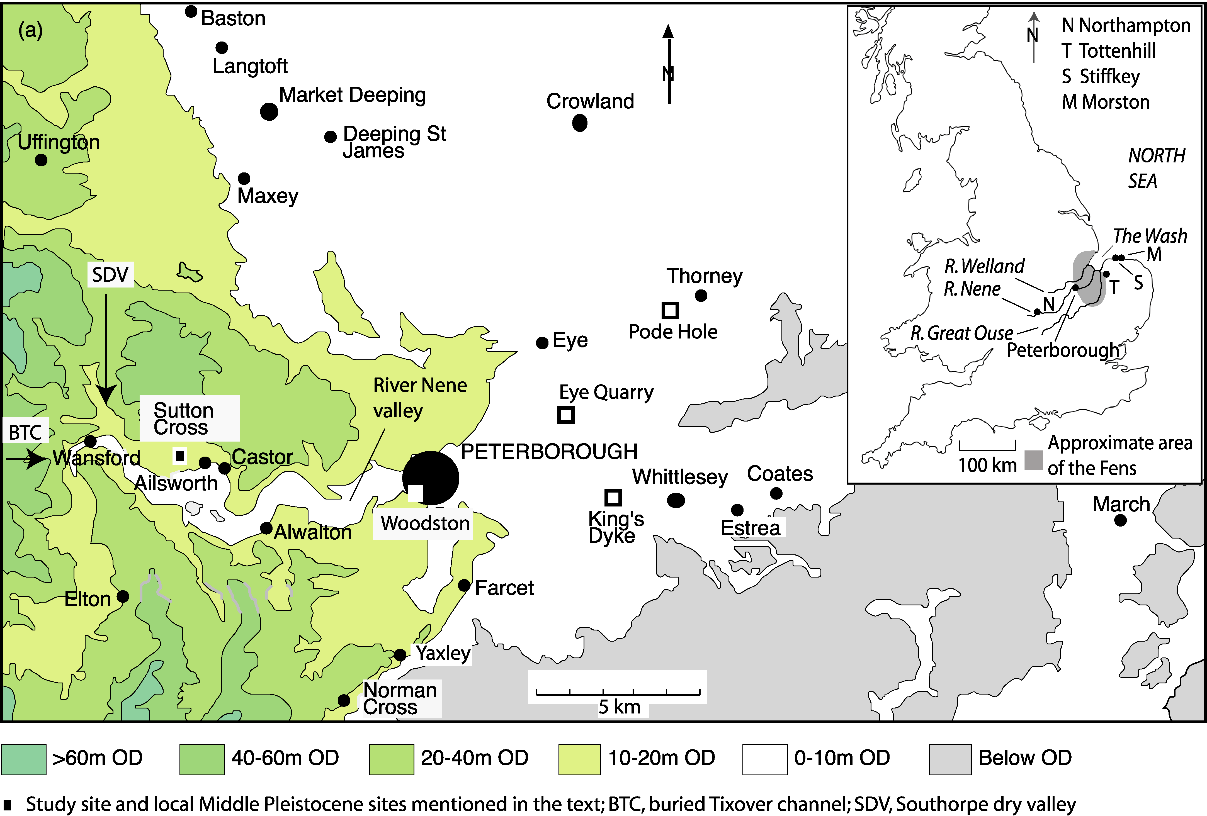
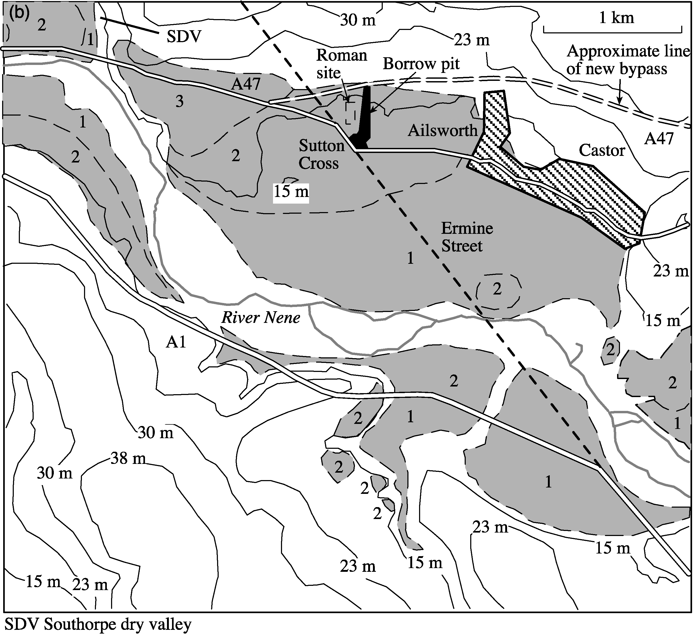
Fig. 1. (a) Location of Sutton Cross in the lower River Nene catchment to the west of Peterborough, and topography of the middle and lower reaches of the River Nene. (Inset shows the rivers Welland, Nene and Great Ouse draining the Cambridgeshire and Lincolnshire Fens through The Wash into the North Sea.) (b) Detailed topography and Pleistocene geology of the study site at Sutton Cross.
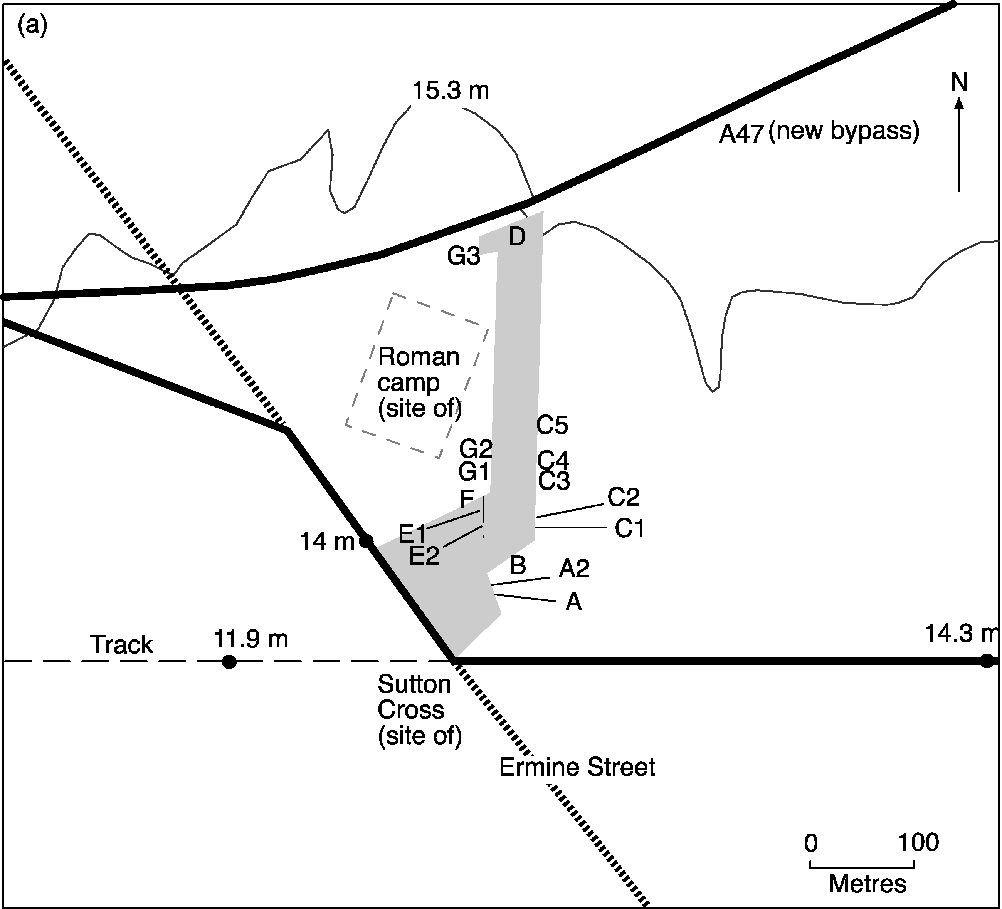
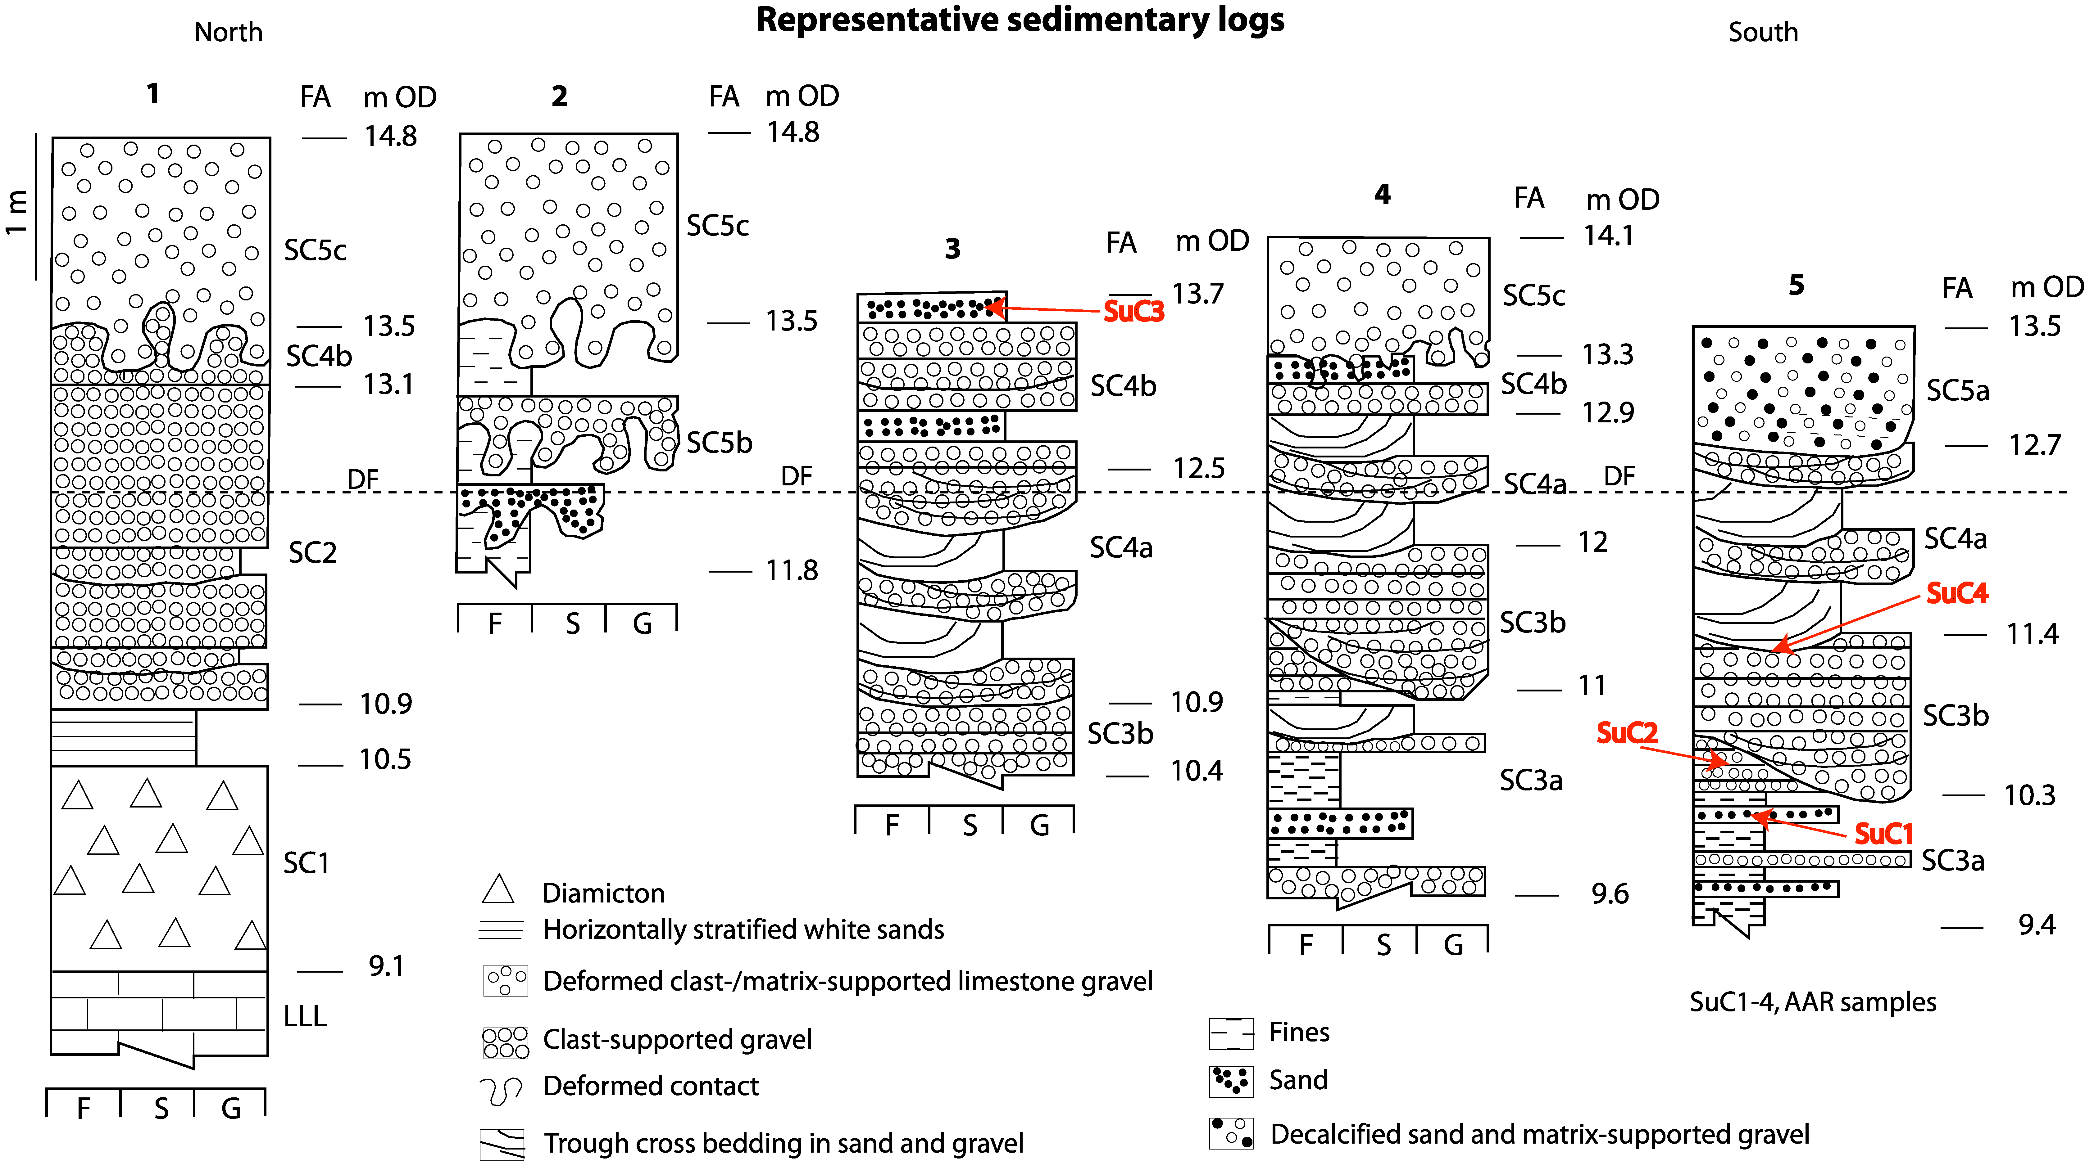
Fig. 2. (a) Location of sedimentary logs at the Sutton Cross study site, showing 15.3 m contour and 11.9, 14 and 14.3 m spot heights. (b) Representative sedimentary logs 1–5 for the borrow pit at Sutton Cross with location of amino acid racemization (AAR) samples (SuC1–SuC4) highlighted in red. 1, based on sedimentary logs G1–G3; 2, based on sedimentary logs C4, C5 and D; 3, based on sedimentary logs C4, C5, G1 and G2; 4, based on sedimentary logs C1–C3, E1, E2 and F; 5, based on sedimentary logs A1 and A2; FA, facies association; LLL, Lower Lincolnshire Limestone Member; DF, decalcification front (approximate depth of); F, fines; S, sand; G, gravel. Heights are metres above Ordnance Datum (m OD).
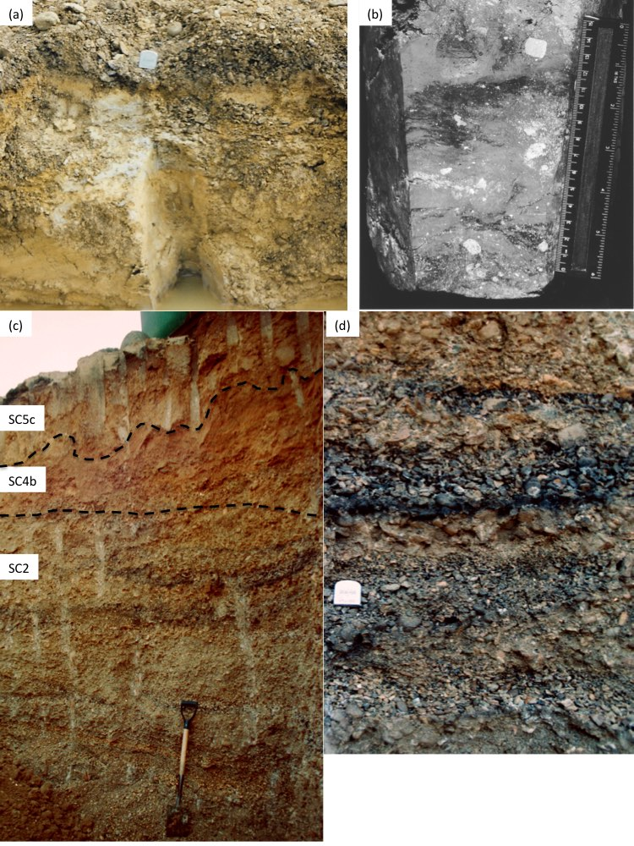
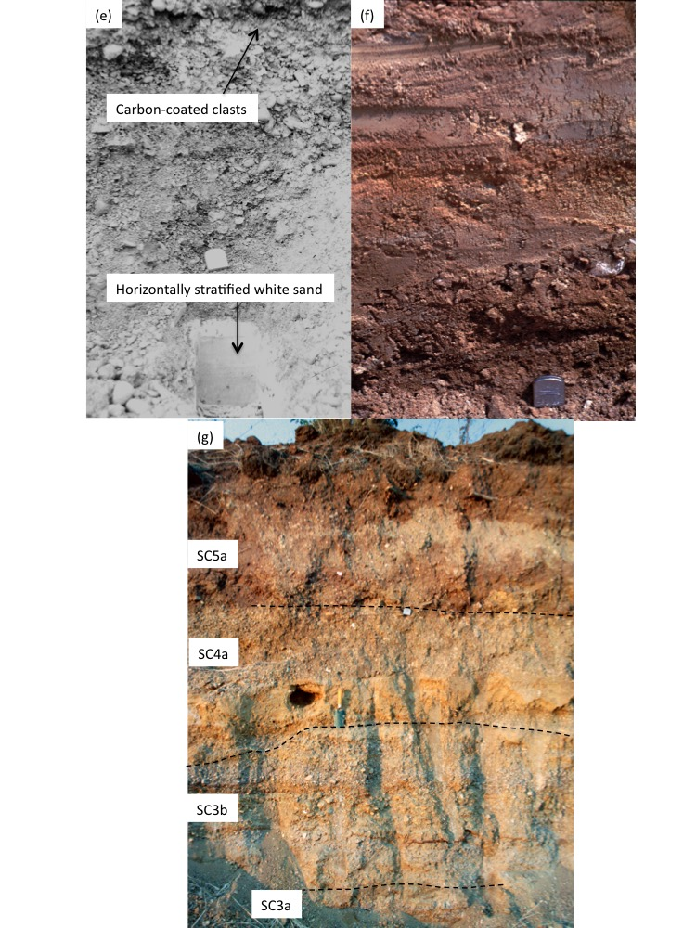
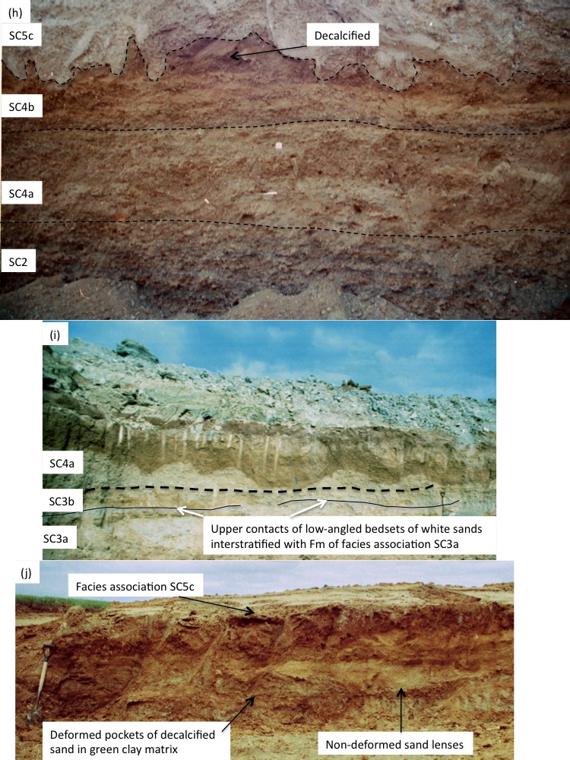
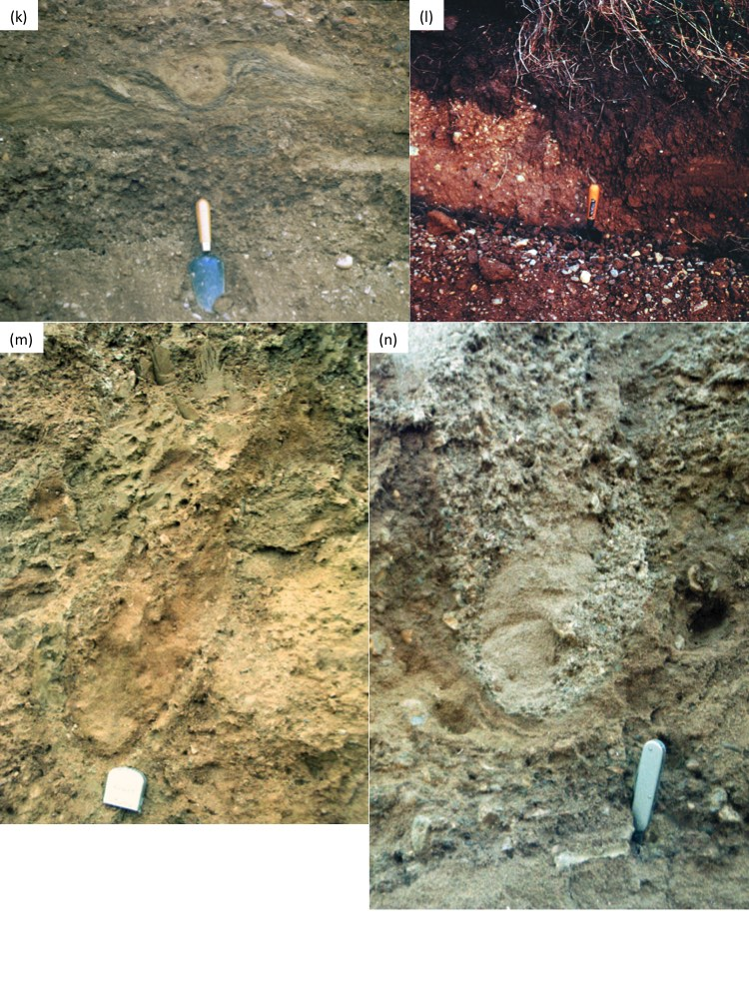
Fig. 3. Photographs of facies association sediments and specific features of interest. (a) Facies association SC1 underlying facies association SC2 at log C5 location of monolith shown in (b). Tape measure in (a) is 5 cm wide. (c) Lenses rich in ironstone in facies association SC2 at log G3. Note the zone of decalcification of facies association SC4b sediments above, overlain by cryogenically deformed sediments of facies association SC5c. Spade is 90 cm long. (d) Lenses of carbon-coated gravel in facies association SC2, southeast of log G3. Tape measure is 5 cm wide. (e) Horizontally stratified white sands at the base of log G1. Tape measure is 5 cm wide. (f) Intercalated ferruginous fines and sands of facies association SC3a. Note the fragments of unionid bivalves. Tape measure is 5 cm wide. (g) Facies associations SC3a, SC3b, SC4a and SC5a at section A. Trowel is 27 cm long. (h) Facies associations SC2, SC4a, SC4b and SC5c in the vicinity of log G1. Note the decalcification of the upper part of facies association SC4b and that this pre-dates the cryogenic deformation associated with facies association SC5c. The penknife and tape (5 cm wide) mark aggradational surfaces (bar tops) in facies association SC4a and a sand ribbon marking most of the contact between facies associations SC4a and SC4b also rests on an aggradational surface. (i) Decalcified sediments of facies associations SC4a and low-angle bedsets of facies association SC3a underlying facies association SC3b at section C. Spade is 90 cm long. (j) Undeformed sand lenses in facies association SC5b overlain by facies association 5c at section D. Spade is 90 cm long. (k) Cryogenic deformation in facies association SC4b. Trowel is 27 cm long. (l) Erosional contact between facies associations SC4a and SC5a at section B. Trowel handle is 13 cm long. (m) Complex deformation of facies association SC5b also affecting underlying sediments of facies association SC4a in vicinity of log C5. Note the incorporation of decalcified sand. Tape measure is 5 cm wide. (n) Cryogenically deformed contact between facies associations SC4b and SC5c in the vicinity of log G1. Handle of penknife is 8.3 cm long. (Photographs by H. E. Langford, 1991. All but (a) and (e) reproduced from Langford, 1999.)
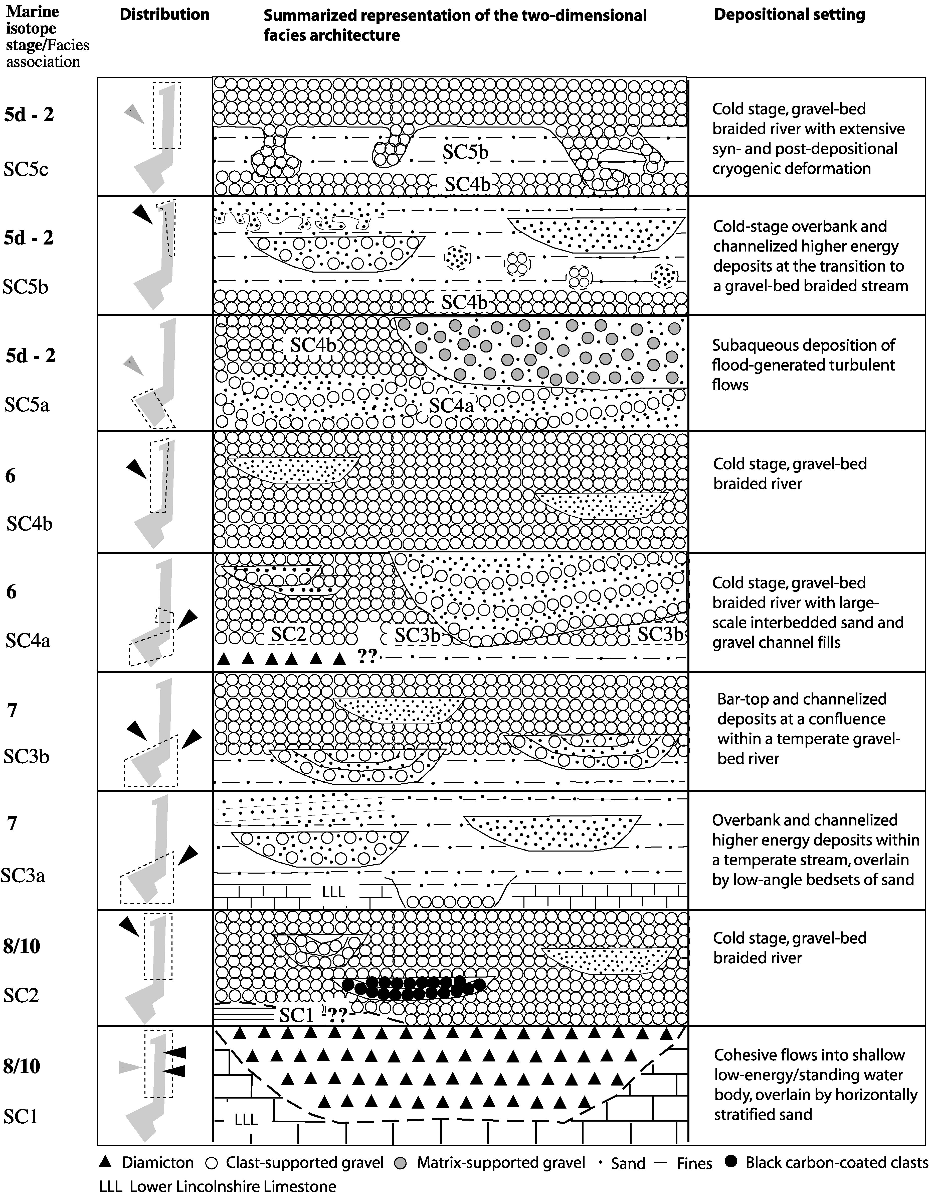
Fig. 4. Stratigraphical interpretation and areal extent of the sedimentary succession at Sutton Cross, based on field sketches, photographs and sedimentary logs. The dashed boxes show the distribution of each facies association within the quarry and direction of likely extent beyond. The black arrows indicate observed direction of transport and the grey arrows indicate inferred direction of transport.
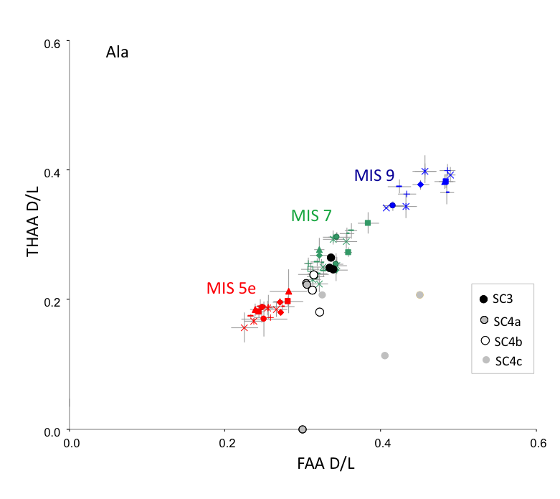
Fig. 5. Free versus total d/l values of Ala from bleached Bithynia tentaculata opercula from Sutton Cross, compared with data from UK sites correlated with MIS 5e (red), MIS 7 (green), and MIS 9 (blue) (Penkman et al., 2011, 2013).

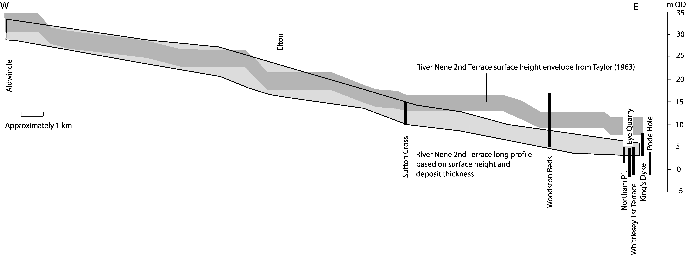
Fig. 6. River Nene 2nd Terrace surface height envelope (dark grey) and subjectively determined long profile using surface height and sediment thickness data from 13 of 35 records (light grey). Also shown are the seven sites within the middle and lower River Nene that have detailed sedimentological and palaeoecological records.
Fig. 7. Optically stimulated luminescence age ranges recorded from Tottenhill (Lukas et al., 2017), Morston (Hoare et al., 2009), Stiffkey (Evans et al., 2018) and King’s Dyke (Langford et al., 2004b). The age range shown for Tottenhill is for seven unpublished dates supplied to Lukas et al. by Steven Pawley. The dates for Morston young upwards in stratigraphic sequence (left to right) and are included here as the raised beach is considered an interglacial feature dating to the transition between MIS 7 and MIS 6. Hence they could provide a control on the age range for the Tottenhill Sand and Gravel Member.

