Appendix 1: An example of a network geometry with three treatments
This figure illustrates an example where we want to compare three treatments (A, B and C) using the mean difference (MD). In this example, there was one trial that compared A vs. B and found a MD of 4.0 (95% confidence interval (CI) 3.0 to 5.0) and one trial that compared A vs. C with a MD of 2.3 (95% CI 1.4 to 3.2). From this hypothetical comparison, we can see that B and C are likely better than A if a reduction is desirable. If the trial samples are clinically homogenous, then we can estimate that B is better than C by 1.7 (95% CI 0.4 to 3.0) through an indirect comparison. If a new trial was then conducted that compared B and C directly, network meta-analysis could combine the indirect estimate of B to C (1.7) and the resulting direct estimate from the new trial.

Appendix 2: Network Geometry for Bacteremia with Separate Control Groups (Placebo, No Antibiotic and Non-absorbable Antibiotic Separate)
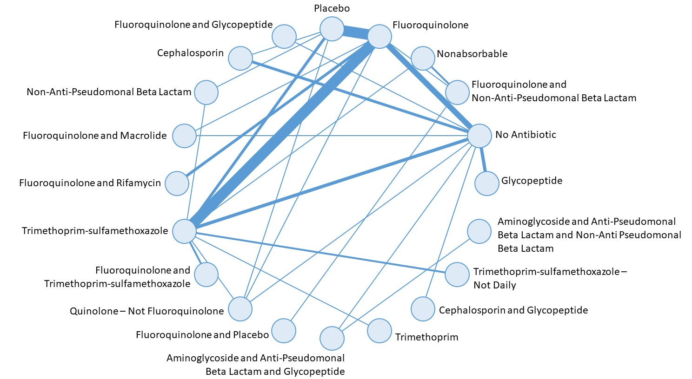

Geometry illustrates direct and indirect comparisons in the network. Link thickness reflects the number of studies.

Appendix 3: Network Geometry for Bacteremia with Placebo or No Antibiotic Control Groups Combined
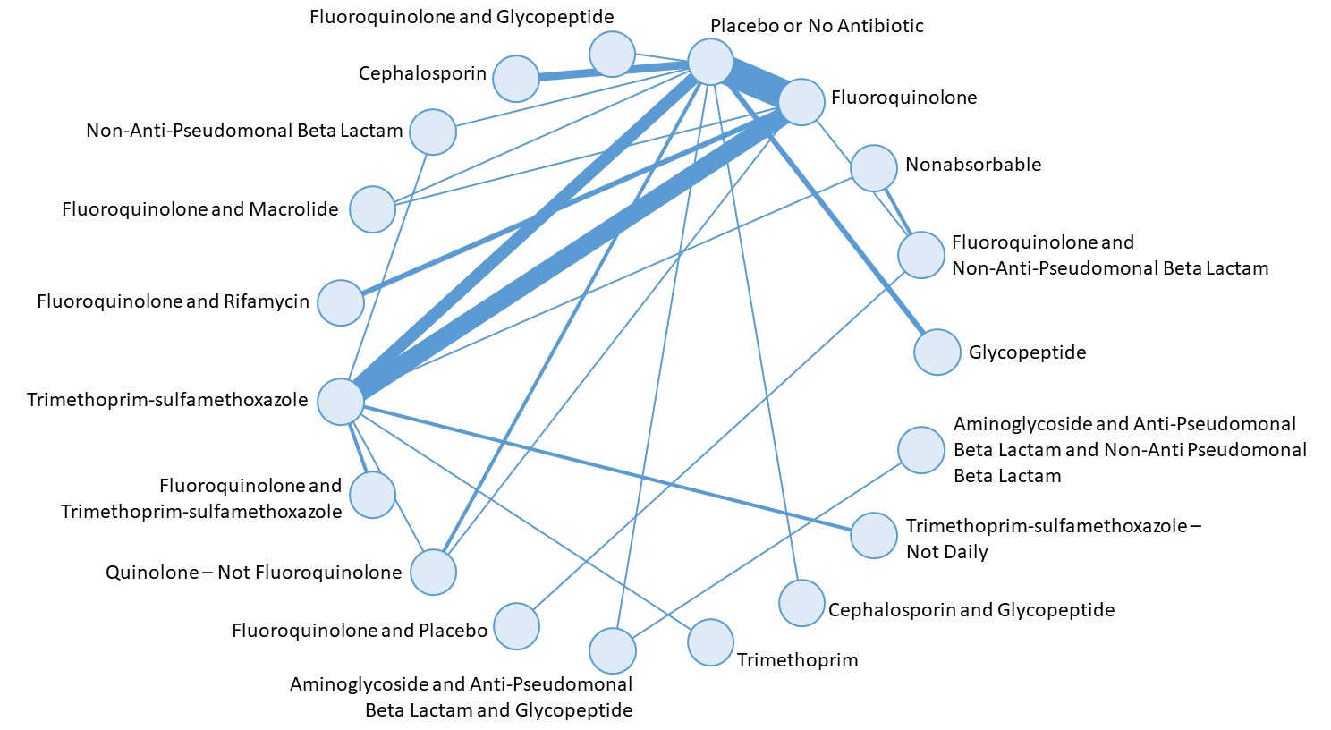

Geometry illustrates direct and indirect comparisons in the network. Link thickness reflects the number of studies.

Appendix 4: Network Geometry for Bacteremia with Placebo, No Antibiotic and Non-Absorbable Antibiotic (All Control Groups) Combined
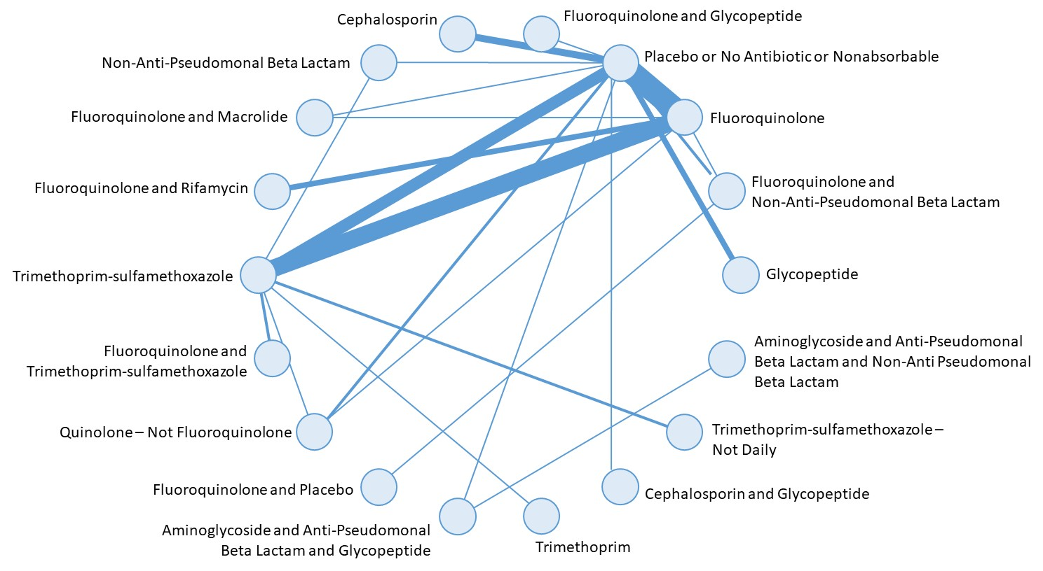
Geometry illustrates direct and indirect comparisons in the network. Link thickness reflects the number of studies.

Appendix 5: Characteristics of Included Studies in Systematic Review (N=113)
Characteristic and Strata | No. Studies (%)
Study Population Characteristics
Treatment
Cancer patients receiving chemotherapy only | 73 (65%)
Hematopoietic stem cell transplantation | 19 (17%)
Both chemotherapy and transplantation | 21 (18%)
Age participants
Adult | 75 (66%)
Pediatric | 13 (12%)
Both | 18 (16%)
Not stated | 7 (6%)
Risk of Bias
Adequate sequence generation | 24 (21%)
Adequate allocation concealment | 21 (19%)
Participants and personnel blinded | 27 (24%)
Outcome assessors blinded | 11 (10%)
Lack of attrition bias | 70 (62%)
Free of selective reporting | 33 (29%)

Appendix 6: Pairwise comparisons in the network meta-analysis for outcome of bacteremia with all control groups combined*

 | Glyco | Fluoro + NAPBL | Fluoro | None | Fluoro + glyco | Cephalo | NAPBL | Fluoro + macro | Fluoro + rifamycin | TMP-SMX | Fluoro + TMP-SMX | Quino | Fluoro + placebo | Amino + APBL + glyco | TMP | Cephalo + glyco | TMP-SMX < daily | Amino + APBL + NAPBL
Glyco | NA | 0.6  (0.2, 1.6) | 0.9  (0.4, 1.8) | 1.5  (0.8, 3.1) | 0.2  (0.1, 0.8) | 0.4  (0.2, 1.1) | 0.7  (0.2, 2.0) | 0.7  (0.2, 2.0) | 0.2  (0.1, 0.7) | 0.8  (0.4, 1.8) | 0.3  (0.0, 4.7) | 1.3  (0.6, 3.3) | 0.9  (0.3, 3.3) | 0.1  (0.0, 0.9) | 0.1  (0.0, 1.3) | 0.3  (0.0, 1.8) | 0.6  (0.2, 1.8) | 0.1  (0.0, 1.2)
Fluoro + NAPBL | 1.7  (0.6, 4.4) | NA | 1.4  (0.7, 2.9) | 2.5  (1.3, 5.0) | 0.4  (0.1, 1.4) | 0.7  (0.3, 1.7) | 1.1  (0.4, 3.2) | 1.1  (0.4, 3.2) | 0.4  (0.1, 1.2) | 1.4  (0.8, 2.9) | 0.5  (0.0, 7.7) | 2.2  (1.0, 5.3) | 1.5  (0.7, 3.5) | 0.2  (0.0, 1.5) | 0.2  (0.0, 2.2) | 0.5  (0.1, 2.9) | 0.9  (0.3, 3.0) | 0.1  (0.0, 2.0)
Fluoro | 1.2  (0.6, 2.4) | 0.7  (0.4, 1.4) | NA | 1.7  (1.4, 2.3) | 0.3  (0.1, 0.8) | 0.5  (0.3, 0.9) | 0.8  (0.3, 1.8) | 0.8  (0.3, 1.8) | 0.3  (0.1, 0.6) | 1.0  (0.7, 1.3) | 0.4  (0.0, 5.0) | 1.6  (0.9, 2.7) | 1.1  (0.4, 3.1) | 0.1  (0.0, 0.9) | 0.2  (0.0, 1.4) | 0.4  (0.0, 1.8) | 0.7  (0.3, 1.7) | 0.1  (0.0, 1.3)
None | 0.7  (0.3, 1.3) | 0.4  (0.2, 0.8) | 0.6  (0.4, 0.7) | NA | 0.2  (0.0, 0.5) | 0.3  (0.2, 0.5) | 0.4  (0.2, 1.0) | 0.5  (0.2, 1.0) | 0.2  (0.1, 0.4) | 0.6  (0.4, 0.8) | 0.2  (0.0, 2.9) | 0.9  (0.5, 1.5) | 0.6  (0.2, 1.8) | 0.1  (0.0, 0.5) | 0.1  (0.0, 0.8) | 0.2  (0.0, 1.0) | 0.4  (0.1, 1.0) | 0.0  (0.0, 0.7)
Fluoro + glyco | 4.6  (1.2, 20.0) | 2.8  (0.7, 12.0) | 3.9  (1.2, 14.0) | 6.9  (2.2, 25.0) | NA | 2.0  (0.5, 8.0) | 3.0  (0.7, 14.0) | 3.1  (0.7, 14.0) | 1.1  (0.3, 5.1) | 3.8  (1.1, 14) | 1.4  (0.0, 27.0) | 6.1  (1.7, 25.0) | 4.2  (0.9, 22.0) | 0.5  (0.0, 5.4) | 0.7  (0.0, 7.8) | 1.5  (0.1, 11.0) | 2.6  (0.6, 13.0) | 0.3  (0.0, 6.7)
Cephalo | 2.3  (1.0, 5.9) | 1.4  (0.6, 3.5) | 2.0  (1.1, 3.9) | 3.5  (2.0, 6.6) | 0.5  (0.1, 1.9) | NA | 1.5  (0.5, 4.4) | 1.6  (0.6, 4.4) | 0.6  (0.2, 1.6) | 1.9  (1.0, 3.9) | 0.7  (0.0, 11.0) | 3.1  (1.4, 7.1) | 2.1  (0.6, 7.4) | 0.3  (0.0, 2.0) | 0.3  (0.0, 3.0) | 0.8  (0.1, 4.1) | 1.3  (0.4, 4.1) | 0.1  (0.0, 2.8)
NAPBL | 1.5  (0.5, 4.7) | 0.9  (0.3, 2.8) | 1.3  (0.6, 3.2) | 2.3  (1.0, 5.6) | 0.3  (0.1, 1.4) | 0.7  (0.2, 1.9) | NA | 1.0  (0.3, 3.4) | 0.4  (0.1, 1.2) | 1.3  (0.6, 3.0) | 0.5  (0.0, 7.6) | 2.0  (0.8, 5.7) | 1.4  (0.4, 5.5) | 0.2  (0.0, 1.5) | 0.2  (0.0, 2.1) | 0.5  (0.1, 3.0) | 0.9  (0.3 3.0) | 0.1  (0.0, 2.0)
Fluoro + macro | 1.5  (0.5, 4.5) | 0.9  (0.3, 2.6) | 1.3  (0.6, 3.0) | 2.2  (1.0, 5.4) | 0.3  (0.1, 1.4) | 0.6  (0.2, 1.8) | 1.0  (0.3, 3.3) | NA | 0.4  (0.1, 1.2) | 1.2  (0.5, 3.0) | 0.5  (0.0, 7.4) | 2.0  (0.8, 5.4) | 1.4  (0.4, 5.3) | 0.2  (0.0, 1.4) | 0.2  (0.0, 2.1) | 0.5  (0.1, 2.9) | 0.8  (0.2, 3.0) | 0.1  (0.0, 1.9)
Fluoro + rifamycin | 4.2  (1.4, 14.0) | 2.5  (0.9, 7.9) | 3.6  (1.6, 9.0) | 6.2  (2.6, 16.0) | 0.9  (0.2, 4.) | 1.8  (0.6, 5.5) | 2.7  (0.8, 9.6) | 2.8  (0.9, 9.6) | NA | 3.4  (1.4, 9.1) | 1.3  (0.0, 21.0) | 5.6  (2.1, 16.0) | 3.8  (1.0, 16.0) | 0.5  (0.0, 4.2) | 0.6  (0.0, 6.0) | 1.3  (0.1, 8.5) | 2.4  (0.7, 8.8) | 0.3  (0.0, 5.4)
TMP-SMX | 1.2  (0.6, 2.6) | 0.7  (0.4, 1.5) | 1,0  (0.8, 1.4) | 1.8  (1.3, 2.6) | 0.3  (0.1, 0.9) | 0.5  (0.3, 1.0) | 0.8  (0.3, 1.8) | 0.8  (0.3, 1.9) | 0.3  (0.1, 0.7) | NA | 0.4  (0.0, 5.1) | 1.6  (0.9, 2.9) | 1.1  (0.4, 3.3) | 0.1  (0.0, 1.0) | 0.2  (0.0, 1.4) | 0.4  (0.0, 1.9) | 0.7  (0.3, 1.7) | 0.1  (0.0, 1.4)
Fluoro + TMP-SMX | 3.3  (0.2, >99) | 2.0  (0.1, 66.0) | 2.8  (0.2, 89.0) | 4.9  (0.4, >99) | 0.7  (0.0, 26.0) | 1.4  (0.1, 46.0) | 2.1  (0.1, 72.0) | 2.2  (0.1, 75.0) | 0.8  (0.0, 27.0) | 2.7  (0.2, 84.0) | NA | 4.4  (0.3, >99) | 3.0  (0.2, >99) | 0.3  (0.0, 20.0) | 0.5  (0.0, 25.0) | 1.0  (0.0, 47.0) | 1.8  (0.1, 64.0) | 0.2  (0.0, 18.0)
Quino | 0.8  (0.3, 1.8) | 0.5  (0.2, 1.1) | 0.6  (0.4, 1.1) | 1.1  (0.7, 2.0) | 0.2  (0.0, 0.6) | 0.3  (0.1, 0.7) | 0.5  (0.2, 1.3) | 0.5  (0.2, 1.3) | 0.2  (0.1, 0.5) | 0.6  (0.3, 1.1) | 0.2  (0.0, 3.4) | NA | 0.7  (0.2, 2.2) | 0.1  (0.0, 0.6) | 0.1  (0.0, 0.9) | 0.2  (0.0, 1.3) | 0.4  (0.1, 1.2) | 0.0  (0.0, 0.9)
Fluoro + placebo | 1.1  (0.3, 4.0) | 0.7  (0.3, 1.5) | 0.9  (0.3, 2.8) | 1.7  (0.6, 4.9) | 0.2  (0.0, 1.2) | 0.5  (0.1, 1.6) | 0.7  (0.2, 2.8) | 0.7  (0.2, 2.9) | 0.3  (0.1, 1.0) | 0.9  (0.3, 2.8) | 0.3  (0.0, 5.8) | 1.5  (0.5, 4.9) | NA | 0.1  (0.0, 1.2) | 0.2  (0.0, 1.7) | 0.4  (0.0, 2.4) | 0.6  (0.2, 2.6) | 0.1  (0.0, 1.5)
Amino + APBL + glyco | 9.2  (1.1, >99) | 5.5  (0.7, >99) | 7.7  (1.1, >99) | 14.0  (1.9, >99) | 2.0  (0.2, 72.0) | 3.9  (0.5, >99) | 6.0 (0.7, >99) | 6.1  (0.7, >99) | 2.2  (0.2, 74.0) | 7.5  (1.0, >99) | 3.0  (0.1, >99) | 12.0  (1.6, >99) | 8.4  (0.9, >99) | NA | 1.3  (0.0, 67.0) | 3.0  (0.2, >99) | 5.2  (0.55, >99) | 0.6  (0.1, 4.3)
TMP | 7.1  (0.8, >99) | 4.2  (0.5, >99) | 6.0  (0.7, >99) | 11.0  (1.3, >99) | 1.5  (0.1, 50.0) | 3.0  (0.3, 85.0) | 4.6  (0.5, >99) | 4.7  (0.5, >99) | 1.7  (0.2, 50.0) | 5.8  (0.7, >99) | 2.2  (0.0, >99) | 9.4  (1.1, >99) | 6.5  (0.6, >99) | 0.8  (0.0, 35.0) | NA | 2.3  (0.1, 84.0) | 4.0  (0.4, >99) | 0.4  (0.0, 34.0)
Cephalo + glyco | 3.1  (0.6, 27.0) | 1.9  (0.3, 16.0) | 2.6  (0.6, 21.0) | 4.6  (1.0, 37.0) | 0.7  (0.1, 7.2) | 1.3  (0.3, 11.0) | 2.0  (0.3, 19.0) | 2.1  (0.4, 19.0) | 0.7  (0.1, 7.0) | 2.6  (0.5, 21.0) | 1.0  (0.0, 27.0) | 4.2  (0.8, 35.0) | 2.8  (0.4, 28.0) | 0.3  (0.0, 5.9) | 0.4  (0.01, 8.6) | NA | 1.8  (0.3, 17.0) | 0.2  (0.0, 6.4)
TMP-SMX_Not_Daily | 1.8  (0.5, 5.9) | 1.1  (0.3, 3.5) | 1.5  (0.6, 4.1) | 2.7  ( 1.0, 7.2) | 0.4  (0.1, 1.8) | 0.8  (0.2, 2.4) | 1.2  (0.3, 4.1) | 1.2  (0.3, 4.3) | 0.4  (0.1, 1.5) | 1.5  (0.6, 3.7) | 0.5  (0.0, 8.9) | 2.4  (0.8, 7.1) | 1.6  (0.4, 6.9) | 0.2  (0.0, 1.8) | 0.3  (0.0, 2.5) | 0.6  (0.1, 3.7) | NA | 0.1  (0.0, 2.4)
Amino + APBL + NAPBL | 17.0  (0.8, >99) | 10.0  (0.5, >99) | 14.0  (0.8, >992) | 25.0  (1.4, >99) | 3.7  (0.2, >99) | 7.3  (0.4, >99) | 11.0  (0.5, >99) | 11.0  (0.5, >99) | 4.0  (0.2, >99) | 14.0  (0.7, >99) | 5.2  (0.1, >99) | 23.0  (1.1, >99) | 15.0  (0.7, >99) | 1.7  (0.2, 16.0) | 2.3  (0.0, >99) | 5.4  (0.2, >99) | 9.6  (0.4, >99) | NA

Abbreviations: glyco – parenteral glycopeptide; fluoro – fluoroquinolone; metro – metronidazole; NAPBL – non-antipseudomonal beta lactam; cephalo – cephalosporin; none – placebo, no antibiotic and non-absorbable; macro – macrolide; TMP-SMX – trimethoprim- sulfamethoxazole; quino – quinolone, not fluoroquinolone; amino – aminoglycoside; APBL – antipseudomonal beta lactam; ; granulo- granulocyte infusion
*Estimate reflects risk ratio with 95% credible region. The row reflects the reference treatment and the column reflects the comparator treatment. Thus, a risk ratio less than 1 suggests that the comparator is better than the reference at reducing the outcome
Appendix 7: Pairwise comparisons in the network meta-analysis for outcome of infection-related mortality with all control groups combined*

 | Glyco | Fluoro + Metro | Fluoro + NAPBL | Fluoro | None | Fluoro + glyco | Cephalo | NAPBL | Fluoro + macro | Fluoro + rifamycin | TMP-SMX | Quino | Amino + APBL + glyco | TMP-SMX + macro | TMP | Amino + glyco + APBL OR cepahlo + APBL | Granulo
Glyco | NA | 0.5  (0.1, 3.1) | 0.9  (0.1, 7.9) | 0.5  (0.1, 2.0) | 0.6  (0.2, 2.1) | <0.01  (<0.01, 0.4) | 0.2  (0.0, 1.5) | 0.2  (0.0, 2.3) | 0.2  (0.0, 1.2) | 0.1  (0.0, 1.6) | 0.3  (0.1, 1.0) | 0.5  (0.1, 2.3) | <0.01  (<0.01, 0.1) | 1.0  (0.1, 14.0) | 0.4  (0.0, 2.1) | 0.6  (0.1, 4.2) | <0.01  (<0.01, 0.1)
Fluoro + Metro | 2.2  (0.3, 15.0) | NA | 1.9  (0.3, 17.0) | 1.1  (0.3, 4.3) | 1.3  (0.3, 5) | <0.01  (<0.01, 0.9) | 0.6  (0.1, 3.5) | 0.5  (0.1, 5.2) | 0.4  (0.1, 2.7) | 0.3  (0.0, 3.4) | 0.6  (0.1, 2.1) | 1.0  (0.2, 5.3) | <0.01  (<0.01, 0.2) | 2.2  (0.2, 32.0) | 0.6  (0.2, 4.7) | 1.4  (0.2, 9.8) | <0.01  (<0.01, 0.2)
Fluoro + NAPBL | 1.2  (0.1, 9.5) | 0.5  (0.1, 4.1) | NA | 0.6  (0.1, 2.9) | 0.7  (0.1, 3.4) | <0.01 (<0.01, 0.5) | 0.3  (0.0, 2.3) | 0.3  (0.0, 3.2) | 0.2  (0.0, 1.7) | 0.1  (0.0, 2.1) | 0.3  (0.0, 1.5) | 0.5  (0.1, 3.5) | <0.01  (<0.01, 0.1) | 1.1  (0.1, 19.0) | 0.3  (0.0, 3.0) | 0.7  (0.1, 6.1) | <0.01  (<0.01, 0.1)
Fluoro | 2.0  (0.5, 8.1) | 0.9  (0.2, 3.3) | 1.7  (0.4, 9.9) | NA | 1.1  (0.7, 1.7) | <0.01  (<0.01, 0.7) | 0.5  (0.1, 1.9) | 0.5  (0.1, 3.0) | 0.4  (0.1, 1.4) | 0.2  (0.0, 2.1) | 0.5  (0.3, 0.9) | 0.9  (0.4, 2.4) | <0.01  (<0.01, 0.2) | 1.9  (0.2, 21.0) | 0.5  (0.2, 2.6) | 1.2  (0.3, 5.3) | <0.01  (<0.01, 0.2)
None | 1.7  (0.5, 6.8) | 0.8  (0.2, 3.2) | 1.5  (0.3, 9.2) | 0.9  (0.6, 1.4) | NA | <0.01  (<0.01, 0.6) | 0.4  (0.1, 1.6) | 0.4  (0.1, 2.6) | 0.3  (0.1, 1.2) | 0.2  (0.0, 1.9) | 0.4  (0.3, 0.7) | 0.8  (0.3, 2.1) | <0.01  (<0.01, 0.2) | 1.7  (0.2, 18.0) | 0.6  (0.2, 2.3) | 1.1  (0.3, 4.5) | <0.01  (<0.01, 0.2)
Fluoro + glycol | >99  (2.4, >99) | >99  (1.2, >99) | >99  (2.1, >99) | >99  (1.4, >99) | >99  (1.6, >99) | NA | >99  (0.7, >99) | >99  (0.6, >99) | >99  (0.5, >99) | >99  (0.2, >99) | >99  (0.7, >99) | >99  (1.2, >99) | 0.0  (<0.01, >99) | >99  (2.4, >99) | >99  (0.7, >99) | >99  (1.6, >99) | <0.01  (<0.01, >99)
Cephalo | 4.1  (0.7, 32.0) | 1.8  (0.3, 15.0) | 3.6  (0.4, 37.0) | 2.1  (0.5, 11.0) | 2.3  (0.6, 11.0) | <0.01  (<0.01, 1.5) | NA | 1.0  (0.1, 11.00) | 0.8  (0.1, 5.8) | 0.5  (0.0, 7.5) | 1.0  (0.3, 5.0) | 1.9  (0.4, 12.0) | <0.01  (<0.01, 0.5) | 4.1  (0.3, 66.0) | 1.1  (0.1, 10.0) | 2.5  (0.4, 21.0) | <0.01  (<0.01, 0.4)
NAPBL | 4.1  (0.4, 41.0) | 1.8  (0.2, 19.0) | 3.5  (0.3, 48.0) | 2.1  (0.3, 14.0) | 2.3  (0.4, 16.0) | <0.01  (<0.01, 1.6) | 1.0  (0.1, 10) | NA | 0.9  (0.1, 7.8) | 0.5  (0.0, 9.2) | 1.0  (0.2, 6.5) | 1.9  (0.3, 15.0) | <0.01  (<0.01, 0.4) | 4.1  (0.3, 80.0) | 1.1  (0.1, 13.0) | 2.5  (0.2, 26.0) | <0.01  (<0.01, 0.4)
Fluoro + macro | 5.2  0.8, 37.0) | 2.3  (0.4, 17.0) | 4.5  (0.6, 44.0) | 2.6  (0.7, 12.0) | 2.9  (0.8, 13.0) | <0.01  (<0.01, 2.1) | 1.3  (0.2, 9.1) | 1.3  (0.1, 13.0) | NA | 0.6  (0.0, 8.6) | 1.3  (0.3, 5.7) | 2.4  (0.5, 14.0) | <0.01  (<0.01, 0.6) | 5.2  (0.4, 79.0) | 1.4  (0.2, 12.0) | 3.1  (0.5, 25.0) | <0.01  (<0.01, 0.5)
Fluoro + rifamycin | 8.6  (0.6, >99) | 3.8  (0.3, >99) | 7.6  (0.5, >99) | 4.2  (0.5, >99) | 4.8  (0.5, >99) | <0.01  (<0.01, 5.2) | 2.1  (0.1, 80.0) | 2.1  (0.1, >99) | 1.7  (0.1, 62.0) | NA | 2.1  (0.2, 68.0) | 3.9  (0.4, >99) | <0.01  (<0..01, 1.4) | 9.0  (0.4, >99) | 2.4  (0.2, 97.0) | 5.2  (0.4, >99) | <0.01  (<0.01, 1.3)
TMP-SMX | 4.0  (1.1, 17.0) | 1.8  (0.5, 8.0) | 3.5  (0.7, 22.0) | 2.0  (1.3, 3.7) | 2.3  (1.5, 3.7) | <0.01  (<0.01, 1.4) | 1.0  (0.2, 4.1) | 1.0  (0.2, 6.1) | 0.8  (0.2, 3.1) | 0.5  (0.0, 4.5) | NA | 1.8  (0.8, 4.9) | <0.01  (<0.01, 0.4) | 4.0  (0.5, 44.0) | 1.1  (0.2, 5.2) | 2.5  (0.6, 12.0) | <0.01  (<0.01, 0.4)
Quino | 2.2  (0.4, 11.0) | 1.0  (0.2, 4.9) | 1.9  (0.3, 14.0) | 1.1  (0.4, 2.9) | 1.3  (0.5, 3.1) | <0.01  (<0.01, 0.8) | 0.5  (0.1, 2.7) | 0.5  (0.1, 3.9) | 0.4  (0.1, 2.0) | 0.3  (0.0, 2.8) | 0.5  (0.2, 1.3) | NA | <0.01  (<0.01, 0.2) | 2.2  (0.2, 26.0) | 0.6  (0.1, 3.4) | 1.3  (0.2, 7.3) | <0.01  (<0.01, 0.2)
Amino + APBL + glyco | >99  (10.0, >99) | >99  (4.4, >99) | >99  (7.9, >99) | >99  (5.2, >99) | >99  (5.8, >99) | >99  (<0.01, >99) | >99  (2.2, >99) | >99  (2.3, >99) | >99  (1.8, >99) | >99  (0.7, >99) | >99  (2.5, >99) | >99  (4.6, >99) | NA | >99  (9.3, >99) | >99  ((2.5, >99) | >99  (5.9, >99) | 0.9  (0.2, 3.9)
TMP-SMX + macro | 1.0  (0.1, 12.0) | 0.5  (0.0, 5.6) | 0.9  (0.1, 14.0) | 0.5  (0.0, 4.4) | 0.6  (0.1, 4.7) | <0.01  (<0.01, 0.4) | 0.2  (0.0, 2.9) | 0.2  (0.01, 4.0) | 0.2  (0.0, 2.3) | 0.1  (0.0, 2.6) | 0.3  (0.0, 2.1) | 0.5  (0.0, 4.7) | <0.01  (<0.01, 0.1) | NA | 0.3  (0.0, 3.7) | 0.6  (0.0, 7.8) | <0.01  (<0.01, 0.1)
TMP | 3.7  (0.5, 31.0) | 1.6  (0.2, 15.0) | 3.1  (0.3, 37.0) | 1.8  (0.4, 11.0) | 2.1  (0.4, 11.0) | <0.01  (<0.01, 1.4) | 0.9  (0.1, 7.4) | 0.9  (0.1, 10.0) | 0.7  (0.1, 5.8) | 0.4  (0.0, 6.8) | 0.9  (0.2, 4.5) | 1.7  (0.3, 11.0) | <0.01  (<0.01, 0.4) | 3.6  (0.3, 65.0) | NA | 2.2  (0.3, 21.0) | <0.01  (<0.01, 0.4)
Amino + glyco + APBL OR cepahlo + APBL | 1.6  (0.2, 12.0) | 0.7  (0.1, 5.6) | 1.4  (0.2, 14.0) | 0.8  (0.2, 3.9) | 0.9  (0.2, 4.0) | <0.01  (<0.01, 0.7) | 0.4  (0.0, 2.8) | 0.4  (0.0, 4.1) | 0.3  (0.0, 2.2) | 0.2  (0.0 2.8) | 0.4  (0.1, 1.8) | 0.8  (0.1, 4.4) | <0.01  (<0.01, 0.2) | 1.7  (0.1, 25.0) | 0.5  (0.0, 3.8) | NA | <0.01  (<0.01, 0.2)
Granulo | >99  ( 11.0, > 99) | >99  (4.7, >99) | >99  (8.5, >99) | >99  (5.4, >99) | >99  (6.1, >99) | >99  (0.01, >99) | >99  (2.4, >99) | >99  (2.4, >99) | >99  (1.9, >99) | >99  (0.8, >99) | >99  (2.6, >99) | >99  (4.8, >99) | 1.1  (0.3, 4.7) | >99  (9.6, >99) | >99  (2.6, >99) | >99  (6.3, >99) | NA

Abbreviations: glyco – parenteral glycopeptide; fluoro – fluoroquinolone; metro – metronidazole; NAPBL – non-antipseudomonal beta lactam; cephalo – cephalosporin; none – placebo, no antibiotic and non-absorbable; macro – macrolide; TMP-SMX – trimethoprim- sulfamethoxazole; quino – quinolone, not fluoroquinolone; amino – aminoglycoside; APBL – antipseudomonal beta lactam; ; granulo- granulocyte infusion
*Estimate reflects risk ratio with 95% credible region. The row reflects the reference treatment and the column reflects the comparator treatment. Thus, a risk ratio less than 1 suggests that the comparator is better than the reference at reducing the outcome

