When Brick Meets Stone: Turko-Iranian Brick Architecture and its Interaction with the Lithic Traditions of India and Anatolia
Richard Piran McClary
At around the same period in history Turkic Muslims with their roots in Central Asia entered, and subsequently controlled, most of Anatolia as well as large portions of the north of the Indian Subcontinent. In both cases of conquest of previously non-Muslim controlled territory the new rulers brought pre-existing brick building styles developed in the wider Iranian world into regions which had traditionally relied on primarily lithic construction methods.

The introduction of architectural forms developed in brick for Islamic commemoration and worship, and the decorative vocabulary used to ornament such buildings in both brick and stucco, into an almost entirely lithic milieu resulted in a process of dynamic synthesis and innovation. Part of this process involved the adoption of local elements and the reuse of materials from entirely different types of buildings. This led to the creation of some of the most truly original architectural styles developed in the medieval Islamic world.

This chapter examines the transformation of the wide array of architectural forms and decoration which had developed in brick in the wider Iranian world into stone in the context of Anatolia on the one hand and India on the other. The aim here is to touch on some of the more general commonalities, and the striking differences, through the examination of a number of the rather less well-known early structures. This will demonstrate that, despite the broad similarities in the initial conquest phase, major differences in the resulting aesthetics emerged over the following centuries in the two regions. Brick, for all its advantages for speed of construction and ability to impart a sense of mass, does not offer the crispness and curvilinearity that stone does, and the type of marble carving seen on portals in Anatolia and mihrabs in India appears to draw instead on the stucco carving tradition of Iran. The major difference, in the context of Anatolia, is the externalisation and monumentalisation of the more durable stone media. In the context of India, new forms developed, as well as the multiplication of traditional elements such as the mihrab, and the increased external articulation of those mihrabs. Local stone carvers interpreted the wishes of the new rulers, in addition to craftsmen, quite likely Indian in origin, who had worked further to the north for Muslim rulers, prior to returning to India to work on the vast amount of new buildings which were required by the new rulers.

For those with an interest in the contemporaneous emergence of two distinctive, hybrid and syncretic styles of Islamic architectural form and decoration, in India and Anatolia, there is a rather limited number of scholarly publications. An increasing amount of the early monuments, in both regions, have been addressed singularly or in groups, but several remain very poorly understood, as do many of the broader process and themes relating to their development. An attempt to address such a vast topic and area must inevitably take a very broad brush approach. However, by addressing a fairly limited selection of structures, in both India and Anatolia, which date from the late twelfth and early thirteenth centuries, it is possible to strike a balance between the micro and the macro. The aim is to give a sense of the largely contemporaneous developments which resulted from Turko-Muslim invaders patronising established forms of architecture in new lands, and a different medium of construction, across vast areas of the newly expanded dār al-Islām in the period of study.
The two very different aesthetics which subsequently developed in Anatolia and India were largely the result of the great differences between the arcuate forms in the pre-existing church architecture of Christian Anatolia on the one hand, and the trabeate tradition of Hindu and Jain temple architecture on the other. Within this broad rubric, there was of course far greater complexity, with evidence of Indic stonemasons having worked in Afghanistan for Muslim patrons in the late twelfth century returning to India in the wake of the Ghurid conquest and working on mosques.
The early development of a distinctively Indo-Islamic aesthetic was a two-stage process, with trabeate spolia structures being erected in the form of Arab hypostyle mosques, with the necessary architectonic elements such as mihrab niches and minbars being newly-carved, in the first phase under the Ghurids. The second phase, pioneered by Aybek but really expanded under Iltutmish, saw the addition of huge pointed-arch screens in the Iranian manner, but in stone and with corbelled arches, such as those at the Quwwat al-Islam Mosque in Delhi and the Adhai din ka Jhompara Mosque in Ajmer. These additions gave a far more distinctively Islamic feel to the structures, and mark the beginning of true hybridity, rather than what appears to be largely practical expediency, combined with elements of conscious cultural appropriation in the first phase. The aim here is not to re-examine the debate around the reuse of architectural material, as this is a topic which has been discussed in great detail by numerous scholars, including Alka Patel and Finbar Barry Flood. Instead the focus is on the translation of brick forms and motifs into stone.

Turkish buildings in Anatolia
The Muslim conquest of Anatolia by Turks was completed sooner that it was in India, and the necessary stability allowing for large scale construction also occurred earlier, and so it is to monuments in Anatolia that attention turns first.
The Citadel Mosque in Divriği boasts the earliest surviving decorative portal attached to an Islamic building in Anatolia, and is securely dated, by the upper inscription, to 576/1180-81. The mosque is rectangular, with the short side facing towards qibla. The portal is built in a hybrid style which reflects the eclectic nature of the early phase of Islamic architecture in Anatolia. It was built for the Mengüjekid ruler Sayf al-Dīn Shāhanshāh, who ruled from about 570 to 593/1175 to 1197, and the lintel features the signature of the craftsman in Kufic script, Ḥasan (?) ibn Pirūz (?) al-Marāghī. Although it is in stone, this early transitional structure has stones cut to look like bricks on the arch. The portal also has examples of incised construction lines for the design of the carved patterns, in the same manner as can be seen on Central Asian brick buildings of the twelfth century, such as the Qarakhanid portal of the Maggok-i Attori Mosque in Bukhara.
It was not just in portal design that the process of transition and translation can be seen. The Tepsi Minaret, in the south west corner of the Erzurum citadel in eastern Anatolia, has the same battered form as seen in the Qarakhanid minarets of Central Asia, such as the ones in Balasagun, Uzgend and Bukhara. The base of the minaret is in black basalt, with a transitional section in alternating bands of red and white stone, and internal stone steps, but with the bulk of the shaft is built with the standard thin square bricks of the Iranian tradition, measuring 20 centimetres square and with a thickness of 5 centimetres. It is at the Tepsi Minaret, over all other structures in the region, that the most intimate union of brick and stone can be found, as the inscription band around the top consists of blocks of white stone with deep slots cut out, into which bricks are set, with only a small portion visible, in order to create the inscription. Subsequently, in cities under Artuqid rule such as Mardin and Hasankeyf, stone minarets were built. However, unlike the long tradition of building square-plan minarets in Syria such as the recently destroyed example at the main mosque in Aleppo, the southern Anatolian examples feature the cylindrical shaft developed in brick in Great Saljuq Iran.
Spolia
The appropriation and re-use of spolia by the victor is a common trope seen across conquered regions, and is by no means exclusive to the Islamic tradition. Destruction of religious monuments, especially for the purposes of reusing the architectural elements, was primarily an Indian rather than Anatolian phenomenon in the Muslim conquest and early period of rule in the twelfth and thirteenth centuries. This was due in part to the far greater degree of intermarriage in the case of Anatolia, with Armenian and Georgian princesses remaining Christian, and having churches inside the royal palaces, while their sons were raised as Muslims.
Although it is the Indian monuments which make the most striking and conspicuous use of spolia in the context of Islamic architecture, in Anatolia there are extensive examples of the reuse of both Byzantine and earlier structural elements, such as columns and capitals, as well as earlier decorative and figural sculpture both as decoration and simply as construction material. However, there was no wholesale re-construction using elements of earlier buildings, and the use of spolia in Anatolia was generally limited to the re-use or re-cutting of decorative marble elements. There are some exceptions to this, with the Roman theatre at Aspendos being the most striking example. In that case the second-century stage building was converted into a palace, and newly-built plastered masonry was incised with lines to imitate the earlier ashlar work around it.
Perhaps the most striking use of spolia in the context of Rum Seljuq architecture, and the one most likely to be laden with meaning due to the prominent location, was the extensive use of figural sculpture on the exterior of the city walls in Konya, built during the rule of ‘Alā’ al-Dīn Kay Qubādh in 615-17/1219-21. The most conspicuous example was a colossal headless statue of Hercules which was used alongside newly-carved zoomorphic sculptures, all of which may have been intended to conflate the contemporary, historical and mythic times.
A wide array of different Byzantine capitals and columns were reused in the construction of the second phase of the Alaeddin Mosque in Konya, probably built in the first two decades of the thirteenth century. At around the same time, one of the most quintessentially syncretic structures in Anatolia, the Ertokuş Tomb and Madrasa at Atabey, near Isparta, between Konya and Antalya, was built in 621/1224. It consists of a stone portal accessing a largely stone-built madrasa, with a raised mosque area and a brick and stone tomb beyond. The seemingly jumbled mix of elements belies an underlying sense of order, with reused marble jambs and lintels alongside limestone rubble, and brick for the arches and domes. Inside the tomb Byzantine spolia sections are recut as window frames. The attempt at coherence is clearer when the tomb is compared with the earlier tomb of ‘Izz al-Dīn Kay Kāwūs in Sivas, which is a far more traditionally Iranian style building, in brick.
The exterior of the tomb has ablaq stone walls, but the corners and roof remain in brick. In addition, along the south wall of the madrasa near the entrance is the head of a statue, as well as stones with defaced crosses used as ashlars. The appropriation of Christian elements into the tomb and madrasa of a member of the Muslim elite is not accidental and is clearly making an overtly political statement of subjugation of the old order and the rise of the new.
Unlike in India, there are several sites across Anatolia which used both brick and stone, with the brick reserved for either minarets, or, in the case of the Sivas hospital the tomb and riwāqs, as well as for decorative elements, as seen in the mosques of Akşehir. The Ferruh Şah Masjid, built in Akşehir in 621/1224, has a mix of glazed inserts, brick pointed arches and indigenous stone spolia all combined to create a quick, relatively cheap, but identifiably Islamic, building right on the frontier with the Christian Laskarids.
Alongside the adoption of forms and decoration developed in brick for the construction of stone buildings, the plastic possibilities for carving stone led to what may be viewed as the monumentalising and externalising of high-relief carvings previously reserved for stucco decoration applied over brick on many of the Seljuq monuments in Iran. Some of the most striking examples are to be found on the portals of the mosque and hospital complex in Divriği, built for the local Mengujekid ruler Dāwūd II b. Bahrām Shāh, and completed in 626/1228-9.
Turkish [?] buildings in India
Attention now turns to some of the contemporaneous monuments which were built under Muslim patronage in India, including a number of early conquest-era mosques and the first tomb. The Adhai din ka Jhompara Mosque in Ajmer is well studied and will not be addressed to any great extent here, and the same goes for the Quwwat al Islam Mosque and the Qutb Minar in Delhi for the same reason. Although these structures are the best known and most important early monuments in India, the focus here is primarily on some of the lesser-known early structures in order to provide a more nuanced approach and highlight the variety of monuments erected in the early period. There are two mosques, the Charasi Kamaba in Kaman and the Ukha Mandir in Bayana, along with a brief mention of the Shahi Mosque in Khatu. This will be followed by some observations about the Sultan Ghari Tomb in Delhi, built in 629/1231.
Twin Minarets
The clearest example of near-direct translation, of both form and decoration, from brick to stone is the Qutb Minar in Delhi. It is closely based on the form of earlier Ghurid and Ghaznavid minarets in Afghanistan, with the tapering of the Ghurid minaret of Jam and the stellate plan of the Ghaznavid minarets in Ghazni, and features relatively little in the way of Hindu ornament, but has extensive inscriptions in Arabic.
One formal element which appears to have emerged in the north-west of Iran in the second half of the twelfth century, and migrated to both Anatolia and India during the period spanning the late twelfth through to the late thirteenth centuries, is the use of twinned minarets over a portal. One of the earliest known, although now lost, examples was at the portal to the Momine Hatun tomb in Nakhchivan, with subsequent examples found from as far afield as Konya, in western Anatolia, Yazd in central Iran and Ajmer in India. The Iranian and Anatolian examples are all brick-built, even if, as is the case in Konya, Sivas and Erzurum, the portals upon which they are placed are built of stone. In contrast, the truncated remains of the two minarets atop the corners of the central elevated section of the screen added to the Adhai din ka Jhompara Mosque in Ajmer by Iltutmish in 627/1229-30 are, like the rest of the screen, built entirely in stone (figure 1). Their ribbed form is very similar to the far larger Qutb Minar built in Delhi between 595 and 634/1199 and 1236, as is the use of collars and a visible taper.
In a near-contemporary text, the Jawāmi‘ al-Ḥikāyāt of Sadīd al-Dīn Muḥammad ‘Awfi, the epigraphic collars on the Qutb Minar in Delhi are compared with an amulet inscribed with Qur’anic verses strung around the neck of a believer. If, in the words of Finbar Barry Flood, the minarets was “implicitly anthropomorphized” by such a comparison, then it is possible that such an interpretation may be applied to the smaller, later pair of minarets at Ajmer.
The similarities extend to the plans, as the Ajmer and Delhi minarets feature alternating semi-circular and right-angle ribs, giving a ‘reeded and flanged’ appearance. These short stubs can be seen as evidence of the ways in which the lithic Indo-Ghurid style of building drew on formal and stylistic tropes from across the wider Iranian world and transformed them into a distinctively Indian style of building during the early syncretic development phase of Islamic architecture in India. Subsequently, the extension to the Ukha Mandir in Bayana, built in 720/1320-21, had very similar twin minarets added over the entrance portal, albeit on a slightly smaller scale to the ones in Ajmer. Although only short stubs survive at the Ukha Masjid the same alternating ribbed and flanged plan can be seen.
Namazgāh / ‘Īdgāh
A structural typology and basic form which transferred directly from Central Asia to India, with a shift from brick to stone, was the namazgāh, referred to as an ‘īdgāh in India. The addition of screen walls, in Delhi and Ajmer, and the contemporaneous construction of the ‘īdgāh north of Bayana, are all arguably a translation of the large central iwan with lower flanking arches of a single side of a four-iwan mosque courtyard, and structures such as the Qarakhanid namazgāh in Bukhara, of the early twelfth century. Here there is a more direct transfer of form from brick to stone, with a similar aesthetic and use of inscriptions, the use of corbelled rather than voussoir arches notwithstanding.
Ghurid Monuments in India
The Ghurid conquest of northern India was by no means a monolithic event or a simple linear process of expansion. Throughout the final three decades of the twelfth century their occupation of regions was often sporadic, and at times they only tenuously held, or occasionally even lost possession of, land.. Such fluid political and military realities must have, in part, affected the development of the nascent Indo-Ghurid architectural aesthetic in the region.
The greatest significance, for the purposes of this study, lies not in the copying from one medium to another in a different place, but the changes, innovations and syntheses that occurred as a result of the interaction of different traditions, craftsmen and materials. These led to the emergence of a distinctive and fresh aesthetic that was unlike anything which had gone before, in either the Muslim or the Hindu tradition.
The early Indian mihrabs represent the first example of true arches in the lithic Islamic architecture of India, due to the small scale and lack of a structural load-bearing role. The cinquefoil-style arches can be seen to draw on the lobed brackets of tōraṇa gates built to access Hindu temple complexes, such as the ones at the Rudra-Mahalaya Shiva temple at Siddhpur in northern Gujarat, which when placed together created an arch-like form suitable for integration into the Islamic architectural context (figure 2).
The Shahi mosque in Khatu features the processional stairway and elevated platform familiar to temples, a form which was to become something of a leitmotif for Indian mosques in a way not seen across the wider Islamic world. The mosque dates from some point in the late twelfth to early thirteenth centuries and has the standard double stacked reused column format for the prayer hall, with reused corbelled domes above. It has one of the finest of the early marble polylobed arched mihrab, which unlike the rest of the construction elements was newly-carved for the purpose, with Qur’an 9, 18-22 in cursive script around the edge. The Shahi mihrab is very similar to the one at the Adhai din ka Jhompara Mosque in Ajmer and is likely to have been produced in the same workshop (figure 3).
Located a little further east and south is the Charasi Kambah mosque in Kaman, which is among the earliest of the surviving monuments built in India under Ghurid occupation. The name simply means 84 columns, and it was built in 600/1204. A case has been put forward for the patron having been Malik Bahā’ al-Dīn Tughrul, one of Muḥammad Ghūri’s generals, however the date makes it more likely to have been built under the patronage of Aybek. It has an example of a rectangular mihrab niche, as seen in most of the early Indian mosques, but there is only one, as opposed to the multiple niches seen in most other early mosques in India. In addition, the Charasi Kambah has the earliest surviving minbar in India (figure 4). This structural element is an example of the translation of a wood structure developed in Iran and the Levant into stone in India, showing that forms and decoration developed in multiple media across the Islamic world were replicated and integrated into stone.
As another one of the earliest Ghurid buildings to survive in India, the Ukha Mandir in Bayana, is relatively poorly studied. It dates from the early thirteenth century and is thought to have been built at the behest of Malik Bahā’ al-Dīn Tughrul. Although the building has been extensively remodelled and altered over the course of the last eight centuries, and is in very poor condition, it is at least mercifully unrestored and retains a genuine patina of originality.
As with most early Indian mosques, the vertical elements are double or triple-height stone pillars from earlier Hindu temples, along with reconstructed corbelled domes, also apparently sourced from earlier temple structures. There is a pishtaq-like portal and three mihrabs, as well as an enclosed elevated mulūk khāna at the far right end of the qibla wall. The inscription of the central mihrab has been effaced, and there is no record of the original text, but it does retain the ajouré carvings on the arch, as well as the carved panels in the rear and traces of engaged columns (figure 5). The portal has a similar form as the Ghurid-era one attached to the Friday Mosque in Herat, albeit without inscriptions, and with a corbelled arch. Comparisons may also be made between the screen portal in Ajmer and the Herat portal, as the former has a very similar style of outer inscription band in Kufic with attenuated hastae, but in stone instead of glazed tiles.
A large Hindu temple structure was built in front of the qibla wall at some point during the Mughal period. The addition is less than two meters away from the original wall and obscures the central mihrab, which is now only visible through the use of flash photography, but not the other, less decorative, mihrabs either side. The structure is now a Hindu shrine as well as serving as a private residence. The building has a similar plan to that of the Chaurasi Khamba in Kaman and reflects the type of sub-imperial mosques which were being built during the early years of Muslim rule in India. The area near the entrance is the least altered, and the original appearance is clearer, with the stacked columns and highly defaced figural elements, although as with most examples of iconoclasm executed towards spoliated architectural elements in mosques, the exact date of the defacement is rarely clear.
It is clear that in both Anatolia, such as in Sivas and Erzurum to name but two examples, and across northern India, it was low dark mosques with large courtyards in the Arab style which were the most popular type. This is in contrast to what was happening in Iran at the time, where large brick-built domed prayer halls were becoming increasingly common. The surviving Indian examples all have riwāqs around the courtyard, and even with the addition of the screens in Delhi and Ajmer, there was no attempt to create the full impression of a four-iwan courtyard mosque typology in the early period.
The majority of the structural elements in the early mosques in India are reused temple and monastery components, from a number different sources, but the mihrabs, being an entirely new architectural element are, like those at Khatu, Ajmer and Kaman, entirely newly-carved stones. It is these mihrabs which lay the foundations for the synthesis of a uniquely Indian Islamic aesthetic which was to emerge over the following decades.
From Stone into Brick
Due in part to the physical boundaries put in place at the time of partition, as well as the preponderance of brick instead of stone for many of the monuments in what is now Pakistan, the two related elements are rarely treated as one. However, there are several incidents where there is a reversal of the standard process, and decorative elements developed in the lithic tradition of India occur in Islamic monuments built of brick.
Many of the Indian mosques of the early period have re-used stone columns and capitals which feature the prominent Pūrna Kalaśa, or vase of plenty. Perhaps more surprisingly, there are examples in Pakistan of brick monuments built for Muslim patrons having carved bricks featuring the same motif. These are clearly not spolia, but newly-carved bricks, adopting an ancient Indic symbol and integrating it into a mihrab. One of the finest surviving, if damaged, examples, datable to the last quarter of the twelfth century, is at the Ghurid Ribat of ‘Alī bin Karmakh at Kabirwala in the Punjab. This structure, in a new and distinctively Indo-Ghurid style, bears similarities to elements of what was being built in Delhi and Ajmer at the same time, but in brick rather than stone, and points to the fluidity and hybridity that was underway in the nascent Islamic architecture of the region in the late twelfth and early thirteenth centuries. It also highlights the fact that elements developed in India and in stone were adopted into brick, and that it was not a simple binary process of translating motifs developed for building with brick into stone construction.
Another example of this phenomenon can be seen in the skeuomorphic pilasters with fictive capitals on the exterior of an anonymous brick-built tomb at Aror in Sindh. The form of the capitals is identical to the ones seen in Hindu temple architecture, and used in the spolia and spolia-style mosques built under Ghurid and later patronage across northern India. The inclusion of this motif on a brick tomb indicates the rich mix of styles, techniques and craftsmen in the region, and the complex interplay of different regional and cultural traditions in the twelfth and thirteenth centuries.
Sultan Ghari Tomb
The final structure to be examined is a tomb complex. Located south of Delhi, eight kilometres from the Qutb Minar, is the tomb of Sultan Ghari, dated to 629/1231. It is the earliest monumental Muslim tomb in India and features what appears to be the earliest use of the octagon in the architecture of Muslim India, although octagonal-plan tombs occur earlier in Ghurid and Ghaznavid controlled territories to the north, including one in Bust. The octagonal tomb in Delhi is sunken into the ground, with a flat roof, and limited monumentality (figure 6), especially in the light of what was to come later in India, and the scale of earlier royal Muslim tombs further north, such as that of Sultan Sanjar in Merv. Although there is no superstructure, the sunken octagonal form of the tomb corresponds closely with that of many of the Seljuq tomb towers across Iran and Anatolia.
It is perhaps this building over all others which inspires comparisons between India and Anatolia, with its octagonal tomb and the mosque topped with a pointed octagonal-plan roof, in a manner more commonly seen in Anatolia. There is also the use of marble, seen in the thirteenth-century portals of both Konya and Sivas, as well as the early Islamic architecture of India. There is reused and newly-cut marble, with the ornate mihrab, shown in figure 6, being of a similar typology to the ones seen in Kaman and Bayana, as well as the slightly later examples in Iltutmish’s own tomb in Delhi.
In addition to the marble columns in front of the mosque area there is also a white marble entrance portal framed with an epigraphic band. This is a lithic monochrome variant of the type of portal seen in earlier Ghurid structures such as the portal of the Friday Mosque in Herat. As with all the sandstone windows piercing the upper walls of the enclosure, the white marble portal arch is corbeled, with a central stone that hints at the beginning stage of the embracing of the idea of a keystone by the masons responsible for its construction (figure 7).
While it is generally assumed that all the reused elements were part of a Hindu temple which previously occupied the site, numerous fragments of figural carved stones from a Buddhist monument of the Gupta period were embedded into the structure, prior to their removal and transfer to the National Museum in Delhi in 1963. The items of red sandstone, consisting of lintels and a railing pillar, are datable to the late fourth or early fifth century. The presence of architectural fragments that were over half a millennia old when the site was built, along with the majority of the far less ancient marble and sandstone columns and corbelled ceilings, raises a number of questions concerning both the nature of the previous structure, and the sources of the materials used to build the existing one. Alas, the lack of evidence makes answers far more elusive than questions in this instance. The overall visual effect of the building is quite unusual, with an exterior appearance closer in form to a fortification, and the low octagonal tomb, of a type not seen elsewhere in the Islamic world, and a small mosque enclosure in axial alignment with the entrance in the east and the tomb in the centre.
Conclusion
Although the early Islamic monuments in both Anatolia and India feature spolia, it is seen to a far greater extent in the Indian monuments. There is some transfer of brick forms and decoration into stone in both regions, but in Anatolia there are numerous examples of brick as well as stone, while in India there is limited use of brick, outside of the Indus valley in the west and, later, in Bengal in the east. In India there is evidence for the transfer of the royal chamber, at the far right of the qibla wall, from Ghurid mosques, and the use of indigenous spoliated material to create an axial hierarchy to accentuate the central element of the mosque in line with the mihrab. Neither of these are seen in the context of early Islamic architecture in Anatolia.
Despite the broad commonality of sources, two very different aesthetic traditions can be seen to have emerged in the Islamic architecture of Anatolia and of India. In Anatolia the forms employed were largely the same, due in part no doubt to the pre-existing arcuate tradition of building long-established under the Byzantines. In addition, there was a continued use of brick alongside stone, especially for the cylindrical minarets, such as the one added to the Great mosque in Sivas in 609/1212-13, as well as hybrid part-brick and part-stone buildings, including the ‘Izz al-Dīn Kay Kāwūs Hospital in Sivas and small mosques in the frontier town of Akşehir.
This is in contrast to the Indian experience, where the addition of screens in a couple of the major mosques, the construction of corbelled arch portals and the limited number of namazgahs / ‘idgahs does not masquerade the fact that the majority of mosques built in the early period have a strongly indigenous Hindu aesthetic. Even after the period of reuse of temple components passed, the columns, lintels and corbelled domes were newly-carved in the same tradition, especially in the case of the mosques built in the major coastal towns of Gujarat, such as Cambay, Baroch and Mangrol in the fourteenth century.
Despite the broadly Turkic moniker being applicable to the occupiers of both regions, one drew more from the Seljuq building tradition, while the other was rooted in a distinctively Ghurid architectural aesthetic. The wholesale adoption of many elements of the indigenous Indian architectural aesthetic and medium led to the emergence of a more coherent and cohesive Indo-Islamic aesthetic somewhat sooner than was the case in Anatolia. There, a more haphazard combination of stone and brick elements, often in the same buildings, continued well into the thirteenth century, before a more coherent and identifiably Anatolian Islamic architectural aesthetic finally emerged.
One of the consequences of the shift from brick to stone, even for the same structural form, is that despite the gain in precision possible with stone, there is often a corresponding loss to the sense of mass of the structure. This may be why a far greater interest in the external façade of stone buildings developed in Anatolia than can be seen in their brick-built antecedents in the Iranian world. In contrast, the addition of large stone screens at the interface of the courtyard and the prayer hall in both the Quwwat al Islam Mosque in Delhi and the Adhai din ka Jhompara Mosque in Ajmer had a different effect. The screens retained the internal focus of the major decorative and overtly Islamic architectonic element of the buildings, and can be seen as an attempt to create the effect of one of the four internal courtyard façades seen in the brick-built four-iwan mosque courtyards built under Turco-Muslim dynasties across the wider Iranian world in the preceding centuries. It remains unclear why there was no attempt to replicate the same form, on a smaller scale, on the other three sides.

Further research into the slightly later developments, especially in Gujarat and the Deccan, alongside study of the brick monuments of Bengal, could add greater nuance to the understanding of the development of a distinctively Indian form of Islamic architecture in the Sultanate period. Although the process did not go full circle, in the following centuries under the Mughals, the style of bulbous dome developed in brick under the Timurids in Central Asia was introduced into India, but in marble instead of baked brick sheathed in glazed tiles. This process reached its apotheosis with the construction of the dome of the Taj Mahal in Agra, flanked by entirely Indian chattris.
Figures
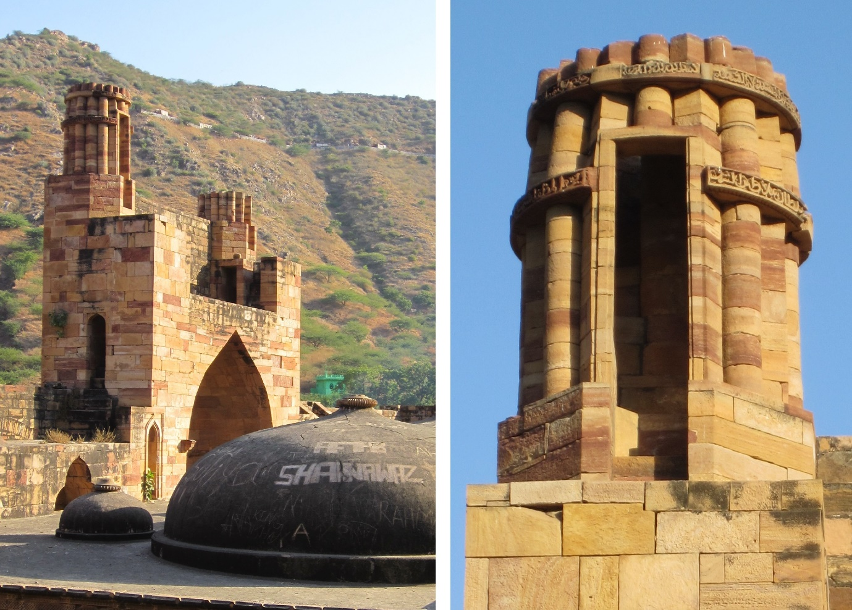
Figure 1: Twin minarets, Adhai din ka Jhompara Mosque, Ajmer © Richard Piran McClary
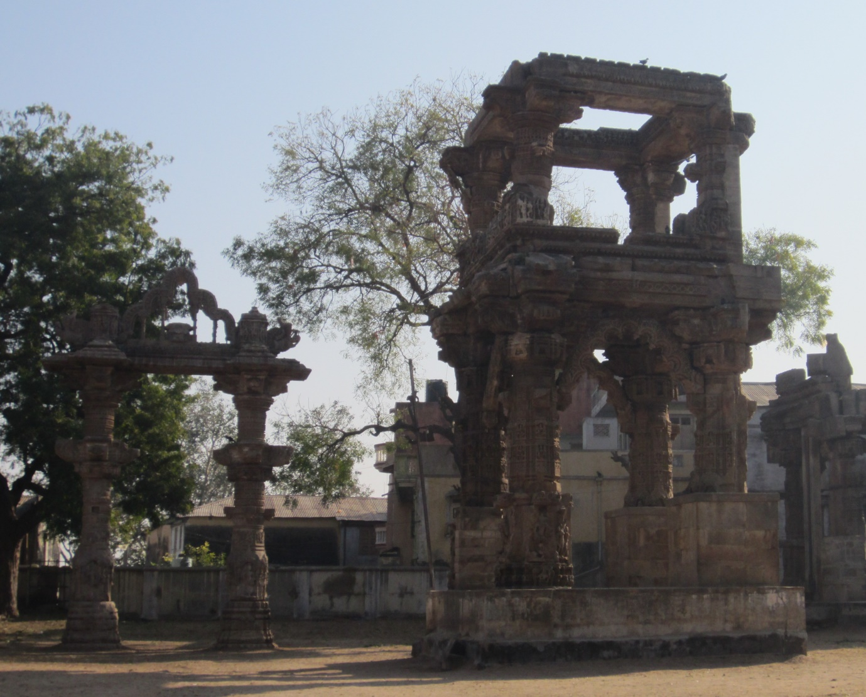
Figure 2: Tōraṇa gates, Rudra-Mahalaya Shiva temple, Siddhpur © Richard Piran McClary
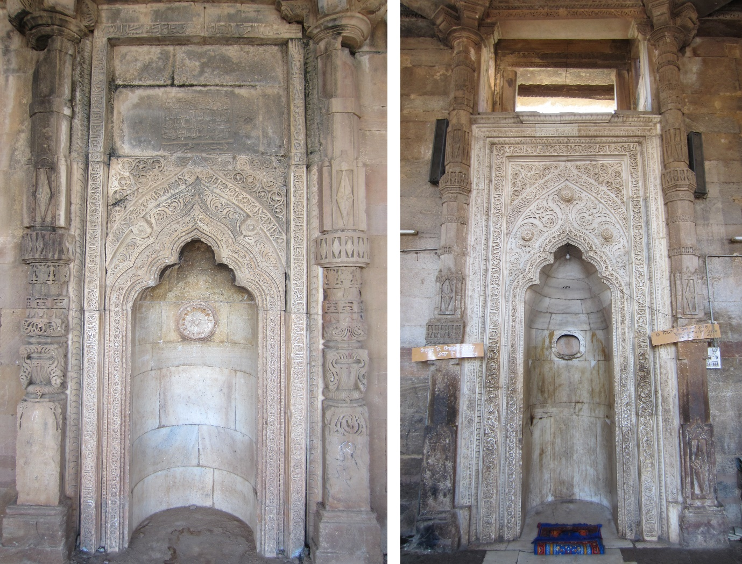
Figure 3: Mihrabs, Shahi Mosque, Khatu (left), and Adhai din ka Jhompara Mosque, Ajmer (right) © Richard Piran McClary

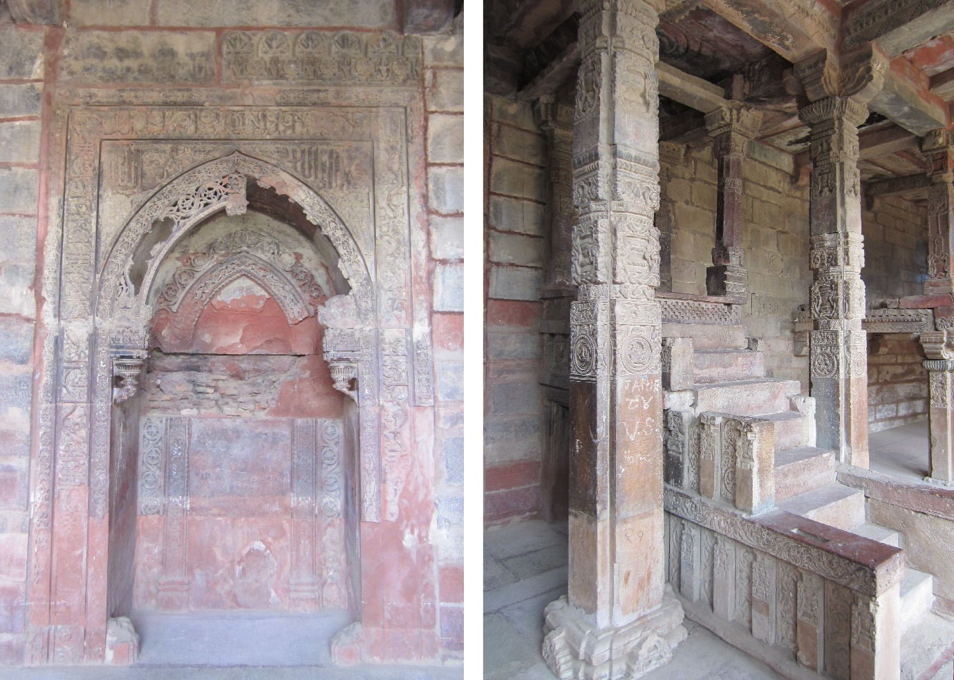
Figure 4: Mihrab and minbar, Charasi Kambah Mosque, Kaman © Richard Piran McClary
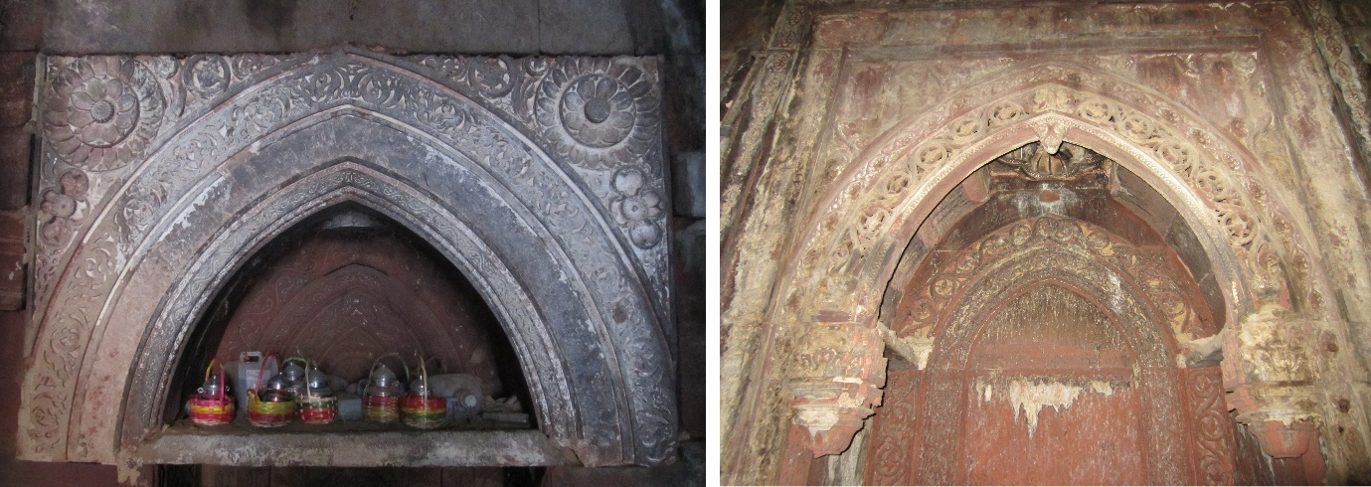
Figure 5: South secondary mihrab (left) and central mihrab (right), Ukha Mandir, Bayana © Richard Piran McClary

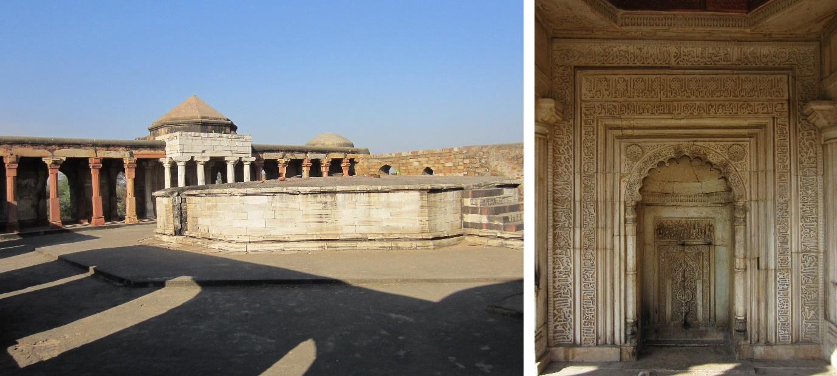
Figure 6: Interior and mihrab, Sultan Ghari Tomb, Delhi © Richard Piran McClary
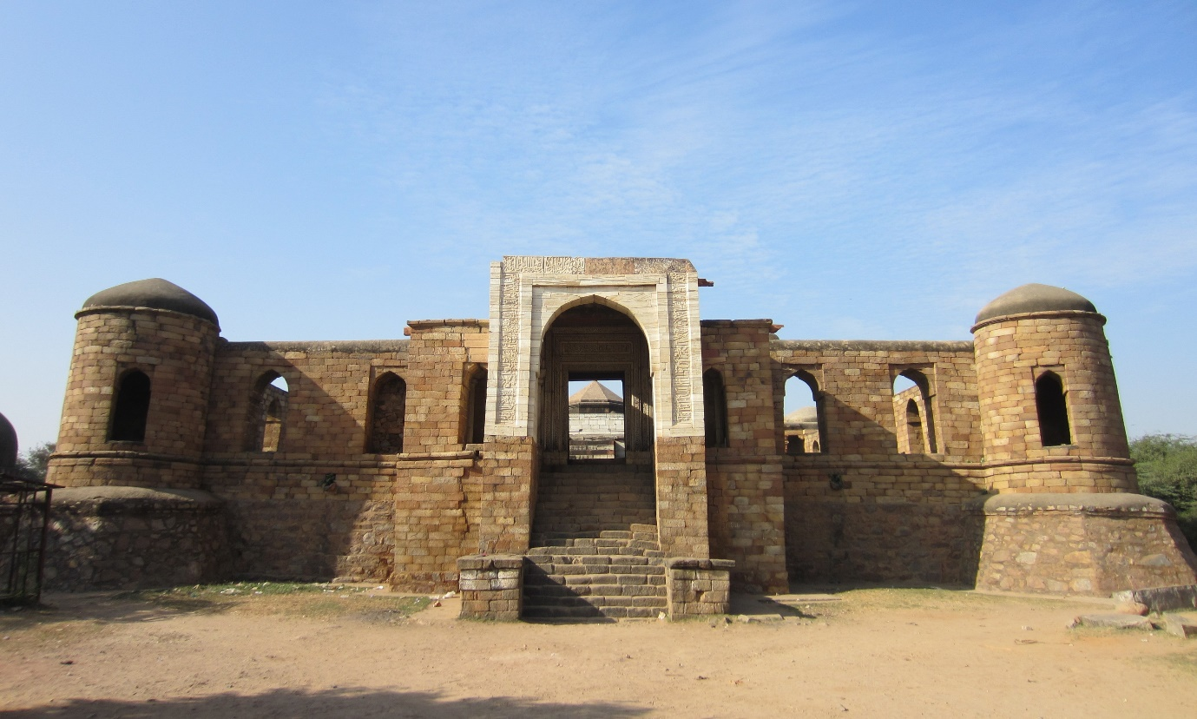
Figure 7: Eastern façade and portal, Sultan Ghari Tomb, Delhi © Richard Piran McClary

Bibliography
Agrawala, R. C. “Unpublished Gupta Reliefs from Sultān Ghārī, near Delhi.” East and West 18, 3/4 (1968): 315-318.
Agrawala, Prithvi Kumar. Pūrna Kalaśa or The Vase of Plenty. Varanasi: Prithvi Prakashan, 1965.
Crane, Howard. “Helmand-Sistan Project: An Anonymous Tomb in Bust.” East and West, 29/1 (1979): 241-246.
Digby, Simon. “Iletmish or Iltutmish? A Reconsideration of the Name of the Delhi Sultan.” Iran 8 (1970): 57-64.
Eaton, Richard M. “Temple Desecration and Indo-Muslim States.” In Sunil Kumar (ed), Demolishing Myths or Mosques and Temples? Readings on History and Temple Desecration in Medieval India. Gurgaon: Three Essays Collective, 2008, 93-139.
Edwards, Holly. Of Brick and Myth: The Genesis of Islamic Architecture in the Indus Valley. Karachi: Oxford University Press, 2015.
Flood, Finbar Barry. “Lost in Translation: Architecture, Taxonomy and the Eastern “Turks”.” Muqarnas 24 (2007): 79-115.
Flood, Finbar Barry (ed). Piety and Politics in the Early Indian Mosque. Delhi: Oxford University Press, 2008.
Flood, Finbar Barry. Objects of Translation: Material Culture and Medieval “Hindu-Muslim” Encounter. Princeton / Oxford: Princeton University Press, 2009.
Hansen, Erik, Abdul Wasay Najimi and Claus Christensen. The Ghurid Portal of the Friday Mosque of Herat, Afghanistan. Aarhus: Aarhus University Press, 2015.
Hillenbrand, Robert. “Political Symbolism in Early Indo-Islamic Mosque Architecture: The Case of Ajmīr.” Iran 26 (1988): 105-118.
Hillenbrand, Robert. “Turco-Iranian Elements in the Medieval Architecture of Pakistan: The Case of the Tomb of Rukn-i ‘Alam at Multan.” Muqarnas 9 (1992): 148-174.
Hillenbrand, Robert. “Brick versus Stone: Seljuq Architecture in Iran and Anatolia.” In Ismail K. Poonawala (ed). Turks in the Indian Subcontinent, Central and West Asia. Delhi: Oxford University Press, 2017, 105-143.
Horovitz, J. “The Inscriptions of Muḥammad Ibn Sām, Quṭbuddin Aibeg and Iltutmish.” Epigraphica Indo-Moslemica (1911-12): 12-34.
Lambah, Abha Narain, and Alka Patel. The Architecture of the Indian Sultanates. Mumbai: Marg, 2006.
McClary, Richard Piran. “A Corpus of Thirteenth-Century Brick Rum Seljuq Minarets.” In Robert Hillenbrand (ed). Seljuq Architecture. Edinburgh: Edinburgh University Press, forthcoming.
McClary, Richard Piran. “Craftsmen in Medieval Anatolia: Methods and Mobility.” In Rachel Goshgarian and Patricia Blessing (eds), Architecture and Landscape in Medieval Anatolia, 1100-1500. Edinburgh: Edinburgh University Press, 2017, 27-58.
McClary, Richard Piran. “Architecture of the Wider Persian World: From Central Asia to Western Anatolia in the Twelfth and Thirteenth Centuries.” In Yuka Kadoi (ed). Persian Art: Image Making in Eurasia. Edinburgh: Edinburgh University Press, 2018, 37-59.
McClary, Richard Piran. Rum Seljuq Architecture, 1170-1220: The Patronage of Sultans. Edinburgh: Edinburgh University Press, 2017.
McClary, Richard Piran. “The Re-use of Byzantine Spolia in Rūm Saljūq Architecture.” Copy – Paste. The Reuse of Material and Visual Culture in Architecture, Bfo-Journal 1 (2015): 14-22.
Meister, Michael W. “Indian Islam’s Lotus Throne: Kaman and Khatu Kalan.” In Finbar Barry Flood (ed), Piety and Politics in the Early Indian Mosque. New Delhi: Oxford University Press, 2008, 225-262.
Merklinger, Elizabeth Schotten. Sultanate Architecture of Pre-Mughal India. New Delhi: Munshiram Manoharlal, 2005.
Moin, A. Azfar. “Sovereign Violence: Temple Destruction in India and Shrine Desecration in Iran and Central Asia.” Comparative Studies in Society and History 57/2 (2015): 467-496.
Naqvi, S. A. A. “Sulṭān Ghāri, Delhi.” Ancient India 3 (1947): 4-10.
Nil’sen, V. A., Monumental’naya Arkhitektura Bukaraskogo Oazisa XI-XII vv, Tashkent: Akademii Nauk Uzbekskoi, 1956.
Pancaroğlu, Oya. “The House of Mengüjek in Divriği: Constructions of Dynastic Identity in the Late Twelfth Century.” In A. C. S. Peacock and Sara Nur Yildiz (eds). The Seljuks of Anatolia: Court and Society in the Medieval Middle East. London: I. B. Tauris, 2013, 25-67.
Patel, Alka. Building Communities in Gujarāt: Architecture and Society during the Twelfth through Fourteenth Centuries. Leiden / Boston: Brill, 2004.
Patel, Alka. “Architectural Histories Entwinned: The Rudra-Mahalaya / Congregational Mosque of Siddhpur, Gujarat.” Journal of the Society of Architectural Historians 63/2 (2004): 144-163.
Patel, Alka. “Expanding the Ghurid Architectural Corpus East of the Indus: The Jāgeśvara Temple at Sādaḍi, Rajasthan.” Archives of Asian Art 59 (2009): 33-56.
Perween, Hasan. “Sultanate Mosques and Continuity in Bengal Architecture.” Muqarnas 6 (1988): 58-74.
Redford, Scott. “The Seljuqs of Rum and the Antique.” Muqarnas 10 (1993): 148-156.
Shokoohy, Mehrdad and Natalie H. Shokoohy. “The Architecture of Baha al-Din Tughrul in the Region of Bayana, Rajasthan.” Muqarnas 4 (1987): 114-132.
Shokoohy, Mehrdad and Natalie H. Shokoohy. Nagaur: Sultanate and Early Mughal History and Architecture of the District of Nagaur, India, Royal Asiatic Society Monographs Volume XXVIII. London: The Royal Asiatic Society, 1993.
Shukurov, Rustam. “Harem Christianity: The Byzantine Identity of Seljuk Princes.” In A. C. S. Peacock and Sara Nur Yildiz (eds). The Seljuks of Anatolia: Court and Society in the Medieval Middle East. London: I. B. Tauris, 2013, 115-150.
Yazar, Turgay. Nahcivan’da Türk Mimarisi (Başlangıcından 19. Yüzyılın Sonuna Kadar). Ankara: Türk Tarih Kurumu, 2007.

For an overview of the conquest of these two areas see Stephen Dale’s chapter in this volume.
Although Byzantine architects in the west of Anatolia used stone combined with larger, thinner bricks than those used in the eastern Islamic world (opus mixtum), the largely Georgian and Armenian architectural traditions of central and eastern Anatolia were almost exclusively based around the use of stone. For a good overview of Byzantine building materials and techniques see Robert Ousterhout, Master builders of Byzantium (Princeton: Princeton University Press, 1999), especially 128-200.
For details of the Central Asian origins of the elements of the brick architectural aesthetic found in Anatolia see Richard McClary, “Architecture of the Wider Persian World: From Central Asia to Western Anatolia in the Twelfth and Thirteenth Centuries”, in Yuka Kadoi (ed), Persian Art: Image Making in Eurasia (Edinburgh: Edinburgh University Press, 2018), 37-59, especially 37-41.
See Robert Hillenbrand, “Brick versus Stone: Seljuq Architecture in Iran and Anatolia”, in Ismail K. Poonawala (ed), Turks in the Indian Subcontinent, Central and West Asia (Delhi: Oxford University Press, 2017), especially 135-36, for an excellent summary of the key differences between the Anatolian stone-built Islamic monuments and earlier brick-built and stucco-decorated structures in Iran and Central Asia.
The most significant is probably Finbar Barry Flood, “Lost in Translation: Architecture, Taxonomy and the Eastern “Turks”,” Muqarnas 24 (2007), 79-115, along with elements of Finbar Barry Flood, Objects of Translation: Material Culture and Medieval “Hindu-Muslim” Encounter (Princeton / Oxford: Princeton University Press, 2009).
For Anatolia see Richard Piran McClary, Rum Seljuq Architecture, 1170-1220: The Patronage of Sultans (Edinburgh: Edinburgh University Press, 2017). For a number of the earliest monuments in northern India see Mehrdad Shokoohy, and Natalie H. Shokoohy, “The Architecture of Baha al-Din Tughrul in the Region of Bayana, Rajasthan,” Muqarnas 4 (1987), 114-132, and Mehrdad Shokoohy and Natalie H. Shokoohy, Nagaur: Sultanate and Early Mughal History and Architecture of the District of Nagaur, India, Royal Asiatic Society Monographs Volume XXVIII (London: The Royal Asiatic Society, 1993).
For details concerning the mobility of craftsmen between India and Afghanistan see Flood, Objects of Translation, 189-90 and 217-20, and Flood, Lost in Translation, 111.
For details of Aybek and Iltutmish see Blain Auer’s chapter in this volume.
See Flood, Objects of Translation, 149 – 52 for a discussion of the various possible reasons for the preference of spolia over newly-cut stone elements in the early mosques of the Ghurid period in India. For the broader context of reuse see Alka Patel, “The Historiography of Reuse in South Asia,” Archives of Asian Art 59 (2009), 1-5. For a discussion of the extent of temple destruction in the early period of Muslim rule in India see Richard M. Eaton, “Temple Desecration and Indo-Muslim States”, in Sunil Kumar (ed), Demolishing Myths or Mosques and Temples? Readings on History and Temple Desecration in Medieval India (Gurgaon: Three Essays Collective, 2008), 93-139.
Given the more extensive research on the shift from brick into stone in the context of Anatolia, and the greater focus on India in this volume, more attention is given to the Indian monuments, with the Anatolian material provided as a counterpoint to the contemporaneous developments in India. For the most recent study on the shift from brick to stone in Anatolia see Hillenbrand, Brick versus Stone, 105-143.
For a detailed study of the design and construction of the Divriği Citadel Mosque portal see Richard Piran McClary, “Craftsmen in Medieval Anatolia: Methods and Mobility,” in Rachel Goshgarian and Patricia Blessing (eds), Architecture and Landscape in Medieval Anatolia, 1100-1500 (Edinburgh: Edinburgh University Press, 2017), 35-38, and pl. 1 for a large colour image taken prior to the recent restoration.
For a detailed study of the Tepsi minaret, and its formal relationship with earlier Qarakhanid minarets in Central Asia see McClary, Architecture of the Wider Persian World, 37-43.
For examples of the destruction of idols and monuments by Indian rulers prior to the period of Muslim Turks see Eaton, “Temple Desecration and Indo-Muslim States,” 105-6. See also A. Azfar Moin, “Sovereign Violence: Temple Destruction in India and Shrine Desecration in Iran and Central Asia”, Comparative Studies in Society and History 57/2 (2015), 467-496, especially 467-70.
One example which survived into the early twentieth century was the church of St. Amphilochios in the citadel of Konya. There are also remains of a church in the Seljuq palace in Alanya.
For details of the intermarriage with Byzantines and Georgians, and evidence for the ongoing practice of Christianity in the Seljuq court see Rustam Shukurov, “Harem Christianity: The Byzantine Identity of Seljuk Princes,” in A. C. S. Peacock and Sara Nur Yildiz (eds), The Seljuks of Anatolia: Court and Society in the Medieval Middle East (London: I. B. Tauris, 2013), 115-51, especially 116-18 and 121-22.
See Scott Redford, “The Seljuqs of Rum and the Antique,” Muqarnas 10 (1993), 151-52.
Ibid., 153.
Ibid., 154. See 153-54, figs. 8 and 9 of the same article for nineteenth-century drawings of the, now lost, walls in Konya.
See Richard Piran McClary, “The Re-use of Byzantine Spolia in Rūm Saljūq Architecture,” Copy – Paste. The Reuse of Material and Visual Culture in Architecture, Bfo-Journal 1 (2015), 14-22.
See Robert Hillenbrand, “Political Symbolism in Early Indo-Islamic Mosque Architecture: The Case of Ajmīr,” Iran 26 (1988), 105-18, for the former and throughout Flood, Objects Of Translation for the latter.
See J. Horovitz, “The Inscriptions of Muḥammad Ibn Sām, Quṭbuddin Aibeg and Iltutmish,” Epigraphica Indo-Moslemica (1911-12), 16-19 and 26-29.
See Turgay Yazar, Nahcivan’da Türk Mimarisi (Başlangıcından 19. Yüzyılın Sonuna Kadar) (Ankara: Türk Tarih Kurumu, 2007), 414-15.
For a study of the twin minarets in Anatolia see Richard Piran McClary, “A Corpus of Thirteenth-Century Brick Rum Seljuq Minarets”, in Robert Hillenbrand (ed), Seljuq Architecture (Edinburgh: Edinburgh University Press, forthcoming).
For the surviving inscription band on the northern minaret giving the name and titles of Iltutmish see Horovitz, The Inscriptions of Muḥammad Ibn Sām, 29 and pl. XXVI. For photographs of the inscriptions and analysis of the various possible readings see Simon Digby, “Iletmish or Iltutmish? A Reconsideration of the Name of the Delhi Sultan,” Iran 8 (1970), 61, and pls. 1a -1b.
Flood, Objects Of Translation, 242-43.
Ibid.
Hillenbrand, Political Symbolism in Early Indo-Islamic Mosque Architecture, 113 notes that this plan can be seen in both tombs and minarets built under Seljuq patronage in Iran.
Shokoohy and Shokoohy, The Architecture of Baha al-Din Tughrul, 126.
Due to the reduced scale there is no internal helix staircase in the Bayana examples, while there is in the somewhat larger ones in Ajmer.
For details of the ‘idgah see ibid., 129-32.
See V. A. Nil’sen, Monumental’naya Arkhitektura Bukaraskogo Oazisa XI-XII vv (Tashkent: Akademii Nauk Uzbekskoi, 1956), 69, fig. 29.
Patel, Expanding the Ghurid Architectural Corpus, 37.
The same arch form as seen in the Indian mihrabs can be seen on small marble funerary reliefs from Ghazni and Bust. See Flood, Objects of Translation, 191-92 and 196-99.
For a study of the complex, and details of the conversion of the site to a mosque, see Alka Patel, “Architectural Histories Entwinned: The Rudra-Mahalaya / Congregational Mosque of Siddhpur, Gujarat,”, Journal of the Society of Architectural Historians 63/2 (2004), 144-63.
Michael W. Meister, “Indian Islam’s Lotus Throne: Kaman and Khatu Kalan,” in Finbar Barry Flood (ed), Piety and Politics in the Early Indian Mosque (Delhi: Oxford University Press, 2008), 253-54.
Shokoohy and Shokoohy, The Architecture of Baha al-Din Tughrul, 114.
The only study remains Shokoohy and Shokoohy, The Architecture of Baha al-Din Tughrul, 121-26.
See Erik Hansen, Abdul Wasay Najimi and Claus Christensen, The Ghurid Portal of the Friday Mosque of Herat, Afghanistan (Aarhus: Aarhus University Press, 2015).
A number of engrailed, or lobed, arches were also inserted between the pillars around the edge of the courtyard at the same time.
See Shokoohy and Shokoohy, The Architecture of Baha al-Din Tughrul, 117, fig. 2.
Many of the medieval Islamic monuments in the Indus Valley have recently been published in a monograph. See Holly Edwards, Of Brick and Myth: The Genesis of Islamic Architecture in the Indus Valley (Karachi: Oxford University Press, 2015). See also Robert Hillenbrand, “Turco-Iranian Elements in the Medieval Architecture of Pakistan: The Case of the Tomb of Rukn-i ‘Alam at Multan,” Muqarnas 9 (1992), 148-74.
For a study of the vase of plenty and its use as a symbol in the art and architecture of India see Prithvi Kumar Agrawala, Pūrna Kalaśa or The Vase of Plenty (Varanasi: Prithvi Prakashan, 1965).
Edwards, Of Brick and Myth, 205.
See Edwards, Of Brick and Myth, 208-9, figs. 31-34.
The same motif is repeated on the qibla wall inside the tomb. For a study of the tomb see Edwards, Of Brick and Myth, 184 -88, including figs. 8, 9 and 10.
See S. A. A. Naqvi, “Sulṭān Ghāri, Delhi,” Ancient India 3 (1947), 5 for a transcription and translation of the inscription around the marble entrance portal.
See Howard Crane, “Helmand-Sistan Project: An Anonymous Tomb in Bust,” East and West 29/1 (1979), 241-46.
This point has been previously noted in Elizabeth Schotten Merklinger, Sultanate Architecture of Pre-Mughal India (New Delhi: Munshiram Manoharlal, 2005), 29.
For a detailed description of the tomb see Naqvi, Sulṭān Ghāri, 8-9, and pls. II-VI for plans, sections and elevations of the site.
See R. C. Agrawala, “Unpublished Gupta Reliefs from Sultān Ghārī, near Delhi,” East and West 18, 3/4 (1968), 315-18 and figs. 2-16.
See Edwards, Of Brick and Myth for the early Islamic architecture of the Indus Valley. For details of some later brick-built mosques in Bengal see Hasan Perween, “Sultanate Mosques and Continuity in Bengal Architecture,” Muqarnas 6 (1988), 58-74.
See McClary, Rum Seljuq Architecture, 39-62 for a study of the Sivas Great Mosque minaret.
See ibid., 91-178 for a study of the complex.
See McClary, The Re-use of Byzantine Spolia, 15-18.
See Alka Patel, Building Communities in Gujarāt: Architecture and Society during the Twelfth through Fourteenth Centuries (Leiden / Boston: Brill, 2004), especially 129-64. In the later period areas formerly reserved for figural decoration were generally replaced in newly-carved elements with the ratna (rhomboid jewel) design. Flood, Objects of Translation, 171, fig. 104 shows a defaced figural element on an upper column in the Adhai din ka Jhompara Mosque in Ajmer which has been reworked to resemble a ratna. This shows that the desire to replace the figural carvings with ratna designs was in place from the very earliest period of construction of mosques with temple spolia in India.
Hillenbrand, Brick versus Stone, 115.
Hillenbrand, Brick versus Stone, 115. Rare exceptions include the façades of the Ribat-i Malik near Bukhara and the Shah-i Mashhad Madrasa in Gharjistan.

