A biorefinery strategy for spent industrial ginger waste
Yang Gao, Mustafa Z. Ozel, Tom Dugmore, Allyn Sulaeman and Avtar S. Matharu*
†Green Chemistry Centre of Excellence, Department of Chemistry, University of York, York YO10 5DD. UK

Keywords: Spent industrial ginger, Biorefinery, Microwave, Ginger oil, Starch, Microfibrillated cellulose

ABSTRACT: An integrated biorefinery approach using spent industrial ginger waste for resource recovery is reported. Valuable products including ginger oil, starch, microfibrillated cellulose (MFC), bio-oil and hydrochar were obtained. Approximately 4% ginger oil, with a profile similar to commercial ginger oil, can be recovered via Soxhlet or Supercritical CO₂ + 10%EtOH extraction. The oil-free ginger residues were processed using two microwave techniques: starch, MFC and sugar-rich hydrolysates were firstly gained through hydrothermal microwave processing (120 to 200 ºC in water alone), whilst chemical-rich bio-oils and energy-dense hydrochar (20 - 24.5 MJ kg⁻¹) were obtained via conventional microwave pyrolysis (220 to 280 ºC). The ginger MFC exhibited increased propensity to form microfibrillated cellulose (as evidenced by Transmission Electron Microscopy) with increasing temperature. Nanocrystalline cellulose was produced at the highest processing temperature (200 ºC). These changes are commensurate with the leaching and decomposition of the amorphous regions within cellulose. The molecules and materials isolated have further downstream applications and, thus, compared to current low value resolution methods (dumping, burning or animal feed), spent industrial ginger waste is a significant resource for consideration within a biorefinery concept.

- Introduction
Ginger (Zingiber officinale), originally derived from Southeast Asia and is now cultivated in a number of countries including India, China, Nepal, and Nigeria, is a flowering plant whose rhizome (ginger root or ginger) is used in food, flavours, fragrances and medicinal products (Mekonnen et al., 2013; Shahrajabian et al., 2019). In 2016, 3.3 million tonnes of ginger was produced globally (Aly et al., 2019). Ginger is often processed for its high-value oleoresins and volatile oils (Kou et al., 2018; Lai et al., 2016; Makanjuola, 2017; Palatty et al., 2013). Ginger oleoresins comprise approximately 20–30% of volatile oil, 10% of fixed oil, 50–70% of pungent resinous matter but only accounts for 4–10% of the total dry weight of the rhizome. Thus, there is a significant amount (by weight) of spent ginger waste produced from industries such as herbal medicine or beverages (Wiastuti et al., 2016). This waste is typically sent to landfill, incinerated (Konar et al., 2013) or used as low value animal feed (ginger waste meal) (Eltazi, 2014; Omage et al., 2007). Alternative means of utilisation have been reported, such as the use of ginger wastes as an adsorbent for wastewater treatment (Kumar & Ahmad, 2011); nevertheless, current scenarios for re-utilisation of spent industrial ginger wastes are limited, especially those that seek to explore resource recovery (valorisation) in the forms of chemicals, materials and energy within the context of a biorefinery.
Microwave (MW) technology is becoming popular for the production of bio-based chemicals and materials (Clark, 2019) compared to conventional heating due to its volumetric heating, rapid extraction ability, energy-efficiency (Kappe, 2004; Luque et al., 2012) and reduced environmental impact (Garcia-Garcia et al., 2019).
Microfibrillated cellulose (MFC) is a promising biobased material with uses in many different applications (food, membranes, textles etc) due to its excellent properties, for example, light weight, water-binding and high mechanical strength Nanostructured cellulose can form hydrogels, aerogels and films (Chen et al., 2016; Khanjani et al., 2019; Ye et al., 2019; Zheng et al., 2016). MFC is conventionally obtained from wood fibres of pulp via intensive chemical and physical pretreatment (e.g. microfluidisation, super-grinding, cryocrushing, steam explosion) (Oliaei et al., 2020; Osong et al., 2016). In previous studies, a novel acid-free microwave hydrothermal treatment (MHT) method was adopted to produce pseudo-nanocellulosic fibrils and/or nanocrystals without any additional chemicals from argi-wastes (e.g. orange peel, pea haulm) (de Melo et al., 2017; Gao et al., 2019). The MFC produced was similar to conventional MFC exhibiting gel and film forming potential.
Herein, the valorisation of spent industrial ginger waste as a source of chemicals, materials and (bio)energy in order to establish a preliminary biorefinery concept is reported (Figure 1). The aims are to i. Recover residual oils (extractives) by Soxhlet (heptane) or supercritical CO₂ entrained with 10% ethanol as co-solvent. ii. Explore hydrothermal microwave-assisted processing of the extractive-free residues to ellicit biopolymers such as starch and to produce MFC (and sugar-rich hydrolysates). The propensity to retain water (water retentioin value and water holding capacity) and ability to form hydrogels will be determined as a possible application area of MFCs iii. Investigate conventional microwave pyrolysis to afford bio-oils and hydrochars in order to ascertain their composition and calorific value as the latter may be used for bioenergy. iv. Undertake detailed characterisation via a variety of techniques, for example, IR, GC, GC-MS, HPLC, TEM, TGA, NMR and XRD) that track structural changes in the spent ginger on route to formation of MFC and provide compositional analysis of molecules ellicited.
MFC
Hydrolysate
Ginger char
Starch
Sugar & Acids
Hydrolysissi
Pyrolysis

Ginger residue
Industrial ginger waste
Extraction
Bio-oil
Ginger oil

Figure 1. Schematic overview of the proposed biorefinery route of spent industrial ginger waste.
- Materials and methods
Spent industrial ginger waste which had been processed for its essential oils was used in this study. On receipt, the industrial ginger waste was milled (Retsch™ Knife Mill Grindomix GM300), sieved (200 μm) and stored in air-tight containers until further required. The integrity of products was confirmed by a variety of characterisation techniques: TGA, ATR-IR, 13C CPMAS NMR, CHN, WRV, WHC, XRD, SEM and TEM, details of which are given in ESI.

2.1. Extraction and analysis of ginger oil

Soxhlet extraction was performed on the milled industrial ginger waste (40 g) with heptane (400 mL) for 24 h. The solvent was removed in vacuo to afford to desired extract as ginger oil (1.58 g, 3.95 %), whilst the oil-free residues were allowed to dry (oven, 40 ºC) to constant weight and used for microwave pyrolysis and hydrothermal microwave processing as outlined below.
Supercritical CO₂ extraction was carried out on a laboratory scale system (SciMed, Stockport, UK) with an extractor vessel capacity of 1 L in which a basket was placed containing 300 g of milled industrial ginger waste. Cylinders containing food grade liquid CO₂ 99.8% (BOC, Guilford, UK) were pressurized using a high-pressure Waters P200 pump to a pressure of 350 bar, and flow rate 15 g/min. Where stated, 10% ethanol co-solvent was pumped in, using a Waters 515 HPLC pump. Extraction temperature was 35 °C. The extraction was left to run for 2 hours. The extract was filtered through grade four filter paper (Fisher Scientific, Loughborough, UK). Where no ethanol was used, the extracts contained a water layer which was removed in a separating funnel and final yield recorded. For supercritical CO₂ with ethanol extracts, the ethanol was removed from the extracts a in vacuum at 40 °C and 90 mbar and, again, the final yield recorded.
The chemical composition of the extracts was analysed by gas chromatography coupled to a mass spectrometer (GC-MS) for component identification. The extracts were run on an Agilent 7890A connected to a single quadrupole Agilent 5975C MS. The column was a fused-silica capillary DB-5HT (30 m x 0.25 mm x 10 µm) with a carrier gas of helium at 99.99% purity. The initial oven temperature was 50 °C, held for 1 minute, ramped at a rate of 10 °C min-1 to reach a final temperature of 300 °C and held for 4 minutes. Component identification was confirmed by comparing the compound’s mass spectrum to the NIST 2017 database. Component quantification was performed by taking the area of each single peak and dividing by the total area of all identified peaks and the result multiplied by 100.

2.2. Conventional microwave pyrolysis: Bio-oil and char production
The pyrolysis experiments were conducted on a CEM Discover SP microwave reactor with 30 mL borosilicate glass vessel. The oil-free ginger residues (1 g) were subjected to microwave irradiation (95 W) at 220, 240, 260 and 280 ºC at 0, 3, 6 and 9 min time intervals. Post pyrolysis, the resultant char was washed with ethyl acetate (10 mL), filtered and dried in an oven (60 ºC) for 48 h until constant weight was achieved, whilst the ethyl acetate extract was evaporated in vacuo to afford bio-oil.
Char and bio-oil yields were calculated according to equations 1 and 2, respectively.
Char yield (%) = (mass of char/mass of dried raw material) x 100 (1)
Bio oil yield (%) = (mass of bio oil/mass of dried raw material) x 100 (2)

2.3. Hydrothermal microwave processing: Starch, microfibrillated cellulose and hydrolysate production

The hydrolysis experiments were carried out using a Milestone SynthWave reactor (1500 W, 2.45 GHz). Oil-free ginger residue (10 g, post Soxhlet extraction)) was mixed with distilled water (350 mL) with a ratio of 1: 35 (w/v) in PTFE vessels (900 mL) and processed at 120, 140, 160, 180 and 200 ºC for 30 min (15 min ramping and 15 min holding time). The resulting slurry was centrifuged (Thermofisher Megafuge 4000R, 20 min at 3000 rpm) and the pellet and supernatant separated. The pellet was washed with hot water (300 mL, 15 min), hot ethanol (2 x 300 mL, 15 min. each), cold ethanol (300 mL, 15 min, around 20 ºC), cold acetone (300 mL, 15 min) and dried (ambient, 24 h) to afford the desired microfibrillated cellulose (MFC). The supernatant was treated with an equal volume of ethanol, stored in a fridge overnight, and resultant precipitate was isolated by centrifugation. The pellet (precipitate, evidenced as starch – see later) was dried (ambient) until constant weight was achieved and the supernatant (hydrolysate) was stored for sugar analysis via HPLC (see later). The samples were coded as MFC and starch was coded as GS based on the temperature, for example, MFC120 refers the cellulose sample with 120 ºC microwave hydrothermal treatment, and GS160 refers to the starch extracted from the hydrolysate from 160 ºC treatment.
The yield MFC and GS were calculated according to equations 3 and 4, respectively.
MFC yield (%) = (mass of MFC /mass of dried raw material) × 100 (3)
GS yield (%) = (mass of starch/mass of dried raw material) × 100 (4)
HPLC was used for the determination of compounds in the hydrolysate using a refractive index detector at 55 °C. For levoglucosan, glucose, xylose, and organic acids (lactic) the samples were analysed using an Agilent 1260 equipped with an Agilent Hi-Plex H (300 x 7.7 mm, 8 μm particle size) column, 0.005 M H₂SO₄ mobile phase, isocratic mode (no gradient), flow-rate of 0.4 mL/min, column temperature of 60 °C, injection volume of 5 μl and a total run time of 35 minutes. Furfural and 5-HMF were analysed using an ACE C18 (250 × 4.6 mm, 5 μm particle size) column with acetonitrile: water (25/75) mobile phase, isocratic mode, 0.8 ml/min flow-rate, column temperature of 30 °C, injection volume of 5 μl and a total run time of 22 minutes.

- Results and Discussion
  - Ginger oil recovery
The yield and composition of the ginger oils (as determined by GC-MS) obtained from spent industrial ginger waste via Soxhlet, SC-CO₂ and SC-CO₂ + 10% EtOH extraction techniques are presented in Table 1. Zingiberene, α-curcumene, β-bisabolene, β-sesquiphellandrene, 6-shogaol, 6-gingerol and 10-shogaol were found to be the major compounds from the spent industrial ginger waste. These are known key molecules present in commercial ginger oil (Munda et al., 2018), thus, immediately representing a potential valorisation opportunity. The SC-CO₂ and SC-CO₂ + EtOH techniques gave a slightly higher number of different analytes. A range of lower molecular weight compounds were found to be absent in the Soxhlet extracts. It is assumed that they were lost by evaporation during the extraction or in the solvent reduction steps. Depending on the quality/grade of ginger oil and its intended application, its value can range from £100 - 500/kg.
Table 1: The yield and composition of the ginger oils as determined by GC-MS
Compoundsa | RT (min)^{b} | % Area^{c}
 |  | Soxhlet | SC-CO2 | SC-CO2 +EtOH
Essential oil content (%)^{d} |  | 4.00 | 2.51 | 4.12
α-Pinene | 6.50 | ^{e} | 0.70 | 0.81
Eucalyptol | 7.66 |  | 5.28 | 2.30
endo-Borneol | 11.45 |  | 1.14 | 0.93
Neral | 13.25 |  | 0.44 | 0.22
Geranial | 14.74 |  | 5.55 | 2.15
α-Curcumene | 22.17 | 9.03 | 3.65 | 8.72
Zingiberene | 22.65 | 22.65 | 8.15 | 15.20
α-Farnesene | 22.89 | 2.62 | 1.14 | 3.09
β-Bisabolene | 22.99 | 4.10 | 1.48 | 6.10
β-Sesquiphellandrene | 23.48 | 9.28 | 4.90 | 11.53
Zingerone | 26.8 | 2.28 | 3.59 | 1.45
6-Shogaol | 42.59 | 7.32 | 15.54 | 16.80
6-Gingerol | 44.66 | 11.17 | 15.83 | 12.14
10-Isoshagaol | 48.27 | 2.17 | 2.77 | 0.96
10-Shogaol | 49.13 | 4.14 | 6.02 | 2.31
γ-sitosterol | 54.24 | 2.10 | 1.50
a As identified by GC-MS software; names according to NIST 2017 mass spectral library.
b Retention times
c Percentage of each component is calculated as peak area of analyte divided by peak area of total ion chromatogram times 100
d %w/w = percent (weight/weight)
e not detected
3.2. Microwave pyrolysis
The yields of microwave pyrolysis gas, bio-oil and char with respect to temperature at fixed holding time (9 min) are displayed in Table 2. With increasing temperature (220 ºC to 280 ºC), the gas yield increased from 9.28% to 15.43%. Yields of oil also increased from 14.06% to 33.38%, with both the gas and oil yields reaching the maximum at 280 ºC. Conversely, yields for the chars reduced from 76.66% to 52.19%, due to cellulose and hemicellulose depolymerisation and subsequent, increased volatilisation (including CO, CO₂ and H₂O) and aromatisation. (Sadaka et al., 2014; Xiong et al., 2019; Zhu et al., 2019).
Table 2. Yield of microwave-assisted pyrolysis products with respect to temperature
Operational condition |  |  | Yield (%)
T (°C) | t (min) | Gas | Oil | Char
220 | 9 | 9.28 | 14.06 | 76.64
240 | 9 | 12.32 | 25.63 | 62.46
260 | 9 | 13.73 | 29.41 | 57.80
280 | 9 | 15.43 | 33.38 | 52.19

3.2.1. Hydrochar characterisation and higher heating value
The calorific value or higher heating value (HHV) of the resultant chars was determined both experimentally and theoretically via bomb calorimetry and elemental analysis, respectively, and are shown in Figure 2 (where GP refers to virgin, non-pyrolysed spent ginger and GCXXXY refers to ginger char (GC), processed at temperature XXX ºC for Y minutes). Compared with the original industrial ginger waste (GP, 16.29 MJ kg⁻¹), the calorific value increases upon char formation (20 - 24.5 MJ kg⁻¹) correlating well with the concept of energy densification.
Figure 2. Higher heating value of ginger and its chars from bomb calorimetry (Experimental) and theoretical HHV from CHN calculation (Theoretical). Values are average of duplicate experiments (N=2).
In comparison with other selected biomass char types based on internal and external data (Figure 3) (Xia et al., 2016), it can be observed that most of the HHV of raw biomass types are similar (about 16 - 17 MJ kg⁻¹) therefore ginger char is comparable to other char types. However, these values are for qualitative analysis only as the chars may have been produced by different methods.
Figure 3. HHV of different biomass and their chars.
The van Krevelen diagram for ginger waste and its chars obtained from different pyrolysis conditions is shown in Figure 4. The H/C and O/C ratios can be used as a measure of the degree of carbonisation (Zhang et al., 2018). The O/C ratio describes the polarity and a higher ratio indicates more polar functional groups. The H/C ratio indicates potential aromaticity in the biochar. It can be observed that O/C and H/C ratios of ginger residue are around 0.98 and 1.9, respectively. With increasing temperature and residence time, the H/C and O/C ratios both decreased (from 1.23 to 1.01 and 0.58 to 0.42, respectively), suggesting removal of polar surface functional groups to afford aromatic structures (Brewer, 2012). Thus, the carbon content is “concentrated” with harsher conditions resulting in a higher degree of carbonisation (Qambrani et al., 2017). Meanwhile, the simultaneous loss of both hydrogen and oxygen also suggests that the main reaction pathway during the process is dehydration.
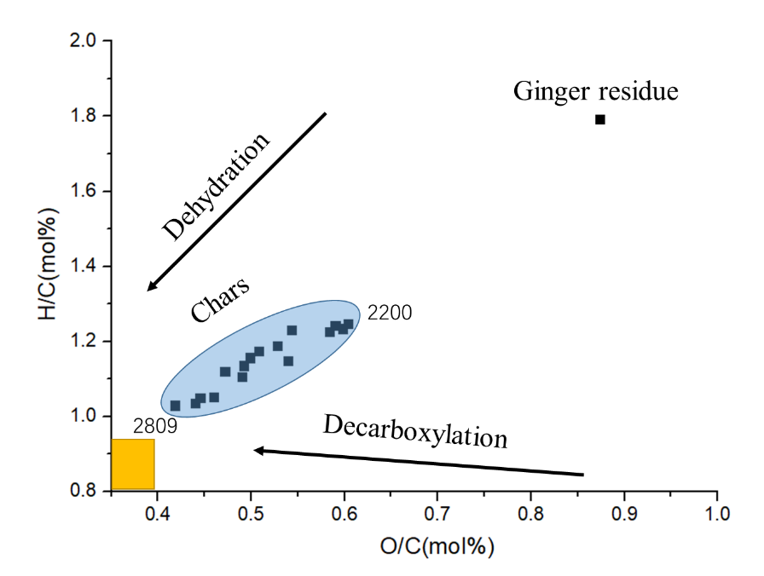
Figure 4. van Krevelen diagram for ginger residue and its biochars obtained at different conditions, optimum H/C and O/C ratios of biochar is in yellow area.
Ideally, the optimum H/C and O/C ratios of biochar should be less than about 0.6 and 0.4, respectively (Zambon et al., 2016) (see the yellow area in Figure 4). In this instance the char produced from spent industrial ginger may be classified as a hydrochar with high oxygen functional groups and more alkyl moieties instead of aromatic structures. Such materials also possess higher nutrient retention capacity than biochars (Dieguez-Alonso et al., 2018). The mechanism of hydrochar or pseudobiochar (Figure 5) is a variety of complex reactions such as dehydration, deoxygenation, and decarboxylation reactions (Ahmed Khan et al., 2019; Wang et al., 2018). Hydrochars have several valuable applications in the industrial and environmental fields: soil amelioration, carbon sequestration, bio fuels, and also pollution remediation due to high energy density and carbon content, porous structure and high degree of aromatization (Fang et al., 2018). The formation was further evidenced by thermogravimetric analysis (see ESI, Figure S2) which still shows a significant decomposition fingerprint for (ligno)cellulose, which in an ideal biochar, should be absent.
Figure 5. Propsed mechanism of hydrochar formation.
ATR-IR analysis (Figure 6) of the chars also supports this notion of a hydro- rather than bio-char. The broad bands centred at approximately 3300 cm⁻¹ are associated with O-H stretching corresponding to hydroxyl moieties in hemicellulose or cellulose. The bands centred at about 2920 cm⁻¹ are due to the symmetric and asymmetric –CH₂ and –CH₃ stretching belonging to hemicellulose. Two small bands at around 1700 cm⁻¹ and 1600 cm⁻¹ are assigned to C=O stretching and C=C stretching in phenolic esters, lactones, conjugated ketones or quinones which are derived from lignin pyrolysis (Qambrani et al., 2017). The bands at approximately 1620 cm⁻¹ confirm the existence of bonded water in biomass, whilst the bands 1340 cm⁻¹ correlate to aromatic C=C commensurate with lignin (Qambrani et al., 2017). The sharp band centred at 1010 cm⁻¹ is assigned to C–O and C-C stretching in cellulose/ hemicellulose. The small bands at about 760 cm⁻¹ are likely due to the aromatic C-H in lignin/hemicellulose (Qambrani et al., 2017).
The spectrum of ginger powder shows characteristic lignocellulosic bands (3300 cm⁻¹, 2920 cm⁻¹, 1340 cm⁻¹, 1010 cm⁻¹ and 760 cm⁻¹) due to its main components (cellulose, hemicellulose and lignin) (Saygideger et al., 2005). But during the pyrolysis process, these major bands gradually disappear in the char samples and are substituted by new, smaller bands (1700 cm⁻¹ and 1600 cm⁻¹) which correspond to aromatic structure compounds, indicating that the raw biomass converts to a char which polycyclic aromatic in character through carbonisation and aromatisation processes (Ghani et al., 2013; Wang et al., 2017).
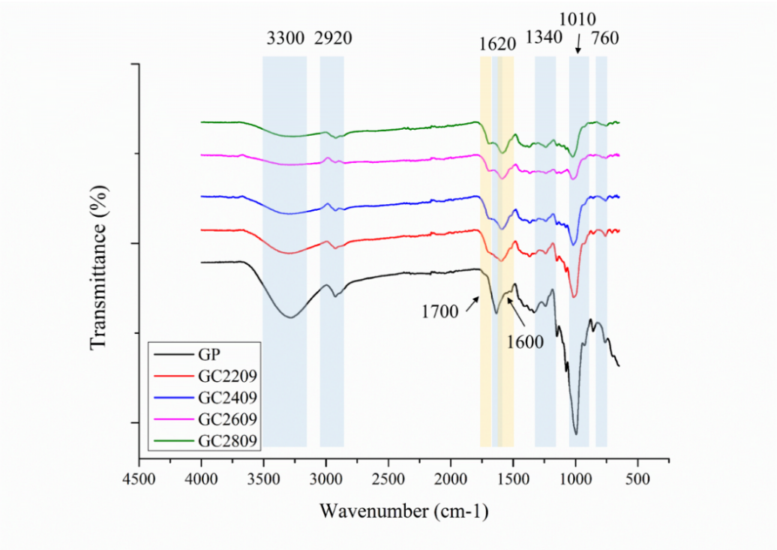
Figure 6. ATR-IR of char varying from 220 to 280 ºC with 9 min residence time
3.2.2. Bio-oil characterisation
Table 3 shows the possible major identified compounds in bio-oils obtained at different temperatures (220, 240, 260 and 280 ºC) with same holding time (9 min). The qualified constituents can be classified by functional group: cellulose/hemicellulose derived furanic structures (furfural and 2-furanmethanol) and 3-methyl-1,2-cyclopentanedione, lignin-derived phenolic-like compounds including phenol –methoxy-, cyclopentanol, catechol and 2-hydroxy-5-methylacetophenone (Ghalibaf et al., 2019). Interestingly, some essential oil components (zingerone, shagaol) were still detected which may be due to their thermal stability.
Table 3. Main chemical composition of waste ginger oils obtained with pyrolysis
Compoundsª | RT (min)^{b} | % Area^{c}
 |  | 2209 | 2409 | 2609 | 2809
Furfural | 3.32 | 6.66 | 5.82 | 5.33 | 5.07
2-Furan-methanol | 3.68 | 28.46 | 28.40 | 32.26 | 27.74
Butyrolactone | 4.73 | 5.94 | 5.52 | 7.04 | 7.03
3-Methyl-1,2-cyclopentanedione | 7.49 | 4.61 | 5.15 | 4.27 | 3.59
Methoxy phenol | 9.23 | 2.16 | 1.79 | 2.14 | 2.07
Cyclopentanol | 9.64 | 5.89 | 7.63 | 5.50 | 3.06
Catechol | 13.04 | 0.74 | 1.40 | 0.39 | 2.59
2-Hydroxy-5-methylacetophenone | 16.58 | 1.90 | 2.09 | 1.03 | 0.49
Zingerone | 26.68 | 0.49 | 0.34 | 0.40 | 0.41
Shagaol | 42.43 | 1.36 | 0.88 | 0.91 | 0.04
ª As identified by GC-MS software; names according to NIST 2017 mass spectral library.
^{b} Retention times
^{c} Percentage of each component is calculated as peak area of analyte divided by peak area of total ion chromatogram times 100

Thus, spent industrial ginger waste can be pyrolysed into both aliphatic and aromatic biobased chemicals. Furanics in particular are interesting as a source of biobased platform molecules for conversion into further molecules of industrial interest such as 5-hydroxymethyl furfural, itaconic acid, furan-2-, 5- dicarboxylic acid (Kucherov et al., 2018; Verma et al., 2017).

3.3. Hydrothermal microwave processing: MFC and hydrolysate
3.3.1. MFC
MFC was successfully obtained via hydrothermal microwave treatment, meanwhile the MFC from agricultural and/or industrial pea, orange and mango waste were also compared (see Table 4). The pore diametersand specific surface area of these products are all between 2- 50 nm and 1.5-124.0 m² /g, respectively. The similar results indicate that MFC can be derived from various feedstocks.

Table 4. A comparison of MFC from various biomass types
Feedstock | Temp  (°C) | Reaction time (min) | L-S ratio | Pore diameter (nm) | Surface area (m² /g) | Reference
Ginger | 120–200 | 30 | 1:35 | 16-20 | 3.6-13.0 | This paper
Orange | 120–200 | 25 | 1:70 | 5-35 | 1.5-107.0 | (de Melo et al., 2017)
Pea | 120–200 | 30 | 1:35 | 2-50 | 15.0-37.0 | (Gao et al., 2019)
Mango Peel | 180 | 10 | 1:20 | 9-10 | 16.3-124.0 | (Matharu et al., 2016)

The yields and Crystallinity Index (CrI, as determined by ¹³C CPMAS spectroscopy – see ESI, Figure S3) of the MFC obtained from hydrothermal microwave processing at different temperatures (120 to 200 ºC) are shown in Figure 7. The yield decreases from 21.6% to 7.8% with increasing temperature. Conversely, the change in CrI of defibrillated cellulose increases with temperature, exhibiting a rapid rise between 120 to 160 ºC. This can be explained by the gradually and selectively removal of hemicelluloses and amorphous cellulose from the lignocellulosic matrix with increasing temperature. After 180 ºC, due to the softening of the amorphous cellulose and lignin, the cellulose microfibrils are released via a proton-transfer mechanism (de Melo et al., 2017) and thus, the CrI increases slightly (Δ=2º).
Figure 7. Crystallinity Index (CrI) calculated from solid-state ¹³C CPMAS NMR data and yield for MFC (N=2).
The thermograms and DTG of MFC are presented in Figure 8, from which, the composition can be calculated. The mass of moisture/volatiles account for 4-10% of the industrial ginger waste, and the mass of lignocellulose accounts for approximately 70%. The mass of residue appears to remain approximately the same (21-24%) despite different processing temperatures. Three major bands are observed in DTG. The first was due to the moisture and volatiles (4-8.5%) between 30-110°C. The second main band at 240-330 ºC is attributed to hemicellulose decomposition. Finally, the third peak between 330-390 °C is associated with the decomposition of cellulose. (Gao et al., 2019; Shankar & Rhim, 2016) Interestingly, the height of the band between 240 to 330 °C starts to reduce with increasing microwave treatment and then can no longer be detected when the MHT temperature reaches 200 °C (blue arrow of DTG in Figure 6). Again, this can be explained by the removal of hemicellulose and amorphous cellulose during MHT. Meanwhile, the main peaks referring to cellulose start to shift to the right (higher decomposition temperatures) with increasing MHT temperature (black arrows in Figure 8), implying that the decomposition temperature of cellulose increased after the MHT, This correlates well with an increase in the CrI with increasing temperature (Lengowski et al., 2016; Saygideger et al., 2005).
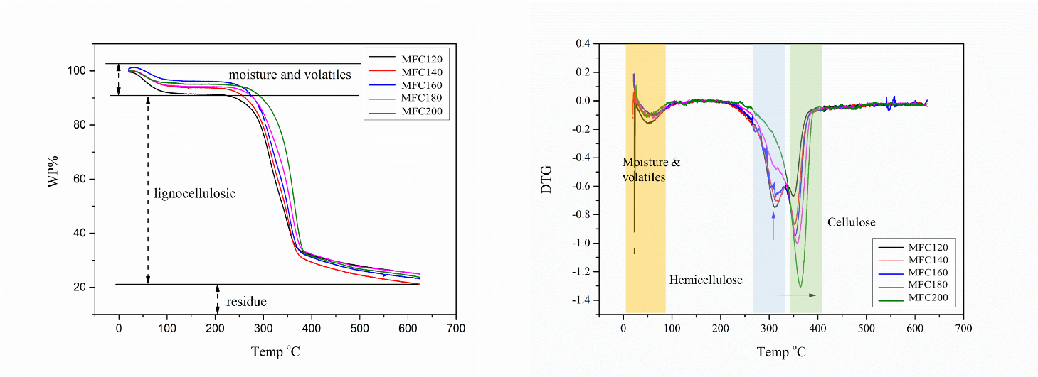
Figure 8. TGA thermograms (left) and DTG profiles (right) of MFC at different processing temperatures
The XRD patterns of ginger powder and MFC are presented in Figure 9. The peaks for crystalline cellulose were observed at 2θ: 16.5°, 22.5° and 34.5° corresponding to Miller Indices of 110, 200 and 004, respectively (Gong et al., 2017). With increasing MHT temperature, the peaks at 22.5° and 34.5° became more intense implying higher crystallinity. This is due to the gradual removal of hemicellulose and amorphous cellulose during the microwave treatment. The additional peaks at 15°, 24.3° and 30° are attributed to insoluble calcium salts (mostly CaC₂O₄) which exist in plant cell walls and vacuoles (de Melo et al., 2017; Synytsya et al., 2003).
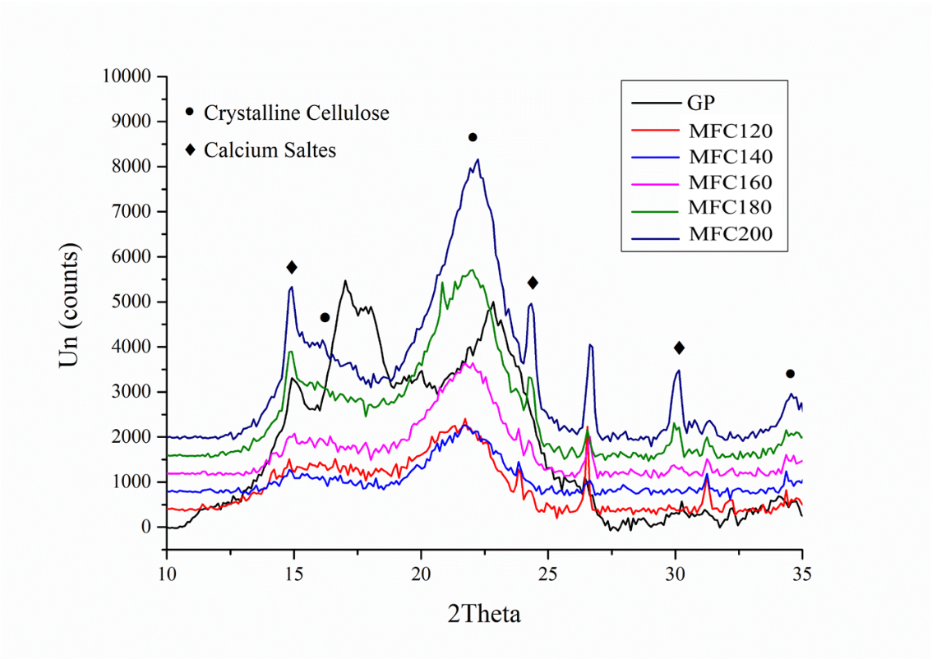
Figure 9. XRD diffractograms of MFC varying from 120 to 200 ºC. The cellulose peaks are shown in circular and calcium salts peaks are in red Planes.
The ATR-IR spectra shown in Figure 10 confirms that the cellulose is the main component of the product, with some residual hemicellulose or lignin as the impurities. The broad bands between 3600 cm⁻¹ and 3100 cm⁻¹ correspond to the hydroxyl moieties in the carbohydrate backbone, with the 2920 cm⁻¹ C-H stretch attributed to cellulose/hemicellulose (Azadfar et al., 2015). The absorption bands at about 1745 cm⁻¹ are attributed to the carbonyl groups which confirms the existence of lignin/hemicellulose in the biomass. With the increasing microwave temperature, the intensity of the C=O bands decrease, this is subsequently attributed to the removal of hemicellulose/lignin (Azadfar et al., 2015). The O-H bending vibration at 1635 cm⁻¹ is assigned to the bonded water which existing in the material. Finally, the sharp bands at about 1025 cm⁻¹ correspond to C–O and C-C stretching and confirm the presence of cellulose in resulting product from ginger residue.
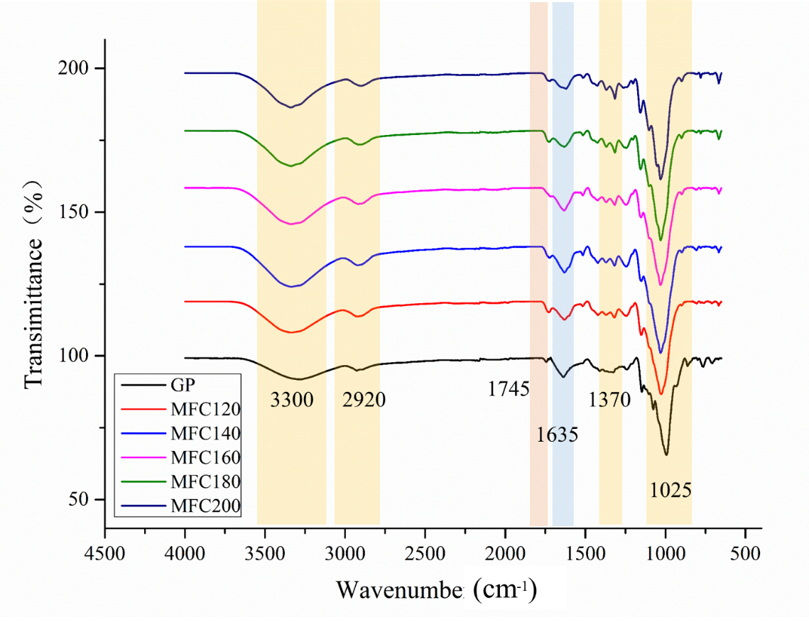
Figure 10. ATR-IR of MFC varying from 120 to 200 ºC.
TEM images successfully proved defibrillation of cellulose to MFC (Figure 11). Both microfibrils (width = 10-100 nm, length=0.5-10 μm ) and elementary fibrils (3–5 nm in width and a few μm in length) in amorphous and crystalline regions were displayed (Cheng et al., 2015; Zhu et al., 2014). Cellulose nanocrystals (width 5–70 nm and length <500 nm) were observed at 180 ºC and above. The formation of MFC and nanocrystals can be explained by the two step Hy-MASS (Hydrothermal Microwave-assisted Selective Scissoring) concept previously discussed (de Melo et al., 2017). Firstly, the non-cellulosic matter and amorphous parts of cellulose are selectively and progressively hydrolysed from the lignocellulosic matrix. Secondly, the softened amorphous cellulose and lignin which are embedded in MFC were released through the proton transfer mechanism (Budarin et al., 2010). Meanwhile, the residual amorphous matter can also be observed in TEM images (grey regions which surround the nanofibrils) (de Melo et al., 2017), and the grey regions seem to reduce with increasing temperature which corresponds to the gradual removal of amorphous cellulose. The dark grey regions may be pseudo-lignin which is defined “an aromatic material that yields a positive Klason lignin value that is not derived from native lignin” (Hu et al., 2012). As can be seen in Figure 8, the carbonyl band (~1745 cm⁻¹) re-emerges at temperature above 180 ºC indicative of pseudo-lignin from decomposition amorphous cellulose (Sannigrahi et al., 2011).
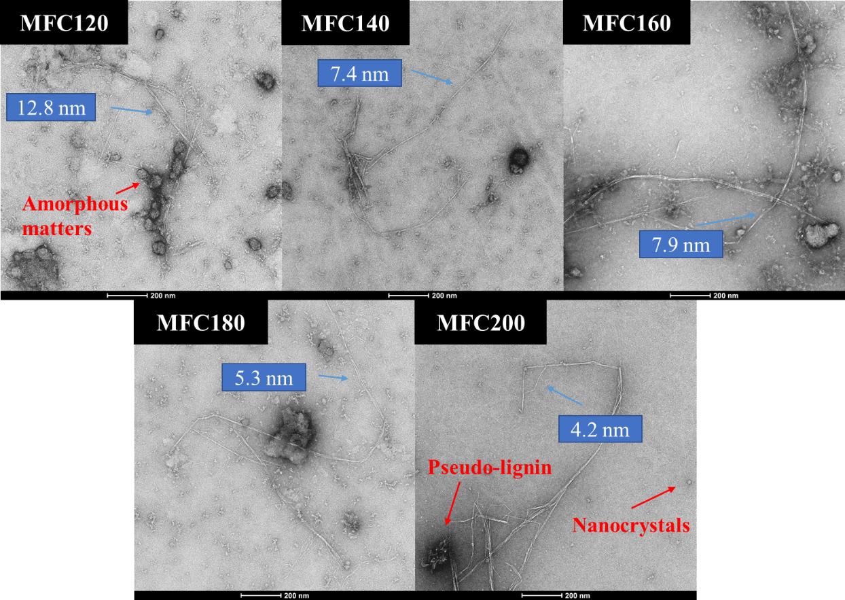
Figure 11. TEM images of MFC (120 to 200 ºC) (scale bar = 200 nm). The width of the MFC are labeled.
The water retention value (WRV) of MFC’s produced is presented in Figure 12. The raw ginger powder has a lower hydration capacity (2-3 g water per g) than the MFC products. It is well known that the insoluble cellulose can hold water by absorbing water in their fibril network through fibre swelling properties (de Melo et al., 2017). Smaller particle size and larger surface area would increase the WRV of cellulose (Gu et al., 2018). The hydrothermal microwave process reduces particle size, increases surface area of the material due to the removal of amorphous matter, thus improving hydration capacity. However, with increasing temperature, amorphous regions were removed and the crystalline cellulose holds less water due to the compact and strongly bonded (via hydrogen bonding) structure, resulting in the more hydrophobic cellulose (Dang et al., 2019).
Figure 12. WRV of defibrillated cellulose (g of water per g of dry sample) (N=2).
Thus, within the context of a spent ginger waste biorefinery microwave processing produces microfibrillated celluloses with improved water retention capacity compared to the virgin material. The ability to retain water makes for interesting applications such as hydrogels and/or biobased rheology modifiers for use in food and non-food applications (pharmaceuticals and cosmetics)(Ali & Ahmed, 2018; Caló & Khutoryanskiy, 2015).

3.3.2. Hydrolysate – starch characterisation
Interestingly, treatment of the hydrolysate with an equal volume of ethanol yielded in the formation of a white precipitate which was confirmed to be starch based on ¹³C CPMAS NMR evidence (See ESI, Figure S4). The starch yield with respect to microwave processing temperature is shown in Figure 13, which shows an initial increase, peaking at 140 ºC (48.6%) before slowly decreasing to 40.2% at 180 ºC, followed by a sharp decrease at 200 ºC (1.95%). It is well known that microwave-induced heating can lower the decomposition temperature of biopolymers such as cellulose, hemicellulose and starch by approximately 100 ºC. Thus, as the temperature increases starch is initially leached without any significant decomposition but at 200 ºC. Significant decomposition occurs which is also noted by the number and type of compounds detected by HPLC in the hydrolysate.
Figure 13. Starch yield (%) with respect to processing temperature (N=2).
The ¹³C CPMAS spectra (ESI, Figure S4) revealed characteristic signals for starch carbons (C1 to C6) in the range110 to 55 ppm (Zhang et al., 2014). The peaks at approximately 20 ppm may refer to acetyl groups present in some polysaccharides (Tai et al., 2017; Zhu et al., 2015). Interestingly, even with the increasing MHT temperature, the signals of starch did not change meaning that the starch retained its strcutural integrity.
The ATR-IR data also suggests that this precipitate is starch (see ESI, Figure S5). The common absorption bands of starch were displayed (Lomelí-Ramírez et al., 2014); the broad bands at about 3300 cm⁻¹ are attributed to O-H stretching vibration which referring to hydroxyl moieties in starch; the bands at 2930 cm⁻¹ and 1370 cm⁻¹ are related to C-H stretch, and the peaks located at 1640 cm⁻¹ may refer to bonded water which exists in biomass. Finally, the bands at 1150 cm⁻¹ and 1020 cm⁻¹ are associated with C-O or C-C stretching vibration in starch.
Thus, spent industrial ginger waste is also a source of starch. Close to 50% by weight of starch can recovered at 140 ºC with respect to dry input feedstock. Starch is a commodity chemical with multifarious applications.
3.3.3 Hydrolysates – sugar and small molecule characterisation
The HPLC analyses of the hydrolysate from hydrothermal microwave processing of ginger residues are summarised in Figure 14 a). In general, the yield of sugars (e.g. glucose, xylose) decreased with increasing microwave processing temperature whilst the concentration of levoglucosan, lactic acid, formic acid, acetic acid increased. 5-Hydroxymethylfurfural (HMF) and furfural were observed above 180 °C. Glucose and xylose were mainly derived from hydrolysis of amorphous cellulose and hemicellulose especially above180 °C. Glucose itself converted into HMF which was regarded as the major secondary byproduct from glucose degradation whilst xylose degraded into the furfural. Small molecule oragnic acids are the final products of biomass depolymerisation (Wu et al., 2015). The conversion pathways are summarised in Figure 14 b.
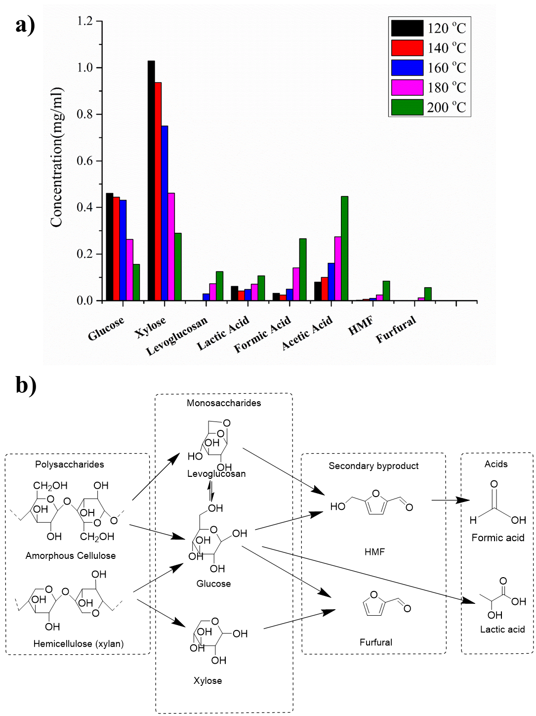
Figure 14. a) Products and sub products from lignocellulosic from ginger waste after MHT;b) conversion pathways to acids.

Thus, the hydrolysate is sugar-rich and rich in platform molecules such as lactic acid, formic acid, acetic acid and furanics. The latter can be further processed to interesting biobased specialty molecules, whereas, the former (providing free small molecule inhibitors) could be explored for their potential as a feedstock for industrial biotechnology.
3.4 Practical implications of this study
The drying process presents several issues – due to its high sugar and moisture content, ginger residues are prone to become a growth medium for bacteria if left undried. Unfortunately, hornification is a major problem in the defibrillation of cellulose. The drying process is one direct reason. In this study, the ginger powder was oven dried which leads to hornification. Thus other drying methods such as freeze-drying should be considered which are unfortunately more expensive. Economically and technically, the implications are that the drying process should ideally be carried out at source, i.e. where the material is generated. Such an implementation would enable the ginger residues to be dried instantly, therefore minimising the timeframe for bacterial growth to set in, and reduce the mass and volume of material to be transported elsewhere, thus reducing any subsequent costs.
On a more positive side, the chemicals used for processing (ethanol and CO₂) are recognized, industry-accepted, biobased solvents. They are both approved for use in food production, thereby negating any potential issues of processing both the ginger and residues in the same facility. The main techniques, chopping, microwave heating and supercritical extraction are also routinely used in the food industry, as is freeze drying (as proposed for the drying step). This therefore presents a feasible method for industrial application as the equipment is, for the most part, readily available. The only exception is the microwave heating as the main application in industry is to cook individual food items, rather than process material on a multi-kilogram scale.
However, the microwave technology has been demonstrated succesfully at pilot (20L) scale (Garcia-Garcia et al., 2019) and the microwave generators themselves are commercially available. The implication though is that the introduction of such a processing step would require the construction of a bespoke equipment setup, rather than an ‘off-the-shelf’ item. As such, this would likely present the biggest obstacle in terms of Technology Readiness Level and cost to commercialisation. Planned future work includes trialling this methodology on pilot scale equipment and carrying out more material testing on the products at gram level applications.

- Conclusions
Spent industrial ginger waste is a potential feedstock for biobased chemicals, materials and (bio)energy elicited via extraction, microwave pyrolysis and hydrothermal microwave processing. The products and technologies used prove the feasibility of the conceptual model described in Figure 1 and enable resource recovery.
The essential oils recovered comprise known key molecules present in commercial ginger oil, which, depending on the quality/grade of oil and its intended application, can range from £100 to £500/kg in value. Although, the ratio of O/C and H/C in the chars is still relatively high, it could further be reduced at higher temperature through more complete pyrolysis, indicating that ginger waste can be a potential feedstock for biochar production and bioenergy. Hydrochars have useful properties including a porous structure, high specific surface area, and abundant functional groups (Cha et al., 2016), for potential applications as soil amendment agents (Yuan et al., 2011), water/air adsorbents (Lee et al., 2016; Shan et al., 2019), catalysts (Dai et al., 2019), and as an energy source (Al Afif et al., 2020). Pyrolysis oils (bio-oils) produced are rich in both aliphatic and also biobased platform molecules (which are both aliphatic and aromatic). Furanics are interesting as a source of biobased platform molecules for conversion into further molecules of industrial interest such as 5-hydroxymethyl furfural, itaconic acid, furan-2-, 5-dicarboxylic acid. Hydrothermal microwave processing, a technology that provides rapid volumetric heating compared to conventional heating (Budarin et al., 2019; Zhang et al., 2017), produces microfibrillated celluloses with improved water retention capacity compared to the virgin material. These materials mimic conventional nanocellulose which is produced via intensive chemical and physical processing of wood pulp. Meanwhile, according to a previous study, depending on reaction time and temperature, the energy cost during the process at lab-scale (£10–50/kg MFC) was proved to be ca. 50–30% more efficient than conventional hydrothermal treatment (£19–79/kg MFC) (de Melo et al., 2017), indicating that the microwave technique is technically and economically feasible.
The ability to retain water makes for interesting applications such as hydrogels and/or biobased rheology modifiers for use in food and non-food applications (pharmaceuticals and cosmetics). Starch and sugars are also produced. The former has multifarious applications whilst the latter can be used as a feedstock in industrial biotechnology applications for downstream specialty biobased products.
In conclusion, as the global production of ginger increases for specific applications such as ginger oil extraction for flavours, fragrances and medicinal applications, then the volume of spent industrial waste will increase commensurately. This waste (resource) is significant by weight and alternatives to dumping, burning or use as cheap animal feed through chemical valorisation is an exciting proposition.

Corresponding Author
Dr Avtar Matharu, Green Chemistry Centre of Excellence, Department of Chemistry, University of York, York, YO10 5DD, avtar.matharu@york.ac.uk.
Author Contributions
The manuscript was written through contributions of all authors. All authors have given approval to the final version of the manuscript.
Competing Interests
The authors declare no competing interests.
ACKNOWLEDGMENT
We would like to thank Dr Meg Stark at the Imaging and Cytometry Lab, Bioscience Technology Facility, University of York for carrying out TEM imaging and Dr Graeme McAllister for carrying out CHN analysis. ASM acknowledges the Indonesian Government for LPDP scholarship to allow AS for PhD and EPSRC (Whole systems understanding of unavoidable food supply chain wastes for re-nutrition EP/P008771/1) for funding TD for Postdoctoral study.
ABBREVIATIONS
MFC, Microfibrillated Cellulose; MHT, Microwave Hydrothermal Treatment; MW, Microwave
References
Ahmed Khan, T., Kim, H.J., Gupta, A., Jamari, S.S., Jose, R. 2019. Synthesis and characterization of carbon microspheres from rubber wood by hydrothermal carbonization. Journal of Chemical Technology & Biotechnology, 94(5), 1374-1383.10.1002/jctb.5867
Al Afif, R., Anayah, S.S., Pfeifer, C. 2020. Batch pyrolysis of cotton stalks for evaluation of biochar energy potential. Renewable Energy, 147, 2250-2258.10.1016/j.renene.2019.09.146
Ali, A., Ahmed, S. 2018. Recent advances in edible polymer based hydrogels as a sustainable alternative to conventional polymers. Journal of agricultural and food chemistry, 66(27), 6940-6967.10.1021/acs.jafc.8b01052
Aly, M.M., El Sawy, A., El Gendy, R.A. 2019. Comparative study of different shading types on growth and yield of ginger plants. Middle East J, 8(4), 1264-1270.10.36632/mejar/2019.8.4.28
Azadfar, M., Gao, A.H., Bule, M.V., Chen, S. 2015. Structural characterization of lignin: A potential source of antioxidants guaiacol and 4-vinylguaiacol. International journal of biological macromolecules, 75, 58-66.10.1016/j.ijbiomac.2014.12.049
Brewer, C.E. 2012. Biochar characterization and engineering.
Budarin, V.L., Clark, J.H., Lanigan, B.A., Shuttleworth, P., Macquarrie, D.J. 2010. Microwave assisted decomposition of cellulose: a new thermochemical route for biomass exploitation. Bioresource technology, 101(10), 3776-3779.10.1016/j.biortech.2009.12.110
Budarin, V.L., Matharu, A.S., Clark, J.H., Remón, J. 2019. New insights into the use of microwave technology for the hydrothermal valorisation of biomass: microwave-assisted liquefaction, decomposition and fractionation reactions. Boletín del Grupo Español del Carbón(52), 8-13
Caló, E., Khutoryanskiy, V.V. 2015. Biomedical applications of hydrogels: A review of patents and commercial products. European Polymer Journal, 65, 252-267.10.1016/j.eurpolymj.2014.11.024
Cha, J.S., Park, S.H., Jung, S.-C., Ryu, C., Jeon, J.-K., Shin, M.-C., Park, Y.-K. 2016. Production and utilization of biochar: A review. Journal of Industrial and Engineering Chemistry, 40, 1-15.10.1016/j.jiec.2016.06.002
Chen, N., Zhu, J., Tong, Z. 2016. Fabrication of microfibrillated cellulose gel from waste pulp sludge via mild maceration combined with mechanical shearing. Cellulose, 23(4), 2573-2583.10.1007/s10570-016-0959-1
Cheng, G., Zhang, X., Simmons, B., Singh, S. 2015. Theory, practice and prospects of X-ray and neutron scattering for lignocellulosic biomass characterization: towards understanding biomass pretreatment. Energy & Environmental Science, 8(2), 436-455.10.1039/C4EE03147D
Clark, J.H. 2019. Green biorefinery technologies based on waste biomass. Green Chemistry, 21(6), 1168-1170.10.1039/C9GC90021G
Dai, L., Zeng, Z., Tian, X., Jiang, L., Yu, Z., Wu, Q., Wang, Y., Liu, Y., Ruan, R. 2019. Microwave-assisted catalytic pyrolysis of torrefied corn cob for phenol-rich bio-oil production over Fe modified bio-char catalyst. Journal of Analytical and Applied Pyrolysis, 143, 104691.10.1016/j.jaap.2019.104691
Dang, X., Liu, P., Yang, M., Deng, H., Shan, Z., Zhen, W. 2019. Production and characterization of dialdehyde cellulose through green and sustainable approach. Cellulose, 26(18), 9503-9515.doi.org/10.1007/s10570-019-02747-9
de Melo, E.M., Clark, J.H., Matharu, A.S. 2017. The Hy-MASS concept: hydrothermal microwave assisted selective scissoring of cellulose for in situ production of (meso)porous nanocellulose fibrils and crystals. Green Chemistry, 19(14), 3408-3417.10.1039/c7gc01378g
Dieguez-Alonso, A., Funke, A., Anca-Couce, A., Rombolà, A.G., Ojeda, G., Bachmann, J., Behrendt, F. 2018. Towards biochar and hydrochar engineering—influence of process conditions on surface physical and chemical properties, thermal stability, nutrient availability, toxicity and wettability. Energies, 11(3), 496.10.3390/en11030496
Eltazi, S.M. 2014. Effect of using ginger powder as natural feed additive on performance and carcass quality of broiler chicks. Assiut Vet. Med. J, 60(141), 87-95
Fang, J., Zhan, L., Ok, Y.S., Gao, B. 2018. Minireview of potential applications of hydrochar derived from hydrothermal carbonization of biomass. Journal of Industrial and Engineering Chemistry, 57, 15-21.10.1016/j.jiec.2017.08.026
Gao, Y., Xia, H., Sulaeman, A., de Melo, E.M., Dugmore, T.I.J., Matharu, A.S. 2019. Defibrillated celluloses via dual twin-screw extrusion and microwave hydrothermal treatment (MHT) of spent pea biomass. ACS Sustainable Chemistry & Engineering.10.1021/acssuschemeng.9b02440
Garcia-Garcia, G., Rahimifard, S., Matharu, A.S., Dugmore, T.I. 2019. Life-cycle assessment of microwave-assisted pectin extraction at pilot scale. ACS Sustainable Chemistry & Engineering, 7(5), 5167-5175.10.1021/acssuschemeng.8b06052
Ghalibaf, M., Doddapaneni, T.R.K.C., Alén, R. 2019. Pyrolytic behavior of lignocellulosic-based polysaccharides. Journal of Thermal Analysis and Calorimetry, 137(1), 121-131.10.1007%2Fs10973-018-7919-y
Ghani, W.A.W.A.K., Mohd, A., da Silva, G., Bachmann, R.T., Taufiq-Yap, Y.H., Rashid, U., Ala’a, H. 2013. Biochar production from waste rubber-wood-sawdust and its potential use in C sequestration: chemical and physical characterization. Industrial Crops and Products, 44, 18-24.10.1016/j.indcrop.2012.10.017
Gong, J., Li, J., Xu, J., Xiang, Z., Mo, L. 2017. Research on cellulose nanocrystals produced from cellulose sources with various polymorphs. RSC advances, 7(53), 33486-33493.10.1039/C7RA06222B
Gu, F., Wang, W., Cai, Z., Xue, F., Jin, Y., Zhu, J.Y. 2018. Water retention value for characterizing fibrillation degree of cellulosic fibers at micro and nanometer scales. Cellulose, 25(5), 2861-2871.10.1007/s10570-018-1765-8
Hu, F., Jung, S., Ragauskas, A. 2012. Pseudo-lignin formation and its impact on enzymatic hydrolysis. Bioresource technology, 117, 7-12.10.1016/j.biortech.2012.04.037
Kappe, C.O. 2004. Controlled microwave heating in modern organic synthesis. Angewandte Chemie International Edition, 43(46), 6250-6284.10.1002/anie.200400655
Khanjani, P., Kosonen, H., Ristolainen, M., Virtanen, P., Vuorinen, T. 2019. Interaction of divalent cations with carboxylate group in TEMPO-oxidized microfibrillated cellulose systems. Cellulose, 26(8), 4841-4851.10.1007/s10570-019-02417-w
Konar, E.M., Harde, S.M., Kagliwal, L.D., Singhal, R.S. 2013. Value-added bioethanol from spent ginger obtained after oleoresin extraction. Industrial crops and products, 42, 299-307
Kou, X., Ke, Y., Wang, X., Rahman, M.R.T., Xie, Y., Chen, S., Wang, H. 2018. Simultaneous extraction of hydrophobic and hydrophilic bioactive compounds from ginger (Zingiber officinale Roscoe). Food chemistry, 257, 223-229.10.1016/j.foodchem.2018.02.125
Kucherov, F.A., Romashov, L.V., Galkin, K.I., Ananikov, V.P. 2018. Chemical transformations of biomass-derived C6-furanic platform chemicals for sustainable energy research, materials science, and synthetic building blocks. ACS Sustainable Chemistry & Engineering, 6(7), 8064-8092.10.1021/acssuschemeng.8b00971
Kumar, R., Ahmad, R. 2011. Biosorption of hazardous crystal violet dye from aqueous solution onto treated ginger waste (TGW). Desalination, 265(1-3), 112-118.10.1016/j.desal.2010.07.040
Lai, Y.-S., Lee, W.-C., Lin, Y.-E., Ho, C.-T., Lu, K.-H., Lin, S.-H., Panyod, S., Chu, Y.-L., Sheen, L.-Y. 2016. Ginger essential oil ameliorates hepatic injury and lipid accumulation in high fat diet-induced nonalcoholic fatty liver disease. Journal of agricultural and food chemistry, 64(10), 2062-2071.10.1021/acs.jafc.5b06159
Lee, H., Park, R.-s., Lee, H.W., Hong, Y., Lee, Y., Park, S.H., Jung, S.-C., Yoo, K.-S., Jeon, J.-K., Park, Y.-K. 2016. Adsorptive removal of atmospheric pollutants over Pyropia tenera chars. Carbon Letters (Carbon Lett.), 19, 79-88.10.5714/CL.2016.19.079
Lengowski, E.C., Magalhães, W.L.E., Nisgoski, S., de Muniz, G.I.B., Satyanarayana, K.G., Lazzarotto, M. 2016. New and improved method of investigation using thermal tools for characterization of cellulose from eucalypts pulp. Thermochimica Acta, 638, 44-51.10.1016/j.tca.2016.06.010
Lomelí-Ramírez, M.G., Barrios-Guzmán, A.J., García-Enriquez, S., de Jesús Rivera-Prado, J., Manríquez-González, R. 2014. Chemical and mechanical evaluation of bio-composites based on thermoplastic starch and wood particles prepared by thermal compression. BioResources, 9(2), 2960-2974
Luque, R., Menendez, J.A., Arenillas, A., Cot, J. 2012. Microwave-assisted pyrolysis of biomass feedstocks: the way forward? Energy & Environmental Science, 5(2), 5481-5488.10.1039/C1EE02450G
Makanjuola, S.A. 2017. Influence of particle size and extraction solvent on antioxidant properties of extracts of tea, ginger, and tea–ginger blend. Food science & nutrition, 5(6), 1179-1185.10.1002/fsn3.509
Matharu, A.S., Houghton, J.A., Lucas-Torres, C., Moreno, A. 2016. Acid-free microwave-assisted hydrothermal extraction of pectin and porous cellulose from mango peel waste–towards a zero waste mango biorefinery. Green Chemistry, 18(19), 5280-5287.10.1039/C6GC01178K
Mekonnen, T., Mussone, P., Khalil, H., Bressler, D. 2013. Progress in bio-based plastics and plasticizing modifications. Journal of Materials Chemistry A, 1(43), 13379-13398.10.1039/c3ta12555f
Munda, S., Dutta, S., Haldar, S., Lal, M. 2018. Chemical analysis and therapeutic uses of ginger (Zingiber officinale Rosc.) Essential Oil: A Review. Journal of essential oil bearing plants, 21(4), 994-1002.10.1080/0972060X.2018.1524794
Oliaei, E., Lindén, P.A., Wu, Q., Berthold, F., Berglund, L., Lindström, T. 2020. Microfibrillated lignocellulose (MFLC) and nanopaper films from unbleached kraft softwood pulp. Cellulose, 27(4), 2325-2341.10.1007/s10570-019-02934-8
Omage, J., Onimisi, P., Adegbite, E., Agunbiade, M. 2007. The effect of ginger (Zingiber officinale Roscoe) waste meal on growth performance, carcass characteristics, serum lipid and serum cholesterol profiles of rabbit. Pakistan Journal of Nutrition, 6(4), 359-362.10.3923/pjn.2007.359.362
Osong, S.H., Norgren, S., Engstrand, P. 2016. Processing of wood-based microfibrillated cellulose and nanofibrillated cellulose, and applications relating to papermaking: a review. Cellulose, 23(1), 93-123.10.1007/s10570-015-0798-5
Palatty, P.L., Haniadka, R., Valder, B., Arora, R., Baliga, M.S. 2013. Ginger in the prevention of nausea and vomiting: a review. Crit Rev Food Sci Nutr, 53(7), 659-69.10.1080/10408398.2011.553751
Qambrani, N.A., Rahman, M.M., Won, S., Shim, S., Ra, C. 2017. Biochar properties and eco-friendly applications for climate change mitigation, waste management, and wastewater treatment: A review. Renewable and Sustainable Energy Reviews, 79, 255-273.10.1016/j.rser.2017.05.057
Sadaka, S., Sharara, M.A., Ashworth, A., Keyser, P., Allen, F., Wright, A. 2014. Characterization of biochar from switchgrass carbonization. Energies, 7(2), 548-567.10.3390/en7020548
Sannigrahi, P., Kim, D.H., Jung, S., Ragauskas, A. 2011. Pseudo-lignin and pretreatment chemistry. Energy & Environmental Science, 4(4), 1306-1310
Saygideger, S., Gulnaz, O., Istifli, E.S., Yucel, N. 2005. Adsorption of Cd (II), Cu (II) and Ni (II) ions by Lemna minor L.: effect of physicochemical environment. Journal of Hazardous Materials, 126(1-3), 96-104.10.1016/j.jhazmat.2005.06.012
Shahrajabian, M.H., Sun, W., Cheng, Q. 2019. Clinical aspects and health benefits of ginger (Zingiber officinale) in both traditional Chinese medicine and modern industry. Acta Agriculturae Scandinavica, Section B—Soil & Plant Science, 69(6), 546-556.10.1080/09064710.2019.1606930
Shan, Y., Yang, W., Li, Y., Liu, Y., Pan, J. 2019. Preparation of microwave-activated magnetic bio-char adsorbent and study on removal of elemental mercury from flue gas. Science of The Total Environment, 697, 134049.10.1016/j.scitotenv.2019.134049
Shankar, S., Rhim, J.-W. 2016. Preparation of nanocellulose from micro-crystalline cellulose: The effect on the performance and properties of agar-based composite films. Carbohydrate polymers, 135, 18-26
Synytsya, A., Copikova, J., Brus, J. 2003. 13C CP/MAS NMR spectra of pectins: A peak-fitting analysis in the C-6 region. Czech Journal of Food Sciences-UZPI (Czech Republic)
Tai, H.-C., Li, G.-C., Huang, S.-J., Jhu, C.-R., Chung, J.-H., Wang, B.Y., Hsu, C.-S., Brandmair, B., Chung, D.-T., Chen, H.M. 2017. Chemical distinctions between Stradivari’s maple and modern tonewood. Proceedings of the National Academy of Sciences, 114(1), 27-32.10.1073/pnas.1611253114
Verma, S., Baig, R.N., Nadagouda, M.N., Len, C., Varma, R.S. 2017. Sustainable pathway to furanics from biomass via heterogeneous organo-catalysis. Green Chemistry, 19(1), 164-168.10.1039/C6GC02551J
Wang, C., Wang, Y., Herath, H. 2017. Polycyclic aromatic hydrocarbons (PAHs) in biochar–Their formation, occurrence and analysis: A review. Organic Geochemistry, 114, 1-11.10.1016/j.orggeochem.2017.09.001
Wang, T., Zhai, Y., Zhu, Y., Li, C., Zeng, G. 2018. A review of the hydrothermal carbonization of biomass waste for hydrochar formation: Process conditions, fundamentals, and physicochemical properties. Renewable and Sustainable Energy Reviews, 90, 223-247.10.1016/j.rser.2018.03.071
Wiastuti, T., Khasanah, L., Kawiji, W.A., Manuhara, G., Utami, R. 2016. Characterization of active paper packaging incorporated with ginger pulp oleoresin. IOP Conference Series: Materials Science and Engineering. IOP Publishing. pp. 012057.
Wu, Q.-Q., Ma, Y.-L., Chang, X., Sun, Y.-G. 2015. Optimization and kinetic analysis on the sulfuric acid–Catalyzed depolymerization of wheat straw. Carbohydrate polymers, 129, 79-86.10.1016/j.carbpol.2015.04.053
Xia, H., Houghton, J.A., Clark, J.H., Matharu, A.S. 2016. Potential utilization of unavoidable food supply chain wastes–valorization of pea vine wastes. ACS Sustainable Chemistry & Engineering, 4(11), 6002-6009.10.1021/acssuschemeng.6b01297
Xiong, J.-b., Pan, Z.-q., Xiao, X.-f., Huang, H.-j., Lai, F.-y., Wang, J.-x., Chen, S.-w. 2019. Study on the hydrothermal carbonization of swine manure: The effect of process parameters on the yield/properties of hydrochar and process water. Journal of Analytical and Applied Pyrolysis, 144, 104692
Ye, D., Lei, X., Li, T., Cheng, Q., Chang, C., Hu, L., Zhang, L. 2019. Ultrahigh tough, super clear, and highly anisotropic nanofiber-structured regenerated cellulose films. ACS nano, 13(4), 4843-4853.10.1021/acsnano.9b02081
Yuan, J.-h., Xu, R.-k., Wang, N., Li, J.-y. 2011. Amendment of acid soils with crop residues and biochars. Pedosphere, 21(3), 302-308.10.1016/S1002-0160(11)60130-6
Zambon, I., Colosimo, F., Monarca, D., Cecchini, M., Gallucci, F., Proto, A.R., Lord, R., Colantoni, A. 2016. An innovative agro-forestry supply chain for residual biomass: Physicochemical characterisation of biochar from olive and hazelnut pellets. Energies, 9(7), 526.doi.org/10.3390/en9070526
Zhang, Y., Chen, P., Liu, S., Peng, P., Min, M., Cheng, Y., Anderson, E., Zhou, N., Fan, L., Liu, C. 2017. Effects of feedstock characteristics on microwave-assisted pyrolysis–a review. Bioresource technology, 230, 143-151.10.1016/j.biortech.2017.01.046
Zhang, Y., Deng, Q., Wang, M., Zhang, J., Man, Y.B., Shan, S., Wu, S., Liang, P., Cao, Y., Song, C. 2018. Role of phosphoric acid in the bioavailability of potentially toxic elements in hydrochars produced by hydrothermal carbonisation of sewage sludge. Waste Management, 79, 232-239.10.1016/j.wasman.2018.07.045
Zhang, Z., Macquarrie, D.J., Clark, J.H., Matharu, A.S. 2014. Chemical modification of starch and the application of expanded starch and its esters in hot melt adhesive. RSC Adv., 4(79), 41947-41955.10.1039/c4ra08027k
Zheng, X., Zhang, Q., Liu, J., Pei, Y., Tang, K. 2016. A unique high mechanical strength dialdehyde microfibrillated cellulose/gelatin composite hydrogel with a giant network structure. RSC advances, 6(76), 71999-72007.10.1039/C6RA12517D
Zhu, G., Yang, L., Gao, Y., Xu, J., Chen, H., Zhu, Y., Wang, Y., Liao, C., Lu, C., Zhu, C. 2019. Characterization and pelletization of cotton stalk hydrochar from HTC and combustion kinetics of hydrochar pellets by TGA. Fuel, 244, 479-491.10.1016/j.fuel.2019.02.039
Zhu, H., Fang, Z., Preston, C., Li, Y., Hu, L. 2014. Transparent paper: fabrications, properties, and device applications. Energy & Environmental Science, 7(1), 269-287.10.1039/C3EE43024C
Zhu, W., Westman, G., Theliander, H. 2015. The molecular properties and carbohydrate content of lignins precipitated from black liquor. Holzforschung, 69(2), 143-152.10.1515/hf-2014-0062

