WELFARE-AS-FREEDOM, THE HUMAN ECONOMY AND VARIETIES OF CAPITALIST STATE

Louise Haagh, University of York, UK

Abstract: This contribution advocates a political economy perspective on systems of well-being. I argue deeper regulatory features of human economy give rise to common institutions in areas such as education, work and care, and that the constraints this imposes on governance explains how a more egalitarian form of public sector development is a key factor in gender equality, control of core human activities, and forms of time. A systems approach to well-being critically engages freedom-focussed perspectives on welfare and the proposal for a Universal Basic Income (UBI), which has received public traction since 2016. Identifying the systemic foundations for wellbeing as control within core human activities and social relations suggests UBI should be seen as an important but insufficient element of systems of well-being. To depict patterns of continuity and change, this chapter compares a set of OECD cross-country data, with particular attention to hierarchical-competitive and developmental-horizontal Anglo-liberal and Nordic trajectories.

Keywords: Control of time, systems of well-being, institutionalist political economy, universal basic income, welfare states

JEL Classification: B, I, P (History of Eocnomic Throught, Methodology, and Heterodox Approaches; Health Education and Well-Being; Economic Systems)

- Introduction

Welfare studies have been enriched in recent decades by critical normative perspectives that argue for a freedom-focussed design of welfare institutions. A key objective of the Welfare-As-Freedom (WAF) literature has been to forefront personal choice within economic and social organisation. Whilst agreeing with this objective, I argue that a too singular perspective on individual governance can set the reality of institutional constraints on personal control too much aside. Also whilst the WAF literature has tended to focus on reshaping post-war welfare institutions towards a more simple pre-distributive form, I use freedom-orientation as an opportunity to re-assess the foundation and functions of welfare systems from a multi-level institutional and well-being perspective. Indeed, I argue that a focus on life style choice gives an unrealistic representation of the scope for personal control, and overdraws the connection between choice and well-being. Instead, acknowledging the reality of institutions leads to a focus on their design from the perspective of impacts on states of well-being, which filter the real extent and quality of choices people enjoy.

Focussing on the framing of everyday activities and social relations offers an avenue for redrawing both the characterisation and explanation of key differences between familiar welfare state varieties, and clearing up prevailing misconceptions about them. Along with much standard economic analysis, WAF scholars tend to assume more encompassing welfare states exert more direct control over persons because social organisation is formalised, whereas greater personal and political freedom require more simple forms of social protection and less regulation. Taking a different direction, I argue that examining developmental dimensions of freedom that can be linked with states of well-being is the basis for a more broadly informative characterisation of welfare state evolution and function. Building on insights from the human development approach (HDA), institutionalist political economy, and the systems varieties literature (SVL), I develop a systems approach to well-being, and identify ways the form of public sector development is a factor in both system function (coherence) and social foundations for well-being (transcendence). More specifically, I deepen the focus of these literatures with reference to the impact, which what I call the human economy (HE) exerts on governance, by setting out the shape of key cooperative problems.

I argue key forms of control of time and social relations have a basis in complex mutual effects between institutions that arise from the way human activities are patterned, so that the more or less egalitarian and developmental bases on which relations are structured, shapes links between institutions. We have reason to assume that in societies in which formal cooperation around core human activities is more developed at the level of systems, the form of institutions is more likely to involve an orientation to promote developmental forms of control (HE responsiveness). In turn, important historical factors in HE responsiveness include the level of social equality underpinning modern state formation, combined with the degree of embedding of social cooperation in public sector development.

On this basis, this contribution proceeds as follows. I first discuss how my approach challenges freedom-focussed inquiry at a methodological level. Responding, next, I consider how an independent view of the nature of the human economy aids understanding of developmental aspects of freedom and of the role of embedding of cooperation in institutional development. Third, I discuss in more detail how systemic support of human development and related freedoms can be examined in terms of public sector development and systems of public finance in advanced capitalist states, focussing especially on the cooperative structure of public finance, developmental policies, and systems of education, care, and the incorporation of women. Fourth, I compare OECD capitalist states along these lines, honing in on the UK and Denmark. Fifth, I set this discussion in relation to specific aspects of HE responsiveness and control of time. Sixth, I discuss implications for contextual and polemical features of the case for UBI as a response to rising insecurity and support of personal control under globalisation. Last, I summarise and conclude.

2. Comparative Capitalism and Human Development

2.1 Welfare as freedom and liberal neutrality

An emerging WAF literature, deriving from Liberal Egalitarian Thought (LET) and the Human Development Literature (HDL), challenges the study of welfare states. This literature draws attention to everyday forms of control of our lives - e.g. of activities like leisure, work and care (van Parijs, 1995; Goodin, 2001,2008; Standing, 2002), and human reasons for acting, being and doing (Sen, 1998; Nussbaum, 2006; Alkire, 2002). Whilst this promises to provide a constructive input into policy debate by revealing the value of individuals’ real or active ends (‘real’ freedom, van Parijs – henceforth VP, 1995), the WAF has tended to overlook the extent to which opportunity for valuable developmental forms of freedom is socially patterned.

First, my account challenges libertarian-inspired approaches in LET (LALET) that prioritise transactional aspects of control of life style and predistributive justice on assuming that regulatory approaches to social and institutional development devalue freedom. Prioritising the frame around production has been Anglo-liberal practice, e.g. as Beveridge (1942, p. 121), architect of the British welfare state, aimed welfare at supporting the poor. Even as parts of Rawls’ later (1971, p. 376, pp. 409-417) influential work extolled the role of fellowship, in heed of Nozick’s (1974, pp. 183-97) critique of society, approaches in LALET have tended to link persons’ control of the structure of their lives with their direct control of resources (Dworkin, 1981; van Parijsm, 1995; discussed in Williams, 2008, pp. 499-500). Informed by a shared ideal of neutrality concerning institutions’ form, differences have centred on the principle that should regulate the distributive frame. In Rawls (1971, pp. 65-72) this entails favouring the least well-off; in Dworkin (1981, pp. 304-5) promotion of equal resources or preference-led insurance (Dworkin, 2000, pp. 70-71, pp. 331-40); and in VP (1995, p. 245, n.18, following Meade, 1964, p. 1989) emphasis on life time basic security, as distinct from (eschewing) more complex organisation and common services. In short, LALET is given to underestimate the collective nature of economic development to make the case for individual property or ‘predistribution’ (PD); a position often bolstered by the idea (in Meade, 1964, pp. 25-6; and recently, The Economist, 2014, November) that automation spells an end to the social nature of production. This points to the salience of feminist critiques of how these approaches (empirically) ignore the reality of social relations (Anderson 1999, pp. 297-300, p. 311; Young, 1990, pp. 29-33, pp. 120-1) and gender bias of neo-classical economies (Elson, 2014, p. 191; Pearson, 2014) in favour of a focus on personal control and choice. However, further to this, I explore how examining the relation between institutions and personal control entails placing feminists' insights within a broader idea of how a human economy shapes common institutions and informs cooperative interests that humans in general have.

Dworkin’s (2000, pp. 258-260) reasoning concerning ways true freedom (ethical integrity) relies on a person herself defining what constitutes her life’s limits or challenges illustrates the problem at hand. Generic HE features, e.g. our orientation to learn, life-cycle biology and dependence on social ties, do not appear in this account; but their attributes (talent, physical powers, friendships and associations (Dworkin, op. cit., p. 260) are listed on a par with specific social arrangements (wealth, technology, culture, being American, pp. 260-1). The way Dworkin (2000) thereby fails to distinguish integrity (life style) challenges that are linked with deeper developmental constraints, reveals how prioritising social neutrality narrows the problems of freedom and just institutions to how to adjust for particular innate handicaps and talents (see, also, Dworkin, 1981; VP, pp. 68-70, p. 241, n. 49). In turn, this obscures how opportunity for autonomy in the generic form of developing mental powers ('choosing for one's own reasons', Dworkin, 1988, pp. 13-18, n. 19-20) is a basis for discovering and developing talents in everyone. The structure of this opportunity not only is informed by wider cooperative practices, but also arguably shapes the whole opportunity structure for all, for example as in education systems, separating or not children by means or ability affects other levels of funding (e.g. of diverse occupational choices; section 4), and the scope for allocation of talent predominating over de-selection of ability in a context of narrow competition.

In another example, we can imagine a woman accepting the job market is much of a challenge, thus making instead her home (and her limits) a positive factor in her life. However, this only illustrates again how the existence of a human economy (e.g. parenting representing the regularity of care) positions individuals between two logics – as not free (in this case) to make choices unless HE features are recognized. In short, a paradoxical aspect of the focus on life style is how features of the human economy that create dependence on others, directly and remotely, entail that HE choices are more socially constrained for the same reason as they are of the highest integrity value. Therefore, embedding cooperation in more complex forms of shared security matters for freedom because transforming social relations away from patterns of domination or isolation toward mutual regard is at the root of expanding core forms of personal control.

In this context, the key problem is then how informational limits about the stuff of human development imposed by the post-libertarian project produces oversimplified welfare proposals on account, in part, of how it misinforms analysis of welfare states. To exemplify, VP (1995) pits his proposal for a universal ‘Basic Income’ (BI) for life – aimed to secure choice of alternative life styles, against “welfarist or outcome-oriented” (n. 30, p. 248) projects. Specifically, he links the egalitarian-seeking aim of social democracy with “the freedom to consume” (VP, op. cit., p. 33). This indicates VP does not recognize human development as a motive rooted in Nordic states’ public institutions and as a source of the kind of post-materialist values linked with voluntary activity and leisure (evidenced as strong in Nordic states in Inglehart et. al., 2001, p. 7, pp. 15-17) that his analysis prioritises, and he imagines are linked with a move to individualise resource distribution. VP (1995, p. 242) appeals to the concern (expressed in Rawls’, 1988, pp. 252-3; 1993, p. 13; 2001, p. 52, p. 60) that public policy should remain neutral on matters of the good life (anti-perfectionism, p. 28, p. 255).

I argue that discounting developmental freedoms in this way involves a methodological mistake given how both VP (1995) and Rawls (1988, 2001) recognize developmental interests humans have. So, Rawls (1971, p. 274) aims to protect against the transactional outcomes of human frailty (differences of talent and energy), and recognizes human rationality as developmental (the Aristotelian principle, pp. 372-376). Yet with reference to the immoral nature of markets (p. 274), and stressing monetary incentives to train and work, he abandons this developmental account in his analysis of economic relations. Similarly, social protection is VP’s (1995, p. 46) rationale for wanting the Basic Income (BI) grant to be paid in a regular form (as distinct from as a one-off grant). However, in depicting Labour Markets (LMs) as transactions of inherent talent (VP, op. cit., 121), he sets aside how talent is developed in education and jobs. For example, in linking our scope to be crazy (leisure) to our opportunity to leave jobs – VP (1995) makes leisure a wholesale life-style choice. Yet I argue the patterned reality of the human economy makes the realisation and wider freedom effects of PD policies highly dependent on the pattern of cooperation in general. On that basis, tendencies in WAF to see the informal as a source of control (e.g. of care and work in Standing, 2002, pp. 269-272), to dichotomize the formal- informal (being work-crazy or leisure-lazy, VP, 1995, pp. 89-96, p. 122), to link control with unstructured time (Goodin, 2001; Goodin et al., 2008). Or viewing protection outside the mainframe of production as a source of protection for women (VP, 2001, pp. 19-20; Alstott, 2001, p. 77) – as distinct from emphasizing institutional sources of equal standing of women - all risk recreating the explanatory problems of Dworkin’s (1981) account.

Another way to proceed – and bring the concern in WAF with control of human activities to bear on welfare analysis - is to think that control of time and activities matters not on grounds of being unaffected by institutions, but in reference to developmental features of being human. In this case, unstructured and structured time matter for reasons such as that (sub-section 2.2), they enable human well-being and operating. For example, at stake is the more creative thinking arising from knowledge of (secure, regular) access to contemplative thought (slow thinking, Kahneman, 2011, p. 36), patterned learning arising from repetition and structure (Sennett, 2008, pp. 19-39), and (developmental) autonomy that stability of resources and time support (Haagh, 2011b). Regularity of both structured and unstructured time enables conciliation of control of everyday and long-term activities and relations (Haagh, 2007), aiding self-development (intrinsic motivation) and mutual regard (Sennett, 2003, pp. 54-56, p. 63) and cooperation (Hood, 2014, pp. 203-4, pp. 267-8) in social relations. Micro-studies have found intrinsic forms of motivation linked with well-being arise in conditions in which individuals enjoy combined security (in external income security, more stable employment, shorter unemployment), with these effects being stronger for women and reinforced by but not dependent on higher levels of schooling (Haagh, 2011b).

Further, in light of this, conceiving life-style choice in terms of leisure is not flawed mainly as this promotes selfishness (Anderson, 1999, p. 299), but because of how it entails an overly simple conception of institutions, e.g. that ignores key features and linked problems of human functioning. The nature of the mutual effect between institutions that support forms of autonomy and forms of cooperation is why the PD approach as set up in LET creates explanatory problems. Adopting instead a broader systemic focus on control of time and activities makes it possible to construct answers to the sort of question that Goodin et. al. (2008, p. 14, p. 54) left open in their examination of unstructured time as to why its extent is higher in high-tax democracies. I argue it is not because of tax as such but the developed formal features of cooperation - including gender equality - it indicates and supports, that a high level of tax in GDP is a conduit for promoting developmental policies at the level of systems.

2.2 The Human Economy, Institutions and Freedom

The HDL provides forms of the kind of independent elaboration of human freedoms (Nussbaum, 2006), reasons-for-acting (Alkire, 2002), and social opportunity (Sen, 1998), that I argue is called for. At the same time, the HDL has been characterised by an intention to leave open the field of individual and social choice (Sen, 1992, pp. 46-48, p. 53, p. 72; Arneson, 2013, pp. 11-12, Anderson, 1999, pp. 331-7). This has meant focus on agency aspects of democracy, including women’s agency and organisations (Nussbaum, 2000, pp. 270-290, in discussion of the state), and basic entitlements (public health, initial schooling (Sen 1998, pp. 40-46), has prevailed over concern with social regulation. To also support an institutional analysis of human development, reference to the broad idea of a human economy can be made against systematic evidence of human functioning in general. For example, core human economy constraints can be identified as conditions relating to developmental cognitive patterns, the biological life cycle (daily, long-term, and reproductive conditions), and social dependence (the need of care, fellowship, learning; Haagh, 2007, 2019e). Without aiming to give an exhaustive account, identification of core HE traits is useful for understanding cooperative dynamics and governance effectiveness in systems; for instance, by clarifying how different inequalities are created and matter. This includes how relational and resource inequalities within education, gender equality in care and occupations, or access to basic security are linked, and underpin welfare legitimacy, as well as affect policy effectiveness and wider inequalities of income and in social relations (sections 4 and 5).

Therefore, developmental features of human cognition explain how human rationality and behaviour are generally patterned (North, 2005; Rawls, 1971 – his Aristotelian principle of human motivation). It arguably helps explain how long-term health is responsive to the creation of sustained patterns in individuals’ lives (as documented in Frederickson, 2013). Social surveys (Parker and Skoufias, 2001; Haagh, 2011b), and behavioural (Kahneman, 2011) and neuro-science experiments (Smallwood, 2013; Collard and Margulies, 2014), indicate that where the form of (formal and informal) institutions enable stability as a basis for structured learning, more intrinsic forms of motivation result (Haagh, 2011b). Psychologists have identified innate needs for a time structure that fits (regularity and reproductive) constraints of the human life cycle (Cantor and Sanderson, 2003), whereas a range of studies now exist to document how cooperation is a human desire that – when enabled in a stable form – is linked with mental and physical health (Hood, 2014, pp. 134-5, p. 193). Conversely, uncontrollable events in everyday life – including in structures affecting others – have been found to cause feelings of helplessness (Peterson, 2003, pp. 291-292). In turn, this generates self-fulfilling behaviours, as both society and individuals adapt and learn to be helpless (ibid., p. 293).

The key point here is then how these areas of reference point to generic (cooperative) interests that humans have in institutions that enable personal control in relation to both the structure of human life itself and its social relations, as vulnerability is a central feature of both. Evidence that women plan fertility in relation to their labour market positions (Haagh, 2011b) and that men gradually take on childcare duties (Nordenmark, 2015, pp. 172-3) and care leave (Bloksgaard, 2015, pp. 148-52) when general institutions permit it (Gornik, 2015, pp. 375-376), indicate both men and women seek to attain a balance in their lives between core human activities and social relations, and respond to institutions accordingly.

To better illustrate how different forms of control of the human economy emerge in linked ways, I distinguish core forms of HE-relevant aspects of control of time, activities and social relations, as follows. First, dynamic control of the human learning process and relations can be hypothesized as linked with developmentally structured education and working life; static control with opportunity for regular time for the core activities of occupation, leisure and care (Haagh, 2007); and, reproductive control with arrangements that make combinations of these processes possible (e.g. parental leave and the occupation-competitive structure). In turn, interests in underlying senses of personal security (constant control) may be seen as basis for independent reason, motivation and choice re features of core activities or any one relation (e.g. both preventing direct domination and protecting persons’ integrity in the Dworkinian sense). Finally, direct political or cooperative control describes opportunity for social relations based on mutual recognition (contra domination), to include then the nature of the patterning of informal activities and relations in core settings (work, the family, vis-à-vis the state).

Unlike previous studies, I suggest the areas concerned are mutually affective in institutional reality because they have roots in the human economy. Put in another way, the above listed forms of control are important in their own right (they require separate forms of support). However, in practice, (i) their exercise depends on the existence of the others; and (ii) partly for this reason, e.g. how these forms of control are mutually affective, we can expect that institutions that support control develop in complex patterns. Explanatory advantages include to avoid that caution as expressed in the HDL to remain neutral (as explained in Alkire, 2002, p. 194) entails linking human development directly with individual choices of functionings whatever they are (also a fallacy of Dworkin’s account). For example, identifying HE features creates a way to distinguish human propensities, well-being, and common and specific forms that institutions take which feature without differentiation in HD depiction or lists (Alkire, 2002; Anderson, 1999, pp. 331-7; Nussbaum, 2006, pp. 76-79). So, capabilities such as, in Nussbaum (2006, pp. 76-77), practical reason, (biological) life and (social) affiliation, are in my account generic traits of the human condition and deeper causes of patterns in social relations. Material security, political rights, social bases of self-respect (Nussbaum, op. cit., pp. 77-78) and specific forms these take (equal rights to seek employment, in work having relations of mutual recognition, p. 78), are general and more specific corollaries. Notably, in Sen (1998, pp. 37-38) the two categories would be, respectively, general and specific forms of instrumental freedoms, as distinct from capabilities and functionings that have intrinsic value.

In addition, HE reference also supports an account of system function and outcomes, as focus on embedded as well as process aspects of cooperation, can reveal how these are linked. For example, further to the constitutive role of women’s agency (Sen, 1998, pp. 189-203), we can explore how institutions sustain it and gender relations count. For example, embedding of cooperation in everyday life and institutional development (the design of public finance and developmental policies), may at once raise the level and differentiate the form of shared security, as well as enable both direct agency and other (more internalised) forms of personal control (as perceptible in Nordic states, sections 4 and 5).

In short, taking HE responsiveness in the institutional form cooperation takes as an interceding variable in accounting for freedom impacts, offers a way to bridge the comparative institutions (including feminist) and HDL literatures. Problems of how states treat citizens, how persons can control social relations, and can have access to time, can be understood as related and shaped by the system of institutions as a whole. The reality of HE can help explain how gender equality is central to system coherence.

3. Public sector Development and Systems of Cooperation in Nordic and Anglo-Saxon States

As in the case of WAF, comparative institutional literatures, which claim or aim for value neutrality, also end up being locked into a too linear analysis, which involves assuming institutions are a direct product of actors’ choices. Focus on human economy as a governing constraint transcends a neutrality/normativity divide within institutional studies by revealing underlying determinants of the functioning of institutions for particular ends.

Questions of value are central in distinguishing post-neo-classical and heterodox economics analyses of institutions, in terms of the way institutions are conceptualised as arising and having effect. The two traditions share certain traits; including to recognize (i) the importance of security in individual motivation (North, 2005, pp. 13-15); and (ii) the pivotal role of institutions in transforming uncertainty into calculated risk (North, 2005; Eggertson, 1990, pp. 26-27) and forging underlying forms of coincidence of interest (political security; Bates, 2006, p. 709; Steinmo, 2018).

North’s (2005) tradition is post-neo-classical in that it lays emphasis on the state’s role in relation to the maintenance of stable institutions in support of market-transacting economies, which are themselves seen as rational (Williamson, 1985, pp. 68-75). In contrast, heterodox approaches such as institutionalist political economy tend to at least implicitly privilege understanding of the role of regulation in generating more egalitarian development outcomes, e.g. actively regulating the labour market is both inescapable (You and Chang, 1993), and part of ‘civilisation’ – as in the case of regulating child labour (Chang, 2003, pp. 542-543; Solow, 1980). Further to this, however, I want to highlight how political choices are constrained by deeper forces. Specifically, we can expect that - irrespective of the motivations at stake - the effect on systems’ function of choices about institutions design depend on the level of HE responsiveness involved.

The SVL has identified factors that distinguish systems, respectively being ‘de-commodification’ (protection from marketized relations) in the Welfare State Varieties (WSV) school - led by Esping-Anderson (1990), and the organisation of skills in the Varieties of Capitalism (VoC) approach. I argue, however, that identifying de-commodification and skills organisation gets us only halfway to recognizing the human economy as a deeper constraint behind human systems.

Esping-Andersen (1990, p. 37) classified welfare systems by use of a freedom measure, de-commodification. On the other hand, relating his definition to a feature of institutions, e.g. protection from wage-related employment; like WAF (Esping-Andersen, op. cit.) did not offer a separate definition of freedom itself, which would explain how and why commodification is a problem. This raises the question of whether Esping-Andersen’s (1990) critique of commodification takes issue with employment per se or with just a certain form of employment. Since Esping-Andersen (op. cit.) does explicitly link good and bad work with different welfare systems (pp. 203-17), this suggests the problem at hand is not the social organisation of work (employment) and commodification in this sense (resourcing productive activity and rewarding individuals for their effort or time). Rather, of concern is the form social work takes and the extent it is backed up by employment-independent security systems. More clearly problematizing the form that employment takes against external criteria is compatible with the human economics approach laid out here, in the terms of which employment can be viewed as a mode of formally recognizing and investing in lines of, at the same time, human and economic activity. In this case, the degree of HE-sensitivity of employment would depend on the societal-level development of employment-internal and employment-external economic security systems. For example, employment structures can be viewed as HE sensitive in the degree they enable stability of expectations around combinations of forms of control in and outside occupational life in ways which would not be feasible through self-organisation (section 4).

Where the WSV starts with state-led social protection in comparing system types, the VoC literature begins with the business-led organisation of skills. By thus giving evidence of how the structuring of a core human capacity and activity - learning - shapes alternative systems, the VoC challenged the central role conventional economics (and political philosophies resting on it, section 2) gave to transactional freedom. Hall and Soskice (2001, p. 17), Thelen (2004), and Maurice et al., 1986) set out how Germany’s ‘coordinated’ market economy promoted industrial skills systemically. Pagano (1991) showed how more developed property rights systems adopted skills development along with social protection as universal goals. In contrast, Schneider (2009) documented how weak representation and hierarchy in production systems in Latin America created inequality and weak investment in skills.

On the other hand, to avoid the charge of being normative, the VoC became wedded to neutralism (Haagh, 2019b). This involves a claim that all systems are equally ‘good’, which then prevents more affirmative analyses of institutional designs in relation to explicit criteria (such as skills organisation and implications for well-being). The VoC can be characterised as politically determinist in the sense that political origins and choices are the normative standard. So, the USA form of capitalism – even though it generates much lower levels of skills - is not necessarily worse or better – merely different (Steinmo, 2010, p. 20; Thelen, 2014, p. 3). When Thelen (2014) notes, referring to the USA and Germany, that the VoC in comparing the two has examined “different ways to organise capitalism [in which] each type operates on a wholly different logic and each does different things well”, she is not only explicating the commitment to neutralism (requiring VoC to acknowledge each does different things well) (p. 3; italics and brackets added). In addition, it is claimed that the ‘logic’ driving each system is ‘wholly different”. This said, the VoC has identified business organisation as a key (common) distinguishing factor in skills organisation (Hall and Soskice, 2001; and Thelen, 2014, p. 39, for the USA). I argue, if further to this we were to say that there are similar constraints and problems acting on all systems, and differences in skills organisation represent varied responses, then the scope for a more informed multi-level analysis of and explanation for systems’ performance would be brought into view.

Business sectors organisation would be only one factor in emergence of different systems (Steinmo, 2010), whilst the coordinating role of the state could be recognized as more important in shaping systemic patterns; such as HE responsiveness. In particular, the role of state-led education systems in shaping economic and social organisation would play a bigger role in the explanation. Accordingly, where Steinmo (2010, p. 16) points to dynamic change as driven by how institutions’ functions combine, I argue mutual effects between institutions can also be understood more affirmatively in terms of transcendence. This refers to dynamic incentives that a wider embedding of cooperative interests in everyday more equal social relations create in evolving more HE-referent and system-coherent solutions to problems. In addition, higher levels of skills organisation then become a very important intermediary factor in explaining state capacity to evolve and sustain systems of well-being. Besides the underlying constraints presented by human economy, modern societies share the reality of states as the dominant legal frame. On this basis, making sense of how in these ways overall cooperative patterns in public sector development shapes systems, entails paying attention to the level of resource coordination and the formality of incorporation, respectively. This requires briefly examining the historical importance of two key factors, being, respectively: social equality in the period prior to and during modern state formation, and the extent the rise of industrial capitalism broke this pattern.

3.1 Actual Equality, State Formation and Freedom

An important sub-variety within historical institutionalism seeks to understand how social conditions behind state formation shape the character of modern political economies. This literature includes rich analysis of the role of ‘inclusive’ reforms and state initiatives in development modernity. Examples include the role of war and taxation in generating more tax effective states (Tilly, 1985; Bates, 2006), and the role of early land reform and inherited property-rights systems in more inclusive market economies and viable democracies (Acemoglu and Robinson, 2002; Boix, 2003). An interesting aspect of this literature turns on the question, what does come first – conditions of equality, or equalising reforms and institutions? Sokoloff and Engerman (2009) argue that an effect of conditions of inequality or equality resulting from the form of new world exploration – e.g. Spanish and Portuguese colonial settlement in the early modern period – produced lasting differential effects, which attained dynamic features. Once economic elites in Latin America were in a position to control policy and the state, they were able to lock in their power, resulting in omissions or actions in public policy, which restricted competitive entry of other groups, notably natives and slaves. By contrast, comparably greater equality in North America, in particular within the North of the modern USA, generated more transparent political and more inclusive market institutions.

If, however, we add to this comparative exercise the case of Nordic states, we discover an additional key factor in filtering and abating the effect of conditions of relatively greater market-based equality. This factor is the extent of state-initiated property-rights redistribution before the rise of capitalism. In Nordic states, the spread and level of literacy and public organisation of elementary education in the 1700s has been argued to be rivalled only by North America at the time (Sandberg, 1979). At the same time, state-led reforms in Nordic states also entailed a more egalitarian distribution of land and small-scale owner farming (Kananen, 2014; Chang, 2009). On this account, Sokoloff and Engerman (2009) arguably overestimate the extent of social equality in North America (understandably given the contrasts with Latin America where inequality was extreme). Specifically, in the USA, contestation of slavery by the Republican North was framed in defence of an alternative freedom of labour in the market space, which in turn suited industrial elites (Foner, 1995). Unlike both North America and Nordic states, the land enclosures in Britain further concentrated land ownership (Fairlie, 2009) and – as in America in the case of ex–slaves and white poor farm labourers – turned a new rural underclass into an impoverished industrial proletariat. In the USA, the consequence was a radical yet disempowered union movement (Archer, 2010), and in both the United States and Britain a persistent legacy of low skill labour (Finegold and Soskice, 1988).

By contrast, in Nordic states, a tradition of peasant appeal to public authorities to exert justice and regulation of work in the countryside before and during the period of state formation (Haagh, 2019b; Jensen, 1936), embedded the role of the state and public policy in society. Effective and rights-based centralisation of power in individual kingdoms gave the state authority to regulate economic affairs, and override claims of the nobility (Haagh, 2019b, Kananen, 2014). In the 19th century, cooperative farmers’ movements in Nordic states received public subsidies and moulded into a rural middle-class, which formed alliances with a gradually emerging urban organised working class (Chang, 2009). On this basis, it can be claimed that Nordic states, whilst market societies, were not exactly a different variety of capitalism as much as they were and have remained less capitalist. The rights-basis of Nordic states prevented the arising of an underbelly of informal economy and extensive proletarianisation and precarisation of labour.

In turn, a pattern of simultaneous central resource coordination and formal incorporation of citizens, through multi-pronged forms of social service expansion and legal changes, took place. This may be exemplified as much in state-backed developmental subsidy of land reform (Kananen, 2014, p. 38, pp. 47-9) as in the legal equality of women in education and family law, and educational expansion (Soysal and Strang, 1989).

By contrast, weaker embedding of cooperative capabilities and HE sensitivity characterised the pattern of Anglo-liberal transitions to modern statehood (in the USA symbolised by the North South-divide, Boix, 2003, pp. 118-23). In movements to extend the franchise, women’s and tenants’ rights were relegated by split working class and left groupings ultimately manipulated by competing factions of capital for larger political ends (Collier, 1999, pp. 62-7). Capital accepted political democratisation only on the basis of special exit (Boix, 2003, p. 228) or rent (e.g. from public debt, Piketty, 2014, pp. 130-133, p. 142) options, which in turn curtailed efforts at redistribution and public investment (Piketty, ibid., pp. 133-136).

In Sweden, the ‘Rehn-Meidner’ labour-capital accord of the 1950s to support high productivity growth by suppressing low wages was actively supported by fiscal (developmental) policy (Steinmo, 2010, p. 51, p. 54, pp. 57-58), to use tax to favour productive investment over speculation, and encourage women’s sustainable inclusion in occupational life through child-care and family subsidies. Counterfactually, a structurally weak business community (in the USA, see Thelen, 2014, p. 39) and a fractured industrial relations in the UK (Crouch, 1977, 1994, pp. 13-16), created fault-lines that after the 1970s crisis made deep deregulatory politics attractive.

A key point here is how the two trajectories reviewed respond to vulnerability differently. The first entailed an abstract moral (external) concern giving rise to group-focussed - but ultimately residual -schemes, such as in Skocpol’s (1992, pp. 532-535) analysis framed early American welfare – whereas a gradual flattening of provision (Clasen, 2001; Hay, 2014) has shaped the UK welfare state. By contrast, the second trajectory entailed a form of progressive and cumulative systemic recognition of more human needs over time.

Notably, Korpi and Palme (1998) referred to how Nordic states lowered old-age poverty as a ‘paradox’, as public schemes (also) involved subsidizing (higher) earners’ savings. Accordingly, Korpi and Palme (op. cit., p. 670) excluded Denmark from the ‘encompassing’ group because of its simple pension model. However, relatively rights-based basic income assistance combined with subsidy of generous second-tier unemployment insurance, housing stability, care, and all levels of education, training and early retirement (Graphs 3 and 5), mean Denmark easily (if not better) fits Korpi and Palme’s (1998) general model of complex incorporation through publicly supported services. Like other Nordic states, Denmark also combined pre- and re-distribution.

Transcendence is also revealed in the general integration of more (educational, care) services from the 1950s on, and over time their progressive coverage of men (see below), and - more recently - legal changes that promote the care status of fathers after divorce (Friðriksdóttir, 2015, pp. 64-8) and choice in publicly supported care (see section 5). In the UK, policies to support single mothers to become economically active did not take off till the 2000s, and again was a largely reactive development, on the back of a long period of falling benefit levels (Atkinson, 2015, p. 66, p. 226), and in the form of threats of benefit or housing withdrawal (section 4). In comparison, in Nordic states, promotion of a developmental-allocative model in education and occupational and family life (see below), aligns distributions of resources (e.g. income) and opportunities more effectively than hierarchical-selective competitive systems can achieve. This embeds more equal social relations in different ways, e.g. in so far as individuals do not have to participate directly (though they can; Pettersson, 2007, p. 177; e.g in school boards, labour unions) to be part of (incorporated in) systems.

4. Public Finance, Systems of Institutions and Developmental Coherence in Capitalist States

The point here, however, is not to establish single causes of developmental coherence, since this can be ascertained in different ways; but rather explore, however established, its functions. This includes investigating how in the contemporary (post-1980s) period in Anglo-liberal states greater propensity to pursue reform through the market, entails fragmentary processes that occur very rapidly. Comparably, institutional resilience in Nordic states is revealed in ways responses to restructuring have taken a more cooperative form. To exemplify, below I discuss how evidence points to ways public sector development is informed by its progressiveness as defined - in systemic terms - by a dynamic relation between the (i) democratic structure – and related overall level - of tax; and (ii) developmental orientation of regulation and spending. Importantly, my understanding of progressiveness here refers to overall system features (cooperative structure of tax, regulation and spend), which contrasts with the OECD’s (2008e, pp. 104-105) strict or narrow definition of progressiveness, as the relative share of tax paid by the highest earners. I argue this latter model forms part of a renewed political tendency to suppress the level and scope of common finance, through targeting services in the form of compensatory protection, along with promotion of adversarial and punitive governing as distinct from the promotion of mutual regard in social relations.

To illustrate, in the US, the high share of the rich’s tax contribution stems from the high earnings threshold at which higher tax rates (notably lower however than the Nordic rate) set in (at 9.6 times the average wage in 2009, up from 8.9 in 2000, the highest in the OECD, Table A.1). The way thus the better off appear to pay a lot only as others pay so little - against a background of high inequality (in part a function of the wide span of earnings), means there is neither the fiscal means, nor political climate, to smooth out education and employment inequalities and thus enable a more even contributions base (for tax). In sum, the low-tax and low-regulation economy legitimises unequal entitlements by diminishing the reality of shared production. A heavily class-redistributive tax structure is thus a source of a low-tax equilibrium. In contrast, the greater formality of sharing under a progressive public finance model – as I define progressiveness - renders the reality of the inter-dependent nature of the modern economy (e.g. to include the human economy) visible. Britain is an interesting hybrid moving in a fragmentary direction by a different route, e.g. as more inclusive public services (health), better social protection (income, housing) and higher (intermediate) levels of public finance in GDP are more entrenched (compared with the USA) but public regulation and services have been over time further withdrawn from production. Median earners pay a higher relative share of tax (than in the USA), but lower marginal rates, combined with declining real wages (and low income tax receipts), have reinforced deep cuts to universal (and middle-class inclusive) services over time. In turn this has contributed to bolster the strong hierarchical structure and exclusive nature of private provision (e.g. in schooling), and eventually changed the state (section 5).

As Thelen (2014) discusses, there are significant differences between countries’ liberalisation policies, e.g. investment in training; differences, which, in contrast to Thelen (op. cit.), I argue are only in the second, instance a (recent) response to global competition (flexicurity). Kongshøj-Madsen, 2003) being in the first instance the outcome of longer-running systemic features of HE responsiveness, e.g. of Nordic states’ more deliberate developmental forms of education, occupation and integration of women. This includes as indicated, a developmental orientation (through regulation and spending) in areas of public policy more central to the organising of human activities, to include leave, training, subsidy of employment, and child-care (Table A.1). Thelen’s (2014) characterisation may also be argued to overlook negative aspects of neo-liberalisation in Nordic states, such as how the element of labour flexibilisation involved has challenged the developmental model of governance rather than enhanced it (Haagh, 2019a). Cuts in entitlement to unemployment insurance (such as from four to two years in 2010) meant a large share of the labour market – between 2010 and 2014 an estimated 80,000 persons (Kirk, 2015) - fell out of the developmental (UI) system to become instead reliant on means-tested support. On the other hand, a sustained high level of spending on training (Haagh, 2019e) has played a key role in sustaining a developmental model, even as this has been challenged.

Accordingly, my composite indices below of trends in public sector development give data indicating both HE orientation (tax, regulation and spending) and impact greater weight. Use of composite indices to draw out key traits of public finance, and education, labour market and other institutions, and to characterise patterns of opportunity, and distributive and cooperative outcomes, reflects the institutional form of explanation pursued. Hence, the graphs to follow depict relevant compound features of systems, and do not indicate direct – but rather mediated - lines of causality between individual policies and outcomes. This is as mutual effects between general opportunity structures and stratification of attainments are argued to shape interactions between incentives, cooperation, policy effectiveness and legitimacy, e.g. the patterning of HE responsiveness in systems’ evolution.

4.1 Progressive public finance and horizontal-developmental versus hierarchical-competitive systems

Then, first, to depict the democratic-developmental structure of public finance that the above discussion suggests is indicative of systemic differences. Graph 1 presents indices of (y axis) the level and egalitarian dimensions of tax and (x axis) developmental public expenditures in GDP. I focus on the immediately preceding 2008-crises period to show how variant patterns were both well-established and deepened during the intermediate (1990s-2000s) period of neo-liberal globalisation, independently of the effect of the 2008 crash.

INSERT GRAPHs 1 and 2 HERE
The index of Progressive Public Finance (PPF) in the dimension of tax (Table A.1) includes marginal rates, the level at which they apply, and the total tax level in GDP: Table A1 (and Graph 1) indicates an up-scaling effect between the two. Also included are taxes on production and profits, showing these are geared to incentivise (being higher on dividends and marginal income) in Nordic states. The spending index of PPF (Table A.2) contains in addition to the level of social expenditure, public spending in GDP on education and services to support occupation stability and balanced time (child-care). Graphs 1 and 2 use comparable (thus more compressed) data for 2000 and 2007, indicating that the Anglo-Saxon countries show the most dramatic change, especially the UK, due to the rapidly rising influence of educational fees and a significant fall in spending on training and job creation (Table A.1). In the US, where spending commitments are already low, change occurs on the side of taxation, with a significant drop of the top marginal rate (the opposite occurs in Britain). This difference reflects the (as discussed) different form of stratification of cooperative interests. Concentration of tax in the US on top earners is politically unsustainable, whereas, in the UK - where tax is already higher and broader, the top marginal rate – effective at a lower threshold – is temporarily increased in response to the (2007 onwards) crisis.

A depiction of impact on distributional outcomes is shown in Graph 3, illustrating how countries with features of more PPF, combining tax and spend in one index (from Table A.1), also tend to have more diversified structures of shared security and more effective targeted policies (column 2.b, Table A.2), lower inequality (Columns 1, 3, 4) and more universal coverage of services (Column 6).

INSERT GRAPH 3 HERE

Ways in turn cooperative features of public finance support developmental-allocative institutions, mutual regard, everyday forms of control in this context include as redistributive properties of PPF, and incorporating initiatives in public policy reinforce each other. In the case of education, broad-based tax raises available resources and the legitimacy of promoting universal (for instance equal quality) schooling. Meanwhile, high average but also progressive tax reinforces this effect by keeping income inequalities that give rise to elite education at bay. Unusually high public spending on education in GDP (A.1, column 4) is evidence of this dynamic. In Nordic states either or both a direct cap on fees (ban in Sweden, Steinmo, 2010, p. 73) or/and a policy to reduce incentives for schools to charge fees (by public subsidy) as well as strong common curricula requirements and elimination of grading (ibid., p. 71) also promote general opportunity (e.g. to discover different talents through delayed examinations). These measures are a source of more widely dispersing occupational attainments, as this structure generates support for high spending on different opportunities (university and vocational); with apprenticeships covering up to 40 per cent of school leavers in Denmark, and 21 per cent of private firms participating, in the late 1990s (Anker, 1998). Mixed-ability teaching within and across classes and schools embed forms of mutual regard in the relation of peers through the educational process – and extension into occupational life of public policies embeds support across generations. Flexicurity corroded this system to some extent, with a fall in youth participation in manual occupational training systems to around 20 % by the late 2010s (Tesfaye, 2013). A government long-term target of upping participation to 30 % (Jyllandsposten, 2018), however, suggests continued efforts to evolve and maintain the developmental systems of occupational inclusion in the face of strain.

By counterfactual reference, a long-standing practice in the UK education system leaves the fee-paying sector outside the purview of public subsidy (except indirectly through the claiming of non-tax charitable status) in exchange for a framework of self-regulation. This exemplifies the emphasis on the distributive frame in Anglo-liberal public policy (and analysis, as above) and systemic impacts it has, e.g. as weak regulatory capacity has undermined effectiveness of individual policies and lowered incentives for common finance of higher education and training. To illustrate, rapidly rising fees to independent schools meant growth of private finance in the UK between the mid-1990s and 2005 (at 174 %) discounted effects of public investment in the same period (at 146 %, OECD, 2008a), as the opportunity structure grew more vertical. In 2006, Britain had one of the most unequal distributions of class sizes between the public and fee-paying sector in the OECD (a ratio of 18.6 to 7.2 between state and fee-paying schools). Private pupils’ chances of entering elite universities (Oxbridge) (as compared with others pupils) was estimated at about 55 to 1 in the late 2000s (Sutton Trust, 2014b, p. 7). Reinforcing the effect of this inequality at the base was a more radical shift in higher education funding, where the share of public spending dropped radically, from 80 per cent to 36 per cent, transforming the UK from a continental European to a US model in the space of 12 years (1995-2007). Inequalities of access to top professions in Britain, already high, rose as well (Sutton Trust, 2007, p. 7). These trends are captured and compared with other OECD countries in an index of education inequality, covering 22 OECD countries giving an overview of inequality structure and direction of change. Notably, a fragmentary trait of the HC trajectory is how at the same time it permits new (e.g. schooling, income) inequalities to rise that less developmentally-focussed public policies are in turn less able to contain. Furthermore, in the UK as employment policy spending was dramatically cut (from 0.37 to 0.05 per cent in GDP in the 2000s), real costs of private care grew (along with Switzerland and Ireland), seeing the highest net costs to parents (Table A.6).

As developmental policies are not extended into occupational life, in turn female equal standing in education is hard to sustain, as care – and so employment – become less affordable at lower levels of education and income. To accordingly reflect the difference life-cycle policies in particular make for women’s positions, an index of occupational inclusion (Table A.4) compares female return rates in addition to the level and stratification of employment security in the form of data on unemployment and earnings, showing the Nordic states are distinctive - and the UK’s position is extreme (Graph 4). The upshot is to show how a more effective developmental –allocative institutional structure – reflecting HE responsiveness, appears to contribute elements of a systemic explanation for more equal occupational inclusion in Nordic (HD) states.

INSERT GRAPH 4 HERE

Assessing underlying factors is also revealing, (Table A.3, column 4), e.g., the UK’s low position in 2007 is shaped by structurally deeper shifts in core background distributions like schooling. In Nordic countries, what above I called dynamic control – e.g. of occupational life in particular, is noticeably higher, with several different dimensions of dynamic control - tied to equality in education and occupational life - contributing to this (Table A 3), as I now further examine.

5. Public Sector Incorporation and Control of Time, Activities and Social Relations

System varieties are – as indicated – shaped by – among other factors – the composite form of their responsiveness to the human economy and in turn, this shapes the incidence of more opportunities for control. In the case of education in Britain, growing competition with the fee-paying sector in the 1990s, meant state-led practices of early de-selection of weaker students intensified with more segregated ability-teaching. A scheme of school competition for pupils and funding through league tables had schools working to statistical projections of children’s grades from entry to exit, where then students’ initial performance levels set (and delimited) their personal targets and peer groups (Sutton Trust, 2014a).

Counterfactually, developmental emphasis at the level of systems can be shown, in Nordic states, to have been a source of integrating the function, quality and effectiveness of services, and of increasing cooperative control, through embedded voice opportunities (e.g. in services like schools, Petersson, 2007, pp. 155-164; OECD, 2007e, p. 147; Piketty 2014, p. 486). Integration is exemplified in how the high spending on family services and child-care already observed (Table A.1, c 8.b) has been driven by the educational content of care (OECD, 2007e, p. 138, pp. 144-146). A qualifications-driven approach is cited as reason the quality of care for under 3s is highest in Denmark, followed by Sweden (European Commission, 2013, p. 7; Mahon, 2010) and (gradually) men are drawn to the profession (ibid., p. 15) as well. A more prevalent use of school buildings for afterschool care (OECD, 2007e, p. 146) shows concern to prioritise and align children’s and parents’ needs. Class stratification of formal child-care is highest in the UK and Italy, high in mid-European countries, and almost negligible in Denmark and low in other Nordic states (European Commission, 2013, p. 7). Time spent in care activity is more equal between men and women in Nordic states. Greater public support for life-work balance combined with greater gender equality and senses of control and well-being in work generate combined more overall control of time in Nordic states (Table A.6, col. 7).

What results in the form of a broad scaffolding of embedding of cooperative interests, has implications for the overall level and structure of control of core activities, forms of time and social relations. As noted earlier, much of the literature on control of time in the WAF has focussed on leisure defined as non-work time. Including this measure, my index also covers the gender structure of (part-time) work, sources of reproductive control (parental leave access and cost of child-care), and data presented earlier of stability in occupational life (dynamic control).

Graphs 5 and 6 show how countries are positioned on this composite index (x axis) as set against an index (y axis) of the public finance nexus as it extends property rights in stability through the school system and public support for occupation, employment transitions, and families (combining the indices of Table A.1, A.3, and A.5).

This points to a tendency for more forms of (static, dynamic and reproductive) control – e.g. embedded forms of empowerment - to be higher in countries where property rights in stability are stronger. The more equal sharing of housework in Nordic states shows the direct impact on female empowerment – e.g. in informal settings – of institutions’ design.

INSERT GRAPHS 5 and 6 HERE

Relatedly, the way overall developmental coherence shapes the developmental nature of institutions can also be depicted as a likely factor behind (relatively) less punitive employment systems of Nordic states. In Holland, a target-based, contracted out model of job placement is reported to generate more intense control over persons (compared with Denmark and Sweden, OECD, 2007a, p. 215), though less than in the UK (OECD, op. cit., p. 223). Finally, in the Nordic states, dynamic responsiveness to new HE-referent needs and choices is indicated in early expansion of life-style options through Home Childcare Allowance (HCAs) systems, alongside subsidized (and so less class-differentiated, Meagher and Szebehely, 2009, p. 102) high quality formal care (ibid., pp. 90-97). Notably, male take-up is greater in longer standing and more fully funded care-leave schemes (Leira, 2006; Duvander and Johansson, 2015, p. 361) – and more so when embedded in legally enshrined occupational norms (in Sweden; Duvander and Johansson, 2015, pp. 352-353). The way women’s equal standing in occupational life positively affects fathers’ view of care and housework (Nordenmark, 2015, p. 181), indicates how in general men’s choice to suppress time for care has a strong institutional basis.

The British case illustrates counterfactually how prioritising the distributive frame is a precarious and incoherent redistributive strategy. For example, deregulation begun in the 1980s over time saw the rapid expansion of use of (‘zero-hour’) contracts that do not guarantee regular work or pay, led by sectors (care services) in which both (primarily female and many foreign) workers and users are vulnerable. On the other hand, as real wages have fallen, the value of income assistance in Britain over time came to exceed that of low-paid employment – the only OECD country in which this was the case; and not because the value of income assistance was high (Atkinson, 2015, pp. 226-9; Haagh, 2019b). More so than in other countries, educational stratifications determine labour market outcomes, as already shown, reproducing stratifications including among women, and increasingly youth. In this context, Britain’s unusual systemic stratification of work time – whereby high-income groups over-work and low-income groups under-work, in international comparison, is worthy of note. This indicates how choices and options to parent are structured by occupational class, and so care has become informalised and stratified at the same time as formal work has grown more precarious.

The period after the economic crisis saw state policies to condition benefits on return to work for single parents (the vast majority women) increase, without, however, the accompanying role of occupational policies of Nordic states. Though the UK spent one-sixth on passive (income) support as compared with Denmark (in 2010, at 0.3% and 1.78% of GDP; OECD, 2013), and 20 times less on training (in 2007); the UK spent five times more than Denmark on the administration of benefits and recipients’ behaviour (at 0.21% of GDP against 0.04% in Denmark). In the same year as a unification of benefits proceeded, and in 2013, previously universal (child) benefits became subject to heavier means tests (introduced for the first time in 2009). Access to income assistance became detached from housing stability (the so-called bedroom tax) and punitive conditions on benefits were strengthened. Unification of schemes (Universal Credit) was combined with an intention to align benefits with flexible work (raising the frequency of reporting of earnings – the ‘real-time information system’). New measures were introduced to remove benefits where claimants refuse to take work on zero-hour contracts, which were considered a form of ‘enabling’ work by the then Employment Minister, Ms. McVey (Guardian, 8th May 2014).

Again, it is relevant to compare this pattern of change with Denmark where, despite a radical cut, in 2010, to coverage of earnings-related benefits (from four to two years), the level and length of protection, along with investment in re-education and child-care (OECD, 2014, p. 115), remained the most generous (bar for Luxembourg, for the level of Unemployment Insurance- UI) in the OECD. This contrasts with the way collapse, in the 1980s, of wage-related coverage in Britain was followed by the state imposing what amounted to a flat-rate system (Clasen, 2001). These policy initiatives induced policy incoherence and were at the same time counterintuitive given the stress in the dominant discourse on work incentives. They involved ending the added risk pooling and structured incentives that can be linked with contribution-based top-up of basic entitlements (e.g. as Atkinson, 2015, pp. 229-230, stresses; Haagh, 2013, 2019b). Notably, in Nordic states, the crisis also entailed introduction of new means-tests, including in Denmark child benefit (for the first time, in 2014). But whilst in Britain the benefit falls away altogether with higher earnings, in Denmark it was cut by 2 per cent of high earnings (e.g. about the equivalent cut-off point of Dkr. 712,000), indicating continuation of a universalist structure. Danish neo-liberalisation has thus been notable but systematically less penetrative compared with the UK’s.

6. Universal Basic Income and Systems of Well-Being

Alternative arguments for basic income as a response to contemporary changes in capitalism, illustrate the importance of placing freedom-oriented analysis within a well-being systems perspective. A Universal Basic Income is an institutional reform, which would entail guaranteeing a small regular income to all individuals in a territory (Standing, 2017) and for life (Haagh, 2019e). The proposal for UBI has been central to debates in WAF in ways which involve a critical view of the role of the state. Alternatively, I argue it is plausible to consider the relevance of UBI historically and today as contributing to consolidate systems of well-being, by enabling the political security of well-being. Institutional literatures conceive of political security historically in terms of the establishment of effective insurance of social risk by the state (Bates, 2006). Recognizing the constraint of human economy on human function and social cooperation, entails state insurance of developmental security should be recognized as a central component of political security in terms of relatedly effective governance and states of well-being. Viewed from this angle, insuring individuals’ subsistence is arguably a long overdue development. Its importance can be demonstrated by failings in the systems we have that are based in policing access to income security through means-tests and behaviour controls, that inevitably leave gaps, the more so as the labour market has become more complex (Haagh, 2019e; section 5 above).

Seeing basic income as contributing to political security of well-being is basis for critique of a neutralist defence of basic income. As far as both orthodox economics and post-libertarian egalitarianisms tie freedom to personal choice, they conceal how translating choice into well-being is parasitic on developmental measures and institutions, which both approaches deny or take for granted, and which are eroding today. Indeed, outcomes of Anglo-liberal globalisation have revealed weaknesses at the same time in the neutralist defence of UBI, which has been influential in freedom-oriented conceptions of welfare, and in the orthodox development economics, which forms a background for the neutralist case. The preceding sections have shown how policies and institutions that support outcomes linked with control of time, and valued in new freedom-oriented welfare approaches, are more developed in horizontal capitalist states. The upshot is to call post-libertarian forms of defence of basic income, which frame the case at the same time on development neutralist grounds and as a defence of control of time, in question.

Neutralist normativity (‘non-perfectionism’, Birnbaum, 2012, pp. 9-10) can be considered heavily prescriptive in terms of advocating a market-neutralist normativity today, even whilst adapting this defence to include more explicit recognition (Birnbaum, 2012) of the need for universal services. A risk inherent in a neutralist defence of basic income is to exaggerate a basic income’s viability and impact within the system of institutions. Whilst there is a strong moral case for basic income in more insecure and unequal societies, the very grounds for inequality, e.g. weak public finances, compromise the likelihood and freedom-enhancing effect of a basic income reform. This generates what I have referred to as equality and crises paradoxes in basic income narrative, characterised by a tendency to overdraw a basic income’s effects precisely where such effects are least likely (Haagh, 2019d).

As occupation-based education, stable employment and state support for secure relocation and education are weaker and corroding at a more rapid rate in Anglo-liberal states, a moral case for basic income – tied to alleviating poverty - may not translate into an effective one – linked with securing control of time. To the extent the latter is true, this undermines the case for basic income as a feasible mechanism of ‘exit’ (Haagh, 2007, 2011a,b), which involves an underlying premise that implies freedom lies in movement, which thereby enables control (Taylor, 2017). The effectiveness of this argument relies (unrealistically) on individuals being able to directly control their surrounding environment, or – alternatively - that conditions both in jobs and in informal activities are universally good. This in turn depends on a strategically incorporating form of public sector development, which then weakens the neutralist defence of basic income reform.

A predominant neutralist-universalist perspective has contributed to shape subsequent and contemporary polemics, including the idea that a case for basic income specifically raises concerns about reciprocity (White, 2003; Atkinson, 2015, p. 121), community (Anderson, 1999), equity (Sen, 2002), or a more expanded view of basic public services (Universal Basic Service, or UBS, Portes et al., 2017, p. 6, p. 13). An outcome of the polemical character of basic income debates has been to leave out of view the broader importance of basic income; as both, (i) a missing piece in the post-war universal welfare state (Haagh, 2011a, 2017), and (ii) as an important but not omni-potent response to the consolidation of a more illiberal state in the wake of post-crisis global public austerity.

Framed as an addendum to the post-war rights project, a basic income could help resolve contradictions in it (Haagh, 2017). These arise from the way post-war state policies sought to promote stability in human development, by limiting market corrosion of rights in housing, employment, and welfare, but failed to do so with regards to the right to subsistence. Once labour protections began to fall away after the 1980s, and access to housing and income support became more restricted, the way modern systems reinforce direct market-dependence has been laid bare. Consider that individuals in contemporary economies have in some ways less security than serfs in feudal systems, who - albeit in expectation of labour contributions - enjoyed some property in productive capital and place – through access to dwellings and land and thus livelihoods. Independent security is necessary for autonomy. Even individuals who enjoy a high wage in today’s economy may have very little real autonomy, if untied to a local community, losing jobs or becoming ill, they face losing housing and everything they own.

There is no inherent reason why the value or form of basic income should be defended in anti-perfectionist terms. Basic income can be defended pragmatically as a contribution to the development and political security of well-being systems. An institutional, developmental defence of basic income is consistent with actual institutional dynamics – e.g. developmental policies tend to enable universalist policies (Haagh, 2011a, 2019e). The alleged trade-offs between basic income and social democracy are objectively false, even if stacking up the case this way has become a self-fulfilling prophecy, generating opposition to basic income among social democrats (Haagh, 2019d). We have evidence (Sections 4, 5) that multiple sources of more independent economic security support intrinsic motivation. In addition, basic income can bolster the stability of other institutions and policies – including health policies - by embedding a stable layer of financial security within the economy (Haagh, 2013; Haagh and Rohregger, 2019; Haagh, 2019e). Having such a system in place would also contribute to generate more resilient responses to crises such as presented by the 2008 crash and coronavirus, where we have seen countries with more plan-rational economies and established social funds and systems – e.g. East Asian and Nordic states, respectively, have been better placed. For example, in response to coronavirus, in Denmark, all behaviour conditionalities on claimants were lifted in early March to synchronize with social distancing measures, and anyone losing their employment would get access to income support via electronic systems up and running already (DR, 2020). Nordic states benefit from electronic citizens’ registers, whereas financial information about citizens in Britain is weak and patchy, on some estimates covering between half to three-quarters of the population – and there is not a single integrated system. Consequently, it would be more costly and very difficult for Britain to enact an equivalent effective response to guarantee individuals’ financial security, and sustain it.

The potential contribution of basic income to support the political security of well-being is also counterfactually demonstrated in the recent transformation of especially Anglo-liberal states towards a more illiberal form. The fact that income security as a right was never guaranteed on the same basis as education or health made legal encroachment on the security of the poor and vulnerable groups a hallmark of every economic downturn. The intensification under austerity in the period after the financial crisis of 2008 of sanctions policies – which entail using state policies to compel individuals’ labour market participation on the pain of subsistence - marks the emergence of a new illiberal state as a form of adaptation to financial globalisation (Haagh, 2019e). At the height of sanctions policies during the 2010s, one quarter of benefit claimants in both the UK and Denmark received at least one sanction – one episode of reduction in income assistance payments or of curtailment of entitlement for a time period – every year. Sanctioning involves a flaw rate of 40 per cent or more in appealed case, and has been found to be overly reliant on agent discretion in all states practising such policies (Adler, 2016; Haagh, 2019b). The impact of austerity on this illiberal form in the UK is evidenced through a documented lack of research into the effects of sanctions-based income assistance reforms (NAO, 2016) as compared with other countries (Haagh, 2019b,e). Guaranteeing a share of income as a right is in this context a way of remedying design flaws in the emergence of modern income assistance schemes as reactive structures in the course of the 19th and 20th centuries.

At the same time, the case for basic income needs to be carefully interpreted in the context of the alternative paths of hierarchical and horizontal capitalist development discussed in this chapter. A relevant difference between the British and Nordic states is that the latter are not just – as Britain has been recently depicted (Sloman, 2019) - ‘transfer states’ – dominated by a monetary redistributive perspective. This chapter has argued that the UK’s ‘transfer state’ status is a feature of the hierarchical capitalist trajectory. If a transfer state is insufficient it is not on account of using transfers (Denmark spends more money on transfers in GDP) but because of what it is not; e.g. transfers are not accompanied by wider efforts to stabilise conditions for control of skills, time, social relations, and cooperation in society.

A compensatory logic when embedded in welfare state evolution, affects the treatment the poor receive. Recent studies confirm the connection between punitive welfare designs and ill mental health in Britain (Whitehead, 2020), and elsewhere (Haagh and Rohregger, 2019). Comparison of sanctions policies in the UK and Denmark has shown that their form and effect are systemically highly variant between the two cases (Haagh, 2019b,e). This reinforces the need to recognize a basic income’s importance contextually. Recent debates about UBI in Britain is evidence of the danger that UBI becomes a part and indeed the source of a new diminished welfare reform debate centred on basic universalism. Although Universal Basic Services (UBS) has been pitted against UBI (Portes et al., 2017), both proposals can be situated as a familiar conflict within a very British anti-poverty paradigm. A concern is that a basic income, which supports a welfare state construct aiming primarily at securing against absolute poverty, might not in fact eradicate coercive forms of economic organisation, in the labour market or even the state. Whilst a basic income would in principle get rid of punitive sanctions and behaviour-testing policies on basic support, it may do nothing to alleviate punishing competition systems, which crush well-being in work (Section 5), and drive down tax (Section 4). On this basis, a basic income cannot be itself a solution to contemporary crises. If rising insecurity is caused by the pursuit of orthodoxy and neutralism in economic governance, a basic income cannot be a response to the failure of that orthodoxy. Whilst the case for basic income is to end assistentialism and enable individual independence, in a context of Anglo-liberal globalisation a singular case for basic income may in fact be a case for assistentalism - and thus orthodoxy - in a new form. To illustrate, the present-day polemic surrounding the alleged conflict between UBI and UBS (Portes et al., 2017) arguably represents an extension of the austerity paradigm by seemingly endorsing the view that the public ought to choose between services or cash under conditions of rationing of public expenditure. Global pressure to induce countries into low tax equilibria through low tax competition are made to appear as a natural and moral constraint under the paradigm that states’ adaptation to global constraints is a social utilitarian feature of competitiveness, which demands public restraint.

In all, the ways in which changes in the welfare state has generated a new basis for a defence of universal basic income, yet this defence is also potentially treacherous, reveals the importance of seeing a basic income’s contribution to political security from a well-being systems perspective.

On the one hand, it is possible to make the case for basic income as a form of political security in terms of the importance of stabilising institutional foundations for individual inclusion in society. Crisis and epidemics – including the recent Coronavirus – which in Britain immediately generated a debate about entitlement to sick-pay – because the poor in society could not afford to self-isolate - to help contain the virus (Daily Mirror, 2019), shows how fragile societies wholly tied to the labour market, and with no common universal security structures or citizens registers, are. Weak incorporation of society, involving the social security of the persons in it, has been at stake in both the rise of economic precarity and how this has affected the state.

On the other hand, contemporary downward pressure on public finance and rising precarity are not good conditions for basic income in terms of its sustainability or effects, which rely on also promoting other developmental policies and collective savings systems. Hence, the need to support people financially during the Corona lock-down should not lead UBI advocates to make a case for UI contra other measures to stabilise employment and services. The biggest long-term risk from Coronavirus may be the disappearance on a mass scale of cooperative structures of production in favour of deregulated work and a flat assistance structure. The implication is that a robust case for basic income reform will continue to depend on the success of wider efforts with respect to raising the level of public finance and ownership in GDP.

7. Summary and Conclusions

In summary, this contribution has compared cases of mature capitalist democracies in terms of their systemic promotion of well-being, arguing that reference to constraints exerted by human economy aids our understanding of systems’ character, evolution, and function. I have argued reference to the human economy adds new dimensions to the contributions of the SVL and WAF, by clarifying how the pattern of human economy generates general cooperative interests yet varied political responses. Where these general interests have greater representation in common institutions and mechanisms of shared security, transcendental effects in terms of the systemic promotion of developmental policies are more likely. Conversely, where political systems promote more market-compensating institutions, the outcome is a tendency towards fragmentation of cooperative interests and to reinforce sources of incoherence in governance.
System incoherence can be shown to affect the effectiveness of individual policies. In Britain, effects of growing public education spending were undermined by hierarchy. In the employment system, spending less (on training and production strategies) undermined the effectiveness of (relatively high) spending on administration to allocate persons to jobs.
Finally, I set the proposal for universal basic income in a wider political and institutional context, focussed on the systemic development of control of time as a multi-level cooperative problem. As we have learnt from history, conditions of equality in society shape the form and impact of individual policies. In this context, a basic income’s contribution to freedom is mediated by the level of political development, defined in terms of the formation of shared risk structures in response to fundamental cooperative problems in human society.

References

Acemoglu, D., Johnson, S. and Robinson J., A. (2002), “Reversal of Fortune”, Quarterly Journal of Economics, 117, pp. 1231-94.

Alkire, S. (2002), “Dimensions of Human Development”, World Development, 30(2), pp. 181-205.

Anderson, E., (1999), ‘What is the Point of Equality?’, Ethics, 109, pp. 287-337
Anker, N., (1998), Eleverne, Virksomhederne og de Nyudlærte’, PhD serie 7.98, SocialForskningsinstitutet, Danmark.
Archer, R., (2010), Why is There No Labour Party in the United States? Princeton: Princeton University Press
Arneson, R., (2013), "From Primary Goods to Capabilities to Well-Being," Critical Reviews in Social and Political Philosophy (2013). http://philosophyfaculty.ucsd.edu/faculty/rarneson/my%20papers/Senrev.pdf
Atkinson, A. B., (2015), Inequality, Harvard: Harvard University Press.
Bates, R., (2006), ‘The Role of the State in Development’, The Oxford Handbook of Political Economy, Oxford: Oxford University Press, pp.708-721
Beveridge, W., (1942), Social Insurance and Allied Services. London: HMSO.
Birnbaum, S., (2012), Basic Income Reconsidered, Basingstoke: Palgrave
Bloksgaard, L. (2015), ‘Negotiating Leave in the Workplace’, Fatherhood in the Nordic Welfare States, G.B. Eydal and T. Rostgaard (Eds.), Bristol: Policy Press.
Boix, C., (2003), Democracy and Redistribution, Cambridge: Cambridge University Press.

British Broadcasting Corporation (BBC), 2020, Coronavirus: Chancellor unveils £350bn lifeline for economy, March 17th https://www.bbc.co.uk/news/business-51935467

Burtless, G.,et al (2010), ‘Income Distribution, Weekly Hours of Work, and Time for Child-rearing’ Luxembourg Income Study Working Paper 489.

Callard, F., & Margulies, D. S. (2014). What we talk about when we talk about the default mode network. Frontiers in Human Neuroscience, 8, p.619.

Cantor, N. and Sanderson, C. A. (2003), “Life-Task Participation and Well-Being,” In Daniel Kahneman, et al, Eds. Well-being, New York: The Russell Sage Foundation.

Chang, H-J., (2009), ‘Under-explored Treasure Trovers of Development Lessons‘ in M. Kremer, P. van Lieshoust & R. Went (eds.), Doing Good or Doing Better, Amsterdam: Amsterdam University Press.

Chang, H-J., (2003), ‘Breaking the mould’, Cambridge Journal of Economics, 26(5), pp. 539–559

Clasen, J., (2001), ‘Social Insurance and the Contributory Principle’’ Social Policy and Administration, 35 (6), pp. 641-657.

Collier, R., (1999), Paths Toward Democracy, Cambridge: Cambridge University Press.

Colombino, U. (2009), Evaluating Alternative Basic Income Mechanisms, Discussion Paper No. 578, Bergen: Statistics Norway, Research Department

Crouch, C., (1994), Industrial Relations and European State Traditions, Oxford: Oxford University Press.

Daily Mirror, (2020) New coronavirus sick pay law announced , March 4th.
https://www.mirror.co.uk/news/politics/breaking-new-coronavirus-sick-pay-21629942

Danish Radio (DR), (2020), Ledige fredes i coronakrise,
https://www.dr.dk/nyheder/penge/ledige-fredes-i-coronakrise-skal-ikke-i-aktivering-faa-understoettelse

Duvander, A-Z. and Johansson, M. (2015), ‘Parental Leave Use For different Fathers’, Fatherhood in the Nordic Welfare States, G.B. Eydal and T. Rostgaard (Eds.), Bristol: Policy Press.

Dworkin, G., (1988), The Theory and Practice of Autonomy, Cambridge: Cambridge University Press.
Dworkin, R., (2000), Sovereign Virtue, Harvard University Press.
Dworkin, R. (1981), ‘What is Equality’ Philosophy and Public Affairs, 10, pp. 185-246, pp. 283-345.
Elson, D., (2014), ‘Economic Crises from the 1980s to the 2010s’, New Frontiers in Feminist Political Economy, S.M. Rai and G. Waylen (Eds.), London: Routledge.

Esping-Andersen, G., (1990), The Three Worlds of Welfare Capitalism, Cambridge: Polity Press.

European Commission, (2013), Barcelona Objectives: The Development of Childcare Facilities for Young Children in Europe. Brussels, Belgium: European Commission.

Fairlie, S., (2009), ‘A short history of the enclosure in Britain’, The Land, No. 7.

Financial Times, 2020, ‘Sunak Unveils £3bn-a-month rescue deal for self-employed’’, 27th March

Finegold, D. and Soskice, P., (1988), The Failure Of Training In Britain, Oxford Review of Economic Policy, Vol. 4, Issue 3, Autumn, 21-53. https://doi.org/10.1093/oxrep/4.3.21

Fredrickson, B., et al. (2013), ‘A functional genomic perspective on human well-being’ Proceedings of the National Academy of Sciences of the United States of America, 110 (33), pp. 13684-13689

Friðriksdóttir, H., (2015), Nordic Family Law’, Fatherhood in the Nordic Welfare States, G.B. Eydal and T. Rostgaard (Eds.), Bristol: Policy Press.

Foner, E., (1995), Free Soil, Free Labor, Free Men, Oxford University Press

Goodin, R. et al, (2008). Discretionary Time, Cambridge: Cambridge University Press.

Goodin, R. E. (2001), “Work and Welfare.” British Journal of Political Science, 31, 13-39.

Haagh, L. and Rohregger, B., (2019), ‘UBI policies and their potential for addressing health inequities’, WHO Policy Paper Series, 1, Venice: WHO

Haagh, L. April (2019a), The Developmental Social Contract and Basic Income in Denmark, Social Policy and Society,18(2), pp. 301-317.

Haagh, L. (2019b), Public Ownership within Varieties of Capitalism, International Journal of Public Policy: Angela Cummine and Stuart White (Eds.), 15(1/2), pp.153-186.

Haagh, L., (2019c), The Political Economy of Governance Capacity and Institutional Change, Social Policy and Society. 18(2), pp. 243-263.

Haagh, L. (2019d) “The Philosophy And Political Economy of Basic Income Revisited”, International Handbook of Basic Income, Malcolm Torry (Ed.), London: Routledge.

Haagh, L. (2019e), The Case for Universal Basic Income, Cambridge: Polity

Haagh, L., (2017), Basic Income Should be Seen as a Democratic Right, March, Royal Society of Arts Journal, https://medium.com/rsa-journal/basic-income-should-be-seen-as-a-democratic-right-b249ab6078b0

Haagh, L., (2011a), Basic Income, Social Democracy and Control over Time, Policy and Politics, 39(1), pp. 41-64.

Haagh, L., (2011b,) 'Working Life, Well-Being and Welfare Reform', World Development, 39(3). pp. 450-573.

Haagh, L., (2007), ‘Developmental Freedom and Social Order, Journal of Philosophical Economics, 1(1), pp. 119-160.

Hall, P. A, and Soskice, D., (2001), Varieties of Capitalism, Oxford: Oxford University Press.

Jyllandsposten (2020), ‘Tredje Aar i Traek’ 26th March: https://www.altinget.dk/artikel/tredje-aar-i-traek-flere-unge-soeger-en-erhvervsuddannelse
Kahneman, D., (2011), Thinking Fast and Slow, Penguin.
Kananen, J., (2014), The Nordic Welfare State in Three Eras, Surrey: Ashgate
Korpi, W. and Palme J. (1998) ‘The Paradox of Redistribution and Strategies of Equality’, American Sociological Review, 63(5), pp. 661-687.

Kongshøj-Madsen, P., (2003), “Flexicurity through Labour Market Policies and Institutions in Denmark,” In Peter Auer & Cazes, Sandrine, eds., Employment Stability in an Age of Flexibility, Geneva: International Labour Organisation.

Leira, A., (2006), ‘Parenthood Change and Policy Reform in Scandinavia’ in A.L. Ellingsæter and A. Leira (eds.) Politicising parenthood in Scandinavia, Bristol: The Policy Press.

Mahon, R., (2010), ‘After Neo-Liberalism?’, Global Social Policy, 10(2), pp. 172-192.

Maurice, M. Sellier, F. and Silvestre, J-.J (1986), The Social Foundations of Industrial Power, Cambridge: MIT press.

Meade, J., (1964), Efficiency, Equality and the Ownership of Property. London: Allen and Unwin

Meagher, G. and Szebehely, M., (2009), Equality in the Social Service State’, Changing Social Equality, J. Kvist, et al Chicago: The Policy Press.

Nordenmark, M., (2015), ‘Gender Regime, Attitudes towards Childcare’, Fatherhood in the Nordic Welfare States, G.B. Eydal and T. Rostgaard (Eds.), Bristol: Policy Press.

National Audit Office (2016), Benefit Sanctions, National Audit Office, London: United Kingdom

North, D. C., (2005), Understanding the Process of Economic Change, Princeton University Press: Princeton.

Nozick, R., (1974), Anarchy, state and Utopia, London: Blackwell.

Nussbaum, M., (2006), Frontiers of Justice, London: The Belknap Press.

Nussbaum, M., (2000), Women and Human Development, New York: Cambridge University Press.
OECD 2007b, 2008b, OECD Revenue Statistics
OECD 2007e, Babies and Boss
OECD 2007d, Taxation of Wage Income

OECD 2008a, Education at a Glance

OECD 2008e, Reforming Corporate Income Tax, Policy Brief, July.

OECD 2008f, Growing Unequal, Report.

OECD 2010a, National Accounts at a Glance

OECD 2010b, 2009a, OECD Tax Database

OECD 2010c, OECD Stat. Extracts
OECD 2010e [a], Benefits and Wages
OECD 2011a, Health at a Glance,
OECD Family Database, 2011b, 2008d, 2006/7,
OECD Employment Outlook, 2013a 2010f, 2008c, 2007a
OECD Society at a Glance, 2014, 2011c, 2009b, 2007c
OECD, 2018, 2019, Employment Outlook, Society at a Glance, Family Database
Pagano, Ugo, (1999), “Property Rights, Asset Specificity and the Division of Labour under Alternative Capitalist Relations”, Cambridge Journal of Economics, 15 (3), pp. 315-42.

Pearson, R., (2014), ‘Gender, Globalisation and the reproduction of Labour’ New Frontiers in Feminist Political Economy, S.M. Rai and G. Waylen (Eds.), London: Routledge.

Peterson, C., (2003), “Personal Control and Well-Being,” In D. Kahneman et al eds., Well-being, New York:The Russell Sage Foundation.

Pettersson, M., (2007), ‘The relationship between Public service dissatisfaction and Political Action’, The Political Sociology of the Welfare State, S. Svallfors (Ed.), Stanford University Press.
Piketty, T. (2013), Capital in the Twenty-First Century, Harvard University Press.
Portes J., et al, (2017), ‘Social Prosperity for the Future’ Institute for Global Prosperity, University College London.
Pyper, D. and McGuinness, F., (2013), “Zero Hour Contracts,” House of Commons Library, Standard Note SN/BT/6553, 5th August.
Rawls, J., (1988), “The Priority of Right and Ideas of the Good”, Philosophy and Public Affairs, 17, pp. 251-76.
Rawls, J., (1971), A Theory of Justice, Oxford: Oxford University Press.

Sandberg, L.G., (1979), ‘The Case of the Impoverished Sophisticate’ The Journal of Economic History, 39(1), pp. 225-241.

Schneider, B.R., (2013), Hierarchical Capitalism in Latin America, Cambridge: Cambridge University Press

Skocpol, T., (1992), Protecting Soldiers and Mothers, Cambridge: Harvard University Press.

Sen, A., (1992), Inequality Re-examined, Oxford: Clarendon Press.

Sen, A., (1998), Development as Freedom, Oxford: Oxford University Press.

Sennett, R. (2003), Respect, Penguin, London.

Sennett, R., (2008), The Craftsman, Allen Lane: Penguin Books, London, New York.

Sloman, P. (2019), Transfer State, Oxford; Oxford University Press

Smallwood, J., (2013), ‘Distinguishing how from why the mind wanders’. Psychological Bulletin. 139(3), pp. 519-535.
Sokoloff, K.L. and Engerman, S.L., (2000), History Lessons, Journal of Economic Perspectives, 14(4), pp. 217-232.
Solow, R., (1990), The Labour Market as a Social Institution, Oxford: Wiley-Blackwell
Soysal, Y. and Strang, D. (1989), Construction of the First Mass Education Systems in Nineteenth Century Europe, Sociology of Education, 62(4), pp. 277-288.

Standing, G. (2017), Basic Income, London: Penguin.

Standing, Guy, (2002), Beyond the New Paternalism, London: Verso.

Steinmo, S.H., (2018), The Leap of Faith, Oxford: Oxford University Press

Steinmo, Sven, (2010), The Evolution of Modern States, Cambridge: Cambridge University Press.

Streeck, W. and Thelen, K. (2005), ‘Introduction’, Beyond Continuity, W. Streeck and K. Thelen (Eds.) Oxford: Oxford University Press.

Streeck, W. and Schäfer, A., 2013, (Eds.) Politics in the Age of Austerity, Polity.
Sutton Trust, (2007), The Educational backgrounds of 500 leading Figures
Sutton Trust, (2014a), Ability Groups and Too Much Praise can Harm students, October.
Sutton Trust, (2014b), Open Access, June.
Svallfors, S., (2011), ‘A bedrock of Support? Social Policy and Administration, 45(7), pp. 806-825.
Taylor, R.A. (2017), Exit Left, Oxford: Oxford University Press.
Tesfaye, M. (2013) Kloge Hænder, Copenhagen: Gyldendal
The Economist, (2014), Special Report: The World Economy, October 4th-10th.
The Family and Childcare Trust Annual Report (2014), United Kingdom.
Thelen, L., (2014), Varieties of Liberalization, Cambridge: Cambridge University press.

Thelen, K., (2004), How Institutions Evolve, New York: Cambridge University Press.

Tilly, C., (1985), War Making and State Making as Organized Crime, Bringing the State Back In, edited by Peter Evans et al, Cambridge: Cambridge University.

van Parijs, P., (1995), Real Freedom for All, Oxford: Clarendon Press.

Vanderborght, Y. and van Parijs, P., (2017), Basic Income, Massachusetts: Harvard University Press

White, S. 2003, The Civic Minimum, Oxford: Oxford University Press

Wickham et al. (2020), Effects on mental health of a UK welfare reform, Lancet Public Health 2020, 5, pp. 157–164

Williams, A., (2008), Liberty, Equality and Property, in John S Dryzek et al (eds.), The Oxford Handbook of Political Theory, Oxford: Oxford University Press.

You, J-I., and Chang H-J, (1993), The Myth of the Free Labour Market in Korea, Contributions to Political Economy, 12, pp.26-49

Young, I. M., (1990), Justice and the Politics of Difference, Princeton University Press.

Diagrams, Graphs and Tables

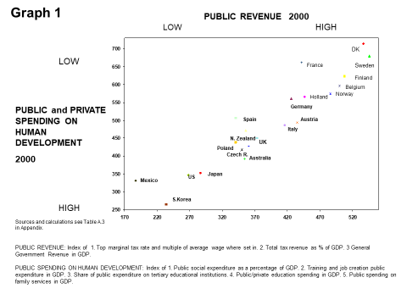

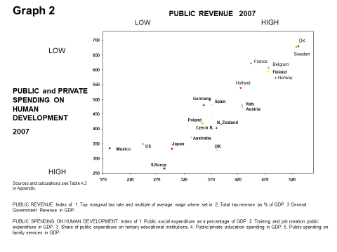

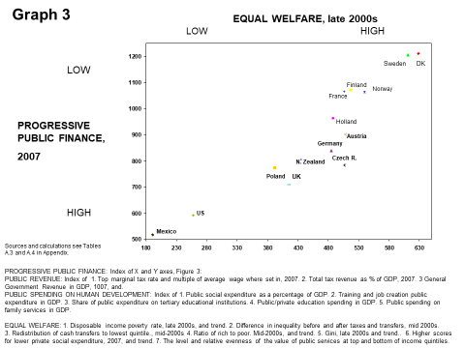

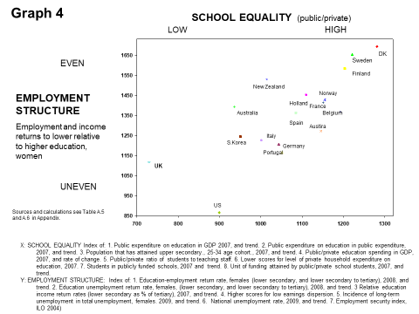

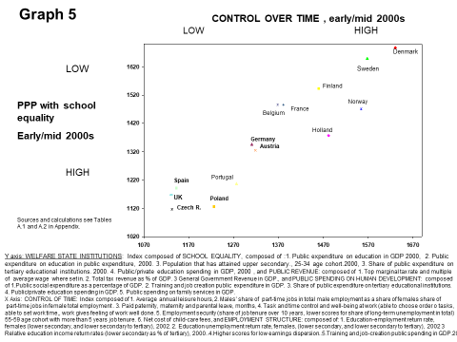

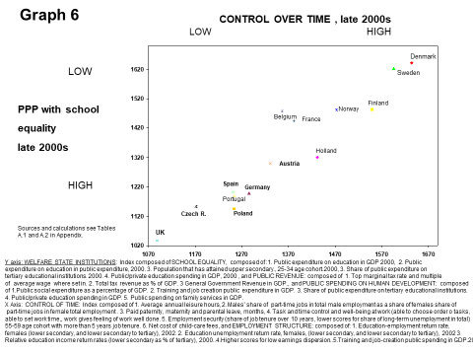

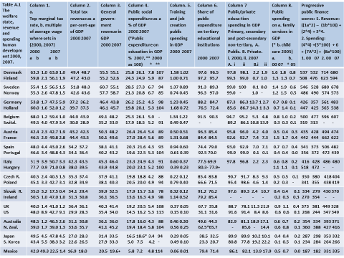

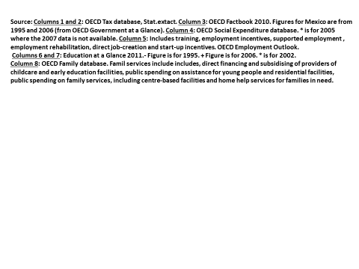

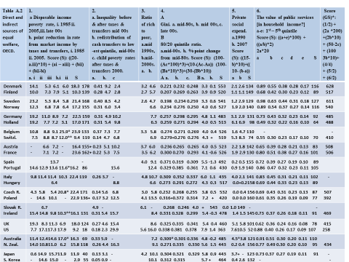

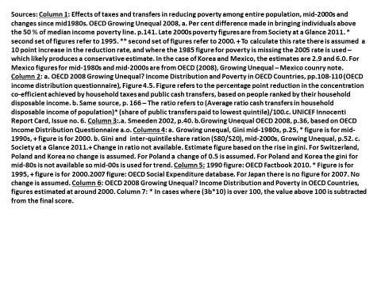

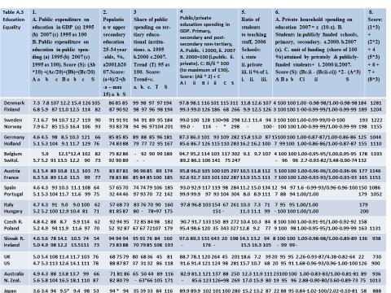

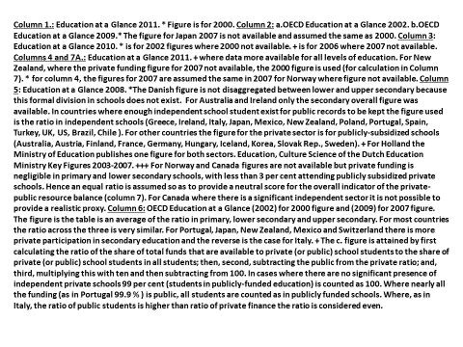

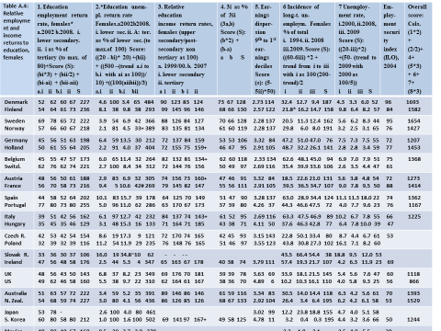

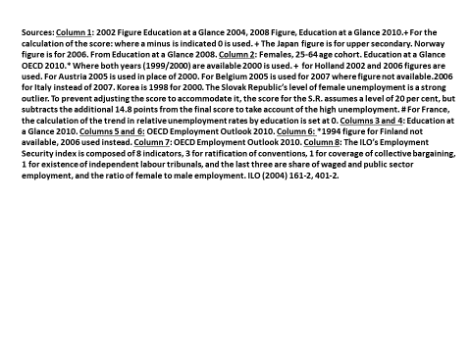

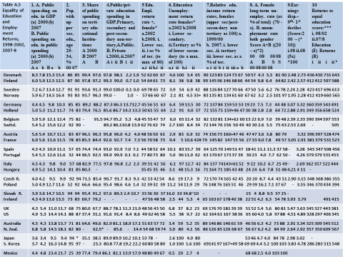

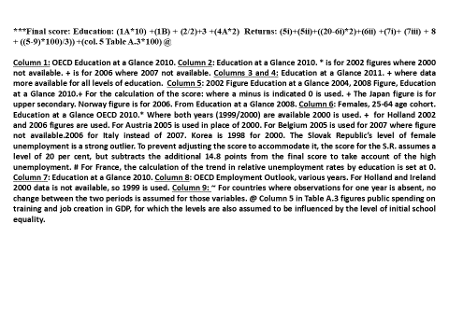

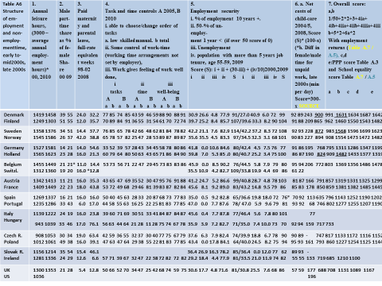

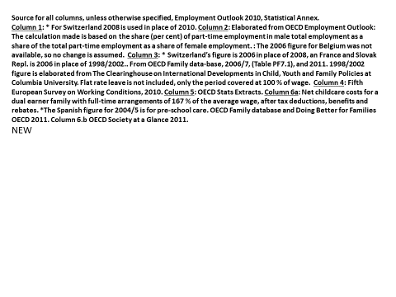

Concern in LALET to restrict intervention to the distributive frame, overshadowed concern with inequality (Williams, 2008, p. 504).
Meade (1964, pp. 35-8) saw different policies as at the root of different systems (e.g. progressive taxation, solidaristic unionism, minimum wages, universal unconditional allowances, respectively), and rejected all but the last as out of date.
Pikkety (2014, p. 265) links growing earnings inequality in Anglo-Saxon countries to rules which permit ‘super-managers’ to set their own wage.
Overtaken only by Switzerland and France in Europe, education coverage was uniformly high in Nordic countries by 1870 (at 58, 71 and 61 % in Denmark, Sweden and Norway), compared with 49 % in the UK and the highest in Southern Europe, 29% in Italy (Soysal and Strang, 1989).
OECD (2008e, p. 36).
The UK’s 2013 marginal rate tax cut was according to accountants KPMG reported in the Daily Telegraph (3rd December 2014) the largest in the world that year.
For 2010 trends, see Haagh (2019e).
Public health as well as long-term care expenditure in GDP is high in Nordic countries (and in Denmark the highest; OECD, 2011a, pp. 36, 165, 72, 177, 163
Sweden’s support for paying higher taxes – and trust in other citizens’ honesty - grew dramatically in the 2000s during a period of cutbacks and recession (Svallfors, 2011, pp. 811-812).
This compares with only 64 companies overall in Britain, reportedly taking apprentices at the height of pro-apprenticeship policy in 2007 under Labour’s flagship Job-Centre Plus network (Financial Times, 10th September 2007).
There are more students in independently (parent-) governed schools in Nordic states (13 % in Denmark – 39% in the capital Copenhagen - against 7 % in the UK). Many charge a small fee though – as noted earlier - the level and effect are contained through public policy. For the same type of school – Steiner, the fees are about 5.6 times higher in the UK (Kr. 15,500 or about £1,737 per year in Århus in Denmark in 2013, and £9,800 in Hounslow, UK). Available at: http://www.steinerskolen-aarhus.dk/information/skolepenge/; and also at: http://www.stmichaelsteiner.hounslow.sch.uk/information/finance.html
Thus, in only 7 years, between 2000 and 2007, the share of public finance for elementary education in Britain fell from 88.7 per cent to 78.1 per cent (the lowest level in the OECD) whilst the share of pupils attending state schools remained constant.
Private educational fees rose by 83 per cent in real terms between 1992 and 2010, almost 3 times the rise in average incomes (Daily Telegraph, 18 June 2010). Half of this rise occurred since 2005 (Daily Telegraph 15 Jan 2010).
Between 2009 and 2014 child-care costs in Britain rose by 27 per cent, whilst real wages remained stagnant (The Family and Childcare Trust, 2014).
Zero-hour contracts, permitting employer discretion in work-hours are especially prevalent in Britain (EOWL, 2010) and in services for vulnerable groups (adult domiciliary care, Pyper and McGuinness, 2013, p. 5) – typically carried out by women - at 61 % of such jobs against 3-4 % of all jobs in England.
In 10 out of total of 32 countries in the report, the figure for children in informal care was over 40 %, at 42 % in the UK, and 54 % in Holland. (European Commission 2013, p. 33), compared with under 5 % in Nordic states.
By July 2013, 1 in 5 firms used the contracts (Guardian Friday 16th August 2013), up from 4% in 2004 (Pyper and McGuinness, 2013, p. 4). .
Britain in 2013 had an average - but by education the most divided - share of youth (15-to-29-year-olds) not in education or employment in the OECD: 24 per cent with low schooling were inactive as compared with 8 per cent with high education. In Denmark, Sweden and Norway the figures are (10.3, 8.2; 8.1, 4.9; 9.8, 6.6). (OECD, 2014, p. 103).
According to Burtless et al. (2010), in the UK top earners work 3 times as many hours as the lowest earners, as compared with 1.6 in the US and 1.5 in Austria.
Introduced in April 2013, the ‘under-occupancy tax’ is intended to entice residents with an extra room to move or take a tenant.
Børnepenge –børne og ungeydelserne, Babyxplore.dk, 3. December 2014
In Britain, the initial financial response to Coronavirus comprised cash for businesses, though mainly in the form of loans (BBC 2019, March 17th). A scheme to support 80 % of individuals’ wages, an equivalent package for the self-employed, and upping the level of Universal Credit payments (albeit by much less) for those depending on assistance, followed (Financial Times 2020). The UK in this sense in effect mimicked – albeit only temporarily – the two-tier more comprehensive economic security system of Nordic and East Asian states, comprising of both wage-linked and basic security systems.

