Microwave-assisted hydrothermal extraction of non-structural carbohydrates and hemicelluloses from tobacco biomass
Yuan Yuanª, Ping Zouª, Jinhui Zhouª, Yuting Gengª, Jiajun Fan^{b}, James Clark^{b}, Yiqiang Liª*, Chengsheng Zhangª*
ª Marine Agriculture Research Center, Tobacco Research Institute of Chinese Academy of Agricultural Sciences, Qingdao, 266101, China
^{b} Green Chemistry Centre of Excellence, University of York, Heslington, York YO10 5DD, United Kingdom

*Corresponding authors:
Yiqiang Li: liyiqiang@caas.cn +86(0)53266715517
Chengsheng Zhang: zhangchengsheng@caas.cn +86(0)53288702115

Abstract
Microwave-assisted hydrothermal extraction of non-structural carbohydrates and hemicelluloses from tobacco biomass was investigated. Non-structural carbohydrates extraction was optimized by an Optimal design. The maximum yields for the leaf and stem were 118.57 mg/g and 120.33 mg/g biomass, respectively. The extracted stem residue was further treated for hemicelluloses extraction. A temperature of 200 ºC without holding was proved to be the most efficient condition to produce a hemicelluloses yield of 105.15 mg/g. GPC results showed that the Mw values of precipitated hemicelluloses decreased from 143.5 kDa to 13.25 kDa with increasing temperature and holding time, while the un-precipitated fraction were ranging from 11.83 to 4.88 kDa. Monosaccharide analysis revealed that hemicelluloses extracted at lower temperature are heterogeneous compositional type, including xylan, glucuronoxylan and xylanglucan, while the ratio of xylose increased significantly (up to 72.64%) with increasing temperature. The developed microwave-assisted hydrothermal extraction process opens new avenues for a sustainable tobacco-based biorefinery.
Keywords: Microwave assisted hydrothermal extraction; carbohydrates; xylan; tobacco; biorefinery

1. Introduction
Tobacco (Nicotiana tabacum) has been an economic crop traditionally used for manufacturing cigarettes for long history dating back to 1400-1000 BC (Kaag, 2005). China is the world’s largest producer of tobacco leaf, and its total output accounts for 42% of the world’s total output, reaching 2,806,770 t/yr (FAOSTAT, 2016). However, with the signing of the World Health Organization's Framework Convention on Tobacco Control (FCTC), many countries and regions have explicitly restricted smoking. China has also introduced a series of tobacco control regulations, which have brought tremendous pressure on the tobacco industry. Considering the investment on fully developed tobacco cultivation skills and mutually established tobacco-cropping machinery, using tobacco for bio-based chemicals and fuels represents a valid alternative to reorganize a sustainable local economy.
Recently, some studies have been done on the exploitation of valuable chemicals and fuels from tobacco rather than cigarette production, including the extraction of bioactive compounds (e.g., cembranoids, solanesol) for medicines and seed oil production for biofuels (Grisan et al., 2016; Yan et al., 2017; Yan et al., 2015). Similar to other biomass, tobacco has high hemicellulose, cellulose and lignin contents. In addition, the dry weight of mature tobacco leaves contain up to 30% starch and 10% pectin (Song et al., 2016; Zhu, Liu, Zheng, & Gao, 2014). The differences in the structure and reactivity of these components make the fractionation of tobacco possible. The starch and pectin can be further hydrolysed to fermentable sugar for biofuel production (Favaro et al., 2017; Santos et al., 2016), while xylan polysaccharides can be used as gels, films, coatings, and prebiotics in the food, biomedical and pharmaceutical industries (Mihiretu et al., 2017).
To achieve fractionation, a sustainable method needs to be developed. Non-structural carbohydrates such as soluble sugars and starch are conventionally extracted by water at ambient temperature (Pinyo, Luangpituksa, Suphantharika, Hansawasdi, & Wongsagonsup, 2017). Pectin is commercially extracted from fruit feedstocks using acidic hot water (60-100 ºC) for several hours (Wang et al., 2015). Hemicelluloses extraction has been reported for many feedstocks including sugarcane bagasse, arecanut husk, and corn cobs in alkaline solutions (Singh, Banerjee, Sasmal, Muir, & Arora, 2018; Sporck et al., 2017). Recently, various techniques including ultrasonic, enzymatic, microwave and pressurized hot water have been applied to biomass for the extraction of soluble components (Hosseini, Khodaiyan, & Yarmand, 2016; Pinyo et al., 2017). According to our previous study, microwave-assisted hydrothermal treatment is an energy efficient method for biomass conversion due to the unique ability of microwaves to rapidly heat up water to highly elevated temperatures within shorter span of time (Yuan & Macquarrie, 2015a, 2015c; Yuan, Zhang, et al., 2018). It is also accepted as an environmentally friendly and controllable tool, allowing for simple and rapid processing (Luo, Fan, Budarin, Hu, & Clark, 2017). Gezahegn et al. extracted xylan with maximal yields of 66% and 50% from aspenwood and sugarcane trash, respectively, under microwave assisted hydrothermal conditions between 165-200 ºC (Mihiretu et al., 2017). Luo et al. achieved the completely removal of hemicelluloses in bamboo at 200 ºC using microwave-assisted hydrothermal treatment (Luo et al., 2017). Microwave-assisted extraction of starch and pectin is mostly conducted at temperatures below 100 ºC; no information is available on microwave-assisted hydrothermal extraction of these components.
The aim of this study is to explore a feasible biorefinery method for the maximal extraction of non-structural carbohydrates, and also xylan polysaccharides using a microwave-assisted hydrothermal extraction process. The effect of microwave-induced temperature and holding time on hydrothermal processes was investigated for tobacco leaves and stems, respectively. The resulting sugars, xylan polysaccharide and biomass residue from each step were further analysed and characterised.

2. Materials and methods

2.1 Raw materials and chemicals
Tobacco (Nicotiana tabacum) leaves and stems were collected in Dongying, Shandong Province, China, in October 2017. The biomass was oven dried, ground, and sieved to obtain particles with sizes of < 420 µm. Standard D-glucose, D-galactose, D-mannose, D-xylose, L-rhamnose, L-fucose and D-glucuronic acid were purchased from Sigma-Aldrich Limited. All chemicals and reagents were of analytical grade.

2.2 Chemical composition analysis of biomass
The tobacco biomass was analysed to determine moisture, protein, ash, ethanol soluble extractives, matrix polysaccharide (e.g. free sugar, starch, pectin and hemicelluloses), cellulose, and lignin levels (Table 1). The moisture content was determined by drying the biomass in an oven at 105 ºC until a constant weight was obtained. Protein content was calculated by multiplying the nitrogen content, determined by the micro-Kjel-dahl method, by a nitrogen-to-protein conversion factor (6.25*N). The ethanol-soluble extractives were extracted in a Soxhlet extractor using ethanol. Ash content was determined by heating the samples at 600 ºC for 4 h. Saccharide analysis was determined by acid hydrolysis (Bruyn et al., 2016). The biomass was initially treated by 2M trifluoroacetic acid (TFA) for 2 h at 121 ºC for matrix polysaccharide determination using HPLC descried in Section 2.5. Then residual biomass was treated by 72% sulfuric acid for 4 h at room temperature, followed by dilute acid (diluted down to 3.2% sulfuric acid) for 4 h at 120 ºC for cellulose determination, the glucose content was measured using the colorimetric Anthrone assay. The lignin content was measured by acetyl bromide method (Chang, Chandra, Berleth, & Beatson, 2008).

Table 1 Compositional analysis of raw biomass
Component |  | Leaf (wt%) | Stem (wt%)
Ethanol-soluble extractives |  | 0.59±0.01 | 0.54±0.01
Matrix polysaccharide |  | 20.16±0.79 | 25.35±1.12
Cellulose |  | 13.48±0.17 | 25.11±1.14
Lignin |  | 16.48±0.12 | 19.29±0.16
Protein content |  | 17.23±0.08 | 11.84±0.03
Moisture content |  | 8.22±0.02 | 8.70±0.05
Ash content |  | 15.44±0.06 | 7.35±0.24
Others |  | 8.40 | 1.82
Matrix polysaccharide composition (mol%) | Man | 4.85 | 6.21
 | Rha | 9.23 | 4.61
 | GalA | 11.21 | 4.58
 | Glc | 40.75 | 37.24
 | Gal | 15.76 | 7.46
 | Xyl | 9.91 | 35.40
 | Ara | 8.23 | 4.51
2.3 Optimisation of microwave assisted extraction of non-structural carbohydrates
The optimization of non-structural carbohydrates extraction was carried out using Design-Expert 8.0.5 (Stat-Ease Inc., Minneapolis, MN, USA) based on an Optimal design under full factorial design with temperature and holding time as two main factors. Parametric value of these variables were chosen based on the preliminary results of hydrothermal treatment (Section3.1). A CEM Mars 6 microwave reactor was used for the experiments. Microwave-assisted hydrothermal treatment of biomass was investigated by varying different process temperatures (120 - 200 ºC) and holding time (0 - 40 min). Briefly, 500 mg of dried biomass was subjected to 10 mL distilled water in a 75 mL reaction tube. The sample was subsequently placed in the microwave and irradiated under the dynamic mode to enable the system to achieve the desired temperature. After irradiation, the suspensions were centrifuged to separate the residual biomass, which was washed with distilled water and dried at 105 ºC until constant weight. The liquid was stored at 4 ºC for further analysis.
A total of 9 runs (1 center point) were performed and the order of the experiments was fully randomized (Tables S3 and S4). A quadratic polynomial equation (Eq. (1)) was proposed to interlink the effects of the two independent variables on fermentable hexose as follows:
Y=B₀+B₁*X₁+B₂*X₂+B₁₂*X₁*X₂+B₁₁*X₁²+B₂₂*X₂² (1)
where Y=predicted response (non-structural carbohydrates yield), β₀=constant, X₁=temperature, X₂=holding time, β₁₂ is interaction coefficients between the two factors; β₁₁ and β₂₂ are the quadratic coefficients.

2.4 Microwave assisted extraction of hemicelluloses from residual tobacco stem
Based on the results from non-structural carbohydrates extraction, stem residue after optimized sugar recovery was subsequently studied for microwave assisted hydrothermal extraction of hemicelluloses. Briefly, 500 mg dried pre-extracted stem residue was subjected to 10 mL distilled water in the microwave reaction tube (75 mL). The sample was subsequently inserted into the microwave and irradiated under dynamic mode to enable the system to achieve the desired temperature (160ºC-200 ºC) and holding time (0-40 min). After irradiation, the suspensions were centrifuged to separate the residual biomass, which was washed with distilled water and dried at 105 ºC until constant weight. 4 times the volume of absolute ethanol was added to the resultant filtrate and the ethanol-precipitated polysaccharide was recovered by centrifugation and freeze-dried. The supernatant after precipitation was concentrated by rotary evaporation and freeze-dried for further saccharide analysis.

2.5 Analytical method
Monosaccharide composition was analysed using our previous method (Yuan, Xu, et al., 2018). Briefly, the samlple was treated with 2 M trifluoroacetic acid (TFA) for 2 h at 121 ºC, while liquid extracts were first nitrogen-dried before being treated with TFA. The resulting monosaccharides were treated with the PMP derivation method and analysed by HPLC (e2695, Waters) on a Hypersil ODS-2(C18) column with UV detection. The monosaccharides were quantified using external calibration with an equimolar mixture of nine monosaccharide standards (arabinose, fucose, galactose, galacturonic acid, glucose, glucuronic acid, mannose, rhamnose, and xylose).
The molecular weight distribution of the polysaccharide was determined by a high-performance gel permeation chromatography equipped with a Refractive Index Detector. The columns used were OHpak SB-804 HQ (7.8 mm× 300 mm) and OHpak SB-806 HQ (7.8 mm ×300 mm). The mobile phase consisted of 0.1 M NaNO₃ solution filtrated on 0.22 μm filters. The flow rate was 1.0 mL/min and analyses were performed at 25 ∘C. The 5 mg sample was resuspended in 1 mL distilled water. This mixture was allowed to solubilize briefly and then filtered on 0.22 μm filters. The gel permeation column was calibrated using dextran standards with different molecular weight.
Fourier transformed infrared (FT-IR) spectra of hemicelluloses were plotted with a Thermo Fisher Scientific Nicolet iS10 FT-IR spectrometer. The spectra of the samples were recorded in the range of 4000–500 cm⁻¹ with a resolution of 2 cm⁻¹ and 32 scans.
The crystallinity (CrI) of raw biomass and extracted residue was measured by XRD using a D8 Advance generator (Bruker, Germany). The dried samples were scanned in 2θ range from 5° to 60° using Cu radiation generated at 40 kV and 40 mA. The CrI of cellulose was calculated from the XRD spectra according to the XRD peak height method (Yu et al., 2016):
CrI%=(I_{crystalline(002)}-I_{amorphous})/I_{crystalline(002)}×100 (2)
Where I_{crystalline(002)} is the intensity of crystalline regions (2^{θ} = 22.5°) and I_{amorphous} means intensity of amorphous regions (2^{θ} = 16.5°)
The surface morphology of the biomass before and after treatment were characterized by scanning electron microscopy (SEM, Hitachi-S4800).

2.6 Statistical analysis
The results are presented as means ± standard deviation of three independent determinations. Statistical analysis was determined at p<0.05 by one-way ANOVA followed by the Duncan’s significance test on SPSS 19.0.

3. Results and discussion

3.1 Selection of experimental set point
According to the compositional analysis (Table 1), tobacco leaf contained less lignocellulosic components (50.12%) than stem (69.75%) but a higher protein (17.23%) and ash (15.44%) content than stem (11.84% and 7.35%, respectively). It is worth mentioning that ash content in tobacco was much higher than that in other terrestrial feedstocks reported previously, which is an advantageous aspect since salt can contribute to the depolymerization of structural components as well as to the ionic conduction of microwave heating (Z. Jiang et al., 2018; Z. C. Jiang, Yi, Li, He, & Hu, 2015; Yuan & Macquarrie, 2015b). Due to the compositional differences, leaf and stem were treated separately to investigate their behaviour under microwave-assisted hydrothermal conditions.
Two batches of preliminary tests were carried out on leaf and stem under microwave-assisted hydrothermal conditions. The aim was to observe the decomposition pattern of biomass and identify reasonable ranges of temperature and holding time to extract non-structural carbohydrates and hemicelluloses consecutively, while minimizing the decomposition of cellulose and lignin. The tests were conducted at the temperature range of 140-200 ºC and the holding time range of 0-40 min selected based on our previous research (Tables S1 and S2) (Yuan & Macquarrie, 2015a). The results showed that the decomposition of stem and leaf was significantly influenced by both the temperature and holding time. It could be seen that sugar yield in liquid extracts increased from 140 to 160 ºC within 20 min and started decreasing with a longer holding time of 40 min and a higher temperature above 180 ºC, indicating the secondary degradation of sugars. Appearance of xylose at 160 ºC suggested the solubilisation of hemicelluloses; the xylose released from stem was 18-50 mg/g biomass from 160 ºC to 200 ºC, much higher than that from leaf, which was 2-15 mg/g biomass, indicating that there are more xylan polysaccharides in stem than that in leaf. It was also observed that the composition of residue biomass showed great changes compared to the initial biomass. Cellulose content increased from 134.82 to 401.21 mg/g biomass for leaf after being heated up to 200 ºC and from 251.11 to 564.53 mg/g biomass for stem after being treated for 20 min at 180 ºC. Lignin content of leaf also increased from 164.82 to 330.15 mg/g biomass while that of stem increased from 192.94 to 266.60 mg/g biomass after microwave treatment, showing that matrix polysaccharides can be intensively removed at higher temperature and longer holding time, leaving cellulose and lignin as the major components of residual biomass. The decomposition behaviour of tobacco biomass makes it possible to set up a temperature gradient process for efficient fractionation of the biomass component, and therefore achieve an economic tobacco biorefinery.

3.2 Optimization of microwave assisted extraction of non-structural carbohydrates
The optimization experiment was designed based on an Optimal design under with two main factors (temperature and holding time). Parametric values for these two variables were chosen based on the preliminary test results (Tables S3 and S4). The statistical model results for both leaf and stem are shown in Table 2. With a low p-value (0.0005<0.05) and a high R-square value (0.9973), the fitted quadratic models for leaf had a high significance to adequately represent the response-factor relationship. In comparison, models for stem optimization had a relatively higher p-value (0.0411<0.05) and a lower R-square value (0.9455), but still showing high significance with a 95% confidence interval. Furthermore, P values of source A (temperature) were higher than those of source B (holding time), indicating that the non-structural carbohydrates extraction for both leaf and stem was predominantly influenced by holding time and, to a lesser extent, by temperature within the experimental design range. Quadratic regression equations can be expressed as:

Table 2 Analysis of variance (ANOVA) test for experimental response for fermentable hexose extraction
 | Leaf |  |  |  |  | Stem
Source | Sum of squares | df | Mean square | F value | p-value | Sum of squares | df | Mean square | F value | p-value
Model | 4068.31 | 5 | 813.66 | 218.45 | 0.0005 | 1504.71 | 5 | 300.94 | 10.41 | 0.0411
A-Temperature | 0.19 | 1 | 0.19 | 0.052 | 0.8340 | 278.12 | 1 | 278.12 | 9.62 | 0.0532
B-Holding Time | 2352.24 | 1 | 2352.24 | 631.54 | 0.0001 | 28.04 | 1 | 28.04 | 0.97 | 0.3974
AB | 92.06 | 1 | 92.06 | 24.72 | 0.0156 | 35.94 | 1 | 35.94 | 1.24 | 0.3462
A² | 277.69 | 1 | 277.69 | 74.56 | 0.0033 | 524.77 | 1 | 524.77 | 18.15 | 0.0237
B² | 1346.11 | 1 | 1346.11 | 361.41 | 0.0003 | 637.84 | 1 | 637.84 | 22.06 | 0.0183
Residual | 11.17 | 3 | 3.72 |  |  | 86.74 | 3 | 28.91
Cor Total | 4079.48 | 8 |  |  |  | 1591.45 | 8
R² | 0.9973 |  |  |  |  | 0.9455
Adjusted R² | 0.9927 |  |  |  |  | 0.8547

Non-structural carbohydrates yield from leaf (mg/g) = -722.11444 + 9.65754X₁ + 5.50333X₂ – 0.011994X₁X₂ – 0.029458X₁² – 0.064858X₂² (3)
Non-structural carbohydrates yield from stem (mg/g) = -762.80028 + 11.82913X₁ + 2.94304X₂ – 7.49375E-003X₁X₂ – 0.040496X₁² – 0.044646X₂² (4)
where X₁ is the actual temperature and X₂ is the actual holding time.
Using the above two equations, the calculated yield and the actual experimental yield were quite similar (Tables S3 and S4). Based on statistical software, the theoretically optimal condition for non-structural carbohydrates from leaf was 158 ºC and 28 min with a yield of 118.57 mg/g biomass, and for stem was 144 ºC and 21 min with a yield of 120.33 mg/g biomass (Figure 1). Under the theoretical conditions, the actual values for maximum non-structural carbohydrates yields were 121.01 mg/g for leaf and 118.03 mg/g for stem. Sugar compositional analysis of extracted carbohydrates was shown in Table 3. Under optimal conditions, monomers accounted for 21.89% and 49.58% for leaf and stem, respectively. Glucose was the major composition for both leaf (46.88%) and stem (66.94%) extracts, which could be potentially used for other industrial processes such as bioethanol fermentation (Yuan & Macquarrie, 2015a).
(A) 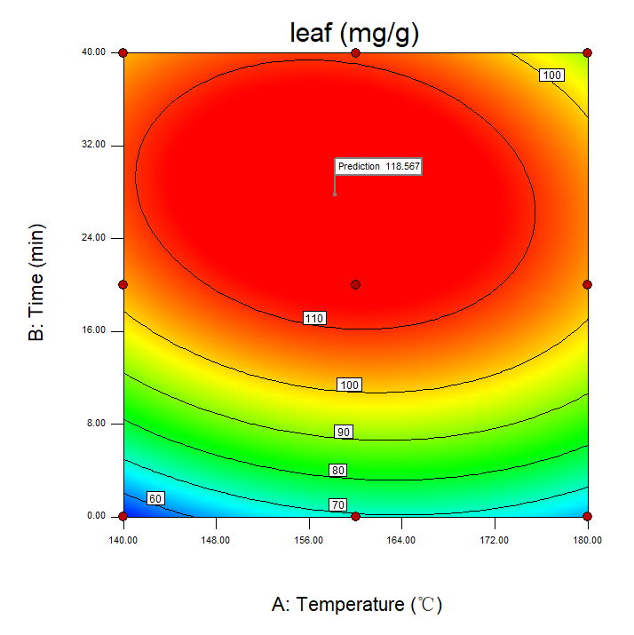(B) 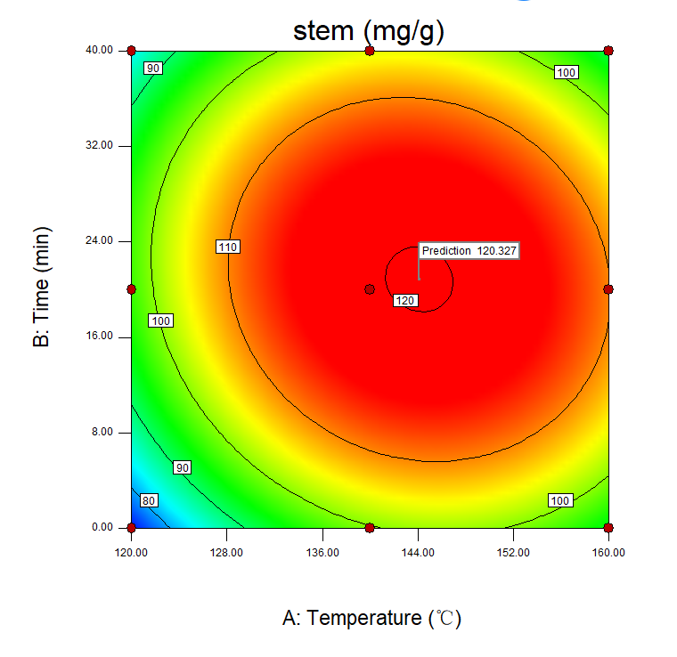
Figure 1. Contour plots of non-structural carbohydrates extraction optimization of (A) leaf and (B) stem
Table 3 Analysis of non-structural carbohydrates at optimal conditions
Sugar composition | Leaf (optimal condition) |  | Stem (optimal condition)
 | Monomers (mg/g) | Total (mg/g) | Monomers (mg/g) | Total (mg/g)
Man | 2.67±0.0.08 | 5.48±0.04 | 1.95±0.04 | 4.33±0.15
Rha | 2.32±0.12 | 13.12±0.18 | 0.44±0.01 | 5.57±0.16
GlcA | 0.00±0.00 | 2.24±0.02 | 0.34±0.01 | 1.05±0.02
GalA | 1.17±0.01 | 4.05±0.66 | 0.45±0.01 | 7.63±0.66
Glc | 16.27±0.92 | 56.73±0.97 | 52.57±0.70 | 79.01±1.45
Gal | 1.43±0.05 | 25.87±0.19 | 2.10±0.02 | 12.05±0.33
Xyl | 0.00±0.00 | 2.38±0.04 | 0.00±0.00 | 1.29±0.06
Ara | 2.62±0.14 | 11.15±0.29 | 0.68±0.01 | 7.11±0.25
total | 26.49±0.64 | 121.01±2.21 | 58.52±0.78 | 118.03±3.03

3.3 Microwave assisted extraction of hemicelluloses from stem
Xylose is an important indicator for the presence of hemicellulose because in most cases, it is the sugar monomer present in the largest amount (Cantu-Jungles, Iacomini, Cipriani, & Cordeiro, 2017). Compared with the leaf biomass in which xylose was 20.54 mg/g biomass, stem contained a significantly higher xylose content of 68.25 mg/g. Up to 54.14 mg/g xylose could be detected in the liquid extract after microwave hydrothermal treatment (Table S2), accounting for 79% of total xylose. Therefore, stem biomass was further treated for hemicelluloses extraction after hexose extraction under optimal conditions.
Figure 2A shows the extraction yield of hemicelluloses from 160 ºC to 200 ºC. Due to the maximum pressure limit of reactor, it was not able to hold retention time at 200 ºC; the holding time for 160-180 ºC was 0-40 min while it was 0 min at 200 ºC. The hemicelluloses yield consisted of two parts, ethanol precipitated saccharide and un-precipitated saccharide. As can be seen, with increasing temperature and holding time, the total hemicelluloses yield increased gradually from 41.26 to 68.40 mg/g biomass at temperature ranging from 160 to 180 ºC, then increased dramatically to 105.15 mg/g at 200 ºC. The increase in the hemicelluloses yield at high temperature could primarily be the result of the increased acidity level of the extraction medium, the pH values were 5.0, 4.5 and 4.0 at 160, 180, 200 ºC with 0 min holding time (data not shown). Such increased acidity level in the extraction medium might have enhanced the auto-catalytic effect on the interactions of H⁺ with hemicellulose and accelerated the progressive depolymerization under such severe conditions (Z. Jiang et al., 2018). Furthermore, with increased temperatures, subcritical water was known to exhibit a high rate of diffusion, low viscosity, and low surface tension – properties that also contribute to the solubility and extraction of hemicellulosic components (Teo, Tan, Yong, Hew, & Ong, 2010). It was also observed that yield of precipitated hemicelluloses increased with holding time at 160 ºC while decreased with holding time at 180 ºC, indicating that at high temperature, longer holding time could lead to the breakage of polysaccharide chain, resulting in smaller molecules that are difficult to be precipitated out (Yuan & Macquarrie, 2015b).
Figure 2B shows the residual mass and composition after hemicelluloses extraction from 160 ºC to 200 ºC. The dissolution of biomass gradually increased with temperature and holding time, with the maximum hydrolysate yield of 29.5% at 180 ºC for 40 min, similar to the yield of 29.0% at 200 ºC without holding. Considering the higher hemicelluloses yield and the cost of energy used for 0 min at 200 ºC and 40 min at 180 ºC, the temperature of 200 ºC without holding was considered the best condition for hemicelluloses extraction from tobacco stem. Compared with the raw materials that contain 18.7% hemicelluloses, 34.5% cellulose, and 27.1% lignin, residual biomass after hemicelluloses extraction at 200 ºC contains 8.9% hemicelluloses, 50.15% cellulose, and 33.0% lignin, demonstrating that the majority of hemicelluloses was removed while most of the cellulose and lignin content remained in the biomass. In addition, the component “other” mainly referring to protein and ash was also minimized in the residue after first hexose extraction and second hemicelluloses extraction. The cellulose and lignin rich residue could then be converted by downstream catalytic processes to targeted high added value intermediate chemicals or final products (Christos K. Nitsos, Choli-Papadopoulou, Matis, & Triantafyllidis, 2016).

Figure 2. (A) Hemicelluloses yield and (B) Residue composition at different hydrothermal conditions
The molar mass distribution of extracted hemicelluloses was evaluated by size exclusion chromatography (Table 4). The M_{w} values of precipitated hemicelluloses decreased from 143.5 kDa to 13.25 kDa with increasing temperature and holding time. The polydispersity was between 2.308 and 1.389. Detailed cumulative distribution of hemicelluloses is shown in Table 4. In comparison, the M_{w} values of the un-precipitated fraction were much lower than those of the precipitated fractions, ranging from 11.83 to 4.88 kDa. Molecular weight is an important property for hemicellulose applications. For example, hemicellulose polymers can be used as surface modifiers (Bosmans et al., 2014) and xylooligosaccharides (XOS) can be used as prebiotics, selectively simulating the growth of beneficial gut microbiota (Samanta et al., 2015). However, most previous work has focused on the removal of hemicellulose to enhance cellulose digestibility in lignocellulosic materials; there are only a few studies on the detail characterisation of hemicellulose molecular weight. Sporck et al. compared different methods to extract xylan from sugarcane bagasse, showing that alkaline-extracted xylan presented significant fractions with molar mass values between 12 kDa and 40 kDa while enzymatically extracted xylan presented molar mass lower than 6 kDa (Sporck et al., 2017). In this work, precipitated fractions with higher molecular weights could be exploited as polymers and un-precipitated fractions with smaller molecular weights could be potentially used as xylooligosaccharides.
The monosaccharide composition of the extracted hemicelluloses was analysed and shown in Table 4. At the lower temperature of 160 ºC, major monomers were rhamnose, galacturonic acid, glucose, galactose and xylose, indicating the heterogeneous composition of hemicellulose type, such as xylan, glucuronoxylan and xylanglucan. With the increase of temperature, the ratio of xylose increased significantly; the highest value was 72.64% at 200 ºC, showing xylan polysaccharide as a major component.

Table 4 Chemical characterisation of extracted hemicelluloses
Extraction temp | Holding time | Type | Mw (kDa) | Mw/Mn | Molecular weight distribution (kDa) | Monosaccharide composition (mo l%)
 |  |  |  |  |  | Man | Rha | GlcA | GalA | Glc | Gal | Xyl | Ara
160 ºC | 0 min | Precipitated | 143.5 | 1.675 | 57-150 kDa (84.4%); 150-1500 kDa (15.0%); 1500-2700 kDa (0.4%) | 0.74 | 12.79 | 1.41 | 14.74 | 19.72 | 33.97 | 9.46 | 7.18
 |  | Un-precipitated | 11.83 | 2.613 | 4.6-21 kDa (64.4%); 21-32 kDa (20.4%); 32-53 kDa (15.2%) | 9.25 | 7.05 | 3.74 | 7.64 | 22.93 | 8.72 | 27.63 | 12.98
 | 20 min | Precipitated | 129.6 | 2.172 | 20-200 kDa (93.0%); 200-2000 kDa (6.4%); 2000-5200 kDa (0.7%) | 0.56 | 13.02 | 1.45 | 10.02 | 23.88 | 34.84 | 10.13 | 6.11
 |  | Un-precipitated | 10.13 | 1.570 | 3.1-13.5 kDa (42.8%); 13.5-16.8 kDa (28.7%); 16.8-40 kDa (28.5%) | 8.40 | 6.62 | 3.40 | 6.14 | 19.01 | 8.13 | 35.97 | 12.36
 | 40 min | Precipitated | 123.7 | 2.308 | 25-100 kDa (86.4%); 100-1000 kDa (12.3%); 1000-6800 kDa (1.3%) | 0.95 | 9.22 | 1.60 | 11.63 | 23.10 | 30.18 | 18.80 | 4.52
 |  | Un-precipitated | 7.03 | 1.345 | 2.1-6.5 kDa (47.1%); 6.5-11 kDa (57.1%); 11-33.5 (5.8%) | 7.81 | 6.03 | 3.19 | 4.93 | 14.89 | 7.66 | 44.76 | 10.69
180 ºC | 0 min | Precipitated | 48.03 | 1.829 | 16-45 kDa (89.4%); 45-450 kDa (10.0%); 450-1500 kDa (0.6%) | 2.10 | 4.86 | 1.17 | 6.98 | 18.45 | 21.19 | 43.34 | 1.92
 |  | Un-precipitated | 6.03 | 1.291 | 1.9-5.5 kDa (32.9%); 5.5-8.3 kDa (57.4%); 8.3-30 kDa (9.4%) | 8.40 | 5.53 | 2.89 | 4.17 | 11.42 | 7.10 | 51.93 | 8.55
 | 20 min | Precipitated | 30.02 | 1.971 | 7.5-15 kDa (37.3%); 15-150 kDa (61.7%); 150-640 kDa (1.0%) | 1.62 | 2.84 | 1.00 | 6.62 | 26.32 | 25.18 | 35.10 | 1.32
 |  | Un-precipitated | 5.45 | 1.449 | 1.7-5.5 kDa (48.9%); 5.5-10 kDa (45.8%); 10-45 kDa (5.2%) | 8.32 | 3.19 | 3.10 | 2.99 | 9.47 | 7.39 | 58.93 | 6.59
 | 40 min | Precipitated | 26.30 | 1.731 | 7-14 kDa (34.6%); 14-140 kDa (64.1%); 140-470 kDa (1.0%) | 0.82 | 3.54 | 1.33 | 8.35 | 29.66 | 26.03 | 28.67 | 1.61
 |  | Un-precipitated | 4.88 | 1.404 | 1.7-4.8 kDa (47.5%); 4.8-6.7 kDa (41.5%); 6.7-33.5 kDa (11%) | 6.52 | 0.96 | 2.07 | 2.10 | 8.86 | 6.54 | 66.52 | 6.43
200 ºC | 0 min | Precipitated | 13.25 | 1.389 | 3.6-6.8 kDa (8.7%); 6.8-2.1 kDa (85.1%); 2.1-1.5 kDa (6.3%) | 1.22 | 2.87 | 0.68 | 2.34 | 11.24 | 9.01 | 72.64 | 0.00
 |  | Un-precipitated | 6.30 | 1.801 | 2.3-3.0 kDa (19.6%); 3.0-23.0 kDa (75.3%); 23.0-37.8 kDa (5.1%) | 5.00 | 5.31 | 0.51 | 1.20 | 7.94 | 4.08 | 71.10 | 4.85

FT-IR spectra of precipitated hemicelluloses extracted from 160 ºC, 180 ºC and 200 ºC with no holding time are shown in Figure 3. Strong signals at 1144 and 1026 cm⁻¹ were characteristics of C-O and C-C stretching from carbohydrates (Sporck et al., 2017). The band at 1602 cm⁻¹ was due to the bending mode of absorbed water (Peng et al., 2009). Peak 1731 and 1242 cm⁻¹ could be assigned to acetyl, uronic, or ester groups, which are the major components of xylan polysaccharide (Luo et al., 2017). The peak at 892 cm⁻¹ was assigned to β-glycosidic linkages between xylose units in the hemicelluloses (Robert, Marquis, Barron, Guillon, & Saulnier, 2005). These three peaks gradually increased with increasing temperature, indicating that xylan polysaccharide was increasingly extracted with at higher temperature, consistent with the monosaccharide analysis of the hemicelluloses fraction. The small bands at 1417, 1373, and 1327 cm⁻¹ represented C-H, C-O, and OH bending vibrations in hemicelluloses, respectively (Peng et al., 2009). Typical lignin bands within 1500-1550 cm⁻¹ were not detected in the spectra, indicating the absence of lignin contamination.
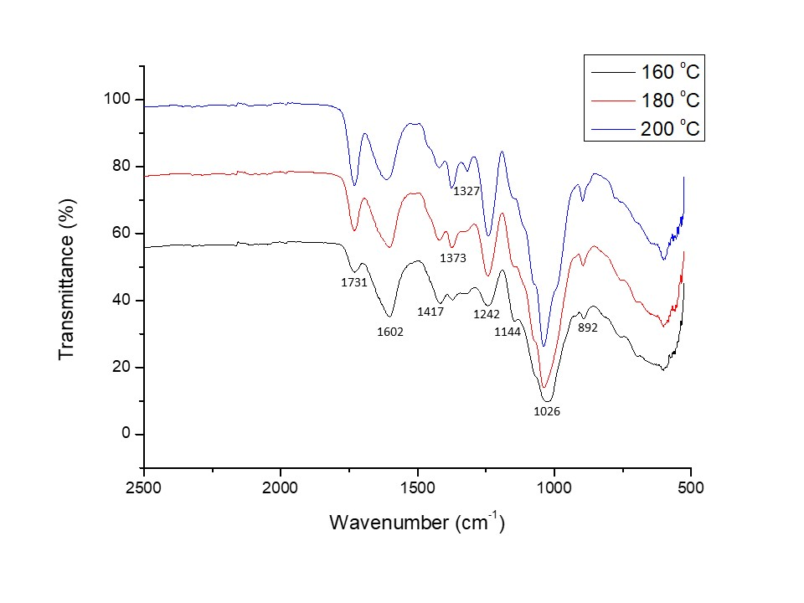
Figure 3. IR spectra of hemicelluloses extracted from 160, 180 and 200 ºC (no holding)
3.4 Characteristics of hydrothermally treated biomass
The X-ray diffraction (XRD) patterns of the raw and hydrothermally treated biomass samples were used to determine the respective crystallinity, which are shown in Figure 4A and B. The CrI increased from 18.79% to 27.71% in leaf after non-structural carbohydrates extraction due to higher concentration of the crystalline cellulose in the treated solids. However, although most matrix polysaccharides including hemicelluloses in stem have been removed after treatment at 200 ºC, the CrI only increased from 30.23% to 31.32%, which was possibly attributed to transformation of crystalline to amorphous of cellulose after sever hot liquid water treatment (Yu et al., 2016).
As presented in SEM images (Figure 4 C and D), the untreated biomass exhibited highly ordered surface, while it became rough after treatment. The deposition of the recondensed lignin in the form of spherical droplets on the surface of biomass could be clearly seen, which was a typical effect of hydrothermal treatment and was in accordance with previous studies on beech wood and poplar (Christos K. Nitsos et al., 2016; C. K. Nitsos, Matis, & Triantafyllidis, 2013). In addition, a darkening of light brown color of the biomass can be observed (Figure 5) due to the recondensation of lignin as well as caramelization of released sugars (Christos K. Nitsos et al., 2016).
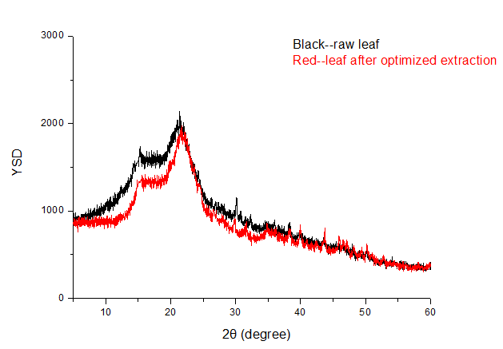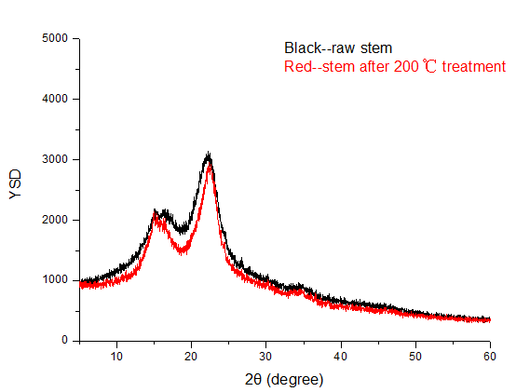
B
A
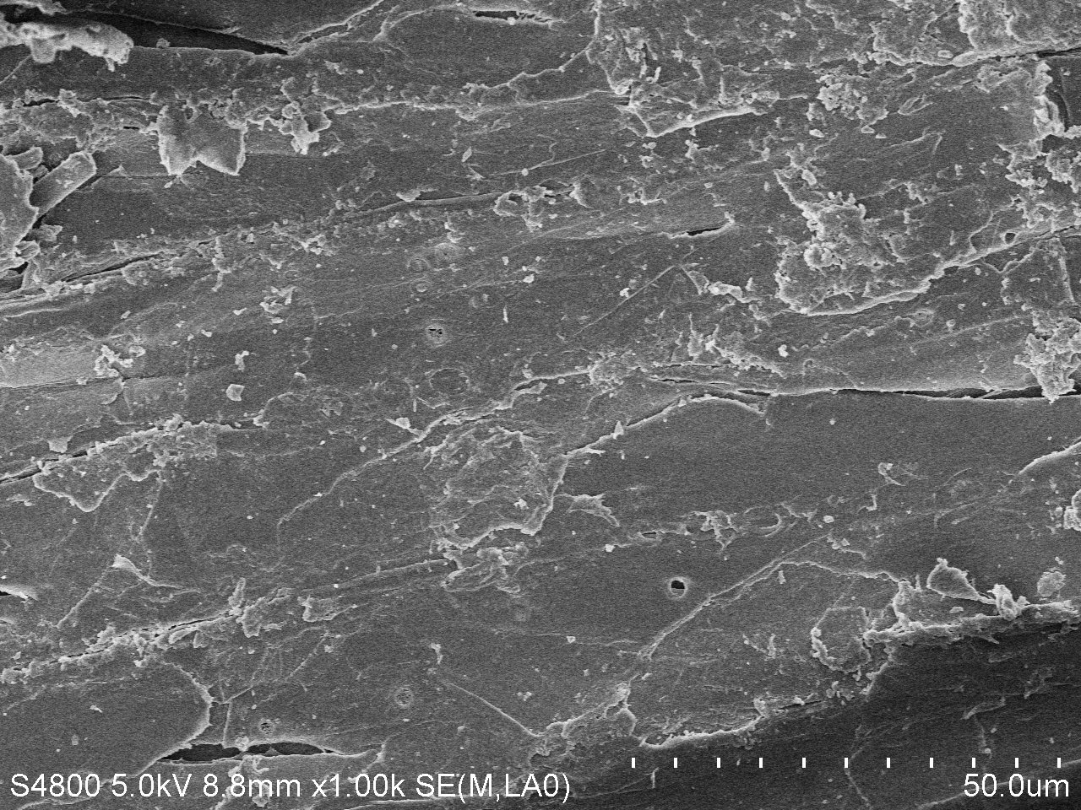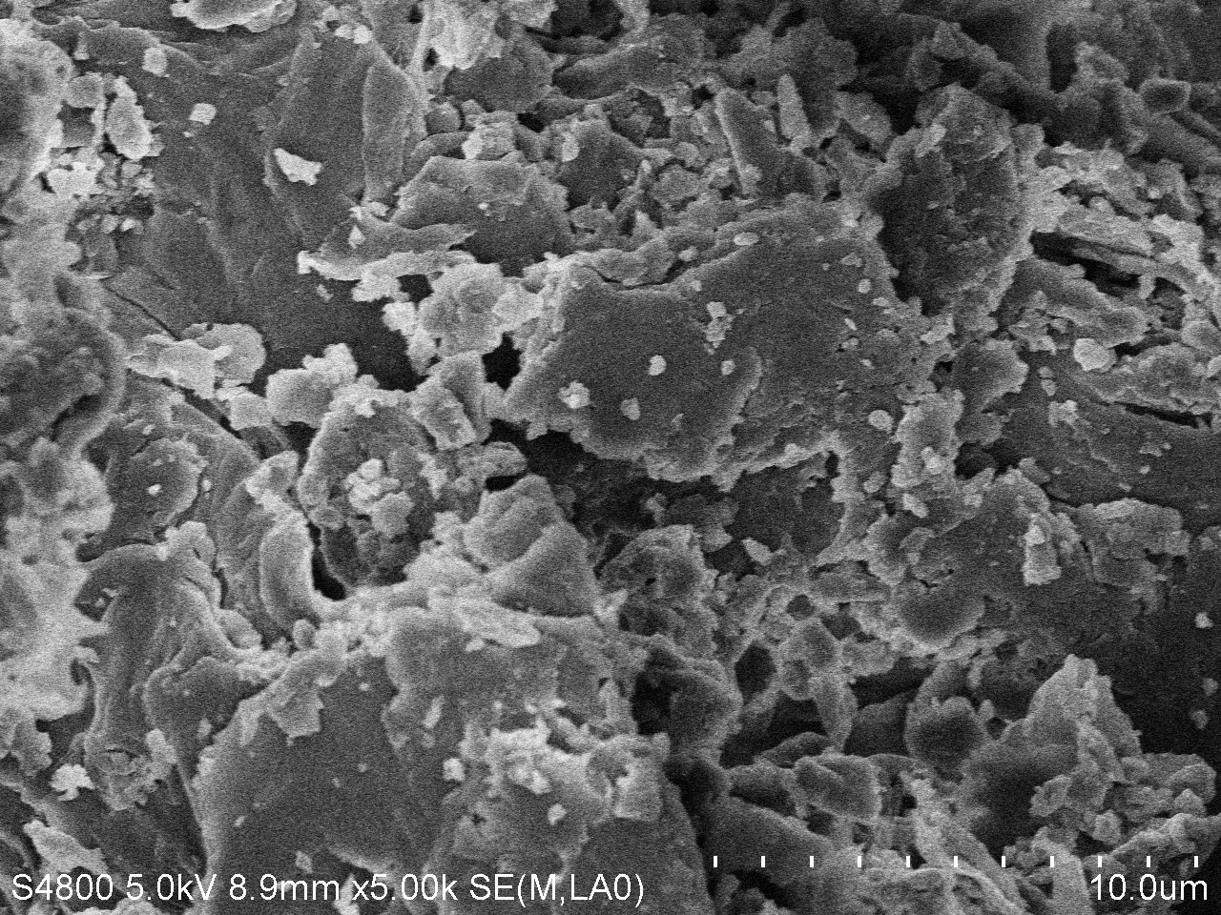
C
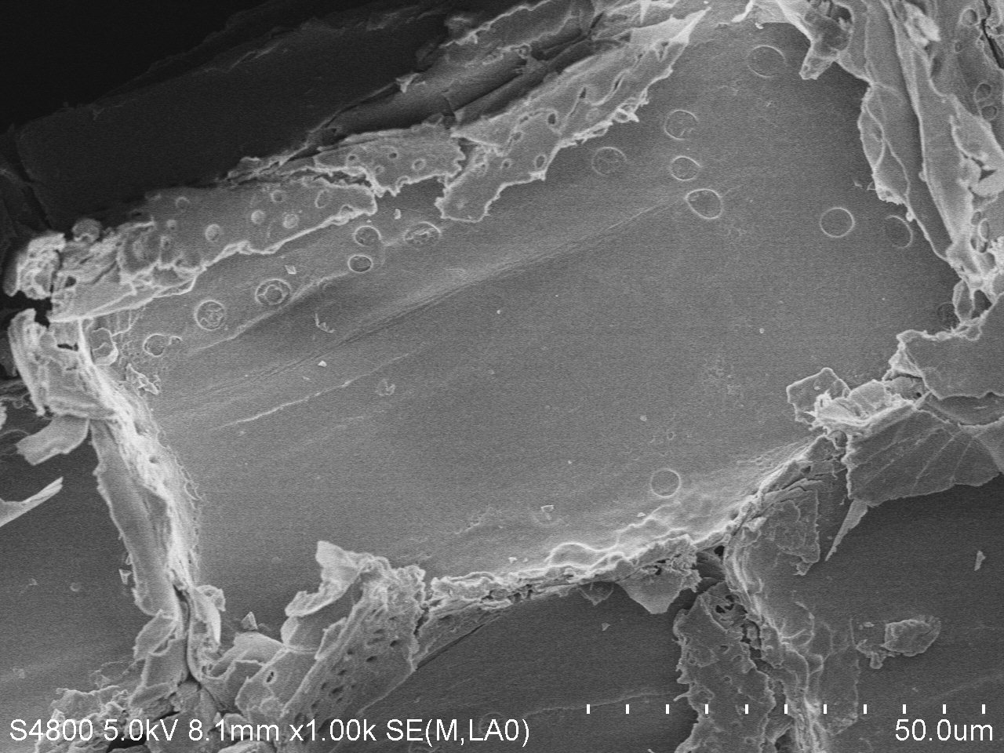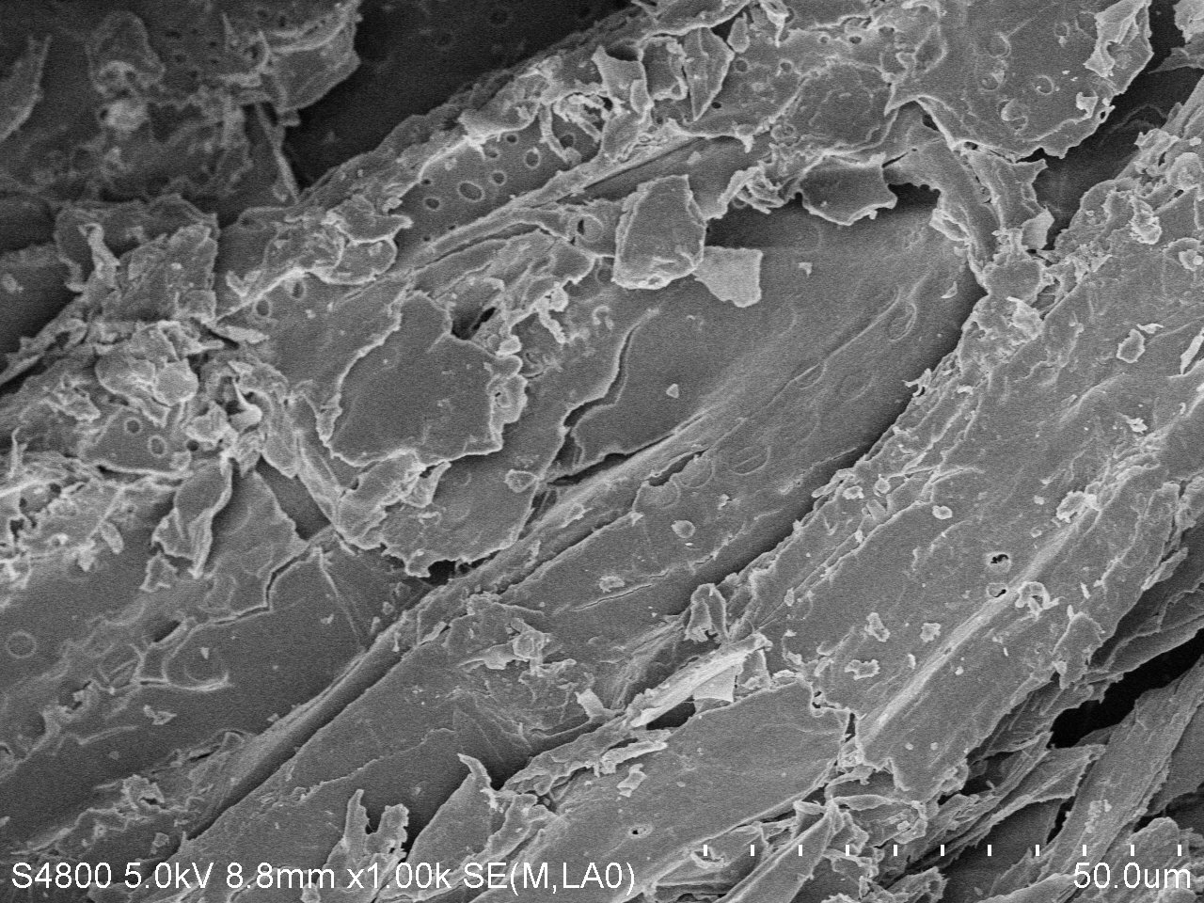
D
Figure 4. (A)XRD spectra of raw leaf (black) and residue after non-structural carbohydrates extraction (red: 158 ºC, 28 min); (B) XRD spectra of raw stem (black) and residue after hemicelluloses extraction (red: 200 ºC, 0 min); (C) SEM images of raw leaf (left) and residue after non-structural carbohydrates extraction (right: 158 ºC, 28 min); (D) SEM images of raw stem (left) and residue after hemicelluloses extraction (right: 200 ºC, 0 min)

3.5 Mass balance of the tobacco hydrothermal treatment process
The mass balance of each component in the tobacco biomass during processing is shown in Figure 5. For 100 g tobacco leaf (Figure 5A), first-step liquid extract contained 12.10 g sugar at the optimal condition. The mass of residual biomass was 37.59 g, containing 4.48 g matrix polysaccharide, 11.42 g cellulose and 10.75 g lignin. The data indicated that 76% matrix polysaccharide was removed, and 84.72% cellulose still remained in the residual biomass. For 100 g tobacco stem (Figure 5B), the first extraction step yielded 11.80 g sugar, leaving 52.37 g residual stem. After the second extraction step, 1.56 g hemicelluloses polymer (with higher molecular weight) and 3.95 g hemicelluloses oligosaccharide (with lower molecular weight) were obtained. The 37.16 g stem residue mainly contained cellulose and lignin, showing that 86.98% of matrix polysaccharide was removed. Fractionation of lignocellulosic materials to cellulose rich biomass can benefit the industrial utilisation of biomass. The design in this work extracted non-structural carbohydrates and hemicelluloses fraction, leaving cellulose rich fraction which could be further converted to valuable chemicals and materials, or could directly be used in currently established ethanol fermentation processes because the final sugar produced from the residual biomass mainly contains glucose rather than a mixture of glucose and xylose (Zabed, Sahu, Boyce, & Faruq, 2016).
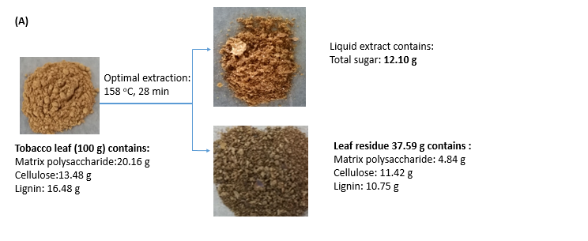
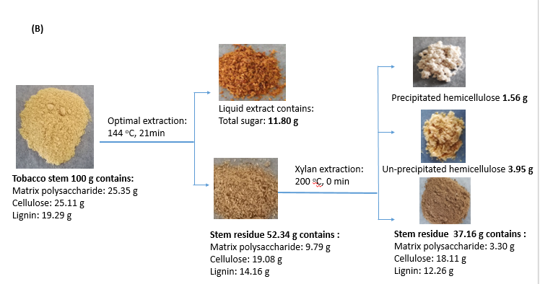
Figure 5. Mass balance for microwave assisted hydrothermal treatment of (A) leaf and (B) stem

4. Conclusions
We demonstrated for the first time the use of tobacco biomass as lignocellulose feedstock for the production of sugar and hemicelluloses. Microwave-assisted hydrothermal extraction of non-structural carbohydrates was optimized by a full factorial design. A quadratic regression equation with high accuracy was made to predict the extraction yields. Then, viable treatment conditions were tested for enhanced hemicelluloses extraction from stem and a high extraction yield (105.15 mg/g) was achieved at 200 ºC. Full analysis of sugar extract, hemicelluloses and solid residue supported potential application of all fractions, suggesting a sustainable tobacco-based biorefinery.

Acknowledgements

This work was supported by the National Key Research and Development Program of China (2018YFD0800404), Science Foundation for Young Scholars of Tobacco Research Institute of Chinese Academy of Agricultural Sciences (2018A02), the Agricultural Science and Technology Innovation Program of China (ASTIP-TRIC07).

Supplementary information
Table S1. Extraction results in liquid fraction and analysis of residue biomass in tobacco leaf
Table S2. Extraction results in liquid fraction and analysis of residue biomass in tobacco stem
Table S3 Factorial design and the response value for non-structural carbohydrates extraction of leaf
Table S4 Factorial design and the response value for non-structural carbohydrates extraction of stem

References
Bosmans, T. J., Stepan, A. M., Toriz, G., Renneckar, S., Karabulut, E., Wagberg, L., & Gatenholm, P. (2014). Assembly of debranched xylan from solution and on nanocellulosic surfaces. Biomacromolecules, 15(3), 924-930.
Bruyn, M. D., Fan, J., Budarin, V. L., Macquarrie, D. J., Gomez, L. D., Simister, R., Farmer, T. J., Raverty, W. D., Mcqueen-Mason, S. J., & Clark, J. H. (2016). A new perspective in bio-refining:Levoglucosenone and cleaner lignin from waste biorefinery hydrolysis lignin by selective conversion of residual saccharides. Energy & Environmental Science, 9(8).
Cantu-Jungles, T. M., Iacomini, M., Cipriani, T. R., & Cordeiro, L. M. C. (2017). Isolation and characterization of a xylan with industrial and biomedical applications from edible açaí berries (Euterpe oleraceae). Food Chemistry, 221, 1595-1597.
Chang, X. F., Chandra, R., Berleth, T., & Beatson, R. P. (2008). Rapid, microscale, acetyl bromide-based method for high-throughput determination of lignin content in Arabidopsis thaliana. Journal of Agricultural and Food Chemistry, 56(16), 6825-6834.
FAOSTAT. Production/Yield quantities of Tobacco, unmanufactured in World + (Total).(2016). http://www.fao.org/faostat/en/#data/QC/visualize Accessed.
Favaro, L., Cagnin, L., Basaglia, M., Pizzocchero, V., van Zyl, W. H., & Casella, S. (2017). Production of bioethanol from multiple waste streams of rice milling. Bioresource Technology, 244, 151-159.
Grisan, S., Polizzotto, R., Raiola, P., Cristiani, S., Ventura, F., di Lucia, F., Zuin, M., Tommasini, S., Morbidelli, R., Damiani, F., Pupilli, F., & Bellucci, M. (2016). Alternative use of tobacco as a sustainable crop for seed oil, biofuel, and biomass. Agronomy for Sustainable Development, 36(4), 55.
Hosseini, S. S., Khodaiyan, F., & Yarmand, M. S. (2016). Optimization of microwave assisted extraction of pectin from sour orange peel and its physicochemical properties. Carbohydrate Polymers, 140, 59-65.
Jiang, Z., Budarin, V. L., Fan, J., Remón, J., Li, T., Hu, C., & Clark, J. H. (2018). Sodium chloride-assisted depolymerization of xylo-oligomers to xylose. ACS Sustainable Chemistry & Engineering, 6, 4098-4104.
Jiang, Z. C., Yi, J., Li, J. M., He, T., & Hu, C. W. (2015). Promoting effect of sodium chloride on the solubilization and depolymerization of cellulose from raw biomass materials in water. Chemsuschem, 8(11), 1901-1907.
Kaag, C. S. (2005). Tobacco in History and Culture: An Encyclopedia. Detroit: Thomson Gale.
Luo, Y., Fan, J., Budarin, V. L., Hu, C., & Clark, J. (2017). Microwave-assisted hydrothermal selective dissolution and utilisation of hemicellulose in phyllostachys heterocycla cv. pubescens. Green Chemistry, 19, 4889-4899.
Mihiretu, G. T., Brodin, M., Chimphango, A. F., Øyaas, K., Hoff, B. H., & Görgens, J. F. (2017). Single-step microwave-assisted hot water extraction of hemicelluloses from selected lignocellulosic materials – A biorefinery approach. Bioresource Technology, 241, 669-680.
Nitsos, C. K., Choli-Papadopoulou, T., Matis, K. A., & Triantafyllidis, K. S. (2016). Optimization of hydrothermal pretreatment of hardwood and softwood lignocellulosic residues for selective hemicellulose recovery and improved cellulose enzymatic hydrolysis. ACS Sustainable Chemistry & Engineering, 4(9), 4529-4544.
Nitsos, C. K., Matis, K. A., & Triantafyllidis, K. S. (2013). Optimization of hydrothermal pretreatment of lignocellulosic biomass in the bioethanol production process. Chemsuschem, 6(1), 110-122.
Peng, F., Ren, J.-L., Xu, F., Bian, J., Peng, P., & Sun, R.-C. (2009). Comparative study of hemicelluloses obtained by graded ethanol precipitation from sugarcane bagasse. Journal of Agricultural and Food Chemistry, 57(14), 6305-6317.
Pinyo, J., Luangpituksa, P., Suphantharika, M., Hansawasdi, C., & Wongsagonsup, R. (2017). Improvement of sago starch extraction process using various pretreatment techniques and their pretreatment combination. Starch - Stärke, 69(9-10), 1700005.
Robert, P., Marquis, M., Barron, C., Guillon, F., & Saulnier, L. (2005). FT-IR investigation of cell wall polysaccharides from cereal grains. arabinoxylan infrared assignment. Journal of Agricultural and Food Chemistry, 53(18), 7014-7018.
Samanta, A. K., Jayapal, N., Jayaram, C., Roy, S., Kolte, A. P., Senani, S., & Sridhar, M. (2015). Xylooligosaccharides as prebiotics from agricultural by-products: Production and applications. Bioactive Carbohydrates and Dietary Fibre, 5(1), 62-71.
Santos, T. d. N., Dutra, E. D., Gomes do Prado, A., Leite, F. C. B., de Souza, R. d. F. R., dos Santos, D. C., Moraes de Abreu, C. A., Simões, D. A., de Morais Jr, M. A., & Menezes, R. S. C. (2016). Potential for biofuels from the biomass of prickly pear cladodes: Challenges for bioethanol and biogas production in dry areas. Biomass and Bioenergy, 85, 215-222.
Singh, R. D., Banerjee, J., Sasmal, S., Muir, J., & Arora, A. (2018). High xylan recovery using two stage alkali pre-treatment process from high lignin biomass and its valorisation to xylooligosaccharides of low degree of polymerisation. Bioresource Technology, 256, 110-117.
Song, Z. P., Wang, J. N., Sun, M., Wu, J. C., Gong, C. R., & Liu, G. S. (2016). Effects of organic fertilizer applications on starch changes in tobacco (Nicotiana tabacum L.) leaves during maturation. Soil Science and Plant Nutrition, 62(2), 173-179.
Sporck, D., Reinoso, F. A. M., Rencoret, J., Gutiérrez, A., del Rio, J. C., Ferraz, A., & Milagres, A. M. F. (2017). Xylan extraction from pretreated sugarcane bagasse using alkaline and enzymatic approaches. Biotechnology for Biofuels, 10(1), 296.
Teo, C. C., Tan, S. N., Yong, J. W. H., Hew, C. S., & Ong, E. S. (2010). Pressurized hot water extraction (PHWE). Journal of Chromatography A, 1217(16), 2484-2494.
Wang, W., Ma, X., Xu, Y., Cao, Y., Jiang, Z., Ding, T., Ye, X., & Liu, D. (2015). Ultrasound-assisted heating extraction of pectin from grapefruit peel: Optimization and comparison with the conventional method. Food Chemistry, 178, 106-114.
Yan, N., Du, Y., Liu, X., Zhang, H., Liu, Y., Shi, J., Xue, S. J., & Zhang, Z. (2017). Analyses of effects of α-cembratrien-diol on cell morphology and transcriptome of Valsa mali var. mali. Food Chemistry, 214, 110-118.
Yan, N., Liu, Y., Gong, D., Du, Y., Zhang, H., & Zhang, Z. (2015). Solanesol: a review of its resources, derivatives, bioactivities, medicinal applications, and biosynthesis. Phytochemistry Reviews, 14(3), 403-417.
Yu, Q., Liu, J., Zhuang, X., Yuan, Z., Wang, W., Qi, W., Wang, Q., Tan, X., & Kong, X. (2016). Liquid hot water pretreatment of energy grasses and its influence of physico-chemical changes on enzymatic digestibility. Bioresource Technology, 199, 265-270.
Yuan, Y., & Macquarrie, D. J. (2015a). Microwave assisted acid hydrolysis of brown seaweed Ascophyllum nodosum for bioethanol production and characterization of alga residue. ACS Sustainable Chemistry & Engineering, 3(7), 1359-1365.
Yuan, Y., & Macquarrie, D. J. (2015b). Microwave assisted extraction of sulfated polysaccharides (fucoidan) from Ascophyllum nodosum and its antioxidant activity. Carbohydrate Polymers, 129, 101-107.
Yuan, Y., & Macquarrie, D. J. (2015c). Microwave assisted step-by-step process for the production of fucoidan, alginate sodium, sugars and biochar from Ascophyllum nodosum through a biorefinery concept. Bioresource Technology, 198, 819-827.
Yuan, Y., Xu, X., Jing, C., Zou, P., Zhang, C., & Li, Y. (2018). Microwave assisted hydrothermal extraction of polysaccharides from Ulva prolifera: Functional properties and bioactivities. Carbohydrate Polymers, 181, 902-910.
Yuan, Y., Zhang, J., Fan, J., Clark, J., Shen, P., Li, Y., & Zhang, C. (2018). Microwave assisted extraction of phenolic compounds from four economic brown macroalgae species and evaluation of their antioxidant activities and inhibitory effects on α-amylase, α-glucosidase, pancreatic lipase and tyrosinase. Food Research International, 113, 288-297.
Zabed, H., Sahu, J. N., Boyce, A. N., & Faruq, G. (2016). Fuel ethanol production from lignocellulosic biomass: An overview on feedstocks and technological approaches. Renewable and Sustainable Energy Reviews, 66, 751-774.
Zhu, X. L., Liu, B. Z., Zheng, S. J., & Gao, Y. (2014). Quantitative and structure analysis of pectin in tobacco by C-13 CP/MAS NMR spectroscopy. Analytical Methods, 6(16), 6407-6413.

