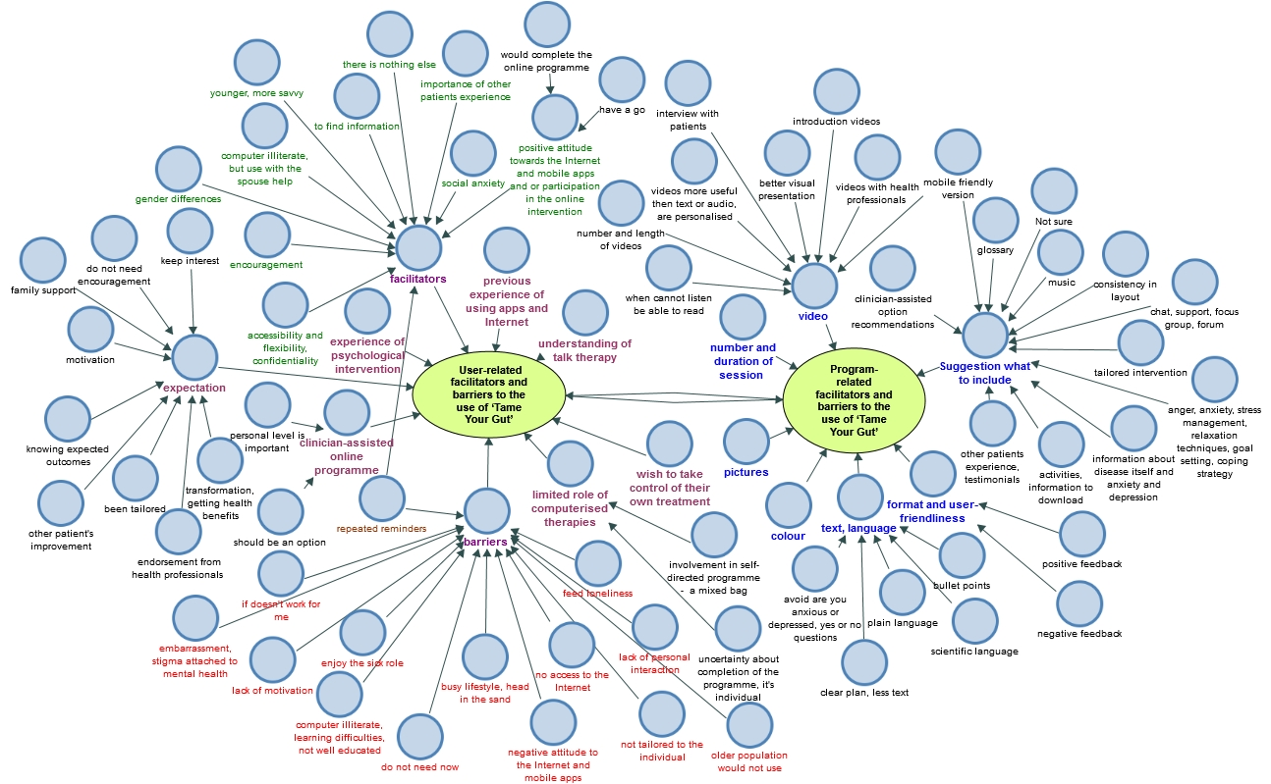
Figure 1: Patients' and health professionals' views about participation in online psychotherapy such as “Tame Your Gut”

