Green Tycoon: A Mobile Application Game to Introduce Biorefining Principles in Green Chemistry.
Matthew Leesª, Michael T. Wentzel^{b}, James H. Clarkª and Glenn A. Hurst*ª

- Green Chemistry Centre of Excellence, Department of Chemistry, University of York, Heslington, York, YO10 5DD, England, United Kingdom.
- Department of Chemistry, Augsburg University, Minneapolis, Minnesota 55454, United States.

Abstract
Green Tycoon is a free-of-charge game-based mobile application that embraces a systems thinking approach to introducing students to a biorefining process model within green chemistry. Players adopt the role of a manager in a chemical factory, synthesizing the fictional compound, Yorkanone. Through upgrading the system and engaging with the integrated quiz, players can learn fundamental green chemistry principles while appreciating some of the considerations in biorefining. Green Tycoon was implemented with 33 undergraduate students where survey feedback demonstrated that the game was engaging, innovative and a helpful tool to appreciate the importance of green chemistry when designing chemical processes. Based on pre- and post-test questions to evaluate learning gain, Green Tycoon proved to be a useful resource to introduce students to green chemistry and its role in moving towards a bioeconomy. Design of the mobile application serves as a useful example of what an upper-division undergraduate student with no coding knowledge can achieve through a chemistry education research project.

Graphic Abstract
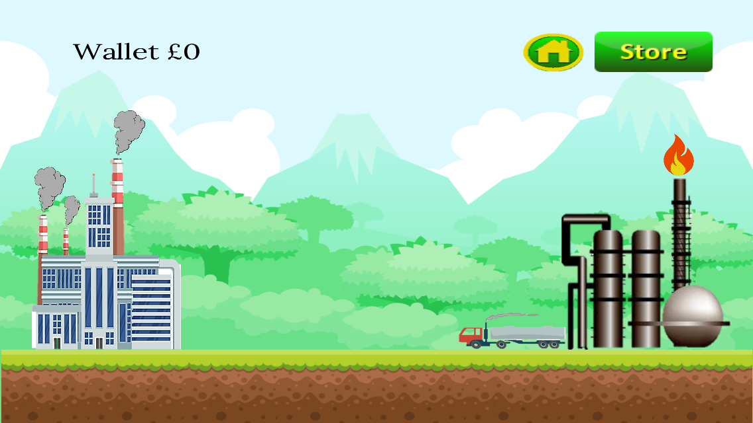
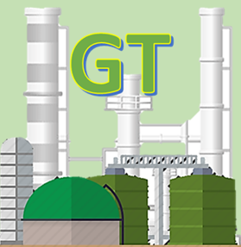

Keywords
First-Year Undergraduate/General, Chemical Engineering, Environmental Chemistry, Humor/Puzzles/Games, Multimedia-Based Learning, Systems Thinking, Green Chemistry, Sustainability

INTRODUCTION
The United Nations Sustainable Development Goals (SDGs) are an interconnected collection of objectives that seek to address global challenges relating to poverty, inequity, climate change, environmental degradation, prosperity and peace and justice by 2030.¹ One focus of achieving the SDGs is how society can transition towards a bioeconomy, making responsible and efficient use of natural resources to include their conservation, restoration and recycling. Biorefinery systems meet this demand well through the sustainable processing of biomass into a spectrum of bio-based products (food, feed, chemicals, materials) and bioenergy (biofuels, power and/or/heat).² The most sustainable third-generation, whole-crop biorefineries take an entire systems-level approach with due consideration of feedstock(s), processing, product stream(s) and associated transport of natural resources/products.³ To continue this global effort, future chemists and chemical engineers must embed green and sustainable chemistry principles within their practice, for which education is vital.⁴
Given the interdependence of system components in various biorefinery models, a systems thinking approach to education is therefore appropriate. Through recognizing the interdependence of components in dynamic systems, students can move from a fragmented and reductionist subject knowledge to a more integrated and holistic understanding of concepts, leading to deeper learning.^{5,6} Green chemistry is well suited for systems thinking approaches to education because applications of the principles of green chemistry and devising molecular design strategies all depend upon considering the reliance of reactions and processes on one another with local and global systems.⁷
Game-based learning methods with defined learning outcomes are one type of intervention that instructors can employ to teach systems thinking while engaging students and introducing a sense of competition. Green Machine is an example of a competitive strategy card game that facilitates systems thinking approaches to learning recycling processes and green chemistry in alignment with the SDGs.⁸ In this game, players compete to launch their own recycling plant by collecting a series of playing cards. Similarly, the Safer Chemical Design Game is an interactive computer game that requires players to consider green chemistry and sustainability issues as they design a hypothetical chemical product.^{9,10} Mobile application-based games for learning in chemistry education have also increased in popularity in recent years given the ubiquitous use of smartphones for communication,¹¹ recreation and more.¹²⁻¹⁶ As such, as part of this work, a mobile application-based game called Green Tycoon was designed, implemented and evaluated, serving to introduce students to the principles of biorefining in green chemistry.

Green tycoon
Green Tycoon is an interactive idle clicker game that is played individually whereby players must upgrade a wasteful and unsustainable industrial process with due consideration of feedstock, the chemical process and process engineering, transport links and factory infrastructure. Aspects of waste treatment to include in-house, disposal and valorization are integrated into the game, reinforcing the need to move towards a circular economy. Upgrades can be purchased through earning money by making deliveries using relevant transport infrastructure and correctly answering questions via an in-built quiz. Associated learning objectives are:

1. Define the 12 principles of green chemistry and key questions relating to their application.
2. Understand and apply the principles of green chemistry to industrial processes.
3. Understand the impact of vehicle transport on emissions and atmospheric chemistry.
4. Considering the system as a whole, understand the real-world decision making associated with industrial processes.
5. Revise green chemistry content through game-based learning.

Green Tycoon was developed using GameSalad Creator 2.0, a web-based game creator tool.¹⁷ A universal build that was compatible with all smartphone and tablet devices regardless of screen size was developed and released for Android¹⁸ and iOS¹⁹ where the game is available to download free-of-charge and hence of benefit to larger audiences, beyond students, with potential utility in informal education. The use of GameSalad to create the game removed the requirement for the developer(s) to use coding language (though knowledge of coding logic was essential). As such, this mobile application was developed by a student studying single honors chemistry with no computing background prior to embarking on the project. Data storage within Green Tycoon is via a combination of attributes and tables. The game uses 74 different attributes to track the activities of the player which exist in a number of forms; the simplest of which is a boolean, or a yes/no attribute. Data stored in tables cannot be saved to the local storage of the host device making tables ideal for storing large amounts of data that does not fluctuate. For example, within Green Tycoon, tables are used to store all of the quiz questions and answers where the logic in the quiz randomly selects a row from within this table and randomizes the order of the answers using a second table. Finally, Green Tycoon has 205 actors where game logic is stored. Actors include visible images (such as the background, factory, biorefinery etc) and invisible images (such as the computer within the quiz, which contains code to respond to player behavior accordingly).
The premise of Green Tycoon involves a player adopting the role of the manager of a chemical factory which synthesizes the fictional compound, Yorkanone. The product synthesis is very wasteful. To reflect this, profits at the beginning of the game are small. The game encourages user interaction as players are required to ‘click the truck’ as in Figure 1 in order to make deliveries. Each delivery earns the player in-game money which can then be invested into making the entire system more sustainable in alignment with the 12 principles of green chemistry.²⁰

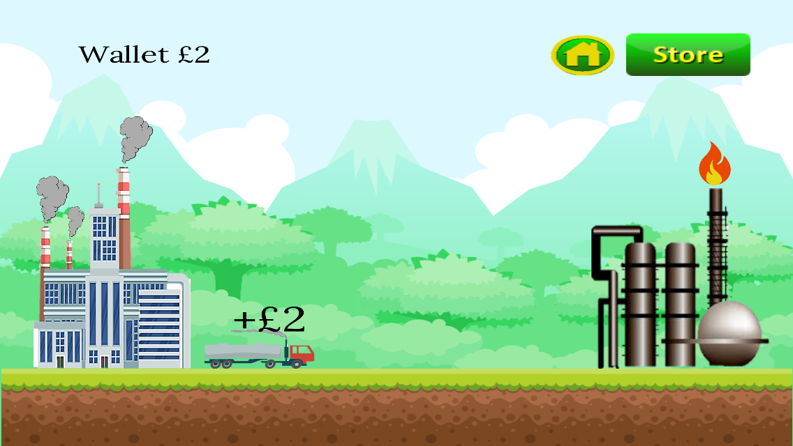

Figure 1. Two screenshots of the main scene of Green Tycoon. The movement of the truck is demonstrated where players tap the truck, instigating a delivery from the refinery (right) to the factory (left). Upon completion, the player earns money, in this instance £2, and the truck returns from the refinery to the factory, ready to commence a new delivery.

Upgrades are an essential component of the game as they incentivize the player to interact with the chemistry content associated with them. Upgrades can be accessed from the store where there are three categories of characters that can be upgraded; the refinery, the truck and the factory. Two conditions must be met for an upgrade to be purchased; (i) enough money must be available for the purchase and (ii) the accompanying text explaining the upgrade must have been accessed and read (Figure 2). The player is rewarded for upgrading various components (such as earning more money as one example), creating an incentive for players to access the educational material.
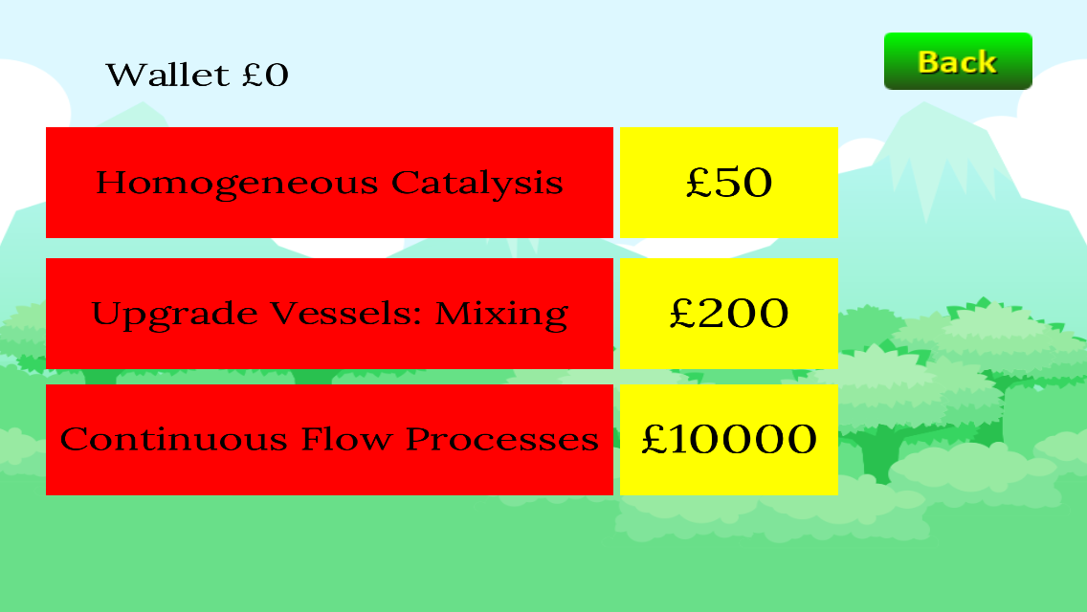
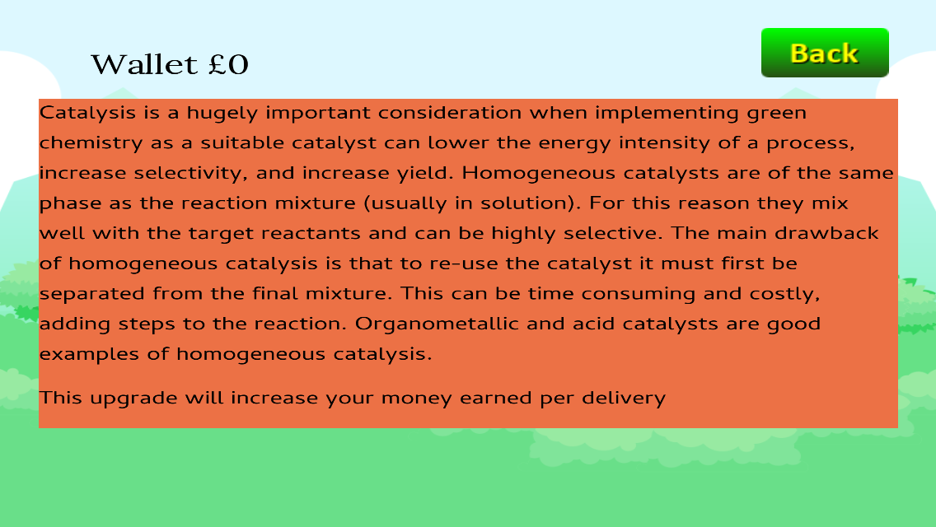

Figure 2. Two screenshots showing part of the upgrade list for the factory (left) and the associated educational material for an upgrade (right).

A summary of the various upgrades available for each of the three characters (factory, transport and refinery) is provided in Table 1 with additional scientific detail being provided in the supporting information. The table is divided into rows associated with the various types/categories of upgrades within that character. Further to the benefits of upgrades being outlined in the accompanying information, some drawbacks are also discussed such as the implications of using food-grade biomass to produce first generation biofuels for the transport of biomass/products (in contrast to second generation food waste biomass).^{21,22} In this way, players can begin to appreciate whole system-level considerations for their process. With this in mind, the transportation upgrades also refer to atmospheric effects such as carbon dioxide emissions; players are encouraged to design a system that minimizes the number of truck deliveries necessary, thereby reducing carbon dioxide emissions. This can be achieved in numerous ways, one of which includes the introduction of freight rail links.

Table 1. A summary of the upgrades available for each of the three characters in Green Tycoon.
 | 1st upgrade | 2nd upgrade | 3rd upgrade | 4th upgrade | 5th upgrade
Factory
Row 1 | Greener solvents and auxiliaries | Homogeneous catalysis | Heterogenous catalysis | Zeolite catalysis | n/a
Row 2 | Upgrade vessels: mixing | Upgrade vessels: heating | Solvent recovery systems | Wastewater treatment facilities | Anaerobic digestion
Row 3 | Continuous flow | Reduce derivatives | Telescoping | Solvent free steps | Reduce number of steps
Transport
Row 1 | Fuel additives | Thermally efficient internal combustion engines | Hybrid vehicles | First generation biofuels | Battery technology
Row 2 | Efficient loading | Improved delivery systems | Safer chemical storage | Safer chemical transport | n/a
Row 3 | Establish rail links | n/a | n/a | n/a | n/a
Refinery
Row 1 | Steam cracking | n/a | n/a | n/a | n/a
Row 2 | Flue gas | n/a | n/a | n/a | n/a
Row 3 | Build biorefinery | n/a | n/a | n/a | n/a

The 12 principles of green chemistry can also be referred to in a section of the mobile application as a convenient reference point, which strongly relate to the in-built quiz (Figure 3). The quiz contains sixty-one multiple choice questions with four possible options for answers and is completed against the clock. A player has three lives (denoted by conical flasks) though they can attempt the quiz on an unlimited number of occasions. A correct answer returns in-game currency that can be spent to progress, incentivizing the player to test their knowledge. The money earned is appropriately scaled so that as the game progresses, the amount of money earned in the quiz also increases. This ensures the quiz does not become obsolete as the money earned through deliveries increases. Additionally, the quiz is designed to ensure that a player is exposed to questions they struggle with on a more frequent basis (which is achieved with an algorithm that removes questions answered correctly from the list until all other questions have been answered correctly). The result of this is that if a question is answered incorrectly multiple times, it will reappear more often until answered correctly. The quiz also tracks the best score achieved by the player in a bid to introduce an aspect of competition to the game. Whilst Green Tycoon is a single player game, users can compete with one another by comparing their high scores or posting them to social media/an instructor as part of a cohort-wide competition.
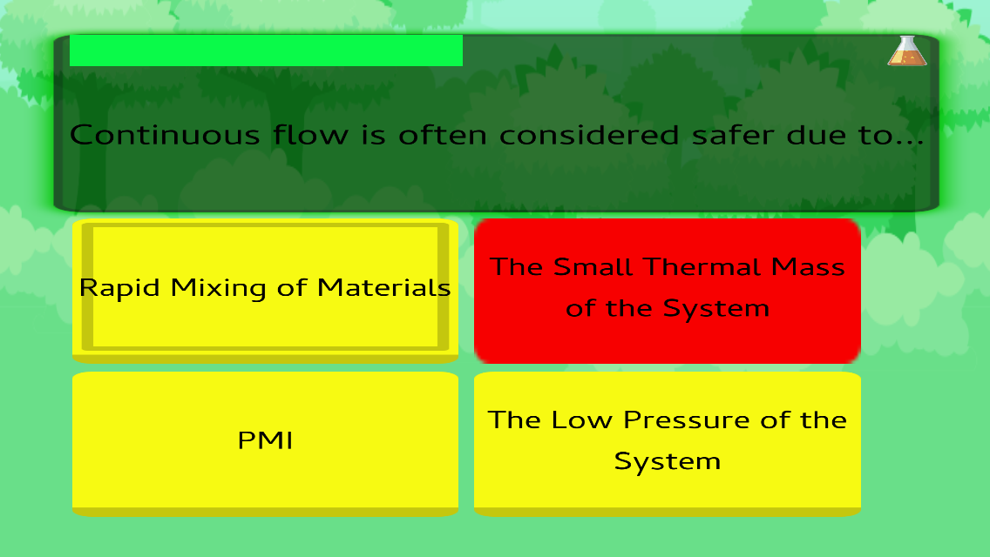
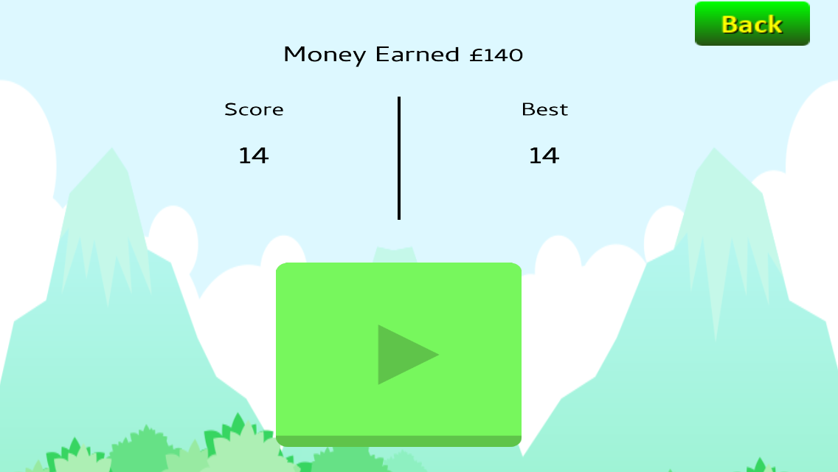

Figure 3. Two screenshots showing a representative multiple-choice quiz question answered incorrectly (left) and a record of the highest score achieved by the player (right).

Green Tycoon was implemented with undergraduate students at Augsburg University. Augsburg University’s student body is approximately 2,000 undergraduate students reflecting the diverse urban Cedar-Riverside neighborhood in which it resides.²³ It also is common for students (37%) to be first-generation university students. The students were taking the second semester of organic chemistry lectures with the majority studying biology, biopsychology, biochemistry, and chemistry. A set of pre-test questions based on the green chemistry content taught in the game was completed by students on an individual basis. Following this, Green Tycoon was introduced to the students where they were given one week to attempt to complete the game. During a follow-up session, a set of post-test questions were completed by each student. The material of the post-test was identical to that of the pre-test. Additionally, students completed a feedback survey. Pre/post test questions and a feedback survey are available as supporting information.

implementation of Green tycoon in chemistry
The resource was implemented with 33 students. Survey feedback was collected anonymously. 73%, or 24 of 33 students, completed the survey.

The survey questions were as follows:
- I enjoyed playing Green Tycoon.
- I found the gameplay to be engaging.
- I found the language used to be of an appropriate level.
- Green Tycoon is an innovative way to revise and learn green chemistry.
- I enjoyed being able to upgrade and progress through the game.
- Green Tycoon helped to place the real-world relevance of chemistry into context.
- I would recommend Green Tycoon to those studying a green chemistry module.
- Green chemistry is an important consideration when designing a synthetic route.

A Likert-style response scale was used to evaluate the student responses (to questions 1-8) with 5 being assigned to “Strongly Agree” and 1 being assigned to “Strongly Disagree”. These scores were multiplied by the number of responses of each type to generate mean values. Figure 4 shows the average score of each survey question (from 1-8) as given by the students. The range of the averages was from 3.8/5.0 (question 3) to 4.6/5.0 (question 8) and the overall average response (i.e. an average of the averages) was 4.1/5.0 – roughly corresponding to an average agree response to all questions.

Figure 4. Clustered average score of survey feedback by question number for (n = 24) students.

Figure 5 shows the percentage of each type of response for all of the survey questions as given by both students. Question 8 had the best response with 100% agreeing or strongly agreeing with the statement (and 61% strongly agreeing) “Green chemistry is an important consideration when designing a synthetic route.”. It was particularly pleasing to see that students appreciate the important role green chemistry has to play in the design of synthetic processes. Question 3 had the worst response, with just 75% agreeing or strongly agreeing with the statement “I found the language used to be of an appropriate level.”

Figure 5. Clustered responses of survey feedback by question number for (n = 24) students.

Students also responded to an open-ended question asking for suggestions for improving the game. These results were helpful and showed a high level of student engagement with the subject of green chemistry and systems thinking. Students requested more content and an increase in complexity perhaps reflecting results from Question 3 but in a positive sense. A particularly interesting suggestion asked for the creation of a “study tool” where earned knowledge from sequential upgrades was stored to be used later versus only in real-time in the application.
33 students completed the pre—test questions, returning an average score of 1.4 out of 18, indicating a poor knowledge of fundamental green chemistry concepts. Following one week of playing Green Tycoon, 23 of the 33 students (70%) completed the post-test questions, recording an average of 6.3/18.0 (an improvement of over four times the pre-test score). As such, this resource is likely to be well suited as an introduction to green chemistry at the undergraduate level. Instructors may wish to implement Green Tycoon as part of a pre-existing green chemistry lecture course or module or via integration with related courses where there is a natural link to green chemistry (e.g. catalysis, synthesis, polymer chemistry etc.).
Further to this report being a good example of a mobile application resource to introduce green chemistry, and more specifically, biorefinery concepts, this work serves as an excellent example of working with students as partners as part of their degree program to design and evaluate a resource in chemistry education. GameSalad has proven to be an excellent platform to enable those with no coding experience to create a mobile application (and in this case, one for game-based learning). Through this project, the student was able to utilize higher order skills to make a real product, Green Tycoon, which is not necessarily a common output of undergraduate research projects.

CONCLUSIONS
Green Tycoon is an enjoyable game serving as a good introduction to green chemistry, highlighting its importance and the impetus to transition away from unsustainable chemical processing to a biorefinery-based system. It is achieved by players adopting a systems thinking approach to the production of Yorkanone. The game is available as a mobile application and we also envision a future web-based version to increase accessibility. It can be played alone as part of independent learning though competition between students can be introduced using the in-built quiz functionality. It is envisaged that following implementation of the game, instructors can facilitate subsequent teaching either from a discipline-specific perspective and/or via a systems thinking approach. This work also serves as an example of working with students to design mobile applications for game-based learning in chemistry with no prior coding knowledge as part of a research project within the latter stages of an undergraduate degree program.

Associated content

Supporting Information
Information provided upon purchasing upgrades (DOCX)
Questions to measure learning gain (DOCX)
Feedback form (DOCX)
This material is available via the Internet at http://pubs.acs.org.

AUTHOR INFORMATION

Corresponding Author
*E-mail: glenn.hurst@york.ac.uk

Notes
The authors declare no competing financial interest.

ACKNOWLEDGEMENT
The authors wish to acknowledge Ethan Poppen and Madeleine Rasche for collating and producing the supporting information that outlines the detail provided upon upgrading each of the three characters in Green Tycoon.

REFERENCES
1. United Nations Sustainable Development Goals, 2015. https://sustainabledevelopment.un.org/?menu=1300 (Accessed Mar 29, 2020).
2. International Energy Agency – Bioenergy Task 42.
https://www.ieabioenergy.com/wp-content/uploads/2013/10/Task-42-Biobased-Chemicals-value-added-products-from-biorefineries.pdf (Accessed Mar 29, 2020).
3. Processum
https://www.processum.se/sv/ (Accessed Mar 29, 2020).
4. Summerton, L.; Hurst, G. A.; Clark, J. H. Facilitating active learning within green chemistry. Curr. Opin. Green Sustain. Chem. 2018, 13, 56-60.
5. Holme, T. A.; Hutchison, J. E. A central learning outcome for the central science. J. Chem. Educ. 2018, 95 (4), 499–501.
6. Mahaffy, P. G.; Krief, A.; Hopf, H.; Mehta, G.; Matlin, S. Reorienting chemistry education through systems thinking. Nat. Rev. Chem. 2018, 2, 0126.
7. Mahaffy, P. G.; Brush, E. J.; Haack, J. A.; Ho, F. M. Journal of Chemical Education Call for Papers – Special Issue on Reimagining Chemistry Education: Systems Thinking, and Green and Sustainable Chemistry. J. Chem. Educ. 2018, 95, 1689-1691.
8. Miller, J. L.; Wentzel, M. T.; Clark, J. H.; Hurst, G. A. Green Machine: A card game introducing students to systems thinking in green chemistry by strategizing the creation of a recycling plant. J. Chem. Educ. 2019, 96 (12), 3006-30013.
9. The safer chemical design game. https://gwiz.yale.edu (Accessed Mar 29, 2020).
10. Mellor, K. E.; Coish, P.; Brooks, B. W.; Gallagher, E. P.; Mills, M.; Kavanagh, T. J.; Simcox, N.; Lasker, G. A.; Botta, D.; Voutchkova-Kostal, A.; Kostal, J.; Mullins, M. L.; Nesmith, S. M.; Corrales, J.; Kristofco, L.; Saari, G.; Baylor Steele, W.; Melnikov, M. L.; Zimmerman, J. B.; Anastas, P. T. The safer chemical design game. Gamification of green chemistry and safer chemical design concepts for high school and undergraduate students. Green Chem. Lett. Rev. 2018, 11 (2), 103-110.
11. Hurst, G. A. Utilizing Snapchat to facilitate engagement with and contextualization of undergraduate chemistry. J. Chem. Educ. 2018, 95 (10), 1875–1880.
12. Winter, J.; Wentzel, M.; Ahluwalia, S. Chairs!: A mobile game for organic chemistry students to learn the ring flip of cyclohexane. J. Chem. Educ. 2016, 93 (9), 1657–1659.
13. Jones, O. A. H.; Spichkova, M.; Spencer, M. J. S. Chirality-2: Development of a multilevel mobile gaming app to support the teaching of introductory undergraduate-level organic chemistry. J. Chem. Educ. 2018, 95 (7), 1216–1220.
14. Koh, S. B. K.; Fung, F. M. Applying a quiz-show style game to facilitate effective chemistry lexical communication. J. Chem. Educ. 2018, 95 (11), 1996-–1999.
15. Lima, M. A. S.; Monterio, A. C.; da Silva Júnior, J. N.; Leite Junior, A. J. M.; de Andrade Matos, I. S.; Alexandre, F. S. O.; Nobre, D. J.; Monteiro, A. J.; da Silva Júnior, J. N. Game-based application for helping students review chemical nomenclature in a fun way. J. Chem. Educ. 2019, 96 (4), 801–805.
16. da Silva Júnior, J. N.; de Lima, P. R. S.; Lima, M. A. S.; Monteiro, A. C.; de Sousa, U. S.; Leite Junior, A. J. M.; Vega, K. B.; Monteiro, A. J. Time Bomb Game: Implementation and evaluation of a fun and challenging game reviewing the structural theory of organic compounds. J. Chem. Educ. 2020, 97 (2), 565–570.
17. GameSalad
https://gamesalad.com (Accessed Mar 29, 2020).
18. Green Tycoon for Android
https://play.google.com/store/apps/details?id=chem.york.greentycoon (Accessed Mar 29, 2020).
19. Green Tycoon for iOS
https://apps.apple.com/us/app/green-tycoon/id1457209101 (Accessed Mar 29, 2020).
20. Anastas, P. T.; Warner, J. C. Green Chemistry: Theory and Practice; Oxford University Press: New York, 1998.
21. Mackenzie, L. S.; Tyrrell, H.; Thomas, R.; Matharu, A. S.; Clark, J. H.; Hurst, G. A. Valorization of waste orange peel to produce shear-thinning gels. J. Chem. Educ. 2019, 96 (12), 3025-3029.
22. Jefferson, M. T.; Rutter, C.; Fraine, K.; Borges, G. V. B.; de Souza Santos, F. A. P.; Hurst, G. A. Valorization of sour milk to form bioplastics: friend or foe? J. Chem. Educ. 2020, Articles ASAP
23. Augsburg University
https://www.augsburg.edu/about/facts/ (Accessed Mar 29, 2020).

