Ultraviolet Photodetector Based on Mg_{0.67}Ni_{0.33}O Thin Film on SrTiO₃

Fahrettin Sarcan¹*, Sam Orchard², Balati Kuerbanjiang³, Aleksandar Skeparovski⁴, Vlado K. Lazarov² and Ayse Erol¹

¹Department of Physics, Faculty of Science, Istanbul University, Vezneciler, 34134, Istanbul, Turkey
²Department of Physics, University of York, Heslington, York, YO10 5DD, United Kingdom
³Department of Physics, University of Oxford, Parks Road, Oxford, OX1 3PU United Kingdom
⁴Ss. Cyril and Methodius University, Arhimedova 3, Skopje, 1000, North Macedonia
E-mail: * fahrettin.sarcan@istanbul.edu.tr

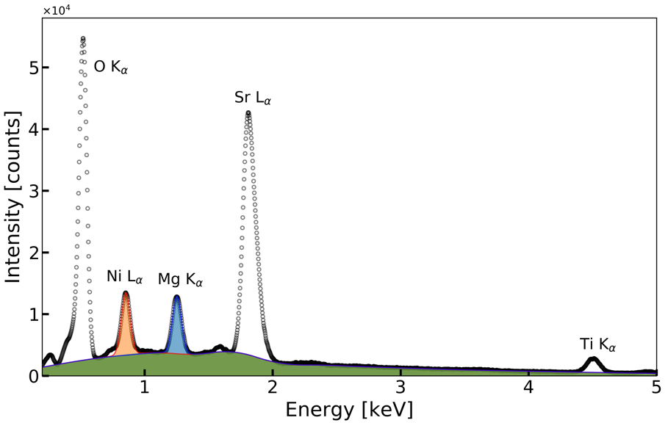
Supplementary figure: EDS analysis of the film and the substrate. Fitted peaks and the Bremsstrahlung are shaded with different colors.

