Can microclimate offer refuge to an upland bird species under climate change?

Dario Massimino¹, Colin M. Beale², Andrew J. Suggitt^{2,3,4}, Humphrey Q.P. Crick⁵, Nicholas A. Macgregor^{5,6}, Matthew J. Carroll⁷, Ilya M.D. Maclean³, James W. Pearce-Higgins¹

¹ British Trust for Ornithology, The Nunnery, Thetford, IP24 2PU, United Kingdom
² Department of Biology, University of York, Wentworth Way, York, YO10 5DD, United Kingdom
³ Environment and Sustainability Institute, University of Exeter, Penryn Campus, Penryn TR10 9FE, United Kingdom
⁴ Department of Geography and Environmental Sciences, Northumbria University, Newcastle-upon-Tyne NE1 8ST, United Kingdom
⁵ Natural England, Eastbrook, Shaftesbury Road, Cambridge, CB2 8DR, United Kingdom
⁶ Durrell Institute of Conservation and Ecology (DICE), School of Anthropology and Conservation, University of Kent, Canterbury, CT2 7NR, United Kingdom
⁷RSPB Centre for Conservation Science, The Lodge, Sandy, Bedfordshire SG19 2DL, United Kingdom

Correspondence
Dario Massimino, British Trust for Ornithology, The Nunnery, Thetford, Norfolk, IP24 2PU, United Kingdom. Email: dario.massimino@bto.org
ORCID IDs
Dario Massimino 0000-0002-5855-4060
Colin M Beale 0000-0002-2960-5666
Andrew J Suggitt 0000-0001-7697-7633
Humphrey QP Crick 0000-0002-5136-378X
Nicholas A Macgregor 0000-0002-7995-0230
Matthew J Carroll NA
Ilya MD Maclean 0000-0001-8030-9136
James W Pearce-Higgins 0000-0003-1341-5080

Abstract

Context Climate change is a severe threat to biodiversity. Areas with a high variety of microclimates may provide opportunities for species to persist in a changing climate.

Objectives Test the extent to which microclimate is an important determinant of the distribution of a widespread upland passerine, the meadow pipit Anthus pratensis, and whether microclimate becomes an increasingly important determinant of distribution towards the warm edge of the species’ range.

Methods We used models of the occurrence of meadow pipits based on data from an extensive survey to identify macroclimate and topographic associations, the latter as proxies of microclimate. We assessed magnitude and direction of the effects of microclimate and whether the magnitude of microclimate effects increases as macroclimate suitability declines.

Results The probability of meadow pipit occurrence is significantly correlated with macroclimate and microclimate. Microclimate accounts for about a third of the variation in occupancy probability and has a stronger effect than macroclimate at all three spatial scales considered. Elevation and topographical wetness index are positively correlated with meadow pipit occurrence, while insolation is negatively correlated. Elevation and macroclimate suitability show a positive interaction, while insolation and macroclimate suitability show a negative interaction.

Conclusions Microclimate substantially influences the distribution of the meadow pipit. For high latitude and upland species such as this, suitable areas on cool slopes could form the focus for conservation protection, as these areas are likely to become increasingly utilised and may remain the only locations occupied in otherwise unsuitable climate.

Keywords

Climate change, meadow pipit, microclimate, refugia, topography, upland species.

Introduction

Climate change is regarded as a severe long-term threat to biodiversity, likely to increase the risk of extinction faced by many species (Bellard et al. 2012; Jetz et al. 2007; Thomas et al. 2004). The shift of climatic zones will force species to move and track their climatic niche or adapt to the new climatic conditions (Maggini et al. 2011). Poleward and, to lesser extent, altitudinal range shifts in species’ distributions have already been observed (see e.g. Chen et al. 2011; Tayleur et al. 2015; Hickling et al. 2006; Parmesan et al. 1999; Zuckerberg et al. 2009). However, range expansions have been documented more frequently than range retractions (Thomas and Lennon 1999; Massimino et al. 2015). Many mechanisms have been suggested to explain the prevalence of range expansions, including different limiting processes at cold and warm margins (Sunday et al. 2012), higher importance of rainfall at warm margins (Thomas and Lennon 1999), accumulation of an extinction debt (Dullinger et al. 2012) and persistence in suitable microclimate despite the surrounding area becoming unsuitable (Hampe and Jump 2011; Maclean et al. 2015).
Microclimate describes the climate experienced by individuals, often at the scale of metres or smaller (Suggitt et al. 2011), which contrasts with descriptors of climate over larger spatial scales such as kilometres or larger, that we refer to as macroclimate. The ability of a species to persist in suitable microclimate may have a significant impact upon the future effectiveness of protected areas, a key tenet of conservation practice (Araújo et al. 2011; Beale et al. 2013; Johnston et al. 2013). Areas of environmental heterogeneity, with a higher variety of microclimates, are likely to provide opportunities for species to persist in a changing climate (Suggitt et al. 2018). For this reason, it has been suggested that management should seek to maximise heterogeneity, and that existing areas of heterogeneity with a greater range of microclimates should be prioritised for protection (Hannah et al. 2007; Hodgson et al. 2009). Understanding whether species distributions are affected by microclimate, particularly in parts of a species’ range that is relatively unsuitable climatically, is an essential first step to assess the potential for species to persist under a changing climate.
The tracking of climatic-induced changes in distribution has been best studied in plants (Maclean et al. 2015) and ectothermic animals (Bennie et al. 2013; Davies et al. 2006; Thomas et al. 1999). Ectotherms are widely considered as vulnerable to climate change because their ability to perform basic physiological functions typically rises gradually with temperature to an optimum and then drops rapidly to a critical thermal maximum (Huey and Stevenson 1979; Deutsch et al 2008). In contrast, endotherms maintain their body at a metabolically optimal temperature, which is thus decoupled to a large degree from the direct influence of ambient heat (Khaliq et al 2014). Even so, endotherms can still be affected by variations in ambient temperature, either directly as a result of increased energetic expenditure or indirectly through variations in the availability of food (Oswald et al 2010). Further, there is increasing evidence that species are threatened by climate change mainly through such impacts on the species with which they interact (Ockendon et al. 2014).
Previous research on the importance of microclimate in determining the distribution or range changes of birds has collected mixed evidence. For example, Bradbury et al. (2011) demonstrated the role of macroclimate in facilitating the range expansion of the Dartford warbler Silvia undata in the United Kingdom towards higher areas but did not find strong evidence of a similar role of microclimate. Conversely, Calladine & Bray (2012) found that the occurrence of breeding Whinchat Saxicola rubetra in the UK uplands was associated with aspect, particularly at low elevations, suggesting that even for some bird species, microclimate can play a role in determining the distribution of individuals. Fine-scale variation in temperature has also been found to influence conditions within bird nests that could then influence breeding success (Dawson et al. 2005, Rockweit et al. 2012). Given this variation and the limited number of studies published, it is unclear where and when microclimate may be important. For ectotherms, microclimate is an increasingly important driver of habitat availability towards the edge of their ranges (Thomas et al. 1999), but this has not been tested in endothermic species.
Species associated with mountain habitats are particularly threatened by warming, because, amongst other things, they are likely to suffer substantial reductions in suitable land simply because of the smaller area existing at higher elevations (Wilson et al. 2005). However, mountains are also extremely heterogeneous environments where topography has a strong impact on microclimate. Notably, spatial variation in temperature and moisture availability is often much greater in mountainous than in lowland areas (Suggitt et al. 2011). The wider range of available microclimates can provide opportunities for species to survive changes in macroclimate by shifting towards more suitable areas within a landscape without having to move large distances (Scherrer and Körner 2011). These climate change refugia are increasingly suggested as a focus for potential conservation strategies (Keppel et al. 2015; Morelli et al. 2016).

Here, we use extensive fine-grained data on the distribution of a passerine, the meadow pipit Anthus pratensis, that is widespread in topographically complex upland (rough grassland, moorland, blanket bog and montane) habitats in Great Britain to investigate the potential influence of microclimate on the distribution of an endotherm. A key mechanism through which insectivorous upland birds like the meadow pipit can be vulnerable to climate change, and therefore potentially be sensitive to microclimate, is through impacts on the abundance of their prey (Pearce-Higgins 2010, Pearce-Higgins et al. 2010). Meadow pipits feed heavily on Diptera such as craneflies (Tipulidae) (Pearce-Higgins 2010), whose abundance is sensitive to localised high temperatures and drying out of the surface layers of the peat or soil (Pearce-Higgins et al. 2010, Carroll et al. 2011, Carroll et al. 2015). Given that meadow pipit select areas of high insect abundance (including tipulids) for foraging (Douglas et al. 2010), it is plausible that meadow pipits might show selection for cool or damp microclimate. More generally, in common with many other upland birds, meadow pipit abundance varies with vegetation cover and structure (Pearce-Higgins and Grant, 2006), which is also sensitive to climate (Pearce-Higgins & Green 2014), and has shown evidence for an upwards elevation shift from 1994 to 2009 (Massimino et al. 2015), further emphasising the potential likelihood of an association with cooler temperatures.
Using bioclimate models of range extent, we test, firstly, the extent to which microclimate is an important determinant of meadow pipit distribution, and secondly, whether microclimate becomes an increasingly important determinant of distribution towards the edge of the species’ range, which would be our theoretical expectation. We chose the meadow pipit as a model species for several reasons. Firstly, it is a predominantly northern and upland species in the study area, which makes it potentially more vulnerable to climate change than southern lowland species (Renwick et al. 2012). Secondly, a large amount of census data is available, as the meadow pipit is widespread across the British uplands where it is often the commonest breeding species (Balmer et al. 2013; Pearce-Higgins and Grant 2006). Thirdly, Britain is one of the most important strongholds for the meadow pipit, with an estimated 1.9 million breeding pairs, comprising an estimated 17% of the European population (Musgrove et al. 2013). The species has recently become of conservation interest, as in the last two decades, it has undergone a population decline throughout Europe (EBCC 2018), including the UK (Harris et al. 2019). It has recently been added to the global red list of birds, being classified as “near threatened” (BirdLife International 2018) and is thus a species of conservation concern.

Methods

Bird data

This study used data from the BTO/JNCC/RSPB Breeding Bird Survey (BBS), an extensive volunteer survey used to monitor bird populations in the United Kingdom (Harris et al. 2019). The BBS is undertaken on a stratified random sample of 1-km squares. Each 1-km square is visited twice between April and July and birds are recorded along two 1-km line transects, each one divided into five 200-m sections. Each section is also classified according to habitat using a hierarchical coding system of nine classes (Crick 1992). The survey season overlaps very well with the breeding season of the meadow pipit, which in Britain starts in the second week of April and peaks between the second and the third week of May, depending on latitude (Cramp & Simmons 1988). Our research therefore focuses on the breeding distribution as the species is a partial migrant in Britain and moves to more lowland and southern areas in winter. For the purposes of this analysis, we considered occurrence data at the 200-m transect section level from years 2007 to 2012. We chose a 6-year period to ensure an appropriate balance between including enough years to have a large sample size, but so as to avoid incorporating any periods of significant change. The species was shown to have a stable population during the study period (Harris et al 2019). We considered only sections where the main land cover was likely to provide habitat for meadow pipits; specifically comprising semi-natural grassland/marsh, heathland and bogs, or inland rock, excluding all other land cover types. By using data from 6 consecutive years and filtering to exclude non-suitable transects, we reduced the variability in the data which is not due to climate, whilst also ensuring that the findings are not simply a function of the weather in one particular year. After filtering non-suitable transects, a total of 4558 transect sections in 956 different 1-km squares and 685 different 10-km squares were left (Fig. 1). To avoid pseudoreplication of the data due to the double sampling within a year, we only used a single data point for each year, with the meadow pipit considered to be occurring if it was detected in at least one of the two visits. Transects which were surveyed only once in a given year were excluded from the analysis for that year. The total sample size was 4890.

Macroclimate model

Meadow pipit distribution at 10 km resolution was modelled using the two-step approach of Beale et al (2013). This applies a Bayesian, spatially explicit (Conditional Autoregressive) Generalised Additive Model (GAM) to species’ distribution data in order to separate climatic, spatial and random components in determining the distribution of each species, and thus accounts for potential spatial autocorrelation in the data (Beale et al. 2010). During the first step, the European meadow pipit distribution (Hagemeijer and Blair, 1997) was modelled as function of four bioclimate variables from the CRU TS 1.2 dataset for 1961-90 (Mitchell et al. 2004): mean temperature of the coldest month (MTCO), growing degree days (GDD5), the coefficient of variation of temperature (CVTemp) and soil moisture (soilWater). MTCO was calculated by simply finding the lowest mean monthly temperature for each cell. GDD5 was calculated by fitting a spline to mean monthly temperatures for each cell to convert monthly data to daily estimates, and then summing the accumulated daily temperature above 5°C. CVTemp was calculated by converting mean monthly temperatures to the Kelvin scale, and then dividing the standard deviation by the mean for each cell. Finally, soilWater was calculated following the bucket model described by Prentice et al. (1992), which takes inputs of temperature, rainfall, % sun/cloud and soil water capacities, then calculates the soil water balance over the year for each cell. This European-scale model was initially constructed using uninformative priors to describe the relationship between occurrence and climate, which were described by the flexible GAM relationships. Once converged, a second model was fitted to the 10x10-km meadow pipit distribution data from Great Britain in 1988-1991 (Gibbons et al. 1993) using the UKCP09 climate data (Murphy et al. 2009) for the same 1961-1990 period as used when analysing the European data. For these models, informative priors were applied from the European-scale model so that any strong climatic signal based on the European distribution would remain essentially unchanged when modelled using only data from Great Britain, unless the evidence for a different climatic signal within Great Britain was strong (see Beale et al. 2014 for full details of the model).

Microclimate data

Directly observed microclimatic data were not available at the required spatial resolution across the UK, so we used topographical information to calculate microclimate proxies. This is possible for open, upland environments where topography is the most important factor contributing to microclimate, and the magnitude of its spatial variation is similar to the amount of temperature change predicted from anthropogenic climate change (Bennie et al. 2008). We therefore summarised microclimate using two variables that describe variation in temperature and one related to variation in moisture availability.
All of the following variables were derived from digital elevation data from the Shuttle Radar Topography Mission at 90 m resolution (Farr et al. 2007), which was resampled to 100 m for consistency with the UK national grid (Suggitt et al. 2014)
First, we considered variation in relative elevation, likely to be strongly correlated with fine-scale variation in mean temperature, by including the difference (expressed in meters) between the elevation of the mid-point of each 200-m transect section and the mean of the 10-km square within which the transect section falls.
Second, we used the midsummer solar index as a proxy of summer maximum temperature, likely to reflect the period when temperature may be limiting (Pearce-Higgins et al. 2010). This was calculated as the proportion of direct full beam radiation that reaches the ground, which is a function of slope, aspect, topographic shading and sun position (itself a function of latitude, longitude, date and time), and was summarised as mean hourly solar radiation on the summer solstice (Maclean et al. 2015).
Third, we calculated a measure of soil moisture (the topographic wetness index) from estimated surface run-off, using the equation by Beven and Kirkby (1979):
topographic wetness index = ln (a / tan β)
where a is the area that contributes to flow accumulation and β is the slope angle (see also Suggitt et al 2014). Higher values are where the contributing area is large and the slope angle is little, while lower values are on mountain tops (very little contributing area) and steep slopes.
The list of microclimatic variables with descriptive statistics is shown in Table 1.

Statistical analysis

We modelled the occurrence of meadow pipits as a function of both macroclimate (as a measure of large-scale climate suitability and proximity to the species’ range edge) and microclimate variables. Secondly, we tested the extent to which the magnitude of microclimate effects varies with macroclimate suitability, through interactions between macroclimate suitability and the solar index, wetness index and relative elevation. We tested the following hypotheses.
- Meadow pipit occurrence is positively correlated with the difference in elevation between the 200-m transect section and the mean of the 10-km square (Pearce-Higgins et al. 2010), negatively correlated with the solar index and positively correlated with the topographical wetness index. Our expectations are based on the importance of craneflies (Tipulidae) in meadow pipit diet, as tipulid abundance and distribution are negatively affected by temperature and positively affected by moisture availability (Carroll et al. 2011; Carroll et al. 2015; Pearce-Higgins 2010, Pearce-Higgins et al. 2010).
- The effects of microclimate are strongest where macroclimate suitability is lowest, resulting in significant interactions between macroclimate suitability and the microclimate variables. Given the northern and upland distribution of meadow pipits in the UK, variation in macroclimate suitability largely represents a gradient from the south (low macroclimate suitability) to the north (high suitability).
The first hypothesis was tested by modelling the probability P_{ijkv} of meadow pipit being recorded in each visit v to the transect section k in the 1-km square j in the 10-km square i. This probability was modelled as a function of both fixed effects and random effects:

logit(P_{ijkv}) = β₀ + β₁m_{i} + β₂h_{k} + β₃s_{k} + β₄w_{k} + z_{1,i} + z_{2,j} + z_{3,k} + ε_{i,j,k,v} (1)

where β₀, ..., β₃ are the estimated fixed effect coefficients for the macroclimate within the 10-km square (m_{i}), the elevation of the transect section relative to the 10-km square (h_{k}), the index of the transect section midsummer insolation (s_{k}) and the index of the transect section topographic wetness (w_{k}). The three random effects are each normally distributed and represent the effect of 10-km square (z_{1,i}), 1-km square nested within 10-km square (z_{2,j}), and transect section nested within 1-km square (z_{3,k}).
In order to examine the relative importance of macroclimate and microclimatic suitability in determining meadow pipit occurrence at different scales we documented changes to residual covariance at the 10-km, 1-km and transect section level upon the insertion of first the macroclimate variable m, and then the inclusion of the microclimate variables (h, s and w). Thus, we first described covariance in a null model with no fixed effect:

logit(P_{ijkv}) =β₀ + z_{1,i} + z_{2,j} + z_{3,k} + ε_{i,j,k,v} (2)

Macroclimatic suitability was then included as the sole fixed effect:

logit(P_{ijkv}) = β₀ + β₁m_{i} + z_{1i} + z_{2j} + z_{3k} + ε_{i,j,k,v} (3)

Finally, this was compared to the full model (1).
The second hypothesis was tested by additionally testing the significance of interactions between macroclimate suitability P_{M} and each of the microclimate variables as follows:

logit(P_{ijkv}) = β₀ + β₁m_{i} + β₂h_{k} + β₃s_{k} + β₄w_{k} + β₅m_{i}h_{k} + β₆m_{i}s_{k} + β₇m_{i}w_{k} + z_{1,i} + z_{2,j} + z_{3,k} + ε_{i,j,k,v} (4)

where β₅, β₆, β₇ are model coefficients associated with the interactions between macroclimate and microclimate. This allowed us to describe the importance of variation in microclimate with increasing macroclimate suitability in driving additional variation in meadow pipit occurrence at the three spatial scales considered of 10-km, 1-km and transect level. A final model was simplified by backwards selection of non-significant (p > 0.05) variables from model (4). Individual relationships between variables and meadow pipit occurrence were plotted by fixing the values of the other explanatory variables to their median values. We checked for spatial autocorrelation in the residuals by calculating Moran’s I for distance classes up to 30 km using the ‘spdep’ package (Bivand et al 2013).
All generalised linear mixed models were fit using Penalised Quasi-Likelihood (function glmmPQL of the R package MASS, Venables and Ripley 2002; R Core Team 2016). Maps were produced using the R libraries rgdal (Bivand et al 2013), raster (Hijmans 2018), and RcolorBrewer (Neuwirth 2014).
This paper forms part of what was a much wider programme of work on microclimate. For more details of our methods and that wider work, see Suggitt et al (2014), some of which has already been published elsewhere (Suggitt et al. 2018).

Results

Macroclimate model

Our model predicted high probabilities of meadow pipit occurrence across north-western Britain, Wales and with additional high probabilities in the moorlands of the Pennines and Devon (Fig. 2). It also identified the southern heaths as having probabilities of occurrence above 50%, with particularly low probabilities estimated only for the West Midlands and a few other areas of central England, accurately reflecting the more or less continuous distribution of the species in preferred upland areas and patchier breeding distribution elsewhere (Balmer et al. 2013). Significant gradients of suitability are evident around the core upland areas, demonstrating suitability of this species for the study undertaken. Note that measures of predictive ability such as Kappa statistics or AUC are unsuitable for occupancy models, and the inclusion of a random effect means mapped suitability is always strongly related to distribution (Beale et al. 2014).

Microclimate importance

The probability of meadow pipit occurrence in a transect section was significantly affected by both macroclimate (m) and each of the microclimate variables (model 1). As expected, meadow pipit occurrence was positively correlated with topographical wetness index (p=0.047) and negatively correlated with the solar radiation index (p<0.001), which supports our hypotheses, although the former relationship was relatively weak. Meadow pipit occurrence was also positively correlated with relative elevation (the difference between the elevation of the transect section and the mean elevation of the 10-km square) (p<0.001), confirming the preference of this species for cooler locations within the wider landscape (Table 2).
Changes in the distribution of the variance components between random effects can be used to assess the relative importance of macroclimate and microclimate in influencing the occurrence of meadow pipits at different spatial scales (Table 3). Firstly, by partitioning the variance components between different random effects it is clear that the majority (54.3%) of variation in meadow pipit occurrence at the 200-m scale can be attributed to 10-km square identity (5.092 as a proportion of summed variance across random effects), 24.8% to 1-km squares and 20.9% between individual transect-sections within 1-km squares. The addition of macroclimatic suitability (model 3) accounts for 6.9% (1-(4.740/5.092)) of the variation in fine-scale meadow pipit occurrence at the 10-km level. In other words, 6.9% of the variation in the occurrence of meadow pipits at the 200-m transect section level that can be attributed between 10-km squares is related to macroclimate, but none of the variation at the 1-km and transect-section level. This is entirely as expected, given macroclimate was predicted at a 10-km square resolution. The inclusion of the microclimate terms accounts for a further 19.8%, 31.1% and 20.1% of variance in meadow pipit occurrence, at the 10-km, 1-km and transect section levels respectively. This indicates that not only does microclimate and topography affect the distribution of meadow pipits within 1-km squares, but it also accounts for significant proportions of the variation in the probability of transect-section occupancy, a surrogate of abundance, between 1-km squares and 10-km squares, and appears more important than macroclimate, even at that large scale.

Interactions between microclimate and macroclimate.

The model (4) with the interactions between microclimatic variables and macroclimate suitability showed that the importance of both elevation and midsummer solar index varied in relation to macroclimate suitability (Table 4, Fig. 3).
The positive interaction between relative elevation (h) and macroclimate suitability (m) means that meadow pipits were more likely to occur at cooler, higher elevation locations in the core of their range with maximum macroclimatic suitability (Fig. 4a). The slope of the association between meadow pipit occurrence with elevation increases with increasing macroclimatic suitability.
The negative interaction between midsummer solar index and macroclimate suitability (Fig. 4b) shows that the probability of meadow pipits being found on transect sections with low macroclimate suitability was greatest at sites with the lowest midsummer solar index , whilst when macroclimate suitability was high, the effect of the midsummer solar index was less important. Thus, meadow pipits preferentially favour cool slopes, particularly in areas of low macroclimate suitability, whilst this preference is less important where macroclimate suitability is high and meadow pipits appear widespread. The interaction between the topographic wetness index and macroclimate was non-significant (P = 0.208), and deleted from the final model (Fig. 4c).
Combined, the effect of these interactions between macroclimatic suitability and measures of microclimate explained a relatively small proportion of the residual variation in meadow pipit occurrence at either the 10-km, 1-km or transect section scale, accounting for additional 3.6%, 0.9% and 0.8% of the variation in occurrence respectively (Table 3).
The spatial autocorrelation of the residuals, measured as Moran’s I, was negligible for all distances, with the highest value being I=0.041 for the distance class 0–200 m.

Discussion

There have been relatively few studies of the impact of microclimate on fine-scale distributions of birds (but see e.g. Frey et al. 2016; Ceresa et al. 2020). Whilst a number of studies have examined the effects of microclimatic variation of nest sites upon measures of the condition of chicks or productivity of those nests (e.g. Burton 2006; Dawson et al. 2005; Rockweit et al. 2012), our aim was to test the impact that microclimate has upon the fine-scale (200-m scale) distribution of birds during the breeding season and, by examining the importance of this variation at different spatial scales, to investigate the relative importance of microclimate in influencing abundance. The mixed modelling approach that we used allowed us to investigate how the variation in bird occurrence is partitioned across three different spatial scales, effectively accounting for the spatially nested structure of the variance and cross-scale correlations (Battin & Lawler 2006).

Our first conclusion is that fine-scale variation in topography, as measured by relative elevation, solar index and topographic wetness, strongly influences where meadow pipits are located in the landscape, explaining about a third of the variation in the probability of meadow pipit occurrence at a fine scale. These factors are also influential in determining variation in the distribution of meadow pipits between 1-km squares and 10-km squares. Previous work has shown that elevation alone can explain almost a quarter of the variation in meadow pipit abundance between 200ha plots (Pearce-Higgins and Grant 2006), some of which, our results suggest, may be directly attributable to microclimatic associations. These apparent associations of meadow pipits with high elevations, cool slopes and wet locations, can be explained by reference to their ecology and that of their prey, whose abundance is positively correlated with soil moisture and negatively with summer temperature (Pearce-Higgins 2010; Pearce-Higgins et al. 2010, Carroll et al. 2011). In that context, the stronger associations with elevation and solar radiation (both P < 0.001), compared to topographical wetness (P = 0.047), may indicate that temperature effects, related to both solar radiation and elevation are more important than soil moisture. This could be because temperature has a multitude of impacts on meadow pipits, not just through the drying out of the soil negatively affecting tipulids, but potentially positively affecting the abundance of other insect prey, or even on habitat condition. Alternatively, given the complexities of hydrology, the topographical wetness index may simply be a poorer descriptor of the conditions experienced by the meadow pipits than the temperature-related measures of microclimate. Given the importance of heterogeneity in topography in determining the abundance or occurrence of a wide range of upland bird species (e.g. Buchanan et al. 2017), these findings may be widely applicable. For example, another bird species for which our results could be important is whinchat, whose altitudinal distribution varies significantly between north- and south-facing slopes in a manner consistent with temperature limiting their occurrence (Calladine and Bray 2012).
Secondly, we considered the extent to which the importance of microclimate varied with decreasing suitability of macroclimatic conditions, as assessed by the outputs from the macroclimate suitability modelling framework of Beale et al. (2014). Previous work has shown how microclimate may be an increasingly important driver of occurrence towards a species range edge in some invertebrate groups, such as butterflies (Thomas et al. 1999; Davies et al. 2006; Oliver et al. 2009) and ants (Thomas et al. 1999), but not others, such as ground beetles (Gillingham et al. 2012). Here we find evidence that this is the case for solar insolation, but not for elevation or topographic wetness. Thus, we find that in warmer areas (lower macroclimatic suitability) meadow pipits are increasingly found on cooler slopes (Fig. 4), but when macroclimate suitability is high, solar index has a weaker effect on occurrence. However, this interaction appeared to be of relatively limited importance in terms of actually accounting for variation in the occurrence of meadow pipits on the ground. Unexpectedly, we found evidence for the opposite interaction than expected for the elevation, with meadow pipits apparently showing stronger selection for higher elevations in the more climatically suitable part of its range, avoiding areas of lower elevation (Fig. 4). This may reflect stronger habitat gradients with elevation in more mountainous areas which may mean that the suitability of lower elevation habitats in these core areas is reduced. Although more work is required to test this further, this does provide only partial support for our hypothesised interaction between microclimate and macroclimate.

There is growing evidence that microclimate can play an important role in buffering extinction risk from climate change, at least for plants and insects (Suggitt et al. 2018). Building on the work presented here, equivalent analysis looking at changes in species’ persistence through time as a function of microclimate should be undertaken for endothermic vertebrates such as upland and mountain birds. Given that they have undergone recent population declines and elevation shifts over the last two decades, meadow pipits would be a good model species for this.
If deteriorating climate suitability leads upland species’ ranges to fragment and persist only within particular microclimates, then further work is required to consider their vulnerability to habitat fragmentation. Although the meadow pipit currently has a very large and mostly continuous range (BirdLife International 2018), an extensive loss of suitable habitats and climate (e.g. Massimino et al. 2017) will likely increase the fragmentation of its populations. Given their migratory behaviour and relatively low level of natal dispersal (Hötker 1982), meadow pipits are probably less sensitive to the effects of fragmentation than some other, less dispersive upland birds for whom the persistence in small areas of refugia within otherwise unsuitable climate may increase their vulnerability to the threats that are typical of relict species (e.g. Rehnus et al 2018). To examine this further, a natural extension of our work could be to incorporate climate projections (e.g. UKCP18, Lowe et al 2018) with the topographic data that we used, to project likely future shifts in microclimate suitability under different climate change scenarios, which ultimately could be incorporated into models of climate change impact on species’ abundance. Previous research on impacts of future climate change of British bird population showed potential declines in meadow pipit population size between 50% and 80%, depending on the scenario and time-period considered (Massimino et al 2017), suggesting that future population declines may be substantial even in areas where the species could persist.
To conclude, these results suggest that in a changing climate, where warming may reduce large-scale climatic suitability for meadow pipits in the UK (Renwick et al. 2012; Massimino et al. 2017), topography and microclimate may influence their distribution. Thus, in principle, for northern and upland species such as this, climate change refugia consisting of areas of potentially suitable habitat on cool slopes with a low solar index could form the focus for conservation protection, as they will become increasingly utilised, and potentially may remain the only locations occupied in conditions of unsuitable climate.

Acknowledgments

The analysis of this work was funded by Natural England, whilst the production of this paper was funded by the British Trust for Ornithology, with further support from Natural England. The UK data used originated from the Breeding Bird Survey, a Partnership jointly funded by the British Trust for Ornithology, Royal Society for the Protection of Birds and Joint Nature Conservation Committee, with fieldwork conducted by volunteers, to whom we are very grateful. We should also like to thank Alison Johnston for her analytical advice and two anonymous reviewers for their constructive comments.

References

Araújo MB, Alagador D, Cabeza M, Nogués-Bravo D, Thuiller W (2011) Climate change threatens European conservation areas. Ecol Lett 5:484–492. https://doi.org/10.1111/j.1461-0248.2011.01610.x
Balmer DE, Gillings S, Caffrey B, Swann RL, Downie IS, Fuller RJ (2013) Bird Atlas 2007-11: the breeding and wintering birds of Britain and Ireland. British Trust for Ornithology, Thetford
Beale CM, Baker NE, Brewer MJ, Lennon JJ (2013) Protected area networks and savannah bird biodiversity in the face of climate change and land degradation. Ecol Lett 16:1061–1068. https://doi.org/10.1111/ele.12139
Beale CM, Brewer MJ, Lennon JJ (2014) A new statistical framework for the quantification of covariate associations with species distributions. Methods Ecol Evol 5:421–432. https://doi.org/10.1111/2041-210X.12174
Beale CM, Lennon JJ, Yearsley JM, Brewer MJ, Elston DA (2010) Regression analysis of spatial data. Ecol Lett 13:246–264. https://doi.org/10.1111/j.1461-0248.2009.01422.x
Bellard C, Bertelsmeier C, Leadley P, Thuiller W, Courchamp F (2012) Impacts of climate change on the future of biodiversity. Ecol Lett 15:365–377. https://doi.org/10.1111/j.1461-0248.2011.01736.x
Bennie J, Huntley B, Wiltshire A, Hill MO, Baxter R (2008) Slope, aspect and climate: Spatially explicit and implicit models of topographic microclimate in chalk grassland. Ecol Model 216:47–59. https://doi.org/10.1016/j.ecolmodel.2008.04.010
Bennie J, Hodgson JA, Lawson CR, Holloway CTR, Roy DB, Brereton T, Thomas CD, Wilson RJ (2013) Range expansion through fragmented landscapes under a variable climate. Ecol Lett 16:921–929. https://doi.org/10.1111/ele.12129
Beven KJ, Kirkby MJ (1979) A physically based, variable contributing area model of basin hydrology. Hydrolog Sci J 24:43–69. https://doi.org/10.1080/02626667909491834
BirdLife International (2018) Anthus pratensis. The IUCN Red List of Threatened Species 2018: e.T22718556A131986875. https://dx.doi.org/10.2305/IUCN.UK.2018-2.RLTS.T22718556A131986875.en. Accessed 07 May 2020.
Bivand RG, Pebesma EJ, Gómez-Rubio V (2013) Applied spatial data analysis with R, second edition. Springer, New York
Bradbury RB, Pearce-Higgins JW, Wotton SR, Conway GJ, Grice PV (2011) The influence of climate and topography in patterns of territory establishment in a range-expanding bird. Ibis 153:336–344. https://doi.org/10.1111/j.1474-919X.2011.01106.x
Buchanan GM, Pearce-Higgins JW, Douglas DJT, Grant MC (2017) Quantifying the importance of multi-scale management and environmental variables on moorland bird abundance. Ibis 159:744–756. https://doi.org/10.1111/ibi.12488
Burton NHK (2006) Nest orientation and hatching success in the tree pipit Anthus trivialis. J Avian Biol 37:312–317. https://doi.org/10.1111/j.2006.0908-8857.03822.x
Calladine J, Bray J (2012) The importance of altitude and aspect for breeding Whinchats Saxixola rubetra in the uplands: limitations of the uplands as a refuge for a declining, formerly widespread species? Bird Study 59:43–51. https://doi.org/10.1080/00063657.2011.623767
Carroll, MJ, Dennis P, Pearce-Higgins JW, Thomas CD (2011) Maintaining northern peatland ecosystems in a changing climate: effects of soil moisture, drainage and drain blocking on craneflies. Glob Change Biol 17:2991–3001. https://doi.org/10.1111/j.1365-2486.2011.02416.x
Carroll MJ, Heinemeyer A, Pearce-Higgins JW, Dennis P, West C, Holden J, Wallage ZE, Thomas CD (2015) Hydrologically driven ecosystem processes determine the distribution and persistence of ecosystem-specialist predators under climate change. Nat Commun 6:7851. https://doi.org/10.1038/ncomms8851
Ceresa F, Brambilla M, Monrós JS, Rizzolli F, Kranebitter P (2020) Within-season movements of Alpine songbird distributions are driven by fine-scale environmental characteristics. Sci Rep 10:5747. https://doi.org/10.1038/s41598-020-62661-0
Chen I-C, Hill JK, Ohlemüller R, Roy D B, Thomas CD (2011) Rapid range shifts of species associated with high levels of climate warming. Science 333:1024–1026. https://doi.org/10.1126/science.1206432
Cramp S, Simmons KEL (1988) The Birds of the Western Palearctic. Vol. V, Oxford University Press, Oxford.
Crick HQP (1992) A bird-habitat coding system for use in Britain and Ireland incorporating aspects of land-management and human activity. Bird Study 39:1–12. https://doi.org/10.1080/00063659209477092
Davies ZG, Wilson RJ, Coles S, Thomas CD (2006) Changing Habitat Associations of a Thermally Constrained Species, the Silver-Spotted Skipper Butterfly, in Response to Climate Warming. J Anim Ecol 75:247–256. https://doi.org/10.1111/j.1365-2656.2006.01044.x
Dawson RD, Lawrie CC, O'Brien EL (2005) The importance of microclimate variation in determining size, growth and survival of avian offspring: experimental evidence from a cavity nesting passerine. Oecologia 144:499–507. https://doi.org/10.1007/s00442-005-0075-7
Deutsch CA, Tewksbury JJ, Huey RB, Sheldon KS, Ghalambor CK, Haak DC, Martin PR (2008) Impacts of climate warming on terrestrial ectotherms across latitude. PNAS 105: 6668–6672. https://doi.org/10.1073/pnas.0709472105
Douglas DJT, Evans DM, Redpath SM (2010) Selection of foraging habitat and nestling diet by Meadow Pipits Anthus pratensis breeding on intensively grazed moorland. Bird Study 55: 290-296
Dullinger S, Gattringer A, Thuiller W, Moser D, Zimmermann NE, Guisan A, Willner W, Plutzar C, Leitner M, Mang T, Caccianiga M, Dirnböck T, Ertl S, Fischer A, Lenoir J, Svenning J-C, Psomas A, Schmatz DR, Silc U, Vittoz P, Hülber K (2012) Extinction debt of high-mountain plants under twenty-first-century climate change. Nat Clim Change 2:619–622. https://doi.org/10.1038/nclimate1514
EBCC (2018) Trends of common birds in Europe, 2018 update. https://pecbms.info/trends_2018/ Accessed 3 May 2019
Farr TG. Rosen PA, Caro E, Crippen R, Duren R, Hensley S, Kobrick M, Paller M, Rodriguez E, Roth L, Seal D, Shaffer S, Shimada J, Umland J, Werner M, Oskin M, Burbank D, Alsdorf D (2007) The Shuttle Radar Topography Mission. Rev Geophys 45: RG2004. https://doi.org/10.1029/2005RG000183
Frey SJK, Hadley AS, Betts MG (2016) Microclimate predicts within‐season distribution dynamics of montane forest birds. Divers Distrib 22:944–959. https://doi.org/10.1111/ddi.12456
Gibbons DW, Reid JB, Chapman RA (1993) The New atlas of breeding birds in Britain and Ireland, 1988-1991. T. & A.D. Poyser , London
Gillingham PK, Palmer SCF, Huntley B, Kunin WE, Chipperfield JD, Thomas CD (2012) The relative importance of climate and habitat in determining the distributions of species at different spatial scales: a case study with ground beetles in Great Britain. Ecography 35:831–838. https://doi.org/10.1111/j.1600-0587.2011.07434.x
Hagemeijer EJM, Blair MJ (1997) The EBCC Atlas of European Breeding Birds: Their distribution and abundance. T. & A.D. Poyser , London
Hampe A, Jump AS (2011) Climate relicts: past, present, future. Annu Rev Ecol Evol S 42:313–333. https://doi.org/10.1146/annurev-ecolsys-102710-145015
Hannah L, Midgley G, Andelman S, Araújo M, Hughes G, Martinez-Meyer E, Pearson R, Williams P (2007) Protected area needs in a changing climate. Front Ecol Environ 5:131–138.
Harris SJ, Massimino D, Eaton MA, Gillings S, Noble DG, Balmer DE, Pearce-Higgings JW, Woodcock P (2019) The Breeding Bird Survey 2018. BTO Research Report 717. British Trust for Ornithology, Thetford
Hickling R, Roy DB, Hill JK, Fox R, Thomas CD (2006) The distributions of a wide range of taxonomic groups are expanding polewards. Glob Change Biol 12:450–455. https://doi.org/10.1111/j.1365-2486.2006.01116.x
Hijmans RJ (2018) raster: Geographic Data Analysis and Modeling. R package version 2.8-4. https://CRAN.R-project.org/package=raster
Hodgson JA, Thomas CD, Wintle BA, Moilanen A (2009) Climate change, connectivity and conservation decision making: back to basics. J Appl Ecol 46:964–969. https://doi.org/10.1111/j.1365-2664.2009.01695.x
Hötker H (1982) Studies of Meadow Pipit Anthus pratensis dispersal, Ringing Migr, 4:45–50. https://doi.org/10.1080/03078698.1982.9673791
Huey RB, Stevenson RD (1979) Integrating thermal physiology and ecology of ectotherms: Discussion of approaches. Am Zool 19:357–366. https://doi.org/10.1093/icb/19.1.357
Jetz W, Wilcove DS, Dobson AP (2007) Projected impacts of climate and land-use change on the global diversity of birds. PLOS Biology 5:e157. https://doi.org/10.1371/journal.pbio.0050157
Johnston A, Ausden M, Dodd AM, Bradbury RB, Chamberlain DE, Jiguet F, Thomas CD, Cook ASCP, Newson SE, Ockendon N, Rehfisch MM, Roos S, Thaxter CB, Brown A, Crick HQP, Douse A, McCall RA, Pontier H, Stroud DA, Cadiou B, Crowe O, Deceuninck B, Hornman M, Pearce-Higgins JW (2013) Observed and predicted effects of climate change on species abundance in protected areas. Nat Clim Change 3:1055–1061. https://doi.org/10.1038/nclimate2035
Keppel G, Mokany K, Wardell-Johnson GW, Phillips BL, Welbergen JA, Reside AE (2015) The capacity of refugia for conservation planning under climate change. Front Ecol Environ. 13:106–12. https://doi.org/10.1890/140055
Khaliq I, Hof C, Prinzinger R, Böhning-Gaese K, Pfenninger M (2014) Global variation in thermal tolerances and vulnerability of endotherms to climate change. Proc Royal Soc B 281:20141097. http://doi.org/10.1098/rspb.2014.1097
Lowe JA, Bernie D, Bett PE, Bricheno L, Brown S, Calvert D, Clark RT, Eagle KE, Edwards T, Fosser G, Fung F, Gohar L, Good P, Gregory J, Harris GR, Howard T, Kaye N, Kendon EJ, Krijnen J, Maisey P, McDonald RE, McInnes RN, McSweeney CF, Mitchell JFB, Murphy JM, Palmer M, Roberts C, Rostron JW, Sexton DMH, Thornton HE, Tinker J, Tucker S, Yamazaki K, and Belcher S (2018). UKCP18 Science Overview report. Met Office
Maggini R, Lehmann A, Kéry M, Schmid H, Beniston M, Jenni L, Zbinden N (2011) Are Swiss birds tracking climate change? Ecol Model 222:21–32. https://doi.org/10.1016/j.ecolmodel.2010.09.010
Maclean IMD, Hopkins JJ, Bennie J, Lawson CR, Wilson RJ (2015) Microclimates buffer the responses of plant communities to climate change. Global Ecol Biogeogr 24:1340–1350. https://doi.org/10.1111/geb.12359
Massimino D, Johnston A, Gillings S, Jiguet F, Pearce-Higgins JW (2017) Projected reductions in climate suitability for vulnerable British birds. Climatic Change 145:117–130. https://doi.org/10.1007/s10584-017-2081-2
Massimino D, Johnston A, Pearce-Higgins JW (2015) The geographical range of British birds expands during 15 years of warming. Bird Study 62:523–534. https://doi.org/10.1080/00063657.2015.1089835
Mitchell TD, Carter TR, Jones PD, Hulme M, New M (2004) A comprehensive set of high-resolution grids of monthly climate for Europe and the globe: the observed record (1901-2000) and 16 scenarios (2001-2100). Tyndall Centre for Climate Change Research , Norwich
Morelli TL, Daly C, Dobrowski SZ, Dulen DM, Ebersole JL, Jackson ST, Lundquist JD, Millar CI, Maher SP, Monahan WB, Nydick KR, Redmond KT, Sawyer SC, Stock S, Beissinger SR (2016) Managing Climate Change Refugia for Climate Adaptation. PLoS ONE 11(8):e0159909. https://doi.org/10.1371/journal.pone.0159909
Murphy JM, Sexton DMH, Jenkins GJ, Boorman PM, Booth BBB, Brown CC, Clark RT, Collins M, Harris GR, Kendon EJ, Betts RA, Brown, SJ, Howard TP, Humphrey KA, McCarthy MP, McDonald RE, Stephens A, Wallace C, Warren R, Wilby R, Wood RA (2009) UK Climate Projections Science Report: Climate change projections. Met Office Hadley Centre, Exeter
Musgrove A, Aebischer N, Eaton M, Hearn R, Newson S, Noble D, Parsons M, Risely K, Stroud D (2013) Population estimates of birds in Great Britain and the United Kingdom. Brit Birds 106:64–100
Neuwirth E (2014). RColorBrewer: ColorBrewer Palettes. R package version 1.1-2. https://CRAN.R-project.org/package=RColorBrewer
Ockendon N, Baker DJ, Carr JA, Almond REA, Amano T, Bertram E, Bradbury RB, Bradley C, Butchart SHM, Doswald N, Foden W, Gill DJC, Green RE, Sutherland WJ, Tanner EVJ, Pearce-Higgins JW (2014) Mechanisms underpinning climatic impacts on natural populations: altered species interactions are more important than direct effects. Glob Change Biol 20: 2221-2229. https://doi.org/10.1111/gcb.12559
Oliver T, Hill JK, Thomas CD, Brereton T, Roy D.B. (2009) Changes in habitat specificity of species at their climatic range boundaries. Ecol Lett 12:1091–1102. https://doi.org/10.1111/j.1461-0248.2009.01367.x
Oswald SA, Huntley B, Collingham YC, Russell DJF, Anderson BJ, Arnold JM, Furness RW, Hamer KC (2011). Physiological effects of climate on distributions of endothermic species. J Biogeogr 38:430–438. https://doi.org/10.1111/j.1365-2699.2010.02435.x
Parmesan C, Ryrholm N, Stefanescu C, Hill JK, Thomas CD, Descimon H, Huntley B, Kaila L, Kullberg J, Tammaru T, Tennent WJ, Thomas JA, Warren M (1999) Poleward shifts in geographical ranges of butterfly species associated with regional warming. Nature 399:579–583. https://doi.org/10.1038/21181
Pearce-Higgins JW (2010) Using diet to assess the sensitivity of northern and upland birds to climate change. Clim Res 45:119–130. https://doi.org/10.3354/cr00920
Pearce-Higgins JW, Dennis P, Whittingham MJ, Yalden DW (2010) Impacts of climate on prey abundance account for fluctuations in a population of a northern wader at the southern edge of its range. Glob Change Biol 16:12–23. https://doi.org/10.1111/j.1365-2486.2009.01883.x
Pearce-Higgins JW, Grant MC (2006) Relationships between bird abundance and the composition and structure of moorland vegetation. Bird Study 53:112–125. https://doi.org/10.1080/00063650609461424
Pearce-Higgins JW, Green RE (2014) Birds and Climate Change: Impacts and Conservation Responses. Cambridge University Press, Cambridge.
Prentice IC, Cramer W, Harrison SP, Leemans R, Monserud RA, Solomon AM (1992) A global biome model based on plant physiology and dominance, soil properties and climate. J Biogeogr 19:117–134
R core team (2016) R: A language and environment for statistical computing. R Foundation for Statistical Computing, Vienna.
Rehnus M, Bollmann K, Schmatz DR, Hackländer K, Braunisch V (2018) Alpine glacial relict species losing out to climate change: The case of the fragmented mountain hare population (Lepus timidus) in the Alps. Glob Change Biol 24: 3236–3253. https://doi.org/10.1111/gcb.14087Renwick AR, Massimino D, Newson SE, Chamberlain DE, Pearce-Higgins JW, Johnston A (2012) Modelling changes in species’ abundance in response to projected climate change. Divers Distrib 18: 121–132. https://doi.org/10.1111/j.1472-4642.2011.00827.x
Rockweit JT, Franklin AB, Bakken GS, Gutiérrez RJ (2012) Potential influences of climate and nest structure on spotted owl reproductive success: a biophysical approach. PLOS ONE 7:e41498. https://doi.org/10.1371/journal.pone.0041498
Scherrer D, Körner C (2011) Topographically controlled thermal-habitat differentiation buffers alpine plant diversity against climate warming. J Biogeogr 38:406–416. https://doi.org/10.1111/j.1365-2699.2010.02407.x
Suggitt AJ, Gillingham PK, Hill JK, Huntley B, Kunin WE, Roy DB, Thomas CD (2011) Habitat microclimates drive fine-scale variation in extreme temperatures. Oikos 120:1–8. https://doi.org/10.1111/j.1600-0706.2010.18270.x
Suggitt AJ, Wilson RJ, August TA, Beale CM, Bennie JJ, Dordolo A, Fox R, Hopkins JJ, Isaac NJB, Jorieux P, Macgregor NA, Marcetteau JJ, Massimino D, Morecroft MD, Pearce-Higgins JW, Walker K, Maclean IMD (2014). Climate change refugia for the flora and fauna of England. Natural England Commissioned Reports 162.
Suggitt AJ, Wilson RJ, Isaac NJB, Beale CM, Auffret AG, August T, Bennie JJ, Crick HQP, Duffield S, Fox R, Hopkins JJ, Macgregor NA, Morecroft MD, Walker KJ, Maclean IMD (2018) Extinction risk from climate change is reduced by microclimatic buffering. Nat Clim Change 8:713–717. https://doi.org/10.1038/s41558-018-0231-9
Sunday JM, Bates AE, Dulvy NK (2012) Thermal tolerance and the global redistribution of animals. Nat Clim Change 2:686–690. https://doi.org/10.1038/nclimate1539
Tayleur C, Caplat P, Massimino D, Johnston A, Jonzén N, Smith HG, Lindström Å. (2015) Swedish birds are tracking temperature but not rainfall: evidence from a decade of abundance changes. Global Ecol Biogeogr 24:859–872. https://doi.org/10.1111/geb.12308
Thomas CD, Cameron A, Green RE, Bakkenes M, Beaumont LJ, Collingham YC, Erasmus BFN, de Siqueira Marinez Ferreira, Grainger A, Hannah L, Hughes L, Huntley B, van Jaarsveld AS, Midgley GF, Miles L, Ortega-Huerta MA, Townsend PA, Phillips OL, Williams SE (2004) Extinction risk from climate change. Nature 427: 145–148. https://doi.org/10.1038/nature02121
Thomas CD, Lennon JJ (1999) Birds extend their ranges northwards. Nature 399:213–213. https://doi.org/10.1038/20335
Thomas, JA, Rose RJ, Clarke RT, Thomas CD, Webb NR (1999) Intraspecific variation in habitat availability among ectothermic animals near their climatic limits and their centres of range. Funct Ecol 13:55–64. https://doi.org/10.1046/j.1365-2435.1999.00008.x
Venables WN, Ripley BD (2002) Modern Applied Statistics with S. Springer, New York
Wilson RJ, Gutiérrez D, Gutiérrez J, Martínez D, Agudo R, Monserrat VJ (2005) Changes to the elevational limits and extent of species ranges associated with climate change. Ecol Lett 8:1138–1146. https://doi.org/10.1111/j.1461-0248.2005.00824.x
Zuckerberg B, Woods AM, Porter WF (2009) Poleward shifts in breeding bird distributions in New York State. Glob Change Biol 15:1866–1883. https://doi.org/10.1111/j.1365-2486.2009.01878.x

Table 1 List of all microclimatic variables and their descriptive statistics

Variable | Abbreviation | Description of variable | Average value ± standard deviation | Extreme values
Elevation difference | h | Difference between the elevation of the mid-point of the transect section and the mean of the 10-km square within which the transect section falls. | 29 ± 91 m | -387 m, 501 m
Midsummer solar index | s | Proportion of direct full beam radiation that reaches the ground in midsummer. | 0.334 ± 0.025 | 0.139, 0.356
Topographic wetness index | w | Soil moisture from estimated surface run-off. | 6.74 ± 3.27 | 0.45, 19.01

Table 2 Parameter estimates for the final model (1) without interactions. h: difference between the elevation of the centroid of the transect section and the average elevation of the 10-km square; s: midsummer solar index; w: topographic wetness index; m: estimated probability of detecting the species from the macroclimatic model

Variable | Coefficient | Std. error | p-value
h | 0.010 | 0.001 | <0.001
s | -14.571 | 2.239 | <0.001
w | 0.021 | 0.010 | 0.047
m | 2.186 | 0.609 | <0.001
Intercept | 2.305 | 0.833 | 0.006

Table 3 Estimated variance of the response variable (detection of meadow pipit) between the three nested random effects. This is useful to understand the relative importance of macroclimate (m) and microclimate (h, s, and w, see table 1 for details on the variables) in influencing the occurrence of meadow pipits at the three different spatial scales. The decrease in variance between model (3) and model (1) across all random effects highlights the importance of microclimate at all spatial scales.

Fixed effects | Random effects
 | 10-km square | 1-km square | Transect section
Model (2) None | 5.092 | 2.324 | 1.960
Model (3) m | 4.740 | 2.355 | 1.969
Model (1) m + h + s + w | 3.800 | 1.622 | 1.573
Model (4) m + h + s +w + m:h + m:s + m:w | 3.664 | 1.608 | 1.560

Table 4 Parameter estimates for the final model with interactions. h: difference between the elevation of the centroid of the transect section and the average elevation of the 10-km square; s: midsummer insolation index; w: topographic wetness index; m: estimated probability of detecting the species from the macroclimatic model

Variable | Coefficient | Std. error | P-value
h | 0.003 | 0.003 | 0.186
s | -37.106 | 7.667 | <0.001
w | 0.025 | 0.012 | 0.044
m | -11.302 | 4.477 | 0.012
m:h | 0.012 | 0.005 | 0.006
m:s | 40.123 | 13.238 | 0.006
Intercept | 9.865 | 2.599 | <0.001

Fig. 1 Map showing the location of the transects used for modelling the occurrence of meadow pipit in Great Britain. Transects with no suitable transect section were not used in the models and are not shown here. For details on the selection of suitable transect sections, see the methods
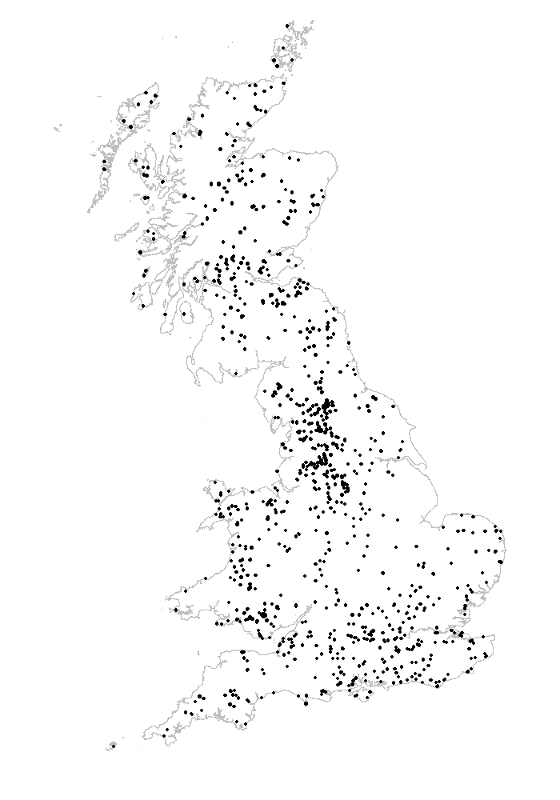

Fig. 2 Probability of meadow pipit occurrence in Great Britain from the macroclimate model

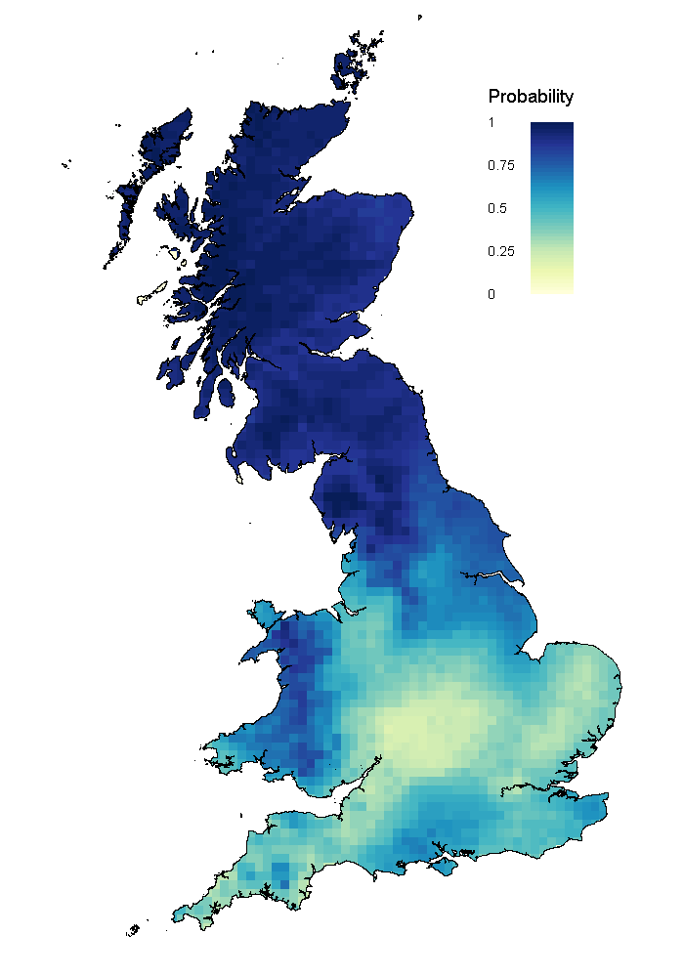
Fig. 3 Probability of meadow pipit occurrence in Great Britain from the microclimate model. To produce the map we used the estimates of the fixed effect coefficients and the average random intercept across all groups. The map therefore does not show the variability that is accounted for by the random effects.
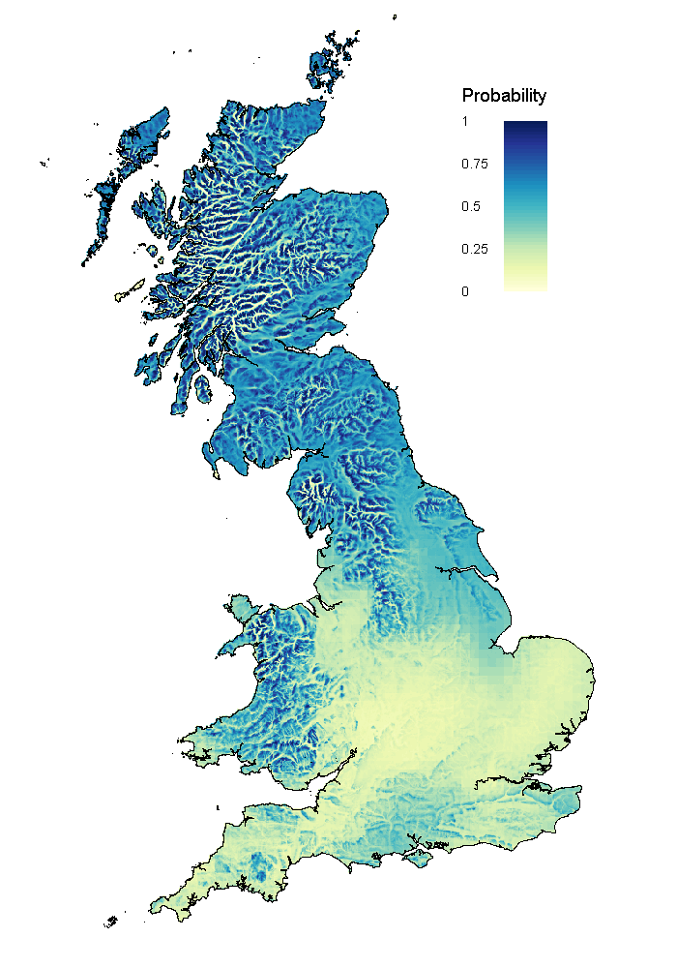

Fig. 4 Plots of the partial effects of elevation difference (h), midsummer insolation index (s) and topographic wetness index (w) on the probability P of finding a meadow pipit in a transect section in Great Britain, for three different values of macroclimatic suitability m (orange: m=0.1, green: m=0.4, blue: m=0.7). Shaded areas show 95% confidence intervals. Raw data are shown on the P=0 line (absence) or on the P=1 line (presence)

