Detailed Visualization of Aromaticity Using Isotropic Magnetic Shielding
Bryan J. Lampkin,^{[a]} Peter B. Karadakov,*^{[b]} and Brett VanVeller*^{[a]}
[a] Bryan J. Lampkin and Prof. Brett VanVeller
Department of Chemistry
Iowa State University
Ames, Iowa 50011, USA
E-mail: bvv@iastate.edu
[b] Dr. Peter B. Karadakov
Department of Chemistry
University of York
Heslington, York YO10 5DD, UK
Email: peter.karadakov@york.ac.uk
Supporting information for this article is given via a link at the end of the document.

Abstract: For many years, Clar’s aromatic sextet theory has served as a qualitative method for assessing the aromatic character of polycyclic aromatic hydrocarbons. A new approach, based on the calculation of isotropic magnetic shielding (IMS) contour plots, is shown to provide a feature-rich picture of aromaticity that is both quantitative yet still easily interpreted. Chemists are visual creatures who are adept at discerning reactivity and chemical behavior from molecular structures. To quote Roald Hoffman, “People like pictures. Chemists live off them.” Thus, the detailed image analysis we present simultaneously provides quantitative assessment of electronic structure, which is still easy-to-understand through visual inspection, embedded in an aesthetically appealing and intuitive picture that draws the reader in. In this study, we provide novel computed IMS contour plots for a representative selection of aromatic molecules. Where Clar’s static drawings capture only a partial sketch of the electronic properties of a molecule, IMS contour plots present a detailed, global landscape of a molecule that sums all possible resonance structures. This novel analysis allows us to correct certain drawbacks of Clar’s analysis with respect to polycyclic aromatics and quantitatively assess the bonding and electronic structure of acene hydrocarbons.
Introduction
The concept of aromaticity is widely used to rationalize the chemical and electronic properties of molecules.^{[1]} Despite the inherent nonquantitative nature of aromaticity, which largely derives from its problematic and often imprecise definition,^{[1b, 2]} its existence and extent are often assessed from experimental observables, theoretical computations of a variety of parameters, some of which are difficult to justify, and simple empirical rules of thumb. Most notably, Hückel formulated the infamous [4n + 2]/[4n] π-electron rules that have since been distinguished as indications of Hückel aromaticity/antiaromaticity. Despite the panoply of aromatic descriptors that have arisen (45 as of a 2016),^{[1b, 2]} the simplicity and general universality of Hückel’s rule enables it to persist as the most common and widely used convention. The [4n + 2]/[4n] rules can be further applied to polycyclic aromatic hydrocarbons (PAHs) to determine if the compound displays global aromatic ([4n + 2]) or antiaromatic ([4n]) character. Understandably, however, the simple [4n + 2] definition of aromaticity fails to discriminate between the relative stability of structural isomers of PAHs as well as the local aromaticity within PAHs. In 1972, Erich Clar developed a simple set of rules to address this deficiency.^{[3]} These rules have become known colloquially as Clar’s aromatic sextets (or simply Clar Sextets, Figure 1).^{[4]}
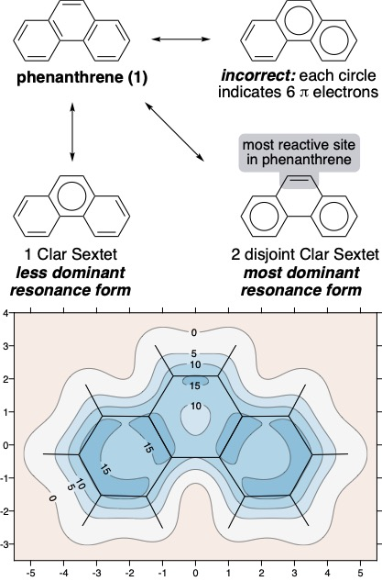
Figure 1. Resonance forms of phenanthrene showing Clar Sextets and the isotropic shielding contour plot 1 Å above the molecular plane (axes in Å). σ_{iso}(r) values were obtained at the B3LYP-GIAO/6-311++G(d,p)//B3LYP-D3BJ/def2TZVP level, σ_{iso}(r) in ppm.
The theory of Clar Sextets states that the most dominant resonance form of a molecule is one in which the maximum number of disjoint aromatic π-sextets can be drawn (Figure 1), where an aromatic π-sextet (consisting of [4n + 2] π-electrons) is typically represented by a circle. Given the pictorial nature of organic chemistry as a field, Clar Sextets provide a convenient visual assessment of the electronic structure and relative stabilities of PAHs that can aid in predicting reactivity. As Roald Hoffmann stated at a symposium honoring his 70th birthday,^{[5]}

Michael Dewar couldn’t understand how people didn’t take to his numerical perturbation theory for organic chemistry—after all, it had everything in it. It did. But it was not taught or used, just because it was not graphic. People like pictures. Chemists live off of them.
– Roald Hoffmann

Isotropic magnetic shielding (IMS) variations—displayed as a function of position in the space surrounding a molecule—effectively map magnetic shielding effects to define the aromatic character across an entire molecule.
There have been numerous approaches relating the calculated properties of PAHs to the predominant resonance form predicted by Clar’s theory including HOMA, NICS, PDI, current density maps and electrostatic potential topography.^{[6]} The IMS maps presented here provide a metric that bridges, with surprising clarity, the physical properties of PAHs with the pictorial nature of Clar’s sextet theory.
While a plethora of theoretical approaches for assessing aromaticity exist, only a few of these provide a pictorial interpretation that is easily interpretable. Importantly, IMS maps address certain drawbacks that are associated with the popular single-point nucleus-independent chemical shift (NICS) values.^{[7]} Chiefly, the arbitrary position at which a single-point NICS value is calculated may not possess sufficient information to fully characterize the aromaticity of a π-system. For example, naphthalene is generally understood to display lower local aromatic character in each of its 6-membered rings than that in the 6-membered ring of benzene. However, a single-point NICS calculation returns a result indicating naphthalene to be more aromatic than benzene.^{[8]} The more feature-rich IMS contour plots presented here furnish a complete picture of the local and global aromaticities of each molecule which supports the more commonly accepted view that the 6-membered ring of benzene is more aromatic than its naphthalene counterparts.^{[9]} Finally, while undoubtedly useful in certain applications, one-dimensional aromatic ring chemical shielding (ARCS)^{[10]} and NICS-XY-scan^{[11]} plots furnish different and much more limited information that misses the link between shielding and bonding. Indeed, we show that IMS maps provide one of the most insightful and succinct means of visualizing the aromaticity of molecules, even in comparison to other 2D and 3D approaches to visualize aromatic character (vide infra).
The contour plots displayed through the remainder of this study show the spatial variation in the values of the IMS, σ_{iso}(r). Positive σ_{iso}(r) values—reported in units of ppm—indicate regions that can be associated with more intensive electronic presence and movement, leading to greater aromatic character. The contour plots have sometimes been called ‘‘fingerprints’’ of aromaticity that allow for unambiguous and quantitative classification of the local degree of aromaticity.^{[7]} This attribute leads to an inherently pictorial yet quantitative analysis of aromaticity. For example, the isosurface plot of phenanthrene (1) in Figure 1 indicates that the outer rings are indeed more aromatic than the central ring. In particular, we were intrigued by the way the curvature of the contour lines is reminiscent of drawing the circles to represent Clar Sextets—where circular contour lines are physical manifestations of the Clar pictographic representations. Thus, the contour plots can be considered as a method of drawing the circles of Clar Sextets, but with different weights of the pencil to represent the aromatic character across a PAH—as Roald Hoffmann would approve!
We elected to examine several classes of molecules that are often discussed in relation to Clar’s aromatic sextet theory to both validate and highlight the strengths of the visual approach of IMS. For brevity and consistency, we only discuss contours mapped at 1 Å above the molecular plane. This approach is also not arbitrary. More positive σ_{iso}(r) values at this height indicate that aromaticity is associated with bond-enhancement due mainly to π-electron activity, which is easier to observe at some distance from the molecular plane. Additional orientations of the planes chosen for isotropic shielding contour plots which emphasize the link between shielding and bonding can be found in the SI (Figures S1–S14).
Results and Discussion
Visualizing localized aromaticity.
We began by examining a series of prototypical Clar aromatic structures (Figure 2). For triphenylene (2) the π-electron structure can be drawn as one of two resonance forms (2a or 2b). According to Clar’s sextet theory, the Kekulé resonance structure with the most disjoint sextets will dominate and therefore we can expect the ‘fully benzoid’ resonance form 2b to provide more molecular insight than that of 2a. In examining the calculated isovalue contour surface of triphenylene, we observe this to be the case. The outer three rings in 2b are more aromatic, reaching σ_{iso}(r) values of over 15 ppm, while the central ring falls to an isovalue of only about 5 ppm. Intriguingly, the discontinuities in the 15 ppm isolines on the outer rings of triphenylene resemble the diene motifs of 2a, which implies that the IMS analysis captures the ensemble of possible resonance structures but still clearly indicates the dominant form.
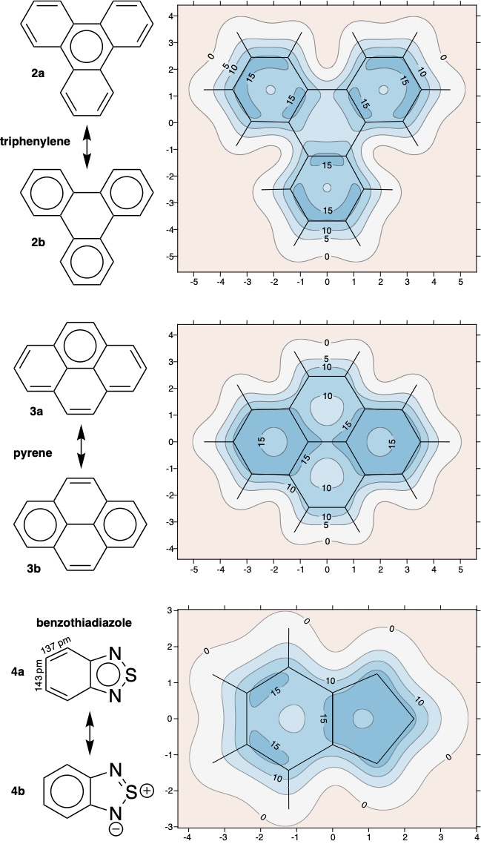
Figure 2. Resonance forms showing Clar Sextets and isotropic shielding contour plots 1 Å (axes in Å) above the molecular plane for triphenylene, pyrene and benzothiadiazole. σ_{iso}(r) values were obtained at the B3LYP-GIAO/6-311++G(d,p)//B3LYP-D3BJ/def2TZVP level, σ_{iso}(r) in ppm.
Next, pyrene can be depicted as containing one (3a) or two (3b) satisfied aromatic sextets. According to Clar’s sextet theory, the ‘partially benzoid’ resonance form (3b) is expected to be the most dominant.^{[4]} Again, the isovalue contour surface plot of pyrene confirms that 3b is indeed the dominant resonance form.
The difference in the number of Clar Sextets between the resonance forms of triphenylene is 1:3 for 2a:2b, whereas the difference for pyrene is 1:2 for 3a:3b. In the qualitative theory of Clar Sextets, the larger difference in the number of Clar Sextets between two resonance forms indicates that there is a greater difference in contribution between the resonance forms of 2a versus 2b than for 3a versus 3b. Thus, 2b makes a more significant contribution to the overall electronic structure of triphenylene than 3b would for pyrene. This qualitative difference can be observed in the quantitative IMS plots in Figure 2. The most aromatic rings of triphenylene and pyrene reach isovalues of over 15 ppm, but for pyrene, the rings of 3b that do not have Clar Sextets are more aromatic (showing significant regions of σ_{iso}(r) > 10 ppm) versus the central ring of triphenylene which is dominated by regions of only about 5 ppm. Thus, these IMS contour plots capture a quantitative view of the of the qualitative, distinct resonance structures that make up the overall picture of the electronic structure of a molecule.
Finally, we can look at the structure of benzothiadiazole (4a and 4b in Figure 3), a heterocycle that has been used in numerous organic electronic and fluorescence applications.^{[12]} An aromatic sextet can only be drawn in the 5-membered ring to give the resonance form 4a. No valid resonance structure can be drawn that places a Clar sextet in the 6-membered ring without invoking the formal charges shown in 4b. Accordingly, the isovalue contour plot of benzothiadiazole indicates the 5-membered ring as having the greatest local aromaticity. Moreover, the lack of aromatic character in the 6-membered ring leads to a significant bond alternation that approaches the traditional CC bond lengths of double (134 pm) and single (147 pm) bonds.^{[13]} This effect is also captured by the isovalue contour plot of the 6-membered ring which shows disjoint regions of σ_{iso}(r) values over 15 ppm centered on the double bonds, indicating strong localization of electrons.
The above examples illustrate the ability of IMS contour plots to corroborate the predictions of Clar for the resonance structures of PAHs. Importantly, the plots further visually quantify the relative contributions from resonance structures to the final structure.

Visualizing migrating sextets.
The static nature of the Clar Sextet representation means that a single resonance picture cannot adequately capture the contribution from all resonance forms. This static aspect is particularly evident for structures in which multiple resonance forms possess the same number of Clar Sextets but in different positions in the PAH. For example, coronene (Figure 3) can be depicted as two possible resonance forms where the central ring is ‘empty’ and three disjoint sextets appear around the perimeter of the molecule with a single double bond in each of the remaining rings. Of course, either picture is equally valid and the Clar Sextets are often referred to as ‘migrating’ around the central ring such that the electronic structure is an average of the two pictures (dashed arrows indicate migrating Clar sextet). The IMS contour plots capture this description of the electron density perfectly, as all peripheral rings in coronene are shown to possess the same degree of aromatic character, indicative of the migrating sextet and the two equivalent resonance forms.

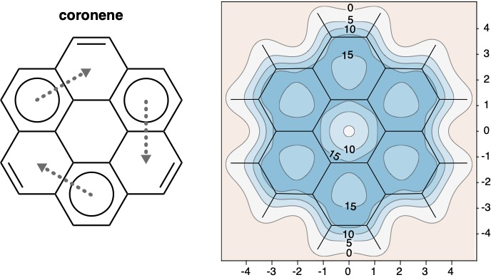
Figure 3. Resonance forms of coronene showing migrating Clar Sextets and isotropic shielding contour plots 1 Å (axes in Å) above the molecular plane. σ_{iso}(r) values were obtained at the B3LYP-GIAO/6-311++G(d,p)//B3LYP-D3BJ/def2TZVP level, σ_{iso}(r) in ppm. The dashed arrows communicate migrating Clar sextets.
The contour plot of coronene (Figure 3) exemplifies the novel and clear way that our IMS maps visualize Clar’s aromatic sextet theory. In this respect, the IMS plots have significant advantages over other tools used to visualize aromaricity such as anisotropy of the induced current density (ACID)^{[14]} and the gauge including magnetically induced current method (GIMIC).^{[15]} Neither of the ACID and GIMIC images of magnetic ring currents in coronene can be associated directly with the migrating Clar Sextets. We note, however, that integration of the diatropic and paratropic currents depicted in the GIMIC plot^{[15]} should result in the IMS distribution surrounding the molecule, a slice of which is shown in Figure 3.
Migrating sextets have also been invoked to describe the aromaticity of linear acenes. Linear acenes ([n]acenes) are attractive organoelectronic materials due to their relatively narrow HOMO-LUMO transitions,^{[16]} where the HOMO-LUMO gap decreases with the increase of the length of the acene. The stability of acenes, however, also decreases with increasing length.
Clar’s theory explains linear acenes in terms of ‘migrating’ sextets which qualitatively assigns equal aromatic character to each ring in the system, where an [n]acene will have n equally likely resonance structures possessing one Clar Sextet each (Figure 4). The limitations of this aspect of Clar’s theory have been well-documented in literature for some time,^{[17]} as differences in the reactivity of inner and outer rings conflicts with the notion that each resonance form is of the same energy.

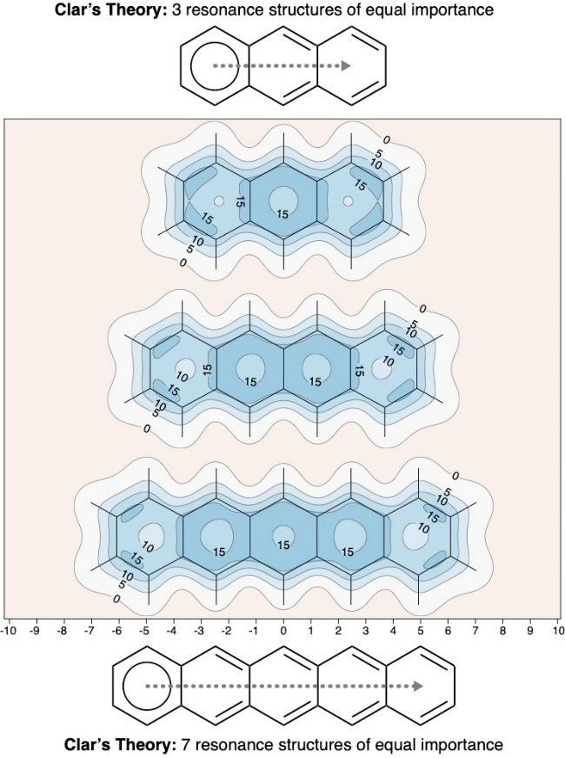
Figure 4. Resonance forms of linear [n]acenes showing migrating Clar Sextets and isotropic shielding contour plots 1 Å (axes in Å) above the molecular plane. σ_{iso}(r) values were obtained at the B3LYP-GIAO/6-311++G(d,p)//B3LYP-D3BJ/def2TZVP level, σ_{iso}(r) in ppm.
The IMS contour plots in Figure 4 were obtained using a level of theory that enforces a closed-shell electronic singlet state (B3LYP-GIAO in spin-restricted form, RB3LYP-GIAO). According to this model, the local aromaticity of the terminal rings should decrease substantially with the increasing length of the acene. Similarly, the plots in Figure 4 suggest that the central rings of acenes are more aromatic than the peripheral rings. This effect suggests that to whatever extent that migrating sextets might be correct for acenes, they are only applicable to the inner rings. This observation aligns with previous NICS studies,^{[18]} but is in conflict with well-documented experimental evidence. For example, the central rings in anthracene and higher acenes can participate preferentially in Diels-Alder reactions. While this seeming contradiction might be explained by the most thermodynamically-favored transition state and product arising through reaction with the central ring of anthracene, it has nonetheless given rise to debate: the so-called ‘anthracene problem’.^{[17]}

Visualizing biradical character.
It has been established that the lowest-lying closed-shell singlet wavefunction enforced by the RB3LYP level of theory becomes unstable for higher [n]acenes, and for n ≥ 6, it is possible to find lower-energy spin-unrestricted B3LYP (UB3LYP) solutions.^{[18b, 19]} The search for unrestricted solutions for all examples presented in Figures 1–4 showed that [6]acene and [7]acene were the only two species with unstable ground states at the restricted (RB3LYP) level and lower-energy unrestricted (UB3LYP) solutions could be found. For comparison, the IMS contour plots of these solutions for [6]acene and [7]acene are shown in Figure 5.
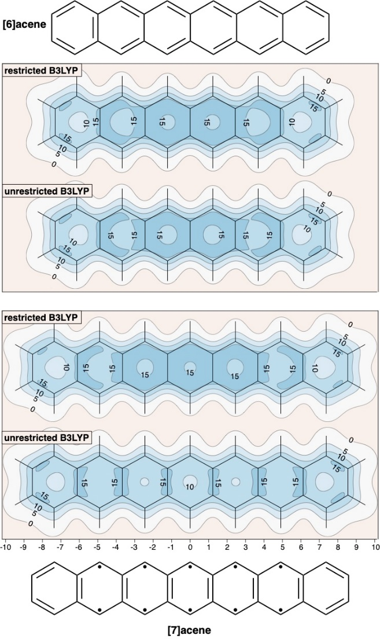
Figure 5. (R or U)B3LYP-GIAO IMS contour plots for [6]acene and [7]acene 1 Å (axes in Å) above the molecular plane and resonance structure describing [7]acene with para-bonds in the internal rings, corresponding to singlet biradical pairs. σ_{iso}(r) values were obtained at the (R or U)B3LYP-GIAO/6-311++G(d,p)//(R or U)UB3LYP-D3BJ/def2TZVP level, σ_{iso}(r) in ppm.
The difference between the restricted and unrestricted contour plots of [6]acene in Figure 5 is relatively minor, suggesting that the electronic nature of these two solutions is rather similar. In contrast, the differences between the restricted and unrestricted contour plots of [7]acene is surprisingly profound. For [7]acene with UB3LYP, the terminal rings feature localized double bonds with no significant aromatic character. Because more positive σ_{iso}(r) values in these IMS plots are associated with bond-enhancement from mainly π-electron activity, the internal rings of [7]acene are likely to feature singlet biradical pairs at the para positions. This insight would explain the increased reactivity of these rings—requiring extensive substitution to observe isolable material.^{[20]} Thus, the additional correlation effects included in the spin-unrestricted B3LYP lead to a completely different description of [7]acene. This type of description is also expected for higher acenes (see ref. ^{[18b]}). While we cannot use UB3LYP to include additional correlation effects for some smaller acenes in which the RB3LYP solutions are stable, for example, pentacene, we hypothesize that higher levels of theory will produce IMS contour plots similar to the UB3LYP-GIAO IMS contour plot for [7]acene. This hypothesis is supported by experimentally measured atomic force microscopy (AFM) images of pentacene that indicate strong localization of electrons in the rings at the outer edge and much less electron density on the inner 3 rings.^{[21]}
Another example of a limitation of Clar Sextet theory and the diradical character of acene derivatives is the molecule 5,6:12,13-dibenzozethrene which, as both experiment and theory demonstrate, has an enhanced diradical character in the ground state.^{[22]} This observation is ostensibly supported by a simple Clar sextet analysis shown in 5a (Figure 6). However, both restricted and unrestricted IMS plots of 5,6:12,13-dibenzozethrene reveal a far more complex picture (Figure 6). While not entirely inconsistent with 5a, the RB3LYP plot is more in line with a structure involving two singlet biradicals (5b). The UB3LYP plot retains hints of Clar sextets in the outermost benzene rings only; six small shielded regions close to different carbons indicate that this π system possesses even more significant radical character. As suggested by the weak shielding around the central benzene rings of the central naphthacene fragment, the planar structure of 5,6:12,13-dibenzozethrene is unstable and twists to a non-planar lower-energy geometry.
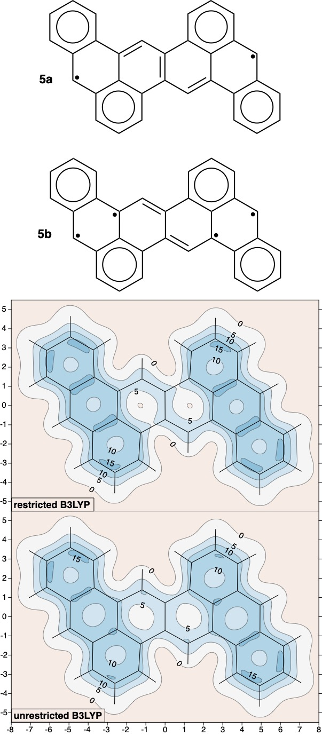
Figure 6. Resonance forms of 5,6:12,13-dibenzozethrene showing Clar Sextets, diradical character and isotropic shielding contour plots 1 Å (axes in Å) above the molecular plane. σ_{iso}(r) values were obtained at the (R or U)B3LYP-GIAO/6-311++G(d,p)//(R or U)B3LYP-D3BJ/def2TZVP level, σ_{iso}(r) in ppm.
Clearly, interpretation of computed metrics of aromaticity and electronic structure requires careful analysis, and ultimately, validation by experiment. The IMS contour plots indicate that the electronic structures of linear acenes and zethrene derivatives are more complicated than Clar Sextet theory suggests and that agreement with experimental observations requires high-level calculations.
Conclusion
For many years, Clar’s aromatic sextet theory has served as a qualitative and easily interpretable method for assessing the aromatic character of polycyclic aromatic hydrocarbons. A new approach, based on the calculation of isotropic magnetic shielding (IMS) contour plots, is shown to provide a more detailed and visually appealing quantitative picture of aromaticity. The analysis of molecules by eye is an ingrained skill in chemistry and the pictographic attributes of IMS plots offer significant advantages when deciphering experimental phenomena. The visual nature of IMS contour plots provides an easily interpretable image of the local aromatic character of polycyclic aromatic hydrocarbons (PAHs) that is more illustrative than other methods which rely on numerical values to assess aromatic character—proving the adage that “a picture is worth a thousand words”. While this pictorial representation aligns well with the visual nature of organic chemistry and Clar’s theory of aromatic sextets in particular, the IMS contour plots are also quantitative and provide a single picture of the ensemble of valid resonance forms that describe the aromatic character of a molecule. Such contour plots can be used to quantitatively assess differences in aromatic stability for both ground and excited state molecules and promise to become a valuable tool to rationalize aromatic behavior.
Computational Details
The ground-state geometries of all PAHs studied in this paper were optimized using density functional theory (DFT), at the spin-restricted or spin-unrestricted (R or U)B3LYP-D3BJ/def2TZVP level (B3LYP with Grimme’s D3 empirical dispersion corrections and Becke-Johnson damping, within the standard def2TZVP basis set). As usual, throughout this paper we denote RB3LYP as B3LYP if this will not cause misunderstanding. Each optimized geometry (see the SI) was confirmed as a local minimum or transition state (in the case of 5,6:12,13-dibenzozethrene only) through diagonalization of the respective analytic nuclear Hessian. σ_{iso}(r) contour plots were constructed using (R or U)B3LYP-GIAO/6-311++G(d,p) calculations (B3LYP with gauge-including atomic orbitals) at dense regular grids of points with a spacing of 0.05 Å covering the areas shown in the contour plots. To reduce computational effort, for each grid σ_{iso}(r) values were calculated at symmetry-unique points only and replicated by symmetry. All of these calculations were carried out using GAUSSIAN16. [reference to GAUSSIAN16]
To check for possible dependence of the results on the level of theory, the data used to construct the IMS plot for coronene in Figure 3 was re-calculated using another popular DFT method, PBE0, at the same geometry and in the same basis. The comparison between B3LYP-GIAO/6-311++G(d,p) and PBE0-GIAO/6-311++G(d,p) results in the SI (Figure S15) shows that the differences are insignificant, up to ca. 0.25 ppm, with no noticeable changes in the overall IMS picture.
The IMS contour plots reported in this paper provide a convenient way of visualising the quantitative information contained in the dense regular two-dimensional grids of IMS values. While the 5 ppm interval has been chosen for clarity, the isovalue lines in the contour plots can be drawn for any value within the range of IMS values included in the grid. A positive IMS value above the center of a ring reports greater aromatic character (in contrast to NICS, where the sign of the computed magnetic shielding is inverted and greater aromatic character is reported in negative values). Above bonds, using positive IMS rather than negative NICS reflects how the shielding is a bond-enhancing factor.
Clearly, IMS contour plots parallel to the molecular plane can be calculated for planar molecules only. For nonplanar molecules it is more appropriate to use three-dimensional IMS isosurfaces or contour plots in planes cutting through specific bonds or molecular regions.^{[23]} The size of the systems that can be treated is limited only by the quantum chemical package used to carry out the shielding calculations.

[reference to GAUSSIAN16]
[Gaussian 16, Revision A.03, M. J. Frisch, G. W. Trucks, H. B. Schlegel, G. E. Scuseria, M. A. Robb, J. R. Cheeseman, G. Scalmani, V. Barone, G. A. Petersson, H. Nakatsuji, X. Li, M. Caricato, A. V. Marenich, J. Bloino, B. G. Janesko, R. Gomperts, B. Mennucci, H. P. Hratchian, J. V. Ortiz, A. F. Izmaylov, J. L. Sonnenberg, D. Williams-Young, F. Ding, F. Lipparini, F. Egidi, J. Goings, B. Peng, A. Petrone, T. Henderson, D. Ranasinghe, V. G. Zakrzewski, J. Gao, N. Rega, G. Zheng, W. Liang, M. Hada, M. Ehara, K. Toyota, R. Fukuda, J. Hasegawa, M. Ishida, T. Nakajima, Y. Honda, O. Kitao, H. Nakai, T. Vreven, K. Throssell, J. A. Montgomery, Jr., J. E. Peralta, F. Ogliaro, M. J. Bearpark, J. J. Heyd, E. N. Brothers, K. N. Kudin, V. N. Staroverov, T. A. Keith, R. Kobayashi, J. Normand, K. Raghavachari, A. P. Rendell, J. C. Burant, S. S. Iyengar, J. Tomasi, M. Cossi, J. M. Millam, M. Klene, C. Adamo, R. Cammi, J. W. Ochterski, R. L. Martin, K. Morokuma, O. Farkas, J. B. Foresman, and D. J. Fox, Gaussian, Inc., Wallingford CT, 2016.
Acknowledgements
B.V. wishes to thank the National Science Foundation (Grant 1848261) for support.
Keywords: aromaticity • Clar sextet • isotropic magnetic shielding • contour • visual
[1] aR. Hoffmann, American Scientist 2015, 103, 18; bM. Solà, Frontiers in Chemistry 2017, 5, 22.
[2] J. Grunenberg, International Journal of Quantum Chemistry 2017, 117, e25359.
[3] E. Clar, The Aromatic Sextet, Wiley, 1972.
[4] M. Solà, Frontiers in chemistry 2013, 1, 22-22.
[5] R. Hoffmann, in Roald Hoffmann on the Philosophy, Art, and Science of Chemistry (Ed.: J. K. a. M. Weisberg), Oxford university press, New York, 2012.
[6] aS. R. G. C. H. Suresh, Journal of Organic Chemistry 1999, 64, 2505--2512; bY. Ruiz-Morales, Journal of Physical Chemistry A 2004, 108; cG. a. P. J. a. S. Portella, Journal of Physical Organic Chemistry 2005, 18, 785--791; dE. a. F. P. W. a. S. A. a. J. L. W. Steiner, Faraday Discuss. 2007, 135, 309--323; eC. J. Evoniuk, G. D. P. Gomes, S. P. Hill, S. Fujita, K. Hanson, I. V. Alabugin, J Am Chem Soc 2017, 139, 16210-16221.
[7] P. B. a. H. P. a. H. K. E. Karadakov, The Journal of Organic Chemistry 2016, 81, 11346--11352.
[8] Z. Chen, C. S. Wannere, C. Corminboeuf, R. Puchta, P. v. R. Schleyer, Chemical Reviews 2005, 105, 3842-3888.
[9] B. J. a. N. Y. H. a. K. P. B. a. V. B. Lampkin, Physical Chemistry Chemical Physics 2019, 21, 11608--11614.
[10] J. Juse′lius, D. Sundholm, Physical Chemistry Chemical Physics 1999, 1, 3429-3435.
[11] R. Gershoni-Poranne, A. Stanger, Chemistry – A European Journal 2014, 20, 5673-5688.
[12] aY. Wang, T. Michinobu, Journal of Materials Chemistry C 2016, 4, 6200-6214; bS. I. Suarez, C. C. Warner, H. Brown-Harding, A. M. Thooft, B. VanVeller, J. C. Lukesh, Organic & Biomolecular Chemistry 2020, 18, 495-499; cA. M. Thooft, K. Cassaidy, B. VanVeller, The Journal of Organic Chemistry 2017, 82, 8842-8847; dS. Norris, C. C. Warner, A. M. Thooft, S. K. Demirci, B. J. Lampkin, K. Miner, A. Ellern, B. VanVeller, Org Lett 2020, 22, 270-273.
[13] T. Suzuki, T. Tsuji, T. Okubo, A. Okada, Y. Obana, T. Fukushima, T. Miyashi, Y. Yamashita, The Journal of Organic Chemistry 2001, 66, 8954-8960.
[14] D. Geuenich, K. Hess, F. Köhler, R. Herges, Chemical Reviews 2005, 105, 3758-3772.
[15] H. Fliegl, S. Taubert, O. Lehtonen, D. Sundholm, Physical Chemistry Chemical Physics 2011, 13, 20500-20518.
[16] aI. Kaur, M. Jazdzyk, N. N. Stein, P. Prusevich, G. P. Miller, Journal of the American Chemical Society 2010, 132, 1261-1263; bB. Shen, J. Tatchen, E. Sanchez-Garcia, H. F. Bettinger, Angewandte Chemie International Edition 2018, 57, 10506-10509.
[17] P. W. a. M. W. Fowler, The Journal of Physical Chemistry A 2011, 115, 13191--13200.
[18] aP. v. R. Schleyer, M. Manoharan, H. Jiao, F. Stahl, Organic Letters 2001, 3, 3643-3646; bJ. Poater, J. M. Bofill, P. Alemany, M. Solà, The Journal of Physical Chemistry A 2005, 109, 10629-10632; cG. Portella, J. Poater, J. M. Bofill, P. Alemany, M. Solà, The Journal of Organic Chemistry 2005, 70, 2509-2521; dG. Portella, J. Poater, J. M. Bofill, P. Alemany, M. Solà, The Journal of Organic Chemistry 2005, 70, 4560-4560.
[19] aM. Bendikov, H. M. Duong, K. Starkey, K. N. Houk, E. A. Carter, F. Wudl, Journal of the American Chemical Society 2004, 126, 7416-7417; bM. Bendikov, H. M. Duong, K. Starkey, K. N. Houk, E. A. Carter, F. Wudl, Journal of the American Chemical Society 2004, 126, 10493-10493.
[20] S. S. Zade, M. Bendikov, Angewandte Chemie International Edition 2010, 49, 4012-4015.
[21] aL. Gross, F. Mohn, N. Moll, P. Liljeroth, G. Meyer, Science 2009, 325, 1110; bD. W. Szczepanik, M. Solà, T. M. Krygowski, H. Szatylowicz, M. Andrzejak, B. Pawełek, J. Dominikowska, M. Kukułka, K. Dyduch, Physical chemistry chemical physics : PCCP 2018, 20, 13430-13436.
[22] P. Yadav, S. Das, H. Phan, T. S. Herng, J. Ding, J. Wu, Organic Letters 2016, 18, 2886-2889.
[23] aP. B. Karadakov, P. Hearnshaw, K. E. Horner, The Journal of Organic Chemistry 2016, 81, 11346-11352; bP. B. Karadakov, M. A. H. Al-Yassiri, D. L. Cooper, Chemistry – A European Journal 2018, 24, 16791-16803; cP. B. Karadakov, K. E. Horner, Journal of Chemical Theory and Computation 2016, 12, 558-563; dP. B. Karadakov, J. Kirsopp, Chemistry – A European Journal 2017, 23, 12949-12954; eB. J. Lampkin, N. Y. H., K. P. B., V. Brett, Physical Chemistry Chemical Physics 2019, 21, 11608--11614.

Entry for the Table of Contents
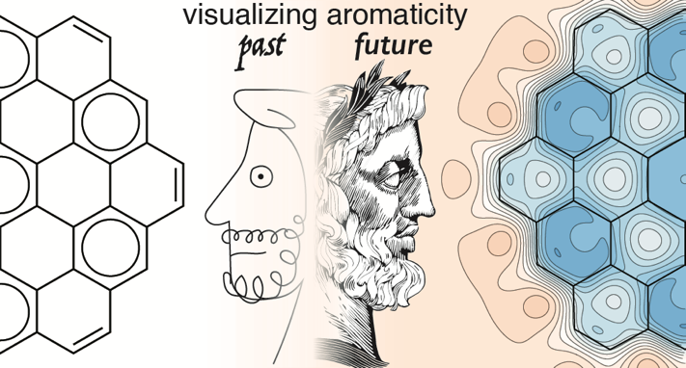

A cartoonish face of the Greek god Janus looks into the past at how Erich Clar’s aromatic sextet theory provided only a qualitative visual inspection of aromaticity, which captures only a single aspect of electronic structure. Alternatively, a more detailed face of Janus looks forward to a future in which the aromatic properties of molecules can be visually inspected for quantitative information using Isotropic Magnetic Shielding (IMS) contour plots.
Twitter: @vanvellergroup @IASTATE_Chem

