SUPPLEMENTARY APPENDIX

CONTENTS
List of Independent Steering Committee (ISC) members 2
List of Data Monitoring Committee (DMC) members 3
List of TB & Tobacco consortium members 4
Brief behavioural Support 5
Cytisine dosing schedule 10
Supplementary Figures 11
Figure S1: Recruitment Progress 12
Figure S2: TB scores* over time (based on TB symptoms, range 0-8, means with 95% CIs) 13
Figure S3: MPSS scores over time (range 5-25, means with 95% CIs) 14
Figure S4: SUTS scores over time (range 0-5, means with 95% CIs) 14
Figure S5: Quit rates and unadjusted Relative Risks among sub-groups 15
Supplementary Tables 16
Table S1: Logistic Regressions of biochemically verified continuous abstinence at 6 months 17
Table S2: Lapse and relapse outcomes 18
Table S3: TB Score* (severity) by Treatment Arm 19
Table S4: Estimated Mean TB Score Differences (mixed effects model) 20
Table S5: Sputum Smear Microscopy Results 21
Table S6: Self-reported compliance with TB medication 22
Table S7: X-Ray outcomes 23
Table S8: Estimated Mean MPSS Score Differences (mixed effects model) 24
Table S9: Estimated Mean SUTS Score Differences (mixed effects model) 24
Table S10: Self-reported compliance with study medication 25
Table S11: Recorded reasons for withdrawals from treatment 26
Table S12: Summary of reasons given for non-compliance (Day 5 / Week 5 combined) 27
Table S13: Non-serious Adverse Events (Summary) 29
Table S14: Expected adverse events from symptoms checklist rated as moderate or severe (events additional to those reported in S13) 30
Table S15: Listing of Serious Adverse Events 31
Table S16: Listing of Non Serious Adverse Events (events matching S13 summary) 33
Table S17: Supplemental smoking cessation support during first 6 months 35

List of Independent Steering Committee (ISC) members

ISC Chair:
Linda Bauld, Bruce and John Usher Professor of Public Health, Usher Institute, College of Medicine and Veterinary Medicine, Old Medical School, Teviot Place, Edinburgh, EH8 9AG, UK

ISC members:
Bertie Squire, Professor, Liverpool School of Tropical Medicine, Pembroke Place, Liverpool, L3 5QA, UK
Andy McEwen, Chief Executive, National Centre for Smoking Cessation and Training (NCSCT), 1 Great Western Industrial Centre, Dorchester, DT1 1RD, UK

List of Data Monitoring Committee (DMC) members

DMEC chair:
Andrew Nunn, Associate Director; Chair of Infectious Diseases Research Theme, MRC CTU, London, WC1V 6LJ, UK

DMEC members:
Martin Raw, Director of the International Centre For Tobacco Cessation; Visiting Professor, NYU College of Global Public Health, 665 Broadway, 11th Floor New York, NY 10012, USA
Andrew Hayward, Professor of Infectious Disease Epidemiology and Inclusion Health Research, Department of Infectious Disease Informatics, Farr Institute at UCL, 1-19 Torrington Place, London, WC1E 7HB, UK

List of TB & Tobacco consortium members
(in addition to those in the authors-list)

Name | Affiliation
Shilpi Swami | University of York
Samina Huque | ARK Foundation
Ejaz Qadeer | Ministry of National Health Services, Regulation and Coordination
Maryam Noor | The Initiative
Salman Sohail | The Initiative
Jiban Karki | University of Leeds
Iveta Nohavová | Charles University and the General University Hospital in Prague
Kamila Zvolská | Charles University and the General University Hospital in Prague
Alexandra Pánková | Charles University and the General University Hospital in Prague
Sushil Baral (PI) | HERD International PVT. Ltd.
Shophika Regmi | HERD International PVT. Ltd.
Prabin Shrestha | HERD International PVT. Ltd.
Basant Joshi | HERD International PVT. Ltd.
Ramesh Pathak | HERD International PVT. Ltd.

Brief behavioural Support

Description of TB & Tobacco Brief behavioural Support (using the TIDieR checklist: https://www.equator-network.org/reporting-guidelines/tidier/)

Item number and label | Description | Location
- Brief name | TB & Tobacco | https://www.york.ac.uk/healthsciences/research/public-health/projects/tb-tobacco/  https://tbandtobacco.org/
- Why | This brief behaviour support package was developed drawing on a longer (approx. 30 minutes) behaviour support intervention trialed and found to be effective in Pakistan, achieving 41.0% [95%CI, 37.1% to 45.0%] quit rates at 6 months.¹ Subsequent implementation research in Nepal ² and Pakistan³ highlighted the need for a shorter intervention integrated into TB services. To reduce the length of the intervention, we asked TB health professionals in Nepal, Pakistan and Bangladesh to prioritize tobacco cessation messages used in the original intervention based on feasibility of delivery, resonance and appropriateness with patients. This enabled us to reduce the tobacco cessation components and add in key messages on TB treatment, resulting in an intervention that could be delivered by TB health workers to all patients (tobacco users and non-users), taking between 8 and 10 minutes, thus increasing the likelihood of the brief behaviour support being delivered within routine practice. | 1. Siddiqi K, Khan A, Ahmad M, Dogar O, Kanaan M, Newell JN, Thomson H. Action to stop smoking in suspected tuberculosis (ASSIST) in Pakistan: a cluster randomized, controlled trial. Annals of internal medicine. 2013 May 7;158(9):667-75.  2. Elsey H, Khanal S, Manandhar S, Sah D, Baral SC, Siddiqi K, Newell JN. Understanding implementation and feasibility of tobacco cessation in routine primary care in Nepal: a mixed methods study. Implementation Science. 2015 Dec;11(1):104.  3. Dogar O, Elsey H, Khanal S, Siddiqi K. Challenges of integrating tobacco cessation interventions in TB programmes: case studies from Nepal and Pakistan. Journal of Smoking Cessation. 2016 Jun;11(2):108-15.  For full details of the intervention development process please see the following reports accessible at: https://tbandtobacco.org/  WP1 Report  WP6 Report describing the final intervention (Deliverable 6.2)
- What materials | Flipbook: Includes 8 pages in a stand-alone calendar format with a picture facing the patient and key messages facing the health worker. The flipbook includes country-specific photos, with one set (i.e. all 8 pages) with pictures of and targeted at women, and one set of pictures of men and targeted at men. Given the gender differences in tobacco use and stigma surrounding women smoking in South Asia, gender-specific photos were seen as an important aspect of the intervention. Description of each page:  Cover page: Smiling patient, Message: TB can be cured.  Page 1: How TB is transmitted and cured. Message: Reassure patient, emphasise, adherence, and explain transmission.  Page 2: How to take TB medication continuously for six months according to national guidelines  Page 3: The importance of adhering to TB medication and dealing with side effects.  Page 4: Encouraging patients to get social support from family and friends.  Page 5: Keeping healthy: eat well, rest, no alcohol. Dangers of tobacco, specifically for TB patients, patients asked if they use tobacco and if they would like help to quit.  Page 6: benefits of quitting tobacco for TB outcomes, other health issues, cost and impact on family and the consequences of not quitting  Page 7: Things to help quitting and things that don’t: support patient for abrupt cessation and setting a quit date, warn not to switch to smokeless tobacco SLT.  Page 8: tobacco-use withdrawal symptoms and context specific coping strategies  Leaflet: With country-specific text and pictures (both male and female) from the flipbook to provide information on the dangers of tobacco use, particularly for TB, possible side effects of quitting and how to deal with them, text and pictures to encourage patients to return to the clinic if they want further support to quit.  Posters: poster 1 advertises the tobacco cessation service now available in the TB clinic, poster 2 reinforces the benefits of quitting for TB patients over time on lung function and long-time benefits for heart health and cancers. | https://tbandtobacco.org/
- What procedures | As we were testing the effectiveness of cytisine, not brief behaviour support, both arms of the trial received the brief behaviour support.  Within 4 weeks of their TB diagnosis, patients were seen by the TB health worker. The TB health worker makes sure the flipbook has the male or female picture pages facing the patient as appropriate. The health worker explains the key messages on the back of the page. When they reach page 5, the health worker explains the dangers of tobacco use for TB patients and asks if the patient smokes or uses any other form of tobacco. If the patient says no, the health worker gives them a leaflet and says they can always come back if they want to talk about tobacco use in future. If they say they do use tobacco, the health worker goes through the remaining pages of the flipbook on tobacco cessation, asking the patient to set a quit date and to commit to ‘not a puff’ following that date. Within the trial, patients were then seen again five days later on their designated quit day for a 5 minute session to further support their quit attempt.  Within the trial, patients were then individually randomized to receive cytisine or not.  Two trained coders went through all the materials and coded the following behaviour change techniques according to the Michie et al 2013 taxonomy:  • Goal setting (1.1)  • Reducing negative emotions (1.2)  • Action planning (1.4)  • Prompting social support (3.1, 3.2, 3.3)  • Instructions on performing behaviours (4.1)  • Information on health and emotional consequences (5.1, 5.6)  • Habit formation (8.3)  • Comparative imagining of future outcomes(9.3)  • Reducing negative emotions (11.2)  • Reducing exposure to cues for behaviour (12.3) | WP1 Report of intervention development, available at: https://tbandtobacco.org/  For details on cytisine and its dosage, see:  Dogar O, Barua D, Boeckmann M, Elsey H, Fatima R, Gabe R, Huque R, Keding A, Khan A, Kotz D, Kralikova E. The safety, effectiveness and cost‐effectiveness of cytisine in achieving six‐month continuous smoking abstinence in tuberculosis patients—protocol for a double‐blind, placebo‐controlled randomized trial. Addiction. 2018 Sep;113(9):1716-26.
- Who provided | TB health workers: within the national TB programs, these health workers are tasked with ensuring TB patients take their 6-months of TB medication. All health workers will have received training on TB management within their basic training and subsequent TB program specific training. The extent that tobacco cessation is included within this training varies from country to country, but is minimal. While routine training will include some basic information on the dangers to health of tobacco use, it does not include training on how to support patients to quit tobacco use.  To deliver the brief behaviour support in this study, a two-day training program was developed and delivered by the research team in collaboration with national TB programs. The two-day program included role plays for health workers to practice delivering the behaviour support to different types of patients (e.g. male, female, illiterate, young people).  A guide for health professionals was provided following training which describes each component of the behaviour support package, how it should be used and the evidence behind the messages on the interactions between TB and tobacco and cessation support. | Generic health professional guide and Desktop reminder, available at: https://tbandtobacco.org
- How | The brief behaviour support, using the flipbook is designed to be delivered individually, face-to-face with each TB patient soon after their diagnosis.
- Where | The brief behaviour support was delivered in TB clinics in Pakistan, Nepal and Bangladesh. Only the Pakistan and Bangladesh sites were included in the trial. A process evaluation using implementation research methods was used in all three countries. TB clinics ranged from relatively small primary care clinics in both rural and urban areas to large hospitals with specific TB clinics.
- When and How much | The brief behaviour support consists of a session of approximately 8-10 minutes delivered soon after the patient has been diagnosed. As TB patients return to receive their TB medication over a 6 month period, the training for brief behaviour support emphasizes the value in asking patients about their tobacco use and quit attempt at every consultation. However, there were no particular materials developed to support this.
- Tailoring | All materials are available in Bengali, Nepali and Urdu. These versions were based on a generic set of materials developed in English. Photos and text were adapted for each country to ensure they were culturally and contextually appropriate, including to the National TB Program guidance.  During training, health workers were encouraged to take a patient-centered approach, by considering each TB patient they consulted and tailoring messages to fit the life circumstances of that particular patient.
Modifications | The process evaluation highlighted how in practice, the use of the flipbook varied with some health workers not using it at all and just repeating key messages, and others using only some of the pages. In several large, busy hospitals, the brief behaviour support was sometimes delivered in a group setting, rather than to individuals.
- How well Planned | A process evaluation work package assessed how well the behavioural support was implemented. | Boeckmann M, Nohavova I, Dogar O, Kralikova E, Pankova A, Zvolska K, Huque R, Fatima R, Noor M, Elsey H, Sheikh A. Protocol for the mixed-methods process and context evaluation of the TB & Tobacco randomised controlled trial in Bangladesh and Pakistan: a hybrid effectiveness–implementation study. BMJ open. 2018 Mar 1;8(3):e019878.
- How well Actual | The process evaluation highlighted that intervention fidelity to TB messages and information on health effects of quitting smoking was high. TB medication and adherence advice were implemented in 90% of the sessions in Bangladesh and in 75% of sessions in Pakistan. Assessing patients’ smoking status occurred in 70% of sessions in Bangladesh and in 30% of sessions in Pakistan. While a quit date was set in 30% of sessions in Bangladesh, this was only addressed in 3% of sessions in Pakistan. Information on health effects of quitting was provided in over 80% of Bangladesh sessions, and in around 50% of sessions in Pakistan  Regarding patient and provider views on implementation, all patients reported willingness to quit smoking. Individuals’ main motivations to quit were their health and the need to financially provide for a family. Behavioural regulation such as avoiding exposure to cigarettes, and social influences from friends, family and colleagues were the main themes of the interviews. Most male patients did not feel shy admitting to smoking, for the sole female patient interviewee stigma was an issue. Health workers reported structural characteristics such as high workload and limited time per patient as primary barriers to offering behavioural support. Self-efficacy to discuss tobacco use with women varied by health worker. | 1. Boeckmann M, Warsi S, Noor M, Dogar O, Mustagfira EH, Firoze F, Zahid R, Readshaw A, Siddiqi K, Kotz D. Health worker and patient views on implementation of smoking cessation in routine tuberculosis care. NPJ primary care respiratory medicine. 2019 Sep 3;29(1):1-2.  2. Boeckmann M, Dogar O […], Kotz D (in progress). Integrating a smoking cessation behaviour support intervention into routine tuberculosis care in Pakistan and Bangladesh.

Cytisine dosing schedule

Day of treatment | Intake interval  (1 to 6 capsules daily over a period of 12 waking hours) | Total daily capsules  (number included in each packet)
Day 1-3 | 1 capsule every 2 hours | 6 capsules daily (6x3=18 capsules per packet)
Day 4-7 | 1 capsule every 2.5 hours | 5 capsules daily (5x4= 20 capsules per packet)
Day 8-12 | 1 capsule every 2.5 hours | 5 capsules daily (5x5= 25 capsules per packet)
Day 13-16 | 1 capsule every 3 hours | 4 capsules daily (4x4= 16 capsules per packet)
Day 17-20 | 1 capsule every 4 hours | 3 capsules daily (3x4= 12 capsules per packet)
Day 21- 24 | 1 capsule every 6 hours | 2 capsules daily (2x4= 8 capsules per packet)
Day 25 | 1 capsule on the last day | 1 capsule on the last day

Supplementary Figures

Figure S1: Recruitment Progress

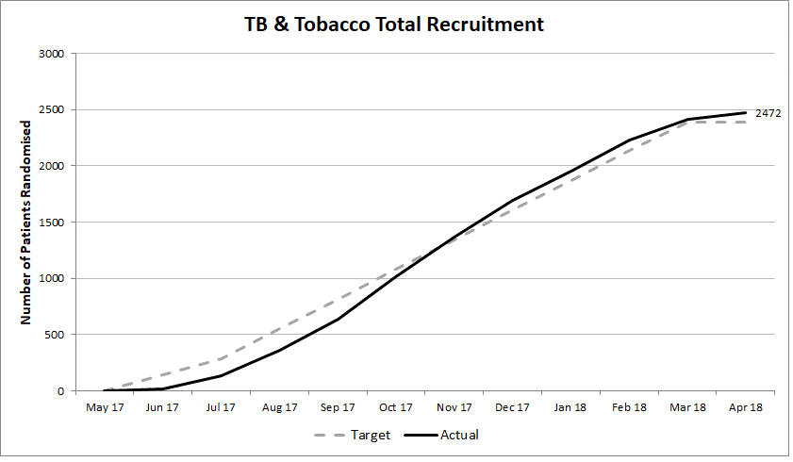

Figure S2: TB scores* over time (based on TB symptoms, range 0-8, means with 95% CIs)
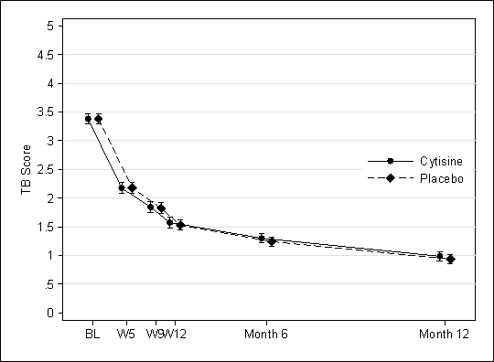
*The TB score was based on the presence of TB related signs and symptoms (e.g. chest pain) and being underweight, with a score of 0 to 8, a higher score indicating a greater number of symptoms present.

Figure S3: MPSS scores over time (range 5-25, means with 95% CIs)
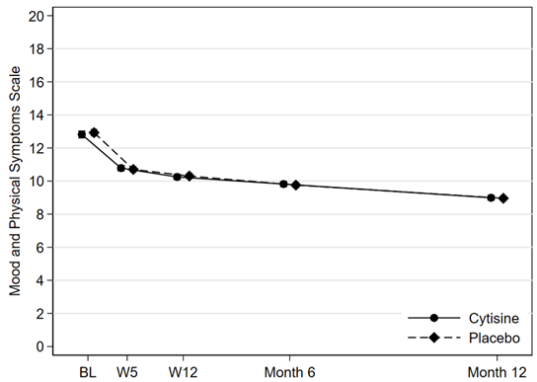
Explanation for Figure S3: The Mood and Physical Symptom Scale (MPSS) is an assessment of five general withdrawal symptoms scored on a 1 to 5 (score range 5 to 25). Scores by treatment arm were nearly identical at all follow-ups.

Figure S4: SUTS scores over time (range 0-5, means with 95% CIs)
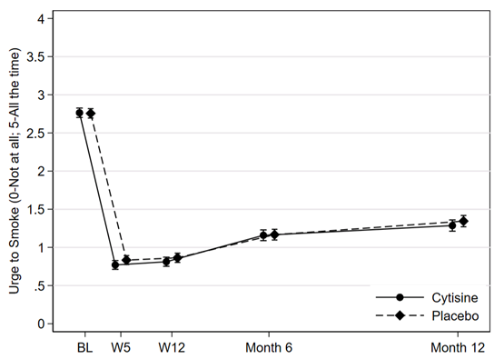
Explanation for Figure S4: The two strengths of urges to smoke (SUTS) questions, ask how often these urges are experienced (score 0 to 5) and if so, then how strongly (0 to 5).

Figure S5: Quit rates and unadjusted Relative Risks among sub-groups

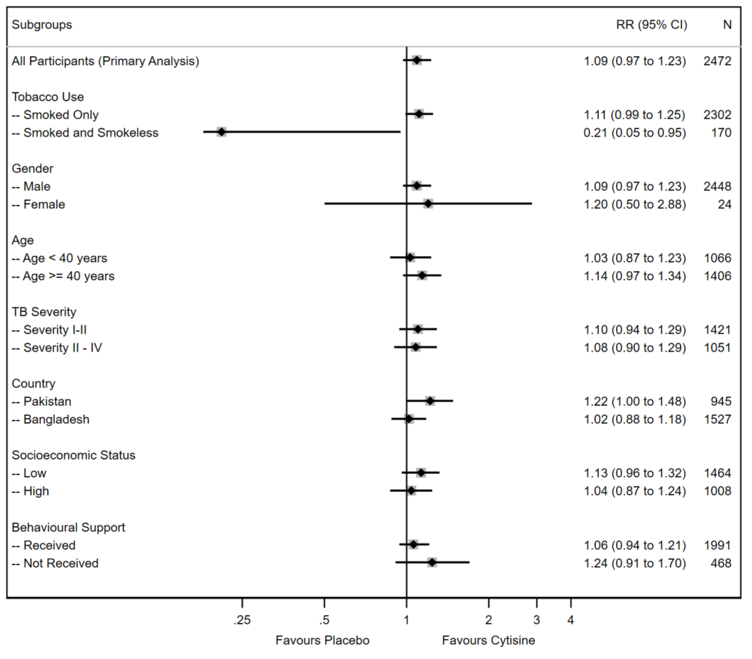

Supplementary Tables

Table S1: Logistic Regressions of biochemically verified continuous abstinence at 6 months
Analysis | N | Treatment  Coefficient | 95% CI
Unadjusted analysis (Primary Analysis) | 2,472 | 0.13 | -0.03 to 0.28
Sensitivity Analyses
Analysis adjusted for baseline dependence* | 2,469 | 0.14 | -0.02 to 0.29
Analysis adjusted for baseline dependence, age, gender, form of tobacco use** | 2,469 | 0.13 | -0.02 to 0.28
Analysis excluding data for patients who have died | 2,402 | 0.13 | -0.03 to 0.28
Analysis using available data only (complete case) | 2,232 | 0.13 | -0.03 to 0.28
*Baseline dependence was heaviness of smoking index defined as time to first tobacco product in the morning
**smoked or smoked and smokeless tobacco

Explanation for Table S1. Of adjusted covariates, there were missing data for only three patients (all heaviness of smoking index), therefore the number of patients included in these analyses remained similar to the full sample (n=2469).
Analysis excluding data for patients who had died: The resulting risk difference was slightly larger than for the primary analysis (RD 2.81, 95% CI -0.92 to 6.53), reflecting verified abstinence rates of 33.3% (n=401/1,203) in the cytisine arm and 30.5% (n=366/1,199) in the placebo arm. Logistic regression adjusted for clustering by trial site revealed a similar effect of treatment arm to the primary analysis (β=0.13, 95% CI -0.03 to 0.28, p=0.101).
The complete case analysis: revealed a slightly larger risk difference compared with the primary analysis (RD 2.83, 95% CI -1.11 to 6.77), reflecting verified abstinence rates of 35.8% (n=401/1,121) in the cytisine arm and 32.9% (n=366/1,111) in the placebo arm. Logistic regression adjusted for clustering by trial site revealed a similar effect of treatment arm to the primary analysis (β=0.13, 95% CI -0.03 to 0.28, p=0.110).

Table S2: Lapse and relapse outcomes
Outcome | Cytisine  N (%) | Placebo  N (%) | Risk Difference (95%CI) | Risk Ratio  (95% CI)
Lapse
Point abstinent at week 5 | n=762 | n=704
Early lapse¹  (before week 5) | 33 (4%) | 25 (4%) | 0.80  (-1.2 to 2.7) | 1.22  (0.73 to 2.03)
Point abstinent at week 5  and week 12 | n=573 | n=538
Late lapse²  (week 5 to week 12) | 12 (2%) | 11 (2%) | 0.05  (-1.6 to 1.7) | 1.02  (0.46 to 2.30)
Relapse
Abstinent at week 5 | n=735 | n=681
Early relapse³  (week 5 to week 12) | 163 (22%) | 137 (20%) | 2.06  (-2.19 to 6.31) | 1.10  (0.90 to 1.35)
Abstinent at week 5  and week 12 | N=551 | N=517
Late relapse⁴  (week 12 to month 6) | 175 (32%) | 179 (35%) | -2.86  (-8.51 to 2.79) | 0.92  (0.77 to 1.09)
Abstinent at week 5  and week 12 and month 6 | N=360 | N=327
Late relapse⁵  (month 6 to month 12) | 57 (16%) | 66 (20%) | -4.35  (-10.11 to 14.07) | 0.78  (0.57 to 1.08)
¹ Early lapse: Self-report of tobacco use (even once) after the quit date but having point abstinence at week 5
² Late lapse: Self-report of tobacco use (even once) between week 5 and week 12 but showing point abstinence at week 5 and week 12
³ Early relapse: Abstinence at week 5 but self-report of tobacco use by week 12
⁴ Late relapse (by 6 months): Self reported abstinence since last visit at week 5 and week 12, but a self-report of tobacco use by month 6
⁵ Late relapse (by 12 months): Self reported abstinence since last visit at week 5, week 12 and month 6, but self-report of tobacco use by month 12

Table S3: TB Score* (severity) by Treatment Arm
 | Cytisine | Placebo | Total
Day 0
Severity I-II | 717 (58%) | 704 (57%) | 1421 (57%)
Severity III-IV | 522 (42%) | 529 (43%) | 1051 (43%)
Week 5
Severity I-II | 911 (81%) | 906 (80%) | 1817 (80%)
Severity III-IV | 215 (19%) | 232 (20%) | 447 (20%)
Week 9
Severity I-II | 934 (84%) | 957 (86%) | 1891 (85%)
Severity III-IV | 181 (16%) | 160 (14%) | 341 (15%)
Week 12
Severity I-II | 1017 (88%) | 1020 (89%) | 1891 (85%)
Severity III-IV | 137 (12%) | 132 (11%) | 341 (15%)
Month 6
Severity I-II | 1034 (91%) | 1033 (91%) | 2067 (91%)
Severity III-IV | 107 (9%) | 99 (9%) | 206 (9%)
Month 12
Severity I-II | 1041 (94%) | 1064 (95%) | 2105 (95%)
Severity III-IV | 64 (6%) | 54 (5%) | 118 (5%)
Explanation for Table S3. *The TB score was based on the presence of TB related signs and symptoms (e.g. chest pain) and being underweight, with a score of 0 to 8, a higher score indicating a greater number of symptoms present. By 12 months, only 118 (5%) of participants had a TB score of severity III or IV, down from over 1051 (43%) at baseline.

Table S4: Estimated Mean TB Score Differences (mixed effects model)
 | Difference (Placebo minus Cytisine)
 | Mean (se) | (95% CI) | p-value
Week 5 | -0.02 (0.05) | -0.12 to 0.08 | 0.757
Week 9 | -0.03 (0.05) | -0.13 to 0.07 | 0.526
Week 12 | -0.05 (0.05) | -0.15 to 0.05 | 0.304
Month 6 | -0.06 (0.05) | -0.16 to 0.04 | 0.232
Month 12 | -0.06 (0.05) | -0.16 to 0.04 | 0.223
Explanation for Table S4. A covariance pattern linear mixed model confirmed that treatment group differences were negligible for this outcome.

Table S5: Sputum Smear Microscopy Results
 | Cytisine  N (%) | Placebo  N (%) | Total  N (%)
Response Rate
Day 0
Negative | 436 (35%) | 400 (32%) | 836 (34%)
Positive | 758 (61%) | 786 (64%) | 1544 (62%)
No data | 45 (4%) | 47 (4%) | 92 (4%)
Week 9
Negative | 938 (76%) | 929 (75%) | 1867 (76%)
Positive | 81 (7%) | 96 (8%) | 177 (7%)
No data | 220 (18%) | 208 (17%) | 428 (17%)
Month 6
Negative | 839 (68%) | 868 (70%) | 1707 (69%)
Positive | 3 (0.2%) | 4 (0.3%) | 7 (0.3%)
No data | 397 (32%) | 361 (29) | 758 (31%)
Month 12
Negative | 731 (59%) | 739 (60%) | 1470 (59%)
Positive | 4 (0.3%) | 5 (0.4%) | 9 (0.4%)
No data | 504 (41%) | 489 (40%) | 993 (40%)
Time to Sputum Conversion
Week 9 | 318 (25.7%) | 284 (23.0%) | 602 (24.4%)
Month 6 | 589 (47.5%) | 608 (49.3%) | 1,197 (48.4%)
Month 12 | 103 (8.3%) | 113 (9.2%) | 216 (8.7%)
No conversion / missing data | 229 (18.5%) | 228 (18.5%) | 457 (18.5%)
Explanation for Table S5. At baseline, 1544 (62%) of participants had a sputum smear positive result. Participants in the cytisine arm were marginally more likely to convert by 9 weeks follow-up (25.7% vs 23.0%), rather than at later time points. A chi-squared test revealed that there was no statistically significant difference in time to conversion between trial arms (X2(df=3)=2.67, p=0.445)).

Table S6: Self-reported compliance with TB medication
 | Cytisine | Placebo | Total
Percentage days TB medicine taken*
N | 1035 | 1038 | 2073
Mean (SD) | 94.3 (16.1) | 93.6 (18.0) | 93.9 (17.1)
Median | 100 | 100 | 100
IQR | 97, 100 | 98, 100 | 97, 100
* Derived from number of days since the start of treatment at Week-9 follow-up (using treatment support card).

Explanation for Table S6. This table presents compliance with TB medication at Week 9 of follow-up; at this point patients had been on TB treatment for a median of 64 days. Using the patient’s treatment support card, it was calculated that patients were taking their TB medicine on an average of 94% of days, a comparable rate to their study medication compliance.

Table S7: X-Ray outcomes
 | Cytisine |  |  |  | Placebo
X-ray Grade | D0 | W9 | M6 | M12 | D0 | W9 | M6 | M12
Normal | 176 (16%) | 64  (15%) | 59  (17%) | 107 (74%) | 174 (16%) | 63  (16%) | 60  (18%) | 110 (71%)
Mild | 357 (32%) | 158 (38%) | 164 (48%) | 7  (5%) | 328 (30%) | 160 (40%) | 148 (44%) | 11  (7%)
Moderate | 451 (41%) | 164 (40%) | 108 (31%) | 27  (19%) | 458 (42%) | 153 (38%) | 114 (34%) | 31  (20%)
Advanced | 124 (11%) | 28  (7%) | 12  (4%) | 3  (2%) | 136 (12%) | 29  (7%) | 11  (3%) | 3  (2%)
Total | 1108 | 414 | 343 | 144 | 1096 | 405 | 333 | 155
Explanation for Table S7. The collection of x-ray assessment data dropped sharply from week 9 onward, with only a few valid assessments in the database. As a result, these data will not be used for formal analysis. The trend of the data shows however the gradual shift from a predominantly moderate to mild grade, whereas over 70% (110) were graded normal by month 12.

Table S8: Estimated Mean MPSS Score Differences (mixed effects model)
 | Difference (Placebo minus Cytisine)
 | Mean (se) | (95% CI) | p-value
Week 5 | -0.08 (0.09) | -0.26 to 0.10 | 0.391
Week 12 | 0.08 (0.09) | -0.11 to 0.26 | 0.414
Month 6 | -0.03 (0.09) | -0.22 to 0.15 | 0.722
Month 12 | -0.01 (0.09) | -0.20 to 0.17 | 0.883
Explanation for Table S8. A linear mixed effect covariance pattern model (adjusted for site and baseline score) confirmed that there mean treatment difference estimates were around zero at all follow-up points.

Table S9: Estimated Mean SUTS Score Differences (mixed effects model)
 | Difference (Placebo minus Cytisine)
 | Mean (se) | (95% CI) | p-value
Week 5 | 0.06 (0.04) | -0.02 to 0.15 | 0.143
Week 12 | 0.06 (0.04) | -0.03 to 0.14 | 0.206
Month 6 | 0.02 (0.04) | -0.07 to 0.11 | 0.642
Month 12 | 0.07 (0.04) | -0.02 to 0.15 | 0.121
Explanation for Table S9. Scores by treatment arm were near identical, and there were no statistically significant differences found by a linear mixed model.

Table S10: Self-reported compliance with study medication
 | Cytisine | Placebo | Total
Day 5 – Study medication taken as prescribed
N | 1150 | 1152 | 2302
Study medication taken as prescribed | 1058 (92%) | 1078 (94%) | 2136 (93%)
Study medication partially taken as prescribed | 83 (7%) | 69 (6%) | 152 (7%)
Study medication not taken at all | 9 (1%) | 5 (0.4%) | 14 (0.6%)
Week 5 – Study medication taken as prescribed
N | 1128 | 1139 | 2267
Study medication taken as prescribed | 1037 (92%) | 1046 (92%) | 2083 (92%)
Study medication partially taken as prescribed | 77 (7%) | 86 (8%) | 163 (7%)
Study medication not taken at all | 14 (1%) | 7 (1%) | 21 (1%)
Percentage days study medication taken*
N | 1115 | 1125 | 2240
Mean (SD) | 96.5 (15.0) | 96.9 (14.1) | 96.7 (14.6)
Median | 100 | 100 | 100
Min, Max | 0, 100 | 0, 100 | 0, 100
Percentage days study medication – grouped
Strong compliance (>=80%) | 1,058 (85%) | 1,076 (87%) | 2,134 (86%)
Moderate compliance (>=50%, <80%) | 16 (1%) | 13 (1%) | 29 (1%)
Poor compliance (<50%) | 41 (3%) | 36 (3%) | 77 (3%)
Missing | 124 (10%) | 108 (9%) | 232 (9%)
* Derived from number of days out of 25 at Week-5 follow-up (using recall and dosing schedule card where available)

Explanation for Table S10. The percentage of compliant days was used to categorise individuals into strong, moderate and poor compliers, using cut-offs decided in advance. As data were significantly skewed, the majority of participants were considered strong compliers.

Table S11: Recorded reasons for withdrawals from treatment
 | Allocation | Reason for withdrawal
1 | Cytisine | discontinued study medicines after 3 days
2 | Cytisine | discontinued due to change in diagnosis
3 | Cytisine | study treatment permanently discontinued by delegated clinician due to adverse event
4 | Cytisine | discontinued after adverse event
5 | Cytisine | discontinued study medicines
6 | Cytisine | quit smoking
7 | Cytisine | discontinued study medicines after 2 days as experienced no improvement
8 | Cytisine | discontinued study medicines due to side effects
9 | Cytisine | refused to take study medicines
10 | Cytisine | refused to take study medicines and quit on his own
11 | Cytisine | refused to take study medicines
12 | Cytisine | refused to take study medicines and quit on his own
13 | Cytisine | refused to take study medicines
14 | Cytisine | refused to take study medicines
15 | Cytisine | discontinued treatment course as claiming to have quit smoking
16 | Cytisine | refused to take study medicines
17 | Cytisine | discontinued after adverse event
18 | Placebo | worried about interference with TB treatment
19 | Placebo | quit smoking
20 | Placebo | experiencing side-effects from anti-TB medicines
21 | Placebo | discontinued study medicines as could not manage time to take pills
22 | Placebo | discontinued after adverse event
23 | Placebo | discontinued study medicine as did not return for follow-ups or to collect the medicine
24 | Placebo | lost study medicine on a bus during commute
25 | Placebo | discontinued after adverse event as advised by the designated clinician
26 | Placebo | Quit smoking
Explanation for Table S11. Twenty six patients formally withdrew from treatment (Cytisine: 17 [1.4%]; Placebo: 9 [0.7%]). The most common reasons for withdrawal from treatment were the experience of side effects and having quit smoking independently.

Table S12: Summary of reasons given for non-compliance (Day 5 / Week 5 combined)
Total | Reasons given for non-compliance | Cytisine | Placebo
66 | Ill health | 38 | 28
42 | Forgot | 22 | 20
33 | Holiday/travel away | 16 | 17
31 | Dosage not practical when at work / busy | 9 | 22
29 | Busy with work | 14 | 15
26 | Side effects | 15 | 11
15 | Quit smoking | 11 | 4
12 | Too busy | 6 | 6
9 | Did not understand dosing schedule | 3 | 6
9 | Does not want to take medicine | 7 | 2
6 | Too many pills | 4 | 2
5 | Hospitalisation | 2 | 3
4 | Personal issues | 2 | 2
4 | Doctor advised to stop | 2 | 2
3 | Had accident | 3 | 0
3 | Wants to quit without medication | 0 | 3
2 | Did not take due to drug addiction | 0 | 2
2 | Misplaced medicine | 1 | 1
2 | Mixed up dosage regimen | 1 | 1
2 | Wanted to check with own doctor first | 1 | 1
2 | Out of medicine due to delay in follow-up | 1 | 1
1 | Busy and bored | 1 | 1
1 | Emergency situation | 0 | 1
1 | Medicine got locked away at home | 1 | 0
1 | By mistake | 0 | 1
1 | Diagnosed as MDR | 1 | 1
1 | Medicine schedule was not communicated clearly as medicines sent to patient | 1 | 1
1 | Only taken when craving cigarettes | 1 | 1
1 | Quit smoking/ill health | 1 | 1
34 | No reason given | 19 | 15
Explanation for Table S12. Patients who did not take the medication exactly as described were asked to provide reasons and the most common reasons were ill health, having forgotten, or having been on holiday.

Table S13: Non-serious Adverse Events (Summary)
 | Cytisine  N | Placebo  N | Total  N
Number of events
Total number of events | 48 | 40 | 88
Average number of events per patient | 0.04 | 0.03 | 0.04
Expectedness
Expected | 27 | 13 | 40
Unexpected | 21 | 27 | 48
Severity
Mild | 33 | 18 | 51
Moderate | 14 | 18 | 32
Severe | 1 | 4 | 5
Relationship to study treatment
Not related | 35 | 30 | 65
Unlikely to be related | 9 | 10 | 19
Possibly related | 3 | 0 | 3
Probably related | 1 | 0 | 1
Number of patients
Number of patients with one or more event | 37 | 31 | 68
Number of patients with 1 event | 29 | 25 | 54
Number of patients with 2 events | 5 | 4 | 9
Number of patients with 3 events | 3 | 1 | 4
Number of patients with 4 events | 0 | 1 | 1

Explanation of Table S13. There were 88 non-serious adverse events (excluding events that were captured as part of the symptoms checklist S14), 48 in the cytisine arm and 40 in the placebo arm. Events in the cytisine arm tended to be expected more often. Only four events were estimated to be either possibly or probably related to study treatment, all of which occurred in the cytisine arm. Notably, fever occurred more frequently in the placebo arm, otherwise there was no particular pattern of events within or between arms.

Table S14: Expected adverse events from symptoms checklist rated as moderate or severe (events additional to those reported in S13)
 | Cytisine |  |  | Placebo
 | Day 5 | Week 5 | Week 9 | Day 5 | Week 5 | Week 9
Nausea | 11 | 1 | 1 | 8 | 5 | 3
Diarrhoea | 3 | - | - | 2 | 1 | -
Dry mouth | 14 | 7 | 4 | 12 | 8 | 7
Epigastric pain | 5 | 3 | - | 5 | 2 | 4
Headache | 8 | 5 | 3 | 8 | 5 | 4
Insomnia | 13 | 8 | 5 | 10 | 6 | 6
Abnormal dreams | 5 | 5 | 3 | 1 | 4 | 4
Irritability | 14 | 5 | 5 | 10 | 3 | 9
Anxiety | 8 | 5 | 7 | 4 | 5 | 7
Palpitations | 19 | 3 | 2 | 7 | 8 | 5
Musculoskeletal Pain | 14 | 3 | 2 | 4 | 5 | 5
Total number of patients | 47 | 20 | 13 | 31 | 23 | 18

Explanation for Table S14. Expected non-serious adverse events associated with the study medication were included in follow-up questionnaires as a symptoms checklist up to week 9 and were graded according to their severity. Moderate or severe events were considered an adverse event reported in this table. At day 5, more participants in the cytisine arm experienced one or more of the symptoms listed (47 vs 31 participants), with palpitations and musculoskeletal pain being more frequent than in the placebo arm. The prevalence of symptoms at other time points appeared similar between the two groups.

Table S15: Listing of Serious Adverse Events
 | Cytisine  Total events: 94  N (%) | Placebo  Total events: 88  N (%) | Total  Total events: 184  N (%)
Death | 49 (52%) | 42 (48%) | 91 (49%)
Angina Pectoris | 0 (0%) | 1 (1%) | 1 (1%)
Breathlessness | 1 (1%) | 0 (0%) | 1 (1%)
Carcinoma bone | 1 (1%) | 0 (0%) | 1 (1%)
Cardiac arrest | 1 (1%) | 0 (0%) | 1 (1%)
Chest Congestion | 1 (1%) | 0 (0%) | 1 (1%)
Chest Pain | 1 (1%) | 2 (2%) | 3 (2%)
Cough | 0 (0%) | 1 (1%) | 1 (1%)
Coughing | 0 (0%) | 1 (1%) | 1 (1%)
Diabetes mellitus | 1 (1%) | 0 (0%) | 1 (1%)
Diarrhoea | 0 (0%) | 1 (1%) | 1 (1%)
Difficulty Breathing | 4 (4%) | 6 (7%) | 10 (5%)
Difficulty Swallowing | 0 (0%) | 1 (1%) | 1 (1%)
Dry Cough | 1 (1%) | 0 (0%) | 1 (1%)
Dyspnea | 1 (1%) | 1 (1%) | 2 (1%)
Epigastric Pain | 0 (0%) | 1 (1%) | 1 (1%)
Fever | 1 (1%) | 3 (3%) | 4 (2%)
Haematemesis | 0 (0%) | 1 (1%) | 1 (1%)
Haematological Disorder | 1 (1%) | 0 (0%) | 1 (1%)
Haemoptysis | 2 (2%) | 1 (1%) | 3 (2%)
Heart Failure | 0 (0%) | 2 (2%) | 2 (1%)
Hepatic cancer | 1 (1%) | 1 (1%) | 2 (1%)
Hepatitis | 0 (0%) | 1 (1%) | 1 (1%)
Hepatitis C | 1 (1%) | 0 (0%) | 1 (1%)
Hepatotoxicity | 0 (0%) | 1 (1%) | 1 (1%)
Hypoglycemia | 1 (1%) | 1 (1%) | 2 (1%)
Intestinal Perforation | 1 (1%) | 0 (0%) | 1 (1%)
Jaundice | 0 (0%) | 1 (1%) | 1 (1%)
Leg fracture | 0 (0%) | 1 (1%) | 1 (1%)
Lung Cancer | 9 (10%) | 6 (7%) | 15 (8%)
Musculoskeletal Pain | 0 (0%) | 1 (1%) | 1 (1%)
Myocardial Infarction | 8 (9%) | 5 (6%) | 13 (7%)
Palpitation | 1 (1%) | 0 (0%) | 1 (1%)
Pleural effusion | 1 (1%) | 1 (1%) | 2 (1%)
Pneumothorax | 0 (0%) | 2 (2%) | 2 (1%)
Pulmonary Oedema | 0 (0%) | 1 (1%) | 1 (1%)
Respiratory failure | 1 (1%) | 0 (0%) | 1 (1%)
Road Traffic Accident | 1 (1%) | 0 (0%) | 1 (1%)
Stroke | 3 (3%) | 2 (2%) | 5 (3%)
Sweating | 0 (0%) | 1 (1%) | 1 (1%)
Vomiting Blood | 1 (1%) | 0 (0%) | 1 (1%)
Weakness | 0 (0%) | 1 (1%) | 1 (1%)

Explanation for Table S15. In a number of cases, multiple adverse events were reported on the same Adverse Event form, and where this was the case (e.g. if the patient was diagnosed with lung cancer and died two months later), events were separated out into separate entries at the end of the trial. As a result, relatedness / expectedness is not available separately for all items. Events were consistent with the profile expected for a population of patients with TB.

Table S16: Listing of Non Serious Adverse Events (events matching S13 summary)
 | Cytisine  Total events: 48  N (%) | Placebo  Total events: 40  N (%) | Total  Total events: 88  N (%)
Allergy | 1 (2%) | 1 (3%) | 2 (2%)
Back pain | 0 (0%) | 1 (3%) | 1 (1%)
Blurred Vision | 0 (0%) | 1 (3%) | 1 (1%)
Breathlessness | 0 (0%) | 1 (3%) | 1 (1%)
Chest Pain | 1 (2%) | 0 (0%) | 1 (1%)
Cold | 2 (4%) | 0 (0%) | 2 (2%)
Cold sweat | 1 (2%) | 0 (0%) | 1 (1%)
Difficulty Breathing | 1 (2%) | 0 (0%) | 1 (1%)
Dizziness | 2 (4%) | 0 (0%) | 2 (2%)
Dry Mouth | 1 (2%) | 0 (0%) | 1 (1%)
Dyspepsia | 0 (0%) | 2 (5%) | 2 (2%)
Dyspnea | 1 (2%) | 0 (0%) | 1 (1%)
Emesis | 0 (0%) | 1 (3%) | 1 (1%)
Fever | 4 (8%) | 11 (28%) | 15 (17%)
General Body Pain | 2 (4%) | 0 (0%) | 2 (2%)
Haemoptysis | 0 (0%) | 2 (5%) | 2 (2%)
Headache | 3 (6%) | 1 (3%) | 4 (5%)
Heartburn | 4 (8%) | 1 (3%) | 5 (6%)
Hemoptysis | 1 (2%) | 0 (0%) | 1 (1%)
Hepatitis C | 0 (0%) | 1 (3%) | 1 (1%)
Hyperemesis | 0 (0%) | 1 (3%) | 1 (1%)
Hyperglycaemia | 1 (2%) | 0 (0%) | 1 (1%)
Insomnia | 2 (4%) | 0 (0%) | 2 (2%)
Irritability | 1 (2%) | 1 (3%) | 2 (2%)
Itching | 3 (6%) | 0 (0%) | 3 (3%)
Jaundice | 1 (2%) | 1 (3%) | 2 (2%)
Leg pain | 0 (0%) | 1 (3%) | 1 (1%)
Libido decreased | 1 (2%) | 0 (0%) | 1 (1%)
Loose Motions | 0 (0%) | 1 (3%) | 1 (1%)
Musculoskeletal Pain | 4 (8%) | 3 (8%) | 7 (8%)
Myoclonic jerks | 0 (0%) | 1 (3%) | 1 (1%)
Nausea | 2 (4%) | 0 (0%) | 2 (2%)
Stomach pain | 0 (0%) | 1 (3%) | 1 (1%)
Palpitation | 1 (2%) | 0 (0%) | 1 (1%)
Pleural effusion | 0 (0%) | 3 (8%) | 3 (3%)
Sore throat | 0 (0%) | 1 (3%) | 1 (1%)
Urinary Tract Infection | 2 (4%) | 0 (0%) | 2 (2%)
Vomiting | 4 (8%) | 3 (8%) | 7 (8%)
Weakness | 2 (4%) | 0 (0%) | 2 (2%)
Explanation for Table S16: In total, there were 98 (7.9%) cytisine and 86 (7.0%) placebo patients with one or more non-SAEs (RR 1.13, 95% CI 0.86 to 1.50).

Table S17: Supplemental smoking cessation support during first 6 months
 | Cytisine |  |  | Placebo
Received help to stop smoking in the past six months | N=299 (26%) |  |  | N=295 (26%)
Number of times in the past 6 months… | N | Mean (SD) | Median | N | Mean (SD) | Median
…had help or advice about smoking from a public/government clinic/hospital? | 292 | 2.4 (1.6) | 2 | 290 | 2.5 (2.0) | 2
...had help or advice about smoking from a private clinic/hospital? | 218 | 0.3 (0.9) | 0 | 213 | 0.3 (0.7) | 0
...attended a group or single counselling session on smoking at a public/voluntary clinic? | 225 | 0.5 (2.4) | 0 | 220 | 0.3 (1.4) | 0
...been given a prescription for nicotine patches? | 213 | 0 (0) | 0 | 209 | 0 (0) | 0
...been given a prescription for an alternative form of NRT? | 213 | 0 (0) | 0 | 209 | 0 (0) | 0
...bought a refill for an electronic cigarette? | 214 | 0.0 (0.1) | 0 | 209 | 0 (0) | 0
...been given a prescription for Zyban (Bupropion)? | 213 | 0 (0) | 0 | 209 | 0 (0) | 0
...been given a prescription for Champix (Varenicline)? | 213 | 0 (0) | 0 | 209 | 0 (0) | 0
...received any traditional medicine? | 206 | 0.1 (0.5) | 0 | 212 | 0.1 (0.4) | 0
Other | 225 | 10.9 (38.6) | 0 | 218 | 9.2 (34.9) | 0
Explanation for Table S17: 594/2472 (24%) of patients enrolled in the trial sought supplemental smoking cessation advice in one form or another, majority of which was advice on smoking from public hospitals of on average 2.5 instances. The supplemental smoking cessation advice was balanced across the cytisine and placebo arms of the trial.

