Figure 2: Risk estimates for Oral Cancers among ever ST users
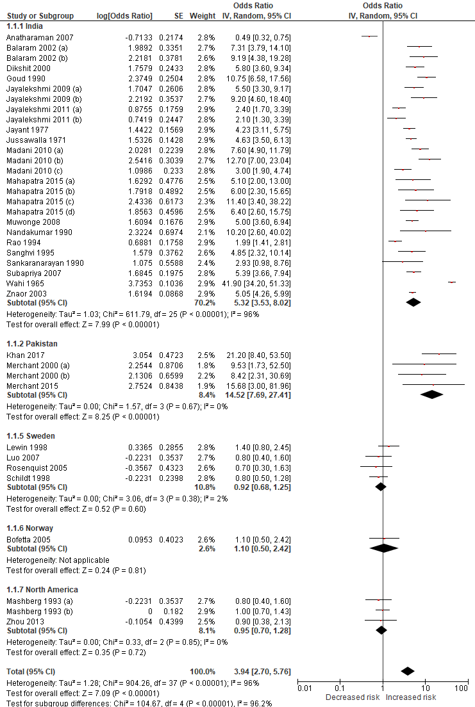
Balaram 2002 (a): Among never drinkers adjusted for smoking, Balaram 2002 (b): Among never smokers adjusted for alcohol
Jayalekshmi 2009 (a) and 2011 (a): Current users, Jayalekshmi 2009 (b) and 2011 (b): Former users
Madani 2010 (a): Tobacco flakes, Madani 2010 (b): Gutkha, Madani 2010 (c): Mishri
Mahapatra 2015 (a): Gutkha, Mahapatra 2015 (b): Chewing tobacco, Mahapatra 2015 (c): Supari with tobacco, Mahapatra 2015 (d): Betel quid with tobacco
Merchant 2000 (a): Naswar, Marchant 2000 (b): Paan with tobacco
Mashberg 1993 (a): Oral snuff, Mashberg 1993 (b): Chewing tobacco

