Figure 3: Risk estimates for cardiovascular diseases (Ischaemic heart disease, stroke) among ever ST users
ISCHAEMIC HEART DISEASE
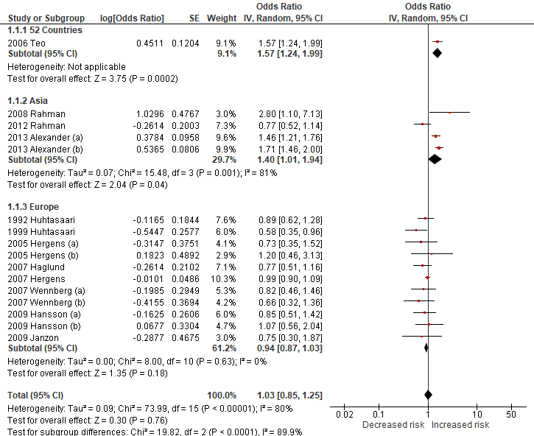

Alexander 2013 (a): Dippers, Alexander 2012 (b): Chewers,
Hergens 2005 (a): Current users, Hergens 2005 (b): Former users,
Wennberg 2007 (a): Current users, Wennberg 2007 (b): Former users,
Hansson 2009 (a): Current users, Hansson 2009 (b): Former users

STROKE
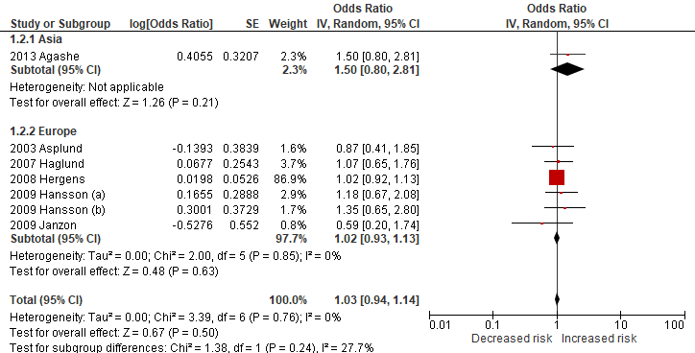

Hansson 2009 (a): Current users, Hansson 2009 (b): Former users

