Magnetic Films for Spintronic Devices
Atsufumi Hirohata, University of York

Status. Spintronic devices [1] can be fabricated using a magnetic film via top-down, e.g., ion-beam milling of an epitaxial film, and/or bottom-up, e.g., lift-off of a polycrystalline film, approaches after electron-beam and/or optical lithography. For a ferromagnetic film, the number of elements in a ferromagnetic layer used have been increasing over the last decades as similarly reported in the other fields. For the case of magnetic tunnel junctions, the total number of publications have been almost monotonically increasing since 1994. Besides the fundamental studies using a single-element ferromagnetic electrode, such as Fe, Co and Ni, studies using binary alloys, e.g., CoFe, NiFe and FePt, took their peak in the early 2000s, followed by those on ternary alloys, including Heusler alloys. Now the focus is shifting towards quaternary or more complicated alloys.
For spintronic devices, physical vapour deposition has been primarily used. Thermal evaporation, electron-beam evaporation and molecular-beam epitaxy (MBE) can induce a kinetic energy of 0.1 ~ 1 eV to the evaporating molecules, achieving minimum damage onto a substrate and/or seed layer underneath the film to be grown. Sputtering and laser ablation generate kinetic energy levels of 1 ~ 10 eV ideal for alloys, while ion plating has the highest energy induced to be a few 10 eV ~ 5 keV. MBE, sputtering and ion plating in an UHV environment (10^{–8} ~ 10^{–5} Pa) can grow an epitaxial film, which is almost the same with a single crystal. By reducing the vacuum quality and/or increasing the deposition rate, the quality of the films can be degraded with increasing their epitaxial grains, leading to polycrystalline films.

Current and future challenges. To sustain the continuous development of spintronic devices, a ferromagnetic film requires to satisfy the following properties: (i) low damping, (ii) high perpendicular magnetic anisotropy, (iii) large spin polarisation, (iv) back end of line (BEOL) compatibility and (v) a small stray magnetic field. Spintronic devices require different combinations of these five properties, e.g., all five for spin-transfer torque (STT) as detailed in Sections 11, 12 and 14, and (i), (ii) and (iv) for spin-orbit torque (SOT) as discussed in Section 4. The damping of a magnetic moment can be described using the Landau-Lifshits-Gilbert equation [2],[3]:
$\frac{d\vec{M}}{dt}=-γ\vec{M}×H_{eff}+\frac{α}{M}\vec{M}×\frac{d\vec{M}}{dt}$, (1)
where the second term is the relaxation term with the Gilbert damping constant $α$. This term increases with increasing temperature. In spin injection devices, such as a magnetic tunnel junction (MTJ) and a spin-valve (SV), the critical current for their magnetisation reversal via the STT is proportional to $α$. Smaller $α$ also reduces the speed of the magnetisation reversal (but it increases the speed of domain wall motion in a racetrack memory). In the conventional ferromagnets, Co_{0.25}Fe_{0.75} shows the smallest $α$ of (5 ± 1.8)×10⁻⁴ [4]. Here, $α$ is induced by spin flips, which is intrinsically proportional to the density of states (DOS) at the Fermi level E_{F} [5] and extrinsically proportional to interfacial spin flips typically caused by interfacial roughness and contaminations. A half-metallic ferromagnet with only one spin DOS at E_{F} holds a great potential to reduce $α$ further, achieving $α$ to be even smaller than 0.001 in some Heusler alloys, such as Co_{1.9}Mn_{1.1}Si [6].

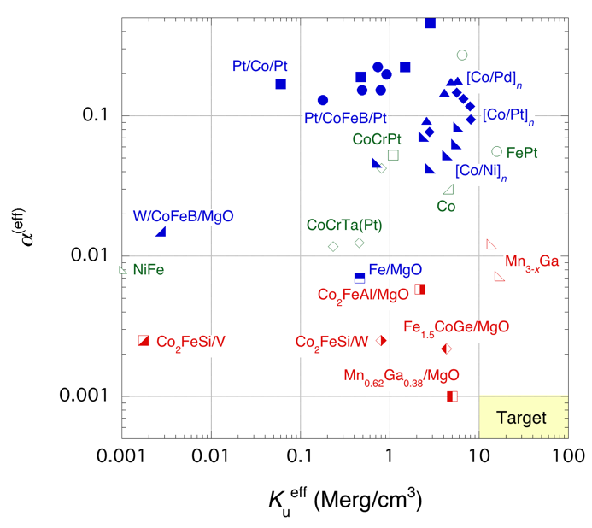
Figure 1. Relationship between the magnetic anisotropy constant K_{u}^{eff} and the Gilbert damping constant $α$. Single films, multilayers with heavy metals and half-metallic Heusler alloy films are shown in green open, blue closed and red open symbols. Heusler alloys with MgO and heavy metals are also shown in half-closed symbols. After [7],[8],[9],[10].

For the integration of such spintronic devices, large perpendicular magnetic anisotropy is also essential. In the conventional ferromagnets, Co shows the largest perpendicular anisotropy constant K_{u}^{eff} of 4.7×10⁵ J/m³ (4.7×10⁶ erg/cm³), which can be further increased by attaching to a heavy metal, e.g., Pt and Pd, and/or MgO up to ~ 10⁶ J/m³ (10⁷ erg/cm³). As an alloy, FePt shows the largest K_{u}^{eff} ~ 1.6×10⁶ J/m³ (1.6×10⁷ erg/cm³), however it has large $α$ of ~ 0.06. Recently, Mn-Ga alloys, which is one of the Heusler alloys, have been reported to satisfy both large K_{u}^{eff} ~ 1.6×10⁶ J/m³ (1.6×10⁷ erg/cm³) and low $α$ ~ 0.007. Further reduction in $α$ while maintaining large K_{u}^{eff} is a challenge for the community.
Large spin polarisation P is the third requirement for device applications as the spin generation efficiency of the spin injection is limited to < 30%. In the bulk form, Heusler alloys have been reported to achieve P=100% but not in their film form at room temperature to date. A large variety of Heusler alloys, including Co₂MnZ (Z=Si, Ga, Ge and Sn), Co₂CrZ (Z=Al and Ga) and Co₂FeZ (Z=Al, Si, Ga and Ge), have been reported to show P~60% in their film form at room temperature [11], requiring further improvement in their interfacial smoothness and atomic ordering. These properties can be controlled by annealing processes either during the film deposition or afterwards. Typically, the crystallisation of the Heusler alloys requires high annealing temperature T_{a} above 650K, which may not be compatible with the current BEOL process. Recently, the (110) plane has been reported to promote layer-by-layer crystallisation, which can reduce over 50% of the crystallisation energy [12]. In a SV consisting of W (10)/Co₂FeAl_{0.5}Si_{0.5} (12.5)/W (1.2)/Co₂FeAl_{0.5}Si_{0.5} (2.5)/Ta (2) (thickness in nm) deposited at 355K for 2 min, over 85% crystallisation into the B2 phase, which contains some atomic disordering between Co and Fe as compared with the perfectly ordered L2₁ phase, has been achieved but the corresponding giant magnetoresistance (GMR) ratio is not large [13]. Further optimisation is required for device implementation.
For integration, the minimisation of stray fields from devices H_{s} can reduce their cross-talks, which can be a major source of noise in their operation. In the Heusler alloys, for example, their saturation magnetisation is known to be proportional to the number of valence band electrons following the generalised Slater-Pauling curve [14]. A great deal of efforts has been devoted recently to develop a ferromagnetic Heusler alloy films with a small magnetisation and a ferrimagnetic film near its compensation temperature to minimise H_{s}. Another option is to use an antiferromagnetic film [15] through the spin-orbit interactions, which are advantageous in terms of power consumption. As demonstrated in MTJ with the SOT switching, the power required can be one order of magnitude smaller than in the STT case. Additionally, the efficiency of spin-current generation can achieve 100% using the quantum spin Hall effect for example [16].

Advances in science and technology to meet challenges. In the current research on ternary/quaternary alloy films, the primary focus has been given to Co-based ferromagnetic alloys, e.g., CoFeB and Co-based Heusler alloys. B dusting on CoFe has initially been used by IBM to promote the Frank-van der Merve mode growth for a ferromagnetic layer, which has now been used as an alloy with a B-absorbing layer of Ta or W. Similar dusting has been utilised for oxide layer growth with Ti and/or Mg. By looking at the periodic table as shown in Fig. 2, there is still a large variety of ternary/quaternary alloys unexplored based on Fe, Ni and Mn for example. Note that some of the elements have criticality and hazardous issues, which may have been overlooked in the recent years. The main difficulty for them is the degrees of crystallisation, interfacial quality and robustness against the device fabrication. Due to the large number of alloy combinations, materials informatics using machine learning has been developed recently (see Section 8). Currently, the selection strongly depends on the list of control parameters for machine learning. Such a new approach is anticipated to accelerate the material selection for future spintronic devices.

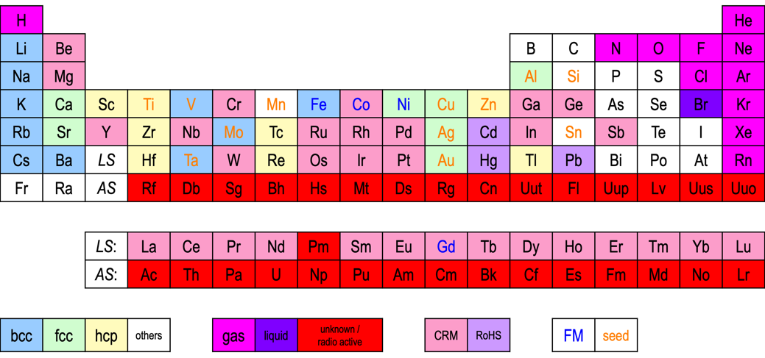
Figure 2. Highlighted periodic table, classifying the materials in their crystalline structures; body-centred cubic (bcc), face-centred cubic (fcc), hexagonal close packing (hcp) and others. Their phases in gas, liquid and unknown or radioactive are also shown. Critical raw materials, those listed as the restriction of hazardous substances (RoHS) are also highlighted. Ferromagnetic and seed materials are shown in blue and orange letters, respectively.

Concluding remarks. The development of new magnetic materials holds a key position for the improvement of the spintronic device performance. Especially five critical improvements need to be achieved: (i) $α$ < 0.001 (for free layers), (ii) K_{u}^{eff} > 1.0×10⁶ J/m³ (1.0×10⁷ erg/cm³), (iii) P~100% at room temperature, (iv) T_{a} < 550K and (v) H_{s}~0. Since damping and anisotropy originate from spin-orbit coupling, the control of internal spin-orbit coupling is a key for the material development as has been demonstrated for the case of interfacial hybridisation between the electronic orbitals of a transition metal and an adjacent oxide layer. The electronic band structures within an alloy and/or at the interface against an adjacent oxide or metal also determine the effective spin polarisation. From the viewpoints of no net magnetisation and magnetisation dynamics in a THz regime, antiferromagnet and (compensated) ferrimagnet can also have a great potential. By controlling these spin-orbit and exchange coupling, a new material (system) can be developed for spintronic devices. Using the advancement in film-growth techniques and machine learning as detailed in Section 8, materials development can be accelerated to realise STT- and SOT-based devices with higher efficiency.

References

[1] A. Hirohata and K. Takanashi, J. Phys. D: Appl. Phys. 47, 193001 (2014)
[2] L. Landau and E. Lifshitz, Physik A (Soviet Union) 8, 135 (1935).
[3] T. L. Gilbert, IEEE Trans. Magn. 40, 3443 (2004).
[4] M. A. W. Schoen, D. Thonig, M. L. Schneider, T. J. Silva, H. T. Nembach, O. Eriksson, O. Karis and J. M. Shaw, Nat. Phys. 12, 839 (2016).
[5] A. Hirohata, H. Sukegawa, H. Yanagihara, I. Žutić, T. Seki, S. Mizukami and R. Swaminathan, IEEE Trans. Magn. 51, 0800511 (2015).
[6] S. Andrieu, A. Neggache, T. Hauet, T. Devolder, A. Hallal, M. Chshiev, A. M. Bataille, L. Fevre and F. Bertran, Phys. Rev. B 93, 094417 (2016).
[7] Z. Bai, L. Shen, G. Han and Y. Feng, Spin 2, 1230006 (2012).
[8] A. Conca, A. Niesen, G. Reiss and B. Hillebrands, AIP Adv. 9, 085205 (2019).
[9] A. Hirohata, W. Frost, M. Samiepour and J.-Y. Kim, Materials 11, 105 (2018).
[10] D. M. Lattery, D. Zhang, J. Zhu, X. Hang, J.-P. Wang and X. Wang, Sci Rep. 8, 13395 (2018).
[11] B. S. D. C. S. Varaprasad, A. Srinivasana, Y. K. Takahashi, M. Hayashi, A. Rajanikanth and K. Hono, Acta Mater. 60, 6257 (2012).
[12] J. Sagar, L. R. Fleet, M. Walsh, L. Lari, E. D. Boyes, O. Whear, T. Huminiuc, A. Vick and A. Hirohata, Appl. Phys. Lett. 105, 032401 (2014).
[13] W. Frost, M. Samiepour and A. Hirohata, J. Magn. Magn. Mater. 484, 100 (2019).
[14] C. Felser and A. Hirohata, Heusler Alloys (Springer, Berlin, 2016).
[15] A. Hirohata, T. Huminiuc, J. Sinclair, H. Wu, M. Samiepour, G. Vallejo-Fernandez, K. O'Grady, J. Balluff, M. Meinert, G. Reiss, E. Simon, S. Khmelevskyi, L. Szunyogh, R. Yanes, U. Nowak, T. Tsuchiya, T. Sugiyama, T. Kubota, K. Takanashi, N. Inami and K. Ono, J. Phys. D: Appl. Phys. 50, 443001 (2017).
[16] M. König, S. Wiedmann, C. Brüne, A. Roth, H. Buhmann, L. W. Molenkamp, X.-L. Qi, S.-C. Zhang, Science 318,766 (2007).

