Controlled semantic summation correlates with intrinsic connectivity between default mode and control networks

Megan Evans*, Katya Krieger-Redwood*1, Tirso RJ Gonzalez Alam, Jonathan Smallwood and Elizabeth Jefferies

Department of Psychology, University of York, York, UK

*Joint first authors

1 Corresponding author

Katya.krieger-redwood@york.ac.uk

**Acknowledgements:** EJ was supported by European Research Council [FLEXSEM-771863], JS was supported by European Research Council [WANDERINGMINDS-646927], TGA was supported by the National Council of Science and Technology of Mexico [Scholarship 411361]. We are also grateful to the insightful comments from the reviewers of this paper; their comments have much improved the manuscript.

**Abstract**

The capacity to identify aspects of meaning that overlap across multiple concepts may relate to individual differences in the strength of intrinsic connectivity within and between distinct brain networks supporting semantic cognition. This study examined a semantic summation task, which tested the capacity to detect weak overlapping aspects of meaning, in 76 participants who were also scanned with resting-state fMRI. We examined associations between summation and the intrinsic connectivity of semantically-relevant default mode and control network regions. These networks are implicated in information integration and controlled retrieval respectively. We found higher intrinsic connectivity between default and control networks was associated with better performance in the summation task. The same pattern of coupling between semantic default mode and control networks was not associated with more efficient retrieval of individual weak as opposed to strong associations in an additional cohort of around 200 participants, suggesting this pattern is specific to the summation of multiple concepts, rather than semantic task difficulty. Finally, higher connectivity within the default mode network was associated with better performance when selecting a word that was strongly-related to a single probe item, supporting the role of this network in more automatic aspects of semantic retrieval.

**Keywords:** semantic cognition; semantic control; default mode network; creativity; resting-state fMRI

**Introduction**

Semantic cognition is a fundamental component of mind and behaviour: it allows us to understand the meaning of words, objects, places and people that we encounter across different modalities, and use this knowledge flexibly to guide our thoughts and actions in a manner that suits the current context (Jefferies, 2013). Semantic cognition is supported by the interaction of multiple neurocognitive components that underpin different aspects of conceptual processing – in particular, retrieval from a heteromodal conceptual store is shaped by semantic control processes to suit the task or context (Lambon Ralph, Jefferies, Patterson, & Rogers, 2017). Ventrolateral anterior temporal lobe (ATL) is thought to be a key site for heteromodal conceptual representations (Lambon Ralph et al., 2017; Patterson, Nestor, & Rogers, 2007; Rogers et al., 2006), and this region activates together with semantic control sites, such as left inferior frontal gyrus (IFG) during semantic tasks (Badre, Poldrack, Pare-Blagoev, Insler, & Wagner, 2005; Noonan, Jefferies, Visser, & Lambon Ralph, 2013; Wagner, Pare-Blagoev, Clark, & Poldrack, 2001; Whitney, Grossman, & Kircher, 2009). However, these sites form distinct networks at rest (Davey et al., 2016; Gonzalez Alam, Karapanagiotidis, Smallwood, & Jefferies, 2019), suggesting that flexible patterns of network connectivity may be critical to successful semantic cognition. In this context, individual differences in intrinsic connectivity within and between semantically-relevant networks may show associations with variations in performance (Mollo et al., 2016; Vatansever et al., 2017).

While recent research has related individual differences in connectivity to semantic cognition (for example: Gonzalez Alam et al., 2019; Krieger-Redwood et al., 2016; Mollo et al., 2016; Vatansever et al., 2017; Wei et al., 2012), tasks used to date have not specifically examined the integration of semantic information across multiple weakly-overlapping concepts. Target concepts can often be identified through a strong association (e.g., ITCH --> SCRATCH), but also through many weak associations (e.g., CAT, ATTACKS, PAW --> SCRATCH; Beeman et al., 1994; Thompson, Henshall, & Jefferies, 2016). Beyond retrieving the meaning of individual words and objects, what are the underlying neural processes that support our ability to add together, or summate, meanings of these individual words to identify conceptual overlap between items? Identifying the convergence of semantic relations across multiple items is likely to be a key process in real-world semantic cognition where items appear in rich contexts – and this is likely to be critical to our capacity to draw inferences, understand novel metaphors, maintain coherence, and integrate ideas in complex discourse (Beeman, 1998). In order to make predictions about how performance on the summation task may be linked to intrinsic neural connectivity, it is important to consider the behavioural mechanisms that may contribute to successful completion of this task.

The present study was based on the semantic summation priming paradigm originally developed by (Beeman et al., 1994), in which participants were presented weakly related probes (CAT – ATTACK – PAW) and then named the target ‘SCRATCH’, presented either to the left or right visual field. This task may involve some degree of mediated priming (e.g., the word lion primes stripes, even though the mediating word “tiger” is missing from the word pair, a process that can occur with increased semantic distance between words (Kenett, Levi, Anaki, & Faust, 2017; Kumar, Balota, & Steyvers, 2019). However, in mediated priming, the probes ‘summate’ onto an unambiguous target, and the first and last word are not related - they are connected through mediating primes (for example ‘mane – tiger’ is linked by the mediator ‘lion’); in contrast, in the summation task, the target is related to all of the probes (i.e., no mediator is necessary to link the words – for example, cat and scratch are related, even without the other two probes; Kandhadai & Federmeier, 2008). Furthermore, in some circumstances competition may arise from other related concepts, and this may require multiple brain networks to work in concert to achieve the appropriate solution (i.e., integration across multiple probes, inhibition of inappropriate responses). This is in line research by De Deyne and colleagues demonstrating that people are able to relate distant semantic associates through a process of successive spreading semantic activation, for example, the connection between athlete and breath is mediated by connections from athlete – to exercise – to pant – to breath. They have shown that the way in which participants associate weakly related concepts is systematic, even when the words are completely unrelated (De Deyne, Navarro, Perfors, & Storms, 2016; see also, Kennet et al., 2017, Kumar et al. 2019). Therefore, in summation tasks, spreading activation across weakly associated items, along with some degree of priming, should facilitate the integration of concepts onto a single target. However, we used a modified version of the summation priming paradigm that manipulated the *difficulty of identifying the target*, by using distractors with the same degree of relatedness to each of the probes (Thompson et al., 2016). This meant that participants had to identify the target that was the result of combining all three probes, while inhibiting other responses related to all of the probes (Figure 1). Therefore, participants cannot rely on a single probe to identify the target alone, because the target and distractors are equally related to the probes, forcing participants to focus on the integrated meaning to identify the target. We will refer to this process as ‘controlled semantic summation’: while participants can rely on spreading activation to relate the weakly-associated concepts, they also need to engage inhibition processes to suppress other equally related items, that do not represent the integrated meaning of all three probes.

This task also finds parallels with tasks commonly used to study creativity, such as the remote associates task (RAT). Successful completion of the RAT requires participants to produce a target following the presentation of three probes (probes: bass – complex – sleep, target: deep; Mednick, 1968). As with the summation task, the RAT requires participants to combine weakly-associated items across multiple probes, however there are key differences between the two tasks. The RAT is a production task (while our summation task is receptive), furthermore, in the C-RAT version developed for fast administration and widely adopted in the fMRI literature, the probes converge on *one unambiguous solution* – in our summation task, the solution is less obvious and is flanked by three pre-potent distractors. However, despite this, we would expect some degree of overlap in some of the processes required to complete the two tasks, for example, the requirement to combine multiple primes into an integrated meaning. Therefore, our experiment may yield some results that overlap with previous literature examining RAT performance, while also producing other results that may be more specific to semantic and/or summation control processes (e.g., inhibition).

Given the degree of control needed to complete the summation paradigm in the present study, we might expect involvement of a strongly left-lateralised semantic control network. This network is relevant to the identification of distant associations (Jefferies, 2013; Noonan et al., 2013; Whitney, Kirk, O'Sullivan, Lambon Ralph, & Jefferies, 2011) and therefore might be expected to play a critical role in the identification of weak conceptual overlap between multiple items. The semantic control network is thought to direct semantic retrieval so that it is relevant to the current task or situation (Jefferies, 2013; Lambon Ralph et al., 2017). When target information is dominant or strongly related to a previously presented cue, semantic representations are already configured to produce the correct response and there is little need for semantic control. In contrast, when the task requires the retrieval of non-dominant features or subordinate meanings, strongly-encoded yet currently irrelevant information must be supressed, and the semantic control network is engaged. In the summation task, it is necessary to focus retrieval for each probe word on aspects of knowledge which overlap with the meaning of the other probe words, even though this information is non-dominant, and this is likely to require control. Both task activation and patterns of intrinsic connectivity suggest the semantic control network is strongly left-lateralised (Gonzalez Alam et al., 2019; Noonan et al., 2013).

However, demanding semantic tasks do also activate bilateral domain-general executive regions of the multiple-demand network (Duncan, 2010; Duncan & Owen, 2000), including bilateral inferior frontal sulcus and pre-supplementary motor area (Davey et al., 2016; Gonzalez Alam, Murphy, Smallwood, & Jefferies, 2018; Hallam, Whitney, Hymers, Gouws, & Jefferies, 2016). Despite this, semantic control peaks in left anterior IFG and pMTG fall outside this multiple-demand network (MDN; see Figure 3; Badre et al., 2005; Krieger-Redwood, Teige, Davey, Hymers, & Jefferies, 2015; Noonan et al., 2013; Thompson-Schill, D'Esposito, Aguirre, & Farah, 1997), and semantic control and domain-general control regions also show different lateralisation. The original summation task was constructed by Mark Beeman to test the hypothesis that the right and left hemispheres “probably store similar representations, but differ in how they dynamically access information” (Jung-Beeman, 2005, p. 513). More specifically, that the LH accesses fine-grained semantic coding limited to concepts strongly related to the input, while the RH employs coarse semantic coding – supporting the activation of large semantic fields including concepts distantly related to the input, thereby crucial to summation. Some evidence for this perspective was provided by their observation that participants benefitted more from three weakly-related prime words presented to the left visual field (RH) than to the opposite hemifield. More recently, the RH was found to increase activity during insight solutions to verbal problems (Jung-Beeman et al., 2004)[1], reinforcing the possible involvement of the RH in retrieving more distant connections. This theory is also compatible with the Graded Salience Hypothesis which suggests two parallel processing streams activate simultaneously: a fast bottom-up stream activated by salience and a slower top-down stream sensitive to both linguistic and extra-linguistic knowledge. Here, all activated meanings are integrated with contextual information, and are retained if instrumental to the intended interpretation (Giora, 1997; Giora, 2003, 2008; Giora, Zaidel, Soroker, Batori, & Kasher, 2000; Peleg, Giora, & Fein, 2008). However, the proposal that RH supports coarse semantic coding remains highly controversial, with most studies finding stronger semantic activation in LH, across a wide range of tasks (Davey et al., 2015; Jefferies, 2013; Krieger-Redwood et al., 2015; Lambon Ralph et al., 2017; Whitney, Kirk, O'Sullivan, Lambon Ralph, & Jefferies, 2012). Furthermore, while creative thought may require the use of coarse semantic coding, for example, in activating semantic fields distant from the original input, a recent meta-analysis found that the number of foci in the RH was significantly less (173) than in the LH (266; Gonen-Yaacovi et al., 2013); the RH coarse semantic coding hypothesis is unable to account for the high degree of LH activation evident across tasks manipulating semantic and creative cognition.

In addition to control processes, semantically-relevant regions of the default mode network (DMN) are likely to be relevant to summation. Although this network deactivates in demanding tasks (Raichle et al., 2001), some DMN regions show a semantic response, including anterior middle temporal gyrus and angular gyrus (AG; Binder, Desai, Graves, & Conant, 2009; Davey et al., 2015; Davey et al., 2016; Humphreys, Hoffman, Visser, Binney, & Lambon Ralph, 2015). Lateral ATL regions falling within DMN may have a role in the integration of different features, represented in distinct brain regions, supporting heteromodal semantic cognition (Mollo, Cornelissen, Millman, Ellis, & Jefferies, 2017; Murphy et al., 2018; Visser, Jefferies, Embleton, & Lambon Ralph, 2012; Zhang, Savill, Margulies, Smallwood, & Jefferies, 2019). This is echoed by Shen and colleagues (2017), who suggest that the temporal lobes are involved in: novelty detection and recognition (medial temporal lobe – MTL), selective access to representations (posterior superior temporal gyrus – pSTG), integration and binding of distributed conceptual representations (aSTG), and extensive semantic processing (e.g., maintaining activation of all possible meanings; anterior Middle Temporal Gyrus - aMTG); all of these temporal lobe subdivisions (aSTG, pSTG, aMTG and part of MTL) fall within semantically relevant DMN, and are important aspects of integrative processing.

Similarly, left AG, a core region within DMN, is implicated in combinatorial semantics: the ability to combine conceptual elements into larger entities (Price, Bonner, Peelle, & Grossman, 2015). For example, Graves et al. (2010) found higher activation in AG to highly meaningful noun-noun phrases (e.g. LAKE HOUSE) compared to non-meaningful forms created by flipping the phrase (e.g. HOUSE LAKE), suggesting this region supports the comprehension of coherent conceptual combinations (see also, Lanzoni et al., under review; Lerner, Honey, Silbert, & Hasson, 2011; Nguyen, Vanderwal, & Hasson, 2019; Pallier, Devauchelle, & Dehaene, 2011; Pylkkänen, 2019; Teige et al., 2019; Teige et al., 2018; Thompson et al., 2007). Similarly, Tylén et al. (2015) found higher activation in DMN regions to coherent compared to incoherent story episodes, supporting the role of the DMN in integrative and constructive processes. The location of DMN, at the apex of a cortical hierarchy from unimodal to heteromodal cortex (Margulies et al., 2016), is consistent with its purported role as an ‘integrational hub’, supporting the convergence of information from multiple sources into more complex meanings (Binder & Desai, 2011; Patterson et al., 2007). These functional characteristics of semantically-relevant DMN regions may support the conceptual integration required in the semantic summation task.

While semantically-relevant regions of DMN in the absence of constraints from other networks are thought to underpin the relatively automatic semantic retrieval of dominant features and associations (Davey et al., 2016; Humphreys et al., 2015), interactions between DMN and control processes might be critical to controlled semantic cognition. Davey et al. (2016) demonstrated that regions of the semantic control network (left anterior IFG and pMTG) sit at the nexus of ATL and the multiple-demand network, suggesting that the interaction of these networks (DMN, MDN) might support our ability to retrieve non-dominant semantic associations (see also, Jefferies, Thompson, Cornelissen, & Smallwood, 2019). Accordingly, Shen et al. (2017) suggest that the pMTG plays an important role in creative thought through inhibition based on convergence of information from multiple sources (i.e., from other parts of the temporal lobes), as well as fusiform gyrus which sits in the MDN for forming gestalt-like representations. Moreover, Krieger-Redwood et al. (2016) found that a control-demanding feature-matching task led to deactivation in a key DMN region, posterior cingulate cortex (as expected for a ‘task-negative’ region); yet at the same time, this site showed increased functional connectivity with dorsolateral prefrontal cortex, within the multiple-demand network. Further, functional coupling at rest between posterior cingulate and prefrontal cortex was stronger for participants who were more efficient at the demanding semantic task. These findings suggest that DMN is also relevant to controlled forms of semantic cognition through its communication with control regions. In a similar way, coupling of DMN and control networks may be associated with greater ability to summate meanings to identify a distant relationship between multiple words.

We examined the association between semantic summation and intrinsic functional connectivity within and between default mode, semantic control, and multiple-demand networks. As this task involves multiple semantic processes – e.g. not just retrieval but also the integration of concepts and the inhibition of other equally related associates – we might expect multiple networks to play a role in successful execution of this task. For example, the left-lateralised semantic control network is important in the retrieval of weak associations, as well as the inhibition and/or selection amongst competing alternatives, an important aspect of our paradigm; however, the task involves a further element – the integration of multiple weak associations to determine a suitable target – which could engage the DMN. We used fMRI to characterise individual differences in intrinsic functional connectivity in 76 participants, who completed the adapted controlled semantic summation task outside the scanner alongside a ‘direct’ retrieval condition which involved a single strong association (Experiment 1). We examined variation in connectivity from seeds composed of left-lateralised semantically-relevant elements of DMN, semantic control, and multiple-demand networks (Figure 3), in order to identify patterns of within and between network connectivity associated with performance. We examined whether performance was associated with greater connectivity only within LH, or also between LH seeds and RH regions. As controlled summation was more demanding than the ‘direct’ retrieval condition, we additionally assessed whether patterns of intrinsic connectivity identified in the first sample of participants could simply be explained by efficient semantic control, by comparing the retrieval of weak and strong associations when there was little demand on semantic summation, using a previously-published cohort of 200 participants (Experiment 2). Therefore, while the previous literature has identified brain areas that activate for processes contributing to controlled semantic summation, this study sought to further elucidate how network connectivity relates to the ability to successfully identify a target as a result of integrating across weakly-related concepts.

Figure 1: Word2Vec scores to demonstrate the semantic distance between probes, targets and distractors in the summation and direct conditions. The relationship between the probes and target in the summation condition could only be achieved by integrating all three probes. The relationship between each probe word and each distractor was similar to the target, meaning that participants had to integrate the meaning and inhibit other related choices to find the target. In the direct condition the target is highly related to the probe, and does not require the integration of multiple probes.

**Method**

This study includes analyses of intrinsic connectivity in two samples. Experiment 1 assessed how intrinsic connectivity from semantic DMN and control regions might relate to performance on summation and direct tasks. The purpose of Experiment 2 was to establish whether the findings for semantic summation reflected connectivity patterns linked to better performance on harder semantic tasks in general, or if the results were specific to summation.

We determined our sample size based on participant availability (i.e., tested as many participants as were willing), and report all data exclusions, all inclusion/exclusion criteria, whether inclusion/exclusion criteria were established prior to data analysis, all manipulations, and all measures in the study. This study was not pre-registered in a time-stamped, institutional registry prior to the research being conducted.

**Participants:** None of the participants in Experiments 1 or 2 had a history of psychiatric or neurological illness, drug use that could alter cognitive functioning, severe claustrophobia, or pregnancy. All volunteers provided written informed consent and were debriefed after data collection. Ethical approval was obtained from Ethics Committees in the Department of Psychology and York Neuroimaging Centre, University of York. All participants were right-handed, native English speakers with normal/corrected vision, and compensated for their time with payment or course credit.

*Experiment 1:*Participants who had previously been scanned using a resting-state fMRI sequence at the York Neuroimaging Centre were invited to take part. We recruited 83 participants (64 females, mean age = 19.7 years, range = 18-26 years). Two participants were removed before pre-processing due to missing resting-state data, and a further three because we did not have full brain coverage. Another two were excluded during pre-processing because motion exceeded 0.3mm, invalid scans exceeded 20% and/or there was mean global signal change of z > 2. The final sample therefore consisted of 76 participants (61 females, mean age = 19.6 years, range = 18-25 years).

*Experiment 2:*We analysed data from a large cohort of 207 volunteers recruited from the University of York (137 females, mean age = 20.21, range = 18-31 years) who completed a resting-state scan, followed by cognitive and memory tests in subsequent sessions on different days. These data have been used in previous studies focused on the lateralisation of semantic cognition (Gonzalez Alam et al., 2019), cortical thickness (Wang et al., 2018b), neurocognitive components of semantic performance (Vatansever et al., 2017), mind-wandering (Poerio et al., 2017; Sormaz et al., 2018; Turnbull et al., 2019; Wang et al., 2018a; Wang et al., 2017), and hippocampal connectivity (Karapanagiotidis, Bernhardt, Jefferies, & Smallwood, 2017; Sormaz et al., 2017). We excluded sixteen participants: nine due to missing behavioural data, one due to missing MRI data, one due to incorrect TR in MRI acquisition, and four during pre-processing because they exceeded our motion cut-off of 0.3mm, had more than 20% invalid scans and/or mean global signal change of z > 2. The final sample size, therefore, consisted of 191 participants (122 females, mean age = 20.55, range = 18-31 years).

In order to characterise the mean patterns of intrinsic connectivity for the clusters linked to summation and direct retrieval in Experiment 1, we also analysed the resting-state data of a subset (n = 152) of this cohort without a behavioural regressor. We excluded 39 participants from the Experiment 2 cohort who had also completed the summation paradigm, to ensure that this subset of participants was a fully independent sample (see Experiment 1).

**MRI data acquisition:** Structural and functional MRI data were acquired for both experiments using a 3T GE HDx Excite MRI scanner utilising an eight-channel phased array head coil tuned to 127.4MHz, at the York Neuroimaging Centre, University of York. Structural MRI acquisition was based on a T1-weighted 3D fast spoiled gradient echo sequence (TR=7.8s, TE=minimum full, flip angle=20°, matrix size=256x256, 176 slices, voxel size=1.13x1.13x1mm3). Resting-state fMRI data was recorded from the whole brain using single-shot 2D gradient-echo-planar imaging (TR=3s, TE=minimum full, flip angle=90°, matrix size=64x64, 60 slices, voxel size=3x3x3mm3, 180 volumes). Participants passively viewed a fixation cross and were not asked to think of anything in particular for the duration of the scan (9 minutes). A T1 weighted FLAIR scan with the same orientation as the functional scans was collected to improve co-registration between subject-specific structural and functional scans (TR=2560ms, TE=minimum full, matrix size=64x64, voxel size=3x3x3mm3).

**Pre-processing:** Pre-processing for both experiments was performed using the CONN functional connectivity toolbox V.18a (http://www.nitrc.org/projects/conn; Whitfield-Gabrieli & Nieto-Castanon, 2012). Functional volumes were slice-time (bottom-up, interleaved) and motion-corrected, skull-stripped and co-registered to the high-resolution structural image, spatially normalised to Montreal Neurological Institute (MNI) space using the unified-segmentation algorithm, smoothed with a 6mm FWHM Gaussian kernel, and band-passed filtered (0.008-0.09Hz) to reduce low-frequency drift and noise effects. A pre-processing pipeline of nuisance regression included motion (twelve parameters: the six translation and rotation parameters and their temporal derivatives), scrubbing (all outlier volumes were identified through the artifact detection algorithm included in CONN, with conservative settings: scans for each participant were flagged as outliers based on scan-by-scan change in global signal above z=3, subject motion threshold above 5mm, differential motion and composite motion exceeding 95% percentile in the normative sample), and CompCor components (the first five) attributable to the signal from white matter and CSF (Behzadi, Restom, Liau, & Liu, 2007), as well as a linear detrending term, eliminating the need for global signal normalisation (Chai, Castañón, Öngür, & Whitfield-Gabrieli, 2012; Murphy, Birn, Handwerker, Jones, & Bandettini, 2009).

All figures were created using BrainNet Viewer (http://www.nitrc.org/projects/bnv/; Xia, Wang, & He, 2013).

**Experiment 1**

**Semantic Summation Task Procedure:** The semantic summation task was adapted from previous studies (Beeman et al., 1994; Thompson et al., 2016). It was presented alongside four other tasks which fall outside the scope of this study. The duration of the full testing session was approximately 1.5 hours. Participants completed the tasks in the same order (with the summation task as the third of the five tasks) to reduce the extent to which testing order contributed to individual differences in performance.

The summation task examined the efficiency with which individuals could detect weak overlapping patterns of semantic activation to obtain an association between distantly-related words. In the “summation” condition, participants were presented with three probe words on screen simultaneously, followed by four possible response words. They were asked to choose the word that related to all three probes. The other three response options were distractors which were semantically-related to only one of the probes. For example, the probes ‘CAT-ATTACK-PAW’ were followed by response options ‘DOG, DEFEND, FOOT, SCRATCH’. The correct response is ‘SCRATCH’ because this is the only word which relates to every probe item. In the “direct” condition, participants were presented with three words, consisting of two ‘filler’ words (with little meaning, such as NULL) and one centrally-presented probe. These were followed by four response options, which were the same as the summation condition and had the same correct response. Participants were simply required to choose the word that semantically-related to the central probe word. For example, ‘NOTHING-ITCH-NULL’ was followed by the response options ‘DOG, DEFEND, FOOT, SCRATCH’. The correct response is ‘SCRATCH’ because it is the only word strongly-related to the probe word. The stimuli were taken from Beeman et al. (1994) and are provided in Supplementary Materials, as well as an item analysis for each condition.

The task was organised into two practice blocks, one for each condition (Direct and Summation), followed by four experimental blocks, two for each condition. The order of the conditions was counterbalanced, with equal numbers of participants tested on Summation-Direct-Direct-Summation and Direct-Summation-Summation-Direct sequences. Practice blocks consisted of 5 trials, while experimental blocks contained 19 trials each. Stimuli were white on a black background. Before the task commenced, an instruction slide explained the task to be performed. At the beginning of each block, a slide indicated the condition and this remained on screen until the participant pressed a key. In each trial (Figure 2), probe words were presented for 1500ms, followed by the response options which remained on screen until a response button press was recorded. Participants indicated their response using the left, right, up or down arrow keys on the keyboard. The inter-trial interval was 1000ms, during which a fixation cross was presented. In each practice trial, there was an additional slide after the response, lasting 1500ms, providing feedback. The duration of the whole task was 5-8 minutes. The task was presented using E-prime (Psychology Tools, Inc., Pittsburgh, PA), which recorded reaction time, and accuracy.

As mentioned in the introduction the summation task shares some similarities with the RAT. We only have RAT data for 25 of our 76 participants, but we have included a brief analysis of the relationship between summation and RAT performance in our small sub-sample of participants in the supplementary materials (Figure S6). No significant relationship between the two tasks was found.

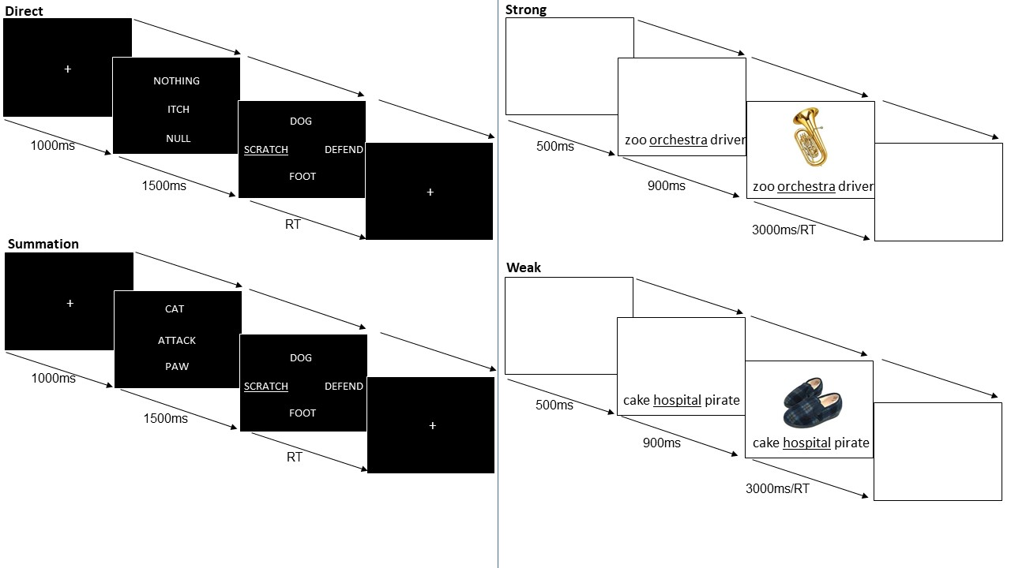

Figure 2.Example trial structure for Direct and Summation conditions (left; Experiment 1) and association strength strong and weak conditions (right; Experiment 2).

**ROI Selection:** Our seeds were formed from three maps: 1) DMN, as identified by Yeo et al. (2011) using a parcellation of resting-state data from 1000 brains; 2) the semantic control network, as identified using a functional meta-analysis of tasks manipulating the control demands of semantic tasks (Humphreys & Lambon Ralph, 2015; Noonan et al., 2013); 3) domain-general executive control regions within the multiple-demand network, identified through a conjunction of multiple hard versus easy task contrasts (Duncan, 2010; Fedorenko, Duncan, & Kanwisher, 2013).

All seed regions included only voxels that fell within a meta-analytic map for the term “semantic”, generated by Neurosynth (formed from a meta-analysis of 1031 studies, downloaded October 2018, http://neurosynth.org/analyses/terms/semantic/; Yarkoni, Poldrack, Nichols, Van Essen, & Wager, 2011), in order to identify regions within the broader DMN and multiple-demand networks that were semantically relevant. Neurosynth is an automated meta-analysis tool that associates spatial activation maps with descriptive terms from the neuroimaging literature. In order to create term-based meta-analyses, such as the one used in this study using the term ‘semantic’, Neurosynth uses text-mining tools to extract high frequency terms taken from the abstract of neuroimaging articles and associates them with peak coordinates of activation, following certain criteria. In this way, it can generate ‘reverse inference’ maps associated with a particular term, such as “semantic”. These maps show regions that are more likely to be activated for that particular term than for others. Figure 3 demonstrates the overlap of the semantic Neurosynth map with each of the three networks (DMN, semantic control network, and multiple-demand network).

We removed voxels from the semantic DMN seed if they were also implicated in semantic control by Noonan et al.’s (2013) semantic control meta-analysis (resulting in the removal of 14.0% of voxels from the semantic DMN map). These voxels were included in the semantic control map. We also identified semantically-relevant multiple-demand regions that fell outside the semantic control meta-analytic map (although 70.9% of semantically-relevant MDN voxels were also in the semantic control network identified by Noonan et al., 2013, as would be expected). For completeness, we examined the connectivity of these regions in addition to the semantic control seed; the results closely resembled those for the semantic control network seed and can be found in Supplementary Materials. The regions of overlap between the Neurosynth semantic map and the DMN, semantic control network and MDN were largely in the LH (86.9%, 99.0%, and 94.6% of voxels, respectively). For all three seeds, we removed the RH voxels, since this allowed us to unambiguously interpret any RH clusters as interhemispheric connectivity. The resulting LH semantic DMN, semantic control and semantic MDN seeds captured 23.9%, 18.1% and 10.9% of the left Neurosynth semantic map, respectively.

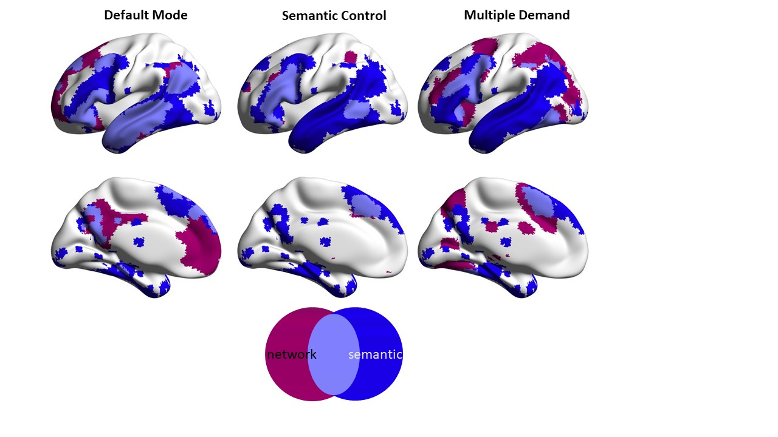

Figure 3**.** The default-mode, semantic control and multiple-demand networks (magenta) overlaid with a semantic meta-analysis from Neurosynth (blue; Yarkoni et al., 2011) within the left-hemisphere. Areas of overlap are shown in violet. Regions of overlap were taken as our seeds, with the additional step of subtracting semantic control regions from the default-mode and multiple-demand seeds to ensure no voxels were contained within more than one seed map.

**Resting-State fMRI Analysis:** This analysis explored associations between task performance and the intrinsic functional connectivity of default mode and semantic control networks. There were three functional connectivity seed-to-voxel analyses; one for each seed (left semantic DMN, left semantic control network, and left semantic MDN). In a first-level analysis, we computed whole-brain seed-to-voxel correlations for each of our seeds.For the second-level analysis, we entered as explanatory variables (EVs) into a GLM analysis the mean-centred efficiency scores of the summation and direct task conditions (inversed, such that higher scores indicated better performance, with outliers more than 2.5SD away from the mean imputed to this cut-off), and a nuisance regressor corresponding to mean motion for each participant (measured in framewise displacement). In all analyses, we convolved the signal with a canonical haemodynamic response function. We used two-sided tests to determine significant clusters. We defined the following contrasts of interest for each seed: Summation>Direct, Direct>Summation, and the main effects of each condition. Group-level analyses in CONN were cluster-size FWE corrected and controlled for the number of seeds (Bonferoni, *p* < .017), and used a height threshold of *p* < .005).

In order to establish the pattern of mean functional connectivity for the regions linked to behaviour on the semantic summation task, we used the clusters from the analysis above as seeds in an independent cohort of 152 participants with resting-state fMRI (a subset of the participants from Experiment 2, removing participants who took part in both experiments). Group-level analyses in CONN were cluster-size FWE corrected and controlled for the number of seeds (Bonferoni, *p* < .017), and used a height threshold of *p* < .005. The connectivity maps resulting from these analyses were uploaded to Neurovault (https://neurovault.org/collections/6140; Gorgolewski et al., 2015). Behavioural data analysis files relevant to Experiment 1 and 2 are uploaded to DOI 10.17605/OSF.IO/EHJ7B, <https://osf.io/ehj7b/?view_only=ff19d72a4a5f4aaa97592c0332e36a46>. The conditions of our ethics approval do not permit public archiving of the raw MRI data supporting this study. Readers seeking access to this data should contact the lead author, Katya Krieger-Redwood, the PI Professor Beth Jefferies, or the local ethics committee at the Department of Psychology and York Neuroimaging Centre, University of York. Access will be granted to named individuals in accordance with ethical procedures governing the reuse of sensitive data. Specifically, the following conditions must be met to obtain access to the data: approval by the Department of Psychology and York Neuroimaging Research Ethics Committees and a suitable legal basis for the release of the data under GDPR.

**Decoding using Neurosynth:** In addition to generating maps associated with a particular term, Neurosynth can be used to generate a set of terms frequently associated with a spatial map (Yarkoni et al., 2011). This approach is used in Figure 6 to decode patterns of connectivity for the results of our semantic DMN and semantic control seeds. In presenting these results as word clouds, we manually excluded terms referring to neuroanatomy (e.g. “inferior”). The size of each word in the word cloud relates to the frequency of that term across studies.

**Experiment 1 Results**

**Behavioural Results:** We analysed the behavioural performance of the sample of 76 participants in the neuroimaging analysis. In addition to accuracy and median response time, we computed response efficiency by dividing response times by accuracy. This composite score provides an overall performance measure for functional connectivity analyses, accounting for any differences in the way in which participants may trade-off response time and accuracy. A higher efficiency score indicates poorer performance (but in brain analyses, the efficiency score was inverted to aid the interpretation of the results, such that a higher score corresponded to better performance). Behavioural outliers were defined as scores ±2.5 standard deviations from mean efficiency per condition and imputed with the value of this cut-off. Table 1 provides descriptive statistics for accuracy, response time and efficiency scores. A paired-samples t-test revealed less efficient performance in the summation condition than in the direct condition (t(75) = -8.15, *p* <. 001). The behavioural data were z-scored for the brain-behaviour analysis – box plots of response efficiency before and after z-scoring are provided in the supplementary materials (Figure S4). Despite the difference in performance on the two conditions, an analysis of accuracy and RT revealed that there were no outlying trials in either condition (direct, summation; Figure S5).

|  |  |  |  |  |  |  |
| --- | --- | --- | --- | --- | --- | --- |
| Condition | Accuracy | | Response Time | | Response Efficiency | |
|  | Mean | SD | Mean | SD | Mean | SD |
| Direct | 0.86 | 0.08 | 1618.76 | 327.46 | 1884.57 | 404.42 |
| Summation | 0.63 | 0.12 | 2382.87 | 1425.23 | 3878.81 | 2274.37 |

Table 1**.** Mean and standard deviation for accuracy, reaction time and response efficiency scores (after imputing outliers) across 76 subjects for each experimental condition (direct and summation). Accuracy is given as a percentage of trials. Response time is shown in milliseconds. Response efficiency was computed by dividing response time by accuracy.

**Left Semantic DMN Seed:** Better performance on the summation trials relative to the direct semantic trials was associated with stronger intrinsic connectivity between the semantic DMN seed (Figure 4, left-hand panel) and a set of regions in bilateral inferior frontal gyrus, and left posterior inferior temporal gyrus (Figure 4). Participants with better summation tended to show this pattern of connectivity more strongly, as shown in Figure 4 (using a median split of participants according to connectivity values). We determined the network associated with these regions by seeding them in an independent resting-state dataset. The resulting pattern of connectivity strongly overlapped with the MDN (Figure 6), while decoding this pattern of connectivity using Neurosynth yielded terms associated with cognitive control (cf. word cloud, Figure 6). These results therefore show that stronger intrinsic connectivity between semantic DMN and MDN regions was associated with better summation relative to direct retrieval performance. The main effect of poorer performance on the direct condition was associated with similar patterns of connectivity (Figure 4, right-hand panel). There were no significant main effects for the summation condition.

In addition, stronger intrinsic connectivity between the semantic DMN seed and left and right frontal pole (FP) was associated with weaker performance on summation relative to direct retrieval (Figure 4). We determined the network associated with these regions by seeding them in an independent cohort of resting-state data. The resulting pattern of connectivity overlapped extensively with the DMN (Figure 6), and decoding these results using Neurosynth yielded terms associated with the DMN (Figure 6, right-hand panel). These results show that stronger resting-state connectivity between semantic DMN and other DMN regions was associated with more efficient direct semantic retrieval, the condition thought to be relatively automatic. The main effect of good performance on the direct condition was associated with stronger intrinsic connectivity to a similar large cluster in left and right frontal pole extending into superior frontal gyrus (Figure 4). There were no significant main effects for the summation condition.

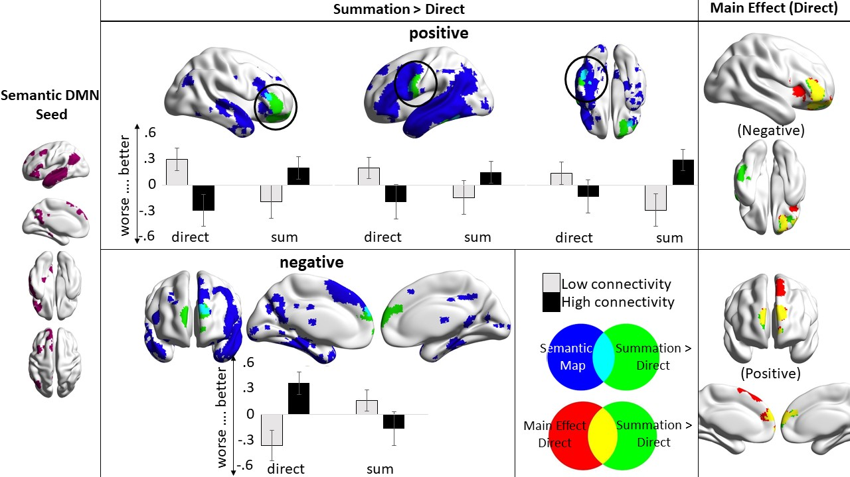

Figure 4. Resting-state connectivity results for the semantic DMN seed (seed pictured in left panel); p-FWE < .005, p < .017, maps are fully saturated to highlight overlaps (dynamic range shown in figures 5 and 6, peak coordinates in Table 2). The positive and negative connectivity associated with the contrast of summation > direct are shown in green (overlaid with the semantic map derived from Neurosynth (Yarkoni et al., 2011) in blue); the z-scored reversed behavioural task response efficiency (higher scores = better performance) for the direct and summation tasks is median-split into a high and low connectivity group and plotted for the two tasks and each cluster. The main effect of the direct task is shown in the right-hand panel (red).

**Left Semantic Control Seed:** Having considered how connectivity from DMN varies with behaviour on summation and direct retrieval conditions, we describe parallel analyses for the semantic control network seed. Better performance on summation than direct retrieval was associated with stronger intrinsic connectivity between the semantic control seed (Figure 5, left-hand panel) and left angular gyrus, and posterior cingulate cortex (Figure 5). We seeded the regions associated with better summation than direct retrieval in an independent cohort of resting-state data. The resulting pattern of connectivity strongly overlapped with the DMN (Figure 6), while cognitive decoding of these results using Neurosynth (Yarkoni et al., 2011) yielded terms associated with the DMN (Figure 6, right-hand panel). These findings again show that more efficient semantic summation was associated with stronger intrinsic connectivity between semantic control and DMN regions. The main effect of good performance on the summation condition was associated with similar patterns of connectivity (Figure 5). There were no significant effects for the direct retrieval condition.

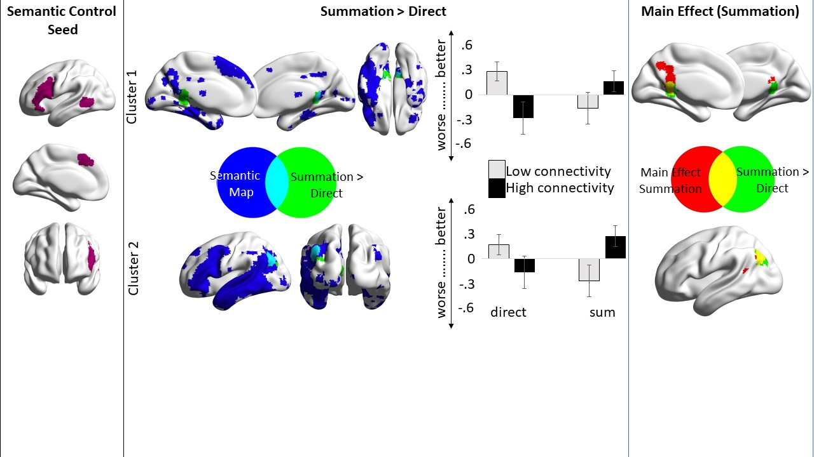

Figure 5. Resting-state connectivity results for the semantic control seed (seed shown in left panel); p-FWE < .005, p < .017, maps are fully saturated to highlight overlaps (dynamic range shown in figures 5 and 6, peak coordinates in Table 2). Regions of higher resting-state connectivity with the semantic control seed associated with better performance on the summation than the direct retrieval condition (represented in green and overlaid with the semantic map derived from Neurosynth (Yarkoni et al., 2011) in blue). The z-scored reversed behavioural task response efficiency (higher scores = better performance) for the direct and summation tasks is median-split into a high and low connectivity group and plotted for the two tasks and each cluster. The right-hand panel shows the main effect of efficient summation (red).

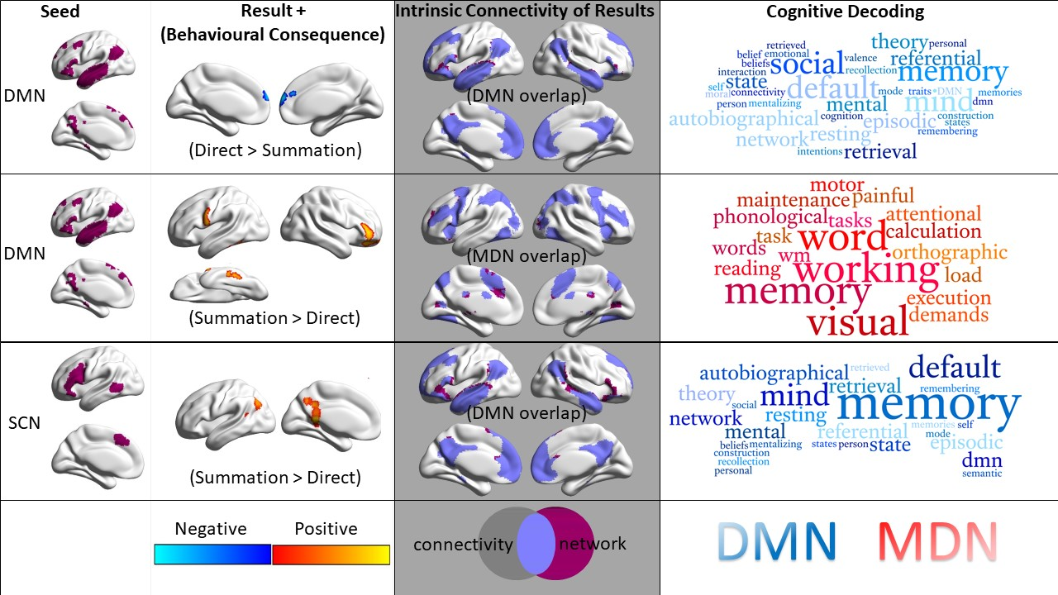

Figure 6.Summary of results. The intrinsic connectivity (p-FWE < .005, p < .017) of the clusters resulting from the semantic DMN seed for the contrast direct retrieval > summation demonstrates high overlap with the DMN (grey panel). The summation > direct clusters resulting from seeding the semantic DMN have a large degree of overlap with the MDN (grey panel), and for the semantic control network (SCN) seed for the same contrast, the results highly overlap with the DMN. Word clouds were generated using the decoding tool in Neurosynth (Yarkoni et al., 2011): the semantic DMN seed results revealed terms associated with default mode for direct > summation and cognitive control for summation > direct. The semantic control (SCN) seed results revealed terms associated with default mode for summation > direct.

|  |  |  |  |  |  |  |  |
| --- | --- | --- | --- | --- | --- | --- | --- |
| Seed | Behaviour | Connectivity | *p*-FWE | x | y | z | Voxels |
| Semantic DMN | summation > direct | FP-mPFC (neg) | < .001 | 4 | 66 | 18 | 986 |
| RIFG-FP (pos) | < .001 | 22 | 46 | -12 | 896 |
| LIFG-Precentral Gyrus (pos) | 0.016 | -62 | 2 | 14 | 328 |
| pITG (pos) | 0.017 | -38 | -34 | -32 | 327 |
| direct (main effect) | FP-SFG (pos) | < .001 | 8 | 62 | 18 | 1723 |
| FP-insular (neg) | < .001 | 22 | 46 | -10 | 1123 |
| Semantic Control Network | summation > direct | pCC (pos) | 0.003 | 12 | -44 | 8 | 441 |
| LOC-AG (pos) | 0.007 | -42 | -72 | 44 | 377 |
| summation (main effect) | pCC (pos) | 0.003 | -8 | -46 | 10 | 437 |
| LOC-AG (pos) | 0.007 | -44 | -72 | 44 | 384 |

Table 2. Peak coordinates resulting from the connectivity analysis.

**Summary of Experiment 1:** We found that individuals with higher resting-state connectivity from the semantic DMN to regions of the MDN had more efficient semantic summation, while higher intrinsic connectivity from semantic DMN to other DMN regions was associated with better performance in the direct retrieval condition. Similarly, higher resting-state connectivity from the semantic control network to DMN was linked to better performance in the summation condition. These results are consistent with the view that both the DMN and the semantic control network are relevant to semantic summation, and that individuals who have efficient summation show stronger intrinsic connectivity between these networks.

Further data is needed to establish if this pattern of connectivity is specifically associated with summation – i.e. tasks that involve identifying overlap between *multiple* weakly-related concepts – or, alternatively, if connectivity between DMN and MDN is associated with better performance on harder semantic tasks in general – including, for example, the retrieval of weak vs. strong associations in the absence of summation. Vatansever et al. (2017) used canonical correlation analysis to identify behaviour-brain associations in a cohort of 160 participants who completed a resting-state scan and a battery of semantic tasks. Relatively good performance on the most demanding semantic tasks was accompanied by greater separation between DMN and control network nodes, implying broad cross-network connectivity is not generally linked to better controlled semantic retrieval. Consequently, the behavioural associations in the current study may be specific to the semantic summation task. However, Vatansever et al. placed seeds in specific cortical regions, as opposed to taking whole networks as seeds, as in the current study. Moreover, there are specific patterns of cross-network connectivity associated with better semantic control (Krieger-Redwood et al., 2016). In Experiment 2, we therefore re-analysed the data reported by Vatansever et al. (2017) to directly examine the behavioural relevance of the patterns of connectivity highlighted in Experiment 1, linked to summation and direct retrieval. This analysis established whether these connectivity patterns were associated with individual differences in the efficiency of semantic control, by comparing the retrieval of weak and strong associations. The weak association task is thought to require more control over semantic retrieval in the absence of a requirement to summate multiple meanings.

**Experiment 2**

**Picture-Word Matching Task Procedure:** We re-analysed a picture-word matching task from a previous study (Vantansever et al., 2017), which manipulated semantic control requirements in a similar way to the summation task, but without the requirement to summate the meanings of multiple concepts. This task employed a three-alternative forced-choice design: participants matched a probe picture with one of three possible target words, pressing a button to indicate the word that was most strongly associated with the probe picture. We manipulated strength of association between the probe and target, resulting in strong (low control) and weak (high control) trials. The trials were created using associations derived from free association databases (e.g., Edinburgh Association Thesaurus), which is thought to be more closely aligned to conceptual representations than computer based methods of approximating semantic relationships (De Deyne et al., 2016; Kenett et al., 2017; Kumar et al., 2019). Strength of association was assessed using ratings on a 7-point scale (from a different set of participants), and differed significantly between conditions (Table 3). The coloured pictures and words were also rated for familiarity using a 7-point scale, and lexical frequency for the words was obtained from the SUBTLEX-UK database (van Heuven, Mandera, Keuleers, & Brysbaert, 2014). We also computed word2vec scores for the probe-target relationships. Word2vec (Mikolov, Chen, Corrado, & Dean, 2013) uses word co-occurrence patterns in a large language corpus to derive semantic features for items, which can then be compared to determine their similarity. The word2vec score for the probe-target relationship differs significantly (t(26) = 4.24, *p* < .001) between the high (mean w2v = .3, SD = .15) and low (mean w2v = .2, SD = .11) conditions. Therefore, our stimuli have been validated using both ratings from participants, and using a computer-based algorithm. Additional psycholinguistic data were taken from the MRC psycholinguistic database (Coltheart, 1981; Wilson, 1988). There were no differences between strong and weak associations in familiarity, word length, lexical frequency or imageability (Table 3).

The stimuli were selected from a larger set of words and photographs used in previous experiments (Davey et al., 2015; Krieger-Redwood et al., 2015). The pictures were photographs from the internet and re-sized (200 pixels, 72 dpi). The distractors were unrelated to the probe and were targets on other trials. We presented 60 coloured pictures of objects (e.g. dog), paired with 60 strongly-related (e.g. bone) and 60 weakly-related (e.g. ball) written words, resulting in 120 trials. These trials were presented in four blocks of thirty trials each, with both conditions interspersed in each block. The order of trials within the blocks was randomised across subjects. The blocks were interleaved with other types of semantic judgements and non-semantic judgements outside the scope of this report).

Each trial started with a blank screen for 500ms. The response options were subsequently presented at the bottom of the screen for 900ms (with the three options aligned horizontally, and the target in each location equally often). Finally, the probe was centrally-presented at the top of the screen. The probe and choices remained visible until the participant responded, or for a maximum of 3 seconds. A schematic of the trial structure can be found on the right-hand panel of Figure 2, and Table 4 summarises behavioural results.

|  |  |  |  |  |
| --- | --- | --- | --- | --- |
|  | **Strength of association** | | | |
|  | Strong | Weak | t | Sig. |
|  | Mean (Standard error) | |  |  |
| **Word Length** | 6.43 (.39) | 6.6 (.34) | -.16 | .873 |
| **Lexical Frequency** | 13564.8 (1887) | 11233.6 (1805) | .89 | .374 |
| **Familiarity** | 6.02 (.09) | 6.12 (.08) | -.88 | .381 |
| **Imageability** | 5.16 (.13) | 4.96 (.13) | 1.07 | .287 |
| **Semantic Association** | 6.02 (.07) | 3.32 (.10) | 21.74 | .000 |

Table 3. Psycholinguistic variables for our semantic battery by strength of association.

**Resting-State fMRI Analysis:** We computed seed-to-voxel correlation maps, using the same seed networks as in Experiment 1 (semantic DMN and semantic control network; Figure 3). For the second-level analysis, a nuisance regressor containing the mean motion (measured in framewise displacement) for each participant was entered as an explanatory variable (EV). We extracted the correlation values from each seed (DMN, SCN) for each participant within the clusters associated with summation and direct retrieval in Experiment 1 (see Figure 7a). Since our aim in this analysis was to establish if the summation effects found in Experiment 1 could be explained in terms of semantic control demands, we chose not to correct the analyses for the number of clusters tested (i.e. the analysis was relatively lenient, to maximise the chances of recovering an association between connectivity and semantic control demands). Given the large sample size, and the ROI-to-ROI nature of the analysis, a null result would support the proposal that the pattern of connectivity described in Experiment 1 is specific to summation.

For completeness, we also ran a whole-brain seed-to-voxel second-level analysis with the means-centred efficiency scores for strong and weak associations (inversed, such that higher scores indicated better performance, with outliers 2.5 SD away from the mean imputed to these cut-off values), and a nuisance regressor containing the mean motion (measured in framewise displacement) for each participant as explanatory variables (EVs). This analysis showed that stronger intrinsic connectivity from the semantic DMN seed to L and R occipitotemporal gyrus was associated with better performance on strong than weak associations. Also greater connectivity from the semantic DMN seed to L and R medial PFC (also in DMN) was correlated with better performance on strong associations, thought to be retrieved relatively automatically. No correlations with the task were found for the semantic control network seed. These results are reported in supplementary materials.

**Results  
  
Behavioural Results:** Accuracy and response time for correct responses were recorded and an efficiency score was calculated for each participant in each condition by dividing response times by accuracy (see Table 4). A higher efficiency score indicates lower performance (note: in brain analyses, this efficiency score was inverted to aid the interpretation of the results, such that a higher score corresponded to better performance). Behavioural outliers were defined as ±2.5 standard deviations from the mean of each condition and were imputed with this cut-off values. A paired-samples t-test revealed less efficient performance for the weak than strong associations (t(190) = -39.85, p < .001).

|  |  |  |  |  |  |  |
| --- | --- | --- | --- | --- | --- | --- |
| Task | Accuracy | | Reaction Time | | Response Efficiency | |
|  | Mean | SD | Mean | SD | Mean | SD |
| PWM Strong | 0.95 | 0.05 | 1315.98 | 173.28 | 1380.99 | 210.04 |
| PWM Weak | 0.77 | 0.09 | 1781.80 | 202.88 | 2352.63 | 485.30 |

Table 4. The mean and standard deviation of accuracy, reaction time and efficiency score (after imputing outliers) across 191 subjects in the semantic picture-word matching (PWM) task (strong and weak associations). Accuracy is given as a percentage of trials. Response time is shown in milliseconds. Efficiency is the ratio of a participant’s response time divided by accuracy (greater = poorer performance).

**Connectivity Results:** We performed a repeated-measures ANCOVA using mean-centred efficiency scores for weak and strong associations as predicted variables (inversed, such that higher scores indicated better performance), and the mean-centred connectivity values between the seeds (left semantic DMN and semantic control) and each cluster as covariates. All of the cluster regions are shown in Figure 7. This analysis yielded two main results: (1) a significant main effect of cluster, reflecting a general association between worse semantic performance and high connectivity from the DMN seed to Cluster 2 in right IFG (F(1, 184) = 4.024, *p* = .046, partial ƞ2 = 0.021), i.e., no differential effect between strong and weak associations; and (2) an interaction between associative strength and connectivity from the DMN seed to Cluster 3 in left IFG (F(1, 184) = 4.018, *p* = .046, partial ƞ2 = 0.021). Table 5 provides results of the repeated measures ANCOVA for all clusters.

To further interpret these results, we computed the effect of strength of association as a difference score and calculated a (two-tailed) partial correlation between association strength and the significant cluster from the ANCOVA model that interacted significantly with task performance. The difference in performance between weak and strong associations was correlated with connectivity between the DMN seed and cluster3-LIFG (r = -.146, *p* = .046; Figure 7c), demonstrating that stronger connectivity between DMN and LIFG was associated with poorer performance on weak than strong associations.

We conducted a further analysis, on a subset of the participants (n = 174) for whom we had Ravens Advance Progressive Matrices scores, to assess the contribution of intelligence (RAPM) to performance on the PWM task. This established a significant Pearson correlation between performance on the weak association tasks and RAPM (r(174) = -.24, *p* = .002), but no relationship between strong associates and RAPM (r(174)= -.116, *p* = .13; Figure S7). Consequently, in Experiment 2, performance on the weak association task might reflect a contribution from general intelligence.

These results complement the findings of Experiment 1, by establishing which effects in that study were specific to semantic summation, and which might be related to difficulty. While cross-network connectivity from the semantic control seed to DMN regions (PCC and AG) was associated with better summation performance, there was no evidence that this effect extended to other hard semantic tasks (e.g. weak associations). Moreover, while semantic DMN connectivity to LIFG and RIFG was associated with relatively *better* performance on summation trials and poorer direct retrieval, in Experiment 2, DMN to LIFG connectivity was associated with *poorer* performance on the more difficult weak association trials, and DMN to RIFG connectivity was associated with *poorer* performance on both strong and weak trials. These findings support the view that cross-network connectivity supports semantic summation, but is associated with poorer performance on non-summation tasks, perhaps particularly when these tasks require more control. In addition, cross-hemisphere connectivity from left DMN regions to a right-hemisphere site implicated in control supports summation but is associated with poorer direct semantic retrieval.

|  |  |  |  |  |  |
| --- | --- | --- | --- | --- | --- |
|  |  | Main Effect | | site x PWM interaction | |
| Cluster | df | F | sig | F | sig |
| DMN to |  |  |  |  |  |
| RL Frontal Pole | 1, 184 | 0.003 | 0.957 | 1.73 | 0.19 |
| R Inferior Frontal Gyrus | 1, 184 | 4.024 | 0.046* | 0.5 | 0.48 |
| L Inferior Frontal Gyrus | 1, 184 | 2.247 | 0.136 | 4.018 | 0.046* |
| L poster Inferior Temporal Gyrus | 1, 184 | 0.397 | 0.53 | 0.178 | 0.674 |
| SCN to |  |  |  |  |  |
| RL posterior cingulate cortex | 1, 184 | 0.131 | 0.718 | 0.13 | 0.719 |
| L Angular Gyrus | 1, 184 | 0.375 | 0.541 | 0.422 | 0.517 |

Table 5. Results of a repeated measures ANCOVA using the connectivity value from the seeds (left semantic DMN and left semantic control) to each cluster as covariates and task condition (weak and strong associations) as dependent variables; *p < .05.

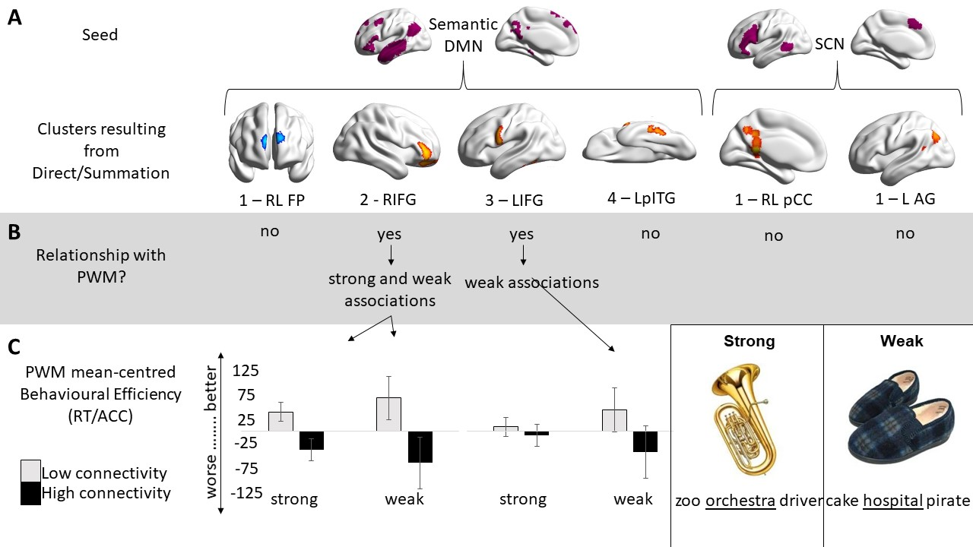

Figure 7. A) Individual clusters from Experiment 1: DMN cluster 1 was associated with lower performance in the summation task compared to the direct condition, shown in blue; DMN clusters 2-4 were associated with better performance on the summation task, and are shown in orange-red. Semantic control (SCN) clusters 1 and 2 were associated with better performance on the summation task. B) Summary of the results from Experiment 2. Two clusters show an association with picture-word matching performance (a main effect of connectivity for the RIFG cluster, and an interaction between connectivity and strength of association for the LIFG cluster). C) Inverted mean-centred response efficiency (i.e., high scores = good performance) for strong and weak associations shown using a median-split into high and low connectivity groups for the two significant clusters emerging from the ANCOVA. The bottom right-hand corner contains the task information; correct answers are underlined.

**Discussion**

This study examined the relationship between individual performance on controlled semantic summation tasks, compared with direct semantic retrieval, and the intrinsic connectivity of the default mode and semantic control networks. We found higher intrinsic connectivity from the semantic DMN to regions of the MDN related to relatively better performance in the summation condition, while higher connectivity from the semantic DMN to other regions of the DMN related to better performance in the direct retrieval condition. Similarly, higher resting-state connectivity from the semantic control network to the DMN was linked to better performance in the summation condition. These results are consistent with the view that both the DMN and the semantic control networks are relevant to processes engaged in our semantic summation manipulation – such as retrieval of non-dominant aspects of meaning, merging, and inhibition of irrelevant but equally associated concepts; and that individuals who are more efficient at engaging these processes have stronger intrinsic connectivity between these networks. Furthermore, our result of cross-network integration did not generalise to other difficult semantic tasks, where, in contrast maximal *separation* of networks was linked to better performance (Experiment 2).

The controlled semantic summation task requires the ability to integrate weak and disparate information from multiple concepts in order to identify the relevant semantic link. For this reason, we might expect a role of both the DMN – which is thought to support the integration of information (Graves et al., 2010; Tylén et al., 2015; Vatansever, Menon, Manktelow, Sahakian, & Stamatakis, 2015), and the semantic control network – which is implicated in the capacity to recover weak yet task-relevant associations (Jefferies, 2013; Lambon Ralph et al., 2017; Noonan et al., 2013; Whitney et al., 2011). For efficient semantic summation, a greater coupling of these two networks may be important. Interestingly, this effect did not generalise to another control-demanding semantic task that involved identifying weak semantic associations between a picture probe and word targets, without a need to integrate multiple probe words. This suggests that the relationship between performance and cross-network connectivity was specific to summation.

Relatively little is known about the complex relationship between semantic performance and individual differences in connectivity between DMN and control regions. Vatansever et al. (2017) used canonical correlation analysis to identify distinct patterns of connectivity associated with specific behavioural profiles across a battery of semantic tasks. Greater *separation* between semantic control nodes (posterior IFG and pre-supplementary motor area) and DMN regions (angular gyrus and posterior cingulate cortex) was linked to better performance on control-demanding semantic tasks, including the weak vs. strong associations we used in Experiment 2, and also a demanding feature-matching task. We re-analysed this data in Experiment 2, using seed-to-voxel connectivity analysis to interrogate the same seeds and clusters linked to summation in Experiment 1. Lower connectivity between the DMN and executive regions was linked to better performance across both tasks for RIFG and better weak than strong associations for LIFG. These findings are in line with our previous findings suggesting greater functional *separation* at rest between DMN and control regions is linked to *better performance on demanding* semantic tasks (Vatansever et al., 2017). Therefore, the results of our two experiments provide an interesting dissociation: while coupling of the DMN and control regions is detrimental to one aspect of semantic control (the controlled retrieval of weak associations from single cues without summation), it is beneficial to the capacity to integrate disparate information to form a semantically coherent concept.

The study by Vatansever et al. (2017) demonstrates an association between relatively good task performance and general separation between DMN and control networks at rest. This is also the case across other cognitive domains, where maximal separation between control (i.e., FPN) and DMN networks is beneficial as task demands increase (Anticevic, Repovs, Shulman, & Barch, 2010; Esposito et al., 2006; Lamp, Alexander, Laycock, Crewther, & Crewther, 2016; McKiernan, Kaufman, Kucera-Thompson, & Binder, 2003). Indeed, separation of DMN-FPN has been shown to mediate the relationship between intelligence and task performance (Sripada, Angstadt, Rutherford, & Taxali, 2019): *flexible separation* of these networks is key to good performance (i.e., in high performers the networks work in close concert in low-demand tasks, and maximally separate when demands increase). Our study used the semantic association task to control for any effects that may be driven by difficulty in the summation task - performance on the weak associations was correlated with intelligence (RAPM), and in line with the previous literature, maximal separation of control and DMN networks was linked to better performance. Furthermore, a recent task-based fMRI study by Japardi and colleagues (2018) used both the Alternate Uses Task (AUT) and the RAT and while their results remained largely unchanged with the addition of IQ as a covariate, the activation in left pIFG (AUT), right PMC (AUT) and right pIFG (RAT) was attributable to IQ – a finding that we have replicated in our results: the summation results in left and right frontal cortex were not specific to summation, but were also linked to performance on the semantic association task (which correlated with intelligence).

Better performance on the controlled semantic summation task was linked to increased communication between control and DMN networks. This finding adds to other current research which has shown that selective patterns of cross-network connectivity can be associated with efficient semantic cognition. For example, stronger coupling of posterior cingulate cortex within DMN with a region of ventral attention network in dorsolateral prefrontal cortex was linked to stronger goal-driven semantic retrieval, both during a task, and when performance outside the scanner was associated with intrinsic connectivity at rest (Krieger-Redwood et al., 2016). Although DMN and MDN are typically anti-correlated (Fox et al., 2005; Fox, Zhang, Snyder, & Raichle, 2009; Smith et al., 2009; Wig, 2017), the ability to bring specific parts of them together might be beneficial for aspects of semantic cognition – including goal driven retrieval, and semantic summation. The specific brain regions implicated in patterns of cross-network connectivity associated with good performance might vary depending on the task. Despite these differences between studies, this work commonly suggests that while the DMN is primarily associated with automatic semantic retrieval (Binder & Desai, 2011; Davey et al., 2016), this network is not irrelevant to controlled semantic retrieval (Davey et al., 2016; Krieger-Redwood et al., 2016). Furthermore, studies of divergent thinking have demonstrated that highly-creative individuals have greater connectivity between DMN and control regions (Beaty, Benedek, Silvia, & Schacter, 2016; Beaty et al., 2014). There is a growing body of research demonstrating that rather than common DMN deactivation in response to external demands (e.g., a task), DMN regions reorganise and work in concert with ‘on-task’ networks (e.g., Fransson, 2006; Piccoli et al., 2015). Similarly, DMN might change its connectivity in the service of successful semantic cognition: for example, by coupling with the semantic control network to support the summation of multiple inputs in one instance, and by coupling with other DMN regions to support relatively automatic retrieval of strongly-encoded information (Krieger-Redwood et al., 2016).

Performance on summation trials may involve some form of conceptual expansion - the ability to widen conceptual structures (Abraham et al., 2012; Ward, 1994) – and many of our results overlap with previous task-based fMRI studies using conceptual expansion tasks. For example, Abraham et al. (2012) used an alternative uses task requiring participants to generate unusual responses to well-known objects (e.g., shoe – flowerpot; this requires conceptual expansion) and contrasted this with a divergent thinking task with low demands in which participants had to name items related to a location (e.g., office). Conceptual expansion recruited LIFG and pITG – much like the RS-summation relationship we uncovered for these areas. Furthermore, pCC, AG and frontal pole were engaged by divergent thinking, and our summation-connectivity results overlap with these results (except for frontal pole which was found to be more related to direct retrieval). This suggests that summation may engaged processes such as divergent thinking and conceptual expansion and that our RS-summation paradigm may not be sensitive to sufficiently separate these processes.

Our results also find many parallels with previous task-based fMRI studies manipulating varying aspects of creative thought. For example, Marron et al. (2018) separated the spontaneous associative processes vs. the executive top-down control (e.g., switching between ideas, inhibition of mundane/inappropriate ones) processes of creative thought. They used chain free association to localise spontaneous free association, with no requirement for control (i.e., participants were encouraged to associate whatever came to mind, with an emphasis on the fact that there are no right or wrong answers). This was compared with control conditions (semantic, phonological fluency and episodic memory tasks), which involved goal-directed search triggered by specific selection criteria. While the tasks used in this experiment differ from our summation task in many ways (e.g., the summation task requires no production, and participants are required to not only integrate but monitor and select stimuli), the results from Marron and colleagues can potentially help to elucidate the contribution of processes reflected by our results. For example, our DMN – right and left frontal pole result linked to better performance on the direct (easy) condition overlaps with Marron et al.’s results in mPFC and superior frontal gyrus, areas found to be active for free association fluency (i.e., unconstrained search in the conceptual store). Furthermore, dorsal pCC was engaged by semantic distance – therefore our pCC result (albeit, ventral to theirs) may reflect the semantic distance between probes and targets in the summation paradigm. Our study uncovered a posterior LIFG site, a site consistently implicated in selection from amongst competing alternatives (Barde & Thompson-Schill, 2002; Demb et al., 1995; Kan & Thompson-Schill, 2004; Thompson-Schill et al., 1997) – accordingly, Marron et al. demonstrated that the more flexible participants were in their chain free association responses, the more *reduced* their LIFG activation was. Moreover, a meta-analysis of creative thought grouped studies into combination or unusual generation tasks, and found that combination tasks elicited more activation in areas such as rostrolateral PFC, LIFG-MFG, RIFG, insula, pMTG and posterior parietal regions (e.g., AG). The summation task we used requires participants to combine concepts, and many of our results overlap with those from this meta-analysis (Gonen-Yaacovi et al., 2013), suggesting that semantic cognition and creativity engage some overlapping processes and therefore brain regions. This overlap between task-based and RS-behaviour analyses provides convergence of methods, demonstrating that areas activated in task-based fMRI can also provide a neural marker (identifiable through RS-behaviour analyses), as well as integration across disciplines (e.g., semantic, creativity).

Our study used a modified version of the summation priming task that was previously created by Beeman and colleagues to test their hypothesis that the right hemisphere is involved in coarse semantic coding, which more readily allows the detection of distant semantic relations (Beeman, 1998; Beeman et al., 1994). Our study used left-hemisphere seeds, such that right hemisphere clusters could be unambiguously interpreted as greater cross-hemispheric connectivity. We identified a region, in right anterior IFG, whose resting-state connectivity to the left semantic DMN seed was associated with relatively good performance on summation in the context of poorer performance in the direct condition. This is potentially consistent with the view that summation benefits from RH engagement. This pattern did not extend to weak associations, which also require control. In fact, cross-hemispheric connectivity was associated with less efficient direct semantic retrieval, potentially consistent with the recent observation that the semantic control network is strongly left-lateralised and that participants with stronger left-lateralisation of this component of semantic cognition show more efficient (direct) controlled semantic retrieval (Frishkoff, 2007; Gonzalez Alam et al., 2018; Gonzalez Alam et al., 2019; Noonan et al., 2013). Our study aligns well with the previous literature – most of our results fall within the left hemisphere, as do those of previous studies of a similar nature (e.g., RAT, chain FA, conceptual expansion), for example one study used a WM task to remove the component of WM from divergent thinking (and conceptual expansion) and found that *only WM* activated the right hemisphere (Abraham et al., 2012). If the summation task does indeed involve conceptual expansion, then Beeman’s RH theory is unable to account for the dominance of the left hemisphere in tasks designed to remove other processes that likely contribute to the resolution of these tasks (e.g., working memory).

A recent MEG study of semantic cognition that manipulated semantic control using association strength in a simple related/unrelated paradigm may help shed some light on the temporal dynamics underlying the ability to complete both the summation and the associative judgment tasks. Teige and colleagues (2018) reported sustained activation in ATL from the onset of the target word for both strong and weak associations, until around 400ms when ATL activation increased more for strong associates. Meanwhile, the left pMTG and IFG were maximally active for the weak condition from around 60ms post target onset, suggesting early recruitment to sustain appropriate activation. This suggests that there is a continual reciprocal flow of information between brain areas falling within DMN and control networks. For successful completion of the summation paradigm, the DMN and control networks may engage in continual communication to form an integrated concept that is relevant to current demands.

In this study, we elected to investigate how connectivity from whole network seeds was implicated in behavioural performance. Therefore, we cannot rule out the possibility that specific regions within our seeds may have driven the resulting clusters. However, by reducing our networks to exclude parts of the network that are not semantically relevant, and further reducing them to the left hemisphere only – we have taken a small step in limiting the size of the network seeds. This was a pragmatic approach, allowing us to investigate within and between network connectivity, as well as cross-hemispheric connectivity. Although using key network nodes would have allowed for greater specification, it may have come with the cost of missing relevant brain areas. While there are limitations to our methods, when considered alongside previous literature, the limitations can be mitigated. Furthermore, while our study did not use task-based fMRI, and is thereby unable to draw specific conclusions based on task elicited activation, our findings mirror results obtained by task-based fMRI investigations; thereby demonstrating an important link between ‘on-task’ brain activation and associations between the intrinsic functional architecture of the cortex and individual differences in cognition (in this case the ability for controlled semantic summation). Further investigation would benefit from investigating the temporal dynamics associated with integrating multiple weakly related concepts to form a coherent concept.

In conclusion, this study indicates that cross-network as well as cross-hemispheric connectivity may be important for semantic summation but not for other forms of controlled semantic retrieval. Good performance on the summation task was associated with stronger connectivity between the DMN and semantic control network, which may interact to retrieve weak associations and integrate disparate semantic information to make the required link. The ability to integrate information is likely to be an aspect of everyday semantic cognition, where items often occur in rich contexts – as well as in the use of, for example, metaphor, and complex discourse. While the previous task-based fMRI literature has implicated certain brain regions in aspects of semantic and creative cognition, the current study has demonstrated how *connectivity* between these brain regions is *linked to better performance* on tasks requiring the integration of weakly-related concepts to form a coherent concept. We have demonstrated that the intrinsic functional architecture of the brain is linked to the ability to efficiently integrate weakly associated concepts in the face of pre-potent distractors, and that this architecture mirrors the findings of task-based fMRI studying similar processes.

**Supplementary Materials**

**Left Semantic MDN Seed Results – Summation/Direct Paradigm (Experiment 1)**

We noted there are domain-general executive control regions within the MDN (Duncan, 2010; Fedorenko et al., 2013) that fall into the semantic Neurosynth network, but do not appear in the semantic control map (Humphreys et al., 2015). For completeness, we also examined connectivity of these regions.

Better performance on summation compared to direct trials was associated with stronger intrinsic connectivity between the semantic MDN seed (Figure S1, left-hand panel) and left middle/superior frontal gyrus and left angular gyrus (Figure S1, represented in green). Neither the summation, nor the direct conditions alone yielded any significant results for this seed (i.e., no main effects). The summation > direct contrast result has considerable overlap with the DMN (48.5%), demonstrating a similar pattern of results as in the analyses report in the paper (connectivity between executive and DMN regions associated with task performance). These results suggest lower resting-state connectivity between the semantic MDN and DMN regions is associated with worse performance on the direct task, but with better performance on the summation task.

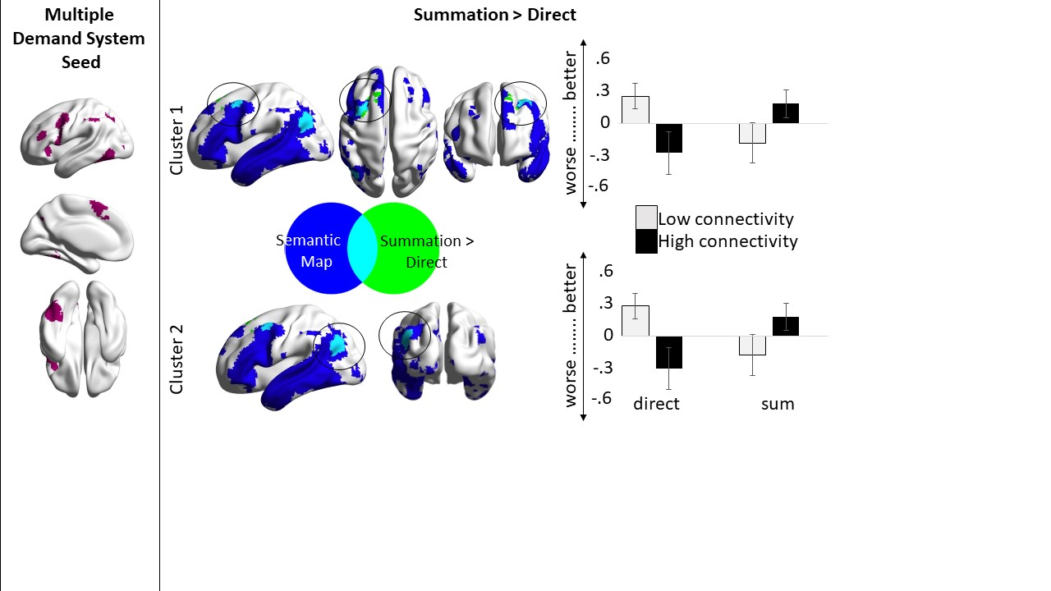

Figure S1. Resting-state connectivity results for the semantic MDN seed (seed pictured in left panel). The positive connectivity associated with the contrast of summation > direct is shown in green (overlaid with the semantic map derived from Neurosynth (Yarkoni et al., 2011) in blue); the mean behavioural task response efficiency (higher scores = worse performance) for the direct and summation tasks is median-split into a high and low connectivity group and plotted over the two tasks for each cluster.

|  |  |  |  |  |  |  |  |
| --- | --- | --- | --- | --- | --- | --- | --- |
| Seed | Behaviour | Connectivity | *p*-FWE | x | y | z | Voxels |
| Semantic DMN | summation > direct | MFG-SFG (pos) | 0.009 | 4 | 66 | 18 | 355 |
| LOC-AG (pos) | 0.014 | 22 | 46 | -12 | 331 |

Table S1.Peak coordinates resulting from the connectivity analysis.

**Picture-Word-Matching Whole Brain Results (Experiment 2)**

**Left Semantic DMN Seed:** Better performance on the strong relative to the weak trials was associated with stronger intrinsic connectivity between the semantic DMN seed (Figure S2, top panel) and a large cluster in left and right medial occipitotemporal gyrus (S2, contrast panel). This contrast is corroborated by main effects for both conditions to the same area: better performance on the strong task and worse performance on the weak task was correlated with stronger connectivity to this region (Figure S2). Furthermore, better performance on the strong task was also associated with increased connectivity between the semantic DMN and a region of mPFC (Figure S2). There is limited overlap between this analysis and the results of the summation analysis (experiment 1). The main effect from the DMN to medial occipitotemporal gyrus associated with better performance on the strong task revealed 12 voxels of overlap with the cluster deriving from better performance on the summation task and SCN connectivity, Figure S3, left-hand side). There were no overlapping voxels for the semantic DMN to the occipitotemporal region associated with worse performance on weak trials to any of the results in the summation experiment. Lastly, the DMN to mPFC cluster associated with better performance on the strong task revealed 22 overlapping voxels with the result of better performance on the direct task and within DMN connectivity in the summation experiment, Figure S3, right-hand side).

**Left Semantic Control seed:** There were no results for this seed.

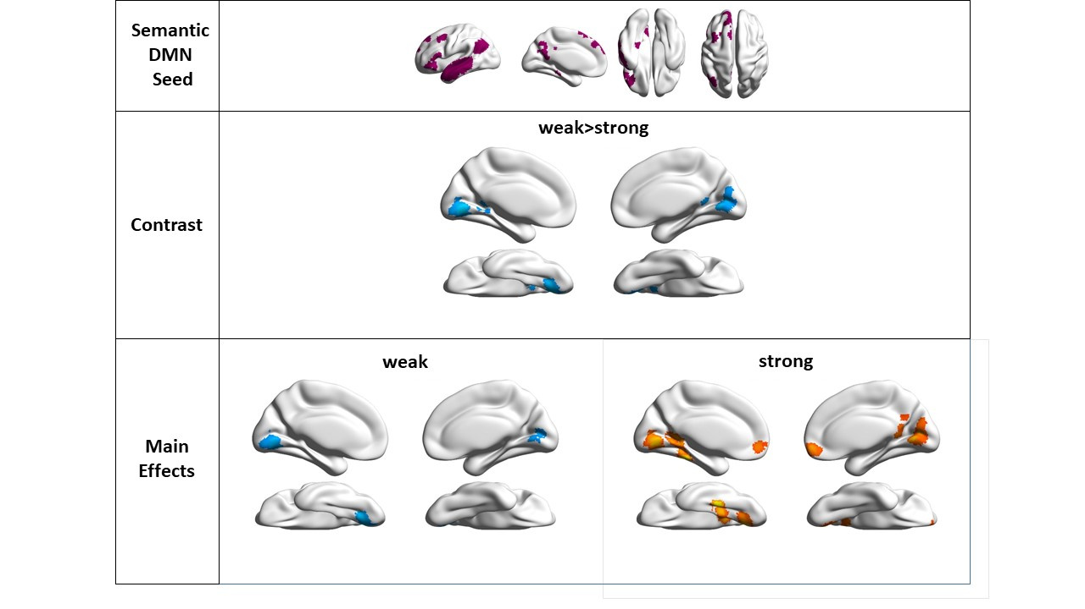

Figure S2.Intrinsic connectivity from semantic DMN to areas in occipitotemporal gyrus was associated with better performance on the strong than weak association trials. Furthermore, connectivity to an area in mPFC was also associated with this more automatic associative retrieval.

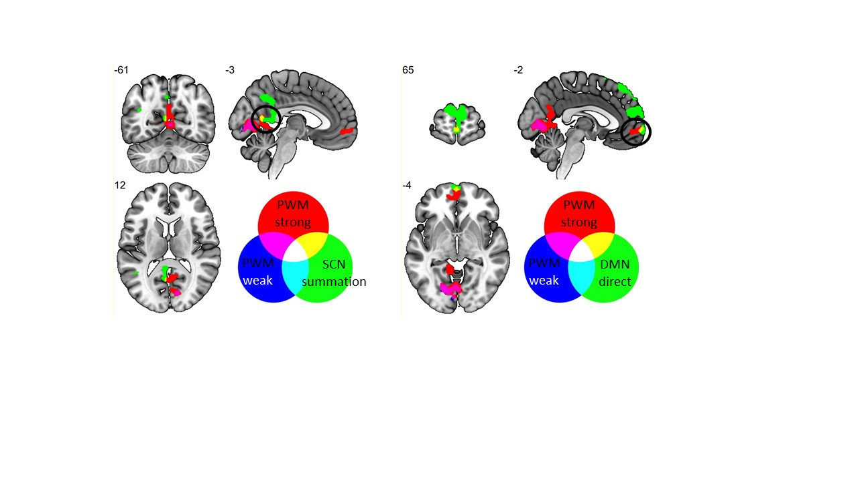

Figure S3.Overlap between whole brain analyses in experiments 1 and 2. Left hand side shows overlap between the DMN connectivity associated with better automatic PWM performance (red) and SCN connectivity associated with better performance on difficult semantic summation (green). Right-hand side shows overlap between the DMN connectivity associated with better automatic PWM performance (red) and DMN connectivity associated with better performance on direct retrieval (green). The DMN cluster associated with worse performance for the weak PWM condition is in blue (overlapping with the strong PWM cluster, but not with any of the summation results from experiment 1).

**Behavioural Data**

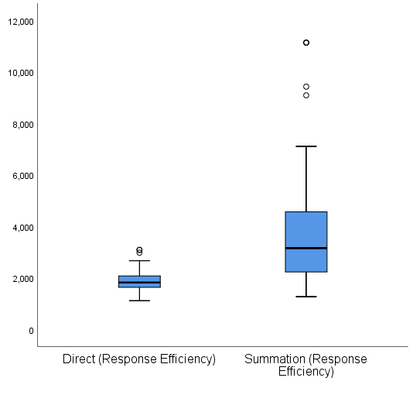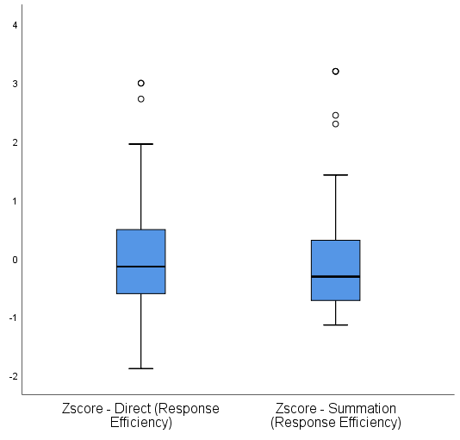

Figure S4.Behavioural summation data before (left) and after (right) z-scoring.

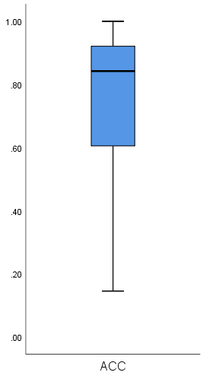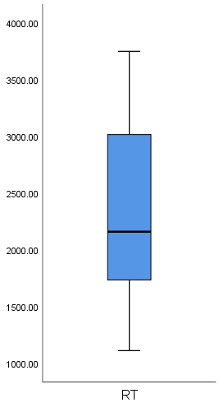

Figure S5.Box plots showing the spread of accuracy and RT across both the Direct and Summation Conditions. Despite the difficulty of the summation condition, there are no outlying trials.

Relationship between Direct, Summation and RAT performance (n = 25).

We conducted an analysis of the relationship between our summation tasks and RAT performance on a subset of 25 of our 76 participants, this is a small sample and the results should be read with caution. Simple pearson-correlations show no significant relationship between performance on the direct or summation task (RAT-direct ACC: r(25) = .33, *p* = .11; RAT-summation ACC: r(25) = -.002, *p* = .992; RAT-direct response efficiency: r(25) = -.13, *p* = .533; RAT – summation response efficiency r(25) = .17, *p* = .42), and a regression analysis also confirmed that performance on the RAT cannot be predicted by performance on the direct or summation conditions (response efficiency: F(2, 24) = .91, *p* = .42, R2 = .08; accuracy: F(2, 24) = 1.6, *p* = .23, R2 = .12).

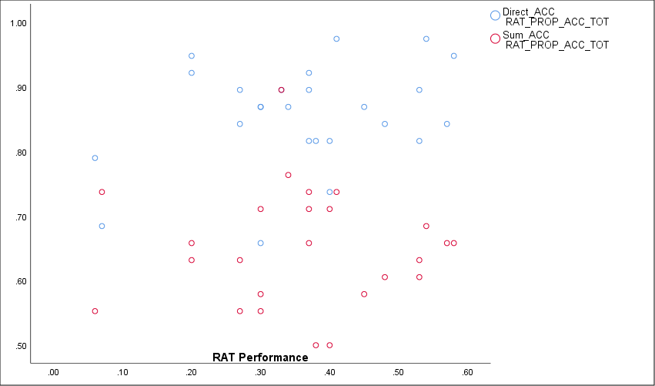 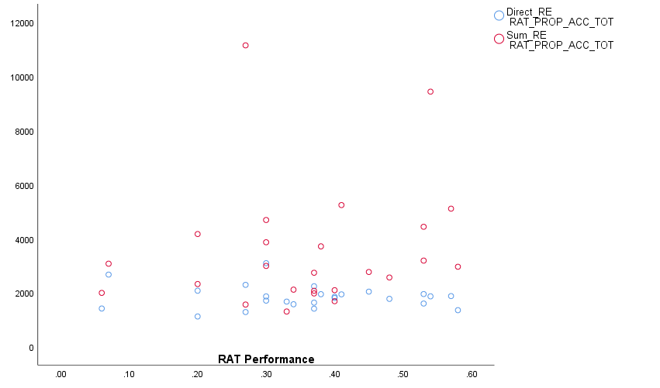

Figure S6. Direct condition in blue and the summation condition in red (left hand plot is accuracy and the right hand plot is response efficiency).

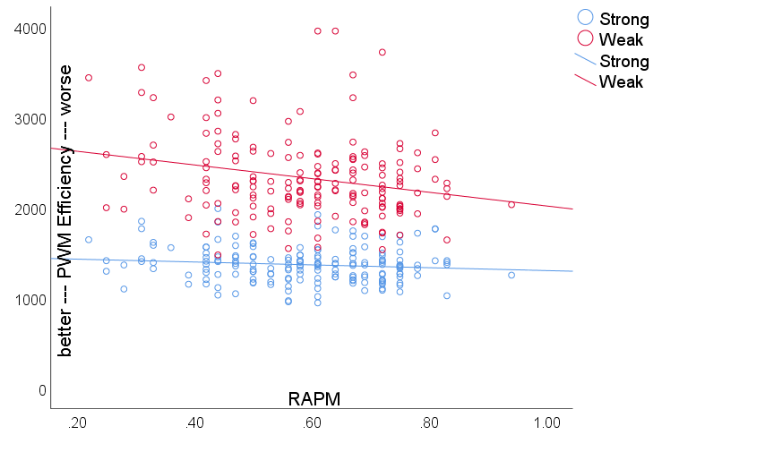

Figure S7. Relationship between performance on semantic association task and RAPM.

**List of Stimuli**

The full list of stimuli used in the semantic summation task, taken from Beeman et al. (1994) and organised by practice and experimental blocks. The correct answer in each trial is indicated in bold.

|  |  |  |  |  |  |  |  |  |  |
| --- | --- | --- | --- | --- | --- | --- | --- | --- | --- |
| Summation Condition: Practice Block | | | |  |  |  |  |  |  |
| Probe 1 | Probe 2 | Probe 3 | Choice 1 | | | | Choice 2 | Choice 3 | Choice 4 |
| Girl | Flower | Colourful | **Pretty** | | | | Boy | Plant | Bleak |
| Mother | Baby | Hug | Father | | | | Old | Shove | **Love** |
| Rush | Flying | Hurry | Hour | | | | Crawling | **Fast** | Relaxed |
| Party | Shouting | Yelling | **Noise** | | | | Drinks | Talking | Running |
| Cemetery | Midnight | Empty | Graves | | | | **Scary** | Noon | Full |

|  |  |  |  |  |  |  |  |  |
| --- | --- | --- | --- | --- | --- | --- | --- | --- |
| Direct Condition: Practice Block | | |  |  |  |  |  |  |
| Probe 1 | Probe 2 | Probe 3 | | | Choice 1 | Choice 2 | Choice 3 | Choice 4 |
| What | Sex | Whether | | | Father | Old | Shove | **Love** |
| What | Quiet | Whether | | | **Noise** | Drinks | Talking | Running |
| Blank | Swift | Although | | | Hour | Crawling | **Fast** | Relaxed |
| Some | Ugly | Nothing | | | **Pretty** | Boy | Plant | Bleak |
| Although | Monster | Ready | | | Graves | **Scary** | Noon | Full |

|  |  |  |  |  |  |  |  |  |  |
| --- | --- | --- | --- | --- | --- | --- | --- | --- | --- |
| Summation Condition: Experimental Block 1 | | | |  |  |  |  |  |  |
| Probe 1 | Probe 2 | Probe 3 | Choice 1 | | | | Choice 2 | Choice 3 | Choice 4 |
| Hunt | Treasure | Map | Search | | | | Chest | **Find** | Survey |
| Vault | Jewellery | Missing | **Theft** | | | | Buried | Precious | Lost |
| Siren | Hurt | Rescue | Police | | | | **Accident** | Care | Injury |
| Doctor | Knife | Stitches | Nurse | | | | **Surgery** | Cut | Needle |
| Subway | Noise | Buildings | Transit | | | | Traffic | **City** | Offices |
| Ticking | Package | Damage | Clock | | | | Letter | **Bomb** | Injury |
| Bullet | Aim | Fire | **Shoot** | | | | Projectile | Point | Discharge |
| Victim | Gun | Trial | Villain | | | | Knife | **Murder** | Guilty |
| Man | Cross | Street | Woman | | | | **Walk** | Path | Travel |
| Weekday | Busy | Pay | **Work** | | | | Hours | Occupied | Profit |
| Tyre | Road | Horn | Rubber | | | | Alarm | **Car** | Lanes |
| Shape | Earth | World | **Round** | | | | Planet | Universe | Form |
| White | Ceremony | Tuxedo | Pure | | | | Occasion | **Wedding** | Dress |
| Grey | Retired | Wrinkled | Dull | | | | Withdrawn | Furrowed | **Old** |
| Itch | Nose | Dust | **Sneeze** | | | | Scratch | Eyes | Pollen |
| Cat | Attack | Paw | Hit | | | | Whiskers | Foot | **Scratch** |
| Pool | Water | Bottom | Swimming | | | | Waves | **Deep** | Seat |
| Boat | Crash | Bottom | Collide | | | | Seabed | **Sink** | Ship |
| Dust | Hot | Sand | Dirt | | | | Intense | Beach | **Dry** |

|  |  |  |  |  |  |  |  |  |  |
| --- | --- | --- | --- | --- | --- | --- | --- | --- | --- |
| Direct Condition: Experimental Block 1 | | | |  |  |  |  |  |  |
| Probe 1 | Probe 2 | Probe 3 | Choice 1 | | | | Choice 2 | Choice 3 | Choice 4 |
| Blank | Swift | Although | Fast | | | | Moving | **Deadline** | Careless |
| Although | Perspire | None | **Sweat** | | | | Hot | Effort | Skin |
| Blank | Dead | Blank | Crash | | | | **Alive** | Old | Revive |
| Some | Pilot | Nothing | Transport | | | | Rain | **Plane** | Hot |
| Ready | Vote | What | Lose | | | | Birthday | Support | **Elect** |
| Whether | Under | Some | Saddle | | | | **Over** | Jockey | Field |
| Whether | Lost | Ready | Sing | | | | Crown | **Won** | Cheer |
| Blank | Birthday | Although | Light | | | | Celebrate | **Cake** | Frost |
| Ready | Bee | What | Sweet | | | | **Sting** | Bite | Rash |
| Although | Simmers | Blank | Sauce | | | | Pan | **Boils** | Noisy |
| Whether | Parched | None | **Thirsty** | | | | Juice | Wet | Sore |
| None | Scared | Ready | Zoo | | | | Blood | Independent | **Afraid** |
| What | Teenager | Ready | Spring | | | | Vigor | **Youth** | Glow |
| Nothing | Bed | Some | Nose | | | | Shut | Black | **Sleep** |
| Although | Eat | What | Glass | | | | Overflow | Drained | **Drink** |
| Nothing | Thread | Some | Farm | | | | Tip | Injection | **Needle** |
| Blank | Stand | None | Walk | | | | **Sit** | Park | Arms |
| Blank | Newborn | Although | **Birth** | | | | Emergency | Cloth | Sleep |
| Whether | Fired | None | Ask | | | | Responsible | Experience | **Hired** |

|  |  |  |  |  |  |  |  |  |  |
| --- | --- | --- | --- | --- | --- | --- | --- | --- | --- |
| Summation Condition: Experimental Block 2 | | | |  |  |  |  |  |  |
| Probe 1 | Probe 2 | Probe 3 | Choice 1 | | | | Choice 2 | Choice 3 | Choice 4 |
| Water | Dry | Throat | **Thirsty** | | | | Juice | Wet | Sore |
| Hospital | Baby | Bundle | **Birth** | | | | Emergency | Cloth | Sleep |
| Lion | Attack | Alone | Zoo | | | | Blood | Independent | **Afraid** |
| Kettle | Water | Whistle | Sauce | | | | Pan | **Boils** | Noisy |
| Candle | Icing | Party | Light | | | | Celebrate | **Cake** | Frost |
| Person | Survive | Accident | Crash | | | | **Alive** | Old | Revive |
| Engine | Travel | Clouds | Transport | | | | Rain | **Plane** | Hot |
| Full | Empty | Cup | Glass | | | | Overflow | Drained | **Drink** |
| Legs | Rest | Bench | Walk | | | | **Sit** | Park | Arms |
| Humid | Work | Brow | **Sweat** | | | | Hot | Effort | Skin |
| Honey | Bug | Pain | Sweet | | | | **Sting** | Bite | Rash |
| Apply | Job | New | Ask | | | | Responsible | Experience | **Hired** |
| Perform | Award | Applause | Sing | | | | Crown | **Won** | Cheer |
| Haystack | Point | Syringe | Farm | | | | Tip | Injection | **Needle** |
| Rush | Writing | Blasé | Pace | | | | Moving | **Deadline** | Careless |
| Fountain | Healthy | Strong | Spring | | | | Vigor | **Youth** | Glow |
| Eyes | Closed | Night | Nose | | | | Shut | Black | **Sleep** |
| May | Party | Win | Lose | | | | Birthday | Support | **Elect** |
| Horse | Jump | Fence | Saddle | | | | **Over** | Jockey | Field |

|  |  |  |  |  |  |  |  |  |  |
| --- | --- | --- | --- | --- | --- | --- | --- | --- | --- |
| Direct Condition: Experimental Block 2 | | | |  |  |  |  |  |  |
| Probe 1 | Probe 2 | Probe 3 | Choice 1 | | | | Choice 2 | Choice 3 | Choice 4 |
| None | Itch | Whether | Hit | | | | Whiskers | Foot | **Scratch** |
| Nothing | Crash | Some | Police | | | | **Accident** | Care | Injury |
| Blank | Job | Although | **Work** | | | | Hours | Occupied | Profit |
| Blank | Robbery | Although | **Theft** | | | | Buried | Precious | Lost |
| Some | Explode | What | Clock | | | | Letter | **Bomb** | Injury |
| Nothing | Cough | Some | **Sneeze** | | | | Scratch | Eyes | Pollen |
| Nothing | Circle | Blank | **Round** | | | | Planet | Universe | Form |
| None | Rifle | Nothing | **Shoot** | | | | Projectile | Point | Discharge |
| Nothing | New | Some | Dull | | | | Withdrawn | Furrowed | **Old** |
| Ready | Saunter | What | Woman | | | | **Walk** | Path | Travel |
| Although | Marriage | Blank | Pure | | | | Occasion | **Wedding** | Dress |
| Ready | Dishes | What | Collide | | | | Seabed | **Sink** | Ship |
| Some | Drive | Nothing | Rubber | | | | Alarm | **Car** | Lanes |
| Some | Kill | Nothing | Villain | | | | Knife | **Murder** | Guilty |
| None | Operate | What | Nurse | | | | **Surgery** | Cut | Needle |
| Ready | Shallow | Whether | Swimming | | | | Waves | **Deep** | Seat |
| Whether | Town | None | Transit | | | | Traffic | **City** | Offices |
| Ready | Hide | What | Search | | | | Chest | **Find** | Survey |
| Although | Wet | Ready | Dirt | | | | Intense | Beach | **Dry** |

Item Analysis:

Direct condition – Cronbach’s Alpha = .659, and the Cronbach’s Alpha would not change with the removal of any of the items (see table below). Summation condition – Cronbach’s Alpha = .64, and the Cronbach’s Alpha would not change with the removal of any of the items (see table below).



**References**

Abraham, A., Pieritz, K., Thybusch, K., Rutter, B., Kröger, S., Schweckendiek, J., . . . Hermann, C. (2012). Creativity and the brain: Uncovering the neural signature of conceptual expansion. *Neuropsychologia, 50*(8), 1906-1917. doi:<https://doi.org/10.1016/j.neuropsychologia.2012.04.015>

Anticevic, A., Repovs, G., Shulman, G. L., & Barch, D. M. (2010). When less is more: TPJ and default network deactivation during encoding predicts working memory performance. *NeuroImage, 49*(3), 2638-2648. doi:<https://doi.org/10.1016/j.neuroimage.2009.11.008>

Badre, D., Poldrack, R. A., Pare-Blagoev, E. J., Insler, R. Z., & Wagner, A. D. (2005). Dissociable Controlled Retrieval and Generalized Selection Mechanisms in Ventrolateral Prefrontal Cortex. *Neuron, 47*(6), 907-918. doi:10.1016/j.neuron.2005.07.023

Barde, L. H., & Thompson-Schill, S. L. (2002). Models of functional organization of the lateral prefrontal cortex in verbal working memory: evidence in favor of the process model. *J Cogn Neurosci, 14*(7), 1054-1063. doi:10.1162/089892902320474508

Beaty, R. E., Benedek, M., Silvia, P. J., & Schacter, D. L. (2016). Creative Cognition and Brain Network Dynamics. *Trends Cogn Sci, 20*(2), 87-95. doi:10.1016/j.tics.2015.10.004

Beaty, R. E., Benedek, M., Wilkins, R. W., Jauk, E., Fink, A., Silvia, P. J., . . . Neubauer, A. C. (2014). Creativity and the default network: A functional connectivity analysis of the creative brain at rest. *Neuropsychologia, 64*, 92-98. doi:10.1016/j.neuropsychologia.2014.09.019

Beeman, M. (1998). Coarse semantic coding and discourse comprehension. In M. Beeman & C. Chiarello (Eds.), *Right Hemisphere Language Comprehension: Perspectives From Cognitive Neuroscience* (pp. 255-284). Mahwah, New Jersey: Erlbaum.

Beeman, M., Friedman, R. B., Grafman, J., Perez, E., Diamond, S., & Lindsay, M. B. (1994). Summation Priming and Coarse Semantic Coding in the Right Hemisphere. *Journal of Cognitive Neuroscience, 6*(1), 26-45. doi:10.1162/jocn.1994.6.1.26

Behzadi, Y., Restom, K., Liau, J., & Liu, T. T. (2007). A component based noise correction method (CompCor) for BOLD and perfusion based fMRI. *NeuroImage, 37*(1), 90-101. doi:<https://doi.org/10.1016/j.neuroimage.2007.04.042>

Binder, J. R., & Desai, R. H. (2011). The neurobiology of semantic memory. *Trends in Cognitive Sciences, 15*(11), 527-536. doi:<https://doi.org/10.1016/j.tics.2011.10.001>

Binder, J. R., Desai, R. H., Graves, W. W., & Conant, L. L. (2009). Where Is the Semantic System? A Critical Review and Meta-Analysis of 120 Functional Neuroimaging Studies. *Cerebral Cortex, 19*(12), 2767-2796.

Chai, X. J., Castañón, A. N., Öngür, D., & Whitfield-Gabrieli, S. (2012). Anticorrelations in resting state networks without global signal regression. *NeuroImage, 59*(2), 1420-1428. doi:<https://doi.org/10.1016/j.neuroimage.2011.08.048>

Coltheart, M. (1981). The Mrc Psycholinguistic Database. *Quarterly Journal of Experimental Psychology Section a-Human Experimental Psychology, 33*(Nov), 497-505.

Davey, J., Cornelissen, P. L., Thompson, H. E., Sonkusare, S., Hallam, G., Smallwood, J., & Jefferies, E. (2015). Automatic and Controlled Semantic Retrieval: TMS Reveals Distinct Contributions of Posterior Middle Temporal Gyrus and Angular Gyrus. *The Journal of neuroscience : the official journal of the Society for Neuroscience, 35*(46), 15230-15239. doi:10.1523/JNEUROSCI.4705-14.2015

Davey, J., Thompson, H. E., Hallam, G., Karapanagiotidis, T., Murphy, C., De Caso, I., . . . Jefferies, E. (2016). Exploring the role of the posterior middle temporal gyrus in semantic cognition: Integration of anterior temporal lobe with executive processes. *NeuroImage, 137*, 165-177. doi:<https://doi.org/10.1016/j.neuroimage.2016.05.051>

De Deyne, S., Navarro, D. J., Perfors, A., & Storms, G. (2016). Structure at every scale: A semantic network account of the similarities between unrelated concepts. *Journal of Experimental Psychology: General, 145*(9), 1228-1254. doi:10.1037/xge0000192

Demb, J. B., Desmond, J. E., Wagner, A. D., Vaidya, C. J., Glover, G. H., & Gabrieli, J. D. (1995). Semantic encoding and retrieval in the left inferior prefrontal cortex: a functional MRI study of task difficulty and process specificity. *The Journal of Neuroscience, 15*(9), 5870-5878.

Duncan, J. (2010). The multiple-demand (MD) system of the primate brain: mental programs for intelligent behaviour. *Trends in Cognitive Sciences, 14*(4), 172-179. doi:DOI 10.1016/j.tics.2010.01.004

Duncan, J., & Owen, A. M. (2000). Common regions of the human frontal lobe recruited by diverse cognitive demands. *Trends in Neurosciences, 23*(10), 475-483.

Esposito, F., Bertolino, A., Scarabino, T., Latorre, V., Blasi, G., Popolizio, T., . . . Di Salle, F. (2006). Independent component model of the default-mode brain function: Assessing the impact of active thinking. *Brain Research Bulletin, 70*(4), 263-269. doi:<https://doi.org/10.1016/j.brainresbull.2006.06.012>

Fedorenko, E., Duncan, J., & Kanwisher, N. (2013). Broad domain generality in focal regions of frontal and parietal cortex. *Proc Natl Acad Sci U S A, 110*(41), 16616-16621. doi:10.1073/pnas.1315235110

Fox, M. D., Snyder, A. Z., Vincent, J. L., Corbetta, M., Van Essen, D. C., & Raichle, M. E. (2005). The human brain is intrinsically organized into dynamic, anticorrelated functional networks. *Proceedings of the National Academy of Sciences of the United States of America, 102*(27), 9673. doi:10.1073/pnas.0504136102

Fox, M. D., Zhang, D., Snyder, A. Z., & Raichle, M. E. (2009). The Global Signal and Observed Anticorrelated Resting State Brain Networks. *Journal of Neurophysiology, 101*(6), 3270-3283. doi:10.1152/jn.90777.2008

Fransson, P. (2006). How default is the default mode of brain function?: Further evidence from intrinsic BOLD signal fluctuations. *Neuropsychologia, 44*(14), 2836-2845. doi:<https://doi.org/10.1016/j.neuropsychologia.2006.06.017>

Frishkoff, G. A. (2007). Hemispheric differences in strong versus weak semantic priming: Evidence from event-related brain potentials. *Brain and Language, 100*(1), 23-43. doi:<https://doi.org/10.1016/j.bandl.2006.06.117>

Giora, R. (1997). Understanding figurative and literal language: The graded salience hypothesis (Psycholinguistics). *Cognitive Linguistics, 8*(3), 183-206.

Giora, R. (2003). *On our mind: Salience, context and figurative language*. New York: Oxford University Press.

Giora, R. (2008). Is metaphor unique? In J. R. W. Gibbs (Ed.), *The Cambridge Handbook of Metaphor and Thought* (pp. 143-160). Cambridge: Cambridge University Press.

Giora, R., Zaidel, E., Soroker, N., Batori, G., & Kasher, A. (2000). Differential Effects of Right- and Left-Hemisphere Damage on Understanding Sarcasm and Metaphor. *Metaphor and Symbol, 15*(1-2), 63-83. doi:10.1080/10926488.2000.9678865

Gonen-Yaacovi, G., de Souza, L., Levy, R., Urbanski, M., Josse, G., & Volle, E. (2013). Rostral and caudal prefrontal contribution to creativity: a meta-analysis of functional imaging data. *Frontiers in Human Neuroscience, 7*, 465.

Gonzalez Alam, T., Murphy, C., Smallwood, J., & Jefferies, E. (2018). Meaningful inhibition: Exploring the role of meaning and modality in response inhibition. *NeuroImage, 181*, 108-119. doi:<https://doi.org/10.1016/j.neuroimage.2018.06.074>

Gonzalez Alam, T. R. J., Karapanagiotidis, T., Smallwood, J., & Jefferies, E. (2019). Degrees of lateralisation in semantic cognition: Evidence from intrinsic connectivity. *NeuroImage*, 116089. doi:<https://doi.org/10.1016/j.neuroimage.2019.116089>

Gorgolewski, K. J., Varoquaux, G., Rivera, G., Schwarz, Y., Ghosh, S. S., Maumet, C., . . . Margulies, D. S. (2015). NeuroVault.org: a web-based repository for collecting and sharing unthresholded statistical maps of the human brain. *Frontiers in Neuroinformatics, 9*(8). doi:10.3389/fninf.2015.00008

Graves, W. W., Binder, J. R., Desai, R. H., Conant, L. L., & Seidenberg, M. S. (2010). Neural correlates of implicit and explicit combinatorial semantic processing. *NeuroImage, 53*(2), 638-646. doi:<https://doi.org/10.1016/j.neuroimage.2010.06.055>

Hallam, G. P., Whitney, C., Hymers, M., Gouws, A. D., & Jefferies, E. (2016). Charting the effects of TMS with fMRI: Modulation of cortical recruitment within the distributed network supporting semantic control. *Neuropsychologia, 93*, 40-52. doi:<https://doi.org/10.1016/j.neuropsychologia.2016.09.012>

Humphreys, G. F., Hoffman, P., Visser, M., Binney, R. J., & Lambon Ralph, M. A. (2015). Establishing task- and modality-dependent dissociations between the semantic and default mode networks. *Proceedings of the National Academy of Sciences of the United States of America, 112*(25), 7857-7862. doi:10.1073/pnas.1422760112

Humphreys, G. F., & Lambon Ralph, M. A. (2015). Fusion and Fission of Cognitive Functions in the Human Parietal Cortex. *Cereb Cortex, 25*(10), 3547-3560. doi:10.1093/cercor/bhu198

bhu198 [pii]

Japardi, K., Bookheimer, S., Knudsen, K., Ghahremani, D. G., & Bilder, R. M. (2018). Functional magnetic resonance imaging of divergent and convergent thinking in Big-C creativity. *Neuropsychologia, 118*, 59-67. doi:<https://doi.org/10.1016/j.neuropsychologia.2018.02.017>

Jefferies, E. (2013). The neural basis of semantic cognition: converging evidence from neuropsychology, neuroimaging and TMS. *Cortex, 49*(3), 611-625. doi:10.1016/j.cortex.2012.10.008

Jefferies, E., Thompson, H. E., Cornelissen, P. L., & Smallwood, J. (2019). The neurocognitive basis of knowledge about object identity and events: Dissociations reflect opposing effects of semantic coherence and control. *Philosophical Transactions Of The Royal Society Of London Series B - Biological Sciences*.

Jung-Beeman, M. (2005). Bilateral brain processes for comprehending natural language. *Trends in Cognitive Sciences, 9*(11), 512-518.

Jung-Beeman, M., Bowden, E. M., Haberman, J., Frymiare, J. L., Arambel-Liu, S., Greenblatt, R., . . . Kounios, J. (2004). Neural Activity When People Solve Verbal Problems with Insight. *PLOS Biology, 2*(4), e97. doi:10.1371/journal.pbio.0020097

Kan, I. P., & Thompson-Schill, S. L. (2004). Selection from perceptual and conceptual representations. *Cogn Affect Behav Neurosci, 4*(4), 466-482.

Kandhadai, P., & Federmeier, K. D. (2008). Summing it up: Semantic activation processes in the two hemispheres as revealed by event-related potentials. *Brain Research, 1233*, 146-159. doi:<https://doi.org/10.1016/j.brainres.2008.07.043>

Karapanagiotidis, T., Bernhardt, B. C., Jefferies, E., & Smallwood, J. (2017). Tracking thoughts: Exploring the neural architecture of mental time travel during mind-wandering. *NeuroImage, 147*, 272-281. doi:<https://doi.org/10.1016/j.neuroimage.2016.12.031>

Kenett, Y. N., Levi, E., Anaki, D., & Faust, M. (2017). The semantic distance task: Quantifying semantic distance with semantic network path length. *Journal of experimental psychology: Learning, Memory, and Cognition, 43*(9), 1470-1489.

Krieger-Redwood, K., Jefferies, E., Karapanagiotidis, T., Seymour, R., Nunes, A., Ang, J. W. A., . . . Smallwood, J. (2016). Down but not out in posterior cingulate cortex: Deactivation yet functional coupling with prefrontal cortex during demanding semantic cognition. *NeuroImage, 141*, 366-377. doi:<https://doi.org/10.1016/j.neuroimage.2016.07.060>

Krieger-Redwood, K., Teige, C., Davey, J., Hymers, M., & Jefferies, E. (2015). Conceptual control across modalities: graded specialisation for pictures and words in inferior frontal and posterior temporal cortex. *Neuropsychologia, 76*, 92-107. doi:10.1016/j.neuropsychologia.2015.02.030

Kumar, A. A., Balota, D. A., & Steyvers, M. (2019). Distant connectivity and multiple-step priming in large-scale semantic networks. *Journal of experimental psychology: Learning, Memory, and Cognition*. doi:10.1037/xlm0000793

Lambon Ralph, M. A., Jefferies, E., Patterson, K., & Rogers, T. T. (2017). The neural and computational bases of semantic cognition. *Nature Reviews Neuroscience, 18*, 42. doi:10.1038/nrn.2016.150

<https://www.nature.com/articles/nrn.2016.150#supplementary-information>

Lamp, G., Alexander, B., Laycock, R., Crewther, D. P., & Crewther, S. G. (2016). Mapping of the Underlying Neural Mechanisms of Maintenance and Manipulation in Visuo-Spatial Working Memory Using An n-back Mental Rotation Task: A Functional Magnetic Resonance Imaging Study. *Frontiers in Behavioral Neuroscience, 10*(87). doi:10.3389/fnbeh.2016.00087

Lanzoni, L., Ravasio, D., Thompson, H., Vatansever, D., Margulies, D., Smallwood, J., & Jefferies, E. (under review). The role of default mode network in semantic cue

integration.

Lerner, Y., Honey, C. J., Silbert, L. J., & Hasson, U. (2011). Topographic Mapping of a Hierarchy of Temporal Receptive Windows Using a Narrated Story. *The Journal of Neuroscience, 31*(8), 2906. doi:10.1523/JNEUROSCI.3684-10.2011

Margulies, D. S., Ghosh, S. S., Goulas, A., Falkiewicz, M., Huntenburg, J. M., Langs, G., . . . Smallwood, J. (2016). Situating the default-mode network along a principal gradient of macroscale cortical organization. *Proceedings of the National Academy of Sciences, 113*(44), 12574. doi:10.1073/pnas.1608282113

Marron, T. R., Lerner, Y., Berant, E., Kinreich, S., Shapira-Lichter, I., Hendler, T., & Faust, M. (2018). Chain free association, creativity, and the default mode network. *Neuropsychologia, 118*, 40-58. doi:<https://doi.org/10.1016/j.neuropsychologia.2018.03.018>

McKiernan, K. A., Kaufman, J. N., Kucera-Thompson, J., & Binder, J. R. (2003). A Parametric Manipulation of Factors Affecting Task-induced Deactivation in Functional Neuroimaging. *Journal of Cognitive Neuroscience, 15*(3), 394-408. doi:10.1162/089892903321593117

Mednick, S. A. (1968). The Remote Associates Test*. *The Journal of Creative Behavior, 2*(3), 213-214. doi:10.1002/j.2162-6057.1968.tb00104.x

Mikolov, T., Chen, K., Corrado, G., & Dean, J. J. a. p. a. (2013). Efficient estimation of word representations in vector space.

Mollo, G., Cornelissen, P. L., Millman, R. E., Ellis, A. W., & Jefferies, E. (2017). Oscillatory Dynamics Supporting Semantic Cognition: MEG Evidence for the Contribution of the Anterior Temporal Lobe Hub and Modality-Specific Spokes. *PLOS ONE, 12*(1), e0169269. doi:10.1371/journal.pone.0169269

Mollo, G., Karapanagiotidis, T., Bernhardt, B. C., Murphy, C. E., Smallwood, J., & Jefferies, E. (2016). An individual differences analysis of the neurocognitive architecture of the semantic system at rest. *Brain and Cognition, 109*, 112-123. doi:<https://doi.org/10.1016/j.bandc.2016.07.003>

Murphy, C., Jefferies, E., Rueschemeyer, S.-A., Sormaz, M., Wang, H.-t., Margulies, D. S., & Smallwood, J. (2018). Distant from input: Evidence of regions within the default mode network supporting perceptually-decoupled and conceptually-guided cognition. *NeuroImage, 171*, 393-401. doi:<https://doi.org/10.1016/j.neuroimage.2018.01.017>

Murphy, K., Birn, R. M., Handwerker, D. A., Jones, T. B., & Bandettini, P. A. (2009). The impact of global signal regression on resting state correlations: Are anti-correlated networks introduced? *NeuroImage, 44*(3), 893-905. doi:<https://doi.org/10.1016/j.neuroimage.2008.09.036>

Nguyen, M., Vanderwal, T., & Hasson, U. (2019). Shared understanding of narratives is correlated with shared neural responses. *NeuroImage, 184*, 161-170. doi:<https://doi.org/10.1016/j.neuroimage.2018.09.010>

Noonan, K. A., Jefferies, E., Visser, M., & Lambon Ralph, M. A. (2013). Going beyond Inferior Prefrontal Involvement in Semantic Control: Evidence for the Additional Contribution of Dorsal Angular Gyrus and Posterior Middle Temporal Cortex. *Journal of Cognitive Neuroscience*, 1-26. doi:10.1162/jocn_a_00442

Pallier, C., Devauchelle, A.-D., & Dehaene, S. (2011). Cortical representation of the constituent structure of sentences. *Proceedings of the National Academy of Sciences, 108*(6), 2522. doi:10.1073/pnas.1018711108

Patterson, K., Nestor, P. J., & Rogers, T. T. (2007). Where do you know what you know? The representation of semantic knowledge in the human brain. *Nat Rev Neurosci, 8*(12), 976-987. doi:nrn2277 [pii]

10.1038/nrn2277

Peleg, O., Giora, R., & Fein, O. (2008). Resisting Contextual Information: You Can't Put a Salient Meaning Down. In *Lodz Papers in Pragmatics* (Vol. 4, pp. 13).

Piccoli, T., Valente, G., Linden, D. E. J., Re, M., Esposito, F., Sack, A. T., & Salle, F. D. (2015). The Default Mode Network and the Working Memory Network Are Not Anti-Correlated during All Phases of a Working Memory Task. *PLOS ONE, 10*(4), e0123354. doi:10.1371/journal.pone.0123354

Poerio, G. L., Sormaz, M., Wang, H.-T., Margulies, D., Jefferies, E., & Smallwood, J. (2017). The role of the default mode network in component processes underlying the wandering mind. *Social Cognitive and Affective Neuroscience, 12*(7), 1047-1062. doi:10.1093/scan/nsx041

Price, A. R., Bonner, M. F., Peelle, J. E., & Grossman, M. (2015). Converging evidence for the neuroanatomic basis of combinatorial semantics in the angular gyrus. *The Journal of neuroscience : the official journal of the Society for Neuroscience, 35*(7), 3276-3284. doi:10.1523/JNEUROSCI.3446-14.2015

Pylkkänen, L. (2019). The neural basis of combinatory syntax and semantics. *Science, 366*(6461), 62. doi:10.1126/science.aax0050

Raichle, M. E., MacLeod, A. M., Snyder, A. Z., Powers, W. J., Gusnard, D. A., & Shulman, G. L. (2001). A default mode of brain function. *Proceedings of the National Academy of Sciences, 98*(2), 676-682.

Rogers, T. T., Hocking, J., Noppeney, U., Mechelli, A., Gorno-Tempini, M. L., Patterson, K., & Price, C. J. (2006). Anterior temporal cortex and semantic memory: Reconciling findings from neuropsychology and functional imaging. *Cognitive, Affective, & Behavioral Neuroscience, 6*(3), 201-213. doi:10.3758/CABN.6.3.201

Shen, W., Yuan, Y., Liu, C., & Luo, J. (2017). The roles of the temporal lobe in creative insight: an integrated review. *Thinking & Reasoning, 23*(4), 321-375. doi:10.1080/13546783.2017.1308885

Smith, S. M., Fox, P. T., Miller, K. L., Glahn, D. C., Fox, P. M., Mackay, C. E., . . . Beckmann, C. F. (2009). Correspondence of the brain's functional architecture during activation and rest. *Proc Natl Acad Sci U S A, 106*(31), 13040-13045. doi:10.1073/pnas.0905267106

Sormaz, M., Jefferies, E., Bernhardt, B. C., Karapanagiotidis, T., Mollo, G., Bernasconi, N., . . . Smallwood, J. (2017). Knowing what from where: Hippocampal connectivity with temporoparietal cortex at rest is linked to individual differences in semantic and topographic memory. *NeuroImage, 152*, 400-410. doi:<https://doi.org/10.1016/j.neuroimage.2017.02.071>

Sormaz, M., Murphy, C., Wang, H.-t., Hymers, M., Karapanagiotidis, T., Poerio, G., . . . Smallwood, J. (2018). Default mode network can support the level of detail in experience during active task states. *Proceedings of the National Academy of Sciences, 115*(37), 9318. doi:10.1073/pnas.1721259115

Sripada, C., Angstadt, M., Rutherford, S., & Taxali, A. (2019). Brain Network Mechanisms of General Intelligence. *bioRxiv*, 657205. doi:10.1101/657205

Teige, C., Cornelissen, P. L., Mollo, G., Gonzalez Alam, T. R. d. J., McCarty, K., Smallwood, J., & Jefferies, E. (2019). Dissociations in semantic cognition: Oscillatory evidence for opposing effects of semantic control and type of semantic relation in anterior and posterior temporal cortex. *Cortex, 120*, 308-325. doi:<https://doi.org/10.1016/j.cortex.2019.07.002>

Teige, C., Mollo, G., Millman, R., Savill, N., Smallwood, J., Cornelissen, P. L., & Jefferies, E. (2018). Dynamic semantic cognition: Characterising coherent and controlled conceptual retrieval through time using magnetoencephalography and chronometric transcranial magnetic stimulation. *Cortex, 103*, 329-349. doi:<https://doi.org/10.1016/j.cortex.2018.03.024>

Thompson-Schill, S. L., D'Esposito, M., Aguirre, G. K., & Farah, M. J. (1997). Role of left inferior prefrontal cortex in retrieval of semantic knowledge: a reevaluation. *Proc Natl Acad Sci U S A, 94*(26), 14792-14797.

Thompson, C. K., Bonakdarpour, B., Fix, S. C., Blumenfeld, H. K., Parrish, T. B., Gitelman, D. R., & Mesulam, M. M. (2007). Neural Correlates of Verb Argument Structure Processing. *Journal of Cognitive Neuroscience, 19*(11), 1753-1767. doi:10.1162/jocn.2007.19.11.1753

Thompson, H. E., Henshall, L., & Jefferies, E. (2016). The role of the right hemisphere in semantic control: A case-series comparison of right and left hemisphere stroke. *Neuropsychologia, 85*, 44-61. doi:<https://doi.org/10.1016/j.neuropsychologia.2016.02.030>

Turnbull, A., Wang, H.-T., Schooler, J. W., Jefferies, E., Margulies, D. S., & Smallwood, J. (2019). The ebb and flow of attention: Between-subject variation in intrinsic connectivity and cognition associated with the dynamics of ongoing experience. *NeuroImage, 185*, 286-299. doi:<https://doi.org/10.1016/j.neuroimage.2018.09.069>

Tylén, K., Christensen, P., Roepstorff, A., Lund, T., Østergaard, S., & Donald, M. (2015). Brains striving for coherence: Long-term cumulative plot formation in the default mode network. *NeuroImage, 121*, 106-114. doi:<https://doi.org/10.1016/j.neuroimage.2015.07.047>

van Heuven, W. J. B., Mandera, P., Keuleers, E., & Brysbaert, M. (2014). SUBTLEX-UK: A new and improved word frequency database for British English. *The Quarterly Journal of Experimental Psychology, 67*(6), 1176-1190. doi:10.1080/17470218.2013.850521

Vatansever, D., Bzdok, D., Wang, H.-T., Mollo, G., Sormaz, M., Murphy, C., . . . Jefferies, E. (2017). Varieties of semantic cognition revealed through simultaneous decomposition of intrinsic brain connectivity and behaviour. *NeuroImage, 158*, 1-11. doi:<https://doi.org/10.1016/j.neuroimage.2017.06.067>

Vatansever, D., Menon, D. K., Manktelow, A. E., Sahakian, B. J., & Stamatakis, E. A. (2015). Default Mode Dynamics for Global Functional Integration. *The Journal of neuroscience : the official journal of the Society for Neuroscience, 35*(46), 15254-15262. doi:10.1523/JNEUROSCI.2135-15.2015

Visser, M., Jefferies, E., Embleton, K. V., & Lambon Ralph, M. A. (2012). Both the Middle Temporal Gyrus and the Ventral Anterior Temporal Area Are Crucial for Multimodal Semantic Processing: Distortion-corrected fMRI Evidence for a Double Gradient of Information Convergence in the Temporal Lobes. *Journal of Cognitive Neuroscience, 24*(8), 1766-1778. doi:10.1162/jocn_a_00244

Wagner, A. D., Pare-Blagoev, E. J., Clark, J., & Poldrack, R. A. (2001). Recovering Meaning: Left Prefrontal Cortex Guides Controlled Semantic Retrieval. *Neuron, 31*(2), 329-338. doi:10.1016/s0896-6273(01)00359-2

Wang, H.-T., Bzdok, D., Margulies, D., Craddock, C., Milham, M., Jefferies, E., & Smallwood, J. (2018a). Patterns of thought: Population variation in the associations between large-scale network organisation and self-reported experiences at rest. *NeuroImage, 176*, 518-527. doi:<https://doi.org/10.1016/j.neuroimage.2018.04.064>

Wang, H.-T., Poerio, G., Murphy, C., Bzdok, D., Jefferies, E., & Smallwood, J. (2017). Dimensions of Experience: Exploring the Heterogeneity of the Wandering Mind. *Psychological Science, 29*(1), 56-71. doi:10.1177/0956797617728727

Wang, X., Bernhardt, B. C., Karapanagiotidis, T., De Caso, I., Gonzalez Alam, T. R. d. J., Cotter, Z., . . . Jefferies, E. (2018b). The structural basis of semantic control: Evidence from individual differences in cortical thickness. *NeuroImage, 181*, 480-489. doi:<https://doi.org/10.1016/j.neuroimage.2018.07.044>

Ward, T. B. (1994). Structured Imagination: the Role of Category Structure in Exemplar Generation. *Cognitive Psychology, 27*(1), 1-40. doi:<https://doi.org/10.1006/cogp.1994.1010>

Wei, T., Liang, X., He, Y., Zang, Y., Han, Z., Caramazza, A., & Bi, Y. (2012). Predicting Conceptual Processing Capacity from Spontaneous Neuronal Activity of the Left Middle Temporal Gyrus. *The Journal of Neuroscience, 32*(2), 481. doi:10.1523/JNEUROSCI.1953-11.2012

Whitfield-Gabrieli, S., & Nieto-Castanon, A. (2012). Conn: A Functional Connectivity Toolbox for Correlated and Anticorrelated Brain Networks. *Brain Connectivity, 2*(3), 125-141. doi:10.1089/brain.2012.0073

Whitney, C., Grossman, M., & Kircher, T. (2009). The Influence of Multiple Primes on Bottom-Up and Top-Down Regulation during Meaning Retrieval: Evidence for 2 Distinct Neural Networks. *Cerebral Cortex, 19*(11), 2548-2560.

Whitney, C., Kirk, M., O'Sullivan, J., Lambon Ralph, M. A., & Jefferies, E. (2011). The Neural Organization of Semantic Control: TMS Evidence for a Distributed Network in Left Inferior Frontal and Posterior Middle Temporal Gyrus. *Cerebral Cortex, 21*(5), 1066-1075.

Whitney, C., Kirk, M., O'Sullivan, J., Lambon Ralph, M. A., & Jefferies, E. (2012). Executive Semantic Processing Is Underpinned by a Large-scale Neural Network: Revealing the Contribution of Left Prefrontal, Posterior Temporal, and Parietal Cortex to Controlled Retrieval and Selection Using TMS. *J Cogn Neurosci, 24*(1), 133-147. doi:10.1162/jocn_a_00123

Wig, G. S. (2017). Segregated Systems of Human Brain Networks. *Trends in Cognitive Sciences, 21*(12), 981-996. doi:10.1016/j.tics.2017.09.006

Wilson, M. D. (1988). The MRC Psycholinguistic Databse: Machine Readable Dictionary, Version 2. *Behavioural Research Methods, Instruments and Computers, 20*(1), 6-11.

Xia, M., Wang, J., & He, Y. (2013). BrainNet Viewer: A Network Visualization Tool for Human Brain Connectomics. *PLOS ONE, 8*(7), e68910. doi:10.1371/journal.pone.0068910

Yarkoni, T., Poldrack, R. A., Nichols, T. E., Van Essen, D. C., & Wager, T. D. (2011). Large-scale automated synthesis of human functional neuroimaging data. *Nat Methods, 8*(8), 665-670. doi:10.1038/nmeth.1635

Yeo, B. T., Krienen, F. M., Sepulcre, J., Sabuncu, M. R., Lashkari, D., Hollinshead, M., . . . Buckner, R. L. (2011). The organization of the human cerebral cortex estimated by intrinsic functional connectivity. *J Neurophysiol, 106*(3), 1125-1165. doi:10.1152/jn.00338.2011

Zhang, M., Savill, N., Margulies, D. S., Smallwood, J., & Jefferies, E. (2019). Distinct individual differences in default mode network connectivity relate to off-task thought and text memory during reading. *Scientific Reports, 9*(1), 16220. doi:10.1038/s41598-019-52674-9

1. Insight solution is characterised by 1) arriving at an impasse to finding a solution, 2) occurring when people are not even aware they are thinking of the problem, 3) the solution arising suddenly 4) creative thinking, and 5) an ‘aha’ moment (Jung-Beeman et al., 2004).