Divergent effects of genetic and pharmacological inhibition of Nox2 NADPH oxidase on insulin resistance related vascular damage
SUPPLEMENTAL MATERIAL

Maqbool et al. 2020
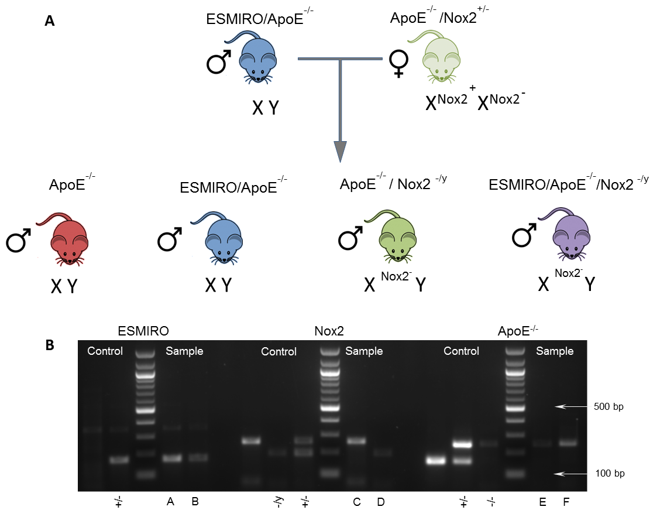
SUPPLEMENTAL FIGURE S1: Breeding and Genotyping Strategy

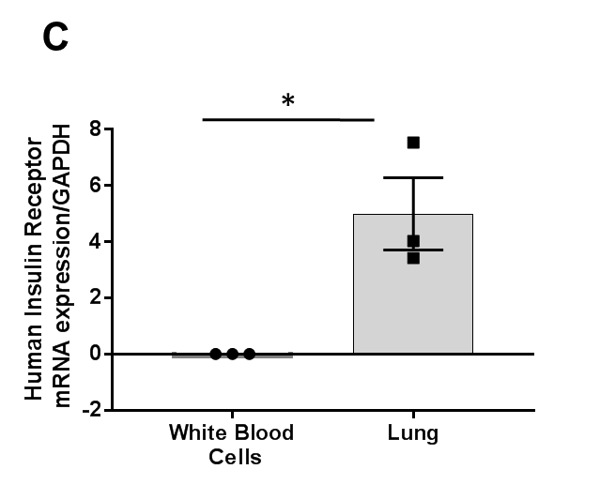

A: Observed male progeny from male ESMIRO/ApoE^{-/-} after mating with female ApoE^{-/-}/Nox2^{+/-}
B: Genotype analysis of PCR products from progeny compare to established control animals: A-ESMIRO (+/-); B-ESMIRO (+/-); C-Nox2^{+/y}; D-Nox2^{-/y}; E&F-ApoE^{-/-}
C: Tie 2 promoter activity is restricted to (endothelial cells in) the lung with no leakage to white blood cells in ESMIRO/ApoE^{-/-}/Nox2^{-/y} mice (n=3). For primer sequences see Refs 9. * denotes P<0.05,
SUPPLEMENTAL FIGURE S2: Genotyping Protocol

For ApoE:
0.5µl 10µM Common: 5’-GCCTAGCCGAGGGAGAGCCG-3’
0.5µl 10µM Wild type Reverse: 5’-TGTGACTTGGGAGCTCTGCAGC-3’
0.5µl 10µM Mutant Reverse: 5’-GCCGCCCCGACTGCATCT-3’
10µl x2 Bio mix red PCR MasterMix (Bioline BIO25006), 12.5µl water and 1µl extracted DNA. PCR cycle conditions are provided in Table S1. Cycles were run using a Verti 96 well thermo cycler (Applied Biosystems). PCR products were then run on a 1.5% agarose gel for 1 hr at 100 V, with a 100 bp ladder (New England Biolabs N0467S). Expected products sizes; were ApoE ^{+/+} 155 bp, ApoE ^{-/-}245 bp, and ApoE ^{-/+} 155 & 245 bp.

For ESMIRO:
0.5µl 10µM ESMIRO Forward: 5’-TGGCAGCTTTCCCCAACACT -3’
0.5µl 10µM ESMIRO Reverse: 5’-CCGTTCCTCAGGGGTGTCC -3’
10µl x2 Bio mix red PCR MasterMix (Bioline BIO25006), 13µl water and 1µl extracted DNA. PCR cycle conditions are provided in Table S2. Cycles were run using a Verti 96 well thermo cycler (Applied Biosystems). PCR products were then run on a 1.5% agarose gel for 1 hr at 100 V, with a 100 bp ladder (New England Biolabs N0467S). Expected products sizes; were WT no band and ESMIRO 172 bp.

For Nox2:
0.5µl 10µM Common: 5’-AAGAGAAACTCCTCTGCTGTG AA -3’’
0.5µl 10µM Wild type: 5’-CGCACTGGAACCCCTGAGAAAGG -3’’
1µl 10µM Mutant: 5’-GTTCTA ATTCCATCAGAAGCTTAT CG -3’
10µl x2 Bio mix red PCR MasterMix (Bioline BIO25006), 12µl water and 1µl extracted DNA. PCR cycle conditions are provided in Table S3. Cycles were run using a Verti 96 well thermo cycler (Applied Biosystems). PCR products were then run on a 1.5% agarose gel for 1 hr at 100 V, with a 100 bp ladder (New England Biolabs N0467S). Expected products sizes; were Nox2 ^{+/+} 240 bp, Nox2 ^{-/-}195 bp, and Nox2 ^{-/+} 195 & 240 bp.

SUPPLEMENTAL TABLE S1: APOE PCR Protocol

PCR | Temperature (°C) | Time | Cycles
Initial denaturation | 94 | 3 min | 1
Denaturation | 94 | 20 sec
Annealing | 68 | 40 sec | 35
Extension | 72 | 2 min

SUPPLEMENTAL TABLE S2: ESMIRO PCR Protocol
PCR | Temperature (°C) | Time | Cycles
Initial denaturation | 94 | 4 min | 1
Denaturation | 94 | 1 min
Annealing | 60 | 1 min | 32
Extension | 72 | 1 min
Final Extension | 72 | 15 min | 1

SUPPLEMENTAL TABLE S3: Nox PCR Protocol
PCR | Temperature (°C) | Time | Cycles
Initial denaturation | 94 | 5 min | 1
Denaturation | 94 | 30 sec
Annealing | 55 | 30 sec | 35
Extension | 72 | 30 sec
Final Extension | 72 | 7 min | 1
SUPPLEMENTAL TABLE S4: Taqman Probes

Target | Cat. No. (ThermoScientific)
NOX2 | Mm01287743_m1
NOX4 | Mm00479246_m1
Catalase | Mm00437992_m1
SOD | Mm01313000_m1
IL-1β | Mm00434228_m1
TNFα | Mm00443258_m1
CCL2 | Mm00441242_m1
CCR2 | Mm99999051_gH
HPRT | Mm03024075_m1

SUPPLEMENTAL FIGURE S3: Metabolic phenotype of ESMIRO/ApoE^{-/-}/Nox2^{-/y} and ESMIRO/ApoE^{-/-}/Nox2^{+/y} mice
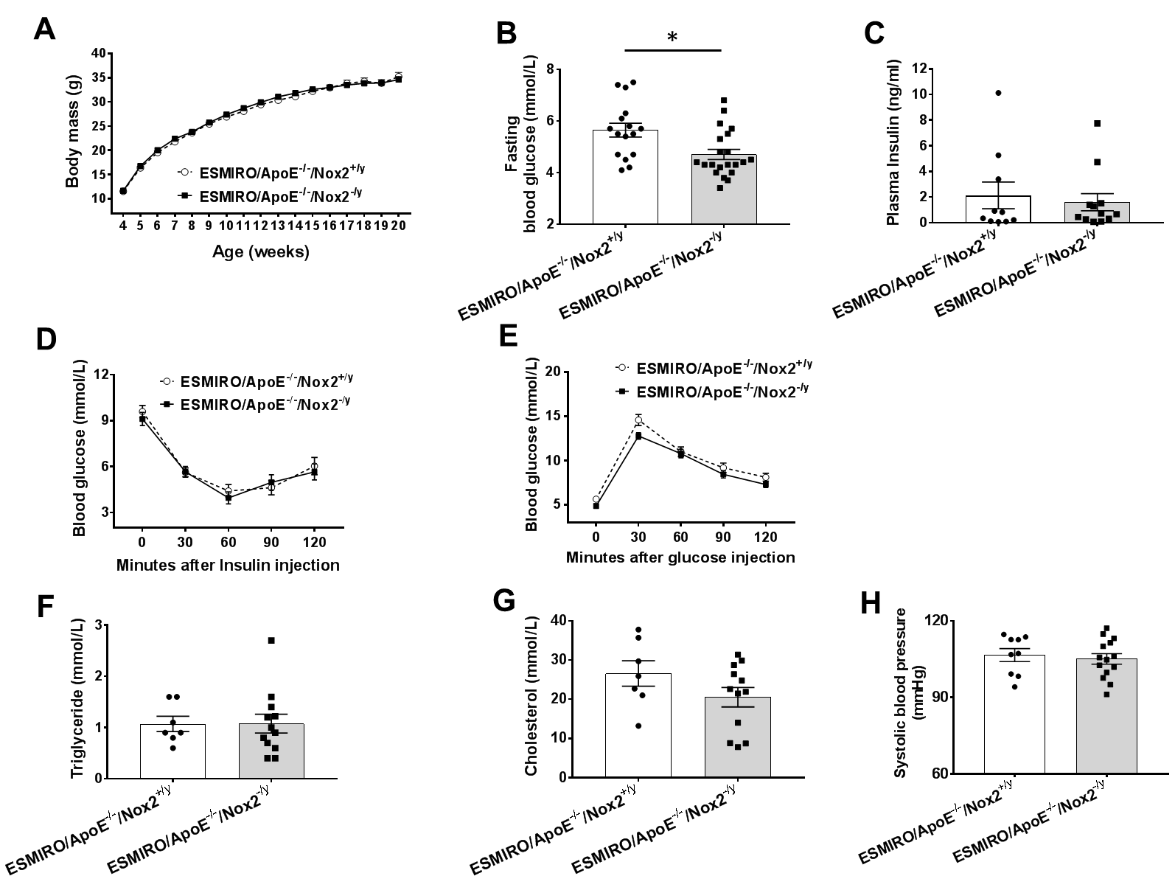

A: No difference in growth when comparing ESMIRO/ApoE^{-/-}/Nox2^{-/y} (n=90) and ESMIRO/ApoE^{-/-}/Nox2^{+/y} mice (n=59), arrow denotes commencement of western diet. B: ESMIRO/ApoE^{-/-}/Nox2^{-/y} mice had lower fasting blood glucose (n=22) than ESMIRO/ApoE-/-/Nox2+/y (n=16). C: No difference in random insulin when comparing ESMIRO/ApoE^{-/-}/Nox2^{-/y} (n=12) and ESMIRO/ApoE^{-/-}/Nox2^{+/y} mice (n=10). D: No difference in intraperitoneal insulin tolerance tests when comparing ESMIRO/ApoE^{-/-}/Nox2^{-/y} (n=23) and ESMIRO/ApoE^{-/-}/Nox2^{+/y} mice (n=13). E: Glucose tolerance was significantly better at 30 min when comparing ESMIRO/ApoE^{-/-}/Nox2^{-/y} (n=22) and ESMIRO/ApoE^{-/-}/Nox2^{+/y} mice (n=16). F: No difference in fasting triglyceride when comparing ESMIRO/ApoE^{-/-}/Nox2_{-/y} (n=12) and ESMIRO/ApoE^{-/-}/Nox2^{+/y} mice (n=7). G: No difference in fasting cholesterol when comparing ESMIRO/ApoE^{-/-}/Nox2^{-/y} (n=12) and ESMIRO/ApoE^{-/-}/Nox2^{+/y} mice (n=7). H: No difference in systolic blood pressure when comparing ESMIRO/ApoE^{-/-}/Nox2^{-/y} (n=14) and ESMIRO/ApoE^{-/-}/Nox2^{+/y} mice (n=9). Data expressed as mean (±SEM), n=number of mice per genotype * denotes P<0.05.
SUPPLEMENTAL FIGURE S4: Elastin fibre fragmentation
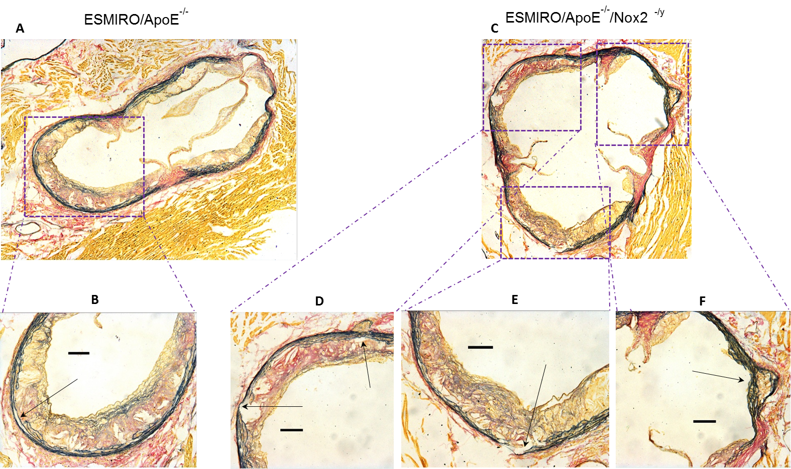
Photomicrographs of aortic sinus from ESMIRO/ApoE^{-/-} (A) and ESMIRO/ApoE^{-/-}/Nox2 ^{-/y} (C) showing elastin fiber fragmentation after 12 weeks Western Diet. Multiple sites of fragmentation of elastic lamina are noted in ESMIRO/ApoE^{-/-}/Nox2 ^{-/y} (high powered views in D, E, F) compared to ESMIRO/ApoE^{-/-} (image B). Scale bar – 100μm
SUPPLEMENTAL FIGURE S5: The effect of genetic ablation or pharma -cological inhibition of Nox2 on Heavy Chain Myosin expression and alpha smooth muscle actin in aortas of mice
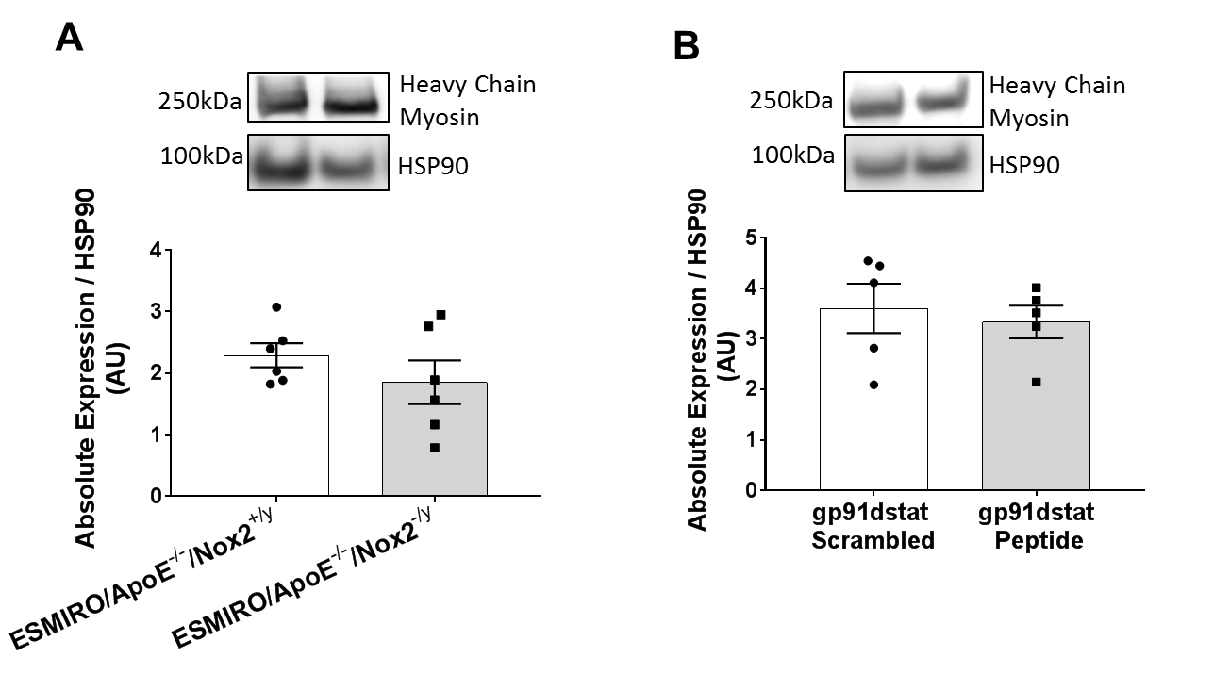
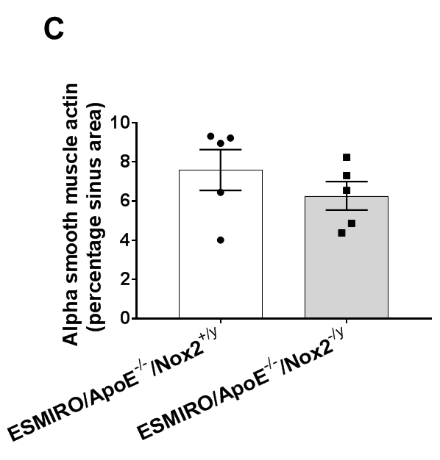

A: No difference in heavy chain myosin expression in the aortas of ESMIRO/ApoE-^{/-}/Nox2^{-/y} (n=6) and ESMIRO/ApoE^{-/-}/Nox2^{+/y} mice (n=6). B: No difference in heavy chain myosin expression in the aortas of ESMIRO/ApoE^{-/-} mice treated with the NOX2 inhibitor, gp91dstat (n=5) compared to ESMIRO/ApoE^{-/-} mice treated with scrambled peptide (n=5). C: No difference in alpha smooth muscle actin expression in the aortic sinus in ESMIRO/ApoE-/-/Nox2-/y (n=5) and ESMIRO/ApoE-/-/Nox2+/y mice (n=5).
SUPPLEMENTAL FIGURE S6: Liver function and lipid deposition in ESMIRO/ApoE^{-/-}/Nox2^{-/y} and ESMIRO/ApoE^{-/-}/Nox2^{+/y} mice

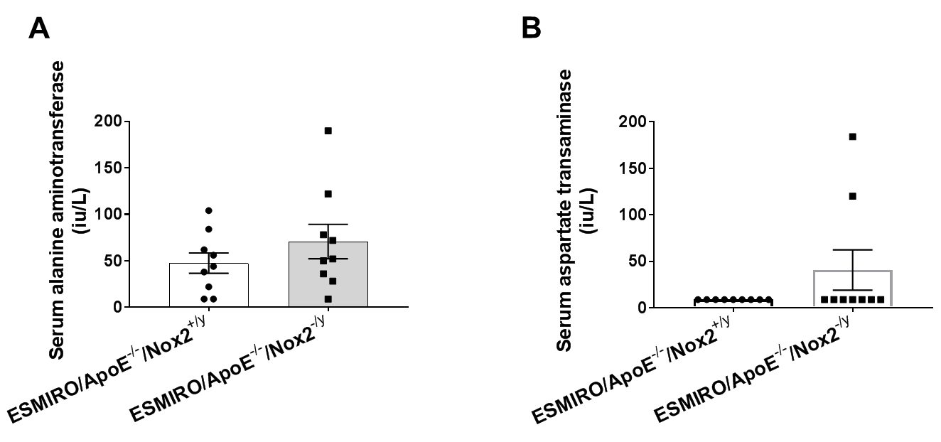

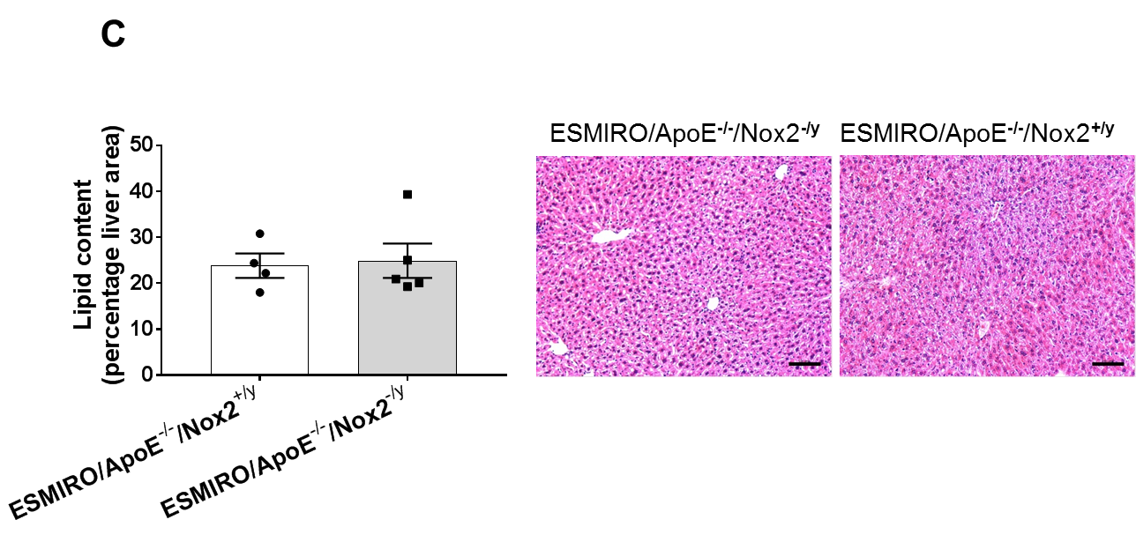

A: No difference in serum alanine aminotransferase (ALT) levels of ESMIRO/ApoE^{-/-}/Nox2^{-/y} (n=9) and ESMIRO/ApoE^{-/-}/Nox2^{+/y} mice (n=9). B: No difference in serum aspartate transaminase (AST) levels of ESMIRO/ApoE^{-/-}/Nox2^{-/y} (n=9) and ESMIRO/ApoE^{-/-}/Nox2^{+/y} mice (n=9). C: No difference in lipid deposition in the liver of ESMIRO/ApoE^{-/-}/Nox2^{-/y} (n=4) and ESMIRO/ApoE^{-/-}/Nox2^{+/y} mice (n=5). Scale bar: 100µm

