Prospective study comparing the outcome of a population-specific adjusted calcium equation to ionised calcium.

Short Title: Population-specific adjusted calcium equation.
Jassam N¹, Selby² P , Allgar V, Barth JH³
¹Department of Clinical Biochemistry, Harrogate Foundation Trust, Harrogate, HG2 7SX, UK
²Department of Endocrinology, Manchester Unversity Hospital, Manchester, M13 9WL, UK
³Department of Clinical Biochemistry, Leeds Teaching Hospitals Trust, Leeds, LS1 3EX, UK

Corresponding Author: Nuthar Jassam
Department of Clinical Biochemistry, Harrogate District Foundation Trust
E-mail: nuthar.jassam@hdft.nhs.uk

Declarations
Competing interests: None
Funding: ionised calcium analyser was loaned by Roche Diagnostics
Ethical approval: approved by the National Research Ethics Committee of Northern Ireland (Ref 17/NI/0010)
Guarantor: Nuthar Jassam
Contributorship: NJ collected and analysed the data. NJ drafted the paper. VA provided statistaical advice. All authors contributed to the content and the final outcome. All authors read and agreed the final manuscript.

Abstract
Calcium circulates bound to albumin and changes in albumin concentration will therefore affect total calcium meansurements. In order to mitigate this, correction factors are frequenly used. The most widely used correction equation was descrinbed by Payne and colleagues in 1973. This equation is derived from well defined hospitalised patients’ data. Current clinical practice is consistent with the general application of the adjusted calcium equation irrespective of clinical setting. This study aims to assess the validity of this approach by the derivation of a primary care specific adjusted calcium equation and the comparison of its performance to a hospitalised patient equation and ionised calcium.
Method: Retrospective data was collected according to Payne’s criteria from an in-patient and primary care setting. Data was used to derive the two equations; the in-patient equation was derived from an in-patient data set and the primary care equation was derived from the community data set. The outcome of these equations was compared to ionised calcium obtained from 123 healthy participants. Ionsed calcium was measured on (ISE) based method on the 9180 Electrolyte Analyser (Roche)
Results: Our data shows that the community specific equation correctly identified the calcium status of 92% of the 123 partipants from the healthy population, whilst the in-patient equation identified 46% only. Regression analysis against ionised calcium showed a higher R² for the community equation than that obtained for the in-patient equation. Furthermore, we have shown that mean albumin and calcium are significantly different between these two populations which is supportive of the use of a population specific equation.
In conclusion, we have evaluated the use of an in-patient equation in the primary care setting. We found that the diagnostic accuracy of the adjusted calcium equation in ambulant patients was improved by the derivation of a population specific equation for the primary care setting.

Background
In clinical practice, the most widely used equations were derived by Payne et al and Orrel , .To date these equations have only been derived using hospitalised patients’ data after excluding patients with diseases that may affect calcium albumin binding such as patients from endocrinology, oncology, haematology, nephrology and those under 18 years. In the absence of a valid equation to report calcium for the community and out-patient clinics, laboratories report adjusted calcium values using a regression equation obtained from in-patient data. We postulate that this may not be a valid practice because the factors that influence calcium binding to albumin are less common in ambulant community patients than acutely sick patients. The evidence suggests that albumin concentrations vary between gender, age and populations , . Reports have described many inherent problems with applying equations to adjust total calcium measurements across different patient groups. For example, the equation derived by Payne et al in 1973, has been found most effective when used on patients with low to normal albumin and total protein concentrations, which is a similar population to the group of patients from which the equation was derived. This finding suggests that the effectiveness of the adjusted calcium equation would be enhanced by deriving an equation for each population. In support of this conclusion, Payne’s original study excluded patients from the renal medicine department. However, Jain et al proved that an equation to adjust calcium derived from haemodialysis patients and applied to them outperformed most of the published equations including Payne’s equation .
The concept of adjusting calcium to albumin equations assumes a constant coefficient of calcium binding to albumin. Besarab and colleagues demonstrated that this rarely true outside the physiological range of albumin in health (albumin 20-50 g/L but see later). They found that the binding constant K_{A} varies significantly with albumin concentrations over the range from 10-90 g/L. In vitro studies confirmed that albumin-bound calcium concentrations vary inversely with albumin concentrations. Moreover, calcium binding is not constant even in the range 30-70 g/L where it shows a trend to decline too. But this trend of decreased calcium to albumin binding where albumin is 30-70g/L was considered insignificant and was assumed to be constant. The increased rate of calcium binding at low albumin was later confirmed by in vivo studies that produced results with a more marked effect at low albumin concentrations leading to a number of hypoalbuminaemic subjects having normal adjusted calcium level despite low ionised calcium . Further support for Besarab’s study came from in vitro studies that have also demonstrated that the binding of calcium to albumin was not saturable at physiological concentrations of either concentrations . The important conclusion from these studies is that protein binding characteristics change with its concentration.
Comparable findings were obtained in several further studies implying that variations in albumin concentration alter protein binding characteristics and are not supportive of the use of a single regression value in different clinical settings and populations ,. Other disagreements with the fixed albumin corrected calcium factor conceptinclude the fact that the binding affinity of albumin for calcium has a considerable intra-individual variation,. We believe the use of a single equation to adjust total calcium results may result in misclassification of a patient’s calcium status and may lead to unnecessary investigations or delay necessary investigations. Therefore, this study examines current practice of general application of a single calcium adjustment equation and postulates that different populations e.g. (hospitalised patients versus ambulant patients) may also generate different regression factors.
In this study, we aim to generate adjusted calcium equation specific to primary care population. This equation will be validated against the gold standard calcium measurement, which is ionised calcium.

Materials and methods

Harrogate adjusted calcium equations: prospective population
This phase of the study was approved by the National Research Ethics Committee of Northern Ireland (Ref 17/NI/0010), Appendix Ia. Healthy volunteers were recruited from among members of staff and visitors to the Harrogate Hospital. The inclusion criteria described a reference individual as:
- Subjectively well.
- Over 18 years. There is no upper age limit.
- Not have been a hospital in-patient nor been subjectively seriously ill during the previous 4 weeks.
- Ideally are not taking any medication but if they are taking medications, these should be recorded (medication, dose and frequency).
- Not have had any alcohol in the previous 24 hours.
- Not smoked in the hour prior to blood sampling.
Ineligible candidates included, pregnant or lactating, known cancer or renal, bone, liver disease patients or artificially fed patients. Participants with unusual or strenuous exercise during the previous days were excluded from participation.

Informed consent and health questionnaire
Poster advertisements were displayed in the clinical areas and electronic invitations were sent to staff within Harrogate hospital. Written and verbal information was presented to the participants explaining the nature of the study and any risks involved in taking part. It was stated that participants can withdraw from the study at any time with no obligation to give the reason for withdrawal.
The participant personally signed and dated the approved version of the informed consent form before blood was collected. Participants were asked to complete a short health questionnaire about their general health. The health questionnaire included demographics data such as date of birth, gender, race and habitual alcohol and tobacco consumption. Details of medical history of disease in any systems and prescribed and over the counter medications were recorded. The blood collections occurred over a 3 month period to ensure the provision of flexible appointments for participants based on their availability. A table was constructed with the date and time of blood collection, ionised calcium measurement and participant’s name and ID number.

Sample collection
Subjects were rested in a seated position for 10 minutes prior to venepuncture. Blood was taken without the use of a tourniquet, when possible, to avoid venous stasis. On some occasions, blood was collected with the use of a tourniquet for a very short time. To minimise venous stasis, a 30 second interval was introduced between the release of the tourniquet and sample collection (McMullan et al., 1990). If a tourniquet was used, it was applied 7-10 cm above the venepuncture site and released within 30 seconds to 1 minute to minimise the effects of venous stasis. Repeated fist pumping was not allowed. A minimum volume of 2.5 mL of heparin and 2 x 5 mL of serum and plasma was collected from each participant. The following blood samples were collected.

- Heparin tube 1 x 2.5 mL for ionised calcium
- Plain tube sufficient to collect 5 mL serum, for total calcium, albumin and vitamin D
- EDTA tube sufficient to collect 5 ml plasma for PTH measurement

The heparinised blood was measured immediately for ionised calcium. The serum sample was allowed to clot at room temperature, and then separated by centrifugation within max 4 hours of venepuncture and the serum stored for a maximum of 24 hours at 4°C until analysis. The following analyses were undertaken; total calcium, albumin, Vitamin D and PTH.

Analytical methods
Blood tubes were allowed to clot at room temperature for 30 minutes and analysed within 4 hours for total calcium, albumin and vitamin D. EDTA samples were analysed for PTH on the day of collection. Total serum calcium, albumin, Vitamin D and PTH concentrations were measured on one of two Roche Cobas 802 in the Blood Sciences Laboratory at Harrogate Hospital. Calcium was measured using a spectrophotometric method “NM-BAPTA”, while albumin was measured using bromocresol green photometric method (BCG). Vitamin D and PTH were measured on immunoassay based methods.

The analytical performance in terms of precision (coefficients of variation) was within acceptable limits defined by this laboratory on either analyser on any of the four analytes and on three levels of internal quality control levels over the period of study (Appendix II). There was no significant bias on External Quality Assurance Scheme during the period of study and bias did not exceed -0.3 % performance limit ±3.5%) for calcium, 2% (performance limit ±5%) for albumin, 10% (performance limit ±25% ) for Vitamin D and -6.4% (performance limit ±15%) for PTH.

Ionised calcium analysis
Ionized calcium was measured by Ion Selective Electrode (ISE) based method on the 9180 Electrolyte Analyser (Roche). All plasma samples were measured within 30 mins from blood collection. Analysis was performed according to the manufacturer’s protocol. The ionised calcium assay performed within acceptable limits defined by the manufacturer in terms of Internal Quality Control (IQC) for the duration of the study. External Quality Assurance (EQA) assessment showed agreement with the overall national mean (appendix III).

Equation derivation
Retrospective biochemical data for calcium equation derivation was extracted from two settings; in-patient and primary care. Primary care extracted data included the following parameters; age (>18 Y), gender, calcium, albumin, ALP, ALT, potassium, creatinine, urea and eGFR. The same above criteria were used for in-patient data extraction with the exception of eGFR.

Data collected excluded patients attending the departments of Endocrinology, Haematology, Nephrology, Oncology or artificially fed patients. Data was collected for a defined period time (2-3 months) to allow the availability of at least 1000 data points per equation with the use of a single set of albumin and calcium per patient. Biochemically, data was further filtered to exclude patients with ALT > 40 iu/L, ALP > URL Creatinine < 200 μmol/L, urea < 15 mmol/L and potassium outside the reference range10 . Primary care setting data, was biochemically filtered according to Payne’s criteria too10 .

Mathematical derivation of calcium adjustment equations
Adjustment equations were derived for each population according to Payne’s described method (Barth et al., 1996). The slope and intercept were obtained from the linear regression plot of total serum calcium on albumin.

The mean total calcium concentration in the population was also calculated using a normal plot histogram. The linearity of albumin regression on calcium was assessed by plotting albumin on calcium using the linear regression. This analysis produced the slope and intercept (non-bound calcium) values. The values for the intercept, slope and mean total calcium were entered into equation 1 for each laboratory and each population.

Equation 1
Adjusted calcium = Total Calcium – (slope x albumin) + (mean total calcium of the population – intercept)…………………………………………………………………………………………1

Equation 1 is mathematically rearranged to give the final format represented in equation …2.

Equation 2
Adjusted Calcium = Total Calcium – (Slope x (Albumin – Constant))…………………………3

This method results in two equations: 1) in-patient equation using hospitalised patients data set and 2) community equation, using primary care patients data set.

Equations validation: comparison to ionised calcium
The Harrogate Hospital in-patient and primary care derived equations are validated by comparing adjusted calcium values from those equations to ionised calcium measurements. For each data set, the respective adjusted calcium equation was applied to total calcium and albumin pairs, to provide adjusted calcium values. To validate the newly derived equations (namely in-patient and primary care equations); the adjusted calcium values obtained from these equations were compared to ionised Ca concentrations that were obtained from the reference population (123 subjects).

Statistical analysis
All data were analysed by a statistical package, Analyse it (Microsoft Excel 2010, version 2.10). A normal probability plot was used to find the constant factor value ((Intercept) which represents the non-protein-bound calcium and to calculate the mean calcium in each population. Linear regression was constructed to derive the regression factor (slope) for each population. The Linear regression model was also used to compare the regression factor R² for the in-patient and community equations. The comparison of adjusted calcium results to ionized calcium was presented using Altman Bland plot and scatter plot. The t-test was used to test the statistical significance between the adjusted calcium mean of the newly derived equation and the routine equation. The Z test was used to test the statistical significance between the albumin and calcium mean from in-patient and primary care populations.

Results

Harrogate equations: perspective population
Ionised calcium study recruited 125 healthy subjects. The age and gender distribution is shown in figure 1. The ethnic distribution of the studied population was 92% white, 4% Asian and 4% of various ethnic groups. 53% of the studied population took no medications. Only 9% and 15% are on vitamin D or multivitamins respectively. The rest of the group, which accounts for a total of 23%, took one or more of antidepressant, HRT, thyroxine, PPI, Ventolin, simvastatin and diuretics.
Figure 1: Flow chart of exclusion process.

Gender | 27 (22%) Male and 97 (78%) female
Age range | 18-69 year old, median 41.3
Exercise in the last 24 hour | 91% no exercise, 8% mild level, 1% strenuous exercise.
Ethnicity | 92% White, 4% Asian and 4% various ethnic groups
Vitamin D status  Sufficient > 60 nmol/L  Insufficient 20-59 nmol/L  Deficient < 20 nmol/L | Sufficient = 66.4%  Insufficient =33%  Deficient =0.8%
PTH (1.6-7.0 pmol/L, Roche Cobas) | 86% within reference interval and 14% within ( 7.3-14.0), median 8 pmol/L
Medication | 9% on Vitamin D, 15% on multivitamins

Table 1: Population characteristics, n=123

Excluded subjects
All participants considered themselves to be healthy at recruitment. No records had missing data, insufficient sample volume or inaccuracy sufficient to warrant exclusion. One subject was excluded due to a heavy strenuous exercise in the last 24 hours before bleeding session. A single subject was regarded as unhealthy and excluded for the following biochemical results: raised PTH, iCa 1.33 (1.18-1.33) (in-house derived reference interval, appendix VI) and total calcium of 2.58mmol/L (2.20-2.60). A referral to endocrinology for possible primary hyperparathyroidism has been arranged.

Community and in-patient equations
Data from Harrogate Hospital has been divided into two main sets; hospitalised patients and community patients. Two calcium equations have been derived one derived for each data setting. Table 2 presents these equations and the criteria that were used to construct each equation. Table 3 presents the mean albumin and calcium of the hospitalised and ambulant populations. The outcome of these equations has been compared to ionised calcium in figure 3 and figure 4.
Equation Name | Calcium Equations | n value
In-Patient Equation | Adjusted Ca=T.Ca- 0.018 ( Alb. - 38.3) | 1141
Community Equation | Adjusted Ca=T.Ca- 0.014 ( Alb. – 44.9) | 6062

Table 2: shows the derived adjusted calcium equations for Harrogate hospitalised patients and community population. Platform: Roche Cobas 702, Calcium method: NM-BAPTA, Albumin method: BCG.
Equation Name | Regressio Coefficient | Intercept | Mean Ca mmol/L | Mean Albumin mmol/L
In-Patient Equation | 0.018 | 1.579 | 2.279  CI ( 2.269-2.289) | 38.7  CI ( 38.3-39.0)
Community Equation | 0.014 | 1.77 | 2.378  CI ( 2.376-2.381) | 44.9  CI ( 44.7-45.1)

Table 3: shows the characteristics of hospitalised versus ambulant patients in terms of albumin and calcium. Calcium mean and albumin means were found significantly different at p< 0.0001.

Validation of the community regression equation against the routine equation
In order to validate the newly derived adjusted calcium for the community population, we first applied the routine in-patient equation and the community specific equation to the data set obtained from 123 healthy subjects. We then used the t-test to compare the difference in the mean of adjusted calcium produced by these equations. Our data showed a significant difference between the two population means with a mean difference of - 0.156 mmol/L, 95% CI of ( -0.1586 to -0.1539, p< 0.0001). The adjusted calcium community equation mean of 2.33 mmol/L was higher than the mean from the routine in-patient equation (mean of 2.177 mmol/L). This difference of - 0.156 mmol or (7.6%) is both a statistically and clinically significant difference as it exceeds the allowable difference of 5% or 0.1 mmol/L for this laboratory or the minimal allowable error of 4.6% as set by the biological variation model .
Similar to the t-test finding, Deming Fit analysis for the adjusted calcium values of the two equations showed that the routine in-patient equations underestimated calcium status by 0.160 mmo/L in comparison to the community specific equation. This finding agrees well with the calcium mean analysis and the difference in adjusted calcium values obtained from these equations exceeds the allowable limits for calcium, which suggests that these equations are distinctively different equations.

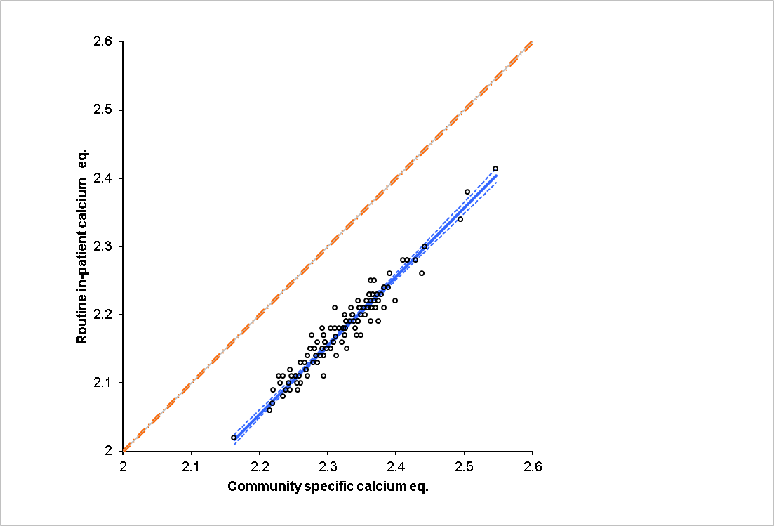
y=1.01x-0.16

Figure 2: Deeming Fit shows a comparison between the adjusted calcium values for 123 healthy subjects obtained from the in-patient equation and the community equation.

Validation of the community regression equation with ionised calcium
Paired samples for ionised calcium and total calcium were analysed for 123 healthy subjects. The routine in-patient equation and the community specific equation have been applied to the data set obtained from 123 healthy individuals. The comparison between adjusted calcium that was calculated using the the routine in-patient equation and ionised calcium is as follows:
Adjusted calcium = 1.292 + (0.7181 x Ionised Calcium), R²= 0.20
Intercept = 1.292 95%CI ( 0.983 to 1.601, p< 0.0001)
Slope= 0.7181 95%CI ( 0.4679 to 0.9683, p < 0.0001)

The comparison between the newly derived adjusted calcium equation for the community population and ionised calcium is as follow:
Adjusted calcium = 1.361 + (0.7887 x Ionised Calcium), R²= 0.26
Intercept= 1.361 95%CI ( 1.065 to 1.658, p<0.0001)
Slope = 0.7887 95%CI ( 0.5483 to 1.0291, p<0.0001)
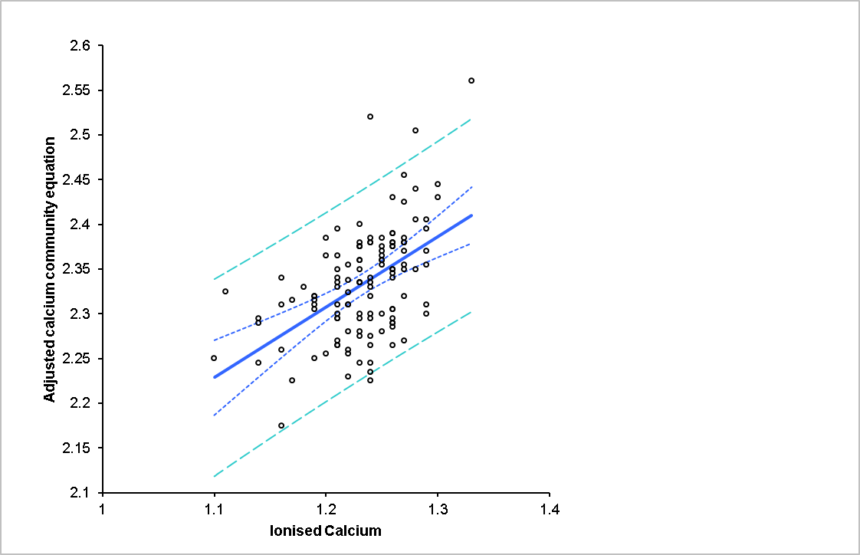
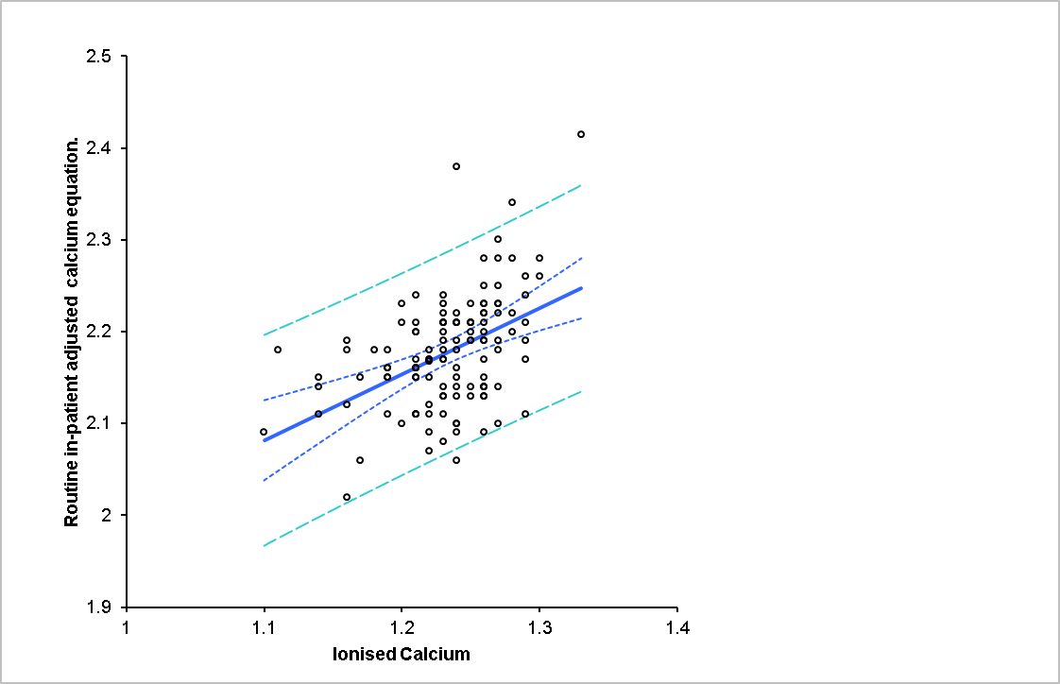
Figure 3: shows comparison of measured ionised calcium and adjusted calcium equation in 123 healthy subjects.(A) using the routine in-patient adjusted calcium equation. (B) using the newly derived community equation.

Calcium status was classified as hypo/hypercalcaemia according to the reference intervals of 1.18-1.33 for ionised calcium and 2.2-2.6 (Pathology Harmony)for adjusted calcium and total calcium. Using ionised calcium as a gold standard, the number of patients in whom calcium status was correctly predicted using the routine in-patient adjusted equation was 56/123 (46%), by the community specific equation was 113/123 (92%) and by total calcium was 112/123 (91%). However, our data shows that adjusted calcium by the routine in-patient equation underestimated calcium in healthy individuals. Our data shows that the use of the in-patient adjusted calcium equation which was derived using Payne’s exclusion criteria significantly misclassifies calcium in healthy subjects. On the contrary, the newly derived community equation, which was also derived using Payne’s exclusion criteria compares well with ionised calcium.

Discussion
At present, adjusted calcium measurements are reported on all patients whether they are hospitalised, out patientsor in primary care settings using equations that have been derived from hospitalised patients data. We postulated that this practice may cause misclassification of calcium status in non-hospitalised patients. In this study, we have evaluated the use of a routine in-patient adjusted calcium in the primary care setting. A locally derived adjusted calcium equation specific to the community population was calculated. We validated the newly derived equation against ionised calcium results obtained from 123 healthy subjects that participated in this study.

The adjusted calcium community specific equation correlated well with ionised calcium and predicted the correct calcium status in 92% of the 123 healthy individuals. On the other hand the routine in-patient equation performed poorly and only correctly predicted calcium status of less than 50% of the healthy participants. Furthermore, Altman–Bland analysis (not shown) for the adjusted calcium from the routine in-patient equation and the community equation showed that the routine in-patient equation produced lower adjusted calcium results (with an average of -0.156%) compared to the community specific equation. These findings suggest that the application of a single regression equation to different clinical settings may result in missclassifying calcium status in these settings. We present an argument against the general application of a single regression equation in different clinical settings and populations.
Albumin regression on calcium is a mathematically derived factor which depends on a number of variables related to albumin, calcium and the environment where the binding occurs. Affinity studies showed that albumin-calcium binding is known to vary widely between individuals and this variation is wider in severely diseased populations than in healthy populations,, . This variation in albumin binding affinity is mathematically translated to a wide regression variation16 . One can conclude that regression variation would only be larger within diseased individuals due to the presence of disturbed metabolic processes which may alter albumin affinity and presence of drugs that may compete with calcium on albumin binding sites17,, .

Binding capacity is another factor that affects the albumin calcium binding relationship. In fact Pedersen ( 1971) showed that the binding constant depends on the concentration of both albumin and calcium. Further evidence indicated that albumin concentrations in recumbent patients are lower than that seen in supine patients (Humphrey et al., 1977). In agreement with Orrell 2, our data showed that mean albumin and calcium concentrations in hospitalised patients were significantly lower (p <0.0001) than in primary care populations ( table 3). Indeed, albumin is an acute phase protein is lower in acutely ill patients than in ambulant patients. A recent study in primary care showed that mean albumin concentration on ambulant patients reaches a peak at the age of 20 years and this declines with old age3.As our data collection criteria excluded all those under 18 years old in both clinical settings, the proportion of patients with old age would certainly be higher in the hospital data set and thus contribute to a lower albumin mean in this population. Whilst calcium disorders are prevalent in both hospital and primary care settings; hypocalcaemia of acute severe illness is well documented and thus contributes, among many other causes to a lower calcium mean in hospitalised patients .

The argument presented above renders the use of a single equation derived from hospitalised patients and applied to ambulant patients as questionable. The difference in mean calcium and albumin also suggests that hospitalised patients and primary care patients are two distinct populations. In support of this point, a previous study that evaluated the use of an adult adjusted equation in neonates and children, also concluded that the significant difference in albumin mean between these age groups invalidated the use of an adult adjusted calcium equation in neonates and children4 .

To highlight the different characteristics of these two populations, these populations can be described as follows; the hospitalised population consists of a group of supine, severely ill patients with probably a higher mean of age than the primary care population. The primary care population on the other hand consists of ambulant, chronically ill patients, those who are attending for health screening and a group of young population with short and minor episodes of illnesses. One can conclude that these are two populations with different calcium albumin binding characterstics and concentrations, therefore different regression equations would rise from those distinctively different populations.
The literature presents compelling evidence supporting the concept of a population specific equation. Ladenson et al (1978) compared 13 published equations versus ionised calcium, and he noted some improvement in calcium classification when an algorithm was derived from their own data. More recently Jain et al (2008) also produced a population specific equation from end-stage renal patients on haemodialysis that out-performed Payne’s calcium equation. Ferrari and colleagues proved that the inclusion of phosphate in the regression equation improved Payne’s equation’s diagnostic accuracy. It is not known however, if the main reason for equation performance improvement was the addition of phosphate to the regression or the application of an equation to the population that it was derived from. On the contrary, another research group presented a similar concept but could not confirm that the addition of phosphate improved the adjusted calcium equation in renal failure patients .

In the healthy individuals we found that total calcium was superior to the routine in-patient adjusted equation and predicted the correct calcium status in 91% of healthy subjects. This finding is not surprising, because the concept of albumin adjusted calcium was introduced to counteract the hypoalbuminaemia effect in the diseased population and this population consisted of healthy subjects. However, in disgreement with the critics of adjusted calcium practice, total calcium completely failed to pick out those with hypocalcaemia or hypercalcaemia in the studied healthy participants.

Calcium is one of the most frequently requested biochemical tests. In primary care, calcium requests by primary care physicians ranged from 46.2 - 526.3 per 1000 practice population (The NHS Atlas of Variation, 2013). An American study demonstrated that a change in calcium concentration as small as 0.025 to 0.125 mmol in either direction, would increase the cost of health care $8-89 per patient due to the increase in number of biochemical and non-biochemical follow up tests requested and drug prescription In this study we found the mean calcium difference between the in-patient equation and community specific equation was 0.156 mmol/L. Therefore, our findings are of clinical and financial importance because enhancing the diagnostic accuracy of the adjusted calcium equation by using a population specific calcium equation has the potential impact of saving health care resources.

Our regression analysis of adjusted calcium equations gave low R² regression factors of 0.2 and 0.26 for in-patient and community specific adjusted calcium equations respectively. It is worth mentioning that low R² value, but with a good residual plot, can still be indicative of a good regression model . In support of that, the small change in R² value from 0.2 to 0.26 with the introduction of the population specific equation resulted in improving the prediction of the correct calcium status from 46% (in-patient equation) to 92% (community equation).

To our knowledge this is the first study that derived and validated an equation specific for ambulant patients. The strength of our findings stems from comparing the newly derived community equation outcome to ionised calcium, which is considered the gold standard for calcium measurement. However, some limitations of this study should be mentioned.

We have previously shown that different analytical platforms produce different regression equations10. This implies that the validated community adjusted calcium equation could only be relevant to a Roche Cobas analytical platform, NM-BAPTA calcium method and BCG albumin method. The process of replicating this work on all commercially available analytical platforms and to account for different methodologies of albumin and calcium would require at least the participation of 12-18 laboratories to cover all the combinations of commercially available calcium and albumin methods. It is therefore, from a resources point of view that such an exercise is out of the scope of this study. Therefore, future studies comparing the impact of community specific equations to routine in-patient equations for different analytical platforms are needed.

Conclusion:
We have evaluated the use of an in-patient equation in the primary care setting. We have shown that mean albumin and calcium are significantly diffierent between these two populations which is supportive of the use of a population specific equation. The literature reports a plethora of attempts to improve the diagnostic accuracy of calcium. This work is an addition to all previous efforts in this field. We found that the diagnostic accuracy of the adjusted calcium equation was improved by the derivation of a population specific equation. We believe the new practice would lead to saving health care resources.

References

Payne, RB. Little, AJ. Williams, RB. et al.Interpretation of Serum Calcium in Patients with Abnormal Serum Proteins. BMJ 1973; 4: 643.
Orrell DH, Albumin as an aid to the interpretation of serum calcium. Clin Chim Acta 1971;35: 483-9.
Weaving G, Batstone G, Jones RG. Age and sex variation in serum albumin concentration: an observational study Ann Clin Biochem 2016;53: 106-111.
Jassam N, Gopaul S, McShane P,et al Calcium adjustment equations in neonates and children. Ann Clin Biochem 2011;49:352-358.
Ladenson JH, Lewis JW, Boyd JC. Failure of total calcium corrected for protein, albumin, and pH to correctly assess free calcium status. J Clin Endocrinol Metab 1978;46: 986-93.
Jain A, Bhayana S, Vlasschaert M, et al. A formula to predict corrected calcium in haemodialysis patients. Nephrol Dial Transplant 2008; 23:2884-2888.
Besarab A, DeGuzman A, Swanson JW. Effect of albumin and free calcium concentrations on calcium binding in vitro. J Clin Pathol 1981;34:1361-7.
Besarab A, Caro JF. Increased absolute calcium binding to albumin in hypoalbuminaemia. J Clin Pathol 1981;34: 1368-74.
Carr CW. Studies on binding of small ions in protein solutions with the use of membrane electrodes. II. The binding of calcium ions in solutions of bovine serum albumin. Arch Biochem Biophys 1953;43:147-56.
Barth JH, Fiddy JB, Payne RB. Adjustment of serum total calcium for albumin concentration: effects of non-linearity and regression differences between laboratories. Ann Clin Biochem 1996;33:55-58.
Sorva A, Elfving P, Pohja A, Assessment of calcaemic status in geriatric hospital patients: serum ionised calcium versus albumin-adjusted total calcium. Scand J Lab Invest 1988;48: 489-94.
Larsson L, Magnusson P. Ionized Calcium or Corrected Total Calcium? J Bone Miner Res 2003;18:1554-5.
PhillipsPJ, Pain RW, Hartley TF, et al. Current "corrected" calcium concept rechallenged. Clin Chem1977; 23:1938-9.
Westgards, J. Biological Variation database. [Online]. Available from: https://www.westgard.com/minimum-biodatabase1.htm ( 2014 update). [ Accessed 4/1/2019]
Berg, J. The UK Pathology Harmony initiative; The foundation of a global model. Clin Chim Acta 2014;432:22-6.
Zaloga GP, Willey S, Tomasic P, et al. Free fatty acids alter calcium binding: a cause for misinterpretation of serum calcium values and hypocalcemia in critical illness. J Clin Endocrinol Metab 1987;64:1010-4.
Ryan GD, Masarei RL.Validity of corrected calcium values. Clin Chim Acta 1979;91: 329-35.
Martin NH, Perkins DJ, The calcium binding of human serum albumin in health and disease. Biochem J 1953; 54:642-5.
Dickerson RN, Alexander KH, Minard G, et al Accuracy of methods to estimate ionized and ‘corrected’ serum calcium concentrations in critically ill multiple trauma patients receiving specialized nutrition support. Journal of Parenteral & Enteral Nutrition 2004;28: 133-14.
Slomp J, Van der Voort PH, Gerritsen RT. Albumin-adjusted calcium is not suitable for diagnosis of hyper- and hypocalcemia in the critically ill. Crit Care Med 2003;31:1389-93.
Pedersen KO. Binding of Calcium to Serum Albumin I. Stoichiometry and Intrinsic Association Constant at Physiological pH, Ionic Strength, and Temperature. Scand J Clin Lab Invest 1971;28:459-69.
Hannan FM, & Thakker RV . Investigating hypocalcaemia. BMJ 2013 (Clinical research ed.), 346, f2213. doi:10.1136/bmj.f2213.
Ladenson JH, Lewis JW, Boyd JC. Failure of total calcium corrected for protein, albumin, and pH to correctly assess free calcium status. J Clin Endocrinol Metab.1978;46:986-93.
Ferrari P, Singer R, Agarwal A, et al. Serum phosphate is an important determinant of corrected serum calcium in end-stage kidney disease. Nephrology 2009;14:383-388.
Lian IA, Åsberg A. Should total calcium be adjusted for albumin? A retrospective observational study of laboratory data from central Norway. BMJ Open 2018 [Online] Available from: https://bmjopen.bmj.com/content/bmjopen/8/4/e017703.full.pdf. (Accessed 7/12/2018)
National Institute of Standards and Technology (NIST) The Impact of Calibration Error in Medical Decision Making.2004 [Online] available from: https://www.nist.gov/sites/default/files/documents/director/planning/Measurement_Infrastr_Roles_Impacts_v3.pdf : [Accessed on 23/01/2019].
Jim Frost . regression analysis; an intuitive guide for using and interpreting linear models. Avaialble from online https://statisticsbyjim.com/regression/interpret-r-squared-regression/ http://www.statsoft.com/Textbook/Multiple-Regression#cresidual

