Short Report

Supporting Families with Children with Special Educational Needs and Disabilities During COVID-19

Short Title: COVID-19 and SEND

Umar Toseeb¹, PhD., Kathryn Asbury¹, PhD., Aimee Code¹, MSc., Laura Fox¹, MSc., Emre Deniz¹, MSc.

¹Department of Education, University of York, York YO10 5DD, UK

Acknowledgements:
This work was part funded by Wellcome (Reference:204829) through the Centre for Future Health at the University of York.

Correspondence regarding this article should be addressed to Dr Umar Toseeb, Department of Education, University of York, York YO10 5DD, UK, Telephone 01904 323405, Email: umar.toseeb@york.ac.uk

Financial Disclosure: The authors have no financial relationships relevant to this article to disclose.

Potential Conflicts of Interest: The authors have no conflicts of interest relevant to this article to disclose

Data Sharing Statement: Deidentified individual participant data will not be made available at this stage due to ongoing data collection but will be made available once data collection is complete.

Abbreviations:
ASCs – Autism Spectrum Conditions
CAMHS – Child and Adolescent Mental Health Services
COVID-19 – Coronavirus Disease 2019
EHCP – Education, Health, and Care Plan
SEND – Special Educational Needs and Disabilities

Abstract
The COVID-19 pandemic has had a huge impact on how people go about their day to day life. The sudden change, along with necessary measures such as self-isolation and social distancing has been particularly challenging for children with special educational needs and disabilities (SENDs) and their families, given their reliance on many on carefully established routines and relationships as well as professional and informal support. Three hundred and thirty nine parents of children with SENDs (the majority with Autism Spectrum Conditions) completed an online survey during the first two months of the social distancing in the UK (23rd March 2020 - 22nd May 2020). Parents provided detailed accounts of their family’s needs both to support their child during lockdown and to transition back to school. Many of these support needs during lockdown were either unique to families of children with SENDs or represented a more profound challenge than in most neurotypical families. There were considerable differences in satisfaction with support during COVID-19 suggesting wide variation in support provided to families of children with SENDs. The findings also suggest that educators and policy makers should place the implementation of clear routines and targeted mental health support at the centre of any strategy designed to support children with SENDs in making the transition back to school. The study provides preliminary insights into parental perspectives on support during the COVID-19 pandemic for families with children with SENDs.

Keywords: Special Educational Needs, Disability, COVID-19, Parents, Support

Lay Summary
- Many families with children with special educational needs and disabilities (SENDs) had a wide variety of unmet support needs during the initial phase of the COVID-19 lockdown in the UK.
- There was considerable variation in parental satisfaction with support for their child with SENDs, suggesting a substantial inequality in support.
- Strategies to help children with SENDs to transition back to school should focus on implementing routines and targeted mental health support.
Introduction
On Friday 20th March 2020, schools in the UK closed to all pupils other than the children of key workers and some vulnerable children, including some with Special Educational Needs and Disabilities (SENDs). These partial school closures represented an attempt to slow down the spread of COVID-19 and similar measures have been taken in countries around the world (The World Bank, 2020). On 24th May, just over two months later, the UK Prime Minister announced that schools in England should commence a phased re-opening for some year groups from 1st June for primary schools and 15th June for secondary schools. The current study asked parents/carers about the support that their children with SENDs have needed and continue to need while not accessing school, and about the support they will need in order to successfully make the transition back.
The sudden switch to remote education in late March 2020, together with measures such as self-isolation and social distancing, presented particular challenges for children with SENDs and their families. Some children with SENDs, such as Autism Spectrum Conditions (ASCs), may be highly reliant on carefully established routines and relationships and may experience acute anxiety when these are disrupted (American Psychiatric Association, 2013; Factor, Condy, Farley, & Scarpa, 2016; van Steensel & Heeman, 2017). Others, for example children with complex physical needs, may depend on access to equipment and professional support that is only available in school. There are good reasons, therefore, to expect that partial school closures, and lockdown, could affect children with SENDs more severely than most neurotypical children. Even though some children with SENDs were allowed to attend school from the start of lockdown many parents were reluctant to send them because of the risk of infection.
Educating a child with SENDs at home represents a different challenge to educating a neurotypical child. The impact of home schooling is likely to be felt particularly keenly by the parents of children with SENDs who were suddenly required to meet their child’s needs all day and every day, without the usual support. Families of children with SENDs are known to face more stressors, on average, than those with neurotypical children, even in normal times (McConnell & Savage, 2015; McStay, Trembath, & Dissanayake, 2014). One initial study during COVID-19 found that many parents of children with SENDs reported that the changes they experienced when schools were closed had a negative effect on their own mental health as well as that of their child (Asbury, Fox, Deniz, Code, & Toseeb, 2020). As home education is likely to continue for many children until at least September 2020, it is important to listen to the needs of this community and to offer support that is both timely and useful.
Beyond lockdown, it is important to understand the support needs of pupils preparing to return to school, some of them in the very near future. While it is clear that adjusting to life without the usual school routine presented a major challenge for children and young people with SENDs and their families, it seems equally clear that returning to school - which may look very different due to social distancing requirements and other COVID-19 adaptations - is also likely to be challenging and that the challenges are likely to be different, or more pronounced, for those with SENDs than for most of their neurotypical peers.
It is clearly important that children and young people with SENDs are supported during COVID-19 school closures, and in the transition back to school. However, the best way of achieving this is somewhat unclear. This is partly the result of there being very limited research available on home educating children with SENDs (Kidd & Kaczmarek, 2010; Maxwell, Doughty, Slater, Forrester, & Rhodes, 2018) but, even if this were not the case, the current situation is different to any that has been seen before. This study therefore aimed to answer three research questions: How do parents of children with SENDs in the UK want to be supported during the COVID-19 pandemic? (Research Question 1); How do parents of children with SENDs rate the level of support they have received during the COVID-19 pandemic? (Research Question 2); What are parents’ views on how their children with SENDs can be supported to successfully transition back to school? (Research Question 3).
Methods
The study was approved by the Department of Education Ethics Committee, University of York (Reference 20/05).
Three hundred and thirty nine parents of children with SENDs were recruited via existing research networks, email invitations sent via non-mainstream schools, and online platforms to complete online questionnaires between 22nd March and 22nd May 2020 (see Figure 1 for further details). Parents with more than one child with SENDs were asked to focus on just one child.
[Figure 1]
The sample demographics were as follows:
- Respondents: 91% were mothers, 96% from England (remainder from Northern Ireland, Scotland, and Wales), 58% had a pre-tax household income of less than £40,000 (approximate UK median income).
- Child: mean age 10 years (range 5 to 18 years), 68% boys, 41% in mainstream schools, 73% with an EHCP, 89% White British (remainder: 6% Mixed, 3% Asian, 3% other). The different types of SENDs represented in the sample are shown in Table 1. 81% of the sample reported an Autistic Spectrum Condition (ASC).
[Table 1 Here]
As part of a wider project on the impact of COVID-19 on children with SENDs and their families, parents were asked the following questions:
- What support would be helpful for you and your child during the Coronavirus outbreak? (Research Question 1)
- To what extent has the support you have received since the start of the lockdown been adequate to meet your child's needs? (extremely inadequate, somewhat inadequate, neither adequate or inadequate, somewhat adequate, extremely adequate). (Research Question 2)
- What support will your child need to successfully transition back into school? (Research Question 3)
Responses to the two open questions (Q1 & Q3) were coded using content analysis (Bryman, 2012; Krippendoorf, 2018). One researcher coded the entire dataset and a second rated every 10th response (10% of the dataset) in an attempt to ensure intercoder reliability. Disagreements were resolved during discussion. For the closed question (Q2), descriptive statistics were calculated.
Results and Discussion
Support Needs During Lockdown
The ten most frequent types of support mentioned by parents are shown in Table 2 (most frequent first). This does not include parents who needed support but were unsure about what kind of support they would like (n=46, 14%) or those who were happy with the support that they were receiving (n=42, 13%). The types of support mentioned by parents varied considerably, which is not surprising given the diverse range of conditions covered under the umbrella term SENDs.
[Table 2 Here]
The nature and extent of support required by parents of children with SENDs appears to be much greater than for parents of neurotypical children, although the current study did not directly compare the two groups. For example, whilst it is likely that all children are at risk of experiencing mental health difficulties during COVID-19, children with SENDs are more likely to have pre-existing mental health conditions that have been exacerbated by the sudden change in routine (a known trigger for many in this population), and are therefore likely to require rapid and more targeted support (van Steensel & Heeman, 2017). Similarly, while all parents are likely to be concerned about their ability to home school their children this concern is likely to be more profound for parents of children with complex educational support needs that are usually met by a team of educational professionals with considerable training. The study sample did not include parents of children without SENDs but the data presented here suggest that the needs identified are either unique to families of children with SENDs, or that they represent a more profound challenge than in most neurotypical families.
Parents of children with SENDs provided detailed descriptions of their families’ support needs during lockdown. The summary presented in Table 2, suggested by parents themselves, is intended to inform policies around how families with SENDs can be supported in future lockdowns or indeed to support those parents who wish to continue to home school their child. For example, our data suggest that setting up a remote professional advice service for the parents/carers of children with SENDs would be welcomed by some families, along with ensuring that children have access to education that is tailored to their needs and delivered by individuals that they recognise.
Parental Perspectives on Support Provided During Lockdown
There were considerable differences among parents of children with SENDs in how supported they have felt during COVID-19 to date. As shown in Figure 2, less than half of parents (40%) reported that the level of support they have received has been adequate to meet their child’s needs. A comparable proportion (37%) rated the support they received as inadequate and the remaining minority (22%) rated the support as neither adequate or inadequate. These statistics highlight the wide variation in support provided to families during COVID-19 and compliment the responses to the open question about differences in support needs (Research Question 1). Data from the current study do not allow for a direct comparison to pre-COVID-19 support but they do suggest a substantial inequality in support for families of children with SENDs.
[Figure 2 Here]
Support Needs For Transitioning Back to School
Parents are uniquely placed to understand the individual needs of their child and how they can be supported in making the transition back to school. The ten most frequent transition needs reported by parents are summarised in Table 3 (most frequent first). This does not include parents who were unsure about what kind of transition support their child would need (n=15, 9%) or those who were happy with the support they were receiving (n=27, 17%). As with the responses to the question about support needs during lockdown, there was considerable variation reflecting the diverse range of needs in the SEND population.
[Table 3 Here]
The transition support needs mentioned by parents were very specific to children with SENDs. For example, routines are key to children with ASCs, the vast majority of the study sample. This is reflected in the transition needs mentioned by parents. Parents reported the view that re-establishing previous routines, developing new routines, and using visual aids to help establish routines will be pivotal to successful transitions back to school for some children with SENDs. Similarly, given the high levels of mental health difficulties in samples of children with SENDs, many of the transition support suggestions identified reflected the need to address these difficulties (e.g. emotional support, phased return, familiar faces, and less pressure/more understanding). The data suggest that educators and policy makers should place the implementation of clear routines and targeted mental health support at the centre of any strategy designed to support children with SENDs in making the transition back to school.
Conclusions
The findings shed new light on the support needs of families during the COVID-19 lockdown and in making a successful transition back to school. Many of the findings presented here are intuitive to those who work with families with SENDs. The only real surprise is the extent of support need disparity represented in the sample. It should be borne in mind that the sample recruited here may not represent families with the most severe needs. Those who were the most overwhelmed may not have been able to spare 10-15 minutes during the current crisis to complete an online questionnaire. Larger studies with a more proportionate representation of the various types of SENDs are needed as we move forward. In summary, this is the first study to provide initial insights into the support needs of families with a child with SENDs during the COVID-19 pandemic and offers initial suggestions about how these needs might be best met.

References
American Psychiatric Association. (2013). Diagnostic and statistical manual of mental disorders (5th edition). Arlington, VA: American Psychiatric Publishing.
Asbury, K., Fox, L., Deniz, E., Code, A., & Toseeb, U. (2020). How is COVID-19 affecting the mental health of children with Special Educational Needs and Disabilities and their families? PsyArXiv Preprints. doi:https://doi.org/10.31234/osf.io/sevyd
Bank, T. W. (2020). World Bank Education and COVID-19. Retrieved from https://www.worldbank.org/en/data/interactive/2020/03/24/world-bank-education-and-covid-19
Bryman, A. (2012). Social Research Methods (Fourth ed.). Oxford, UK: Oxford University Press.
Factor, R. S., Condy, E. E., Farley, J. P., & Scarpa, A. (2016). Brief report: insistence on sameness, anxiety, and social motivation in children with autism spectrum disorder. Journal of Autism and Devevelopmental Disorders, 46(7), 2548-2554. doi:10.1007/s10803-016-2781-x
Kidd, T., & Kaczmarek, E. (2010). The experiences of mothers home educating their children with autism spectrum disorder. Issues in Educational Research, 20(3), 18.
Krippendoorf, K. (2018). Content Analysis: An Introduction to Its Methodology (Fourth Edition ed.). London: UK: Sage Publishing.
Maxwell, N., Doughty, J., Slater, T., Forrester, D., & Rhodes, K. (2018). Home education for children with additional learning needs – a better choice or the only option? Educational Review, 1-16. doi:10.1080/00131911.2018.1532955
McConnell, D., & Savage, A. (2015). Stress and Resilience Among Families Caring for Children with Intellectual Disability: Expanding the Research Agenda. Current Developmental Disorders Reports, 2(2), 100-109. doi:10.1007/s40474-015-0040-z
McStay, R. L., Trembath, D., & Dissanayake, C. (2014). Stress and family quality of life in parents of children with autism spectrum disorder: parent gender and the double ABCX model. Journal of Autism and Developmental Disorders, 44(12), 3101-3118. doi:10.1007/s10803-014-2178-7
van Steensel, F. J. A., & Heeman, E. J. (2017). Anxiety Levels in Children with Autism Spectrum Disorder: A Meta-Analysis. J Child Fam Stud, 26(7), 1753-1767. doi:10.1007/s10826-017-0687-7

Table 1. Type of Special Educational Need and Disabilities Reported by Parent
Type of SEND | Overall N (%)
Autism Spectrum Conditions | 274 (81%)
Attention Deficit Hyperactivity Disorder | 73 (22%)
Attention Deficit Disorder | 26 (8%)
Developmental Coordination Disorder | 32 (9%)
Developmental Language Disorder | 59 (17%)
Dyslexia | 38 (11%)
Dyscalculia | 12 (4%)
Global Developmental Delay | 16 (5%)
Physical Disability | 30 (9%)
Sensory Processing Disorder | 12 (4%)
Speech Disorder or Impediment | 44 (36%
Social, Emotional, and Mental Health Difficulties | 123 (36%)
Visual Impairments | 17 (5%)
Otherª | 69 (20%)
Note. Parents were asked to select all that applied to their child from a list. ªTable only includes types of special educational needs and disabilities that were endorsed by >10 parents. The remainder were included in the other category, which includes dyscalculia, dyspraxia, Down’s syndrome, epilepsy, hearing impairment, and moderate learning difficulties.

Table 2. Summary of Support Needs during Lockdown
Type of Support | Support Description
1. Specialist professional advice for parent (n=45, 14%) | Specialist professional advice from special educational needs coordinators and teaching staff (and others). The support mentioned was to offer parents some reassurance, provide specific advice about the child's needs, or to help implement the new routine. E.g. “to be able to touch base with help from [specialist professionals]”.
2. Advice or support focussed on child’s mental health and wellbeing (n=36, 11%) | Specific advice or support relating to their child’s mental health and wellbeing keeping in mind their child’s special educational needs and disabilities (as opposed to generic advice on children’s mental health). E.g. “advice to stop existing mental health issues from getting worse during [the] crisis” and “help with anxiety and ways to cope with melt down in this situation”.
3. Appropriate educational activities set by school (and other sources) (n=33, 10%) | Educational activities that are being set for their child to be appropriate keeping in mind their child’s needs and existing support plans. E.g. “[child] is mainly just being sent general tasks which are beyond her level”.
4. Child to see familiar faces (n=26, 8%). | Child to see some familiar faces to help bring some alignment to previous routines. E.g. “teachers faces on zoom or skype daily as a point of pastoral care just to read a story and say morning”.
5. Respite care for child (n=24, 8%). | A break from caring responsibilities for the parent. E.g. “any form of respite now that school has closed”.
6. Regular structured activity outside home (n=23, 7%). | Their child to attend a structured activity outside the home. This includes part-time school, a play group, or other group activity. E.g. “weekend clubs open on a limited basis”.
7. Help with shopping or food (n=23, 7%). | To be given priority for online shopping as it is not practical to go shopping with their child or because their child only eats specific foods that are not available. E.g. “forced to take disabled child out to places that are their meltdown trigger to get basic food”.
8. Materials or ideas for home learning (n=21, 7%). | Need for materials, physical equipment, or smart phone applications to help with their child’s additional needs e.g. sensory objects or arts and crafts materials. E.g. “sensory toys and equipment for my son to use”.
9. Social stories or similar (n=18, 6%). | Access to resources such as social stories, to explain the situation to their child who may not be able to communicate typically. E.g. “picture flashcards of explanation and reassurance”.
10. Specialist professional support for child (n=17, 5%) | For support from speech and language therapists, occupational therapists etc. to continue during lockdown albeit in a different format. E.g. “for speech therapies to continue as specified in EHCP”

Table 3. Summary of Transition Needs
Transition Needs | Support Description
1. Re-establishing previous routines (n=40, 25%) | Support for child to be able to return to pre-lockdown routines. For parents to know in advance what will happen when child is in school, which staff will be at school and when so it can be communicated with child. E.g. “knowing exactly which staff are in, minimal disruption to the normal school day”
2. Emotional support for child (n=38, 24%) | Support for the child to overcome anxieties associated with returning to school and parental separation after a period of being at home. This also includes reassurance that it is safe to go back to school. E.g. “having not had to deal with the outside world for so long her stress levels have dropped so I am concerned about how any change will affect her as she generally feels happy and safe here”
3. Phased return to school (n=32, 20%) | For the return to school to be phased. This includes extra time to settle in, late starts, part-time return (the same time each week), and blended learning. E.g. “time to settle in, maybe starting later and build up to get back to the normal start times”
4. Personalised educational support for child (n=30, 19%) | 1:1 support from teaching assistants or other staff (e.g. Ed Psych, SENCos) who usually support the child. A continuation of pre-lockdown support and/or as specified in EHCP. This can include help to catch up with learning lost during lockdown or because of the parents perceived increase in attainment gap between their child and neurotypical children. This also includes support to help child re-engage with schoolwork or support at home to help transition back to school. E.g. “I think she may need 1 to 1 support for a while and input from the Ed psych”
5.Familiar faces (n=16, 10%) | For child to be able to see familiar faces that they associate with school, which will help to re-establish trust and friendships such as friends and teachers. E.g. “help to establish peer groups again” or “return to same class and staff”
6.Establishing new routines (n=15, 9%) | This includes help to transition into a new school or class. For child to know who new teachers are, new classroom, new school, new timetable or transition visits to help with return. E.g. “he will mainly need support with his transition to secondary school. This was all set up and in place with a weekly program and additional days at his new school. I’m not sure what will go ahead now”
7.Visual aids (n=14, 9%) | Social stories or other visual aids to explain to child how things will be different once they return to school, how they will need to social distance, what classroom will look like etc. E.g. “photo of what classroom changes have been made with an explanation on what his place and what's expected of him in class would be”.
8.Less pressure more understanding (n=13, 8%) | For parents to not be pressured for their child to return to school. For school staff to have reasonable expectations of what the child can achieve once back at school and not expect a return to pre-lockdown learning immediately. E.g.“no pressure to do extra work to catch up as standard workload is already too much” or “to lower the expectations and celebrate the basic things accomplished”
9.Reassurance for parent (n=8, 5%) | For parents to know that it is safe to go back to school and that their child will be appropriately supported at school. E.g. “reassurance from her teacher, that specific school related strategies won't just have disappeared when she goes back”
10. Unwilling/unable to return (n=6, 4%) | Some parents expressed reservations about their child returning to school. E.g.“I don’t think we will ever get him back to school. It will be too different and he doesn’t cope well at school despite having full time support in mainstream. He will never cope with the “new normal” and I don’t know how his support can work with him at a social distance”

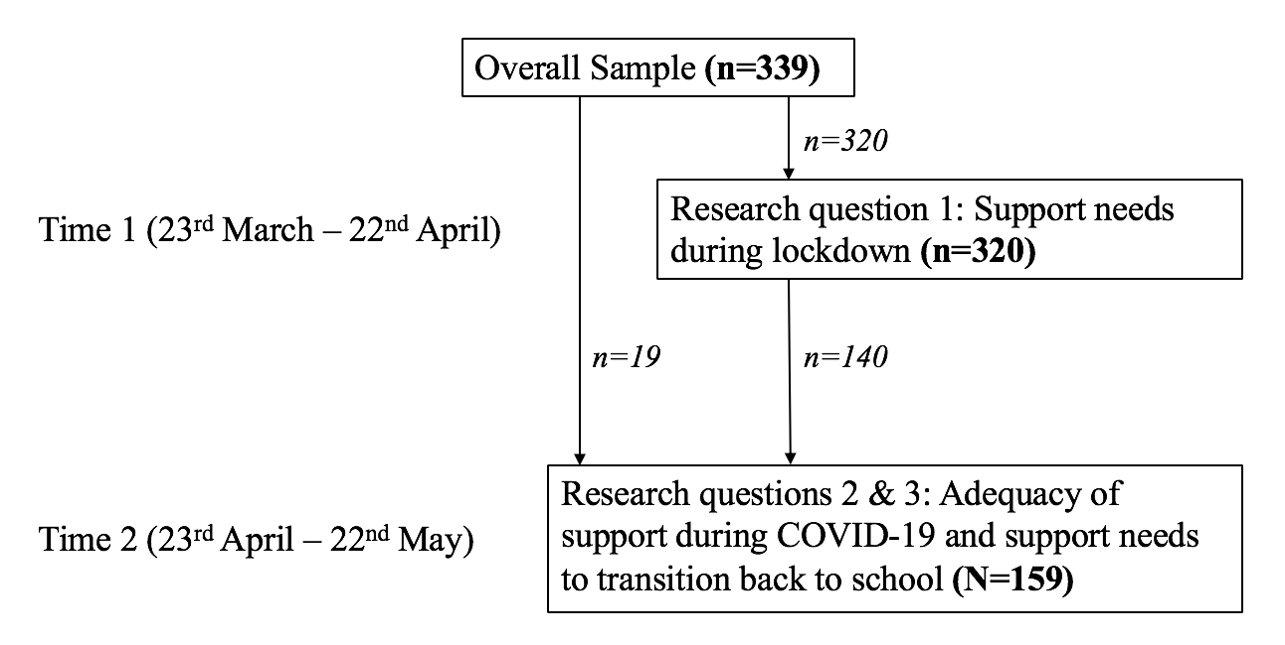
Figure 1. Sample distribution by time point

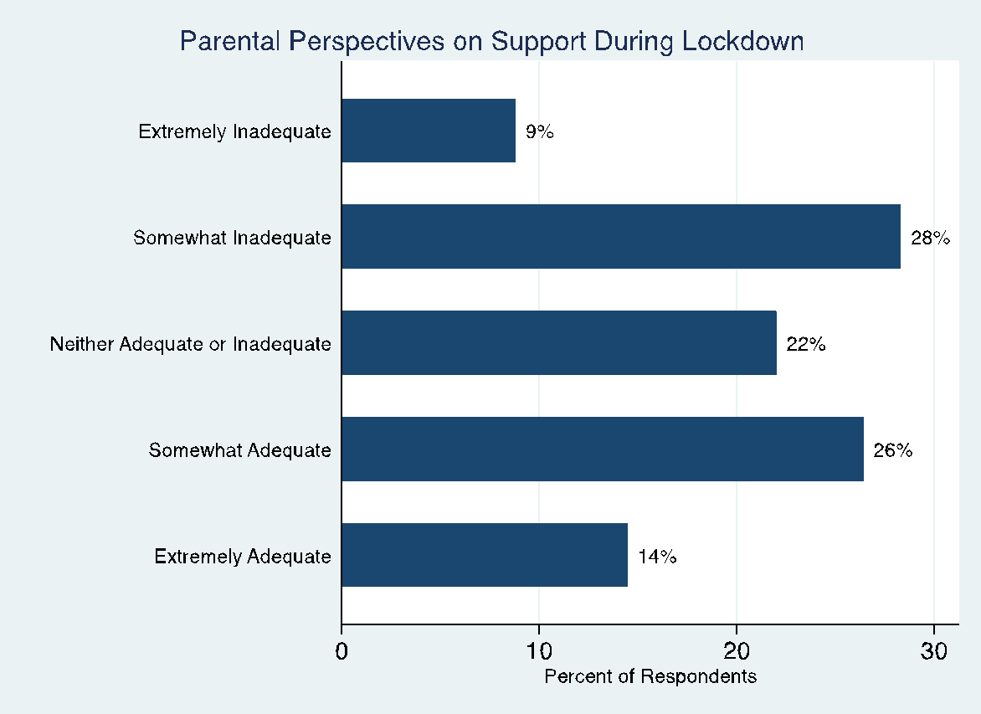
Figure 2. Parental responses to the question “To what extent has the support you have received since the start of the lockdown been adequate to meet your child's needs?”

