Chapter 9

Years of Good Life Based on Consumption and Health:

A Practical Well-Being Metric for Economic Evaluation

Cookson, R1, Cotton-Barrett, O2, Adler, M3, Asaria, M4, Ord, T2

1University of York 2 University of Oxford 3 Duke University   
4 London School of Economics

Pre-print version of chapter 9 In Eyal, N, Hurst, S A, Murray, C J L, Schroeder, S A and Wikler, D. *Measuring the Global Burden of Disease: Philosophical Dimensions*, Oxford University Press.

This chapter proposes a practical measure of individual well-being to facilitate the economic evaluation of public policies. The authors propose to evaluate policies in terms of years of good life gained, in a practical and flexible way that complements and builds upon the standard outcome measures used in cost-effectiveness and cost–benefit analysis. The authors show how to do this by adjusting years of life lived for consumption-related quality of life—that is, the material standard of living—as well as health-related quality of life. This is a straightforward extension of the quality-adjusted life year metric used in health economics for measuring years of healthy life. The authors’ approach allows for differences between people in the marginal value of money. It also permits distributional impact analysis in terms of lifetime well-being—that is, how many good years of life different people can expect over the course of their lives. The authors aim to show how years of good life could be measured in practice by harnessing readily available data on three important elements of individual well-being: consumption, health-related quality of life, and mortality. They also aim to identify the main ethical assumptions needed to use this measure.

*health, QALY, quality of life, well-being, cost-effective*

9.1. Introduction

The UK governmental body NICE (the National Institute for Health and Care Excellence) . . . has performed a signal service. It has shown to the world that the well-being approach can become an acceptable basis for public policy.

Lord O’Donnell, head of the UK civil service, 2005–2011

(O’Donnell et al. 2014)

In this chapter, we propose a practical measure of individual well-being to facilitate the economic evaluation of public policies. We propose to evaluate policies in terms of years of good life gained, in a practical and flexible way that complements and builds upon the standard outcome measures used in cost-effectiveness and cost–benefit analysis. Our approach allows for differences between people in the marginal value of money. It also permits distributional impact analysis in terms of lifetime well-being—i.e. how many good years of life different people can expect over the course of their lives. We aim to show how years of good life could be measured in practice by harnessing readily available data on three important elements of individual well-being: consumption, health-related quality of life, and mortality. We also aim to identify the main ethical assumptions needed to use this measure.

Our proposed measure is a straightforward extension of the quality-adjusted life year (QALY) measure of individual health used in health economics (Cookson and Culyer 2010). Instead of measuring years of healthy life—the health QALY—we propose to measure years of good life—the well-being QALY.[1] The basic idea is the same—to measure years of life, adjusted for quality of life. The difference is just that we propose adjusting for aspects of quality of life related not only to health but also to material living standards, or what economists call “consumption.” Consumption can be measured in different ways, depending on the purpose of the analysis and the availability of data. A broad definition of “consumption,” for example, would include not only the market value of all purchased goods and services but also the imputed value of nonmarket goods and services provided or subsidized by the state—such as health, education and local public amenities—and by the family and others—such as housing, cooking and informal care.[2]

The well-being QALY is a flexible tool that can be implemented in different ways and does not commit the user to any particular philosophical theory about the nature of individual well-being. For example, the well-being QALY could be interpreted either as an indicator of realized well-being or as an indicator of opportunity to realize well-being. This is because consumption, health and longevity are all central ingredients not only in people’s actual achieved level of flourishing but also in their ability to achieve different levels of flourishing.[3] The well-being QALY thus indicates rather than constitutes well-being.

The most obvious application of this approach is to public health policies which are primarily designed to impact on people’s consumption and health, such as “health taxes” on tobacco, alcohol and sugar. Such policies can be evaluated by combining epidemiological models of morbidity and mortality over the life course with economic models of supply and demand for the product under consideration. Models of this kind have been used in the UK, for example, to evaluate alcohol minimum pricing proposals for differential impacts by age, gender, alcohol risk group and income group (Holmes et al. 2014; Meier et al. 2016). Once a combined epidemiological-economic model of this kind has been built, one can then take the outputs—i.e. effects on consumption, health and mortality by social subgroups—and convert them into well-being QALYs.

However, the well-being QALY approach can also be applied to wider public policies which are primarily designed to impact on policy outcomes other than health—including policies on education, social protection and the environment. Wider public policies of this kind are currently evaluated using conventional cost–benefit analysis, based on a diverse range of policy outcome metrics converted into monetary values, usually without any underpinning economic-epidemiological model of impacts on consumption, health and longevity. Well-being QALYs can be used to complement conventional cost–benefit analysis by translating monetary benefits into years of good life gained. Wider public policies often do have important long-run impacts on people’s consumption and health, even if those impacts are not the primary policy objectives. For example, improvements in a child’s educational outcomes and family stability can have important long-term impacts on their life chances—including their earnings, health and mortality risk later in life.

If there are important policy benefits that are not captured by long-term effects on consumption, health quality and mortality, the well-being QALY can be extended in two ways. First, any measure of policy outcome can be given a monetary value based on people’s willingness to pay for improved outcomes. Those monetary benefits could then be treated as consumption and converted into years of good life gained, using data on the individual’s existing level of consumption and health and explicit normative assumptions about the rate of conversion from additional income into additional well-being. Second, the well-being QALY can be extended by adjusting quality of life directly for other outcomes—for example by including simple additive disutility values for adverse experiences such as unemployment, crime, loneliness and so on.

An alternative way of operationalizing the concept of the well-being QALY was proposed by the “Commission on Well-being and Policy,” chaired by a former head of the UK civil service, Lord O’Donnell (O’Donnell et al. 2014). O’Donnell and colleagues propose to adjust for quality of life directly using data on subjective well-being or life satisfaction. By contrast, we propose to adjust for quality of life indirectly using data on consumption and multiple dimensions of health-related quality of life—data which we believe are more readily available and more informative. Another complementary approach to creating a well-being QALY would be to use a multi-dimensional quality of life questionnaire (Al-Janabi et al. 2012; Mukuria et al. 2018). Finally, a leading alternative to the well-being QALY is the “equivalent income” approach, which adjusts income to allow for other dimensions of well-being (Fleurbaey et al. 2013; Fleurbaey and Schokkaert 2013). We return to the similarities and differences between these various well-being metrics in the discussion.

9.2. What Is Wrong with Unweighted Monetary Valuation of Outcomes?

In conventional cost–benefit analysis, nonmonetary outcomes are given a monetary value based on how much people are willing to pay for them. These monetary amounts are then added up. Various methods have been proposed for adjusting or “distributionally weighting” monetary benefits before adding them up, but these are rarely used in practice. This conventional approach, which we shall refer to as “unweighted monetary valuation,” has two major limitations. First, it makes no allowance for variation between individuals in the conversion rate from money to well-being—i.e. the marginal utility of money. Second, it provides no information about the social distribution of costs and benefits and the resulting impacts of policies on social inequalities. Public polices and institutions often have important distributional equity objectives relating to the reduction of social inequalities. Decision makers are thus interested to know whether policy options are likely to increase or reduce social inequalities, and by how much.

The fundamental problem with the conventional approach is that it fails to measure well-being impacts accurately. There is substantial variation between people in how far changes in consumption impact upon their well-being. Two particularly important sources of variation are that (1) an extra dollar does more to improve the well-being of a poor person than a rich person and (2) an extra dollar is no use to anyone after their death. To take an extreme example, consider elderly billionaire Adam with end-stage cancer and young pauper Bob with a painful and disfiguring skin disease that renders him unable to work, socialize or enjoy physical intimacy. Bob is not able to pay one dollar for an extra 50 years of healthy life free of skin disease. By contrast, Adam is willing to pay a billion dollars for an extra three months of life undergoing debilitating chemotherapy. This is not because he or anyone else thinks these extra three months of life will be particularly enjoyable. Rather, it is because he is extremely rich, cannot take the money with him, and does not want to give the money away. Unweighted monetary valuation values both treatments at something approaching the respective willingness to pay of both individuals, though somewhat less due to the administrative costs and “deadweight” losses of raising new public funds through taxation. It therefore implies that the government should be willing to spend something approaching a billion dollars of public money for Adam’s extra three months of unhealthy life, but should not be willing to spend a dollar giving Bob a healthy life for the next 50 years. When applied in a thoroughgoing manner, therefore, valuing policies in terms of people’s willingness to pay may not accurately reflect strength of preference and can have ethically and politically unacceptable implications. Things are not quite so stark in practice, of course, because instead of looking at each individual’s willingness to pay a substantial amount of averaging takes place. However, this averaging is an ad hoc move that is not justified by the underlying theory and only partly alleviates the problems.

We propose the well-being QALY as a practical way of addressing these limitations. Our proposal can be seen as a practical application of the theoretical frameworks for economic evaluation developed by Broome (1991, 2004) and Adler (2012). A key feature of these frameworks is that they are based on a set of explicit value judgments, some of which are formulated mathematically in the form of a “social welfare function.” This contrasts with what we might call the “Paretian” philosophy of welfare economics underpinning unweighted monetary valuation, as advocated in health economics for example by Pauly (1995, 1996).

The Paretian approach seeks to minimize the need for explicit value judgments. Of course, when making normative claims it is never possible to avoid value judgments altogether. For example, the Paretian approach makes a value judgment about the nature of well-being (i.e., that well-being consists in preferences, rather than experienced happiness or objective goods) and about the comparison of social states (i.e., that state A is a “Pareto improvement” compared with state B if at least one person prefers A and no one prefers B). In practice, it makes a substantially more controversial value judgment based on the idea of a “potential” Pareto improvement. The idea is that a policy change is worthwhile if the winners (in the previous example, Adam the billionaire) can hypothetically compensate the losers (Bob, the pauper) so that everyone would prefer the policy change. This is controversial, because the compensation is not actually paid in practice and often cannot be paid even in theory due to imperfect information, transaction costs and other market imperfections (Blackorby and Donaldson, 1990). This means that the Paretian approach systematically prioritizes improvements to the well-being of the wealthy over improvements to the well-being of the poor, in rough proportion to difference in ability to pay—something that conflicts with most people’s intuitive value judgments.

The Paretian approach can be contrasted with what we might call the “social choice” philosophy of welfare economics (Adler and Fleurbaey 2016), as advocated for example by Atkinson (2009, 2011), Sen (1999), and Fleurbaey and Schokkaert (2013) and in health economics by Williams (1972) and Culyer (Cookson and Claxton 2012). The “social choice” approach seeks to make explicit value judgments about social objectives, and to subject those value judgments to public scrutiny and deliberation. For example, Fleurbaey and Schokkaert (2013) write: “When one aims at policy evaluation, it is better to make the underlying value judgments as open as possible. Having an informed debate about such value judgments in a formal model has always been the main objective of social choice theory.” The idea is that economic evaluation aims to provide social decision makers and stakeholders with useful information about how far alternative decision options are likely to achieve their objectives. The appropriate set of value judgments and policy objectives is ultimately a matter for the legitimate social decision maker to specify. However, alternative sets of value judgments can be explored in sensitivity analysis to help decision makers and stakeholders think through the implications of policies in a deliberative decision-making process. In this way, economic evaluation using a “social choice” approach can be seen as a contribution toward democracy in the broad sense of “the exercise of public reason” (Sen 2003, 2011).

9.3. Measuring Individual Well-Being

We can distinguish “period-specific well-being” during a specific time period from “lifetime well-being” over the entire lifecourse. Lifetime well-being is generally what social decision makers ultimately care about, but it is harder to measure than period-specific well-being. We propose to treat lifetime well-being as the sum total of period-specific well-being over the individual’s lifetime. This assumption of additive separability of well-being over time is standard practice in economics and agrees with some theories of lifetime well-being in the philosophical literature (Broome 2004).

We propose measuring period-specific well-being as the time spent alive during that period, adjusted for overall quality of life during that period. We estimate quality of life during the period as a function of both health and consumption during that period. For convenience, we use one year as the standard time period. The choice of period does raise issues of value judgment, however, since additive separability over time becomes less plausible over short periods of time. For example, imagine time periods were measured in minutes. Straight after consuming a hearty meal, your well-being is likely to depend more on consumption in the previous few minutes, and perhaps on anticipated consumption later in the day, than on consumption in the current minute. This kind of issue is less problematic when consumption is measured over a year, or perhaps even over a month. However, parallel arguments can of course be made that there may be “spillovers” in well-being effects from one year to another and that the pattern of well-being over a lifetime matters.

We propose to anchor the well-being QALY at zero and 1 in a way that makes it compatible with the health QALY and allows us to interpret 1 as a year of good life. This means that our well-being QALY measurements accord with the data used to produce health QALY weightings, for the people who were the source of these data, at least as far as agreeing whether a given health state is better or worse than death. More specifically, we propose that a score of 1 represents a year of life that is lived in full health while enjoying a good standard of living. This standard can vary from case to case, depending on the setting and purposes of the analysis, in the same way as a poverty line or a value of statistical life or a discount rate. However, for the purpose of global comparisons one proposal might be to set standard consumption equal to the high living standards—by global historical standards—of the average person in a modern high-income country. A score of zero represents a year of life in a severely ill state of health that is considered not worth living for a person with a standard level of consumption.[4] This aligns the scale with the health QALY scale and facilitates the use of existing data on health-related quality of life in the construction of the well-being QALY.

We do not propose bounding the scale at 0 and 1. This means that values below 0 and above 1 are allowed, reflecting the possibility of states of health that are worse than being merely alive and unconscious, and levels of consumption that are better than the standard level of consumption. We say more in the following discussion about how these concepts might be defined and measured in practice. In line with our social decision-making philosophy, these definitions are value judgments that are ultimately a matter for legitimate social decision makers to specify.

So far, everything is almost exactly the same as the health QALY in mathematical terms—except that we have reinterpreted period-specific quality of life as “overall quality of life” rather than “health-related quality of life” and have allowed scores greater than 1. The key innovation is that we now propose to measure period-specific quality of life as a function of consumption as well as health.

In reality, of course, quality of life depends on a lot more than just consumption and health. But we are simplifying for practical purposes, since consumption and health are two important components of quality of life that are influenced by public policy, are of substantial concern to policy makers, and are readily measurable. Our proposal allows other important public policy outcomes, such as education outcomes, crime outcomes, and so on, to be valued in two ways. First, via long-term impacts on the individual’s consumption and health over the lifecourse. Second, by monetizing these outcomes using willingness to pay, just as in traditional cost–benefit analysis, and then treating those monetary benefits as consumption benefits that can be converted into years of good life gained.

Although our two-dimensional approach to measuring period-specific well-being may seem simple, it is more demanding in terms of data requirements than unweighted cost–benefit analysis as commonly practiced. This is because to estimate well-being impacts we need to know not only the “average” effects on consumption and health for the “average” person, but also (1) the distribution of baseline consumption and health between different social groups, and (2) the distribution of effects on consumption and health between different groups and over the whole lifetime of the individual. In theory, unweighted cost–benefit analysis does also need to allow for both (1) and (2), since willingness to pay will depend on baseline consumption and health. In practice, however, this is almost never done—instead, analysts simply work with averages.

Mathematically, we can specify an individual lifetime well-being function as follows:

(9.1)



where

wi is the lifetime well-being of individual i

wit is the period-specific well-being or quality of life or individual i

cit is the consumption of individual i in period t

hit is the health quality of individual i in period t.

Consumption can be measured in real financial resources—such as dollars in a given year. Health quality[5] hit is a function h(**Hit**) of **Hit**, a multidimensional vector of the health attributes of individual *i* in period *t*. Whereas **Hit** is highly multidimensional, hit is a scalar—we assume it is measured on the standard scale of the health QALY, bounded above at 1, where 1 represents full health and 0 represents death or a health state as bad as death. A key assumption here is that the interaction between health states and consumption operates only through health quality, such that well-being only depends on health quality and income and not also upon the pattern of underlying multidimensional health states. This assumption might be violated, for example, if mental and physical dimensions of health interact with consumption in different ways to produce well-being. For example, a person with depression might have the same quality of health score as a person with severe osteoarthritis, but their well-being may be less sensitive to income if their depressed state of mind prevents them enjoying the consumption of goods and services.

The period-specific well-being function wit(cit, hit) is monotonically increasing in both variables. To measure this, however, some further specification is necessary.

There are various possibilities (Hammitt 2013). One is the following simple additive well-being function, decomposing well-being into the utility of health and the utility of consumption:

 (9.2)

u(cit) is a standard isoelastic[6] utility of consumption function defined as follows:

 (9.3)

A and B are normalization constants, which ensure that the utility scale is appropriately anchored so that 1 is a good year of life and 0 is barely worth living, and are defined thus:





• η >1 (“eta”) is a normative parameter representing the diminishing marginal value of income

• cmin is minimal consumption, defined as the lowest possible level of income at which life is considered worth living[7] for an individual in full health.

• cstd is standard consumption, defined as a good standard of living according to the relevant social decision makers.

In equation (9.3), the normalization constants, A and B, anchors well-being to 1 when health quality, h, is 1 and consumption is standard consumption; to zero when health quality is 1 and consumption is minimal consumption; and to 0 when health quality is 0 and consumption is standard consumption.

The higher the eta parameter, η, the more rapidly diminishing returns set in as consumption increases. The theoretical literature on isoelastic functions supports the possibility that η ≤ 1, in which case the well-being function is not bounded above. However, the empirical literature supports values of η of at least 1. Based on a study of the association between subjective well-being and consumption by Layard and colleagues, using four large cross-sectional surveys of subjective happiness and two panel surveys from multiple countries between 1972 and 2005 one reasonable assumption might be η = 1.26 (Layard et al. 2008).

In this chapter, we illustrate by setting minimal consumption around the level of subsistence consumption. We start with the World Bank’s current absolute global poverty line of $1.90 a day in 2011 prices (updating the previous line of $1.25 a day in 2005 prices), corresponding to $693.50 per year in 2011 prices.[8] Since we normally think that healthy lives in extreme poverty are worth living, we set cmin below this level. So in the following example we use a value of cmin = $300 per year, which is a little under half the World Bank poverty line.

For Cstd, we use a value of $30,000 US dollars in 2014, based on the following calculation and using income as an indicator of consumption. In 2014, US median household income before taxes and benefits was $53,657, average household size was 2.6 and 23% of the population were children (aged 0 to 17).[9] We can thus think of the average household as comprising 2 adults and 0.6 of a child. To allow for household size and composition, the standard equivalence scale used in the US for this kind of household is (adults + 0.5*children)0.7 which yields a scale of 1.79.[10] Dividing household income by 1.79 then gives us a figure of $29,951 for individual income, which we round up to $30,000.

We use this figure for convenience, as ideally one would want a figure after taxes and benefits and including the value of “in kind” benefits and services from the state and family. This figure is not an unreasonable starting point, however, insofar as the taxes paid to the state by the typical household can be assumed approximately equal in value to the cash and noncash benefits received from the state. It will nevertheless underestimate the broad concept of individual consumption that we would ideally wish to measure, since it excludes the value of informal household services such as cooking, cleaning, childcare and so on.

Figure 9.1 shows what the resulting relationship between period-specific well-being and consumption for someone in full health would look like, under these parameter assumptions.

**Figure 9.1: Wellbeing value of consumption in full health (η = 1.26)**

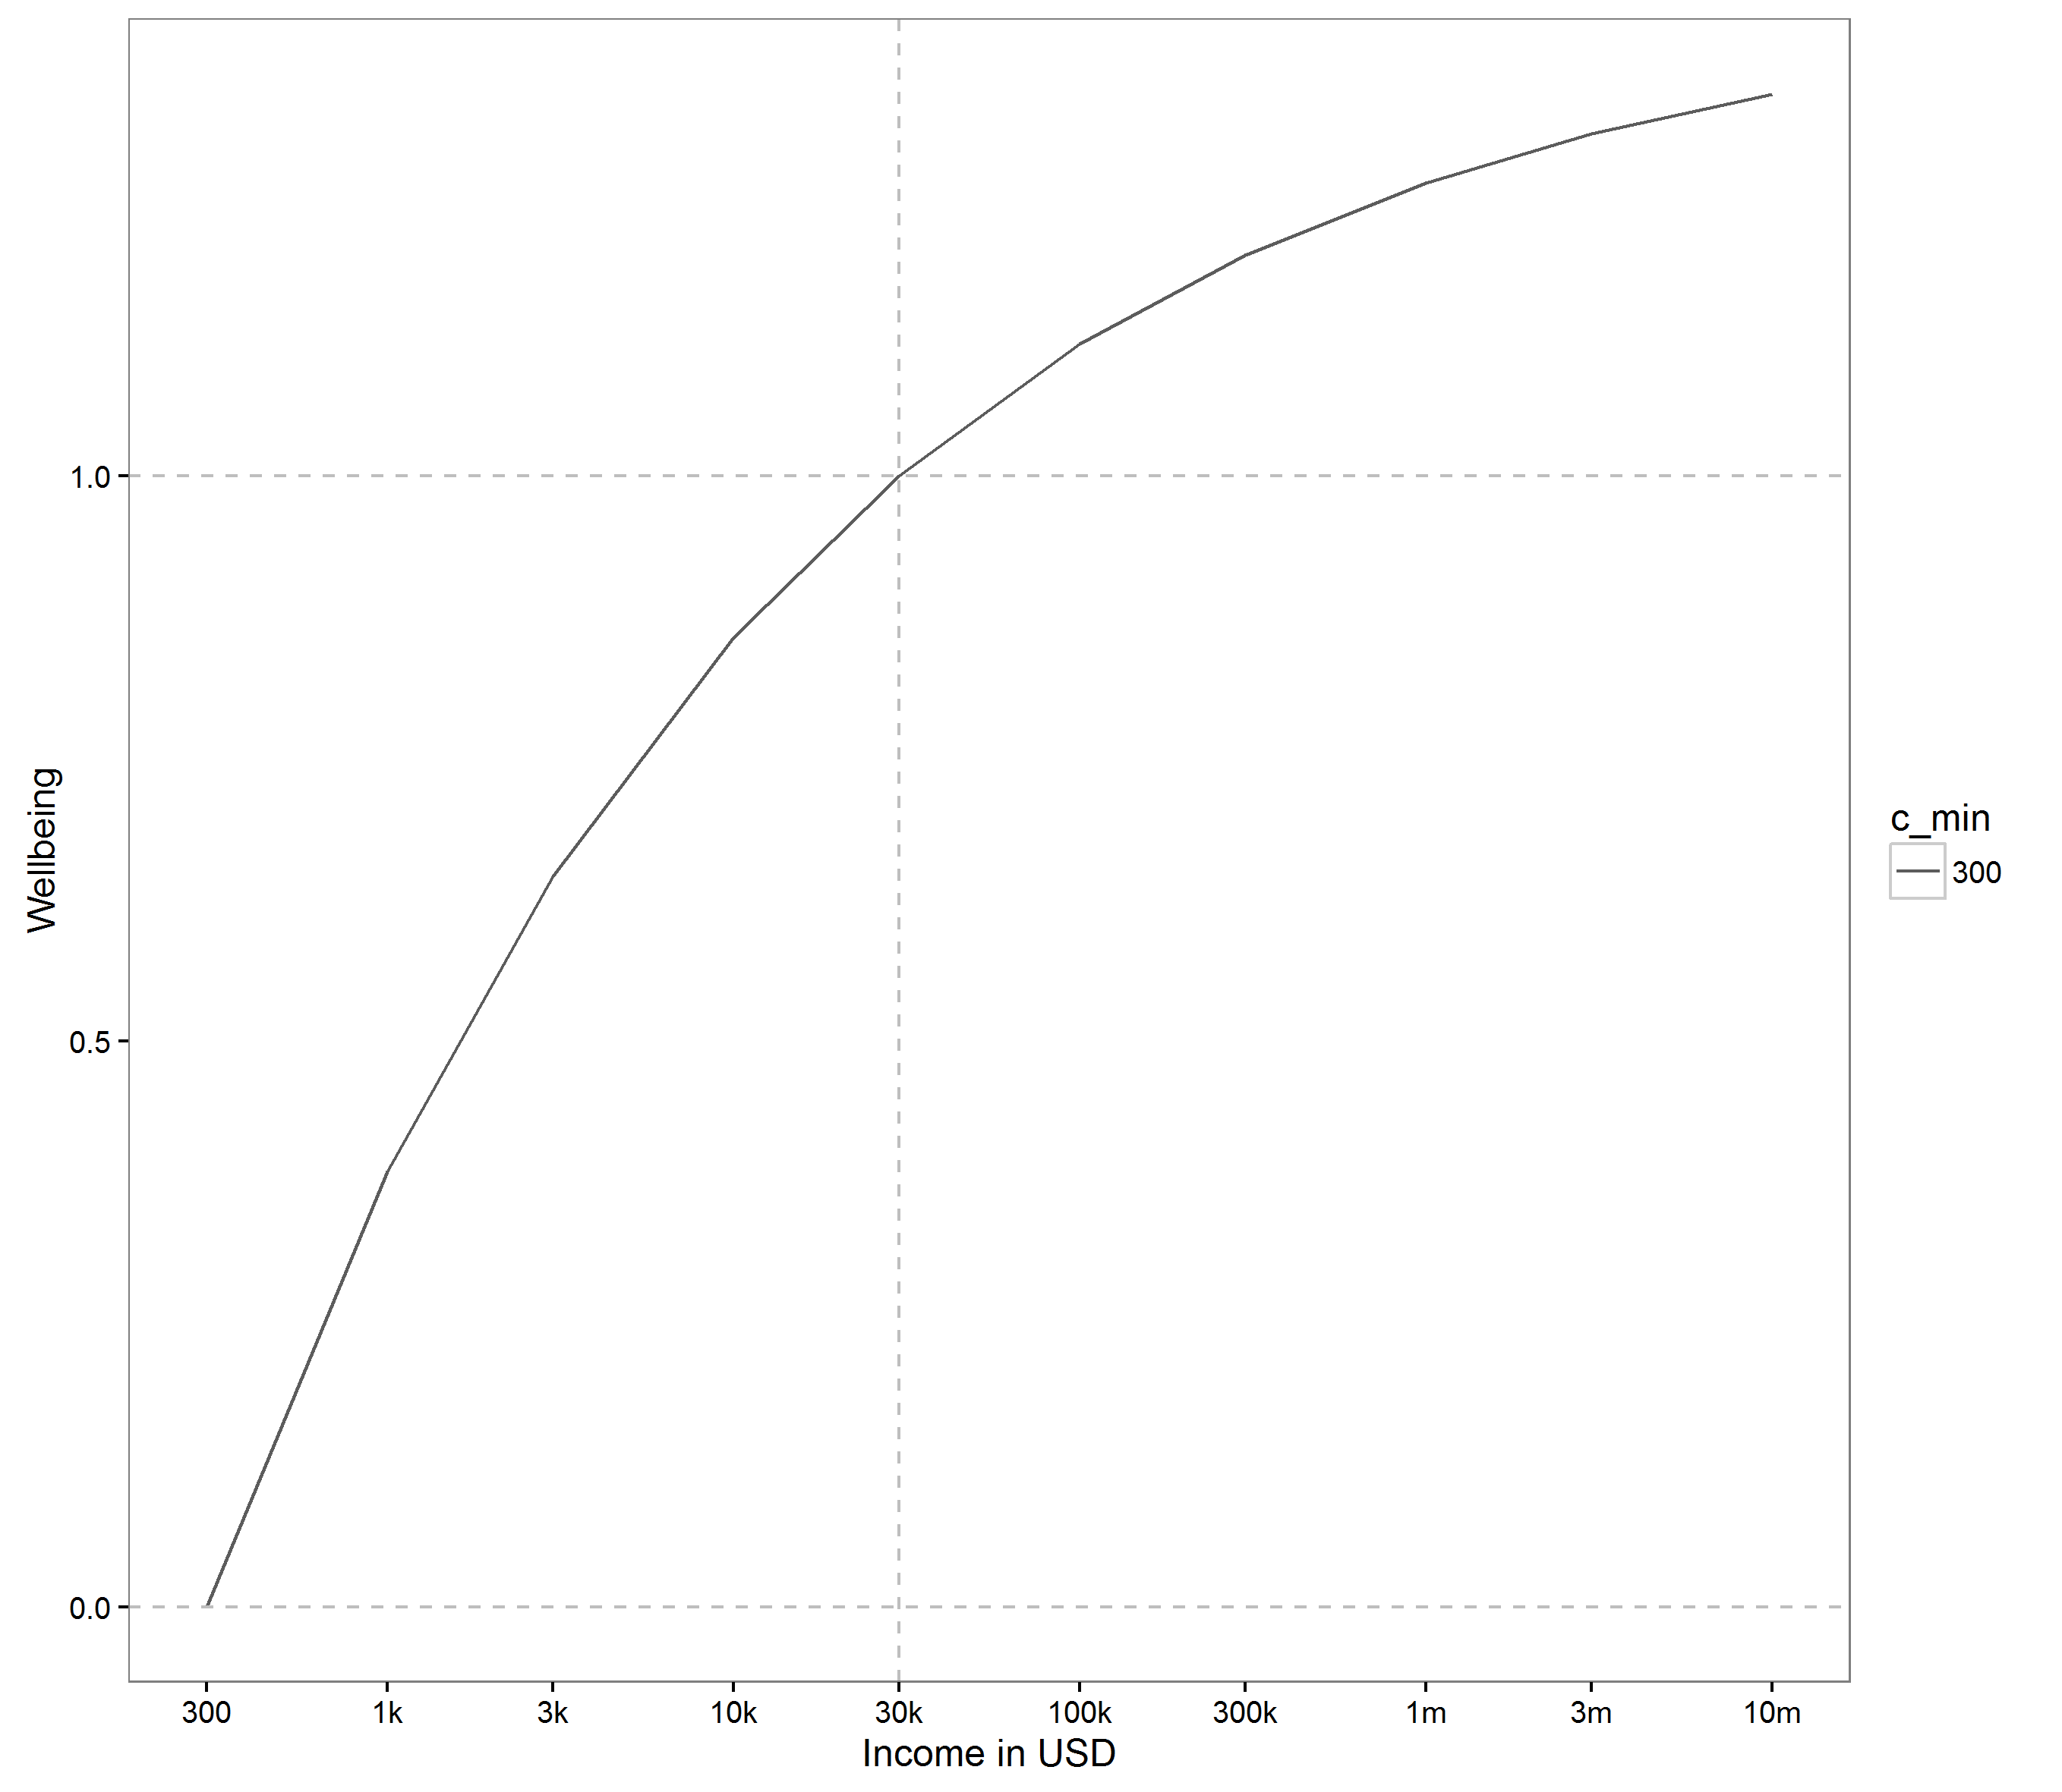

0 = minimum income (half World Bank poverty line)

1 = standard income

(US median)

**Note:** Consumption is shown on a log scale and is measured as annual individual income after tax from all sources, including the imputed value of non-market services provided by state and family.

We do not show well-being scores for consumption below the subsistence level, since by definition individual consumption cannot fall below the subsistence level for long periods of time. Subsistence consumption is well below the minimal level of consumption that a modern high-income country government would consider acceptable for its poorest citizen. This is because the market price of basic food and shelter is substantially more than $1 a day in any high-income country, and our concept of consumption includes the imputed market value of goods and services provided free by the state, family and others. So living on subsistence consumption would require avoiding offers of food and shelter from the state, family, or others. It would require living like a lone wild animal: sleeping rough, foraging for food, and avoiding almost all social contact.

An alternative assumption would be to set Cmin around the minimal level of consumption considered acceptable for the poorest citizen in a high-income country, for example, the consumption of an unemployed adult with no private wealth who relies entirely on benefits and services provided by the state. To illustrate the implications of this alternative assumption, Figure 9.2 explores the value of Cmin = $10,000 per year. This assumption implies that human life is barely worth living as the poorest citizen in a high-income country. By contrast, the subsistence consumption approach implies that human life is barely worth living as a lone wild animal.

**Figure 9.2: Wellbeing under alternative assumptions   
about minimal consumption(η = 1.26)**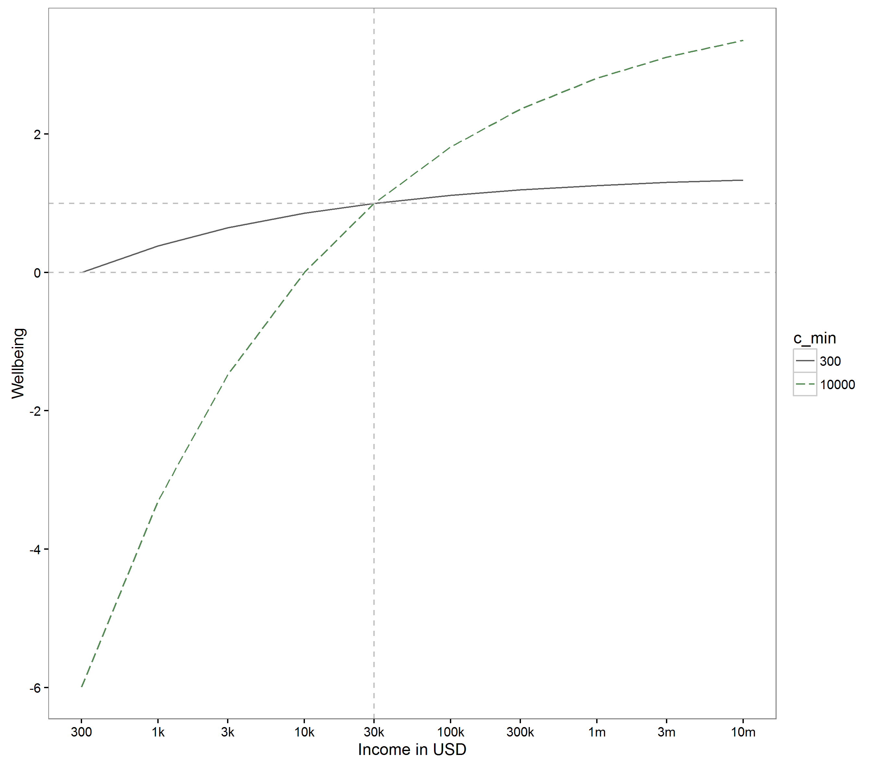

We can also calculate the marginal rate of substitution (MRS) of consumption for health by dividing the marginal utility of the latter by the marginal utility of the former. The marginal utility of health is simply 1, and the marginal utility of consumption is –B×(1 – η)×c–η. So we get

$MRS=1/(-B×(1-η)×c^{-η}$.

Re-arranging,

$MRS=c^{η}×1/(B×(η-1))$.

**Figure 9.3: Implied marginal consumption value of a QALY**

**(eta 1.26, Cmin 300 and Cstd 30,000)**



This is a useful expression for the implied marginal consumption value of health, at different levels of consumption. Figure 9.3 shows implied values for our base case parameters, with the consumption value of health on a log scale on the vertical *y* axis.

This shows that, according to our normative model, rich individuals should be willing to sacrifice substantially larger amounts of consumption than poor individuals to gain an additional year of healthy life. For example, an individual at a “subsistence” level of consumption ($300 dollars a year) should be willing to sacrifice consumption for health at an exchange rate of less than $1,000 per QALY, whereas an individual at a “standard” level of consumption ($30,000 a year) should be willing to pay $267,000 per QALY. If we invert these figures to consider willingness to pay in health for gains in consumption, what this shows is that one dollar of additional consumption is worth substantially more to a poor individual than a rich individual.

9.4. Allowing for Interactions between Income and Health

The simple additive well-being function assumes the marginal benefit of consumption does not depend on ill health (Bleichrodt and Quiggin, 1999; Hammitt 2013; Smith and Keeney 2005). An alternative view might be that the marginal benefit of consumption increases with ill health. For example, additional income may bring substantial benefits to someone unable to walk, in allowing them to purchase mobility equipment and a variety of transport, communication and personal care services. Yet another view might be that the marginal benefit of consumption decreases with ill health. For example, additional income may bring limited benefits to someone who is severely depressed and no longer able to enjoy the good things in life.

To allow for these possibilities, a more general well-being function would have the following form, based on a weighted average of additive and multiplicative functional forms:

 (9.4),

where

• u(cit) is the well-being of consumption in full health.

• α is a consumption-health interaction parameter, bounded above by 1 to ensure that the marginal utility of consumption is always positive so long as health is positive.

When α = 0, this reduces to the additive form in equation (9.3). When α > 0 the marginal benefit of consumption decreases with ill health, so that health and consumption function like economic complements. When α < 0 the marginal benefit of consumption increases with ill health, so that health and consumption function like economic substitutes. This form is uniquely determined by the assumptions that (i) the gambles people would accept over consumption levels are independent of quality of health state; (ii) the gambles people would accept over health states are independent of consumption level; and (iii) the boundary conditions if u(c)=h = 1 then w = 1; (iv) if u(c) = 1, h = 0, then w = 0; and (v) if u(c) = 0, h = 1, then w = 0. There is not much empirical evidence about this issue (Evans and Viscusi, 1991; Rey and Rochet 2004), but one study suggested a positive value (Viscusi and Evans, 1990) whereas a more recent study supports a negative value of alpha of around –1 (Tengstam 2014).

In practice, we would therefore propose using a base case assumption of alpha = 0, for convenience and simplicity, and then sensitivity analysis around alternative plausible values such as alpha = 0.5 (in the middle of the possible range up to 1) and alpha = –1.

Figure 9.4 shows how well-being changes with different levels of health under different assumptions about alpha, returning to our base case assumption that minimal income is subsistence income.[11] The lowest health quality score in Figure 9.3 is –0.281, reflecting the lowest score from the latest EQ-5D-5L health value set for England (Devlin et al. 2018).

**Figure 9.4: Wellbeing as a function of income and health with different values of alpha (η = 1.26 and Cmin = 300)**

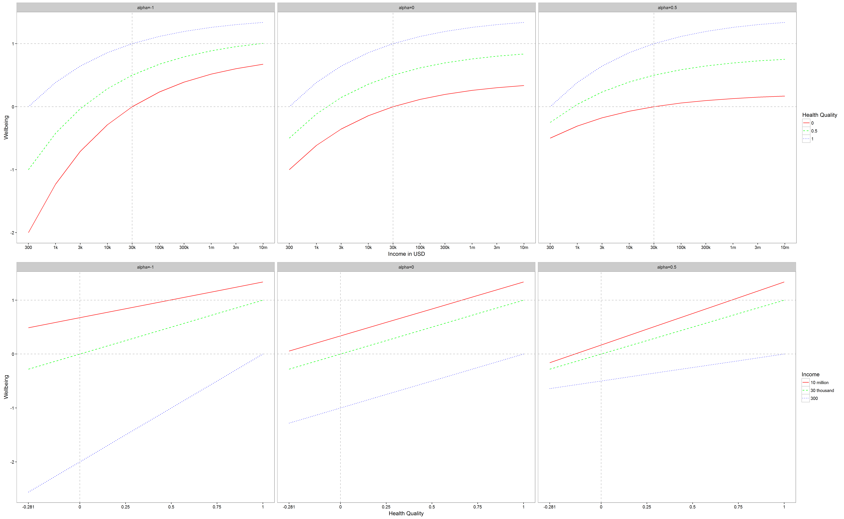

9.5. Measuring Population Average Lifetime Well-Being

To compare the outcomes of alternative social policies, we need to aggregate individual well-being outcomes to the population level. The simplest way of doing this is just to take the average of individual well-being outcomes—that is, to calculate average lifetime well-being. As is standard practice in economic evaluation, we assume that the population is stable and set aside the thorny issue of how to value population change.

Our proposal allows average lifetime well-being to be measured on a ratio scale, in the same way that consumption can be measured on a ratio scale. Unlike an interval scale (e.g., degrees Fahrenheit), a ratio scale has an absolute zero, and so it makes sense to calculate ratios and percentage differences. As well as being useful for economic evaluation, this is also useful for measuring social progress, since a ratio scale allows the calculation of percentage changes in a society’s average lifetime well-being over time, and percentage differences in average lifetime well-being between different societies. Not all measures of social progress allow this. For example, the concept of “full national income” augments standard measures of change in national income by adding in the monetary value of changes in population health over time (Jamison et al. 2013; see, in particular, Global Health 2035 2014). Unfortunately, however, this only allows one to calculate changes in full national income over time, not baseline levels of full national income. So unlike well-being QALYs, the concept of “full national income” does not allow comparison of percentage changes over time or percentage differences between societies.

9.6. Measuring Social Inequality in Lifetime Well-Being

Our approach to measuring lifetime well-being already embodies one important type of concern for social inequality. The well-being QALY embodies an assumption of diminishing marginal value of consumption. It thus embodies the same form of concern for inequality in consumption as classical utilitarianism. The utilitarian case for redistribution is that a dollar of consumption is worth less to a rich person than a poor person—hence, other things equal, taking a dollar from a rich person and giving it to a poor person will tend to increase sum total well-being.

However, policymakers may have additional concerns for social inequality in lifetime well-being, as well as inequality in current consumption. Our well-being QALY metric is well suited to analyzing such concerns, for three reasons. First conducting separate analyses of inequality in different components of well-being (e.g., inequality in consumption and inequality in health) may be misleading, insofar as different components of well-being can compensate for one another (Adler 2012; Fleurbaey and Schokkaert 2009). Second, a ratio scale measure of individual lifetime well-being allows the use of standard indices of relative inequality based on percentage differences between individuals. Third, the well-being QALY is well suited to analyzing trade-offs between “efficiency” in terms of average well-being versus “equity” in terms of reducing inequality in the social distribution of lifetime well-being. The well-being QALY metric allows the use of standard social welfare functions to analyze equity-efficiency trade-offs of this kind. Standard social welfare functions can be expressed in the following abbreviated or reduced form (Adler 2012):

,

where W is social welfare; ***w*** is a vector of the individual lifetime well-being of all individuals or groups in society;  is mean individual lifetime well-being across the whole population; I(.) is an inequality index scaled from zero to 1 (where 0 is full equality and 1 full inequality); and ε is an inequality aversion parameter.

One plausible functional form for the inequality index is the Atkinson function (Adler 2012; also see Chapter 5 of this volume). In the Atkinson function, ε = 0 represents zero aversion to inequality in which case I = 0. Higher values of ε imply greater weight to the worse off (i.e., those with lower lifetime well-being). Finally, an infinite value of ε implies exclusive priority to the worst-off individual or group—that is, a “maximin” principle. Once ε has been specified, it is then possible to compare populations and policies in terms of overall social well-being and to analyze trade-offs between changes in average lifetime well-being, $\overline{w}$, and changes in inequality, I.

An extension of this approach is to adjust the vector of lifetime well-being as appropriate to focus on “unfair” determinants of individual well-being (e.g., parental class or race) and to set aside “fair” determinants (e.g., personal responsibility) and determinants that are neither “fair” nor “unfair” (e.g., misfortunes considered a matter of personal tragedy rather than social injustice; Adler 2012; Asada et al. 2015; Ferriera and Peragine 2016; Fleurbaey and Schokkaert 2009, 2011).

Analyzing inequality in lifetime well-being QALYs does not preclude performing additional forms of distributional analysis. Decision makers may still want to have information about dimension-specific inequality in consumption, for example, if they have nonutilitarian concerns about inequality in consumption. And they may want information about dimension-specific inequality in health if they have special concerns for inequality in health. For example, in 1997, the then–U.K. Secretary of State for Health Frank Dobson said, “Health inequality is the worst inequality of all. There is no more serious inequality than knowing that you’ll die sooner because you’re badly off” (http://www.lgcplus.com/govt-takes-action-to-reduce-health-inequalities/1494985.article). Our framework complements dimension-specific analyses of this kind, by analyzing interactions between consumption, health, and well-being and placing the analysis within a more general framework.

9.7. Discussion

We have proposed a practical way of evaluating public policies by combining data on consumption, health-related quality of life and mortality to measure years of good life. The “well-being QALY” could in principle be used in any type of economic evaluation, including both cost-effectiveness analysis and cost–benefit analysis. Cost-effectiveness analysis using well-being QALYs would assume an exogenously fixed public budget—i.e. no scope for raising taxes or finding other new sources of public finance. It would then compare social policies by asking which way of spending that fixed budget yields the most years of good life. Cost-benefit analysis would go beyond this by allowing the possibility of raising taxes and changing the public budget—and it would value those taxation costs, along with all other costs and benefits, in terms of their impacts on years of good life. Either way, it would be important to know where the opportunity costs of social policies fall—for example, which public budget(s) will be used to finance the policy. This is because different sources of funding will have different implications for who bears the opportunity costs of the policy in terms of reduced income (including reductions in “in kind” consumption of public services)—and hence the net impact on years of good life.

The attractive features of our approach are:

1. It builds on well-understood concepts, data and methods already extensively used to inform decision making in the health sector.

2. It uses a simple, intuitive metric—years of good life.

3. It requires only readily available data on income, health and longevity.

4. It facilitates clarity about policy objectives and value judgments.

5. It allows decision makers to explore the implications of alternative policy objectives and value judgments.

6. It allows analysis of percentage changes and equity-efficiency trade-offs.

The main disadvantages of our approach compared with conventional unweighted cost–benefit analysis are:

1. It has more demanding requirements for explicit modeling of income and health distributions.

2. It has more demanding requirements for explicit social value judgment.

Our approach requires explicit modeling of distributions of consumption and health by population subgroup over the lifecourse, as well as average effects. Although more demanding in terms of data and assumptions, this kind of modeling is becoming ever more feasible in the age of “big data” (Layard et al. 2014; Wolfson, 1995; Wolfson and Rowe 2013, 2014). Furthermore, a thoroughgoing application of conventional cost–benefit analysis would also require modeling of these distributions, since willingness to pay depends on baseline consumption and health. It is just that in practice this explicit modeling is rarely if ever done—instead, the analysis relies upon implicit factual assumptions.

In terms of social value judgment, the simplest implementation of our approach requires explicit specification of three new normative parameters:

1. Diminishing marginal value of consumption, η

2. Minimal consumption, cmin

3. Standard consumption, cstd

These three parameters specify how much well-being is derived from any given level of consumption, for a person in full health. The first specifies the degree of curvature in the curvilinear relationship between consumption and well-being, the second specifies where it crosses the horizontal axis at zero well-being, and the third specifies the standard level of consumption in full health that is considered to represent a year of good life. Taken together, these parameters tell us how much change in well-being is derived from a one-dollar change in consumption, and how this varies for people with different baseline levels of consumption.

A fuller implementation of our approach requires two further normative parameters:

4. Consumption-health interaction, α

5. Aversion to inequality in lifetime well-being, ε

The fourth parameter, α, allows for interactions between health and consumption in determining well-being. And finally, the lifetime well-being inequality aversion parameter, ε, allows the analysis to incorporate the value of reducing inequality in lifetime well-being as well as the value of increasing sum total lifetime well-being.

Like other normative parameters in economic evaluation—such as the appropriate discount rate for benefits accruing to future generations, or the monetary value of a life year—these parameters are ultimately a matter for value judgment by the relevant social decision makers, after a due process of public deliberation. However, to help guide this process of deliberation, empirical “benchmarks” can be found for all five parameters—for example using data on life satisfaction for 1 and 4, data on average and subsistence levels of income for 2 and 3, and data on public views for 5. Furthermore, the implications of different value judgments on all five parameters can be explored in sensitivity analysis. The search for robust, evidence-based benchmarks of this kind suitable for use in different decision-making contexts opens up an interesting and wide-ranging agenda for future research in this area.

The leading alternative to the “well-being QALY” approach is the “equivalent income” approach (Fleurbaey et al. 2013). This approach retains money as the metric of value but allows for wider dimensions of well-being by using a system of distributional weights to adjust the raw willingness to pay amounts. The distributional weights are based upon (i) a normative parameter reflecting aversion to income inequality and (ii) a preference-based measure of equivalent income, defined as the level of income in full health and at a reference level of other dimensions of well-being that the individual considers equally as good as their current level of income, health, and other dimensions of well-being. Equivalent income can be estimated, for example, through a survey exercise asking people their willingness to pay for full health. This approach has similarly demanding distributional modeling requirements to the well-being QALY approach. The main advantage of the equivalent income approach is that it is more respectful of individual preferences. Instead of making normative assumptions about the rate of conversion between income, health and well-being, it relies upon survey data on how much people are actually willing to pay for full health. The main disadvantages are that distributionally weighted willingness to pay figures are somewhat unintuitive for policy makers—it is not clear what a “distributionally weighted” dollar means. Of course, there are similar risks with the concept of “years of good life,” which decision makers may initially find unintuitive. However, experience in the health field has shown that decision makers are capable of understanding and using the QALY concept in practice, despite initial qualms.

The well-being QALY approach could be adjusted to reflect individual preferences as closely as possible, by adjusting the normative parameters in line with empirical evidence about individual preferences regarding income and consumption. A difficulty here is that empirical evidence about people’s actual preferences often appears inconsistent, because individual behavior can be powerfully influenced by apparently irrelevant contextual factors such as “priming” and “framing” effects (Kahneman 2011; Sugden 2008). However, it may be possible to find acceptable ways of “laundering” people’s actual preferences to discover a well-informed and logically coherent set of underlying preferences (Adler 2012; Goodin, 1995).

**Table 9.1.**

Key Features of the Four Leading Alternatives to Conventional Cost–Benefit Analysis

|  |  |  |  |  |
| --- | --- | --- | --- | --- |
| **Approach** | **Main data sources** | **Main explicit normative parameters** | **Metric** | **Respects preferences?** |
| **Health and consumption QALY** | Consumption, health | Elasticity of marginal utility of consumption, standard consumption, minimal consumption | Years of good life | No |
| **Life satisfaction QALY** | Life satisfaction | None—although embodies normative assumptions in treating ordinal data as a ratio scale | Years of good life | No |
| **Multidimensional questionnaire QALY** | Multidimensional quality of life questionnaire | None—although embodies normative assumptions in collapsing multi-item survey responses to a ratio scale | Years of good life | No |
| **Equivalent income** | Willingness to pay, including willingness to pay for full health | Aversion to income inequality | Distributionally weighted income | Yes |

QALY = quality-adjusted life years

O’Donnell and colleagues have proposed a different way of operationalizing the well-being QALY approach, which we might call the life satisfaction QALY. They propose to measure period-specific well-being directly, using data on life satisfaction, rather than indirectly using data on consumption and health. Data on life satisfaction are collected in surveys, usually on a scale of zero to 10, using questions like the following one from the 1970 British Cohort Study:

“Here is a scale from 0 to 10, where “0” means that you are completely dissatisfied and “10” means that you are completely satisfied. Please enter the number which corresponds with how satisfied or dissatisfied you are with the way life has turned out so far.”

O’Donnell et al. (2014) propose taking this data, dividing by 10, and interpreting the resulting zero to 1 index as a ratio scale where zero is a quality of life as bad as death, and 1 is a fully satisfactory quality of life. An advantage of this approach is that it measures (subjective) well-being directly rather than relying on a modeled estimate based on other variables. It thus avoids a limitation with our approach, which is that an individual’s rate of conversion from income to well-being may depend on individual characteristics other than just income and health. A disadvantage of this approach, however, is that the interpretation of life satisfaction data as a ratio scale is an ad hoc assumption that so far has only been subjected to limited psychometric testing—in contrast to the large literature on developing and testing ratio scale measures of health quality (Brazier 2007). This assumption may work as an approximation, but it is not clear that the well-being difference between, say, 3 and 4 as a survey answer is the same as the difference between 7 and 8. Another issue is that the research community has less experience using data on life satisfaction to measure policy impacts than data on income and health, and there are many potential biases around issues such as expectations, adaptation and set points that have not yet been fully explored in the context of policy evaluation (Di Tella and MacCulloch 2006; Fujita and Diener 2005; Lucas 2007). A final disadvantage is that data on consumption and health outcomes are more frequently collected at present than data on the effects of interventions on subjective well-being.

Another complementary approach to creating a well-being QALY would be to use a multidimensional quality-of-life questionnaire (Al-Janabi et al. 2012; Mukuria et al. 2018), and then find a way of converting multi-item survey responses into a ratio scale with suitable anchoring at 0 and 1. However, although multidimensional quality of life questionnaires do exist they are not yet in widespread use and hence this approach is not yet ready for widespread application.

Despite these differences, these various alternative approaches to measuring well-being all share a key similarity: they all require models of the long-term effects of policies on different dimensions of well-being for different types of individual. A key next stage in research will therefore be to develop microsimulation models of individual well-being over the lifecourse and use them to apply these novel metrics in practice and assess their added value in providing decision makers with useful new information.

Acknowledgements

This chapter arose from serendipitous encounters at two meetings on the ethical implications of the Global Burden of Disease project that were held in 2014—one in Bergen in May, when the basic idea was mooted in conversations between Toby Ord, Owen Cotton-Barrett and Richard Cookson, and then one in Geneva in June, when the idea was presented and further conversations were held with Matthew Adler and the editors of this book. For helpful comments, we would like to thank Jim Hammitt, Samia Hurst, Christian Piller, Andrew Schroeder, Michael Spackman and participants at various seminars where earlier versions of this work have been presented, including the Network for Behavioural Social Sciences Annual Conference, April 4–6, 2016. During the course of this work, Richard Cookson and Miqdad Asaria were supported by the National Institute for Health Research (SRF-2013-06-015). The views expressed in this publication are those of the authors and not necessarily those of the NHS, the National Institute for Health Research or the Department of Health.

References

Adler, M. D. (2012). Well-being and fair distribution : beyond cost-benefit analysis. New York: Oxford University Press.

Adler, M. D., & Fleurbaey, M. (Eds.). (2016). The Oxford Handbook of Well-Being and Public Policy: Oxford University Press.

Al-Janabi, H., N Flynn, T., & Coast, J. (2012). Development of a self-report measure of capability wellbeing for adults: the ICECAP-A. Quality of Life Research, 21(1), 167-176. doi:10.1007/s11136-011-9927-2

Asada, Y., Hurley, J., Norheim, O., & Johri, M. (2015). Unexplained health inequality - is it unfair? International Journal for Equity in Health, 14(1), 11.

Atkinson, A. B. (2009). Economics as a moral science. Economica, 76(s1), 791-804.

Atkinson, A. B. (2011). The restoration of welfare economics. The American Economic Review, 157-161.

Blackorby, C., & Donaldson, D. (1990). A review article: The case against the use of the sum of compensating variations in cost-benefit analysis. Canadian Journal of Economics, 471-494.

Bleichrodt, H., & Quiggin, J. (1999). Life-cycle preferences over consumption and health: when is cost-effectiveness analysis equivalent to cost–benefit analysis? Journal of Health Economics, 18(6), 681-708.

Brazier, J. (2007). Measuring and valuing health benefits for economic evaluation: Oxford University Press.

Broome, J. (1991). Weighing goods : equality, uncertainty, and time. Cambridge, Mass.: Basil Blackwell.

Broome, J. (2004). Weighing lives. Oxford ; New York: Oxford University Press.

Cookson, R. (2005). QALYs and the capability approach. Health Economics, 14(8), 817-829.

Cookson, R., & Claxton, K. (2012). The Humble Economist: Tony Culyer on Health. Health Care and Social Decision Making. York and London: University of York and Office of Health Economics.

Cookson, R., & Culyer, A. (2010). Measuring overall population health: the use and abuse of QALYs. In A. Killoran & M. Kelly (Eds.), Evidence-based public health: effectiveness and efficiency (pp. 148-168). Oxford: Oxford University Press.

Devlin, N., Shah, K., Feng, Y., Mulhern, B., & van Hout, B. (2016). Valuing Health-Related Quality of Life: An EQ-5D-5L Value Set for England.

Di Tella, R., & MacCulloch, R. (2006). Some uses of happiness data in economics. The Journal of Economic Perspectives, 20(1), 25-46.

Evans, W. N., & Viscusi, W. K. (1991). Estimation of state-dependent utility functions using survey data. The Review of Economics and Statistics, 94-104.

Ferriera, F. H. G., & Peragine, V. (2016). Individual Responsibility and Equality of Opportunity (Chapter 25). In M. D. Adler & M. Fleurbaey (Eds.), The Oxford Handbook of Well-Being and Public Policy: Oxford University Press.

Fleurbaey, M., Luchini, S., Muller, C., & Schokkaert, E. (2013). Equivalent incomes and the economic evaluation of health care. Health Econ, 22, 711 - 729.

Fleurbaey, M., & Schokkaert, E. (2009). Unfair inequalities in health and health care. Journal of Health Economics, 28(1), 73-90. doi:http://dx.doi.org/10.1016/j.jhealeco.2008.07.016

Fleurbaey, M., & Schokkaert, E. (2011). Chapter Sixteen - Equity in Health and Health Care. In T. G. M. Mark V. Pauly & P. B. Pedro (Eds.), Handbook of Health Economics (Vol. Volume 2, pp. 1003-1092): Elsevier.

Fleurbaey, M., & Schokkaert, E. (2013). Behavioral welfare economics and redistribution. American Economic Journal: Microeconomics, 5(3), 180-205.

Fujita, F., & Diener, E. (2005). Life satisfaction set point: stability and change. Journal of personality and social psychology, 88(1), 158.

Goodin, R. E. (1995). Laundering preferences. In Utilitarianism as a Public Philosophy (pp. 132-148). Cambridge: Cambridge University Press.

Hammitt, J. K. (2013). Admissible utility functions for health, longevity, and wealth: integrating monetary and life-year measures. Journal of risk and uncertainty, 47(3), 311-325.

Holmes, J., Meng, Y., Meier, P. S., Brennan, A., Angus, C., Campbell-Burton, A., . . . Purshouse, R. C. (2014). Effects of minimum unit pricing for alcohol on different income and socioeconomic groups: a modelling study. The Lancet, 383(9929), 1655-1664.

Jamison, D. T., Summers, L. H., Alleyne, G., Arrow, K. J., Berkley, S., Binagwaho, A., . . . Frenk, J. (2013). Global health 2035: a world converging within a generation. The Lancet, 382(9908), 1898-1955.

Kahneman, D. (2011). Thinking, fast and slow: Macmillan.

Layard, R., Clark, A. E., Cornaglia, F., Powdthavee, N., & Vernoit, J. (2014). What Predicts a Successful Life? A Life‐course Model of Well‐being. The Economic Journal, 124(580), F720-F738.

Layard, R., Mayraz, G., & Nickell, S. (2008). The marginal utility of income. Journal of Public Economics, 92(8), 1846-1857.

Lucas, R. E. (2007). Adaptation and the set-point model of subjective well-being does happiness change after major life events? Current Directions in Psychological Science, 16(2), 75-79.

Meier, P. S., Holmes, J., Angus, C., Ally, A. K., Meng, Y., & Brennan, A. (2016). Estimated effects of different alcohol taxation and price policies on health inequalities: a mathematical modelling study. PLoS Med, 13(2), e1001963.

Mukuria, C., Connell, J., Carlton, J., Peasgood, T., Brazier, J., Scope, A., . . . Jones, K. (2018). Developing Content for a New Generic Qaly Measure: Results from a Qualitative Literature Review (E-Qaly Project). Value in health, 21, S110. doi:10.1016/j.jval.2018.04.743

O’Donnell, G., Deaton, A., Durand, M., Halpern, D., & Layard, R. (2014). Wellbeing and policy. Retrieved from London: http://li.com/docs/default-source/commission-on-wellbeing-and-policy/commission-on-wellbeing-and-policy-report---march-2014-pdf.pdf

Pauly, M. V. (1995). Valuing health care benefits in money terms. In F. Sloan (Ed.), Valuing Health Care: Costs, Benefits and Efectiveness of Pharmaceuticals and Other Medical Technologies: Cambridge University Press.

Pauly, M. V. (1996). Reply to Anthony J. Culyer and Robert G. Evans. Journal of Health Economics, 15(2), 253-254.

Rey, B., & Rochet, J.-C. (2004). Health and wealth: How do they affect individual preferences? The Geneva Papers on Risk and Insurance Theory, 29(1), 43-54.

Sen, A. (1999). On ethics and economics. OUP Catalogue.

Sen, A. (2003). Democracy and Its Global Roots. New Republic, 29.

Sen, A. (2011). The idea of justice: Harvard University Press.

Smith, J. E., & Keeney, R. L. (2005). Your money or your life: A prescriptive model for health, safety, and consumption decisions. Management Science, 51(9), 1309-1325.

Sugden, R. (2008). Why incoherent preferences do not justify paternalism. Constitutional Political Economy, 19(3), 226-248.

Tengstam, S. (2014). Disability and marginal utility of income: Evidence from hypothetical choices. Health Economics, 23(3), 268-282.

Viscusi, W. K., & Evans, W. N. (1990). Utility functions that depend on health status: estimates and economic implications. The American Economic Review, 353-374.

Williams, A. (1972). Cost-benefit analysis: bastard science? And/or insidious poison in the body politick? Journal of Public Economics, 1(2), 199-225.

Wolfson, M., & Rowe, G. (2014). Unjust Health Inequalities: an Analysis Based on Canada’s National Population Health Survey and the HealthPaths Microsimulation Model. Paper presented at the IARIW 33rd General Conference, Netherlands.

Wolfson, M. C. (1995). Socio-Economic Statistics and Public Policy: A New Role for Microsimulation Modeling. Statistics Canada Working Paper(81).

Wolfson, M. C., & Rowe, G. (2013). HealthPaths—Using health trajectories to estimate and simulate the relative importance of determinants of health-adjusted life expectancy (HALE): a statistical analysis. The Lancet, 381, S148.

1. Some authors refer to this concept as the “well-being adjusted life year” (WELBY). We have no strong views on terminology, other than seeking to avoid an acronym with off-putting connotations such as WALY.
2. Economists generally define an individual’s “consumption” as the market value of the goods and services they use in a given time period. This can differ from “income”, since income can be saved or given away rather than consumed, and consumption can be financed by borrowing or reducing one’s stock of wealth. We do not have a strong view on whether to focus in practice on income or consumption, for two reasons. First, income is often used as a proxy for consumption. Second, income can enhance well-being by providing financial security, even if it is not actually used to pay for goods and services—indeed, arguably, financial security can be thought of as a form of beneficial consumption.
3. It can also be seen as a way of operationalizing Amartya Sen’s “capability approach” in the context of economic evaluation—although this interpretation is controversial as different scholars interpret the capability approach in different ways (Cookson, 2005).
4. An alternative would be to set 0 as a severely ill state of health that is considered not worth living for a person with a minimal level of consumption.
5. We use the phrase “health quality” to emphasize that this is not a “value-free” physical quantity of health, but rather is a value-laden index of health-related quality of life that requires value judgments both in selecting and describing the relevant dimensions of health and in combining measurements of the different health dimensions to generate an overall score. We do not take sides in the philosophical debate about whether this number is more appropriately referred to as “health” or as “the value of health.”
6. Isoelastic means a constant elasticity, i.e. the percentage change in utility caused by a one percent change in consumption is always the same. When the elasticity is one, the function is simply the log of consumption.
7. This does not necessarily mean it would be better for the person to die, since death is irreversible (lasting for all future periods) whereas we are here defining utility for a single period of time, e.g., a year. Rather than thinking of absolute zero utility as being as bad as death, therefore, it may be more helpful to think of absolute zero utility as being a period of life that is no better than remaining unconscious.
8. See http://documents.worldbank.org/curated/en/2015/10/25114899/global-count-extreme-poor-2012-data-issues-methodology-initial-results
9. Data sources: (1) http://www.census.gov/content/dam/Census/library/publications/2015/demo/p60-252.pdf, (2) https://www.census.gov/prod/cen2010/briefs/c2010br-14.pdf (3) http://www.childstats.gov/americaschildren/tables/pop2.asp?popup=true; all accessed 17 May 2016.
10. Source of equivalence scale <https://www.census.gov/topics/income-poverty/income-inequality/about/metrics/equivalence.html>; accessed Jan 2020.
11. A web-based application for drawing further graphs of this kind based on different parameter values is available at https://miqdadasaria.shinyapps.io/wellbeing_adjusted_life_years/.