Phosphorus and Nitrogen Transformation in Antibiotic Mycelial Residue derived Hydrochar and Activated Pyrolyzed Samples: Effect on Pb (II) Immobilization

Shakeel Ahmadª, Xiangdong Zhu^{a,b}, Jiewen Luoª, Shaojie Zhouª, Cheng Zhangª, Jiajun Fan^{c}, James H. Clark^{a,c}, Shicheng Zhang^{a,b,}*

ª Shanghai Key Laboratory of Atmospheric Particle Pollution and Prevention (LAP³), Department of Environmental Science and Engineering, Fudan University, Shanghai 200438, China
^{b} Shanghai Institute of Pollution Control and Ecological Security, Shanghai 200092, China.
^{c} Green Chemistry Centre of Excellence, Department of Chemistry, University of York, York, YO10 5DD, UK

*Corresponding author,
Shicheng Zhang;
Tel/fax: +86-021-31242297;
E-mail: zhangsc@fudan.edu.cn
Introduction:
Worldwide antibiotics production is booming to treat human and animal bacterial infections. Meanwhile, solid waste produced from antibiotics, known as an antibiotic mycelial residue (AMR), is gaining attention as a hazardous waste affecting humans and the ecosystem (Zhang et al., 2014). Lincomycin residue (LR) is a type of AMR, representing about 15% of the production of antibiotics in China. LR contains higher protein, polysaccharides, and organic content making it suitable for nutrient reclamation. However, remaining lincomycin content makes it unfit for environmental applications without treatment (Wang et al., 2018a). Currently, researchers are taking a keen interest in the treatment of AMR and possible (re)use via different techniques like biodegradation (Wang et al., 2015), combustion (Yang et al., 2015), co-composting (Yang et al., 2016), pyrolysis (Zhu et al., 2016) and hydrothermal treatment (Ma et al., 2015; Zhang et al., 2014).
Hydrothermal carbonization (HTC) is a promising approach for treating animal waste, manure, sewage sludge, agricultural and antibiotic residue waste streams. HTC treatment improves the physical and chemical properties of the feedstock. Drying of wet feedstock is unnecessary for HTC reducing the operational costs of wet waste stream treatment. A series of reactions happen during HTC due to its homogeneous nature. Hydrolysis is the initial step in HTC that is responsible for the degradation of organics and their transformation to inorganics via adsorption or precipitation. However, higher temperatures boost polymerization and condensation reactions due to enlarged micropore surfaces, as well as dehydration (Cantero-Tubilla et al., 2018; Li et al., 2018a; Liu et al., 2018a; Zhuang et al., 2017; Zhuang et al., 2018). However, pyrolysis is mostly applied in oxygen-free environments in the temperature range 300 to 1000 °C, giving biochar, oil, and gaseous products (Frišták et al., 2018). Utilization of biochar, herein termed as activated pyrolyzed samples (APs), as fertilizers could enhance the quality and nutrient availability for soils (Frišták & Soja, 2015). Liu et al. pyrolyzed LR in CO₂ and N₂ atmosphere and described CO₂ is considered fortunate enough to decompose calcium carbonates (CaCO₃ → CaO + CO₂) (Liu et al., 2018b). In this research, activation of LR samples via pyrolysis is studied under the CO₂ atmosphere.
AMR has a relatively large amount of N, compared to biomass wastes and some of sewage sludge compositions, as well as higher contents of P. Transformation of P, N, and other elements to more stable forms can occur during HTC as is reflected in the composition of the final products (Wang et al., 2018b). It’s also been reported that antibiotic residues contain some fermentation additives, e.g., phosphates and carboxylates. The activation temperature during pyrolysis alters the P and N availability of samples, especially at higher temperatures. The depletion of P is a concern globally, and its recovery from hydrochar obtained from HTC and biochar from pyrolysis, and application as soil amending agents could represent a possible P recycling approach (Huang & Tang, 2015). Synthetic fertilizers with P and N compounds are being applied as soil amendments in dense livestock areas in European countries (Paneque et al., 2017). It was reported that organic phosphates were converted to inorganic ones during HTC via hydrolysis. Moreover, higher temperature pyrolysis was vital for inorganic phosphates transformation (e.g. Ca₅(PO₄)₃OH) (Huang et al., 2018). Similarly, it was reported that organic phosphorus transformed to inorganics at 700 °C in a CO₂ atmosphere (Zhu et al., 2018). Cao et al. reported that water-insoluble N species were converted to water-soluble ones during secondary cracking of volatiles at 700 °C (Cao et al., 2013). Due to the sensitive nature of N, extra measures could be taken during activation by pyrolysis. Moreover, N containing compounds can be considered better materials for bioremediation. All the above-mentioned researches did not report studies on N and P transformation collectively during consecutive HTC and pyrolysis treatments but just focused on either N or P species transformation in either HTC or pyrolysis. In this research, we have addressed the transformation mechanism of N and P species via two basic thermal techniques for biomass valorization.
Lead (Pb) contaminated waters are generated by the dyeing, battery, and glass industries. Direct disposal of such wastewaters to natural water bodies is harmful to the environment (Cechinel & de Souza, 2014). A number of innovative and easy to handle materials (activated carbon, porous silica, and porous gels, etc.) have been described to help control heavy metals release to the environment (Araújo et al., 2018; Li et al., 2018b; Li et al., 2015b). Based on common and inexpensive adsorbents, adsorption is a suitable, simple and user-friendly process for the removal of heavy metals and dyes (Qian et al., 2016; Zhu et al., 2014a; Zhu et al., 2014b; Zhu et al., 2014c). To help elucidate the mechanism of immobilization (adsorption), several standard kinetic and isotherm models have been reported (Asuquo et al., 2017; Gedam & Dongre, 2015).
The objective of this research is the treatment of antibiotic mycelial residue and the use of treated samples for environmental applications. Specifically, LR was treated with HTC and pyrolysis and comparisons were made between LR derived hydrochars and activated pyrolyzed samples. Previously, researchers have just studied the final products and the carbon transformation of AMR during HTC and pyrolysis with no consideration of other elements. Herein, the main focus is on P and N transformation during HTC and pyrolysis via different characterization approaches. We also briefly report the use of these LR derived samples as environmental remediants, an area that has so far been largely neglected.
- Materials and methods:
  - Synthesis of LR-HCs and LR-APs
The lincomycin residue was provided by the pharmaceutical industry in Henan Province, China, following 40-mesh sieve size fractions LR was stored for experimentation.
For HTC treatment, a 250ml hydrothermal reactor with a 200-rpm stirring mechanism was used. Added 15 g LR in 150 mL water (feedstock and water ratio1:10) while reaction temperature was varying 200, 250 and 300 °C with heating rate 5 °C/min, the time of reaction was 2 h. The obtained LR derived hydrochars (LR-HCs) dried at 80 °C for 24 h. Furthermore, for getting LR activated pyrolyzed samples (LR-APs), LR-HCs were pyrolyzed for 1.5 h in a furnace at 700 °C under CO₂ ﬂow of 0.2 L min⁻¹ at a heating rate of 10 °C min⁻¹. Afterward, samples were denoted dry LR as LR, LR derived hydrochars obtained at 200, 250 and 300 °C HTC temperatures as LR-HC-200, LR-HC-250, and LR-HC-300, LR activated pyrolyzed samples obtained from dry LR as LR-AP, and from LR derived hydrochars as LR-AP-200, LR-AP-250, and LR-AP-300, respectively. All samples passed through a 60-mesh sieve after crushing for subsequent analysis. For better experimental and graphical elaboration, LR-HCs were described as one unit, and LR-APs as another unit.
  - Characterization of LR, LR-HCs, and LR-APs
The elemental compositions (CHNS) of LR samples were characterized by the elemental analyzer (Vario EL III, Elementar) and all calculations were repeated three times. Estimation of the ash content of samples was undertaken in a horizontal furnace at 600 °C for 2h in air atmosphere. Metals (e.g. Mg, Ca, Al, Fe,) and total P concentration were determined by ICP-OCS spectrometer (iCAP 7400) with three repetitions, following the acid digestion at 200 °C about five hours. Investigative approaches were applied, i.e. XRD (X'Pert PRO powder X-ray diffraction) for examining crystal structures, FT-IR (Nexus 470 instrument) for the chemical functional groups of the surfaces, XPS (Thermo ESCALAB 250 XI) for elemental configurations and chemical states, and TG/DTG (TGA 8000, Perkin Elmer) for thermal performance of LR samples. XRD peaks were evaluated with the assistance of Jade 6.0 software. FT-IR and TG/DTG graphical data were compiled with the aid of the OriginPro 2018 software. XPS spectra were fitted with background type Shirley and symmetrical Lorentzian-Gaussian approach in XPSPEAK Version 4.0.
The proportion of phosphorus species (P-water soluble (P-WS), P-NaHCO₃, P-HCl, and P-NaOH) was accomplished by extraction in ultrapure water, 0.5M NaHCO₃, 1M HCl and 0.1M NaOH, respectively (Liu et al., 2018b). For the analysis of soluble P species, 0.2 g of the sample was suspended in a 30 mL solution for 16 h at 25 °C. After centrifugation, the solution was filtered with a 22-µm filter membrane, and concerned P was determined by the ICP-OCS spectrometer with three repetitions. P-NaHCO₃ was attributed as P attached to crystalline structures, P-NaOH as P portions attached to Fe and Al complexes, and P-HCl as P attached to Ca crystals. P-WS comes in the account of P-NaHCO₃ composition. P-residue was P remained after the above-mentioned extraction steps.
2.3. Pb (II) Immobilization by LR, LR-HCs, and LR-APs
For the adsorption experiment, 0.04 g of dry LR, LR-HCs, and LR-APs were mixed with 30 mL of diﬀerent Pb (II) concentration solutions (Pb(NO₃)₂: 10 to 200 mg L⁻¹). 3.5 mL 80-mM MES buﬀer was added to Pb (II) concentration solutions for controlling solution pH around 5. Afterward, the solution was shaken with 150 rpm at 30 °C for 24 h, filtered by a 0.22-μm membrane and Pb (II) concentration of the solution was detected thrice by ICP-OCS spectrometer. Immobilization capacity, kinetic, and isotherm models are discussed in Text S1.
- Results and discussion:
  - Characterization of LR, LR-HCs, and LR-APs
For a better understanding of the experimental procedure, a schematic is shown in Fig. S1. The basic characteristics of LR, LR-HCs, and LR-APs are presented in Table 1. with mean ± standard deviation values. The yield of LR-HCs from HTC decreased with temperature. Dry LR has relatively low ash content compared to LR-HCs with moderate while LR-APs having the highest. Dry LR has a light brown appearance which turned darker brown as the temperature of HTC increased from 200 to 300 °C (Fig. S2). In contrast, LR-APs were black. Changes in visual appearance proposed the inherent properties of modified samples from HTC. LR, LR-HCs, and LR-AP were attributed with higher C contents while other LR-APs (LR-AP-200, -250 and -300) contained a smaller amount of C. The amount of C and S increase slightly in LR-HCs with temperature rise and the amount of H and N first decrease up to 250 °C and then increase at 300 °C. The amount of C of LR (39 %) was lower than that of LR-HC-300 (40.8 %) and the amount of S of LR (1.21 %) was lower than that of LR-HC-250 (1.39 %) and LR-HC-300 (1.58 %). But the amount of H and N of LR was always higher than those of LR-HCs. The amount of C, H, N, and S was quite close to one another for LR-APs. Dry LR has the highest O contents. The amount of O declined in LR-HCs with temperature increase due to deoxygenation while it increased in LR-APs. Elements Mg, Ca, Al and Fe present in the LR sample were 2.55, 74.6, 2.22 and 13.49 mg g⁻¹, respectively and those in LR-AP were 5.08, 199.65, 3.34 and 34.91mg g⁻¹, respectively. Collectively, the contents of Mg, Ca, Al and Fe of LR-HC-250 were higher than other LR-HCs and in the same way LR-AP-250 had higher contents of those elements than other LR-APs. Iron is present in modest quantities in all LR samples. Calcium contents in all LR samples were far higher than any other calculated elements in this study. Higher Ca contents were prominent in XRD and P-extraction analysis and also play a role for Pb (II) immobilization.
Table 1. Basic characteristics of LR, LR-HCs, and LR-APs
Sample | Yield  (wt. %) | Ash  (wt. %) | C  (wt. %) | H  (wt. %) | N  (wt. %) | S  (wt. %) | O^{d}  (wt. %) | Mg  (mg g⁻¹) | Ca  (mg g⁻¹) | Al  (mg g⁻¹) | Fe  (mg g⁻¹) | Total P (mg g⁻¹)
LR | -- | 16.0 | 39.0 ± 0.282 | 5.89 ± 0.107 | 7.91 ± 0.062 | 1.21 ± 0.030 | 29. 9 ± 0.341 | 2.55 ± 0.714 | 74.6 ± 1.23 | 2.22 ± 0.214 | 13.5 ± 0.810 | 25.5 ± 4.03
LR-HC-200 | 43.8ª | 32.0 | 37.7 ± 0.266 | 4.66 ± 0.185 | 2.88 ± 0.035 | 0.890 ± 0.382 | 21.8 ± 0.806 | 2.87 ± 0.022 | 162 ± 2.59 | 2.46 ± 0.297 | 23.1 ± 0.062 | 26.7 ± 1.39
LR-HC-250 | 38.3ª | 40.0 | 37.7 ± 0.300 | 4.51 ± 0.091 | 2.51 ± 0.030 | 1.39 ± 0.138 | 13.8 ± 0.153 | 4.66 ± 0.087 | 193 ± 4.42 | 3.41 ± 0.225 | 31.2 ± 0.404 | 62.4 ± 5.35
LR-HC-300 | 27.1ª | 40.0 | 40.8 ± 0.298 | 4.56 ± 0.136 | 2.75 ± 0.032 | 1.58 ± 0.084 | 10.3 ± 0.234 | 4.30 ± 0.071 | 176 ± 4.60 | 3.41 ± 0.114 | 25.1 ± 0.240 | 95.4 ± 7.29
LR-AP | 33.8^{b} | 40.0 | 41.4 ± 0.057 | 1.33 ± 0.060 | 4.61 ± 0.00 | 0.84 ± 0.429 | 11.8 ± 0.539 | 5.08 ± 0.087 | 199 ± 1.59 | 3.34 ± 0.199 | 34.9 ± 0.443 | 61.2 ± 6.64
LR-AP-200 | 45.7^{c} | 74.0 | 21.9 ± 0.318 | 1.83 ± 0.255 | 1.34 ± 0.045 | 0.31 ± 0.054 | 0.62 ± 0.629 | 6.58 ± 0.049 | 322 ± 4.40 | 5.41 ± 0.269 | 47.1 ± 0.360 | 49.7 ± 4.56
LR-AP-250 | 52.9^{c} | 68.0 | 23.4 ± 0.112 | 1.26 ± 0.465 | 1.60 ± 0.036 | 2.01 ± 0.234 | 3.73 ± 0.383 | 7.62 ± 0.087 | 303 ± 3.59 | 5.91 ± 0.319 | 48.7 ± 0.646 | 94.0 ± 7.11
LR-AP-300 | 58.4^{c} | 72.0 | 18.7 ± 0.180 | 0.96 ± 0.121 | 1.12 ± 0.006 | 1.95 ± 0.403 | 5.27 ± 0.217 | 5.63 ± 1.28 | 278 ± 9.19 | 4.79 ± 1.01 | 35.2 ± 3.68 | 166 ± 11.5
a= (LR-HCs / LR feedstock) *100
b= (LR-AP / LR feedstock) *100
c= (LR-APs / LR-HCs) *100
d= by difference (O = 100 – Ash - C - H - N - S)
  - XRD of LR, LR-HCs, and LR-APs
X-ray diffraction of LR, LR-HCs, and LR-APs was carried out to understand inorganic compound identities and their trending pattern with thermal treatments. Dry LR spectra show weddellite and whewellite contents representative of Ca in LR. After HTC treatment of LR, most of the weddellite transformed into whewellite, LR-HC-200 and -250 mostly exhibited whewellite contents. Further increase in HTC temperature to 300 °C resulted in major changes in the hydrochar structure. Most of weddellite and whewellite species disappeared in LR-HC-300 and calcite can be seen at a 2θ of 29.5°. Later, immobilization results reveal this structural change of LR-HC-300 will badly affect the Pb (II) removal. The highest peaks of the whewellite of LR-HCs appeared at a 2θ of 14.8 and 24.3° (Fig. 1. (a)). All LR-APs showed calcite as the main constituent in the XRD. Here, calcite was representative of Ca in LR-APs. The appearance of calcite may be due to the possibly enhanced alkaline nature of LR-APs. Peaks of calcite appeared at a 2θ of 23.17, 36.08, 39.49, 43.23, 47.46 and 48.57° with the highest peak at a 2θ of 29.42° (Fig. 1. (b)). Traces of hydroxyapatite (Ca₅(PO₄)₃(OH)) were evident in some LR samples, especially LR-APs because of carbon depletion at a higher temperature.
  - FT-IR of LR, LR-HCs, and LR-APs
FT-IR spectroscopy was analyzed for chemical functional groups of all LR, LR-HCs, and LR-APs (Fig. 1. (c) and (d)). The broad and strong band at 3430 cm⁻¹ due to O-H stretching can be ascribed to the alcoholic and phenolic groups of LR and LR-HCs. The medium intensive absorption band of alkane compounds of LR and LR-HCs at 2850-3000 and 1460 cm⁻¹ are due to C-H stretching and bending, respectively. N-H bending of amine 1° and amine 1°/2° were assigned the band at 1622 and 780 cm⁻¹, respectively, consistent with amine groups in LR and LR-HCs. The strong absorption band of C-N stretching was attributed to aromatic amine at 1315 cm⁻¹ and aliphatic amine at 1062 cm⁻¹. N-O stretches of nitro compounds were evident at 1537 cm⁻¹, and nitrile and/or isonitrile compounds may be the origin of the band at 2082 cm⁻¹ but only in LR. Similarly, strong and broad peak at 3430 cm⁻¹ due to O-H stretching of LR and LR-HCs was evident at 3443 cm⁻¹ in LR-APs. N-H bending could be seen at 1632 cm⁻¹ for amine 1°, and as a strong and intensive N-H absorption band at 876 cm⁻¹ for amine 1°/2°. C-C stretching bands of medium intensity at 1425 cm⁻¹ were allocated to aromatics. Strong C-N stretching can be attributed to the band at 1030 cm⁻¹ consistent with aliphatic amines.
The FT-IR bands for O-H, N-H, and C-N shifted a little after pyrolysis. The absorption band for alkane compounds at 2850-3000 and 1460 cm⁻¹ and for the aromatic amine at 1315 cm⁻¹ for LR and LR-HCs was not evident for LR-APs. Although, a new band probably due to C-C stretching at 1425 cm⁻¹ was allocated to aromatics for LR-APs (Fig. 1. (d)). Oxygenated functional groups could be eliminated during the high-temperature pyrolysis (> 600 °C). However, in this research, LR-APs show O-H functional groups which also labeled in previous research (Xiao et al., 2017).
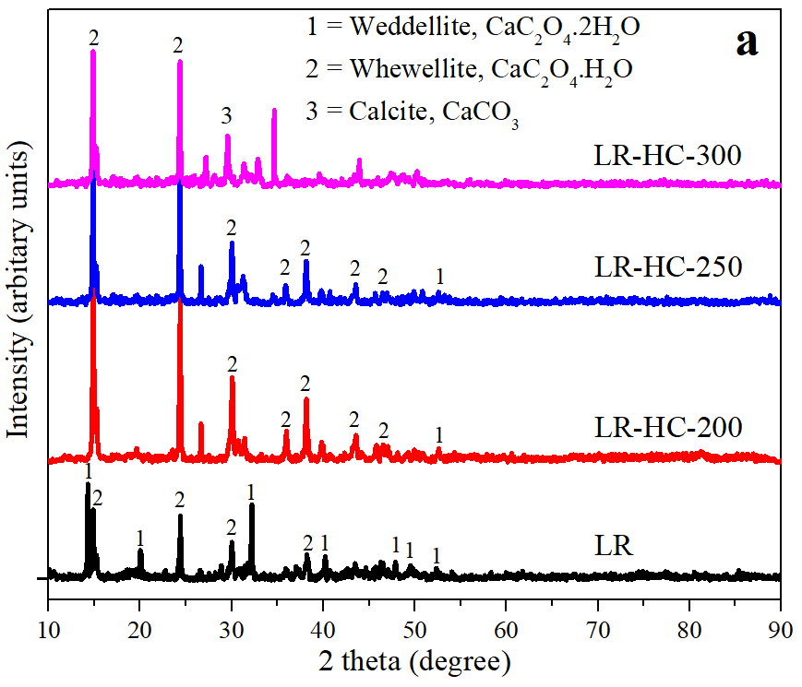 | 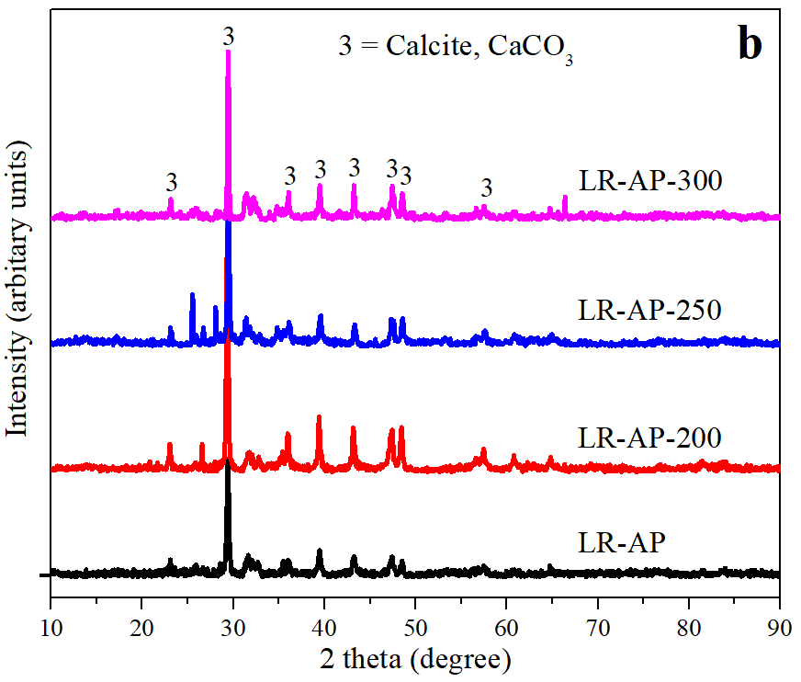
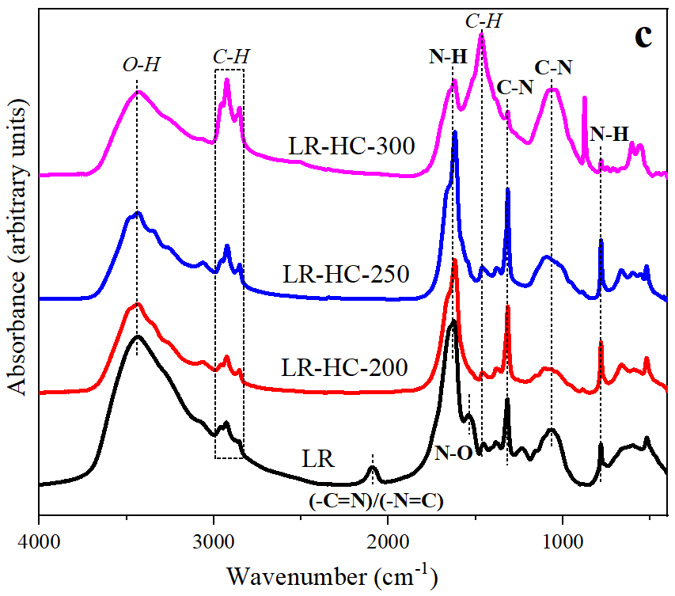 | 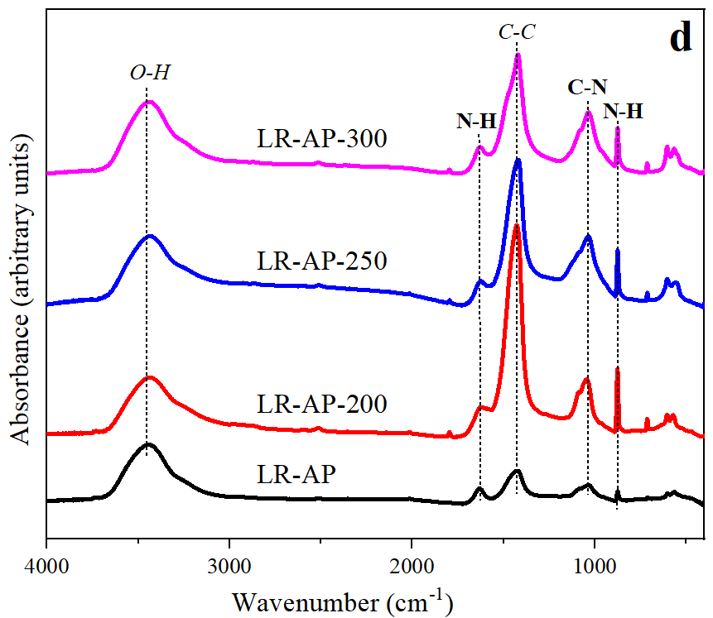
Fig. 1. XRD spectra of LR, LR-HCs (a) and LR-APs (b), and FT-IR spectra of LR, LR-HCs (c) and LR-APs (d)
  - TG/DTG of LR, LR-HCs, and LR-APs
The TG/DTG was performed to study the thermal behavior of LR samples. The TG/DTG analysis was carried out in an N₂ atmosphere with a temperature function (Fig. S3). For a better understanding of DTG analysis, DTG curves were divided into three phases for LR and LR-HCs (Fig. S3. (a)). The evaporation of moisture contents of LR samples was attained at 105 °C. Therefore, Phase Ⅰ (105 - 385 °C) was assigned to LR weight loss due to the dominant decomposition of proteins and other biodegradable components as well as the evaporation of any volatiles. Phase Ⅱ (385 - 509 °C) was ascribed to the loss of aromatics formed by aliphatic particle disintegration and recombination and degradation of remaining antibiotic residues. Phase ⅠⅡ of DTG curves (630 - 744 °C) was attributed to the degradation of minerals (e.g. CaCO₃) present in LR and LR-HCs (Yang et al., 2015; Zhu et al., 2016). The weight of the samples left at 800 °C was denoted as the residual weight. The residual weight of LR-HCs increased with increasing HTC temperature.
LR-APs showed simple DTG curves. LR-AP and LR-AP-200 have two phases, while LR-AP-250 and LR-AP-300 showed only one phase. Prior pyrolysis treatment at 700 °C would have already removed moisture and volatile compounds of LR-APs. The phase Ⅰ (345 - 624 °C) of LR-AP and LR-AP-200 was assigned to the aromatic loss and degradation of antibiotic residues, and the phase Ⅱ (624 - 734 °C) was attributed to the decomposition of minerals (CaCO₃) present in samples (Fig. S3. (b)). LR-AP-250 and LR-AP-300 showed only one phase (521 - 734 °C) of the minerals degradation because pyrolysis had already degraded most of the lighter aliphatics, and aromatics. The presence of CaCO₃ for LR-APs in XRD spectra is in good agreement with the TG/DTG results. The residual weights of LR-APs were much higher than those of LR-HCs. Features of the TG/DTG investigation of LR, LR-HCs, and LR-APs are tabulated in Table S1.
  - Characterization of N and P species during HTC and pyrolysis
XPS analysis was conducted for N and P species present in LR samples. Binding energies of N 1s and P 2p3 of LR samples were documented with a corrected peak of C 1s at 284.5 in identical situations.
    - XPS of N species of LR, LR-HCs, and LR-APs
The N peaks were examined and evaluated for probable Pyridinic-N, Amine-N, Protein-N, Pyrrolic-N, and Quaternary-N (He et al., 2015; Zhu et al., 2016) and graphical results are shown in Fig. 2. In deconvolution of the spectra for LR, significant components of the peak were Pyridinic-N and Amine-N species, and lesser intensive peaks for Protein-N and Pyrrolic-N (Fig. 2. (a)). During the fermentation process of LR, Pyridinic-N and Pyrrolic-N formed from the degradation process. The Pyridinic-N was the major N species in the raw LR, accounting for around 55 % of total N in LR. The amount of other N species (Amine-N, Protein-N, Pyrrolic-N) was 25.8 %, 12 %, and 6.9 % apart. HTC treatment of LR enhanced Protein-N and Pyrrolic-N contents in hydrochars. Quaternary-N was not observed for LR but increased for LR-HCs. In addition, HTC treatment promoted the formation of Quaternary-N from the transformation of pyridinic-N and pyrrolic-N (He et al., 2015). The proportion of N species in the XPS spectra is shown in Table S2. Deconvolution spectra of LR-AP showed a unique peak pattern compared with other LR-APs (i.e. LR-AP-200, -250 and -300). LR-AP-250 has lower FWHM in deconvoluted spectra for all N peaks compared to those of other LR-APs. Pyridinic-N, Amine-N, and Pyrrolic-N has shown variations while Protein-N and Quaternary-N are stable for LR-APs (Fig. 2. (b)). Furthermore, the less intense peaks of Quaternary-N were seen in LR-APs. From XPS spectra, a new N peak was found attributed to the Quaternary-N in LR-HCs and LR-APs. It agrees with previous research where it described less stable N species tended to condense into more stable ones through the ring condensation (Tian et al., 2013).
    - FT-IR of N species of LR, LR-HCs, and LR-APs
The transformation of N species was also demonstrated by FT-IR. N species are shown in bold text in Fig. 1. (c) and (d). It can be seen that dry LR shows many N species in its structure. Strong N-O stretches of nitro groups occurred at 1537 cm⁻¹, and nitrile and isonitrile compound apparent from the band at 2082 cm⁻¹ only appeared in LR after HTC and pyrolysis these N species decomposed. This shows the decrease of N contents in LR-HCs and LR-APs as described in Table 1. For LR-HCs, N-H bending modes of primary and secondary amines (amine 1° and 1°/2°), and C-N stretching attributed to aromatic amine increased with HTC temperature up to 250 °C and then decreased for 300 °C. The amine content of LR-HCs was temperature-dependent. Meanwhile, C-N stretching bands were attributed to aliphatic amine and increased with HTC temperature increase. FT-IR results show that LR-HC-300 has a different peak intensity for N species in comparison to other LR-HCs. Pyrolysis activation of LR and LR-HCs changed most of N species. LR-APs display fewer peaks of N species in comparison to LR-HCs. N-H bending of primary amines (amine 1°) was displayed with the same intensity for all LR-APs. Strong and intensive N-H absorption bands for primary and secondary amines showed LR-AP-200 > LR-AP-250 > LR-AP-300 > LR-AP peak intensity trend. C-N stretching bands indicative of aliphatic amines were less intense and broader for LR-AP compared to other LR-APs. From FT-IR results, it can be concluded that compared to LR-APs, LR-HCs possess much higher N species in their composition and N species were affected during HTC and pyrolysis. Amine groups' presence in XPS and FTIR spectra are considered valuable for heavy metal ions immobilization (Venkateswarlu & Yoon, 2015).
    - XPS of P species of LR, LR-HCs, and LR-APs
The P peak was assessed as being made of two peaks from orthophosphate (ortho-P, (PO₄³⁻)) combined with pyrophosphate (pyro-P, (P₂O₇⁴⁻)), and P connected to aromatic rings of organics (Ar-P) as P species. The ortho-P/pyro-P is less stable compared to Ar-P (Qian et al., 2014). Deconvolution results of LR show 28 % ortho-P/pyro-P, and 72 % Ar-P species. XPS investigation reveals the transformation of Ar-P into ortho-P/pyro-P in LR-HCs during HTC (Fig. 2. (c)). The peak intensity of ortho-P/pyro-P was increased abruptly with HTC temperature increase from 200 to 250 °C and then comparatively decreased with a temperature rise of 300 °C. Highest ortho-P/pyro-P (78 %), and lowest Ar-P (around 22 %) can be seen for LR-HC-250 among LR-HCs. Higher ortho-P/pyro-P in LR-HC-250 will be better for heavy metal removal. Deconvolution results of LR-AP show a moderate level of P species made up of 61.4 % ortho-P/pyro-P, and 38.5 % Ar-P. LR-APs show a decreasing trend for ortho-P/pyro-P peak area as LR-AP-300 < LR-AP-250 < LR-AP-200 and increasing for Ar-P peak area as LR-AP-300 > LR-AP-250 > LR-AP-200 (Fig. 2. (d)). The lowest ortho-P/pyro-P (22 %) content and the highest Ar-P (78%) content were contained in LR-AP-300. The proportion of P species in XPS spectra is shown in Table S3.
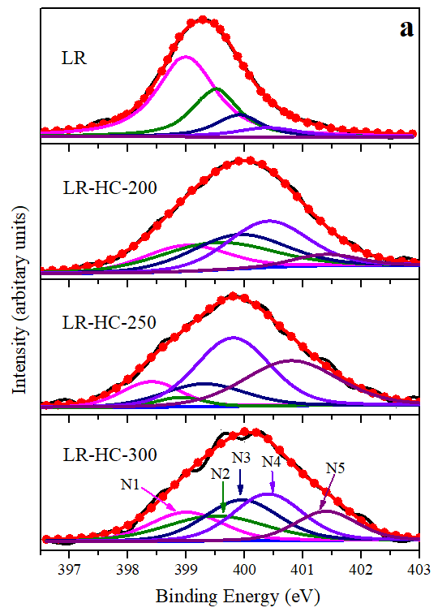 | 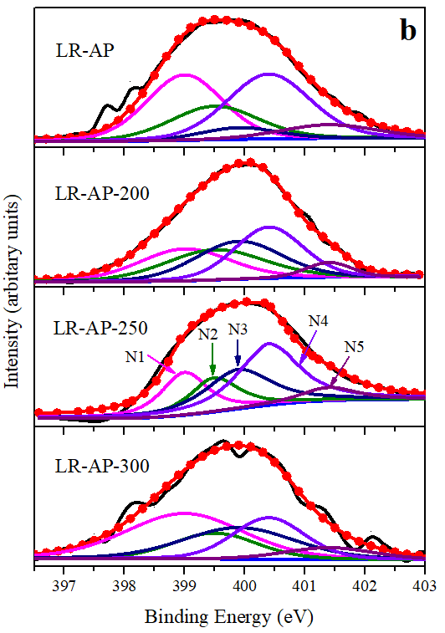
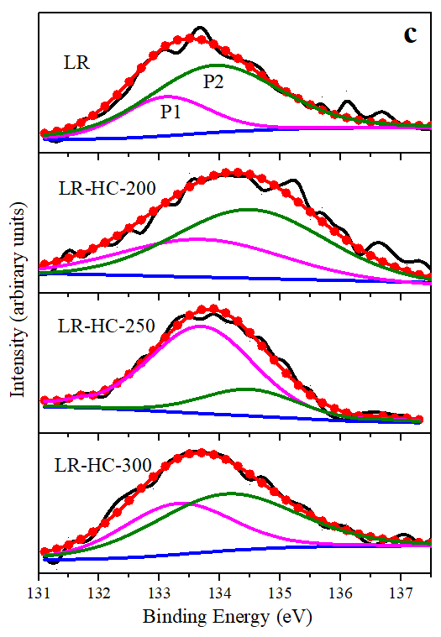 | 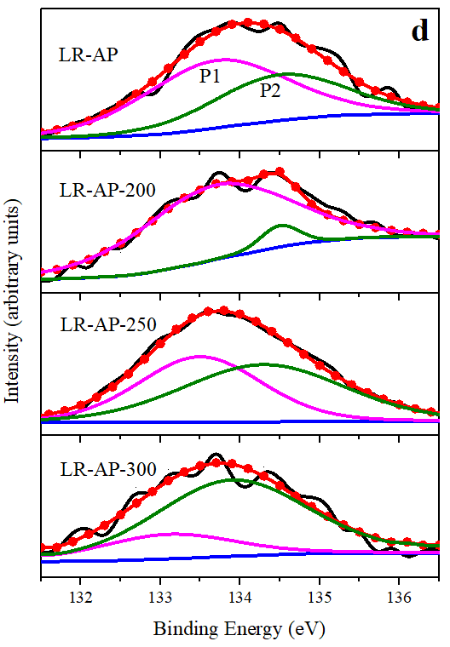
Fig. 2. XPS spectra of LR, LR-HCs and LR-APs; (a, b) N species (N1= Pyridinic-N; N2= Amine-N; N3= Protein-N; N4= Pyrrolic-N; N5= Quaternary-N) and (c, d) P species (P1= ortho-P/pyro-P; P2= Ar-P)
    - P-extraction of LR, LR-HCs, and LR-APs
Phosphorus-containing compounds play a role for Pb (II) immobilization so we designed the P-extraction so as to measure the P-fractions in LR samples (Fig. 3). Dry LR contained 15 % P-NaHCO₃, 32 % P–NaOH, 29 % P-HCl, along with 23 % P-residue during the extraction process (Table S4). Fractions P-NaHCO₃ and P–NaOH decrease, and P-HCl and P-residue increase in LR-HCs with HTC temperature. P fractions for LR-HC-200 were 5 % P-NaHCO₃, 7 % P–NaOH, 45 % P-HCl and 43 % P-residue although P-NaHCO₃ and P–NaOH disappeared completely for LR-HC-300. Only P-HCl 33 % and P-residue 67 % could be seen for LR-HC-300. We believed that the high temperature of HTC changed the P species from labile to stable ones. LR-APs mostly contain P-HCl and P-residue. LR-AP contains P-NaOH, P-HCl, and P-residue in the relative amounts 2, 37 and 61%, respectively. LR-APs did not show a P-NaOH fraction, while a minute amount of 2% P-NaHCO₃ could be seen for LR-AP-200 and 1% for LR-AP-250 but not for LR-AP-300. The fraction P-HCl for LR-AP-200, -250 and -300 is 51, 49 and 31%, respectively, and the P-residue of those samples is 46, 50 and 69%, respectively. Higher P-HCl was related to higher Ca contents (weddellite, whewellite, and calcite) found in XRD spectra. Higher P-residue might also be possible due to a higher stable Ar-P amount found in XPS spectra.
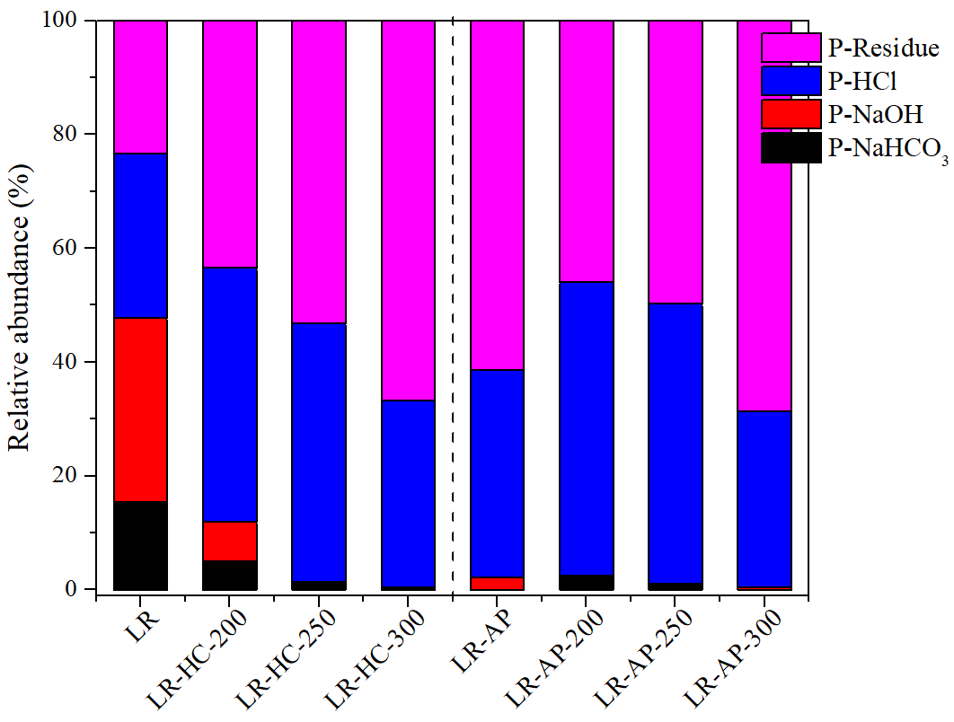
Fig. 3. The proportion of P species of LR, LR-HCs, and LR-APs
  - Immobilization performances
    - Isotherm models for Pb (II) immobilization
Langmuir and Freundlich isotherms are often used for the evaluation of monolayer sorption on homogenous and non-identical sorption on heterogeneous active sites, respectively (Tofighy & Mohammadi, 2011). In this investigation, the Freundlich isotherm provides comparatively suitable results (Table 2), and the graphical explanations of LR, LR-HC-250, and LR-AP-250 are shown in Fig. 4. (a). All samples show a higher correlation coefficient R² (above 0.98) except LR-AP and LR-HC-300. The results show that direct pyrolysis of dry LR enhanced the Pb (II) immobilization, but experimental results could not be matched well with isotherm models. Consecutive HTC and pyrolysis improved the immobilization of Pb (II) ions along with the best acceptable fit of data with the Freundlich isotherm. In addition, Fig. S4 describes the effect of initial concentration on the immobilization of Pb (II) onto LR, LR-HCs, and LR-APs. LR-HCs and LR-APs display better Pb (II) removal performance than dry LR, while LR-HC-300 exhibited an unusual trend among all LR samples. Different trends in the XRD spectra show that HTC at 300 °C causes saturation of active sites on LR-HC-300 and, in response, less availability of active sites for Pb (II) ions. All LR samples show high Freundlich constent K_{f} value, in addition, LR-APs with the highest ones. Values of n below one for all samples except LR-HC-300 describe the feasibility of Freundlich isotherm for all LR samples. It can be determined that on a surface, physical and chemical immobilization could happen simultaneously as ions immobilize on upper layers physically while those of on underlying layers are immobilized chemically (El-Araby et al., 2017). So as to check the credibility of LR samples, a comparative analysis of different adsorbents for the Pb (II) removal from aqueous solution is shown in Table S5.
Table 2. Freundlich isotherm model parameters for LR, LR-HCs, and LR-APs
Sample | K_{f} (mg^{1-n} L^{n} g⁻¹) | n | R²
LR | 3.65 | 0.99 | 0.980
LR-HC-200 | 4.60 | 0.95 | 0.991
LR-HC-250 | 3.21 | 0.84 | 0.990
LR-HC-300 | 12.4 | -2.41 | 0.504
LR-AP | 29.2 | 0.68 | 0.755
LR-AP-200 | 713 | 0.44 | 0.983
LR-AP-250 | 977 | 0.40 | 0.991
LR-AP-300 | 668 | 0.43 | 0.985
    - Pb (II) Immobilization by LR, LR-HCs, and LR-APs
The amount of Pb (II) immobilized was measured as a function of contact time for LR, LR-HC-250, and LR-AP-250 as representatives of dry LR, LR-HCs, and LR-APs, respectively (Fig. 4. (b)). In the beginning, LR and LR-HC-250 slowly enabled Pb (II) immobilization reaching equilibrium at 300 min. The slow and steady effect of dry LR and LR-HC-250 indicated that immobilization could be done physically with little chemical assistance. Hydroxyl and amine groups evident from the FT-IR spectra could play a part in surface immobilization. On the other end, LR-AP-250 outperformed and achieved the highest Pb (II) immobilization at more than 74.7 mg g⁻¹ in just 60 min. The degree of mass transfer of the Pb (II) ions from aqueous solution to the active sites of LR-AP-250 shows faster Pb (II) removal. Consecutive HTC and pyrolysis treatment of LR-AP-250 are attesting the higher Pb (II) immobilization capacity. Furthermore, a higher content of ash and Ca species in LR-AP-250 were contributors to the immobilization of heavy metal ions. Zhu et al. prepared porous carbon (PC) from hydrochar through pyrolysis (300–700 °C) and stated that the PC formed at higher temperatures was well carbonized and presented higher removal efficiency for organic contaminant (Zhu et al., 2014b). For a better comparison of kinetic results, equilibrium time was adjusted to 300 min for LR and LR-HC-250 and 60 min for LR-AP-250.
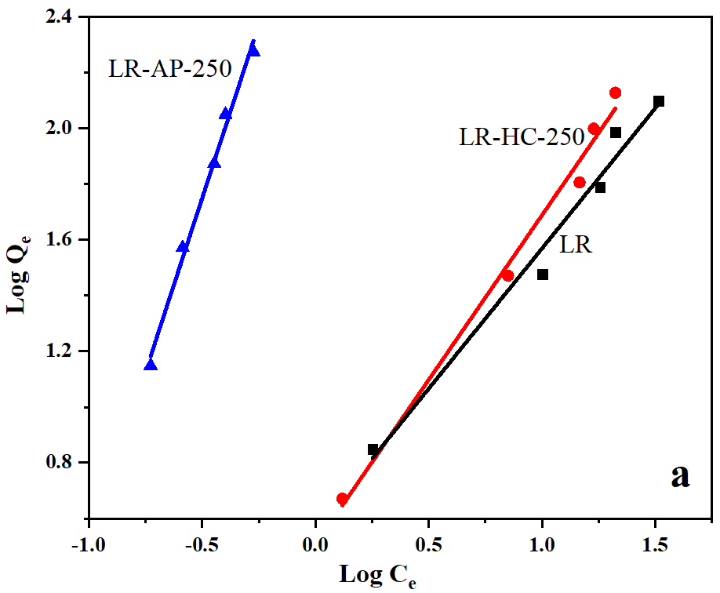
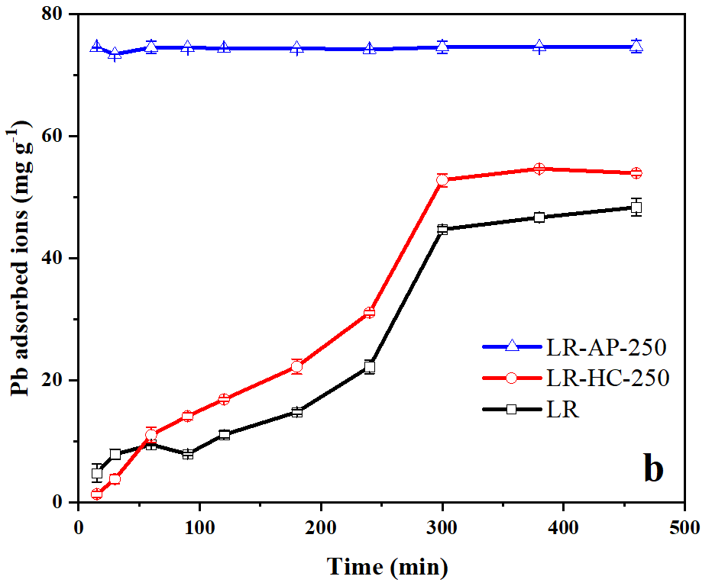
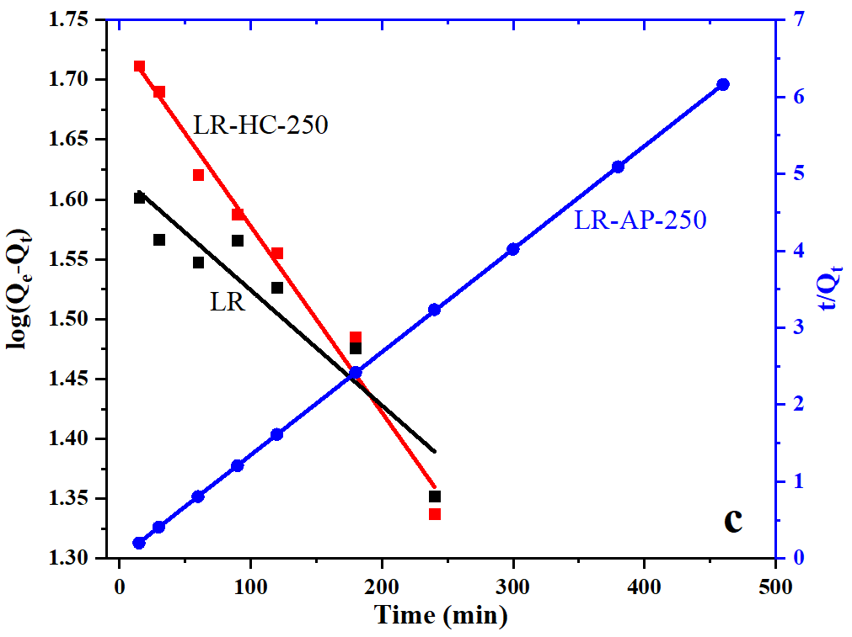
Fig. 4. Freundlich isotherm model (a), Pb (II) immobilization as a function of contact time (b) and Kinetic models (c) of LR, LR-HC-250, and LR-AP-250
    - Kinetic models for Pb (II) immobilization
For kinetic studies, linear forms of pseudo-1st-order and pseudo-2nd-order models were established for LR, LR-HC-250, and LR-AP-250. Results were evaluated with linear regression shown in Table 3. Interestingly, experimental LR and LR-HC-250 results have revealed relations with calculated parameters of pseudo-1st-order while LR-AP-250 followed the pseudo-2nd-order model (Fig. 4. (c)). The evaluated value of Qe shows a near match with the experimental value, and relatively higher R² for LR and LR-HC-250 shows a kinetic fit with a pseudo-1st-order model. Thus, pseudo-1st-order model fit demonstrates that immobilization was dependent on Pb (II) solution concentration and the available active sites on LR samples in equilibrium through the reversible process (Li et al., 2015a). Our previous study also stated that antibiotic residue derived hydrochars produced from microwave-assisted hydrothermal liquefaction applied for Pb²⁺ removal showed good agreement with a pseudo-1st-order model (Ahmad et al., 2019). On the contrary, LR-AP-250 that displays similar experimental and evaluated Qe with perfect correlation coefficient (R² = 1) is best fitted to a pseudo-2nd-order model. A faster initial immobilization was a hint of chemisorption mechanism as it relates the exchange of valence forces or electrons between adsorbate and adsorbent (Tofighy & Mohammadi, 2011).
Table 3. kinetic models’ parameters for LR, LR-HC-250, and LR-AP-250
Pseudo-1st-order | Q_{e} (exp.) | Q_{e} (cal.) | K₁ | R²
Sample | (mg g⁻¹) | (mg g⁻¹) | (min⁻¹)
LR | 44.7 | 41.7 | 0.0023 | 0.889
LR-HC-250 | 53.8 | 54.1 | 0.0036 | 0.979
Pseudo-2nd-order | Q_{e} (exp.) | Qe (cal.) | K₂ | R²
Sample | (mg g⁻¹) | (mg g⁻¹) | (g mg⁻¹ min⁻¹)
LR-AP-250 | 74.7 | 74.6 | 0.037 | 1.00
- Pb (II) post immobilization mechanism of LR, LR-HCs, and LR-APs
XRD analysis was used to analyze Pb (II) immobilization mechanisms on LR samples. LR and LR-HCs were assigned with PbC₂O₄ peaks (Fig. 5. (a)). Dry LR and LR-HC-300 contained few PbC₂O₄ peaks. Most of the PbC₂O₄ peaks were found in LR-HC-200 and LR-HC-250. Thus, PbC₂O₄ peaks in LR-HC-200 and LR-HC-250 have seen at a 2θ of 18.5, 19.4, 23.5, 26.1, 26.9 and 34.7° and describing the reason of higher Pb (II) removal by LR-HC-200 and LR-HC-250. Pre and Pb (II) post immobilization XRD analysis described the ion-exchange interaction between Ca²⁺ and Pb²⁺ ions. Before immobilization, XRD spectra showed that Ca²⁺ was a significant part of LR samples, but Ca²⁺ is less intense or, somehow, missing in the Pb (II) post immobilization XRD analysis. Again, LR-HC-300 shows a different trend, in contrast to LR-HC-200 and LR-HC-250, with few peaks due to Pb (II) immobilization. This indicated that LR-HC-300 performed worst and unfavorable Pb (II) immobilization was due to compositional changes during HTC.
LR-APs show prominent peaks for PbCO₃ and Pb₅(PO₄)₃OH. LR-AP shows different peaks than other LR-APs (LR-AP-200, -250 and -300) presented in Fig. 5. (b). The highest peak of PbCO₃ at a 2θ of 24.8° and that of Pb₅(PO₄)₃OH at a 2θ of 30.1° for LR-AP. Pb₅(PO₄)₃OH was also observed in the XRD spectra of amino-functionalized hydrochar in Pb²⁺ immobilization by Chen et al. (Chen et al., 2015). The intensity of peaks is affected by temperature increase. Overall, the arrangement of peaks was the same as for all LR-APs. A prominent PbCO₃ peak lies at a 2θ of 24.8° with the highest intensity and Pb₅(PO₄)₃OH at a 2θ of 31.2° for LR-AP-200, -250 and -300.
The expected mechanism of Pb (II) ions on LR, LR-HCs and LR-APs could be explained with the help of XRD spectra in context of below mentioned double replacement equations.
2CaC₂O₄.H₂O + Pb²⁺ = 2PbC₂O₄ + Ca²⁺ + 2H₂O Eq. 1.
2CaC₂O₄ + Pb²⁺ = 2PbC₂O₄ + Ca²⁺ Eq. 2.
2CaCO₃ + Pb²⁺ = 2PbCO₃ ↓+ Ca²⁺ Eq. 3.
2Ca₅(PO₄)₃(OH) + 5Pb²⁺ = 2Pb₅(PO₄)₃OH ↓+ 5Ca²⁺ Eq. 4.
The substitution of metal cations (Pb²⁺) to Ca²⁺ ions present in P-materials is presumably responsible for the immobilization process, called an ion-replacement or substation (Zeng et al., 2017). Zhang et al. demonstrated that Pb²⁺ ions could be replaced/exchanged with Ca²⁺ ions in the aqueous phase (Zhang et al., 2018). Similarly, PbC₂O₄ and PbCO₃ appeared by exchanging Pb²⁺ with Ca²⁺ of CaC₂O_{4,} and CaCO₃ compounds (Eq. 1., 2., and 3.) had shown in XRD spectra (Fig. 1. and 5.). Ca₅(PO₄)₃(OH) was formed during the aqueous phase and the exchange of Pb²⁺ with Ca²⁺ formed Pb₅(PO₄)₃OH according to Eq. 4. Active P-OH sites on Ca₅(PO₄)₃(OH) in LR samples were complementary in the immobilizing of Pb (II) ions. Higher Ca²⁺ content shown in XRD spectra can also be supported by elemental analysis and P-extraction results which show higher Ca and P-HCl contents, respectively. It is elucidated from XRD results that Pb (II) adsorption reaction mechanism is mainly determined by the content of C₂O₄²⁻ for LR-HCs and PO₄³⁻ and CO₃²⁻ for LR-APs. Furthermore, surface properties (surface complexion and its coprecipitation) have an influence on Pb (II) immobilization in P-compounds (Koptsik, 2014). Moreover, versatile oxygenated and N functional groups in LR samples will be available for surface immobilization. In addition, precipitation is employed for heavy metals removal with common precipitants being OH⁻, CO₃²⁻ and S²⁻ and metals precipitated as hydroxide, carbonates, and sulfide, respectively (Eckenfelder, 1989). In the above mechanism, PbCO₃ and Pb₅(PO₄)₃OH precipitates were a probable reason for higher Pb (II) removal using LR-APs. For better process outcomes, the pH of samples was kept 5 - 6. LR-APs show higher ash contents, as mentioned in Table 1. The higher ash content in samples is considered helpful in metals immobilization through precipitation response (Rawal et al., 2016).
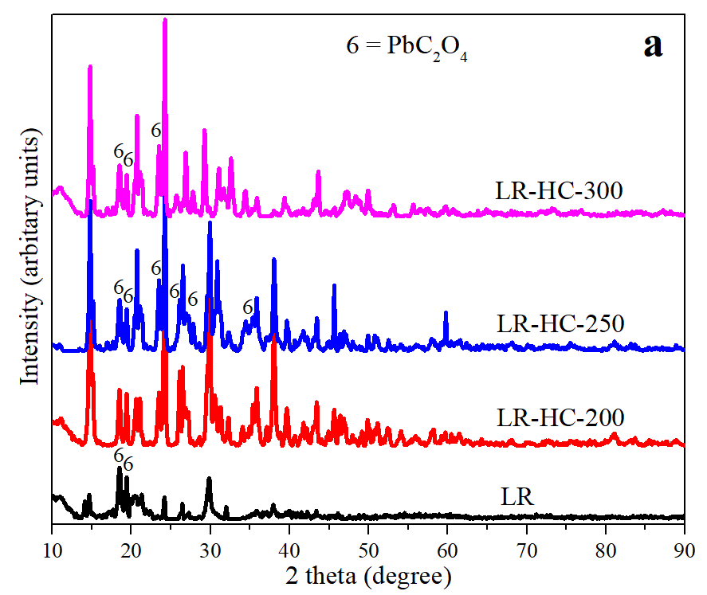 | 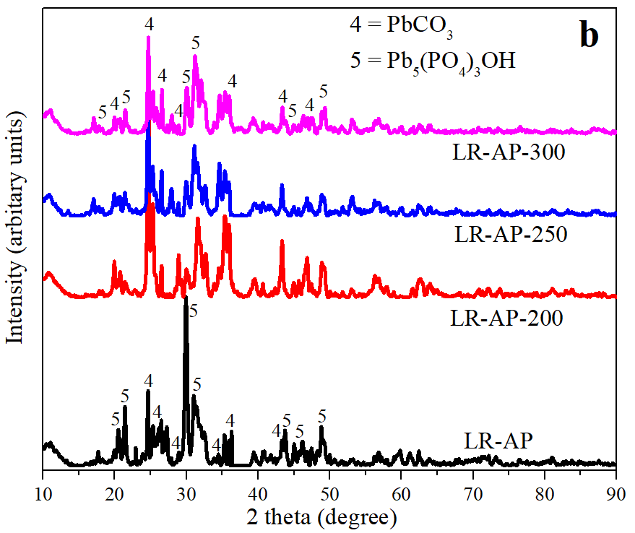
Fig. 5. XRD spectra of Pb (II) post immobilized LR, LR-HCs (a) and LR-APs (b)
The full-spectrum XPS analysis of LR, LR-HC-250, and LR-AP-250 after Pb (II) immobilization is displayed in Fig. S5. (a). Pb 4f peaks are clearly seen in all three samples; the absolute peak of Pb 4f of LR-AP-250 proves the higher immobilization rate of this sample for Pb (II) removal. Peaks of P 2p and N1s were also being transformed during the immobilization process and post Pb (II) immobilized peaks were more distinct. For a better understanding of Pb (II) immobilization, the deconvolution of Pb spectra was further interpreted as Pb 4f_{7/2} and Pb 4f_{5/2} (Yu et al., 2016). The highest intensity of Pb 4f_{7/2} and Pb 4f_{5/2} was obtained for LR-AP-250. LR and LR-HC-250 had shown the relatively lesser strength of Pb 4f peaks in comparison to LR-AP-250 (Fig. S5. (b)). Higher intensity of independent Pb 4f_{7/2} and Pb 4f_{5/2} peaks was proven for higher immobilization of Pb (II) ions on LR-AP-250. Results attained from XRD, and XPS spectra suggest that Pb (II) immobilization on LR samples was attributable to the ion-exchange/substitution mechanism for LR and LR-HC-250 and also included precipitation mechanism for LR-AP-250. Moreover, control of van der Waals forces for moderate surface energy might cause a higher Pb (II) removal (Wang et al., 2018c). Surface immobilization could also be considered owing to the presence of hydroxyl, amine and other surface functional groups on LR samples (Fig. 1. and 2.). Higher N content in LR may take part in surface immobilization mechanism. It can be stated that P species took part in ion-exchange and precipitation mechanism and probably N species in surface immobilization. Thus, it is shown that consecutive treatment of LR samples via HTC and pyrolysis leads to improved heavy metals immobilization from aqueous solutions. In future research, these LR samples could be utilized for other heavy metals removal from aqueous solutions.
- Conclusion:
In this study, the effective utilization of lincomycin residues was demonstrated. LR-HCs were obtained from HTC and LR-APs by consecutive HTC and pyrolysis treatment and showed the interesting transformation of P and N species in LR samples. Characteristic techniques proved that P and N transformed during HTC and pyrolysis. Immobilization of Pb (II) ions was studied using synthesized LR samples. Immobilization results corresponded with standard kinetic (pseudo-1st-order and pseudo-2nd-order) and isotherm (Freundlich) models. Generally, LR-APs show the highest immobilization capacity due to higher P species possession. Immobilization mechanism studies show that that P species took part in ion-exchange and precipitation mechanisms and probably N species in surface immobilization. So it concluded that consecutive treatment of LR with HTC and pyrolysis has an advantageous effect on Pb (II) removal from solutions, and P and N transformation contribute to Pb (II) immobilization.
Abbreviation and nomenclature
LR = Lincomycin residue
LR-HCs = LR derived hydrochar samples
LR-APs = LR activated pyrolyzed samples
LR-HC-200 = LR derived hydrochar obtained via HTC at 200 °C temperature
LR-HC-250 = LR derived hydrochar obtained via HTC at 250 °C temperature
LR-HC-300 = LR derived hydrochar obtained via HTC at 300 °C temperature
LR-AP = LR activated pyrolyzed sample obtained from pyrolysis of dry LR
LR-AP-200 = LR activated pyrolyzed sample obtained from pyrolysis of LR-HC-200
LR-AP-250 = LR activated pyrolyzed sample obtained from pyrolysis of LR-HC-250
LR-AP-300 = LR activated pyrolyzed sample obtained from pyrolysis of LR-HC-300
XRD = Powder X-ray diﬀraction
FT-IR = Fourier transform-infrared spectroscopy
XPS = X-ray photoelectron spectroscopy
TG/DTG = Thermogravimetry/derivative thermogravimetry
Acknowledgments
This study was supported by the National Natural Science Foundation of China (No. 21577025, 21876030), and the International Cooperation Project of Shanghai Municipal Science and Technology Commission (No. 18230710700).
Reference:
Ahmad, S., Zhu, X., Luo, J., Shen, M., Zhou, S., Zhang, S. 2019. Conversion of phosphorus and nitrogen in lincomycin residue during microwave-assisted hydrothermal liquefaction and its application for Pb²⁺ removal. Sci. Total Environ. 687, 1381-1388.
Araújo, C.S., Almeida, I.L., Rezende, H.C., Marcionilio, S.M., Léon, J.J., de Matos, T.N. 2018. Elucidation of mechanism involved in adsorption of Pb (II) onto lobeira fruit (Solanum lycocarpum) using Langmuir, Freundlich and Temkin isotherms. Microchem. J. 137, 348-354.
Asuquo, E., Martin, A., Nzerem, P., Siperstein, F., Fan, X. 2017. Adsorption of Cd (II) and Pb (II) ions from aqueous solutions using mesoporous activated carbon adsorbent: Equilibrium, kinetics and characterisation studies. J. Environ. Chem. Eng. 5(1), 679-698.
Cantero-Tubilla, B., Cantero, D.A., Martinez, C.M., Tester, J.W., Walker, L.P., Posmanik, R. 2018. Characterization of the solid products from hydrothermal liquefaction of waste feedstocks from food and agricultural industries. J. Supercrit. Fluids. 133, 665-673.
Cao, J.-P., Li, L.-Y., Morishita, K., Xiao, X.-B., Zhao, X.-Y., Wei, X.-Y., Takarada, T. 2013. Nitrogen transformations during fast pyrolysis of sewage sludge. Fuel 104, 1-6.
Cechinel, M.A.P., de Souza, A.A.U. 2014. Study of lead (II) adsorption onto activated carbon originating from cow bone. J. Cleaner Prod. 65, 342-349.
Chen, Y., Chen, J., Chen, S., Tian, K., Jiang, H. 2015. Ultra-high capacity and selective immobilization of Pb through crystal growth of hydroxypyromorphite on amino-functionalized hydrochar. J. Mater. Chem. A. 3(18), 9843-9850.
Eckenfelder, W.W. 1989. Industrial water pollution control. McGraw-Hill.
El-Araby, H.A., Ibrahim, A.M.M.A., Mangood, A.H., Adel, A.-H. 2017. Sesame husk as adsorbent for copper (II) ions removal from aqueous solution. J. Geosci. Env. Prot. 5(07), 109.
Frišták, V., Pipíška, M., Soja, G. 2018. Pyrolysis treatment of sewage sludge: A promising way to produce phosphorus fertilizer. J. Cleaner Prod. 172, 1772-1778.
Frišták, V., Soja, G. 2015. Effect of wood-based biochar and sewage sludge amendments for soil phosphorus availability. Nova Biotechnologica et Chimica 14(1), 104-115.
Gedam, A.H., Dongre, R.S. 2015. Adsorption characterization of Pb (II) ions onto iodate doped chitosan composite: equilibrium and kinetic studies. RSC Adv. 5(67), 54188-54201.
He, C., Wang, K., Yang, Y., Amaniampong, P.N., Wang, J.-Y. 2015. Effective nitrogen removal and recovery from dewatered sewage sludge using a novel integrated system of accelerated hydrothermal deamination and air stripping. Environ. Sci. Technol. 49(11), 6872-6880.
Huang, R., Fang, C., Zhang, B., Tang, Y. 2018. Transformations of Phosphorus Speciation during (Hydro) thermal Treatments of Animal Manures. Environ. Sci. Technol. 52(5), 3016-3026.
Huang, R., Tang, Y. 2015. Speciation dynamics of phosphorus during (hydro) thermal treatments of sewage sludge. Environ. Sci. Technol. 49(24), 14466-14474.
Koptsik, G. 2014. Modern approaches to remediation of heavy metal polluted soils: a review. Eurasian Soil Sci. 47(7), 707-722.
Li, H., Lu, J., Zhang, Y., Liu, Z. 2018a. Hydrothermal liquefaction of typical livestock manures in China: Biocrude oil production and migration of heavy metals. J. Anal. Appl. Pyrolysis. 135, 133-140.
Li, Y., Liu, X., Zhang, P., Wang, X., Cao, Y., Han, L. 2018b. Qualitative and quantitative correlation of physicochemical characteristics and lead sorption behaviors of crop residue-derived chars. Bioresour. Technol. 270, 545-553.
Li, Z., Kong, Y., Ge, Y. 2015a. Synthesis of porous lignin xanthate resin for Pb²⁺ removal from aqueous solution. Chem. Eng. J. 270, 229-234.
Li, Z., Xiao, D., Ge, Y., Koehler, S. 2015b. Surface-functionalized porous lignin for fast and efficient lead removal from aqueous solution. ACS Appl. Mater. Interfaces. 7(27), 15000-15009.
Liu, C., Zhao, Q., Lin, Y., Hu, Y., Wang, H., Zhang, G. 2018a. Characterization of Aqueous Products Obtained from Hydrothermal Liquefaction of Rice Straw: Focus on Product Comparison via Microwave-Assisted and Conventional Heating. Energy Fuels 32(1), 510-516.
Liu, Y., Zhu, X., Wei, X., Zhang, S., Chen, J., Ren, Z.J. 2018b. CO₂ activation promotes available carbonate and phosphorus of antibiotic mycelial fermentation residue-derived biochar support for increased lead immobilization. Chem. Eng. J. 334, 1101-1107.
Ma, D., Zhang, G., Zhao, P., Areeprasert, C., Shen, Y., Yoshikawa, K., Xu, G. 2015. Hydrothermal treatment of antibiotic mycelial dreg: more understanding from fuel characteristics. Chem. Eng. J. 273, 147-155.
Paneque, M., De la Rosa, J., Kern, J., Reza, M., Knicker, H. 2017. Hydrothermal carbonization and pyrolysis of sewage sludges: What happen to carbon and nitrogen? J. Anal. Appl. Pyrolysis. 128, 314-323.
Qian, F., Zhu, X., Liu, Y., Hao, S., Ren, Z.J., Gao, B., Zong, R., Zhang, S., Chen, J. 2016. Synthesis, characterization and adsorption capacity of magnetic carbon composites activated by CO₂: implication for the catalytic mechanisms of iron salts. J. Mater. Chem. A. 4(48), 18942-18951.
Qian, T.-T., Li, D.-C., Jiang, H. 2014. Thermochemical behavior of tris (2-butoxyethyl) phosphate (TBEP) during co-pyrolysis with biomass. Environ. Sci. Technol. 48(18), 10734-10742.
Rawal, A., Joseph, S.D., Hook, J.M., Chia, C.H., Munroe, P.R., Donne, S., Lin, Y., Phelan, D., Mitchell, D.R., Pace, B. 2016. Mineral–biochar composites: molecular structure and porosity. Environ. Sci. Technol. 50(14), 7706-7714.
Tian, Y., Zhang, J., Zuo, W., Chen, L., Cui, Y., Tan, T. 2013. Nitrogen conversion in relation to NH3 and HCN during microwave pyrolysis of sewage sludge. Environ. Sci. Technol. 47(7), 3498-3505.
Tofighy, M.A., Mohammadi, T. 2011. Adsorption of divalent heavy metal ions from water using carbon nanotube sheets. J. Hazard. Mater. 185(1), 140-147.
Venkateswarlu, S., Yoon, M. 2015. Core–shell ferromagnetic nanorod based on amine polymer composite (Fe3O4@ DAPF) for fast removal of Pb (II) from aqueous solutions. ACS Appl. Mater. Interfaces 7(45), 25362-25372.
Wang, M., Cai, C., Zhang, B., Liu, H. 2018a. Characterization and mechanism analysis of lincomycin biodegradation with Clostridium sp. strain LCM-B isolated from lincomycin mycelial residue (LMR). Chemosphere 193, 611-617.
Wang, P., Liu, H., Fu, H., Cheng, X., Wang, B., Cheng, Q., Zhang, J., Zou, P. 2015. Characterization and mechanism analysis of penicillin G biodegradation with Klebsiella pneumoniae Z1 isolated from waste penicillin bacterial residue. J. Ind. Eng. Chem. 27, 50-58.
Wang, T., Zhai, Y., Zhu, Y., Peng, C., Xu, B., Wang, T., Li, C., Zeng, G. 2018b. Influence of temperature on nitrogen fate during hydrothermal carbonization of food waste. Bioresour. Technol. 247, 182-189.
Wang, Y.-Y., Liu, Y.-X., Lu, H.-H., Yang, R.-Q., Yang, S.-M. 2018c. Competitive adsorption of Pb (II), Cu (II), and Zn (II) ions onto hydroxyapatite-biochar nanocomposite in aqueous solutions. J. Solid State Chem. 261, 53-61.
Xiao, X., Chen, B., Zhu, L., Schnoor, J.L. 2017. Sugar cane-converted graphene-like material for the superhigh adsorption of organic pollutants from water via coassembly mechanisms. Environ. Sci. Technol. 51(21), 12644-12652.
Yang, L., Zhang, S., Chen, Z., Wen, Q., Wang, Y. 2016. Maturity and security assessment of pilot-scale aerobic co-composting of penicillin fermentation dregs (PFDs) with sewage sludge. Bioresour. Technol. 204, 185-191.
Yang, S., Zhu, X., Wang, J., Jin, X., Liu, Y., Qian, F., Zhang, S., Chen, J. 2015. Combustion of hazardous biological waste derived from the fermentation of antibiotics using TG–FTIR and Py–GC/MS techniques. Bioresour. Technol. 193, 156-163.
Yu, H., Liu, J., Shen, J., Sun, X., Li, J., Wang, L. 2016. Preparation of MnOx-loaded biochar for Pb²⁺ removal: adsorption performance and possible mechanism. J. Taiwan Inst. Chem. Eng. 66, 313-320.
Zeng, G., Wan, J., Huang, D., Hu, L., Huang, C., Cheng, M., Xue, W., Gong, X., Wang, R., Jiang, D. 2017. Precipitation, adsorption and rhizosphere effect: the mechanisms for phosphate-induced Pb immobilization in soils—a review. J. Hazard. Mater. 339, 354-367.
Zhang, G., Ma, D., Peng, C., Liu, X., Xu, G. 2014. Process characteristics of hydrothermal treatment of antibiotic residue for solid biofuel. Chem. Eng. J. 252, 230-238.
Zhang, Z., Wang, X., Wang, H., Zhao, J. 2018. Removal of Pb (II) from aqueous solution using hydroxyapatite/calcium silicate hydrate (HAP/CSH) composite adsorbent prepared by a phosphate recovery process. Chem. Eng. J. 344, 53-61.
Zhu, X., Liu, Y., Luo, G., Qian, F., Zhang, S., Chen, J. 2014a. Facile fabrication of magnetic carbon composites from hydrochar via simultaneous activation and magnetization for triclosan adsorption. Environ. Sci. Technol. 48(10), 5840-5848.
Zhu, X., Liu, Y., Qian, F., Shang, H., Wei, X., Zhang, S., Chen, J., Ren, Z.J. 2018. Carbon transmission of CO2 activated nano-MgO carbon composites enhances phosphate immobilization. J. Mater. Chem. A. 6(8), 3705-3713.
Zhu, X., Liu, Y., Zhou, C., Luo, G., Zhang, S., Chen, J. 2014b. A novel porous carbon derived from hydrothermal carbon for efficient adsorption of tetracycline. Carbon 77, 627-636.
Zhu, X., Liu, Y., Zhou, C., Zhang, S., Chen, J. 2014c. Novel and high-performance magnetic carbon composite prepared from waste hydrochar for dye removal. ACS Sustainable Chem. Eng. 2(4), 969-977.
Zhu, X., Yang, S., Wang, L., Liu, Y., Qian, F., Yao, W., Zhang, S., Chen, J. 2016. Tracking the conversion of nitrogen during pyrolysis of antibiotic mycelial fermentation residues using XPS and TG-FTIR-MS technology. Environ. Pollut. 211, 20-27.
Zhuang, X., Huang, Y., Song, Y., Zhan, H., Yin, X., Wu, C. 2017. The transformation pathways of nitrogen in sewage sludge during hydrothermal treatment. Bioresour. Technol. 245, 463-470.
Zhuang, X., Zhan, H., Song, Y., Huang, Y., Yin, X., Wu, C. 2018. Reutilization potential of antibiotic wastes via hydrothermal liquefaction (HTL): Bio-oil and aqueous phase characteristics. J. Energy Inst. 92(5), 1537-1547.

