The role of surface functionality of sustainable mesoporous materials Starbon® on the adsorption of toxic ammonia and sulfur gasses
Roxana A. Milescuª, Michael R. Dennis^{b}, C. Rob McElroyª, Duncan J. Macquarrieª, Avtar S. Matharuª, Martin W. Smith^{b}, James H. Clark^{a,}*, Vitaliy L. Budarin^{a,}*
ªGreen Chemistry Centre of Excellence, Department of Chemistry, University of York, York, UK, YO105DD
^{b}CBR Division, DSTL Porton Down, Building 231, Salisbury, UK, SP40JQ
Corresponding author: E-mail: james.clark@york.ac.uk; vitaliy.budarin@york.ac.uk

Abstract: The interest in adsorbing toxic gases nowadays is primarily due to their short- and long-term adverse health effects. It is generally accepted that the pore morphology and the surface nature play key roles in the adsorption mechanism of any molecules. The interactions between the adsorbate and adsorbent are affected by their polarity, where nonpolar surfaces would be attracted to a non-polar adsorbate, while polar surfaces have a higher affinity for polar molecules. The primary issue is access to a controllable set of materials with multiple functionalities that provide both polar and nonpolar surfaces for adsorption, which would present an advantage over single-phase adsorbents. Recently this has become available thanks to a novel class of bio-based carbonaceous materials (Starbon®). The functionality of these materials can be easily controlled by their temperature of preparation. The present work studies the nature of the surface chemistry and porosity of bio-based mesoporous materials Starbon and the role this plays in the adsorption of toxic volatile molecules such as ammonia, as a basic adsorptive and two acidic gasses (hydrogen sulphide and sulphur dioxide) using an InfraSorp optical calorimeter. Both hydrogen sulphide and sulphur dioxide adsorb better onto a hydrophobic surface, while ammonia adsorbs best onto a hydrophilic surface. The results showed that in both cases, Starbon significantly outperformed the industrially available powdered Norit® activated carbon (AC) and reacted chemically with the gasses to some extent.
Keywords: green chemistry, benign synthesis method, toxic gasses

Introduction

The ability to remove small molecule noxious gases, such as ammonia (NH₃), hydrogen sulphide (H₂S) and sulphur dioxide (SO₂), from a contaminated airstream is essential due to their adverse effects on human health. Applications such as adsorption, catalysis or gas storage rely on the surface area and surface chemistry of the carbon materials. The microporous form of carbon, activated carbon (AC), is commonly used as a dry adsorbent of such molecules from industrial sources before emission into the atmosphere. They have a high surface area, developed internal pore structure, are relatively cheap and are biodegradable (Bandosz, 2002)(Girgis and El-Hendawy, 2002). Due to the preponderance of micropores containing in AC, the diffusion of toxic molecules could potentially be limited because of filling or blocking, preventing the desorption of the adsorbates. Recent progress has shown a significantly better CO₂ adsorption capacity in comparison to AC through the pore morphology, by the introduction of mesopores (Dura et al., 2016a) (Zhang et al., 2019), which were found to afford direct and indirect access to the micropores.
Moreover, surface chemistry could further increase adsorption capability and selectivity by using different methods of surface functionalisation (Figueiredo et al., 1999). Activated carbon does not present functional groups on its surface, unless functionalised. However, approaches towards the introduction of surface functionality typically require harsh conditions that could be detrimental to the carbon pore structure (Zhi and Liu, 2016)(Babatunde, 2016)(Moreno-Castilla et al., 1998). Recently developed Starbon® technology gives the opportunity to generate a new class of bio-based mesoporous carbonaceous materials (with pore diameter around 17 nm) with tuneable surface functionality (White et al., 2009).
Mesoporous carbons were previously produced from metal activation of carbon precursors (Yasuda et al., 1997)(Kyotani, 2000), carbonisation of organic aerogels (Tamon et al., 1998) and templates and lignin (Herou et al., 2019) and polysaccharides, discussed as follow.
Starbons mostly consist of mesopores and are produced from polysaccharides (A Borisova et al., 2015) by gelation and freeze-drying to give a mesoporous aerogel which is then carbonised at different temperatures (300 – 800°C or higher). This template-free approach retains the structure of the mesoporous aerogels during carbonisation producing a range of mesoporous materials. These have a range of surface properties and functional groups from hydrophilic to hydrophobic (Shuttleworth et al., 2011) that provide the ability to optimise adsorption efficiency towards different gases (Dura et al., 2016b)(J. Attard et al., 2018).
In this study, Starbon materials prepared from three precursors (starch, alginic acid and pectin) have been assessed for their ability to adsorb acidic and basic low molecular weight gases at a temperature of 297K.

Materials and experimental methods

Materials
Due to their ability to form highly mesoporous structures, three different precursors were used to produce the Starbon employed in this study: starch, alginic acid and pectin. The starch used in this project was corn starch HYLON VII PCR from Ingredion ANZ Pty Ltd. Commercial alginic acid derived from kelp was purchased from Sigma Aldrich (now Merck). Pectin was obtained from citrus waste following a previously published methodology (Pfaltzgraff et al., 2013), using the peel of oranges sourced from a local supermarket. Activated Carbon Norit was purchased from Merck.

Starbon preparation
The organised, mesoporous Starbon® materials were synthesisedfrom natural precursors such as starch, alginic acid and pectin, without the help of a templating agent. The process of obtaining these materials occurs in three steps: gelation of polysaccharides in water, addition of t-butanol (TBA), followed by freeze-drying of the gel (Aleksandra Borisova et al., 2015). The obtained aerogel is carbonised at different temperatures: 100 °C, 300 °C 550º, 800ºC. For pectin-based materials, the orange peel was first removed, dried and then milled using a food processor and sealed for further uses. Pectin was isolated from aqueous solution and a pectin pellet was obtained. The white pellet is then treated with a solution of water/TBA and left overnight. This gel is freeze dried in small portions and ground into 1mm diameter powder, which is subsequently carbonised at the desired temperatur. All Starbon materials produced were white powders at room temperature (S/A/P000) which became pale yellow when carbonised at 100 °C and dark brown when carbonised at temperatures of 300 °C or higher.

Characterisation
The textural properties of the fabricated Starbons were evaluated using a Micromeritics ASAP2020 volumetric adsorption analyser. Adsorption characterisation data was derived from measurement of nitrogen adsorption isotherms at 77 K. Tables SI 1-3 show the BET surface areas, total pore volumes, micropore and mesopore volumes and average pore diameter for S, A, and P series materials respectively. The Barrett–Joyner–Halenda (BJH) equation (Barrett et al., 1951) was used to determine the micropore, mesopore volume and pore-size distribution of the Starbon materials. The functional groups present in samples were investigated using PerkinElmer Spectrum 400 ATR-FTIR Spectrometer with transmittance peaks in 4000-450 cm⁻¹ region, with rapid scanning (4 scans) and resolution 4 cm⁻¹ at room temperature. The elemental analyses for all prepared Starbon materials are given in Tables SI 1-3 and were conducted on an Exeter Analytical CE-440 analyser in conjunction with a Sartorius SE2 analytical balance.
The scanning electron microscopy (SEM) measurements were performed using JEOL JSM-6490LV, at 8kV from Bioscience Technology Facility, Biology Department, University of York, where the samples were mounted on alumina plates and coated with Au/Pd prior to analysis. For the transmission electron microscopy (TEM) images, the samples were suspended in ethanol and deposited onto carbon grids via solvent evaporation and then the images recorded using a Tecnai 12 BioTwin at 120 kV (Zuin et al., 2017b).
The X-ray photoelectron spectroscopy (XPS) deconvolutions were produced by Cardiﬀ Catalysis Institute at Cardiff University.

The adsorption experiments
The adsorption of gases onto Starbons at 298 K was analysed using an InfraSorp optical calorimeter, in accordance with literature procedure (Sandra et al., 2015)(Woellner et al., 2017)(Werner et al., 2018)(Wollmann et al., 2011)(Wollmann et al., 2012) Test gases were supplied by CK Special Gases Ltd (Ibstock, Leicestershire, UK) as 5000 ppm mixtures in dry air in lecture bottles. Samples (typically <20 mg) were loaded into the instrument and dry air passed through them at 70 cm³ min⁻¹ until a constant mass was achieved. The flow was then switched to pass the desired gas mixture through the sample, with any resulting temperature change being recorded. The area of the resulting peak (temperature versus time) was analysed and normalised according to the sample mass, yielding a value in K s mg⁻¹ allowing comparison between the materials.

Results and Discussion

Surface areas and pore size distributions

In this paper the Starbon materials are referred to using names based on their source (starch-“S”, alginic acid-“A” or pectin-“P” ) and the carbonisation temperature, e.g. S300 signifies starch-based Starbon carbonised at 300 °C whilst S000 represents expanded starch where no carbonisation step was applied. The various mesoporous samples demonstrate significant diversity in pore structure (Table 1) and surface functionality (Tables S1-S3 in the Supporting Information). Commercially available Norit® AC (Guo et al., 2006) was used as a reference material. Table 1 shows a very small quantity of mesopores found in Norit-AC, while the microporosity predominates. Also, the smallest pores are shown in the activated carbon with only 2 nm diameter. The amount of mesopores in Starbon materials is significant, accounting for between 60 and 100% of the total porosity and pores with diameter of 3.5-17 nm. The BET surface areas are strongly dependent on the carbonisation temperature. Materials carbonised at low temperatures have surface area below 100 m² g⁻¹, however carbonisation at higher temperatures results in a significant increase in surface area of up to 770 m² g⁻¹ (Table 1). S800 and Norit-AC possess the largest micropore volume, followed by P800, A800 and A550, while all the non-carbonised and low temperature carbonised Starbons have little or micropores (Table 1). The same data shows the “A” samples having the smallest pore diameter and the “P” samples the largest. Pore size distribution of Starbon materials was calculated from the Barrett–Joyner–Halenda (BJH) and density functional theory (NLDFT) using desorption isotherms.

Table 1 Total pore volume and pore size distribution of the Starbon materials and activated carbon before the adsorption was performed
Sample | S^{BET} surface m²/g | V_{p} ^{BJH}  cm³/g | V_{p}^{DFT}  cm³/g | Micropore vol^{BJH} cm³/g | Micropore vol^{DFT} cm³/g | Mesopore  vol^{BJH}  cm³/g | D^{BJH}  nm
AC | 641.27 | 0.1966 | 0.5235 | 0.1777 | 0.2445 | 0.0189 | 2.33
S000 | 85.62 | 0.4879 | 0.4716 | 0.0085 | 0.0098 | 0.4794 | 12.68
A000 | 83.09 | 0.4483 | 0.3919 | -0.0003 | 0.0004 | 0.4483 | 8.51
P000 | 83.62 | 1.3980 | 1.3483 | 0.0058 | 0 | 1.3922 | 3.53
S100 | 96.58 | 0.5823 | 0.5626 | 0.0142 | 0.0102 | 0.5681 | 10.63
A100 | 80.13 | 0.3624 | 0.3600 | 0.0076 | 0.0064 | 0.3548 | 11.83
P100 | 54.12 | 0.5966 | 0.7042 | 0.0116 | 0 | 0.5850 | 17.17
S300 | 291.98 | 0.6085 | 0.5565 | 0.0449 | 0.0583 | 0.5636 | 11.44
A300 | 137.29 | 0.1976 | 0.3476 | 0.0095 | 0.0157 | 0.1881 | 12.04
P300 | 100.33 | 0.5248 | 0.4384 | -0.0008 | 0.0072 | 0.5248 | 13.86
S550 | 629.61 | 0.7130 | 0.8384 | 0.1958 | 0.1888 | 0.5172 | 11.73
A550 | 508.06 | 0.6725 | 0.6699 | 0.1412 | 0.1584 | 0.5313 | 6.81
P550 | 264.17 | 0.7365 | 0.6929 | 0.0538 | 0.0534 | 0.6827 | 12.16
S800 | 773.84 | 0.6779 | 1.0245 | 0.2605 | 0.2442 | 0.4174 | 10.50
A800 | 689.20 | 0.9617 | 1.1391 | 0.1472 | 0.1755 | 0.8145 | 11.70
P800 | 631.18 | 0.9860 | 0.9970 | 0.1576 | 0.1582 | 0.8284 | 9.93

SEM and TEM analyses of Starbon materials were already described in previous literature (A Borisova et al., 2015)(Muñoz García et al., 2015)(Zuin et al., 2017a) and only starch-derived Starbon carbonised at 550 °C (P550) was studied here.

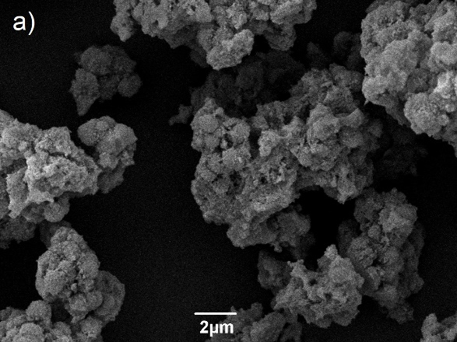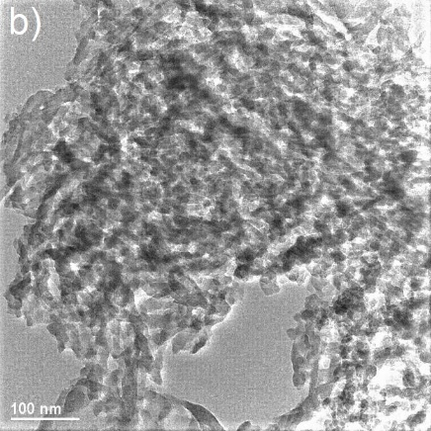

Figure 1 SEM (a) and TEM (b) images of starch-derived Starbon carbonised at 550 °C

The S550 contains nanostructured platelets or spheres in conglomerates (Figure 1a), a phenomenon more clearly observed with the help the TEM image (Fig1b), consistent with the previous literature findings.

Characterisation by infrared spectroscopy
To investigate the Starbon functionality, FTIR was performed on the prepared samples. The spectra of starch-derived, alginic acid-derived and pectin-derived Starbons (Figure 2, in red, blue and black respectively) show a decreasing intensity of the C-O stretch at ca. 1000 cm⁻¹ with increasing pyrolysis temperature.

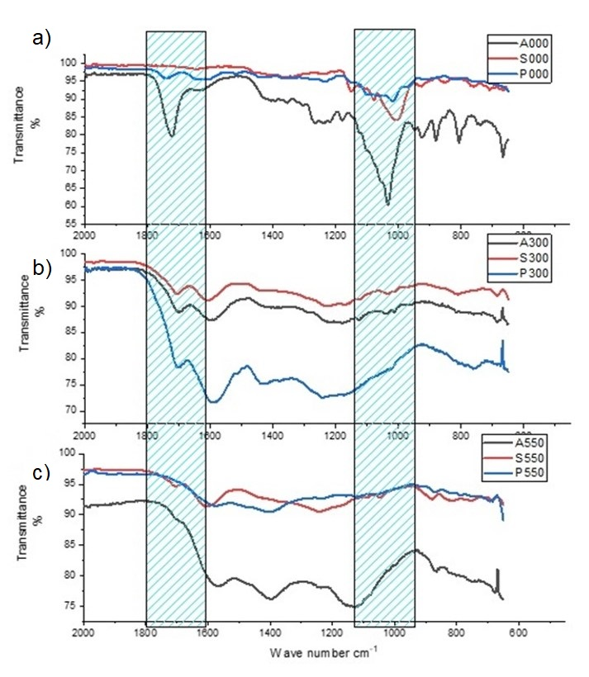
Figure 2 Infrared spectra of Starbons at RT (a), 300 °C (b) and 550 °C (c)

Additionally, the OH stretch at 3300-2500 cm⁻¹ is also seen to decrease in intensity (full spectra in ESI, Figures SI 1-3). This reduction in OH absorbance occurs simultaneously with an increase in intensity around 1600 and 850 cm⁻¹ indicative of increasing aromaticity, suggesting reduction of the Starbon surface.
The spectra of S800, A800 and P800 materials were impossible to record due to their high conductivity (Garcia et al., 2018). The result shows that Starbon functionality is significantly influenced by the carbonisation temperature, demonstrating the change of properties from “starch-like” at room temperature to more “activated carbon-like” on heating, tending towards a graphitic structure above 800°C. Carbonyl groups at 1712 cm⁻¹ (for “S” series) or 1739 cm⁻¹ (for “P” series) are evident as are the vinyl ether groups (band ranging from 950–1200 cm⁻¹ with a maximum at 1223 cm⁻¹, ESI, Figures SI 1-3). Elemental analysis data (Tables SI 1-3) shows that with increasing temperature of Starbon preparation, the relative carbon content increases. The starch and alginic acid-based materials both behave in a similar manner with the carbon content stabilising around 550 °C, although the hydrogen content continues to decrease at higher temperatures, suggesting greater conjugation/aromaticity.

Characterisation by simultaneous thermal analysis
The XPS data for the three materials (Table SI 4) show differing surface chemistries depending on of the different feedstock employed. S800 is almost exclusively organic, having a carbon content of 90.8% with a very small amount of calcium, phosphorus and sodium. This is consistent with simultaneous thermal analysis (STA) in air (Figure SI 4) which indicates a homogeneous material stable up to approximately 500 °C that thermally degrades in a single mode and with a low residual ash content (2.6 %). In contrast, A800 has a higher inorganic content on its surface, with only 81.7% carbon and increased levels of calcium (4.7%) and sodium (1.5%) (Table SI 5). STA analysis of this sample (Figure SI5) shows a broadly homogeneous thermal decomposition, but at a slightly lower temperature than that observed for S800 and with a higher ash content (8.8%). In contrast, A800 has a higher inorganic content on its surface, with only 81.7% carbon and increased levels of calcium (4.7%) and sodium (1.5%). STA analysis of this sample (Figure SI5 shows a broadly homogeneous thermal decomposition, but at a slightly lower temperature than that observed for S800 and with a higher ash content (8.8%). In contrast, the surface chemistry of P800 is significantly different, with a carbon content of 40.9% and a high level of inorganic compounds, most significantly potassium (33.6%) (Table SI 5). The STA for this material (Figure SI 6) shows a significant difference also, with thermal degradation occurring at a much lower temperature (375 °C) and in two distinct modes. The ash content is also significantly higher at 28.6%. This indicates that the inorganic content of P800 is indeed higher than that of A800 and S800 and is predominantly found on the surface of the material. Analysis of pectin extracted from oranges shows potassium is present in significant quantity and is tightly bound (chelated) s it is not removed by microwave hydrothermal treatment (J.A. Houghton et al., 2017).

The adsorption of noxious gases
The adsorption of NH₃, H₂S and SO₂ at 298 K onto porous carbon materials was analysed (Sandra et al., 2015)(Woellner et al., 2017) by direct IR-heat-release measurements ( InfraSorp Technology) seen in the Figure 3a.
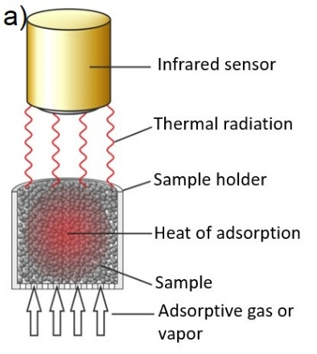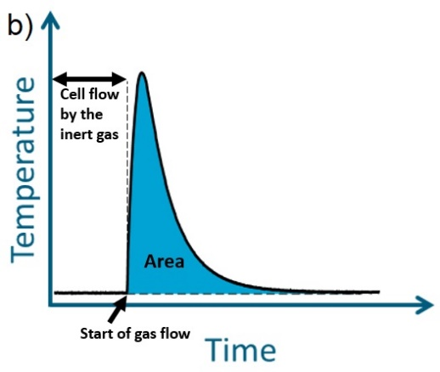

Figure 3 Schematic single cell-setup of InfraSORP (a) and sensor output during the heat of adsorption measurement (b) on Starbon materials and activated carbon
fvzdtrfg
InfraSorp technique was shown to enable the rapid estimation of heat of adsorption in order to evaluate catalytic activities. This method is fast, requires a small quantity of sample, permits screening of a large batch of samples in short time and can be used as an alternative to breakthrough measurements. InfraSorp has been previously used for NH₃ uptake in MOFs, activated carbons, zeolites (Rieth and Dinca, 2018)(Branton et al., 2017) H₂S (Sandra et al., 2015) with a maximum of NH₃ uptake registered by MOFs with 19.79 mmol NH₃ g⁻¹ (dynamic breakthrough measurement), twice than AC (Rieth and Dinca, 2018). H₂S uptake of MOFs only gave 7.25 mg⁻¹ activity, and even less in ZnO particles with 1.1-1.5 mg⁻¹ (Sandra et al., 2015) much lower than P800 from present study, with 105.7 mg⁻¹ activity (Table SI 4).
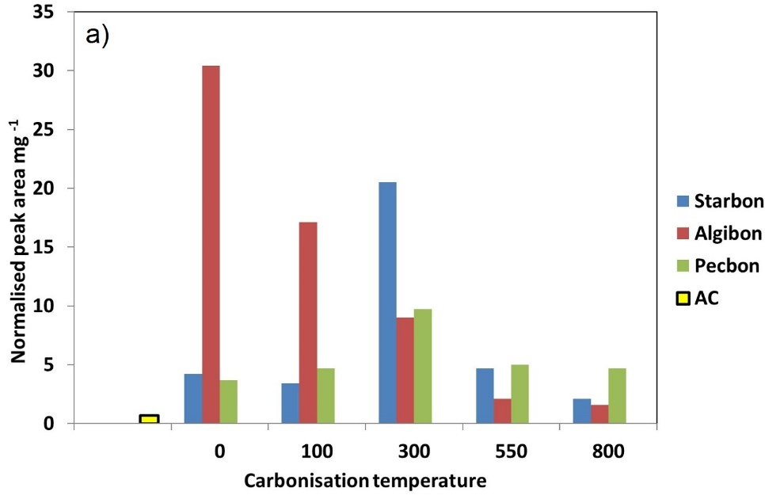
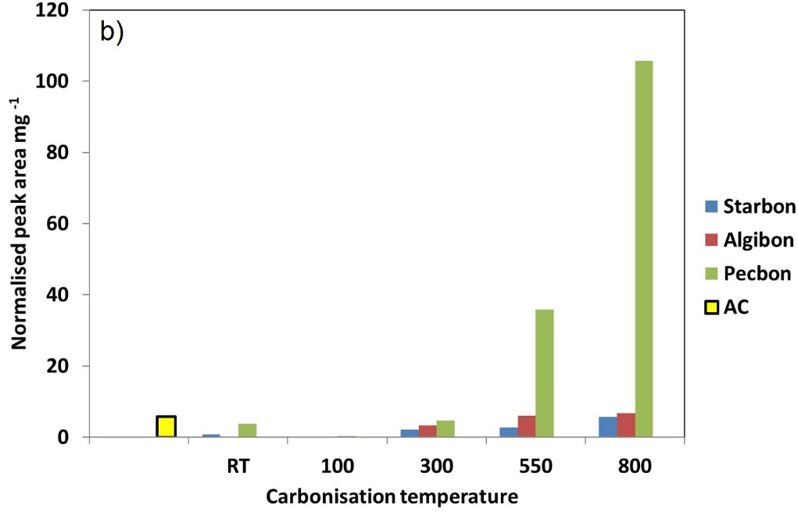
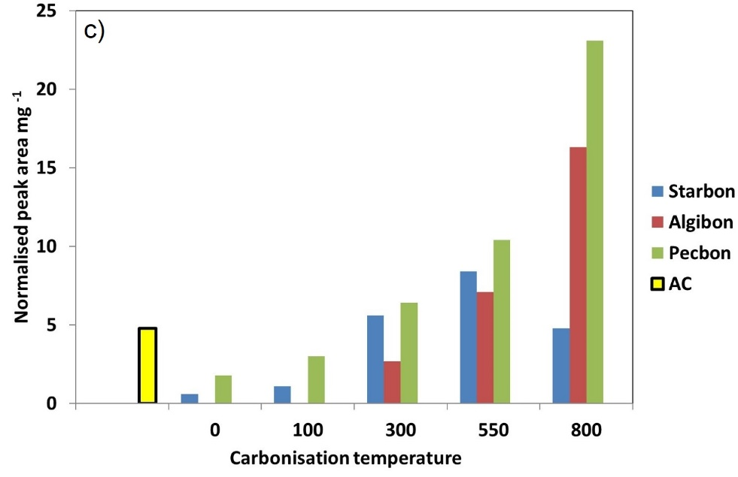
Figure 4 Normalised InfraSorp thermal responses for exposure to 5000 ppm ammonia (a), hydrogen sulfide (b) and sulfur dioxide (c) in dry atmosphere
Figure 4 summarises the InfraSorp responses of the “S, A and P” series materials to air containing 5000 ppm NH₃, H₂S and SO₂ respectively and the results are summarised in Table SI 4. As seen in Figure 4 all Starbons outperform Norit-AC in regard to NH₃ adsorption. However, the varying classes of Starbons demonstrate different trends towards NH₃. The response of “A” series Starbons to this gas reduces with increasing carbonisation temperature. The highest thermal response was seen with the un-treated A000 sample, while A800 gives the lowest response. The behaviour of “P” and “S” series materials is very different from “A” series showing minimum activity at lower preparation temperature and maximum response around 300 °C. At this temperature, S300 performs twice as well as P300. The surface area of materials, the total pore volume and micropores had not influenced the adsorption of ammonia. The nature of adsorbate and sorbent dictates the volumes of ammonia adsorbed onto the materials. The obtained data could be explained based on acid-base interaction between acidic/electrophilic functional groups (carbonyl, carboxyl) of Starbons and the basic nature of NH₃. The FTIR spectrum of the most active Starbon (A000) indicates the highest amount of carbonyl groups (peaks around 1700-1721 cm⁻¹) while the low affinity materials, A550 and S000, do not contain any such functionality (see Figures SI 1-3). Though the FTIR spectrum of S300 does not show the presence of carboxylic acid groups, they do indicate significant carbonyl functionality (peak around 1705 cm⁻¹, see Figure 2b) which in the presence of water and oxygen could be converted into the corresponding acids, or could react directly to form imines, which could then be oxidised. Hence, the results shown in Figure 4a could be explained based on the importance of electrophilic Starbon functionality for adsorption of basic/nucleophilic NH₃. Additionally previous work in this area described the reaction of NH₃ onto Starbon materials where, most likely, the OH present on the surface catalysed the dehydrogenation of amines to nitriles (J. Attard et al., 2018). This hypothesis is confirmed by XPS data for S300 (Table SI5) which shows that the amount of oxygen from the original sample S300 (26.6%) is higher in relation to the carbon content than the NH₃ treated sample (20.1%), coupled with a significant nitrogen content (11.5%). As XPS analysis requires a high vacuum (greater than 10⁻⁷ Pa) to be applied to the sample, any physisorbed species would be removed meaning this nitrogen has to be chemisorbed, most likely through imine (via reaction with aldehyde) which then could be oxidised to nitriles.
The Starbons prepared at high temperature demonstrate the biggest response to the acidic gases H₂S and SO₂. P800 shows the largest InfraSorp response to H₂S in air, while A000, A100, S000 and S100 gave little to no response. The increasing response to H₂S with increasing carbonisation temperature could potentially be explained in terms of the gas being adsorbed onto the Starbon surface via weak Van der Waals interactions with the pi-electrons (Michalak et al., 2009) that become more prevalent with increasing aromaticity. The increase in conductivity of the Starbon materials with increasing temperature is a direct result of increased conjugation of the system. This is confirmed by CHN and XPS data, as well as the inability to collect IR data for these samples. Both the A800 and S800 gave similar responses to AC, however the pectin series of Starbon showed far higher activity. The adsorption of acidic gasses H₂S and SO₂ increases with increasing surface area as a result of greater micropore volume interconnected with the mesopores of Starbon materials. Also, the functional groups from the surface have influenced the quantitative adsorption of the sulphur species onto Starbon materials as is explained later in this paper.
InfraSorp responses to SO₂ in air exhibit a broadly similar trend to H₂S, with highest thermal response for P800 (Figure 4c) followed by A800. Norit activated carbon shows a higher response to SO₂ in comparison to the low temperature materials but it has been outperformed by nearly all Starbons prepared at 300 °C or higher (Figure 4c). It was found previously (Berl, 1938) that carbonaceous materials containing oxygen, hydrogen, potassium, and sulphur are most effective for sulphur gas adsorption. This could explain why P800 adsorbs better than A800 and S800 (Table SI4).
In all cases, with the Norit AC containing more micropores than the Starbon materials, the expectation would be that this would perform better in such small molecule adsorption as mesopores are considered too large to play a role in gas capture. However a recent publication (Dura et al., 2016b) has highlighted the role of easily accessible micropores via mesoporous “transport pores’’ in the adsorption of carbon dioxide using Starbon materials, which were shown to have a greater adsorption capacity than AC. Of note and in contrast to the present work, the CO₂ adsorption process only consists of physisorption (Dura et al., 2016b).

Elemental composition of Starbons before and after adsorption
All materials were analysed post InfraSorp exposure by a number of techniques including both X-ray photoelectron spectroscopy (XPS) and elemental analysis. Elemental analysis gave consistently higher nitrogen and sulphur content on all Starbon materials as compared to data generated by XPS (Table 2). This can be explained by the elemental analysis giving the bulk content, i.e. the total nitrogen and sulphur content within the material. However, XPS only probes the chemistry on the surface of Starbon and thus would not account for material deeper in the pore structure. Additionally, elemental analysis accounts for both physisorbed and chemisorbed compounds, while XPS only gives chemisorbed nitrogen and sulphur content. This also suggests that XPS observed heteroatoms must have been chemisorbed onto the Starbon surface.

Table 2 The elemental analysis of various Starbons before and after adsorption of NH₃, SO₂ and H₂S

Adsorbent | Adsorbate | Before adsorption |  |  |  | After adsorption
 |  | N content (Wt. %) |  | S content  (Wt. %) |  | N content  (Wt. %) |  | S content (Wt. %)
 |  | CHN | XPS | CHN | XPS | CHN | XPS | CHN | XPS
S300 | NH₃ | 0 | 0 | N/A | N/A | 12.4 | 10.7 | N/A | N/A
S550 | SO₂ | 0.2 | 0.2 | 0 | 0 | 0 | 0 | 1.5 | 0.9
S800 | NH₃ | 0.1 | 0.1 | 0 | 0 | 1.4 | 0.9 | 0 | 0
A800 | SO₂ | 0.2 | 0.2 | 0.7 | 0.8 | 0 | 0 | 6.2 | 2.5
P800 | SO₂ | 0.6 | 1.7 | 1.0 | 1.2 | 0 | 0 | 4.2 | 3.5
 | H₂S |  |  |  |  | 0 | 0.1 | 7.6 | 5.4

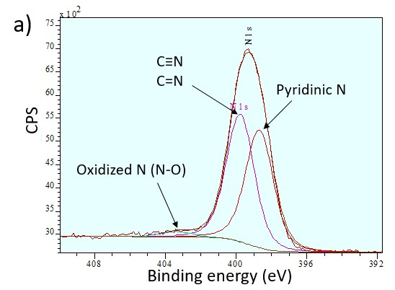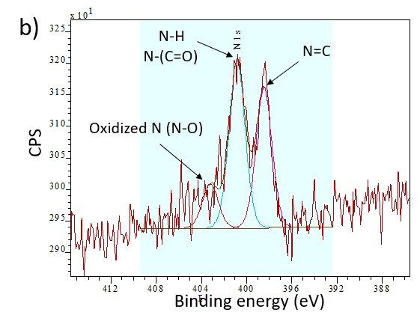

Figure 5 The X-ray Photoelectron Spectroscopy deconvolution and quantification of nitrogen species in starch-derived Starbon S300 (a) and S800 (b) after ammonia adsorption
To understand the mechanism of NH₃ adsorption, a study of the binding energy of C1s, O1s, and N1s electrons of starch Starbons prepared at different temperatures before and after adsorption was carried out. According to elemental analysis, the amount of chemisorbed nitrogen demonstrates a significantly (eleven times) higher loading on S300 °C as compared to S800 °C (Table 2), due to more acidic groups on S300 (1.16 mmol/g from XPS data) than in S800 (acidic groups 0.30 mmol/g). Deconvolution of N 1s (Figure 5) peaks for S300 (a) and S800 (b) after NH₃ adsorption shows chemisorption of this molecule onto the sample surface has occurred.
Interestingly, the Starbon nature influences the surface functionality of the obtained new materials. For the S300 sample post-NH₃ exposure, pyridinic (Wallace et al., 1989) and nitrile nitrogen-containing groups dominate (Jennifer Attard et al., 2018)(Lalitha and Manoharan, 1989) (Figure 5a). The mechanism of forming the nitriles was discussed previous research papers (Attard et al., 2018), where N-Starbons are formed using ammonia at 300 °C, a lower temperature than previously reported, (Stöhr et al., 1991) which showed the catalytic activity of activated carbon treated with ammonia at higher temperature (700-900 °C). Both results from the literature are consistent with adsorption of low temperature carbonised materials at 298 K from the present study. In this study, Starbon materials play a catalytic role in the adsorption of ammonia onto these materials in this study due to the functional groups from their surface. The mesoporous Starbons materials were used previously in other catalysis reactions due to their high surface area, large pore size and thermal and hydrothermal stabilities (White et al., 2009)(Matharu et al., 2018) (Clark et al., 2008)
The formation of nitrogen species could be as a result of the carboxylate groups from low temperature and non-carbonised alginic acid materials (A000-A300) could form ammonium salts with ammonia, which then could dehydrate to carboxylic amides to nitriles:
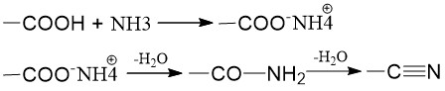
Figure 6 The formation of ammonium salt and its dehydration to form amides and nitriles

As this reaction seems to be happening at an unusually low temperature, a second route may be more likely, with immines being formed via ammonia reacting with aldehydes, which in turn could then be oxidised to nitriles:
Figure 7 The formation of imines

The imines are present in S800 after the adsorption of ammonia with a peak at 398.45 eV, due to the presence of acidic/electrophilic functional groups in a smaller amount in the high temperature carbonised Starbon than in S300 (Figure 7). The peak at 400.82 eV could be explained by the hydrating of nitriles to form amides (Gomez et al., n.d.). Amines could be formed by the reductive amination of carbonyl groups in the presence of Na from the Starbon surface as catalyst (Table SI 5)(Gomez et al., n.d.)(Alinezhad et al., 2010). First, the amination of carbonyl group by the ammonia leads to the formation of imines as intermediate and water. Then, the reduction of imines (C=N) to amines (N-H) was presumably catalysed by the sodium present on the surface of S800.
Oxidised forms of nitrogen are evident in both samples, at 403.34 for S300 and 403.18 for S800 (Batich and Donald, 1984)(Pashutski and Folman, 1989). This could be a result of oxidation of NH₃ by air or by oxygen-containing surface functionality on the Starbon.
The amount of oxidised nitrogen is higher in S300 (0.23%) than in S800 (0.12%), which indicates that interaction with oxygen-containing surface functionality is significant for the NH₃ adsorption process.

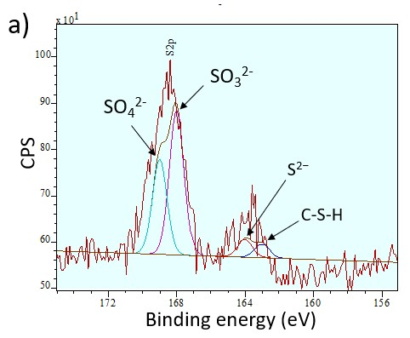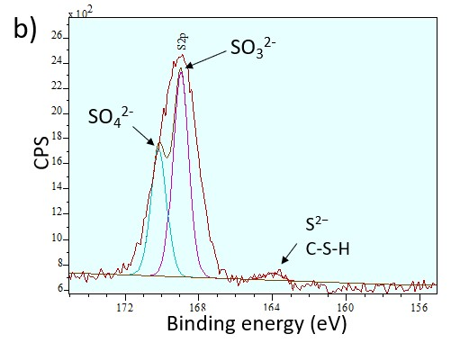

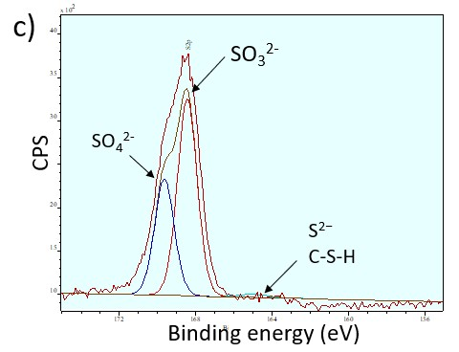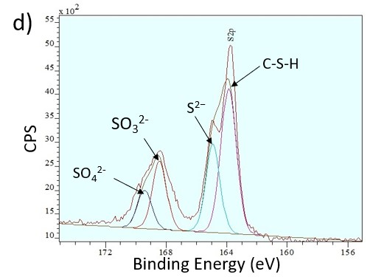

Figure 8 The X-ray Photoelectron Spectroscopy deconvolution peaks of sulfur species and their quantification after adsorption of SO₂ onto stach-based Starbon S550 (a), alginic acid-based A800 (b) and pectin-based P800 (c) and H₂S onto pectin-based P800 (d)

The S2p region of Starbons carbonised at 550 and 800 °C after SO₂ and H₂S adsorption (Figure 8) can be fitted as follows: two peaks between 163 and 165 eV, which are attributed to sulphide and thiol respectively, and two peaks with binding energy higher than 168 eV attributed to sulphites and sulphates. The individual peaks are centered 1.2 eV apart and with an area relation of 1:3 (Kappes et al., 2012). For SO₂ adsorption, all the samples tested (S550, A800 and P800) yielded 2p 3/2 peaks centered between 163.79 and 165.24 eV, with at least three times bigger area than the 2p ½ peaks, suggesting that the sulfur gas was mostly chemisorbed onto these materials. As mentioned before, the 2p ½ peaks were centered at 1.2 eV and with at least three times bigger area. H₂S adsorption onto P800 presents 2p 3/2 peaks at 163.93 and 165.13 eV and 2p ½ peaks at 168.45 and 169.65 eV, with much bigger areas, demonstrating that the biggest amount of the purged gas was chemisorbed.
The XPS results show that sulfur dioxide and hydrogen sulphide adsorption led to the formation of three sulfur species: SO₂, sulphites and sulfates, described as follows, similar to the previous studies (Guimon et al., 2001).
The evolution of sulphates could be the result of oxidation of the gas adsorbed, SO₂. This surprising result suggests that the Starbons play a catalytic role in the air oxidation of SO₂ to SO₃. According to the literature (Figueiredo and Pereira, 2010), this phenomenon of sulfur oxidation from 4+ (SO₂) to 6+ (SO₃) could be a result of the catalytic activity of pyridinic nitrogen surface functionality. Indeed, pyridinic nitrogen groups have been found in Starbons prepared at 800 °C (P800 especially, see Table SI 7). Moreover, the surface concentration of the pyridinic and quaternary groups follows the Starbon catalytic activity trend with relation to sulphur, increasing quaternary concentration from S800 (<0.1%) to A800 (<0.3%) and to P800 with a pyridinic group concentration of 1.14% (Table SI 7). Additionally, the pyridinic N-oxides present in P800 could potentially allow a form of Polonovski reaction (Kubas et al., 1979) to oxidise the sulfur centre.
The activity of surface nitrogen in RedOx reactions was proven by XPS of the samples exposed at ambient temperature (without S-containing compounds). The peak at 404.14 eV corresponds to surface nitrogen with an oxidation state of 5+ which could then be reduced while playing a role in converting SO₂ to SO₃.(Pels et al., 1995)
For hydrogen sulfide adsorption onto P800 (Figure 8d) the oxidation could lead to formation of sulfates observed at 169.65 eV (Figure 9).
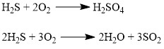
Figure 9 The oxidation mechanism of hydrogen sulfide from the oxidation number -2 (H₂S) to +6 (H₂SO₄) and +4 (SO₂)
In addition, the oxidation of H₂S could lead to the formation of SO₂ (Figure 9), which could then be further oxidised in the presence of nitrogen oxide and converted to SO₃.

Conclusions

In conclusion, the flexibility of Starbon materials in terms of biomass, feedstock and carbonisation temperature has been demonstrated by the high adsorption capacities for the gases NH₃, SO₂ and H₂S. The InfraSorp optical calorimetry method has enabled rapid screening of sixteen samples against three gases without a precise determination of the gasses uptake by mass units of adsorbent. As the Starbon materials have been tested for the first time using this tool, the breakthrough testing, desorption studies and the removal mechanisms will form part of a further study of adsorption of these gasses together with the liquid form of other toxic molecules. The physical properties of the materials including surface area, total pore volume and micropores did not influence the adsorption of ammonia, but the presence of functional groups from the surface. For NH₃ adsorption, the un-carbonised alginic acid-derived material (A000) is the most active adsorbent, with 30.4 ks mg⁻¹ ctivity, presumably due to acid-base interactions, 43 times more than microporous form of carbon, AC.
The surface area and the interconnected micropores and mesopores of Starbon materials enhanced the adsorption of acidic gasses H₂S and SO₂ together with the functional groups from the surface. The total pore volume and the micropores did not have an influence on the adsorption these two gasses. For hydrogen sulfide and sulfur dioxide, the pectin-based sample carbonised at 800 ⁰C gives the highest response, with 105.7 and 23.1 ks mg⁻¹ respectively, 5 to 18 times more than AC. The adsorption of all three small molecules was influenced by the surface chemistry at the active sites of the Starbon materials as confirmed by XPS analyses, with different mechanisms of adsorption proposed. NH₃ chemisorption may be result of its interaction with oxygen containing groups (carbonyl, carboxyl and alcohols), while sulfur-containing compounds are oxidised by air or surface oxygen to sulphites and sulphates which are then taken up by Starbon. In this case, Starbon materials have a dual role of natural catalyst and adsorbent, without the need of a prior chemical activation process, which are generally complex and non-green. This study has successfully demonstrated how Starbon not only has a simple and green synthesis, but a greater activity in adsorption of the gasses than activated carbon and the zeolites or MOFs described previously in the literature.

Acknowledgements
We thank DSTL for part-funding this research work.

References
Alinezhad, H., Tajbakhsh, M., Mahdavi, N., 2010. One-pot reductive amination of carbonyl compounds using sodium borohydride-amberlyst 15. Synth. Commun. 40, 951–956. https://doi.org/10.1080/00397910903026731
Attard, J., Milescu, R., Budarin, V., Matharu, A.S., Clark, J.H., 2018. Unexpected nitrile formation in bio-based mesoporous materials (Starbons®). Chem. Commun. 54. https://doi.org/10.1039/c7cc09586d
Attard, J., Milescu, R., Budarin, V., Matharu, A.S., Clark, J.H., 2018. Unexpected nitrile formation in bio-based mesoporous materials (Starbons®). Chem. Commun. 54, 686–688. https://doi.org/10.1039/C7CC09586D
Babatunde, O.A., 2016. Surface Modification of Activated Carbon for Improved Iodine and Carbon Tetrachloride Adsorption.
Bandosz, T.J., 2002. On the Adsorption/Oxidation of Hydrogen Sulfide on Activated Carbons at Ambient Temperatures. J. Colloid Interface Sci. 246, 1–20. https://doi.org/10.1006/jcis.2001.7952
Barrett, E.P., Joyner, L.G., Halenda, P.P., 1951. THE DETERMINATION OF PORE VOLUME AND AREA DISTRIBUTIONS IN POROUS SUBSTANCES .1. COMPUTATIONS FROM NITROGEN ISOTHERMS. J. Am. Chem. Soc. 73, 373–380. https://doi.org/10.1021/ja01145a126
Batich, C.D., Donald, D.S., 1984. X-RAY PHOTOELECTRON-SPECTROSCOPY OF NITROSO-COMPOUNDS - RELATIVE IONICITY OF THE CLOSED AND OPEN FORMS. J. Am. Chem. Soc. 106, 2758–2761. https://doi.org/10.1021/ja00322a004
Berl, E., 1938. Formation and properties of activated carbon. Trans. Faraday Soc. 34, 1040–1052. https://doi.org/10.1039/tf9383401040
Borisova, A., De Bruyn, M., Budarin, V.L., Shuttleworth, P.S., Dodson, J.R., Segatto, M.L., Clark, J.H., 2015. A Sustainable Freeze-Drying Route to Porous Polysaccharides with Tailored Hierarchical Meso- and Macroporosity. Macromol. Rapid Commun. 36, 774–779. https://doi.org/10.1002/marc.201400680
Borisova, A., De Bruyn, M., Budarin, V.L., Shuttleworth, P.S., Dodson, J.R., Segatto, M.L., Clark, J.H., 2015. A Sustainable freeze-drying route to porous polysaccharides with tailored hierarchical meso- and macroporosity. Macromol. Rapid Commun. 36, 774–779. https://doi.org/10.1002/marc.201400680
Branton, P., Leistner, M., Wöllner, M., Kaskel, S., 2017. An Innovative Technique for Rapid Screening of Cigarette Filter Adsorbents. Chem. Eng. Technol. 40, 71–75. https://doi.org/10.1002/ceat.201600232
Clark, J.H., Budarin, V., Dugmore, T., Luque, R., Macquarrie, D.J., Strelko, V., 2008. Catalytic performance of carbonaceous materials in the esterification of succinic acid. Catal. Commun. 9, 1709–1714. https://doi.org/10.1016/j.catcom.2008.01.037
Dura, G., Budarin, V.L., Castro-Osma, J.A., Shuttleworth, P.S., Quek, S.C.Z., Clark, J.H., North, M., 2016a. Importance of Micropore-Mesopore Interfaces in Carbon Dioxide Capture by Carbon-Based Materials. Angew. Chemie-International Ed. 55, 9173–9177. https://doi.org/10.1002/anie.201602226
Dura, G., Budarin, V.L., Castro-Osma, J.A., Shuttleworth, P.S., Quek, S.C.Z., Clark, J.H., North, M., 2016b. Importance of Micropore-Mesopore Interfaces in Carbon Dioxide Capture by Carbon-Based Materials. Angew. Chemie-International Ed. 55, 9173–9177. https://doi.org/10.1002/anie.201602226
Figueiredo, J.., Pereira, M.F.., Freitas, M.M.., Órfão, J.J.., 1999. Modification of the surface chemistry of activated carbons. Carbon N. Y. 37, 1379–1389. https://doi.org/10.1016/S0008-6223(98)00333-9
Figueiredo, J.L., Pereira, M.F.R., 2010. The role of surface chemistry in catalysis with carbons. Catal. Today 150, 2–7. https://doi.org/10.1016/j.cattod.2009.04.010
Garcia, A.M., Budarin, V.L., Zhou, Y.X., De Bruyn, M., Hunt, A.J., Lari, L., Lazarov, V.K., Salavagione, H.J., Morales, E., Ellis, G.J., Clark, J.H., Shuttleworth, P.S., 2018. Monolithic mesoporous graphitic composites as super capacitors: from Starbons to Starenes (R). J. Mater. Chem. A 6, 1119–1127. https://doi.org/10.1039/c7ta09338a
Girgis, B.S., El-Hendawy, A.N.A., 2002. Porosity development in activated carbons obtained from date pits under chemical activation with phosphoric acid. Microporous Mesoporous Mater. 52, 105–117. https://doi.org/10.1016/S1387-1811(01)00481-4
Gomez, S., Peters, J.A., Maschmeyer, T., n.d. The Reductive Amination of Aldehydes and Ketones and the Hydrogenation of Nitriles: Mechanistic Aspects and Selectivity Control.
Guimon, C., Gervasini, A., Auroux, A., 2001. XPS study of the adsorption of SO2 and NH3 over supported tin dioxide catalysts used in de-NOx catalytic reaction. J. Phys. Chem. B 105, 10316–10325. https://doi.org/10.1021/jp0108869
Guo, B., Chang, L., Xie, K., 2006. Adsorption of Carbon Dioxide on Activated Carbon. J. Nat. Gas Chem. 15, 223–229. https://doi.org/10.1016/S1003-9953(06)60030-3
Herou, S., Ribadeneyra, M.C., Madhu, R., Araullo-Peters, V., Jensen, A., Schlee, P., Titirici, M., 2019. Ordered mesoporous carbons from lignin: a new class of biobased electrodes for supercapacitors. Green Chem. 21, 550–559. https://doi.org/10.1039/C8GC03497D
J.A. Houghton, E. and D. of, Methodologies., V.R. for C. and P.W. using G., PhD thesis 2017, Chapter 3, 80
Kappes, M., Frankel, G.S., Sridhar, N., Carranza, R.M., 2012. Corrosion behavior of carbon steel in acidified, thiosulfate-containing brines. Corrosion 68, 872–884. https://doi.org/10.5006/0610
Kubas, G.J., Larson, A.C., Ryan, R.R., 1979. REACTIONS OF QUINUCLIDINE N-OXIDE AND OTHER AMINE OXIDES WITH SULFUR-DIOXIDE - STRUCTURE OF QUINUCLIDINE SULFUR-TRIOXIDE. J. Org. Chem. 44, 3867–3871. https://doi.org/10.1021/jo01336a026
Kyotani, T., 2000. Control of pore structure in carbon. Carbon N. Y. 38, 269–286. https://doi.org/10.1016/S0008-6223(99)00142-6
Lalitha, S., Manoharan, P.T., 1989. X-RAY PHOTOELECTRON SPECTROSCOPIC STUDIES ON SOME DITHIOLATE COMPLEXES. J. Electron Spectros. Relat. Phenomena 49, 61–75. https://doi.org/10.1016/0368-2048(89)80037-4
Matharu, A.S., Ahmed, S., Almonthery, B., Macquarrie, D.J., Lee, Y.S., Kim, Y., 2018. Starbon/High-Amylose Corn Starch-Supported N-Heterocyclic Carbene–Iron(III) Catalyst for Conversion of Fructose into 5-Hydroxymethylfurfural. ChemSusChem 11, 716–725. https://doi.org/10.1002/cssc.201702207
Michalak, W., Broitman, E., Alvin, M.A., Gellman, A.J., Miller, J.B., 2009. Interactions of SO2 and H2S with amorphous carbon films. Appl. Catal. a-General 362, 8–13. https://doi.org/10.1016/j.apcata.2009.04.008
Moreno-Castilla, C., Carrasco-Marin, F., Maldonado-Hodar, F.J., Rivera-Utrilla, J., 1998. Effects of non-oxidant and oxidant acid treatments on the surface properties of an activated carbon with very low ash content. Carbon N. Y. 36, 145–151. https://doi.org/10.1016/s0008-6223(97)00171-1
Muñoz García, A., Hunt, A.J., Budarin, V.L., Parker, H.L., Shuttleworth, P.S., Ellis, G.J., Clark, J.H., 2015. Starch-derived carbonaceous mesoporous materials (Starbon®) for the selective adsorption and recovery of critical metals. Green Chem. 17, 2146–2149. https://doi.org/10.1039/C5GC00154D
Pashutski, A., Folman, M., 1989. LOW-TEMPERATURE XPS STUDIES OF NO AND N2O ADSORPTION ON AL(100). Surf. Sci. 216, 395–408. https://doi.org/10.1016/0039-6028(89)90383-x
Pels, J.R., Kapteijn, F., Moulijn, J.A., Zhu, Q., Thomas, K.M., 1995. EVOLUTION OF NITROGEN FUNCTIONALITIES IN CARBONACEOUS MATERIALS DURING PYROLYSIS. Carbon N. Y. 33, 1641–1653. https://doi.org/10.1016/0008-6223(95)00154-6
Pfaltzgraff, L.A., De Bruyn, M., Cooper, E.C., Budarin, V., Clark, J.H., 2013. Food waste biomass: a resource for high-value chemicals. Green Chem. 15, 307–314. https://doi.org/10.1039/c2gc36978h
Rieth, A.J., Dinca, M., 2018. Controlled Gas Uptake in Metal-Organic Frameworks with Record Ammonia Sorption. J. Am. Chem. Soc. 140, 3461–3466. https://doi.org/10.1021/jacs.8b00313
Sandra, F., Klein, N., Leistner, M., Lohe, M.R., Benusch, M., Woellner, M., Grothe, J., Kaskel, S., 2015. Speeding Up Chemisorption Analysis by Direct IR-Heat-Release Measurements (Infrasorp Technology): A Screening Alternative to Breakthrough Measurements. Ind. Eng. Chem. Res. 54, 6677–6682. https://doi.org/10.1021/acs.iecr.5b01404
Shuttleworth, P.S., Parker, J., Budarin, V.L., Breeden, S.W., Macquarrie, D.J., Luque, R.L., White, R., Clark, J.H., 2011. Starbon (R): Preparation, applications and transition from laboratory curiosity to scalable product. Clean Technol. 2011 Bioenergy, Renewables, Storage, Grid, Waste Sustain. 267–270.
Stöhr, B., Boehm, H.P., Schlögl, R., 1991. Enhancement of the catalytic activity of activated carbons in oxidation reactions by thermal treatment with ammonia or hydrogen cyanide and observation of a superoxide species as a possible intermediate. Carbon N. Y. 29, 707–720. https://doi.org/10.1016/0008-6223(91)90006-5
Tamon, H., Ishizaka, H., Araki, T., Okazaki, M., 1998. Control of mesoporous structure of organic and carbon aerogels. Carbon N. Y. 36, 1257–1262. https://doi.org/10.1016/S0008-6223(97)00202-9
Wallace, S., Bartle, K.D., Perry, D.L., 1989. QUANTIFICATION OF NITROGEN FUNCTIONAL-GROUPS IN COAL AND COAL DERIVED PRODUCTS. Fuel 68, 1450–1455. https://doi.org/10.1016/0016-2361(89)90044-6
Werner, A., Wöllner, M., Bludovsky, P., Leistner, M., Selzer, C., Kaskel, S., 2018. Rapid screening of zeolite acidity by thermal response measurements using InfraSORP technology. Microporous Mesoporous Mater. 268, 46–49. https://doi.org/10.1016/j.micromeso.2018.03.032
White, R.J., Budarin, V., Luque, R., Clark, J.H., Macquarrie, D.J., 2009. Tuneable porous carbonaceous materials from renewable resources. Chem. Soc. Rev. 38, 3401–3418. https://doi.org/10.1039/b822668g
Woellner, M., Leistner, M., Wollmann, P., Benusch, M., Klein, N., Graehlert, W., Kaskel, S., 2017. Estimating pore size distributions of activated carbons via optical calorimetry. Adsorpt. Int. Adsorpt. Soc. 23, 313–320. https://doi.org/10.1007/s10450-016-9852-3
Wollmann, P., Leistner, M., Grahlert, W., Throl, O., Dreisbach, F., Kaskel, S., 2012. Infrasorb: Optical detection of the heat of adsorption for high throughput adsorption screening of porous solids. Microporous Mesoporous Mater. 149, 86–94. https://doi.org/10.1016/j.micromeso.2011.08.028
Wollmann, P., Leistner, M., Stoeck, U., Grünker, R., Gedrich, K., Klein, N., Throl, O., Grählert, W., Senkovska, I., Dreisbach, F., Kaskel, S., 2011. High-throughput screening: Speeding up porous materials discovery. Chem. Commun. 47, 5151–5153. https://doi.org/10.1039/c1cc10674k
Yasuda, H., Tamai, H., Ikeuchi, M., Kojima, S., 1997. Extremely large mesoporous carbon fibers synthesized by the addition of rare earth metal complexes and their unique adsorption behaviors. Adv. Mater. 9, 55–58. https://doi.org/10.1002/adma.19970090112
Zhang, Z., Schott, J.A., Liu, M., Chen, H., Lu, X., Sumpter, B.G., Fu, J., Dai, S., 2019. Prediction of Carbon Dioxide Adsorption via Deep Learning. Angew. Chemie Int. Ed. 58, 259–263. https://doi.org/10.1002/anie.201812363
Zhi, Y., Liu, J.X., 2016. Surface modification of activated carbon for enhanced adsorption of perfluoroalkyl acids from aqueous solutions. Chemosphere 144, 1224–1232. https://doi.org/10.1016/j.chemosphere.2015.09.097
Zuin, V.G., Budarin, V.L., De bruyn, M., Shuttleworth, P.S., Hunt, A.J., Pluciennik, C., Borisova, A., Dodson, J., Parker, H.L., Clark, J.H., 2017a. Polysaccharide-derived mesoporous materials (Starbon®) for sustainable separation of complex mixtures. Faraday Discuss. 202, 451–464. https://doi.org/10.1039/C7FD00056A
Zuin, V.G., Budarin, V.L., De Bruyn, M., Shuttleworth, P.S., Hunt, A.J., Pluciennik, C., Borisova, A., Dodson, J., Parker, H.L., Clark, J.H., 2017b. Polysaccharide-derived mesoporous materials (Starbon®) for sustainable separation of complex mixtures. Faraday Discuss. 202, 451–464. https://doi.org/10.1039/c7fd00056a

