Food system approach offers new opportunities for climate change responses
Cynthia Rosenzweig^{*,1,2}, Cheikh Mbow³, Luis G. Barioni⁴, Tim G. Benton^{5,6}, Mario Herrero⁷, Murukesan Krishnapillai⁸, Emma Liwenga⁹, Prajal Pradhan¹⁰, Marta G. Rivera-Ferre¹¹, Tek Sapkota¹², Francesco N. Tubiello¹³, Yinlong Xu¹⁴, Erik Mencos Contreras^{2,1}, Joana Portugal Pereira^{15,16}

¹NASA Goddard Institute for Space Studies, 2880 Broadway, New York, NY, 10025 USA
²Columbia University, Center for Climate Systems Research, 2880 Broadway, New York, NY, 10025 USA
³Future Africa at the University of Pretoria, South St, Koedoespoort 456-Jr, Pretoria, 0186, South Africa
⁴Embrapa Agricultural Informatics, Laboratory of Agri-Environmental Modelling, Av. Dr. André Tosello, 209, Campinas, SP, 13083-886 Brazil
⁵University of Leeds, School of Biology, Leeds, LS2 9JT UK
⁶Royal Institute of International Affairs, Chatham House, 10 St James Sq, London, SW1Y 4LE UK
⁷Commonwealth Scientific and Industrial Research Organisation, 306 Carmody Road, St Lucia, 4067 Qld, Australia
⁸College of Micronesia-FSM, Yap Campus, Colonia, Yap, FM 96943, Federated States of Micronesia
⁹University of Dar es Salaam, Institute of Resource Assessment, Dar es Salaam, Tanzania
¹⁰Potsdam Institute for Climate Impact Research (PIK), Member of the Leibniz Association, P.O. Box 60 12 03, D-14412 Potsdam, Germany.
¹¹University of Vic-Central University of Catalonia, Chair Agroecology and Food Systems, Carrer de la Sagrada Família, 7, 08500 Vic, Barcelona, Spain
¹²International Maize and Wheat Improvement Center (CIMMYT), El Batan, Texcoco, 56237 Mexico
¹³FAO, Statistics Division, Viale delle Terme di Caracalla, Rome, 00153 Italy
¹⁴Chinese Academy of Agricultural Sciences, Climate Change Lab, No 12, Zhong-Guan-Cun South Street, Haidian District, Beijing, 100081 China
¹⁵Universidade Federal do Rio de Janeiro, Graduate School of Engineering, Centro de Tecnologia, Cidade Universitária, Ilha do Fundão, Rio de Janeiro, 21941-972 Brazil
¹⁶Imperial College London, Centre for Environmental Policy, Princes Garden 18, South Kensington Campus, London SW7 2AZ, UK
*crr2@columbia.edu

A food system framework breaks down entrenched sectoral categories and existing adaptation and mitigation silos, presenting novel ways of assessing and enabling integrated climate change solutions from production to consumption.

Introduction

In a food system approach^{1,2}, food production, supply chain, and consumption activities are conceptualized as a unified whole with multiple and complex interactions and outcomes³ (Fig. 1). The new global food systems approach enables several important changes in the way climate change is addressed by major assessments and monitoring activities such as the IPCC^{3,4} and the UNFCCC^{5,6}.

First, it liberates agriculture from the AFOLU category of emissions inventories so that the full measure of the food system's contributions to total anthropogenic GHG emissions can be estimated. This paper estimates that this contribution is a considerable 21-37% of total human-caused emissions. This then provides a much clearer and broader motivation for development of response options across an expanded set of actors.

Following from this, the global food systems approach facilitates the scaling up of integrated adaptation and mitigation policies. Such integrated policies can take both supply-side (i.e., in crop and livestock production) and demand side (i.e., dietary change) response strategies into account. Reducing food loss and waste from across the entire food system can now be considered as well.

Further, the global food system approach is important to proposing potential ways to address synergies and trade-offs, such as competition between land for bioenergy and food security. This involves the potential for dietary change and reduction in food loss and waste to have a 'land-sparing' effect that enables both food production and mitigation activities to proceed.

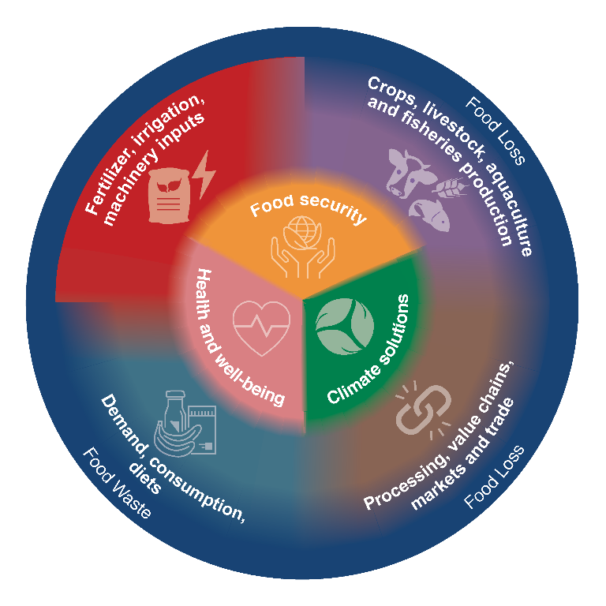
Figure 1 | Food system components, linkages, and outcomes.

Calculating food system GHG emissions

The addition of GHG emissions from energy use, supply chains, and consumption activities provides a much more comprehensive depiction of how food is contributing to climate change (Table 1). The result is an overall contribution of a considerable 21-37% of total anthropogenic emissions, compared to ~23% from agriculture combined with land-use change for food production (deforestation and peatland degradation) and ~10% from agriculture alone when defined as within-farm-gate crop and livestock production. These current assessments, while building on earlier syntheses of food systems emissions^{7–9}, have significantly expanded the global analysis of key sub-components and their contributions to climate change adaptation and mitigation.

Operationally and from the vantage point of achieving effective mitigation, food systems have not been cast effectively in either the IPCC guidelines¹⁰ as agriculture, forestry, and other land use (AFOLU) or the emission categories used in national GHG inventories (NGHGI)⁶. While these measurement protocols form the basis of national reporting under the UNFCCC and the Paris Agreement,⁵ and the planned Global Stock Take due in 2023, the food system approach could be much more useful for countries as they decide on the next stage of their nationally determined commitments (NDCs).
Table 1 | Comparison of 2007-2016 mean values and standard deviations of emissions from AFOLU¹¹ and global food system³ emissions by component, including food loss and waste.
AFOLU |  |  | Food System
Components | Emissions [GtCO₂-eq yr⁻¹]ª | Percentage of anthropogenic GHG emissions (%)^{b} | Components | Emissions [GtCO₂-eq yr⁻¹]ª | Percentage of anthropogenic GHG emissions (%)^{b}
Agriculture | 6.2 ± 1.4^{12,13} | 10–14 | Agriculture | 6.2 ± 1.4^{12,13} | 9–14
FOLU | 5.8 ± 2.6¹² | 6–16 | Food-related FOLU | 4.9 ± 2.5¹² | 5–14
 |  |  | Pre- to post-production | 2.6–5.2^{7,8} | 5–10^{c}
Total | 12.0 ± 2.9 | 17–29 | Total | 10.8–19.1 | 21–37
ªUsing GWP values of the IPCC AR5 with no climate feedback (GWP-CH₄=28; GWP-N₂O=265); using square root of sum of squares of standard deviations when adding uncertainty ranges.
^{b}Computed using a total emissions value for the period 2007–2016 of 52 GtCO₂-eq per year¹¹
^{c}Rounded to nearest fifth percentile due to assessed uncertainty in estimates.

Expansion of food-related response options

Because economic activity for the production, supply, and consumption of food extends beyond farmers’ fields (and producing countries), the food system approach provides a far more realistic landscape within which policy and response actions can be taken. It incorporates dietary change and reduction of food loss (reduction of edible food during production, postharvest, and processing)¹⁴ and food waste (food discarded by consumers and retailers)¹⁴ to complement the more traditional supply-side mitigation options, while also effectively linking them to resilience and adaptation

Dietary change. The EAT/Lancet Report raised awareness of the role that dietary choices can play in addressing pressing health and climate change challenges^{15,16}. Consumption of healthy and sustainable diets presents major opportunities for increasing food security (e.g., reducing obesity), expanding adaptation options (e.g., by reducing competition for land) and reducing GHG emissions from the food system while improving health outcomes. Table 2 shows total technical mitigation potentials – the maximum amount of GHG mitigation achievable through technology diffusion – as well as total economic mitigation potentials at a specified carbon price of both dietary changes (demand-side) and crop, livestock, and agroforestry activities (supply-side). This has important implications for both agri-businesses as well as smallholders; the latter could benefit from opportunities for raising diverse nutrient-rich foods³.
Table 2 | Food system supply-side and demand-side technical and economic mitigation potentials³.
Mitigation Potential | Supply-side [GtCO₂eq yr⁻¹] | Demand-side [GtCO₂eq yr⁻¹]
Technical | 2.3–9.6 | 0.7–8.0
Economic | 1.5–4.0ª | 1.8–3.4^{b}
ªBy 2030 at prices ranging from 20-100 USD/tCO₂eq
^{b}By 2050 at prices ranging from 20-100 USD/tCO₂eq

However, the potential for dietary changes are highly specific to different food systems, food environments¹⁵, and socioeconomic and cultural factors. Achieving the full mitigation potential of dietary change will require fundamental changes to local production systems, lowering of existing technical and financial barriers, changed dynamics in the global food system, and promotion of change in the cultural and socio-economic practices of both producers and consumers.

Food loss and waste. Since food loss and waste is associated with release of 8-10% of total anthropogenic GHG emissions³, reducing food loss and waste is an important GHG mitigation measure and a means to moderate growing food demand. Twenty-five to thirty percent of global food production¹⁷ is either lost or wasted during production, supply and consumption. Food loss, i.e., reduction of edible food during production, postharvest, and processing, increases the already-large pressures on the use of natural resources, for instance through expansion of land area for production. Food waste, i.e., food discarded by consumers and retailers, adds to demand for agricultural production. Globally, food waste has been increasing in the recent decades¹⁸. Halving the global per capita food waste and reducing food loss is a target of SDG 12 (Responsible Production and Consumption)¹⁹.

There are many technical methods to reduce food loss and waste (e.g., improved harvesting, on-farm storage, infrastructure, packaging to keep food fresher longer, and refrigeration), but these need to be done in GHG-efficient ways. There are also non-technical methods that include changes in behaviors and attitudes (such as acceptance of less-than-perfect fruit and vegetable appearance), and programs such as redistribution of food surplus and lowered prices on nearly expired food.

Synergies and trade-offs in a food system approach

Positive interactions can be more easily promoted and trade-offs avoided under a system approach. There is an expanded scope for adaptation as well as mitigation, since many practices that contribute to climate change mitigation have an adaptive role, as well as co-benefits (Fig. 2). For example, crop management practices such as increasing soil organic matter, erosion control, intercropping, and improved fertilizer, water and other input management all increase crop production while reducing GHG emissions and helping increasing resilience of crops to climate changes. Similarly, livestock options such as better grazing land management and improved manure management can contribute to both mitigation and adaptation.

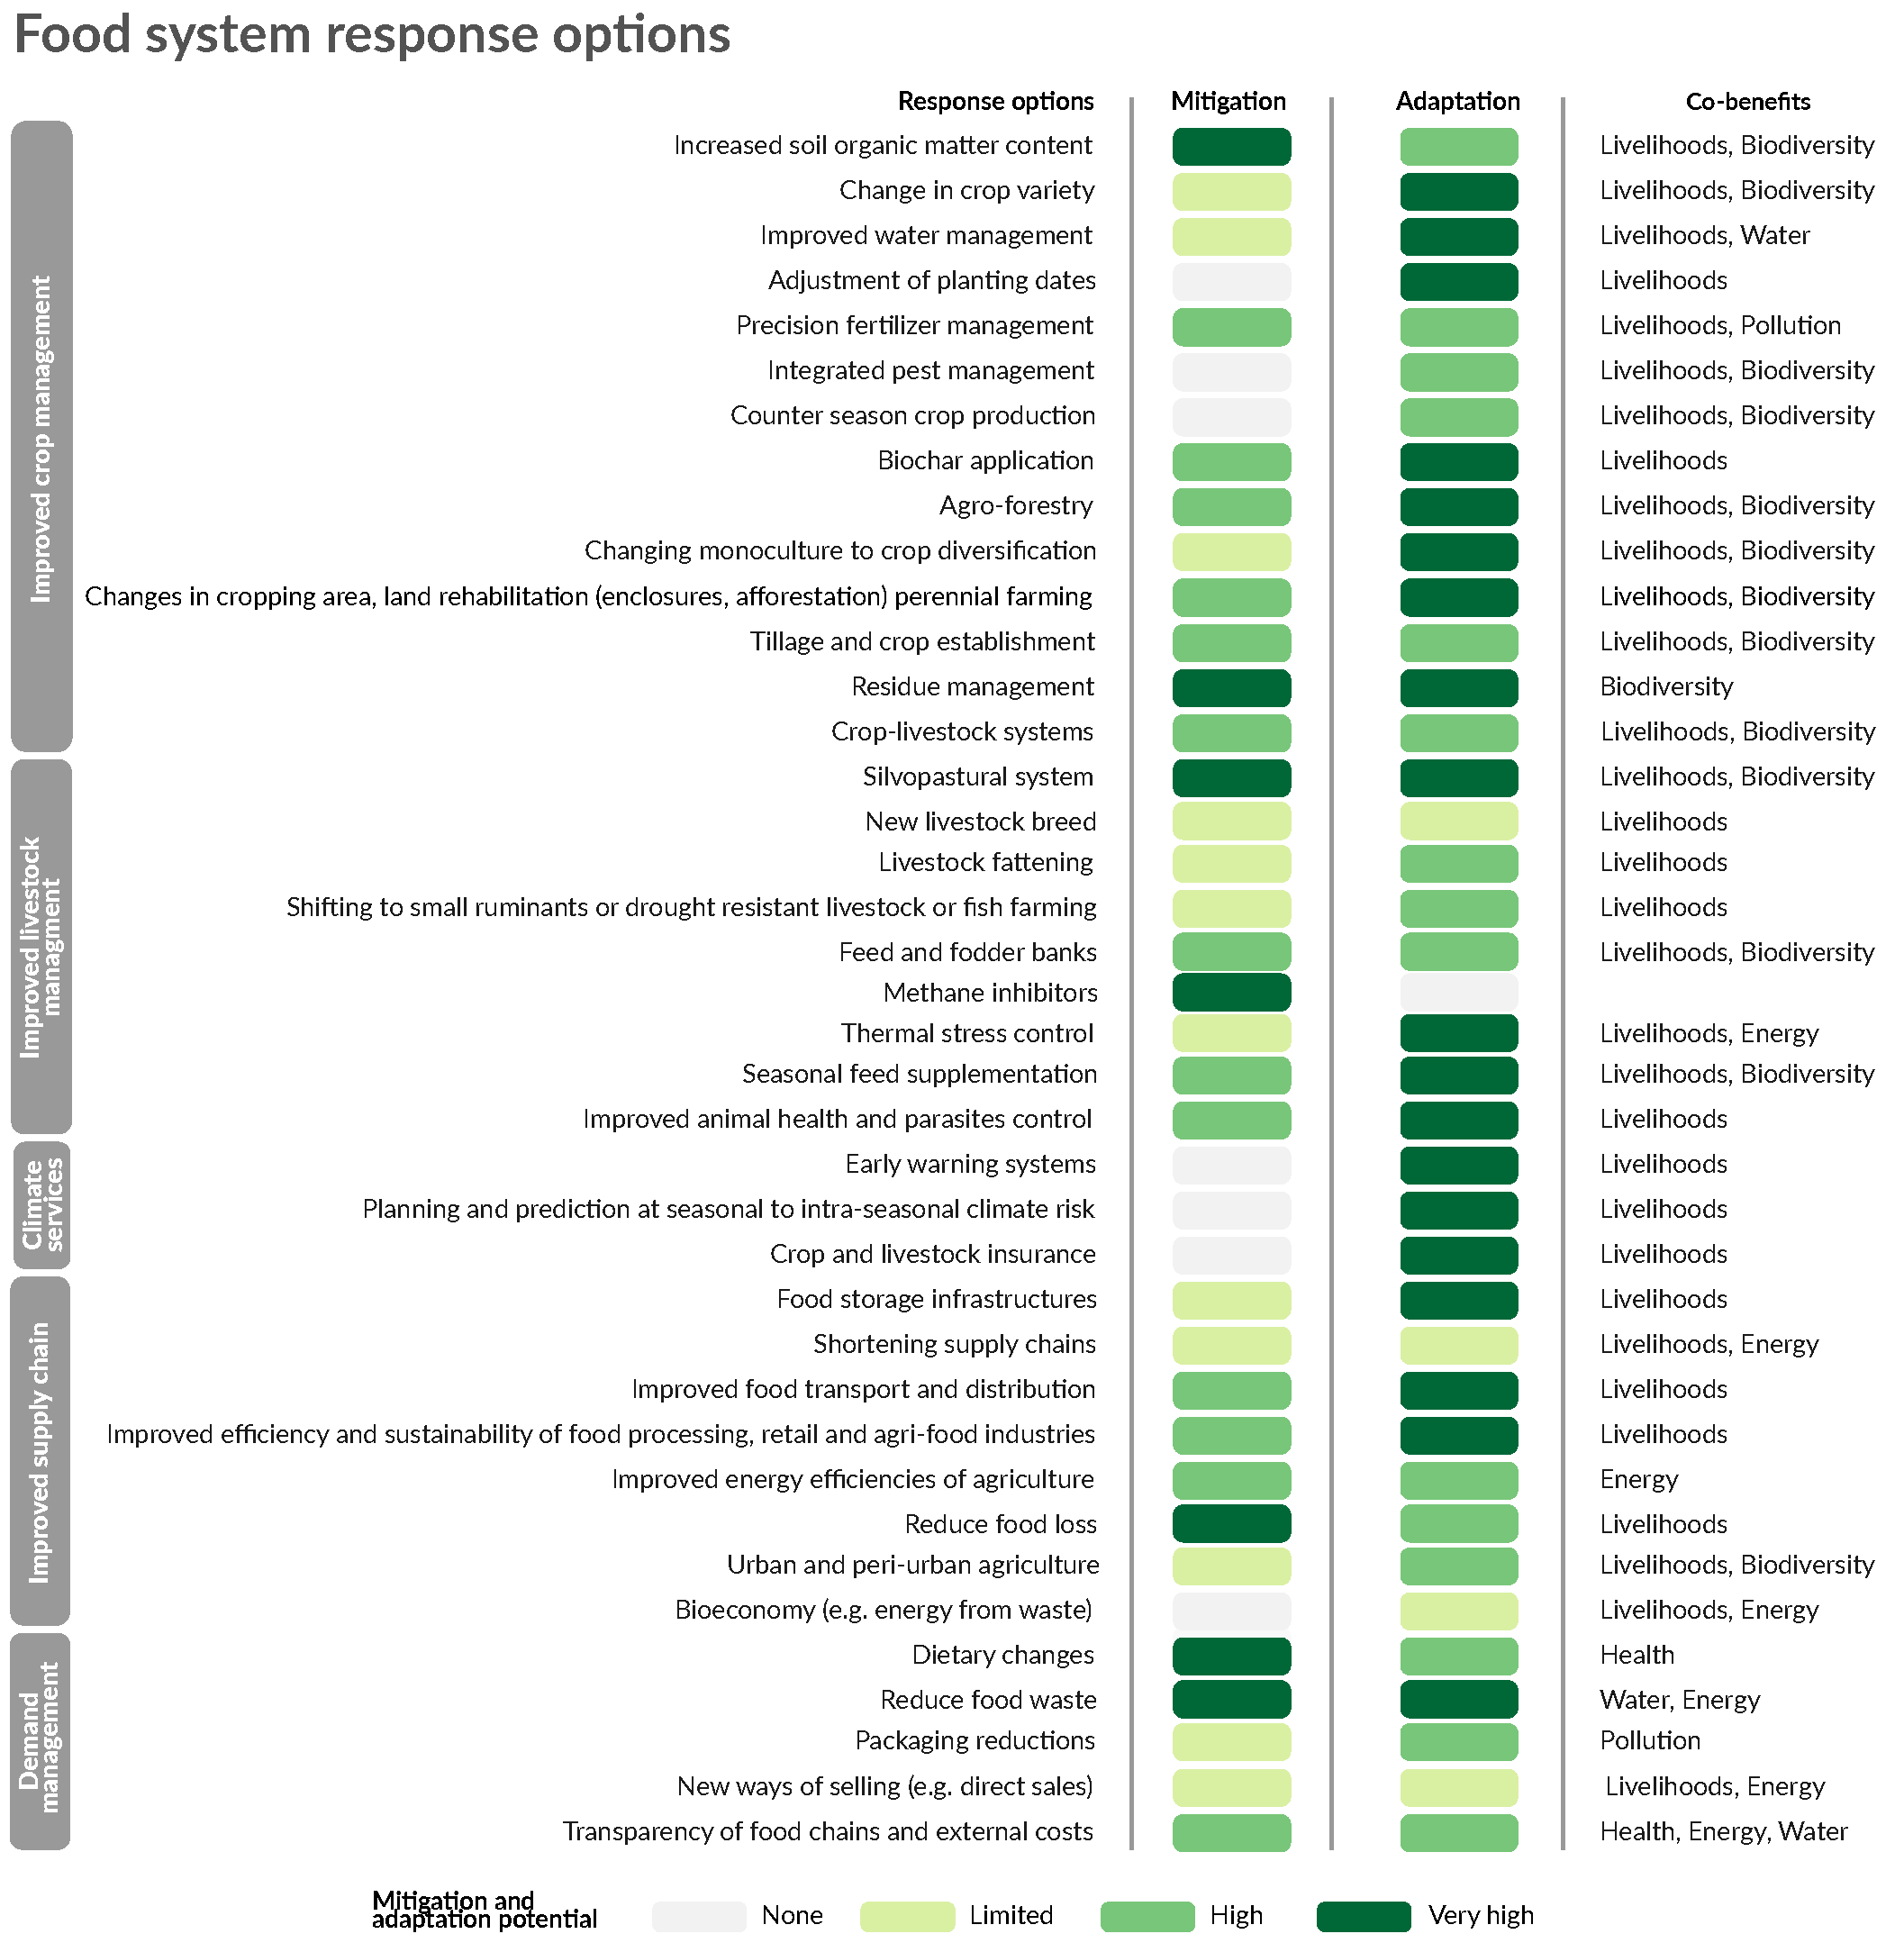
Figure 2 | Synergies between mitigation, adaptation, and other co-benefits resulting from food system climate change response options²⁰.

Potential trade-offs are also highlighted by the approach. A key trade-off, for example, involves competition for land from bioenergy to contribute to climate change mitigation vs. food production. If promulgated at large scales, bioenergy and carbon sequestration projects might encourage ‘land grabbing’ with negative trade-off effects on food security²⁰, while demand-side dietary change can generate a signal to farm-gate production that can result in a 'land-sparing' effect that reduces exposure and promulgates sustainable food production while minimizing competition for land-based carbon sequestration.

Further, attention needs to be paid to the ‘rebound effect’ by which gains in GHG emissions efficiencies are offset by increases in total emissions due to expansion of production linked to the increased efficiencies. Appropriate regulations and incentives, as well as monitoring systems, may need to be put in place to ensure that actual emission reductions in farming systems are taking place, as well as just transitions for producers who are bearing the brunt of system changes.

Scaling up

The food system approach offers significant advances for scaling up of climate change adaptation and mitigation by integration of a much broader set of actors and institutions. But more research is urgently needed for this scaling up to occur. First, a complete accounting of food system emissions is needed. The recent IPCC Special Report on Climate Change and Land revealed that many GHG sources – such as grain drying, packaging, and supply chain emissions – are less well characterized than those accounted for in AFOLU.

Second, the dynamics of dietary change are not well understood: key topics are behavioral studies of how to effect change to healthy and sustainable diets, their economic potential in regard to reduced healthcare costs, how and at what rate dietary change can feedback to changes in agricultural production, and its social and environmental impacts.

Third, it is essential to find actionable ways to increase adoption of key mitigation and adaptation practices, e.g., rigorous testing of the role of incentives and rapid development of innovative techniques such as circular economies. Research topics include rapid identification, e.g., through models and ex ante simulations, of adaptation and mitigation synergies; how to overcome barriers to implementation of promising practices in farmers’ fields; how to avoid competition between climate change mitigation and food security; and which governance structures favor equitable participation in climate change solutions.

Conclusion

Integrated approaches to climate change adaptation and mitigation across the global food system could lead to ‘transformation’ – a change in its fundamental attributes of natural and human dynamics. By explicitly recognizing fundamental connections between consumer demand, dietary choices, and production, the food system approach contributes to achievement not only of the Paris Agreement on Climate Change, but leads as well to a broader engagement with Sustainable Development Goal 2 to eliminate hunger^{3,19}. A focus on healthy and low-GHG emission diets will enable the development of targets for transforming the food supply into a more diverse array of agricultural products needed to ensure healthy populations. For this transformation to eventuate, it is essential to find actionable ways to increase adoption of key adaptation and mitigation practices, e.g., rigorous testing of the role of incentives and rapid development of innovative techniques such as circular economies.

References

1. Ericksen, P. J. Conceptualizing food systems for global environmental change research. Glob. Environ. Chang. 18, 234–245 (2008).
2. Ingram, J. A food systems approach to researching food security and its interactions with global environmental change. Food Secur. 3, 417–431 (2011).
3. Mbow, C. et al. Food Security. in Climate Change and Land an IPCC special report on climate change, desertification, land degradation, sustainable land management, food security, and greenhouse gas fluxes in terrestrial ecosystems 114 pp (2019).
4. Porter, J. R. et al. Food security and food production systems. Clim. Chang. 2014 Impacts, Adapt. Vulnerability. Part A Glob. Sect. Asp. Contrib. Work. Gr. II to Fifth Assess. Rep. Intergov. Panel Clim. Chang. 2, 485–533 (2014).
5. UNFCCC. The Paris Agreement. (2015). Available at: http://unfccc.int/paris_agreement/items/9485.php. (Accessed: 20th December 2017)
6. UNFCCC. National Inventory Submissions 2019. (2019). Available at: https://unfccc.int/process-and-meetings/transparency-and-reporting/reporting-and-review-under-the-convention/greenhouse-gas-inventories-annex-i-parties/national-inventory-submissions-2019.
7. Poore, J. & Nemecek, T. Reducing food’s environmental impacts through producers and consumers. Science 360, 987–992 (2018).
8. Fischedick, M. et al. Industry. in Climate Change 2014: Mitigation of Climate Change. Contribution of Working Group III to the Fifth Assessment Report of the Intergovernmental Panel on Climate Change (eds. Edenhofer, O. et al.) (Cambridge University Press, 2014).
9. Vermeulen, S. J., Campbell, B. M. & Ingram, J. S. I. Climate Change and Food Systems. Annu. Rev. Environ. Resour. 37, 195–222 (2012).
10. Calvo Buendia, E. et al. 2019 Refinement to the 2006 IPCC Guidelines for National Greenhouse Gas Inventories. (2019).
11. Jia, G. et al. Land-Climate Interactions. in Climate Change and Land an IPCC special report on climate change, desertification, land degradation, sustainable land management, food security, and greenhouse gas fluxes in terrestrial ecosystems 186 pp (2019).
12. FAOSTAT. Food and Agriculture Organization Corporate Statistical Database (FAOSTAT). (2018). Available at: http://www.fao.org/faostat/en/#home. (Accessed: 3rd December 2017)
13. USEPA. Global Anthropogenic Non-CO2 Greenhouse Gas Emissions: 1990-2030. EPA 430-R-12-006, Office of Atmospheric Programs, Climate Change Divison, U.S. Environmental Protection Agency. (2012).
14. FAO. Global food losses and food waste: Extent, causes and prevention. Food and Agriculture Organization (FAO, Rome, 2011).
15. Willett, W. et al. Food in the Anthropocene: the EAT-Lancet Commission on healthy diets from sustainable food systems. Lancet (London, England) 393, 447–492 (2019).
16. Dalin, C. & Outhwaite, C. L. Impacts of Global Food Systems on Biodiversity and Water: The Vision of Two Reports and Future Aims. One Earth 1, 298–302 (2019).
17. Kummu, M. et al. Lost food, wasted resources: Global food supply chain losses and their impacts on freshwater, cropland, and fertiliser use. Sci. Total Environ. 438, 477–489 (2012).
18. Hiç, C., Pradhan, P., Rybski, D. & Kropp, J. P. Food Surplus and Its Climate Burdens. Environ. Sci. Technol. (2016). doi:10.1021/acs.est.5b05088
19. United Nations. Transforming our world: the 2030 Agenda for Sustainable Development. (2015).
20. Smith, P. et al. Interlinkages between Desertification, Land Degradation, Food Security and GHG fluxes: synergies, trade-offs and Integrated Response Options. in Climate Change and Land an IPCC special report on climate change, desertification, land degradation, sustainable land management, food security, and greenhouse gas fluxes in terrestrial ecosystems (2019).

